*Case report*

Role of Immunohistochemistry in a Rare Case of Undifferentiated Soft Tissue Sarcoma with Cytohistopathological Correlation

ABSTRACT

|  |
| --- |
| Soft tissue sarcomas (STS) constitute a rare subset of malignancies, posing diagnostic challenges due to their varied clinical and histopathological presentations. This case report describes a young adult female who presented with a rapidly growing thigh mass initially misinterpreted as chronic hematoma on ultrasound examination. Subsequent cytological and histopathological correlation revealed features consistent with high-grade sarcoma, necessitating further characterization through immunohistochemistry (IHC). The tumour, displaying spindle cells with pleomorphic nuclei and abundant giant cells, posed a differential diagnosis, including pleomorphic leiomyosarcoma, liposarcoma, rhabdomyosarcoma, and malignant melanoma. Immunohistochemical examination was pivotal, confirming strong Vimentin positivity and a 30% Ki67 proliferation index while ruling out CDK4, Myogenin, MDM2, S100, SMA, and CD34 markers. This case underscores the critical role of IHC in accurate diagnosis and prognosis of challenging STS cases, advocating for a multidisciplinary approach to optimize patient management. |

*Keywords: Histopathology, vimentin positive, thigh mass, immunohistochemistry, soft tissue sarcoma.*

1. INTRODUCTION

Soft tissue sarcomas account for less than 1% of all malignant neoplasms. Undifferentiated soft tissue sarcoma is a high-grade aggressive tumour with mesenchymal differentiation [1]. With two incidence peaks, one at age 50 and the other at age 80, the average age of diagnosis is 60 years, with male predominance. It usually manifests in the head, neck, viscera, retroperitoneum, and extremities during life’s sixth and seventh decades [2]. There are more than 100 distinct histologic subtypes of soft tissue tumours, most of which are STS, according to the fifth edition of the World Health Organisation (WHO) Classification of Tumours of Soft Tissue and Bone. Each of these subtypes has its own distinct clinical, prognostic, and therapeutic characteristics. When examining all adult STS, liposarcoma, leiomyosarcoma, and undifferentiated pleomorphic sarcoma (UPS) are the most prevalent histotypes. Soft tissue tumours are typically classified using an assumed cell lineage method considering morphologic, immunohistochemical, and genetic characteristics. Histologically, immunohistochemical staining is generally used to make the diagnosis. Molecular testing, such as reverse transcriptase-polymerase chain reaction or fluorescence in situ hybridization, can also help because these methods can identify mutations, translocations, and recurrent gene amplifications specific to certain histologic subtypes of sarcoma [3].Sarcomas can be grouped into 3 main types based on their genetic changes- 1. Sarcomas with specific gene fusions - Example: Synovial sarcoma, which has a unique SYT-SSX fusion gene. 2. Sarcomas with single, known mutations – Example: Gastrointestinal stromal tumors (GISTs), which usually have a mutation in the c-KIT gene. 3. Sarcomas with many complex genetic changes– Example: Undifferentiated pleomorphic sarcoma (UPS) and leiomyosarcoma, which don't have a clear or specific genetic pattern. As research advances, doctors are now using both histology and genetic mutations to make more accurate diagnoses and treatment decisions [3]. Initially, the nature of the tumour is benign, eventually leading to its locally malignant nature with a wide variety of presentation and thus forming a diagnostic challenge. Surgical resection remains the mainstay of treatment [4].In our case, we would like to highlight the importance of immunohistochemistry as an essential tool for the timely diagnosis and prognosis of soft tissue sarcomas.

**2. PRESENTATION OF CASE**

A woman in her early 40s presented with swelling over the left thigh for four months. Clinically, mass measured 7 x 7cm, firm to hard, fixed and non-tender. Patient was tested HIV positive. USG findings were suggestive of Chronic hematoma. FNAC showed spindle cells with elongated pleomorphic nuclei, prominent nucleoli and bizarre forms suggestive of High-grade sarcoma (Figure 1). A surgical-wide excision of the mass was performed. Grossly, we received a skin-covered fibrofatty tissue mass measuring 8x6 cm. The cut section of the tumour was soft and fleshy (Figure 2). Histopathological examination showed tumor arranged in sheets comprised of spindle cells with elongated pleomorphic and hyperchromatic nuclei, with scant to moderate amount of cytoplasm. Also noted were plenty of pleomorphic tumour giant cells (Figure 3). Based on the cytohistopathological features, differential diagnoses considered were pleomorphic leiomyosarcoma, pleomorphic liposarcoma, pleomorphic rhabdomyosarcoma and malignant melanoma.

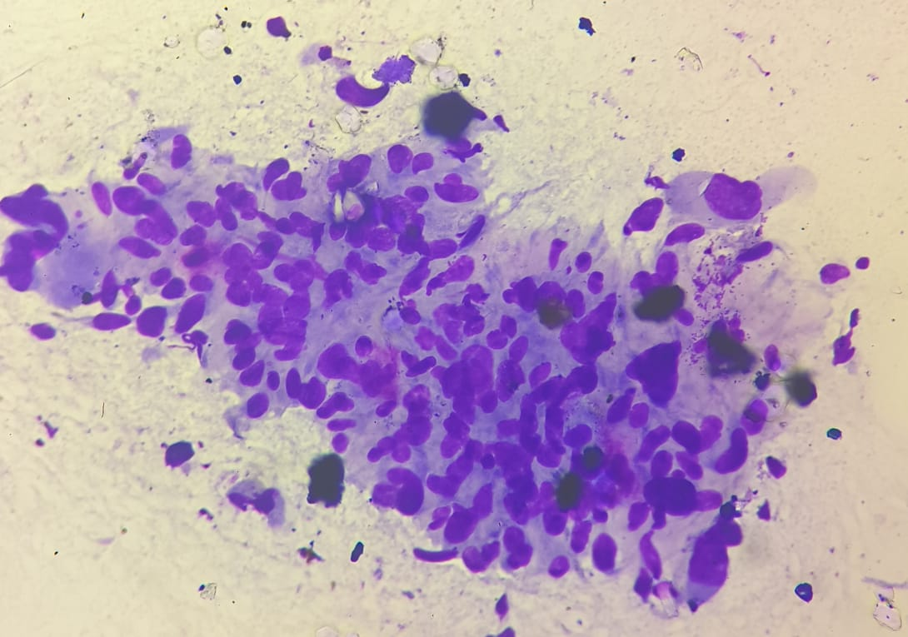

**Figure 1-** **Photomicrograph (40x, Giemsa) showing spindle cells with elongated pleomorphic nuclei, prominent nucleoli and bizzare forms suggestive of High grade sarcoma.**

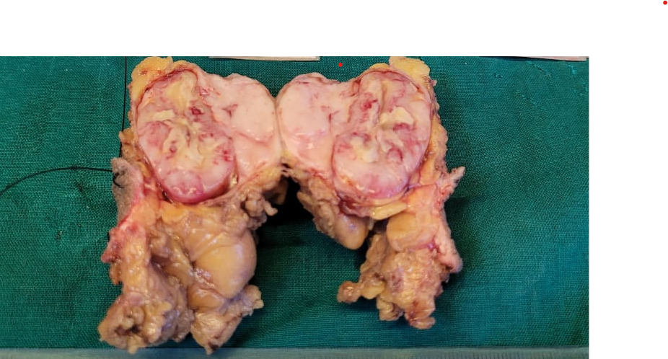

**Figure 2- The excised specimen received in the histopathology section is a skin covered fibrofatty tissue mass measuring 8 x 6 cm. The cut section is showing soft fleshy appearance.**

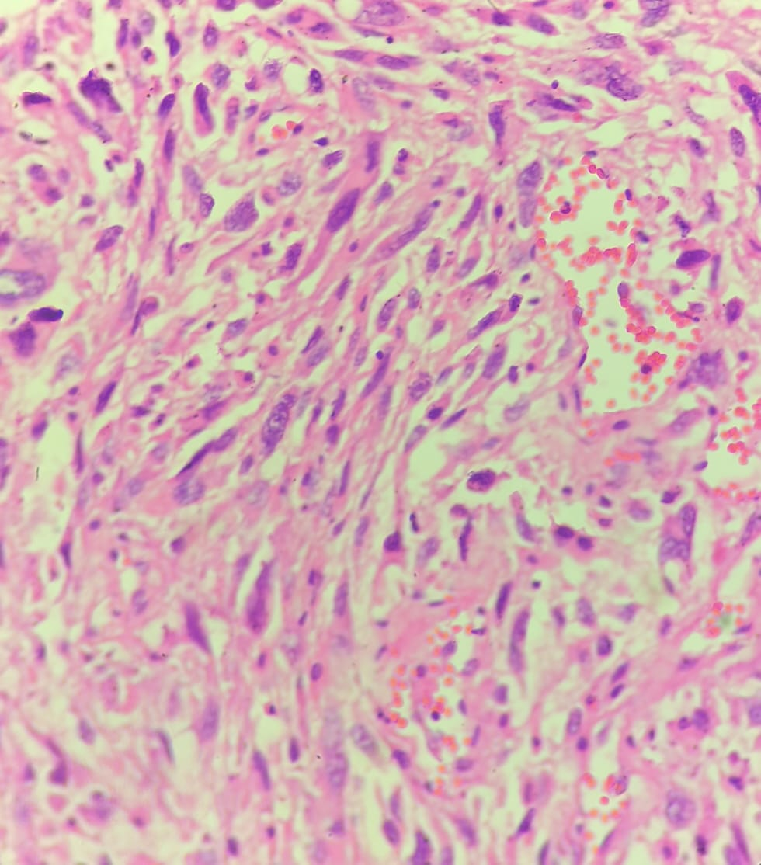

**Figure 3-** **Photomicrograph (40x, Hematoxylin & Eosin) showing tumor arranged in sheets comprised of spindle cells with elongated pleomorphic and hyperchromatic nuclei, with scant to moderate amount of cytoplasm. Also noted were plenty of pleomorphic tumor giant cells amidst.**

Immunohistochemical analysis revealed strong positivity for Vimentin, a mesenchymal marker commonly expressed in soft tissue sarcomas ( Figure 4). The proliferation index, indicated by Ki67, showed a significant 30% nuclear positivity, highlighting the tumour’s aggressive nature ( Figure 5). Notably, the tumour cells were negative for CDK4, Myogenin

( Figure 6 ), MDM2, S100, SMA (Figure 7) and CD34, ruling out alternative diagnoses and confirming the undifferentiated nature of the sarcoma. In our case, Immunohistochemistry is essential as it is challenging to diagnose on histopathology alone.

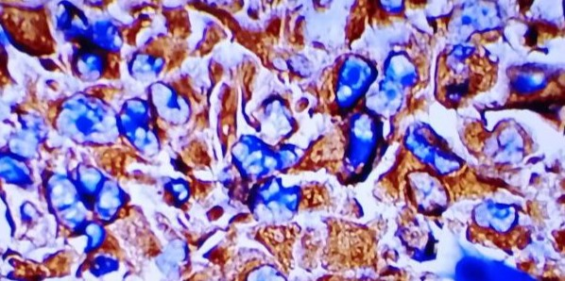

**Figure 4- Photomicrograph (40x) immunohistochemical study of vimentin showing strong cytoplasmic positivity.**

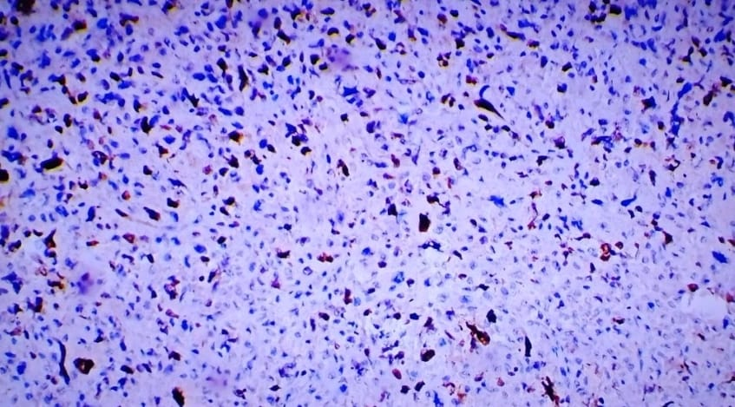

**Figure 5-** **Photomicrograph (40x) immunohistochemical study of Ki67 showing 30% nuclear positivity.**

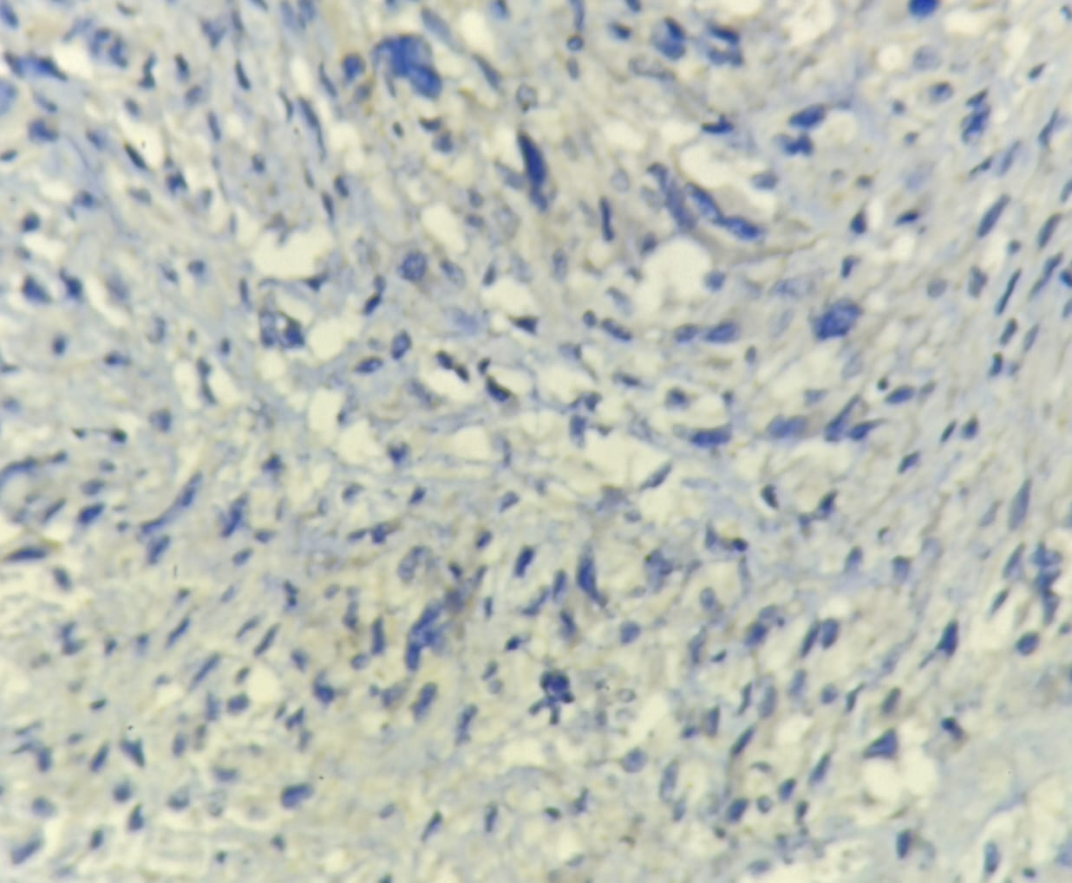

**Figure 6-** **Photomicrograph (40x) immunohistochemical study of Myogenin showing negative staining in tumor cells.**

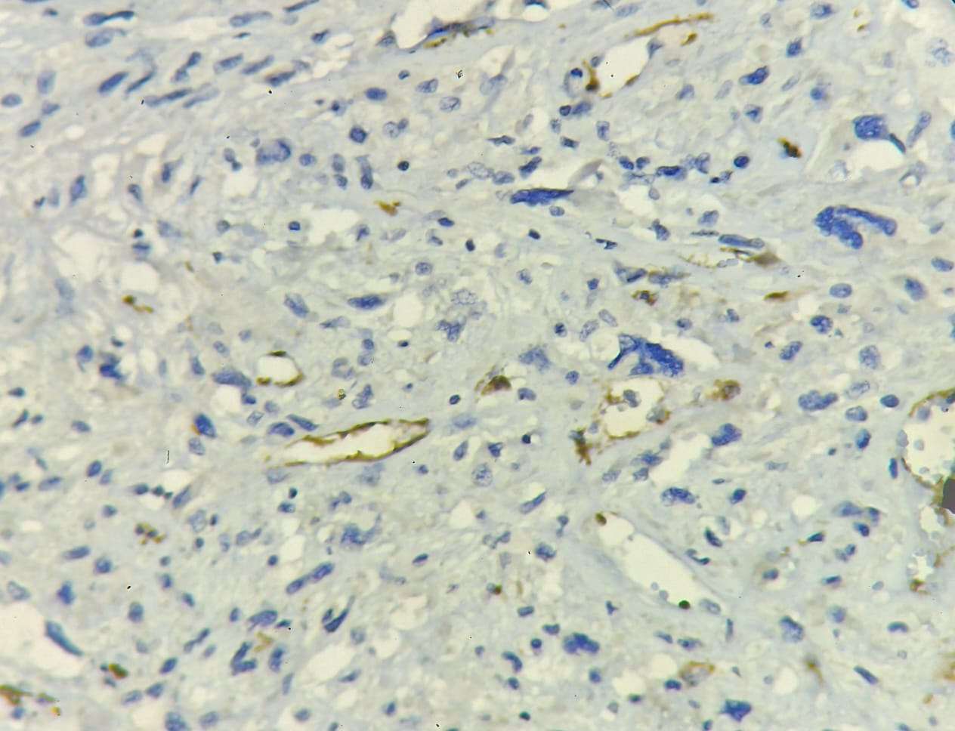

**Figure 7- Photomicrograph (40x) immunohistochemical study of SMA showing negative staining in tumor cells.**

3. discussion

Soft tissue sarcomas (STS) represent a heterogeneous group of rare malignancies originating from mesenchymal tissues, accounting for less than 1% of all malignant neoplasms [4].

Soft tissue sarcomas occur in 2 to 3 cases per 100,000 people annually; in the case of undifferentiated pleomorphic sarcoma, the fourth most prevalent soft tissue sarcoma, the incidence is 1 per 100,000 people annually[5].

The common site of involvement is the extremities, followed by the trunk. Clinically, the patient has a painless lump that appears and increases with time. Sarcomas are more locally concentrated than benign lesions, and they are frequently diagnosed later [2].

Undifferentiated pleomorphic sarcomas usually manifest as confined, multinodular, lobulated tumours with degeneration that are painless. Systemic symptoms like fever, weight loss, and leukocytosis may be present in the inflammatory type. While MRI has already been shown to be useful in assessing the extent of sarcomas, its capacity to distinguish between benign and malignant lesions, as well as between different subtypes of sarcoma, remains debatable.

This is because the majority of soft tissue tumours exhibit nonspecific imaging findings, such as intermediate SI on T1WI, high SI on T2WI, and heterogeneous enhancement following contrast administration, which is caused by hemorrhage and necrosis within the tumour. Low SI regions can be seen on T2WI in tumours containing fibrous tissue, such as UPS and low-grade fibrosarcomas [6].

Tissue diagnosis is crucial in cases in which neoadjuvant therapy will be given. Specimen review should be done by an experienced sarcoma pathologist with access to ancillary techniques, such as immunohistochemistry, classical cytogenetics, and molecular genetic testing, if needed to make a definitive diagnosis [3].

Although their cellularity and appearance are highly varied histologically, pleomorphic cells are present in every one. Certain variations feature many giant cells or a diffuse inflammatory component (inflammatory UPS/giant cells) [6].

In this case, the gross and histopathological features raised a challenging differential diagnosis, including pleomorphic leiomyosarcoma, pleomorphic liposarcoma, pleomorphic rhabdomyosarcoma, and malignant melanoma. The presence of spindle cells with elongated pleomorphic nuclei, hyperchromatic features, and abundant pleomorphic tumour giant cells added to the complexity of the diagnosis. Given these challenges, immunohistochemistry emerged as a crucial tool for definitive characterization. Targeted treatments using immune checkpoint inhibitors blocking the binding between PD-L1 and PD1 is already established in many solid cancers such as melanoma and lung cancer, with favorable response even in operable or disseminated disease. Treatment response is often correlated with the presence of tumor infiltrating lymphocytes and PD-L1 expression in both tumor and immune cells. In a study done by Yifan Zhang et al, it was observed that PD- L1 immunoreactivity was more common in undifferentiated pleomorphic sarcoma compared to chondrosarcoma and liposarcoma [7]. Furthermore, the patient's positive HIV status adds an additional layer of complexity to the case. The impact of immunosuppression on the development and behavior of soft tissue sarcomas, particularly undifferentiated subtypes, warrants further investigation. In this case the gross and histopathological features raised a challenging differential diagnosis, including pleomorphic leiomyosarcoma, pleomorphic liposarcoma, pleomorphic rhabdomyosarcoma and malignant melanoma. The presence of spindle cells with elongated pleomorphic nuclei, hyperchromatic features and abundant pleomorphic tumor giants added to the complexity of diagnosis. Given these challenges, immunohistochemistry emerged as a crucial tool for definitive characterization as histopathology solely possess difficulty in diagnosis. Many IHC markers were done to arrive at the final diagnosis.

4. Conclusion

The development of metastatic disease affects the prognosis of approximately 50% of soft tissue sarcoma patients, presenting a significant challenge. Therefore, maintaining close patient follow-up is crucial to detect any tumour recurrence. This case underscores the pivotal role of immunohistochemistry in differentiating challenging soft tissue sarcomas, providing valuable information for accurate diagnosis and prognosis.The comprehensive use of a panel of markers aids in ruling out mimickers and guiding appropriate clinical management.

Consent (where ever applicable)

All authors declare that written informed consent was obtained from the patient (or other approved parties) for publication of this case report and accompanying images. A copy of the written consent is available for review by the Editorial office/Chief Editor/Editorial Board members of this journal.

Ethical approval (where ever applicable)

As per international standards or university standards written ethical approval has been collected and preserved by the authors.

References

1.Babamiri B, Yavari S, Nikpey S, Faraji N, Goli R, Rahimi K. Undifferentiated soft-tissue sarcoma (STS) in a 34-year-old woman: a case report. International Journal of Surgery Case Reports. 2023 Apr 1;105:108104.

2. Zhang S, Zhang X, Zhao Z, Xu L, Xu S, Liu T, et al: Undifferentiated pleomorphic sarcoma of the extremity and trunk: a retrospective cohort study of 166 cases in a large institution. Translational Cancer Research. 2022 Apr;11(4):678.

3.Gamboa AC, Gronchi A, Cardona K. Soft‐tissue sarcoma in adults: an update on the current state of histiotype‐specific management in an era of personalized medicine. CA: a cancer journal for clinicians. 2020 May;70(3):200-29.

4. Ishihara S, Yamada Y, Iwasaki T, Yoshimoto M, Toda Y,et al: PD-L1 and IDO-1 expression in undifferentiated pleomorphic sarcoma: The associations with tumor infiltrating lymphocytes, dMMR and HLA class I. Oncology reports. 2021 Jan 1;45(1):379-89.

5.Upasham PS, Dighavkar SP, Roplekar PM. Undifferentiated pleomorphic sarcoma: Diagnosis of exclusion. Asian J Oncol 2017;3:133‑5.

6. Black MA, Charville GW. Diagnosis of soft tissue tumors using immunohistochemistry as a surrogate for recurrent fusion oncoproteins. In Seminars in Diagnostic Pathology 2022 Jan 1 (Vol. 39, No. 1, pp. 38-47). WB Saunders.

7. **Zhang Y, Chen Y, Papakonstantinou A, Tsagkozis P, Linder‑Stragliotto C, Haglund F.** Evaluation of PD‑L1 expression in undifferentiated pleomorphic sarcomas, liposarcomas and chondrosarcomas. Biomolecules. 2022;12(2):292. doi:10.3390/biom12020292