***Case report***

**Unsual localizations of hydatid disease**

**Abstract**

The hydatid cyst is a cosmopolitan parasitic infection which constitutes a

public health problem in our country and in the breeding areas of

developing countries. The gluteal localization of the hydatid cyst is

exceptional among the muscular localization which makes only 1 to 5% of all

cyst localizations.

In this work, we present a retrospective study of a series of 1

cases of isolated and primary hydatid cyst in the gluteal muscle observed at

emergency department of visceral surgery at ibn sina rabat hospital.

The aim of this study was to analyze the epidemiological, clinical,

biological, radiological and therapeutic aspects of this condition.

The predilection field was that of the woman, with an average age of 40 years,

and without notion of contact with dogs.

The clinical picture was represented in 66.6% by signs of compression of

neighboring structures (lumbosciatica, rectal compression), and in 33.3%, the

symptomatology was poor, consisting of a painless, non-inflammatory muscle swelling

progressively increasing in volume, and evolving slowly in a context of preservation of general condition. No associated visceral localization was detected in any of our 3 patients.

Computed tomography confirmed the diagnosis, and enabled us to specify more precisely the location of the cyst and its relationships. The diagnosis was made intraoperatively in

our case.

Treatment consisted of surgical excision, supplemented in some cases by

antiparasitic medical treatment. Results were generally satisfactory, and no cases of recurrence were reported in our case. Prophylaxis is the best way to combat this parasite in endemic areas.

**Introduction**

This is a potentially fatal parasitic disease, in which man is the accidental intermediate host

and the dog is the reservoir and definitive host of the tapeworm

echinococcus [1.2]

Contamination occurs through consumption of water or raw vegetables contaminated with

dog faeces, or directly through contact with the parasitized dog [3]

The clinical symptoms of echinococcosis are variable and are determined by

the size, site and condition of the cysts[4].

Extrahepatic echinococcal cysts often pose diagnostic dilemmas

and sometimes the diagnosis is made intraoperatively [5]

Diagnosis is based on ultrasonography and computed tomography (CT), which

remain the examinations of choice. Nuclear magnetic resonance (MRI) is also

effective [6].

The diagnosis must be made in the presence of any liquid mass, especially in an endemic

country such as Morocco [7]

Surgery is the most effective treatment, with a significant morbidity of

conservative treatment that must be emphasized. Recent years have seen the development of percutaneous interventional radiology techniques such as puncture, aspiration, injection and reaspiration (PAIR), percutaneous drainage without reaspiration, which have improved the mortality and morbidity of hydatid cysts. Post-surgical drug treatment is necessary for complete cure. [8,9]

Prophylaxis is a real tool which must act at all levels of the

epidemiological chain[10].

**Case Présentation**

**observation 1**

This is a 29-year-old female patient, with no previous history and in particular no

notion of contact with dogs, hospitalized for a gluteal mass with a

rectal compression.

Symptoms began 6 months ago with the appearance of a painless right gluteal

mass that progressively increased in size, causing rectal compression

. All this evolved in a context of apyrexia and preservation of general condition.

Clinical examination revealed a mass on the right buttock extending into the intergluteal groove, painless, kidney-shaped, 14cm in diameter and without

inflammatory signs. On rectal examination, the mass was seen to extend upwards along the ana canal and to contact the rectal ampulla. Vaginal examination was normal.

Ultrasound showed a homogeneous mass of hydrous density, without

internal partitions or hepato-splenic abnormalities. Computed tomography (CT)

showed a hydatid cyst in relation to the vulva and rectum .

The hydatid disease work-up was normal. Rectoscopy showed extrinsic elevation of the rectum. Biological work-up was normal, with no eosinophilia.

Treatment consisted of intraoperative puncture of the mass, which yielded a

rock-water liquid. A short elective vertical incision revealed a

type I hydatid cyst, contracting adhesions with the anal sphincter.

Proper cleansing with hydrogen peroxide was performed, and the

proligeral membrane was extracted (figure 1).

Post-operative follow-up was straightforward, with no sign of recurrence after six years

of follow-up.

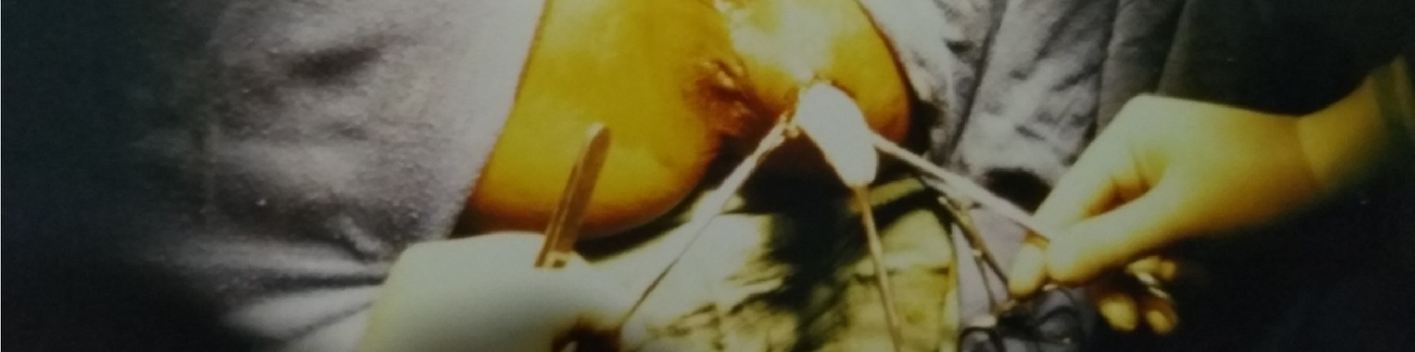

**Figure 1: intraoperative image showing extraction of the proligeral membrane**

**Observation 2:**

60-year-old woman, operated on for a lithiasis vesicle 20 years ago, with no notion of contact with dogs, admitted to the department on 10/05/2008 for a swelling of the upper external part of the right buttock. The onset of symptoms was one year ago, with the appearance of a renitrating mass, progressively increasing in volume, on the right buttock without any associated signs, in a context of apyrexia and with preservation of general condition. Clinical examination revealed a renal mass 7cm in diameter on the upper external part of the right buttock, with no inflammatory signs. 2.1. Radiological findings: Ultrasound examination revealed a 7cm cystic mass in the upper lateral quadrant of the right buttock region, with a regular wall and homogeneous fluid content, suggesting a hydatid cyst .

The liver, spleen and rest of the abdominal cavity were without abnormalities. A parietal CT scan showed a cystic mass in the right buttock, approximately 7cm in diameter, with a liquid-like structure and discrete peripheral parietal enhancement after injection of an iodine bolus. The mass was posterior in location, just behind the right iliac crest, protruding into the subcutaneous fatty tissue and in contact with the upper part of the buttock muscle, suggesting a hydatid cyst .

She underwent elective surgery after protection with hydrogen peroxide-soaked drapes and cyst isolation (figure 2). Suction puncture yielded a clear rockwater liquid, and extraction of the proligeral membrane was followed by abundant cleansing with hydrogen peroxide. We then performed a pericystectomy, removing the entire hydatid cyst shell (figure 3) and draining the subcutaneous tissue with a Redon suction drain.

Post-operative follow-up was straightforward, and the patient left the department three days later with a good clinical and radiological evolution. There was no sign of recurrence over a four-year follow-up**.**

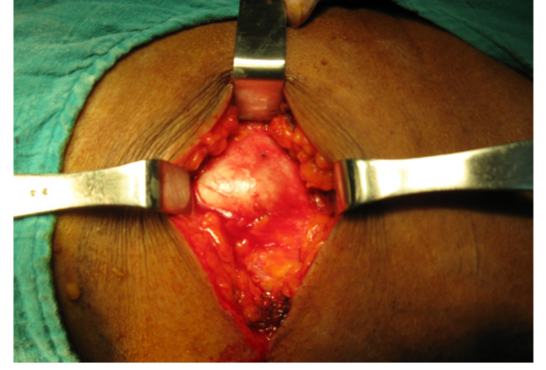

**Figure 2: Preoperative exposure of the KH after dissection**

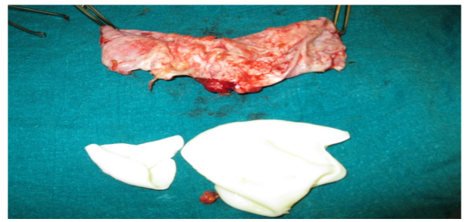

**Figure 3: Complete surgical excision specimen**

**Observation 3:**

A patient, aged 30, with no previous history, living in a rural area, was admitted to the department for a left buttock mass with low back pain. The symptomatology began 9 months ago with the appearance of a mass in the left buttock, progressively increasing in size and causing low back pain that was not improved by anti-inflammatory medication. All this was evolving in a context of preserved general condition and apyrexia. On examination, a painless mass was found in the left buttock, mobile in relation to the deep plane. The patient's general condition was preserved, and mobility of the left hip was not restricted. 3.1. Radiological findings: Abdominopelvic CT scan showed remodelling of the iliac wing and left sacral fin (figure 4), associated with a voluminous mass measuring 10 cm by 8 cm in diameter, with a liquid-like structure and a multiloculated appearance, shooting along the left iliac muscle and extending towards the posterior wall, infiltrating the gluteus medius and gluteus maximus muscles .

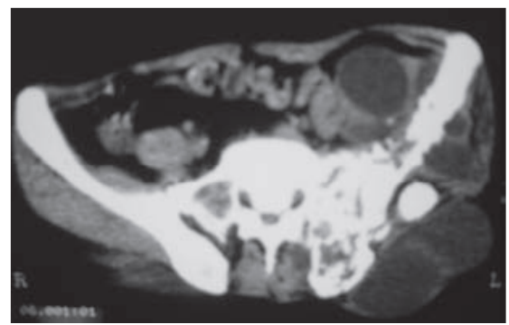

**Figure 4: CT scan showing remodelling of the iliac wing and left sacral fin**

**DISCUSSION**

Hydatidosis tends to be a disease of young adults, with the average age of

discovery being 40[3].

There is a predominance of females, estimated at 70% in the majority

of studies, as women are more involved than men in the care of livestock

and dogs. However, hormonal or immunological factors cannot be ruled out. In France, there are as many men as women. This female predominance is found in all

anatomical locations of hydatid cysts[11]. The epidemiology of hydatidosis varies.

The ancestral cycle is carried out by herbivores and wild canids. This is the beginning of the more common rural cycle, which is carried out between farmed livestock and dogs[12].

Since 2005, the Ministry of Health has set up a notification system

for hydatidosis, which has become a notifiable disease [13].

In 2008, Morocco officially launched a national hydatidosis/echinococcosis control program

[14]. In the Maghreb, according to Ministry of Health figures, Morocco

ranks 3rd after Tunisia (14 cases/100,000 inhabitants) and Algeria (10 cases/100,000 inhabitants[33]).

The initial phase of infection is always asymptomatic, and may persist for several years. Clinical manifestations then depend on the location and size of the cysts. Small

cysts and/or calcified cysts may remain asymptomatic indefinitely. The

clinical signs are secondary [52]:Either to the existence of a

mass syndrome in the affected organ. obstruction of blood flow or

lymphatic flow. a complication such as cyst rupture with secondary superinfection.

Hydatid cysts can be found in all parts of the body,Because of their physiological role as filters capillaries and their vast capillary volume, the liver and lungs are

most often affected. Cerebral, muscular, renal, bone, cardiac and

pancreatic involvement is less common. Eighty-five to 90% of patients have

an affected organ, and 70% have a single cyst[15].

Imaging is the essential tool for avoiding biopsy, which can

trigger anaphylactic shock and should therefore be avoided altogether.

Ultrasound is the first-line examination. The typical appearance is

A hypoechoic round image with a smooth wall. The multiplicity of vesicles

gives a “honeycomb” image. The ultrasound classification of

hydatid cysts, drawn up by a WHO expert committee, allows them to be classified as either

active or inactive, but is only used in hepatic localizations[16].

MRI remains the best examination for diagnosing muscular cysts by showing a multiloculated cystic image. It also allows precise localization. CT scans are still useful in the d'extension assessment[17].

Biologically, hypereosinophilia is inconstant. Serology for

hydatidosis is based on at least 2 screening techniques (HAI,

ELISA, immuno-fluorescence, electrosynthesis, etc.), followed, in the case of

positivity, by a confirmatory technique (Western Blot). Serology

is highly sensitive in hepatic and pulmonary forms, whereas

is positive in only around 25% of other forms. A negative

serology therefore does not exclude the diagnosis [18].

Treatment of muscular hydatidosis is primarily surgical,

consisting of total perikystectomy, combined with lavage with a

scolicidal agent (hypertonic saline or hydrogen peroxide) to avoid

dissemination during surgery.

A definitive diagnosis is made by examination of the extracted mass

, within which daughter vesicles are found. Microscopic examination of the hydatid fluid at

may reveal the presence of

protoscolex if the cyst is still active[19].

Long-term monitoring of the patient is necessary in order to detect

local or distant recurrence. It is based on clinical examination,

imaging and follow-up serology (every 3 months, for 2 years).

Serology can be negative for several months or even years. A rise

in antibodies may indicate recurrence or reinfection[20].

**Conclusion**

Hydatidosis is a parasitosis that is widespread in areas where

sheep are bred, notably in southern Europe, Asia, Australia,

Africa and the Middle East. In Morocco, it represents a veritable

public health problem.

In humans, the liver is the most frequent site of

cyst development (60%), followed by the lungs (20%).

Muscular hydatidosis is a rare condition, and gluteal localization

appears to be exceptional, even in endemic countries.

The rarity of muscle hydatidosis may be explained by the fact that

the parasite passes through two filters (hepatic and pulmonary) before reaching

the general circulation. Muscle is a less than ideal environment

for the development of hydatid larvae, owing to the contractility of

muscles on the one hand, and the production of lactate on the other.

Clinically, muscular hydatidosis, and specifically

gluteal localization, is characterized by a long clinical latency. It

is clinically manifested by the appearance of a mass, often

painless, progressively increasing in volume, with no change in general condition

.

However, very large cysts can cause

functional discomfort or compression neuropathy

This disease is reputed to be benign, but can become serious at

due to its inescapable complications, which are dominated by

cyst rupture, which can lead to clinical manifestations

of hypersensitivity, such as fever, but can also lead to true anaphylactic shock

.

The clinical diagnosis of muscular hydatidosis is difficult to make.

Imaging is an indispensable tool for avoiding biopsy, which can

trigger anaphylactic shock and is therefore totally inadvisable.

Treatment of muscular hydatidosis is primarily surgical,

consisting of total perikystectomy, combined with lavage with a

scolicidal agent (hypertonic saline or hydrogen peroxide) to avoid

dissemination during surgery.

REFERENCES

[1]. P. L. Moro and P. Cantey, 281 - Echinococcus Species: Agents of Echinococcosis, Fifth Edit. Elsevier Inc., 2018.

[2]. M. O. Sarra, “PERITONEAL HYDATID DISEASE EXPERIENCE OF THE SURGERY DEPARTMENT C OF THE AVICENNE UNIVERSITY HOSPITAL,” pp. 1–73, 2018.

[4]. M. BENKOURDEL, “Hydatid cyst of the liver,” J. Chir. (Paris)., vol. 142, no. 2, pp. 120–122, 2017.

[5]. D. Mezioug and C. Touil-Boukoffa, “Interleukin-17A correlates with interleukin-6 production in human cystic echinococcosis: A possible involvement of IL-17A in immunoprotection against echinococcus granulosus infection,” Eur. Cytokine Netw., vol. 23, no. 3, pp. 112–119, 2012.

[6]. M. Labsi, I. Soufli, L. Khelifi, Z. C. Amir, and C. Touil-Boukoffa, “In vivo treatment with IL-17A attenuates hydatid cyst growth and liver fibrogenesis in an experimental model of echinococcosis,” Acta Trop., vol. 181, no. June 2017, pp. 6–10, 2018.

[7]. P. Aubry, “Hydatidosis: Hydatid cyst,” pp. 2–6, 2013.

[8]. I. Alaoui, F. Hjoui, M. Doumbia, S. Aoufi, and M. Lyagoubi, “Hydatid cyst of the psoas muscle: A case report,” Pan Afr. Med. J., vol. 24, pp. 1–5, 2016.

[9]. A. G. Ait lahcen, A. Messoudi, A. Rafaoui, A. Rahmi, B. Messoudi, H. Garnaoui, M. Rafai, M. Rahmi, “Peripheral Muscle Hydatidosis: Diagnostic and Therapeutic Particularities. About 5 Cases and Review of the Literature,” Rev. Marocaine Chir. Orthopédique Traumatol., pp. 60–65, 2017.

[10]. F. G. E. ELALOUANI, “Muscular Localization of Hydatid Cysts in the Limbs (about 7 Cases),” 2013.

[11]. A. Ouassou, “Hydatid Cyst,” pp. 1–151, 2008.

[12]. O. Mourafiq, “Peritoneal Hydatidosis in Children,” 2014.

[13]. B. Ziouani, “Hydatid Cyst of the Liver Complicated in the Visceral Surgery Department at the HMA,” 2015.

[14]. D. L. E. N. Marocain, “EPIDEMIOLOGICAL STUDY ON BOVINE HYDATIDOSIS,” vol. 152, no. 1, pp. 7–18, 2013.

[15]. M. H. Bouhaouala, L. Hendaoui, and P. Taourel, “Imaging of Hydatid Disease,” J. Radiol., vol. 87, no. 5, pp. 582–583, 2006.

[16]. E. Brunetti, P. Kern, and D. Vuitton, “Expert consensus for the diagnosis and treatment of cystic and alveolar echinococcosis in humans,” Acta Trop, p. 114:1–16, 2010.

[17]. Z. Orhan, H. Kara, T. Tuzuner, I. Sencan, and M. Alper, “rimary subcutaneous cyst hydatic disease in proximal thigh: an unusual localization: a case report,” BMC Musculoskelet Disord, vol. 4:25, 2003.

[18]. E. Cappello et al., “Epidemiology and clinical characteristics of cystic hydatidosis in Western Sicily: a ten-year review,” World J Gastroenterol, p. 19:9351–8, 2013.

[19]. S. Arif et al., “Albendazole as an adjuvant to the standard surgical management of hydatid cyst liver,” Int J Surg, p. 6:448–51, 2008.

[20]. O. Thaunat and P. Priollet, “Hepatic hydatidosis,” Press. Med, p. 33:30, 2004.