Original Research Article

Analytical Performance Assessment of Three Used Glucometers in Côte d'Ivoire: Compliance with ISO 15197 Standards

Abstract
Background: Self-monitoring of blood glucose is essential for effective diabetes management, necessitating the use of glucometers that maintain precision and accuracy. Environmental factors and prolonged usage may impact their performance. However, there is limited knowledge regarding the analytical performance of these devices after extended periods of use. This study assessed the compliance of three commonly used glucometers in Côte d'Ivoire with ISO 15197 standards. Objective: This study assessed the analytical and diagnostic performance of Accu-Chek Go, Accu-Chek Active, and OneTouch Verio IQ glucometers after prolonged use in tropical settings. Methods: A cross-sectional study was conducted at CeDReS, Treichville University Hospital, Abidjan, from June to December 2023. Capillary blood glucose levels were measured in 100 patients aged 16–84 years using three glucometers. Results were compared with venous blood glucose values obtained via hexokinase/glucose-6-phosphate dehydrogenase enzymatic assay on a Roche Cobas c311 analyzer. Clarke and Parkes error grids assessed diagnostic accuracy, while Bland-Altman plots evaluated analytical precision. Results: Clarke error grid analysis showed diagnostic accuracy above 99%, whereas Parkes consensus grid results were lower. Bland-Altman analysis revealed concordance rates of 91% for Accu-Chek Active, 90% for OneTouch Verio IQ, and 88% for Accu-Chek Go, which failed to meet ISO 15197:2013 precision standards. All devices showed lower accuracy in hypoglycemic ranges. Conclusion: Despite acceptable diagnostic accuracy, none of the glucometers met ISO 15197 precision standards, emphasizing the need for periodic performance reevaluation to ensure reliable diabetes management in tropical environments.

Keywords
Blood glucose monitoring, glucometer performance, diagnostic accuracy, analytical precision, ISO 15197, Côte d'Ivoire

INTRODUCTION
Diabetes mellitus is a global health concern, with increasing prevalence in developing countries (Abdul et al., 2019). Effective diabetes management depends on accurate blood glucose monitoring using portable glucometers, which enable patients to self-monitor levels and adjust treatment (Mariani et al., 2017). However, glucometer reliability can be affected by environmental conditions, duration of use, and maintenance (Fink et al., 2002; Tonyushkina et al., 2009; Gautier et al., 1996). This is crucial in tropical climates, where temperature and humidity may affect device performance. In Côte d'Ivoire, a West African country with a tropical humid climate, long-term glucometer performance under local conditions remains understudied. As these devices are essential for diabetes management, ensuring their accuracy after prolonged use in challenging environments is critical.
This study evaluated the functionnal performances of three glucometers that have been utilized for several years in Côte d'Ivoire, aiming to understand their long-term effectiveness in tropical environments and to inform healthcare practices in similar settings. In Côte d'Ivoire, the Accu-Chek Go and Accu-Chek Active, both manufactured by Roche Diagnostics in Mannheim, Germany, along with the OneTouch Verio IQ from Lifescan, Inc., USA, are frequently used in medical facilities and by the general public. Despite their widespread use, the long-term analytical and diagnostic performance of these devices in the region's humid tropical climate has not been verified. This study hypothesized that the analytical and diagnostic performance of glucometers in Côte d'Ivoire could not meet ISO 15197 standards after prolonged use in tropical settings. Therefore this research sought to assess the analytical and diagnostic performance of these three glucometers after several years of use in the local conditions of Côte d'Ivoire's tropical humid climate.

MATERIALS AND METHODS
This study was conducted at CeDReS (ISO 15189:2012 accredited laboratory), located within the Treichville University Hospital in Abidjan, Côte d'Ivoire. The study was conducted from June to December 2023. It involved venous and capillary blood samples from patients attending diabetes consultations and the Medical Emergency Unit.

- Study Design and Decision Criteria
The principle of the study was based on measuring blood glucose levels across normal and pathological ranges using the three glucometers and comparing the results with those obtained using a reference method. Analytical accuracy measures the agreement between glucometers and glucose reference method values (Malerba et al., 2019; Kuo et al.; 2011). Diagnostic accuracy evaluates how capillary-versus-venous differences impact clinical decisions, reflecting the effects on diagnosis and treatment based on glucometer results (Rebel et al., 2012). The Parkes consensus error grid is known to be more demanding than the Clarke error grid (Pfützner et al., 2013). Self-monitoring of blood glucose levels in patients with diabetes should be performed using a glucometer with good analytical and diagnostic performance (Dunne et al., 2015). The decision criterion for evaluating the diagnostic performance of the glucometers relied on the ISO 15197 standard applied to Clarke and Parkes error grids. The analytical performance was assessed using Bland-Altman plots, following the ISO 15197 standard. These graphical tools enabled the comparison of each glucometer performance against the reference method (Table 1 and Figures 1A, 1B, 1C) (Clarke et al., 1987; Parkes et al., 2000; Klonoff et al., 2014).

- Biological Material
Patients were enrolled from the Medical Emergency Unit and Diabetes Clinic at the Treichville University Hospital. A total of 100 patients volunteered for the study. The biological specimens consisted of:
- Fingertip capillary blood: Collected using test strips for immediate measurement on a glucometer.
- Venous blood: Collected in tubes containing potassium fluoride and ammonium oxalate and transferred to the laboratory in a triple refrigerated package with ice packs for automated analysis.
The hematocrit range of the patients’ blood samples was 35%–50%. Capillary and venous samples were collected simultaneously. Plasma glucose levels in venous samples were measured within two hours of collection.

Table 1: Comparative versions of ISO 15197 standard (Freckmann et al., 2015).

 | ISO 15197 : 2003 |  | ISO 15197 : 2013
Percentage of results | 95% |  | 95% |  | Criteria according to modified Bland-Altman plot
Tolerance interval | ±15 mg/dl | ± 20% | ± 15 mg/dl | ± 20% | Criteria according to modified Bland-Altman plot
Blood glucose range | <75 mg/dl | ≥75 mg/dl | <100 mg/dl | ≥ 100 mg/dl | Criteria according to modified Bland-Altman plot
Blood glucose range | <75 mg/dl | ≥75 mg/dl | 99% of results in zones A + B  of the consensus error grids |  | Clarke and Parkes errors grids
interference requirements | None |  | hematocrit,  medications interference
User requirements | None |  | User performance assessment
User instructions | None |  | Clear and informative instructions

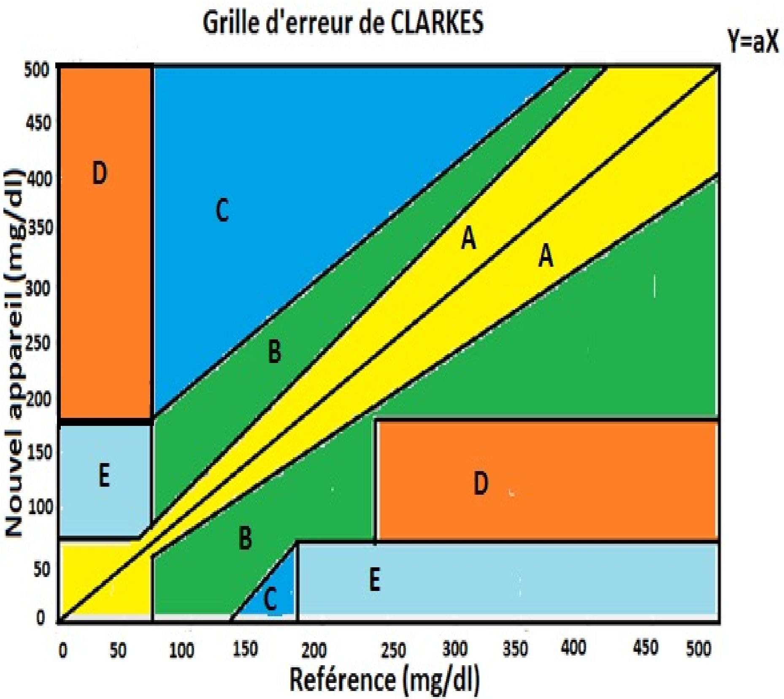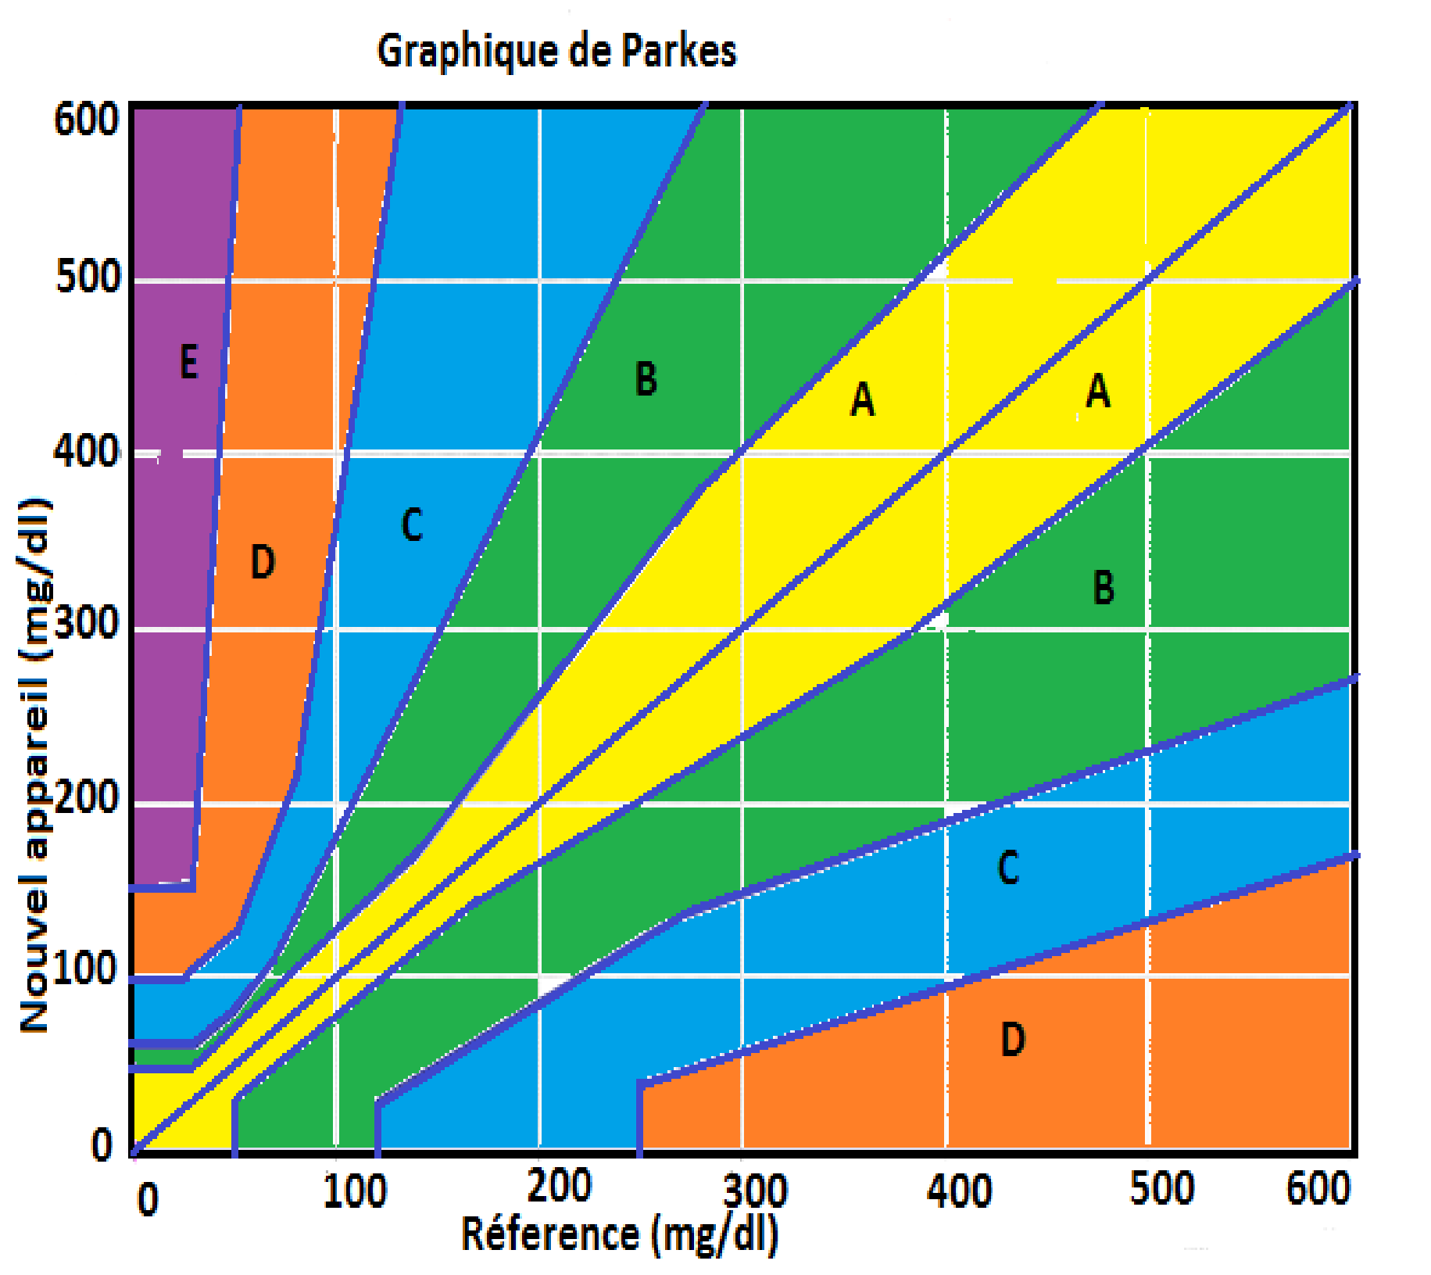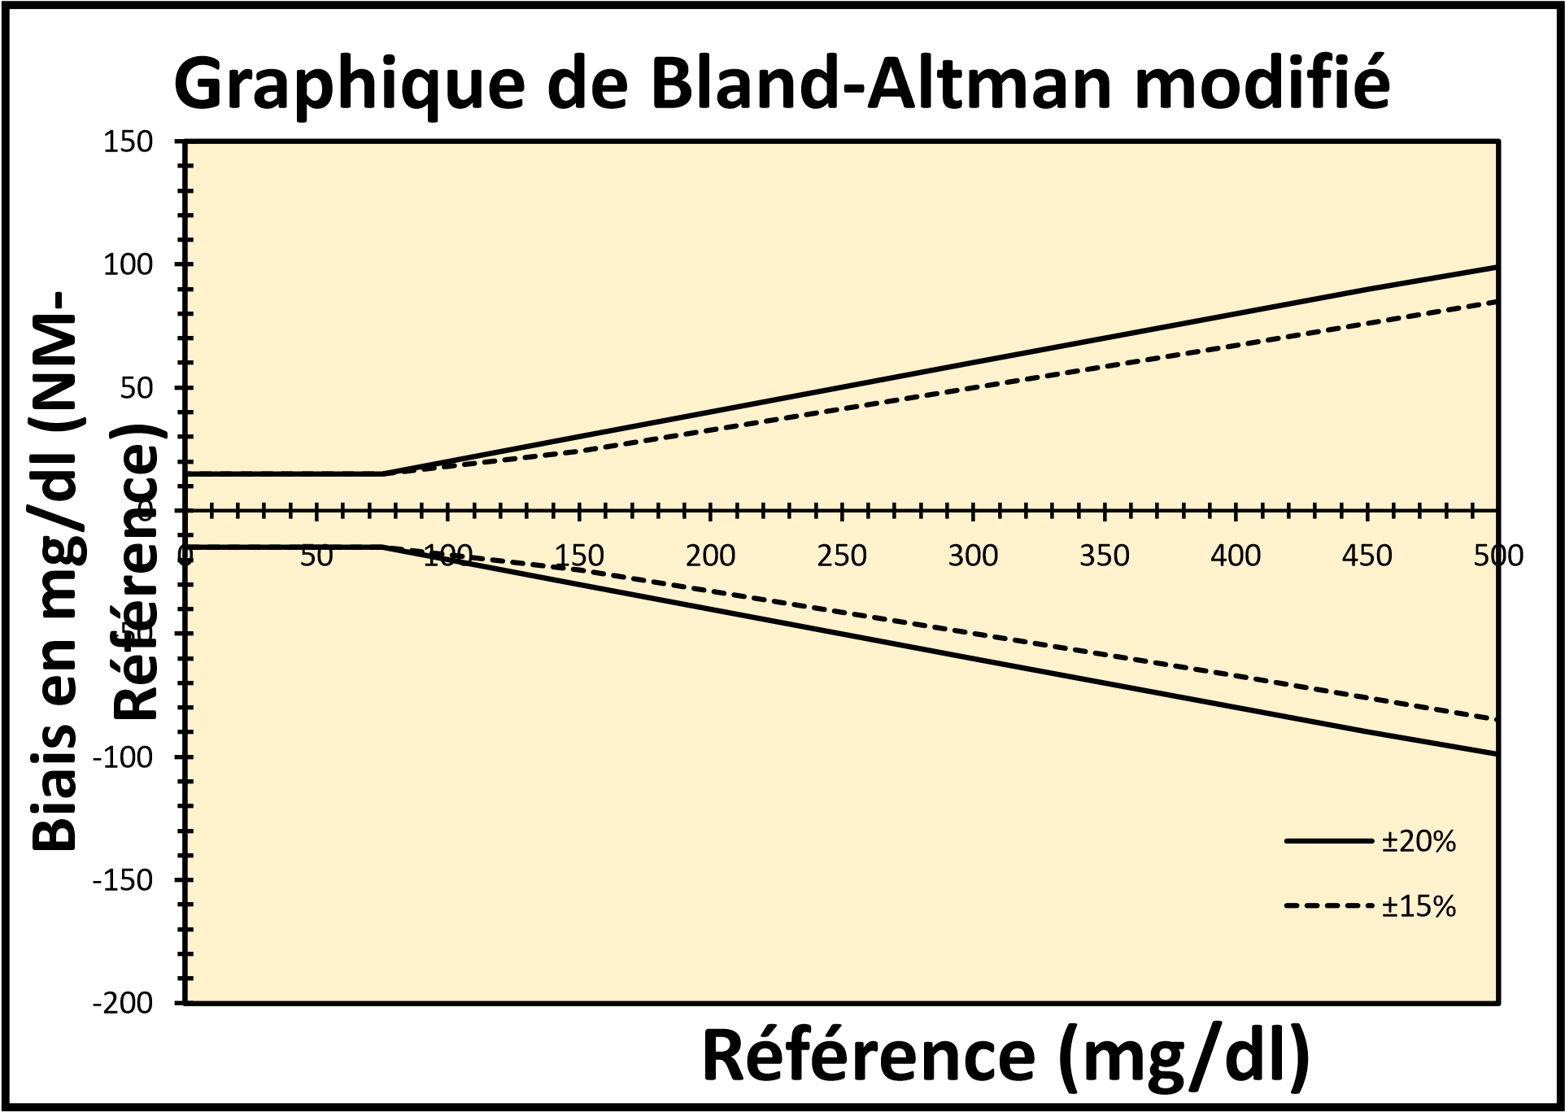
A: Clarke Error Grid
Zones A, B, and C: Acceptable agreement Deviations without consequences for therapeutic decisions. Zone D: Failure to detect and treat hypo/hyperglycemia. Zone E: wrong treatment.
B : PARKES error grid
Zone A and B: Acceptable agreement; Zone C: Error without consequences for therapeutic decisions; Zone D: Failure to detect and treat hypo/hyperglycemia; Zone E: Wrong treatment.
ISO 15197 v2013 requirement: 99% of points in zones A and B and less than 5% in zone B.
C : Modified BLAND-ALTMAN graph according to ISO 15197 v2013
Requirement ISO 15197 v2013: For blood glucose levels <100 mg/dl, 95% of points within the ± 15 mg/dl interval; For blood glucose levels ≥ 100 mg/dl, 95% of points within the ± 15% reference interval.

Figure 1: Error grids (Clarke and Parkes) and Bland-Altman chart for evaluating the diagnostic and analytical performance of glucometers

- Laboratory Analysis
- Reference Method
The reference method used in this study was the hexokinase/glucose-6-phosphate dehydrogenase (G6PD) enzymatic assay performed using a Cobas c311 analyzer (Roche Diagnostics) (Bondar et al., 1974). The glucose results obtained from the analyzer were used as reference values for this study.

- Glucometers and Test Strips Methods
The glucometers assessed used different chemical and measurement principles (Table 2).

Table 2: Physicochemical Principles of the Glucometers (Rensburg et al.,2014; Sonmez et al., 2010).

 | OneTouch® Verio® IQ | Accu-Chek® Go | Accu-Chek® Active
Test Strip Enzyme | Glucose  DeHydrogenase - Flavin Adenine Dinucleotide  (GDH-FAD) | Glucose  DeHydrogenase - Pyrroloquinoline  Quinone  (GDH-PQQ) | Glucose  DeHydrogenase - Pyrroloquinoline Quinone  (GDH-PQQ)
Principle of Measurement | Amperometry | Reflectometry | Reflectometry

The glucometers had been acquired and used for at least five years before the study began. Analyses were performed according to the manufacturers’ instructions. Only the test strips provided by the respective manufacturers of glucometers were used. All test strips were within their validity period, with at least six months remaining before their expiration. The capillary blood glucose results from the three glucometers were compared with the venous blood glucose values measured using a Cobas c311 analyzer (Roche Diagnostics).

- Data Analysis
The respective blood glucose results (in mg/dL) obtained from the respective glucometers (Accu-Chek Active, Accu-Chek Go, and OneTouch Verio IQ) were compared with the values obtained with the reference method (Cobas c311) using the Clarke and Parkes error grids for diagnostics performances. The analytical performance was assessed using Bland-Altman plots. The decision criteria were based on the ISO 15197 standard.

RESULTS AND DISCUSSION
- Results
- Patient characteristics
Blood samples were collected from 100 volunteers, including 47 women. The ages of the patients ranged from 16 to 84 years. The average age of the volunteer population was 47.5 years, with a standard deviation of 15.3 years.
The mean blood glucose values measured by the glucometers were significantly different from those obtained using the reference method (hexokinase method, P= .05). The mean glucose measurement for Cobas c311 was 142.05 ± 7.78 mg/dL. For the glucometers, the mean values were Accu-Chek Go: 151.95 ± 7.47 mg/dL, Accu-Chek Active: 147.49 ± 7.56 mg/dL, and OneTouch Verio IQ: 146.66 ± 7.75 mg/dL.

- Glucometers diagnostic Performance Evaluation according to Clarke and Parkes error grids
- Clarke Error Grid Analysis
Compared with the Cobas c311, the diagnostic performance of the glucometers based on the Clarke error grid analysis yielded the following results: Accu-Chek Go: 99%, Accu-Chek Active: 100%, and OneTouch Verio IQ: 100% (Figures 2A, 4A, 6A).
- Parkes Consensus Error Grid Analysis
Using the Parkes consensus error grid, the diagnostic performances were as follows: Accu-Chek Go: 98%, Accu-Chek Active: 99%, and OneTouch Verio IQ: 98% (Figures 2B, 4B, 6B). Based on Clarke and Parkes error grids, the percentage of glucose values within the accepted tolerance intervals (zones A + B) exceeded 99%, satisfying the diagnostic performance criteria.
- Precision and Accuracy Performance according to modified Bland-Altman
Precision and accuracy were assessed based on the ISO 15197 standards using Bland-Altman plots. The results showed concordance rates of 88 %, 91 %, and 90% for Accu-Chek Go, Accu-Chek Active: 91% and OneTouch Verio IQ: 90% (Figures 3, 5, 7). On these modified Bland-Altman plots, the distribution of glucose concordance points for all three glucometers failed to meet the precision requirements of the ISO 15197 standards (2003 and 2013 versions), which require at least 95% of the observed points to fall within acceptable glucose ranges (Table 1).

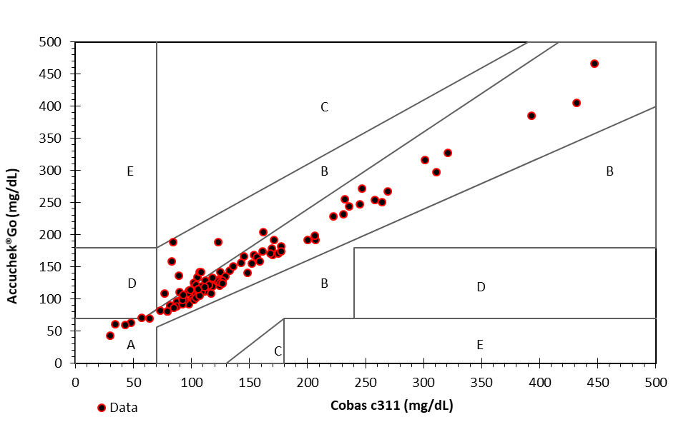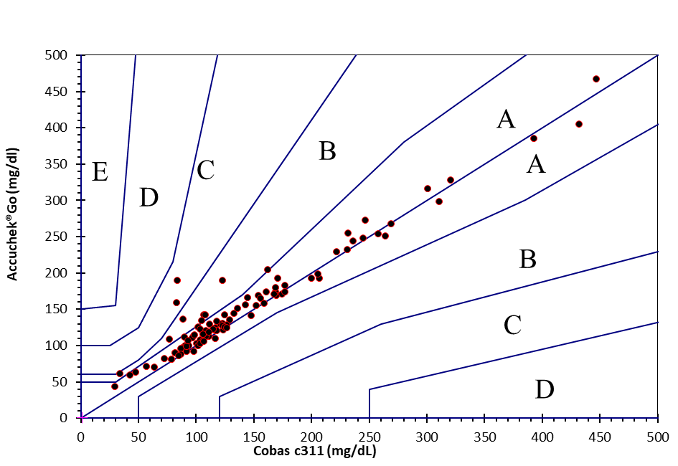
A : Concordance of blood glucose results according to the Clarke Error Grid : Cobas c311® vs Accu-Chek®Go
99% of the results are in zones A and B, with 11% in zone B.

B : Concordance of blood glucose results according to the Parkes Error Grid : Cobas c311® vs Accu-Chek®Go
98% of the results are in zones A and B, with 6% in zone B.

Figure 2 : Consensus error grids for the evaluation of diagnostic performance of Accu-Chek Go vs Cobas c311.

88% of the results are within the interval of the ISO 15197 standard

Figure 3 : Concordance of blood glucose : Cobas c311 vs Accu-ChekGo according to the modified Bland-Altman plot

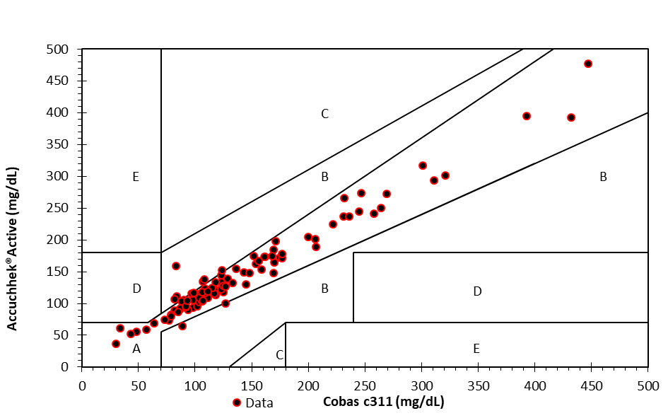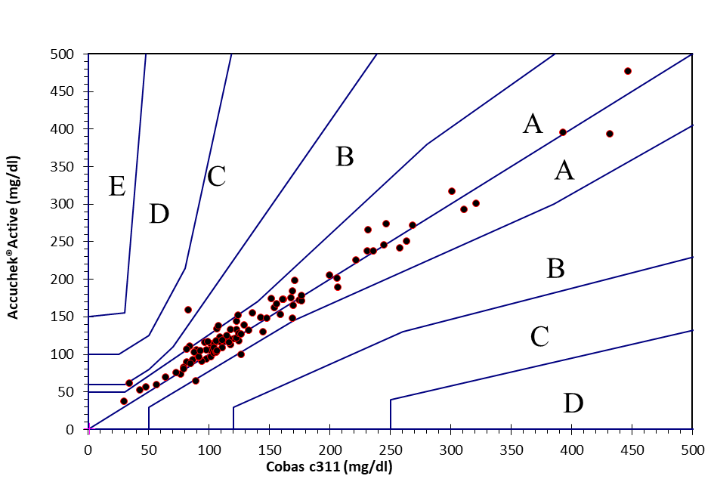
A : Concordance of blood glucose results according to the Clarke Error Grid : Cobas c311® vs Accu-Chek®Active
100% of the results are in zones A and B, with 8% in zone B.
B : Concordance of blood glucose results according to the Parkes Error Grid : Cobas c311® vs Accu-Chek®Active
99% of the results are in zones A and B, with 5% in zone B.

Figure 4 : Consensus error grids for the evaluation of diagnostic performance of Cobas c311 vs Accu-ChekActive

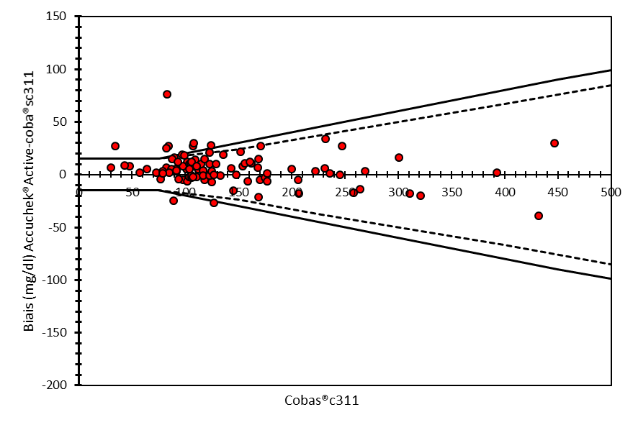
91% of the results are within the interval of the ISO 15197 standard

Figure 5 : Concordance of blood glucose : Cobas c311 vs Accu-ChekActive according to the modified Bland-Altman plot

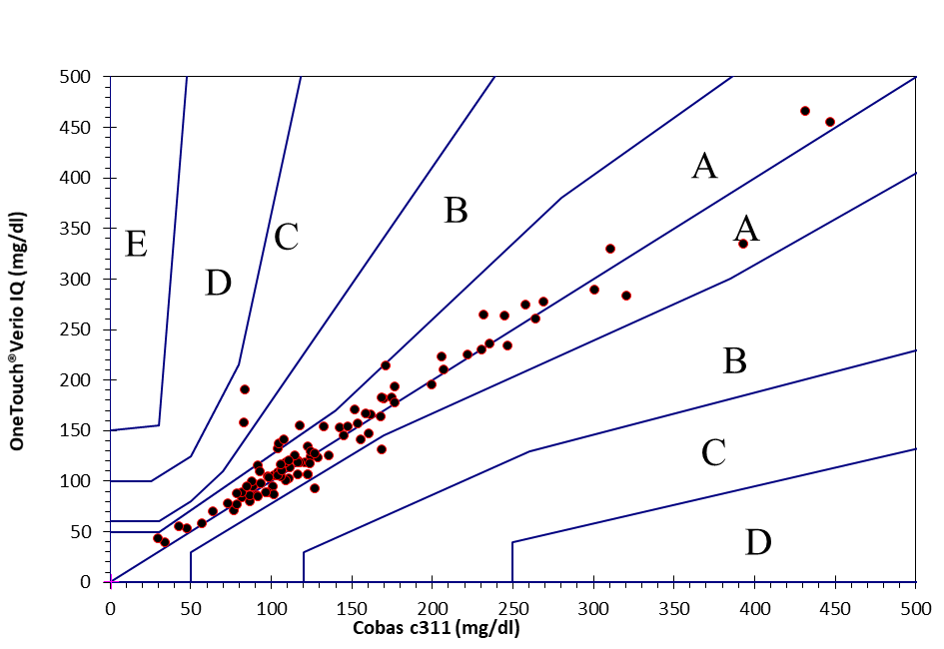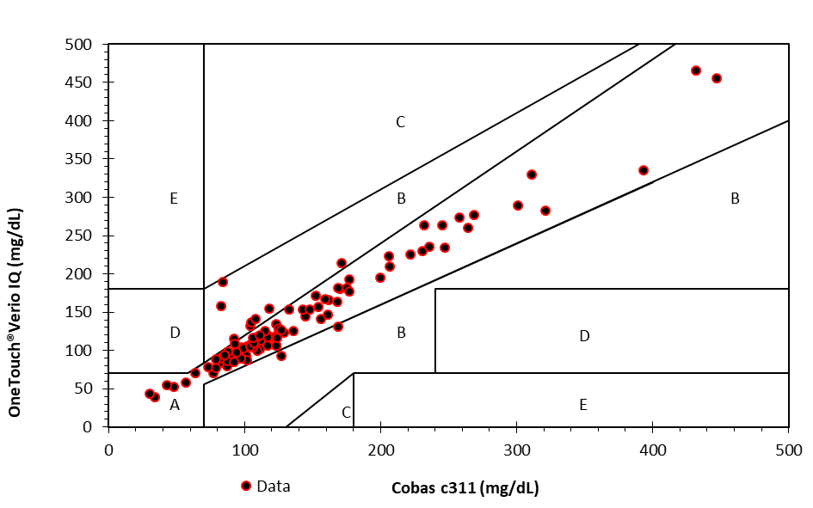
A : Concordance of blood glucose results according to the Clarke Error Grid : Cobas c311® vs OneTouCH®Verio®IQ
100% of the results are in zones A and B, with 10% in zone B.

B : Concordance of blood glucose results according to the Parkes Error Grid : Cobas c311® vs OneTouCH®Verio®IQ
98% of the results are in zones A and B, with 6% in zone B.

Figure 6 : Consensus error grids for the evaluation of diagnostic performance of Cobas c311 vs OneTouCHVerioIQ

90% of the results are within the interval of the ISO 15197 standard

Figure 7 : Concordance of blood glucose : Cobas c311 vs OneTouCHVerioIQ according to the modified Bland-Altman plot

All three devices achieved minimum diagnostic accuracy according to the former ISO 15197:2003 standard but did not achieve analytical accuracy according to Bland-Altman and the current ISO 15197:2013 standard (Table 3).

Table 3 : Summary of compliance with different versions of ISO 15197 standard

Discussion

The tropical setting of this study raises questions about the impact of environmental factors on glucometer performance over time. This emphasizes the importance of regular reevaluation of glucometers, particularly in settings where the climate and storage conditions may accelerate device degradation according previous studies (Vaid et al. , 2021 ; Nerhus et al., 2011; King et al., 1995). From these studies, nothing is known about the glucometer performance after long-term usage.
The study's findings reveal important insights into the performance of three long-term used glucometers in Côte d'Ivoire.
The mean values obtained from each glucometer compared to the hexokinase reference method showed slightly different mean values: all three glucometers systematically overestimated blood glucose levels. These results underscore the importance of considering potential measurement discrepancies when using long-term used point-of-care devices for glucose monitoring, particularly in clinical settings where precise glucose measurements are crucial for patient management (Klonoff DC et al., 2014).
While the Clarke error grid analysis showed high diagnostic accuracy (>99%) for all devices, suggesting their ability to guide appropriate clinical decisions, none met the ISO 15197:2013 precision standards. This discrepancy between diagnostic accuracy and analytical precision raises concerns regarding the reliability of individual readings for optimal diabetes management. According to Table 3, the three long-term glucometers should no longer be used according to the latest requirements of ISO 15197:2013. Although the diagnostic accuracy is maintained, the analytical accuracy no longer meets the requirements of the current standards. However, the results do not allow the deterioration of performance to be attributed to technological obsolescence, long-term usage, or both.
Narrowing the gap between diagnostic accuracy and analytical precision is vital for advancing diabetes management. Therefore, the use of state-of-the-art technologies and proper healthcare practices are the way to address these challenges, ultimately enhancing patient outcomes (Lundgrin et al., 2025).
The lower accuracy observed in hypoglycemic ranges is particularly problematic, as precise measurements are crucial in extreme glucose levels. This variation in performance across different glucose ranges highlights the need for caution when interpreting results, especially in critical situations.
Among the three devices, Accu-Chek Active showed slightly better concordance (91%) compared to OneTouch Verio IQ (90%) and Accu-Chek Go (88%). However, these differences were minimal, but none of the devices met the ISO standards. In an earlier investigation, the Accu-Chek Aviva, which is a similar model within the Accu-Chek brand, successfully fulfilled the ISO 15197:2003 accuracy standards, with compliance rates exceeding 97% (Tack et al.,2011). However, no information is available regarding the usage duration of the device. This indicates that Accu-Chek systems generally demonstrate satisfactory performance in relation to the standard criteria. However, specific data concerning the Accu-Chek Active and Accu-Chek Go models under more recent criteria were not available from the reviewed sources. In other studies for various brands and models of glucometers labeled with the European Conformity (CE) mark, not all the glucometers meet the minimal accuracy criteria set by the ISO 15197:2003 (Kuo et al., 2011). Anyway, our results underscore the need to evaluate the performance of all the three brands of devices after five years of use. One limitation of our study is that it was carried out at a single location in Abidjan, Côte d'Ivoire, which means the results might not accurately reflect glucometer performance in other areas. Besides that, due to the undefined environmental exposure of the devices, our study did not measure specific environmental conditions, such as temperature and humidity, that could impact glucometer performance. These limitations provide context for interpreting the results and highlight areas for potential future research to further evaluate glucometer performance.
These findings have significant implications for diabetes management in resource-limited settings, where the regular replacement of glucometers may not be feasible. They highlight the need for strategies to maintain glucometer accuracy over prolonged periods and for healthcare providers to be aware of potential inaccuracies in readings.
In summary, our results showed that none of the three glucometers met all the performance requirements of standard 15197 v2013 after several years of service, especially for extreme values. Future research should focus on factors affecting glucometer performance in tropical settings and on developing methods to enhance and maintain accuracy over time. Additionally, investigating the impact of these inaccuracies on patient outcomes and exploring cost-effective solutions for regular device replacement or recalibration in resource-limited settings would be valuable.

CONCLUSION
Despite the variable analytical and diagnostic performances based on Clarke or Parkes error grids, this study highlights significant differences in the performance of the Accu-Chek Go, Accu-Chek Active, and OneTouch Verio IQ glucometers. However, precision and accuracy assessments based on Bland-Altman analyses showed that these devices did not meet all the requirements of ISO 15197. These results demonstrate the necessity of continuous reevaluation of glucometer performance, particularly after several years of use, to ensure reliable and safe blood glucose management in patients. It is imperative for future research to systematically quantify the environmental factors that lead to the decline in glucometer performance within tropical environments.

ETHICAL CONSIDERATIONS
The study was approved by the Institutional Review Board of CeDReS (#20250226H03). All participants were volunteers and provided oral informed consent. Anonymity and confidentiality were managed according to the requirements of the ISO 15189:2012 standard applicable to medical diagnostic analysis laboratories. All investigators disclosed any financial, personal, or professional relationships that could influence the work, including funding sources, affiliations, or consultancy roles.

DECLARATION OF COMPETING INTEREST
The authors declare that they have no known competing financial interests or personal relationships that could have appeared to influence the work reported in this paper.

REFERENCES

Abdul Basith Khan M, Hashim MJ, King JK, Govender RD, Mustafa H, Al Kaabi J. (2019). Epidemiology of Type 2 Diabetes — Global Burden of Disease and Forecasted Trends. Journal of Epidemiology and Global Health;10:107. https://doi.org/10.2991/jegh.k.191028.001.
Mariani HS, Layden BT, Aleppo G. (2017). Continuous Glucose Monitoring: A Perspective on Its Past, Present, and Future Applications for Diabetes Management. Clinical Diabetes : A Publication of the American Diabetes Association;35:60–5. https://doi.org/10.2337/cd16-0008.
Fink KS, Ellsworth A, Christensen DB. (2002). Effect of high altitude on blood glucose meter performance. Diabetes Technology & Therapeutics;4:627–35. https://doi.org/10.1089/152091502320798259.
Tonyushkina K, Nichols JH. (2009). Glucose Meters: A Review of Technical Challenges to Obtaining Accurate Results. Journal of Diabetes Science and Technology;3:971–80. https://doi.org/10.1177/193229680900300446.
Gautier J-F, Douce P, Duvallet A, Bigard AX, Cathelineau G. (1996). Influence of simulated altitude on the performance of five blood glucose meters. Diabetes Care;19:1430–3. https://doi.org/10.2337/diacare.19.12.1430.
Malerba E, Cattani C, Golinelli S, Drudi I, Fracassi F, Del Baldo F, et al. (2019). Accuracy of a flash glucose monitoring system in dogs with diabetic ketoacidosis. Journal of Veterinary Internal Medicine; 34:83–91. https://doi.org/10.1111/jvim.15657.
Kuo C-Y, Su T-E, Hsu C-T, Wu M-H, Ho C-S, Wang C-J. (2011). Accuracy and Precision Evaluation of Seven Self-Monitoring Blood Glucose Systems. Diabetes Technology & Therapeutics; 13:596–600. https://doi.org/10.1089/dia.2010.0223.
Rebel A, Fahy BG, Rice MA. (2012). Accuracy of point-of-care glucose measurements. Journal of Diabetes Science and Technology; 6:396–411. https://doi.org/10.1177/193229681200600228.
Pfützner A, Pardo S, Parkes JL, Klonoff DC. (2013). Technical Aspects of the Parkes Error Grid. Journal of Diabetes Science and Technology; 7:1275–81. https://doi.org/10.1177/193229681300700517.
Dunne N, Viggiani MT, Parkes JL, Pardo S, Robinson C. (2015). Accuracy Evaluation of CONTOUR(®)PLUS Compared With Four Blood Glucose Monitoring Systems. Diabetes Therapy; 6:377–88. https://doi.org/10.1007/s13300-015-0121-3.
Clarke WL, Carter W, Pohl SL, Cox D, Gonder-Frederick LA. (1987). Evaluating clinical accuracy of systems for self-monitoring of blood glucose. Diabetes Care; 10:622–8. https://doi.org/10.2337/diacare.10.5.622.
Parkes JL, Ginsberg BH, Pardo S, Slatin SL. (2000). A new consensus error grid to evaluate the clinical significance of inaccuracies in the measurement of blood glucose. Diabetes Care; 23:1143–8. https://doi.org/10.2337/diacare.23.8.1143.
Klonoff DC, Scott S, Kovatchev B, Serrano K, Landree L, Hinzmann R, et al. (2014). The Surveillance Error Grid. Journal of Diabetes Science and Technology; 8:658–72. https://doi.org/10.1177/1932296814539589.
Freckmann G, Heinemann L, Haug C, Rutschmann M, Baumstark A, Schmid C. (2015). Analytical Performance Requirements for Systems for Self-Monitoring of Blood Glucose With Focus on System Accuracy: Relevant Differences Among ISO 15197:2003, ISO 15197:2013, and Current FDA Recommendations. Journal of Diabetes Science and Technology; 9:885–94. https://doi.org/10.1177/1932296815580160.
Bondar RJL, Mead DC. (1974). Evaluation of Glucose-6-Phosphate Dehydrogenase from Leuconostoc mesenteroides in the Hexokinase Method for Determining Glucose in Serum. Clinical Chemistry; 20:586–90. https://doi.org/10.1093/clinchem/20.5.586
Rensburg MA, Erasmus RT, Hudson C. (2014). Evaluation and Performance of StatStrip Glucose Meter. Point of Care: The Journal of Near-Patient Testing & Technology; 13:137–41. https://doi.org/10.1097/poc.0000000000000037.
Sonmez A, Kutlu M, Aydogdu A, Serdar M, Yazici M, Kilic S, et al. (2010). The Accuracy of Home Glucose Meters in Hypoglycemia. Diabetes Technology & Therapeutics; 12:619–26. https://doi.org/10.1089/dia.2009.0183.
Vaid R, Yildirim E, Pasquinelli MA, King MW. (2021). Hydrolytic Degradation of Polylactic Acid Fibers as a Function of pH and Exposure Time. Molecules; 26:7554. https://doi.org/10.3390/molecules26247554.
Nerhus K, Sandberg S, Rustad P. (2011). Effect of Ambient Temperature on Analytical Performance of Self-Monitoring Blood Glucose Systems. Diabetes Technology & Therapeutics; 13:883–92. https://doi.org/10.1089/dia.2010.0255.
King JM, Eigenmann CA, Colagiuri S. (1995). Effect of ambient temperature and humidity on performance of blood glucose meters. Diabetic Medicine; 12:337–40. https://doi.org/10.1111/j.1464-5491.1995.tb00488.x.
Klonoff DC. (2014). Point-of-Care Blood Glucose Meter Accuracy in the Hospital Setting. Diabetes Spectrum : A Publication of the American Diabetes Association;27:174–9. https://doi.org/10.2337/diaspect.27.3.174.
Lundgrin EL, Kelly CA, Bellini N, Lewis C, Rafi E, Hatipoglu B. (2025). Diabetes Technology Trends: A Review of the Latest Innovations. The Journal of Clinical Endocrinology and Metabolism; 110:S165–74. https://doi.org/10.1210/clinem/dgaf034.
Tack C, Behnke T, Forst T, Schmid V, Pfützner A, Pohlmeier H, et al. (2011). Accuracy Evaluation of Five Blood Glucose Monitoring Systems Obtained from the Pharmacy: A European Multicenter Study with 453 Subjects. Diabetes Technology & Therapeutics;14:330–7. https://doi.org/10.1089/dia.2011.0170.

