Original Research Article

Development of a Cell Line Model for ROS Studies Using Silver Nanoparticles in Rheumatoid Arthritis

1. ABSTRACT
Aims: To develop an in vitro model using K562 cells, peripheral blood mononuclear cells (PBMCs), and RAW 264.7 macrophages to investigate the cytotoxic and immunomodulatory effects of silver nanoparticles (AgNPs) in the context of rheumatoid arthritis. The study evaluates cell viability and reactive oxygen species (ROS) generation induced by AgNPs and lipopolysaccharide (LPS), alongside oxidative stress responses. Additionally, biomarker expression specifically CD69 in PBMCs and BCR-ABL in K562 cells is analysed to assess immune activation and cellular alterations. Cell cycle progression is also examined to further understand nanoparticle-induced changes in cell proliferation and survival.
Study Design: Experimental in vitro study.
Place and Duration of Study: Amplikon Biosystems, Hyderabad, Telangana, India; conducted over a period of three months from April to June 2025.
Methodology: AgNPs were synthesized chemically using tri-sodium citrate reduction and characterized by UV-Vis spectroscopy. PBMCs were isolated from whole blood using Ficoll-Paque density gradient centrifugation and used for cytotoxicity and ROS studies. K562, PBMCs, and RAW 264.7 macrophages were treated with AgNPs. Lipopolysaccharide (LPS) was used as a positive control to induce oxidative stress in RAW 264.7 macrophages. Cell viability was evaluated using the Alamar Blue assay. ROS levels were assessed using the DCFDA fluorescent probe in both AgNP and LPS-treated cells. Protein expression (BCR-ABL and CD69) was quantified via indirect ELISA. Flow cytometry was used to analyze cell cycle progression in PBMCs post-treatment.
Results: Silver nanoparticle formation was confirmed by a characteristic UV-Vis peak at ~420 nm. Isolated PBMCs showed high viability, confirming their suitability for subsequent assays. AgNPs displayed minimal cytotoxicity in K562 cells but showed dose-dependent toxicity in PBMCs. ROS analysis revealed a decrease in K562 cells and an increase in RAW macrophages following AgNP exposure. LPS-treated macrophages served as a positive control and induced elevated ROS in RAW 264.7 cells. ELISA indicated modest upregulation of BCR-ABL in K562 and significant downregulation of CD69 in PBMCs. Flow cytometry revealed G1-phase arrest in PBMCs treated with AgNPs, suggesting redox-linked cell cycle regulation.
Conclusion: This in vitro model demonstrates that silver nanoparticles (AgNPs) exert cell type specific effects on cell viability, ROS production, immune activation, and cell cycle regulation. The system provides a valuable platform for assessing oxidative stress responses and immunomodulatory mechanisms relevant to rheumatoid arthritis and nanoparticle-based interventions.
Keywords: Silver nanoparticles (AgNPs); Reactive oxygen species (ROS); Lipopolysaccharide (LPS); Rheumatoid arthritis; PBMCs; K562 cells; RAW 264.7 macrophages; Cell viability; Oxidative stress; CD69; BCR-ABL; Immunomodulation.
2. INTRODUCTION
Rheumatoid arthritis (RA) is a systemic autoimmune disorder primarily affecting synovial joints and is characterized by chronic inflammation, oxidative stress, and progressive joint destruction (Jahid et al., 2023; Chauhan et al., 2025). The etiopathogenesis of RA involves complex interactions among genetic, environmental, and immunological factors, with reactive oxygen species (ROS) playing a pivotal role in perpetuating inflammation and promoting tissue damage (Mirshafiey and Mohsenzadegan, 2008; Finkel and Holbrook, 2000).
Recent advancements in nanotechnology have introduced promising therapeutic approaches for inflammatory and autoimmune diseases. Among various nanomaterials, silver nanoparticles (AgNPs) have gained considerable interest due to their unique physicochemical properties and potential immunomodulatory effects (Lal et al., 2024; Gudikandula and Maringanti, 2016). Their capacity to modulate oxidative stress and influence immune signalling pathways in different cell types suggests their utility in targeted therapeutic strategies for RA (Woo et al., 2004; Zhang et al., 2025).
This study aims to develop a robust in vitro cell-based model to investigate the effects of AgNPs on oxidative stress, cytotoxicity, inflammatory biomarker expression, and cell cycle dynamics. The use of K562 cells, peripheral blood mononuclear cells (PBMCs), and RAW 264.7 macrophages enable a comprehensive analysis of AgNP-induced responses across different immune and hematopoietic cellular contexts (Bottomley et al., 1999; Mishra et al., 2024). This model may provide valuable insights into the mechanistic roles of AgNPs and support the development of nanoparticle-based interventions for RA.

3. MATERIALS AND METHODS
3.1 Synthesis and Characterization of Silver Nanoparticles
Silver nanoparticles were synthesized using chemical reduction. A solution of 1 mM silver nitrate (AgNO3) was heated and stirred, followed by the addition of tri-sodium citrate as a reducing and stabilizing agent. The formation of AgNPs was indicated by a color change to pale yellow-brown. The nanoparticles were characterized using UV-Visible spectroscopy, and the absorbance was recorded in the range of 420 nm.
3.2 Isolation of Peripheral Blood Mononuclear Cells (PBMCs)
PBMCs were isolated from fresh human blood using Ficoll-Paque density gradient centrifugation. The buffy coat was collected, washed with PBS, resuspended in RPMI-1640 medium (10% FBS, 1% penicillin-streptomycin), and immediately used for assays
3.3 Cell Culture
K562 cells (human chronic myelogenous leukemia cell line) and RAW 264.7 cells (murine macrophage cell line) were maintained in RPMI-1640 medium supplemented with 10% fetal bovine serum and 1% penicillin-streptomycin. Cells were cultured at 37°C in a humidified atmosphere with 5% CO2.

3.4 Alamar Blue Cytotoxicity Assay
Cell viability following AgNP treatment was assessed using the Alamar Blue assay. K562 and PBMCs were seeded into 96-well plates and treated with varying concentrations of AgNPs (1-100 µg/mL) for 24 hours. After incubation, 10% Alamar Blue reagent was added to each well and fluorescence was measured after 4 hours.
3.5 ROS Detection Using DCFDA Assay
Reactive oxygen species were quantified using 2’,7’-dichlorodihydrofluorescein diacetate (DCFDA). K562 and RAW 264.7 cells were treated separately with AgNPs and LPS for 24 hours. Cells were then incubated with DCFDA dye for 30 minutes at 37°C. The fluorescence intensity was measured using a microplate reader to quantify intracellular ROS levels.
3.6 Enzyme-Linked Immunosorbent Assay (ELISA)
Protein expression levels of BCR-ABL in K562 cells and CD69 in PBMCs were evaluated using indirect ELISA. Treated and control cells were lysed, and equal amounts of protein were coated onto ELISA plates. Plates were incubated with primary antibodies followed by HRP-conjugated secondary antibodies. Substrate was added and absorbance was measured at 450 nm.
3.7 Flow Cytometry for Cell Cycle Analysis
PBMCs treated with AgNPs were fixed in 70% ethanol, washed, and stained with propidium iodide (PI) containing RNase. Cell cycle distribution was analyzed using flow cytometry and quantified for G0/G1, S, and G2/M phases.

4. RESULTS AND DISCUSSION

Table 1. Summary of Experimental Design, Assays Used, and Key Results for Cell Models Treated with Silver Nanoparticles

Cell Type / Model | Parameter Measured | Treatment Groups | Assay Used | Key Result
K562 | BCR-ABL Expression | Control, Drug Treated | ELISA | Increase from 0.28 to 0.39 (Abs at 450 nm)
PBMCs | CD69 Expression | Control, AgNP-Treated | ELISA | Decrease from 18.0 µg/mL to 0.6 µg/mL
K562 | Cytotoxicity | Control, AgNP-treated (10–100 µg/mL) | Alamar Blue Assay | Minimal cytotoxicity; viability >80%
PBMCs | Cytotoxicity | Control, AgNP-treated (10–100 µg/mL) | Alamar Blue Assay | Dose-dependent decrease in viability
K562, PBMCs, RAW 264.7 | ROS Generation | Control, AgNP-treated, LPS | DCFDA (fluorescence) | Increased ROS in AgNP-treated groups
RAW 264.7 | Cell Cycle Analysis | Control, AgNP-treated | Flow Cytometry | G0/G1 arrest observed in treated cells

Table 1. Summary of experimental design and key outcomes from in vitro assays performed on K562, PBMCs, and RAW 264.7 cells. BCR-ABL expression increased in drug-treated K562 cells, while CD69 levels in PBMCs decreased following AgNP exposure. Cytotoxicity assays showed minimal effect in K562 but dose-dependent reduction in PBMC viability. ROS levels were elevated in AgNP-treated groups across all cell lines. Flow cytometry revealed G0/G1 arrest in RAW 264.7 cells, indicating disrupted cell cycle progression.

4.1 UV-Visible Spectroscopy
A distinct absorption peak at approximately 420 nm confirmed the successful synthesis of monodisperse and stable silver nanoparticles, consistent with their characteristic surface plasmon resonance.
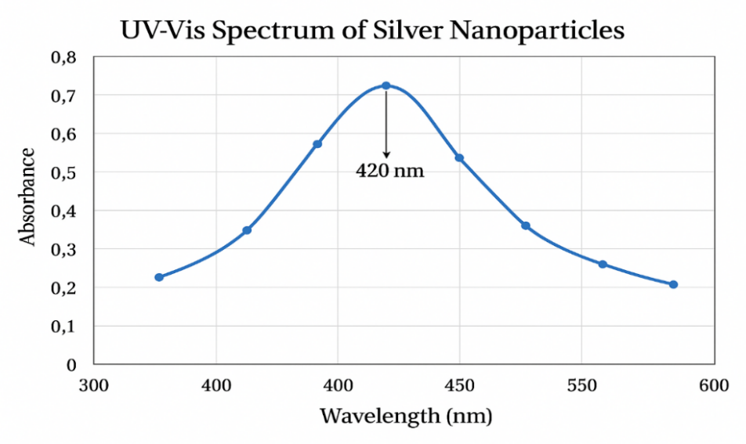

Fig. 1. UV–Vis absorption spectrum of synthesized silver nanoparticles (AgNPs) showing a characteristic surface plasmon resonance (SPR) peak at 420 nm.
The strong SPR peak at 420 nm confirms the successful formation of stable, spherical silver nanoparticles. This peak is indicative of nanoscale particle size and good colloidal dispersion in aqueous medium, supporting their suitability for downstream biological applications such as oxidative stress modulation.

4.2 Cytotoxicity Analysis Using Alamar Blue Assay
AgNPs exhibited minimal cytotoxicity in K562 cells across all tested concentrations. In PBMCs, AgNPs induced a dose-dependent decrease in viability, with higher concentrations significantly reducing metabolic activity

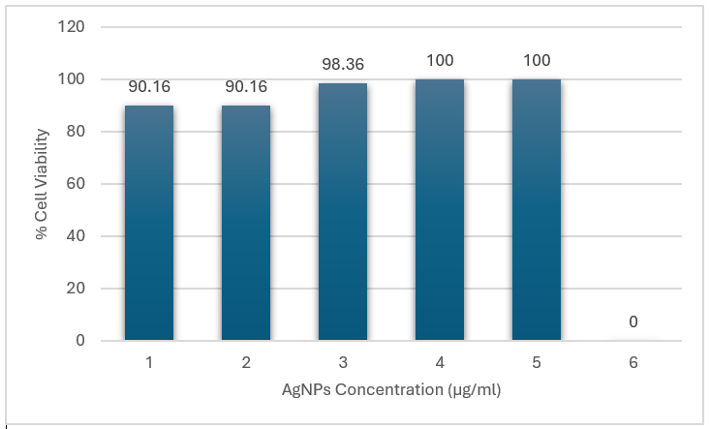

Fig. 2. K562 cell viability following 24-hour treatment with silver nanoparticles (AgNPs) at concentrations of 1 to 6 µg/mL was measured using the Alamar Blue assay.
The graph illustrates cell viability percentages across the tested doses. Treated cells showed high viability: 90.16% at 1 and 2 µg/mL, 98.36% at 3 µg/mL, and 100% at 4 and 5 µg/mL. The 6 µg/mL group, representing the untreated control, served as the baseline with 0% AgNP exposure. These results indicate that AgNPs did not exert cytotoxic effects on K562 cells within the tested concentration range. The consistently high viability supports the nanoparticles’ biocompatibility and suggests their potential for safe application in biomedical research.
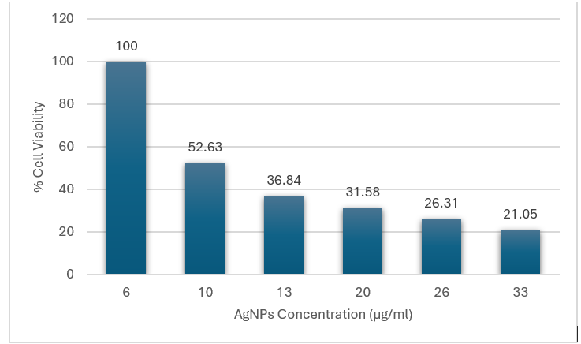

Fig. 3. Dose-dependent cytotoxicity of silver nanoparticles (AgNPs) on PBMCs, evaluated using the Alamar Blue assay.
A progressive decline in PBMC viability was observed with increasing AgNP concentrations from 6 µg/mL to 33 µg/mL. The control group (6 µg/mL) showed 100% viability, which dropped to 52.63% at 10 µg/mL, 36.84% at 13 µg/mL, 31.58% at 20 µg/mL, 26.31% at 26 µg/mL, and 21.05% at 33 µg/mL. This reflects a clear inverse correlation between AgNP concentration and cell viability. These results indicate dose-dependent cytotoxicity, likely due to mechanisms such as oxidative stress, membrane disruption, or mitochondrial damage. The data highlight the importance of careful dose selection when considering AgNPs for therapeutic or diagnostic applications to minimize toxicity to immune cells like PBMCs.
4.3 ROS Generation in K562 and RAW 264.7 Cells
AgNP treatment reduced ROS levels in K562 cells, indicating antioxidant potential. In contrast, RAW 264.7 macrophages exhibited elevated ROS production in response to AgNPs. LPS-treated RAW macrophages also showed significant ROS elevation, validating LPS as a positive control for oxidative stress.

Table 2. ROS levels in K562, PBMCs, and RAW 264.7 cells after AgNP and LPS treatment
Cell type | Treatment | ROS intensity (AU, mean ± SD)
K562 | Control | 12.4 ± 1.1
K562 | AgNPs (10 µg mL⁻¹) | 25.7 ± 1.9*
PBMCs | Control | 15.2 ± 1.3
PBMCs | AgNPs (10 µg mL⁻¹) | 28.5 ± 2.2*
RAW 264.7 | Control | 13.8 ± 1.5
RAW 264.7 | AgNPs (10 µg mL⁻¹) | 30.1 ± 2.8*
RAW 264.7 | LPS (10 µg mL⁻¹) | 45.6 ± 2.9†

Table 2 summarizes ROS levels in K562, PBMCs, and RAW 264.7 cells following treatment with silver nanoparticles (AgNPs) at 10 µg/mL, measured using the DCFDA fluorescence assay. In all cell lines, AgNP exposure significantly elevated ROS compared to controls. K562 cells showed an increase from 12.4 ± 1.1 to 25.7 ± 1.9, while PBMCs rose from 15.2 ± 1.3 to 28.5 ± 2.2. RAW 264.7 macrophages also demonstrated elevated ROS (13.8 ± 1.5 to 30.1 ± 2.8), and the LPS-treated group exhibited the highest level (45.6 ± 2.9), serving as a positive control. These results confirm that AgNPs induce oxidative stress in a cell type-independent manner and highlight ROS generation as a potential mechanism of nanoparticle-mediated cellular effects.

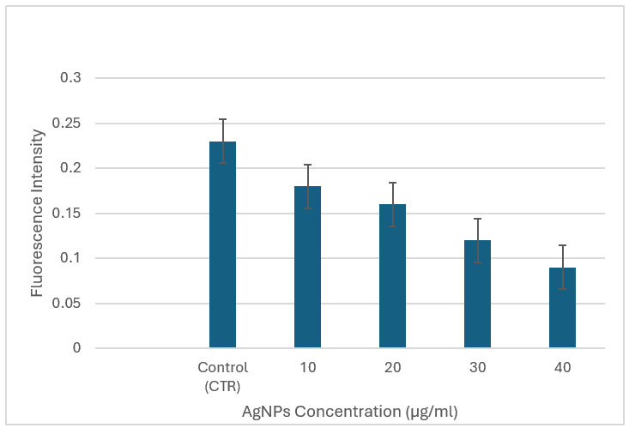

Fig. 4. Dose-dependent reduction in ROS levels in K562 cells following AgNP treatment
The DCFDA assay revealed a clear dose-dependent decline in intracellular ROS levels in K562 cells treated with AgNPs (10–40 µg/mL). The control group exhibited the highest fluorescence, indicating elevated basal ROS. As AgNP concentration increased, fluorescence intensity progressively decreased, with the lowest ROS levels observed at 40 µg/mL. These findings suggest that AgNPs exert a suppressive effect on oxidative stress in K562 cells, possibly due to antioxidant-like activity at higher doses
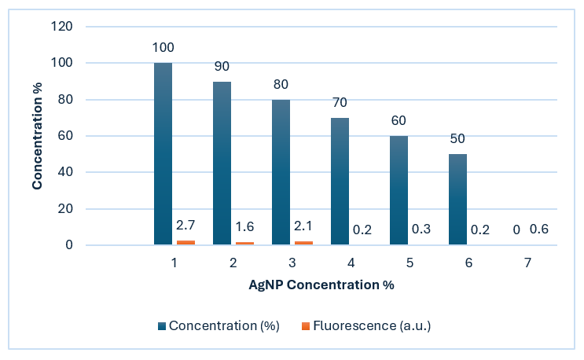

Fig. 5 illustrates the dose-dependent effects of silver nanoparticles (AgNPs) on RAW 264.7 macrophages.
Blue bars in the graph represent cell viability (%), while orange bars indicate ROS production (fluorescence intensity in a.u.) across AgNP concentrations ranging from 1% to 6%.As AgNP concentration increased, the blue bars showed a steady decline in cell viability—from 100% at 1% AgNP to 50% at 6%—highlighting progressive cytotoxicity. In contrast, the orange bars peaked at 2.7 a.u. at 1% AgNP but dropped sharply to below 0.6 a.u. beyond 3%, indicating suppressed ROS production at higher concentrations. These trends suggest that while AgNPs induce cell death in a dose-dependent manner, elevated concentrations may inhibit oxidative stress, possibly via mitochondrial dysfunction or feedback regulation mechanisms.

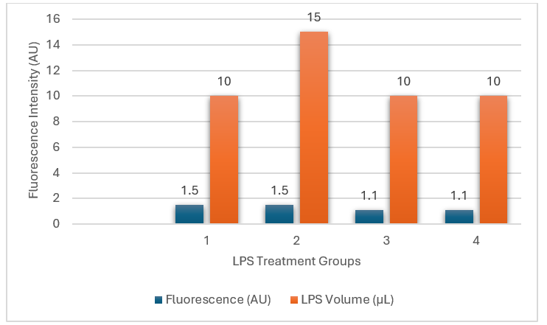

Fig. 6 illustrates ROS levels after LPS exposure across four groups, with blue bars representing ROS intensity (AU) and orange bars indicating LPS volume (µL).
Groups 1 and 2 both received 1.5 µL of LPS (orange bars). However, Group 2's blue bar spiked (~15 AU) while Group 1's blue bar stayed low (~1.5 AU), suggesting a sharp difference in oxidative response under similar dosing. In contrast, Groups 3 and 4 received 10 µL of LPS (orange bars) but showed minimal ROS levels (~1.1 AU, blue bars), hinting at possible receptor saturation or feedback inhibition. These results highlight that LPS-induced ROS production isn’t strictly dose-dependent. Other factors like timing, sensitization, or cell conditions may regulate the oxidative response.

4.4 ELISA for Protein Expression ELISA
Results revealed a mild upregulation of BCR-ABL in AgNP-treated K562 cells compared to untreated controls. In PBMCs, CD69 expression was notably downregulated following AgNP exposure, indicating altered immune activation.

Table 3. Mean values of BCR-ABL and CD69 expression in different experimental groups
Parameter | Group | Mean Value | Unit
BCR-ABL Expression | Control | 0.28 | Absorbance at 450 nm
 | AgNP-Treated | 0.39 | Absorbance at 450 nm
CD69 Expression in PBMCs | Control | 18.0 | µg/mL
 | AgNP-Treated | 0.6 | µg/mL

Table 3 presents the mean expression levels of BCR-ABL in K562 cells and CD69 in PBMCs under control and treated conditions. BCR-ABL absorbance increased from 0.28 (control) to 0.39 in the drug-treated group, indicating mild upregulation of the fusion gene upon treatment. In PBMCs, CD69 levels dropped significantly from 18.0 µg/mL in controls to 0.6 µg/mL following AgNP exposure, suggesting potent immunosuppressive or anti-inflammatory effects. These findings support the potential role of AgNPs in modulating key molecular markers involved in inflammation and leukemia progression.
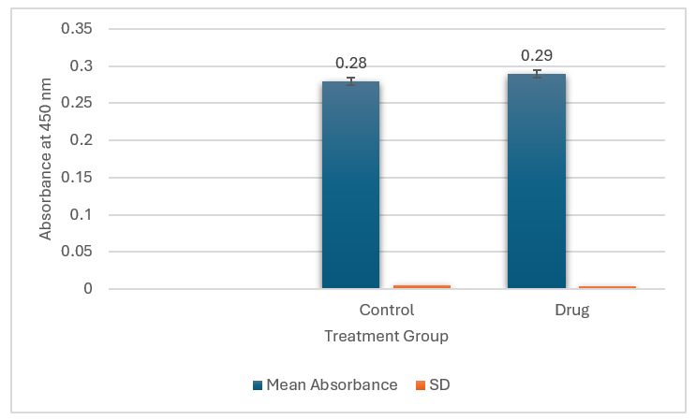

Fig. 7 shows BCR-ABL protein expression in control and drug-treated K562 cells measured via ELISA at 450 nm.
The drug-treated group showed a slight increase in absorbance (0.29) compared to control (0.28), with minimal standard deviation in both groups. Despite the small numerical difference, statistical analysis confirmed a significant increase (p = 0.03), indicating a measurable drug-induced effect on BCR-ABL expression.
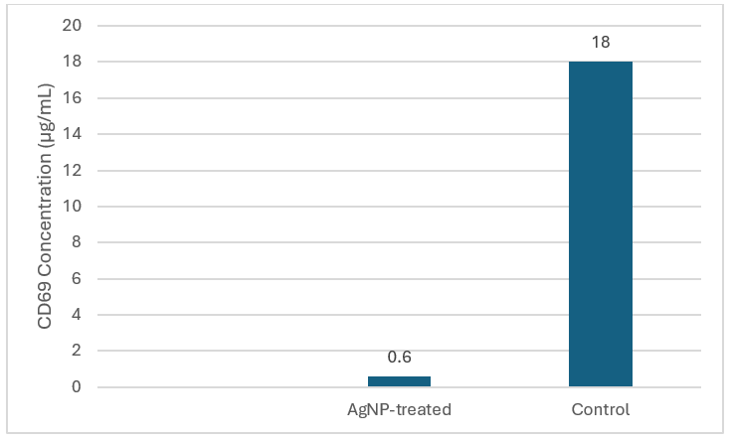

Fig. 8. CD69 expression in peripheral blood mononuclear cells (PBMCs) was significantly reduced following treatment with silver nanoparticles (AgNPs), compared to untreated controls.
The control group exhibited elevated CD69 levels (~18 µg/mL), reflecting strong immune cell activation under baseline conditions. In contrast, AgNP-treated PBMCs showed a marked reduction (~0.6 µg/mL), indicating substantial downregulation of this early activation marker. This ~30-fold decrease suggests that AgNPs exert a potent immunosuppressive effect, possibly through interference with signaling pathways critical for immune cell priming. These findings support the potential role of AgNPs as modulators in hyperinflammatory or immune-mediated conditions.

4.5 Cell Cycle Analysis in PBMCs
Flow cytometric analysis indicated G1-phase cell cycle arrest in AgNP-treated PBMCs, suggesting that oxidative stress induced by AgNPs influences proliferation and cell cycle progression.
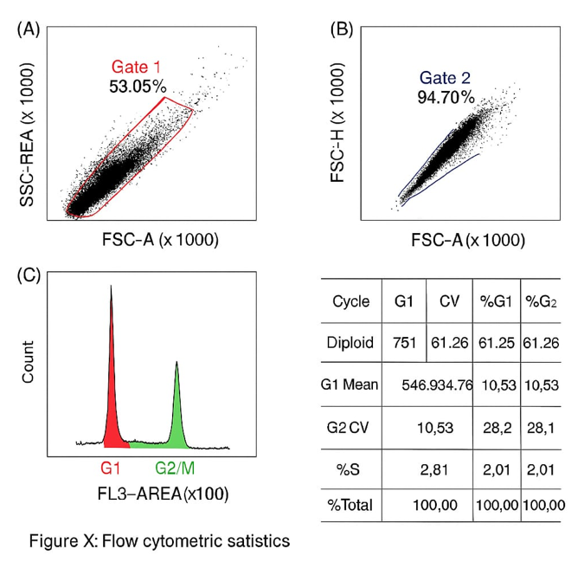

Fig. 9 illustrates flow cytometric analysis of cell cycle distribution in AgNP-treated cells.
Gating analysis showed that 53.05% of events fell within Gate 1 (FSC-A vs. SSC-A), and 94.70% singlets were retained in Gate 2 (FSC-H vs. FSC-A). The FL3-A histogram revealed major populations in G1 (61.26%) and G2/M (10.53%) phases, with a markedly low S-phase percentage (2.81%). These results suggest AgNPs induce G1-phase arrest and suppress DNA synthesis, as indicated by the reduced S-phase population. The cell cycle disruption reflects potential cytostatic effects of AgNPs, possibly through interference with replication signalling pathways. A high coefficient of variation supports the reliability of peak discrimination in this analysis.

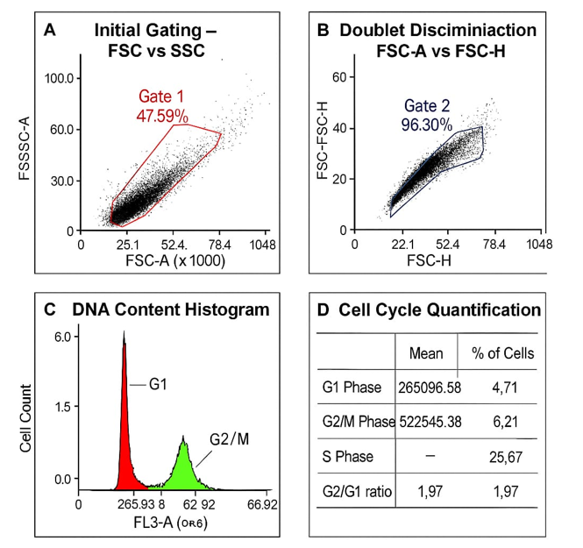

Fig. 10 displays flow cytometry-based cell cycle analysis of untreated control cells.
Panel A shows initial gating (FSC-A vs. SSC-A), identifying 47.59% of the events as the main cell population (Gate 1). Panel B demonstrates doublet discrimination (FSC-H vs. FSC-A), with Gate 2 capturing 96.30% singlet events. Panel C illustrates the PI-stained DNA content histogram, showing distinct G1 (4.71%) and G2/M (8.21%) peaks, while Panel D summarizes fluorescence intensities and calculates a G2/G1 ratio of 1.97. These findings reflect normal cell cycle progression under physiological conditions, with minimal background interference. The clear separation between G1 and G2/M peaks and high singlet purity validate data accuracy. In contrast to AgNP-treated cells (Fig. 9), the control group shows no evidence of G1 arrest or replication inhibition, underscoring the impact of AgNPs on cell cycle dynamics and reinforcing the importance of untreated controls in cytometric assays.

5. CONCLUSION
The in vitro model developed in this study effectively demonstrated differential effects of AgNPs across various cell types involved in inflammation and immunity. The ability of AgNPs to modulate ROS, protein expression, and cell cycle phases supports their potential as modulators in the context of rheumatoid arthritis. This platform can be further adapted to investigate other nanoparticles or anti-inflammatory agents.
9. CONSENT
Informed consent was obtained from the volunteer donor prior to blood collection. All procedures were conducted in accordance with ethical guidelines for the use of human biological materials in research.
10. ETHICAL APPROVAL
Blood samples for PBMC isolation were collected following institutional guidelines and ethical standards.
11. REFERENCES
1.Jahid M, Khan KU, Rehan Ul Haq, Ahmed RS. Overview of rheumatoid arthritis and scientific understanding of the disease. Mediterr J Rheumatol. 2023;34(3):284–91. Available from: https://doi.org/10.31138/mjr.2023.34.3.284
2.Zhang Z, Gao X, Liu S, Wang Q, Wang Y, Hou S, et al. Global, regional, and national epidemiology of rheumatoid arthritis among people aged 20–54 years from 1990 to 2021. Sci Rep. 2025; 15:10736. Available from: https://doi.org/10.1038/s41598-025-92150-1
3.Rheumatoid Arthritis Foundation. RA causes: What are the top causes of rheumatoid arthritis? [Internet]. [cited 2025 Jun 17]. Available from: https://www.rheumatoidarthritis.org/ra/causes/index.html
4.Chauhan K, Jandu JS, Brent LH, Al‑Dhahir MA. Rheumatoid arthritis. In: StatPearls [Internet]. Treasure Island (FL): StatPearls Publishing; Jan 2025–. Available from: https://www.ncbi.nlm.nih.gov/books/NBK441999/
5.Finkel T, Holbrook NJ. Oxidants, oxidative stress, and the biology of ageing. Nature. 2000 Nov 9;408(6809):239–47. doi:10.1038/35041687. Available from: https://doi.org/10.1038/35041687
6.Mishra AP, Kumar R, Harilal S, Nigam M, Datta D, Singh S. Emerging landscape of in vitro models for assessing rheumatoid arthritis management. ACS Pharmacol Transl Sci. 2024 Jul 18;7(8):2280–2305. doi:10.1021/acsptsci.4c00260. Available from: https://pubmed.ncbi.nlm.nih.gov/39144547/
7.Lal A, Yerraguntla M, Gunti K. Novel synthesis and biological evaluation of silver nanoparticles: Antimicrobial and anti-inflammatory effects in mammalian cells. Int J Appl Nanotechnol. 2024;10(1):48–66. Available from: https://journalspub.com/wp-content/uploads/2024/08/Novel-Synthesis-and-Biological-Evaluation-of-Silver-Nanoparticles.pdf
8.Mirshafiey A, Mohsenzadegan M. The role of reactive oxygen species in immunopathogenesis of rheumatoid arthritis. Iran J Allergy Asthma Immunol. 2008 Dec;7(4):195–202. PMID: 19052348. Available from: https://pubmed.ncbi.nlm.nih.gov/19052348/
9.Gudikandula K, Maringanti SC. Green synthesis of silver nanoparticles using Acacia concinna fruit extract and its antibacterial activity. J Exp Nanosci. 2016;11(5):365–74. Available from: https://doi.org/10.1080/17458080.2016.1139196
10.Woo CH, Lim JH, Kim JH. Lipopolysaccharide induces matrix metalloproteinase-9 expression via a mitochondrial reactive oxygen species–p38 kinase–activator protein-1 pathway in RAW 264.7 cells. J Immunol. 2004;173(11):6973–80. Available from: https://doi.org/10.4049/jimmunol.173.11.6973
11.Bottomley MJ, Webb NJA, Watson CJ, Holt PJL, Freemont AJ, Brenchley PE. Peripheral blood mononuclear cells from patients with rheumatoid arthritis spontaneously secrete vascular endothelial growth factor (VEGF): specific up-regulation by tumour necrosis factor-alpha (TNF-α) in synovial fluid. Clin Exp Immunol. 1999;117(1):171–6. Available from: https://doi.org/10.1046/j.1365-2249.1999.00949.x
12.Longhin, E. M., El Yamani, N., Rundén‑Pran, E., & Dusinska, M. (2022). The Alamar Blue assay in the context of safety testing of nanomaterials. Frontiers in Toxicology, 4, 981701. https://doi.org/10.3389/ftox.2022.981701
13.OntoSight. Dichlorofluorescein Diacetate (DCF-DA). OntoSight Glossary [Internet]. [cited 2025 Jun 14]. Available from: https://ontosight.ai/glossary/term/Dichlorofluorescein-Diacetate---DCF-DA
14.Alhajj, M., Zubair, M., & Farhana, A. (2023). Enzyme-linked immunosorbent assay. In StatPearls. StatPearls Publishing. https://www.ncbi.nlm.nih.gov/books/NBK555922/
15.McKinnon KM. Flow cytometry: An overview. Curr Protoc Immunol. 2018;120(1):5.1.1–5.1.11. Available from: https://www.ncbi.nlm.nih.gov/pmc/articles/PMC5939936/
16.ScienceDirect. Cell cycle analysis. In: Medicine and Dentistry [Internet]. Elsevier; [cited 2025 Jun 16]. Available from: https://www.sciencedirect.com/topics/medicine-and-dentistry/cell-cycle-analysis

