*Original Research Article*

Identification of some Acyclic Phosphate Resistant genes in Hepatitis B Positive Subjects attending Rivers State University Teaching hospital

.

ABSTRACT

|  |
| --- |
| **Aim:** To identify some acyclic phosphate resistant genes in hepatitis B positive subjects attending Rivers State University Teaching hospital  **Study design:** Analytical Cross-sectional study  **Place and Duration of Study:** Rivers State University Teaching hospital, between February and August 2024.  **Methodology:** One hundred and thirty-eight (138) subjects aged 35 – 70 years were recruited for this study. This is made up of 44 HBV positive naïve subjects, 44 HBV Positive subjects on antiretroviral therapy (ART) and 50 subjects who are HBV negative as control subjects. DNA from the sera was extracted using quick– DNA mini-Kit supplied by inqaba west Africa following the Zymo research instructions. Extracted genomic DNA was quantified using the Nanodrop 100 Spectrophotometer. The S gene of the virus was amplified using nested PCR approach with primer with on a ABI 9700 applied Biosystem thermal Cycler at a final volume of 30 microlitres for 35 cycles. The data were analyzed using GraphPad Prism version 9.02.  **Results:** The result of the Hepatitis B Resistant Genes in Subjects with Hepatitis B Infection showed that A202C was detected in 7 subjects, T184G detected in 10 subjects and A181T detected in 27 subjects.  **Conclusion:** This study has shown the presence of A202C, T184G and A181T genes in some Hepatitis B positive subjects on acyclic phosphonate drug. |

*Keywords: Acyclic Phosphate Resistant genes, Hepatitis B, Rivers State University Teaching hospital*

1. INTRODUCTION

Hepatitis B virus (HBV) is a hepatotrophic virus known to be a leading cause of chronic liver disease such as chronic hepatitis, liver cirrhosis and hepatocellular carcinomia [1]. This virus was estimated to have been the cause of about 820,000 deaths in 2019 with 3.6% of the global population affected by chronic HBV infection, and in response to this, the World Health Organisation adopted the global health strategy on viral hepatitis, with a goal to eliminate the viral hepatitis as a public health problem by 2030 [2]. Infection with the hepatitis B virus (HBV) remains a global health problem despite successful vaccination program [3]. Almost two billion people worldwide have been infected with HBV at some point in their lives, and around 296 million live with chronic infection [4,5]. Complications related to chronic infection are still a source of significant morbidity and mortality of approximately 820,000 annually, primarily due to liver cirrhosis and hepatocellular carcinoma (HCC) [6,7].

To end the negative impacts of hepatitis B virus, currently the international guidelines recommend PEGylated-interferon (PEG-IFN) and nucleos(t)ide analogues (NAs) as the first line therapies [8]. Those treatment options aim to stop the progression of the disease by suppressing the replication of HBV. According to Won et al [6], interferon alpha and nucleos(t)ide analogues (NAs) are clinically available to treat hepatitis B virus infection, and several NAs, such as Lamivudine (LMV), adefovir (ADV), Entecavir (ETV) and tenofovir (TDF or TAF) have been approved and administered to chronic hepatitis B patients. Meanwhile, chronic hepatitis B requires long-term treatment which leads to mutation, thus emerging drug resistance [8].

According to Nguyeng et al [9], although NAs have been proven to be safe and well tolerated, cumulative toxicity may develop in some patients after long-term use, and since there were previous reports of developed bone disease and renal tube injury with the use of tenofovir in elderly patients and those with HIV infection. Similarly, Warner and Locarnini [10] reported there could be increased risk of liver cancer following sequential lamivudine-adefovir dipivoxii therapy, due to A181T variant selection and the development of the cystoplasmic accumulation of S proteins which have truncated, causing activation of the C-Raf-1/mitogen-activated protein Kinase pathway. All these put together, become a major source of concern to clinicians and the other experts in the field.

Unfortunately, irrespective of thousands of research work done by different medical practitioners, there has been a paucity of work on the identification of some acyclic phosphate resistant genes in hepatitis B positive subjects in Rivers State University Teaching Hospital. This is where this research holds much promise as data obtained will serve as baseline information, which will add to the pool of knowledge in the medical field where much work on molecular biology has not been done.

2. materialS and methods

**3.1** **Study Area**

This research was conducted in Rivers State University Teaching Hospital (RSUTH). [11].

**3.2 Study Population**

All subjects comprised of hepatitis B positive and naïve patients sampled at the study population. They were randomly sampled with their consent obtained and questionnaire administered to them to ascertain their age, the use or non-use of ART is put into consideration, and type of antiretroviral therapy used. Information obtained from them was confidentially treated and maintained.

**3.3 Study Design**

This is an analytical cross-sectional study, which consist of 88 patients (test subjects) aged 35 – 70 years were used on this study out of which 44 subjects are HBV Positive (Naïve) who are not on drugs, 44 subjects are HBV Positive on antiretroviral therapy (ART) for Six months and 50 subjects who are HBV negative were used as control.

**3.4 Eligibility Criteria**

**3.4.1 Inclusion Criteria**

Subjects who are HBV positive, comprising those on ART, those who are not on ART (naïve) and those who are HBV negative during this research who gave their consent to participate were included.

**3.4.2 Exclusion Criteria**

Subjects with history of diabetes, kidney diseases, hypertension, those below or above the stipulated age and pregnant women were excluded.

**3.5 Sample Size**

The sample size was determined by Cochran formula [12].

**3.6 Sample Collection**

Venous Blood (10mls) was collected from the subjects and put into a plain sample bottle with the aid of 10mls syringe and needle, cotton wool and methylated spirit. The samples collected were put in a specimen rack and moved to the laboratory where they were separated by centrifugation at 3500 rpm for 10 minutes using 800D Centrifuge CE. The supernatant was collected using a pasture pipette into a new plain bottle and stored in a refrigerator at -20oc until the time of analysis.

**3.7 Laboratory Analysis**

**3.7.1 DNA Extraction**

The DNA from the sera was extracted using quick– DNA mini-Kit supplied by inqaba west Africa following the zymo research instructions. The tubes containing the buffer in which the plasma were vortexed, 400ul of the buffer were transferred to 1.5ml tube, 20ul of proteinase K and 400ul of Bio-fluid (red) were added, mixed and incubated at 550C for 20 minutes. Four hundred and twenty microliters of Genomic Binding Buffer were added and mixed thoroughly by vortexing. The mixture was transferred to a zymo spin IIC – XLR Column in a collection tube and centrifuged at 12000xg for 1 minute using Eppendent Microcentrifuge 5424 Inqaba Biotec. The collection tube was discarded with the flow through and 400ul of DNA pre-wash buffer were added and to the Spin column in a new collection tube, after centrifuging at 12000xg. 500ul of DNA wash buffer were added and spun at 12000xg. The spin Column was then transferred to a collection tube and 200ul of DNA wash buffer were added and spun at 12000xg for 1 minute. The spin Column was finally transferred to a new 1.5ml tube add 50ul of DNA elution buffer were added directly to the matrix and spun a top speed for 1 minutes the harvested product was store at -200C for quantification and amplification.

**3.7.2 DNA Quantification**

The extracted genomic DNA was quantified using the Nanodrop 100 Spectrophotometer. The software of the equipment was launched by double clicking on the Nanodrop icon. The equipment was initialized with 2ul of sterile distilled water and blanked using normal saline.

Two microlitre of extracted DNA was loaded into the lower pedestal, the upper pedestal was brought down to contact the extracted DNA on the lower pedestal. The DNA concentraction was measured by clicking on the “measure” button.

**3.7.3** **Amplification for the S gene of HBV**

The S gene of the virus was amplified using nested PCR approach with primer with on a ABI 9700 applied Biosystem thermal Cycler at a final volume of 30 microlitres for 35 cycles. The PCR mix included: the X2 dream Taq master mix supplied by inquaba Biotec, South Africa (Taq Polymerase, DNTPs, MgCL), the primers at a concentration of 0.5um and the extracted DNA as template. The PCR conditions were as follows:

Initial denaturation, 950C for 5 minutes; denaturation, 950C for 30 seconds minutes; annealing 560c and 590c for primary and secondary PCR respectively for 30 seconds; extension, 720C for 30 seconds for 35 cycles and final extension, 720c for 5 minutes. The product was resolved a one % agarose gel at 130V for 30 minutes and visualized on a blue light transilluiminator. [13].

**3.7.4 Determination of Agarose Gel Electrophoresis**

**Procedure.**

2% Agarose gel was weighed and put in a conical flask. 10mls of TAE Buffer (10X TAE) and 90mls of water were added and mixed. The flask was covered with tissue paper (Not tightly). It was mixed and micowaved for 3 minutes. It was allowed to cool, until hand hot. 5ul of safe view dye was added. The gel was poured on the gel tray with comb already placed.

**Loading of PCR Product and loading dye**

10ul of PCR products were loaded into a corresponding sample well on the gel submerged in Buffer. Also, 10ul of DNA was loaded into the wells on the gel to serve as a measuring tool for the PCR product. The Electrophoresis Machine Power Pro 300v 700Ma 150w was set at 200v for 15 minutes. The higher the voltage, the shorter the time for running. The DNA size was measured with DNA ladder,

**3.8 Statistical Analysis**

The results obtained were analyzed using GraphPad Prism version 9.02. Descriptive statistics involving the use of mean and standard deviation, and statistical significance was set at p 0.05. Inferential statistical involving the use of one-way ANOVA (PostHoc:Tukey’s multiple comparison test), Student t-test, and Pearson’s correlation were used.

3. results and discussion

**Table 1: Some Hepatitis B Resistant Genes in Subjects with Hepatitis B Infection**

|  |  |  |  |
| --- | --- | --- | --- |
| **Genes** | **Resistant**  **Positive** | **Naïve**  **Negative** | **Control**  **Negative** |
| A202C | 7 | Nil | Nil |
| T184G | 10 | Nil | Nil |
| A181T | 27 | Nil | Nil |

**Table 2: Some Acyclic drugs taken by the Subjects (Resistant) and their Genes.**

|  |  |  |  |
| --- | --- | --- | --- |
| **Drugs** | **Genes** |  | **Total** |
| Adefovir | A2023C |  | 7 |
| Entecavir | T184G |  | 10 |
| Lamivudine | A181T |  | 27 |

1 2 3 4 L 6 7 8 9 10

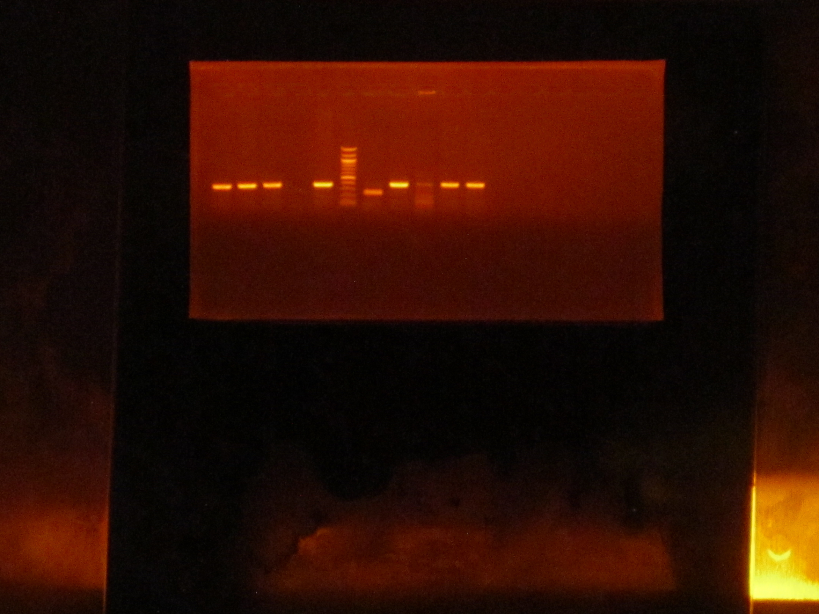

500bp

P gene(A181T)

**Plate 1: Agarose gel electrophoresis showing the amplified mutant P gene (A181T), lanes 1, 2, 4, 7, 9 and 10 showing the amplified mutant P gene at 350bp while lane L represents the 100 bp molecular ladder**

L 1 2 3 4 5 67 8

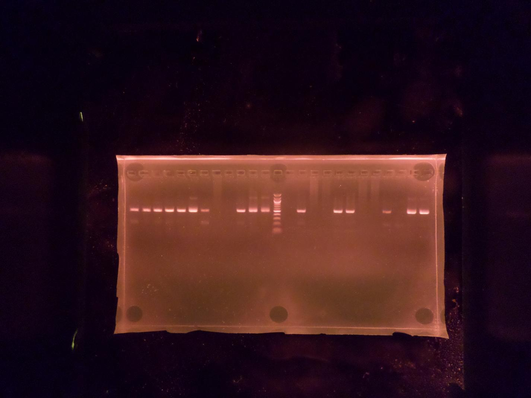

500bp

P gene mutant (T184G)

**Plate 2: Agarose gel electrophoresis showing the amplified mutant P gene (T184G), lanes 2, 5and 6 showing the amplified mutant P gene at 350bp while lane L represents the 100 bp molecular ladder**

1 2 3 L 4 5 6 7

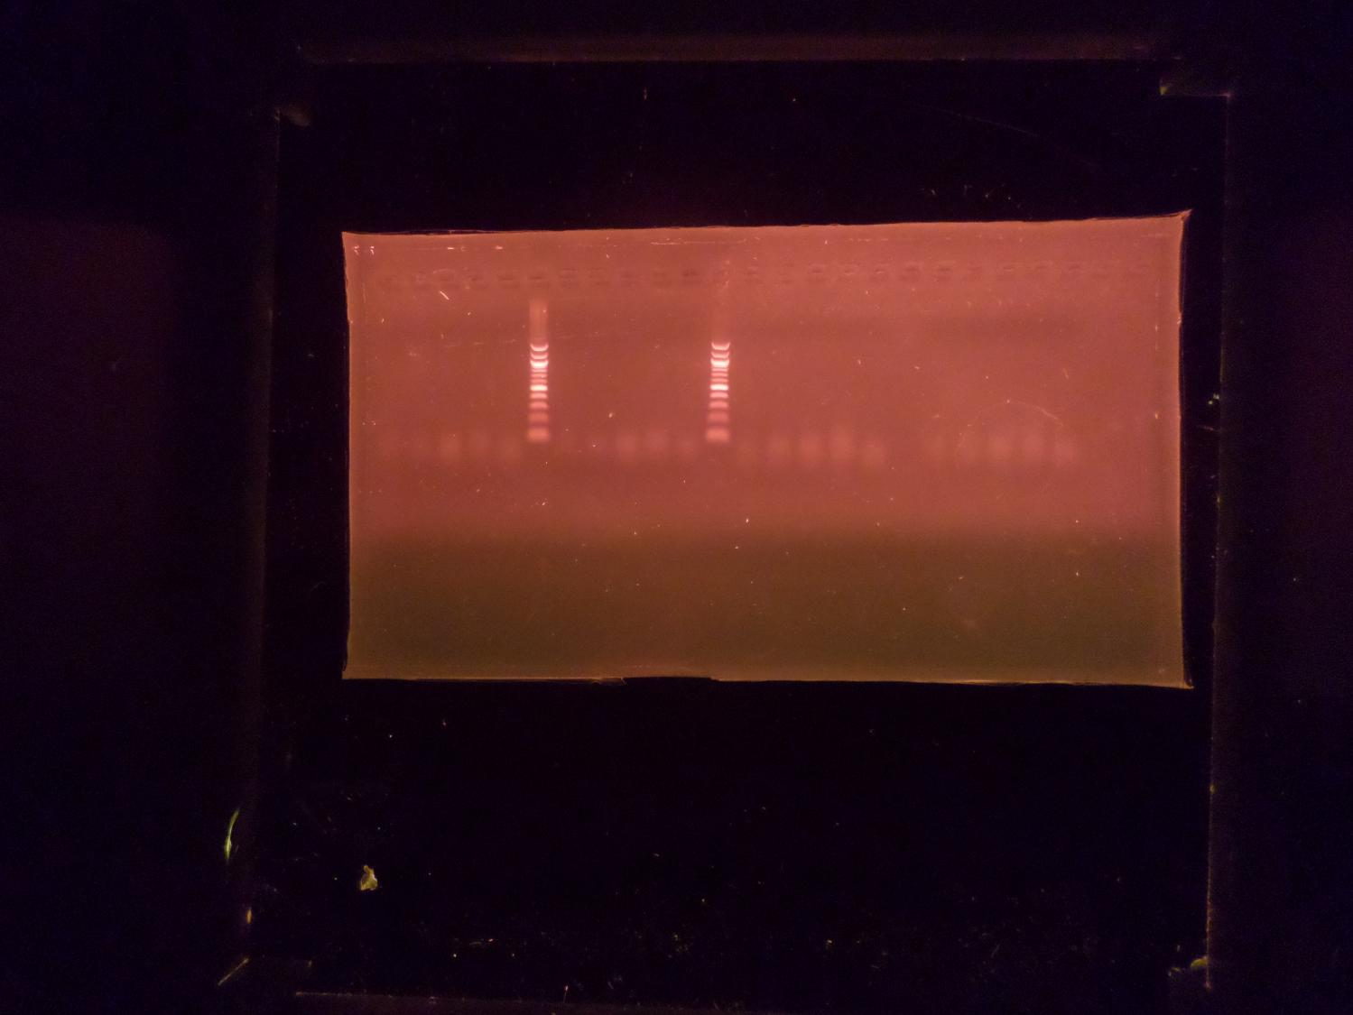

500bp

**Plate 3: Agarose gel electrophoresis showing no mutant P gene (A202C) band, lane L represents the 100 bp molecular ladder**

**Figure 1: Column Chart Showing the Number of Male and Female Subjects with**

**Different Hepatitis BResistance Gene Undergoing Hepatitis B Treatments**

**Figure 2: Pie Chart Indicating the Distribution of Hepatitis Resistant Genes in Male**

**Subjects**

**Figure 3: Pie Chart Indicating the Distribution of Hepatitis Resistant Genes in Female**

**Subjects**

This study investigated some acyclic phosphate resistant genes in hepatitis B positive subjects attending Rivers State University Teaching Hospital. The treatment of chronic hepatitis B (CHB) has been improved by introducing nucleos(t)ide analogs (NAs) such as lamivudine (LMV), adefovir (ADV), entecavir (ETV), telbivudine (LDT), and tenofovir (TDF) [14,15,16]. Lok et al. [17] reported that although NAs are more convenient than IFN-based therapies and have fewer side effects, sustained viral suppression is usually not achieved after withdrawal of a 48week course of NA therapy, necessitating long, and in many cases, indeﬁnite treatment. Unfortunately, a long duration of NA treatment is associated with an increasing risk of development of drug resistance. Antiviral resistance and poor adherence are the most important factors in treatment failure.

NA therapy can be effective in suppressing HBV viraemia, thus reducing the risks of inflammation, fibrosis and hepatocellular carcinoma (HCC) as well as lowering the risk of transmission. However, NAs are not curative due to the persistent intracellular hepatic reservoir of HBV covalently closed circular DNA (cccDNA). Long-term administration is therefore typically required, with a potential risk of selection of resistance-associated mutations (RAMs) in the virus. RAMs are most likely to arise in the context of high viral replication, arising because of the error prone RT enzyme [18]. Accurate and real-time monitoring and observation of the occurrence characteristics of HBV drug-resistant mutations have important clinical significance for the treatment of HBV and the reduction of liver cancer or liver failure caused by HBV [17]. The study showed resistance gene A202C with 7, T184G with 10, and A181T with 27 in the subjects studied. Also, the study reported resistance gene A202C with males 4(19%) and females as 3(13%), T184G had 4(19%) males and 6(26%) females while A181T genes of 13 (62%) males and 14 (61%) females. This is suggestive of high level of resistance genes in the population studied with A181T genes as the most detected in the hepatitis B positive subjects studied. Zhou et al. [19] in their study in northern Henan Province of China, using 148 cases of HBV patients showed that drug resistance mutation sites of ETV were I169T (1 case, 0.95%), T184I (2 cases, 1.90%), S202G (2 cases, 1.90%) and T184I (1 case, 0.95%), and no mutation sites of T184A, T184F and T184G were found; the drug resistance mutation sites of ADV were A181T (8 cases, 7.6%). Previous study has reported two primary adefovir resistant mutations, the rtA181T and rtN236T substitutions in the viral polymerase [20]. TFV resistance has been linked to the rtA194T substitution, but only in association with changes that cause LMV resistance and typically in the setting of coinfection with HIV-1 [21]. It is known that TDF resistance mutation site is A194T in RT gene region [19].

In a Malawi cohort study, two subjects showed the less common pathway M204V + L180M+A181S, which also confers resistance to adefovir and to a lesser extent tenofovir [22]. By deep sequencing, 4 subjects harbored A181T, which reduces susceptibility to tenofovir [23], mutant frequencies were low, however, A181T did not emerge in the Sanger sequences obtained at 12 months, although 1 subject acquired A181S. Thus, most patients in the Malawi cohort are expected to respond virologically to tenofovir [24].

HBV resistance-associated mutations (RAMs) were classed as major (M204I/V/S, A181T/V/S, A194T, N236T) and compensatory (L80I/V, I169T, V173L, L180M/C, T184A/G/I/S, S202C/G/I, M250L/V) [25]. HBV mutations outside active sites of the enzyme occurred in combination with RAMs located within active sites, except for A194T. Only two studies reported TFV resistance arising from the selection of a single mutation, S78T and A194T [18]. S78T was defined by sequencing HBV from two individuals in whom viraemia was not suppressed by TDF, combined with in vitro assays, while A194T was only defined in vitro. In all other studies, ≥2 RAMs were required to confer TFV resistance (2 RAMs in four studies [18], 3 RAMs in one study, 5 RAMs in one study, and ≥8 RAMs in a further four studies [18].

Another study has also reported high frequency of lamivudine resistance in up to 70% of HBV patients who were treated for 5 years with lamivudine, 29% after 5 years with adefovir, 20% after 2 years with telbivudine, and 1% after 5 years with entecavir [26]. The mutations found in the four patients were L180M/V, M204I, A181T, and V173L. Among these, L180M/V and M204I were frequently observed. Some study reported that in most cases, the M204V/I mutation was not present alone but linked with a leucine to methionine exchange at position 180 (L180M) [27].

The most frequently described RAMs were L180M, A181T/V, M204I/V, and N236T which were all identified through sequencing and tested in vitro assays to measure the effect of TDF on viral replication in cell lines [18]. Among these, the M204 mutation (within the ‘YMDD’ motif) is well established in association with 3TC resistance, commonly arising in combination with substitutions at positions V173, L180 and A181, while N236 substitutions appear to be more specifically associated with reduced susceptibility to ADV and TFV7. Mutations at sites 177, 194 and 249 may also be more specific to TFV resistance, having been less clearly reported in association with resistance to other agents [18]. Polymorphisms at positions 80,173 and 184 have been described as compensatory changes to allow the virus to accommodate the primary drug escape substitution [18]. These mutations on their own may not be sufficient to mediate TVF resistance but may be a necessary compensatory contribution to combinations of mutations that underpin resistance [18] Mokaya et al. [18] reported that TFV resistance seems likely to depend on the selection of suites of mutations (most commonly including L180M, A181V/T, M204I/V and/or N236T), overlapping with RAMs that allow escape from other NA drugs. There is also a suggestion that, rarely, single mutations can confer TFV resistance, best demonstrated for S78T.

Among several drug resistance-conferring mutations, the single rtA181T mutation can confer cross-resistance by removing or reducing the genetic barrier to drugs [28]. The rtA181T mutation has been reported in patients undergoing LMV, ADV, clevudine, or LdT therapy [29] According to the 2012 EASL Guidelines, the rtA181T mutation leads to LMV, ADV, and LdT resistance. The mutation causes intermediate or reduced susceptibility to TDF, and mutant strains are only sensitive to ETV treatment [30]. In vitro phenotypic studies showed that the rtA181T mutant showed decreased susceptibility to LMV, ADV, and TDF [31].

4. Conclusion

This study has shown the presence of A202C, T184G and A181T genes in some Hepatitis B positive subjects on acyclic phosphonate drug.

Consent

All authors declare that written informed consent was obtained from the patient (or other approved parties) for publication of this case report and accompanying images.

Ethical approval

Ethical approved for the research was obtained from Rivers State Hospitals Management Board (RSHMB/RAHREC/2023/055).

References

1. Oshun, P. O. & Odeghe, E. Seroprevalance of Hepatitis B virus infection and associated risk factors among apparently healthy individuals in Lagos. *Annals of Tropical Pathology,* 2023; 14(1): 11-5.
2. Ajuwon, B. I., Yujuice, I., Roper, K., Richardson, A., Sheel, M. and Lidbury, B. Hepatitis B virus Infection in Nigeria: A Systematic Review and Meta-analysis of Data Published between 2010 and 2019. BMC Infectious Disease, 2021; 21: 1120 <https://doi.org/10.1186/s12879-021-06800-6>.
3. Kazmi, S. A., Rauf, A., Latif, M. Z., Shahid, B., Khawaya, S. and Anjum, Z. A 28-year old male patient with asymptomatic and multi-drug resistant HBV infection: a case report. *Egyptian Liver Journal,* 2024;14:13. <https://doi.org/10.1186/s43066-024-00319-6>.
4. Lavanchy, D. Hepatitis B virus epidemiology, disease burden, treatment, and current and emerging prevention and control measures. *J. Viral Hepat*., 2004; 11: 97–107.
5. World Health Organization Hepatitis B; World Health Organization: Geneva, Switzerland, 2022. Available online: <https://www>. who.int/news-room/fact-sheets/detail/hepatitis-b (accessed on 9 March 2024), 2022.
6. Won, J., Lee, A. R., Dezhbord, M., Lee, D. R., Kim, S. H., Kim, J. C., Park, S., Kim, N., Jae, B. and Kim, K. H. Susceptibility of Drug Resistant Hepatitis B Virus Mutants to Besifovir. Biomedicine, 2022; 10: 1637. http//doi.org/103390/biomedicine.
7. Mathew, A., Ismael, N., Meeds, H., Vubil, A., Zicai, A. F., Mabunda, N. and Blackad, J. T. Hepatitis B Virus Genotypes and Drug Resistance Mutations Circulating in Blood Donors in Beira, Mozambique.PLOS One, 2023; 18(2): e0281855.
8. Özlük, S., Bayram, Y., Ozkagmaz, A., Parlak, M., Ozdemir, A. Antiviral Drug Resistance Rates among Patients with Chronic Hepatitis B Infection *European Journal of Clinical and Experimental Medicine,* 2023;21(2): 283-8. https/doi.org/10.15584/ejcem.2023.2.23
9. Nguyeng, M. H., Wong, G., Gane, E., Jia-Horng, K. and Dusheiko, G. Hepatitis B Virus: Advances in Prevention, Diagnosis and Therapy. Clinical Microbiology Review, 2020; 33(2): 200046-19.
10. Warner, N. and Locarnini, S. The Antiviral Drug Selected Hepatitis B Virus rtA181T/sW172*mutant has a dominant negative secretion defect and altersthetypical proﬁleofviral rebound. *Hepatology,* 2008;48: 88–98.
11. Wekere, F.CC, Iwoh-Amah, R.S.,Kwosah, J.N., Bademosi, A. and Amadi, S.C. A Five-year review on Caesarean section at the Rivers State University Teaching Hospital, South-South, Nigeria. *Journal of Advances in Medicines & Medical research*, 2021; 33923: 159-67.
12. Cochran W.G. Sampling Techniques *3rd Edition*. John Wiley & Sons New York, 1977.
13. Suppiah J, Mohd Zain R, Nawi S.H, Bahari N. &Saat Z. Drug-Resistance Associated Mutation in Polymerase (P) Gene of Hepatitis B virus isolated from Malaysian HBV Carriers: *Hepat Mon.* 2014; 14(1): e13173.
14. Delaney W.E. Progress in the treatment of chronic hepatitis B: long-term experience with adefovir dipivoxil. *Journal of Antimicrobial Chemotherapy*, 2007; 59: 827-32.
15. Dienstag J.L. Hepatitis B virus infection. *New England Journal of Medicine*, 2008; 359: 1486-500.
16. Lee JM, Park JY, Kim do Y, Nguyen T, Hong SP, Kim SO, Chon CY, Han KH, Ahn SH. Long-term adefovir dipivoxil monotherapy for up to 5 years in lamivudine-resistant chronic hepatitis B. *Antiviral Therapy*, 2010; 15: 235-41.
17. Lok, A. S., Zoulim, F., Locarnini, S., Bartholomeusz, A., Ghany, M. G., Jean-Michel P., Yun-Fan L., Mizokami, M., Kuiken, C., and the Hepatitis B Virus Drug Resistance Working Group. Antiviral Drug-Resistant HBV: Standardization of Nomenclature and Assays and Recommendations for Management*. Hepatology*, 2007; 46(1): 254-65.
18. Mokaya J, McNaughton AL, Bester PA Goedhals D., Barnes E.J.,Marsden B.D.,Matthews P.C.Hepatitis B virus resistance to tenofovir: fact or fiction? A systematic literature review and structural analysis of drug resistance mechanisms. *Wellcome Open Research*, 2020; 5: 151-7.
19. Zhou, Z., Chen, M., Li, P., & Yang J. Multilocus drug resistance mutation analysis in 148 HBV patients in northern Henan Province of China. *Med Rxiv*. 2021; https://doi.org/10.1101/2021.05.14.21257253.
20. Angus P., Vaughan R., Xiong S., Yang H., Delaney W., Gibbs C., Brosgart C., Colledge D., Edwards R., Ayres A, Bartholomeusz A, Locarnini S. Resistance to adefovir dipivoxil therapy associated with the selection of a novel mutation in the HBV polymerase. *Gastroenterology,* 2003; 125: 292–7.
21. Sheldon J, Camino N, Rodes B, Bartholomeusz A, Kuiper M, Tacke F, et al. Selection of hepatitis B virus polymerase mutations in HIV-coinfected patients treated with tenofovir. *Antiviral Therapy*, 2005; 10: 727-34.
22. Karatayli E, Karayalcin S, Karaaslan H, *et al*. A novel mutation pattern emerging duringlamivudine treatment shows cross-resistance to adefovir dipivoxil treatment. Antivir Ther, 2007; 12: 761–8.
23. Locarnini S.& Zoulim F. Molecular genetics of HBV infection. Antivir Ther 2010; 2010; 15(suppl 3): 3–14.
24. Baranovich, T*. et al*. T-705 (Fapiravir) Induces Lethal Mutagenesis in Inﬂuenza A H1N1 Viruses In Vitro. *Journal of Virology*, 2013; 87: 3741–51.
25. Rhee S.Y ,Margeridon-Thermet S, Nguyen MH, *et al.* Hepatitis B virus reverse transcriptasesequence variant database for sequence analysis and mutation discovery. *Antiviral Resistance*, 2010; 88: 269–75.
26. Strasfeld L, Chou S. Antiviral drug resistance: mechanisms and clinical implications. Infect Dis Clin North Am. 2010; 24(2): 413–37.
27. Tacke F, Shirvani-Dastgerdi E. Impact of Drug-Resistance Polymerase Mutations on the Replication of HBeAg-Positive and HBeAg-Negative Hepatitis B Virus Strains in Vitro. Hepat Mon., 2012; 12(6): 357–60.
28. Gish R., Jia J.D., Locarnini S. & Zoulim F. Selection of chronic hepatitis B therapy with high barrier to resistance. *Lancet Infectious Disease*, 2012; 12: 341–53.
29. Yoo B.C., Kim J.H., Chung Y.H., Lee K.S., Paik S.W., Ryu S.H., Han B.H., Han J.Y., Byun K.S., Cho M., Lee H.J., Kim T.H., Cho S.H., Park J.W., Um S.H., Hwang S.G., KimY.S.,LeeY.J.,ChonC.Y.,KimB.I,LeeY.S.,YangJ.M.,KimH.C.,HwangJ.S.,Choi S.K., Kweon Y.O., Jeong S.H., Lee M.S., Choi J.Y., Kim D.G., Kim Y.S., Lee H.Y., Yoo K.,Yoo H.W.,&LeeH.S. Twenty-four-weekclevudinetherapyshowedpotent and sustained antiviral activity in HBeAg-positive chronic hepatitis B. *Hepatology,* 2007; 45: 1172–8.
30. European Association for the Study of the Liver (EASL) EASL Clinical Practice Guidelineson management of chronic hepatitis B. Association for the Study of the Liver. *Journal of Hepatology,* 2012; 57: 167-85.
31. Villet S, Pichoud C, Billioud G, Barraud L ,Durantel S, Trépo C , & Zoulim F. Impact of hepatitis B virus rtA181V/T mutants on hepatitis B treatment failure. *Journal of Hepatology*, 2008; 48: 747–55.