Original Research Article

Seawater-based Battery for Charging Mobile Devices

.
ABSTRACT

With the electronic revolution that the world has nowadays, there is a necessity to look for alternative energy sources to meet the increasing electricity demand. One of the innovative alternatives to fossil-fuel-dependent energy sources is electricity from saltwater. This study utilized different salt solutions as electrolytes for voltaic cells that used the pairings of Cu, Mg, and Zn as electrodes. Results showed that seawater recorded the highest voltage among all salt solutions in a voltaic cell that used Mg-Cu as electrodes. Moreover, with the use of a buck-boost regulator module, a maximum of 8 V was recorded when six voltaic cells were assembled into a battery. Thus, the seawater-based battery has the potential to charge mobile devices.

Keywords: seawater-based battery, saltwater, electrodes, mobile devices

1. INTRODUCTION

The electronic revolution, characterized by the extensive use of highly sophisticated portable devices such as cellular phones with amazing applications, demands high-energy-density, safe, and cheap power sources (Yoo et al., 2014). As the world population grows, affluence tends to increase, which in turn results in consuming fossil fuels at a faster rate. This implies the necessity to look for alternative sources of energy so that the world will remain sustainable. Moreover, the use of fossil fuels poses a threat to the environment, considering that about three-quarters of global greenhouse gas emissions arise from the use of fossil fuels (Stoner R.,2017, Sustainable energy options for Africa. Unpublished). One of the adopted solutions to this problem is the use of renewable energy sources. Renewable energy sources (RES) are innovative alternatives to fossil fuels due to their inexhaustible and environmentally friendly features (He, 2016).
Previous studies have shown the high possibility of generating electricity from salt in seawater (Zhao et al.,2009). Examples of such studies include "saltwater-powered" Sustainable Alternative Lighting (SALt) lamps and Seawater Batteries for fishing lamps. As of today, the application of this technology is not widely adopted due to the high cost of the electrode material. The common electrode is produced by the combination of several metals, such as magnesium, nickel, tin, or lithium, which are expensive and restricted (Susanto et al., 2017a).
This study aims to expand the use of this technology by developing a saltwater-based battery for charging mobile devices, the most commonly used devices today. To produce the voltaic cell, the researchers determined the right pairing of economically and readily available metals (such as zinc, magnesium, and copper) as electrodes, which were tested using the different electrolytes in order to determine the optimum voltage that can be generated. The experimental electrolytes were the different concentrations of saltwater and seawater, which were compared with sulfuric acid as the standard electrolyte. A battery was assembled from the voltaic cells to generate electricity enough to charge mobile devices. Finally, the efficiency of the prototyped battery is limited to the voltage produced by the battery with and without a load.

2. material and methods

2.1 Research Design
This study utilized a Randomized Complete Block Design (RCBD) to determine the voltages (dependent variable) produced from the three pairs of electrodes (independent variable) using the different concentrations (independent variable) of electrolytes. The researchers made voltaic cells using different pairs of metals (Zn-Cu, Mg-Zn, Mg-Cu) with three replicates for each pair. Each replicate has five versions of a voltaic cell with a specific electrode pair. The electrolytes were randomly assigned to a particular version. Since voltage readings can be affected by contamination of different electrolytes, and electrodes can be corroded upon the application of the treatment, five versions of each replicate were made so that only one treatment is accommodated per version of the replicate. Aside from having three replicates, three trials were also done for each treatment using the same version of the replicate to ensure consistency of voltage readings.

2.2 Data Gathering Procedure Experimental Set-up
2.2.1 Construction of an Experimental Voltaic Cell
The experiment was conducted from September 2018 to February 2019 in the Chemistry Laboratory of Southern Leyte State University-College of Teacher Education, San Isidro, Tomas Oppus, Southern Leyte, Philippines. The different electrodes used were copper (Cu), magnesium (Mg), and zinc (Zn), which have been paired with each other. The copper plate was used as the cathode, and zinc and magnesium were used as anodes in the Zn-Cu and Mg-Cu pairings, respectively. In the Mg-Zn pairing, the magnesium served as the anode. The dimensions of the electrodes in the experimental phase were 0.2 cm wide and 9.0 cm long, and the distance between electrodes was 5.0 cm. Twenty-seven (27) strips of each type of metal were prepared. Each strip was folded once to prevent it from touching the bottom of the glass container, and then an alligator clip was clasped on its tips. The alligator clip was soldered with a fifteen-centimeter (15 cm) long copper wire. The wires were inserted in the two holes drilled into the lids of each glass container, and then another alligator clip was soldered at the other end of the wire. Hot stick glue was applied around the gap of the holes in the lids to prevent the solution from spilling and to secure the electrodes in place. Sixty-three bottles were used: 27 bottles for T₀, nine bottles for T₁, nine bottles for T₂, nine bottles for T₃, and nine bottles for T₄. The design of the experimental phase for all electrode combinations is shown in Figure 1.

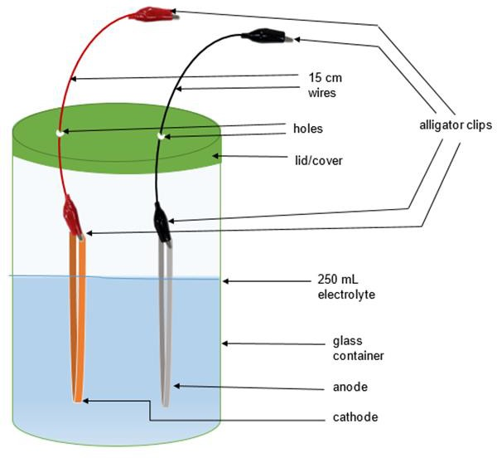
Figure 1. Design of the Experimental Voltaic Cell

2.2.2 Construction of Final Battery
The dimensions of the electrodes used for the final battery were 2.8 cm wide and 9.0 cm long. The magnesium ribbons, used as the anode, were woven and connected using an epoxy resin to form a plate. The size of the electrodes in all experiment combinations of the final battery set-up is shown in Figure 2.

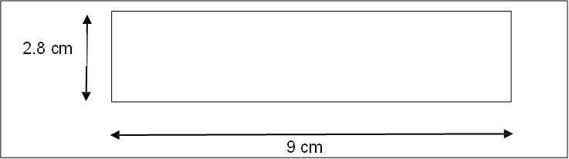
Figure 2. The Size of Electrodes

The battery was assembled inside a 250 ml experiment tank. A thick plastic was used to divide the battery container into six cell compartments, with an anode and a cathode, respectively. The battery was then connected to the buck-boost regulator module, as shown in Figure 3. The electrode plates were placed in the slit of a 25 mm rubber to keep the electrodes in place. Subsequently, the width of the cubic rubber was also the size of each cell compartment. Prior to use of the battery, the cells were activated spontaneously by immersing the electrodes in seawater. Figure 4 shows the circuit diagram of the battery and the buck-boost regulator module. Inside the battery, copper wires had been soldered onto the copper strips that connect the copper electrodes in the other cells, as shown in Figure 5.
Meanwhile, magnesium electrodes in each cell were extended vertically using a magnesium ribbon that was cut equally. As shown in Figure 6, holes were drilled in the lid of the plastic container. The two magnesium electrodes were joined and inserted into the holes to connect to the circuit outside the battery, forming a series connection with alligator clips. A Universal Serial Bus (USB) port was attached to the buck-boost regulator module so that a phone charger can be connected.
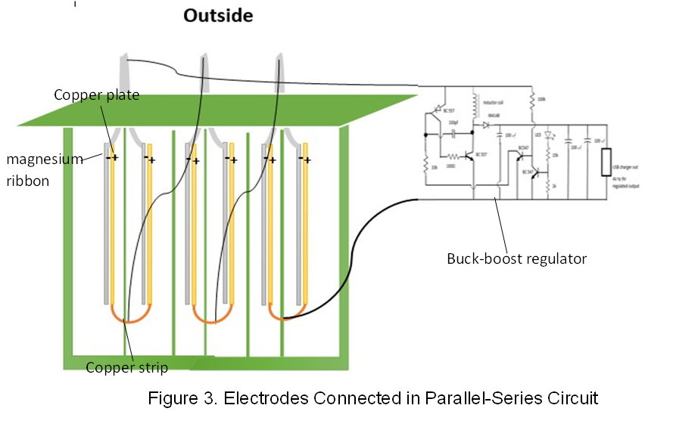
Figure 3. Electrodes Connected in a Parallel-Series Circuit

Figure 4. Circuit Diagram of Battery with Buck-boost Regulator Module

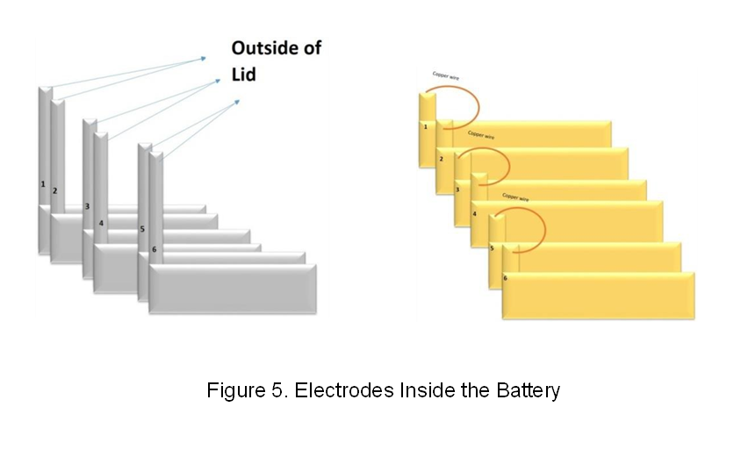
Figure 5. Electrodes Inside the Battery Module

Figure 6. Electrodes Inside the Battery Module

2.2.3 Collection of Seawater Samples
To get the average concentration of sodium chloride in seawater, three samples were collected from each of the three sampling locations within San Isidro Fish Sanctuary San Isidro, Tomas Oppus Southern Leyte namely: at the shore near the IFI Cemetery (10º15’02.5’’N 124º59’12.0’’E); at the shore near the Easter Faith Church School (10º15’05.2’’N 124º59’11.8’’E); and the shore near the Yepes Boarding House (10º15’08.0’’N 124º59'11.7''E). The samples were collected from a depth of one meter below sea level. The weather was sunny on the date of the collection, so there was a high chance of high salinity.

2.2.4 Determination of Molar Concentration of NaCl in Seawater Samples
The seawater samples were tested for the Percent Sodium Chloride (% NaCl) of the total salinity using the HI 9835 Auto Ranging EC/TDS/NaCl/Temperature Meters. Salinity is necessary in order to measure the total ions present in the seawater. Furthermore, the %NaCl of the total salinity was measured in order to check the contribution of NaCl to the total salinity of seawater.
2.2.5 Quantitative Analysis of Sulfuric Acid through Standardization and Titration
The concentration of the sulfuric acid solutions was analyzed quantitatively by titration using the standard sodium hydroxide solution (NaOH). The sodium hydroxide solution was standardized using KHP.
2.2.6 Formulation of Sodium Chloride Solutions
In the preparation of sodium chloride (NaCl) solutions to specified molarities and volume, the amount of impure NaCl was computed prior to weighing as reflected in Appendix 1. Using an analytical balance, 14.910 g, 22.362 g, and 29.816 g of impure NaCl were measured for sodium chloride solutions with 1.0 M, 1.5 M and 2.0 M concentrations, respectively. After weighing, the salt was transferred to a 250 ml beaker, and an adequate amount of distilled water was added to dissolve the salt. The petri dish used as a container for weighing the impure salt was also rinsed with distilled water to remove all the salt left on it. After dissolving, the solution was transferred to a 250 ml volumetric flask and diluted with distilled water up to the mark.
2.2.7 Preparation of Treatments
The treatments were prepared using the concentrations specified below. The control treatment (T₀) was a 1.0 M sulfuric acid solution, Treatment 1 (T₁) was a 1.0 M NaCl solution, Treatment 2 (T₂) was a 1.5 M NaCl solution, Treatment 3 (T₃) was a 2.0 M NaCl solution, and Treatment 4 (T₄) was the collected seawater. All treatments had a volume of 250 mL.

Table 1. Concentration and Volume of Treatments

Treatment | Concentration | Volume (mL)
T₀ | 1.0 M sulfuric acid solution | 250
T₁ | 1.0 M sodium chloride solution | 250
T₂ | 1.5 M sodium chloride solution | 250
T₃ | 2.0 M sodium chloride solution | 250
T₄ | 0.475 M seawater | 250

2.2.8 Testing of the Experimental Voltaic Cells
The multimeter was calibrated or adjusted to a known zero value prior to use for accurate readings in testing the experimental voltaic cells. Starting from version one of Zn-Cu pairing, 250 mL of T0 was poured into the voltaic cell. The lid was fixed (with one alligator clip already connected to the electrodes) to the glass container. Then the other alligator clip was connected to the test probe of the multimeter tester. The positive end of the multimeter test probe was connected to the cathode, and the negative end was connected to the anode. All three replicates of electrode pairing (Mg-Zn, Mg-Cu, Zn-Cu) with five versions of a voltaic cell and their assigned electrolyte underwent three trials. The voltage produced from each trial was measured and recorded.
2.2.9 Testing of Final Battery
The treatment and electrode pairing that produced the highest voltage were utilized for the final battery, which consists of six cells connected in a parallel-series circuit. Using a DC terminal cord, the battery was connected to the buck-boost regulator module to step up and regulate the output voltage of the battery. The phone was then connected to the USB port of the buck-boost regulator module for charging. The voltages produced from the battery alone, from the battery with the buck-boost regulator module, and from the battery with the buck-boost regulator module and load were measured and recorded. The phone's battery specification used as a load was 3.7 V, 600 mA-h.
To test the device's performance, the voltages it can produce over five days were recorded. The first recording was done immediately after immersing the electrodes in seawater (electrolyte). The second recording was done two days after the first, and the third was performed two days after the second recording.
2.2.10 Statistical Analysis
One-way Analysis of Variance (ANOVA) was used to determine if the difference between the voltages produced by the two best treatments was statistically significant.

3. results and discussion

3.1 Molar Concentration of NaCl in Seawater Samples
Table 2 shows the molar concentration of NaCl in seawater samples per location. These samples were taken at three different locations within San Isidro Fish Sanctuary, with the corresponding coordinates shown in the table.

Table 2. Density, Temperature, and Salinity of Seawater and Mass and Molarity of NaCl in Seawater

Sample | Location | Average Mass (g) of NaCl in one kg of Seawater | Average Density of Seawater (g/mL) | Molar Concentration of NaCl in Seawater (M) | Temperature (⁰C) | Percent (%)  NaCl of the Total Salinity
1 | 10º15’02.5’’N  124º59’12.0’’E |  |  |  | 31.10C | 93.9%
2 | 10º15’02.5’’N  124º59’12.0’’E | 27.21* | 1.02 | 0.475 | 30.20C | 93.7%
3 | 10º15’02.5’’N  124º59’12.0’’E |  |  |  | 30.10C | 93.3%
4 |  |  |  |  | 29.40C | 94.3%
5 | 10º15’05.2’’N  124º59’11.8’’E | 27.21 | 1.02 | 0.475 | 29.40C | 94.3%
6 | 10º15’05.2’’N  124º59’11.8’’E |  |  |  | 29.40C | 94.3%
7 |  |  |  |  | 29.30C | 94.5%
8 | 10º15’08.0’’N  124º59’11.7’’E | 27.21 | 1.02 | 0.475 | 29.40C | 94.2%
9 | 10º15’08.0’’N  124º59’11.7’’E |  |  |  | 29.80C | 93.3%
*27.21 g is adapted from (Magno, 2009). Chemistry, Science, and Technology Textbook, Vibal Publishing House, Inc.
It can be observed that the molar concentrations of NaCl in seawater are the same at different locations within the said sanctuary. This concentration of NaCl (0.475 M) in seawater comprises approximately 94% of the total salinity of seawater as reflected in column 7. The remaining 6% of the total salinity can be attributed to other ions such as sulfate ion, magnesium ion, calcium ion, and potassium ion, which are also present in seawater (Millero, 1974). Meanwhile, it can be observed that there is a slight difference in the percent NaCl of the total salinity of seawater and the temperature recorded in this study. This negligible difference can be attributed to the precision and accuracy of the measuring device and human error incurred in the process of collecting the seawater samples.

3.2 Electrode Pairing and Treatment that Produced the Highest Voltage
Table 3 presents the individual readings of the voltages produced from the different treatments and electrode pairings using the Professional Analogue Multimeter Tester (YH-372C). These readings were averaged to determine the highest voltage reading in different treatments and electrode pairings.

Table 3. Voltage Reading per Treatment and Electrode Pairing
 |  |  |  |  |  | Treatment
Pair | Replicates | T₀ |  | T₁ |  | T₂ |  | T₃ |  | T₄
 |  | Mean | stdev | Mean | stdev | Mean | stdev | Mean | stdev | Mean | stdev
 | Replicate 1  / Trials | .57 | .03 | .62 | .20 | .42 | .03 | .47 | .03 | .40 | 0.00
Zn-Cu | Replicate 2  /Trials | .60 | .01 | .47 | .03 | .42 | .03 | .44 | .03 | .40 | 0.00
 | Replicate 3  /Trials | .60 | .05 | .44 | .03 | .40 | 0.00 | .40 | 0.00 | .40 | 0.00
 | Average | .59 | .03 | .51 | .09 | .41 | .02 | .44 | .02 | .40 | .00
 | Replicate 1  / Trials | 1.40 | .15 | .53 | .03 | .66 | 0.00 | .59 | .16 | .78 | .14
Mg-Zn | Replicate 2  /Trials | 1.27 | .16 | .62 | .06 | .72 | .06 | .74 | .05 | .68 | .10
 | Replicate 3  /Trials | 1.26 | .15 | .69 | .15 | .75 | .05 | .79 | .03 | .70 | .05
 | Average | 1.31 | .15 | .61 | .08 | .71 | .04 | .70 | .08 | .72 | .10
 | Replicate 1  / Trials | 1.97 | .03 | 1.30 | .00 | 1.31 | 0.00 | 1.30 | .00 | 1.35 | .05
Mg-Cu | Replicate 2  /Trials | 1.92 | .06 | 1.30 | .00 | 1.30 | .00 | 1.30 | .00 | 1.37 | .03
 | Replicate 3  /Trials | 1.87 | .03 | 1.29 | .03 | 1.30 | .00 | 1.29 | .03 | 1.34 | .03
 | Average | 1.92 | .04 | 1.30 | .01 | 1.30 | .00 | 1.30 | .01 | 1.35 | .03
Legend: T₀ = 1.0 M H₂SO₄, T₁ = 1.0 M NaCl, T₂ = 1.5 M NaCl, T₃ = 2.0 M NaCl, T₄= 0.475 M Seawater

As shown in Table 3, there was a difference in voltages produced from the different pairings of electrodes immersed in the same type of electrolytes. This result affirms the findings of Norsworthy (2014) and Susanto et al. (2017b) that the high voltage produced is dependent on the combination of an appropriate pair of electrodes in a galvanic seawater cell. Norsworthy (2014) further explained that this difference is due to the electrical difference or difference in potential energy between the two electrodes (the anode and cathode) in the electrochemical cell.

The highest voltage produced is from the Mg-Cu pairing. This can be explained by the high electropositivity of magnesium and the high tendency of copper to accept electrons. In addition, magnesium has a negative standard electrode potential of -2.37 V (Wang et al., 2014) or -1.63 V in 3% sodium chloride (Zeng et al., 2006), which is more negative than zinc, which has a standard electrode potential of -1.25 V (Zeng et al., 2006; Wang et al., 2014). On the other hand, copper has a standard electrode potential of 0.34 V (Rorabacher and Schroeder, 2007). Thus, given these values, when magnesium is paired with copper and zinc is paired with copper, Mg-Cu pairing will produce a greater potential difference or emf.

Moreover, magnesium has a Faradic capacity of 2.205 A·h/g that is significantly higher than zinc’s Faradic capacity of 0.820 A·h/g (Wang et al. 2014; Hahn et al. 2015). This would mean that the magnesium anode could theoretically offer a larger number of electrons per unit mass to produce an electric current than zinc. Meanwhile, copper as a cathode electrode is widely used as a cathode material and in electrical products due to its high viability, high electrical conductivity (5.9 x 10⁷), and low resistivity (1.7 x 10⁹ Ω).

On the other hand, the result shows that there was a difference in voltages produced from the different electrolytes with the same electrode pairing. This voltage difference produced can be attributed to the nature of ions present in the electrolyte (Chang, 2008). As reflected in Table 3, different ions produced varying voltages, while the same ions produced equal voltages. For instance, T₁, T₂, and T₃, which are composed of Na⁺ and Cl⁻ ions, produced the same voltage. The voltages produced from these treatments are lower when compared to T₀, which is composed of H⁺ and SO₄⁻², and T₄ (seawater), which is composed of sulfate ion (SO₄⁻²), magnesium ion (Mg⁺²), calcium ion (Ca⁺²), and potassium ion (K⁺¹). The result observed in T₁, T₂, and T₃ supports the statement of Masrufaiyah et al. (2017) that the voltages do not depend strongly on the concentration of salt.

3.4 Mean Difference of the Voltages Produced by the Two Best Treatments

Table 4 presents a comparison of H₂SO₄ and seawater electrolytes in terms of the voltage produced using the electrode pairing that yielded the highest voltage reading, as shown in Table 3.

Table 4. Comparison between H₂SO₄ and Seawater Electrolytes in terms of the Voltage Produced

Pair | Treatment | N | Mean voltage | STDEV | Mean difference | df | t- value | p- value
Mg-Cu | H₂SO₄ (T₀) | 45 | 1.92 | 0.04 | 0.57 | 81 | 9.39 | .001
Mg-Cu | Seawater (T₄) | 45 | 1.35 | 0.03

Table 4 shows that there is a significant difference between H₂SO₄ (T₀) and seawater (T₄) in terms of voltage produced. The computed (P = .001) means that the mean difference of 0.57 V between the voltage produced by T₀ and the voltage produced by T₄ is statistically higher. This result implies that, in terms of producing current, sulfuric acid as an electrolyte is better than seawater. This is because, as Chang (2008) has said, H₂SO₄ is a strong electrolyte that dissociates almost completely into H⁺ and SO₄⁻². In contrast, seawater is a complex mixture of 96.5% water, 2.5% salts, and smaller amounts of other substances (Mackenzie et al., 2019). This means that only a part of the seawater dissociates into ions such as chlorine ion, sulfate ion, sodium ion, magnesium ion, calcium ion, and potassium ion (Millero, 1974).

Additionally, the 1.0 M H₂SO₄ is a higher concentration compared to the 0.475M NaCl in seawater. This would mean that more ions can participate in the voltaic cell that uses 1.0 M H₂SO₄ as electrolyte than in the voltaic cell that uses seawater that has 0.475 M NaCl. The greater number and concentration of ions that can participate in the reactions of H₂SO₄ enable it to generate a higher voltage than seawater. Moreover, H⁺, SO₄⁻², Na⁺, and Cl⁻ differ in their positions in the electrochemical series. Among the positively charged ions, the hydrogen ion accepts electrons more readily because it is more electronegative compared to the sodium ion. The electrochemical series also showed that the lower the position of a negative ion, just like Cl⁻ in the series, the more it gives off electrons at the anode. Thus Cl⁻ gives off electrons easily than SO₄⁻². However, even though Cl⁻ has a higher tendency to discharge, SO₄⁻² can discharge more electrons because it has a charge of -2. Furthermore, seawater also contains dissolved inorganic and organic materials (Mackenzie et al., 2019), which may have influenced the chemical reactions and current flow in the seawater either positively or negatively.

Nevertheless, seawater (T₄) was used in the final product of this study because of the voltage produced, as shown in Table 4. Although it is lower than that of H₂SO₄, when assembled into a battery and used with a buck-boost regulator module, it has the potential to charge mobile devices that require 3.7 V.

3.5 Voltages Produced by the Prototyped Battery

Table 5 presents the data obtained from the final device testing. Each trial has an interval of two days from the day the electrodes were immersed in seawater, except for Trial 1. The phone's battery specification used as a load was 3.7 V, 600 mA-h.

Table 5. Voltages Produced by the Seawater-based Battery alone, with Booster and Load

 | TRIAL 1 | TRIAL 2 | TRIAL 3
Battery | 4 V | 2.2 V | 1.4 V
Battery with booster | 8 V | 3.9 V | 2.4 V
Battery with booster and load | 4.7 V | 3 V | 0.7 V

As shown in Table 5, the voltages produced by the seawater-based battery were almost doubled after it had been connected to the booster. However, after the phone (load) was connected, the voltages decreased by half. This is because the load has already consumed some of the energy from the seawater-based battery. Meanwhile, two days after Trial 1, which was performed immediately after immersing the electrodes in seawater, the voltages produced were reduced by almost half of the original. The same was observed in Trial 3. The diminishing voltages may be attributed to the continuous reactions occurring in the battery during the two-day wait, which depleted some of the ions and electrons present in the system. A rise in temperature in the battery was also observed while charging. There could be energy loss in the form of heat, which is consistent with the second law of thermodynamics, which states that a machine cannot convert all energy into another form of energy without loss. Navasa and Valdez (1990) also said that whenever an electric current flows, heat energy is given off.
Despite the observed voltage decrease, the voltages produced by the seawater-based battery alone in the first trial was 4 V, the battery with booster was 8 V. The battery with booster and load was 4.7 V, were high enough to reach the minimum voltage to charge, which was 3.7 V. This means that the seawater- based battery design has the potential to charge mobile devices.

4. Conclusion

The study found that the average molar concentration of NaCl in the seawater sample collected was 0.475 M. Among all electrode pairings tested in a voltaic cell, the Mg-Cu pairing generated the highest voltage, recording an average of 1.35 V when immersed in seawater. A six-cell battery system equipped with a buck-boost regulator module achieved an average output voltage of 4.8 V and was able to charge a 600 mAh, 3.7 V phone battery at an average voltage of 2.8 V. However, over time, the performance of this six-cell battery decreased to about half of its original voltage output. Based on these findings, the seawater-based battery demonstrates potential for use in charging mobile devices.

DISCLAIMER (ARTIFICIAL INTELLIGENCE)

The authors hereby declare that Grammarly has been used during the writing or editing of this manuscript.

References

- Yoo, H., Markevich, E., Salitra, G., Sharon, D., Aurbach, D., &, (2014). On the challenge of developing advanced technologies for electrochemical energy storage and conversion. Materials Today, https://doi.org/10.1016/j.mattod.2014.02.014
- He W. 2016. Modelling, optimisation and control of osmotic energy extraction from natural salinity gradients using pressure retarded osmosis. Queen Mary, University of London. https://books.google.com.ph/books?id=XN4nyAEACAAJ
- Hongyang ZHAO, Pei BIAN, Dongying JU. 2009. Electrochemical performance of magnesium alloy and its application on the sea water battery. J Environ Sci. 21(SUPPL. 1): S88– S91. https://doi.org/10.1016/S1001-0742(09)60045-0.
- Susanto A, Baskoro MS, Wisudo SH, Riyanto M, Purwangka F. 2017a. Performance of Zn-Cu and Al-Cu electrodes in seawater battery at different distance and surface area. Int J Renew Energy Res. 7(1). https://doi.org/10.20508/ijrer.v7i1.5506.g7018
- Magno M. 2009. Chemistry, Science, and Technology Textbook. Vibal Publishing House, Inc., pp. 42
- Millero FJ. 1974. The physical properties of seawater. Annual Review of Earth and Planetary Sciences, Vol. 2, p.101. https://doi.org/10.1146/annurev.ea.02.050174.000533.
- Norsworthy, R. 2014. Understanding corrosion in underground pipelines: Basic principles. Woodhead Publishing Limited. https://doi.org/10.1533/9780857099266.1.3
- Susanto A, Baskoro MS, Wisudo SH, Riyanto M, Purwangka F. 2017b. Seawater battery with Al-Cu, Zn-Cu, Gal-Cu electrodes for fishing lamp. Int J Renew Energy Res. 7(4). https://doi.org/10.20508/ijrer.v7i4.6291.g7229
- Wang NG, Wang RC, Peng CQ, Hu CW, Feng Y, Peng B. 2014. Research progress of magnesium anodes and their applications in chemical power sources. Oral Oncol. 50(10):2427–2439. https://doi.org/10.1016/S1003-6326(14)63367-7
- Zeng, R.-C., Zhang, J., Huang, W., Dietzel, W., Kainer, K. U., Blawert, C., & Ke, W. (2006). Review of studies on corrosion of magnesium alloys. Transactions of Nonferrous Metals Society of China, 16. https://doi.org/10.1016/S1003-6326(06)60297-5
- Rorabacher, D.B. and Schroeder, R.R. (2007). Electrochemistry of Copper. In Encyclopedia of Electrochemistry, A.J. Bard (Ed.). https://doi.org/10.1002/9783527610426.bard072407
- Hahn R, Mainert J, Glaw F, Lang KD. 2015. Sea water magnesium fuel cell power supply. J Power Sources. 288:26–35. https://ui.adsabs.harvard.edu/abs/2015JPS...288...26H
- Chang, R. 2008. General chemistry: the essential concepts. 5th ed. The McGraw-Hill Companies, Inc. pp. 97-111
- Masrufaiyah M, Hantoro R, Nugroho G, Biyanto TR, Hamidah NL. 2017. Performance of seawater activated battery as alternative energy resources. IPTEK J Eng. 3(1):11. http://dx.doi.org/10.12962%2Fj23378557.v3i1.a2266
- Mackenzie FT, Byrne RH, Duxbury AC. 2019. Seawater. Britannica. https://www.britannica.com/science/seawater
- Navasa DC and Valdez BJ. 1990. You and the natural world physics. Phoenix Publishing, Inc. p. 297

