Adoption of Climate-Smart Agriculture Innovations in Drought-Prone Regions: A Global Bibliometric Review (2016–2025)

Abstract:
Climate-Smart Agriculture (CSA) innovations are vital for building drought resilience, yet their adoption remains uneven in vulnerable regions. This study conducts a systematic bibliometric review of CSA adoption research in drought-prone areas using 107 Scopus-indexed articles published between 2016 and 2025. We address five research questions concerning publication trends, geographic and institutional contributions, thematic evolution, and knowledge gaps. Results show a 31.8% annual increase in publications, with 48.6% involving international collaboration. Institutions from drought-prone areas such as ICAR-CRIDA (India), KNUST (Ghana), and CIAT (Colombia) lead in productivity. Research clusters focus on: (1) socio-technical adoption barriers (e.g., access to extension and credit); (2) socioecological intersections (e.g., drought-food security linkages); and (3) geographic concentration in South Asia and Sub-Saharan Africa, with limited representation from Latin America. Despite growth, significant gaps remain in gender inclusion, policy integration, and market connectivity. High-impact research is often disconnected from local contexts, highlighting the need for more regionally embedded knowledge systems. This study informs policy and research by advocating for community-led CSA practices, South-South learning networks, and national resilience assessments. A globally informed but locally grounded innovation ecosystem is essential to accelerating CSA adoption among drought-vulnerable smallholders.

Keywords:
Climate-Smart Agriculture (CSA), Innovation Adoption, Bibliometric Analysis, Drought, Smallholder Resilience.

1.0 Introduction

Climate change is one of the most significant challenges of the 21st century, particularly for agriculture, which is closely tied to local weather and natural resources (Natarajan et al., 2022; Parolini, 2022). Among the stresses associated with a changing climate, it is one of the most widespread and damaging to global food security. The drought events, characterized by their prolonged dry spells, low rainfall, and water scarcity, directly impact agricultural production, particularly in rainfed cropping systems (Bal et al., 2022; Santini et al., 2022). Areas such as Sub-Saharan Africa, South Asia, and the drylands of Latin America are among the most vulnerable (Blicharska et al., 2024), as they are highly dependent on seasonal rains for crop production and rural livelihoods. The growing increase in GHTs and their increasing severity, along with other climate extremes, has led to global strategies for agricultural sustainability that not only promote sustainability but also foster resiliency (Fazekas et al., 2022; Srivastav et al., 2021).
To address these challenges, Climate-Smart Agriculture (CSA) has come up as a paradigm that seeks to simultaneously deepen efforts to achieve three core objectives of Cropping Systems intensification: sustainably increasing agricultural productivity, adapting and building resilience to climate change, and at the same time minimizing greenhouse gas emissions (Kabato et al., 2025; Wijerathna-Yapa & Pathirana, 2022). CSA may not be a technology per se but rather a holistic approach that brings together several context-specific and often well-known practices, such as drought-resistant cultivars, conservation tillage, agroforestry, water harvesting, precise irrigation, and climate service information (Wilkinson, 2023). Strategically adopted, these innovations can be crucial for drought adaptation, enabling farmers to manage water shortages, mitigate risks of crop failure, and safeguard food and income security (Shiferaw et al., 2014; Vasavi et al., 2025).
Despite growing political, scientific, and donor attention, the uptake of CSA is uneven on the ground, especially in drought-prone areas where it is most needed (Mpala & Simatele, 2024). Studies have indicated that several interrelated variables influence the adoption of CSA technologies. These comprise socio-demographic factors (age, gender, education), endowments, institution-household relations (land tenure status, extension access), economic pressures (such as credit access, input affordability), and contextual influences (agroecological circumstances, cultural perceptions). Furthermore, the adoption process is not a standard cutout; it is highly diverse and specific, differing in every community and largely depending on local circumstances, family capabilities, and risk exposure. Furthermore, even when evidence is available, this complexity impedes the scaling up of interventions. It requires a sophisticated understanding of the factors that enable and constrain adoption, especially in drought contexts where the demand for action is at its most urgent (Grainger et al., 2021).
While there is an emerging literature on the adoption of CSA more broadly, there has been a limited systematic review of evidence specifically focused on the overlap between CSA and drought adaptation (Totin et al., 2018). Existing reviews of the literature have either focused on general issues related to CSA or tend to cover specific geographic or methodological perspectives. Accordingly, our understanding of how CSA is integrated and applied in a drought context is fragmented and incomplete. This disconnect limits the ability of researchers, policymakers, and practitioners to develop measures that are well-suited to the socio-ecological behavior of drought-stricken areas.
To address this fragmentation, a bibliometric approach provides a robust and data-driven method for synthesizing global research patterns, identifying thematic gaps, and mapping scholarly networks, thereby advancing a more cohesive understanding of CSA adoption in drought contexts.
In this regard, a systematic and bibliometric review serves as a valuable analytical instrument, enabling the condensation of existing knowledge, the identification of thematic clusters, the mapping of influential contributors, and the identification of new research areas. The scientometric analysis, which encompasses publication trends, citation patterns, co-authorship networks, and keyword co-occurrences, provides a precise quantitative measure of the intellectual structure of the field (Klarin, 2024). When paired with qualitative findings from a systematic literature review, this methodology provides a complete, comprehensive assessment of both the breadth and depth of CSA research on drought adaptation.
Accordingly, this study aims to address the gap above by systematically examining the adoption of CSA in drought-affected contexts through a literature review spanning the period from 2016 to 2025. The following are the research questions to be addressed:

RQ1: What is the pattern in the literature on acceptance of Climate-Smart Agriculture technologies in drought-stricken areas?
RQ2: What are their author, institutional, and country active distributions that dominate CSA adoption research in drought-prone areas?
RQ3: What are the core issues and methodological foci of the CSA adoption studies in drought-prone regions?
RQ4: What are the primary journals and publication venues for CSA adoption research in drought contexts?
RQ5: What gaps are left by the current literature and the future frontiers?

By answering these questions, our paper aims to provide a systematic and evidence-informed characterization of the global research landscape regarding the adoption of CSA for drought adaptation. The evidence will be used to shape future research agendas, inform policy design, and target development programs aimed at strengthening the resilience of some of the most drought-exposed smallholder farming communities worldwide.

2.0 Literature Collection

2.1. Collection of Bibliographic Data
A rigorous search strategy was employed to retrieve information from the Scopus Database. As of 17 May 2025, the set of 107 records was retrieved by running an advanced search with the keyword "adoption AND climate AND smart AND agriculture AND drought" in Titles, Abstracts, and Keywords, covering the period from 2016 to 2025.

2.2. Analysis and Visualization of Data
A bibliometric analysis was conducted to measure publication productivity and its impact on the CSA field. Based on the Main Information of the Data, Publication Trend Analysis, Most Relevant Sources and Authors, Top Countries, and Manuscripts by Citation, and Keyword Analysis, the fundamental metrics were calculated with the help of some bibliometric programs, for example, R, R Studio, and Excel (Mahedi et al., 2025; Md Shahriar Kabir et al., 2025). This quantitative review mapped the evolution of CSA and distinguished between the most active research clusters and hotspots across the globe. The bibliometric measures served as a valid indicator of academic significance, providing insight into the evolution of the field. Data presentation was crucial in examining both the bibliometric and qualitative findings. Network maps were also created using visualization tools such as Excel and R Studio to visualize the keywords and citation trends (Uddin, 2022). A series of time-series graphs was generated to visualize publication trends and the evolution of key research topics over time. These visual aids facilitated comprehension of complex information and provided explicit graphical representations of the interconnections between various study elements. These visualizations significantly added to the story by succinctly showing and emphasizing the trends and relationships in CSA research.

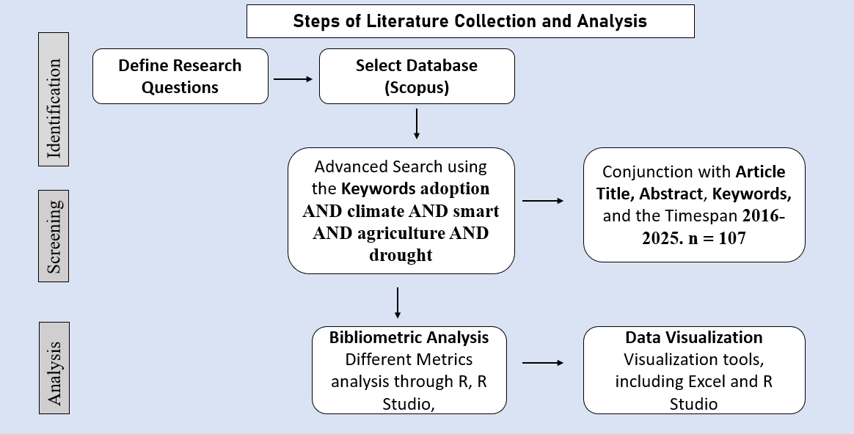
Figure 1. Steps of Literature Collection and Analysis

3.0 Findings of the Analysis

3.1 Description of the Data
Table 1 delivers a descriptive overview of the bibliometric dataset comprising 107 documents related to Climate-Smart Agriculture (CSA) adoption in drought-prone areas, spanning the period from 2016 to 2025. The data were sourced from 76 different publication outlets, including peer-reviewed journals, books, and conference proceedings. Notably, the annual growth rate of publications in this domain stands at a robust 31.8%, indicating a rapid and increasing scholarly interest in CSA innovations for drought adaptation. The average age of the documents is 2.8 years, suggesting that the field is relatively recent and characterized by the publication of up-to-date and relevant research. The documents have garnered an average of 23.14 citations per publication, reflecting their academic influence and the growing visibility of CSA-related topics within the scientific community.

Table 1. Information summary on retrieved CSA studies (2016–2025)
Description | Results
Timespan | 2016:2025
Sources (Journals, Books, etc.) | 76
Documents | 107
Annual Growth Rate % | 31.8
Document Average Age | 2.8
Average citations per doc | 23.14
Keywords Plus (ID) | 473
Author's Keywords (DE) | 365
Authors | 428
Authors of single-authored docs | 5
Single-authored docs | 5
Co-Authors per Doc | 4.4
International co-authorships % | 48.6

In terms of keyword analysis, the dataset includes 473 Keywords Plus (ID) and 365 author-assigned keywords (DE), highlighting the thematic diversity and multidisciplinary nature of the research. A total of 428 individual authors contributed to the 107 publications, with a mean of 4.4 co-authors per document, indicating a strong tendency toward collaborative and often interdisciplinary research efforts. Interestingly, only five documents were single-authored, underscoring the collaborative ethos prevalent in CSA research. Furthermore, the rate of international co-authorships is relatively high, at 48.6%, suggesting that nearly half of the studies involved cross-border collaboration, which is vital for addressing the transboundary nature of climate change and drought adaptation challenges. Overall, these metrics reflect a dynamic and rapidly evolving research field characterized by growing international cooperation and scholarly impact.

3.2 Publication Progression
Figure 2 illustrates the annual number of published articles from 2016 to 2025 that investigate the factors influencing the adoption of Climate-Smart Agriculture (CSA) innovations for drought adaptation. The figure shows a clear upward trend in research activity over the past ten years. In 2016, only one article was published, indicating initial interest in this topic. This number increased steadily to three articles in 2017 and five in 2018. A notable rise occurred in 2019, with 11 articles published. However, in 2020, there was a slight decline to six articles. The number of publications rebounded in 2021, reaching 13 articles, followed by another dip to six articles in 2022. Research output peaked in 2023 with 16 articles, and this upward trajectory culminated in 2024, which recorded the highest number of publications at 34. As of 2025, 12 articles have been published to date, indicating continued strong interest. This pattern reflects increasing scholarly attention towards CSA innovations as essential strategies for drought adaptation, highlighting the growing recognition of this field within the academic community.

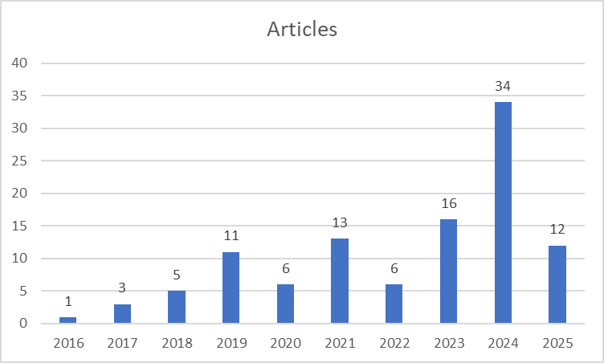
Figure 2. Annual Scientific Publications

3.3 Top Relevant Sources
Table 2 summarizes the leading academic sources that have published research on factors influencing the adoption of Climate-Smart Agriculture (CSA) innovations for drought adaptation. The table ranks the top ten journals and publications by the number of relevant articles they have contributed. At the forefront is Mitigation and Adaptation Strategies for Global Change, which has published five articles, making it the most prolific source in this domain. Following closely are Climate Risk Management, Frontiers in Sustainable Food Systems, Land Use Policy, and Sustainability (Switzerland), each contributing four articles. These journals represent key platforms for disseminating research on climate adaptation strategies and sustainable agriculture. Agricultural Systems and Climate Change Management rank next, each with three articles, highlighting their importance in the intersection of agriculture and climate resilience. Additionally, comprehensive works such as the African Handbook of Climate Change Adaptation have contributed to two significant studies, alongside journals like Agriculture and Food Security and Climate Resilience and Sustainability, which also published two articles each. This distribution reflects the multidisciplinary nature of research on CSA adoption and underscores the critical role these sources play in advancing knowledge on drought adaptation strategies through innovative agricultural practices.

Table 2. Top 10 relevant sources
Rank | Sources | Articles
1 | MITIGATION AND ADAPTATION STRATEGIES FOR GLOBAL CHANGE | 5
2 | CLIMATE RISK MANAGEMENT | 4
3 | FRONTIERS IN SUSTAINABLE FOOD SYSTEMS | 4
4 | LAND USE POLICY | 4
5 | SUSTAINABILITY (SWITZERLAND) | 4
6 | AGRICULTURAL SYSTEMS | 3
7 | CLIMATE CHANGE MANAGEMENT | 3
8 | AFRICAN HANDBOOK OF CLIMATE CHANGE ADAPTATION: WITH 610 FIGURES AND 361 TABLES | 2
9 | AGRICULTURE AND FOOD SECURITY | 2
10 | CLIMATE RESILIENCE AND SUSTAINABILITY | 2

3.4 Top Relevant Affiliations
Table 3 presents the leading institutional affiliations that contribute to research on the adoption of Climate-Smart Agriculture (CSA) innovations for drought adaptation. The data highlight the prominent role of academic and research institutions worldwide in advancing this field. Topping the list is Kwame Nkrumah University of Science and Technology, which has published 14 articles, indicating its significant engagement in CSA research. Close behind are two institutes associated with the Indian Council of Agricultural Research (ICAR) — the Central Research Institute for Dryland Agriculture (CRIDA), which appears twice with 13 and 11 articles, respectively, underscoring their vital contributions to dryland agriculture and climate resilience. The International Center for Tropical Agriculture (CIAT) also features prominently, with 11 articles credited to one listing and 8 to another, reflecting its global leadership in tropical agricultural research. The University of KwaZulu-Natal follows with 10 publications, demonstrating strong regional involvement in CSA studies. Other key contributors include Ariana, with nine articles, Baba Ghulam Shah Badshah University, and the CSIR-Crops Research Institute, each with eight articles, and the International Crops Research Institute for the Semi-Arid Tropics (ICRISAT), with seven articles. This distribution highlights the collaborative and international nature of research efforts aimed at promoting the adoption of CSA innovations to mitigate the impacts of drought.

Table 3. Most Relevant Affiliations
Rank | Affiliation | Articles
1 | KWAME NKRUMAH UNIVERSITY OF SCIENCE AND TECHNOLOGY | 14
2 | INDIAN COUNCIL OF AGRICULTURAL RESEARCH (ICAR) - CENTRAL RESEARCH INSTITUTE FOR DRYLAND AGRICULTURE (CRIDA) | 13
3 | ICAR- CENTRAL RESEARCH INSTITUTE FOR DRYLAND AGRICULTURE (CRIDA) | 11
4 | INTERNATIONAL CENTER FOR TROPICAL AGRICULTURE (CIAT) | 11
5 | UNIVERSITY OF KWAZULU-NATAL | 10
6 | ARIANA | 9
7 | BABA GHULAM SHAH BADSHAH UNIVERSITY | 8
8 | CSIR-CROPS RESEARCH INSTITUTE | 8
9 | INTERNATIONAL CENTRE FOR TROPICAL AGRICULTURE (CIAT) | 8
10 | INTERNATIONAL CROPS RESEARCH INSTITUTE FOR THE SEMI-ARID TROPICS (ICRISAT) | 7
In addition, Centurion University of Technology and Management (12 articles) and the University of California (12 articles) indicate that both emerging and global institutions are active in the push for CSA research agendas. ICAR-CRIDA is mentioned twice with different names (13 and 11 articles), which points to the potential need for standardization of affiliation. Taken together, all data show a geographically spread, thematically coherent structure of institutions, with the heavy influence of South Asia and Sub-Saharan Africa regions that are highly susceptible to drought. These agencies are key in directing research, conducting field-based research, and shaping policy discussions around CSA innovation adoption. Their visibility demonstrates the significance of regional academic leadership and international collaboration in responding to climate resilience through science-based agriculture innovation.

3.5 Corresponding Author’s Countries
Table 4 outlines the contributions from various nations in research on the adoption of Climate-Smart Agriculture (CSA) innovations for drought adaptation, highlighting the number of published articles and the distribution of Single Country Publications (SCPs) and Multiple Country Publications (MCPs). India has the first position with 19 publications, including 13 SCPs and 6 MCPs, accounting for a 31.6% share of worldwide partnerships. Ethiopia and Nigeria, although possessing a lower number of publications (8 and 6, respectively), demonstrate significant cooperation, with MCP percentages of 62.5% and 66.7%. Kenya has a similar pattern, with 50% of its six articles being collaborative.

Table 4. Corresponding Author’s Country and Publications
Country | Articles | SCP | MCP | MCP %
INDIA | 19 | 13 | 6 | 31.6
ETHIOPIA | 8 | 3 | 5 | 62.5
GHANA | 8 | 5 | 3 | 37.5
KENYA | 6 | 3 | 3 | 50
NIGERIA | 6 | 2 | 4 | 66.7
SOUTH AFRICA | 6 | 5 | 1 | 16.7
UNITED KINGDOM | 4 | 1 | 3 | 75
USA | 4 | 3 | 1 | 25
AUSTRALIA | 3 | 1 | 2 | 66.7
CHINA | 3 | 0 | 3 | 100

Ghana has eight papers with an MCP proportion of 37.5%, whilst South Africa's six articles have a comparatively lower MCP percentage of 16.7%, reflecting a greater emphasis on indigenous research. The United Kingdom exhibits the most significant percentage of international cooperation among non-African nations, with 75% of its four articles classified as MCPs. The United States and Australia have modest levels of cooperation at 25% and 66.7%, respectively. China's contributions are distinctly collaborative, as all three publications are MCPs, underscoring its involvement in global research alliances. This data highlights the global and collaborative essence of research initiatives aimed at enhancing CSA innovations for drought adaptation, reflecting differing levels of international collaboration across nations.

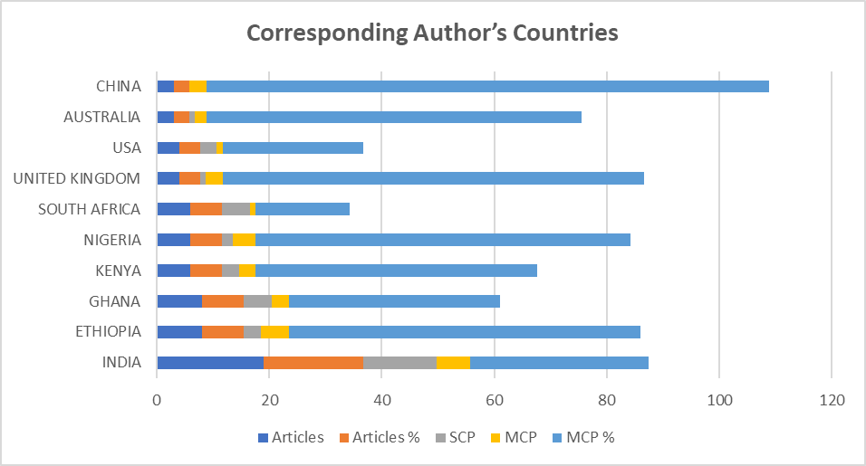
Figure 3. Corresponding Author’s Countries with their Publications

3.6 Most Globally Cited Countries in the Scopus Database
Figure 4 illustrates the total citations (TC) and average article citations from the leading nations that contribute to Climate-Smart Agriculture (CSA) adoption for drought adaptation. India ranks first in overall citations, amassing 533 citations throughout its articles, with an average of 28.10 citations per article, indicating the substantial volume and enduring influence of its research output. Ethiopia, although possessing a lower number of citations (313), has a significant impact, with an average of 39.10 citations per article. The Netherlands, with 298 citations, has the highest average article citation count at 149.00, reflecting the significant influence of a limited number of highly referenced works. Germany and Australia have a significant academic impact, with average citation counts of 61.30 and 46.00, respectively. Colombia distinguishes itself with 103 citations and an exceptional average of 103.00 citations per article, indicating the existence of a seminal publication. Zimbabwe and China have significant citation strength, with averages of 39.00 and 23.00, respectively. In contrast, Ghana and South Africa, although active in publishing, have lower average citation rates of 17.00 and 14.00, respectively. Figure 4 illustrates both productivity and the varied degrees of academic influence across nations, underscoring the worldwide and unequal citation dynamics in CSA adoption research.
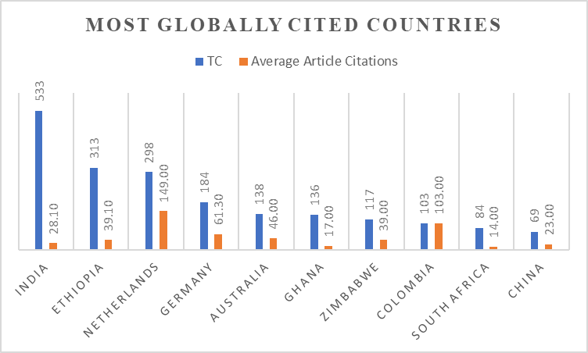
Figure 4. Most Globally Cited Countries

3.7 Words' Frequency over Time
Figure 5 illustrates a bifurcated analysis of phrase frequencies within the literature corpus, emphasizing conceptual priority in the investigation of Climate-Smart Agriculture (CSA) adoption for drought adaptation. The Term category (Panel A) quantifies fundamental technological and agronomic concepts, primarily characterized by "AGRICULTURAL TECHNOLOGY" (indicating innovation-focused research), "TECHNOLOGY ADOPTION" (directly tackling adoption barriers and facilitators), "AGRICULTURE" (encompassing broad contextual references), and "ZEA MAYS" (signifying maize-specific case studies, frequently utilized as a model crop for drought resilience). The Year category (Panel B) identifies emerging drivers and impacts, with "DROUGHT" demonstrating the highest cumulative frequency (underscoring the significance of water scarcity in the analysis), followed by "CLIMATE CHANGE" (situating drought within broader climatic transformations), "FOOD SECURITY" (connecting adaptations to nutritional results), "ALTERNATIVE AGRICULTURE" (emphasizing sustainable methodologies), and "MAIZE" (strengthening crop-specific emphasis). The pronounced cumulative increase in the terms "DROUGHT" and "TECHNOLOGY ADOPTION" highlights the growing scholarly focus on Climate-Smart Agriculture (CSA) solutions in water-scarce regions. At the same time, comparative frequencies indicate significant thematic relationships, particularly among drought intensity, technology implementation, and co-benefits for food security.

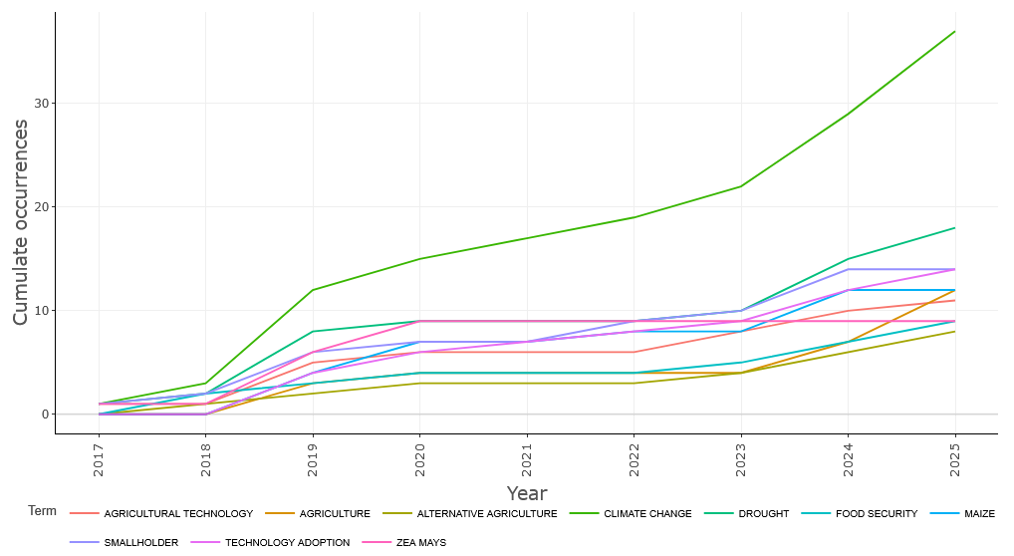
Figure 5. Words’ Frequency over Time

3.8 Word Cloud
Figure 6 displays a word cloud visualization that highlights the most prevalent phrases in the academic literature on climate-smart agriculture (CSA) technologies and their implementation in drought-prone regions. The first and most significant word is "climate change," indicating its paramount importance in the realm of CSA study. Subsequently, phrases such as "drought," "technology adoption," "smallholder," "agricultural technology," "agriculture," and "food security" underscore the essential focal points within the discipline.
The use of the term "smallholder" highlights the significance of small-scale farmers in research on CSA adoption, particularly in areas vulnerable to climate stress. The terms "technology adoption" and "agricultural technology" indicate a significant study focus on the processes and facilitators of the uptake of CSA practices. Terms like "maize," "zeamays," "farming system," and "crop yield" denote the specific agricultural settings and results examined about drought adaptation.
Geographic references such as "India," "Zimbabwe," "Ghana," "Pakistan," and "Malawi" indicate the geographical focus of current work, particularly in Sub-Saharan Africa and South Asia, where the effects of drought are most pronounced. Additional significant categories include "agricultural extension," "livestock," "adaptive management," and "alternative agriculture," highlighting the many tactics and institutional supports investigated to bolster resilience. Figure 6 presents a word cloud that graphically encapsulates the principal issues, stakeholders, technologies, and geographies prevalent in the discourse on CSA innovation uptake, providing a succinct but thorough overview of the research environment informing this systematic review.

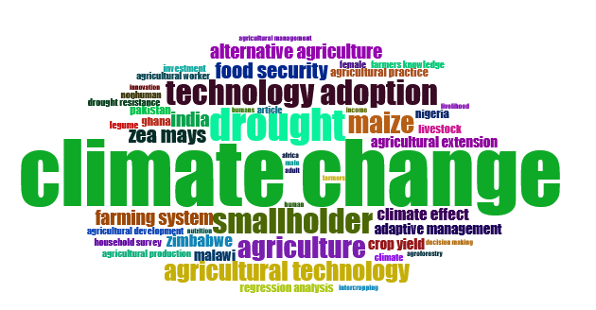
Figure 6. Word Cloud of this Research

4.0 Discussion

This comprehensive literature analysis elucidates the changing dynamics of Climate-Smart Agriculture (CSA) technologies and their implementation in drought-affected areas. The bibliometric study reveals numerous significant trends and thematic objectives that have shaped academic discourse over the past decade. The rapid expansion of CSA research, marked by a significant yearly rise of 31.8%, highlights an increasing acknowledgement of the need to improve agricultural resilience in the face of climate stress. The recent average age of the papers (2.8 years) indicates the field's growing and dynamic nature, marked by prompt reactions to environmental issues. The elevated citation average of 23.14 citations per document substantiates the significance and influence of this study topic among the broader scientific community.
A pronounced propensity for collaborative research is evident, with an average of 4.4 co-authors per paper and approximately 48.6% of papers including foreign co-authorships. This underscores the fundamentally global and multidisciplinary nature of CSA adoption research, which requires exchanging information across boundaries and fields. The limited quantity of single-authored articles highlights a shift from solitary endeavors to collaborative academic engagement in addressing complex climate challenges. The publishing pattern (Figure 2) shows a heightened academic interest, culminating in a notable peak in 2024. The minor declines in 2020 and 2022 may be ascribed to exogenous disturbances, including the COVID-19 pandemic. The trend indicates a growing dedication to understanding and advancing CSA technologies as essential adaptation strategies, particularly in water-scarce regions. The source analysis (Table 2) highlights that research on CSA uptake encompasses many prominent publications dedicated to sustainability, policy, and climate adaptation. Journals such as Mitigation and Adaptation Strategies for Global Change and Climate Risk Management provide multidisciplinary venues for promoting discussions on Climate-Smart Agriculture (CSA). This distribution confirms the interdisciplinary nature of CSA research, which encompasses agricultural science, environmental studies, development policy, and socioeconomics.
Institutional contributions (Table 3) indicate a robust research presence from South Asia and Sub-Saharan Africa, with institutions such as ICAR-CRIDA (India) and KNUST (Ghana) assuming prominent roles. These places exhibit significant susceptibility to drought, elucidating their scholarly involvement and leadership. The repetition of institutional names (e.g., ICAR-CRIDA appearing twice) suggests a need for metadata harmonization in bibliometric datasets, a common issue in affiliation mapping. The study by the associated author (Table 4 and Figure 3) corroborates the geographical concentration of CSA research in the Global South, particularly in India, Ethiopia, Nigeria, and Kenya. Elevated MCP (Multiple Country Publication) percentages, particularly in Ethiopia (62.5%) and China (100%), indicate a commitment to international cooperation, which is essential for formulating context-sensitive, scalable CSA tactics. In contrast, nations such as South Africa have reduced MCPs, suggesting a research agenda that is more locally oriented, which may be attributable to a robust national capability.
The citation data (Figure 4) demonstrates the variation in research impact across nations. Despite a lower volume of publications, nations such as the Netherlands and Colombia have very high average citations per article, indicating significant contributions or impactful techniques that have influenced CSA adoption frameworks. India's preeminence in publication quantity and citation frequency underscores its pivotal position in the global CSA dialogue.
The historical and conceptual examination of keyword frequencies (Figure 5) highlights the rising prominence of "drought" and "technology adoption" in contemporary literature, corresponding with an increased understanding of climate change's effects on water availability and agricultural output. The use of crop-specific terminology, such as "maize" and "Zea mays," demonstrates the utilization of these crops as primary subjects in assessing the efficacy of crop-specific agriculture (CSA).
The word cloud (Figure 6) confirms the principal topics in CSA adoption research: climate change, drought, smallholders, food security, and agricultural technology. The use of terminology associated with adaptive management, extension services, and regional case studies (e.g., India, Zimbabwe, Ghana) reinforces the contextual and practical focus of the CSA study.
The results indicate that research on CSA adoption is:
- Expanding swiftly and becoming more collaborative;
- Motivated by organizations and nations in susceptible drought-affected areas;
- Concentrated on smallholder farmers, technical advancements, and food security results;
- Influenced by many widely regarded foundational texts that impact global dialogue.
This analysis underscores the crucial need for ongoing support of international partnerships, the standardization of research information, and inclusive policies that bridge the gap between scientific knowledge and its local application. Future studies must explore the socio-economic, institutional, and behavioral determinants of CSA adoption, especially in settings with rapidly changing climatic conditions and resource limitations (Kifle et al., 2022; Manono et al., 2025).
Limitations of this bibliometric approach should also be acknowledged. First, the analysis is limited to the Scopus database, which, while comprehensive, may exclude relevant studies published in regional journals or languages other than English. Second, the bibliometric metrics (e.g., citation counts, keyword co-occurrence) emphasize quantity over contextual depth and may overlook nuanced socio-cultural dynamics that affect CSA adoption. Third, inconsistencies in author affiliations and keyword tagging can lead to data duplication or misrepresentation. Finally, while network visualizations reveal trends, they do not explain causal relationships. These limitations highlight the need to complement bibliometric findings with qualitative insights and field-based case studies.

5.0 Conclusions

This comprehensive literature analysis consolidates a decade (2016–2025) of academic investigations into the implementation of Climate-Smart Agriculture (CSA) technologies for drought adaptation, highlighting a swiftly evolving yet unequal research terrain. A bibliometric examination of 107 articles reveals significant growth (31.8% yearly increase) and strong international cooperation (48.6% multiple-country publications), highlighting the critical need for climate resilience in agriculture. The domain is characterized by robust leadership from institutions and countries in drought-prone areas, particularly the Kwame Nkrumah University of Science and Technology (Ghana), ICAR-CRIDA (India), and CIAT (Colombia), highlighting the regional need for adaptable solutions. Thematic analysis designates smallholder farmers as pivotal stakeholders, emphasizing research on scientific breakthroughs (e.g., drought-resistant cultivars such as Zea mays), socioeconomic facilitators (e.g., extension services and access to financing), and co-benefits related to food security. The geographic concentration in South Asia and Sub-Saharan Africa, as indicated by connections and country-specific terms such as "India," "Zimbabwe," and "Malawi," corresponds with these countries' severe vulnerability to water shortages while highlighting notable deficiencies in Latin America and arid regions.
Notwithstanding advancements, significant constraints remain. Initially, methodological uniformity prevails, with household surveys dominating over mixed-methods techniques that might elucidate intricate adoption hurdles (e.g., gender dynamics, cultural attitudes). Thematic imbalances arise: whereas "agricultural technology" and "drought resistance" are prominently featured (Figure 5), policy frameworks, market connections, and gender equality are insufficiently examined, thereby impeding the development of scalable solutions. The disconnection between research impact and local applicability is apparent: high-impact publications from the Netherlands (average of 149 citations per article) and Colombia (average of 103) emphasize theoretical models, while practitioner-oriented studies from drought-affected regions (such as Ethiopia and Nigeria) garner disproportionately less attention, despite their contextual significance. Fourth, discrepancies in affiliations (e.g., multiple entries for ICAR-CRIDA) and fragmented information hinder knowledge synthesis, indicating a lack of uniformity in bibliographic reporting.
This study contributes uniquely to the literature by providing the first comprehensive bibliometric mapping of CSA adoption in drought-prone areas across nearly a decade of research. It bridges fragmented evidence, highlights regional leadership, uncovers systemic gaps, and proposes actionable pathways for aligning innovation ecosystems with localized resilience needs. These insights are essential for guiding both policy interventions and future academic inquiry in climate-resilient agriculture.
This review confirms that for policymakers, the expansion of Climate-Smart Agriculture (CSA) necessitates integrated innovation ecosystems that are both locally rooted and globally interconnected. It emphasizes three key actions: (i) directing investments towards contextually validated practices such as water harvesting and agroforestry in community-managed landscapes; (ii) enhancing knowledge exchange through South learning networks, exemplified by India-Africa collaborations on drought-resistant seeds; and (iii) instituting "resilience impact assessments" within national agricultural policies to formalize CSA implementation. Transforming drought adaptation requires a shift from technology-focused models to comprehensive resilience frameworks that integrate research, policy, and grassroots initiatives to protect smallholder livelihoods in the face of climate instability.

COMPETING INTERESTS DISCLAIMER:
Authors have declared that they have no known competing financial interests OR non-financial interests OR personal relationships that could have appeared to influence the work reported in this paper.

6.0 References

- Bal, S. K., Sandeep, V. M., Kumar, P. V., Rao, A. V. M. S., Pramod, V. P., Manikandan, N., Rao, Ch. S., Singh, N. P., & Bhaskar, S. (2022). Assessing impact of dry spells on the principal rainfed crops in major dryland regions of India. Agricultural and Forest Meteorology, 313, 108768. https://doi.org/10.1016/j.agrformet.2021.108768
- Blicharska, M., Haddad, F., Riccardi, T., & Smithers, R. J. (2024). Global presumed drylands: Drivers, pressures, state, impacts, responses. Journal of Environmental Planning and Management, 1–28. https://doi.org/10.1080/09640568.2024.2351424
- Fazekas, A., Bataille, C., & Vogt-Schilb, A. (2022). Achieving net-zero prosperity: How governments can unlock 15 essential transformations. https://shs.hal.science/halshs-03742125
- Grainger, S., Murphy, C., & Vicente-Serrano, S. M. (2021). Barriers and Opportunities for Actionable Knowledge Production in Drought Risk Management: Embracing the Frontiers of Co-production. Frontiers in Environmental Science, 9, 602128. https://doi.org/10.3389/fenvs.2021.602128
- Kabato, W., Getnet, G. T., Sinore, T., Nemeth, A., & Molnár, Z. (2025). Towards Climate-Smart Agriculture: Strategies for Sustainable Agricultural Production, Food Security, and Greenhouse Gas Reduction. Agronomy, 15(3), 565. https://doi.org/10.3390/agronomy15030565
- Kifle, T., Ayal, D. Y., & Mulugeta, M. (2022). Factors influencing farmers adoption of climate smart agriculture to respond climate variability in Siyadebrina Wayu District, Central highland of Ethiopia. Climate Services, 26, 100290. https://doi.org/10.1016/j.cliser.2022.100290
- Klarin, A. (2024). How to conduct a bibliometric content analysis: Guidelines and contributions of content co‐occurrence or co‐word literature reviews. International Journal of Consumer Studies, 48(2). https://doi.org/10.1111/ijcs.13031
- Mahedi, M., Pervez, A. K. M. K., Rahman, S. M. M., Sheikh, Md. M., & Shaili, S. J. (2025). Emerging Trends in Livelihood Diversification in Rural Communities: A Bibliometric and Systematic Review. Asian Journal of Agricultural Extension, Economics & Sociology, 43(4), 162–177. https://doi.org/10.9734/ajaees/2025/v43i42727
- Manono, B. O., Khan, S., & Kithaka, K. M. (2025). A Review of the Socio-Economic, Institutional, and Biophysical Factors Influencing Smallholder Farmers’ Adoption of Climate Smart Agricultural Practices in Sub-Saharan Africa. Earth, 6(2), 48. https://doi.org/10.3390/earth6020048
- Md Shahriar Kabir, Md Mahedi, A K M Kanak Pervez, Md Jahangir Alam, & Shabrin Jahan Shaili. (2025). Bibliometric analysis of “precision agriculture” in the Scopus database. World Journal of Advanced Research and Reviews, 25(3), 1087–1098. https://doi.org/10.30574/wjarr.2025.25.3.0733
- Mpala, T. A., & Simatele, M. D. (2024). Climate-smart agricultural practices among rural farmers in Masvingo district of Zimbabwe: Perspectives on the mitigation strategies to drought and water scarcity for improved crop production. Frontiers in Sustainable Food Systems, 7, 1298908. https://doi.org/10.3389/fsufs.2023.1298908
- Natarajan, N., Newsham, A., Rigg, J., & Suhardiman, D. (2022). A sustainable livelihoods framework for the 21st century. World Development, 155, 105898. https://doi.org/10.1016/j.worlddev.2022.105898
- Parolini, G. (2022). Weather, climate, and agriculture: Historical contributions and perspectives from agricultural meteorology. WIREs Climate Change, 13(3). https://doi.org/10.1002/wcc.766
- Santini, M., Noce, S., Antonelli, M., & Caporaso, L. (2022). Complex drought patterns robustly explain global yield loss for major crops. Scientific Reports, 12(1). https://doi.org/10.1038/s41598-022-09611-0
- Shiferaw, B., Tesfaye, K., Kassie, M., Abate, T., Prasanna, B. M., & Menkir, A. (2014). Managing vulnerability to drought and enhancing livelihood resilience in sub-Saharan Africa: Technological, institutional and policy options. Weather and Climate Extremes, 3, 67–79. https://doi.org/10.1016/j.wace.2014.04.004
- Srivastav, A. L., Dhyani, R., Ranjan, M., Madhav, S., & Sillanpää, M. (2021). Climate-resilient strategies for sustainable management of water resources and agriculture. Environmental Science and Pollution Research, 28(31), 41576–41595. https://doi.org/10.1007/s11356-021-14332-4
- Totin, E., Segnon, A. C., Schut, M., Affognon, H., Zougmoré, R. B., Rosenstock, T., & Thornton, P. K. (2018). Institutional Perspectives of Climate-Smart Agriculture: A Systematic Literature Review. Sustainability, 10(6), 1990. https://doi.org/10.3390/su10061990
- Uddin, M. S., Pervez, A. K., Kabir, M. S., & Mahedi, M. (2022). The Trend of Agribusiness Research Worldwide: A Bibliometric Analysis Based on the Scopus Database.
- Vasavi, S., Anandaraja, N., Murugan, P. P., Latha, M. R., & Pangayar Selvi, R. (2025). Challenges and strategies of resource poor farmers in adoption of innovative farming technologies: A comprehensive review. Agricultural Systems, 227, 104355. https://doi.org/10.1016/j.agsy.2025.104355
- Wijerathna-Yapa, A., & Pathirana, R. (2022). Sustainable Agro-Food Systems for Addressing Climate Change and Food Security. Agriculture, 12(10), 1554. https://doi.org/10.3390/agriculture12101554
- Wilkinson, A. (2023). Social-Ecological Systems Analysis and Perceptions of Change in Agriculture, Food and Farm Systems in Southern Alberta and Yukon Territory. Graduate Studies. https://doi.org/10.11575/PRISM/41949

