**Original Research Article**

**Dependence of Tribal households on medicinal Non-Timber Forest Products (NTFPs) in Southern India: A study on economic vulnerability**

**ABSTRACT**

The study analysed the economic vulnerability of tribal communities in Kerala's Wayanad district, India, in terms of its reliance on medicinal Non-Timber Forest Products (NTFPs). Through a survey of 90 families, quantifying economic vulnerability using Economic Vulnerability Index (EVI), with exposure, sensitivity, and adaptive capacity. Findings showed that both female-headed households (FHHs) and male-headed households (MHHs) obtained significant proportion of their income from NTFPs, with MHHs obtaining 75% and FHHs 70% respectively. Female heads, bear the burden of household expenditure with less resource base, reduced overall income, and lower capacity to adjust, especially to climate change and environmental degradation. The research found that FHHs were more exposed to extreme weather events, with higher vulnerability scores in disaster preparedness and recovery. The proportion of households that were not warned of an upcoming natural disaster was the most influencing indicator for exposure while the average livelihood diversification index influenced the sensitivity of medicinal plant collectors. The average livelihood diversification index followed by annual income status were found to be contributing to adaptive capacity. Additionally, MHHs were marked by higher social networks and better access to productive assets, which relatively reduced their vulnerability. FHHs, on the other hand, faced income uncertainty and lack of diversification. By filling the research gap between MHHs and FHHs, the study reaffirms the critical role of medicinal NTFPs in building resilience among vulnerable families.

**KEYWORDS**:Economic vulnerability; medicinal Non-Timber Forest Products (NTFPs); tribal communities; gender disparities; sustainable livelihoods; income share.

**1.INTRODUCTION**

India’s diverse ecosystem spanning from tropical rainforests to semi-arid woodlands, supports a vast array of Non-Timber Forest Products (NTFPs) that hold both domestic and global value. NTFPs play a crucial role in the livelihoods of millions of people, both in rural and urban areas worldwide (Shackleton et al., 2015). They provide essential resources such as food, shelter, medicine, fibres, energy, and cultural artifacts, benefiting not only some of the world's poorest populations but also a substantial portion of the relatively wealthier groups (Saha and Sundriyal, 2012). NTFPs also serve as a crucial safety net for the communities that rely on them, providing sustenance during periods of scarcity and even famines. Indigenous forest and rural communities continue to depend on NTFPs for a decent livelihood and their reliance stems from their poor economic conditions, which are largely due to the lack of recognition of their rights and the absence of empowerment in their own socioeconomic development (Alex et al., 2016).

Kerala’s forests are a home to a variety of NTFPs, such as bamboo, medicinal herbs, and aromatic plants, which have long served as sources of food, medicine and income. A livelihood consists of capabilities and assets (including stores, resources, claims, and access) that enable individuals to recover from stress and shocks, sustain or improve their resources, and create sustainable livelihood opportunities for future generations. Additionally, it contributes net benefits to other livelihoods at both local and global levels, in both the short and long term (Chambers and Conway, 1992). It focuses on enhancing people's economic power and empowering them. It involves facilitating asset creation, capacity building, and access to opportunities and aims to build livelihood security. Occupation serves as the basis of generating income to sustain livelihoods. Remote and isolated nature of the study area, coupled with inadequate physical infrastructure such as limited accessibility, had contributed to the overall underdevelopment (Daneji & Suleiman, 2011). A large number of family members involved in collection led to increased resource gathering, thereby improving income and livelihood sustainability. Larger family sizes tend to have a higher dependency on these resources, utilizing all available family labour for collection (Endamana et al., 2016).

Wayanad district of Kerala is marked highly vulnerable mainly due to its heavy dependence on agriculture, plantation crops, and NTFPs (Nikhil, 2024). Economic vulnerability of forest-dwelling tribals and medicinal plant consumers is further aggravated by issues associated with stringent forest laws and biodiversity loss. It is also assessed that the combined effect of unpredictable rain, forest cover loss, and soil degradation is a hurdle along the path to sustainable agriculture, and Wayanad is most susceptible to climate change and emphasizes the need for measures to be taken for promoting sustainable development and livelihood security (Sundaran et al. 2024). Dependency on NTFPs is extremely high among the tribal families, who utilize them for their livelihood alone. Some of these families are also beset by financial resource constraints, increasing indebtedness, and poor infrastructure, further enhancing their economic vulnerability.

The study outlines the major medicinal NTFPs collected by the tribal communities and their share in total income of the tribal medicinal NTFP households. The major medicinal NTFPs such asKurunthotti (*Sida rhombifolia),* Chunda (Solanum *torvum),* Cheenikkaya (*Acacia sinuate),* Padakkizhangu (*Cyclea peltate) and* Kalpasam (*Parmelia dilatate)* contributed relatively a higher share to the income. Economic Vulnerability Index (EVI) was estimated and measured in terms of exposure, sensitivity, and adaptive capacity. Furthermore, the determinants of economic vulnerability were also analysed by using logistic regression.

**2.MATERIALS AND METHODS**

**2.1. STUDY AREA**

The present study was conducted in the tribal settlements of Wayanad district in Kerala, India. Wayanad spans a geographical area of **2,132 square kilometres** and comprises one revenue division, three taluks, 49 villages, 25 Gram Panchayats, three Block Panchayats, and one municipality. The district lies between **11°27′ and 11°58′ north latitude** and **75°47′ and 76°27′ east longitude**. It is bounded on the east by the Nilgiri Hills and Mysuru district of Karnataka, to the north by Kodagu (Coorg) district, to the south by Malappuram district, and to the west by Kozhikode and Kannur districts.

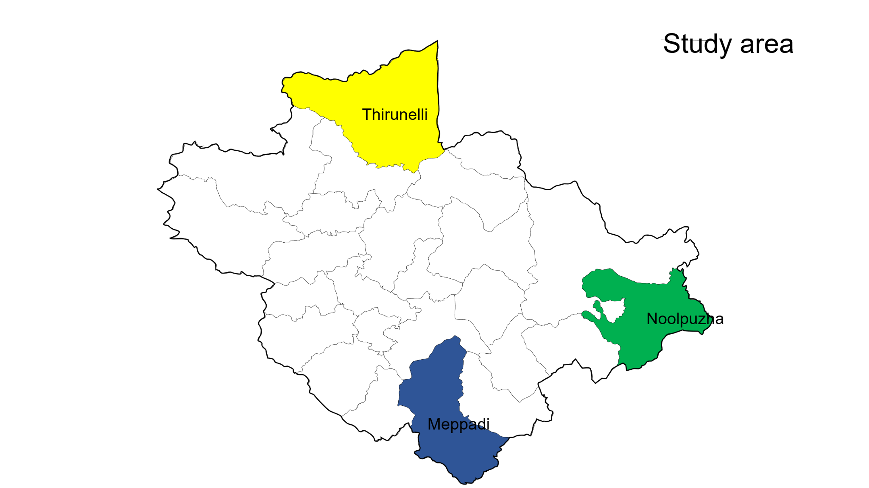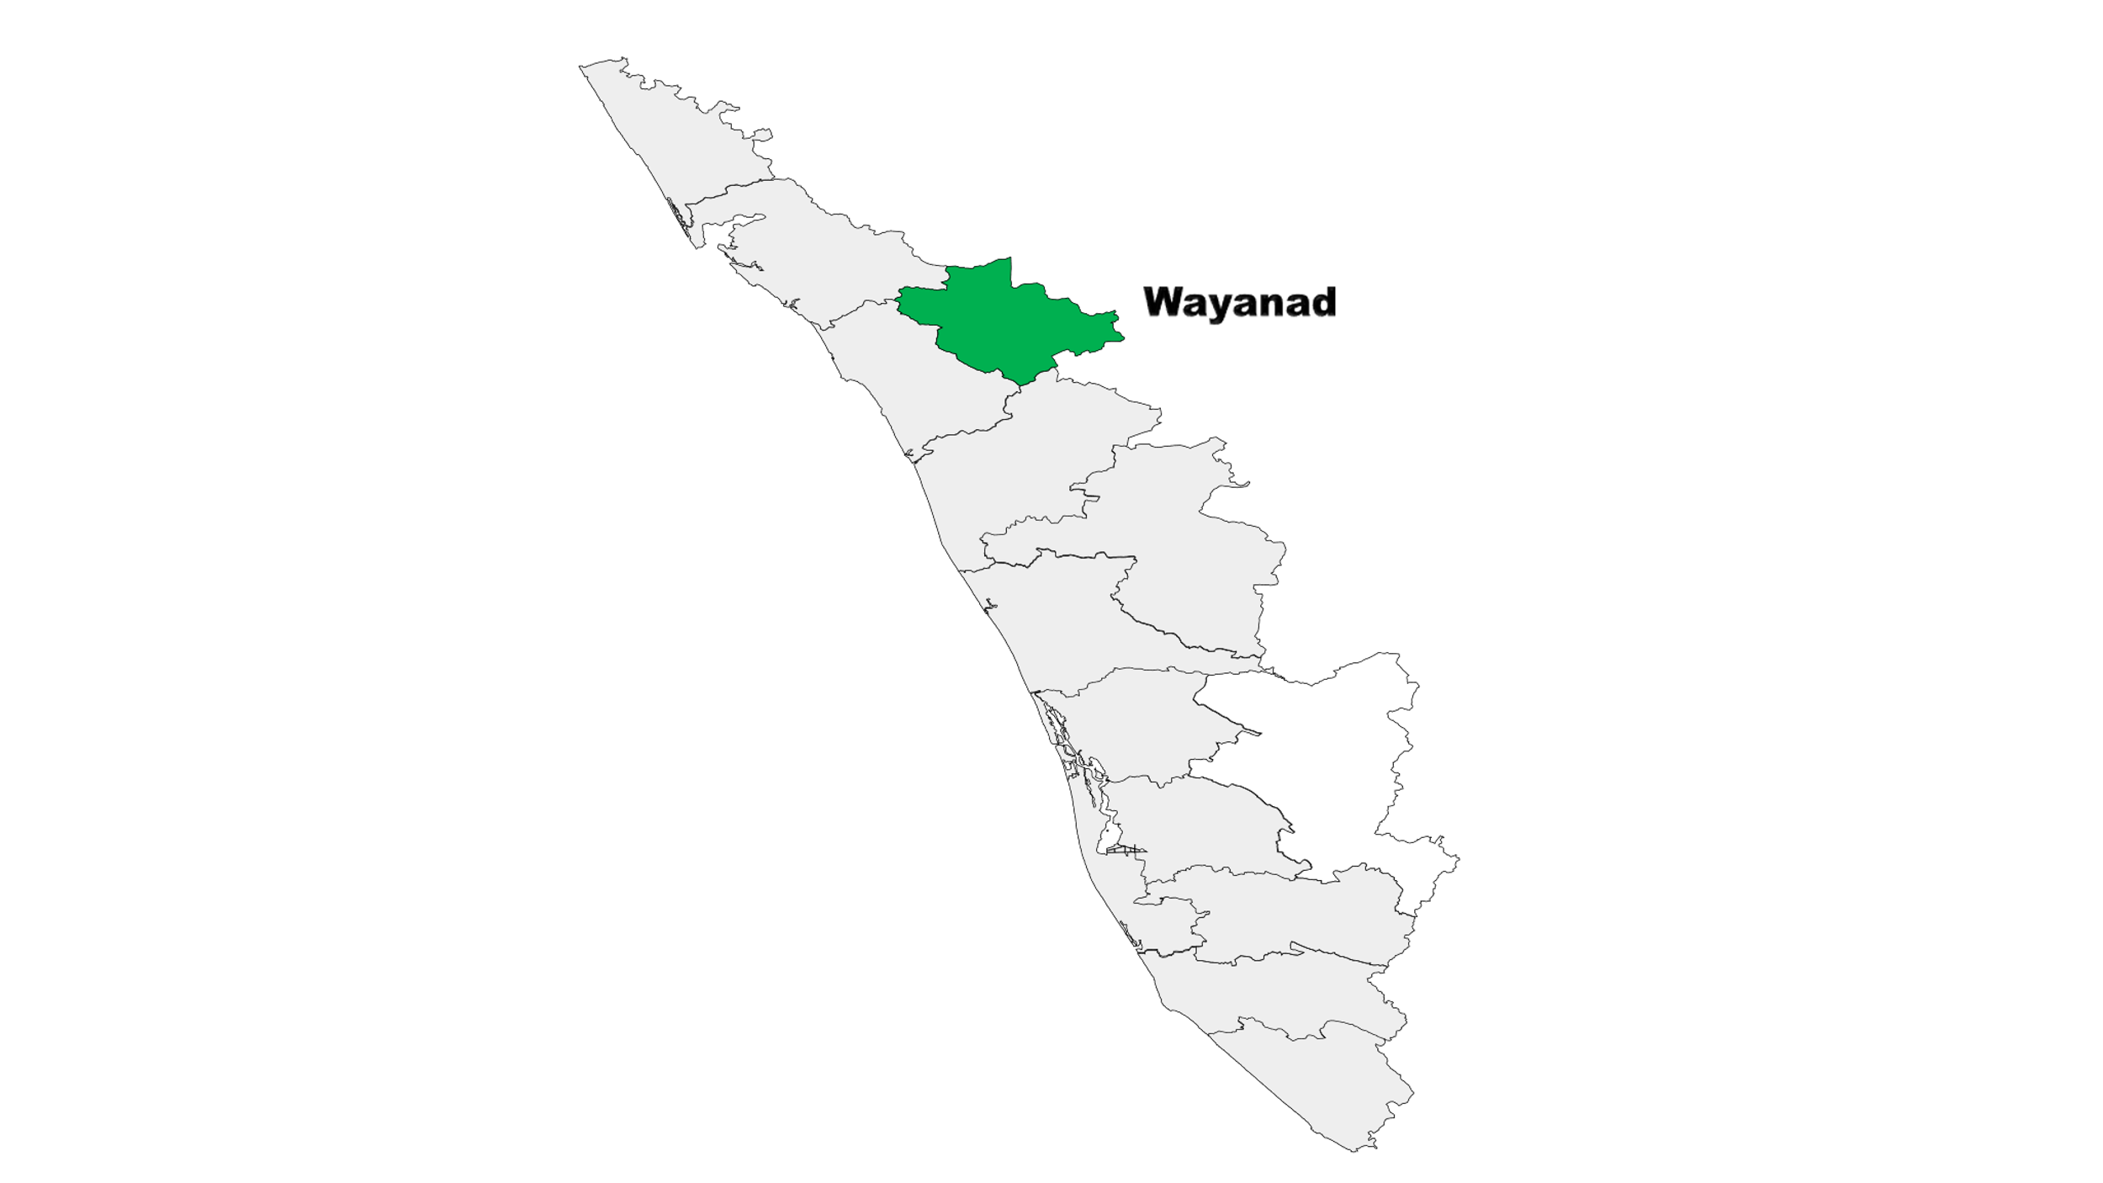 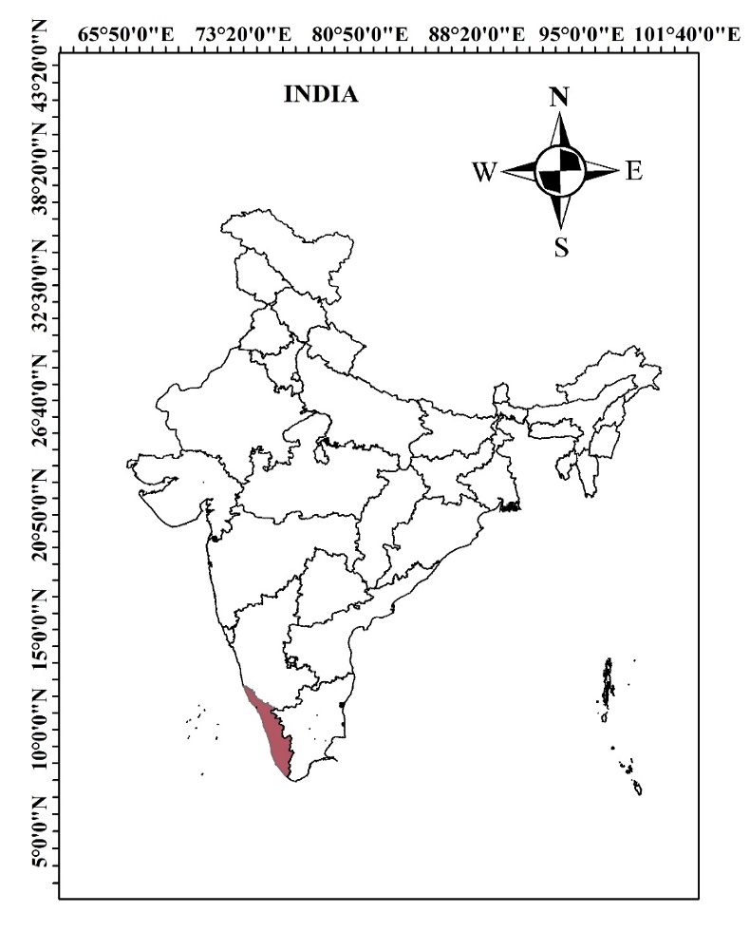

Fig.1. Map of the study area

**2.2. SAMPLING METHOD**

Due to the rich diversity of medicinal plants in thickly forested areas and the maximum tribal people are residing in the three Taluks namely, Vythiri, Mananthavady and Sulthan Bathery of Wayanad.One panchayath each was purposively selected based on the highest tribal population. Meppadi from Vythiri, Thirunelli from Mananthavady and Noolpuzha from Sulthan Bathery were selected based on the population-based data received from Integrated Tribal Development Project (ITDP) office at Kalpetta.

The total of 90 households with 30 from each taluk surveyed were purposively using a pre-tested and well-structured, questionnaire. Headship of each household was determined on the individual responsible for making economic and household choices within the family. Households were classified as women-headed if the female member was widowed, separated from her spouse, or if the husband had been away for more than six months. In Kerala, tribal families follow patriarchy predominantly. Widowed women solely dependent on NTFPs were over 40 years of age and co-resided with their sons and worked very hard.

Data regarding collection, utilization, and share of medicinal NTFPs in household income was collected from the respondents and secondary data from authorized sources.

**3. QUANTIFYING HOUSEHOLD ECONOMIC VULNERABILITY**

Economic vulnerability can be defined as the likelihood that a country’s economic development process is hindered by the occurrence of exogenous unforeseen events, often called external shocks (Guillaumont, 2009).

Economic vulnerability of the households was estimated by modifying the ASPIRES (Accelerating Strategies for Practical Innovation & Research in Economic Strengthening) Economic Vulnerability Tool which was developed by FHI 360 and a consortium of 20 organisations in the US. The components used in the tool are given in detail in the Table1.

Economic Vulnerability Index (EVI) developed by IPCC was used as the vulnerability assessment framework for this study. This framework was designed based on three key criteria of vulnerability: exposure, sensitivity, and adaptive capacity, as its significant components. In this context, the magnitude of disasters and the extent of losses incurred is reflected by exposure, the degree to which a system is affected by exposure refers to sensitivity, and adaptive capacity indicates the system’s ability to recover from or withstand such exposure. The study adopted four indicators under the exposure component, while the sensitivity considers six indicators, and the adaptive capacity component is constituted by five indicators. Table 1. presents the major components and indicators used for the assessment of economic vulnerability.

**Table 1. Major components and sub-components of the Economic Vulnerability Index (EVI)**

|  |  |  |  |  |  |
| --- | --- | --- | --- | --- | --- |
| Major component | Subcomponent | Explanation of subcomponent | Survey question | Source | Potential limitation |
| Exposure | Number of natural disasters affected in past 6 years | Total number of landslides, storms, cyclones, and wildfires that hit the households during 2019–2024. The number of events is divided by 10 to lower the value so that they come under a smaller range | How many times was your household affected by landslides/storms/ cyclones/wildfires. | Adapted from  [27] | Recall bias |
|  | Losses suffered from the disasters that affected the household in past 6 years. | Physical losses suffered from the disasters. | How severe were the losses you suffered from these disasters?  a) No loss-0  b) < 10,000 – 0.1  c) 10,000–50,000 – 0.2  d) 50,000–1 lakh – 0.3  e) > 1 lakh – 0.4 | Developed to meet the purpose of this study. | Tendency of the household to project greater loss. |
|  | Recovery status of households from the disasters that hit them. | The status of households if they have returned to normalcy from the losses caused by disasters. | Which of the below options best describe the recovery status as what happened? a) Household never recovered – 0.4 b) Household is still recovering – 0.3 c) Household recovered over time – 0.2 d) Household recovered immediately – 0.1 | Adapted from  [15] | Tendency to state that the household has not yet recovered. |
|  | Percent of households that did not receive a warning about the pending natural disaster. | Percentage of households who have not received a warning about disasters that hit them in the past 6-year period. | Have you received any warning for the cyclone/flood/storms that hit your area during the 2019–2024 period? | Adapted from  [27] | Subjective definition of warning |
| Sensitivity | Percent of households dependent solely on NTFPs medicinal plants and related activities as a source of income | Percent of households that state medicinal plants and NTFP’s related activities as their only income source. | Do any of the family members work outside the medicinal plant collection or NTFP’s related collection or earn income through various means other than from the Medicinal plants collection or NTFP’s? | Modified from  [28] | Subjective definition of “solely” |
|  | Average medicinal plants collectors livelihood diversification index. | The number of livelihood activities engaged by the family members in the medicinal plant collection. | List all the livelihood activities undertaken by the family members of the household in the medicinal plant collection. | Modified from  [30] | Tendency to ignore activity that yield occasional income. |
|  | Proportion of NTFP’s (medicinal plants) income to annual household income | Proportion of the income from various activities in the NTFP’s (medicinal plants) (drying, processing, selling) to the total annual income (comprising income from other sources as well) of the household. | Can you please mention the income received from each source in a year? | Modified from  [31] | Due to lack of trust, people may not reveal the exact income. |
|  | Ability of household to meet its basic needs | How well the household is able to meet its basic needs like food, shelter, education and health care. | Which response most accurately describes your household’s ability to meet its basic needs, including food, shelter, education, and health care? 1. We struggle to pay for food and shelter: 0.4 2. We can usually pay for food and shelter, but we struggle to make lump sum payments for health and education expenses: 0.3 3. We can usually pay for food, shelter, and education and health care expenses. Sometimes we struggle, but we usually make lump sum payments: 0.2 4. We are always able to pay for food, shelter, education, and health care without struggle: 0.1 | Adapted from  [15] | Tendency of people to project themselves as poor. |
|  | Income volatility if sudden halt in primary income source | The steps taken by the household when something bad happens and earning from the primary source of livelihood stops. | If something bad happened and you could no longer earn money through your primary livelihood, what would you do? 1. Find a new job: 0.1 2. Rely more on other existing income generating activity: 0.2 3. Rely on family for support or loans: 0.3 4. Rely on charity, I don’t have a livelihood: 0.4  5) How frequently is this income available throughout the year | Adapted from  [15] | Confusion among the options regarding which one to follow. |
|  | Income volatility in terms of frequency of income availability | The status of income availability of the household based on the regularity in their income earnings. | a)Unpredictable: 0.4 b)Predictable, but changes dramatically depending on the season:0.3c)Predictable, but changes slightly depending on the season:0.2d) Predictable throughout the year: 0.1 | Adapted from  [15] |  |
| Adaptive capacity | Productive assets | Productive assets are the resources used to generate income, like livestock, land for agriculture, tools, or equipment for a business. | How would you describe your household’s productive assets? a) We don’t have any productive assets: 0.1 b) We have some productive assets: 0.2 c) We have a lot of productive assets: 0.3 | Adapted from  [15] | Confused whether some are productive assets or not. |
|  | Savings | The difference between a household’s disposable income and its consumption on goods and services. | How much money do you have in savings? 1. Nothing or nearly nothing: 0.1 2. Some, but the amount changes a lot during the year: 0.2 3. Some, but the amount changes a little during the year: 0.3 4. We always have a lot of savings: 0.4 | Adapted from  [15] | Variability in the amount of savings. |
|  | Annual income status | The annual income of the household | What is the annual income range of your household?  a) Less than 50,000: 0.4  b) 50,000 – 1 lakh: 0.3  c) 1 lakh – 2 lakhs: 0.2 d) Above 2 lakhs: 0.1 | Developed to meet the purpose of this study.  [15] | Difficult to quantify income from supplementary and informal sources. |
|  | Economic status | Household’s perception about their economic status | Describe your household’s economic status? 1. Destitute: we are barely surviving 2. Struggling to make ends meet: we are surviving, but our economic status is not stable 3. Prepared to grow: our status is mostly stable and we are investing in new opportunities, though we sometimes struggle 4. Not vulnerable: we are stable and secure | Adapted from  [15] | Tendency of people to project themselves as poor. |
|  | Liquid assets | Is there anything your household owns that can be turned into cash quickly, such as livestock, food stores, or personal belongings such as gold, silver etc. These are called liquid assets. | What describes your household best? a) We never have many liquid assets: 0.1 b) We have some liquid assets, but the amount changes a lot during the year: 0.2 c) We have some liquid assets, and the amount changes a little during the year: 0.3 d) We always have many liquid assets: 0.4 | Adapted from  [15] | Confused whether some are liquid assets or not. |

         EVI is the arithmetic average of all sub-components to its final value even if all the main components are comprised of varying numbers of indicators. To achieve this, a balanced weighted average method, commonly used in vulnerability assessment studies, was applied. This method involves standardizing all sub-components using an equation adapted from the Human Development Index:

Sg  = (1)

Where, Sg represents the original sub-component for gender (g), while Smin and Smax denote the minimum and maximum values recorded for each sub-component across both male- and female-headed household groups.

$Mg=\frac{\sum_{i=0}^{n}{indexXSgi}}{n}$ (2)

Where, Mg= one of the major components of gender g[Exposure(E), Sensitivity (S), Adaptive capacity(A), indexsgi represents the subcomponent indexed by 1, which make up each major component and n is the number of sub-components.

After determining the values for each of the three key components for both male-and female-headed households, the mean was calculated using Eq. (3) to obtain the LVI:

$EVIg=\frac{\sum_{i=1}^{3}{wuMgi}}{\sum_{i=1}^{3}{wMi}}$ (3)

which can also be expressed as-

$EVIg=$*wEEg+wSSg+w**ADADg*

wE+wS+wAD

Where, EVIg the Economic Vulnerability Index for gender g, equals the weighted average of major components. The weight of each major component (*wMi*) was determined based on the number of sub-components. The weights were assigned to ensure that all sub-components contributed equally to the overall EVI. In this study, the EVI values range from 0 (least vulnerability) to 1 (highest vulnerability).

**3.1. NORMALISATION AND ALIGNMENT**

Normalization is a technique that scales the range of features to a standard one. Data scaling is required when the dataset has features with different ranges. Different normalization methods are tailored to accommodate different data distributions and model requirements. It is to ensure that negative scores are converted into positive score.

**3.2. DETERMINANTS OF ECONOMIC VULNERABILITY**

**3.2.1 LOGIT REGRESSION**

The determinants of economic vulnerability was analysed using a logit regression. The dependent variable is defined by classifying the respondents into two groups: those with the value of the vulnerability index above 0.35 (high vulnerability) and those with a value below 0.35 (low vulnerability) on a scale of 0 to 0.5. The model equation is as follows and it was estimated using R software.

$$Pi =E (Y = 1|Xi)=\frac{1}{1 + e-\left(α+βiXi\right)}$$

Where,

𝑃𝑖 → probability

𝑋𝑖 → vector of independent variables

𝛽𝐼𝑠 → coefficients to be estimated

Pi  =  =

Where,

𝑍𝑖 → 𝛼 + 𝛽𝑖𝑋𝑖

1-Pi = = ezi

This represents the probability of a respondent being categorized as less vulnerable for a given set of independent variables.

Taking logarithm on both sides,

𝐿𝑖 = ln (𝑃𝑖⁄1 − 𝑃𝑖) = 𝑍𝑖

= 𝛼 + 𝛽𝑖𝑋𝑖

*L* is called the logit.

In the present study, the model is

𝑌 = 𝛼 + 𝛽1𝑋1 + 𝛽2𝑋2 + 𝛽3𝑋3 + 𝛽4𝑋4 + 𝛽5𝑋5 + 𝛽6𝑋6

Where,

𝛼 → the intercept

𝛽 → coefficient of subsequent variables

**Table 2. Variables used in the logit model**

|  |  |  |
| --- | --- | --- |
| Sl No. | Variables | Unit |
|  | Households with NTFPs  (medicinal as the only source of income) (X1) | 1-Solely dependent  0-Not solely dependent |
|  | Gender (X2) | 1-Male  0-Female |
|  | Chronically ill members (X3) | Count in numbers |
|  | Total income generated from medicinal NTFPs to annual income (X4) | (**₹)** Range: 0.1-0.4 |
|  | Monthly per capita consumption expenditure (X5) | (**₹)** Range: 0.1-0.4 |
|  | Assets owned by the household(X6) | Range: 0.1-0.4 |
|  | Average household livelihood  diversification index (X7) | Range: 0.1-0.4 |
|  | Economic vulnerability (Y) | 1-High vulnerability  0-Low vulnerability |

**4.RESULTS AND DISCUSSION**

Approximately 25% of respondents didn’t disclose/answer regarding income volatility. The frequency of income generation remained relatively consistent among the surveyed households. The household's debt status was included earlier as a sub-component. Additionally, the facilities for group credit accessed by households were also considered. Microcredit facilities were less prevalent in the tribal areas of South India. NTFP medicinal plant collectors played a central role in their households, efficiently managing earnings and income generation.

**Table 3. Major medicinal NTFPs collected**

|  |  |  |
| --- | --- | --- |
| Sl.No. | Common Name | Botanical name |
| 1 | Kurunthotti | *Sida rhombifolia* |
| 2 | Cheenikkaya | *Parmelia dilatate* |
| 3 | Kalpasam | *Parmelia dilatate* |
| 4 | Chunda | Solanum *torvum* |
| 5 | Padakkizhangu | *Cyclea peltate* |

The collection of medicinal non-timber forest products (NTFPs) varies across species, both in terms of quantity and household participations Table 4.

**Table 4. Major Medicinal Non-Timber Forest Products (NTFPs) and their share**

|  |  |  |  |  |  |
| --- | --- | --- | --- | --- | --- |
| Sl. No. | Common name | Annual quantity collected (Kg) | Sale price per (**₹/**kg) | Value (****₹ lakhs)**** (% share) | Number of households |
| 1 | Kurunthotti | 198000 | 85 | 168.3 (51.19) | 87 |
| 2 | Cheenikkaya | 183000 | 72 | 131.76(40.07) | 80 |
| 3 | Kalpasam | 49200 | 43 | 21.15(6.43) | 78 |
| 4 | Chunda | 16000 | 42 | 6.72(2.04) | 73 |
| 5 | Padakkizhangu | 1280 | 68 | 0.832 (0.27) | 65 |
|  | **Total** | **447480** |  | **32.88 (100)** | **383** |

Table 4. shows that Kurunthotti and Cheenikkaya were the most collected medicinal NTFPs by quantity and it was found that Kurunthotti had the highest share of **₹168.3 lakhs (51.19%)** of the total value, followed by Cheenikkaya with**₹131.76** **lakhs (40.07%),** while Chunda, Kalpasam, and Padakkizhangu together accounted for a smaller share of **₹** **28.7 lakhs** (8.74%) highlighting a high dependence on a few key species for household income.

Most of the medicinal plant (NTFPs) collectors were tea and coffee estate labourers, and belonged to the BPL category, the primarily focus was on collection, cleaning, grading, chopping etc along with sun-drying. In order to extend the shelf-life, the plants were sold to tribal societies immediately due to limited knowledge of value addition and packaging skills. Therefore, most women-headed households struggled to generate consistent income. Some family members worked as labourers in other neighbouring states such as Tamil Nadu and Karnataka for additional income. Sikder et al. (2017) emphasized that remittances provide crucial financial support, allowing families to secure the basic three meals a day and the financial stability contributed to stronger social resilience helping the households cope with calamities.

**4.1. Economic vulnerability of male-headed and female-headed households**

EVI of medicinal plant **gatherers**, households were determined using three key sub-components: exposure, sensitivity, and adaptive capacity. Table 3 provides a detailed summary of the average values for these sub-components, along with their respective minimum and maximum values. The vulnerability scores of the sub-components revealed that women-headed household were most vulnerable across all major components analysed.

**4.1.1. Exposure**

Exposure describes the presence of people, resources, infrastructure, or other things in hazard-vulnerable locations where they are subject to possible loss. Exposure is measured at the household level depending on the frequency and intensity of severe weather, economic losses incurred, and readiness for such incidents.

FHHs saw more frequent extreme weather events than MHHs. FHHs had an average of 3.0 extreme weather events, while MHHs had 2.9 events. Their respective vulnerability scores were 0.08 and 0.5.

MHHs experienced greater disaster losses (0.09) than FHHs (0.48). MHHs were more vulnerable since they were unable to recover from disaster-related losses in contrast to FHHs (MHHs- 0.17; FHHs-0.25). The exposure score for MHHs was 0.61, compared to 0.87 for FHHs, indicating that MHHs were less likely to get warnings about impending natural disasters. Sreya et al. (2021) and Aiswarya et al. (2022) in their reports also confirmed the same regarding how the households respond to extreme weather events.

**4.1.2 Sensitivity**

Sensitivity refers to the degree to which individuals or communities may be negatively impacted by climate-related disasters. Sensitivity is defined by the extent to which households are vulnerable to climatic changes due to their economic characteristics and was evaluated by assessing household income and overall economic status.

After 75% of MHHs (0.75) depended on NTFPs mainly medicinal and other related activities for their earnings while it was 70% for the FHHs (0.70). Livelihood diversification enhanced household income, reduced risk and abated the vulnerability to stress. MHHS (0.81) emerged as more vulnerable than FHHs (0.74) with regard to sensitivity. The proportion of annual income earned from medicinal plants and related works were also assessed. Both MHHs and FHHs received similar share of earnings from sector (MHHs:0.34, FHHs:0.33). FHHs (0.34) face economic difficulties to fulfil their daily households in comparison to MHHs (0.28). Both MHHs and FHHs faced unpredictability in terms of their income sources. Compared to the FHHs (0.34), the MHHs (0.36) had greater exposure. The frequency of income generation was also used to gauge the volatility. MHHs and FHHs had vulnerability scores of 0.49 and 0.43, respectively, for both household groups. Similar findings by Zhang (2024) and Batista (2022) revealed poverty vulnerability between households led by females and those led by males.

**4.1.3. Adaptive capacity**

The adaptive capacity score of a household reflects its level of vulnerability, with higher scores indicating a greater ability to adapt. To assess how households coped with a sudden halt in their primary income-generating activities, income volatility was examined. Both MHHs and FHHs exhibited minimal volatility in their income sources.

Regarding asset ownership, MHHs possessed more productive assets (0.65) than FHHs (0.46), including livestock, poultry, and land for homestead farming. However, in terms of liquid assets, FHHs (0.70) held more compared to MHHs (0.64). While MHHs had some savings (0.19), FHHs managed to have a little saving (0.04). In terms of economic status, MHHs (0.65) were less vulnerable than FHHs (0.30). For major components indexed vulnerability scores and sub-components of both household groups are presented in Table 5.

**Table 5. Major components and sub-components of the Economic Vulnerability Index (EVI).**

|  |  |  |  |  |  |  |
| --- | --- | --- | --- | --- | --- | --- |
| Major component | Sub-component | Units | MHH | FHH | Max value | Min Value |
| Exposure | 1.Number of extreme weather events affected in past 6 years.  2. Losses suffered from the disasters that affected the household in past the 6 years.  3. Recovery status of households from the disasters that hit them.  4. Percent of households that did not receive a warning about the pending natural disaster. | Count/10  Range  (0.1–0.4)  Range  (0.1–0.4)  Range  (0.1-0.4)  Percent | 0.290  0.303  0.169  0.612  44.20 | 0.300  0.339  0.165  0.693  16.00 | 0.6  0.4  0.4  100 | 1  0.1  0.1  0 |
| Sensitivity | 1. Percent of households dependent solely on NTFP (medicinal plants) and related activities as a source of income. 2. Average NTFP (medicinal plants) collectors livelihood diversification index. 3. Proportion of NTFP (medicinal plants) income to annual household income. 4. Ability of the household to meet its basic needs. 5. Income volatility if sudden halt in primary income source. 6. Income volatility in terms of frequency of income availability. | Percent  1/1+no. of livelihoods  Ratio  Range (0.1–0.4)  Range (0.1–0.4)  Range (0.1–0.4)  Range  (0.1-0.4) | 33.300  0.195  0.304  0.328  0.279  0.366  0.349 | 20.00  0.696  0.190  0.25  0.335  0.339  0.343 | 100  0.5  1  0.4  0.4  0.4  0.4 | 0  0.17  0.16  0.1  0.1  0.1  0.1 |
| Adaptive capacity | 1.Productive assets  2.Savings  3.Annual income status  4.Economic status  5.Liquid assets | Range (0.1–0.4)  Range (0.1–0.4)  Range (0.1–0.4)  Range (0.1–0.4)  Range (0.1–0.4) | 0.354  0.075  0.330  0.349  0.440 | 0.274  0.378  0.339  0.361  0.339 | 0.4  0.4  0.3  0.4  0.4 | 0.1  0.1  0.1  0.1  0.1 |

The three major characteristics – exposure, sensitivity and adaptive capacity the vulnerability status of male and female headed households is presented in figure 2. MHH encountered more extreme natural disasters than the other four indicators. While gathering wild honey, several male heads stated that they experienced difficulties including fall from trees and being attacked by wild animals. Some women climbed trees to gather leaves, fruits, and bark or dug for roots. Majority of the menfolk in tribal region were involved in honey collection while the womenfolk focused on medicinal plants. Significant gender inequalities were noted by Abhishek and Parayil (2024), indicating that men were involved in risky taking and NTFP collecting activities. The study revealed a decreasing interest in NTFP collection as the younger generation increasingly turned to alternative sources of income.

**Table 6. EVI major sub-components**

|  |  |  |  |  |  |  |
| --- | --- | --- | --- | --- | --- | --- |
|  | Sub-component | MHHs | FHHs | Major component | MHHs | FHHs |
|  |  |  |  |  |  |  |
| 1 | Number of extreme  Weather events affected in the past 6 years. | 0.08 | 0.5 | Exposure | 0.24 | 0.52 |
| 2 | Losses suffered from the  disasters that affected the  household in the past 6  years. | 0.09 | 0.48 |  |  |  |
| 3 | Recovery status of households from the disasters that hit them. | 0.17 | 0.25 |  |  |  |
| 4 | Percent of households that did not receive a warning about the pending natural disaster. | 0.61 | 0.87 |  |  |  |
|  |  |  |  |  |  |  |
| 1 | Percent of households dependent solely on NTFPs medicinal plants and related activities as a source of income | 0.75 | 0.70 | Sensitivity | 0.63 | 0.58 |
| 2 | Average medicinal plants collector’s livelihood diversification index. | 0.81 | 0.74 |  |  |  |
| 3 | Proportion of NTFPs (medicinal plants) income to annual household income | 0.63 | 0.29 |  |  |  |
| 4 | Ability of household to meet its basic needs | 0.29 | 0.35 |  |  |  |
| 5 | Income volatility if sudden halt in primary income source | 0.63 | 0.70 |  |  |  |
| 6 | Income volatility in terms of frequency of income availability | 0.65 | 0.72 |  |  |  |
| 1 | Productive assets | 0.65 | 0.46 | Adaptation | 0.56 | 0.44 |
| 2 | Savings | 0.19 | 0.04 |  |  |  |
| 3 | Annual income status | 0.67 | 0.70 |  |  |  |
| 4 | Economic status | 0.65 | 0.30 |  |  |  |
| 5 | Liquid assets | 0.64 | 0.70 |  |  |  |
|  | EVI: MHHs | 0.50 |  |  |  |  |
|  | EVI: FHHs | 0.52 |  |  |  |  |

Note: Index values should be interpreted as relative values within the study sample only

Fig.2. Vulnerability diagram

Employment opportunities are linked to higher education while the tribal women are disproportionately affected by climate change, facing increased water scarcity and health risks, which threaten their livelihoods and well-being (Joseph, 2024). According to Baez, Caruso, and Niu (2020) extreme weather events exacerbated poverty in affected households. Rahman (2013) observed the financial damages resulting from disasters had the greatest impact on economically vulnerable to women. The study revealed that male heads had stronger social networks and connections compared to female heads, which enabled them to access financial assistance. MHHs recovered from the impacts of these disasters more quickly than FHHs, who faced greater difficulties and took longer to overcome their losses. MHHs were able to obtain financial aid more readily than female heads since they had greater social networks and contacts. Chant (2004) reported that female heads tend to maintain their calm in challenging circumstances and were hesitant to avail credit facility (Chant, 1997).

The MHHs (67) were either actively working, retired, or had transitioned from medicinal plant collection to other occupations. This provided them with stronger social networks and better access to warning messages, which they primarily received via SMS or WhatsApp. In contrast, FHHs had fewer members engaged in other occupations and typically were informed of warnings through television, neighbours, or relatives.

**5.1. Sensitivity**

NTFPs are deeply embedded in the cultural practices and beliefs of the tribal communities, serving not only as economic resources but also as symbols of identity and heritage. Due to their lower earnings, many female household heads opted to work outside the sector during lean season. They worked for the rest of the year, taking up labour-intensive jobs under Mahatma Gandhi National Rural Employment Guarantee Scheme (MGNREGA) program. Many tribal households rely entirely on NTFPs collection and had little access to official employment options (Abhishek & Parayil, 2024). Females usually gathered medicinal herbs and were involved in post-harvest processes such as drying and selling of herbs. MHHs earned an income from alternate sources like working as estates labourers in coffee and tea plantations, growing their own black pepper and cardamom, and engaging in agricultural work, and, to some extent, working as contract-based forest guards. A few members from both household groups were employed in salaried work, for example, teachers and caretakers at local Anganwadi centres or nurses at primary health centres in surrounding towns.

Climate-induced natural disasters have disrupted their livelihood resources, compelling many to migrate from their ancestral lands (Khan et al., 2024). Climate change has worsened the marginalization of women within the tribal community. Hannagan and Morduch (2015) observed that households classified as Below Poverty Line experienced the greatest fluctuations and instability in their monthly income.

**5.2. Adaptive capacity**

Productive assets also provide extra earnings above main subsistence activities like crops, and livestock are a source of financial relief. The hilly terrain proved to be hard for cultivation. The study respondents owned an average of about five to fifteen cents of land. A few households had livestock, *viz*., cattle and poultry and they rarely had productive assets.

Savings help to supporteconomic growth as they generate finance for investment. Both groups of households had little savings, though MHHs was relatively in a better position than FHHs. Among those with savings, most of them invested in chit funds. However, the savings were rapidly depleted, thus causing dearth of funds throughout the year.

Tribal households were more economically disadvantaged than the overall population. Whereas MHH (0.65) were relatively better off than FHH (0.30), both were unable to manage a fair level of living. The loss of medicinal resources and the hope for better economic prospects led them to move to nearby states like Tamil Nadu and Karnataka, as they mostly resided in border regions.

The assets they owned, mainly gold, were often sold to cope with financial strain caused by health issues or educational expenses of family members. However, FHHs generally held more liquid assets than MHHs. In FHHs, women typically preserved their assets for future needs, whereas in MHHs, assets were more readily used to address fund scarcity as they arose.

Both male- and female-headed households, classified under the BPL category, had significantly low mean annual incomes (MHHs: USD $1,400; FHHs: USD $947), which were far below the average income of the general population. FHHs were in disadvantaged position, earning substantially less than their male-headed counterparts, despite having diversified income sources.

FHHs were found to be more vulnerable across all key components of vulnerability assessment, including exposure (FHHs-0.52; MHHs-0.24), sensitivity (MHH-0.53; FHHs-0.67), and adaptive capacity (FHHs-0.44). Women's social responsibilities, household duties, and limited decision-making power further heightened their exposure to disasters. There were notable differences in adaptive capacity scores between MHHs and FHHs. Phan, Jou, and Lin (2019) found that men showed greater adaptive capacity to resist the impacts of climate change. Bhadra (2017) also mentioned that women's higher susceptibility to disasters is attributed to their overall lower socioeconomic status.

Van Aelst and Holvoet (2016) claimed that while societal actions limited women's capacity to respond, they also increased their exposure to climate change. Even though the exposure differences between the two groups were insignificant, EVI revealed that FHHs were economically more exposed (0.52) to extreme climatic events than MHHs (0.50). This increased risk among FHHs was attributed to their poor asset base, income and savings decline, greater vulnerability due to livelihood instability, and higher exposure based on poor capacity for recovery as well as the unreliability of early warning systems access. These conclusions coincided with that of Flatø, Muttarak, and Pelser's (2017) study. Omolo and Mafongoya (2019) as well as by Balikoowa and Nabanoga (2019) also mentioned that female-headed households were more vulnerable to climate change than male-headed households, and this difference was primarily driven by disparities in their adaptive capacity.

**6.KEY INDICATORS INFLUENCING ECONOMIC VULNERABILITY**

**6.1. Exposure**

The subcomponents of exposure, strongest predictor for both MHHs and FHHs was the proportion of households that were not warned of an upcoming natural disaster. This was 61% (0.61) for MHHs and 87% (0.87) for FHHs. The second strongest predictor for MHHs was the recovery status of households from previous disasters, with a value of 0.17. For FHHs, the main issue was the damages incurred due to disasters in the last six years, and their value was 0.48, as indicated in the figure 3.

Fig.3. Indicators for economic vulnerability- exposure

**6.2. Sensitivity**

In terms of sensitivity, the most influential indicator for MHHs was the average livelihood diversification index of medicinal plant collectors, i.e. 0.81. This was ranked by the percentage of households which relied exclusively on NTFP medicinal plants and their activities for income, i.e., 75% (0.75). For FHHs, the greatest indicator was also the mean livelihood diversification index of medicinal plant collectors (0.81), followed by the volatility of income, indicated by the frequency of income availability and with a measure of 0.72 as shown in figure 4.

Fig. 4. Indicators for economic vulnerability-sensitivity

**6.3. Adaptive capacity**

The most powerful predictor for MHHs regarding adaptative capacity was annual income status at 0.67, followed by productive assets with the same value of 0.65 for economic status. For FHHs, annual income status and liquid assets had the same power of influence.

Fig.5. Indicators for economic vulnerability- adaptive capacity

**7.Drivers of Economic vulnerability**

Fig.6. Economic vulnerability drivers- MHHs

Among the chosen 15 indicators the important drivers that affected economic vulnerability for MHHs was failure to provide an early warning about future natural disasters (0.61), thus the households had no preparedness and their economic vulnerability rises. Moreover, the low recovery rate from previous disasters (0.17) and the losses incurred (0.09) and occurrence of natural disasters (0.08) exacerbate income uncertainty. Under sensitivity, the overdependence on medicinal plants as the only source of income (0.75) makes such households extremely vulnerable to environmental change and market fluctuations, while income variation (0.63) and percentage income from medicinal plants (0.63) further demonstrate economic vulnerability. Basic needs satisfaction (0.29) is also a major issue, which shows fiscal pressure. Finally, adaptive capacity is largely influenced by yearly earnings (0.67), economic condition (0.65), productive assets (0.65), and liquid assets (0.64), which are the deciding factors regarding resilience. Increased ownership of assets and economic stability allow for improved coping with economic shocks. Nevertheless, savings (0.19) were low, with no buffer income. Overall, the livelihood diversification index (0.81) is the most significant factor, indicating that those with more than one income source are substantially less exposed. This underscored the significance of supporting income diversification and asset building as primary measures to improve economic resilience among MHHs.

Fig.7. Economic vulnerability drivers for female headed households (FHH)

The economic vulnerability of FHHs among the chosen indicators was influenced by various factors, as shown in the figure 7. The most dominant driver of vulnerability is percent of households that did not receive a warning about the pending natural disaster (0.86), thus causing pending repayments and outstanding loans. Average medicinal plants collector’s livelihood diversification index (0.74) is also a significant factor, implying that they were less vulnerable when they had diversified sources of income. Income volatility in terms of frequency of income availability (0.72), liquid assets (0.70), annual income status (0.70), income volatility in primary income source (0.70), and medicinal plants as the only source (0.70) emphasize the need for secure income and income buffers. Low values, including savings (0.04) and recovery status of households from the disasters that hit them (0.24), reflect poor financial resilience and slow recovery from economic shocks. Natural disasters (0.50) and losses (0.47) also increased vulnerability. These conditions demonstrated the precarious economic position of FHHs, with low financial cushions and heavy reliance on individual income sources, making them more vulnerable to economic uncertainty.

**Table 7. Determinants of Economic Vulnerability**

|  |  |  |  |  |
| --- | --- | --- | --- | --- |
| Variable | Coefficient | Standard error | Wald statistic | Odds ratio |
|  |  |  |  |  |
|  |  |  |  |  |
|  |  |  |  |  |
| Constant | 0.265 | 3.613 | 0.000 | 0.023 |
| Households with NTFP’s (medicinal as the only source of income (X1) | 0.450 | 0.070 | 0.279 | 1.047 |
| Gender (X2) | 0.034 * | 0.683 | 0.000 | 0.265 |
| Chronically ill members (X3) | 0.858 | 0.365 | 0.000 | 1.313 |
| Total income generated from NTFP’s to annual income(X4) | 0.109 | 0.281 | 0.090 | 0.992 |
| Monthly per capita consumption expenditure(X5) | 0.046 * | 0.006 | 0.0444 | 0.991 |
| Assets owned by the household(X6) | 0.187 | 0.187 | 0.000 | 3.36×1012 |
| Average household livelihood diversification index (X7) | 0.125 | 28.265 | 0.265 | 0.999 |
| No. of observations | 90 |  |  |  |
| McFadden’s Pseudo R-square | **0.2** |  |  |  |

***Significance at 0.1% level, **Significance at 1% level, *Significance at 5% level

**8.VARIABLES FOR ESTIMATING ECONOMIC VULNERABILITY**

**8.1. Households with NTFPs (medicinal plants as the only source of income**

Though it has a positive value for the coefficient (0.45), the reliance on medicinal NTFPs as the only source of earnings (X1) is not statistically significant. This showed that even as dependence on NTFPs can assure economic vulnerability, the effect is not large enough to be influential. Percentage contribution of NTFPs to total income (X4) also had no significant impact on economic vulnerability (odds ratio = 0.992), indicating that other varied sources of income could be more critical to sustaining economic stability.

**8.2 Gender**

The results indicate that gender (X2) is a predictor of economic vulnerability at the 5% level (p<0.05) with an odds ratio of 0.265. This meant that FHHs were economically more vulnerable compared to MHHs.

**8.3. Household Health Status and Economic Risk**

Having family members with chronic conditions is positively correlated with economic vulnerability (X3) (coefficient = 0.858, odds ratio = 1.313). This suggested that such households had greater financial insecurity, which might be due to higher medical expenses incurred.

Chronic disease led to decreased contribution to the workforce and increased medical expenses, and increased economic burden. In addition, the members of the household with chronic disease may also limit other members of the household from seeking job opportunities outside the home, reducing the sources of household income further.

**8.4. Income Dependency on NTFPs**

The dependency on medicinal NTFPs as the sole source of income (X1) had a positive coefficient (0.45) but is not statistically significant. The proportion of total income derived from NTFPs (X4) does not significantly impact economic vulnerability (coefficient = 0.109, odds ratio = 0.992). This suggested that while NTFPs income contributes to household earnings, it does not provide enough financial stability to significantly mitigate economic vulnerability.

**8.5. Household spending and Economic Vulnerability**

The study showed a negative relationship between economic vulnerability and monthly per capita consumption expenditure (X5) (coefficient = 0.046, 5% significance level). High household expenditure per capita decreased economic vulnerability. A stable and sufficient level of consumption is likely to be an indicator of better financial management and availability of resources, both of which reduce economic vulnerability. Furthermore, higher spending is likely to be linked with better access to quality food, health care, and education—all of which enhance household resilience. This protective effect can vary based on the assets held, the source of income, and the prevailing external economic conditions. Social safety programs, improved employment opportunities, consumer education programs, and access to loans are all likely to raise household consumption capacity and economic resilience.

**8.6. Asset Holding and Economic Resilience**

A very strong odds ratio (3.36 × 10¹²) suggests that people with greater asset holding (X6) are considerably less likely to be economically vulnerable. This result highlights the significance of asset building as a major means of mitigating economic vulnerability among populations reliant on forests.

**8.7. Livelihood Diversification**

The diversification of household livelihood (X7) has no statistical effect on economic vulnerability (coefficient = 0.125, odds ratio = 0.999). This suggested that diversification in itself maybe not sufficient to affect vulnerability. Thus, leading to greater vulnerability of female-headed households which may be due to chronically ill members. Asset ownership is the most important driver to mitigate economic insecurity, whereas sole dependence on NTFPs is not a predictor of vulnerability.

**CONCLUSION AND POLICY RECOMMENDATIONS**

The study emphasized high economic vulnerability of tribal households specifically in their dependence on medicinal NTFPs. FHHs were found to be more economically vulnerable compared to MHHs across all key components of vulnerability, including exposure, sensitivity, and adaptive capacity. Both MHHs and FHHs heavily relied on NTFPs, particularly medicinal plants, for their income. FHHs were more exposed to extreme weather events and had lower disaster preparedness and recovery capabilities compared to MHHs. Logistic regression analysis revealed that gender, chronic illness in the family, asset ownership, and monthly per capita consumption expenditure were significant predictors of economic vulnerability. The study advocates the necessity of specific policy interventions to enhance human institutional capacity building of these marginalized households, particularly focusing on physical assets, health care facilities, and gender inclusive economic interventions to improve their resilience. This research highlighted that NTFPs are significantly supporting livelihoods of tribal community. It is imperative to address the economic vulnerabilities of tribal communities, especially female-headed households.

The following policy suggestions are put forth based on the study undertaken.

Livelihood diversification and capacity building of the communities by encouraging agroforestry and sustainable farming as alternative income sources alongside NTFP collection. Skill development programs in sustainable harvesting techniques could be provided and traditional knowledge documentation could also enhance their resilience. Launching of microfinance and credit schemes tailored to tribal communities to support entrepreneurial activities. With regard to the sustainable resource management and conservation practices, implementing community-based conservation programs to ensure the sustainable harvesting of medicinal NTFPs can be taken up. Encouraging scientific research and traditional knowledge integration for improved resource management in this subject area. Promoting biodiversity conservation through community seed banks and nurseries for medicinal plants also could be a viable option. Improving social protection and economic resilience by introducing crop insurance and risk management strategies for forest-based livelihoods. Providing healthcare access and occupational safety measures for NTFP collectors must be of utmost priority. Recognition of traditional medicinal knowledge within mainstream healthcare systems along with certification measures such as voluntary certification scheme for medicinal plant produce (VCSMPP) for the medicinal plants collectors could also be seen as a prospective solution.

Strengthening Tenure Security and Forest Rights by ensuring the effective implementation of the Forest Rights Act (FRA) 2006 to provide individual and community rights over forest resources. Facilitation of participatory mapping and community forest management to secure access to medicinal NTFPs. Legal literacy programs to educate tribal communities on their rights and entitlements under FRA would help to empower the tribal communities to understand their own rights in this area. Last but not the least, institutional support and policy synergy by means of strengthening linkages between forest departments, tribal welfare departments, and research institutions and ensuring policy coherence between forest conservation laws and livelihood programs for tribal communities. Establishment of grievance redressal mechanisms for addressing issues related to NTFP collection, pricing, and market access could also be a commendable effort in this direction.

**DISCLAIMER (ARTIFICIAL INTELLIGENCE)**

Author(s) hereby declares that generative AI technologies such as Large Language Models, etc. have been used during the rephrasing of manuscripts. This explanation will include the name, version, model, and source of the generative AI technology and as well as all input prompts provided to the generative AI technology.

Details of the AI usage are given below:

1.ChatGPT basic model was used to rephrasing

2.No AI technology was used in writing

**COMPETING INTERESTS**

The authors have no conflict of interests to declare. The authors also declare that they have no known competing financial interests or personal relationships that could have appeared to influence the work reported in this paper.

We certify that the submission is original work and is not under review at any other publication.

COMPETING INTERESTS DISCLAIMER:

Authors have declared that they have no known competing financial interests OR non-financial interests OR personal relationships that could have appeared to influence the work reported in this paper.

**REFERENCES**

[1] Abhishek, S., & Parayil, C. (2024) Social Analysis of NTFP (Non-Timber Forest Products) Dependent Livelihoods of South India.

[2] Aiswarya, T. P., Parayil, C., Bonny, B. P., Nameer, P. O., Prema, A., & Sreya, P. S. (2022). Gendered vulnerabilities in small scale agricultural households in southern India. International Journal of Disaster Risk Reduction, 84, 103475. https://doi.org/10.1016/j.ijdrr.2022.103475.

[3] Alex, A., Vidyasagaran, K., Prema, A., & Kumar, A. V. S. (2016). Analyzing the opportunities among the tribes of the Western Ghats in Kerala. Studies on Tribes and Tribals, 14, 11-17.

[4] Baez, J. E., Caruso, G., & Niu, C. (2020). Extreme weather and poverty risk: evidence from multiple shocks in Mozambique. Economics of Disasters and Climate Change, 4, 103-127.

[5] Balikoowa, K., Nabanoga, G., Tumusiime, D. M., & Mbogga, M. S. (2019). Gender differentiated vulnerability to climate change in Eastern Uganda. Climate and Development, 11(10), 839-849.

[6] Batista, A., & Costa, L. (2022). The effects of income shocks on female headship and poverty in Brazil. Brazilian Review of Econometrics, 42(1).

[7] Bhadra, S. (2017). Women in disasters and conflicts in India: Interventions in view of the millennium development goals. International Journal of Disaster Risk Science, 8(2), 196-207.

[8] Chambers R and Conway G (1992) Sustainable rural livelihoods: practical concepts for the 21st century. Institute of Development Studies (UK).

[9] Chant. S. (1997). Women-headed households: poorest of the poor? Perspectives from Mexico, Costa Rica and the Philippines, IDS Bull. 28 (1997) 26–48, https://doi. org/10.1111/j.1759-5436.1997. mp28003003. x.

[10] Chant. S. (2004). Dangerous equations? How female-headed households became the poorest of the poor: causes, consequences and cautions, IDS Bull. 35:19–26, https://doi.org/10.1111/j.1759-5436.2004.tb00151.x.

[11] Daneji, M. I., & Suleiman, M. S. (2011, March). Accessibility and utilization of agricultural information among farmers in Wudil Local Government Area, Kano State. In Proceedings of the 36th Annual Conference of the Nigerian Society for Animal Production (NSAP) held at Abuja 13th–16th March (pp.652-654). doi:10.1080/0972639X.2016.11886727.

[12] Endamana, D., Shepherd, G., Akwah Neba, G., Angu Angu, K., Ntumwel Bonito, C., & Eyong Ako, C. (2019). Rapid assessment of the value of forest income for people in Central Africa. Journal of Sustainable Forestry, 38(4), 343-368.

[13] Flatø, M., Muttarak, R., & Pelser, A. (2017). Women, weather, and woes: The triangular dynamics of female-headed households, economic vulnerability, and climate variability in South Africa. World development, 90, 41-62.

[14] Hannagan, A., & Morduch, J. (2015). Income gains and month-to-month income volatility: Household evidence from the US Financial Diaries. NYU Wagner research paper, (2659883).

[15] Household Economic Vulnerability Tool Indicator Guide, FHI 360. 2017. 〈https ://www.marketlinks.org/sites/default/files/resource/files/ASPIRES_Household_ Economic_Vulnerability_Tool_Indicator_Guide.pdf〉.

[16] Joseph, J. (2024). Tribal Women in India: Addressing Climate Change Challenges. Ecology, Environment & Conservation, 30(Suppl), S332–S337. https://doi.org/10.53550/eec.2024.v30i06s.049

[17] Khan, Z., Khan, I., & Kamal, U. (2024). Climate Change Intersecting Socio-economic Vulnerabilities of Kalash Indigenous Community in Nothern Pakistan. Journal of Environmental Science and Economics, 3(3), 10-56556.

[18] Omolo, N., & Mafongoya, P. L. (2019). Gender, social capital and adaptive capacity to climate variability: A case of pastoralists in arid and semi-arid regions in Kenya. International Journal of Climate Change Strategies and Management, 11(5), 744-758.

[19] Phan, L. T., Jou, S. C., & Lin, J. H. (2019). Gender inequality and adaptive capacity: The role of social capital on the impacts of climate change in Vietnam. Sustainability, 11(5), 1257.

[20] Rahman, M. S. (2013). Climate change, disaster and gender vulnerability: A study on two divisions of Bangladesh. American Journal of Human Ecology, 2(2), 72-82.

[21] Saha, D. and R.C. Sundriyal, 2012. Utilization of non-timber forest products in humid tropics: Implications for management and livelihood. For. Policy Econ., 14: 28-40.

[22] Shackleton, S., B. Campbell, H. Lotz-Sisitka and C. Shackleton, 2008.Links between the local trade in natural products, livelihoods and poverty alleviation in a semi-arid region of South Africa. World Dev., 36: 505-526.

[23] Sreya, P. S., Parayil, C., Aswathy, N., Bonny, B. P., Aiswarya, T. P., & Nameer, P. O. (2021). Economic vulnerability of small-scale coastal households to extreme weather events in Southern India. Marine Policy, 131, 104608.

[24] Sundaran, N. K., Radhakrishnan, A., Ravindran, D., Bonny, B. P., & Nandini, N. (2024). Climate Change and Farmer Livelihoods in Wayanad, India: A Livelihood Vulnerability Index Assessment. https://doi.org/10.5194/nhess-2024-155

[25] Sikder, M. J. U., Higgins, V., & Ballis, P. H. (2017). Remittances and Livelihood Strategies: Improving Household Life Chances (pp. 119–162). Palgrave Macmillan, New York. https://doi.org/10.1057/978-1-137-57771-9_4

[26] Van Aelst, K., & Holvoet, N. (2016). Intersections of gender and marital status in accessing climate change adaptation: Evidence from rural Tanzania. World development, 79, 40-50.

[27] Williamsburg Emergency Management, Household Natural Hazards Preparedness Questionnaire, 2004.Peninsula Hazard Mitigation Planning Committee, Williamsburg, VA.

[28] World Bank, Survey of living conditions: Uttar Pradesh and Bihar, 1997. Household Questionnaire, December 1997–March 1998.

[29] Zhang, M., You, S., Yi, S., Zhang, S., & Xiao, Y. (2024). Vulnerability of poverty between male and female-headed households in China. Journal of Family and Economic Issues, 1-19.

[30] DHS (Demographic Health Survey), Measure DHS: model questionnaire with commentary, 2006. Basic Documentation, Number 2.

[31] Booth, A. 2002. The Economics of Labor Unions, Two volume set, Edward Elgar Publishing, https://EconPapers.repec.org/RePEc:elg:eebook:2201〉.