Original Research Article
Level of adoption for agricultural water management practices among smallholder farmers in Rongai Sub-county, Kenya

ABSTRACT
Agricultural water management refers to the planning, development, distribution, and efficient use of water resources for agricultural purposes. Effective agricultural water management is vital for sustainable farming, especially in the face of climate change and increasing demand for food. It requires a combination of technological, ecological, and policy solutions tailored to specific regions and farming systems. Agricultural water management practices include rainwater harvesting, irrigation, soil moisture conservation, and use of drop resistant crops. Adoption of these practices can be affected by factors such as socio economic, institutional, environmental and cultural factors. This study examined the level of adoption of agricultural water management practices among smallholder farmers in Rongai Sub-county Kenya. Cross-sectional survey design was adopted, while proportionate and simple random sampling techniques were used to obtain the respondents. The accessible population was 6,230 smallholder farmers from the target population of 26,804 smallholder farmers in Rongai sub county Kenya. The study was done in August 2023 to November 2023, and included 120 smallholder farmers in Rongai Sub County. A questionnaire as used to collect data, while and descriptive statistics were used to analyze the data. The findings of this study indicates that adoption of agricultural water management practices is low, being at 35.8%. The findings may help in improving adoption of agricultural water management by creating awareness about the practices, training smallholder farmers and advocating for supportive policies through collaborative engagement between local government and agricultural organizations.

Keywords: Agricultural Water Management Practices (AWMPs), Adoption, Smallholder farmers, Rongai, Kenya

1. INTRODUCTION
Agriculture is the largest consumer of freshwater globally, accounting for around 70% of freshwater withdrawals. Effective water management is critical for food security, environmental sustainability, and climate resilience. As global populations grow and climate change intensifies, the need for more efficient, equitable, and sustainable agricultural water practices becomes increasingly urgent (Abate, 2024).
Agricultural water management practices include: efficient irrigation systems, rainwater harvesting, soil moisture management, contour farming, terracing, water recycling and reuse (Adams & Jumpah, 2021). Adoption of these practices is important as it reduces water usage and costs, improved crop productivity and resilience, enhances sustainability of water resources and mitigates climate-related water stress (Wordofa et al., 2021).
In Kenya, adoption of agricultural water management practices is increasingly critical due to climate change, erratic rainfall, and growing water scarcity. While various innovative solutions are being implemented, adoption rates vary across regions and are influenced by socio-economic, institutional, and infrastructural factors (Kahenge et al., 2020).Many parts of Rongai Sub County of Nakuru County in Kenya, receive rainfall of 500-800mm per annum =- which is below the average of 800-1000mm per annum in Nakuru county. This leads to scarcity of water for domestic and agricultural purposes, leading to low agricultural production and consequently, food insecurity.
The Kenyan Government through extension service providers has made efforts to introduce AWMPs in the area, for example by creating awareness and training farmers on AWMPs (Gachie, 2020).However It was not clear about the level of adoption of agricultural water management practices and, therefore, the study sought to determine the level of adoption of agricultural water management practices in the area.
2. METHODOLOGY
2.1 Study Location
The study was done in Soin and Visoi wards of Rongai Sub-County, Nakuru County in Kenya. Rongai comprises five wards: Soin, Solai, Mosop, Visoi, and Menengai West. It covers an area of 988.1 square kilometres with a population of 199,906 people. It has a population density of 202 per square kilometer. The primary economic activities in Rongai include livestock production, crop farming, trade and investment (Gachie, 2020). Rongai Sub-County experiences variations in seasonal rainfall and is susceptible to droughts. Soin and Visoi, experience extremely low seasonal rainfall of 400-600 mm per annum (Gachie, 2020). (See Figure 1)

Figure 1.Map of Rongai Sub County
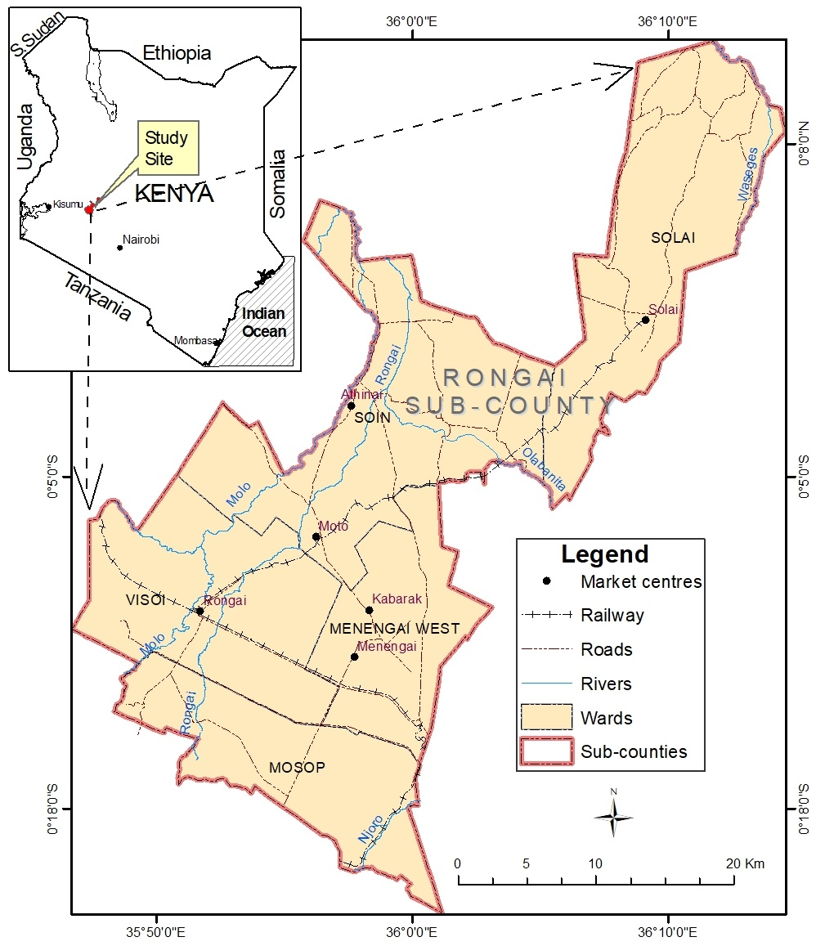.
2.2 Sampling procedure and Sample size
Proportionate sampling method was used to determine the number of respondents from purposively sampled wards, while simple random sampling techniques were used to obtain the respondents from the two wards. The study incorporated one hundred and twenty (120) respondents.
The following formula as stated by Nassiuma (2000) was used to come up with an appropriate sample size for the study:
$$n=\frac{NC^{2}}{C^{2}+\left(N-1\right)e^{2}}$$
$$\frac{6230x(0.21)^{2}}{{(0.21)}^{2}+\left(6230-1\right)x(0.02)^{2}}=108$$
n= the required sample size
N= the population within the study area,
C= Coefficient of variation
e= Standard error.
The sample was obtained using the coefficient of variation of 21%, a standard error of 2.This meets Nassiuma's (2000) assertion that in most surveys a coefficient of variation occurs within the range of 21%≤C≤30% and that standard error occurs within the range of 2%≤e≤5%. The study expected 95% confidence (5% sampling error).
The sample size was 108, but as advised by (Kaur, 2019), to cater for non-responses, attrition, and for a representative sample, the researcher revised the sample size to 130 by adding 20% of 108.Therefore, the study incorporated 130 smallholder farmers. After cleaning, out of the 130 questionnaires only 120 questionnaires were used in data analysis.

Table 1: Summary of the distribution of sample size
Ward | Number of smallholder farmer | Proportion | Sample size
Visoi | 3156 | 50.66 | 66
Soin | 3074 | 49.34 | 64
Total | 6230 | 100 | 130

2.3 Instrumentation
The study employed a semi-structured questionnaire. The questionnaire was chosen to collect data from the farmers, because of its effectiveness especially when used in a study with large samples.
2.4 Validity
The questionnaires face and content validity were ascertained by experts from the Egerton University’s Faculty of Education and Community Studies. Recommendations given were applied to enhance the instrument’s validity.
2.5 Reliability
Piloting the questionnaire enabled the researcher to estimate its reliability. Piloting involved 30 smallholder farmers in Lare ward of Njoro Sub County in Nakuru County. Lare Ward has similar climatic and agricultural characteristic to Rongai sub county (Gachie, 2020).Cronbach Alpha Scale was used to estimate the reliability. The instrument was modified for data collection.
2.6 Data Collection
Upon receiving a research authorization letter from the Board of Postgraduate Studies of Egerton University, a research permit from the National Commission for Science, Technology and Innovations (NACOSTI) and authorization from Ministry of Agriculture and Livestock Development Rongai sub-county the study was conducted.

2.7 Data Analysis
Data was cleaned, coded, scored and entered into the Statistical Packages of Social Sciences (SPSS).After cleaning, out of the 130 questionnaires only 120 questionnaires were used in data analysis. Descriptive analysis was used to determine the frequency of the level of adoption of agricultural water management practices.
3. RESULTS AND DISCUSSION
The objective was to determine the level of adoption of Agricultural Water Management Practices among smallholder farmers in Rongai Sub County. Agricultural Water Management Practices refer to the strategies and techniques used to efficiently and sustainably manage water resources in agricultural systems. These practices aim to optimize water use for crop irrigation, livestock, and other agricultural activities while minimizing waste and conserving water resources (Glória et al., 2020). This study focused on rainwater harvesting, irrigation, and drought-resistant crops. Adoption of AWMPs was coded and analyzed as: 1, Rainwater harvesting; 2, irrigation; and 3, use of drought-resistant crops. For each practice, the entries were scored as 1 for adopted and 0 for not adopted. The AWMPs composite data scores were generated to determine the adoption of AWMPs.
The composite data represents the average data of the three AWMPs to determine whether the farmer has adopted it or not. To generate the composite data, the first step was to determine the score for each Agricultural Water Management Practice. The second step was adding the scores for the three practices, and the third step was dividing the totals by the number of AWMPs, which is 3. The resultant data provided composite data.

3.1Agricultural Water Management Practices Information Sources
Smallholder farmers can access information on agricultural production from various sources. Table 2 shows the farmers’ sources of knowledge on AWMPs:

Table 2
Sources of Information on Agricultural Water Management Practices (n=120)
Source of Information | Frequency | Percent
Ward extension officer | 59 | 49.2
Mass media | 21 | 17.5
Farm groups | 18 | 15.0
Chief | 16 | 13.3
No information | 4 | 3.3
Internet | 2 | 1.7
Total | 120 | 100.0

Remarkably, 49.2% of the respondents cited ward extension officers as their primary source of AWMPs information. This percentage illustrates how important it is for local extension agencies to disseminate knowledge and encourage smallholder farmers to adopt sustainable water management techniques. Information is also disseminated via farm groups (15.0%), the media (17.5%), and local leaders (13.3%) to a lesser degree.
The significance of community-based channels in providing smallholder farmers with essential information on AWMPs is underscored by the internet's comparatively low effect of 1.7%. Collaboration among extension service providers is needed to enhance the adoption of agricultural technology effectively (Nguyen et al., 2023).
3.2 Adoption of Specific Agricultural Water Management Practices
Figure 2 show that adoption rates vary. The adoption rate of drought-resistant crops was high at 69.2%, rainwater harvesting at 53%, whereas irrigation methods were adopted at a far lower rate of 26.7%. The results point to the necessity of focused interventions to remove the obstacles preventing the adoption of AWMPs. The differences in adoption rates emphasize the importance of customizing training from extension services to particular practices according to the local environment. Specific agricultural water management practices are crucial for ensuring sustainable crop production, optimizing water use, and addressing challenges related to water scarcity. These practices help improve agricultural productivity while conserving water resources, protecting ecosystems, and enhancing the resilience of farming systems (Tatis Diaz et al., 2022). Fig 2 shows the status of adoption of the 3 AWMPs studied:
Figure 2
Adoption of the Selected Agricultural Water Management Practices

3.3 Average Adoption of Agricultural Water Management Practices
Optimizing smallholder farmers' adoption of AWMPs can increase crop yields and improve farm profitability (Wordofa et al., 2021). Table 3 shows the average adoption of AWMPs in Rongai Sub-County.

Table 3
Average Adoption of Agricultural Water Management Practices (n=120)
AWMPs Adoption | Frequency | Percent
No | 77 | 64.2
Yes | 43 | 35.8
Total | 120 | 100.0
Results in Table 3 indicate that 64.2% of the farmers did not adopt AWMPs, while 35.8% did. Therefore, the level of adoption of agricultural water management practices is low among smallholder farmers in Rongai Sub-County. The low adoption of AWMP may lead to environmental degradation, economic inefficiencies, threats to food and water security, and reduced resilience to climate change. Research has shown that several factors may affect the adoption of agricultural technologies, especially among smallholder farmers, such as personal, socio-economic, and institutional factors (Feyisa, 2020).
4. CONCLUSION
Adoption of Agricultural Water Management Practices in Rongai Sub County is low. This may be due to low income and lack of trainings from the extension service providers regarding the use and benefits of AWMPs adoption. These findings may help to improve adoption of agricultural water management practices by creating awareness about the practices, training smallholder farmers and advocating for supportive policies through collaborative engagement with local government and agricultural organizations.
ETHICAL APPROVAL
The study ensured numerous ethical considerations, which included attaining research authorization letter, research ethical approval and research permit. The research permit was thereafter presented to the Rongai sub-county agricultural office to seek approval for the same. The study was introduced to the farmers, and the principles of voluntary participation and confidentiality of participants were applied. The dignity, norms and culture of the farmers were respected at all times during the research process.

REFERENCES
Abate, T. W. (2024). Analysis of agricultural technology adoption: The use of improved maize seeds and its determinants in Ethiopia, evidence from Eastern Amhara. Journal of Innovation and Entrepreneurship, 13(1), 61. https://doi.org/10.1186/s13731-024-00421-4
Adams, A., & Jumpah, E. T. (2021). Agricultural technologies adoption and smallholder farmers’ welfare: Evidence from Northern Ghana. Cogent Economics & Finance, 9(1), 2006905. https://doi.org/10.1080/23322039.2021.2006905
Wordofa, M. G., Hassen, J. Y., Endris, G. S., Aweke, C. S., Moges, D. K., & Rorisa, D. T. (2021). Adoption of improved agricultural technology and its impact on household income: A propensity score matching estimation in eastern Ethiopia. Agriculture & Food Security, 10(1), 5. https://doi.org/10.1186/s40066-020-00278-2
Kahenge, Z., Kavoi, M., & Nhamo, N. (2020). Determinants of non-transgenic soybean adoption among smallhoder farmers in Zambia. Cogent Food & Agriculture, 6(1), 1797260. https://doi.org/10.1080/23311932.2020.1797260
Gachie, L. (2020). Major Economic Activities of all Constituencies in Nakuru County.html.
Kaur, S. (2019). Review article sample size determination (for descriptive studies). 9(3), 8365–48367. http://www.journalcra.com
Glória, A., Dionisio, C., Simões, G., Cardoso, J., & Sebastião, P. (2020). Water Management for Sustainable Irrigation Systems Using Internet-of-Things. Sensors, 20(5), Article 5.https://doi.org/10.3390/s20051402
Nguyen, L. H., Alrence Halibas, & "Trung Quang, T. (2023). Determinants of precision agriculture technology adoption in developing countries: A review. 37(1), 1–24.
Tatis Diaz, R., Pinto Osorio, D., Medina Hernández, E., Moreno Pallares, M., Canales, F. A., Corrales Paternina, A., & Echeverría-González, A. (2022). Socioeconomic determinants that influence the agricultural practices of small farm families in northern Colombia. Journal of the Saudi Society of Agricultural Sciences, 21(7), 440–451. https://doi.org/10.1016/j.jssas.2021.12.001
Feyisa, B. W. (2020). Determinants of agricultural technology adoption in Ethiopia: A meta-analysis. Cogent Food & Agriculture, 6(1), 1855817. https://doi.org/10.1080/23311932.2020.1855817

