*Original Research Article*

Phenotypic and agronomic characterization of sesame (*Sesamum indicum* L.) accessions in three agroclimatic zones of Côte d'Ivoire

.

ABSTRACT

|  |
| --- |
| **Context**: In Côte d'Ivoire, sesame currently contributes to diversifying household incomes, particularly in the north. However, the lack of high-quality seeds adapted to the growing areas prevents the efficient exploitation of its agronomic potential.  **Aims**:To identify accessions with high production potential.  **Study design**:Seventeen accessions collected in Côte d'Ivoire and five from Senegal were evaluated using a randomized complete block experimental design.  **Place and Duration of Study**: The study was conducted in the localities of Korhogo, Diawala, and Touba during 2022 and 2023.  **Methodology**: Observations and measurements focused on agromorphological parameters. Descriptive, univariate, and multivariate analyses were performed using R software.  **Results**: The results of the study revealed significant diversity in agromorphological parameters between accessions. Principal component analysis and ascending hierarchical classification identified three agromorphological groups. One group was characterized by late maturity (100 to 107 days), tall plants (154.39 to 206.08 cm) with a large number of branches (between 13 and 25 branches) and high grain yield (1336.26 kg/ha in Diawala; 577.17 kg/ha in Korhogo and 542.57 kg/ha in Touba). One group with an early cycle (82 to 86 days), low vegetative development, and low yield (424.47 kg/ha in Korhogo; 445 kg/ha in Touba and 1211.04 kg/ha in Diawala). And an intermediate group with a development cycle of between 87 and 99 days and moderate yield (543.72 kg/ha in Korhogo; 1,090.84 kg/ha in Touba and 1,256.99 kg/ha in Diawala). Discriminant factor analysis showed that most of the measured characteristics, except for the number of grains per pod, allow for discrimination between the groups formed.  **Conclusion**: The high-yielding accessions identified could be recommended to producers. |

*Keywords: Sesame accessions, agromorphological, yield, agroclimatic zones, genetic diversity*

1. INTRODUCTION

Over the past few decades, the degradation of agricultural land, combined with poor rainfall distribution and declining soil fertility, has led to a decline in the productivity of food and cereal crops in West Africa, particularly in Côte d'Ivoire. In this context, it is essential to explore alternative crops that are more resilient and less demanding, capable of adapting to new climatic constraints (**Boureima, 2012**). Among these crops, sesame (*Sesamum indicum* L.) stands out for its agronomic and economic potential. This oilseed plant, one of the oldest cultivated plants, is known for its high quality oil content and its multiple uses in the food, pharmaceutical, and cosmetic industries (**Ashri, 2007**). Its seeds, which are highly prized on the market, are used in the manufacture of confectionery, pastries, soaps, and even in the production of high value-added oils (**Khan *et al.*, 2001**). In addition, sesame has significant agronomic advantages, including good drought tolerance thanks to its deep root system, which makes it compatible with crop rotations in demanding agricultural systems.

Despite these advantages, sesame cultivation remains undervalued in Côte d'Ivoire. This marginalization can be explained by several factors, including a lack of knowledge of cultivation techniques, phytosanitary constraints, and, above all, the use of low-yielding local varieties and the absence of a genuine variety selection program adapted to local conditions (**Coulibaly *et al.*, 2018; Diouf, 2002**). In contrast, other West African countries, such as Nigeria (365,000 t), Burkina Faso (208,795 t), and Niger (104,088 t), have seen their production grow significantly (**FAOSTAT, 2023**). Between 2008 and 2017, global production increased by 26%, from 5,015,600 to 6,314,700 tons (**FAO, 2019**). This shows that sesame is experiencing a resurgence of interest, particularly on international markets.

In response to this situation, several authors have emphasized the importance of promoting the existing genetic diversity within African sesame accessions. Indeed, this variability is a valuable resource for genetic improvement programs (**Wang *et al.*, 2023**). Thus, the identification and selection of high-performing accessions that are well adapted to local agroclimatic conditions would strengthen the competitiveness of the sector (**Dossa *et al.*, 2017**). With this in mind, the implementation of multi-location trials appears to be an essential step in identifying accessions that are suitable for each production area (**Zakir, 2018**). This is the context for the present study, which aims to evaluate the agronomic potential of 22 sesame accessions in three agroclimatic zones of Côte d'Ivoire. Specifically, it will (i) characterize the phenological and morphological diversity of sesame accessions collected in cultivation areas in Côte d'Ivoire, (ii) evaluate the structure of the agromorphological diversity of these accessions, and (iii) identify the main agronomic variables that distinguish the sesame accessions collected.

2. MATERIALS AND METHODS

**2.1. Plant material**

The plant material used consisted of twenty-two (22) accessions of sesame (*Sesamum indicum* L.), including five (5) genotypes from Senegal and seventeen (17) accessions collected in Côte d'Ivoire.

**2.2. Description of study areas**

The study was conducted in rural areas for two consecutive years (2022 and 2023) during the rainy seasons in crop-growing areas such as Touba (in the west of the country), Ouangolodougou, and Korhogo (in the north-central part of the country) [**Figure 1**]. These areas are characterized by Sudano-Guinean, dry Sudano-Sahelian, and sub-humid Sudano-Sahelian climates, respectively (**Kpla *et al.*, 2018**). Geographic coordinates were recorded using GPS. These areas are characterized by a rainy season (May to October) and a dry season (November to April) with tropical ferruginous, loamy, ferruginous alteral, ferralitic, and sandy soils (**Soro *et al.*, 2011**). Monthly climate data for each area were collected. These data concerned rainfall and temperature. These data were used to analyze climate change and its impact on sesame growth and productivity. They are available online on METDATA and were downloaded from the Historical Climate (Monthly) website. This tool allowed us to download customized historical climate data in CSV (comma-separated values) file format. The download involved selecting the dates, location, and variables concerned. **Figure 2** shows the comparative monthly evolution of rainfall and average temperature from July to December for the years 2022 and 2023 in the localities of Korhogo, Diawala, and Touba. Regardless of the area considered, rainfall follows a similar trend over the two years, with a marked peak in August in Korhogo and Diawala, and in September in Touba. Overall, rainfall amounts are higher in 2022 than in 2023. In Korhogo, cumulative rainfall reached 809 mm in 2022 compared to 708 mm in 2023. In Diawala, these values were 815.6 mm in 2022 and 682.6 mm in 2023. In Touba, cumulative rainfall amounts to 813.8 mm in 2022 and 679.2 mm in 2023. The average temperature varies little from month to month, ranging between 23°C and 28°C in the three areas studied. However, 2023 is characterized by slightly higher temperatures than in 2022, with maximum temperatures reached in November.

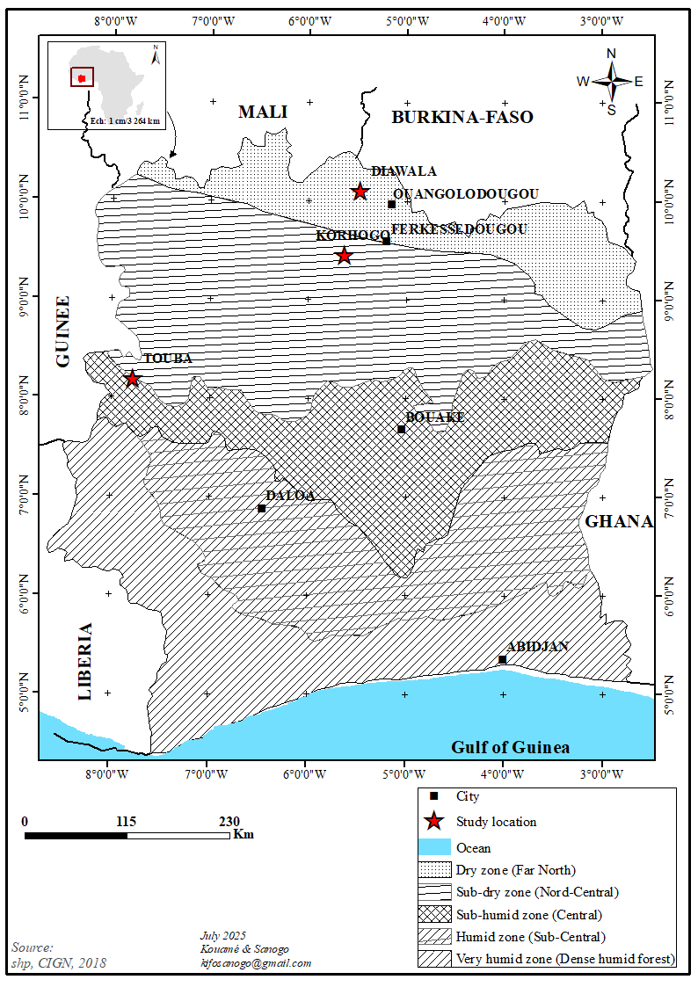

**Fig.1. Map of the study sites**

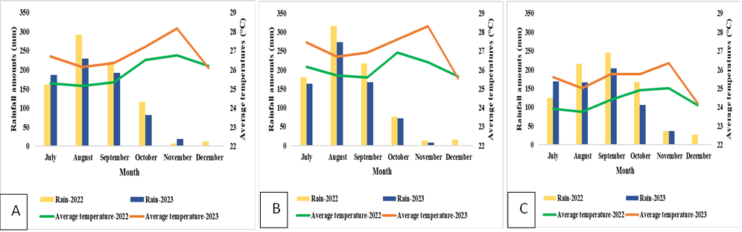

**Fig.2. Monthly rainfall and temperature distribution in the Korhogo (A), Diawala (B) and Touba (C) areas during the 2022 and 2023 experimental periods**

**2.3. Experimental design and treatments studied**

The sesame accessions were sown in a randomized complete block design with one factor and four (4) replicates (blocks). These replicates or blocks were spaced 1.5 meters apart. Each block consisted of 22 elementary plots, separated from each other by one meter (1 m). Each elementary plot consisted of four rows of seedlings, each with five holes, with 0.3 m between rows and 0.75 m between holes in the row (i.e., a size of 3 m x 0.9 m = 2.7 m²). This experimental setup comprised a total of eighty-eight (88) elementary plots and measured 40.8 meters in length and 16.5 meters in width, for a total area of 673.2 m². The factor studied was accession at 22 levels corresponding to the different genotypes and accessions of sesame.

**2.4. Conduct of the trial**

Plowing followed by leveling and staking was carried out a few days before the various sowings. Thinning to two plants per hole was carried out approximately 21 days after sowing (jas) for most plots, followed by transplanting the thinned plants into missing holes. Fertilization was carried out in two applications as recommended by **Djigma (1985)**. The first was NPK (15 N-15 P-15 K) at a dose of 1.5 g/hole, or 30 g/plot, on the day of thinning. The second application was urea at a dose of 0.75 g/hole, or 15 g/plot, approximately three weeks after the first application. Insecticide treatment was carried out during periods of heavy flowering (the period most susceptible to pests) with contact insecticides in the three study locations (Sauveur 62 EC for the Korhogo location, Kapaas 80 EC for the Diawala location, and Pichen 672 EC for the Touba location).

**1.2.5.** **Observations and measurements**

The characterization of the accessions was based on a set of parameters related to phenology (flowering and maturity), plant morphology (plant height, number of branches per plant, height of insertion of the first capsule, and number of capsules per plant), as well as yield and its components (length and width of capsules, number of seeds per locule and per capsule, thousand-grain weight, and yield). Phenological observations were made daily on all plants in each elementary plot. For each plot, each stage was considered effective when 50% of the plants had reached it. At maturity, the agro-morphological parameters were measured from the plants of four holes per elementary plot. At harvest, yield was determined in a yield square measuring 1.35 m2 (0.6 m x 2.25 m), representing six (6) plants per elementary plot. Located in the center of each elementary plot, this yield square was thus composed of three (3) rows of two (2) pockets. Yield was calculated using the ratio of dry grain weight per yield square to yield square area (**Table 1**).

**1.2.6. Data analysis**

The data was processed using Excel spreadsheets. In the first phase, the data underwent descriptive analysis. The structure of morpho-phenological diversity was determined using multivariate analyses. First, principal component analysis (PCA) was used to highlight the traits that best distinguished the different accessions and their association. Next, ascending hierarchical classification (AHC) was performed to elucidate the phylogenetic relationships between the accessions analyzed. A one-factor analysis of variance (ANOVA) was performed to compare the mean values of the different AHC classes in order to identify the genotypes with the best morpho-phenological characteristics. Finally, a discriminant factor analysis (DFA) was used to highlight the characteristics that discriminate between the groups resulting from the hierarchical classification on principal components. The values of the ranking functions and the one-dimensional test of equality of means were used to determine the most discriminating variables of the groups. All these analyses were performed using R software version 4.4.0. The data processed are the mean values for the two years of experimentation per location.

**Table 1. List of variables used in agromorphological characterization**

|  |  |
| --- | --- |
| **Characteristics studied** | **Designations** |
| 50% Flowering | FLO50% |
| Maturity | MAT |
| Plant height | HP |
| Number of branches per plant | NRP |
| Height of 1st capsule insertion | HIPC |
| Number of capsules per plant | NCP |
| Capsule length | LongC |
| Capsule width | LargC |
| Number of grains/log | NGL |
| Number of grains/capsule | NGC |
| Weight of thousand grains | P1000G |
| Yield | RDT |

3. RESULTS AND DISCUSSION

**3.1. Results**

**3.1.1. Agromorphological characterization of accessions**

The results of the descriptive analysis of the agromorphological parameters of the sesame accessions studied in the three locations are shown in **Table 2**. These results reveal significant variation in most of the variables studied, depending on the location. The coefficients of variation are high for the number of capsules per plant, the height of insertion of the first capsule, yield, and especially the number of branches per plant (up to 76.18% in Touba). On the other hand, variables such as maturity, pod length, pod width, number of seeds per locule, and number of seeds per pod show relatively low coefficients of variation (< 15%) across all locations. Large differences were observed between the minimum and maximum values for most variables. This was particularly the case for the number of branches, with the least branched accessions having fewer than three branches, while the most branched had between 37 and 62 branches depending on the locality. According to observations, the dates of 50% flowering and maturity varied depending on the locality. These periods were longest in Korhogo and Diawala compared to Touba. For the earliest accessions, the values observed were 39 and 81 days after sowing (jas) in Korhogo, 38 and 81 jas in Diawala, and 38 and 81 jas in Touba. For late accessions, the durations observed were 77 and 115 jas in Korhogo, 81 and 115 jas in Diawala, and 69 and 101 jas in Touba. The average plant height was highest in Diawala (184.87 cm), followed by Korhogo (151.73 cm) and Touba (141.36 cm).

The average yield per hectare was 1,279.92 kg in Diawala, 582.16 kg in Touba, and 533.35 kg in Korhogo. In general, Diawala stands out for its better agromorphological performance, both in terms of plant height and yield, although each location has specific advantages depending on the variables.

.

|  |  |  |  |  |  |  |  |  |  |  |  |  |  |  |  |  |
| --- | --- | --- | --- | --- | --- | --- | --- | --- | --- | --- | --- | --- | --- | --- | --- | --- |
| LocaIity | KORHOGO | | | | | DIAWALA | | | | | | TOUBA | | | | |
| **Variables** | **Min** | **Max** | **Moy** | **SD** | **CV (%)** | **Min** | **Max** | **Moy** | **SD** | **CV (%)** | **Min** | | **Max** | **Moy** | **SD** | **CV (%)** |
| FLO50% | 39.0 | 77.00 | 58.35 | 10.43 | 17.8 | 38.00 | 81.00 | 57.59 | 14.28 | 24.8 | 38.00 | | 69.00 | 53.70 | 10.42 | 19.40 |
| MAT | 81.0 | 115.00 | 97.16 | 12.13 | 12.4 | 81.00 | 115.00 | 97.16 | 12.13 | 12.4 | 81.00 | | 101.00 | 92.00 | 8.86 | 9.63 |
| HP | 70.8 | 236.25 | 151.73 | 35.99 | 23.7 | 113.5 | 247.50 | 184.87 | 28.76 | 15.5 | 89.00 | | 201.88 | 141.36 | 21.51 | 15.21 |
| NRP | 1.38 | 43.88 | 10.83 | 6.89 | 63.6 | 2.13 | 37.88 | 16.53 | 9.87 | 59.7 | 2.38 | | 62.50 | 14.22 | 10.83 | 76.18 |
| HIPC | 26.8 | 152.50 | 85.36 | 34.33 | 40.2 | 26.88 | 155.50 | 83.99 | 31.44 | 37.4 | 21.88 | | 111.88 | 65.10 | 22.11 | 33.96 |
| NCP | 6.75 | 146.42 | 63.48 | 32.08 | 50.5 | 42.58 | 220.92 | 118.77 | 38.39 | 32.3 | 21.00 | | 199.33 | 74.48 | 41.74 | 56.04 |
| LongC | 2.12 | 3.10 | 2.54 | 0.23 | 8.86 | 2.19 | 3.26 | 2.55 | 0.22 | 8.72 | 2.07 | | 3.12 | 2.53 | 0.24 | 9.41 |
| LargC | 0.44 | 0.56 | 0.50 | 0.02 | 3.14 | 0.47 | 0.63 | 0.51 | 0.02 | 4.37 | 0.45 | | 0.55 | 0.50 | 0.01 | 2.75 |
| NGL | 5.90 | 17.50 | 14.12 | 1.44 | 10.1 | 12.43 | 18.57 | 14.95 | 1.20 | 8.03 | 9.67 | | 15.83 | 13.56 | 1.09 | 8.01 |
| NGC | 23.6 | 70.00 | 56.48 | 5.76 | 10.1 | 49.73 | 74.27 | 59.79 | 4.80 | 8.03 | 38.67 | | 63.33 | 54.22 | 4.34 | 8.01 |
| P1000G | 1.48 | 4.62 | 2.90 | 0.47 | 16.1 | 2.16 | 4.16 | 2.93 | 0.32 | 11.0 | 1.95 | | 4.19 | 2.86 | 0.44 | 15.54 |
| RDT | 11.8 | 1708.8 | 533.35 | 371.17 | 69.5 | 296.3 | 2646.89 | 1279.92 | 445.9 | 34.8 | 349.5 | | 1831.2 | 582.1 | 349.5 | 60.04 |

**Table 2. Characteristics of agromorphological parameters of accessions**

FLO50% : 50% Flowering, MAT : Maturity, HP : Plant height, NRP : Number of branches per plant, HIPC : Height of 1st capsule insertion, NCP : Number of capsules per plant, LongC : Capsule length, LargC : Capsule width, NGL : Number of grains/log, NGC : Number of grains/capsule, P1000G : Weight of thousand grains, RDT : Yield, Min : minimum, Max : maximum, Moy : mean, SD: Standard deviation, CV : coefficient of variation

**3.1.2. Evaluation of the agromorphological diversity structure of sesame accessions according to location**

**3.1.2.1. Principal component analysis**

**Variability factors**

**Table 3** show the eigenvalues and percentages of variance for each axis for Korhogo, Diawala, and Touba. In accordance with Kaiser's criterion, any axis with an eigenvalue greater than 1 is retained for factor analysis (**Zangui *et al.*, 2020**). Thus, in Korhogo and Touba, the first three axes were retained to describe the maximum variability of the accessions produced. Together, these axes account for total variances of 88.167% for Korhogo and 88.357% for Touba, distributed as follows: 51.624% and 58.983% for the first axes, 26.557% and 19.691% for the second axes, and 9.985% and 9.681% for the third axes. In contrast, in Diawala, only the first two axes were retained, accounting for 83.762% of the total variance, with 72.287% for the first axis and 11.475% for the second axis.

**Table 3. Eigenvalues and percentage variation expressed by the first two axes (Diawala) and the first three axes (Korhogo, Diawala, Touba)**

|  |  |  |  |  |  |  |  |
| --- | --- | --- | --- | --- | --- | --- | --- |
|  | **Localities** |  |  | **Principal components** | **Axis 1** | **Axis 2** | **Axis 3** |
|  |  |  |  | Eigenvalue | 6.194 | 3.186 | 1.198 |
|  | Korhogo |  |  | %Total variance | 51.624 | 26.557 | 9.985 |
|  |  |  |  | %Cumulative variance | 51.624 | 78.182 | 88.167 |
|  |  |  |  | Eigenvalue | 8.674 | 1.377 |  |
|  | Diawala |  |  | %Total variance | 72.287 | 11.475 |  |
|  |  |  |  | %Cumulative variance | 72.287 | 83.762 |  |
|  |  |  |  | Eigenvalue | 7.078 | 2.363 | 1.161 |
|  | Touba |  |  | %Total variance | 58.983 | 19.691 | 9.681 |
|  |  |  |  | %Cumulative variance | 58.983 | 78.675 | 88.357 |

**Figure 3** presents the PCA biplots showing the relationships between accessions and variables measured in the three locations. The PCA graphs show that the different accessions studied are not all linked by the same variables. These graphs also show that some accessions are very different from others (when they are far apart) while others are quite similar (when they are close to each other). Vectors that are close in direction and length indicate a strong positive correlation, while opposite vectors indicate a negative correlation. Thus, in Korhogo, the first two principal components (Dim1 and Dim2) explain 51.6% and 26.6% of the total variance, respectively, for a cumulative total of 78.2%. Accessions A7, A9, A15, A6, and A12, located on the right, are strongly correlated with characteristics related to vegetative productivity (yield, number of branches per plant, number of pods per plant, plant height, 50% flowering, and maturity); they are productive and have a long cycle. On the left, accessions A1, A5, and A3 are linked to pod length and thousand-grain weight. Accessions A8, A17, and A18, located in the lower left area, are not highly correlated with most variables. Accessions close to the center, such as A2, A4, A10, A19, A20, A21, and A22, have intermediate characteristics. This analysis made it possible to distinguish two main types of characteristics in this locality. In particular, growth and productivity characteristics were the most discriminating on axis 1, while characteristics related to reproductive structure were less discriminating on axis 2 but still significant. In Diawala, axis 1 (Dim1) explains 72.3% of the total variance and axis 2 (Dim2) 11.5%, giving a total variance of 83.8%. Accessions A15, A9, A12, and A13 are positively correlated with the number of capsules per plant and yield, suggesting good agronomic potential.

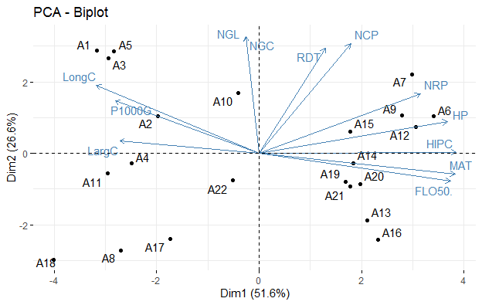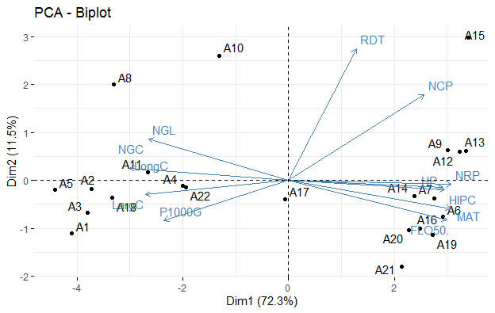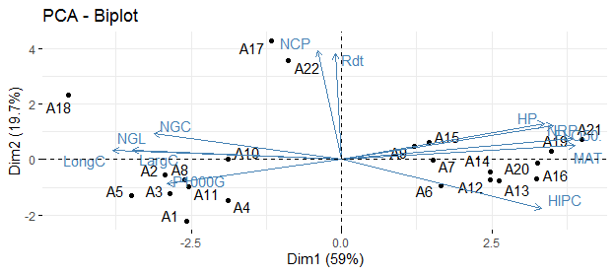

A

B

C

Fig 3. Representation of variables in the plane of axes 1 and 2 of the acp in the localities of Korhogo (a), Diawala (b) and Touba (c)

FLO50%: 50% Flowering, MAT: Maturity, HP: plant height, NRP: Number of branches per plant, HIPC: Height of 1st capsule insertion, NCP: Number of capsules per plant, LongC: Capsule length, LargC: Capsule width, NGL: Number of grains/log, NGC: Number of grains/capsule, P1000G: Weight of thousand grains, RDT: Yield

On the other hand, accessions A1, A2, A3, A4, and A5 are located at the opposite end of the yield vector and are therefore likely to be low-performing. Accessions A6, A7, A14, and A16 are correlated with vegetative traits such as maturity, flowering, plant height, number of branches per plant, and height of insertion of the first capsule, reflecting a common phenotypic and morphological profile. Principal component analysis (PCA) showed that the different accessions studied are not all linked by the same characteristics. We can therefore distinguish between those with high yield and a large number of capsules per plant, those with late maturity and significant vegetative development, and those with low performance. In Touba, axis 1 (59%) and axis 2 (19.7%) together explain 78.7% of the variance. Accessions A17 and A22, aligned with the vectors of number of capsules per plant and yield, are identified as productive. Accessions A19, A21, A6, A16, A20, A7, A14, A12, A13, A15, and A9 are aligned with the variables of plant height, height of insertion of the first capsule, maturity, flowering, and number of branches per plant. These accessions show a strong correlation with these traits, reflecting significant vegetative development and late maturity. In contrast, accessions A1, A2, A3, A4, A5, A8, A10, and A11 are located on the left, and are therefore associated with low values for vegetative traits. However, they have high values for pod length and width, number of seeds per locule and per pod, and thousand-seed weight. They could represent an early group with low vegetative development but good grain yield characteristics. Accession A18, on the other hand, stands out in the upper left corner with no correspondence to the vectors, indicating a profile that is very different from the others. In this locality, PCA identified three main axes of variability, namely the yield-number of capsules per plant component, which is positively correlated on axis 2, the vegetative development-maturity component, which is positively correlated on axis 1, and the capsule size-grain structure component, which is negatively correlated on axis 1.

**3.1.2.2. Agromorphological structuring of sesame accessions by ascendant hierarchical classification (AHC)**

Hierarchical ascending classification (HAC) analysis based on the agro-morphological variables measured made it possible to group the twenty-two (22) sesame accessions into three distinct groups according to location (**Figures 4**). This structuring highlights significant morpho-phenological diversity between the groups (**Table 4**).

An analysis of variance performed on the different groups resulting from the hierarchical classification on principal components highlighted the main distinctive characteristics (Table 4). In Korhogo, group 1, consisting of eleven sesame accessions (A15, A7, A6, A9, A12, A16, A13, A14, A20, A19, and A21), was distinguished by the longest times observed for the appearance of 50% of flowers (66 days after sowing) and for maturity (107 days after sowing). This group also has the tallest plants (174.19 cm), a higher average number of branches (13 branches), and a particularly high insertion height for the first capsule (114.43 cm). In addition, the accessions in this group produce a high number of capsules per plant (67 capsules) and have a relatively high yield (577.17 kg/ha). However, these performances are associated with the lowest yield component values, particularly capsule length and width, number of seeds per locule and per capsule, and thousand-seed weight.

Group 2, comprising five accessions (A4, A11, A17, A18, and A8) that are early maturing (86 days), has the lowest values for most of the measured variables, including low plant height (121.67 cm), low number of branches (5 branches), and an average yield of 424.47 kg/ha. Group 3, comprising six accessions (A1, A5, A3, A22, A10, and A2), is characterized by intermediate values for most parameters. It combines relative earliness (87 days after sowing) with a high number of pods per plant (67 pods) and a good yield (543.72 kg/ha). This group also includes the accessions with the best yield component values. These are pod length (2.80 cm), number of seeds per locule (14.70) and per pod (58.83), and thousand-seed weight (3.15 g). In Diawala, group 1 includes the same accessions as in Korhogo (A15, A7, A6, A9, A12, A16, A13, A14, A20, A19, and A21), with similar agronomic characteristics. This group is distinguished by late flowering and maturation (70 and 107 jas), tall plant height (206.08 cm), and greater first pod insertion height (109.46 cm). It also has a high number of branches (25 branches) and capsules (62 capsules), as well as the highest average yield (1336.26 kg/ha). However, these accessions have the lowest yield component values (capsule length and width, number of grains per log and per capsule, and thousand-grain weight). Group 2 comprises three accessions (A4, A17, and A22) with characteristics intermediate between those of groups 1 and 3. These accessions have a cycle of 99 days, an average yield of 1,256.99 kg/ha, and a higher thousand-grain weight (3.22 g). Group 3, consisting of eight accessions (A10, A8, A18, A11, A2, A3, A5, and A1), is distinguished by early flowering and maturation (43 and 85 days), shorter plant height (162.64 cm), fewer branches (6 branches), and low capsule production (99 capsules). Despite a lower yield (1211.04 kg/ha), these accessions have the best capsule dimensions, with a length of 2.77 cm and a width of 0.52 cm. They are also characterized by a high number of seeds per locule (15 seeds) and per capsule (62 seeds). In Touba, group 1, composed of eleven accessions (A6, A9, A7, A21, A19, A20, A15, A12, A14, A13, and A16), is characterized by a relatively long flowering and maturity cycle (62 and 100 days after sowing, respectively), a tall plant height (154.39 cm), the tallest among the groups, a large number of branches (19 branches), and a high insertion height of the first capsule (78.92 cm), indicating a vigorous architecture. However, the number of pods per plant (68 pods) and grain yield (542.57 kg/ha) remain low compared to those of group 3. The pods are relatively small, with a length of 2.36 cm and a width of 0.49 cm. The number of seeds per pod (13.22 seeds) and per capsule (52.88 seeds) is also low, with a low thousand-seed weight (2.60 g). Group 2 comprises eight accessions (A4, A1, A5, A2, A3, A10, A8, and A11) with low development and low yield. The accessions in this group showed early flowering and maturity (42 and 82 days after sowing), indicating a short cycle, reduced plant height (123 cm), and low number of branches (6 branches). These accessions also had the lowest values for number of capsules per plant (59 capsules) and yield (445 kg/ha), but the best values for yield components, particularly capsule length (2.69 cm), capsule width (0.50 cm), number of seeds per locule (13.82 seeds) and per pod (55.29 seeds), and thousand-seed weight (3.16 g). Group 3 consists of three accessions (A18, A17, and A22) characterized by a short cycle with flowering at 50 days and maturity at 88 days, and average plant height (142.50 cm). The number of branches and the number of capsules per plant are particularly high, with 13 branches and 139 capsules respectively, which has a positive influence on yield. This group has the highest grain yield (1090.84 kg/ha) with the best yield component values.

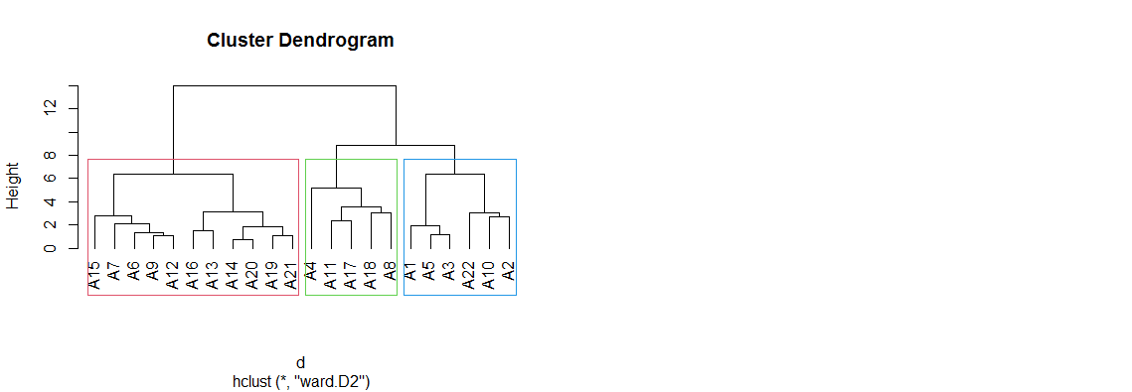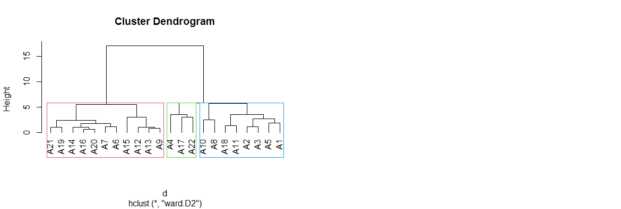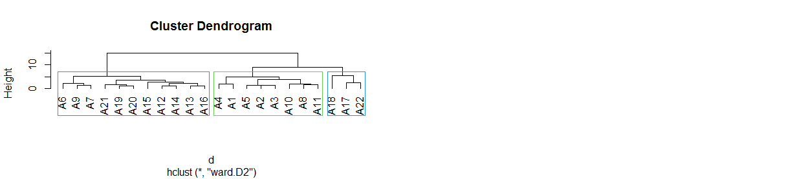

C

A

B

**G1**

**G2**

**G3**

**G1**

**G2**

**G3**

**G3**

**G2**

**G1**

**Fig 4. Dendrogram based on agromorphological characters classifying the 22 sesame accessions into three distinct groups G1, G2 and G3 in the Korhogo (A), Diawala (B) and Touba (C) localities)**

**Table 4. Main characteristics of the different groups obtained from hierarchical clustering on principal components (Korhogo, Diawala, Touba)**

|  |  |  |  |  |  |  |  |  |  |  |  |  |  |  |  |  |  |
| --- | --- | --- | --- | --- | --- | --- | --- | --- | --- | --- | --- | --- | --- | --- | --- | --- | --- |
| **Localities** | | |  |  | **Variables** | | | **Group 1**  **(11 accessions)** | | **Group 2**  **(5 accessions)** | | **Group 3**  **(6 accessions)** | | **Pr > F** | | **Significance** | |
|  | | |  |  | FLO50% (jas) | | | 66.84 a | | 49.00 b | | 50.56 b | | 0.000 | | Yes | |
|  | | |  |  | MAT (jas) | | | 107.31 a | | 86.50 b | | 87.41 b | | 0.000 | | Yes | |
|  | | |  |  | HP (cm) | | | 174.19 a | | 121.67 c | | 135.58 b | | 0.000 | | Yes | |
|  | | |  |  | NRP | | | 13.78 a | | 5.30 c | | 10.01 b | | 0.000 | | Yes | |
| Korhogo | | |  |  | HIPC (cm) | | | 114.43 a | | 51.49 c | | 60.31 b | | 0.000 | | Yes | |
|  | | |  |  | NCP | | | 67.21 a | | 50.59 b | | 67.36 a | | 0.01 | | Yes | |
|  | | |  |  | LongC (cm) | | | 2.37 c | | 2.58 b | | 2.80 a | | 0.000 | | Yes | |
|  | | |  |  | LargC (cm) | | | 0.49 c | | 0.51 a | | 0.50 b | | 0.000 | | Yes | |
|  | | |  |  | NGL | | | 14.05 b | | 13.55 b | | 14.70 a | | 0.000 | | Yes | |
|  | | |  |  | NGC | | | 56.23 b | | 54.20 b | | 58.83 a | | 0.000 | | Yes | |
|  | | |  |  | P1000G (g) | | | 2.67 b | | 3.08 a | | 3.15 a | | 0.000 | | Yes | |
|  | | |  |  | RDT (kg/ha) | | | 577.17 a | | 424.47 b | | 543.72 ab | | 0.096 | | Yes | |
| **Localities** | | |  |  | **Variables** | | | **Group 1**  **(11 accessions)** | | **Group 2**  **(3 accessions)** | | **Group 3**  **(8 accessions)** | | **Pr > F** | | **Significance** | |
|  | | |  |  | FLO50% (jas) | | | 70.41 a | | 48 b | | 43.54 c | | 0.000 | | Yes | |
|  | | |  |  | MAT (jas) | | | 107.31 a | | 99.66 b | | 85.25 c | | 0.000 | | Yes | |
|  | | |  |  | HP (cm) | | | 206.08 a | | 166.36 b | | 162.64 b | | 0.000 | | Yes | |
|  | | |  |  | NRP | | | 25.40 a | | 9.46 b | | 6.98 c | | 0.000 | | Yes | |
| Diawala | | |  |  | HIPC (cm) | | | 109.46 a | | 59.89 b | | 58.01 b | | 0.000 | | Yes | |
|  | | |  |  | NCP | | | 134.38 a | | 111.95 b | | 99.85 b | | 0.031 | | Yes | |
|  | | |  |  | LongC (cm) | | | 2.37 c | | 2.59 b | | 2.77 a | | 0.000 | | Yes | |
|  | | |  |  | LargC (cm) | | | 0.50 b | | 0.50 b | | 0.52 a | | 0.000 | | Yes | |
|  | | |  |  | NGL | | | 14.80 b | | 14.80 b | | 15.54 a | | 0.000 | | Yes | |
|  | | |  |  | NGC | | | 58.19 b | | 59.21 b | | 62.19 a | | 0.000 | | Yes | |
|  | | |  |  | P1000G (g) | | | 2.74 c | | 3.22 a | | 3.07 b | | 0.000 | | Yes | |
|  | | |  |  | RDT (kg/ha) | | | 1336.26 a | | 1256.99 b | | 1211.04 b | | 0.022 | | Yes | |
| **Localities** | | |  |  | **Variables** | | | **Group 1**  **(11 accessions)** | | **Group 2**  **(8 accessions)** | | **Group 3**  **(3 accessions)** | | **Pr > F** | | **Significance** | |
|  | | |  |  | FLO50% (jas) | | | 62.96 a | | 42.01 c | | 50.91 b | | 0.000 | | Yes | |
|  | | |  |  | MAT (jas) | | | 100.27 a | | 82.00 c | | 88.33 b | | 0.000 | | Yes | |
|  |  |  | | |  |  | HP (cm) | | 154.39 a | | 123.00 c | | 142.50 b | | 0.000 | | Yes | |
|  |  |  | | |  |  | NRP | | 19.55 a | | 6.99 b | | 13.92 a | | 0.000 | | Yes | |
|  |  | Touba | | |  |  | HIPC (cm) | | 78.92 a | | 56.32 b | | 37.77 c | | 0.000 | | Yes | |
|  |  |  | | |  |  | NCP | | 68.04 b | | 59.07 b | | 139.21 a | | 0.01 | | Yes | |
|  |  |  | | |  |  | LongC (cm) | | 2.36 b | | 2.69 a | | 2.73 a | | 0.000 | | Yes | |
|  |  |  | | |  |  | LargC (cm) | | 0.49 b | | 0.50 a | | 0.51 a | | 0.001 | | Yes | |
|  |  |  | | |  |  | NGL | | 13.22 b | | 13.82 a | | 14.06 a | | 0.008 | | Yes | |
|  |  |  | | |  |  | NGC | | 52.88 b | | 55.29 a | | 56.27 a | | 0.008 | | Yes | |
|  |  |  | | |  |  | P1000G (g) | | 2.60 b | | 3.16 a | | 2.96 ab | | 0.005 | | Yes | |
|  |  |  | | |  |  | RDT (kg/ha) | | 542.56 b | | 445.85 b | | 1090.84 a | | 0.000 | | Yes | |

*All values followed by the same letter are statistically identical. F: test statistic associated with the ANOVA. Pr: Probabilitty*

FLO50% : 50% Flowering, MAT : Maturity, HP : Plant height, NRP : Number of branches per plant, HIPC : Height of 1st capsule insertion, NCP : Number of capsules per plant, LongC : Capsule length, LargC : Capsule width, NGL : Number of grains/log, NGC : Number of grains/capsule, P1000G : Weight of thousand grains, RDT : Yield,

**3.1.2.3. Structuring diversity through discriminant factor analysis**

**Table 5** present the results of Wilks' test applied to the three locations, measuring the discriminating power of each variable between groups. The three groups resulting from the hierarchical classification on principal components were used as categorical variables. The test of equality of group means reveals that 11 of the 12 variables tested can be used to discriminate between groups in the different localities. In Korhogo, the variables 50% flowering, maturity, plant height, height of insertion of the first capsule, and capsule length are the most discriminating (< 0.0001). In Diawala, most variables allow for significant discrimination, with the exception of number of pods per plant, thousand-grain weight, and grain yield. In Touba, all variables have a high discriminatory capacity except for three (pod width, number of grains per pod, and thousand-grain weight).

**Table 5. Test of equality of group means (Korhogo, Diawala, Touba)**

|  |  |  |  |  |  |  |
| --- | --- | --- | --- | --- | --- | --- |
| **Localities** | **Variables** | **Lambda de Wilks** | **F** | **DF1** | **DF2** | **p-value** |
|  | FLO50% | 0.098 | 87.615 | 2 | 19 | < 0.0001 |
|  | MAT | 0.099 | 86.944 | 2 | 19 | < 0.0001 |
|  | HP | 0.123 | 67.778 | 2 | 19 | < 0.0001 |
|  | NRP | 0.392 | 14.737 | 2 | 19 | 0.000 |
| Korhogo | HIPC | 0.048 | 188.453 | 2 | 19 | < 0.0001 |
|  | NCP | 0.657 | 4.960 | 2 | 19 | 0.018 |
|  | LongC | 0.177 | 44.156 | 2 | 19 | < 0.0001 |
|  | LargC | 0.681 | 4.453 | 2 | 19 | 0.026 |
|  | NGL |  |  | 2 | 19 |  |
|  | NGC | 0.429 | 12.652 | 2 | 19 | 0.000 |
|  | P1000G | 0.615 | 5.953 | 2 | 19 | 0.010 |
|  | RDT | 0.854 | 1.630 | 2 | 19 | 0.222 |
|  | FLO50% | 0.069 | 128.099 | 2 | 19 | < 0.0001 |
|  | MAT | 0.064 | 139.448 | 2 | 19 | < 0.0001 |
|  | HP | 0.187 | 41.202 | 2 | 19 | < 0.0001 |
|  | NRP | 0.037 | 246.416 | 2 | 19 | < 0.0001 |
|  | HIPC | 0.096 | 88.971 | 2 | 19 | < 0.0001 |
| Diawala | NCP | 0.531 | 8.383 | 2 | 19 | 0.002 |
|  | LongC | 0.199 | 38.332 | 2 | 19 | < 0.0001 |
|  | LargC | 0.258 | 27.269 | 2 | 19 | < 0.0001 |
|  | NGL |  |  | 2 | 19 |  |
|  | NGC | 0.238 | 30.422 | 2 | 19 | < 0.0001 |
|  | P1000G | 0.507 | 9.219 | 2 | 19 | 0.002 |
|  | RDT | 0.924 | 0.782 | 2 | 19 | 0.472 |
|  | FLO50% | 0.058 | 154.128 | 2 | 19 | < 0.0001 |
|  | MAT | 0.072 | 123.200 | 2 | 19 | < 0.0001 |
|  | HP | 0.160 | 50.026 | 2 | 19 | < 0.0001 |
| Touba | NRP | 0.335 | 18.821 | 2 | 19 | < 0.0001 |
|  | HIPC | 0.090 | 96.014 | 2 | 19 | < 0.0001 |
|  | NCP | 0.213 | 35.056 | 2 | 19 | < 0.0001 |
|  | LongC | 0.234 | 31.119 | 2 | 19 | < 0.0001 |
|  | LargC | 0.463 | 11.031 | 2 | 19 | 0.001 |
|  | NGL |  |  | 2 | 19 |  |
|  | NGC | 0.598 | 6.386 | 2 | 19 | 0.008 |
|  | P1000G | 0.570 | 7.160 | 2 | 19 | 0.005 |
|  | RDT | 0.325 | 19.738 | 2 | 19 | < 0.0001 |

FLO50%: 50% Flowering, MAT: Maturity, HP: Plant height, NRP: Number of branches per plant, HIPC: Height of 1st capsule insertion, NCP: Number of capsules per plant, LongC: Capsule length, LargC: Capsule width, NGL: Number of grains/log, NGC: Number of grains/capsule, P1000G: Weight of thousand grains, RDT: Yield

**3.2. Discussion**

The agromorphological evaluation of sesame accessions in three distinct locations (Korhogo, Touba, and Diawala) made it possible to assess the diversity existing in this material. This evaluation revealed high phenotypic variability for several agronomic traits, including yield, number of branches per plant, number of capsules per plant, and height of insertion of the first capsule. This could be explained by the fact that all accessions were collected in different locations and therefore originated from parents with distant genetic backgrounds. This would have caused significant morphological differences. It could also be explained by environmental factors, since the expression of a given trait may be the result of the interaction between genetic factors and those of the plant's living environment. Certain ecological conditions could also lead to seed flow between populations of diverse geographical origins. Although sesame has been described as a self-pollinating plant, recent evidence suggests the possibility of natural cross-pollination within the species (**Baydar and Gurel, 1999**). This variability is essential for genetic selection, as it constitutes a reservoir of genetic diversity that can be exploited for varietal improvement (**Wang *et al.*, 2023**).

The high coefficients of variation observed for yield and plant morphology traits (number of branches, height) confirm the heterogeneity of the accessions studied. This corroborates the results of **Dossa *et al.* (2016)**, who highlight a high phenotypic diversity in local sesame populations in West Africa. Conversely, variables such as maturity, capsule length, and number of seeds per capsule showed relatively low variability (<15%), suggesting a certain stability of these traits under the agroclimatic conditions tested.

The study also highlighted significant differences between early accessions (flowering as early as 38 days after sowing) and late accessions (maturity up to 115 days), demonstrating a high capacity for adaptation in terms of plant development. This parameter is important in the context of climate change, as it allows varieties to be adapted to seasonal constraints and the length of the growing season **(Weiss, 2000)**.

In terms of agronomic performance, the accessions grown in Diawala recorded the highest average height (184.87 cm) and the highest average yield (1279.92 kg/ha), far surpassing the results observed in Touba and Korhogo. These differences could be explained by more favorable soil and climate conditions in Diawala. However, the rainfall recorded during the growing cycle in all three areas was above the average required by sesame to meet its water needs (525 mm). This indicates that the cycle took place under good humidity conditions. Furthermore, these results could also be linked to better genetic adaptation of the accessions to the Diawala site, as suggested by **Pandey *et al.* (2015)**.

The number of branches per plant, which varied between less than 3 and more than 60 depending on the accessions and locations, is also an important distinguishing criterion. Indeed, extensive branching is generally positively correlated with the number of capsules and yield (**Bedigian, 2003**). Thus, the most branched accessions are of particular interest for breeding programs focused on yield improvement.

Following this evaluation, multivariate analyses (PCA and PCA) allowed them to be structured into three groups. Principal component analysis (PCA) applied to sesame accessions revealed significant agromorphological variability between the locations studied. This variability is reflected in a clear structuring of accessions according to discriminating traits such as number of capsules per plant, branching, plant height, flowering, and yield.

In all three locations, the accessions were grouped according to traits related to productivity, in particular the number of capsules per plant and grain yield. This is the case in Diawala, where axis 1 (Dim1), which explains 72.3% of the variance, is strongly influenced by these two characteristics, making it possible to distinguish a group of accessions with high agronomic potential (A15, A9, A12, A13). These observations confirm that yield-related traits are among the most effective for differentiating sesame genotypes in breeding programs. Indeed, **Baydar (2005)** and **Zangui *et al.* (2020)** have shown that the number of capsules and yield are reliable indicators for identifying high-performing accessions, especially in tropical environments.

The best-performing accessions in Korhogo (A7, A9, A15, A6, and A12) had strong branching and average height, reflecting a vegetative morphology favorable to better capsule distribution and therefore higher yield. In contrast, some less branched accessions or those with high capsule insertion (A18 in Touba) showed vegetative development that was not conducive to production. This finding is supported by **Dossa *et al.* (2017)**, who emphasized that plant height and number of branches positively influence capsule production and yield stability in sesame, particularly in semi-arid areas.

The structure of the accessions differs depending on the location. For example, the high-performing accessions in Diawala are different from those identified in Touba or Korhogo. This difference may be related to the specific soil and climate conditions at each site (rainfall, soil type, temperature), which influence the expression of traits. Indeed, analysis of these parameters shows that rainfall, soil type, and temperature vary from one location to another. Previous work (**Boureima *et al.*, 2017**) has confirmed that the local environment strongly influences the phenotypic behavior of sesame accessions.

ACP has identified high-yielding and highly branched accessions, late-maturing accessions with significant vegetative development, and low-performing accessions with little correlation to yield traits. This structure is typical in sesame diversity studies. According to **Mohammadi and Prasanna (2003)**, PCA is particularly effective in grouping accessions according to their morpho-agronomic traits and thus guiding selection.

The ascending hierarchical classification (AHC) analysis revealed significant morpho-phenological diversity between locations (Korhogo, Diawala, and Touba), reflecting the different adaptations of accessions to environmental conditions. This morpho-phenological structure corroborates the observations of **Zangui *et al.* (2020)**, who highlighted the influence of environmental and genetic variability on sesame diversity in Niger.

In Korhogo and Diawala, groups 1 have late flowering and maturity (66-70 days for flowering, 107 days for maturity). These groups are distinguished by their tall plant height, high number of branches, and high number of capsules per plant. These results reflect high yield potential (577.17 kg/ha in Korhogo and 1,336.26 kg/ha in Diawala), despite low yield components (grains per pod, pod length, weight of 1,000 grains). These results could be attributed to their long cycle length and sufficient water supply during the growing cycle. According to **Zangui *et al.* (2020)**, a long cycle allows for biomass accumulation, which promotes a high number of pods per plant, although this may be at the expense of yield component quality. This dynamic was also reported by **Baydar (2005)**, who explains that late accessions make better use of the water resources available at the beginning of the season. However, the average height of the plants in these groups (174.19 cm in Korhogo and 206.08 cm in Diawala) remains higher than the average plant height (139.75 cm) in the Nigerien collection **Zangui *et al.* (2020)** and that obtained by **Siéné *et al.* (2021)** in Côte d'Ivoire in Korhogo (160 and 169.42 cm). This could be explained by their diverse origins and provenances. According to **Zangui *et al.* (2020)**, sesame has indeterminate growth, which leads to asynchronous maturity and very tall plants. However, reducing plant height improves resistance to lodging.

But shorter plant height appears to be a disadvantage in terms of seed yield, as taller plants tend to bear more capsules and therefore produce more seeds **Zangui *et al.* (2020).** This statement contrasts with the results observed in Touba, where Group 1 accessions, despite their tall height and high number of branches, were less productive. This low yield could be due to stress during flowering or grain filling, given the late sowing carried out in this locality.

Groups 2 in Korhogo and Touba, as well as group 3 in Diawala, consist of early accessions with cycle lengths of less than 90 days. These accessions are short in stature, have few branches, and produce average yields (424.47 kg/ha in Korhogo, 1,211.04 kg/ha in Diawala, and 445.85 kg/ha in Touba). These results could be due to the length of the cycle. Early varieties complete their cycle in a short period of time. This rapidity limits vegetative growth and favors rapid reproduction (flower and capsule formation). According to **SIRI *et al.* (2024)**, although earliness is advantageous in avoiding end-of-season stress, it is often associated with reduced biomass, which limits capsule production. Furthermore, according to **Belayneh *et al.* (2024)**, the later a variety is, the more time it has to accumulate biomass and seeds, which explains its higher yields.

Group 3 at Korhogo and group 2 at Diawala, group together accessions that are intermediate in terms of cycle length (99 days at Diawala), height, branching and yield (543.72 kg/ha at Korhogo). These accessions show the best performance in terms of yield components. This performance could be explained by the fact that intermediate accessions generally end their cycle when climatic conditions (rain, temperature, humidity) are most favorable for flowering, boll formation and grain filling. On the other hand, **Boureima *et al.* (2010)** indicate that good agronomic performance depends not only on earliness or vegetative vigor, but also on the balance of yield components. **Siéné *et al.* (2021)** also emphasize that long, well-filled capsules are essential traits in the selection of improved sesame varieties. At Touba, group 3 also presented accessions intermediate in terms of cycle length (88 days) and height (142.50 cm), but with a high number of branches, capsules and high yield values (1090.84 kg) and its components. This group of accessions shows that a compromise between development cycle, plant morphology and fruiting density can result in higher productivity, even under restrictive environmental conditions.

Discriminant factor analysis (DFA) applied to all sesame accessions studied in three agroclimatic localities (Korhogo, Diawala and Touba) highlighted the structuring of diversity according to morpho-phenological and agronomic traits. This method has proved effective in discriminating between groups of accessions on the basis of their multivariate variability, confirming its usefulness in genetic improvement and the management of plant genetic resources (**Mohammadi and Prasanna, 2003**). Earliness, plant height, number of branches per plant, insertion height of the first boll, number of bolls per plant, boll length and width, number of grains per boll, thousand-grain weight and yield are the main traits used to discriminate between the different groups. These traits are therefore the most useful for studying the variability of accessions. **Akbar *et al.* (2011)** suggested that using traits such as plant height, number of seeds per capsule and seed yield would save considerable time in identifying sesame germplasm for downstream breeding work.

**4. CONCLUSION**

The agro-morphological study carried out on sesame accessions in three localities (Korhogo, Diawala and Touba) revealed great diversity in morphological and phenological traits, as well as a strong influence of local conditions on the expression of agronomic traits. The results showed that most of the traits measured, such as earliness (flowering and maturity dates), plant height, number of branches, yield and its components (length and width, number of bolls per plant, number of kernels per bin, thousand kernel weight) varied significantly between accessions and localities. Principal component analysis (PCA) and hierarchical ascending classification (HAC) were used to identify three main groups: a group with high vegetative development, characterized by late flowering and maturity, high plant height, large number of branches and high yield; an early group with low vegetative development, made up of low-yielding accessions; and an intermediate group with a good balance between vegetative and reproductive traits. Localities exerted a differentiated effect on trait expression, reflecting the influence of local agro-climatic conditions. Diawala recorded the highest yields, while Touba had the shortest plants. PCA was used to separate traits related to productivity (yield, number of bolls, thousand kernel weight) from those related to plant morphology (height, branching). Discriminant factor analysis revealed a significant structuring of agronomic diversity between the three localities. All variables were able to discriminate between the different groups formed, except for the number of grains per lodge. This study highlights a high level of agronomic diversity between localities. This is an important asset for breeding programs, helping to identify the varieties best suited to each area.

DISCLAIMER (ARTIFICIAL INTELLIGENCE)

Author(s) hereby declare that NO generative AI technologies such as Large Language Models (ChatGPT, COPILOT, etc) and text-to-image generators have been used during writing or editing of this manuscript.

**RÉFÉRENCES**

Boureima, S. (2012). Amélioration variétale du sésame par la mutation induite: effet de la mutagegèse sur la tolérance à la sécheresse et la productivité. Thèse de doctorat (PhD), Ghent University, Ghent, belgium, 194 p.

Ashri, A. (2007). Sesame (S*esamum indicum* L.). In : R. J. Singh, Ed.,Genetics Resources, Chromosome Engineering, and Crop Improvement, Vol.4, Oilseed Crops, p. 231 - 289, CRC Press, Boca Raton, FL, USA.

Khan, N.U.I., Akbar, M., Sabir, K. M. & Iqbal, S. (2001). Characters association and path coefficient analysis in sesame (*Sesamum indicum* L.). Online Journal of BiologicalSciences, 1(3): 99-100. DOI: 10.3923/jbs.2001.99.100.

Coulibaly, A., Konaré, H., Dembélé, S., Cissé, S. & Kamkam, W. (2018). Plaidoyer pour une Adoption des Pratiques de Système de Production Intégrée Durable (SPID) du Sésame à Travers la Mise en Œuvre des Champs Ecole Paysan (CEP) et des Tests dans le Cercle de Kita. DCG Report No. 78, 18p.

Diouf, M. (2002). Effect of genotype x environment interaction on growth and productivity of sesame (*Sesamum indicum* L.) in Senegal. Agronomy engineering thesis, Ecole Nationale Supérieure d'Agriculture (ENSA), Thiès, 93p. + ann.

FAOSTAT. (2023). FAO statistical data bases and data sets. Fao.org/faostat/fr/data/QCL/visualize. consulté le 20/03/2023.

FAO. (2019). [www.faostat.org](http://www.faostat.org).

Wang, Z., Zhou, F., Tang, X., Yang, Y., Zhou, T. & Liu, H. (2023). Morphology and SSR Markers-Based Genetic Diversity Analysis of Sesame (*Sesamum indicum* L.) Cultivars Released in China. Agriculture 13, no. 10: Article 10. <https://doi.org/10.3390/agriculture13101885>.

Dossa, K., Diouf, D. & Wang, L. (2017). The Emerging Oilseed Crop *Sesamum indicum* Enters the “Omics” Era. Frontiers in Plant Science 8: 1154. <https://doi.org/10.3389/fpls.2017.01154>.

Zakir, M. (2018). Review on genotype X environment interaction in plant breeding and agronomic stability of crops. Journal of Biology, Agriculture and Healthcare 8 (12) (2018). ISSN2224-3208. ISSN 2225-093X.

Kpla, A.C. F., Touré, A. et Ipou, I.J. (2018). Distribution of a new weed *Porophyllum ruderale* (Asteraceae), in croplantds of Côte d'Ivoire.10.19044. <http://dx.doi.org/10.19044/esj.2018.v14n36p333>.

Soro, D., Bakayoko, S., Dao, D., Bi Tra, T., Angui, P. & Girardin, O. (2011). Soil fertility diagnosis in north-central Ivory Coast. Agronomie Africaine 23 (3): 205 - 215.

Djigma, A. (1985). Summary of the results obtained from sesame resarrch in Burkina Faso Oléagineux, 40(8-9), 443-449.

Zangui, H., Adamou, A., Seyni, B. Robert, T. & Najat, T. (2020). Determination of Genetic Diversity of Nigerien Sesame (Sesamum indicum L.) Using Amplified Fragment Length Polymorphisms Markers.” International Journal of Current Research 12, no. 9: 13637–13645. <https://doi.org/10.24941/ijcr.39649.09.2020>.

Baydar, H. & Gurel, F. (1999). The effects of honey bees on cross-pollination and hybrid seed production in sesame (*Sesamum indicum* L.). Turk. J. Field Crops. 4: 21-24.

Dossa, K., Wei, X. & Zhang, Y. (2016). Analysis of Genetic Diversity and Population Structure of Sesame Accessions From Africa and Asia as Major Centers of Its Cultivation. Genes 7, no. 4: 14. https://doi.org/ 10.3390/genes7040014.

Weiss, E.A. (2000). Oilseed Crops (second edition). Blackwell Science LTD: United Kingdom; 355p.

Pandey, S. K., Das, A., Rai, P. & Dasgupta, T. (2015). Morphological and Genetic Diversity Assessment of Sesame (*Sesamum indicum* L.) Accessions Differing in Origin. Physiology and Molecular Biology of Plants 21, no. 4: 519–529. <https://doi.org/10.1007/s12298-015-0322-2>.

Bedigian, D. (2003). Evolution of sesame revisited: domestication, diversity and prospects. Genetic Resources and Crop Evolution, 50(7), 779-787. <http://dx.doi.org/10.1023/A:1025029903549>.

Baydar, H. (2005). Breeding for the improvement of the ideal plant type of sesame. Plant Breeding. 12(4), 263-267.

Boureima, S., Yaou, A. & Lawali S. (2017). Seed yield stability and analysis of genotype x environment interaction of sesame genotypes in central south of Niger. Journal of Animal &Plant Sciences, Vol.34, Issue 3: 5535-5547, http://www.m.elewa.org/JAPS; ISSN 2071-7024.

Mohammadi, S. A. & Prasanna, B. M. (2003). Analysis of genetic diversity in crop plants—Salient statistical tools and considerations. Crop Science, 43(4), 1235–1248. <https://doi.org/10.2135/cropsci2003.1235>.

Siéné, L.A.C., Doumbouya, M., Bayala, R., Guei, D.H., Kouadio, A.F.B., Condé, M., Kouamé, A.K.M.L., N'guettia, T.V.F. & Yéo, Z. (2021). Evaluation of agronomic characteristics of five sesame (*Sesamum indicum* L.) accessions in Korhogo, northern Côte d'Ivoire. Int. J. Adv. Res. 9(11), 1248-1258. http://dx.doi.org/10.21474/IJAR01/13863.

Siri, A., Ouedraogo, J., Somda, B.B., Chabi, F., Serme, I., Amadji, L.G., Dagbenonbakin, G., Kouelo, A.F. & Saïdou, A. (2024). Determination of optimal sowing periods for sesame (*Sesamum indicum* L.) cultivation in the context of climatic variability in Burkina Faso. Int. J. Biol. Chem. Sci. 18(4): 1296-1312 ISSN 1997-342X (Online), ISSN 1991-8631 (Print) DOI : <https://dx.doi.org/10.4314/ijbcs.v18i4.8>.

Belayneh, D.B., Chondie, Y.G. & Aloto, D.E. (2024). Participatory Evaluation of Sesame (*Sesamum indicum* L.) Varieties in the Gamo and Gofa Zones of Southern Region Parts of Ethiopia. European Journal of Ecology, Biology and Agriculture, 1(1), 20-28. DOI: 10.59324/ejeba.2024.1(1). 03.

Boureima, S., Diouf, M. & Cissé, N. (2010). Water requierements, growth, and yield of sesame (*Sesamum indicum* L.) in semi-arid zone. Agronomie Africaine, 22 (2): 139 - 147. https:doi.org/10.4314/aga.v22i2.68362.

Akbar, F., Rabbani, M. A., Masood, M. S. & Shinwari, Z. K. (2011). Genetic diversity of sesame (*Sesamum indicum* L.) germplasm from Pakistan using RAPD markers. Pakistan. Journal of Botany. 43(4), 2153-2160.