Commentaries / Opinion Articles

Performance of Waste Cooking Oil Rubber Powder Composite Modified Asphalt in High Temperature Study

Abstract: In order to investigate the effect of rubber powder on the performance of waste cooking oil modified asphalt, this paper carries out the conventional performance tests such as penetration, softening point, ductility and other tests, as well as dynamic shear rheological (Dynamic Shear Rheological (DSR)) test and high temperature mechanical properties of the matrix asphalt, modified asphalt with waste cooking oil, and modified asphalt composite with waste cooking oil/rubber powder. The test results show that the addition of rubber powder significantly improves the softening point and ductility properties of waste cooking oil-modified asphalt while increasing the degree of penetration, and the DSR test results show that the rutting factor of the waste cooking oil/rubber powder composite modified asphalt is significantly higher than that of the base asphalt and waste cooking oil-modified asphalt under the same temperature conditions, indicating that it has a better performance of high-temperature deformation resistance. Therefore, improving the high-temperature performance of waste cooking oil-modified asphalt by adding rubber powder has good application prospects and practical feasibility.
Keywords: road materials; waste cooking oil; rubber powder; modified bitumen; high temperature performance
- Introduction
Huge traffic construction needs to consume a large amount of petroleum asphalt, and petroleum asphalt as a non-renewable resource, the shortage of resources is increasingly obvious, looking for asphalt alternative materials is a big idea to solve the problem. In order to alleviate the phenomenon of frequent damage to asphalt pavement, so that the new road can better meet the demand for traffic, the use of catering industry and machinery manufacturing waste oil to replace part of the asphalt, not only can it be used to replace the asphalt, but also can be used as a substitute.
The use of waste oil from the catering industry and machinery manufacturing industry to replace part of the asphalt not only reduces the consumption of petroleum resources, reduces the cost of road construction materials and improves economic efficiency, but also realises the use of resources and responds to the ecological concept of green environmental protection and sustainable development. In recent years, two kinds of waste materials, waste cooking oil and waste rubber powder, have a wide range of sources. China's annual output of waste cooking oil is up to about 4 million tonnes, and the annual output of waste tyre rubber is up to about 20 million tonnes. A large number of waste materials if not properly handled, will not only cause landfill problems, but also will seriously pollute the environment so it will be recycled as pavement materials is an effective waste treatment approach, has a certain engineering value.
Waste oil and petroleum asphalt chemical components are similar, the light component content is more, can be used as asphalt modifier, according to the existing research shows that the waste vegetable oil or waste lubricating oil blended into the asphalt can significantly improve its low-temperature performance, its high-temperature performance will be unfavourable.[1-5] Wan Guijian et al [6] compared the effect of waste cooking oil and waste lubricating oil on the improvement of low-temperature rheological properties of aged asphalt, and found that both types of waste oils can soften aged asphalt and enhance the stress relaxation of asphalt, thus improving the low-temperature creep properties of asphalt, in which the modification effect of waste cooking oil is more obvious. Pan Haozhi [7] used castor oil to prepare bio-oil modified asphalt, through conventional
Physical properties test and high and low temperature rheological properties test found that the modified asphalt has good low temperature performance, but the high temperature performance has deteriorated.
Rubber powder as a typical polymer elastomer material, mainly from waste tyres, has good elasticity, high temperature resistance and stable physicochemical properties, and its application in asphalt can not only significantly improve the high temperature stability and rutting resistance of asphalt, but also improve its low-temperature flexibility and anti-cracking properties. The three-dimensional network structure of rubber powder can enhance the viscoelasticity of the internal structure of asphalt, delay the aging process, and improve the overall durability of the material. In order to improve the comprehensive performance of modified asphalt at high and low temperatures, the synergistic application of rubber powder and waste cooking oil in matrix asphalt is expected to achieve complementary optimisation of performance, not only to give the asphalt better mechanical properties, and the study of the mechanism of the role of rubber powder in the modified asphalt with waste cooking oil and its effect on the performance of the asphalt, has important engineering significance and application value. Based on this paper, waste cooking oil and rubber powder are added to the matrix asphalt; then, waste cooking oil/rubber powder composite recycled asphalt is prepared; finally, the influence law of the composite regenerant on the high-temperature mechanical properties of aged asphalt is analysed by the Dynamic Shear Rheology (DSR) test system to explore the mechanism of the role of the high-temperature performance enhancement in the regeneration process.
2. Test material
2.1 Base asphalt
In this paper, the A grade 70# road petroleum asphalt provided by Zhengzhou Municipal Engineering Corporation (Asphalt Paving Company) was used, and its conventional indexes were tested in accordance with the relevant test protocols [8], as shown in Table 1.
Table.1 Matrix asphalt technical indicators
Pilot project | Test results | Technical requirement | Test Methods
Penetration of a needle（25℃，100g，5s）/（10⁻¹mm） | 68.9 | 60～80 | T0640
Softening point/℃ | 50.1 | ≥45.0 | T0606
Ductility（5cm/min，10℃）/cm | 18.4 | ≥15 | T0605

2.2 Waste cooking oil
In this paper, the waste cooking oil used for frying is rapeseed oil after repeated frying of catering, with the appearance of yellow liquid, and the main technical indexes are shown in Table 2.
Table.2 Matrix asphalt technical indicators
Pilot project | Test results | Unit (of measure)
Colour | Yellow liquid | -
Density（25℃） | 0.925 | g/cm3
Stickiness（25℃） | 0.114 | Pa·S
Moisture Content | 0.02 | %

2.3 Rubber powder
In this paper, 50 mesh waste tyre rubber powder is used, which is provided by Hebei Kexu Building Materials Co.
Table.3 Technical index of rubber powder
Pilot Project | Relative Density | Extras（%） | Mineral Content（%） | Metal Conten（%） | Rubber Hydrocarbon Content  （%）
Test results | 1.2 | 2.6 | 3.8 | 0.06 | 62
3.Preparation of modified bitumen asphalt
3.1 Pre-treatment of waste cooking oil
Firstly, the collected waste cooking oil was left to settle for 24 hours to remove the large particles of suspended matter and the impurities deposited at the bottom, and then the upper clarified portion was filtered to remove the residual solid particles through the filter. The filtered waste oil was placed in a constant temperature heating device and heated at 120 ℃ for 30 to 60 minutes to fully evaporate the water and volatile impurities, and to prevent it from drastically vaporising or causing foaming during the mixing process with the asphalt. After the treatment, the waste cooking oil was cooled to room temperature and sealed for storage.
3.2 Preparation of modified bitumen from waste cooking oil
Heat the base bitumen to 120 - 140°C to give it good flowability for subsequent operations. Stirring is required during the heating process to ensure uniform heating and avoid local overheating resulting in changes in asphalt properties. Add the pre-treated waste cooking oil into the preheated base asphalt slowly at a ratio of 8%, stirring while adding, and the stirring speed is controlled at 300 - 500r/min, so that the two are initially mixed evenly, and the mixing process lasts for 10 - 15 minutes. In order to promote the full reaction between the waste cooking oil and asphalt, add a catalyst which is generally 0.5% - 1% of the asphalt mass, and keep the stirring speed at 500 - 800r/min, and the reaction time is controlled at 1 - 3 hours.
3.3 Preparation of waste cooking oil/rubber powder modified asphalt
The base asphalt was heated to 160±5°C to make it fully molten, and then it was modified according to the ratio of 8% waste cooking oil and 15% waste tyre rubber powder. Firstly, the pre-treated rubber powder was gradually added to the asphalt, using a high-speed shear set at 4000 r/min and 180±2°C for 40 minutes to ensure that the rubber particles were fully dissolved and dispersed. Subsequently, the dehydrated and filtered used cooking oil was slowly mixed in, and the shear rate was adjusted to 2000 r/min, and the mixing was continued for 30 min to ensure the homogeneity of the system.
- Analysis of test results
  - Testing of three major indicators
According to the test protocol for three different types of asphalt for the test of conventional performance, the test results are shown in Table 4 below.
Table.4 Basic performance indexes of matrix asphalt and composite modified asphalt
Pilot project | Penetration of a needle  (25℃，100g，5s)/(10⁻¹mm) | Ductility(5cm/min，10℃)/cm | Softening point(℃)
Aged Bitumen | 25.6 | 1.0 | 59.7
Waste cooking oil modified asphalt | 68.7 | 51.2 | 50.1
Waste Cooking Oil/Rubber Powder Composite Modified Asphalt | 68.5 | 54.8 | 55.7
Table 4 lists the basic performance indexes of penetration, ductility and softening point of aged asphalt, waste cooking oil modified asphalt and waste cooking oil/rubber powder composite modified asphalt. From the data in the table, waste cooking oil modified asphalt and waste cooking oil/rubber powder composite modified asphalt penetration is significantly higher than the aged asphalt, respectively, 68.7 (0.1 mm) and 68.5 (0.1 mm), much higher than the aged asphalt of 25.6 (0.1 mm), indicating that the waste cooking oil can effectively restore the mobility of aged asphalt to improve the flexibility and processability of its low temperature.From the point of view of ductility indicators, waste cooking oil modified asphalt and waste cooking oil / rubber powder composite modified asphalt were 51.2 cm and 54.8 cm, respectively, are much higher than the aging asphalt of 1.0 cm, which further indicates that the incorporation of waste cooking oil can effectively improve the ductility of asphalt system, improve the asphalt low-temperature brittle cracking problems, and is conducive to improving its anti-cracking properties. At the same time, the ductility of composite modified asphalt is slightly higher than that of pure waste cooking oil modified asphalt, indicating that the rubber powder plays an active role in improving the elasticity and toughness of asphalt.
In terms of softening point, the softening point of waste cooking oil modified asphalt (50.1°C) is significantly lower than that of aged asphalt (59.7°C), indicating that although the incorporation of waste cooking oil improves the low-temperature performance, it reduces the high-temperature stability of asphalt to a certain extent.
  - Dynamic shear rheology test
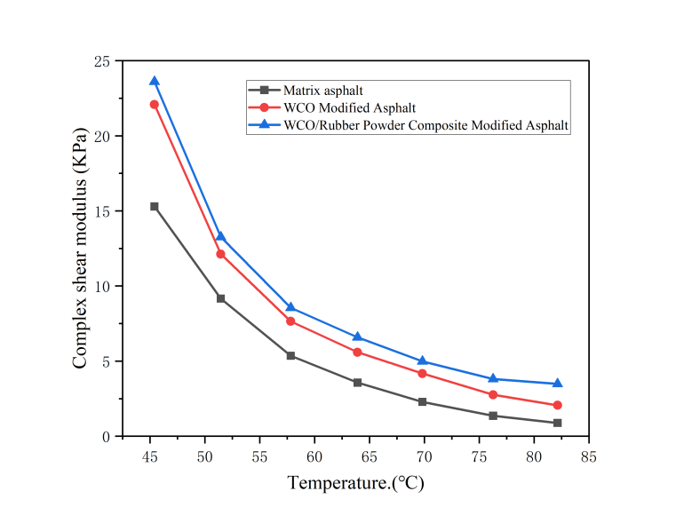
Fig. 1 Complex shear modulus diagram
Figure 1 shows the trend of complex shear modulus (G*) of matrix asphalt, WCO-modified asphalt and WCO/rubber powder composite modified asphalt at different temperatures. As the temperature increases, the complex shear modulus of the three kinds of asphalt shows a significant decrease, indicating that the increase in temperature leads to a decrease in the viscoelasticity of the asphalt material, and its resistance to deformation is weakened. At the same temperature, the complex shear modulus of WCO/rubber powder composite modified asphalt is the highest, followed by WCO modified asphalt, and matrix asphalt is the lowest. This indicates that under the same conditions, the composite modified asphalt has higher stiffness and load carrying capacity, which is conducive to improving the rutting resistance at high temperatures.The higher modulus of WCO modified asphalt compared with matrix asphalt suggests that the waste cooking oil rejuvenator can replenish the light components lost in the aged asphalt and improve the structure of asphalt, which in turn improves the stiffness. The further incorporation of rubber powder, through its polymer network structure in the asphalt to form a reinforcing support, significantly improve the overall stiffness and elastic recovery properties of the material, so that the composite modified asphalt in the range of 46-82 ℃ to maintain a high modulus level.
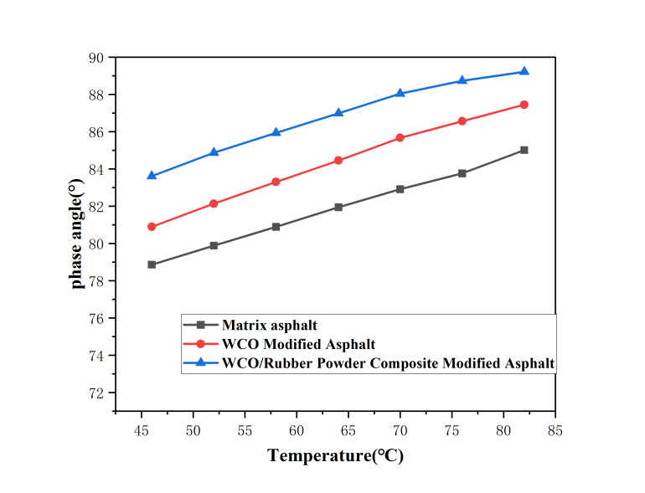
Fig. 2 Phase angle-temperature relationship graph
Fig. 2 shows the variation patterns of phase angle (δ) of matrix asphalt, WCO modified asphalt and WCO/rubber powder composite modified asphalt at different temperatures. With the increase of temperature, the phase angle of the three kinds of asphalt are upward trend, indicating that the increase of temperature makes the asphalt viscoelastic characteristics from elastic dominant to viscous dominant gradually change, and the material mobility is enhanced. At the same temperature, the phase angle of WCO/rubber powder composite modified asphalt is the lowest, followed by WCO modified asphalt, and matrix asphalt is the highest, which indicates that the composite modified asphalt still maintains high elasticity composition at high temperatures, and the viscous proportion of the material is low, which helps to resist the permanent deformation and improve the stability at high temperatures.The phase angle of WCO modified asphalt is lower than that of matrix asphalt, which suggests that the introduction of the waste cooking oil regeneration agent improves the flexibility of asphalt, and the viscous proportion of material increases the flexibility of asphalt. flexibility of the asphalt while being able to enhance the elasticity performance of the asphalt to some extent. After the rubber powder is further incorporated, its polymer chain structure forms a three-dimensional network in the asphalt system, which significantly improves the elastic recovery ability of the asphalt, further reduces the phase angle, and counteracts the viscosity enhancement effect brought about by the increase in temperature. In addition, the synergistic effect of WCO and rubber powder can effectively regulate the asphalt viscoelastic equilibrium relationship, in order to enhance the low-temperature flexibility and cracking resistance of recycled asphalt on the basis of improving the high-temperature rutting resistance, for asphalt pavements in high temperature and heavy-duty traffic conditions to provide a strong support for the application.
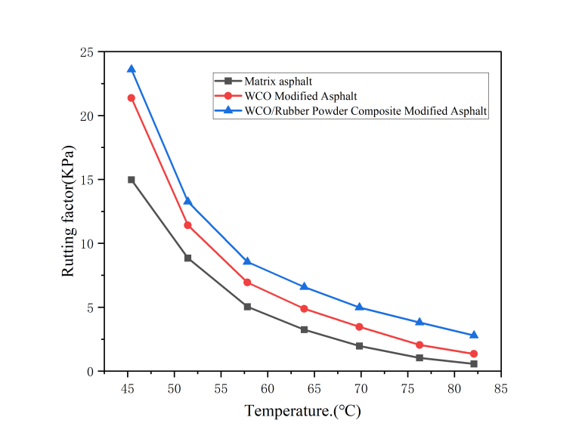
Fig. 3 Rutting factor-temperature relationship
The figure demonstrates the rutting factor (G*/sinδ) change rule of matrix asphalt, WCO modified asphalt and WCO/rubber powder composite modified asphalt at different temperatures. Overall, the rutting factors of the three asphalts decreased significantly with increasing temperature, indicating that the high-temperature rutting resistance of asphalt materials decreases with increasing temperature, showing typical temperature sensitivity characteristics. At the same temperature, the overall rutting factor of matrix asphalt is higher than that of WCO-modified asphalt, while the rutting factor of WCO/rubber powder composite-modified asphalt is in between the two, and shows a relatively high rutting factor in the middle and low temperature section (45-65°C), which suggests that the composite-modified asphalt has a better high-temperature rutting resistance performance in this temperature range. This is mainly attributed to the fact that the incorporation of waste cooking oil (WCO) reduces the stiffness and viscoelastic structure of the asphalt while improving its low-temperature fluidity, leading to a decrease in the high-temperature rutting resistance. The introduction of rubber powder effectively improves the stiffness and viscoelastic energy storage capacity of the asphalt system through the formation of an elastic skeleton and network structure, compensating for the lack of high-temperature performance brought about by the incorporation of WCO, so that the composite modified asphalt in the medium and high temperature zone shows better rutting resistance.
6. Concluding remarks
(1) Compared with WCO modified asphalt and matrix asphalt, the softening point of modified asphalt after WCO/rubber powder composite significantly increased, the ductility has been improved to some extent, and the degree of penetration was slightly reduced compared with matrix asphalt.The softening point of WCO/rubber powder composite modified asphalt was increased by 5% and 13.5% compared with rubber powder modified asphalt and matrix asphalt, respectively.
(2) By comparing the G* and δ of matrix asphalt and WCO/rubber powder composite modified asphalt, at the same temperature, the G* of matrix asphalt is the smallest, and the G* of composite modified asphalt is large; while the δ of matrix asphalt is the largest, and the δ of composite modified asphalt is the smallest. It shows that after adding surface waste cooking oil and rubber powder, the composite modified asphalt has a stronger ability to resist high temperature deformation compared with the matrix asphalt.
(3) In the DSR test, the rutting factors at different temperatures were compared and analyzed, and the results showed that with the increase in temperature, the WCO/rubber powder composite modified asphalt was greater than the rubber powder modified asphalt and matrix asphalt under the seven temperature conditions of 52°C, 58°C, 64°C, 70°C, 76°C, 82°C, and 88°C. The results showed that the rutting resistance of asphalt was significantly improved by adding WCO.

References
- Xian Yougong, Zhang Jianming, Luo Chengbin, et al. Study on the recycling performance of SBS modified asphalt with plant oil-based recycling agent [J]. Contemporary Chemical Engineering, 2022, 51(12): 2847-2850
- Linjian S ,Yuming X . Design and Experimental Research on Centralized Lubrication an
d Waste Oil Recovery System for Wind Turbines[J]. Applied Sciences,2023,13(3): 167- 172.
- Ning X ,Hainian W ,Huimin W,et al. Research progress on resource utilization of waste
cooking oil in asphalt materials:A state-of-the-art review[J]. Journal of Cleaner Product ion,2023,38(5): 74-77.
- Liang Chenghao. Research on the Road Performance of Two Types of Bio-oil Modified Asphalt and Mixtures [D]. Central South University of Forestry and Technology, 2022.
- Lei Jiechao. Research on the Performance of Castor Oil-Based Bio-Asphalt/TLA Composite Modified Asphalt and Its Mixtures [D]. Guangxi University, 2022.
- Wan Guizhi. Study on the Preparation and Performance of Waste Cooking Oil-Based Asphalt Regenerant [D]. Wuhan University of Technology, 2019.
- Pan Haozhi. Research on the Performance of Bio-asphalt Modified Asphalt Binder [D]. Hunan University, 2016.
- Ministry of Transport of the People's Republic of China. Test Methods of Bitumen and Bituminous Mixtures for Highway Engineering: JTG E20-2011 [S]. Beijing: People's Communication Press, 2011.

