Opinion Article

Research and application progress of artificial wetland sewage treatment technology: from ecological significance to future challenges

.
ABSTRACT

Constructed wetlands (CWs), as an eco-friendly wastewater treatment technology with low investment and energy consumption, are playing an increasingly vital role in global water environment management. This paper systematically reviews their development and applications worldwide, with a focus on China's significant achievements in large-scale implementation. Taking Shandong Mata Lake as a representative case, the study demonstrates how the three-tiered "treatment, utilization, and preservation" model effectively restores regional groundwater depth and biodiversity. Addressing efficiency degradation in cold regions and low-carbon nitrogen ratio wastewater treatment bottlenecks, the research reveals breakthroughs in sulfur autotrophic denitrification technology and directional control of filler processes, while exploring intelligent operation methods like clogging prediction to enhance system stability. The paper also analyzes core challenges including winter efficiency decline in cold regions, intensified greenhouse gas (CH₄) emissions under salinity stress, and delayed standardization of design systems and quantified ecological service valuation. Future priorities include developing resilient plant-microorganism co-culture technologies, optimizing wetland flow patterns to suppress methane production, establishing smart management platforms, and improving carbon accounting evaluation standards. Ultimately, this advancement will propel constructed wetlands toward intelligent resource recovery (e.g., closed-loop systems integrating wastewater treatment, energy production, and agricultural reuse), reinforcing their critical role in global carbon neutrality and sustainable water ecosystem restoration.

Keywords: Constructed wetland; sewage treatment; ecological restoration; sulfur autotrophic denitrification; greenhouse gas; intelligent operation and maintenance; standardized design.

1. INTRODUCTION

As an efficient sewage treatment technology that simulates the ecological process of natural wetland, constructed wetland (CWs) has become a key ecological engineering means in the field of water environment management worldwide due to its low investment, low energy consumption, easy maintenance and significant ecological and environmental synergistic benefits.

In recent years, as China has advanced its ecological civilization construction and implemented national strategies like the "Water Ten-Year Plan" and the 14th Five-Year Plan for Ecological and Environmental Protection, which set higher standards for water quality improvement and ecological restoration, the country has increasingly prioritized and actively promoted artificial wetland technology. This innovation has seen rapid development and widespread application in wastewater treatment plant effluent upgrading, ecological water replenishment for rivers and lakes, agricultural non-point source pollution control, and black-odorous water body remediation. Successful cases such as Shandong's Mata Lake and Jining's Old Canal Wetland demonstrate significant potential in achieving water quality upgrades (e.g., from below Class V to Class III) and ecosystem restoration.

However, artificial wetland technology faces critical challenges including significant efficiency degradation in cold regions during winter, inadequate adaptability to saline-alkaline and fluoride-rich environments, limited removal capacity for emerging pollutants like antibiotics and microplastics, as well as substrate clogging and insufficient control of greenhouse gas emissions (e.g., CH₆). These issues necessitate further improvements in long-term operational stability, environmental risk management, and ecological benefit maximization. Such technical barriers not only restrict the technology's application across broader regions and complex scenarios but also undermine its sustainability as "green infrastructure".

Building on this foundation, this study systematically examines the research progress, large-scale engineering practices, core challenges, and innovative solutions in China's constructed wetland technology. It conducts an in-depth analysis of the technical framework, particularly focusing on critical aspects such as addressing complex environmental stresses, enhancing deep purification capacity, reducing ecological risks, and quantifying environmental benefits. By analyzing successful case studies and existing issues while incorporating international trends, the research proposes targeted improvement measures and development recommendations. These efforts aim to promote the greater and more sustainable application of constructed wetland technology in China's water environment management and ecological restoration initiatives.
2. Development status: technology evolution and large-scale application

2.1 The evolution of global technology

2.1.1 Origin and theoretical foundation

The systematic study of constructed wetlands originated in the mid-20th century. In 1953, German aquatic biologist Kathe Seidel discovered through observations in the Rhine River basin that reeds could effectively remove organic pollutants and heavy metal ions from water bodies, marking the first revelation of wetland ecosystems' water purification function (Seidel K,Happel H,Graue G,1978). By the 1970s, Reinhold Kickuth proposed the "Root Zone Method" (RZM), scientifically explaining how the oxygen-rich microenvironment created by plant roots drives pollutant degradation through redox reactions. This breakthrough officially established constructed wetlands as an ecological engineering technology for water pollution control (Zhu Hui, Yan Baixing, Wang Xinyi,2022).

In the late 1980s, Europe pioneered vertical/horizontal flow processes centered on particle size classification fillers (coarse sand layer-gravel layer), which were later scaled up in countries like the United States and Australia. Through systematic analysis of 217 global engineering cases during this phase, scientists identified key design parameters including hydraulic load rate (HLR=0.05–0.2 m³/m²·d) and substrate thickness (0.6–0.8 m), driving the standardization of these technologies.

In the 1990s, the application scenarios of constructed wetlands were significantly expanded: from domestic sewage to agricultural non-point pollution (such as nitrogen and phosphorus runoff interception), industrial wastewater (food processing, mine drainage) and stormwater runoff management.

2.1.2 Regional technical characteristics

European constructed wetlands have evolved from experimental technologies into standardized, large-scale ecological engineering solutions. By 2025, over 12,000 operational wetland systems will be operational across the EU, covering scenarios ranging from domestic sewage treatment to wastewater purification for communities of up to 500 people, and even advanced industrial wastewater treatment (Zhang Zhiqin ,Wu Peng,2016). As the technological hub, Germany accounts for over 50% of Europe's constructed wetlands. A prime example is the "Subsurface Flow Constructed Wetland (HSSF)", which achieves COD removal rates of 85%-90% and TN removal rates of 75%-91% through synergistic interactions between gravel layers, reed root systems, and microbial communities (Lei Xu,2015).

North America, particularly the United States, is actively promoting modular prefabricated wetland systems. Studies indicate that modular design reduces construction time by over 30% through pre-manufactured components and parallel production processes. A prime example is Bio-Microbics' FAST system, which employs fixed-film activated sludge technology and requires installation by just two technicians. This decentralized solution, exemplified by the Dawn Community in Virginia, allows flexible expansion as needed, effectively cutting down on the high costs associated with traditional centralized pipeline networks.

2.2 Current situation of technology application in China

2.2.1 Large-scale engineering practice

Starting from the seventh Five-Year Plan period (Tianjin Reed Wetland in 1987), China has gradually developed a three-level model of "treatment, use and preservation", and achieved an ecological leap from inferior class V to Class III water in sewage treatment plants (such as the case of Mata Lake in Shandong Province).

Mata Lake: Systematic treatment from "Class V" to Class III water Mata Lake treatment process: sewage treatment plant → subsurface flow wetland → surface flow wetland → ecological stabilization pond → lake replenishment. Mata Lake was once polluted by papermaking, chemical and other industries, resulting in water quality deterioration to class V (COD up to 1000mg/L).The local government reversed the situation through the strategy of "governance, use and protection".

Source "pollution control": Strict local emission standards are imposed to force enterprises to upgrade their processes or quit, and enterprises are required to set up "biological indicator pools" to ensure that the drainage can support fish survival (Ministry of Ecology and Environment,2024).

Process "reuse": After the effluent from the sewage treatment plant reaches the standard of grade A (COD ≤50mg/L), it is purified by three levels of subsurface flow wetland, surface flow wetland and ecological stabilization pond, and the COD is reduced to less than 20mg/L, reaching the standard of class ⅲ surface water.

Terminal "protection": 11,000 mu of artificial wetland buffer zone was built to restore lake water storage capacity (increased by 7 times) and biodiversity, and the depth of groundwater was raised by 5.2 meters.

Jining City Case Study: Old Canal Wetland Process: Wastewater Treatment Plant → Composite Subsurface Flow → Horizontal Subsurface Flow → Surface Flow → Stabilization Pond → Old Canal.To ensure water quality for the South-to-North Water Diversion Project, Jining City directs effluent from 44 wastewater treatment plants into artificial wetlands for secondary purification. The core technology employs a combined system of "composite subsurface flow wetland + horizontal subsurface flow wetland + stabilization pond", achieving stable effluent COD levels ≤30 mg/L and ammonia nitrogen ≤1.5 mg/L, surpassing Class III surface water standards. An independent monitoring section was established 500 meters downstream from the main discharge outlet of Jining's Old Canal Artificial Wetland. Long-term observation data shows that since the wetland purification project began operation in 2010, chemical oxygen demand (COD_{Cr}) and ammonia nitrogen (NH₃-N) concentrations in the river have shown significant downward trends (Gao Ben,2019).

The specific manifestations are as follows: ① CODCr decreased continuously from about 30 mg/L (2010 level) before the project operation, and stabilized ≤20 mg/L in 2015, reaching the limit of Class III in "Surface Water Environmental Quality Standard" (GB 3838-2002) (monitoring data in Figure 1)

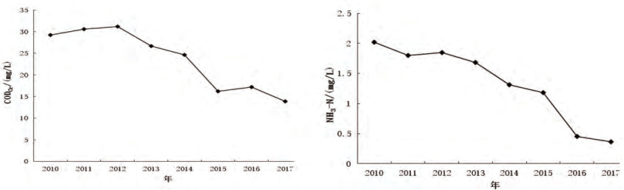
Fig. 1. Changes in CODCr and NH3-N content at monitoring sites from 2010 to 2017
② NH3-N decreased from 2 mg/L in the early stage to 0.3 mg/L in 2017, with a decrease of more than 85%, far lower than the standard limit of class III (1.0 mg/L)
Table 1 Main indicators of Grade A standard and Surface Water Class Ⅲ standard

water-quality index | Daily mean (mg/L) | Standard name
COD_{cr} | 50  20 | Discharge standard of pollutants for municipal wastewater treatment plant（GB 18918－2002）Grade A standard  Surface Water Environmental Quality Standard (GB3838-2002) Class III standard
10
4
NH₃-N | 5  1.0
TN | 1.5  1.0
TP | 0.5  0.2
*The values in the table correspond to two criteria in sequence

2.2.2 Technology integration innovation

2.2.2.1 Low temperature and efficient nitrogen removal mechanism of sulfur autotrophic denitrification system

In the field of wastewater treatment, traditional heterotrophic denitrification technology faces bottlenecks such as dependence on high carbon-to-nitrogen ratios and performance degradation under low-temperature conditions, making it difficult to meet both low-carbon emission requirements and efficient nitrogen removal needs. To address this, research teams have conducted in-depth studies on sulfur autotrophic denitrification constructed wetland systems. The team developed a reaction system using sodium thiosulfate and sulfur as sulfur sources, with ceramic beads, siderite, and limestone as fillers (Gao Jingqing, Wang Qing, Yang Jiao,2025). This breakthrough not only successfully resolved the nitrogen removal challenge for wastewater with low carbon-to-nitrogen ratios but also revealed the synergistic purification mechanism between microorganisms and the filler materials (as shown in Figure 2).
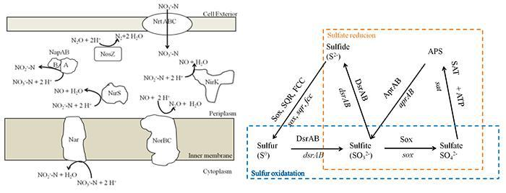

Fig. 2. Prediction of nitrogen removal and sulfur metabolism pathway in the sulfur autotrophic denitrification system

Sulfur autotrophic denitrification technology uses sulfur (S) and siderite (FeCO₃) as composite fillers, and reduces nitrate to nitrogen gas through sulfur-oxidizing bacteria (such as denitritizing sulfur bacteria). The core reaction is: 5S+6NO⁻³+2H₂O→3N₂↑+5SO₂⁻⁴+4H⁺

The engineering practice shows that under the condition of 15-25℃ low temperature, the biofilter filled with sulfur (particle size 2-4 mm) and siderite in a mass ratio of 3:1 can achieve a nitrate removal rate of ≥99% and a TN removal rate of>95%, without the need for additional carbon source.

2.2.2.2 Functional modular design can be achieved by directional control of filler

The clay particle-based wetland (60% sulfur + 30% clay particles + 10% zeolite) specializes in nitrogen removal, achieving a TN removal rate of 60.8% (Gao Jingqing, Wang Qing, Yang Jiao,2025). The porous structure of clay particles promotes biofilm formation, enabling efficient collaboration between nitrifying and denitrifying bacterial communities in alternating microaerobic and anoxic environments. This system is particularly suitable for treating industrial wastewater from coking, dyeing, and related processes.

The sludge-based wetland focuses on phosphorus removal, achieving a TP removal rate of 76.7%. The residual aluminum salts in the sludge fix phosphate through coordination adsorption. The Fe2+ released from pyrite forms Fe3(PO4)₂ precipitates with PO4³⁻, while limestone regulates the calcium-phosphorus crystallization process (as shown in Figure 3).

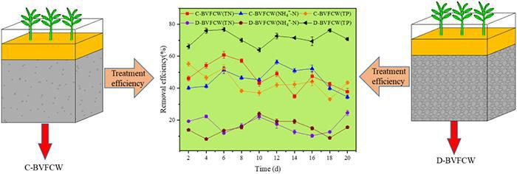
Fig. 3. Denitrification and phosphorus removal of vertical flow constructed wetlands (C-BVFCW/D-BVFCW) based on clay pellets/water supply sludge.

2.2.2.3. Process coordination and long-term operation guarantee

The two-stage system achieves stepwise pollutant removal through the "biofilter-artificial wetland" configuration (Zhaoqian Jing,Rui He,Yong Hu,Qigui Niu,Shiwei Cao & Yu-You Li,2015): The sulfur autotrophic unit primarily removes nitrogen while reducing COD, whereas the directional wetland regulates residual nitrogen, phosphorus, and sulfate byproducts. Key operational parameters include: hydraulic load of 0.5-0.8 m³/(m²·h) for biofilters, 8-12 h hydraulic retention time in wetlands, and air-water backwash cycles lasting 7-10 days with a flow rate of 4 L/(m²·s) (Wang Hongjie, Han Kai, Wang Yali, et al,2021).

2.3 Core scientific breakthroughs

2.3.1 Plant-microbe synergistic mechanism

Acanthus powderii can tolerate an ammonia nitrogen concentration of 100 mg/L and regulates osmotic potential through sucrose metabolism. It demonstrates a cadmium accumulation capacity of 1.2 mg/g (dry weight) (Gao Jingqing, Wang Qing, Yang Jiao,2025), with rhizosphere probiotics further enhancing heavy metal purification efficiency. Siberian iris achieves over 95% cadmium removal rate under low temperatures, providing a novel approach for heavy metal pollution remediation (Wang Hongjie, Han Kai, Wang Yali, et al,2021).

2.3.2 Development of functional fillers

The clay-based wetland specializes in nitrogen removal (TN removal rate of 60.8%), and the water supply sludge-based wetland strengthens phosphorus removal (TP removal rate of 76.7%), realizing the "customized" purification function （Gao Jingqing, Wang Qing, Yang Jiao,2025).

- Research hotspots and challenges: bottlenecks and breakthroughs

3.1 Technical bottleneck: efficiency attenuation and material limitation

3.1.1 Low temperature inactivation problem

The treatment efficiency in northern regions decreases by 30%-80% during winter, primarily due to microbial activity inhibition and freezing effects. The "ice cap insulation layer + geothermal circulation pipe" system (Technical Guide for Water Purification in Wetlands, compilation group,2021) has been promoted to maintain substrate temperature (5℃) through geothermal circulation, thereby reducing microbial activity suppression. Alternatively, cold-resistant bacterial agents can be added to enhance COD removal rates to 65% during low-temperature periods (Zhaoqian Jing,Rui He,Yong Hu,Qigui Niu,Shiwei Cao & Yu-You Li,2015). Combining this approach with cold-hardy plants like Siberian iris (Wang Hongjie, Han Kai, Wang Yali, et al,2021) further strengthens the synergistic removal of heavy metals and nitrogen/phosphorus.

3.1.2 Matrix blockage and life decay

After 3-5 years of operation, the permeability decreases by 40%-60%, while prices of traditional fillers like volcanic rock and vermiculite increase by 17% due to mineral control policies (Zeng Lin, Yuan Yue, Wang Pan,2022). The development of "self-regenerating" fillers (such as biochar loaded with nZVI) (Zhang Yalei, Zhou Xuefei, Zhao Jiang, Du Jiawen, Huang Baorong, & Chen Tianyin,et al,2022) utilizes micro-electrolysis reactions to delay clogging. Through IoT monitoring of permeability changes, algorithms predict blockage risks with 92.6% accuracy in Hangzhou cases) (Lu Ning,2016), extending filler lifespan beyond 10 years.

3.1.3 Insufficient removal of refractory pollutants

Existing treatment systems lack effective removal pathways for emerging pollutants such as antibiotics and microplastics. Current wetland systems demonstrate low removal efficiency of tetracycline antibiotics while posing risks of antibiotic resistance gene spread. A solution involves using pre-treatment UV/ozone units to degrade antibiotics (e.g., tetracyclines)(Chen Xin, Zhu Hui, Zhang Haitao, et al,2023), which reduces resistance gene transmission risks. Additionally, constructing microbial fuel cell wetlands (CW-MFC) with biochar anodes enables electrochemical degradation of microplastics (experimental data shows 60% particle size reduction)(Li Ang, Ai Peng, Lin Lili, Lu Rui, Rong Peng, Li Zhiwei,2021), while simultaneously generating electricity (121 mW/m³).

3.2 Inadequate adaptability to complex environment

3.2.1 Salinity and fluoride stress

Research indicates that COD removal rates decrease by 25%-40% under combined salinity and fluoride stress, with the global warming potential (GWP) of high-salinity wetlands reaching 4.2 times that of conventional systems. To counteract these stresses, microbial communities enhance diffusion limitation to improve network modularity, leading to abnormal abundance of functional bacteria like Anaeromyxobacter. Alternative solutions include planting Suaeda (pH tolerance>9.5) as a replacement for reeds, achieving over 90% winter survival rates. Alternatively, introducing salt-tolerant bacterial communities (e.g., Halomonas genus) can neutralize pH fluctuations caused by salinity stress, maintaining COD removal rates ≥75%(Liu Li, Sun Xue, Wang Na, Shi Jiping, Cui Wenhui, & Li Yonghong,2020). Additionally, using FeCO₃ filler to release CO₃⁻ and neutralize H⁺ can suppress greenhouse gas emissions, reducing GWP to 1.5 times that of conventional systems (Chengye Feng,Xinwen Zhang,Guangcan Gao,Kerui Ren,Zichao Li,Zhenghe Xu.etc ,2025).

3.2.2 Threat of sea level rise

Salinity intrusion in tidal freshwater wetlands causes salinization, leading to the death of freshwater organisms. Simulation studies show that natural marshes, with their efficient salt drainage networks, can reduce the duration of high salinity during storm surges by 48.7% compared to artificial wetlands (Saccon E ,Hendrickx G G ,Hulscher J S , et al,2025). Combining salt-tolerant plant communities (such as Suaeda and reeds) enhances ecosystem resilience.

3.2.3 Lack of greenhouse gas emission control

Constructed wetlands are significant sources of methane emissions, particularly in anaerobic environments. Traditional wetlands exhibit CH4emission fluxes ranging from 30 to 100 mg CH₄/m²/h, which demonstrate a substantial contribution to global warming potential. The increasing number of publications on greenhouse gas emissions from constructed wetlands highlights growing attention to this environmental issue (as shown in Figure 4).

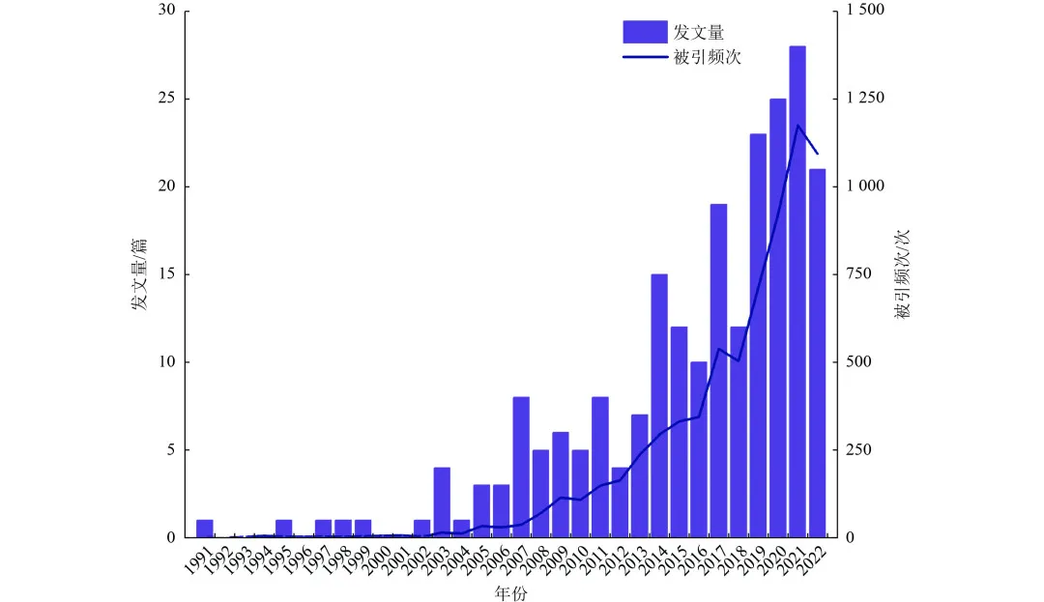
Fig. 4. Number of articles and citation frequency of greenhouse gas emissions in constructed wetland research

The design of wetland flow patterns can be optimized through anaerobic-aerobic zonation control (e.g., tidal flow), while water level regulation creates an aerobic microenvironment to inhibit methanogens (Methanosaeta) activity (Ma Hongyun, Zhou Lei, Zhang Xueqi, et al,2023), reducing CH₄ emission flux below 15 mg/m²·h. By leveraging the X-MethaneWet platform's intelligent management system to integrate global monitoring data, the model predicts peak CH₄ emissions (Sun Yiming, Chen Shuo, Chen Shengyu et al,2025). This enables coordinated regulation of influent load and dissolved oxygen levels, achieving a 30% reduction in emissions.

3.4 Standard system and lagging realization of ecological services

3.4.1 Design specification disconnection

Current standards inadequately address native plant species selection. A notable case is the Yellow River Basin wetlands where reeds were indiscriminately introduced to replace local cattails, resulting in over 40% winter mortality rates (Department of Soil and Agriculture and Rural Affairs, Ministry of Ecology and Environment, 2025). To address this, national authorities should establish guidelines for native plant configuration in artificial wetlands. These guidelines must mandate the use of native cattails in northern high-cold regions (with winter mortality rates <10%), while prioritizing Suaeda salsa in southern saline-alkali zones.

3.4.2 Ecological value is difficult to quantify

Wetland carbon sinks and biodiversity benefits were excluded from the project evaluation system, with only 8% of operators receiving payments for ecological services. At the national level, an "incremental wetland carbon sink" accounting model (based on IPCC Wetland Guidelines) was established and incorporated into the evaluation framework. Pilot carbon trading programs (such as Shandong Mata Lake) achieved payment coverage for 30% of projects . Additionally, eDNA technology was introduced to monitor wetland biodiversity , quantify ecological gain indicators, and apply for international eco-labels like the "Wetland Biodiversity Five-Star" certification.

3.4.3 Weak international patent layout

China holds 62% of global patents in the filler industry, yet only 7% are international applications, with core technologies facing obstacles in global commercialization. The government should prioritize promoting PCT international applications for sulfur autotrophic denitrification filler technology, conductive biochar electrodes, and artificial wetland treatment systems.

- Conclusion

4.1 Progress Summary

Through decades of development, constructed wetland technology has evolved from standalone wastewater treatment facilities into integrated ecological complexes. In fundamental research, the synergistic mechanisms among microorganisms, plants, and filter media have been progressively clarified. Technologically, modular design and smart operation systems have significantly enhanced efficiency. Policy-wise, ecological compensation mechanisms and carbon trading systems have injected momentum into sustainable development. However, challenges such as efficiency degradation in cold regions, deep removal of complex pollutants, and greenhouse gas emission control still require breakthroughs.

4.2 Future research ideas and development suggestions

Constructed wetland restoration serves as a pivotal initiative to enhance the aquatic ecological quality of China's coastal waters and preserve vital habitats for coastal biodiversity. As an active participant in both the Ramsar Convention on Wetlands and the Convention on Biological Diversity, China plays a significant role in global marine governance. However, the scientific and technological support systems for constructed wetland restoration in China still lag behind international advancements and domestic practical needs. Moving forward, it is imperative to establish a tailored theoretical framework and engineering standards system aligned with national conditions, as proposed by scholar Zhu Hui (Seidel K,Happel H,Graue G,1978).

The future of constructed wetlands lies in the triple integration of ecological, intelligent, and resource-oriented approaches. By strengthening fundamental research, innovating technological applications, and improving policy safeguards, these ecosystems will play a more significant role in global water environment governance and carbon neutrality efforts. To this end, the following research strategies and development recommendations are proposed.

Salt-tolerant wetland plants (e.g., Suaeda) were selected and cultivated, and functional microbial agent library was constructed to improve the adaptability of the system in high salinity and alkali areas such as Songnen Plain.

The "Wetland Digital Twin Platform" was established to integrate X-MethaneWet data [21] collection and mathematical model, so as to realize real-time warning and optimization of CH₄ emission.

We will accelerate the formulation of "Ecological Benefit Assessment Specifications for Artificial Wetlands"(Xing Wei, Yu Cai Zhi, Wei Yuyu, Pang Yanbing, Ge Zhiwei & Xue Jianhui,2023), incorporate carbon sink increment and biodiversity index into the evaluation system, and promote 47 national standards to cover the whole life cycle.

Develop a closed-loop model of "sewage treatment-energy production-agricultural reuse", such as wetland coupled with algae cultivation system, which produces biodiesel and organic fertilizer simultaneously.

Competing interests

Authors have declared that no competing interests exist

COMPETING INTERESTS DISCLAIMER:
Authors have declared that they have no known competing financial interests OR non-financial interests OR personal relationships that could have appeared to influence the work reported in this paper.

References

Seidel K,Happel H,Graue G. (1978). Contrilbutions to revitalisation of waters.Stiftung Limnologische Arbeitsgruppe.
Zhu Hui,Yan Baixing,Wang Xinyi. (2022). Research and application progress of constructed wetland in China and suggestions for future development. China Science Foundation,36(03), 391-397. doi:10.16262/j.cnki.1000-8217.2022.03.004.
Zhang Zhiqin and Wu Peng. (2016). The European Union's constructed wetland achieves comprehensive economic, social and environmental benefits in wastewater treatment, https://eu.china-mission.gov.cn/kjhz/kjjl/201608/t20160812_8430517.htm.
Lei Xu. (2015). Structural analysis of microbial communities in composite vertical flow constructed wetland-circulating aquaculture system (Master's thesis, Nanjing Agricultural University).https://kns.cnki.net/kcms2/article/abstract?v=wOuTVkq58Nlo4O496KlT8R6oMqF7M25_T9BXami4p6v0I5UUWSM759B4NkiDXK_22cd7D997X2CyFa2Pj6IBtfaRRQcbiLdtgE0N9MYAILq0UeM_iLFfhmX8vtRGPioJDTBghv5xiUKHFM---keyBCTmgJdBwyNwAucEt4Al-6V5w8Cyjnld6w==&uniplatform=NZKPT&language=CHS
Ministry of Ecology and Environment. (2016). First in the country! Mata Lake was selected as the first batch of excellent cases of beautiful rivers and lakes in China,https://www.sohu.com/a/518952585_120182157
Gao Ben.(2019).Northern composite constructed wetland project: Taking the wetland at the inlet of the old Canal into the lake in Jining as an example. Wetland science and management,15(03),4-7.
Gao Jingqing, Wang Qing, Yang Jiao. (2025). Wetlands are cleverly used to control pollution and give the ecology a new look,http://www.kepu.gov.cn/news/2025-04/26/content_331493.html
Wang Hongjie, Han Kai, Wang Yali, Li Yingying, Teng Yajie, & Zhang Yu. (2021). Sulfur autotrophic denitrifying biofilter, sewage treatment system and its treatment method. CN112744912A.
Wang Wenlong.(2014).Study on purification of polluted river water by artificial wetland of Siberian Iris in cold season (Master's thesis, Zhengzhou University). Master https://kns.cnki.net/kcms2/article/abstract?v=wOuTVkq58NnkAf9OgzV-d99LcrKnhEmV8KNCBc1dgL3ulNXYzhCWofKQ4VXQFRTvhlE1ZbIwuwIpbNDyt3QvOemOKMG7GJVUGzqgvPctueXzielACfa0SaYVk2_6CiuwLFZarFs1xI6o4cHxEMeVIUJHZpIQ9XOkB0TRfKznTyFkUjXQFhKnLQ==&uniplatform=NZKPT&language=CHS
Zhaoqian Jing,Rui He,Yong Hu,Qigui Niu,Shiwei Cao & Yu-You Li.(2015).Practice of integrated system of biofilter and constructed wetland in highly polluted surface water treatment.Ecological Engineering,75,462-469.
Zeng Lin, Yuan Yue, Wang Pan & Tan Xuejun.(2023).Research progress on blocking mechanism and control measures of artificial wetlands. Water purification technology,42(11),18-26.doi:10.15890/j.cnki.jsjs.2023.11.003.
Zhang Yalei, Zhou Xuefei, Zhao Jiang, Du Jiawen, Huang Baorong, & Chen Tianyin,et al. (2022). Preparation and application of biochar supported nano zero iron materials. CN115231680A.
Lu Ning.(2016).Design and research of Internet of Things wetland environmental monitoring system. Modern agriculture,(07),61-62.
Cheng Xianwei, Liang Yinxiu, Zhu Hui, Zhou Qingwei, Yu Xiangfei and Yan Baixing.(2017).Research progress on antibiotics in water treated by constructed wetlands. Wetland Science,15(01),125-131.doi:10.13248/j.cnki.wetlandsci.2017.01.018.]
Li Ang, Ai Peng, Lin Lili, Lu Rui, Rong Peng, Li Zhiwei.(2021).Experimental study on biofouling mitigation by artificial wetland-microbial fuel cell coupling system. Journal of Aquatic Biology,45(01),190-196.
Liu Li, Sun Xue, Wang Na, Shi Jiping, Cui Wenhui, & Li Yonghong. (2020). Application of a salt-tolerant probiotic in the improvement of saline-alkali land. CN111187737A.
Chengye Feng,Xinwen Zhang,Guangcan Gao,Kerui Ren,Zichao Li,Zhenghe Xu.etc .(2025).A new insight on simultaneous water purification and greenhouse gas reduction by constructing sulfur-siderite driven autotrophic denitrification pathways in constructed wetlands.Water Research,274,123130-123130.
Eleonora Saccon,Gijs G. Hendrickx,Suzanne J.M.H. Hulscher,Tjeerd J. Bouma & Johan van de Koppel.(2025).Wetland topography drives salinity resilience in freshwater tidal ecosystems.Ecological Engineering,217,107650-107650.
Ma Hongyun, Zhou Lei, Zhang Xueqi, Kong Lingwei & Cheng Shuiping.(2023).Research progress on greenhouse gas emissions in constructed wetlands and optimization of pollution and carbon reduction. Journal of Environmental Engineering Technology,13(06),2043-2052.
Sun Yiming, Chen Shuo, Chen Shengyu, Qiu Chonghao, Liu Licheng, Wu Youmei et al, (2025).machine learning ,https://doi.org/10.48550/arXiv.2505.18355.
Department of Soil and Agriculture and Rural Affairs, Ministry of Ecology and Environment.(2025).Technical guidelines for plant selection in constructed wetlands.Chinese Society of Landscape Architecture,www.ttbz.org.cn/upload/file/20230323/6381515990864855482414456.pdf.
Xing Wei, Yu Cai Zhi, Wei Yuyu, Pang Yanbing, Ge Zhiwei & Xue Jianhui.(2023).Study on carbon sink measurement methodology in Suzhou Wetland. Wetland Science and Management,19(05),43-47.

