Original Research Article

Optimizing Hybrid Eggplant Production: A Comparative Assessment of Drip Fertigation and Conventional Fertilization on Vegetative Growth, Agricultural Productivity, and Water Utilization Efficiency

ABSTRACT

|  |
| --- |
| **Aims:** The primary objective of this research was to evaluate the comparative effects of drip fertigation and conventional fertilization methods on vegetative growth, fruit yield, and water utilization efficiency in hybrid eggplant (Solanum melongena L.) cultivation. The study further aimed to identify an economically optimal fertigation level for maximizing productivity and resource use efficiency.  **Study design:** A **Randomized Block Design (RBD)** was implemented to ensure experimental rigor, incorporating five distinct treatments and four replications per treatment.  **Place and Duration of Study:** The field experiment was conducted at Dr. Panjabrao Deshmukh Krishi Vidyapeeth, Akola, Maharashtra, India, during the Rabi season from November 2021 to May 2022.  **Methodology:** The experiment included five treatments: T1 to T4: Drip fertigation at 75%, 100%, 125%, and 150% of the Recommended Dose of Fertilizers (RDF). T5 (Control): Conventional fertilization at 100% RDF. Each treatment was replicated four times. Key agronomic parameters measured included plant height, number of branches, number of fruits per plant, total yield (q/ha), and water utilization efficiency (q/ha-cm). Data were subjected to statistical analysis to determine significance and performance differences.  **Results:** All drip fertigation treatments outperformed the conventional fertilization method in terms of vegetative growth, branching, fruit number, yield, and water use efficiency. T4 (150% RDF through drip) achieved the maximum yield of 470.33 q/ha, followed closely by T3 (125% RDF) with 467.98 q/ha, both being statistically comparable. T4 also recorded the highest water utilization efficiency at 8.54 q/ha-cm. The lowest yield and efficiency were observed in T5 (conventional fertilization).  **Conclusion:** Drip fertigation significantly enhances eggplant productivity and water-use efficiency compared to conventional fertilization. Although the highest yield was observed under 150% RDF, drip fertigation at 125% RDF (T3) is recommended as the most economically sustainable and agronomically efficient strategy, offering reduced fertilizer input without compromising yield potential. |

*Keywords: Eggplant, drip fertigation, recommended dose of fertilizer, water utilization efficiency*

1. INTRODUCTION

Eggplant, commonly known as eggplant, holds significant agronomic and cultural importance worldwide, particularly in India, which is one of its primary centers of diversity and production. Its Latin name, *Solanum melongena*, places it within the Solanaceae family, alongside tomatoes and potatoes. Domesticated over 2,000 years ago in Southeast Asia, eggplant has been a staple crop in tropical and subtropical regions. It is believed to have originated in India and China, as historical texts and early agricultural records from these regions frequently mention its cultivation (FAO, 2020). Today, India stands as the second-largest producer of eggplant globally, accounting for approximately 26% of the world's production, with major cultivating states being West Bengal, Odisha, and Gujarat (Shah *et al.,* 2023). The crop thrives in well-drained, loamy soils with pH levels between 6.5 and 7.5 and under warm, frost-free conditions. There are three major species of eggplant, including *S. melongena* (common eggplant), *S. aethiopicum* (African eggplant), and *S. macrocarpon* (wild eggplant), each with unique morphological and ecological adaptations (Singh & Kumar, 2019). Nutritionally, eggplant is valued for its high fiber content, low calories, and rich antioxidant profile, including nasunin, which supports cardiovascular and cognitive health (Ali *et al.,* 2021).

Globally, eggplant is cultivated on approximately 1.85 million hectares, yielding about 56 million tons annually, with China and India contributing over 85% of the total production (FAO, 2022). In India, eggplant is grown on approximately 0.72 million hectares, producing around 13.4 million tons, with an average productivity of 18.6 tons per hectare (NHB, 2023). The states of West Bengal, Odisha, Andhra Pradesh, and Gujarat are leading contributors, collectively accounting for over 60% of the nation’s eggplant production (Singh *et al.,* 2021). Globally, productivity varies widely, with China achieving some of the highest yields due to advanced cultivation practices and superior hybrid varieties, averaging 35 tons per hectare (Li and Zhang, 2021).

Efficient irrigation management is crucial for eggplant cultivation to ensure optimal growth, yield, and water-use efficiency. Modern irrigation technologies, such as drip irrigation, have transformed water management in eggplant farming by delivering water directly to the plant's root zone through a network of emitters and pipes. This method significantly enhances water-use efficiency, reduces weed growth, and minimizes soil erosion. Studies have shown that drip irrigation can save up to 50% of water compared to traditional methods while increasing Eggplant yield by 30–40% (Patel *et al.,* 2022). Additionally, drip irrigation facilitates the application of fertilizers through fertigation, ensuring precise nutrient delivery and reducing losses (Tiwari & Singh, 2020). Drip irrigation has been increasingly adopted in eggplant cultivation in Maharashtra, improving water use efficiency and productivity by 20-30% in the 2024-2025 period (Patil *et al.,* 2024). This system minimizes water wastage and enhances yield quality, making it a sustainable approach for eggplant farming in the region (Kumar & Singh, 2024).

Drip fertigation is an advanced irrigation and nutrient management technique that combines the benefits of drip irrigation and fertigation, offering precise delivery of water and nutrients directly to the root zone. Its adoption in eggplant cultivation is driven by the crop's high sensitivity to moisture stress and nutrient availability during critical growth stages. Drip fertigation addresses problems such as nutrient leaching, wastage of water and uneven distribution by allowing controlled and uniform application of water-soluble fertilizers in synchronization with the crop's nutrient uptake pattern, thereby improving nutrient-use efficiency and minimizing losses due to runoff and leaching (Patel *et al.,* 2022). This method also facilitates frequent, small-dose applications, ensuring a steady supply of nutrients to meet the plant's dynamic requirements, ultimately enhancing root development, vegetative growth, and fruit quality (Singh *et al.,* 2021).

The rationale for using drip fertigation in eggplant is further strengthened by its environmental and economic benefits. Studies have demonstrated that it reduces water consumption by 30–50% and fertilizer usage by 20–40% compared to conventional methods, making it highly suitable for water-scarce regions (Kumar *et al.,* 2020). Additionally, the reduction in weed growth and soil erosion associated with drip fertigation contributes to sustainable cultivation practices. Given the increasing pressures of climate change and resource constraints, drip fertigation represents a critical innovation for improving the productivity, profitability, and sustainability of eggplant cultivation. Keeping all the above points in mind, the field experiment is planned to compare eggplant production under drip fertigation and traditional fertilization, along with objective given as follows - To compare the growth and yield of hybrid eggplant under drip fertigation and traditional fertilization methods.

2. material and methods

The experiment was conducted at the Instructional Farm of the Department of Irrigation and Drainage Engineering, Dr. Panjabrao Deshmukh Krishi Vidyapeeth, Akola, during the rabi season of 2021-2022. The field site was characterized by a uniformly level topography, providing an ideal setting for the study.

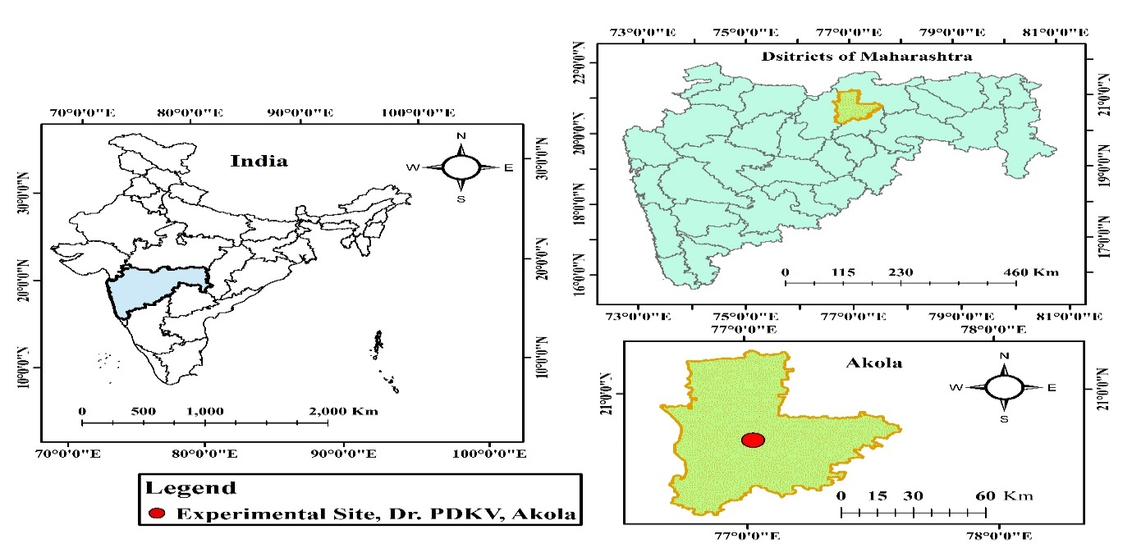

Figure 1. Study area map showing the location of the experimental site

### **2.1 Experimental Details**

The specifics of the experiment are as outlined below

Table 1. Experimental details

|  |  |  |
| --- | --- | --- |
| **Sr. No.** | **Particulars** | **Specifications** |
| 1 | Crop | Eggplant |
| 2 | Scientific name | *Solanum melongena* L. |
| 3 | Variety | Phule Krishna |
| 4 | Experimental Design | Randomized Block Design |
| 5 | Number of treatments | 5 |
| 6 | Number of replications | 4 |
| 7 | Number of plots | 20 |
| 8 | Plot size | 5.4 m × 3 m |
| 9 | Season | Rabi |
| 10 | Crop spacing | 0.90 m X 0.75 m |
| 11 | Crop period | 180 days |
| 12 | Recommended fertilizer dose | 150:75:75 |
| 13 | Date of sowing | 30/09/2021 |
| 14 | Date of transplanting | 16/11/2021 |
| 15 | Period of picking | 18/01/2022 to 01/05/2022 |

(Gavit et al., 2023)

2.2 Details of experimentation

**2.2.1 Experimental design and treatments**

An overview of the experimental plot is presented in Figure 1, while the detailed descriptions of the treatments are provided in table number 2.

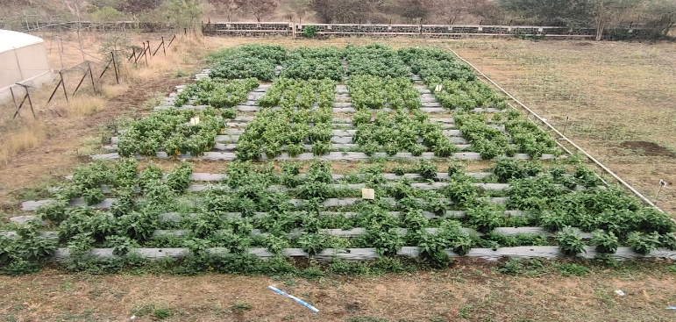

Figure 2. Over all view of experimental plot

Table 2. Treatment details

|  |  |
| --- | --- |
| **Treatments** | **Specification** |
| T1 | Drip fertigation with 75% of RDF |
| T2 | Drip fertigation with 100% of RDF |
| T3 | Drip fertigation with 125% of RDF |
| T4 | Drip fertigation with 150% of RDF |
| T5 | Traditional application of fertilizer with 100% RDF (Soil application of basal dose of 50% N + 100% P + 100% through solid fertilizers at the time of transplanting and remaining 50% N in two equal splits at 30 and 45 DAT) – Control |

(Gavit et al., 2023)

**2.3 Morphometric characteristics**

To evaluate the impact of varying fertilizer levels and application methods on the growth and yield of eggplant, the following morphometric observations were meticulously recorded.

**2.3.1 Growth observations**

Five plants from the net plot of each replication were randomly selected and labeled to record various growth parameters. Observations were systematically gathered at regular intervals from the date of transplanting. Plant height was measured every 30 days throughout the growth period by assessing the length of the main shoot in centimeters from ground level. The number of branches was determined by counting the primary branches originating from the main stem and the secondary branches that developed over time, with the cumulative total recorded at 30-day intervals. Canopy cover was assessed by measuring the plant's spread in both North-South and East-West directions at noon.

### **2.4 Yield contributing observations**

The mean number of fruits per plant was calculated by considering the total number of fruits harvested from the designated observation plants at each picking. For the yield per plant, the weight of harvested eggplant from each observation plant was recorded at every picking, and the cumulative weight across the season was computed for each treatment. The overall yield of eggplant was determined by recording the total harvest from the net plot for each treatment at every picking.

3. results and discussion

**3.1 Morphometric characteristics**

The morphometric characteristics of the eggplant crop, as influenced by varying levels of drip fertigation and the traditional method of fertilizer application, were thoroughly investigated. Field observations for each morphometric parameter were meticulously recorded from five randomly selected plants per plot and subsequently analyzed. The findings are elaborated upon in the following discussion and are shown in fig. 3-7.

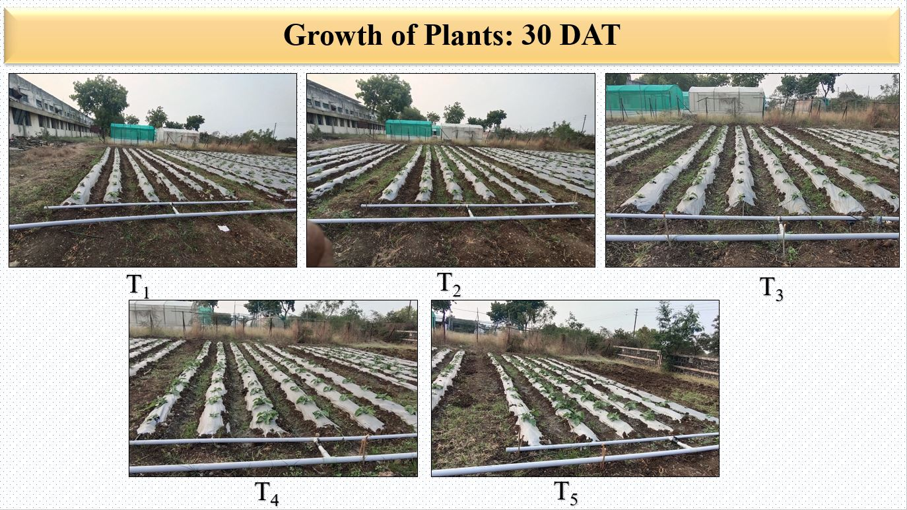

Figure 3. Difference in growth of eggplant crop - 30 DAT

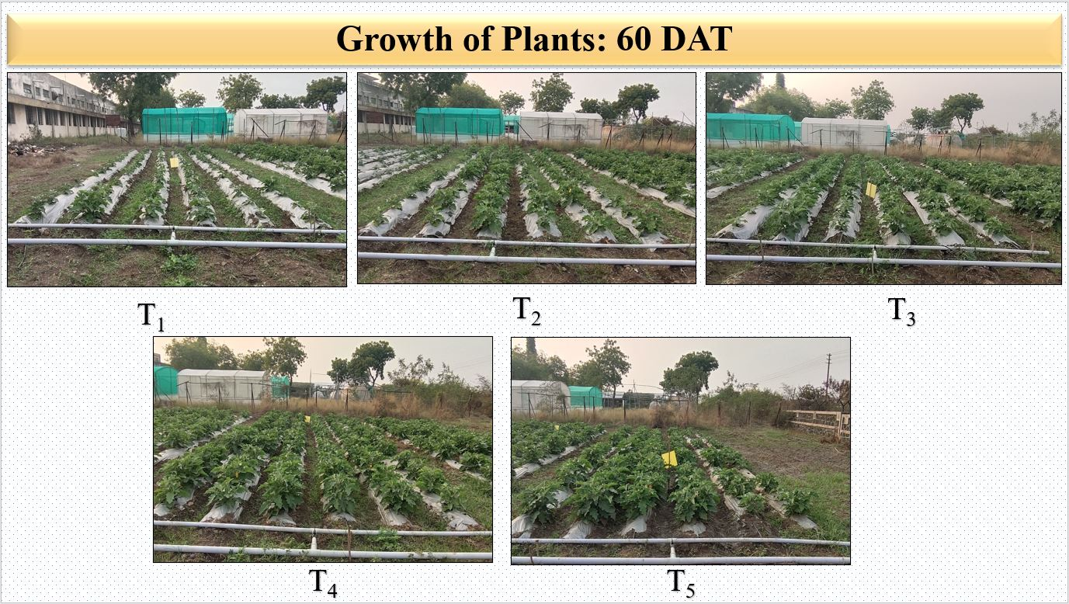

Figure 4. Difference in growth of eggplant crop - 60 DAT

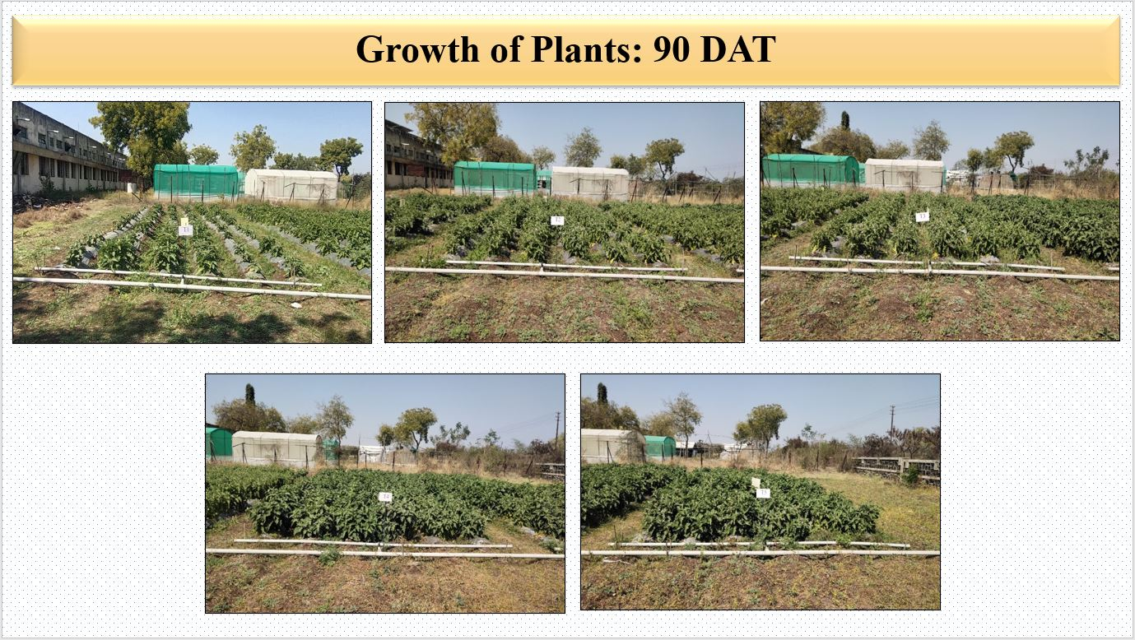

Figure 5. Difference in growth of eggplant crop - 90 DAT

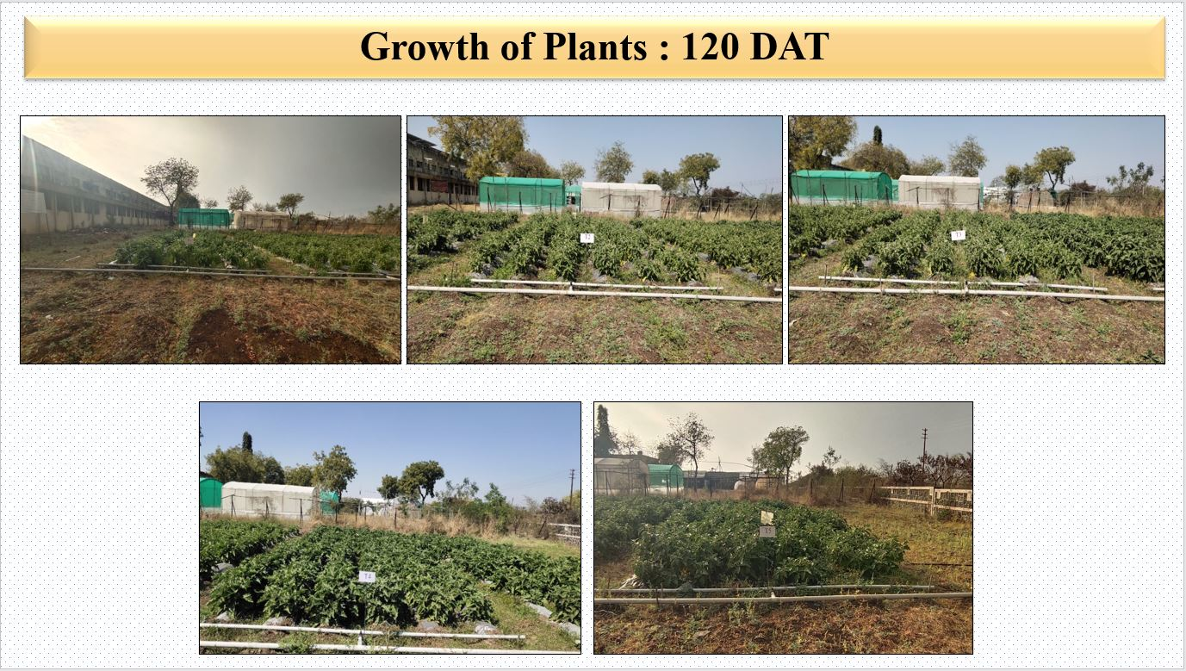

Figure 6. Difference in growth of eggplant crop - 120 DAT

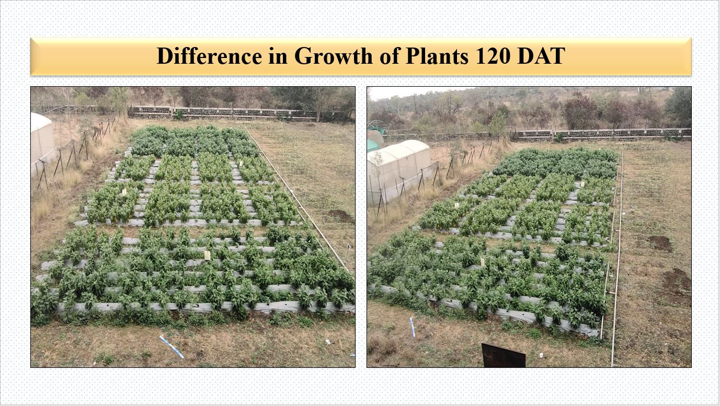

Figure 7. Variation in eggplant crop growth - 120 DAT

### **3.1.1 Growth observations**

#### **3.1.1.1 Plant height**

Plant height in the eggplant crop was measured at 30-day intervals from transplanting, with the mean heights, influenced by different drip fertigation levels and traditional fertilization methods, graphically illustrated in Figure 8. An overall increase in plant height was observed across all treatments as the crop progressed, with the maximum height recorded at the harvest stage. Initially, during the early growth phases (30 and 60 DAT), the control treatment T5, involving traditional fertilization with 100% RDF, exhibited the highest plant height, likely due to the complete application of fertilizers at the outset. However, significant differences emerged from 90 DAT onwards, with treatment T4 showing the tallest plants, statistically similar to T3 indicating a shift in growth dynamics favoring the drip fertigation treatments in the later stages.

Figure 8. Plant height as influenced by drip fertigation with different fertilizer levels and traditional method of fertilizer application

#### ***3.1.1.2 Number of branches per plant***

The average number of branches per eggplant plant, as influenced by varying drip fertigation levels and traditional fertilizer application, is graphically depicted in Figure 9. The data reveal a progressive increase in branch count over time, reaching its peak at the harvest stage. While early growth stages (30 and 60 days after transplanting, DAT) showed no significant differences among treatments, the later stages exhibited notable variation, with branch numbers increasing alongside higher proportions of the recommended fertilizer dose. Initially, treatment T5 recorded the highest number of branches, likely due to the complete fertilizer application within the first 60 DAT, highlighting its initial impact on plant development. At 90, 120 DAT, and at harvest, treatment T4 exhibited the highest number of branches per plant, statistically on par with treatment T3. In contrast, the lowest branch count was observed in treatment T5, similar to T1.

Figure 9. Number of branches per plant as influenced by drip fertigation with different fertilizer levels and traditional method of fertilizer application

#### **3.1.1.3 Canopy cover**

Canopy cover, a critical indicator of vigorous crop growth under varying fertilizer levels with mulch, was measured and is graphically depicted in Figure 10. Initially, at 30 DAT, no significant differences were noted, though treatment T5 exhibited the highest canopy cover numerically. By 60 DAT, T5 continued to show superior canopy coverage compared to drip fertigation treatments, likely attributed to the complete fertilizer application during the early growth stages (up to 45 DAT) in T5, enhancing early vegetative development.

Figure 10. Canopy cover as influenced by drip fertigation with different fertilizer levels and traditional method of fertilizer application

### At 90 DAT, treatment T4 exhibited the highest canopy cover, statistically comparable to treatments T3 and T2. Conversely, treatment T5 recorded the lowest canopy cover, which was on par with treatments T1 and T2. At harvest, treatment T3 demonstrated the highest canopy cover, statistically comparable to T4, while T5 continued to show the lowest, similar to T1.

### **3.2 Yield contributing observations**

#### **3.2.1 Number of fruits per plant**

The data on the number of fruits harvested per plant, as influenced by varying drip fertigation levels and traditional fertilization, is illustrated in table 3. The results indicate that an increase in fertigation level corresponded with a rise in the number of fruits per plant. The highest number of fruits per plant (82.70) was observed in treatment T4, which was statistically similar to treatment T3. Treatment T4 consistently outperformed treatments T1, T2, T3, and T5 in terms of fruit count. On the other hand, treatment T5 recorded the lowest number of fruits per plant (55.25), statistically comparable to treatment T1. Additionally, treatment T2 yielded significantly more fruits than treatment T5.

Table 3. Number of fruits per plant as influenced by drip fertigation with different fertilizer levels and traditional method of fertilizer application

|  |  |
| --- | --- |
| **Treatments** | **Number of fruits per plant** |
| T1 (Drip fertigation at 75% RDF) | 60.85 |
| T2 (Drip fertigation at 100% RDF) | 72.60 |
| T3 (Drip fertigation at 125% RDF) | 78.50 |
| T4 (Drip fertigation at 150% RDF) | 82.70 |
| T5 (Traditional fertilization at 100%RDF) | 55.25 |
| F test | Sig. |
| SE (m) ± | 2.95 |
| CD at 5 % | 9.10 |
| CV % | 8.44 |

#### **3.2.2 Yield of fruit per plant**

The yield of fruits per plant, influenced by varying drip fertigation levels and traditional fertilization methods, is presented in table 4. The results indicated a positive correlation between fertigation levels and fruit yield, with treatment T4 yielding the highest number of fruits per plant, statistically comparable to treatment T3. The lowest yield was recorded in treatment T5, which was on par with treatment T1. Treatment T2 also outperformed treatment T5 in terms of fruit yield.

Table 4. Yield of fruit per plant as influenced by drip fertigation with different fertilizer levels and traditional method of fertilizer application

|  |  |
| --- | --- |
| **Treatment** | **Yield per plant (gm)** |
| T1 (Drip fertigation at 75% RDF) | 3123.83 |
| T2 (Drip fertigation at 100% RDF) | 3557.33 |
| T3 (Drip fertigation at 125% RDF) | 4420.86 |
| T4 (Drip fertigation at 150% RDF) | 4574.38 |
| T5 (Traditional fertilization at 100%RDF) | 2927.70 |
| F test | Sig. |
| SE (m) ± | 151.21 |
| CD at 5 % | 465.91 |
| CV % | 8.13 |

## **3.2.3** **Yield of eggplant and water utilization efficiency**

The total eggplant yield, harvested over 15 pickings, is presented in table 5. The yield was significantly influenced by the different fertigation levels, with treatment T4 achieving the highest yield (470.33 q/ha), followed by treatments T3, T2, and T1. Treatment T4 was statistically similar to treatment T3, which produced a yield of 467.98 q/ha. In contrast, treatment T5 yielded the lowest (346.65 q/ha), due to the application of the entire fertilizer dose during the vegetative growth stage, limiting nutrient availability during the flowering and fruiting phases. Although treatment T4 outperformed T3 in terms of yield, it required 25% more fertilizer. Therefore, considering the lower fertilizer requirement, treatment T3 (drip fertigation at 125% RDF) is recommended as the optimal treatment for eggplant production. Treatment T4 exhibited the highest water utilization efficiency, followed by treatments T3, T2, T1, and T5. The lower water use efficiency in treatment T5 can be attributed to its lower yield.

Table 5. Yield of eggplant and water use efficiency as influenced by drip fertigation with different fertilizer levels and traditional method of fertilizer application

|  |  |  |  |
| --- | --- | --- | --- |
| **Treatments** | **Yield (q/ha)** | **Amount of water applied(ha-cm)** | **Water use efficiency**  **(q/ha-cm)** |
| T1 (Drip fertigation at 75 % RDF) | 362.04 | 55.09 | 6.57 |
| T2 (Drip fertigation at 100 % RDF) | 415.39 | 7.54 |
| T3 (Drip fertigation at 125 % RDF) | 467.98 | 8.50 |
| T4 (Drip fertigation at 150% RDF) | 470.33 | 8.54 |
| T5 (Traditional fertilization at 100 % RDF) | 346.65 | 6.29 |
| F Test | Sig. | - | - |
| SE (m) ± | 16.67 | - | - |
| CD at 5% | 51.38 | - | - |
| CV% | 8.09 | - | - |

4. Conclusion

Drip fertigation in the cultivation of hybrid eggplant crop is crucial because it synchronizes water and nutrient application with the crop's specific growth stages, ensuring optimal uptake and reducing resource wastage. This method not only boosts yield and quality in eggplant but also promotes sustainability by conserving water, preventing soil nutrient depletion, and minimizing environmental contamination. The morphometric parameters of eggplant, including plant height, number of branches, canopy cover, fruit number, and yield, were significantly influenced by drip fertigation at varying fertilizer levels. At 90 DAT, 120 DAT, and harvest, treatment T4 consistently exhibited the highest plant height, which was statistically similar to T3. Number of branches showed non-significant differences at early growth stages (30 and 60 DAT), but by 90 DAT and harvest, T4 demonstrated the highest number of branches, with T4 and T3 being statistically at par. Canopy cover was highest in treatment T5 at 60 DAT, but by 90 DAT and harvest, T4 outperformed all other treatments, showing values statistically at par with T3. Similarly, number of fruits and yield per plant were highest in T4, with T4 and T3 yielding statistically similar results. T5 recorded the lowest fruit number and yield per plant. Overall, T4 resulted in the highest eggplant yield (470.33 q/ha), followed by T3 (467.98 q/ha), while T5 yielded the least. Water use efficiency was highest in T4, followed by T3, T2, T1, and T5, with the latter showing the lowest due to reduced yield. Considering 25% reduction in the fertilizer application drip fertigation at 125% RDF, combined with 80% of crop evapotranspiration (ETc) and silver-black polyethylene mulch, proved to be the most effective strategy for maximizing eggplant yield.

Consent (where ever applicable)

“All authors have read and approved the final version of the manuscript.  
Informed consent was obtained from all participants involved in the study, where applicable.”

Ethical approval (where ever applicable)

“The field experiment was conducted in accordance with institutional guidelines and approved by the departmental research committee of Dr. Panjabrao Deshmukh Krushi Vidyapeeth, Akola. All necessary permissions for conducting the field study were obtained prior to the initiation of the research.”

References

Ali, R., Singh, P., & Kumar, S. (2021). Nutritional and phytochemical profile of eggplant (*Solanum melongena*): A review. *International Journal of Agricultural Research*, **10**(2), 65-78.

Gavit, D., Deshmukh, M., & Wadatkar, S. (2023). Estimation of water requirement and water use efficiency of hybrid eggplant crop under drip fertigation and traditional fertilization methods. In *The Pharma Innovation Journal* (Vols. 12–12, Issue 3, pp. 3054–3057). https://www.thepharmajournal.com

Food and Agriculture Organization (FAO). (2020). Eggplant cultivation and production: A global overview. Retrieved from [FAO Website](http://www.fao.org).

Food and Agriculture Organization (FAO). (2022). Global statistics on eggplant production and productivity. Retrieved from <http://www.fao.org>

Kumar, R., Sharma, A., & Gupta, S. (2020). Advances in drip fertigation for sustainable vegetable production. *Journal of Agricultural Engineering*, **37**(4), 122-130.

Kumar, R., & Singh, A. (2024). *Sustainable practices in vegetable cultivation: A case study of eggplant with drip irrigation*. Agricultural Research Journal, 15(2), 45-50.

Li, J., & Zhang, L. (2021). Advances in eggplant cultivation: Lessons from China. *Asian Vegetable Research Journal*, **10**(3), 105-117.

National Horticulture Board (NHB) (2023). Horticultural statistics at a glance: Eggplant cultivation in India. Retrieved from <http://nhb.gov.in>

Patel, R., Singh, M., & Yadav, T. (2022). Drip irrigation: An advanced water-saving technology for eggplant cultivation. *Agricultural Engineering Today*, **46**(3), 89-97.

Patel, R., Singh, T., & Yadav, V. (2022). Drip fertigation: A modern nutrient management technique for eggplant. *Horticultural Science Today*, **47**(3), 89-96.

Patil, S., Deshmukh, P., & Kale, A. (2024). *Impact of drip irrigation on productivity of eggplant in Maharashtra*. Journal of Horticultural Science, 19(3), 101-108.

Shah, A., Patel, R., & Singh, T. (2023). Eggplant production and its economic importance in India. *Indian Journal of Horticulture*, **45**(1), 23-31.

Singh, A., & Kumar, P. (2019). Eggplant species and their ecological adaptations: An overview. *Plant Sciences Today*, **5**(3), 156-163.

Singh, P., Mehta, S., & Yadav, R. (2021). Enhancing eggplant productivity through precision farming techniques. *International Journal of Horticultural Innovations*, **12**(1), 35-42.

Singh, R., Mehta, S., & Yadav, P. (2021). Eggplant cultivation in India: Area, production, and productivity trends. *Indian Journal of Agricultural Economics*, **76**(4), 455-465.

Tiwari, R., & Singh, A. (2020). Advances in fertigation practices for vegetable production. *International Journal of Water Management*, **12**(4), 245-256.