Leveraging Data Analysis and Artificial Intelligence to Enhance EV Battery Quality and Support Environmental Sustainability

.

ABSTRACT

|  |
| --- |
| **Aim:** To examine leveraging data analysis and artificial intelligence to enhance EV battery quality and support environmental sustainability.  **Problem Statement:** The influence of greenhouse gases on global warming due to emissions from fossil-fueled vehicles has become so harsh and significant, calling for global attention due to carbon emissions.  **Significance of Study:** The minimization of energy consumed when the same mileage is covered when driving together with environmental sustainability has called for the progressive replacement of fuel vehicles with electric vehicles (EVs). Thus, there is a need to incorporate data analysis and artificial intelligence into improving the quality of EV batteries.  **Methodology:** Consultation was made with articles, books, journals, preprints, and lots more to source the required information in the area of how the quality of EV batteries can be improved via the application of data analysis and artificial intelligence.  **Discussion:** It is imperative to develop and enhance EV battery quality, which can be achieved via artificial intelligence incorporation into battery management systems. Substantial research outputs have revealed the suitability of existing EV types, the charging techniques, costs, and vehicle emissions that can assist in the shift from fuel-based vehicles to electric vehicles. This review article has presented the fundamental knowledge of EVs’ superiority over traditional fossil-fueled vehicles. Future mobility has been transformed through charging technology improvement and the incorporation of emerging trends. The application of artificial intelligence via battery management system (BMS) to enhance EV battery quality and the methods via which this can be achieved were presented.  **Conclusion:** Data analysis and artificial intelligence have found promising contributions to enhancing the quality of EV batteries while still maintaining a sustainable environment. However, numerous sophisticated calculation issues and elongated processing times have made the incorporation of optimization approaches into AI methods quite challenging, which calls for the attention of future researchers. |

*Keywords: Data Analysis, Artificial Intelligence, Battery Quality, Electric vehicle, Environmental Sustainability*

1. INTRODUCTION

The advancement of electric vehicle (EV) battery quality is critical to achieving sustainable transportation goals and combating climate change. This endeavor proposes applying **data analysis** and **artificial intelligence (AI)** to optimize EV battery manufacturing processes, improve product reliability, and reduce environmental impact. Leveraging AI-driven predictive models and statistical analysis tools (e.g., Spotfire, Minitab), this initiative will identify root causes of manufacturing defects, implement process improvements, and ensure stringent quality control for EV batteries.

The proposed methodology will reduce energy waste, minimize resource consumption, and enhance the overall lifespan of EV batteries by addressing defects and improving production efficiency. Such advancements align with national sustainability goals, **energy independence**, and **greenhouse gas emission reduction**. Additionally, incorporating environmental data analytics ensures battery manufacturing adheres to regulatory standards (EPA and OSHA) while supporting eco-friendly manufacturing practices.

Integrating environmental engineering principles, AI technologies, and quality assurance expertise, this multidisciplinary approach will drive innovation in EV battery production, fostering cleaner energy solutions and advancing the United States' commitment to a sustainable future.

Recently, the influence of greenhouse gases on global warming has become so harsh, calling for global attention due to the carbon emissions [1]. Great efforts have been made by the electric vehicle industry the create effective and dependable technologies to ensure passengers’ security. There has been a direct proportional relationship between the volume of air pollutants released into the atmosphere in urban areas and the number of cars. Studies have shown that about twenty-seven percent of greenhouse gas (GHG) emissions are generated via the transportation industry, while seventy percent of the emissions are attributed to vehicle transportation, as referenced in the presented data by the European Union. Many countries around the world are now targeting the reduction of carbon emissions in all forms [2]. This has greatly influenced the progressive replacement of fuel vehicles with electric vehicles (EVs) as a result of the benefits accorded to minimizing the energy consumed when the same mileage is covered when driving. Also, the potential of EVs to address the issues of global warming by lowering emissions has given them the positive edge to have widespread popularity [3].

There has been a continual rise in the sales of electric cars in many developed nations around the world in the past decades based on this fact. This is evident from the outlook presented by the IEA on global EVs. However, there are some shortcomings of EVs, which include the inability to travel long distances, degradation of battery performance under different conditions, and the need for battery charging over a long period. Thus, there is a need to address these vital challenges of using EVs, which also include unbalancing of cells, overheating, overcharging, thermal runaway,over-discharging, and fire dangers. The rise in the electric vehicles (EVs) recognition and production has positively influenced different areas of developing an EV ecosystem to support environmental sustainability [4].

Numerous improvements have been revealed by previous research studies, which include the development of public charging infrastructure, a remarkable increase in government policies that support EV projects, reduced EV maintenance and production costs, and a rise in awareness based on global warming consequences [5]. Many companies dealing with car rentals, like Europcar, Uber, and Hertz, have also significantly contributed to the expansion of the EV market via the introduction of net-zero emission vehicles. The shift from fossil fuel-based vehicles to electric vehicles (EVs) has caused high demand for EV batteries in the market. This speedy growth in the EV area has encouraged the advancement of different kinds of customizable EV battery products, which are designed for different vehicles such as loaders, buses, trucks, and excavators. Consequently, this improvement influences high product demand within the construction and transportation industries. Conventional sources of energy, such as charcoal, oil, wood, gas, coal, petroleum, and uranium, are adopted to meet the energy demands [6]. Figure 1 depicts the primary influencing factors that drive the rise in the growth of EVs.

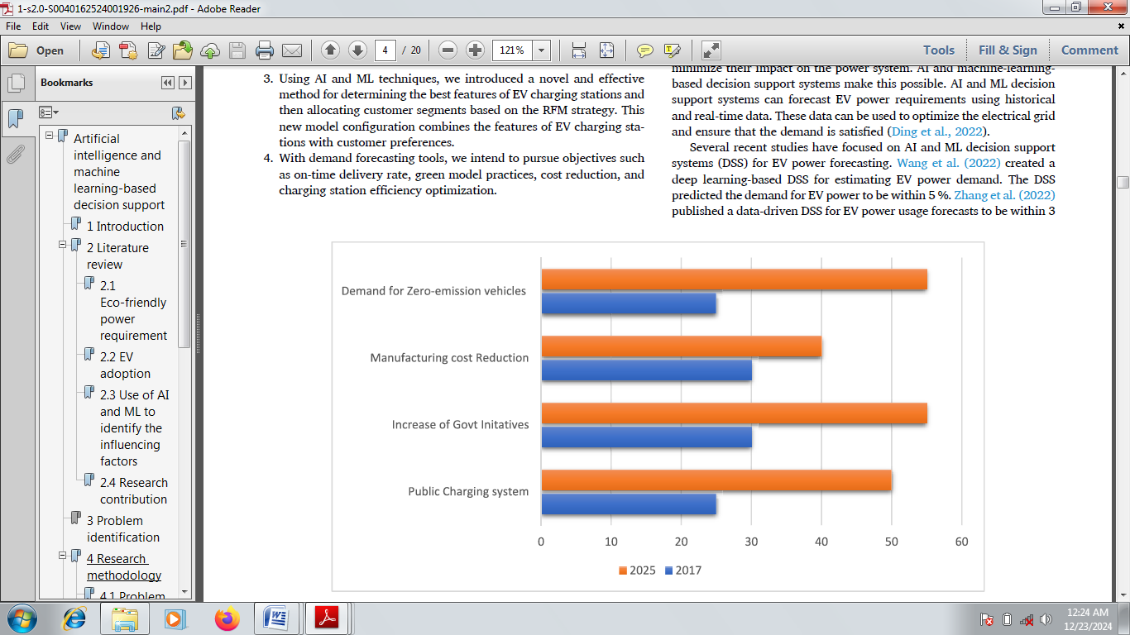

Figure 1: Factors influencing the rise in the growth of EVs

With these several ways of enhancing EVs with sufficient batteries, environmental sustainability is vital. Concerning finite energy resources, efforts are on the way to maximize the utilization of energy, causing progressive minimization of over-dependence on fossil fuels. Simultaneously, there is a significant uptick in the request for renewable energy sources such as hydro, biomass, solar, and geothermal. The change to renewable energy sources has resulted in new applications in the automotive industry, especially in the EV sector [3]. Li-ion batteries have materialized as the most effective alternative to fossil fuel energy, and the same pattern has been noticed in the acceptance by government bodies, industrialists, researchers, and others. Additionally, government policies to publicize the market with EVs positively influenced the rise in product demand. Moreover, adopting EVs enhances the government’s provision of different financial aid and incentives for the EV battery market [7].

In the past decades, machine learning (ML) and artificial intelligence (AI) have revolutionized many industries, which has enormously enhanced the accuracy and efficiency in some sectors such as education, transportation, entertainment, healthcare, finance, etc. To attain excellent performance, ML models have increasingly become complex, requiring a larger volume of parameters to evaluate [8]. However, these improvements are associated with a huge cost because the required resources to train and simulate these models have significantly increased. A huge volume of computational resources is required to train modern ML models. Also, the efficiency and perfection of the ML models are a function of the volume of data used in training. Although the pattern a few years back was tailored towards speedy growth in data demands and higher volumes of hyperparameters, this pattern has not been exhibited in model exactness improvements.

However, artificial intelligence (AI) possesses a huge capacity for countries’ shift to sustainable and clean practices via the propagation of efficient and sustainable solutions. To attain this, numerous sustainability evaluations need to be executed with the potential of increasing the model results transparency, not focusing only on accuracy and performance, but also on the carbon footprint, which reflects water and energy consumption. This energy consumption is predicted to potentially attain more than 30% of the world’s total energy consumption by the year 2030 [9]. The substantial energy requirements of large language models (LLMs) like the presently launched ChatGPT worsen this trend. Originally, huge volumes of data and computational power were required by traditional ML algorithms, causing a noticeable rise in the consumption of water needed to refrigerate the data centers that are holding the training data, energy usage by the algorithms, and improved greenhouse gas (GHG) emissions. To attain environmental sustainability with the use of EVs, green AI intends to tackle its environmental influences by maximizing algorithms, increasing the efficiency of hardware, and allowing sustainable data management policies. Green AI is described with a reduced carbon footprint, excellent data quality, minute models, reduced computational robustness, and rational transparency. This provides effective solutions to energy challenges via mobile/edge devices and cloud centers. Green AI also provides logical and decision-making processes to ascertain people’s trust. Then, social sustainability is added as a further benefit [10]. Figure 2 presents the promising field of green algorithms and green AI based on different methodologies, approaches, and innovations that make ML and AI more environmentally sustainable in terms of enhancing EV battery quality as an alternative to fossil-fueled vehicles, which are known for environmental pollution.

In the 21st Century, the main focus is targeted towards achieving sustainable development encompassing environmental protection and energy conservation. This has also catalyzed the advancement of electric vehicle technology, which improves the current road utilization and traffic safety when facilitated with artificial intelligence-based systems. The use of AI turns electric vehicles into an attractive consumer choice as it advances independent driving and driver assistance systems, enhances charging of EVs, increases optimization and management of energy, supports management of battery, allows predictive maintenance, propagates intelligent infrastructure charging, and facilitates integration with the smart grid. Indeed, the application of AI in EVs is progressively advancing, but the overall sustainability and performance are yet to be improved [11]. This review article is divided into four chapters. Chapter One dealt with the introduction, explaining the fundamental principles of EVs and the significance of artificial intelligence in improving EV battery quality. Chapter two discusses how EV battery qualities can be improved via various charging technologies. Chapter three examines the application of artificial intelligence via a battery management system (BMS) to enhance EV battery quality and the methods by which this can be achieved. Chapter four states the conclusion and recommendations.

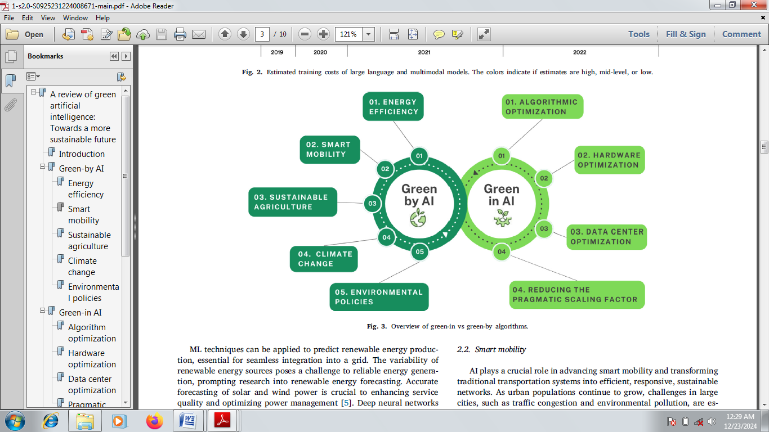

Figure 2: Promising field of green algorithms and green AI based on different methodologies, approaches, and innovations.

**2.0 ENHANCING EV BATTERY QUALITY VIA CHARGING TECHNOLOGIES**

The charging technologies simply mean the techniques and adopted technologies used in restoring rechargeable devices’ energy. This can be improved to enhance the quality of EV batteries, which are rechargeable cells. There are various kinds of batteries, which include nickel–metal hydride, nickel-cadmium, lithium-ion batteries, and many others. However, the most efficient and suitable for EV application is lithium-ion (Li-ion) batteries due to their high energy density and lightweight [12]. To the present moment, different kinds of charging technologies have been practically applied. However, inductive and conductive charging techniques are the most prominent types. The well-organized and developed type is the conductive technology, while others, such as inductive charging and trending technologies like Vehicle-to-Grid (V2G), battery swapping, and smart charging, are motivating topics for researchers [13]. Figure 3 presents the types and subtypes of global charging technologies. This includes the conductive and wireless charging techniques, which are respectively subdivided into level 1, level 2, and level 3; and inductive and capacitive. Figure 4 shows a block diagram of the vehicle-to-grid (V2G) technique. The source of energy for the converter could either be renewable or non-renewable energy, as shown.

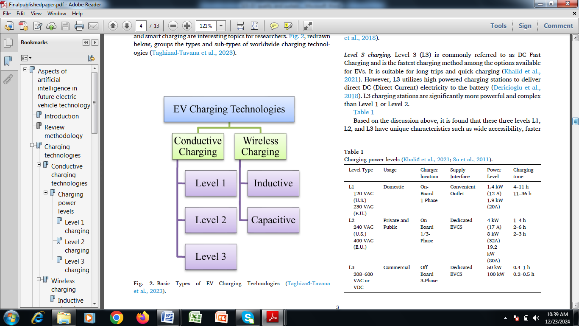

Figure 3: Types and sub-types of global charging technologies

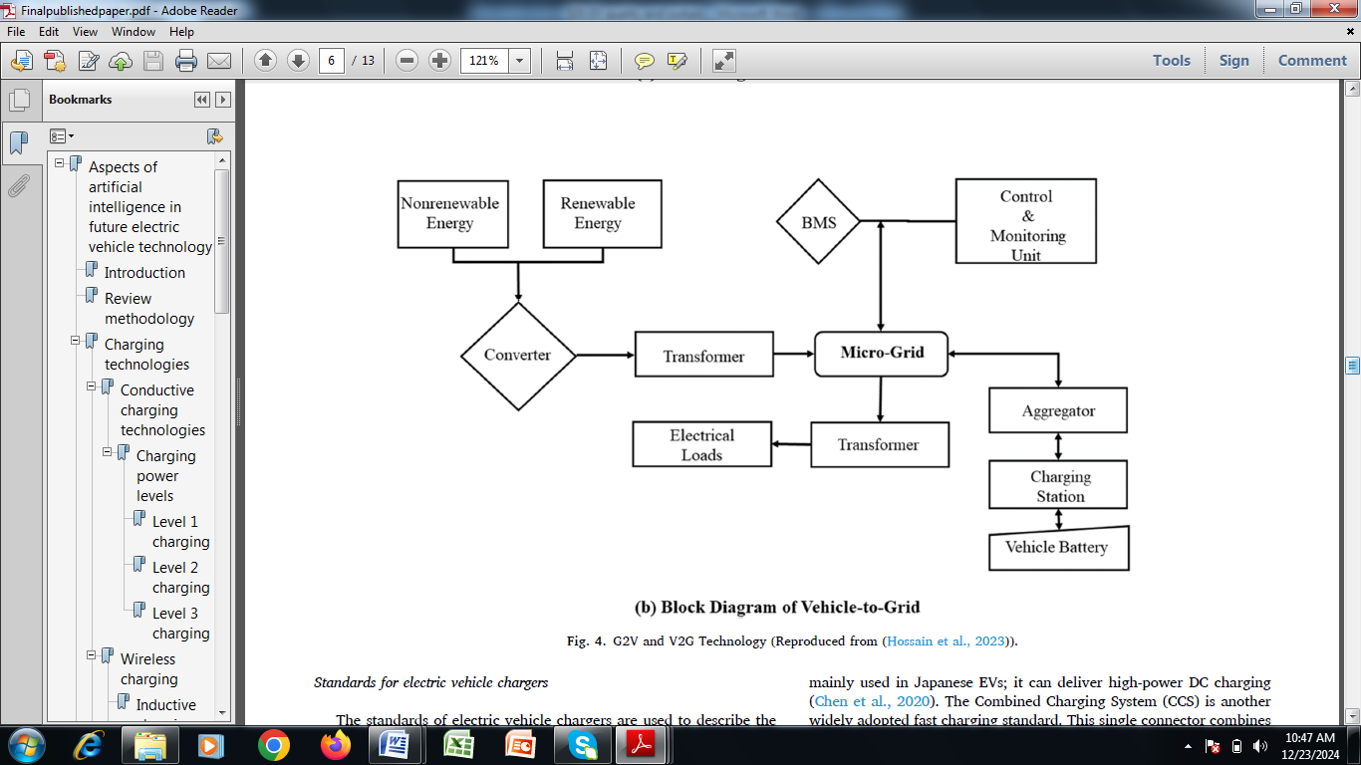

Figure 4: Block diagram of the vehicle-to-grid (V2G) technique

**2.1 Conductive Charging Technologies**

The conductive charging technologies transmit power between the EV and the grid via straight metal-to-metal contact and thus allow both off-board and on-board charging. This makes this technology mature and highly effective when compared with other techniques. The attached constraints are cost, weight, size, and dimensions of on-board chargers with conductive charging techniques. Off-board chargers are not vital components of the EVs, and thus, the power stage of off-board chargers remains unlimited. Shortly, On-board chargers are usually utilized in cases of slow charging, while off-board chargers are most commonly used in cases of fast charging [14].

**2.2 Wireless Charging**

The development of wireless EV charging technology has gained speedy interest from recent researchers around the globe. This technology involves using electromagnetic fields to transfer energy to a receiver pad installed around EVs from a charging pad that is implanted in the ground. As a result of this, it gives room for a more convenient means of automated charging in the absence of conductive cable connections. However, the power stages, efficiency, and speed rely seriously on the charging infrastructure system. It is essential to take note that the present literature groups wireless charging technology separately. For example, as per the transmitted wavelength, the groups are medium, near-field, and far-field charging technologies [15].

**2.3 Inductive Charging**

In inductive charging, the fundamental principle of electromagnetic induction is employed in powering EV batteries. Inductive charging technology has been identified as the most recent cost-saving near-field charging technology for modern transportation. Additionally, it also utilizes both electrical and physical contacts, and it should be noted that precise alignment is irrelevant in this technique. However, attaining optimum power transfer alongside increased efficiency should be considered during the design and operation phase. Studies have revealed a maximum charging efficiency of 85% which could be lowered further in cases where the coils are misaligned. This reported efficiency was noticed at an optimum input power of 22 kVA, having a 250 mm offset between the surface coil and the ground coil. The controlled EV power bus voltage is needed to achieve the battery’s elongated lifetime [16]. Despite this, there is a need for switching frequency simultaneous regulation and conversion ratio of both the secondary-side and primary-side converters. The system’s efficiency is often enhanced via the utilization of the compensation/ matching circuits.

**2.4 Capacitive Charging**

The electric field principles within the range of kilohertz or megahertz are usually employed to make capacitive charging technology effective. The technique integrates two metallic plates, which are incorporated within the receiver and transmitter pads, which are additionally attached to the load and power source. The plates placed in the systems then operate as two capacitors arranged in parallel connection and produce an electric field that induces an electrical current in the receiver pad. With this method, 90 %efficiency has been exhibited within a range of 1 m. There is a direct proportionality between the induced current and the electric field rate that was generated. Thus, specific power converters can be adopted to improve the electric field rate [17].

3.0 applIcation of Artificial Intelligence via battery management system (bms) to Enhance EV Battery Quality

Artificial intelligence and enhanced battery management systems (BMS) have found wide applications in enhancing EV battery quality and also support environmental sustainability via the minimization of poisonous gas emissions. The role of BMS in the management and optimization of EV performance is inestimable [12]. The BMS is a vital constituent of EVs that ensures the battery pack's longevity, safety, and performance, purpose of enhancing the general users’ driving experience. To evaluate the state of charge (SOC), remaining useful life (RUL), state of health (SOH), and state of energy (SOE) together with the execution of temperature management, charge balancing, and fault diagnostics, it is imperative to develop an intelligent and effective BMS to enhance the EV battery quality [5]. The BMS uses different power electronics components and circuit devices alongside methods and algorithms to execute different functionalities like control of overvoltage, management of SOC, protection of under-voltage, control of temperature, balancing of the battery cell, battery life expansion, and energy efficiency [10].

The ineffective BMS algorithms in EVs can give rise to numerous problems, such as safety concerns, reduction in battery performance, and lowering of the lifespan of the battery [18]. To tackle the aforementioned issues, it is vital to design and execute well-arranged BMS algorithms that consider factors such as improved modeling techniques, data exactness, quality of sensor, real-time monitoring, and ability to adapt to various driving situations and user behaviors. The rise in the electric vehicles (EVs) recognition and production has positively influenced different areas of developing an EV ecosystem to support environmental sustainability. The approaches of data analysis and artificial intelligence (AI) in enhancing BMS performance and functionality in EVs have been quite significant. A wide range of advantages has been accorded to AI-driven BMS in EVs. These include user-friendliness, energy efficacy and efficiency, safety, and better-quality performance. All these are achievable together with the extension of the battery lifespan [19].

The relevance and contribution of AI techniques in the examination of the efficiency of EV applications have been proven by previous studies. Numerous advantages have been accorded to using the AI approach when compared with the traditional techniques. To design a complex battery system, less development time and less knowledge are required using AI techniques in comparison with the conventional model-based frameworks. Additionally, data analysis and AI algorithms together with their optimization schemes require simple domain knowledge regarding battery chemistry, physics, and chemical reactions [20]. The major constraint is the need for a large volume of data to enhance the computing power. Nonetheless, the adoption of data analysis and AI algorithms requires adequate data to effectively operate, which enables them to deal effectively in an exceptional way in the presence of uncertainties such as temperature fluctuations, noise, and aging effects. Nonetheless, the self-learning attributes of data analysis and AI techniques applications to EV in terms of executing the parameterization operations with fast online execution make them unique [21].

**3.1 METHODS OF DATA ANALYSIS AND ARTIFICIAL INTELLIGENCE APPLICATIONS IN ENHANCING EV BATTERY QUALITY**

AI algorithm-based techniques and online measurement systems are the two ways in which SOH, SOC, and RUL can be evaluated in EV BMS technology. Both approaches are distinct methods, and they utilize different methods in the estimation of the health and performance of a battery. Both current and historical battery system data are often examined by AI algorithms using data-driven techniques [22]. Just like support vector machines and neural networks, existing correlations and patterns between various parameters of battery conditions are found with the aid of huge datasets that are used in training the machine learning algorithms. Additionally, huge volumes of both historical and current data are essential in the execution of both the training and testing operations. Examples of possible sources where data can be obtained are charge-discharge cycles, temperature profiles, and other significant operational data. Sensors are usually used for online measurement systems, while direct measurement is usually adopted for the continuous monitoring of both the physical and electrical attributes of the battery. Other significant indicators, such as temperature, current, and voltage, may be sensed by these two methods [14]. The collected data from these measurements can be directly used in the estimation of the SOH of the battery. Figure 5 is an AI algorithm that can be adopted in EV battery manufacturing companies to enhance their quality. It ranges from problem identification, data collection, data cleaning, data analysis, dividing data, feature extraction, and model forecasting to results generation.



Figure 5: An AI algorithm that can be adopted in EV battery manufacturing companies to enhance their quality

The data analysis, as a research technique, utilizes the quantitative and statistical approaches to supply the required information gathered from the library and information science. It is a vital tool that reveals insights regarding past and specific discoveries that may be adopted in building future study avenues for prospective researchers [5]. A variety of metrics, such as citations, current status, h-index, impact factors, collaboration, and research networks, are often used by research organizations, industries, universities, and corporations to estimate researchers’ expertise and capacity. Many statistical analyses and examinations of BMS applications to EV battery quality enhancement have been previously executed to achieve: (1) optimization of EV battery energy management via bibliometric analysis, (2) BMS estimation using technical and bibliometric data analysis, (3) management of EV battery thermal systems using bibliometric analysis (4) lithium-ion batteries recycling methods, (5) integration of battery storage systems, (6) management of energy schemes for hybrid EVs, and (7) renewable resources [8].

Lastly, various AI methods may be merged with different optimization approaches to enhance the quality of EV batteries using both current and historical data. However, there may be variations in the results in terms of the rate at which convergence was attained and the time of execution. The incorporation of optimization approaches into AI methods is generally cumbersome and requires a huge effort to achieve the set target [10]. Additionally, parameter initialization and operational loop running require broad expertise in the creation of an optimization framework. The incorporation of optimization approaches with an AI algorithm has significantly enhanced the efficiency of prediction, accuracy, and BMS durability, but numerous sophisticated calculation issues and elongated processing times are part of the attributes of this development. Nonetheless, parameter selections and poor searching capabilities may cause incorrect predictions. These have been the major limitations of this integration innovation, calling for future studies [23].

4. Conclusion

An effective means by which a sustainable environment can be achieved is a paradigm shift from using fossil fuel cars to renewable EVs. To make this a reality, there is a need for the development and enhancement of EV battery quality, which can be achieved through the incorporation of artificial intelligence into battery management systems. Recently, substantial research outputs have revealed the suitability of existing EV types, the charging techniques, costs, and vehicle emissions that can assist in the shift from fuel-based vehicles to electric vehicles. This review article has presented the fundamental knowledge of EVs’ superiority over traditional fossil-fueled vehicles. Future mobility has been transformed through charging technology improvement and the incorporation of emerging trends. The application of artificial intelligence via battery management system (BMS) to enhance EV battery quality and the methods via which this can be achieved were presented. In conclusion, data analysis and artificial intelligence have found promising contributions to enhancing the quality of EV batteries while still maintaining a sustainable environment. However, numerous sophisticated calculation issues and elongated processing times have made the incorporation of optimization approaches into AI methods quite challenging. It is imperative for the concerned stakeholders aiming at the infrastructure chain and EV adoption to work collectively to achieve user expectations to attain net-zero emissions.

**COMPETING INTERESTS DISCLAIMER:**

Authors have declared that they have no known competing financial interests OR non-financial interests OR personal relationships that could have appeared to influence the work reported in this paper.

References

1. Khezri, R.; Razmi, P.; Mahmoudi, A.; Bidram, A.; Khooban, M.H. Machine Learning-based Sizing of a Renewable-Battery System for Grid-Connected Homes with Fast-Charging Electric Vehicle. IEEE Trans. Sustain. Energy 2022, 14, 837–848.

2. Showers, S.O.; Raji, A.K. State-of-the-art review of fuel cell hybrid electric vehicle energy management systems. AIMS Energy, 2023, 10, 458–485.

3. Sukkam, N.; Onsree, T.; Tippayawong, N. Overview of Machine Learning Applications to Battery Thermal Management Systems in Electric Vehicles. AIP Conf. Proc. 2022, 2681, 020004.

4. Liu, S.; Li, K. Thermal monitoring of lithium-ion batteries based on machine learning and fiber Bragg grating sensors. Trans. Inst. Meas. Control 2024, 45, 1570–1578.

5. Jafari, S.; Shahbazi, Z.; Byun, Y.C. Lithium-Ion Battery Health Prediction on Hybrid Vehicles Using Machine Learning Approach. Energies 2022, 15, 4753.

6. Herle, A.; Channegowda, J.; Prabhu, D. Overcoming limited battery data challenges: A coupled neural network approach. Int. J. Energy Res. 2024, 45, 20474–20482.

7. Driscoll, L.; de la Torre, S.; Gomez-Ruiz, J.A. Feature-based lithium-ion battery state of health estimation with artificial neural networks. J. Energy Storage 2023, 50, 104584.

8. Liu, J.; Zhou, Y.; Yang, H.; Wu, H. Uncertainty energy planning of net-zero energy communities with peer-to-peer energy trading

and green vehicle storage considering climate changes by 2050 with machine learning methods. Appl. Energy 2022, 321, 119394.

9. Sharma, N., Peterson, V.K.: Overcharging a lithium-ion battery: effect on the LixC6 negative electrode determined by in situ neutron diffraction. J. Power Sources, 2019, 244, 695–701.

10. Jin, S.; Sui, X.; Huang, X.; Wang, S.; Teodorescu, R.; Stroe, D.I. Overview of machine learning methods for lithium-ion battery remaining useful lifetime prediction. Electronics 2021, 10, 3126.

11. Zahid, T.; Xu, K.; Li, W. Machine learning an alternate technique to estimate the state of charge of energy storage devices. Electron.Lett.2017, 53, 1665–1666.

12. Lei, M.; Mohammadi, M. Hybrid machine learning based energy policy and management in the renewable-based microgrids considering hybrid electric vehicle charging demand. Int. J. Electr. Power Energy Syst. 2021, 128, 106702.

13. Elia G.A., Ulissi U., Jeong, S. Exceptional long-life performance of lithium-ion batteries using ionic liquid-based electrolytes. Energy Environ. Sci., 2022, 9, 3210–3220.

14. Chandrasekaran R., Koh, M., Ozhawa, Y. Electrochemical cell studies on fluorinated natural graphite in propylene carbonate electrolyte with difluoromethyl acetate (MFA) additive for low temperature lithium battery application. J. Chem. Sci., 2019, 121, 339–346.

15. Abdullah, H.M.; Gastli, A.; Ben-Brahim, L. Reinforcement Learning Based EV Charging Management Systems-A Review. IEEE Access 2021, 9, 41506–41531

16. Tang, X.; Liu, K.; Li, K.; Widanage, W.D.; Kendrick, E.; Gao, F. Recovering large-scale battery aging dataset with machine learning.

Patterns 2021, 2, 100302.

17. Babaeiyazdi, I.; Rezaei-Zare, A.; Shokrzadeh, S. State of charge prediction of EV Li-ion batteries using EIS: A machine learning approach. Energy 2021, 223, 120116.

18. Li, J.C., Ma, C., Chi, M.F. Solid electrolyte: the key for high-voltage lithium batteries. Adv. Energy Mater., 2022, 5, 1401408.

19. Ahsan, M. S., Tanvir, F. A., Rahman, M. K., Ahmed, M., & Islam, M. S. Integration of Electric Vehicles (EVs) with Electrical Grid and Impact on Smart Charging. International Journal of Multidisciplinary Sciences and Arts, 2023, 2(2), 225-234.

20. Hu, Y.; Yu, Y.; Huang, K.; Wang, L. Development tendency and future response about the recycling methods of spent lithium-ion batteries based on bibliometrics analysis. J. Energy Storage 2020, 27, 101111.

21. Cabeza, L.F.; Frazzica, A.; Chàfer, M.; Vérez, D.; Palomba, V. Research trends and perspectives of thermal management of electric batteries: Bibliometric analysis. J. Energy Storage 2020, 32, 101976.

22. Wang, H.Y., Tang, A.D., Huang, K.L.: Oxygen evolution in overcharged LixNi1/3Co1/3Mn1/3O2 electrode and its thermal analysis kinetics. Chin. J. Chem., 2022, 29, 1583–1588.

23. Wali, S.B.; Hannan, M.A.; Reza, M.S.; Ker, P.J.; Begum, R.A.; Rahman, M.S.A.; Mansor, M. Battery storage systems integrated renewable energy sources: A bibliometric analysis towards future directions. J. Energy Storage 2024, 35, 102296