Nasopharyngeal Non-Hodgkin’s Lymphoma with a Rare Extra-Nodal Manifestation– A Case Report

ABSTRACT

Aim: This case report highlights a rare instance of a patient who presented at the Redeemers Health Village, a multi-specialty academic hospital, with an extra-nodal manifestation of nasopharyngeal non-Hodgkin’s lymphoma.

Presentation of Case: The report details a 51-year-old clergyman diagnosed with a rare extra-nodal nasopharyngeal non-Hodgkin’s lymphoma, classified as Ann Arbor stage II, A, E, X. This diagnosis was confirmed through histological analysis of a core tissue biopsy and a series of contrast-enhanced computed tomography (CECT) scans. The patient was successfully treated with chemotherapy and immunotherapy.

Discussion: Nasopharyngeal lymphoma has some similarities with nasopharyngeal carcinoma in terms of presentation and aetiology. Consequently, distinguishing between these two conditions requires meticulous histological analysis, as well as CT or MRI scans, alongside an examination of their tumorigenesis. In this case, the diagnosis of extra-nodal nasopharyngeal non-Hodgkin’s lymphoma was established based on the clinical presentation, tissue morphology, immunohistochemistry, and CT imaging. The patient responded well to chemotherapy and immunotherapy and is currently being followed up in the Haematology clinic, where he is receiving counselling on risks and benefits of radiotherapy as part of further management.

Conclusion: Extra-nodal nasopharyngeal lymphoma is rare in the sub-Saharan Africa region compared to its higher prevalence in Southeast Asia. The definitive method for diagnosis is through histological analysis of tissue biopsies, while imaging studies play a vital role in identifying the location and extent of the disease.
The choice of targeted therapy depends on the presence of specific tissue markers; however, chemotherapy, radiotherapy, or a combination of both can be utilised to achieve a successful outcome.

- INTRODUCTION

Non-Hodgkin's Lymphoma (NHL) accounts for approximately 5% of malignancies in the head and neck. [1] it is relatively uncommon in Sub-Saharan Africa but has been reported to be more prevalent in the North Africa, Southern China, and Southeast Asia. [2] Nasopharyngeal Non-Hodgkin's Lymphoma (NPNHL) is a rare primary malignancy, representing a minority of cancers that originate from the nasopharynx. [3, 4] NPNHL typically affects individuals between the ages of 40 and 59, although it can occur in people of all ages, with a relative male predominance. [8, 9] The distribution of lymphoid tissue around the base of the tongue (lingual tonsil), palatine tonsil, pharyngeal tonsil (adenoid), and tubal tonsil, collectively known as Waldeyer’s ring predisposes these areas to lymphoproliferative diseases, affecting 16-43% of cases [5, 6]. The paranasal sinuses are the most common site for extra-nodal NHL, [7] and generally, the sinuses account for 90% of head and neck NHL cases, while the primary nasal tumours occur in 10%. [5]

The histological subtypes of NHL include diffuse large B-cell lymphoma, natural killer (NK)/T-cell lymphoma, marginal zone lymphoma of mucosa-associated lymphoid tissue, small lymphocytic lymphoma, and mantle cell lymphoma. [9, 10] The development of NPNHL is influenced by a combination of factors, including Epstein-Barr virus infection, genetic predisposition, immune dysregulation, and environmental factors. [11]

Given the rarity of lymphoma in the nasopharynx in Sub-Saharan Africa, this case report aims to highlight important pathological manifestations of head and neck lymphoma. It also includes a review of relevant literature and outlines the management strategy utilised for the treatment of this patient at Redeemers Health Village a multi-specialty Academic hospital.

2. CASE PRESENTATION

A 51-year-old married clergyman, presented to Redeemers Health Village, a multi-specialty Academic hospital with a two-year history of nasal swelling. The swelling, located on the anterior aspects of the sino nasal region, began as a pinhead-sized, painless induration that gradually increased in size over six months. Further inquiries revealed a history of mild facial swelling, but there were no associated symptoms such as intermittent headache, fever, poor appetite, facial pain, night sweats, or weight loss. The patient could not recall any history of nasal congestion, anosmia, stridor, snoring, exertional dyspnoea, bleeding diathesis, or easy fatigability.
There was no history of cranial nerve involvement, similar swelling in other parts of his body, or any accompanying gastrointestinal, cardiovascular, or urogenital problems. The patient had not been exposed to chemicals, pesticides, or other harmful agents, and there was no family history of a similar conditions. He does not consume alcohol or smoke cigarettes, although he mentioned using traditional medications during this illness without achieving the desired relief. He has visited multiple hospitals, including a Maxillofacial Clinic for treatment.

Examination findings revealed a middle-aged man who appeared well, showing no signs of pallor, jaundice, or distress. There was no pedal oedema; however, two discrete submandibular lymphadenopathies were noted, each measuring approximately 2 x 2 cm. The lymph nodes were mobile, firm, rubbery, and non-tender. The examination of the axillary lymph nodes revealed no abnormalities. A bulky mass was identified on the nasal region; it was oval in shape, shiny, with an irregular surface, firm, and non-tender, measuring 11 x 11 cm. The surface of the mass was partially ulcerated, featuring ragged edges. Additionally, the left nasal cavity appeared smaller in size compared to the right nasal cavity. There were no indications of epistaxis, bleeding gums, or visible swelling of Waldeyer's ring.

Assessment of the chest and cardiovascular system showed no abnormalities. The abdomen was flat, with no areas of tenderness or palpable organ enlargement. The patient was conscious, active, and exhibited intact sensory and motor functions. vital signs were stable with a temperature of 36.7ºC, systolic blood pressure of 119mmHg, Diastolic blood pressure of 76mmHg, and an SpO2 level of 98%.

An intranasal core biopsy revealed tumour tissue composed of proliferating atypical small round to oval cells arranged in sheets, solid nests, and short cords. The malignant cells exhibited pleomorphism, with irregular nuclear outlines, hyperchromatic nuclei, and scant eosinophilic cytoplasm. Infiltration of the stroma by these neoplastic cells was observed, along with necrosis in some areas. A partial covering of keratinized stratified squamous epithelium was also noted.

Immunohistochemistry revealed tumour cells that were positive for CD45 and CD20, but negative for CD23, BCL2, BCL6, AE1/AE3, and CD56. Reactive T cells were found to be positive for CD3 and CD4.

The patient tested negative for serological screening for Hepatitis B surface antigen (HBsAg), Hepatitis C Virus (HCV), and Human immunodeficiency Virus (HIV I & II). The average values for the Full Blood Count (FBC), Liver Function Test (LFT), Renal function test, and other electrolytes are detailed in Table 1. The D-dimer level measured at 0.85 which is slightly above the reference range of 0 – 0.5. The electrocardiogram (ECG) showed a normal tracing throughout the treatment period. Bone marrow aspiration (BMA) indicated no involvement.

Based on the clinical features and histological findings, the diagnosis of nasopharyngeal lymphoma, specifically Extra-Nodal B Cell Non-Hodgkin Lymphoma, Ann Arbor stage II, A, E, X was established. The patient was counselled regarding treatment options, however, due to financial limitations, patient received 6 cycles of combination chemotherapy (cyclophosphamide, doxorubicin, vincristine and prednisolone) along with 3 cycles of immunotherapy (rituximab). Xanthine oxidase inhibitor, Allopurinol, was administered to serve as a prophylaxis for tumour lysis syndrome. Additionally, a broad-spectrum antibiotic was provided to cover potential aerobes and anaerobic infections.

Images of the nasal mass, both before and after chemotherapy and immunotherapy, along with enhanced contrast computed tomography scans (pre- and post-treatment) are presented in Figures 1, 2, 3, 4, and 5 respectively.

Table 1: The average values for the Full Blood Count (FBC), Liver Function Test (LFT), Renal function test, and other electrolytes are given in the table below:

INVESTIGATIONS PARAMETERS
HAEMATOLOGY  FBC x̄ value  reference range  CHEMISTRY  RFT x̄ value  reference range  LFT x̄ value  reference range | WBC x 10^9/L RBC x 10^9/L HBg/dL PCV % PLT x 10^9/L ESR mm/hr NEUTR % LYMH%  3.4 3.7 11.9 35.6 192.3 25 63.1 25.8  (4-11) ( 3.5-5.5) (12-18) (39-54) (100-400) (0-10) 40-75) (20-40)  Na mmol/L K mmol/L Urea mmol/L Creatinine umol/L Uric acid umol/L Ca mmol/L PO4 mmol/L LDH u/L  137.9 3.8 3.4 55.8 301.5 2.4 0.93 198.7  (137-147) (3.5-5.3) (2.8-7.2) (59-104) (214-468) (2.2-2.65) (0.81-1.45) (140-248)  ALT u/L AST u/L ALP u/L GGT iu/L Total Protein g/L Albumin g/L Globulin g/L Alb/Glo  40.7 30.2 72.7 28.2 72 43.9 28.2 1.6  (7-45) (8-35) (40-129) (5-78) (66-83) (34-53) (25-35) (1.1-2.2)

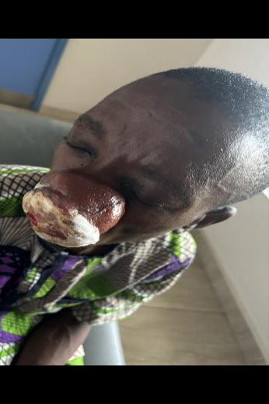
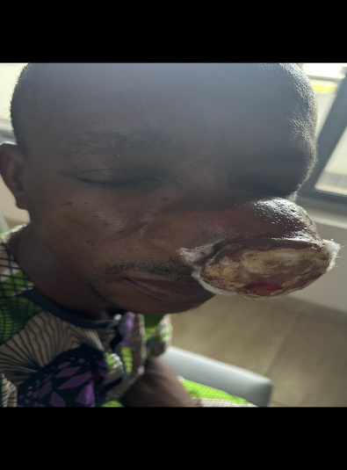
Figure 1: Images before chemotherapy and immunotherapy

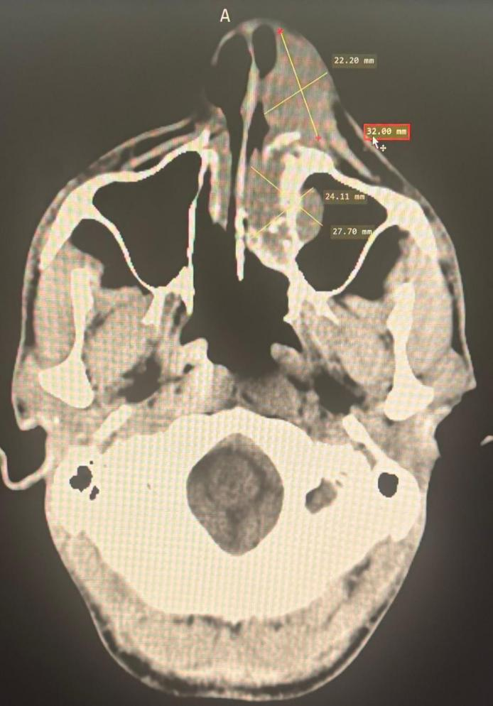
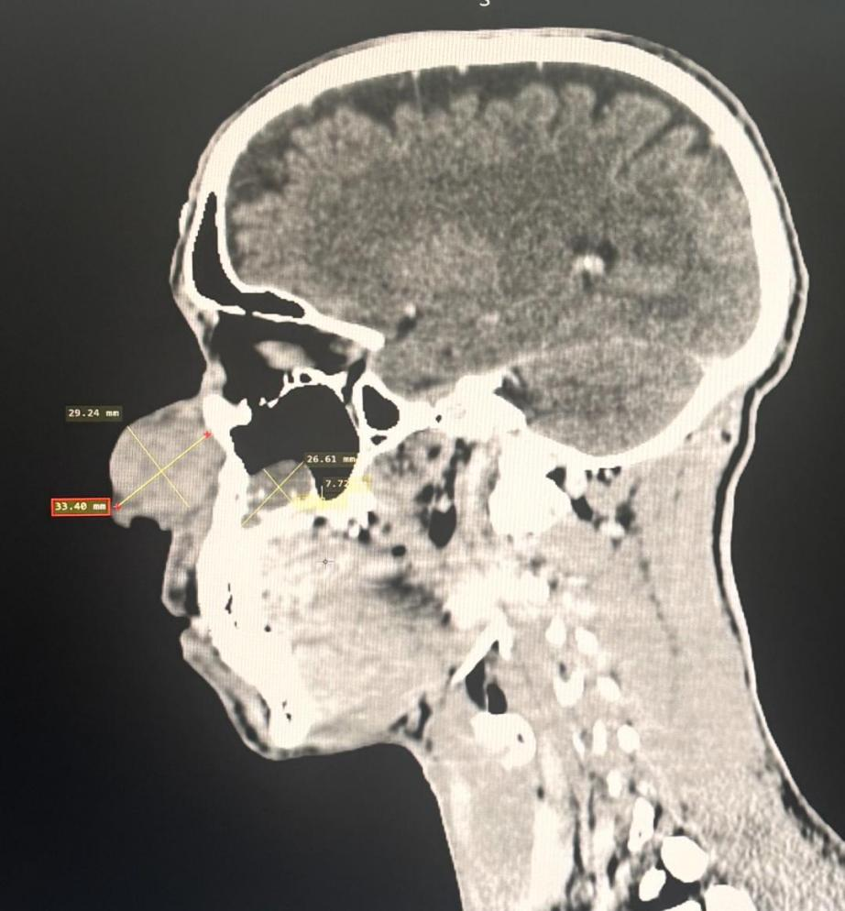

Figure 2: Images before chemotherapy and immunotherapy
A Contrast Enhanced Computed Tomography of paranasal sinuses (sagittal and axial sections) showing left-sided nasopharyngeal NHL with extra-Nodal Mass. (white and blue arrows)

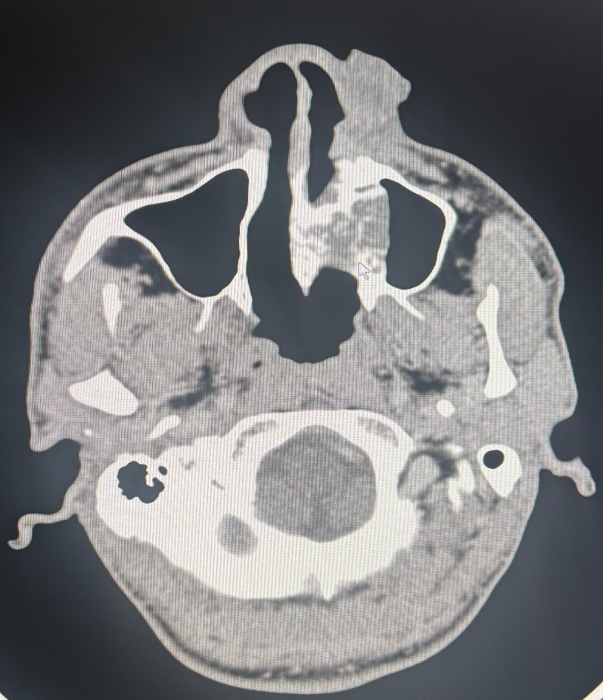
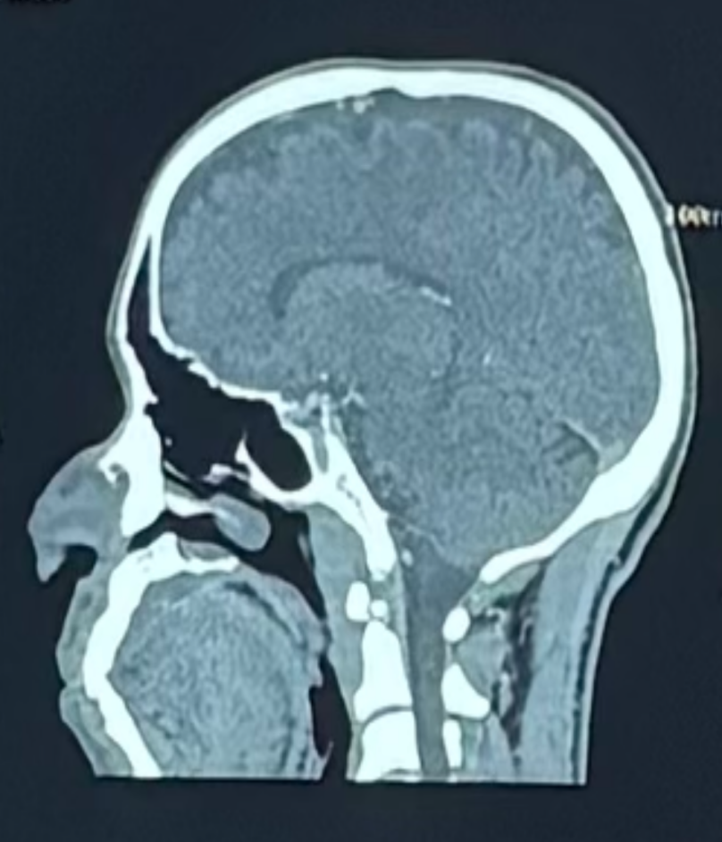
Figure 3 A Contrast Enhanced Computed Tomography of paranasal sinuses (sagittal and axial sections) showing regressing extra-Nodal Mass /nasopharyngeal mass after the 3rd cycle of chemotherapy (blue arrow)

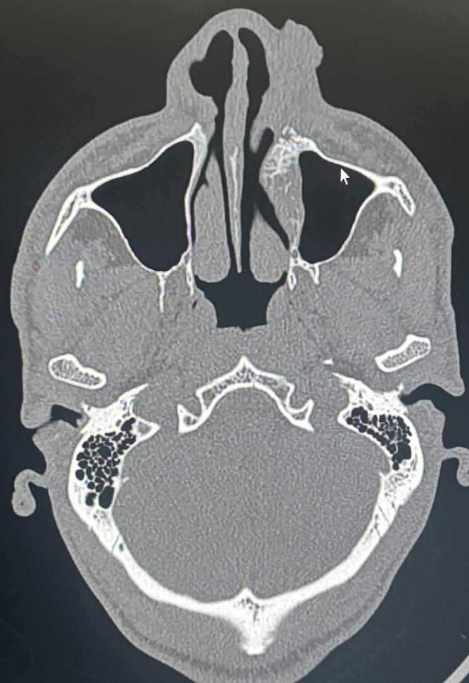
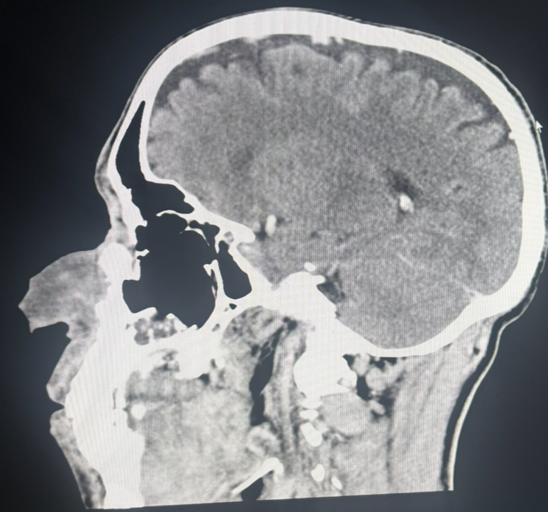

Figure 4: A Contrast Enhanced Computed Tomography of paranasal sinuses (sagittal and axial sections) showing substantial regression of the left sided nasopharyngeal / extra-nodal mass after the 5th cycle of chemotherapy and 2nd cycle of immunotherapy (blue arrow)

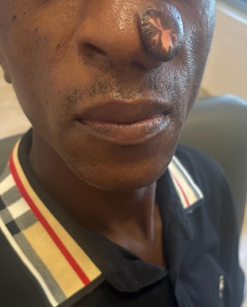
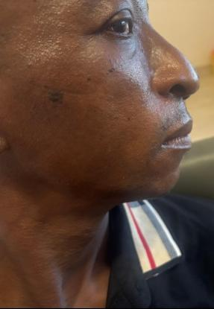

Figure 5: Images of substantial regression after the 5th cycle of chemotherapy and 2nd cycle of immunotherapy

- DISCUSSION:

Nasopharyngeal non-Hodgkin’s lymphoma (NPNHL) is a rare of cancer that occurs in the head and neck region., Diagnosis this condition can be challenging due to the tumour’s obscure location and the existence of other similar malignancies in the nasopharynx. Medical facilities that treat patients with this type of cancer should have the expertise, diagnostic tools, histological techniques, and immunohistochemistry (IHC) methods. A nasal endoscope is often necessary to visualize lesions affecting the nasal cavity, Sino nasal tracts, and nasal conchae, and it can also serve as a guide for a obtaining a tissue biopsy. Additionally, imaging studies, such as computed tomography (CT) scan, magnetic resonance imaging (MRI), and positron emission tomography (PET) scan play a critical role in supportive tissue diagnosis, determining the extent of the disease, lesions with increased metabolic uptake, and facilitating treatment and monitoring. [17]

Given the established gold standard for diagnosing of malignancies, having experienced pathologists and haematologist is crucial for thoroughly characterizing tissue specimens and distinguishing NHL from other malignancies affecting the nasopharynx. Nasopharyngeal non-Hodgkin’s lymphoma often rivals the nasopharyngeal carcinoma (NPC) and typically presents with three primary morphological types: keratinizing squamous cell carcinoma, non-keratinizing squamous cell carcinoma, and undifferentiated carcinoma. [12, 13] The pathology usually reveals an asymmetrical, infiltrative pattern with extensive invasion into adjacent muscles, bones, and neural foramina.

In contrast, NPNHL, as demonstrated in the index case, typically appears as a bulky, symmetrical, and homogeneous mass. This mass typically shows high enhancement with minimal invasion of surrounding tissues and may sometimes involve the Waldeyer's ring. [16] However, in this specific case, the Waldeyer's ring was spared.

In the context of tumour development, NPNHL and NPC share similar pathognomonic risk factors. These factors arise from a combination of triggers, particularly Epstein-Barr virus infection, as well as environmental influences such as exposure to pesticides, smoke, dust, and chemicals. Unlike NPC, NPNHL, like other types of lymphomas, originates from the clonal expansion of lymphoid cells that have undergone genetic changes affecting oncogenes and tumour suppressor genes. [14]

The diagnosis of nasopharyngeal Extra-Nodal B-cell non-Hodgkin lymphoma, classified as Ann Arbor stage II A, E, X, was established based on several factors. These included clinical symptoms indicative of a bulky nasal mass measuring 11 cm by 11 cm, histological examination revealing infiltrating pleomorphic neoplastic cells, and the presence of a B-cell marker (CD20) confirmed through immunohistochemistry studies. Notably, there was an absence of T-cell markers (CD3. CD, 4, CD8 & CD 56).
Findings from a contrast-enhanced CT scan (CECT) further supported the diagnosis. [17 18] The CECT, viewed in both sagittal and axial sections prior to treatment showed a primary NPNHL mass extending from the nasopharynx to the superior turbinate, measuring 26.61 mm by 7.72 mm. additionally, there was a bulky nasal mass measuring 33.40 mm by 29.24 mm. The axial section of the CECT revealed complete obliteration of the medial wall of the left maxillary sinus, with encroachment into the maxillary sinus.
It is important to note that diffuse large B-cell NHL typically invades the sinuses in 90% of cases, while primary nasal tumours occur in the remaining 10%. [15] In cases involving the nasal cavity, the NK/T cell variant is most commonly observed. [14] However, in this specific case, there was no significant involvement of the nasal cavity, and there was no invasion of surrounding vital structures, including the brain, orbits or other essential surrounding organs.

This patient, with normal laboratory test results including ECG, full blood count, electrolyte levels, urea and creatinine, LDH, uric acid, phosphate, and liver function tests was started on a combination of chemotherapy and immunotherapy. The chemotherapy regimen included cyclophosphamide, vincristine, doxorubicin, and prednisolone, while the immunotherapy consisted of rituximab. The decision to prioritize chemotherapy and immunotherapy over radiotherapy for these limited-stage tumours was based on several factors: the intermediate-high-grade classification of the tumour, its proximity to vital structures, and a heightened risk of secondary malignancies associated with the use of radiotherapy in sino nasal tumours. [15] The patient underwent six cycles of chemotherapy (cyclophosphamide, Vincristine, Doxorubicin, Prednisolone) and three cycles of rituximab, resulting in the overall well-being of the patient. As shown in Figures 3, 4, and 5, the medical team observed a notable significant regression in the size of the tumour without any identifiable complication related to the chemotherapy.
According to Zagólski et al., the prognosis for NPNHL largely depends on the stage and grade of the lymphoma, the extent of extra-nodal involvement, central nervous system (CNS) invasion, and the patient’s performance status. Generally, patients with disseminated and recurrent high-grade lymphoma face the poorest prognosis. The overall five-year survival rates are approximately 30% for all lymphoma types, 55% specifically for diffuse large B-cell lymphoma (DLBCL), 33% for peripheral T-cell lymphoma, and 30% for angiocentric lymphoma. [14]

Currently, the patient is being followed up in the Haematology clinic at the Redeemers Health Village - a multi-specialty Academic hospital. During this visit, the medical team is also providing the patient with counselling on the risks and benefits of radiotherapy as a potential part of further treatment.

- CONCLUSION:
Nasopharyngeal lymphoma, especially the extra-nodal type, is rare in the sub-Saharan Africa region compared to its higher prevalence in Southeast Asia. The definitive method for diagnosis is histological analysis of tissue biopsies, imaging studies play a vital role in identifying the location and extent of the disease. The choice of targeted therapy depends on the presence of specific tissue markers; however, chemotherapy, radiotherapy, or a combination of both can be used to achieve a successful outcome.

- LIMITATION:
This study is limited by the facility's inability to assay for EBV RNA, determine the Ki-67 proliferative index and the absence of a PET scan.

CONSENT

As per international standards or University standards, patient’s written consent has been obtained and preserved by the author(s).

ETHICAL APPROVAL
It is not applicable

DISCLAIMER (ARTIFICIAL INTELLIGENCE)
Author(s) hereby declare that NO generative AI technologies such as Large Language Models (ChatGPT, COPILOT, etc) and text-to-image generators have been used during or editing of this manuscript.

COMPETING INTERESTS DISCLAIMER:
Authors have declared that they have no known competing financial interests OR non-financial interests OR personal relationships that could have appeared to influence the work reported in this paper.

REFERENCES

- King A.D, Lei K.I.K, Richards P.S, Ahuja A.T. Non-Hodgkin's Lymphoma of the Nasopharynx: CT and MR Imaging and MR Imaging. Clinical Radiology Volume 58, Issue 8, August 2003, Pages 621-625.
- Jaishika Seedat, Kim Coutts, Ellen Vlok. Epidemiology and demographics of head and neck cancer in Africa: A scoping review. Afr J Prim Health Care Fam Med. 2023 Aug 1;15(1): 3749.doi:10.4102/.phcfm.v15i1.3749

- Chien-Yu Hsueh , Ching-Fen Yang , Jyh-Pyng Gau , Edward C Kuan , Ching-Yin Ho , Tzeon-Jye Chiou , Liang-Tsai Hsiao , Ting-An Lin, Ming-Ying Lan. Nasopharyngeal Lymphoma: A 22-Year Review of 35 Cases. J Clin Med. 2019 Oct 3;8(10):1604. doi: 10.3390/jcm8101604.
- Lei K. I.-K., Suen J. J., Hui S, P., Tong M., Li W., Yau S. H. Primary Nasal and Nasopharyngeal Lymphomas: A Comparative Study of Clinical Presentation and Treatment Outcome. Clinical Oncology (1999) 11:379–387.
- Eytan Keidar, D. O, Quynh-Nhu Vu, DO, Carl Shermetaro, DO, FAOCO. When Snoring isn’t just Snoring: Primary Nasopharyngeal Mantle Cell Lymphoma - A Rare Pathology in the Nasopharynx. Vol. 4, Issue 1, 2019July 01, 2019 EDT. https://doi.org/10.51894/001c.7959PMCID:
- Bickle I, Nasopharyngeal non-Hodgkin lymphoma. Case study, Radiopaedia.org (Accessed on 26 Jul 2025) https://doi.org/10.53347/rID-30099).
- Koichiro Okumura, Yu Sato, Atsumi Matsunaga, Yohya Shigehara. Skin lesion of extranodal natural killer/T-cell lymphoma nasal type. J Gen Fam Med. 2021 May 5;22(5):294-295. doi:10.1002/jgf2.445

- Vasile Musteata, Sr., Lilian Nichifor, Larisa Musteata,Galina Durbailova. Diagnosis Issues and Management of Nasopharyngeal Non-Hodgkin Lymphomas. Blood (2021) 138 (Supplement 1): 4588. https://doi.org/10.1182/blood-2021-144340)

- Han, Yongliang; Wei, Shufei1; Zhang, Yihang; Wang, Liangliang; Xu, Xiao. Extranodal nasal-type NK/T-cell lymphoma with CD20 positive: A case report and review of literature. Indian Journal of Pathology and Microbiology 67(2): p 459-462, Apr–Jun 2024. | DOI: 10.4103/ijpm.ijpm_32_22
- Albert Y. Han, Edward C. Kuan, Jose E. Alonso, Karam W. Badran, Maie A. St. John. Epidemiology of Nasopharyngeal Lymphoma in the United States: A Population-Based Analysis of 1119 Cases. Otolaryngol Head Neck Surg. 2017 May;156(5):870-876. doi: 10.1177/0194599817695808.Epub 2017 Mar 21.
- Sachin Gandhi, Shradha Saindani, Renuka Mundalik . Nasopharyngeal Lymphoma: Rare Case Report. Indian J Otolaryngol Head Neck Surg. 2023 Mar 25;75(3):2383–2386. doi: 10.1007/s12070-023-03701-9
- Cleveland Clinic. Nasopharyngeal carcinoma. Available at https//my.clevelandclinic.org. Accessed 6th August 2025
- Karen F. Ross, Mark C. Herzberg. Autonomous immunity in mucosal epithelial cells: fortifying the barrier against infection. Microbes and Infection
Volume 18, Issue 6, June 2016, Pages 387-398
- Katsuyuki Aozasa and Mona A.A. Zaki. Epidemiology and Pathogenesis of Nasal NK/T-Cell Lymphoma: A Mini-Review. TheScientificWorldJournal. (2011) 11, 432-428 ISSN1537-744X; DOI10.1100/tsw.211.41
- Olaf Zagólski, Raghav C. Dwivedi, Somasundaram Subramanian, Rehan Kazi. Non-Hodgkin’s lymphoma of the sino-nasal tract in children. J Cancer Res Ther - January-March 2010 - Volume 6 - Issue 1
- Ahmed Abdel Khalek Abdel Razek and AnnKing. MRI and CT of Nasopharyngeal Carcinoma. AJR. 2012; 198:11-1 2025. https://doi.org/10.2214/AJR.11.6954. Accessed 9 August, 2025.
- Laohaburanakit P, Hardin A. K. NK/L cell lymphoma of the lung: a case report and review of literature. Thorax. 2006 Mar;61(3):267-270. doi:10.1136/thx.2004.025767.
- Preeyawat Ngamdamrongkiat , Sanya Sukpanichnant , Manasmon Chairatchaneeboon , Archrob Khuhapinant , Panitta Sitthinamsuwan . Cutaneous Involvement of Extranodal NK/T Cell Lymphoma, Nasal Type, a Clinical and Histopathological Mimicker of Various Skin Diseases. Dermatopathology (Basel). 2022 Sep 9;9(3):307–320. doi: 10.3390/dermatopathology9030037. Accessed 13/08/25

