Case report

The Great Mimicry: Platelet Artefacts Masquerading as Trypanosomes

ABSTRACT

Introduction: Peripheral smear evaluation is essential in hematologic diagnosis, but EDTA-induced and storage-related artefacts can mimic infections, malignancies, or thrombocytopenia by altering blood cell morphology. Recognizing these artefacts is crucial to avoid misdiagnosis, and a fresh fingerprick smear may be necessary for accurate assessment. Case presentation: We report an uncommon case of artefactual platelet morphology mimicking flagellated hemoparasites on peripheral smear in a 45-year- old male with chronic kidney disease stage V on dialysis, who presented with headache, nausea, and severe hypertension (BP 260/160 mmHg). His hemogram revealed anemia (Hb 5 g/dL), leukopenia (3.9
× 10⁹/L), and a normal platelet count (1.02 × 10⁵/µL), with no history of fever or blood loss, and renal function was markedly deranged (serum creatinine 6.40 mg/dL). A Leishman-stained smear from an early morning EDTA sample showed burr cells and numerous extracellular, slender, eosinophilic, tapered structures (~5–6 µm), resembling miniature trypanosomes but lacking kinetoplasts, consistent with artefactually elongated platelets. Discussion: Elongated or flagellated platelet forms may result from mechanical artefacts during smear preparation, potentially mimicking hemoparasites and leading to diagnostic confusion. This case highlights the importance of clinical correlation and confirms that a properly prepared fingerprick smear is a reliable tool for distinguishing artefactual changes from true pathology. Conclusion: Pathologists should be alert to artefacts that mimic parasites or abnormal cells, especially in suspected thrombocytopenia or infection. In doubtful cases, a fresh fingerprick smear offers more reliable assessment of platelet morphology.
KEYWORDS

Platelet artefact, EDTA-induced changes, Flagellation, Trypanosomes, Fingerprick smear

INTRODUCTION
Microscopic analysis of peripheral blood smears is a crucial component of diagnostic evaluation. While EDTA is commonly used as an anticoagulant for blood sample collection, it can induce morphological distortions and increase the fragility of blood cells. (1)
Storage-related artefacts can lead to misinterpretation on peripheral blood smears if not carefully recognized. In white blood cells, neutrophils may show nuclear hypersegmentation and cytoplasmic vacuolation mimicking infection or sepsis, while lymphocytes may develop nuclear lobulation and hyperchromasia, and monocytes may display vacuolation and nuclear degeneration—also falsely suggesting infection. Red blood cells can exhibit crenation, resembling burr cells, or lose central pallor, mimicking spherocytes. Awareness of these artefacts is essential to avoid mistaking them for true pathological changes during smear evaluation. (1,2)
Platelet abnormalities in shape, granulation, and size are seen in various inherited or acquired blood disorders like MDS, MPN, acute megakaryoblastic leukemia, and hereditary thrombocytopenias. The presence of circulating megakaryocytes, micromegakaryocytes, or megakaryoblasts may suggest an underlying hematologic malignancy. Artefactual platelet changes include platelet clumping, swelling, and degranulation due to delayed smear preparation or EDTA-induced pseudothrombocytopenia, Platelet satellitium leading to falsely low counts or altered morphology. (3,4,5)

CASE PRESENTATION
Herein we present an uncommon case with artefactual changes in platelet morphology mimicking a flagellated hemoparasite on a peripheral smear. A 45-year-old gentleman, known case of chronic kidney disease stage V on thrice-weekly dialysis presented to our hospital with complaints of headache, nausea, and vomiting since 2 days. Clinical examination revealed markedly elevated blood pressure (260/160 mmHg). His complete blood hemogram showed Hemoglobin of 5 g/dL, a total leukocyte counts of 3.9 × 10⁹/L, and a platelet count of 1.02 × 10⁵/µL, with no history of fever or blood loss. Laboratory investigations showed deranged renal function, with a serum creatinine level of 6.40 mg/dL and serum urea of 60.9 mg/dL. All other routine blood investigations were within normal limits. A Leishman stained peripheral smear prepared from an early morning venous blood sample collected in a 2ml K₂-EDTA vacutainer showed red blood cells with burr cell/ echinocyte morphology along with many extracellular, slender eosinophilic structures with tapered ends measuring 5-6 µm, closely mimicking miniature flagellated trypanosomes, but without identifiable kinetoplasts. (Fig A-D).

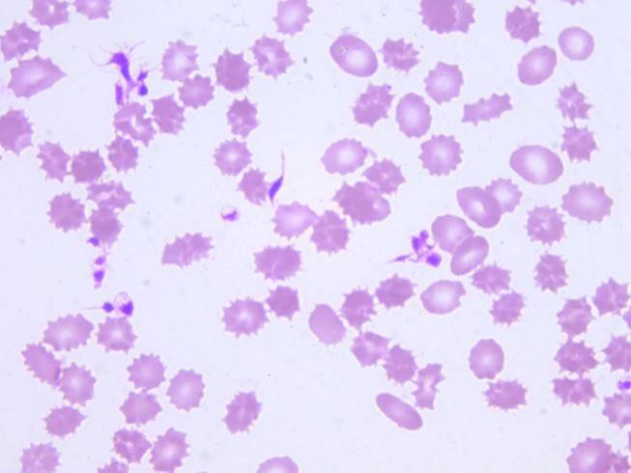
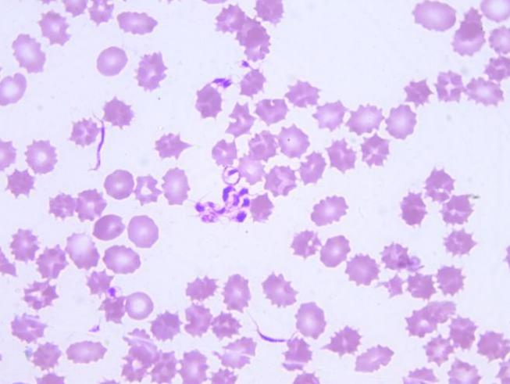
A

B

C

D

FIG 1. (A-D) The peripheral smear reveals numerous curved elongated structures with tail-like tapered ends mimicking small trypanosome-like forms, likely representing smear-induced artefactual distortion of platelets.(Green Circles)
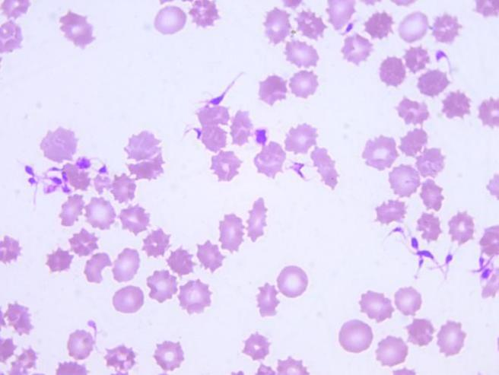
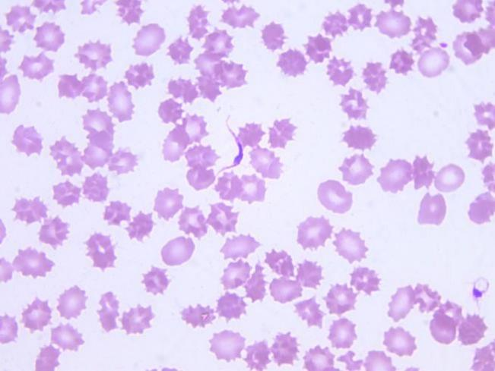
Detailed clinical information was requested regarding recent blood transfusion, history of fever, travel to endemic regions, and any evidence of hemolysis, lymphadenopathy, or meningoencephalitis suggestive of Trypanosomiasis (6). The slide was reviewed by three pathologists, and noting that the structures were considerably smaller than the typical 30 µm size of trypanosomes (7), a repeat smear was prepared from fresh fingerpick blood sample in order to exclude potential anticoagulant induced artefactual changes on stored blood. The follow-up smear identified the structures as normal round to oval platelets. (Fig E-F)

E

F

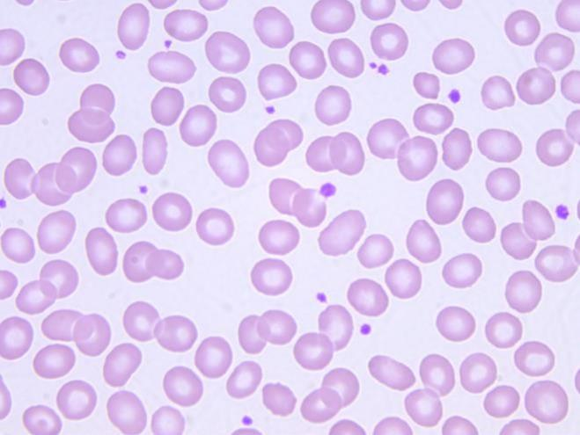
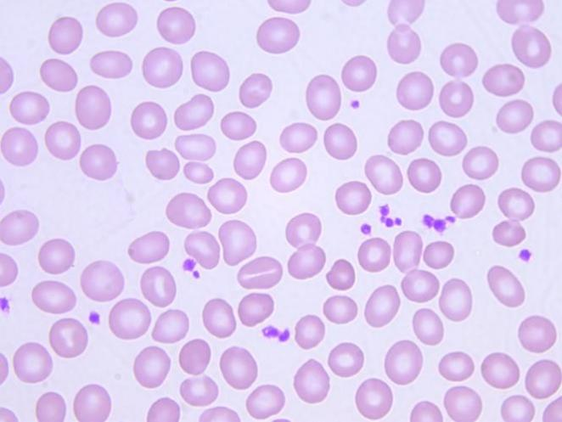
FIG 2. (E-F) Fingerprick sample smear showing round to oval platelets.

The patient was ultimately diagnosed with accelerated hypertension, with no evidence of parasitic infection. Patient stay was uneventful and discharged on stable condition.

DISCUSSION
Platelets may appear elongated or flagellated due to mechanical artefacts introduced during smear preparation, particularly when excessive pressure or delayed fixation occurs. In this case, the early morning sample showed elongated, spindle-shaped platelets, whereas the repeat sample collected later in the morning no longer displayed these flagellated-like forms. Additionally, studies have shown that platelet morphogenesis in plasma involves various stages of maturation—from elongated proplatelets to curved, fusiform, and disc-like shapes—which can further mimic the appearance of flagellated protozoa under microscopy. (8)

To rule out the possibility of artefactual changes in blood cell morphology, a fingerprick direct smear was performed, which revealed normal red blood cell and platelet morphology, effectively excluding the doubt of an existing parasitic etiology.
Our findings underscore the necessity for pathologists to remain alert to possible artefacts on peripheral smears. Awareness of actual platelet count and morphology, along with clinical correlation, is crucial since artefacts can resemble parasitic organisms or abnormal cells, potentially leading to diagnostic errors in cases of suspected thrombocytopenia or infection. Properly prepared fingerprick smears serve as a dependable method for accurately evaluating platelet morphology and distribution, particularly when automated counts or EDTA-related alterations are in question (9,10).

CONCLUSION
Pathologists must remain vigilant for artefacts mimicking parasites or abnormal cells on peripheral smears, particularly when evaluating platelet morphology in suspected thrombocytopenia or infection. When findings are doubtful or EDTA-related changes are suspected, a freshly prepared fingerprick smear can provide a more accurate assessment.

Abbreviations: PS: Peripheral Smear; K2-EDTA: Dipotassium Ethylene diamine tetra acetic Acid; MDS: Myelodysplastic Syndrome; MPN: Myeloproliferative Neoplasm

REFERENCES:

- Choudhary S, Katkar RS, Nagaram D. Storage artefacts in peripheral blood smears. IP J Diagn Pathol Oncol. 2018;3(3):187–91. doi:10.18231/2581-3706.2018.0039.
- Koolwal MS, Meena S, Mandal A, Sirohi P, Saxena AK. Anticoagulant (EDTA) induced storage effect artifacts on peripheral blood cells. J Med Sci Clin Res. 2017;5(4):20677–20683.
- Robier C. Platelet morphology. J Lab Med. 2020;44(5):231–9. doi:10.1515/labmed- 2020-0007.
- Zandecki M, Genevieve F, Gerard J, Godon A. Spurious counts and spurious results on haematology analysers: a review. Part I: platelets. Int J Lab Hematol. 2007;29(1):4–20. doi:10.1111/j.1365-2257.2006.00870 x.
- Bain BJ, Bates I. Dacie and Lewis Practical Haematology. 12th ed. London: Elsevier; 2021. p. 108–10.
- Ortiz-Martínez Y, Kouamé MG, Bongomin F, Lakoh S, Henao-Martínez AF. Human African Trypanosomiasis (Sleeping Sickness): epidemiology, clinical manifestations, diagnosis, treatment, and prevention. Curr Trop Med Rep. 2023 Dec;10(4):222–34. doi: 10.1007/s40475-023-00304-w.
- Koneman EW, Allen SD, Janda WM, Schreckenberger PC, Winn WC. Koneman's Color Atlas and Textbook of Diagnostic Microbiology. 7th ed. Philadelphia: Lippincott Williams & Wilkins; 2017.
- Agrarwal AS, Singh N, Priyavadhana B, Kaira K, et al. Trypanosomes or platelet artefacts? A morphological dilemma! J Clin Images Med Case Rep. 2023;4(2):2303.
- Koopman J, van Dongen-Lases EC. EDTA-induced pseudothrombocytopenia: a clinical and laboratory challenge. Ned Tijdschr Geneeskd. 2006;150(44):2448–51.
- McPherson RA, Pincus MR. Henry's Clinical Diagnosis and Management by Laboratory Methods. 24th ed. Philadelphia: Elsevier; 2022. p. 803–5.

