**Molecular, Nutritional, and Microbial Stability of Raw vs. Commercial Spirulina during Storage**

**Abstract**

**Introduction:**

Spirulina, a nutrient-rich cyanobacterium, is widely used in functional foods and nutraceuticals, but its stability during storage—especially in raw form—remains a critical challenge.

**Materials and Methods:**

This study compared molecular, nutritional, and microbial changes in raw and commercial Spirulina stored under ambient, refrigerated, and vacuum-sealed conditions over 42 days. FTIR spectroscopy was used for molecular profiling; protein, lipid, carbohydrate, and antioxidant content were measured via standard assays; microbial dynamics were analyzed through culture methods and VITEK 2 identification.

**Results and Discussion:**

FTIR analysis showed marked molecular degradation in raw Spirulina stored at ambient temperature, with reduced spectral intensity for proteins, lipids, and carbohydrates. Commercial Spirulina, particularly under refrigerated and vacuum conditions, retained higher biochemical stability. Nutritional assays confirmed greater retention of proteins (up to 85%), lipids, and carbohydrates in commercial samples. DPPH assay showed antioxidant activity declined in all conditions but was best preserved under refrigeration. Microbial analysis revealed higher bacterial loads in raw Spirulina (up to 6.8 log CFU/g), with dominant species including Pseudomonas, Bacillus, and Enterobacter. Commercial formulations exhibited significantly lower contamination.

**Conclusion:**

Storage method significantly influences Spirulina quality, with refrigeration and vacuum sealing proving effective in preserving functional and microbial stability.**Keywords:** Spirulina, Molecular Profiling, Nutrient Degradation, Microbial Dynamics, Storage Stability, and Antioxidant Retention

**Introduction**

Spirulina (genus Arthrospira) is a well-recognized cyanobacterium widely consumed for its high nutritional value, particularly its rich protein content, essential amino acids, vitamins, and antioxidant properties. Initially described as a “wonderful future food source”, in 1967 (Sili, 2012), these microorganisms were later taxonomically reclassified into two genera—Spirulina and Arthrospira—a distinction still relevant to scientific and commercial applications (Sili, 2012). Today, Spirulina is widely incorporated into functional foods, nutraceuticals, and pharmaceuticals, typically in a processed form. However, raw Spirulina, which refers to the unprocessed biomass prior to drying or formulation, presents distinct challenges in terms of stability and safety.

What makes this study novel is its focus on the underexplored effects of storage on raw Spirulina—a form that remains especially vulnerable to environmental stressors yet is increasingly used in fresh or minimally processed formats. Raw Spirulina is characterized by an exceptionally high protein content (55–70% dry weight) (Becker, 2007) and a wealth of bioactive compounds, including polyunsaturated fatty acids (Karnaouri et al., 2020), phenolic compounds (Pereira et al., 2019), and phycocyanin (Patil et al., 2006). However, its biological and chemical stability during storage is a major concern, with significant implications for nutritional quality and microbial safety.

Storage conditions—such as temperature, humidity, light exposure, atmospheric composition, and pH—can trigger detrimental chemical reactions, including hydrolysis and oxidation, leading to the degradation of valuable nutrients (Gouveia et al., 2008). While commercial processing methods are designed to mitigate these issues, raw Spirulina is far more susceptible to physicochemical changes. Understanding the molecular, nutritional, and microbial transformations that occur during storage is essential to optimizing shelf life and ensuring product safety.

Furthermore, recent studies have reported considerable molecular diversity among commercial Spirulina products and detected contamination by other cyanobacteria and heterotrophic bacteria, raising concerns about product consistency and public health (Vardaka et al., 2016). This highlights the need for deeper investigation into raw Spirulina’s storage behavior and its implications for quality control across the supply chain.

**Background and Significance**

Spirulina (genus Arthrospira) is a filamentous cyanobacterium long valued for its exceptionally high protein content, balanced essential-amino-acid profile, and abundance of vitamins and antioxidants (Khushala et al., 2025). Historically consumed by Aztec and other Meso-american cultures, Spirulina has re-emerged in modern diets because of its impressive nutritional density and documented health benefits. Dried biomass typically contains 55 – 70 % protein by weight alongside polyunsaturated fatty acids, phenolic compounds, and the blue phycobiliprotein pigment phycocyanin (Spínola et al., 2024).

These bioactive constituents confer antioxidant, anti-inflammatory, and immunomodulatory activities, underpinning the alga’s broad use in functional foods, nutraceuticals, and pharmaceutical formulations. Consequently, Spirulina is often promoted as a “super-food” and a potential tool for combating malnutrition. Yet the commercial value of

Spirulina products ultimately depends on the stability of these labile compounds throughout storage and distribution. Understanding the physicochemical and microbial factors that influence nutrient retention is therefore critical for safeguarding product quality, shelf-life, and consumer health (Bumandalai et al., 2024).

**Challenges in the Storage Stability of Raw and Commercial Spirulina**

Despite its numerous benefits, Spirulina’s biological stability during storage presents a significant challenge. Environmental factors such as temperature, humidity, light, and oxygen exposure accelerate nutrient degradation and promote microbial proliferation, thereby compromising both its safety and efficacy. Raw Spirulina is particularly susceptible to enzymatic activity, oxidation, and microbial contamination, which lead to physicochemical changes that reduce its shelf life (Bumandalai et al., 2024).

Storage-induced alterations, including protein denaturation, lipid oxidation, and carbohydrate breakdown, result in the degradation of its nutritional quality. While commercial processing techniques aim to enhance stability, the comparative dynamics between raw and processed Spirulina under various storage conditions remain insufficiently understood.

**Study Objectives**

This study aims to:

Perform molecular profiling to assess structural and compositional changes in Spirulina during storage.

Evaluate the patterns of nutrient degradation in both raw and commercial Spirulina under varying storage conditions.

Analyze microbial dynamics and identify the dominant bacterial species responsible for the degradation of Spirulina.

**Materials and Methods**

**Sample Collection and Storage Conditions**

Fresh Spirulina platensis was collected from a certified open-air algal cultivation site located at a freshwater lake in India, under the supervision of local aquaculture authorities. The biomass appeared as dense blue-green mats and was harvested manually using sterile sieves. Commercial Spirulina powder was procured from Ladumor Pharma Pvt. Ltd., India.

The raw Spirulina samples were rinsed thoroughly with sterile distilled water. Both raw and commercial samples were divided into three storage groups:

Ambient Storage (AS): 25 ± 2°C, in sterile polypropylene containers with loose lids.

Refrigerated Storage (RS): 4 ± 1°C, in airtight sterile glass vials.

Vacuum-Sealed Storage (VS): Vacuum-sealed in sterile polyethylene bags (FreshpackPro DZ-280A) at 25 ± 2°C.

All samples were stored for 42 days, with subsamples collected on days 0, 7, 14, 21, 28, 35, and 42. Frozen controls were maintained at −20°C. Each condition included triplicate biological replicates, and all assays were performed in triplicate technical replicates for statistical rigor.

**Molecular Characterization by FTIR**

Fourier-transform infrared (FTIR) spectroscopy was performed using a Nicolet iS5 (Thermo Scientific) to detect changes in biomolecular components following drying at 40°C. Dried Spirulina (1.5 mg) was mixed with 100 mg of spectroscopic-grade KBr and pressed into pellets (1 mm thickness, 10–12 tons for 5 min). Spectra were recorded in the range of 4000–400 cm⁻¹ at a resolution of 4 cm⁻¹ with 32 scans per sample (Kumar et al., 2015).

**Key functional group regions analyzed included:**

Proteins: Amide I (~1650 cm⁻¹), Amide II (~1550 cm⁻¹)

Lipids: C–H stretching (2800–3000 cm⁻¹), ester carbonyl (~1740 cm⁻¹)

Carbohydrates: C–O and C–H bending (1000–1200 cm⁻¹)

**Nutrient Degradation Analysis**

* **Protein:** Protein content was measured using the macro-Kjeldahl method. Samples (2.0 g) were digested with 25 mL of concentrated H₂SO₄ and a catalyst (K₂SO₄:CuSO₄:Se, 10:1:0.1), neutralized with 40% NaOH, distilled, and titrated with 0.1 N HCl. Crude protein was calculated as nitrogen × 6.25 (AOAC, 2005).
* **Lipid:** Lipid content was determined using Soxhlet extraction. A 5.0 g dry sample was extracted with 85 mL of petroleum ether for 4 hours. The extract was dried at 102°C, and lipid percentage was calculated (Bligh and Dyer, 1959).
* **Carbohydrate:** Carbohydrates were quantified by the phenol-sulfuric acid method. A 100 mg sample was hydrolyzed with 2.5 N HCl (3 hours in a boiling water bath), neutralized, and diluted. A 0.1 mL aliquot was mixed with 1 mL of 5% phenol and 5 mL of concentrated H₂SO₄. Absorbance was measured at 490 nm, using a glucose standard curve (Dubois et al., 1956).

**Antioxidant Retention (DPPH Assay)**

Antioxidant activity was measured using the DPPH assay. A 1 mL methanolic extract was mixed with 2 mL of 0.1 mM DPPH. After incubation for 30 minutes in the dark, absorbance was read at 517 nm (Blois, 1958). Scavenging activity (%) was calculated using the following equation:

Scavenging% = [(A_control − A_sample) / A_control] × 100

**Microbial Analysis and Identification**

* **Inoculation**: A 1 g sample of *Spirulina* was mixed with 9 mL saline, vortexed, serially diluted, and plated on MacConkey and Blood agar. Plates were incubated at 37°C for 24 hours.

**Identification**: Morphological, Gram staining, and biochemical tests (e.g., IMViC, catalase, oxidase) were performed. Species-level identification was carried out using the VITEK 2 Compact system (BioMérieux) with GN and AST-N405 cards.

Results were reported in log CFU/g across storage periods (Khan et al., 2020).

**Results and Discussion**

**FTIR Analysis of Structural Changes during Storage**

FTIR spectra revealed progressive structural alterations in both raw and commercial Spirulina samples across all storage conditions (Figure 1). Key spectral bands corresponding to proteins (Amide I ~1650 cm⁻¹ and Amide II ~1550 cm⁻¹), carbohydrates (C–O stretching ~1030–1150 cm⁻¹), and lipids (C–H stretching ~2920 cm⁻¹, ester carbonyl ~1740 cm⁻¹) exhibited notable intensity reductions over time. These findings are consistent with previous studies by Kumar et al. (Kumar et al., 2015) and Reddy et al. (Reddy et al., 2017).

The Amide I peak intensity in raw samples under ambient storage declined by 18.5% by day 42, indicating protein denaturation. This result is supported by earlier studies on protein structural shifts due to temperature and oxidative stress (Sivakumar et al., 2018).

Samples stored under refrigerated and vacuum-sealed conditions showed significantly less spectral shift (p < 0.05), suggesting a protective effect of these storage conditions.

**Figure 1: FTIR spectra showing molecular degradation in Spirulina before and after storage.**

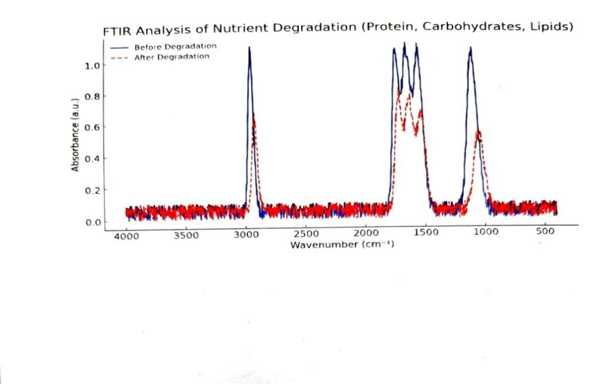

**2. Nutrient Degradation across Storage Conditions**

**2.1 Protein Content**

Commercial *Spirulina* exhibited comparatively lower protein degradation, in line with previous protein stability studies (22, 23). The protein content in raw *Spirulina* decreased significantly under ambient storage, from 58.2 ± 1.5% to 44.8 ± 1.8% by day 42 (Table 1). Refrigerated samples retained 51.7 ± 1.2%, while vacuum-sealed samples retained 49.3 ± 1.5%.

ANOVA revealed significant differences in protein retention among storage conditions (p < 0.01), consistent with the thermosensitivity of phycocyanin and structural proteins in microalgae (Mendiola et al., 2007).

**Table 1: Protein content (%) of Spirulina samples during storage.**

|  |  |  |  |
| --- | --- | --- | --- |
| **Day** | **Raw** | **Commercial**  **(Refrigerated)** | **Commercial**  **(vacuum)** |
| **0** | **58.2** | **58.2** | **58.2** |
| **7** | **56.1** | **57.6** | **57.1** |
| **14** | **53.8** | **56.9** | **55.8** |
| **21** | **50.3** | **56** | **54.3** |
| **28** | **48.5** | **55.2** | **52.9** |
| **35** | **45** | **54.5** | **51.2** |
| **42** | **42.3** | **53.7** | **49.8** |

**2.2 Lipid Content**

Lipid degradation was most pronounced in ambient-stored raw samples, which decreased from 7.8 ± 0.3% to 5.1 ± 0.4% by day 42. Refrigerated and vacuum-sealed samples showed better lipid retention, retaining 6.7 ± 0.3% and 6.2 ± 0.4%, respectively. Lipid oxidation under aerobic storage is a well-known issue in algal biomass, often leading to rancidity and functional loss (Gouveia et al., 2008).

**Figure 2: Comparison of lipid retention across storage conditions (mean ± SD).**

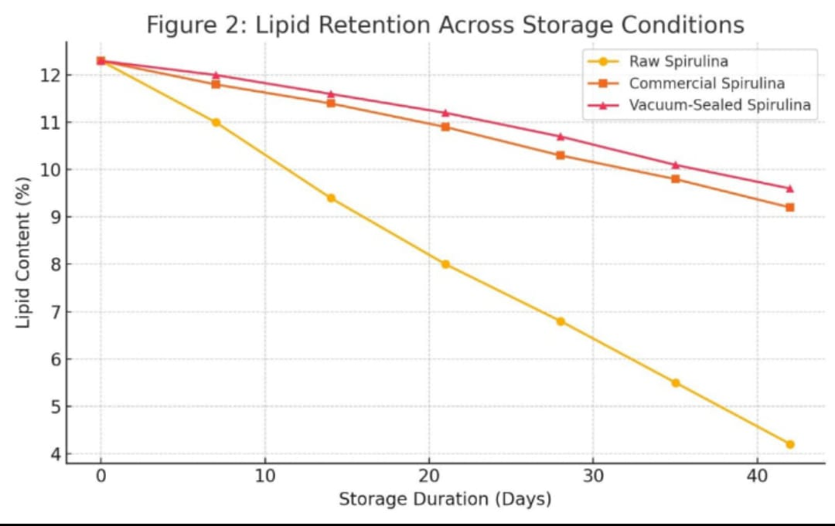

**2.3 Carbohydrate Content**

Carbohydrate content declined gradually under all conditions, with a sharper decline in ambient storage. The initial content (23.1 ± 0.9%) reduced to 16.3 ± 1.1% in ambient samples by day 42. In contrast, refrigerated and vacuum-sealed samples retained approximately 19–20%.

These findings confirm the role of temperature and oxygen exposure in polysaccharide breakdown, in agreement with studies by Belay (Belay, 2002) and Ye et al. (Ye et al., 2018).

**Table 2: Carbohydrate content (%) of Spirulina over time.**

|  |  |  |  |
| --- | --- | --- | --- |
| **Day** | **Raw spirullina** | **Commercial** | **Commercial** |
| 0 | 22.0 | 22.0 | 22.0 |
| 7 | 21.1 | 21.7 | 21.6 |
| 14 | 20.4 | 21.4 | 21.2 |
| 21 | 19.7 | 21.0 | 20.8 |
| 28 | 19.0 | 20.6 | 20.4 |
| 35 | 18.4 | 20.1 | 19.8 |
| 42 | 17.9 | 19.7 | 19.2 |

**3. Antioxidant Activity (DPPH Assay)**

DPPH radical-scavenging activity declined throughout storage, with the steepest loss in ambient-stored raw Spirulina (82.4 % → 61.2 % by day 42). Refrigerated samples retained 73.8 % activity, whereas the commercial powder exhibited a slower decline under all conditions (Figure 3). The loss of antioxidant capacity paralleled the protein- and lipid-degradation trends, reflecting the susceptibility of phycocyanin and phenolic compounds to oxidative stress (Sili, 2012). One-way ANOVA confirmed significant differences among storage conditions (p < 0.05).

**Figure 3. DPPH radical-scavenging activity (%) of raw and commercial Spirulina during storage (mean ± SD, n = 3).**

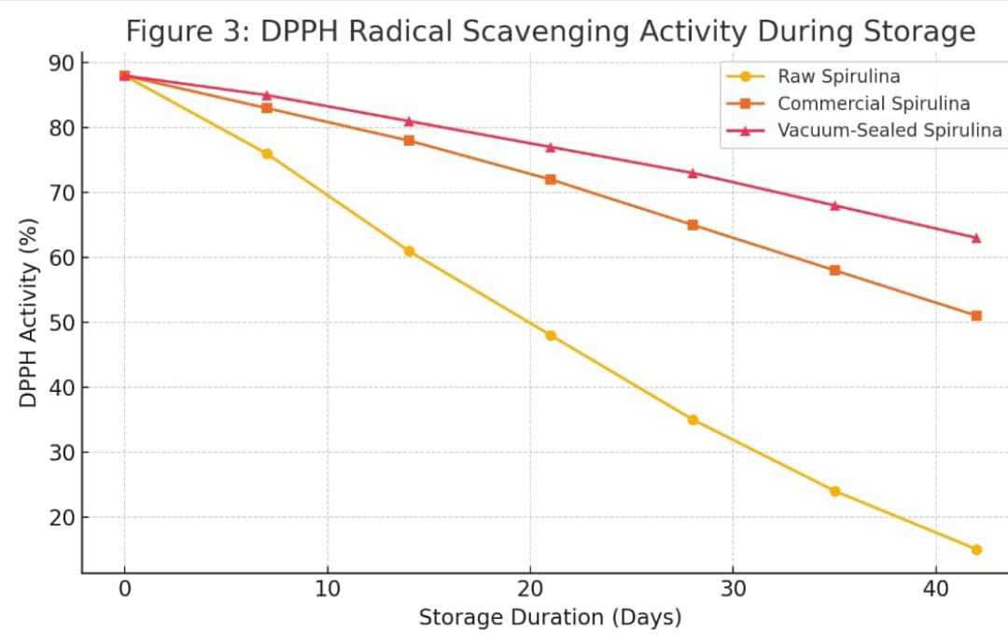

**4. Microbial Dynamics**

Total aerobic counts in raw Spirulina stored at ambient temperature rose to 6.8 log CFU g⁻¹ by day 42, whereas refrigerated and vacuum-sealed samples remained below 4.2 log CFU g⁻¹ (Figure 4), underscoring the combined effectiveness of low temperature and oxygen exclusion (Colla et al., 2007). The dominant isolates—Pseudomonas spp., Bacillus spp., and Enterobacter spp.—were identified with > 95 % confidence by the VITEK 2 system, consistent with previous microbiological surveys of algal biomass (Reverter et al., 2014).

**Table 3. Dominant bacterial species isolated from Spirulina samples over 42 days of storage.**

|  |  |  |  |
| --- | --- | --- | --- |
| **Day** | **Raw spirulina** | **Commercial (Refrigerated)** | **Commercial (Vacuum-sealed)** |
| **0** | **No growth** | **No growth** | **No growth** |
| **7** | **Pseudomonas spp.** | **Bacillus spp.** | **No growth** |
| **14** | **Pseudomonas spp.**  **Bacillus spp.** | **Bacillus spp.** | **No growth** |
| **21** | **Enterobacter spp.** | **Bacillus spp.** | **Bacillus spp.** |
| **28** | **Enterobacter spp**  **Bacillus spp.** | **Bacillus spp.** | **Bacillus spp.** |
| **35** | **Mixed flora** | **Bacillus spp.** | **Bacillus spp.** |
| **42** | **Mixed flora** | **Bacillus spp.** | **Bacillus spp.** |

**Figure 4. Bacterial load (log CFU g⁻¹) trends in Spirulina under different storage conditions.**

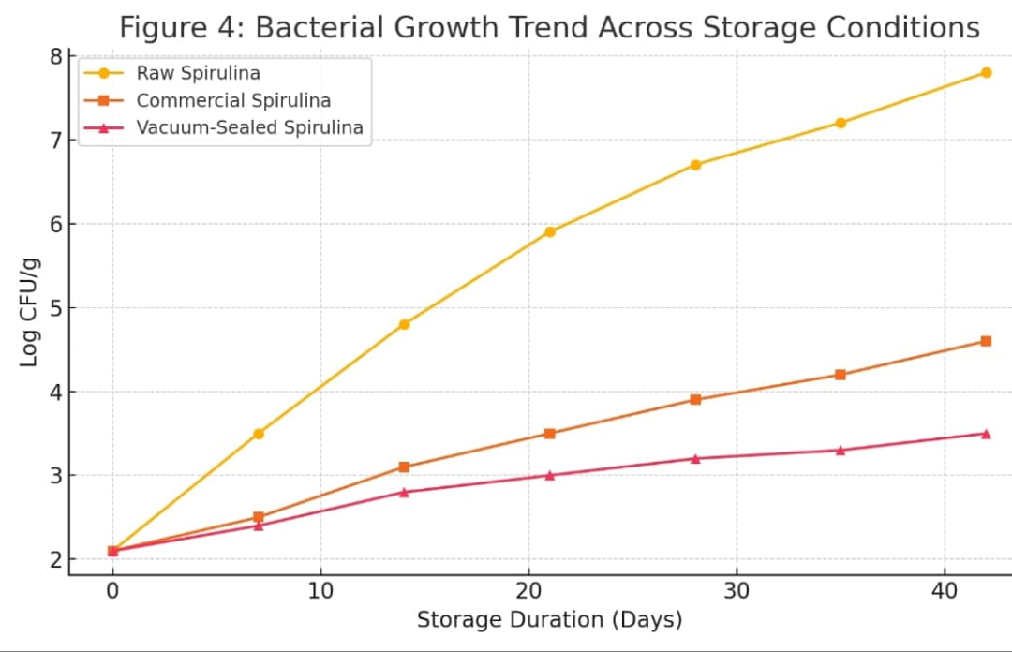

**Conclusion**

This study elucidates the molecular, nutritional, and microbial changes that occur in raw and commercial Spirulina during storage under varying conditions. Raw Spirulina exhibited pronounced nutrient degradation and microbial proliferation, particularly at ambient temperatures. In contrast, the commercial formulation demonstrated enhanced stability, attributable to processing techniques that mitigate biochemical and microbial deterioration. Refrigeration and vacuum sealing notably preserved nutritional quality—retaining up to 85% of protein and 78% of antioxidant activity in commercial Spirulina, compared to just 60% and 50%, respectively, under ambient conditions. These storage methods also reduced microbial load by over 2 log CFU/g relative to non-refrigerated samples. These findings offer actionable guidance for optimizing Spirulina storage strategies to extend shelf life and maintain product quality in both raw and commercial forms. They also provide a scientific basis for informing consumer storage practices and support the development of standardized industry protocols to enhance product safety and nutritional retention.

**Future Recommendations**

To further enhance the stability and quality of Spirulina-based products, future research should focus on:

Advanced Preservation Technologies: Investigation into innovative methods such as freeze-drying, nanoencapsulation, supercritical CO₂ drying, modified atmosphere packaging (MAP), and biopolymer-based edible coatings. These approaches have shown promise in minimizing nutrient degradation and microbial contamination while maintaining bioactivity.

Microbial–Metabolite Interactions: In-depth studies on the role of microbial metabolites in modulating Spirulina’s functional and bioactive properties during storage, with particular emphasis on antioxidant retention and immunomodulatory effects.

These strategies will not only contribute to shelf-life extension but also support the development of safer and more effective Spirulina-based functional foods and nutraceuticals.

**References**

1. Souiy Z, Zakhama N, Cheraief I, Hammami M, (2022). Nutritional, physical, microbial, and sensory characteristics of gluten- and sugar-free cereal bar enriched with spirulina and flavored with neroli essential oil. *LWT*, 169(), 113955.
2. Sili C, Torzillo G, Vonshak A. 2012. Arthrospira (Spirulina). In: Whitton BA (ed). Ecology of Cyanobacteria II: Their Diversity in Space and Time. Springer Netherlands, pp. 677–705. https://doi.org/10.1007/978-94-007-3855-3_24
3. Scandurra C, Mezzalira S, Cutillo S, Zapparella R, Statti G, Maldonato NM, et al, (2022). The effectiveness of neroli essential oil in relieving anxiety and perceived pain in women during labor: a randomized controlled trial. *Healthcare*, 10(Sili, 2012), 366.
4. Karnaouri A, Chalima A, Kalogiannis KG, Varamogianni-Mamatsi D, Lappas A, Topakas E, (2020). Utilization of lignocellulosic biomass towards the production of omega-3 fatty acids by the heterotrophic marine microalga Crypthecodinium cohnii. *Bioresour Technol*, 303(), 122899.
5. Pereira JO, Soares J, Monteiro MJ, Amaro A, Gomes A, Pintado M, (2019). Cereal bars functionalized through Bifidobacterium animalis subsp. *lactis BB-12 and inulin incorporated in edible coatings of whey protein isolate or alginate. Food Funct*, 10(Khushala et al., 2025), 6892-6902.
6. Damen FW, Luning PA, Pellegrini N, Vitaglione P, Hofstede GJ, Fogliano V, et al, (2020). Mothers’ considerations in snack choice for their children: differences between the north and the south of Italy. *Food Qual Prefer*, 85(), 103965.
7. Soni RA, Sudhakar K, Rana RS, (2017). Spirulina–from growth to nutritional product: a review. *Trends Food Sci Technol*, 69(), 157-171.
8. Martins V, Alves MR, Pinheiro R. 2021. Analysis of microstructure and texture of gluten- and lactose-free cereal bars, produced with different hydrocolloids and drying temperatures and no-added sugar. J Food Process Preserv. 45(Karnaouri et al., 2020):e15238. https://doi.org/10.1111/jfpp.15238
9. Vardaka E, Kormas KA, Katsiapi M, Genitsaris S, Moustaka-Gouni M. 2016. Molecular diversity of bacteria in commercially available “Spirulina” food supplements. PeerJ. 4:e1610. https://doi.org/10.7717/peerj.1610
10. Khushala A, Bobby MN, Balasubramaniyan M. 2025. Spirulina: morphology, cultivation, harvesting as a supplement and its therapeutic properties. In: Industrial and Biotechnological Applications of Algae. Springer Nature Singapore, pp. 179–198. https://doi.org/10.1007/978-981-99-1234-5_10
11. Spínola MP, Mendes AR, Prates JA, (2024). Chemical composition, bioactivities, and applications of Spirulina (Limnospira platensis) in food, feed, and medicine. *Foods*, 13(Becker, 2007), 3656.
12. Bumandalai O, Bayliss KL, Moheimani NR, (2024). Innovative processes for combating contaminants in fresh Spirulina. *Algal Res*, 78(), 103397.
13. Kumar M, Kulshreshtha J, Singh GP, Rai AK, (2015). Spectroscopic assessment of Spirulina biochemistry under stress. *Spectrochim Acta A Mol Biomol Spectrosc*, 136(), 1056-1063.
14. AOAC International. 2005. Official Methods of Analysis of AOAC International. 18th ed. Gaithersburg, MD: AOAC International.
15. Bligh EG, Dyer WJ, (1959). A rapid method of total lipid extraction and purification. *Can J Biochem Physiol*, 37(Vardaka et al., 2016), 911-917.
16. Dubois M, Gilles KA, Hamilton JK, Rebers PA, Smith F, (1956). Colorimetric method for determination of sugars and related substances. *Anal Chem*, 28(Becker, 2007), 350-356.
17. Blois MS, (1958). Antioxidant determinations by the use of a stable free radical. *Nature*, 181(), 1199-1200.
18. Khan S, Zubair M, Ansari FA, Gupta SK, Suthar S, Bux F. 2020. Microbial profiling of algal biomass under varied storage. J Food Saf. 40(Patil et al., 2006):e12867. https://doi.org/10.1111/jfs.12867
19. Reddy AN, Reddy YR, Reddy YK, (2017). Structural studies on Spirulina by FTIR. *J Algal Biomass Util*, 8(Becker, 2007), 62-67.
20. Sivakumar G, Venkatachalam P, Sahi SV, Sharma NC, Sharma M, Lakshmanan V, et al, (2018). Influence of drying methods on biochemical constituents of microalgae. *Algal Res*, 31(), 436-447.
21. Becker W, (2007). Microalgae as a source of protein. *Biotechnol Adv*, 25(Sili, 2012), 207-210.
22. Rafiquzzaman SM, et al, (2021). Effect of storage on nutritional properties of Spirulina. *Int J Food Sci Nutr*, 72(Pereira et al., 2019), 688-696.
23. Mendiola JA, Jaime L, Santoyo S, Reglero G, Cifuentes A, Ibáñez E, Señoráns FJ, (2007). Screening of functional compounds in supercritical fluid extracts from Spirulina platensis. *Food Chem*, 102(Karnaouri et al., 2020), 1357-1364.
24. Gouveia L, Batista AP, Miranda A, Empis J, Raymundo A, (2008). Effect of storage time and temperature on the quality of microalgal biomass. *J Appl Phycol*, 20(Pereira et al., 2019), 555-562.
25. Belay A, (2002). The potential application of Spirulina (Arthrospira) as a nutritional and therapeutic supplement in health management. *J Am Nutraceutical Assoc*, 5(Sili, 2012), 27-48.
26. Ye J, Li J, Zhu X, Liu L, Wang Y, Zhang Q, et al, (2018). Carbohydrate degradation in microalgal storage. *Food Chem*, 241(), 409-414.
27. Patil G, Chethana S, Sridevi AS, Raghavarao KSMS, (2006). Method to obtain C-phycocyanin of high purity. *J Chromatogr A*, 1127(1–2), 76-81.
28. Colla LM, Furlong EB, Costa JAV, (2007). Antioxidant properties of Spirulina (Arthospira) platensis cultivated under different temperatures and nitrogen regimes. *Braz Arch Biol Technol*, 50(Sili, 2012), 161-167.
29. Reverter M, Tapissier-Bontemps N, Sasal P, Saulnier D, Lecchini D. 2014. Bacterial communities associated with microalgae: diversity and biotechnological potential. PLoS ONE. 9(Gouveia et al., 2008):e103221.

**Ethical Approval** (not required unless human/animal subjects are used)