Design of an Internet of Things Based-Home Automation System

Abstract
Today modern homes are increasingly transition from manual systems to automated ones with remote control capabilities as automation technology develops. Conventional home electronic appliance access is strict and requires the user to physically attend to many appliance locations before they can be used. This can be stressful for the elderly and disabled and only offers a limited level of operating ease for everyone. To improve the flexibility of a user's remote access to home appliances, the products' wireless connection features become crucial. Furthermore, as technology advances in the modern period, a growing number of individuals get dependent on automated gadgets that they perceive to be able to improve and simplify their lives, particularly in the workplace. By meeting these requirements, the Internet of Things (IoT) improves people's quality of life. This project, an Internet of Things-based smart home lighting system using an ESP32 microcontroller, is designed to make life easier for people, especially for those who are disabled. The major objective of developing a mobile IoT app-based portable home automation system is to provide remote access and control of household appliances and electronics. The project controls the ON and OFF of electrical appliances using an ESP32 and an Internet of Things remote application server and overall response times are relatively consistent but vary slightly depending on the time of day and the specific test, with the system performing slightly better in the afternoon and night compared to the morning that is there is a lot of traffic on the network service provider in the morning for the system to perform better when compared to performance in the afternoon and night.

Keywords: ESP32 microcontroller, Internet of Things, Smart home lighting, wireless communication, IoT remote application.

1. Introduction
New discoveries and technologies are desperately needed in today's modern society to make daily tasks easier. Almost every element of the house may be managed and communicated with by one special system; home automation. The term "home automation" refers to the integration of all domestic appliances and amenities. The majority of home electrical appliances can be controlled by a microcontroller, but for this to happen, the appliances must be connected to one another in order for each one to establish communication with the others. Because home automation systems have so many benefits, like centralized appliance control, comfort and convenience, cost savings, energy conservation, security, and safety, their use in daily life is only increasing. Users can live better thanks to home automation systems (Pujaria et al., 2020).
Wi-Fi (wireless fidelity) is a wireless technology that uses radio frequency to transmit data through the air. The home automation system can be achieved via Wi-Fi enabled devices where mobile phones are used, but more importantly to this work is our connection over the Internet, a technology known as the Internet of Things (IoT). The initial speed of Wi-Fi is between 1 and 2 Mbps. Data is transmitted via Wi-Fi using the 2.4 GHz frequency spectrum. It puts frequency division multiplexing technology concepts into practice. Wi-Fi technology has a range of 40–300 feet. The Internet of Things, or IoT, is a concept in which every gadget is given an IP address, which anybody may use to identify that object online. Recent technological advancements have made it possible to use wireless controlling environments like Bluetooth and WiFi, which has allowed many gadgets to be able to communicate with one another. There are now many distinct kinds of connections thanks to the development of wireless technology; each of these connections has specific requirements and uses.
Wi-Fi is one of the most widely used connections that are frequently used in HAS (Home automation System) projects. The capabilities of Wi-Fi are more than sufficient for this job. Moreover, the cost of the system will be lowered because the majority of electronics and gadgets have built-in Wi-Fi adapters. An ESP32 DEV KIT V1 microcontroller is used in this project as the controlling device for the automation. We also used the Arduino IoT cloud infrastructure in this project, which allows for the connection of several devices, the sharing of real-time data between them, and the monitoring of that data via a straightforward user interface from any location. We plan to integrate an ESP32 Wi-Fi module with an 8-channel relay module. This would enable us to control lights, fans, and other electrical appliances by sending ON/OFF commands from either the computer dashboard or the dashboard of our mobile phone on the Arduino IoT cloud platform.

Methodology

2. Related Works:
A lot of researchers have expended efforts in developing automated system for home use; some of these articles are discussed as follows: Abdulraheem et al., (2020) developed a system that uses sensors to collect data about the home environment such as temperature, humidity and light levels. Al-Gburi and Abdul-Rahaim (2022) implemented a system using an Arduino Uno board, a Wi-Fi module, and a variety of sensors and actuators. The system is designed to be scalable and can be easily expanded to control more devices and add more security features and it is cost-effective.
Pujari et al., (2020) implemented home automation system using node-MCU microcontroller, a firebase database and an android mobile app. The node-MCU is a popular open-source firmware and development kit that is primarily associated with the ESP8266 and ESP32 microcontrollers. Salman Iqbal et al., (2021) proposed a system that is composed of the following four major components which include the controller (Raspberry pi), sensors, home devices and the android application. Ali et al. (2020) developed a home automation system using the ThingSpeak cloud platform and the Arduino UNO microcontroller with microchip AT mega 328P. Arduino transfer the data over ThingSpeak that offers Realtime updates for user via mobile application or web interface.
Stolojescu-Crisan et al., (2021) implemented the system using the ESP8266EX Wi-Fi module version and the Raspberry Pi 4 boards. The ESP8266 Wi-Fi module is used as a sensor node to collect data from the environment, such as temperature, humidity, and light levels. Banjo Oluwafemi et al., (2022) developed a smart home automation system that uses the following components, ATmega328P, GSM SIM 900 Module, relays, PIR sensors, MQ2 gas sensor amongst others. ATmega328P microcontroller is used as the central processing unit (CPU) of the smart home system. Kadali et al., (2020) proposes a system for home automation that uses a Chatbot and voice assistant. The Raspberry pi 3B+ is used alongside the with the python NLTK library, Python GPIO library, Raspbian OS, and Telegram Bot API to develop the Chatbot and voice assistant. Meshram et al., (2022) implemented a system that uses the following components which include the Arduino UNO board, 4-channel 5V relay module and HC-05 Bluetooth module to build a smart home automation system.

3. Design Approach
Design methodology of this system has two major parts, the software and hardware design. The hardware is designed by arranging smartphones, micro-controller ESP32 DEV KIT V1, Power supply, 8- channel relays, whereas software design includes the Arduino IoT cloud software application and the program or source code that is written and uploaded in the microcontroller. The appliances are controlled using relays via Wi-Fi. The activation of the home appliances is achieved by using the remote-control app. on the smartphone. Fig. 1 shows the block diagram of android application using Wi-Fi and ESP32 microcontroller for home automation via the Arduino IoT cloud platform.
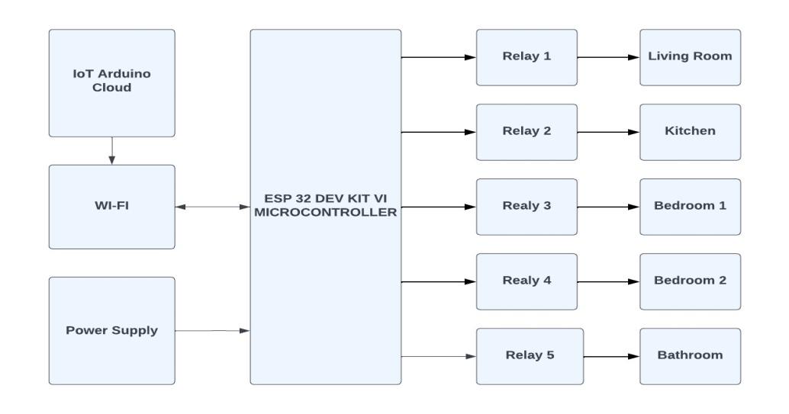
Fig. 1: Block diagram of the design

3.1 The Hardware
The hardware part of the system entails basically the following units. These units are:
- The Input Unit which covers mainly the processes that is followed in setting up the input environment i.e., Arduino IoT remote control app. via the smartphone being used.
- The Processing Unit which focuses on the ESP32 microcontroller and,
- The Output Unit which entails the relays and the connected loads

3.2 Software
The software part of this system consist the written C++ programming language that actually defines the operations of each button on the smartphone “Arduino Remote Control” application. This program is written using the Arduino Web Editor. The Arduino Web Based Editor is a cloud-based application that is supported by any operating system with a web browser. It is used to write and upload programs to Arduino compatible boards, such as the micro-controller ESP32 DEV KIT V1 and the interface in fig. 2 shows Arduino IoT cloud dashboard. The microcontroller receives data from the smartphone, and processes the data sent with already written and uploaded program. Although using the main Arduino IDE provides a more powerful and feature-rich platform than the Arduino web editor, the Arduino web editor is a good option for beginners and users who needs a simple and easy-to-use platform.

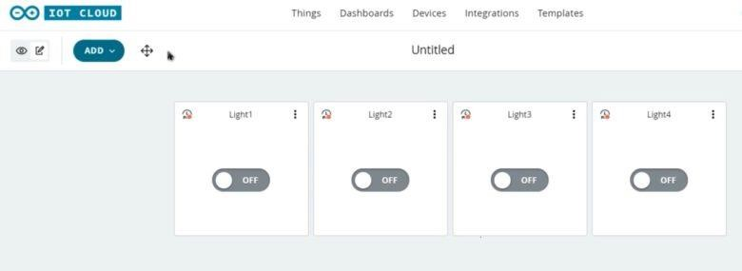

Fig. 2: Arduino IoT Cloud Dashboard

4. Result & Discussion
While building this system, the breadboard, Veroboard, and a mobile device were tested at both low and high temperatures. It was discovered that the components were functioning as intended. The speed at which the system responds to commands is determined in part by the system reaction time when a command signal is delivered through the mobile phone, for example, to switch on the lightbulb. To determine the average system performance time, this test is run several times a day across a distance of less than and greater than one km in the morning, noon, and evening using a stop watch. Both at above and below one kilometre in distance, the system functioned successfully. Table 1 displays the response time of the lightbulb when it is activated, and Fig. 3 shows a chart with the system's response times in the morning, afternoon, and night.

Table 1: Response time of home appliance

Time Test 1(sec) Test 2 (sec) Test (sec) Signal Signal Average Response Response Time (sec)
Below 1km Above 1km
Morning 0.86 0.83 0.75 ON ON 0.81
Afternoon 0.71 0.75 0.81 ON ON 0.75
Night 0.83 0.75 0.79 ON ON 0.79

Fig. 3: Representation of the response time in a chart

The chart shows the response times of a bulb across three tests (Test 1, Test 2, and Test 3) conducted at different times of the day (Morning, Afternoon, and Night). It shows that in the morning, Test 1 has the highest response time because the microcontroller has not been on for more than 8 hours while Test 3 has the lowest. In the afternoon, Test 1 has the lowest response time and Test 3 has the highest. At night, Test 1 again shows the highest response time with Test 2 having the lowest. Overall, response times are relatively consistent but vary slightly depending on the time of day and the specific test, with the system performing slightly better in the afternoon and night compared to the morning that is there is a lot of traffic on the network service provider in the morning for the system to perform better when compared to performance in the afternoon and night. And Fig. 4 and Fig. 5 represented front and back view images of the prototype system.

4.1 Integrity Test (Using different passwords and SSID)
Different service set identifier (SSID) was created with the same password “password” but the system microcontroller did not connect with it. Another scenario was created by creating same SSID but different password, the system was also unable to connect to this network. A perfect connection was established when the same SSID and Password as specified in the program was used.

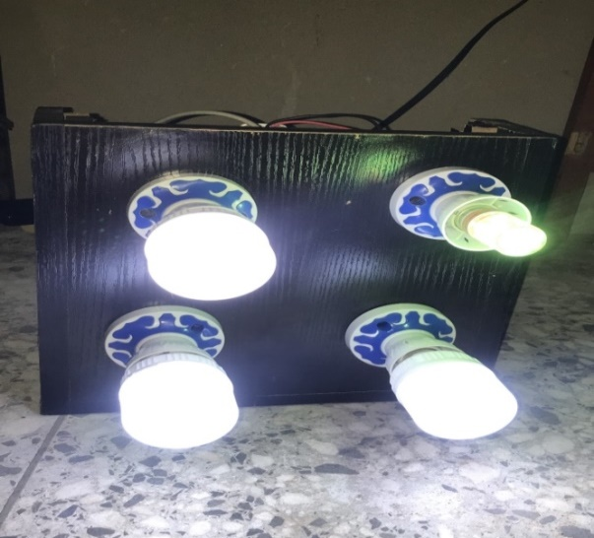

Fig. 4: Front view image of the prototype system

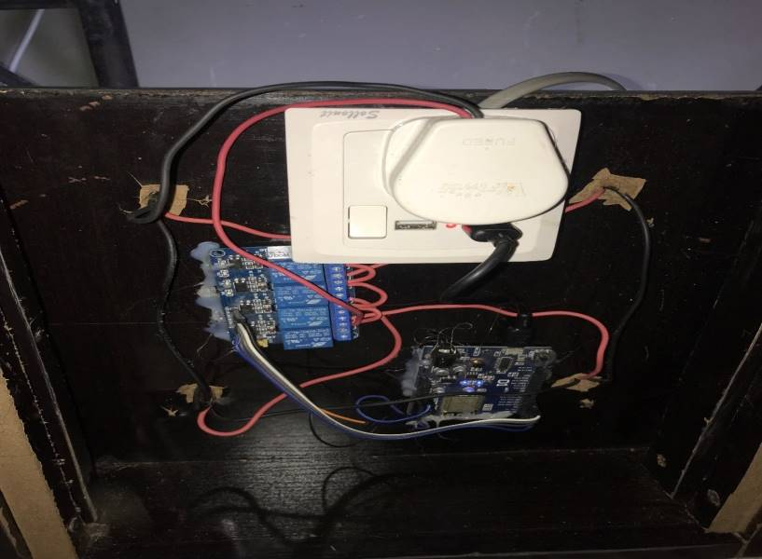

Fig. 5: Back view image of the prototype system

5. Conclusion
A system which can monitor and control multi devices at home using IoT based ESP32 microcontroller was presented. The fabrication of an IoT-based home automation lighting system using the ESP32 microcontroller is a highly effective approach to modernizing home environments. By combining hardware and software development with IoT technology, this project offers a practical solution that enhances user convenience, promotes energy efficiency, and can be adapted to various applications in smart home automation.
The project successfully demonstrates the potential of IoT-based solutions to revolutionize home automation. By leveraging the capabilities of the ESP32 microcontroller, the system provides a cost-effective, scalable, and flexible solution for modern smart homes. Additionally, the using of internet access that can control from far away can ease people in controlling appliances if they are absent from home and to ease disable people. The system's versatility, cost-effectiveness, and ability to integrate with other smart home devices make it a compelling solution for modern smart homes.

COMPETING INTERESTS DISCLAIMER:
Authors have declared that they have no known competing financial interests OR non-financial interests OR personal relationships that could have appeared to influence the work reported in this paper.

References
Abdulraheem, A. S., Salih, A. A., Sadeeq, M. A. M., Salim, N. O. M., Abdulla, A. I., Abdullah, H., Khalifa, F. M., & Saeed, R. A. (2020). Home Automation System based on IoT Cloud Computing Resources Impacts on Heavy-Load Parallel Processing Approaches View project Handover in a mobile wireless communication network-A Review Phase View project Home Automation System based on IoT (Vol. 62). https://www.researchgate.net/publication/342561938
Al-Gburi, M. K., & Abdul-Rahaim, L. A. (2022). Secure smart home automation and monitoring system using internet of things. Indonesian Journal of Electrical Engineering and Computer Science, 28(1), 269–276. https://doi.org/10.11591/ijeecs.v28.i1.pp269-276
Ali, M., Nazim, Z., Haroon, M., Azeem, W., Javed, K., Tariq, M., & Hussain, A. (2020). An IoT based Approach for Efficient Home Automation with ThingSpeak. In IJACSA) International Journal of Advanced Computer Science and Applications (Vol. 11, Issue 6). www.ijacsa.thesai.org
Banjo Oluwafemi, I., Olawale Bello, O., & Dorcas Obasanya, T. (2022). DESIGN AND IMPLEMENTATION OF A SMART HOME AUTOMATION SYSTEM. https://doi.org/10.22159/ijet.2022v10i1.46883
Iqbal, S., Sharif, Z., Shahid, M. A., & Abbas, M. Z. (2021). Internet-of-Things based Smart Home Automation System using Android Phone. Sir Syed University Research Journal of Engineering & Technology (SSURJET), 11(2).
Kadali, B., Prasad, N., Kudav, P., & Deshpande, M. (2020). Home Automation Using Chatbot and Voice Assistant. ITM Web of Conferences, 32, 01002. https://doi.org/10.1051/itmconf/20203201002
Malhotra, M., Mittal, R., & Jain, M. (2019). A Gesture Controlled and Cost Effective - Home Automation System. International Journal of Scientific Research in Computer Science, Engineering and Information Technology, 1033–1038. https://doi.org/10.32628/cseit1952267
Meshram, K., Meshram, K., Mekhe, R., Meshram, Y., Meshram, A., & Narule, Y. (2022). Home Automation Using Arduino. International Journal for Research in Applied Science and Engineering Technology, 10(12), 948– 951. https://doi.org/10.22214/ijraset.2022.47912.
Pujari, U., Patil, P., Bahadure, N., & Asnodkar, M. (2020). International Conference on Communication and Information Processing Internet of Things based Integrated Smart Home Automation System. https://ssrn.com/abstract=3645458.
Stolojescu-Crisan, C., Crisan, C., & Butunoi, B. P. (2021). An iot-based smart home automation system. Sensors, 21(11). https://doi.org/10.3390/s21113784

