**Exploring the Nutritional and Physiological Benefits of Bee-Derived Products: Honey and Pollen as Emerging Functional Foods**

**Abstract**

Honey and bee pollen are natural products that come from bees and are known for being good for your health and full of nutrients. This study looked at the physical, chemical, nutritional, and antioxidant properties of multifloral honey and bee pollen to see if they could be used as functional foods. The honey sample had a lot of carbohydrates (83.4%), mostly in the form of fructose (38.74%) and glucose (31.38%). The ratio of fructose to glucose was 1.25. It had a total phenolic content of 51.24 mg GAE/g and a DPPH radical scavenging activity of 39.45%, which means it had moderate antioxidant activity. In contrast, bee pollen had a higher nutrient density, with 21.23% protein, 11.68% fiber, and 252.98 mg GAE/g of total phenolics. It also had a lot of potassium (248.02 mg/100 g), calcium (131.76 mg/100 g), and ascorbic acid (13.40 mg/100 g). The antioxidant capacity of bee pollen was noteworthy, as evidenced by its 4.65 µmol Fe²⁺/g FRAP value and 71.69% DPPH activity. Its functional value was further increased by the presence of unsaturated fatty acids and essential amino acids. These results lend credence to the idea that honey and bee pollen are natural functional foods that have physiological and nutritional advantages.

**Keywords:** Honey, Bee pollen, Functional food, Nutritional composition, Antioxidants, Bioactive compounds

**1. Introduction**

Recent years have seen a surge in the search for foods that promote health and have both nutritional and physiological advantages, especially as consumers and researchers have come to understand the drawbacks of highly processed diets and artificial supplements. The idea of functional foods—those that offer health benefits beyond basic nourishment, frequently by boosting immunity, lowering oxidative stress, or assisting in disease prevention—was born out of this interest (Gardiner et al. 2017). Because of their distinct nutrient profiles and bioactive potential, bee-derived products like honey and bee pollen have garnered a lot of interest within this category (Cornara et al., 2017; Karaman, 2019).

Honey is a natural sweet substance made by honeybees from the nectar of flowers. It has a lot of different nutrients, such as simple sugars, organic acids, amino acids, enzymes, vitamins, minerals, and polyphenolic compounds. It is a good source of energy because it is mostly made up of fructose and glucose. Its low pH, enzymes, and antioxidants also help it fight bacteria, reduce inflammation, and get rid of free radicals (Silva et al., 2016; Stevenson et al., 2017). The good ratio of fructose to glucose also makes the product taste better and slows down crystallization, which makes it more appealing to customers and keeps it fresh longer (Close et al., 2016).Honeybees gather bee pollen from flowering plants. It is thought to be one of the most complete foods in nature. It has a lot of proteins, essential amino acids, unsaturated fatty acids, fiber, and natural antioxidants (Campos et al., 2008; Denisow & Denisow-Pietrzyk, 2016). Bee pollen is a great source of vitamins and minerals that help with metabolism and other bodily functions. It has a lot of B-complex vitamins, ascorbic acid, and fat-soluble vitamins, as well as important micronutrients like iron, magnesium, calcium, and zinc. Researchers have also found that it may boost the immune system, cognitive function, and antioxidant defenses because it contains polyphenols, flavonoids, and gamma-aminobutyric acid (GABA) (Komosinska-Vassev et al., 2015; Sommano et al., 2020).

Bee pollen is known as a "complete and concentrated natural food" because it has a good balance of nutrients and bioactives (Krell, 1996; Kieliszek et al., 2018). International organizations like the FAO and WHO have recognized it. Its high digestibility, especially when ground and spread out, makes it easier for the body to absorb nutrients and stay healthy.Honey and bee pollen are a powerful combination of easily accessible energy, a wide range of micronutrients, and bioactive protection. This is why they are becoming more common in functional food formulations, nutraceuticals, and wellness diets.

**Objectives**

1. To determine the physico-chemical characteristics of honey and bee pollen.
2. To analyze their proximate composition, including macronutrient content.
3. To quantify essential micronutrients, amino acids, and fatty acids.
4. To evaluate their antioxidant potential through DPPH, FRAP, and total phenolic and flavonoid content.

**2. Materials and Methods**

Multifloral honey and bee pollen were procured from local, authenticated sources during the spring harvest season from the Punjab region. The samples were kept in sterile, airtight containers at room temperature, away from light and moisture, to keep their nutritional and bioactive properties intact. The AOAC (2005) and FSSAI (2012) set standard methods for looking at the physical and chemical properties of honey and bee pollen. We used refractometry to find out how much water was in the honey, and we used a calibrated pH meter and conductometer to record the pH and electrical conductivity of a 20% w/v honey solution. We used titration and incineration to figure out how much free acidity and ash there was, and we used spectrophotometry to figure out how much hydroxymethylfurfural (HMF) there was, following White (1979). For bee pollen, the color coordinates (L, a, b*) were determined using a Lovibond Tintometer (Model F) and the proximate composition— moisture, ash, crude protein (CP), fat, fiber, and total carbohydrate—was determined following AOAC methods.

The sugar profile (fructose and glucose content) was determined by High-Performance Liquid Chromatography (HPLC) following the procedures of Doner (1977) and White (1979), and the fructose-glucose ratio was determined to investigate crystallization tendencies. Vitamin (thiamine, riboflavin, niacin, pyridoxine and ascorbic acid) analyses were performed using the methods of Oser (1979) and Desai (1984), while minerals like iron, calcium, phosphorus, magnesium, potassium, sodium and zinc were determined by wet digestion, employing Atomic Absorption Spectrophotometry (Ranganna, 1986). Fatty acid composition The fatty acid composition of bee pollen was analysed after esterification of its lipid fraction following AOAC (2005) guidelines by Gas Liquid Chromatography (GLC). Free and bound amino acids in bee pollen The composition of essential and non-essential amino acids in bee pollen were identified after hydrolysis with 6 N HCl, then, analyzed by cation exchange chromatography in a Shimadzu Amino Acid Analyzer. The antioxidant capacity of the two products was tested using different in vitro tests such as total phenolic content (TPC) according to the Folin–Ciocalteu method (Singleton and Rossi, 1965), total flavonoid content (TFC) by aluminum chloride colorimetry (Zhishen et al., 1999) and DPPH radical scavenging activity (Brand-Williams et al. (1995), ferric reducing antioxidant power (FRAP) according to Benzie and Strain (1996). All tests were performed in triplicate. Results were presented as mean ± standard deviation (SD). Statistical significance was determined using ANOVA and Tukey’s post-hoc test using SPSS (Version XX). A p-value <0.05 was considered statistically significant.

**3. Results**

The present study sought to evaluate nutritional composition, bioactive properties, and physiological functioning of multifloral honey and bee pollen as functional foods from nature. Results showed that there was a great variation in the nutrition density and antioxidant properties of these bee-derived foods, thus stressing their individual dietary health benefits.

**Nutritional and Physico-Chemical Profile of Honey**

The physicochemical evaluation of honey indicated the usual characteristics of high-quality multifloral honey. The golden-yellow color as determined by L*, a*, and b* values indicates good visual appeal and floral purity, which is often desired by consumers (Table 1). A pH value of 4.2 and conductivity of 236 µS/cm give evidence to its acidic nature, which contributes to its shelf stability and antimicrobial property. Very low hydroxymethylfurfural (HMF) value evidenced minimal heat exposure or aging so that its nutritional and enzymatic activity was well preserved. Honey, analyzed for proximate composition, contains 83.4% carbohydrates, chiefly simple sugars like fructose and glucose, which are responsible for its quick release of energy (Table 2). This profile enables honey to be used as a natural replacement for processed sugars, particularly within the environmental arousal space. Although the concentrations of protein, lipid, and fiber are minimal, the amounts contribute toward its functional profile with trace nutrients and antioxidants.

According to the micronutrient analysis, honey is a fair source of essential minerals, with a predominance of potassium (Table 4). Also, the presence of magnesium, calcium, and iron adds potential for electrolyte balance, bone health, and hemoglobin formation. Some vitamins, like thiamine, riboflavin, and pyridoxine, although present in very low amounts, strengthen honey's standing as a bioactive-rich natural product.Sugar profile indicated a favorable fructose-to-glucose ratio (1.25), which is indicative of good palatability and slow crystallization (Table 3). Antioxidant property of honey has been confirmed by moderate DPPH inhibition and a measuring of ferric reducing antipirine power (FRAP) (Table 5) path, presumably, due to its phenolic and flavonoid contents. These bioactive substances have an accreting contribution to the honey's free radical scavenging potential, which implies reducing oxidative stress.

**Nutritional and Functional Profile of Bee Pollen**

Bee pollen is much more balanced and denser than honey regarding macronutrients. It contains a lot of protein (21.23 percent), very high amounts of fiber (11.68 percent), and lipids (6.30 percent), making it compact in terms of nutrient density. This is quite impressive considering the little amounts consumed. Its low moisture content favors a long shelf life and microbial stability. Sugar analyses showed moderate amounts of simple sugars, with fructose and glucose being the most critical ones again. The fructose-to-glucose ratio reflects its naturally sweet taste but with slower crystallization, which is important from a product-formulation and storage standpoint (Table 8).

Bee pollen exceeded honey in the content of most micronutrients. It was quite rich in potassium, calcium, and magnesium and iron, confirming a strong mineral profile for promotion of cardiovascular, muscular, and hematological health (in Table 9). The vitamin profile was equally remarkable because of the high values for ascorbic acid, riboflavin, and pyridoxine, which help support immune function, metabolism, and energy production. One hit about bee pollen was its fatty acid composition, especially oleic, linoleic, and linolenic acid, which support cardiovascular health and anti-inflammatory responses (see Table 10). These unsaturated fatty acids, together with palmitic acid and stearic acid, show yet another balanced lipid profile with energy and therapeutic implications. The amino acid profile showed that bee pollen has all essential amino acids in value. The presence of high amounts of leucine, lysine, and isoleucine strengthens its importance for muscle repair and protein synthesis (Table 11). The high amount of glutamic acid and asparagic acid, along with serine, glycine, and proline, strengthen its being classified as a high-value protein source. Bee pollen, in particular, was found to have a very high antioxidant potential, far exceeding honey with respect to total phenolic and flavonoid content. The results obtained in DPPH scavenging activity and FRAP also confirmed its supreme ability to detoxify oxidative stress (Table 12). Such antioxidant potential not only protects the integrity of products but also aids in maintaining good health when regularly consumed.

**Table 1 Physico-chemical properties of honey.**

|  |  |
| --- | --- |
| **Parameters** | **Honey** |
| Colour | |
| L* | 62.89±1.47 |
| a* | 1.56±0.38 |
| b* | 29.72±1.08 |
| Hydroxymethylfurfural (HMF) (mg/kg) | 4.90±0.05 |
| Methylglycosol (mg/g) | 0.47±0.02 |
| Conductivity (µS/cm) | 236±0.50 |
| pH | 4.2±0.07 |

Values are expressed as mean±SD

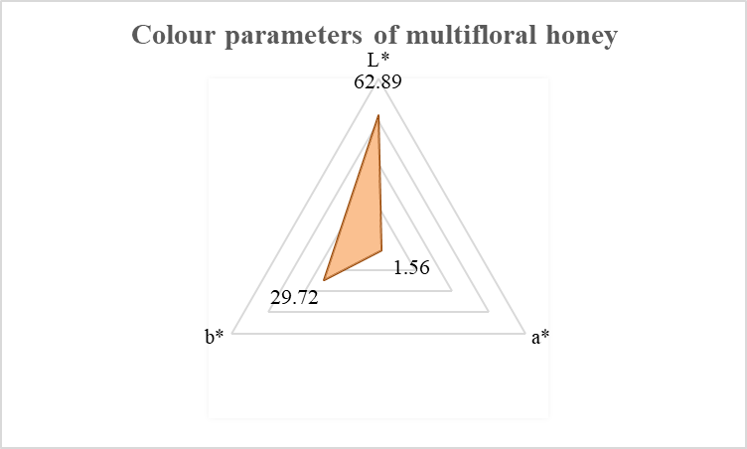

**Fig 1: Colour parameters of honey**

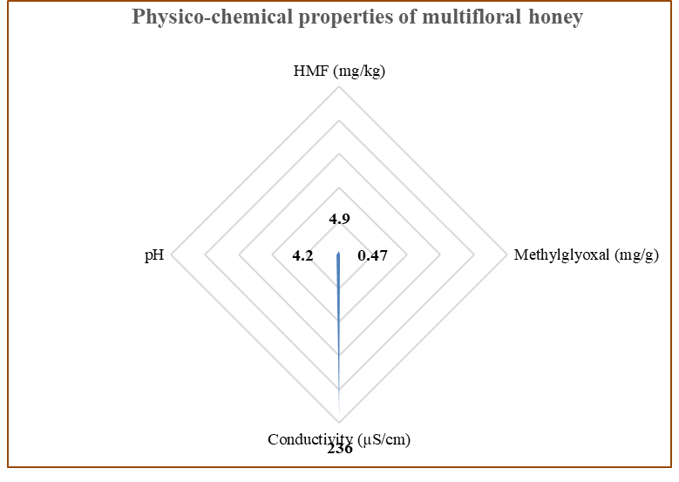

**Fig 2: Physico-chemical properties of honey**

# Table 2 Proximate composition of honey (%)

|  |  |
| --- | --- |
| **Proximate parameters (%)** | **Honey** |
| Moisture | 15.07±1.78 |
| Ash | 1.03±0.06 |
| Protein | 1.08±0.04 |
| Lipid | 0.25±0.03 |
| Carbohydrates | 83.4±1.02 |
| Fibre | 0.94±0.05 |

Values are expressed as mean±SD

**Table 3 Total sugars content in honey (%)**

|  |  |
| --- | --- |
| **Sugar content** | **Honey** |
| Total sugars | 73.45±0.06 |
| Sucrose | 2.60±0.20 |
| Fructose | 38.74±0.59 |
| Glucose | 31.38±0.46 |
| Fructose- Glucose ratio | 1.25±0.16 |

Values are expressed as mean±SD

**Table 4 Vitamin and mineral (mg/100g) composition of honey**

|  |  |
| --- | --- |
| **Vitamin content** | **Honey** |
| Ascorbic acid (Vit C) | 2.88±0.22 |
| Thiamine (Vit B1) | 0.61±0.04 |
| Riboflavin (Vit B2) | 0.75±00.02 |
| Pyridoxine (Vit B6) | 0.44±0.01 |
| **Mineral content** | |
| Calcium | 17.78±0.65 |
| Potassium | 48.0±0.08 |
| Sodium | 14.70±1.02 |
| Phosphorus | 3.62±0.28 |
| Magnesium | 19.62±0.02 |
| Iron | 2.91±0.08 |

Values are expressed as mean±SD

**Table 5 Antioxidant properties of honey**

|  |  |
| --- | --- |
| **Antioxidant parameters** | **Honey** |
| Total Phenolic content (mg GAE/g) | 51.24 ± 0.09 |
| Total Flavonoid content (mg/g) | 9.53±0.90 |
| DPPH (1,1 diphenyl- picrylhydrazl) radical scavenging activity | 39.45±2.02 |
| Ferric Reducing antioxidant power assay (FRAP Assay) (µmol Fe2+/g) | 0.84±1.02 |

Values are expressed as mean±SD

**Table 6 Proximate Composition of Bee Pollen (%)**

|  |  |
| --- | --- |
| **Proximate parameters** | **Bee pollen** |
| Moisture | 4.37±0.08 |
| Ash | 3.3±0.33 |
| Protein | 21.23±0.23 |
| Lipid | 6.30± 0.03 |
| Carbohydrates | 65±2.46 |
| Fibre | 11.68±1.41 |

Values are expressed as mean±SD

**Table 7 Physicochemical Properties of Bee Pollen**

|  |  |
| --- | --- |
| **Parameters** | **Bee pollen** |
| Colour |  |
| L* | 49.32±0.08 |
| a* | 5.98±0.13 |
| b* | 30.13±0.40 |
| pH | 3.8±0.04 |

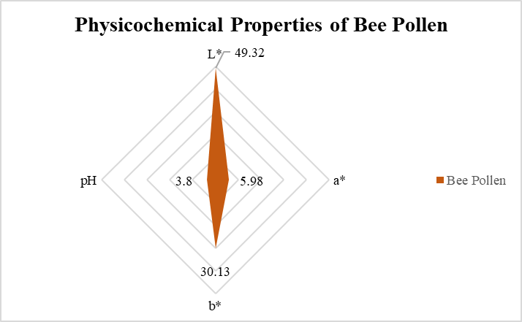

**Fig 3: Physico-chemical properties of bee pollen**

**Table 8 Total sugars content in bee pollen (%)**

|  |  |
| --- | --- |
| **Sugar content** | **Bee pollen** |
| Total sugars | 32.97±1.78 |
| Sucrose | 3.98±0.06 |
| Fructose | 16.89±0.07 |
| Glucose | 10.14±0.86 |
| Fructose- Glucose ratio | 1.33±0.02 |

Values are expressed as mean±SD

**Table 9 Vitamin and mineral (mg/100g) composition of Bee Pollen**

|  |  |
| --- | --- |
| **Vitamin content** | **Bee pollen** |
| Ascorbic acid (Vit C) | 13.40±0.26 |
| Thiamine (Vit B1) | 0.67±0.02 |
| Riboflavin (Vit B2) | 1.05±0.01 |
| Pyridoxine (Vit B6) | 0.77±0.05 |
| **Mineral content (mg/100g)** | **Bee pollen** |
| Calcium | 131.76±0.46 |
| Potassium | 248.02±1.40 |
| Sodium | 94.02±0.34 |
| Phosphorus | 105.28±0.04 |
| Magnesium | 81.45±0.01 |
| Iron | 19.79±0.11 |

Values are expressed as mean±SD

**Table 10 Fatty Acids composition of Bee Pollen (%)**

|  |  |
| --- | --- |
| **Fatty acid** | **Bee pollen** |
| Palmitic (C16:0) | 17.36±0.12 |
| Stearic (C18:0) | 4.55±0.03 |
| Oleic (C18:1) | 13.20±0.86 |
| Linoleic (C18:2) | 11.14±0.01 |
| Linolenic (C18:3) | 15.64±0.23 |
| Arachidic (C20:0) | 3.27±0.05 |

Values are expressed as mean±SD

**Table 11 Amino acid profiling of bee pollen (mg/g)**

|  |  |
| --- | --- |
| *In vitro* **protein content** | 21.89±0.59 |
| **Amino acid profiling of bee pollen (mg/g)** | |
| Valine | 5.69±0.54 |
| Leucine | 12.90±0.05 |
| Iso-leucine | 10.20±0.50 |
| Threonine | 8.85±0.16 |
| Methionine | 2.92±0.76 |
| Lysine | 11.19±0.06 |
| Phenyl alanine | 7.65±0.01 |
| Histidine | 9.80±0.23 |
| Tyrosine | 4.48±0.05 |
| Arginine | 7.66±0.03 |
| Cystine | 4.79±0.01 |
| Tryptophan | 1.12±0.13 |
| Alanine | 8.88±0.19 |
| Glycine | 7.70±0.06 |
| Serine | 6.82±0.18 |
| Proline | 8.70±0.17 |
| Aspartic acid | 19.11±0.02 |
| Glutamic acid | 20.79±0.13 |

Values are expressed as mean±SD

**Table 12 Antioxidant properties of bee pollen**

|  |  |
| --- | --- |
| **Antioxidant parameters** | **Bee pollen** |
| Total Phenolic content (mg GAE/g) | 252.98 ± 1.03 |
| Total Flavonoid content (mg/g) | 91.72 ± 0.45 |
| DPPH (1,1 diphenyl- picrylhydrazl) radical scavenging activity | 71.69 ± 1.57 |
| Ferric Reducing antioxidant power assay (FRAP Assay) (µmol Fe2+/g) | 4.65 ± 1.42 |

**Discussion**

This study was an effort to characterize both the nutritional and functional properties of multifloral honey and bee pollen as a possible natural functional food. Findings showed that both bee products have good physico-chemical properties and a very dense nutrient profile that contributes to their strong antioxidant capacity, which is essential in their health-promoting value.

**Physico-Chemical and Nutritional Characteristics**

The physico-chemical metrics of honey, such as moisture content, pH, and hydroxymethylfurfural (HMF) contents, are within acceptable limits for "fresh and good processing" as defined by Codex and FSSAI standards. These factors, directly linked to the length of shelf life without changes, stability, and safety of honey, were reported similarly by Silva et al. (2016). According to the same researchers, lower moisture and acidity levels are important in the maintenance of the antimicrobial activity associated with honey and inhibition of fermentation.

In contrast, bee pollen had a rather complicated and rich nutrient profile with a higher-protein, fiber, and lipid content than honey, thus fitting it into the category of complete food. These characteristics are also in line with previous findings by Campos et al. (2008), where it is mentioned that bee pollen serves as a significant source of macronutrients needed for metabolic health and tissue repair. The pleasant color attributes seen for this experiment also reflect the presence of naturally occurring pigments and flavonoids which add to the antioxidant activity.

**Micronutrients and Bioactive Nutrient analysis**

Bee pollens nutritional compositions shows that it is exceptionally rich in the truly indispensable essential micronutrients-potassium, calcium, magnesium, and iron. These serve for major physiological functions, such as those involved in the transport of oxygen, metabolism in bones, regulation in enzymes, and others. Denisow and Denisow-Pietrzyk (2016) and Kieliszek et al. (2018) also observed the mineral riches of bee pollen and endorsed it as a nutrient supplement and a health promoter. In context of the amino acids found in bee pollen- are classified a good range of essential as well as non-essential amino acids. A few typical examples include leucine and lysine, valine; amino acids that are reported to support muscle metabolism, neurotransmission, and immune function. Earlier, high biological value in protein in bee pollen was analyzed by Thakur and Nanda (2015) and Komosinska-Vassev et al.(2015), because, they claimed, it has balanced proportions of amino acids fit for human nutrition.

**Antioxidant Activity**Antioxidant ability is the key feature of functional food assessment. In the current research, bee pollen had much greater phenolic and flavonoid concentrations than honey, as well as better performance in DPPH and FRAP tests. This pattern confirms previous findings by Alvarez-Suarez et al. (2010) and Pascoal et al. (2014), which reported that bee pollen polyphenols are responsible for its ability to scavenge free radicals, inhibit oxidative stress, and maintain cellular integrity. Although honey also had moderate antioxidant activity, its more straightforward composition—mainly sugars and trace levels of bioactives—might be responsible for its relatively weaker activity in comparison to bee pollen. Nonetheless, the presence of organic acids, enzymes, and polyphenols in honey still supports its antioxidant, antimicrobial, and wound-healing properties as described by Bogdanov et al. (2008) and Silva et al. (2016).

Together, the findings firmly justify the designation of honey and bee pollen as natural functional foods. The value of honey is in its potential to offer rapid energy coupled with enzymatic and phytochemical protection, while that of bee pollen is a more comprehensive array of nutrients, such as complete proteins, unsaturated fatty acids, essential minerals, and potent antioxidant compounds.Their use separately or collectively in functional food, dietary, and therapeutic diets might contribute significantly towards improving nutritional sufficiency and long-term health. Such evidence is consistent with the expanding body of literature underpinning the introduction of minimally processed and bioactive-dense foods into standard dietary regimens for prevention of oxidative stress-related chronic diseases (Cornara et al., 2017; Komosinska-Vassev et al., 2015).

**Conclusion:** The present study points to the great nutritional and functional food value of multifloral honey and bee pollen. Honey proved to be a concentrated source of natural sugar, trace minerals, and low-level antioxidants, corroborating its status as a natural energy giver with added health benefits. Bee pollen, on the other hand, had a higher nutrient density, containing high protein, essential fatty acids, vitamins, minerals, and outstanding antioxidant activity. These characteristics merit the designation of both foods as functional foods, having the potential to make healthful contributions and prevent disease. Their inclusion in health-oriented diets or in functional food preparations presents promising leads for enhancing nutrition health.

**Data Availability**

The datasets generated and/or analyzed during the current study are available from the corresponding author on reasonable request.

**References**

Alvarez-Suarez, J.M., Tulipani, S., Romandini, S., Bertoli, E. and Battino, M., 2010. Contribution of honey in nutrition and human health: A review. Mediterranean Journal of Nutrition and Metabolism, 3, pp.15–23.

AOAC, 2005. Official methods of analysis. 18th ed. Washington, DC: Association of Official Analytical Chemists.

Benzie, I.F.F. and Strain, J.J., 1996. The ferric reducing ability of plasma (FRAP) as a measure of “antioxidant power”: the FRAP assay. Analytical Biochemistry, 239, pp.70–76.

Bogdanov, S., Jurendic, T., Sieber, R. and Gallmann, P., 2008. Honey for nutrition and health: A review. Journal of the American College of Nutrition, 27(6), pp.677–689.

Brand-Williams, W., Cuvelier, M.E. and Berset, C., 1995. Use of a free radical method to evaluate antioxidant activity. LWT - Food Science and Technology, 28(1), pp.25–30.

Campos, M.G.R., Bogdanov, S., de Almeida-Muradian, L.B., Szczesna, T., Mancebo, Y., Frigerio, C. and Ferreira, F., 2008. Pollen composition and standardisation of analytical methods. Journal of Apicultural Research, 47(2), pp.154–161.

Cornara, L., Biagi, M., Xiao, J. and Burlando, B., 2017. Therapeutic properties of bioactive compounds from different honeybee products. Frontiers in Pharmacology, 8, p.412.

da Silva, P.M., Gauche, C., Gonzaga, L.V., Costa, A.C.O. and Fett, R., 2016. Honey: Chemical composition, stability and authenticity. Food Chemistry, 196, pp.309–323.

Denisow, B. and Denisow-Pietrzyk, M., 2016. Biological and therapeutic properties of bee pollen: A review. Journal of the Science of Food and Agriculture, 96(13), pp.4303–4309.

Desai, I.D., 1984. Vitamin E analysis methods for animal tissues. In: P. Lester, ed. Methods in Enzymology, 105. New York: Academic Press, pp.138–147.

Doner, L.W., 1977. The sugars of honey – A review. Journal of the Science of Food and Agriculture, 28(5), pp.443–456.

FSSAI, 2012. Manual of methods of analysis of foods – Honey. New Delhi: Food Safety and Standards Authority of India, Ministry of Health and Family Welfare, Government of India.

Kieliszek, M., Piwowarek, K., Kot, A.M., Błażejak, S., Chlebowska-Śmigiel, A. and Wolska, I., 2018. Pollen and bee bread as new health-oriented products: A review. Trends in Food Science & Technology, 71, pp.170–180.

Komosińska-Vassev, K., Olczyk, P., Kaźmierczak, J., Mencner, Ł. and Olczyk, K., 2015. Bee pollen: Chemical composition and therapeutic application. Evidence-Based Complementary and Alternative Medicine, 2015, Article ID 297425.

Kroyer, G. and Hegedus, N., 2001. Evaluation of bioactive properties of pollen extracts as functional dietary food supplement. Innovative Food Science and Emerging Technologies, 2(3), pp.171–174.

Oser, B.L., 1979. Hawk’s physiological chemistry. 14th ed. New Delhi: Tata McGraw-Hill.

Pascoal, A., Rodrigues, S., Teixeira, A., Feás, X. and Estevinho, L.M., 2014. Biological activities of commercial bee pollens: Antimicrobial, antimutagenic, antioxidant and anti-inflammatory. Food and Chemical Toxicology, 63, pp.233–239.

Ranganna, S., 1986. Handbook of analysis and quality control for fruit and vegetable products. 2nd ed. New Delhi: Tata McGraw-Hill.

Silva, P.M.D., Gauche, C., Gonzaga, L.V., Costa, A.C.O. and Fett, R., 2016. Honey: Chemical composition, stability and authenticity. Food Chemistry, 196, pp.309–323.

Singleton, V.L. and Rossi, J.A., 1965. Colorimetry of total phenolics with phosphomolybdic-phosphotungstic acid reagents. American Journal of Enology and Viticulture, 16, pp.144–158.

Thakur, M. and Nanda, V., 2015. Composition and functionality of bee pollen: A review. Trends in Food Science & Technology, 48, pp.48–59.

Tuksitha, L., Chen, Y.L.S., Muhammed, A.M., Chen, Y.L. and Huang, T.C., 2017. Antioxidant and antimicrobial properties of different floral origin honeys from Malaysia. International Journal of Food Properties, 20(S3), pp.S2723–S2734.

White, J.W., 1979. Spectrophotometric method for hydroxymethylfurfural in honey. Journal of the Association of Official Analytical Chemists, 62, pp.509–514.

Zhishen, J., Mengcheng, T. and Jianming, W., 1999. The determination of flavonoid contents in mulberry and their scavenging effects on superoxide radicals. Food Chemistry, 64, pp.555–559.

AOAC, 2005. Official Method 969.33. Fatty acids in oils and fats—Preparation of methyl esters. In: Official methods of analysis. 18th ed. Washington, DC: AOAC International.

AOAC, 2005. Official Method 982.30. Total dietary fiber in foods. In: Official methods of analysis. 18th ed. Washington, DC: AOAC International.