Weeding practices in Agriculture

ABSTRACT
Weeding is a critical agricultural activity essential for maintaining crop health and optimizing yield by eliminating competition from unwanted plants. In India, manual weeding remains the predominant practice due to its cost-effectiveness and environmental sustainability compared to chemical herbicides. This study explores the use of various traditional hand tools for weeding, focusing on their design, the postures assumed during their use, and the ergonomic challenges faced by workers. Observational analysis and video documentation reveal that prolonged squatting, bending, and repetitive movements during manual weeding lead to significant physical strain and musculoskeletal issues among agricultural workers. The findings highlight the urgent need for ergonomic interventions to minimize worker discomfort and improve productivity. This paper provides insights into traditional weeding practices, their implications on worker health, and the potential benefits of redesigning tools to enhance safety, comfort, and efficiency in agricultural settings.
Keywords: Weeding practices, manual weeding, ergonomic challenges, agricultural tools, hand tools, musculoskeletal disorders, traditional farming, worker safety, postural analysis, sustainable agriculture

INTRODUCTION
Agriculture in India is a vital sector that contributes significantly to the country's economy. With a large percentage of the population engaged in agricultural activities, India has a diverse range of crops being cultivated across different regions (Mbatha, 2020; Smolińska, 2019). One important aspect of agriculture in India is the weeding activity.
Weeds are unwanted plants in agriculture fields which grow along with the main crop (Woyessa, 2022; Scavo & Mauromicale, 2020). They are strong and dominating competitors for crops and these unsown plant species hinder the growth of the intended crops (Radicetti and Mancinelli, 2021). From an agronomical perspective, the term "weed" refers to any plant that is not intentionally sown or propagated by the farmer but requires management to prevent interference with crop or livestock production Schonbeck, (2011). Interestingly, even "volunteer crops" like buckwheat, rye, Japanese millet, corn, or soybean can become weeds when they self-seed and emerge in a different part of the crop rotation where they are no longer desired (Scavo and Mauromicale, 2020). The presence of weeds can significantly impact crop growth and yield by reducing nutrient availability and hindering sunlight penetration. Therefore, farmers in India employ various weeding techniques to ensure the optimal growth of their crops.
One of the commonly used weeding practices in Indian agriculture is manual weeding (Singh et al., 2022; Cordeau, 2022). In India, manual weeding is predominantly done by farmers themselves or by hired laborers. Farmers use various tools like hoes, sickles, or hand weeder to uproot the weeds from the soil manually. This method is preferred over chemical herbicides due to its cost-effectiveness and the minimal risk of environmental pollution. Additionally, manual weeding allows farmers to closely inspect their crops for any signs of diseases or nutrient deficiencies.
Although manual weeding can be a labor-intensive process, it is an important aspect of sustainable agriculture (Liu et al., 2023). It not only helps in maintaining crop health but also contributes to the overall well-being of the farming community. By practicing manual weeding, farmers in India are able to protect their crops and ensure a bountiful harvest.
METHODOLOGY
Research Design
This study utilized an observational and descriptive research design to assess ergonomic aspects of weeding activities in agricultural fields. Data collection involved field observations, video analysis, surveys, and postural assessments.
Study Area and Participants
The study was conducted in agricultural fields with limited mechanization. A purposive sample of farm workers engaged in manual weeding was selected.
Data Collection Methods
Observation and Video Analysis
Direct field observations and video recordings documented weeding techniques, tool usage, and worker postures.
FINDINGS AND DISCUSSION

Weeding activity in agricultural fields
In agricultural fields, hand tools and implements are vital for the performance of weeding activities, particularly in regions where mechanization is limited. These tools, often simple in design, play a crucial role in maintaining crop health by effectively removing weeds that compete for nutrients, water, and sunlight. Traditional hand tools, such as hoes, sickles, and Khurpis, are commonly used due to their versatility and ease of use. Each tool is designed to target specific types of weeds and is adapted to the physical demands of manual labor, often reflecting the local agricultural practices and environmental conditions. The efficiency of these tools directly impacts the productivity and well-being of farm workers, highlighting the importance of ergonomic design to minimize the physical strain associated with repetitive weeding tasks.
Table 1: Information on hand tools and implements used in performance of weeding activity in agricultural fields
Features | Using Posture | Specifications
- Khurpi  A traditional hand tool used in agriculture, features a blade with a tang and a sturdy handle. The blade, typically made from medium to high carbon steel, is designed with a slightly curved edge to efficiently cut through weeds. Its tang extends into the handle, ensuring stability and durability during use. | Squatting | 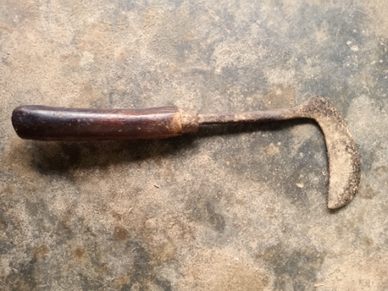  Length of the handle - 10-12 cm, Handle diameter -2.5-3 cm
- Sickle  The Sickle, also known as a Khurpi, is a widely used handheld tool available in different sizes and shapes. Primarily employed for weeding, it features a sharp, curved metal blade attached to a wooden handle. Crafted from medium to high carbon steel, its design facilitates a push-pull action while working. | Squatting | The overall length -31 cm  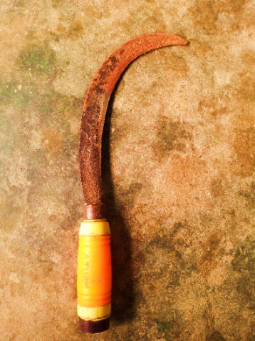  Plain edge arc length - 20-25 cm. Width of the blade - 3.7 cm
- Hand Shovel:  The hand shovel is a valuable tool for weeding in gardening and agriculture. Its blade, designed with a curved edge for effective soil penetration, allows precise weed uprooting. | Squatting | 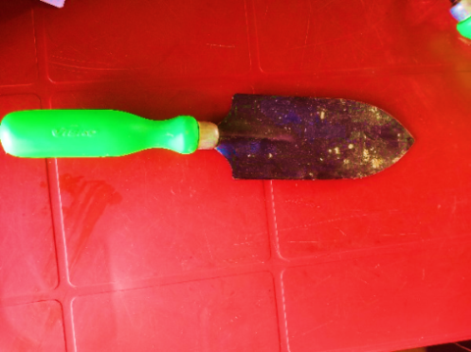  Handle length - 17 cm,  Blade length - 10.5 cm  Blade width- 3.5 cm
- Weeding hook:  The weeding hook is equipped with a V-shaped blade, specifically designed for precise weed removal in gardening and agriculture. This unique blade shape enables users to effectively target weeds at their base. | Squatting | Handle length - 13 cm,  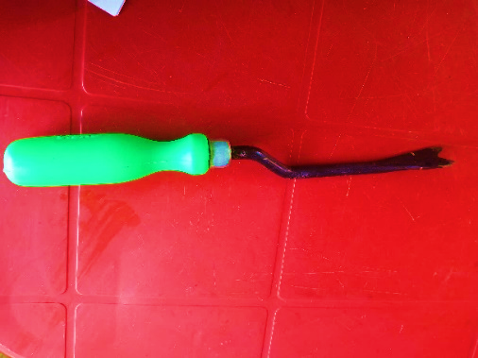  Blade measures 16.5 cm in length and 3.5 cm in width
- Khurpi (traditional):  Similar to other Khurpis used in the northeastern region of the country, this tool features a slightly curved cutting edge, sharpened for effortless soil penetration. | Squatting | Handle length - 14.5 cm  blade measures 9.5 cm in length and 2.6 cm in width.  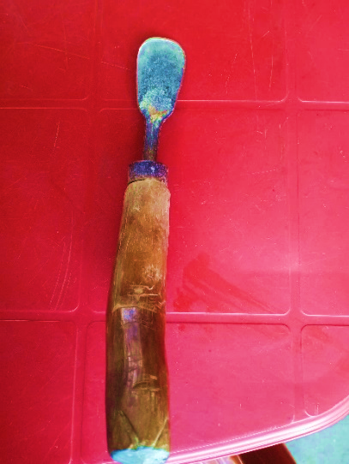
- Hoe (Powrah):  The hoe, an essential tool in agriculture and gardening, features a blade attached to a long handle. The blade is usually flat or slightly curved, designed to break up soil, remove weeds, and shape planting rows. The handle provides leverage and control during hoeing tasks. | Standing cum forward bending | 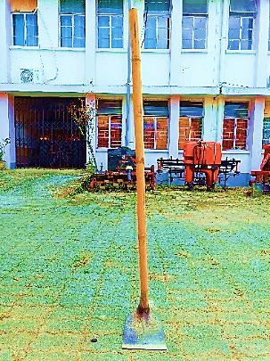  Handle height -162.82 cm, diameter - 4 cm. The blade dimensions measure 17 cm in width and 19 cm in length.

Posture assumed during weeding task
The posture of workers during tasks is influenced by the demands of the job, the working environment, and the design of the tools they use. Occasional unnatural postures are not typically a cause for concern. However, holding unnatural postures for extended periods should raise alarm. When the body remains in one position for too long, or repetitive gestures are made, the body naturally adjusts, leading some muscles to tighten while others weaken. Over time, this imbalance can place strain on certain joints, causing pain and potentially leading to work-related health issues. Workers involved in weeding often experience high static postural loads due to the restrictive nature of the work methods and tools. These postures were studied and analysed through observation, still photography, and video analysis.
The postural analysis clearly demonstrate that the workers assume a variety of abnormal postures at work. From the illustrations and description (presented in Table 2 and Fig 1) revealed that squatting with slight forward bending, flexion at the neck, back and at the knees with the movement of both the hands were assumed while performing the weeding task by small hand tools. For hand hoe workers assumed a standing cum forward bending posture with movement of both the hands.
Muscle movement with shoulder adduction, shoulder flexion, extension of fingers, abduction and adduction of hands, flexed and pronated wrist of both hands was found among the workers during weeding. Similar postures with legs (flexed legs) in slow dynamic motion and arms stretched forward were also found to be assumed by respondent while caring out the weeding task. Standing and slight forward bending posture was assumed by workers while using hoe for weeding.

Table. 2 Analysis of different postures assumed by the respondents while performing weeding activity with different hand tools.

Hand tools | Types of posture | Illustration | Description
- Hand Shovel | Squatting cum bending | 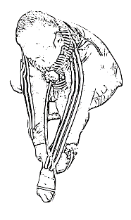 | The worker sits in a squatting posture, holding the tool in right hand and removing the weeds in left hand
- Khurpi | Squatting cum bending | 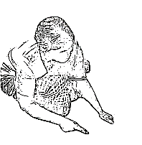 | The worker sits in a squatting posture, holding the tool in right hand and removing the weeds in left hand
- Sickle | Standing cum bending | 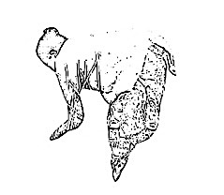 | The worker bends her whole body in a standing posture and hold the weeds in left hand while cutting it using the tool held in right hand
- Hoe (Powrah) | Standing cum bending | 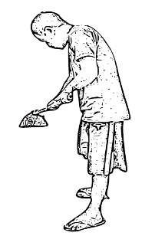 | The worker stands with slight forward bending and holding the tool in both hands for removing the weeds
- Khurpi (traditional) | Standing cum bending | 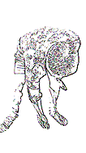 | The worker bends his whole body in a standing posture and remove the weeds using tool held in right hand and keeps his left hand on left thigh for support
- Weeding hook | Squatting cum bending | 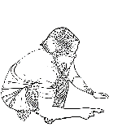 | The worker sits in a squatting posture, holding the tool in right hand and removing the weeds in left hand

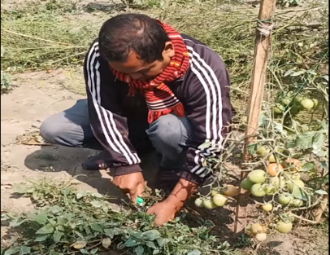
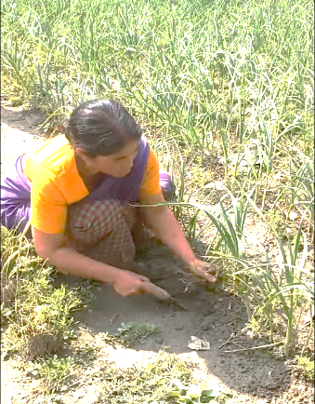
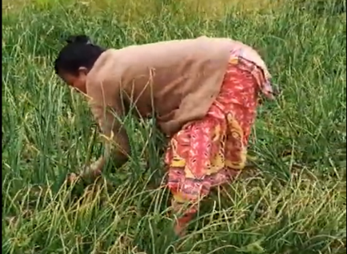
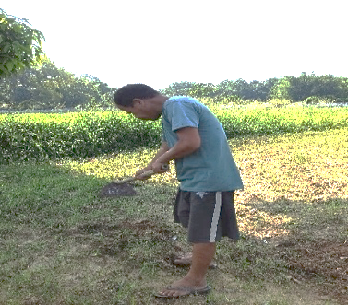
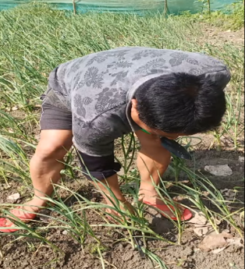
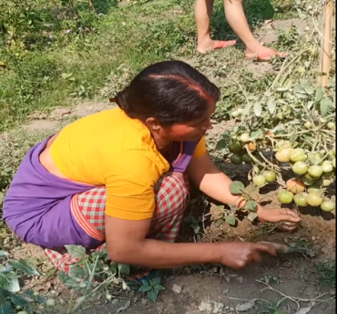
Figure 1: POSTURES ASSUMED BY THE RESPONDENTS WHILE PERFORMING WEEDING ACTIVITY WITH DIFFERENT HAND TOOL
- Hand Shovel

(b) Khurpi

(c) Sickle

(d) Hoe (Powrah)
(e) Khurpi (traditional)

(f) Weeding hook

Problems faced by the respondents while using different hand tools used for weeding activity
In agriculture, hand tools and manual work accessories play a crucial role in aiding farmers with various tasks. These tools are designed for manual operation, offering flexibility and convenience in small-scale agricultural fields. They help farmers efficiently perform tasks like digging, planting, weeding, and harvesting. However, the frequent and strenuous use of these tools can cause issues for workers, such as muscle and joint strain, particularly during long working hours. This can lead to musculoskeletal disorders and chronic pain. Additionally, poor posture while using hand tools often results in back and neck pain, with these issues worsening if the tools are not ergonomically designed. (Table 3).

Table 3: Problem faced by farmers while using hand tools

Name of tools | Problems faced by workers in using different hand tools
Hoe (Powrah) | This is the most common tool used in weeding activities. Hoe requires force while using. The constant bending and stooping required to effectively use a hoe can lead to strain and discomfort in the back, neck, and shoulders.  These postures may also cause unexpected injuries like carpel tunnel syndrome, musculoskeletal disorder and lower back injuries.
Weeding hook | Weeding hook requires a continues squatting and bending posture to reach the weeds, which leads to strain on workers back, neck and shoulders. This continuous bending and crouching can result in musculoskeletal disorders and chronic pain.
Sickle | Sickle requires a bending posture. However, the bend position during longer periods creates tension of certain muscles thus results in quicker tiredness and soreness in the lower back and necks of the workers.
Hand Shovel | Squatting and bending posture assumed by workers for a longer period of time causes strain on certain muscles, resulting in back and neck pain.
Khurpi | Khurpi, a handheld tool with a small blade, requires workers to bend down and maintain a crouched position for extended periods of time. This repetitive action puts a strain on the workers' backs, causing discomfort and potential long-term health issues.

CONCLUSION
Weeding is an indispensable aspect of agricultural practices, particularly in India, where traditional manual methods remain prevalent due to economic and environmental considerations. The study underscores the critical role of hand tools such as hoes, sickles, khurpis, and shovels in facilitating weeding activities. However, the analysis reveals that these tools, while effective, often necessitate physically demanding postures that contribute to significant musculoskeletal strain and discomfort among workers. Prolonged squatting, bending, and repetitive motions not only impact worker well-being but also pose challenges to productivity in agricultural operations.
The findings highlight the urgent need for ergonomic interventions in the design of hand tools and work methods. By incorporating principles of ergonomic engineering, tools can be optimized to reduce physical strain, thereby improving worker safety, comfort, and efficiency. Additionally, education and training on proper postures and tool usage can further alleviate the adverse effects associated with manual weeding tasks.
Addressing these challenges is vital for fostering sustainable agricultural practices and enhancing the quality of life for farm workers. Future research should focus on developing and testing innovative tool designs and mechanized alternatives that balance tradition with technological advancement to ensure the continued growth and sustainability of the agricultural sector.

References
Radicetti, E., & Mancinelli, R. (2021). Sustainable Weed Control in the Agro-Ecosystems. Sustainability, 13(15), 8639. https://doi.org/10.3390/su13158639

Scavo, A. and Mauromicale, G. (2020). Integrated Weed Management in Herbaceous Field Crops. Agronomy. 10: 466.
Schonbeck, M., and Tillage, B. (2011). Principles of sustainable weed management in organic cropping systems. In Workshop for Farmers and Agricultural Professionals on Sustainable Weed Management. 3: 1-24. Clemson, SC, USA: Clemson University.
Mbatha, M. W. (2020). The Agricultural Sector in Improving the Country’s Economy. Journal of African Foreign Affairs, 7(2), 77-93.
Smolińska, K. (2019). The role of Agriculture in the national economy of China and India–a longterm analysis. Roczniki (Annals), 2019(3).
Woyessa, D. (2022). Weed control methods used in agriculture. American Journal of Life Science and Innovation, 1(1), 19-26.
Scavo, A., & Mauromicale, G. (2020). Integrated weed management in herbaceous field crops. Agronomy, 10(4), 466.
Singh, M., Kukal, M. S., Irmak, S., & Jhala, A. J. (2022). Water use characteristics of weeds: A global review, best practices, and future directions. Frontiers in Plant Science, 12, 794090.
Cordeau, S. (2022). Conservation agriculture and agroecological weed management. Agronomy, 12(4), 867.
Liu, C., Yang, K., Chen, Y., Gong, H., Feng, X., Tang, Z., ... & Qi, L. (2023). Benefits of mechanical weeding for weed control, rice growth characteristics and yield in paddy fields. Field Crops Research, 293, 108852.

