Case report
MANAGEMENT OF CLOSED PYOMETRA INDUCED ACUTE KIDNEY INJURY BY INTERMITENT HEMODIALYSIS IN A LABRADOR RETRIEVER DOG

ABSRACT
Aims: This study underscores the importance of intermittent hemodialysis (IHD) for treatment of closed pyometra induced AKI in dog.
Presentation of Case: A 9-year-old female Labrador retriever dog with history of inappetence, lethargy, intermittent vomiting, melena, polyuria and polydipsia was presented to Multispecialty Hospital, Guru Angad Dev Veterinary and Animal Sciences University, Ludhiana. Initial physical assessment revealed body condition score- 3, congested mucus membrane, with normal vital parameters. Complete blood counts revealed neutrophilic leukocytosis and severe left shift. Biochemistry revealed derailed renal function values [Blood urea nitrogen (BUN)- 93 mg/dl, Creatinine- 9.7mg/dl, Sodium (Na)-150 mEq/l, Potassium (K)- 4 mEq/l, Chloride (Cl)- 108 mEq/l, Phosphorus (P)- 18.4mg/dl). Routine urine analysis was normal. Ultrasound examination revealed distended uterine horns with echogenic material, measuring approximately 4.07 cm. However, cortico-medullary differentiation, size and contour of both the kidneys was within the normal limits suggesting pyometra with AKI. Initially to counter the AKI, IHD was undertaken along with rational treatment to extend the window of renal recovery as well as to undertake surgical intervention for ovario-hysterectomy. After surgery, dog was again referred to dialysis unit due to elevated uremic toxins. Blood gas analysis revealed metabolic acidosis with compensatory alkalosis. Again IHD was started immediately to lower down the blood creatinine level. After three sessions of hemodialysis animal’s renal function values (creatinine 2.1mg/dl) and BUN 27mg/dl) improved with resolved clinical signs.
Discussion and Conclusion: This case report explains the management of complicated cases of pyometra with renal involvement using IHD concomitant with surgical intervention.
Keywords: Hemodialysis, Closed Pyometra, Creatinine, Ovario-hysterectomy
- INTRODUCTION
Pyometra is one of the most common uterine infections in intact, sexually mature bitches. It is estimated that around one-third of bitches in anestrus may develop pyometra. Most common pathogen of pyometra is Escherichia coli followed by Streptococcus and Staphylococcus (Xavier et al., 2024; Rocha et al., 2022). Female dogs with pyometra may develop a range of renal complications, including reduced renal perfusion, immune-mediated glomerular injury, impaired urine concentrating ability, interstitial tubular pathology and a decreased glomerular filtration rate (GFR), reflecting both functional and structural alterations in renal physiology (Chew et al, 2010; de Sousa., 2007). If left untreated, it may result in the patient’s death. Due to the insidious nature of the disease and its sometimes-equivocal clinical signs, patients are often presented in poor condition for anesthesia and surgery. Intermittent hemodialysis is a technically sophisticated procedure which is safe and effective for the management of dogs with severe AKI for removing uremic toxins.
- PRESENTATION OF CASE
A 9-year-old female Labrador retriever dog with history of inappetance, lethargy, intermittent vomiting, melena, polyuria and polydipsia was presented to Multispecialty Hospital, Guru Angad Dev Veterinary and Animal Sciences University, Ludhiana. Animal also show signs of estrus 15 days ago. Initial physical assessment revealed body condition score (BCS)-3 (on 5-point scale), congested mucus membrane, normal mentation, with normal vital parameters. Systolic Blood pressure reveals normotensive stage (130mmHg) (Doppler Vet BP mano medical, France). Complete blood counts revealed hemoglobin 8.4 g/dL indicates macrocytic hypochromic anemia, TLC 52,330 along with neutrophilic leukocytosis and severe left shift with mild thrombocytopenia (Platelets 130 ×10³/µL). Biochemistry revealed derailed renal function values (BUN- 93 mg/dl, Creatinine- 9.7mg/dl, Na-150 mEq/l, K- 4 mEq/l, Cl- 108 mEq/l, P- 18.4mg/dl). Routine urine analysis shows mild proteinuria (1+). Liver function tests shows hyperbilirubinemia (Total bilirubin-1.9) with elevated alkaline phosphatase (308 U/L). Ultrasound examination revealed distended uterine horns with echogenic material, measuring approximately 4.07 cm (fig.1.a) (Alpinion X-Cube 70). However, cortico-medullary differentiation, size and contour of both the kidneys was within the normal limits suggesting pyometra with AKI (fig.1.b).
Initially to counter the AKI, IHD was undertaken along with rational treatment to extend the window of renal recovery as well as to undertake surgical intervention for ovario-hysterectomy. After the initial hemodialysis session, the dog was referred to the Department of Gynecology and Obstetrics for surgical treatment. An ovario-hysterectomy was carried out through a ventral midline incision under gaseous anesthesia (fig.2). After surgery, dog was again referred to dialysis unit due to elevated uremic toxins. On the next day, the second session of intermittent hemodialysis was performed, during which the dog showed slight improvement in overall condition (fig.3). Before the third dialysis session, a whole blood transfusion was necessary to address anemia caused by ongoing blood loss, as indicated by a drop in hematocrit and hemoglobin values. This coordinated approach combining surgical intervention, renal support and transfusion played a vital role in stabilizing the dog's health and supporting recovery.
Table 1 summarizes the progressive changes in hematological, biochemical and electrolyte parameters over three sessions of intermittent hemodialysis (IHD) in a canine patient, with session durations increasing from 120 to 210 minutes. A consistent and marked reduction in azotemia markers was observed, with BUN decreasing from 93 mg/dL to 27 mg/dL and serum creatinine from 9.7 mg/dL to 2.1 mg/dL across sessions, indicating effective clearance of nitrogenous waste. Serum phosphorus levels also declined significantly, suggesting improved control of hyperphosphatemia. Electrolyte profiles showed stabilization, particularly with notable improvement in serum K, reducing the risk of hyperkalemia. Mild fluctuations were observed in hematological values, with Hb and PCV showing an initial decline followed by improvement, while TLC and platelet counts remained relatively stable. Liver enzymes (ALT and GGT) remained within normal ranges throughout the sessions. Serum calcium showed a gradual decline, warranting monitoring in extended dialysis protocols. Glucose levels remained stable, and serum proteins showed no significant change, suggesting preserved nutritional and oncotic status. Collectively, these findings highlight the clinical efficacy of IHD in correcting metabolic derangements and improving renal function in a controlled and progressive manner.
The venous blood gas and metabolic profile of the patient revealed significant abnormalities prior to hemodialysis, most notably a marked metabolic acidosis (Table 2). This was evident from the consistently low bicarbonate levels and highly negative base excess values, particularly before the second session of dialysis. The blood pH dropped below the normal range, indicating acidemia, which was corrected to a large extent following dialysis, especially during the second session where it even approached alkalosis. Carbon dioxide levels remained on the lower side throughout, suggesting a degree of respiratory compensation. Although bicarbonate and base excess improved after dialysis, oxygen saturation remained below the normal reference range, pointing towards persistent hypoxemia. The anion gap and potassium-corrected anion gap fluctuated but stayed within acceptable limits, indicating a mixed acid-base disorder. Overall, intermittent hemodialysis brought about a substantial correction in metabolic derangements, though some respiratory and oxygenation parameters remained suboptimal.
After two session of hemodialysis animal show some signs of recovery with start oral intake for 2 days but before third session of hemodialysis shows clinical signs of complete anuria with fluid overload sign and hypotension was there. Third session of hemodialysis done with ultrafiltration and extra fluid overload was corrected. Unfortunately, after 2 days of last session animal was collapsed.
- DISCUSSION
Pyometra is a frequent and potentially fatal condition seen in older, non-spayed female dogs, involving the accumulation of purulent discharge within the uterine lumen. This disorder often arises during the diestrus phase due to hormonal imbalances, particularly elevated progesterone levels (Hagman, 2022). In this case, clinical presentation occurred roughly two weeks following the last observed estrus, aligning with typical disease onset. Initial hematological evaluations revealed a macrocytic hypochromic anemia alongside marked leukocytosis with a left shift, pointing toward an ongoing systemic inflammatory response. Mild thrombocytopenia was also noted, which may reflect consumption due to sepsis or inflammation-induced endothelial damage. Biochemically, the patient showed significantly raised blood urea nitrogen and serum creatinine levels, indicating acute kidney injury (AKI), along with hyperphosphatemia and hyperbilirubinemia. Renal impairment associated with pyometra is frequently multifactorial triggered by prolonged hypotension, septicemia, or direct nephrotoxicity from bacterial endotoxins (Sant’Anna et al., 2014). Although serum creatinine is not the most sensitive indicator of early renal damage, it continues to be widely used in practice due to its accessibility and reliability in reflecting glomerular filtration rate (De Loor et al., 2013; Pressler, 2013). In this case, the substantial increase in creatinine and BUN levels confirmed the presence of significant renal compromise.
Given the severity of azotemia and insufficient response to initial medical therapy, intermittent hemodialysis (IHD) was implemented as a supportive therapy (Singh, R. 2025). IHD is considered a valuable intervention in cases of AKI, particularly when conventional treatments are unable to manage uremia, fluid retention, or electrolyte imbalances effectively (Segev et al., 2024). The use of an incremental approach gradually increasing the duration of dialysis sessions was aimed at allowing better cardiovascular tolerance while progressively clearing nitrogenous wastes and correcting metabolic derangements (Soi et al., 2022). . Following the first two dialysis sessions, the patient exhibited clinical improvement, including a return of appetite and better overall condition. Hemodialysis led to significant decreases in azotemia markers, with BUN levels dropping from 93 mg/dL to 27 mg/dL and serum creatinine from 9.7 mg/dL to 2.1 mg/dL. There was also effective control of hyperphosphatemia and potassium levels, minimizing the risk of life-threatening electrolyte disturbances. These results align with previous veterinary studies demonstrating the efficacy of dialysis in managing severe AKI (Singh et al., 2024; Bloom and Lobato, 2011).
Intermittent hemodialysis (IHD) in this case showed a steady and meaningful improvement in the dog’s acid-base status, particularly in correcting metabolic acidosis. This highlights the reliability and safety of IHD as a supportive therapy in managing uremic complications in dogs. Similar patterns have been observed in human medicine. Marano et al. (2017) found that hemodialysis had a notable effect on oxygenation levels, particularly PaO₂ and SaO₂. Likewise, Rindaha et al. (2015) reported metabolic acidosis as the most frequently encountered disturbance in dialysis patients with chronic kidney disease, followed by occasional cases of respiratory alkalosis and acidosis. These findings reinforce that acid-base imbalance is a common concern in both canine and human renal failure. Consistent with this, a recent study by de Azevedo et al. (2025) in dogs undergoing bypass-mode IHD also showed improved pH, bicarbonate levels, and base excess, supporting the clinical observations in the present case.
Despite initial progress, the patient developed fluid overload and hypotension prior to the third dialysis session, ultimately progressing to complete anuria. Ultrafiltration was performed during the final session to manage fluid imbalance. However, the development of anuria indicated irreversible renal damage or complete tubular dysfunction, both of which are associated with poor prognosis in AKI cases (Brown et al., 2015). The eventual collapse of the patient may have been due to ongoing hemodynamic instability, persistent inflammation, or multi-organ dysfunction. It is also possible that ischemic damage to the nephrons, sustained before the intervention, rendered renal recovery impossible despite aggressive therapy. Although the blood gas profile improved over successive sessions indicating correction of metabolic acidosis the late-stage onset of anuria reduced the likelihood of renal regeneration.
- CONCLUSION
This report emphasizes the importance of a combined approach in treating complex conditions such as pyometra complicated by AKI. Hemodialysis, surgical management, and supportive therapy must work in tandem to enhance the chances of survival. However, the timing of intervention remains critical. The use of newer renal biomarkers, such as symmetric dimethylarginine (SDMA) and neutrophil gelatinase-associated lipocalin (NGAL), could facilitate earlier detection of renal compromise, potentially allowing more timely and targeted interventions (Hall et al., 2014).

REFERENCES
AKÇAY A. The comparative evaluation of serum biochemical, haematological, bacteriological and clinical findings of dead and recovered bitches with pyometra in the postoperative process. Acta Veterinaria-Beograd. 2009;59.
Bloom CA, Labato MA. Intermittent hemodialysis for small animals. Veterinary Clinics: Small Animal Practice. 2011 Jan 1;41(1):115-33.
Brown N, Segev G, Francey T, Kass P, Cowgill LD. Glomerular filtration rate, urine production, and fractional clearance of electrolytes in acute kidney injury in dogs and their association with survival. Journal of veterinary internal medicine. 2015 Jan;29(1):28-34.
Chew DJ, DiBartola SP, Schenck P. Canine and feline nephrology and urology. Elsevier Health Sciences; 2010 Oct 29.
de Azevedo, M. G. P., Maia, S. R., de Moraes, R. S., Geraldes, S. S., García, H. D. M., Melchert, A., ... & Guimarães-Okamoto, P. T. C. Evaluation of intermittent hemodialysis therapy in the bypass mode in dogs with chronic kidney disease in uremic crisis. BMC Veterinary Research, 2025 21(1), 286.
De Loor J, Daminet S, Smets P, Maddens B, Meyer E. Urinary biomarkers for acute kidney injury in dogs. Journal of veterinary internal medicine. 2013 Sep;27(5):998-1010.
de Sousa Oliveira K. Complexo hiperplasia endometrial cística. Acta Scientiae Veterinariae. 2007;35(Supl 2):s270-2.
Hagman R. Pyometra in small animals 2.0. Veterinary Clinics: Small Animal Practice. 2022 May 1;52(3):631-57.
Hall JA, Yerramilli M, Obare E, Yerramilli M, Jewell DE. Comparison of serum concentrations of symmetric dimethylarginine and creatinine as kidney function biomarkers in cats with chronic kidney disease. J Vet Intern Med. 2014 Nov-Dec;28(6):1676-83. doi: 10.1111/jvim.12445. Epub 2014 Sep 17. PMID: 25231385; PMCID: PMC4895610.
Marano, M., Marano, S., & Gennari, F. J. Beyond bicarbonate: complete acid–base assessment in patients receiving intermittent hemodialysis. Nephrology Dialysis Transplantation, 2017 32(3), 528-533.
Pressler BM. Clinical approach to advanced renal function testing in dogs and cats. Vet Clin North Am Small Anim Pract. 2013 Nov;43(6):1193-208, v. doi: 10.1016/j.cvsm.2013.07.011. Epub 2013 Aug 1. PMID: 24144085.
Rindaha, N. S., Wibawa, S. Y., Widaningsih, Y., & Muhiddin, R. A. Comparison of Blood Gas Analysis on Hemodialysis in Patients with Chronic Kidney Diseases. Indonesian Journal of Clinical Pathology and Medical Laboratory, 2021 28(1), 55-60.
Rocha MF, Paiva DD, Amando BR, Melgarejo CM, Freitas AS, Gomes FI, Ocadaque CJ, Costa CL, Guedes GM, Lima‐Neto RG, Cordeiro RA. Antimicrobial susceptibility and production of virulence factors by bacteria recovered from bitches with pyometra. Reproduction in Domestic Animals. 2022 Sep;57(9):1063-73.
Sant'Anna MC, Giordano LG, Flaiban KK, Muller EE, Martins MI. Prognostic markers of canine pyometra. Arquivo Brasileiro de Medicina Veterinária e Zootecnia. 2014 Dec;66(6):1711-7..
Segev G, Foster JD, Francey T, Langston C, Schweighauser A, Cowgill LD. International renal interest society best practice consensus guidelines for intermittent hemodialysis in dogs and cats. The Veterinary Journal. 2024 Mar 3:106092.
Singh R. Treatment of meloxicam induced acute kidney injury by intermittent hemodialysis. Platelets. 2024;213:116.
Singh R., Sachin and Updhayay, SR (2025) Advanced insights into hemodialysis therapy for companion animals: Techniques, Challenges, Outcomes. AI and digital health technology in animal healthcare and welfare. New india publishing agency, New delhi ISVM978-93-58878-47-9 : 113-123.
Soi V, Faber MD, Paul R. Incremental hemodialysis: what we know so far. International Journal of Nephrology and Renovascular Disease. 2022 Apr 29:161-72.
Xavier RG, Santana CH, da Silva PH, Paraguassú AO, Nicolino RR, Freitas PM, de Lima Santos R, Silva RO. Association between bacterial pathogenicity, endometrial histological changes and clinical prognosis in canine pyometra. Theriogenology. 2024 Jan 15;214:118-23.

Parameter | IHD  Session-I  (Session time: 120 minute) |  | IHD  Session-II  (Session time: 180 minutes) |  | IHD  Session-III  (Session time: 210 minutes)
 | Pre-IHD | Post-IHD | Pre-IHD | Post-IHD | Pre-IHD | Post-IHD
Hemoglobin (g/dL) | 8.2 | 8.0 | 6.2 | 5.8 | 5.6 | 7.2
TLC (ul) | 52330 | 50300 | 34320 | 34200 | 31500 | 20940
PCV (%) | 25.4 | 24.3 | 19.3 | 16.2 | 15.9 | 21.3
Platelet (10³/ul) | 79 | 76 | 90 | 80 | 78 | 72
ALT (U/L) | 29 | 33 | 20 | 25 | 21 | 23
GGT (U/L) | 16 | 12 | 13 | 11 | 10 | 14
Total Protein (g/dL) | 6.3 | 6.5 | 5.2 | 5.3 | 5.6 | 4.9
Albumin (g/dL) | 2.1 | 2.2 | 1.9 | 2.0 | 2.3 | 2.1
BUN (mg/dL) | 93 | 50 | 85 | 43 | 96 | 27
Creatinine (mg/dL) | 9.7 | 5.3 | 7.9 | 3.86 | 6.5 | 2.1
Phosphorus (mg/dL) | 18.4 | 10.7 | 14.5 | 7.5 | 12.1 | 5.5
Sodium (mEq/L) | 150 | 146 | 140 | 141 | 139 | 142
Potassium (mEq/L) | 4.0 | 3.3 | 5.2 | 2.7 | 5.2 | 3.5
Chloride (mE/L) | 108 | 105 | 101 | 102 | 99 | 102
Glucose (mg/dL) | 100 | 98 | 88 | 82 | 98 | 99
Calcium(mg/dL) | 10.6 | 1o. | 10.9 | 10.6 | 11.3 | 8.8
Table 1. Comparison of hematological, biochemical and electrolyte parameters over three sessions of intermittent hemodialysis (IHD)

Table 2: Comparison of venous blood gas analysis in dog undergoing IHD
Parameter | Reference | Pre-IHD  (Session-I) | Post-IHD  (Session-I) | Pre-IHD  (Session-II) | Post-IHD  (Session-II)
pH | 7.35-7.45 | 7.411 | 7.153 | 7.071 | 7.569
pCO2 (mmHg) | 35-48 | 25.7 | 28.4 | 31 | 22.1
cHCO3⁻ (mmol/L) | 21-28 | 16.3 | 16 | 10 | 20.2
BE (mmol/L) | -2 to 3 | -8.3 | -18.8 | -21.1 | -1.9
cSO2 (%) | 94-98 | 82.4 | 85.6 | 85 | 78.9
TCO2 (mmol/L) | 22-29 | 15.6 | 9.3 | 8.3 | 19.5
AGap(mmol/L) | 7-16 | 7 | 14 | 11 | 13
AGapk (mmol/L) | 10-20 | 10 | 19 | 16 | 15

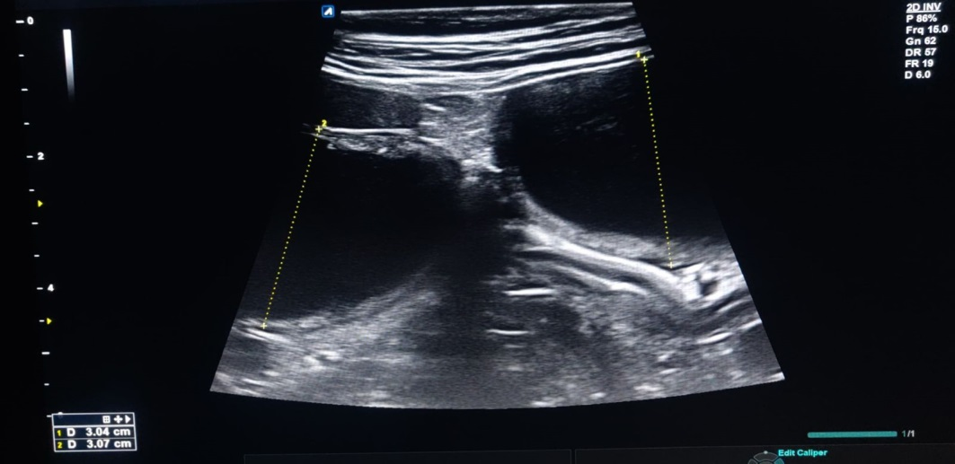 | 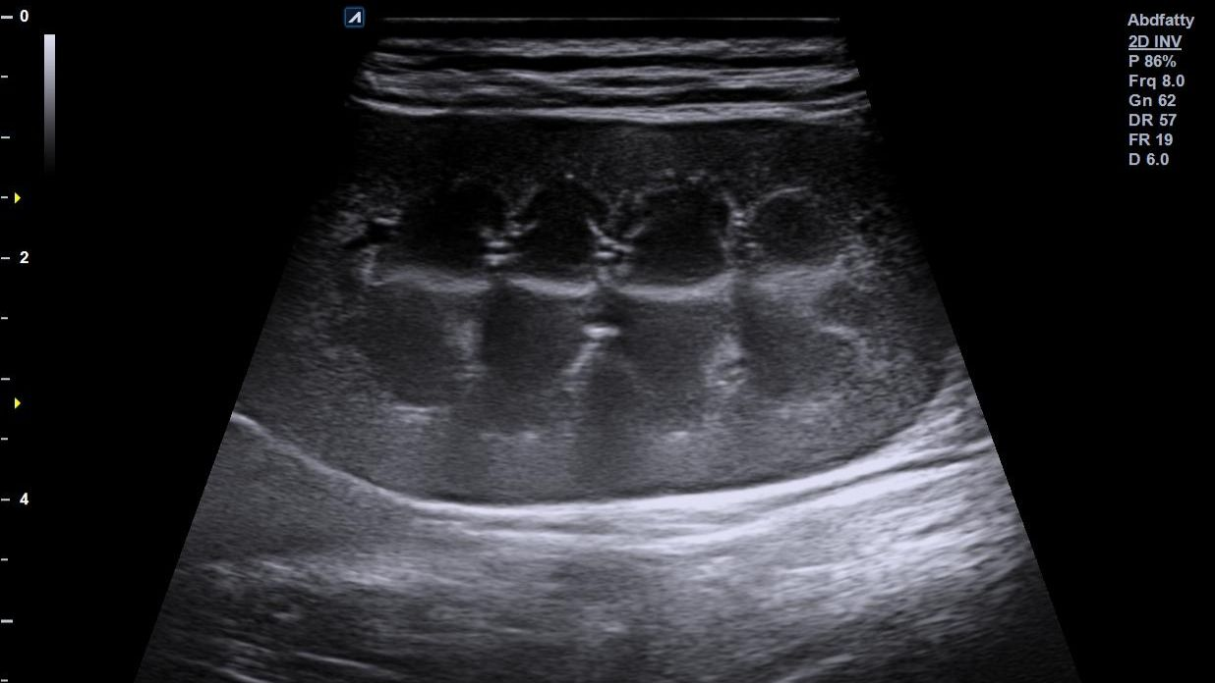
Fig. 1a. Ultrasound findings revealed large uterine horns with anechoic content | Fig. 1b. Normal CMD

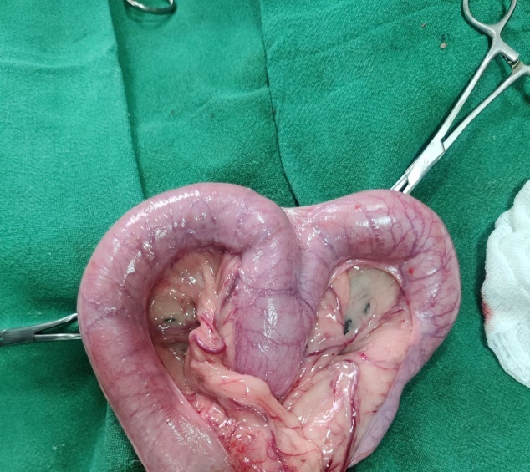
Fig. 2. Ovariohysterectomy

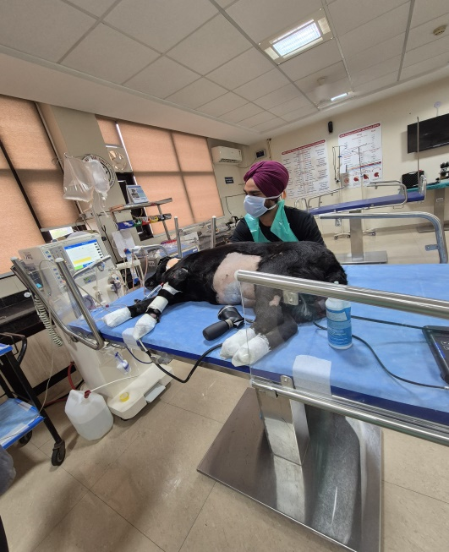
Fig. 3. Ongoing hemodialysis

