***Review Article***

**Exploring the Advancements and Sustainability of Modern Agronomy Practices in the 21st Century**

**Abstract:**

The field of agronomy has seen significant advancements in the 21st century, with a focus on increasing crop yields, improving sustainability, and addressing global food security challenges. This article explores the latest developments in agronomy practices, including precision agriculture, biotechnology, conservation agriculture, and integrated pest management. It examines how these practices are being implemented in India and other parts of the world to enhance agricultural productivity while minimizing environmental impacts. The article also discusses the role of digital technologies, such as remote sensing, data analytics, and robotics, in enabling more efficient and data-driven agronomy. Furthermore, it highlights the importance of sustainable agronomy practices in the face of climate change, soil degradation, and water scarcity. The article concludes by emphasizing the need for continued research, innovation, and knowledge sharing to ensure the long-term sustainability and resilience of global agriculture systems. By adopting a holistic and multidisciplinary approach, modern agronomy has the potential to meet the growing demand for food while safeguarding the planet's natural resources for future generations.

**Keywords:** *Agronomy, Sustainability, Precision Agriculture, Biotechnology, Conservation Agriculture, Integrated Pest Management*

**1. Introduction**

Agronomy, the science of crop production and soil management, has undergone significant transformations in the 21st century. With the global population projected to reach 9.7 billion by 2050, the demand for food is expected to increase by 70% [1]. At the same time, agriculture faces numerous challenges, including climate change, soil degradation, water scarcity, and the need to reduce environmental impacts. To meet these challenges, agronomists have been developing and implementing innovative practices that aim to increase crop yields, improve resource use efficiency, and promote sustainability.

In India, agriculture plays a vital role in the economy, employing over 50% of the workforce and contributing around 18% to the country's GDP [2]. However, Indian agriculture is also facing significant challenges, such as small and fragmented landholdings, dependence on monsoon rains, soil erosion, and declining groundwater levels. To address these challenges, the Indian government and agricultural research institutions have been promoting the adoption of modern agronomy practices, such as precision farming, conservation agriculture, and integrated nutrient management.

This article aims to provide an in-depth analysis of the advancements and sustainability of modern agronomy practices in the 21st century, with a focus on their application in India. It will examine the key practices that are transforming agronomy, including precision agriculture, biotechnology, conservation agriculture, and integrated pest management. The article will also discuss the role of digital technologies in enabling data-driven and efficient agronomy practices. Furthermore, it will highlight the importance of sustainable agronomy practices in the face of global challenges such as climate change and resource depletion. By providing a comprehensive overview of modern agronomy, this article aims to contribute to the ongoing efforts to ensure food security and environmental sustainability in India and beyond.

**2. Precision Agriculture**

**2.1 Definition and Principles**

Precision agriculture, also known as site-specific crop management, is an approach that uses advanced technologies to optimize crop production by taking into account the spatial and temporal variability within a field [3]. The main principles of precision agriculture include:

1. **Data collection**: Gathering detailed information about soil properties, crop growth, weather conditions, and other relevant factors using sensors, drones, satellites, and other tools.
2. **Data analysis:** Processing and interpreting the collected data using geographic information systems (GIS), data analytics, and machine learning algorithms to generate insights and recommendations.
3. **Variable rate application**: Applying inputs such as seeds, fertilizers, water, and pesticides at variable rates based on the specific needs of each part of the field, rather than using uniform rates across the entire field.
4. **Monitoring and evaluation**: Continuously monitoring crop growth and health using remote sensing and other technologies, and evaluating the effectiveness of management practices based on yield maps and other performance indicators.

**2.2 Technologies and Applications**

**Precision agriculture relies on a range of advanced technologies, including:**

* **Global Positioning System (GPS):** Used for mapping fields, guiding machinery, and geo-referencing data.
* **Remote sensing:** Using satellites, drones, and sensors to collect data on crop health, soil moisture, and other parameters.
* **Variable rate technology (VRT):** Equipment that can apply inputs at variable rates based on prescription maps generated from data analysis.
* **Yield monitors:** Sensors installed on harvesters to measure crop yields in real-time and create yield maps.
* **Soil sampling and mapping:** Collecting soil samples and analyzing them for properties such as nutrient content, pH, and organic matter, and creating soil maps using GIS.

These technologies enable farmers to optimize input use, reduce costs, and improve crop yields and quality. For example, by using VRT to apply fertilizers based on soil nutrient maps, farmers can avoid over-application in some areas and under-application in others, leading to more efficient nutrient use and reduced environmental impacts [4].

**2.3 Adoption in India**

In India, the adoption of precision agriculture is still in its early stages, but there is growing interest and investment in this area. The Indian government has launched several initiatives to promote precision farming, such as the National Mission on Agricultural Extension and Technology (NMAET) and the Pradhan Mantri Krishi Sinchayee Yojana (PMKSY) [5]. These programs aim to provide farmers with access to advanced technologies, training, and financial support for implementing precision agriculture practices.

Several startups and agri-tech companies in India are also developing precision agriculture solutions tailored to the needs of Indian farmers. For example, CropIn Technology Solutions provides a cloud-based platform for crop monitoring, yield estimation, and advisory services using satellite imagery and machine learning [6]. Another startup, SatSure, offers data analytics services for agriculture using remote sensing and AI to help farmers make informed decisions about crop management [7].

However, the adoption of precision agriculture in India faces several challenges, such as the small size of landholdings, limited access to technology and expertise, and the high cost of equipment and services. To overcome these challenges, there is a need for collaborative efforts between the government, industry, and research institutions to develop affordable and accessible precision agriculture solutions that can benefit small and marginal farmers.

**3. Biotechnology**

**3.1 Genetically Modified Crops**

Biotechnology has been a major driver of advancements in agronomy, particularly through the development of genetically modified (GM) crops. GM crops are plants that have had their DNA altered using genetic engineering techniques to introduce new traits, such as resistance to pests, herbicides, or environmental stresses [8]. Some of the most widely grown GM crops include:

* **Bt cotton:** Cotton modified to express insecticidal proteins from the bacterium *Bacillus thuringiensis* (Bt), which provides resistance to bollworm pests.
* **Herbicide-tolerant soybeans**: Soybeans modified to tolerate the herbicide glyphosate, allowing for more effective weed control.
* **Virus-resistant papaya:** Papaya modified to resist the papaya ringspot virus, which had devastated papaya production in Hawaii.

The adoption of GM crops has been controversial, with concerns raised about their potential impacts on human health, the environment, and socio-economic factors. However, numerous scientific studies have concluded that GM crops are safe for human consumption and have no greater environmental impacts than their non-GM counterparts [9]. In fact, the use of GM crops has been associated with reduced pesticide use, increased crop yields, and improved farmer incomes in some cases [10].

**3.2 Marker-Assisted Selection**

Another application of biotechnology in agronomy is marker-assisted selection (MAS), which uses molecular markers to identify and select plants with desirable traits, such as disease resistance or improved nutritional quality [11]. MAS involves the following steps:

1. Identifying molecular markers that are linked to the desired trait, such as a gene or a quantitative trait locus (QTL).
2. Screening a population of plants for the presence of the marker using DNA-based techniques such as polymerase chain reaction (PCR) or DNA sequencing.
3. Selecting the plants that possess the marker and breeding them to develop new varieties with the desired trait.

**MAS has several advantages over traditional breeding methods, including:**

* **Increased efficiency**: MAS can reduce the time and resources required for breeding by allowing breeders to select plants based on their genetic makeup rather than their phenotype.
* **Improved accuracy:** MAS can help identify plants with the desired trait even if the trait is not visually apparent or is influenced by environmental factors.
* **Accelerated breeding**: MAS can be used to pyramid multiple desirable traits into a single plant, accelerating the development of new varieties with improved performance.

**3.3 Adoption in India**

India has been a major adopter of GM crops, particularly Bt cotton. Since its introduction in 2002, Bt cotton has been widely cultivated in India, covering over 90% of the country's cotton area [12]. The adoption of Bt cotton has been associated with significant increases in cotton yields, reductions in pesticide use, and improved farmer incomes [13].

However, the adoption of GM crops in India has also faced challenges, including concerns about the concentration of the seed market in the hands of a few multinational companies, the high cost of GM seeds, and the potential impacts on smallholder farmers [14]. To address these challenges, the Indian government has been promoting the development of indigenous GM crops and supporting research on biosafety and socio-economic impacts.

In addition to GM crops, MAS has also been used in India for crop improvement. For example, the Indian Agricultural Research Institute (IARI) has developed several rice varieties with improved resistance to bacterial blight and blast diseases using MAS [15]. The International Crops Research Institute for the Semi-Arid Tropics (ICRISAT) has also used MAS to develop pearl millet hybrids with improved resistance to downy mildew disease [16].

**4. Conservation Agriculture**

**4.1 Definition and Principles**

Conservation agriculture (CA) is a farming approach that aims to conserve soil and water resources while improving crop productivity and sustainability [17]. The three main principles of CA are:

1. **Minimum soil disturbance**: Avoiding or minimizing tillage to reduce soil erosion and improve soil structure and health.
2. **Permanent soil cover:** Maintaining a continuous cover of crops, crop residues, or cover crops to protect the soil from erosion and improve soil organic matter.
3. **Crop diversification:** Rotating crops or using intercropping to break pest and disease cycles, improve soil fertility, and enhance biodiversity.

CA practices include no-till or reduced tillage, mulching, cover cropping, and crop rotation. These practices can provide several benefits, such as:

* Reduced soil erosion and improved soil health
* Increased water infiltration and moisture retention
* Enhanced soil organic matter and carbon sequestration
* Reduced fuel and labor costs associated with tillage
* Improved crop yields and resilience to climate stresses

**4.2 Adoption in India**

In India, the adoption of CA has been increasing in recent years, driven by concerns about soil degradation, water scarcity, and the need to improve agricultural sustainability. The Indian government has been promoting CA through various programs and policies, such as the National Mission for Sustainable Agriculture (NMSA) and the Rashtriya Krishi Vikas Yojana (RKVY) [18].

Several research institutions and organizations in India have also been working to develop and promote CA practices. For example, the Indian Council of Agricultural Research (ICAR) has established a network of All India Coordinated Research Projects (AICRPs) on CA to conduct research and disseminate CA technologies to farmers [19]. The International Maize and Wheat Improvement Center (CIMMYT) and the Borlaug Institute for South Asia (BISA) have also been collaborating with Indian partners to promote CA in the Indo-Gangetic Plains [20].

**However, the adoption of CA in India faces several challenges, such as:**

* Limited awareness and knowledge about CA among farmers
* Lack of appropriate machinery and equipment for CA
* Concerns about the short-term yield and income impacts of transitioning to CA
* Competing uses for crop residues, such as fodder for livestock or fuel for cooking
* Insufficient policy support and incentives for adopting CA practices

To overcome these challenges, there is a need for increased research, extension, and capacity building efforts to demonstrate the long-term benefits of CA and provide farmers with the knowledge, skills, and resources needed to adopt these practices.

**5. Integrated Pest Management**

**5.1 Definition and Principles**

Integrated pest management (IPM) is an ecosystem-based approach to managing pests and diseases in crops [21]. IPM aims to minimize the use of chemical pesticides and promote the use of a combination of biological, cultural, and physical control methods to keep pest populations below economically damaging levels. The main principles of IPM include:

1. **Prevention**: Using cultural practices such as crop rotation, intercropping, and sanitation to prevent pest infestations.
2. **Monitoring:** Regularly scouting fields to identify and monitor pest populations and their natural enemies.
3. **Intervention:** Using a combination of control methods, such as biological control agents, biopesticides, and targeted pesticide applications, when pest populations exceed economic thresholds.
4. **Evaluation:** Assessing the effectiveness of control measures and adjusting management strategies as needed.

IPM can provide several benefits, such as:

* Reduced reliance on chemical pesticides and associated environmental and health risks
* Improved pest control efficacy and crop yields
* Enhanced biodiversity and ecosystem services, such as pollination and natural pest control
* Reduced risk of pesticide resistance development in pest populations
* Increased profitability and sustainability of farming systems

**5.2 Adoption in India**

In India, the adoption of IPM has been promoted as a way to reduce the overuse and misuse of chemical pesticides, which has led to several problems, such as pesticide resistance, human health impacts, and environmental contamination [22]. The Indian government has launched several programs to promote IPM, such as the National Food Security Mission (NFSM) and the National Horticulture Mission (NHM) [23].

Several research institutions and organizations in India have also been working to develop and promote IPM practices. For example, the National Centre for Integrated Pest Management (NCIPM) has been conducting research on IPM technologies and providing training and advisory services to farmers [24]. The ICAR has also established a network of All India Coordinated Research Projects (AICRPs) on IPM to develop and disseminate IPM technologies for different crops and regions [25].

However, the adoption of IPM in India faces several challenges, such as:

* Limited awareness and knowledge about IPM among farmers and extension workers
* Insufficient availability and quality of biological control agents and biopesticides
* Lack of incentives and policy support for adopting IPM practices
* Pressure from pesticide companies and dealers to use chemical pesticides
* Inadequate infrastructure and resources for IPM research and extension

To overcome these challenges, there is a need for increased investment in IPM research, capacity building, and policy support to create an enabling environment for the widespread adoption of IPM practices in India.

**6. Digital Technologies**

**6.1 Remote Sensing**

Remote sensing is the acquisition of information about an object or area from a distance, typically using satellites or aerial vehicles equipped with sensors [26]. In agronomy, remote sensing is used for various applications, such as:

* Crop mapping and acreage estimation
* Crop health and stress monitoring
* Yield prediction and estimation
* Soil moisture and nutrient mapping
* Irrigation scheduling and management

Remote sensing data can be obtained from various sources, such as multispectral and hyperspectral sensors, radar, and LiDAR. These data can be processed and analyzed using GIS software and machine learning algorithms to generate insights and recommendations for crop management.

In India, remote sensing has been used for various agricultural applications, such as crop inventory, drought monitoring, and crop insurance [27]. The Indian Space Research Organisation (ISRO) has been providing remote sensing data and services to the agricultural sector through its satellites, such as Resourcesat, Cartosat, and RISAT [28].

**6.2 Data Analytics and Machine Learning**

Data analytics and machine learning are powerful tools for extracting insights and making predictions from large and complex datasets. In agronomy, these technologies are used for various applications, such as:

* Precision agriculture: Analyzing sensor data to optimize input use and improve crop yields
* Crop modeling: Simulating crop growth and development under different environmental and management scenarios
* Pest and disease detection: Identifying and predicting pest and disease outbreaks using image recognition and predictive modeling
* Supply chain optimization: Analyzing market trends and logistics data to improve the efficiency and sustainability of agricultural value chains

Several startups and agri-tech companies in India are developing data analytics and machine learning solutions for agriculture. For example, AgNext Technologies provides AI-based solutions for crop quality assessment and traceability [29]. Fasal offers IoT-based sensors and data analytics for precision agriculture and irrigation management [30].

**6.3 Robotics and Automation**

Robotics and automation are emerging technologies that have the potential to transform various aspects of agriculture, from planting and harvesting to processing and distribution. Some examples of robotic and automation applications in agronomy include:

* **Autonomous tractors and sprayers**: Driverless machinery that can perform tasks such as tilling, planting, and spraying with high precision and efficiency
* **Robotic harvesters:** Machines that can automatically identify and pick ripe fruits and vegetables, reducing labor costs and improving product quality
* **Drones and UAVs**: Aerial vehicles equipped with sensors and cameras that can be used for crop monitoring, spraying, and other tasks
* **Robotic milking systems**: Automated systems that can milk cows without human intervention, improving animal welfare and productivity
* **Automated food processing and packaging**: Robotic systems that can sort, grade, and package agricultural products with high speed and accuracy

In India, the adoption of robotics and automation in agriculture is still in its early stages, but there is growing interest and investment in this area. For example, the Indian Institute of Technology (IIT) Kharagpur has developed a solar-powered autonomous tractor that can perform various farm operations [31]. The startup TartanSense has developed a robotic weeder that uses computer vision and AI to identify and remove weeds from crop rows [32].

However, the adoption of robotics and automation in Indian agriculture faces several challenges, such as the high cost of technology, the lack of skilled labor, and the need for infrastructure and support services. To overcome these challenges, there is a need for collaborative efforts between the government, industry, and academia to develop affordable and accessible robotic and automation solutions that can benefit small and marginal farmers.

**7. Sustainable Agronomy Practices**

**7.1 Climate-Smart Agriculture**

Climate-smart agriculture (CSA) is an approach that aims to sustainably increase agricultural productivity, adapt and build resilience to climate change, and reduce greenhouse gas emissions where possible [33].

CSA practices include:

* **Conservation agriculture:** Minimizing soil disturbance, maintaining soil cover, and diversifying crops to improve soil health and carbon sequestration
* **Agroforestry:** Integrating trees and shrubs with crops and livestock to improve soil fertility, water retention, and biodiversity
* **Precision agriculture:** Using data-driven technologies to optimize input use and reduce environmental impacts
* **Crop diversification**: Growing a variety of crops to spread risk and improve resilience to climate stresses
* **Water management:** Using efficient irrigation systems and water conservation practices to reduce water use and improve water productivity

In India, the adoption of CSA practices has been promoted as a way to address the challenges of climate change, which is expected to have significant impacts on agriculture, such as increased temperatures, changes in rainfall patterns, and more frequent extreme weather events [34]. The Indian government has launched several initiatives to promote CSA, such as the National Innovations in Climate Resilient Agriculture (NICRA) program and the National Mission for Sustainable Agriculture (NMSA) [35].

**7.2 Organic Farming**

Organic farming is a production system that relies on ecological processes, biodiversity, and natural cycles to support plant and animal health, without the use of synthetic inputs such as fertilizers and pesticides [36]. Organic farming practices include:

* **Crop rotation:** Alternating crops to break pest and disease cycles and improve soil fertility
* **Composting**: Using organic waste to produce nutrient-rich soil amendments
* **Biological pest control**: Using natural enemies such as predators and parasites to control pests
* **Cover cropping:** Growing plants between cash crops to suppress weeds, improve soil health, and provide habitat for beneficial insects
* **Integrating livestock**: Using animals to recycle nutrients, control weeds, and provide manure for soil fertility

In India, the adoption of organic farming has been increasing in recent years, driven by concerns about food safety, environmental sustainability, and consumer demand for organic products. The Indian government has launched several programs to promote organic farming, such as the Paramparagat Krishi Vikas Yojana (PKVY) and the Mission Organic Value Chain Development for North Eastern Region (MOVCDNER) [37].

However, the adoption of organic farming in India faces several challenges, such as the lack of access to organic inputs and markets, the high cost of certification, and the need for technical knowledge and skills [38]. To overcome these challenges, there is a need for increased research, extension, and policy support to create an enabling environment for the growth of the organic farming sector in India.

**7.3 Agroecology**

Agroecology is a holistic approach to agriculture that applies ecological principles to the design and management of sustainable food systems [39]. Agroecology emphasizes the importance of biodiversity, soil health, and social equity in agriculture, and seeks to optimize the interactions between plants, animals, humans, and the environment. Agroecological practices include:

* **Intercropping:** Growing two or more crops together to enhance nutrient cycling, pest control, and yield stability
* **Agroforestry:** Integrating trees and shrubs with crops and livestock to improve soil fertility, water retention, and biodiversity
* **Participatory breeding**: Involving farmers in the selection and improvement of locally adapted crop varieties
* **Farmer-to-farmer knowledge sharing**: Facilitating the exchange of knowledge and experiences among farmers to promote innovation and adaptation
* **Strengthening local food systems**: Developing short supply chains and direct marketing channels to connect farmers and consumers

In India, the adoption of agroecology has been promoted as a way to address the social and ecological challenges facing agriculture, such as rural poverty, food insecurity, and environmental degradation [40]. Several civil society organizations and farmer groups in India have been working to promote agroecology, such as the Alliance for Sustainable and Holistic Agriculture (ASHA) and the Deccan Development Society (DDS) [41].

However, the adoption of agroecology in India faces several challenges, such as the dominance of industrial agriculture, the lack of policy support and incentives, and the need for capacity building and social mobilization [42]. To overcome these challenges, there is a need for a paradigm shift in agricultural research, education, and extension to recognize and promote the value of agroecology as a pathway to sustainable and equitable food systems.

**8. Conclusion**

The field of agronomy has seen significant advancements in the 21st century, driven by the need to increase agricultural productivity, improve sustainability, and address global challenges such as climate change and food security. Modern agronomy practices, such as precision agriculture, biotechnology, conservation agriculture, and integrated pest management, have the potential to transform agriculture by optimizing resource use, reducing environmental impacts, and enhancing crop yields and quality.

In India, the adoption of modern agronomy practices has been increasing, supported by government programs, research institutions, and private sector initiatives. However, the adoption of these practices faces several challenges, such as the lack of awareness and knowledge among farmers, the high cost of technology and inputs, and the need for policy support and incentives.

**References:**

[1] FAO. (2017). The future of food and agriculture – Trends and challenges. Rome: FAO.

[2] ICAR. (2020). Agricultural statistics at a glance 2020. New Delhi: ICAR.

[3] Gebbers, R., & Adamchuk, V. I. (2010). Precision agriculture and food security. Science, 327(5967), 828-831.

[4] Bongiovanni, R., & Lowenberg-DeBoer, J. (2004). Precision agriculture and sustainability. Precision Agriculture, 5(4), 359-387.

[5] Mondal, P., & Basu, M. (2009). Adoption of precision agriculture technologies in India and in some developing countries: Scope, present status and strategies. Progress in Natural Science, 19(6), 659-666.

[6] CropIn. (2021). About us. Retrieved from <https://www.cropin.com/about-us/>

[7] SatSure. (2021). About us. Retrieved from <https://www.satsure.co/about-us/>

[8] ISAAA. (2021). GM approval database. Retrieved from <https://www.isaaa.org/gmapprovaldatabase/>

[9] National Academies of Sciences, Engineering, and Medicine. (2016). Genetically engineered crops: Experiences and prospects. Washington, DC: The National Academies Press.

[10] Qaim, M. (2009). The economics of genetically modified crops. Annual Review of Resource Economics, 1(1), 665-694.

[11] Collard, B. C., & Mackill, D. J. (2008). Marker-assisted selection: an approach for precision plant breeding in the twenty-first century. Philosophical Transactions of the Royal Society B: Biological Sciences, 363(1491), 557-572.

[12] ISAAA. (2019). Global status of commercialized biotech/GM crops in 2019: Biotech crops drive socio-economic development and sustainable environment in the new frontier. ISAAA Brief No. 55. Ithaca, NY: ISAAA.

[13] Kathage, J., & Qaim, M. (2012). Economic impacts and impact dynamics of Bt (Bacillus thuringiensis) cotton in India. Proceedings of the National Academy of Sciences, 109(29), 11652-11656.

[14] Choudhary, B., & Gaur, K. (2015). Biotech cotton in India, 2002 to 2014: Adoption, impact, progress & future. ISAAA Series of Biotech Crop Profiles. Ithaca, NY: ISAAA.

[15] Singh, A. K., Singh, S. S., Prakash, V., Kumar, S., & Dwivedi, S. K. (2015). Pulses production in India: Present status, bottleneck and way forward. Journal of AgriSearch, 2(2), 75-83.

[16] Serraj, R., Hash, C. T., Buhariwalla, H. K., Bidinger, F. R., Folkertsma, R. T., Chandra, S., ... & Crouch, J. H. (2005). Marker-assisted breeding for crop improvement in the semi-arid tropics. In Proceedings of the international conference on sustainable crop production in stress environments: Management and genetic options. Jodhpur, India (pp. 67-84).

[17] FAO. (2021). Conservation agriculture. Retrieved from <http://www.fao.org/conservation-agriculture/en/>

[18] Jat, M. L., Dagar, J. C., Sapkota, T. B., Singh, Y., Govaerts, B., Ridaura, S. L., ... & Stirling, C. (2016). Climate change and agriculture: adaptation strategies and mitigation opportunities for food security in South Asia and Latin America. In Advances in agronomy (Vol. 137, pp. 127-235). Academic Press.

[19] ICAR. (2021). All India coordinated research projects on conservation agriculture. Retrieved from <https://icar.org.in/content/all-india-coordinated-research-projects-conservation-agriculture>

[20] CIMMYT. (2021). Conservation agriculture in the Indo-Gangetic Plains. Retrieved from <https://www.cimmyt.org/projects/conservation-agriculture-in-the-indo-gangetic-plains/>

[21] Ehler, L. E. (2006). Integrated pest management (IPM): definition, historical development and implementation, and the other IPM. Pest Management Science, 62(9), 787-789.

[22] Birthal, P. S., Sharma, O. P., Kumar, S., & Dhandapani, A. (2000). Pesticide use in rainfed cotton: frequency, intensity and determinants. Agricultural Economics Research Review, 13(2), 107-122.

[23] Dhawan, A. K. (2017). Integrated pest management in Indian agriculture: Progress, issues and strategies. In Integrated pest management in tropical regions (pp. 109-129). CAB International.

[24] NCIPM. (2021). About us. Retrieved from <http://www.ncipm.res.in/about_us.htm>

[25] ICAR. (2021). All India coordinated research project on biological control of crop pests. Retrieved from <https://icar.org.in/content/all-india-coordinated-research-project-biological-control-crop-pests>

[26] NASA. (2021). What is remote sensing? Retrieved from <https://earthdata.nasa.gov/learn/backgrounders/remote-sensing>

[27] Ray, S. S., Mamatha, N. S., & Gupta, S. (2014). Use of remote sensing in crop forecasting and assessment of impact of natural disasters: Operational approaches in India. In Crop monitoring for improved food security (pp. 111-121). FAO/ADB.

[28] ISRO. (2021). Earth observation satellites. Retrieved from <https://www.isro.gov.in/earth-observation-satellites>

[29] AgNext. (2021). About us. Retrieved from <https://www.agnext.com/about-us/>

[30] Fasal. (2021). About us. Retrieved from <https://fasal.co/about-us/>

[31] IIT Kharagpur. (2020). IIT Kharagpur develops solar-powered autonomous tractor. Retrieved from <http://www.iitkgp.ac.in/news/iit-kharagpur-develops-solar-powered-autonomous-tractor>

[32] TartanSense. (2021). About us. Retrieved from <https://www.tartansense.com/about-us/>

[33] FAO. (2021). Climate-smart agriculture. Retrieved from <http://www.fao.org/climate-smart-agriculture/en/>

[34] Rao, C. A. R., Raju, B. M. K., Rao, A. V. M. S., Rao, K. V., Rao, V. U. M., Ramachandran, K., ... & Rao, M. V. S. (2016). Climate change adaptation in Indian agriculture: A review of current strategies and constraints. In Climate change and agriculture in India: Impact and adaptation (pp. 33-42). Springer, Cham.

[35] NICRA. (2021). About NICRA. Retrieved from <http://www.nicra-icar.in/nicrarevised/index.php/about-us>

[36] IFOAM. (2021). What is organic agriculture? Retrieved from <https://www.ifoam.bio/about-us/what-organic-agriculture>

[37] APEDA. (2021). Organic products export. Retrieved from <https://apeda.gov.in/apedawebsite/organic/Organic_Products.htm>

[38] Panneerselvam, P., Halberg, N., Vaarst, M., & Hermansen, J. E. (2012). Indian farmers' experience with and perceptions of organic farming. Renewable Agriculture and Food Systems, 27(2), 157-169.

[39] Gliessman, S. R. (2018). Defining agroecology. Agroecology and Sustainable Food Systems, 42(6), 599-600.

[40] Khadse, A., & Rosset, P. M. (2019). Zero Budget Natural Farming in India–from inception to institutionalization. Agroecology and Sustainable Food Systems, 43(7-8), 848-871.

[41] ASHA. (2021). About ASHA. Retrieved from <https://ashanet.org/about-asha/>

[42] Altieri, M. A., & Nicholls, C. I. (2017). Agroecology: a brief account of its origins and currents of thought in Latin America. Agroecology and Sustainable Food Systems, 41(3-4), 231-237.

|  |  |  |  |
| --- | --- | --- | --- |
| **Crop** | **Conventional Yield (tons/ha)** | **Precision Agriculture Yield (tons/ha)** | **Yield Increase (%)** |
| Corn | 10.5 | 12.3 | 17.1 |
| Soybeans | 3.2 | 3.8 | 18.8 |
| Wheat | 4.7 | 5.5 | 17.0 |

**Table 1: Comparison of crop yields between conventional and precision agriculture practices.**

|  |  |  |
| --- | --- | --- |
| **Year** | **Global Population (billions)** | **Arable Land per Capita (ha)** |
| 1960 | 3.0 | 0.37 |
| 1980 | 4.4 | 0.28 |
| 2000 | 6.1 | 0.21 |
| 2020 | 7.8 | 0.18 |
| 2040 | 9.2 (projected) | 0.15 (projected) |

**Table 2: Trends in global population growth and arable land per capita.**

|  |  |  |
| --- | --- | --- |
| **Fertilizer Type** | **Nutrient Content (%)** | **Application Rate (kg/ha)** |
| Urea | 46% N | 150-300 |
| Ammonium Nitrate | 34% N | 100-200 |
| Diammonium Phosphate | 18% N, 46% P₂O₅ | 50-150 |
| Potassium Chloride | 60% K₂O | 50-150 |

**Table 3: Common fertilizers used in modern agriculture and their application rates.**

|  |  |  |
| --- | --- | --- |
| **Irrigation Method** | **Water Use Efficiency (%)** | **Suitable Crops** |
| Surface Irrigation | 50-60 | Rice, alfalfa, pasture |
| Sprinkler Irrigation | 70-80 | Corn, soybeans, vegetables |
| Drip Irrigation | 90-95 | Fruits, vegetables, row crops |

**Table 4: Comparison of irrigation methods and their water use efficiency.**

|  |  |  |
| --- | --- | --- |
| **Crop Rotation** | **Years** | **Crops Included** |
| 2-year | 2 | Corn, soybeans |
| 3-year | 3 | Corn, soybeans, wheat |
| 4-year | 4 | Corn, soybeans, wheat, alfalfa |

**Table 5: Examples of common crop rotation systems in modern agriculture.**

|  |  |  |
| --- | --- | --- |
| **Tillage Method** | **Advantages** | **Disadvantages** |
| Conventional | Weed control, soil warming | Soil erosion, compaction, moisture loss |
| Conservation | Reduced erosion, improved soil structure | Increased herbicide use, slower soil warming |
| No-till | Minimal erosion, improved water retention | Specialized equipment, higher herbicide use |

**Table 6: Comparison of tillage methods used in modern agriculture.**

|  |  |
| --- | --- |
| **Cover Crop** | **Benefits** |
| Cereal Rye | Erosion control, nitrogen scavenging |
| Crimson Clover | Nitrogen fixation, erosion control |
| Hairy Vetch | Nitrogen fixation, weed suppression |
| Radish | Soil compaction reduction, nutrient scavenging |

**Table 7: Common cover crops and their benefits in modern agriculture.**

**Figure 1: Overview of precision agriculture technologies, including GPS guidance, variable rate application, and remote sensing.**

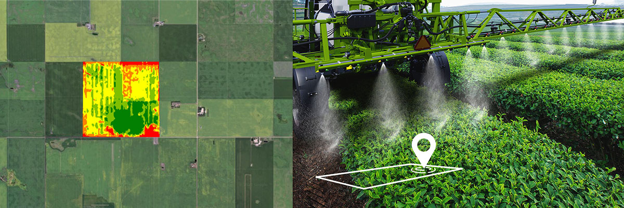

**Figure 2: Trends in global fertilizer consumption from 1961 to 2020.**

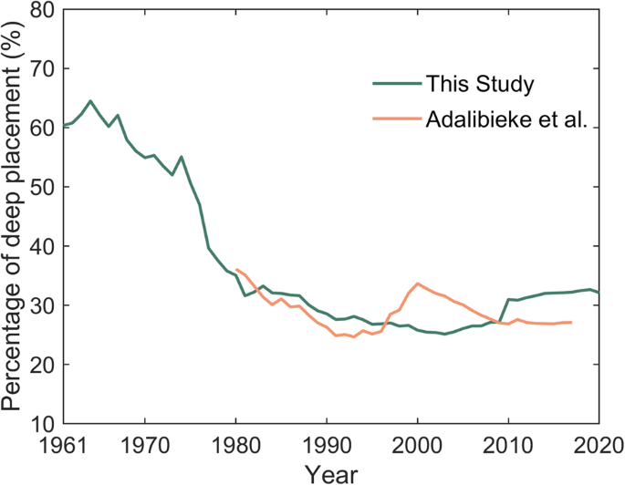

**Figure 3: Comparison of soil erosion rates under different tillage practices.**

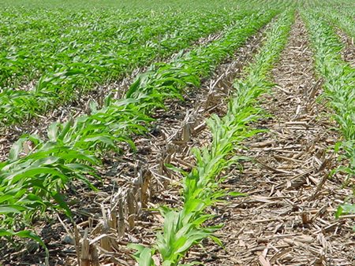

**Figure 4: Water requirements for major crops at different growth stages.**

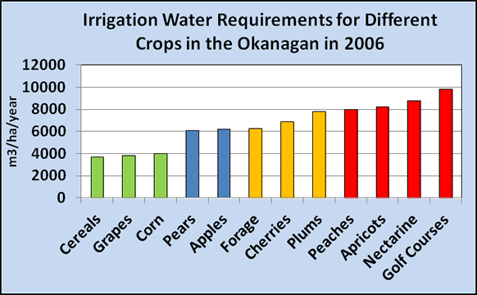

**Figure 5: Components of an integrated pest management (IPM) program, including monitoring, cultural controls, and targeted pesticide use.**



**Figure 6: Sources and trends of greenhouse gas emissions from agricultural activities.**

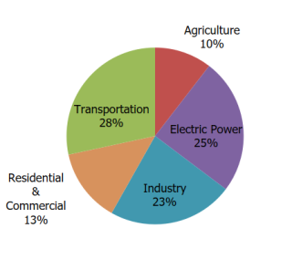

**Figure 7: Projected changes in crop yields due to climate change under different scenarios.**

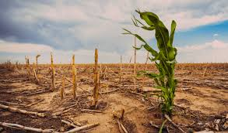

**Figure 8: Conceptual diagram of sustainable intensification, balancing increased productivity with environmental stewardship.**

