Original Research Article

Synergistic Role of Trichoderma viride and Phosphate-Solubilizing Microorganisms in Enhancing Phosphorus Availability in Paddy Cultivation

ABSTRACT
The study investigates the role of Trichoderma viride (T.V) in enhancing phosphorus solubilization and its impact on Rice (Oryza sativa) cultivation. Phosphorus (P) is a critical nutrient for plant growth, but its availability in soil is often limited due to its fixation into insoluble forms. T.V, a phosphate-solubilizing fungus (PSF), has been shown to improve P availability through the production of organic acids, promoting better nutrient uptake and plant growth. Trichoderma-enriched biofertilizer reduces the application of chemical fertilizers and therefore, can be considered as a noble practice in sustainable agriculture. The high efficiency of T.V is the result of its potential of nutrient solubilization and harboring soil microorganisms. This study applied T.V both alone and in combination with other phosphate-solubilizing microorganisms (PSMs) such as Azotobacter chroococcum (A.C) and Pseudomonas striata (P.S) in paddy fields. The results demonstrated a significant increase in microbial populations, phosphorus solubilization, and grain yield. The highest yield increase was observed in treatments combining T.V with other PSMs, indicating a synergistic effect. These findings suggest that T.V is a valuable biofertilizer that can improve soil fertility, enhance crop productivity, and promote sustainable agriculture by reducing dependence on chemical fertilizers. Further research is recommended to optimize its use under varying soil conditions.

Keywords: Trichoderma viride, paddy cultivation, phosphorus availability, biofertilizers, rice yield.

- INTRODUCTION
Rice (Oryza sativa L.) is one of the most important staple crops globally and it occupies around one-fifth of the total land area under cereal production, with China being the largest producer, followed by India, Indonesia, and Bangladesh (Julia et al., 2016; Singh & Singh, 2016). P is a vital nutrient for plant growth, playing a critical role in various physiological processes such as energy transfer, photosynthesis, and cell division. It also contributes to seed germination and root development, which are essential for optimal crop production (Sutaliya & Singh, 2005). However, phosphorus availability in soils is often limited due to its fixation into insoluble forms, making it inaccessible to plants (Asuming-Brempong, 2013). One promising solution to overcome this challenge lies in the use of PSMs, which convert insoluble forms of P into soluble forms that plants can readily absorb (Tian et al, 2021; Silva et al, 2023). PSF and phosphate-solubilizing bacteria (PSB) play a crucial role in this process by secreting organic acids and enzymes that help release phosphorus from soil minerals (Rodriguez et al., 2006., Vassileva et al, 2022). T.V is a soil fungus known for its ability to decompose organic matter, solubilize phosphate, and enhance nutrient availability in the soil. It acts as a natural biofertilizer, improving soil health and promoting plant growth (Johri & Sharma, 2002; Mahato et al, 2018; Datta et al, 2022). Moreover, T.V has been shown to enhance root and shoot development, increase crop yields, and improve plant resistance to diseases (Amira et al., 2011; Yao et al, 2015). When used in combination with other PSMs, such as Azotobacter and Pseudomonas, it can further boost phosphorus solubilization and nutrient cycling, leading to improved soil fertility and higher rice yields (Pradhan & Sukla, 2005; Banayo et al, 2012)
- MATERIALS AND METHODS
The experiment was conducted from December 2016 to May 2017 to study the effect of Trichoderma viride on PSMs in paddy (Satabdi-IET-4786) cultivation. The research was carried out at the experimental farm of Calcutta University, Baruipur, 24 parganas (South), West Bengal. The meteorological observation (table 1) and initial soil analysis are recorded (table 2). The experimental design followed a randomized block design (RBD) with six treatments and four replications (table 3). The treatments involved the application of Trichoderma viride alone and in combination with other PSMs like Azotobacter chroococcum and Pseudomonas straita, as well as a control group without any biofertilizers. The strain Trichoderma viride was collected from Soil microbiology lab at Baruipur, Kolkata. Potato dextrose agar (PDA) with rose bengal (Fig.1) was used as culture medium, incubated for 7 days at 28⁰C. Azotobacter chroococcum and Pseudomonas straita biofertilizers are used are provided from the Baruipur experimental farm. Except for control, full recommended doses of fertilizers, graded doses of nitrogen (N), phosphorus (P), and potassium (K) were applied in the field.

Table 1. The monthly meteorological observations at the crop weather observatory centre of Agricultural Experimental Station (C.U.), Baruipur, 24 parganas (South), West Bengal.

MONTH |  | TEMPERATURE  ⁰C |  |  |  | RELATIVE  HUMIDITY |  |  | MONTHLY RAINFALL  (mm)
 |  | Maximum |  |  | Minimum | Maximum |  | Minimum
December 2016 |  | 26.4 |  | 14.3 |  | 96 |  | 53 | 0
January 2017 |  | 25.5 |  | 10.3 |  | 95 |  | 46 | 0
February 2017 |  | 29.6 |  | 15.3 |  | 96 |  | 41 | 0
March 2017 |  | 32.1 |  | 20.7 |  | 95 |  | 54 | 4
April 2017 |  | 34.8 |  | 25.6 |  | 90 |  | 55 | 2
May 2017 |  | 35.5 |  | 26.8 |  | 88 |  | 55 | 2
Table 2. Soil Analysis

Sl. No | Soil Analysis |  | Factors |  |  |  | Readings
1 | Mechanical analysis |  | Sand |  |  |  | 16.20 %
1 |  |  | Silt |  |  |  | 27.30 %
1 |  |  | Clay |  |  |  | 50.50 %
2 | Physical analysis |  | Apparent density |  |  |  | 1.27 gm/cc
2 |  |  | Absolute specific gravity |  |  |  | 2.55 gm/cc
2 |  |  | Maximum water holding capacity |  |  |  | 53.84 gm/cc
3 | Chemical analysis |  | Soil Ph |  |  |  | 6.8
3 |  |  | Electrical conductivity |  |  |  | 0.13 dS/m
3 |  |  | Cation exchange capacity |  |  |  | 21.8 meq/100g of soil

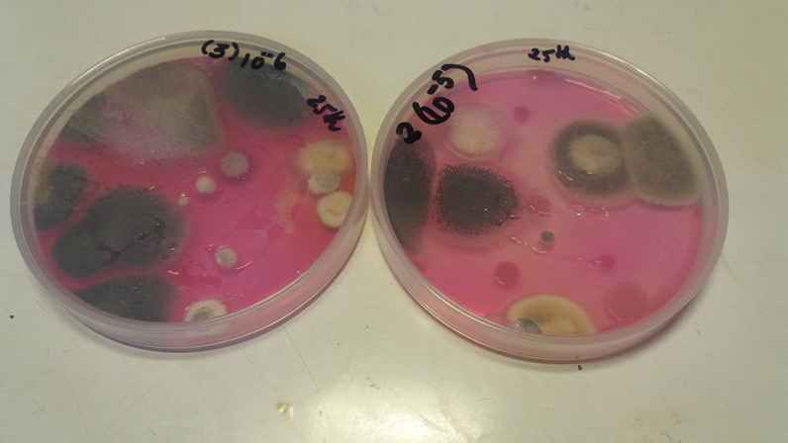

Fig.1. Trichoderma viride detected using PDA with rose bengal
Quantitative value of P is obtained and pH value of each treatment is observed.
Soil samples were collected at 0, 30 (peak vegetative stage), 45 (grain development stage), and 75 (harvesting stage) days after sowing (DAS). The collected samples were cultured on pikovskaya medium (PM) for enumeration of PSMs (Fig.2) at pH 5.6 containing glucose, tricalcium phosphate, ammonium sulphate, potassium chloride, magnesium, ferrous and manganese sulphate and yeast extract in 1 L sterilized distilled water. The cultured Trichoderma viride were incubated at 28 ± 1 °C for 5 days. Through serial dilutions, colony-forming unit (CFU) was estimated 1 × 10³ CFU mL⁻¹.

Table 3: Experimental Treatments for Study on Effect of Trichoderma viride and PSMs in Paddy cultivation.

Treatment Code | Description | Explanation
Control (C) | No biofertilizer application (Control group) | Baseline treatment to compare the effect of Trichoderma viride and other PSMs on paddy growth and soil health.
T1 | Trichoderma viride | This treatment evaluates the sole effect of Trichoderma viride and on phosphate solubilization and paddy growth.
T2 | Azotobacter chroococcum + Trichoderma viride | This treatment combines nitrogen-fixing Azotobacter chroococcum with Trichoderma viride and to test their synergistic effects on phosphorus solubilization and nitrogen availability.
T3 | Pseudomonas striata + Trichoderma viride | In this treatment, phosphate-solubilizing Pseudomonas straita is combined with to Trichoderma viride and assess the enhancement in phosphate availability for rice plants.
T4 | Azotobacter chroococcum + Pseudomonas striata + Trichoderma viride | This is a multi-strain treatment involving nitrogen-fixing and phosphate-solubilizing bacteria combined with Trichoderma viride for a holistic approach to nutrient cycling and plant growth promotion.
T5 | Azotobacter chroococcum alone | This treatment isolates the effect of nitrogen-fixing Azotobacter chroococcum to compare its impact against other treatments.
T6 | Azotobacter chroococcum + Pseudomonas striata | This combination treatment assesses the combined effect of Azotobacter chroococcum and Pseudomonas straita without Trichoderma viride, focusing on nitrogen and phosphorus availability.

Quantitative value of P is obtained and pH value of each treatment is observed.
Soil samples were collected at 0, 30 (peak vegetative stage), 45 (grain development stage), and 75 (harvesting stage) days after sowing (DAS). The collected samples were cultured on pikovskaya medium (PM) for enumeration of PSMs at pH 5.6 containing glucose, tricalcium phosphate, ammonium sulphate, potassium chloride , magnesium, ferrous and manganese sulphate and yeast extract in 1 L sterilized distilled water. The cultured Trichoderma viride in were incubated at 28 ± 1 °C for 5 days. Through serial dilutions, colony-forming unit(CFU) was estimated 1 × 10³ CFU mL⁻¹.
Day and night temperatures were maintained at 35 °C and 23 °C. Randomized block design (RBD) was followed for the designing of the experiments and
the data was analyzed by ANOVA (analysis of variance). The critical difference (CD) of the treatments was considered to be significant at the 5% level (P= 0.05).

RESULTS AND DISCUSSION
  - INTERPRETATION OF RESULTS IN THE CONTEXT OF INTERACTION BETWEEN T.V AND PSM
The results of this study align well with previous research on the role of T.V in enhancing microbial population dynamics and phosphorus solubilization. The observed increase in microbial populations, particularly in treatments involving T.V, confirms the findings of Harman et al. (2004), who demonstrated that Trichoderma species enhance microbial activity by promoting beneficial interactions in the soil. The significant improvements in phosphorus availability (up to 30% in treatment T4) are also consistent with earlier studies by Song et al. (2023), which highlighted the effectiveness of T.V in solubilizing inorganic phosphates through organic acid production.
The mean of the highest total PSB population of 0.373 × 10³ cfu/g in T6@ Azotobacter chroococcum(A. C) + Pseudomonas striata (P.S) is recorded at 30 DAS (Table 4).The lowest total PSB population of 0.107× 103 cfu/g was noticed in T1@Trichoderma viride(T.V) at 60 DAS. The sequences of the reading for total PSB population at 0 DAS as follow T5>T6>T4>T3>T2>T1 (Table 4). At 30 DAS the total PSB is as follow T6>T4>T3>T5>T2>T1.At 45 DAS the total PSB is as follow T6>T4>T5>T3>T2>T1 and at 75 DAS the sequence is as follows T6>T4>T3>T5>T2>T1 (Table 4).
The mean of the highest total PSF population of 29.7 × 10³ cfu/g in T1@ Trichoderma viride (T.V) is recorded at 30 DAS (Fig 2, Table 4). Lowest PSF population detected was 2.3 × 10³ cfu/g in T6@ Azotobacter chroococcum (A. C) + Pseudomonas striata (P.S) at 0 DAS.

Table 4. Enumeration of phosphate solubilizing microorganisms at 0, 30, 45 and 75 DAS.

(n=4: mean ± SE)

Soil samples | Phosphate Solubilizers
Soil samples | 0 DAS |  | 30 DAS |  | 45DAS |  | 75 DAS
Soil samples | Bacteria  (1 x 10³ cfu/g) | Fungi  (1 x 10³ cfu/g) | Bacteria  (1 x 10³ cfu/g) | Fungi  (1 x 10³ cfu/g) | Bacteria  (1 x 10³ cfu/g) | Fungi  (1 x 10³ cfu/g) | Bacteria  (1 x 10³cfu/g) | Fungi  (1 x 10³ cfu/g)
T1@Trichoderma viride(T.V) | 0.107 ± 0.007 | 9± 1.52 | 0.29 ± 0.012 | 29.7 ± 2.19 | 0.162 ± 0.001 | 20.7±1.2 | 0.143± 0.003 | 11.767±0.094
T2@Azotobacter chroococcum(A. C)+ Trichoderma viride(T.V) | 0.123± 0.009 | 8.7± 1.2 | 0.323 ± 0.013 | 28.3± 2.03 | 0.192 ± 0.001 | 20.3±1.86 | 0.162± 0.002 | 8.071±0.15
T3@Pseudomonas striata ( P.S) + Trichoderma viride(T.V) | 0.136 ± 0.001 | 7.3 ± 2.33 | 0.343± 0.012 | 23.3±1.86 | 0.198 ± 0.001 | 17.7±1.76 | 0.182± 0.001 | 5.64±0.174
T4@Azotobacter chroococcum (A. C)+ Pseudomonas striata ( P.S) + Trichoderma viride(T.V). | 0.137 ± 0.001 | 7.7± 1.33 | 0.350 ± 0.015 | 24±1.73 | 0.214± 0.002 | 19.3±1.2 | 0.184± 0.001 | 7.596±0.225
T5@Azotobacter chroococcum(A. C) | 0.143 ± 0.003 | 3.7 ± 0.33 | 0.333 ± 0.013 | 14±1.73 | 0.211± 0.001 | 11.7±2.03 | 0.180 ± 0.001 | 5.64±0.174
T6@Azotobacter chroococcum(A. C+ Pseudomonas striata ( P.S) | 0.139 ± 0.001 | 2.3 ± 0.33 | 0.373 ± 0.009 | 9.7±2.33 | 0.224 ± 0.002 | 8.7±1.2 | 0.190 ± 0.001 | 4.774±0.139
CD (0.05) | 0.015 x 10³ | 4.214x 10³ | 0.039 x 10³ | 6.13 x 10³ | 0.004x 10³ | 4.872 x 10³ | 0.006 x 10³ | 0.511x 10³

Furthermore, the increased grain observed in this study corroborate previous research showing that the application of T.V results in improved crop performance due to better nutrient uptake and enhanced plant growth (Elhaissoufi et al, 2022). The present study provides additional evidence of T.V for beneficial role in rice cultivation, particularly when combined with other PSMs like Azotobacter and Pseudomonas.

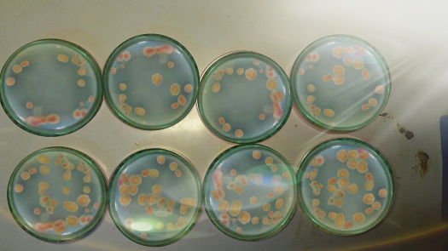
T₁
T₆
T₆
T₅
T₅
T₂
T₄
T₃
Fig 2: Maximum PSM enumeration of various treatments at 30 DAS
3.2. ANALYSIS OF SYNERGISTIC EFFECTS BETWEEN T.V AND OTHER PSM ON PHOSPHORUS AVAILABILITY
The pH of the soil in these treatments remained slightly acidic ranging 6.2-6.5 (Table 5), which is conducive to phosphorus solubilization. P-content increased by 25-30% in treatments involving T.V (Table 5, Fig.3), with treatment T4 showing the highest improvement (Song et al, 2023). The combined application of T.V with other PSMs, such as A. C and P.S, showed a clear synergistic effect on phosphorus solubilization and plant growth. In treatments that combined these microorganisms (T4), phosphorus availability and microbial population increased significantly compared to treatments where each microorganism was applied individually.

Table 5. Available phosphorus and pH of the soil under different treatments.
Notations | Treatments | pH | Available  Phosphorus  (kg/ha)
C | Control | 6.5 | 11.80
T1 | Trichoderma viride(T.V) | 5.0 | 21.34
T2 | Azotobacter chroococcum(A. C)+Trichoderma viride(T.V) | 5.4 | 28.13
T3 | Pseudomonas striata (P.S) + Trichoderma viride(T.V) | 5.6 | 32.33
T4 | Azotobacter chroococcum(A. C)+Pseudomonas striata ( P.S) + Trichoderma viride(T.V).S) | 5.5 | 35.13
T5 | Azotobacter chroococcum(A. C) | 6.2 | 13.45
T6 | Azotobacter chroococcum(A. C) + Pseudomonas striata ( P.S) | 6.0 | 19.27
Mean |  | 5.74 | 23.06
Range |  | 5-6.5 | 11.80-35.13
CD (5% Level of significance) |  | 0.35 | 4.06
Standard Deviation |  | 0.52 | 9.07
Initial |  | 6.8 | 10.098

This synergistic interaction is likely due to the complementary mechanisms of phosphorus solubilization employed by T.V and the other PSMs. While Trichoderma produces organic acids and enzymes to break down insoluble phosphorus, bacteria like Pseudomonas and Azotobacter contribute additional solubilizing compounds and nitrogen fixation, further boosting nutrient availability (Rodriguez & Fraga, 1999; Elhaissoufi et al., 2022).
The enhanced plant growth metrics, including increases in root length, shoot length, and biomass in treatments T2, T3, and T4, demonstrate the beneficial effects of combining these biofertilizers (Aseel et al, 2023). This combination not only improved nutrient uptake but also stimulated root
development, leading to better overall plant health.
Previous studies, such as those by Yedidia et al. (2001), reported similar findings where Trichoderma enhanced root growth and nutrient absorption, confirming the synergistic potential of these PSMs when applied together (Chabot et al,1996).
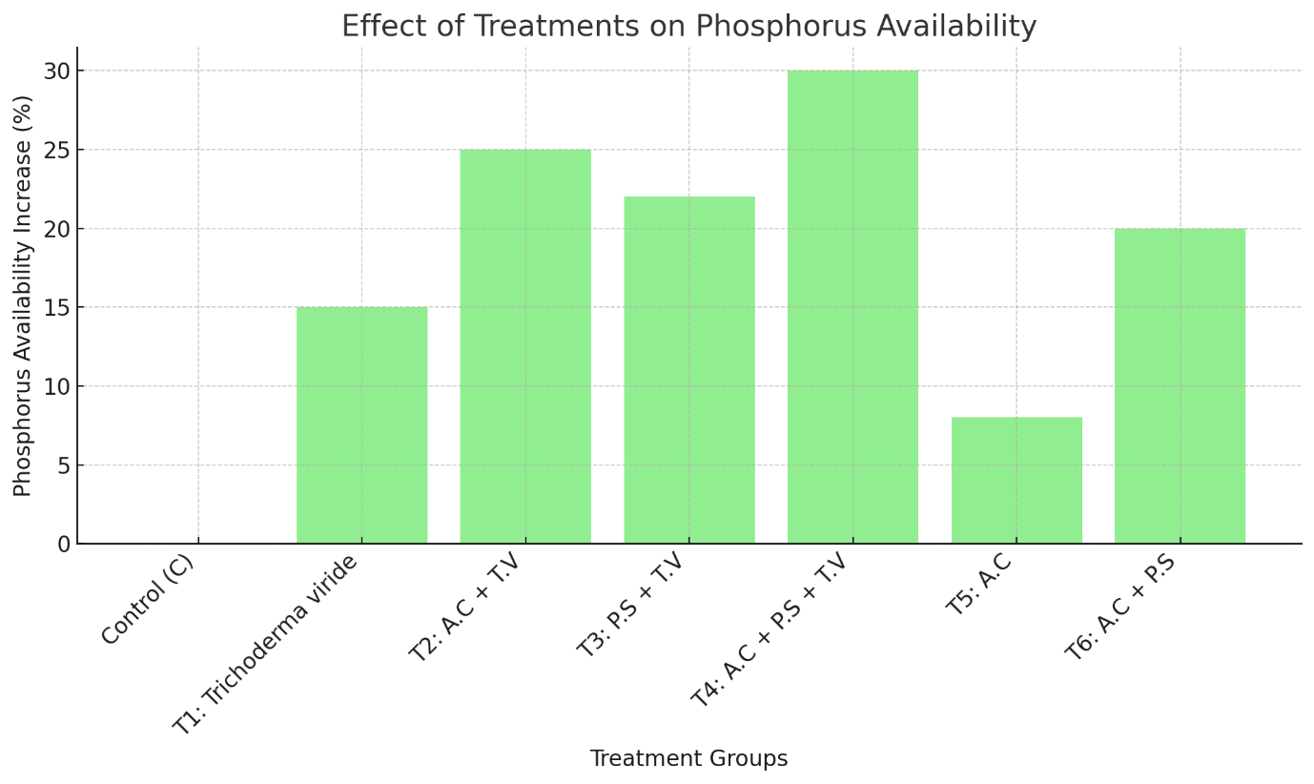
Fig 3: Phosphorus availability
3.3 Interpretation of results in the context of previous studies on T.V and PSM interactions
The yield data indicated that grain and straw yield improved significantly with the application of T.V and other PSMs (table 6). Treatment T4, which included the combination of A. C, P.S and T.V, resulted in the highest grain yield, with a 25% increase compared to the control (C). Treatment T1, where T.V was applied alone, showed a 12% increase in grain yield, further highlighting the positive effect of T.V on rice production (Fig.4, table 6).

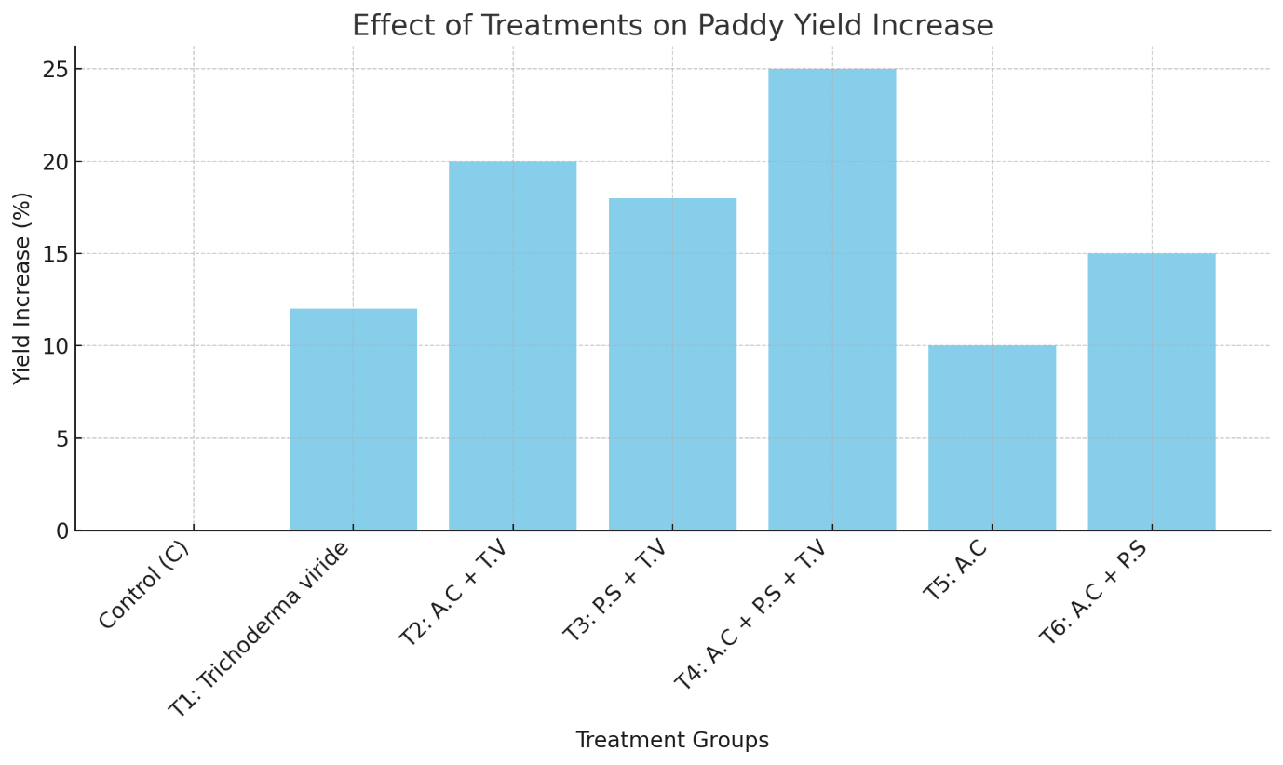
Fig 4: Paddy yield
One of the most significant benefits of using T.V in paddy cultivation is its contribution to soil health. In addition to solubilizing phosphate, Trichoderma enhances the overall microbial diversity and activity in the soil, as observed in the increased microbial populations in treatments involving T.V (Harman et al., 2004, Hameeda et al., 2008). The fungus's ability to suppress soil-borne pathogens through competitive exclusion and production of antifungal metabolites helps create a more balanced and healthy soil environment, reducing the need for chemical pesticides (Babalola, 2010; Malik et al., 2024).

Table 6. Paddy yield
Notations | Treatments | Grain  Yield  (t/ha)
C | Control | 0.80
T1 | Trichoderma viride | 0.93
T2 | Azotobacter chroococcum +Trichoderma viride | 2.43
T3 | Pseudomonas striata + Trichoderma viride | 1.57
T4 | Azotobacter chroococcum +Pseudomonas striata + Trichoderma viride | 2.67
T5 | Azotobacter chroococcum | 2.33
T6 | Azotobacter chroococcum+ Pseudomonas striata | 1.23
 | CD (5% Level of significance) | 0.67
Furthermore, the improvements in soil nutrient levels such as increased nitrogen and potassium in addition to phosphorus demonstrate that T.V plays a role in nutrient cycling, further enhancing soil fertility (Bononi et al, 2020; Chen et al, 2021; Donbiaksiam et al, 2024). These effects not only increase crop yields but also reduce the dependence on synthetic fertilizers, which is crucial for promoting sustainable and environmentally friendly agricultural practices (Song et al, 2023 ; Shrivastava, 2015).
The integration of T.V into paddy cultivation systems offers a sustainable solution to many of the challenges associated with intensive farming, such as soil degradation and nutrient depletion. By promoting natural nutrient cycling and enhancing plant growth, T.V can help improve rice productivity while minimizing the environmental impact of chemical inputs, aligning with the goals of sustainable agriculture (Mathews et al, 2010 V;assileva et al., 2022).

CONCLUSION
This study highlights the significant role of T.V in enhancing phosphorus solubilization and improving rice yield. The application of T.V, both alone and in combination with other PSMs like A.C and P.S, resulted in substantial increases in microbial population, phosphorus availability, and plant growth parameters. The highest yields were observed in treatments combining T.V with other PSMs, confirming the synergistic effect of these biofertilizers in promoting nutrient cycling and plant health. These findings align with previous research demonstrating the multiple benefits of T.V as a biofertilizer that not only improves soil fertility but also enhances crop productivity in a sustainable manner. The use of T.V in paddy cultivation offers an eco-friendly alternative to chemical fertilizers, reducing the environmental impact of intensive farming. By enhancing the natural processes of phosphorus solubilization and nutrient availability, T.V contributes to the sustainability of soil health, thereby supporting long-term agricultural productivity. Further research is recommended to investigate its performance across varying soil types, moisture levels, and environmental conditions. In addition, studies focusing on the long-term effects of repeated Trichoderma application on soil health and crop performance would provide valuable insights into its potential for broader agricultural adoption.
Competing interest
There is no competing interest among the authors.

Disclaimer (Artificial intelligence)
Option 1:
Author(s) hereby declare that NO generative AI technologies such as Large Language Models (ChatGPT, COPILOT, etc.) and text-to-image generators have been used during the writing or editing of this manuscript.

References:
- Julia, C., Wissuwa, M., Kretzschmar, T., Jeong, K., Rose, T. (2016). Phosphorus uptake, partitioning and redistribution during grain filling in rice. Annals of Botany, 118(6):1151–1162.
- Singh, N., Singh, G. (2016). Response of lentil (Lens culinaris Medikus) to phosphorus-a review. Agricultural Review, 37(1):27–34.
- Sutaliya, R., Singh, R.N. (2005). Effect of planting time, fertility level and phosphate solubilizing bacteria on growth, yield and yield attributes of winter maize (Zea mays) under rice (Oryza sativa) – maize cropping system. Indian Journal of Agronomy, 50: 173-175. https://doi.org/10.59797/ija.v50i3.5097
- Asuming-Brempong, S. (2013). Phosphate solubilizing microorganisms and their ability to influence yield of rice. Agricultural Science Research Journal, 3(12): 379-386.
- Tian J, Ge F, Zhang D, Deng S, Liu X. (2021). Roles of Phosphate Solubilizing Microorganisms from Managing Soil Phosphorus Deficiency to Mediating Biogeochemical P Cycle. Biology (Basel).10(2):158. https://doi.org/10.3390/biology10020158
- Silva, L. I. d., Pereira, M. C., Carvalho, A. M. X. d., Buttrós, V. H., Pasqual, M., & Dória, J. (2023). Phosphorus-Solubilizing Microorganisms: A Key to Sustainable Agriculture. Agriculture, 13(2), 462. https://doi.org/10.3390/agriculture13020462
- Rodriguez, H., Fraga, R., Gonzalez, T. & Bashan, Y. (2006). Genetics of phosphate solubilization and its potential applications for improving plant growth-promoting bacteria. Plant and Soil, 287: 15–21. https://doi.org/10.1007/s11104-006-9056-9
- Vassileva M., Mendes, G. d. O., Deriu, M. A., Benedetto, G. d., Flor-Peregrin, E., Mocali, S., Martos, V., & Vassilev, N. (2022). Fungi, P-Solubilization, and Plant Nutrition. Microorganisms, 10(9): 1716. https://doi.org/10.3390/microorganisms10091716
- Johri, J. K., & Sharma, A. (2002). Phosphorus-solubilizing bacteria: Potential application as biofertilizers. Bioresource Technology, 95(2): 169-172. 10.1155/2019/4917256
- Mahato, S., Bhuju, S & Shrestha, J. (2018). Effect of Trichoderma viride as biofertilizer on growth and yield of wheat. Malaysian Journal of Sustainable Agriculture. 2: 1-5. http://dx.doi.org/10.26480/mjsa.02.2018.01.05
- Datta, D., Senapati, A.K., Panda, A.G.P., Boblina, B., Mishra. M.K., Srinivas, P., Samantaray, D., Dey, P., Saha, D. (2022). Effect of Different Trichoderma asperellum Formulations on Management of Sheath Blight of Rice. International Journal of Plant and Soil Science.34(24):1136-1143. https://journalijpss.com/index.php/IJPSS/article/view/2791
- Amira, R.D., Roshanida, A.R., Rosli, M.I., Zahrah, M.S.F., Anuar, J.M., Adha, C.N., (2011). ‘Bioconversion of empty fruit bunches (EFB) and palm oil mill effluent (POME) into compost using Trichoderma virens’. African Journal of Biotechnology .10: 18775–18780. 10.5897/AJB11.2751
- Yao X, Guo H, Zhang K, Zhao M, Ruan J, Chen J. (2023). Trichoderma and its role in biological control of plant fungal and nematode disease. Frontiers in Microbiology. 3(14):1160551. https://doi.org/10.3389/fmicb.2023.1160551
- Pradhan, N., & Sukla, L. B. (2005). Solubilization of inorganic phosphates by fungi isolated from agriculture soil. African Journal of Biotechnology, 5(10): 850-854.
- Banayo, N. P. M., Cruz, P. C. S., Aguilar, E. A., Badayos, R. B., & Haefele, S. M. (2012). Evaluation of Biofertilizers in Irrigated Rice: Effects on Grain Yield at Different Fertilizer Rates. Agriculture, 2(1), 73-86. https://doi.org/10.3390/agriculture2010073
- Harman, G. E., Howell, C. R., Viterbo, A., Chet, I., & Lorito, M. (2004). Trichoderma species—Opportunistic, avirulent plant symbionts. Nature Reviews Microbiology, 2(1): 43-56. 10.1038/nrmicro797
- Song, M., Wang, X., Xu, H. et al. (2023). Effect of Trichoderma viride on insoluble phosphorus absorption ability and growth of Melilotus officinalis. Scientific Reports, 13:12345. https://doi.org/10.1038/s41598-023-39501-y
- Elhaissoufi, W., Ghoulam, C., Barakat, A., Zeroual, Y and Bargaz, A.(2022). Phosphate bacterial solubilisation: A key rhizosphere driving force enabling higher P use efficiency and crop productivity, Journal of Advanced Research. 38: 13-28.
- Aseel, D. G., Soliman, S. A., Al-Askar, A. A., Elkelish, A., Elbeaino, T., & Abdelkhalek, A. (2023). Trichoderma viride Isolate Tvd44 Enhances Potato Growth and Stimulates the Defense System against Potato Virus Y. Horticulturae, 9(6), 716. https://doi.org/10.3390/horticulturae9060716
- Rodriguez, H., & Fraga, R. (1999). Phosphate-solubilizing bacteria and their role in plant growth promotion. Biotechnology Advances, 17(4): 319-339. https://doi.org/10.1016/s0734-9750(99)00014-2
- Yedidia, I., Benhamou, N., & Chet, I. (2001). Induction of defense responses in cucumber plants by the biocontrol agent Trichoderma harzianum. Applied Environmental Microbiology, 65(3): 1061-1070. https://doi.org/10.1128/aem.65.3.1061-1070.1999
- Chabot, R., Antoun, H. and Cescas, M. P. (1996). Growth promotion of maize and lettuce by phosphate-solubilizing Rhizobium leguminosarum biovar phaseoli. Plant and Soil, 184: 311-321. https://doi.org/10.1007/BF00010460
- Hameeda, B., Harini, G., Rupela, O. P., Wani, S. P., & Reddy, G. (2008). Growth promotion of maize by phosphate-solubilizing bacteria isolated from composts and macrofauna. Microbiological Research, 163(2): 234-242. https://doi.org/10.1016/j.micres.2006.05.009
- Babalola, O. O. (2010). Beneficial bacteria of agricultural importance. Biotechnology Letters, 32(11): 1559-1570. https://doi.org/10.1007/s10529-010-0347-0
- Malik, M.A., Ahmad, N & Mohd. Bhat Y, (2024). The green shield: Trichoderma's role in sustainable agriculture against soil-borne fungal threats, Current Research in Microbial Sciences. 7:100313. https://doi.org/10.1016/j.crmicr.2024.100313
- Bononi, L., Chiaramonte, J.B., Pansa, C.C., Moitinho, M.A., Melo, I.S.(2020). Phosphorus-solubilizing Trichoderma spp. from Amazon soils improve soybean plant growth. Scientific Report .18:10(1):2858. https://doi.org/10.1038/s41598-020-59793-8
- Chen, D., Hou, Q., Jia, L., & Sun, K. (2021). Combined Use of Two Trichoderma Strains to Promote Growth of Pakchoi (Brassica chinensis L.). Agronomy, 11(4), 726. https://doi.org/10.3390/agronomy11040726
- Donbiaksiam, T., Jyotsna, N. (2024). Study on the Effect of Trichoderma viride on Phosphate Solubilizing Microorganisms in Paddy Cultivation with the Combination of Chemical Fertilizer on soil Fertility Parameters. Asian Journal of Soil Science and Plant Nutrition. 10(2):101-104. https://journalajsspn.com/index.php/AJSSPN/article/view/265
- Srivastava, A.K. (2015). Microbial solubilisation of phosphate: Pseudomonas versus Trichoderma. Annals of Plant and Soil Research. 17: 227-232.
- Mathews, D.V, Patil, P.L & Dasog, G.S. (2010). Effect of Nutrients and Biofertilizers on Yield and Yield Components of Rice in Coastal Alluvial Soil of Karnataka. Karnataka Journal of Agricultural Sciences. 19(4):799-803

