Review Article

Deepfake Detection Using Deep Learning: A Review

ABSTRACT

Of late, social media has amplified rapidly, and deepfake information has cropped in. The Artificial Intelligence (AI) and data analytics have distorted enhancing program performance, which distracted dynamic, real-time insights and intrude risk assessments. But deepfake AI have altered social media that truncate the instantaneous decision-making processes, and mislead the strategic planning. The present review focuses on insights blended approaches, highlighting real-time analytics and improved decision-making by differentiating between real-time data from fake interpretations.
The proliferation of deepfakes across social media has raised significant concerns about misinformation, identity fraud, and public trust. Using advanced AI techniques such as Generative Adversarial Networks (GANs) and diffusion models, they often mimic human likenesses with high precision, making manual detection increasingly difficult. This review explores recent advancements in automated deepfake detection using deep learning architectures, including Convolutional Neural Networks (CNNs), Recurrent Neural Networks (RNNs), Autoencoders, GANs and Diffusion Models. Each model's role in identifying manipulated visual and audio content is critically analysed. Detection methodologies span across spatial, temporal, and physiological signal analyses, employing hybrid frameworks for enhanced accuracy. The review also evaluates the effectiveness of publicly available datasets and real-time detection tools such as Sentinel, Sensity, and Fake-catcher. With the continuous evolution of generative models, this study underscores the need for interpretable detection systems to safeguard digital authenticity.

Keywords: Artificial Intelligence, Deepfake Detection, Deep learning, GAN, CNN, RNN

INTRODUCTION
Deepfake is utilised by cybercriminals and malicious actors, adopting advanced AI tools and techniques for the wrong purposes. The article also highlights software systems helpful for detecting and combating deepfakes. Deep learning is a subset of machine learning that uses multilayered neural networks to simulate the decision-making power of the human brain. It also includes latent variables organised layer-wise in deep generative models, such as in deep belief networks and deep Boltzmann machines.[1]
The main difference between deep learning and machine learning is the underlying neural network architecture. Traditional machine learning models use one to two computational layers, but deep learning models use hundreds to thousands of layers to train the model. Deep learning, unsupervised learning models can extract the characteristics from raw and unstructured data, and make accurate outputs.[2],[3]
Deep learning is a part of data science that drives many applications and services, performing physical and analytical tasks without human intervention. This enables many everyday products and services such as digital assistants, self-driving cars, credit card fraud detection, fake video detection and generative AI. (Fig. 1) [4].

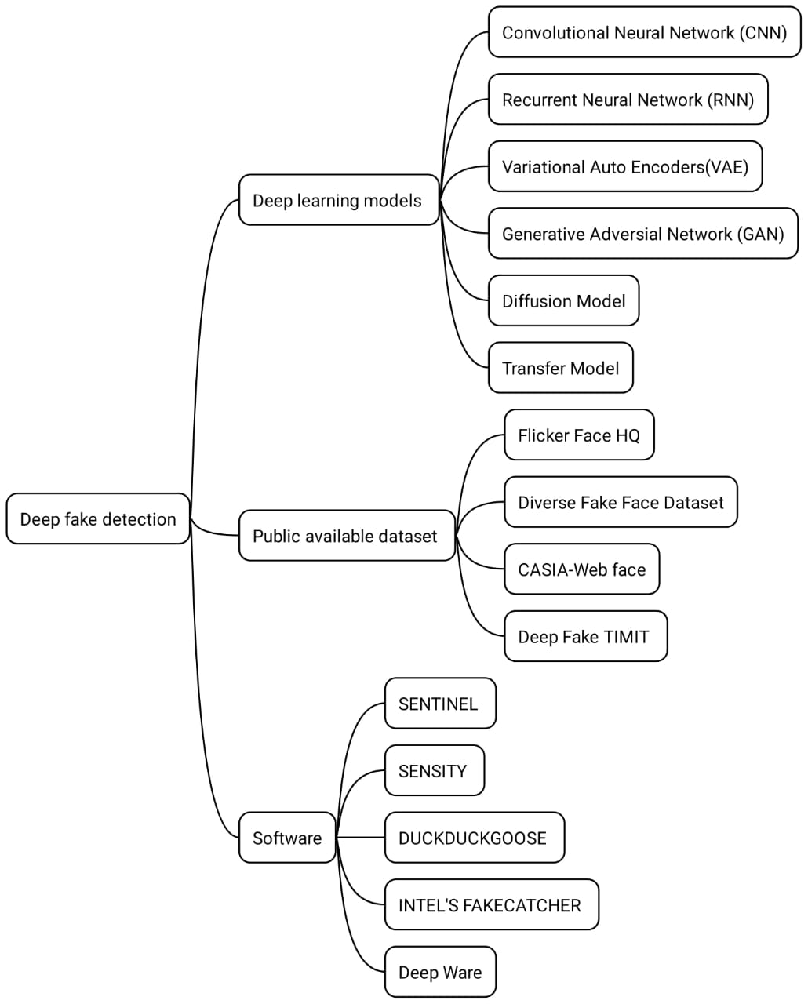

Fig. 1. The deep learning models, the dataset and the software methodology applied in Deep fake detection
1.1 Why deepfake detection
The Artificial Intelligence (AI) and machine learning (ML) is at jeopardy due to incorporation of deepfakes, which are real like manipulated videos and images formed by AI . To combat delusions, protect the stakeholder, maintain trust on the media against malicious uses against dispersal of misinformation, impersonation, or defamation, it is needed to these deepfakes and mitigate their harmful effects on individuals and society. The deepfake detection can use machine learning and deep learning approaches.
1.2 The objective of research
- The present search is detecting deepfake interpretations/methods that use deep learning. i. It searches various deep learning models, including CNNs, RNNs, autoencoders, GANs, diffusion models, and transformers.
- ii. The review explains how these models are used to identify altered images, videos, and audio.
- iii. It also covers publicly available datasets and software tools for deepfake detection, such as Sentinel, Sensity, and Fake-Catcher, as well as the current challenges in this area.

TYPES OF DEEP LEARNING MODELS

2.1 Convolutional Neural Network (CNN)
Convolutional Neural Networks (CNNs) aid in object detection, image detection and pattern recognition within images and videos. These networks are based on linear algebra, particularly matrix manipulation, to identify patterns within an image. CNN is composed of node layers, containing an input and an output layer. Each node joins with another and has an associated weight and threshold. If the output of any individual node is greater than the threshold value, it is activated and sends data to the next layer of the network (Fig. 1).
There are three main layers in a CNN: the convolutional layer, the pooling layer and the fully connected layer. Starting layers focus on simple features, such as colour and edges, with an increase in layer CNN increases in its complexity, identifying a larger portion of the image. As image data progresses through CNN layers, it recognises elements or shapes of the object until it finally reaches the object of interest. [5]
CNN has superior performance with image or audio signal inputs, as compared to other neural networks. CNN can exchange data between layers to deliver more significant data processing.

Disadvantages
Information might be lost in data processing. Requiring many graphical processing units (GPUs), requires highly trained experts with cross-domain knowledge, hyperparameters and configuration.

Recurrent Neural Network (RNN)
Recurrent Neural Networks (RNNs) are widely used in speech recognition applications due to their ability to process time series data, which is essential for predicting future outcomes.[5] They are also employed in tasks such as language translation, natural language processing (NLP), and image captioning, with practical applications including Siri, voice search, and Google Translate. RNNs share weight parameters across network layers, and they utilise backpropagation and gradient descent to adjust weights during reinforcement learning.[6] Traditional back propagation is specific to a sequence of data, but the RNN uses a Back Propagation Through Time (BPTT) algorithm to determine the gradient.

Auto Encoders and Variational Autoencoders
Variational Autoencoders (VAEs) are widely used for generating realistic images and speech. It is the base of generative AI. Autoencoders encode unlabeled data into a compressed representation and decode the data back to its original form. Plain Auto encoders were used for reconstructing blurry images. Variational Autoencoders not only reconstruct data, but also output variations on the original data.
This ability to generate new data ignited a rapid-fire succession of new technologies. From Generative Adversarial Network (GANs) to diffusion models capable of producing more realistic, but fake images.
Autoencoders are made up of blocks of an encoder and decoder that also support today’s large language models. Encoders arrange similar data closer together in an abstract form and compress data sets into a dense presentation (Fig.2) [7].
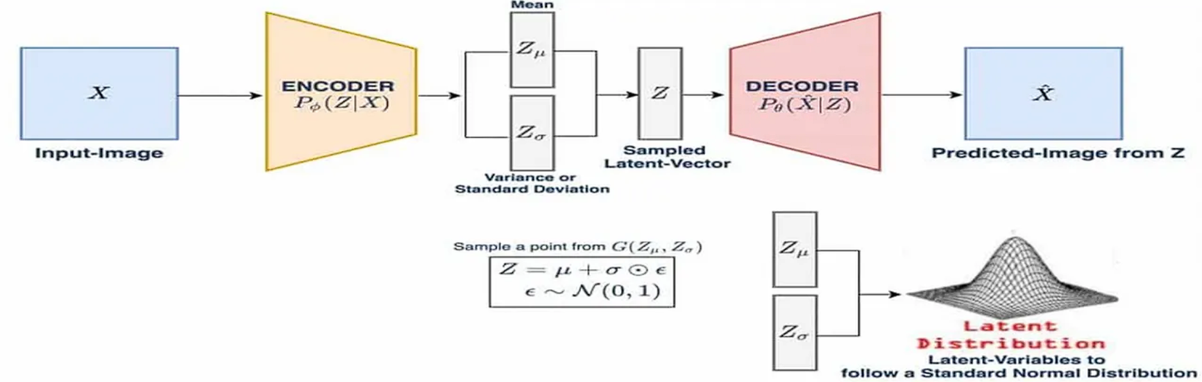
Fig. 2. The Variational Auto-Encoders (VAEs); (Source: https://medium.com/ tech-ai-made-easy /what-are-variational-autoencoders-vaes-449e3ba9d208 by Francesco Franco)

Advantages
Autoencoders can handle large batches of data. The significant aspect is anomaly detection and classification of tasks. It also speeds transmission and reduces storage requirements. VAE can produce new sample data for text or image generation.[8]

Disadvantages
The training can be a drain on computational resources. It doesn’t identify complex relationships correctly.[9]

Generative Adversarial Network (GANs)
GANs are used both in and outside of AI to create new data resembling the original training data. It has a dual generator and discriminator. The generator creates an artefact, maybe an image, video or audio and produces a twisted output. For example, a polar bear can be transformed into a sloth bear with high accuracy. The discriminator is opposite, where the generative result (fake image, video or audio) is compared with real data. The discriminator tries to differentiate between real and fake images, video or audio. [10]

Diffusion Models
Diffusion models are generative models that use both forward and reverse diffusion processes of progressive noise addition and deletion. It generates data, mostly images similar to trained data, but then overwrites the data to train them. They progressively add Gaussian data to the training data until it is unrecognizable, then learn a reverse denoising process that can synthesize output from random noise input. [11]
It can minimise the difference between the generated sample versus the desired target. Any discrepancy is detected, and the model’s parameters are updated to minimise the loss. The model is trained to produce samples similar to the authentic training data.
The diffusion models have advantages that, without the need for adversarial training, speed up the learning process. The diffusion models can require more computing resources to train, including more fine-tuning compared to GANs. Information Business Machine (IBM) research also discovered that GAN can be hijacked with hidden back doors, giving control to the attacker over the image creation process so that Artificial Intelligence (AI) diffusion models can be tricked into generating manipulated images.

Transformer Models
Transformer models combine both encoders and decoders with a text processing mechanism. An encoder embeds the raw text; the decoders take this embedding together and sequentially predict each word in a sentence. Using fill-in-the-blanks guessing, the encoder learns how words and sentences are related to each other to make a representation of the language. The Transformer processes the word in a sentence, along with enabling text processing to speed up the training. Unlike advanced techniques, RNNs process words one by one. Transformers also know the position of words and their relationship. [12]
Previously, labelled data was gathered to train one model on a specific task. In Transformers, a model trained on a large amount of data can be adapted to multiple tasks by fine-tuning it on a small amount of labelled task-specific data. Currently, language transformers are used for both non-generative tasks such as classification and entity extraction, and generative tasks such as question answering, summarising and machine translation.
Transformers enable users to understand the overall context more clearly and create superior output by tracking long-term dependencies in text. As to limitations, because of their complexity, Transformers require huge computational resources and extensive training.

DEEPFAKE DETECTION

Image detection
Different methods have been used to detect artificially generated images. The neural network-based method employs preprocessing techniques to examine the statistical features of images and detect fake images created by humans.[13] Another method utilises a deep learning network to extract face features based on face recognition. After that, a fine-tuning step is used to make face features easy to detect in real or fake images. These methods produce good results.
Some researchers ignore the critical issue of forensic models’ generalisation capabilities, i.e. they use the same type of dataset to train and test their models. To address this issue, a forensic Convolutional Neural Network (CNN) is proposed that employs a two-step process involving Gaussian blur and Gaussian image analysis to detect fake images. The aim behind this model is to use preprocessing steps to neglect low-level high-frequency artefacts in generated images and improve high-frequency pixel noise in low-level pixel statistics. This helps forensic experts to distinguish between real and fake images based on certain facial characteristics. [14]
In addition to the traditional deep fake detection model, a hybrid approach was introduced to accurately detect fake images. For example, a two-stream neural network is used for the detection of face tampering. The Goggle Net uses a face classification stream to train the model on authentic and tampered images. Then, the steganalysis feature extractor uses a patch triplet stream to capture low-level camera characteristics and local noise residual. The results show that this approach can learn both real and fake images.[15]
Another hybrid method was used, which uses pairwise learning for Deep Fake image detection. Here, GANs were used to create a fake image, then a pairwise learning model was used to capture the discriminant information between the real and fake images. The experimental result shows that this method can overcome the shortcomings of the existing state-of-the-art fake image detectors. [16]

Video Detection
In the last year, deep learning methods have been successfully developed for fake image detection. However, the current deep learning methods of image identification cannot be used for fake video detection due to the loss of frame information after video compression. The deep fake video detection task is divided into two categories: Biological single analysis and spatial and temporal features analysis.[17]

Biological Signals Analysis
This method considers eye blinking to detect fake videos. It uses a convolutional neural network (CNN) with a recurrent neural network (RNN) to find the physiological signals, such as eye movements and eye blinking. Then it uses a binary classifier to detect closed and open eye tests. This method is tested with a dataset called eye blinking, crawled from the internet. The eye blinking dataset is the first dataset which is specifically designed for eye blinking detection.[18]
Another biological signal, such as heartbeat, is also used for real video. The model has several detectors, where the input to this model is real video. Subsequently, the pair of real and fake videos is assigned to another layer called registration, which extracts the facial Region of Interest (ROI) and biological signals to create Photoplethysmography(PPG) cells. The PPG cells are spatiotemporal windows containing multiple faces extracted using a face detector. The last layer classifies the video as real or fake. By performing various tests on a publicly available dataset, it shows 97.3% accuracy in deep fake detection.[19]
In addition to biological signals, there is a close relationship between various audio-visual modalities of the sample. Another deep learning model is used to detect deepfakes in multimedia content. It focuses on analysing the relationship between audio and video. The model uses a Siamese network to extract features from both the face and the audio. It uses two tools—Open Face for video and Py-Audio analysis for sound. These tools help create feature vectors for each input. Then, a Triplet loss function compares the vectors to find differences and decides if the content is real or fake. This method has been tested on the Deepfake TIMIT and DFDC datasets and shows high accuracy.[20]

Spatial and Temporal Features Analysis
Current deep fake detection uses only a single video frame. But video manipulation is carried out on multiple frame-level features. Analysing temporal sequences between frames successfully helps to distinguish the real video from the fake one. Temporally aware models first use a CNN for frame feature extraction. Then these features are passed to the Long Short-Term Memory (LSTM) layer to analyse a temporal sequence for face manipulation between frames. At last, a SoftMax function is used to classify the video as real or fake. [21]
Based on the previous version of Cycle-GAN, a new approach called Recycle-GAN uses a conditional GAN to merge spatial and temporal data. The results show that combining spatial and temporal constraints can produce effective output. [22]
Another method consists of two stages: face processing and face manipulation detection. In the face processing stage of the Spatial Transformer Network (STN), crop and align the face. The output of the processing stage is transferred to face manipulation detection using a recurrent neural network (RNN), where temporal information across the frames is analysed.[23]

PUBLICLY AVAILABLE DATASET

Flicker Face HQ
Flickr Faces HQ is a dataset containing 70,000 high-resolution images (1024 pixels) with a wide range of variations in age, ethnicity, backgrounds, and accessories like eyeglasses and hats. The images were automatically collected and aligned from Flickr, using only those available under permissive licenses. Several filtering techniques were applied to refine the dataset, and Amazon Mechanical Turk was used to remove non-human images such as statues, paintings, or photographs of other photos.[24]

Diverse Fake Face Dataset (DFFD)
Diverse Fake Face Dataset (DFFD) contains 1,00,000 to 2,00,000 fake images generated by adopting respective state-of-the-art methods ( Pro GAN and style GAN methods). It contains 47.7% percent male photographs, 52.3% female images, and most of the sample range between 21 to 50 years old. [25]

CASIA- Web Face
CASIA-Web Face (Chinese Academy of Sciences Institute of Automation) contains 10,000 subjects and 50,000 images. The dataset was crawled from the IMDB website, which contains 10,575 images of actors and actresses of (Internet Movie Database (IMDB. [26]

Deepfake TIMIT
Deep Fake Texas Instruments/Massachusetts Institute of Technology (TIMIT) is a database containing a collection of swapped faces videos generated by a GAN. The database was produced by both a lower-quality model with a 64×64 size and a higher-quality model with a 128×128 size. Each fake video collection contains 32 subjects, and for each subject, there are 10 fictitious videos. [27]
5. DISCUSSION
The paper focus on the key problem related to Deepfakes and related solutions to mitigate or minimize the impact such as deep learning and machine learning modules. The manuscript discusses a highly relevant topic in the field of AI, Deepfakes and its impact to media authenticity. The manuscript offers comprehensive review of the deep learning technology used in Deepfake detection. The topic provides open datasets and helpful tools for future exploration of the topic. Its relevance on AI making it a timely contribution to the research community. The various deepfake detection software in use area:

5.1 Centinel (The Guard)
The platform works by analysing critical visual and auditory cues to detect deep fakes. The architecture of Sentinel is based on a multi-layer defence system that includes a vast database of deepfakes and neural network classifiers. This advanced AI detection system is specifically designed to recognise deepfake videos and audio through the analysis of facial expressions, blinking patterns, and audio manipulation. The incorporation of CNNs further enhances its detection capabilities, allowing for a comprehensive examination of various media types.[28]

5.2 Sensity
Sensity (All-In-One Deepfake Detection) is a leading platform dedicated to deep fake detection in 2025. The company employs advanced artificial intelligence and deep learning algorithms to analyse various attributes of digital content, identifying inconsistencies that could indicate a deepfake. Sensity’s architecture is built on a multi-layered detection framework that combines visual, audio, and metadata analyses. The system inspects textures and edges within media files to identify signs of manipulation, particularly around facial features where deepfakes often struggle to maintain realism. Sensity’s working mechanism involves submitting media content through its platform, where various algorithms conduct automatic analyses to detect potential manipulations. Specifically, the detection process examines pixel data, voice inconsistencies, and structural attributes of the media to ascertain its authenticity. This real-time capability enables immediate alerts and assessments regarding suspicious content, which is crucial for timely intervention in instances of misinformation or fraud.[29]

5.3 DuckDuckGoose
DuckDuckGoose is a multi-layered system that analyses various aspects of media files, including textures and edges, to pinpoint signs of manipulation, especially around facial features, where deepfakes can be most difficult to detect. The company’s software offers solutions for detecting a wide range of deep fakes, including videos, images, voices, and texts, serving as vital tools for identity verification and fraud prevention. The deep fake detector enables real-time detection capabilities, as the software can provide results in under a second, offering users immediate insights into the authenticity of the content they are evaluating. [30]
5.4 Intel’s Fakecatcher
Intel’s Fake Catcher is a real-time deepfake detection system introduced in November 2022 that aims to combat the rising threat posed by manipulated videos. It claims a 96% accuracy rate by utilising a unique method that analyses subtle blood flow changes within the pixels of a video. It leverages Intel’s Xeon Scalable processors and employs specialised software libraries such as OpenVino, Intel® Integrated Performance Primitives, and OpenCV for optimised performance in real-time environments.
Fake Catcher operates by analysing the pixel data in videos to detect blood flow signals using a technique known as Photoplethysmography (PPG). When a person is filmed, changes in blood circulation cause variations in pixel colour, which are difficult for deepfakes to replicate accurately. The system collects these signals from strategic points on the face and translates them into spatiotemporal maps, then applies deep learning algorithms to assess whether the video is real or fake, all in real-time.[31]

5.5. Deepware
Deepware is an AI-powered software specifically developed to detect and combat deepfakes, utilising machine learning algorithms to analyse videos. Deepware provides real-time deepfake detection services accessible to individuals, businesses, and researchers, making it a versatile tool in addressing the challenge of synthetic media.
The architecture of Deepware relies on advanced machine learning algorithms and utilises the EfficientNet-B7 model, which is a convolutional neural network optimised for deepfake detection tasks. This model is trained on the CFDC dataset, consisting of 120,000 consented videos, and incorporates additional technologies such as facial landmark analysis, temporal consistency checks, and flicker detection to enhance detection effectiveness. When a video is submitted for analysis, Deepware applies its AI algorithms to detect inconsistencies, giving results that include a confidence score indicating the likelihood of deepfake manipulation. [32][33]]

Deepfake Challenges
Various applications and tools create Deepfake images and videos. It has become a great challenge for academic researchers when studying and analysing deep fake images and videos. One of the most important challenges is the lack of a high-quality dataset. The Deepfake method uses a fragmented dataset to detect tampering. Deep learning models require large datasets during training to produce good results, which are not freely accessible. The rapid enhancements of deepfake GAN models can also bring new challenges, where the obscene types of generated images and videos may not be discovered by the current deep learning models. Hence, all these challenges show the great demand to develop robust and scalable deep learning models to detect deep fake images and videos. [34]

6. CONCLUSION
The detection of deepfakes remains a critical challenge in today’s digital landscape, as the rapid advancement of generative models continues to blur the line between real and synthetic media. This review highlights the effectiveness of deep learning techniques—such as CNNs, RNNs, GANs, diffusion models, autoencoders, and transformers—in identifying manipulated content across images, videos, and audio. By integrating spatial, temporal, and physiological cues, these models significantly enhance detection accuracy. Additionally, the availability of curated datasets and real-time detection tools supports ongoing research and practical application. However, as deepfake technology evolves, detection methods must also become more robust, adaptive, and scalable.
Furthermore, fostering public awareness and critical media consumption habits will empower individuals to identify and counter the spread of deep fakes. Ultimately, a collaborative effort involving researchers, policymakers, technology companies, and the public is essential to navigate the challenges and safeguard trust in the digital age. As dip fake is a black-ship and has a global impact, providing a comprehensive theoretical analysis is of concern subject matter and a thorough theoretical review is recommended for further research.
COMPETING INTERESTS DISCLAIMER
Authors have declared that they have no known competing financial interests OR non-financial interests, OR personal relationships that could have appeared to influence the work reported in this paper.

REFERENCES
- Nguyen, T. T., Nguyen, Q. V. H., Nguyen, D. T., Nguyen, D. T., Huynh-The, T., Nahavandi, S., Nguyen, T. T., Pham, Q. V., & Nguyen, C. M. (2022). Deep learning for deepfake creation and detection: A survey. Computer Vision and Image Understanding, 223, 103525. https://doi.org/10.1016/j.cviu.2022.103525
- Brock, A., Lim, T., Ritchie, J. M., & Weston, N. (2016). Neural photo editing with introspective adversarial networks (arXiv:1609.07093). arXiv. https://arxiv.org/abs/1609.07093
- Yu, P., Xia, Z., Fei, J., & Lu, Y. (2021). A survey on deepfake video detection. IET Biometrics, 10(6), 607–624. https://doi.org/10.1049/bme2.12043
- Rössler, A., Cozzolino, D., Verdoliva, L., Riess, C., Thies, J., & Nießner, M. (2019). FaceForensics++: Learning to detect manipulated facial images. In Proceedings of the IEEE/CVF International Conference on Computer Vision (pp. 1–11). Seoul, Republic of Korea.
- Elman, J. L. (1990). Finding structure in time. Cognitive Science, 14(2), 179–211. https://doi.org/10.1207/s15516709cog1402_1
- Bengio, Y., Simard, P., & Frasconi, P. (1994). Learning long-term dependencies with gradient descent is difficult. IEEE Transactions on Neural Networks, 5(2), 157–166. https://doi.org/10.1109/72.279181
- Chauhan. BS. Introduction to Auto-Encoder and Variational Auto-Encoder (VAE). https: //www.theaidream.com/post/an-introduction-to-autoencoder-and-variational-autoencoder-vae
- Huang, D., & De La Torre, F. (2012). Facial action transfer with personalised bilinear regression. In A. Fitzgibbon, S. Lazebnik, P. Perona, Y. Sato, & C. Schmid (Eds.), European Conference on Computer Vision – ECCV 2012 (pp. 144–158). Springer. https://doi.org/10.1007/978-3-642-33709-3_11
- Zakharov, E., Shysheya, A., Burkov, E., & Lempitsky, V. (2019). Few-shot adversarial learning of realistic neural talking head models. In Proceedings of the IEEE/CVF International Conference on Computer Vision (pp. 9459–9468). https://ieeexplore.ieee.org/document/9009591
- Nataraj, L., Mohammed, T. M., Manjunath, B. S., Chandrasekaran, S., Flenner, A., Bappy, J. H., & Roy-Chowdhury, A. K. (2019). Detecting GAN-generated fake images using co-occurrence matrices. Electronic Imaging: Media Watermarking, Security, and Forensics, 2019(5), 532-1–532-7. https://doi.org/10.2352/ISSN.2470-1173.2019.5.MWSF-532
- Ho, J., Jain, A., & Abbeel, P. (2020). Denoising diffusion probabilistic models. In Advances in Neural Information Processing Systems (Vol. 33, pp. 6840–6851). https://proceedings.neurips.cc/paper/2020/file/4c5bcfec8584af0d967f1ab10179ca4b-Paper.pdf
- Vaswani, A., Shazeer, N., Parmar, N., Uszkoreit, J., Jones, L., Gomez, A. N., Kaiser, Ł., & Polosukhin, I. (2017). Attention is all you need. In Advances in Neural Information Processing Systems (Vol. 30). https://papers.neurips.cc/paper/7181-attention-is-all-you-need.pdf
- Tariq, S., Lee, S., Kim, H., Shin, Y., & Woo, S. S. (2018). Detecting both machine and human-created fake face images in the wild. In Proceedings of the 2nd International Workshop on Multimedia Privacy and Security (pp. 81–87). https://doi.org/10.1145/3267357.3267367
- Yuan, X., Peng, B., Wang, W., & Dong, J. (2019). On the generalisation of GAN image forensics. In Chinese Conference on Biometric Recognition (pp. 134–141). Springer. https://doi.org/10.1007/978-3-030-31456-9_15
- Zhou, P., Han, X., Morariu, V. I., & Davis, L. S. (2017). Two-stream neural networks for tampered face detection. In 2017 IEEE Conference on Computer Vision and Pattern Recognition Workshops (CVPRW) (pp. 1831–1839). https://doi.org/10.1109/CVPRW.2017.229
- Su, C.-C., Zhuang, Y.-X., & Lee, C.-Y. (2020). Deep fake image detection based on pairwise learning. Applied Sciences, 10(1), 370. https://doi.org/10.3390/app10010370
- Afchar, D., Nozick, V., Yamagishi, J., & Echizen, I. (2018). MesoNet: A compact facial video forgery detection network. In 2018 IEEE International Workshop on Information Forensics and Security (WIFS) (pp. 1–7). https://doi.org/10.1109/WIFS.2018.8630761
- Li, Y., Chang, M.-C., & Lyu, S. (2018). In ictu oculi: Exposing AI-generated fake face videos by detecting eye blinking. In 2018 IEEE International Workshop on Information Forensics and Security (WIFS) (pp. 1–7). https://doi.org/10.1109/WIFS.2018.8630787
- Ciftci, U. A., Demir, I., & Yin, L. (2020). How do the hearts of deep fakes beat? Deep fake source detection via interpreting residuals with biological signals. In 2020 IEEE International Joint Conference on Biometrics (IJCB) (pp. 1–10). https://doi.org/10.1109/ IJCB48548.2020.9304909
- Güera, D., & Delp, E. J. (2018). Deepfake video detection using recurrent neural networks. In 2018, 15th IEEE International Conference on Advanced Video and Signal Based Surveillance (AVSS) (pp. 1–6). https://doi.org/10.1109/AVSS.2018.8639163
- Mittal, T., Bhattacharya, U., Chandra, R., Bera, A., & Manocha, D. (2020). Emotions don’t lie: An audio-visual deepfake detection method using affective cues. In Proceedings of the 28th ACM Int. Conf. on Multimedia (2823–2832). https://doi.org/10.1145/3394171.3413887
- Zhu, J.-Y., Park, T., Isola, P., & Efros, A. A. (2017). Unpaired image-to-image translation using cycle-consistent adversarial networks. In Proceedings of the IEEE International Conference on Computer Vision (pp. 2223–2232). https://doi.org/10.1109/ICCV.2017.244
- Sabir, E., Cheng, J., Jaiswal, A., AbdAlmageed, W., Masi, I., & Natarajan, P. (2019). Recurrent convolutional strategies for face manipulation detection in videos. CVPR Workshops. https://arxiv.org/abs/1905.00582
- Dang, H., Liu, F., Stehouwer, J., Liu, X., & Jain, A. K. (2020). On the detection of digital face manipulation. In Proceedings of the IEEE/CVF Conference on Computer Vision and Pattern Recognition (pp. 5781–5790). https://doi.org/10.1109/CVPR42600.2020.00582
- Dang, H., Liu, F., Stehouwer, J., Liu, X., & Jain, A. K. (2020). On the detection of digital face manipulation. In Proceedings of the IEEE/CVF Conference on Computer Vision and Pattern Recognition (pp. 5781–5790). https://doi.org/10.1109/CVPR42600.2020.00582
- Yi, D., Lei, Z., Liao, S., & Li, S. Z. (2014). Learning face representation from scratch. arXiv preprint. https://arxiv.org/abs/1411.7923
- Korshunov, P., & Marcel, S. (2018). Deepfake: A new threat to face recognition? Assessment and detection. https://www.researchgate.net/publication/329841498_DeepFakes_a_New_Threat_to_Face_Recognition_Assessment_and_Detection
- Romain, S. (2023). Sentinel AI: The new frontier in deepfake detection. Romain Berg. https://www.romainberg.com/blog/artificial-intelligence/sentinel-ai-your-ultimate-deepfake-detection-solution/
- Groh, M., Epstein, Z., Firestone, C., Picard, R. (2021). On deepfake detection by human crowds, machines, and machine-informed crowds. Proceedings of the National Academy of Sciences, 119(1), e2110013119. https://doi.org/10.1073/pnas.2110013119
- Mahl, A., Melnnis, K., Gray, M. (2021). DuckDuckGo: White paper on the search engine market. DuckDuckGo. https://staticcdn.duckduckgo.com/press/DuckDuckGo-White-Paper-on-search_March-2021.pdf
- Ciftci, U. A., Demir, I., & Yin, L. (2020). FakeCatcher: Detection of synthetic portrait videos using biological signals. IEEE Transactions on Pattern Analysis and Machine Intelligence. Advance online publication. https://doi.org/10.1109/TPAMI.2020.2992927
- Ganfure, G. O., Wu, C.-F., Chang, Y.-H., & Shih, W.-K. (2023). DeepWare: Imaging performance counters with deep learning to detect ransomware. IEEE Transactions on Computers, 72(3), 600–613. https://doi.org/10.1109/TC.2022.3173149
- Siddique Md., Mohanta D. Ku., Mishra S. P., 2020, A Hybrid Model of Artificial Neural Network and Particle Swarm Optimisation for Forecasting of Stock Price of Tata Motors, Indian Journal of Natural Sciences (IJNOS), .10 (59); 12999- 13005 /l, 2020.
- Afzal, S., Ghani, S., Hittawe, M. M., Rashid, S. F., Knio, O. M., Hadwiger, M., & Hoteit, I. (2023). Visualisation and visual analytics approaches for image and video datasets: A survey. ACM Transactions on Interactive Intelligent Systems, 13(5). https://doi.org/10.1145/3570747

