**A Bitter Brew: The Impact of Climate Change on Coffee Production and Pest Dynamics**

**Abstract**

Global coffee production is seriously threatened by climate change, which will affect crop productivity and quality. The ideal growing areas for coffee are changing due to rising temperatures, changed precipitation patterns, and an increase in the frequency of extreme weather events, especially for the delicate *Arabica* variety. In addition to affecting the physiological growth of coffee plants, these changes in climate also have an impact on the biology, distribution, and life cycle of important pests and diseases. The difficulties experienced by coffee farmers may be exacerbated by warmer temperatures, which may result in wider pest ranges, higher rates of reproduction, and more severe infestations. This review synthesizes current research on how climate variables affect coffee plant health and pest dynamics, highlighting the interconnectedness of agroecological systems. It also explores adaptive strategies, including agroforestry, resistant cultivars, and Integrated Pest Management (IPM), as essential tools for mitigating these impacts. Understanding these complex interactions is crucial for developing sustainable approaches to coffee cultivation under a changing climate.

Keywords: ***Coffee, arabica, berry borer, entomology and climate smart agriculture***

**Introduction**

After crude oil, coffee is the most important commodity on the global market. It is grown on more than 11 million hectares of land in more than 60 tropical countries. It contributes significantly to the foreign exchange profits of numerous developing nations. According to RCP 2.6, RCP 4.5, RCP 6.0, and RCP 8.5 scenarios, the average global surface temperatures for 2081–2100 will rise by 0.3°C to 1.7°, 1.1°C to 2.6°C, 1.4°C to 3.1°C, and 2.6°C to 4.8° C, respectively, in comparison to 1986–2005 ( **IPCC, 2013**). Coffee production is negatively impacted by climate change in several ways. Global crop yields are predicted to drop by 10–20% by 2050 (**IPCC, 2007**). Since coffee is a major source of income for many farmers in developing countries, the effect will be fairly hazardous for crops like coffee. Furthermore, the least temperature rises could seriously harm Arabica coffee because of its specific temperature requirements, which could have a disastrous effect on the coffee industry (**Jaramillo et al., 2009).** A warning has also been issued that the majority of the currently suitable locations for coffee production will see a significant decline if climate change continues on the current course. According to **Davis et al. (2012),** wild Arabica coffee species—the source of many resistant genes—would also face significant challenges due to climate change. It is previously predicted that coffee wild species will become extinct by 2080. Additionally, coffee may be impacted indirectly by climate change due to its influence on diseases and insect pests. Arabica coffee has been under attack from coffee leaf rust in all developing nations, and it is the primary hazard to coffee that is directly related to climate change. Coffee leaf rust is becoming more common at greater altitudes despite farmers' preference to cultivate coffee in highland regions to protect their crop from rust attacks. This is because climate change has created favorable conditions for the fungus. Furthermore, *Hypothenemus hampei*, also referred to as the coffee berry borer, is the insect that is posing the greatest threat to coffee plants (**Jaramillo et al., 2009**).

Any organism that has the capacity to reduce the quantity and quality of any product produced from a managed plant system is regarded as a pest, including insects, plants, microbes, and animals. As a result, keeping these systems viable requires effective pest control. These pests directly or indirectly harm mankind [ **Panigrahi et al. 2025**]. By 2100, it is expected that there will be significant increase in atmospheric carbon dioxide (CO2) concentration, potentially 2x above current levels. This will be followed by corresponding increase in average temperature of 0.15 to 0.3°C every decade.(**Jaramilo et al. 2009 , Davis et al. 2012**). The degree of uncertainty regarding the potential effects of environmental changes on pest biology (insects, plant diseases, and weeds) and the consequences for future biotic losses from managed plant systems is increased by these projections. There are two primary means that recent and anticipated changes in atmospheric CO2 could alter pest biology. The first has been associated with the physical alterations in the environment brought due to rising CO2. Along with other radiation trapping gases (such as CH4, N2O), these increases will raise surface temperatures [**Qian et al. 2011**], change the frequency of precipitation [**Dore, 2006**], change the Diurnal Temperature Range (DTR) [**Qu et al. 2014**], and change the distribution and intensity of extreme weather events. The "fertilization" effect of rising CO2 on plant photosynthesis is a second crucial consequence. Approximately 95% of plant species, including invasive and agricultural weeds, that only use the C3 photosynthetic pathway may grow and reproduce more when CO2 rises. Increase in atmospheric CO2 can have numerous physiological effects for a wide variety of C3 plants . From the view of pest biology, the establishment, spread, and impact of pest species within controlled systems are expected to be affected by the changes in the regional and global climate, including temperature, precipitation, and DTR [Bebber et al.2015, Taylor et al 2018].

**Effect of Climate change on the quality and production of coffee**

According to the **United Nations (1992)** climate change is defined as a change in the climate triggered by both natural climate variables and human action over comparable time periods. Greenhouse gases (GHG) including CO2, CH4, and N2O are produced by agriculture and other human activities, and they have contributed to the increase in global temperatures. Deforestation and burning of fossil fuels have been contributing to the rise in global temperature over the last 200 years (**Greenhouse Gas Working Group, 2010**).

*Coffea arabica* performs its best at temperatures between 18 and 21 degrees Celsius. Arabica coffee plant productivity can be significantly impacted by extreme temperatures in a number of ways: At temperatures higher than 25 degrees Celsius, the efficiency of photosynthesis decreases (**Willson, 1985; Descroix and Snoeck, 2008**). Coffee yields can be decreased by exposure to temperatures above 30 degrees Celsius, which slows growth and may cause abnormalities in the leaves, stems, blossoms, or plants (**Franco, 1958; DaMatta, 2004; Eakin et al., 2009**). However, with careful selection and rigorous management techniques, Arabica coffee would produce satisfactory yields in marginal locations with typical temperatures as high as 24 to 25 degrees Celsius (**DaMatta, 2004**). According to **Craparo et al. (2015**), the primary climatic factor causing a decline in *C. arabica* yields is due to increase in nighttime temperatures. Additionally, it is predicted that by 2060, average coffee production will reduce to 145 kg/ha, and many coffee-producing regions with comparable minimum temperature trends will be severely impacted.

In general, coffee berries expand and mature more quickly at temperatures above 23°C, which frequently results in a reduction in coffee quality. On the other hand, growth is severely restricted in areas where the mean annual air temperature is less than 18°C. Frequent frosts severely restrict the crop's economic potential, and when water stress arises, the coffee plant's stomata close and its physiological activity declines, which restricts the process of photosynthesis **(Camargo, 2010).**

Coffee flowering is hindered by heavy and unpredictable rains. High precipitation driven on by climate change greatly favors coffee berry disease, which need considerable amounts of moisture for growth. Changes in the amount of rainfall will also have a significant impact on the drying and processing of coffee. In order to produce high yields, both species of coffee rely heavily on the climate; rainfall and temperature are thought to be key determinants of prospective coffee yield. Both elements affect the crop's performance, which in turn affects quality and productivity. Numerous scientific explanations suggested that during the next four decades, coffee industries would probably be impacted by climate change. Additionally, they show that extreme temperatures have caused changes in the coffee producing area, making the most suited location unsuitable owing to climate instability. It is anticipated that coffee will grow more suited at higher elevations and less suited at lower ones.

The results of studies have shown that temperature and rainfall conditions affect coffee's potential yield and quality, suggesting that both factors can affect the crop's growth.  
These effects, which ultimately lead to decreased coffee quantity and quality, include, interrupted flowering cycles and prolonged drought spells [**DaMatta FM (2004)].** Additional climate variations, like the soil water balance at different phases of the coffee crop's growth, can impact the amount of soil water available and lower the final yield [**Camargo MBPD (2010).**]. Particularly during the blossoming and frutification stages, Arabica coffee is more susceptible to changes in the climate [Haggar, J., & Schepp, K. (2011).].

Coffee will flower at different times throughout the year because of the unexpected rains, forcing producers to repeatedly pick small amounts. The crop physiology will be impacted by this alteration, particularly during the stages of blooming and fruit filling. Climate-induced risk is predicted to rise in the future due to altered rainfall patterns and variability, as well as more frequent extreme events including drought, floods, and high temperature waves.

**Effect of Climate Change on Pest and Diseases of Coffee**

One of the major coffee diseases that may severely damage coffee yield and quality is coffee leaf rust [CLR]. According to a survey done by 16 Bigirimana et al. (2012) to determine the relationship between CLR severity and elevation, it was seen that Coffee farms at higher elevations had lower CLR than those at lower elevations.

On the other hand, coffee leaf rust was common at higher elevations where the fungus could not thrive. One of the main environmental factors influencing insect life is temperature. Exposure of populations to varying climatic regimes has a substantial impact on insect phenology, reproduction, and developmental rates. Particularly, a major factor in insect demography and dispersal are minimum temperatures. Being ectotherms, insect pests benefit greatly from warming temperatures because they may extend their ranges to higher latitudes and elevations [Bale et al 2002] and produce greater numbers of offspring because of longer growing seasons. As a result, pest epidemics or pest outbreaks are more frequent worldwide. In the same way, longer growing seasons encourage the growth of pest populations. For instance, a 20-year study revealed that a slight  1 °C increase in winter temperatures caused aphids’ migration phenology to accelerate by 19 days [Zhou et al 1995]. DTR can also change the rate at which insects emerge. For instance when the DTR is smaller, the grape berry moth *Paralobesia viteana* exhibits delayed adult emergence and decreased voltinism; when the DTR is larger, the voltinism increases and the adult emergence occurs earlier. A “peak” hydrologic cycle is expected due to climate change, and the same location could witness an increase in both droughts and above-normal rainfall events. Gypsy moth caterpillars, *Lymantria dispar* (L.) showed their first significant outbreak in the Northeast U.S. in more than 30 years after a severe drought in 2015–2016 [Pasquarella **2017**].

The most significant challenge to coffee production worldwide Is the coffee berry borer *Hypothenemus hampei* (Ferrari). Apparently, coffee plantations were exclusively attacked and damaged by the coffee berry borer at elevations lower than 1500 meters (Agegnehu et al., 2015). However, the insect is now common at greater elevations above 1500m because of the favorable environmental conditions that the rising temperatures in the majority of coffee-growing regions of the world have generated for the pest.

**Coffee Berry Borer**

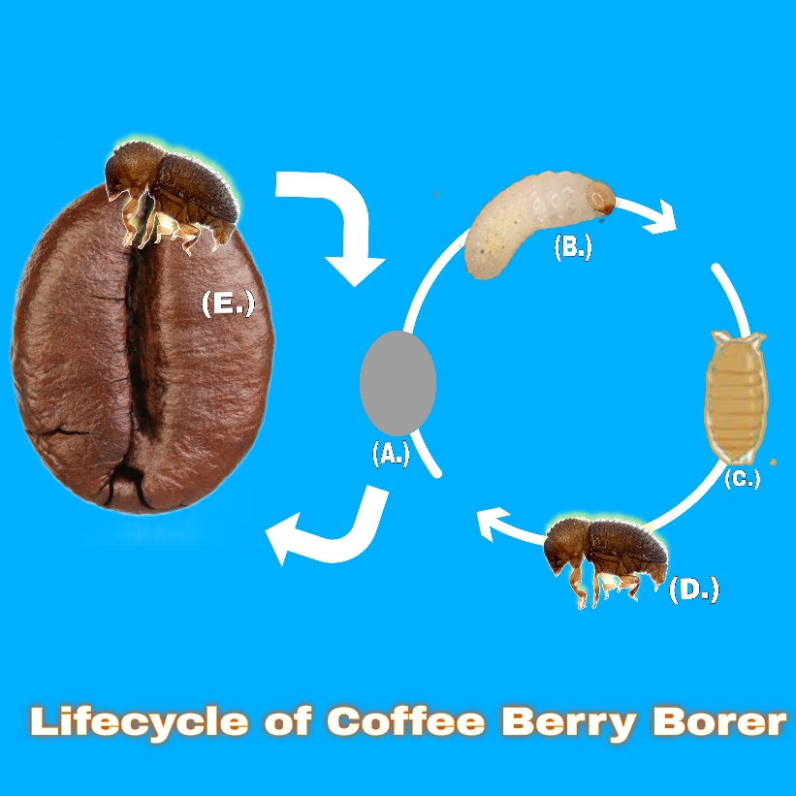

**Figure 1: Indicating Lifecyle of Coffee Berry Borer**

Jaramillo et al. 2009 used eight different temperatures (15, 20, 23, 25, 27, 30, 33, or 35 °C) to measure the developmental period (days) from egg to adult in order to determine the coffee berry borer's thermal tolerance. Growth at all other temperatures demonstrated that development accelerated with temperature, but the insect was unable to develop in 15 and 35 °C. By 2050, the percentage of the surface area under coffee cultivation infested by the coffee berry borer is expected to rise from the current 57% and 50% for *C. arabica* and *C. canephora*, respectively, to 78% and 93%. According to a projection made by Magrach and Ghazoul, 2015 [19]. Climate change may make pest incidence severe. According to a study in 2011, *Hypothemus hampei*, the coffee berry borer, seemed to be flourishing in warmer climates. According to the authors, losses from coffee bean damage from berry borer infestations currently exceed $500 million annually [Wolf 2010 ]. A temperature increase of 1 to 2 degrees Celsius may result in more coffee berry borer generations, dispersal, and damage; however, a temperature increase of 2 degrees Celsius or more may cause changes in the pest's latitudinal and altitudinal distribution. There are compelling signs that these changes are already taking place [ mac Donald 2009, Kutywayo 2013].

**Coffee Leaf Miner**

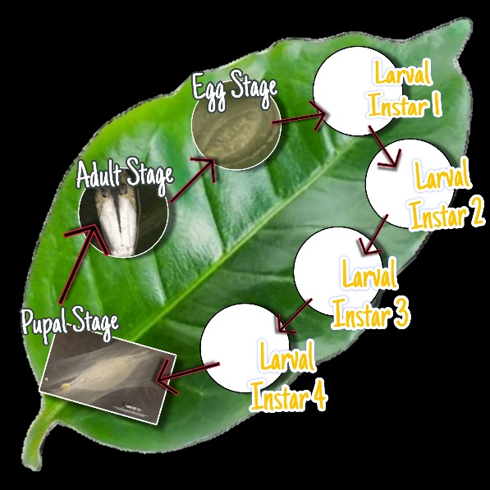

**Figure 2: Indicating Lifecycle of Coffee Leaf Miner**

It is regarded as an even more significant pest than the coffee berry borer in countries like Brazil. In Brazil, two climate change models have predicted higher monthly coffee leaf miner generations in 2020, 2050, and 2080.

**Coffee White Stem Borer**

Infested plants typically need to be removed from the plantation since the pest is very difficult to control. Kutywayo 2013 found that precipitation is more significant than temperature in determining the projected range of the coffee white stem borer, with several areas, probably becoming more suitable for increased infestations. This is in contrast to studies that focus on temperature (e.g., coffee berry borer and coffee leaf miner).

**Coffee Leaf Rust**

An analysis of coffee leaf rust incidence prompted Bebber et al. 2015 to conclude that climate change was not the cause of a series of coffee rust epidemics that occurred in between 2008 and 2013. Rather, the outbreaks might have been caused by longer periods of leaf wetness, warmer canopy temperatures, and less fertilizer application, which led to a decrease in plant vigor. Warmer temperatures may shorten the fungus's incubation period, or the interval between infection and the appearance of symptoms [Ghini 2011].

**CLIMATE CHANGE MITIGATION STRATEGIES FOR IMPROVED COFFEE PRODUCTIVITY**

1. **Genetic Improvement:** The goal of selective breeding  is to support the long-term viability of coffee production in areas that may be impacted by climate change.Additionally, it's crucial to conduct research on cultivating varieties that require less water and developing others that can withstand higher temperatures. Despite their complicated characteristics, coffee production requires the development of ecologically friendly, stable, and more resistant heat shock and drought cultivars in order to overcome the difficulties posed by climate change.
2. **Shade-based reforestation :** Shade protects coffee trees from dry spells and strong winds. Shade-grown coffee plants are less vulnerable to environmental pressures brought on by climate change. As the air temperature inside the coffee trees is constant, it gets warmer in the evening and colder in the morning. The coolness brought on by daytime shade lowers transpiration from the roots as well as the leaves. Compared to coffee plants grown in full sun, the crop grown in shade produces coffee with a stronger biochemical and physiological capability for carbon fixation as well as larger, heavier beans with a higher-quality taste. On steep slopes, shade trees can also be employed to reduce erosion
3. **Dense planting with soil cover and irrigation :** To improve the viability of farming in unfavorable climatic circumstances, high-density planting, vegetated soils, and irrigation are used to preserve and/or increase organic matter and soil water-retention capacity.
4. **Integrated pest management :** Use of integrated pest management- Pests and diseases of coffee pose a danger to coffee production and can affect farmer livelihoods
5. **Improved access to climate information**
6. **Reducing Green House Gas Emissions**

**Conclusion**

There will be threats related to the worldwide production of food, fiber, and feed as the climate changes and as the CO2 levels rise. Additionally, climate change and CO2 will cause pests to react differently, changing their biology and evolution and the way they affect managed plant systems, such as forests and crops. There is already evidence that the distribution and biology of both new and existing pest species in regulated agricultural commodities, like coffee, have already been impacted by recent climatic changes and rising CO2.

Authorship Contributions

D, CKP, SNS, SP and BA: Writing and analysis of the review with Editing of the Manuscript.

D, CKP, SNS, SP and BA: Conceptualisation of the work.

D, CKP, MP, DS, PD, RSP, JJ, SParmar Supervision, Revision and Correction.

D,CKP, SP, RSP, PD and DS **:** Preparation of Graphical presentations

D,CKP: Preparation of Final Draft.

Acknowledgement

Authors would like to express their sincere gratitude to Dr. Sangeeta Panigrahi of Utkal University for her valuable guidance and insightful overview on the topic "Endosymbionts in Insects: Functional Roles and Applications in Pest Management." Her expertise input greatly enhanced the understanding of the subject and contributed significantly to the direction and depth of this work.

Disclaimer (Artificial intelligence)

Option 1:

Author(s) hereby declare that NO generative AI technologies such as Large Language Models (ChatGPT, manuscript.

**References**

1. Agegnehu E, Thakur A, Mulualem T (2015). Potential impact of climate change on dynamics of coffee berry borer (Hypothenemus hampi Ferrari) in Ethiopia. Open Access Library Journal. 2(1):1
2. Bale, J.S.; Masters, G.J.; Hodkinson, I.D.; Awmack, C.; Bezemer, T.M.; Brown, V.K.; Butterfield, J.; Buse, A.; Coulson, J.C.; Farrar, J.; et al. Herbivory in global climate change research: Direct effects of rising temperature on insect herbivores. *Glob. Chang. Biol.* 2002, *8*, 1–16.
3. Bebber, D.P. Range-expanding pests and pathogens in a warming world. *Annu. Rev. Phytopathol.* 2015, *53*, 335–356.
4. Bigirimana J, Njoroge K, Gahakwa D, Phiri NA( 2012). Incidence and severity of coffee leaf rust and other coffee pests and diseases in Rwanda. Afr. J. Agri. Res. 7(26):3847-3852
5. Camargo MBPD (2010). The impact of climatic variability and climate change on Arabica coffee crop in Brazil. Bragantia. 69(1): 239-247
6. Craparo CW, Van Asten PJA, Läderach P, Jassogne LT, Grab SW (2015). Coffea arabica yields decline in Tanzania due to climate change: Global implications. Agric. For. Meteorol. 207:1-10.
7. DaMatta FM (2004). Ecophysiological constraints on the production of shaded and unshaded coffee: A review. Field crops research. 86(2 :99-114.
8. Davis AP, Gole TW, Baena S, Moat J. The impact of climate change on indigenous Arabica coffee (Coffea arabica): Predicting future trends and identifying priorities. PLoS ONE; 2012.
9. Descroix F, Snoeck J (2008). Environmental factors suitable for coffee cultivation. Coffee: Growing, processing, sustainable production: A guidebook for growers, processors, traders and researchers: pp.164-177
10. Dore, M.H. Climate change and changes in global precipitation patterns: What do we know? *Environ. Int.* 2005, *31*, 1167–1181.
11. Eakin HC, Wehbe MB(2009). Linking local vulnerability to system sustainability in a resilience framework: Two cases from Latin America. Climatic change. 93 (3-4):355-377.
12. Franco CM (1958). Influence of temperature on growth of coffee plant. IBEC Research Institute.
13. Ghini, R.; Hamada, E.; Pedro, M.J., Jr.; do Valle Gonçalves, R.R. Incubation period of *Hemileia vastatrix* in coffee plants in Brazil simulated under climate change. *Summa Phytopathol.* 2011, *37*, 85–93.
14. Greenhouse Gas Working Group. 2010. Agriculture’s role in greenhouse gas emissions & capture. Greenhouse Gas Working Group Rep. ASA, CSSA, and SSSA, Madison, WI.
15. Haggar, J., & Schepp, K. (2011). Coffee and climate change. Desk study: impacts of climate change in four pilot countries of the coffee and climate initiative. Hamburg: Coffee and Climate.
16. IPCC (2007) Summary for policymakers. In Climate Change 2007, published for the inter-governmental Panel on Climate Change. Cambridge: Cambridge University Press. pp 2–18.
17. IPCC (2013). Summary for Policymakers. In: Climate Change 2013: The Physical Science Basis. Contribution of Working Group I to the Fifth Assessment Report of the Intergovernmental Panel on Climate Change.
18. Jaramillo J, Chabi-Olaye A, Kamonjo C, Jaramillo A, Vega FE, Poehling HM, Borgemeister C (2009). Thermal tolerance of the coffee berry borer (Hypothenemus hampei): predictions of climate change impact on a tropical insect pest. PLoS One: 4(8), p.e6487.
19. Kutywayo, D.; Chemura, A.; Kusena, W.; Chidoko, P.; Mahoya, C. The impact of climate change on the potential distribution of agricultural pests: The case of the coffee white stem borer (*Monochamus leuconotus* P.) in Zimbabwe. *PLoS ONE* 2013, *8*, e73432.
20. Magrach, A.; Ghazoul, J. Climate and pest-driven geographic shifts in global coffee production: Implications for forest cover, biodiversity and carbon storage. *PLoS ONE* 2015, *10*, e0133071.
21. McDonald, A.; Riha, S.; DiTommaso, A.; DeGaetano, A. Climate change and the geography of weed damage: Analysis of US maize systems suggests the potential for significant range transformations. *Agric. Ecosyst. Environ.* 2009, *130*, 131–140.
22. Panigrahi, C. K., Satapathy, S. N., Parida, R. S., Das, P., Bhowmik, P., Pradhan, D., ... & Nanda, A. (2025). Pesticide Toxicity and Human Health: A Comprehensive Review of Risks and Impacts. *Asian Journal of Research in Biochemistry*, *15*(3), 83-94.
23. Pasquarella, V.J.; Bradley, B.A.; Woodcock, C.E. Near-real-time monitoring of insect defoliation using Landsat time series. *Forests* 2017, *8*, 275.
24. Qian, B.; Gregorich, E.G.; Gameda, S.; Hopkins, D.W.; Wang, X.L. Observed soil temperature trends associated with climate change in Canada. *J. Geophys. Res.* 2011, *116*, D02106.
25. Qu, M.; Wan, J.; Hao, X. Analysis of diurnal air temperature range change in the continental United States. *Weather Clim. Extremes* 2014, *4*, 86–95.
26. Taylor, R.A.J.; Herms, D.A.; Cardina, J.; Moore, R.H. Climate change and pest management: Unanticipated consequences of trophic dislocation. *Agronomy* 2018, *8*, 7
27. United Nations (1992). United nations framework convention on climate change. PP.13. In Waller, J.M, Bigger, M, Hillocks, R.J. (eds.) 2007. Coffee pests, diseases and their management. CABI.
28. Willson KC (1985). Climate and soil. In:Clifford,M.N., Willson, K.C. (eds.). Coffee - Botany, Biochemistry and Production of Beans and Beverage, pp.97-107. Crom Helm, London
29. Wolf, J.; O’Neill, N.R.; Rogers, C.A.; Muilenberg, M.L.; Ziska, L.H. Elevated atmospheric carbon dioxide concentrations amplify *Alternaria alternata* sporulation and total antigen production. *Environ. Health Perspect.* 2010, *118*, 1223–1228.
30. Zhou, X.; Harrington, R.; Woiwod, I.P.; Perry, J.N.; Bale, J.S.; Clark, S.J. Effects of temperature on aphid phenology. *Glob. Chang. Biol.* 1995, *1*, 303–313.