**Regional Development through Thematic Tour Packages: A Case Study of Tapanuli Tengah Regency, Indonesia**

**Abstract**

Tourism plays a central role in Indonesia’s economic strategy, acting as both a significant source of income and a driver of regional development. This study explores the potential of regional development through thematic tour packages in Tapanuli Tengah Regency, Indonesia. Utilising a mixed-methods approach, including qualitative descriptive techniques and quantitative analyses such as SWOT(Strengths, Weaknesses, Opportunities, and Threats) and ODTWA (Tourism Object and Attraction Evaluation Guidelines), the research evaluates four tourism sites—Makam Papan Tinggi, Pulau Kalimantung, Air Terjun Sipitu-pitu, and Air Terjun Aek Bottar. Findings indicate that Makam Papan Tinggi and Pulau Kalimantung are highly feasible for development, while the other two require infrastructural improvements, particularly in accessibility and accommodation. The SO (Strengths-Opportunities) strategy is identified as the most viable for promoting sustainable tourism, emphasising local community involvement and policy support. The study concludes that a well-integrated tourism package can enhance both regional income and community welfare, offering a replicable model for similar regions with diverse yet underutilised attractions.

**Keywords:** Tapanuli Tengah, tourism package, regional development, SWOT analysis, ODTWA

1. **Introduction**

Tourism is defined as the activities of people who travel to and stay in places outside their typical surroundings for less than a year for leisure, business, or other objectives. Tourism is considered an effective method of reducing poverty in some traditional communities because tourism provides different jobsthan traditional livelihoods as well as opportunities to sell local products (Dema et al., 2023). It plays a central role in Indonesia’s economic strategy, acting as both a significant source of income and a driver of regional development. Before the COVID-19 pandemic, the tourism sector contributed 5.0% to Indonesia's Gross Domestic Product (GDP), highlighting its value not only in terms of national economic output but also as a catalyst for local economies through job creation and small enterprise stimulation (Pan et al, 2024; Li, 2018).

Following the downturn caused by the pandemic in 2020, the Indonesian government implemented a series of recovery programs designed to rejuvenate the tourism and creative sectors. Notable among these were the "Bangga Buatan Indonesia," "Bangga Berwisata di Indonesia," and "Indonesia Care" initiatives. These campaigns aimed to encourage domestic consumption and travel while reinforcing health and safety standards in tourism services (Efthimiou, 2024; Karunanithi, 2024).

Domestic tourism is most probably the first form of tourism, that was practised in the earlier period of civilisation. Today it continues as a significant form of tourism all over the world, accounting for about 5–6 billion estimated tourist arrivals, which is more than 74%–86% of total tourism arrivals (Bayih & Singh, 2020; Moya Calderón et al., 2022). Recent data reveal a strong rebound in domestic tourism. In 2022, domestic tourist visits reached 734.86 million, and by the first half of 2023, the figure had already reached 433.57 million. This remarkable growth signifies renewed public interest in exploring national destinations and underscores the rising importance of domestic tourism in the post-pandemic recovery phase (Litvinova, 2023; Rwigema, 2024).

The tourism resurgence has also been observed in North Sumatra, particularly in Tapanuli Tengah Regency. The region has gained attention with the development of emerging attractions such as Pulau Kalimantung, The Caldera, and Hill Park Sibolangit. These developments, supported by government and private initiatives, position Tapanuli Tengah as a promising site for strategic tourism investment.

Tapanuli Tengah boasts a diverse array of tourism assets, ranging from pristine beaches and adventure waterfalls to sites of cultural and religious significance. A notable example is Makam Mahligai in Barus, believed to be one of the first locations in the Indonesian archipelago where Islam was introduced. This blend of natural and historical appeal offers the region a unique competitive edge in heritage and ecotourism development (Satrya, 2023; Kiper, 2013).

Despite its tourism potential and increasing visitor numbers, Tapanuli Tengah has faced persistent challenges. The average hotel occupancy rate remained below 40%, and the average length of visitor stays was just 1.35 nights in 2023. These figures suggest that tourists may not be engaging deeply with local attractions, highlighting a gap in service integration and tourism planning (Obradovic, 2023).

One strategy to address these issues is the development of thematic tour packages. By bundling attractions, accommodations, and services into cohesive itineraries, tour packages can create seamless travel experiences that encourage longer stays, promote visitor satisfaction, and increase economic returns for local communities (Chaisriya et al, 2024).

To evaluate the feasibility of such development, this study applies both the Object and Attraction Evaluation (ODTWA) method and SWOT analysis. ODTWA provides a structured framework to assess site readiness across variables like accessibility, infrastructure, and environmental quality, while SWOT analysis aids in identifying strengths, weaknesses, opportunities, and threats associated with the tourism system (Ghanbari, 2012).

Equally crucial to the success of tourism initiatives is the role of multi-stakeholder collaboration. In Tapanuli Tengah, tourism advancement depends on coordinated action among local government units, private sector operators, and community groups. Effective governance and community engagement are essential for ensuring that development is inclusive and aligned with local cultural values (Usmaedi, 2024).

This study focuses on evaluating the potential for tour package-based regional development in Tapanuli Tengah. Through comprehensive site assessments and stakeholder input, it aims to identify actionable strategies that can enhance local economic welfare and promote sustainable tourism. The findings are expected to inform policymakers and practitioners seeking to replicate successful models in other underutilised yet resource-rich regions (Wang D, 2020).

1. **Methodology**

**2.1 Research Approach and Design**

This study employed a mixed-methods approach, combining qualitative descriptive exploration with quantitative evaluation. The qualitative design focused on capturing stakeholder perspectives, while the quantitative component involved systematic evaluation of tourism objects using structured scoring models. The goal was to assess tourism potential and formulate applicable development strategies based on empirical site assessments.

**2.2 Population and Sample**

The population included key tourism stakeholders: policymakers, local business actors, community members, and tourism influencers. A purposive sampling strategy was used to select 31 informants across four research sites—Makam Papan Tinggi, Pulau Kalimantung, Air Terjun Sipitu-pitu, and Air Terjun Aek Bottar. The sample consisted of 5 policymakers, 12 tourism operators, 12 local residents, and 2 influencers.

**2.3 Data Collection**

Three primary techniques were used for data collection:

* Interviews with stakeholders to gather qualitative insights on tourism package feasibility.
* Field observations to assess infrastructure, environmental features, and accessibility at each site.
* Documentation review, including government reports and regional planning data relevant to tourism development.

**2.4 Operational Definitions and Variables**

The study used two analytical models. First, the Object and Attraction Evaluation (ODTWA) model, which assessed tourism feasibility across variables such as attraction appeal, accessibility, accommodation, supporting facilities, environmental cleanliness, safety, and comfort. Second, SWOT analysis was used to identify internal and external strategic factors influencing development potential.

**2.5 Validity and Reliability Testing**

To ensure research rigour, triangulation of interview, observation, and documentation data was applied. Consistency of responses across stakeholder groups was used to validate qualitative findings. Quantitative indicators were derived from standardised scoring matrices to minimise subjectivity and enhance reliability.

**2.6 Data Analysis**

Qualitative data were organised using thematic analysis, while the ODTWA results were tabulated and scored to yield feasibility indices. SWOT analysis was conducted by calculating IFAS and EFAS scores to derive strategic alternatives. Results were visualised using matrices to facilitate interpretation and policy recommendation.

**2.7 Ethical Considerations**

The study adhered to ethical research standards, including voluntary participation, informed consent, and respondent anonymity. All interviews and observations were conducted respectfully, in line with local cultural norms, and with the approval of relevant authorities..

1. **Results and Discussion**

**3.1.1 Overview of Tapanuli Tengah as a Tourism Region**

Tapanuli Tengah Regency in North Sumatra represents a mosaic of natural beauty and historical significance. Stretching across coastal and highland ecosystems, the region is home to a wide range of attractions—from tropical islands and waterfalls to ancient Islamic heritage sites. The regency comprises 20 districts with a combined population of approximately 403,000 people. Despite this rich landscape and demographic potential, tourism development remains uneven, with central hubs like Pandan district outperforming remote areas.

The area's geographical positioning between Aceh and the Indian Ocean makes it a strategic corridor for marine and cultural tourism. However, a lack of interconnectivity among attractions and supporting infrastructure, particularly in remote sub-districts, has inhibited the creation of seamless tourism experiences. A unified strategy that packages these assets into coherent, thematic offerings could help bridge these gaps and amplify the region’s visibility on national tourism maps.

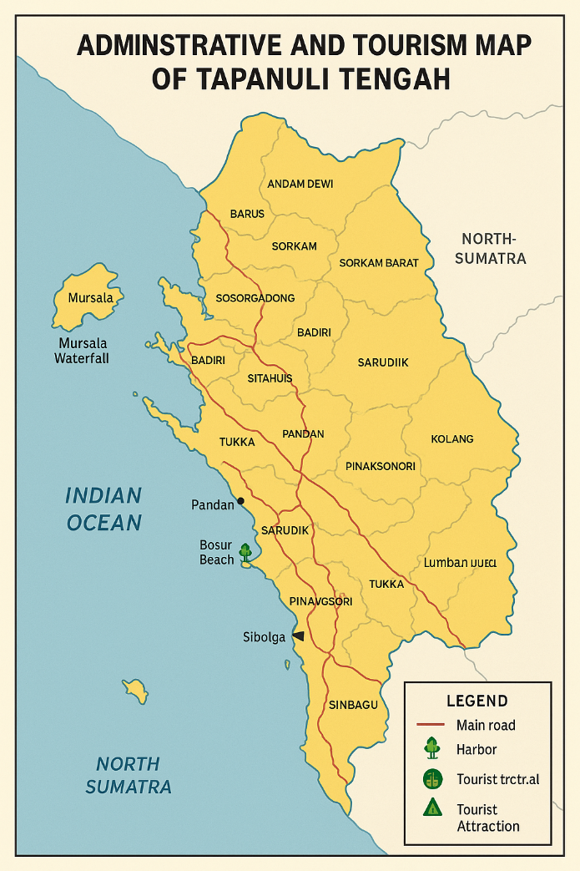

Figure 1: Administrative and Tourism Map of Tapanuli Tengah

**3.1.2 Tourist Site Assessment Using ODTWA**

The evaluation of the four primary tourist sites—Makam Papan Tinggi, Pulau Kalimantung, Air Terjun Sipitu-pitu, and Air Terjun Aek Bottar—was conducted using the ODTWA (Object and Attraction Evaluation) model. This model scores destinations on parameters such as attractiveness, accessibility, accommodation, safety, and supporting infrastructure.

Results indicate that Makam Papan Tinggi and Pulau Kalimantung scored above the 66.6% threshold, qualifying them as highly suitable for development. Pulau Kalimantung, often described as the “Maldives of Tapanuli Tengah,” offers clear waters and snorkelling experiences, while Makam Papan Tinggi appeals to cultural and religious tourists. In contrast, Air Terjun Sipitu-pitu and Aek Bottar, though visually stunning, fell short due to access limitations and a lack of visitor facilities, placing them in the “not yet feasible” category.

Table 1: ODTWA Evaluation Results for the Four Tourist Sites

|  |  |  |  |
| --- | --- | --- | --- |
| **No.** | **Name of Tourist Attraction** | **Index (%)** | **Feasibility Status** |
| 1 | Makam Papan Tinggi | 84.35 | Feasible |
| 2 | Pulau Kalimantung | 71.02 | Feasible |
| 3 | Aek Sipitu-pitu Waterfall | 65.40 | Not Yet Feasible |
| 4 | Aek Bottar Waterfall | 64.75 | Not Yet Feasible |

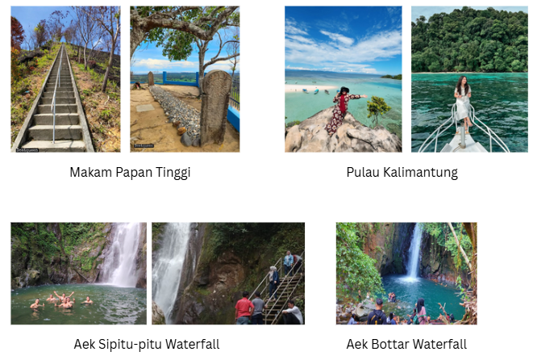

Figure 2: Photos of Sites with ODTWA Component Scores

This data highlights a developmental imbalance: while some sites are "ready to go," others require significant foundational investments—such as road upgrades, signage, rest areas, and sanitation facilities—to be viable within a regional tour package framework..

**3.1.3 Stakeholder Perceptions of Tour Packages**

Interview data from 31 informants representing four stakeholder categories confirmed strong interest and optimism regarding tourism packaging. Policymakers viewed packaged tours as a tool to organize and extend tourist flows beyond iconic coastal areas. Business actors saw potential in building supporting services such as homestays, boat rentals, and guided tours. Community members expressed hope that increased visits could translate into greater economic inclusion and job creation, especially for youth and women.

Thematic segmentation emerged as a key insight. Respondents suggested packaging tourism into categories—e.g., “Islamic Heritage Trails,” “Jungle and Waterfall Expeditions,” or “Marine Leisure Routes”—to meet diverse market interests. However, they also noted the need for institutional support in marketing and logistics to operationalise these ideas.

Table 2: Thematic Summary of Stakeholder Interviews by Group

|  |  |
| --- | --- |
| **Stakeholder Group** | **Common Themes Identified** |
| **Policymakers** | - Acknowledge the potential of tour packages to boost regional revenue.  - Emphasise the need for infrastructure support and regulatory coordination. |
| **Tourism Operators** | - View tour packages as a tool for business expansion and tourist retention.  - Request more government promotion and logistical support. |
| **Local Communities** | - Expect economic benefits from increased tourist visits.  - Show willingness to participate in package implementation with proper guidance. |
| **Influencers** | - Believe themed packages can attract targeted travel segments (youth, heritage, nature lovers).  - Advocate for digital marketing integration. |

This convergence of interest between stakeholders signals a fertile policy window. If properly guided, these groups could co-create tailored tourism experiences, reducing visitor leakage and increasing regional economic circulation..

**3.1.4 Classical Assumption Testing**

To translate site assessments into actionable strategies, a SWOT analysis was conducted. Internal strengths include high natural and cultural appeal, growing community awareness, and local storytelling traditions. External opportunities include increased domestic tourism, digital promotion platforms, and alignment with national tourism recovery programs. On the downside, internal weaknesses were mainly infrastructural—insufficient accommodations, low hygiene standards, and inadequate signage. External threats included environmental degradation due to unmanaged visitation and potential tourism saturation in fragile ecosystems.

**3.1.5 Internal Factor Analysis Summary (IFAS)**

To formulate an effective tourism-based regional development strategy in Tapanuli Tengah, an Internal Factor Analysis Summary (IFAS) was developed to identify the region's key strengths and weaknesses. This analysis was based on empirical field observations and stakeholder interviews, and scoring was conducted using weighted ratings for each factor.

**a. Identified Strengths**

The internal strengths highlight the strategic tourism assets found at the four primary destinations: Makam Papan Tinggi, Pulau Kalimantung, Aek Bottar Waterfall, and Sipitu-pitu Waterfall. The main strengths identified include:

1. High natural tourism potential and unique attractions at each site.
2. Local community hospitality, which fosters a welcoming environment for visitors.
3. Pristine natural landscapes that offer ecotourism appeal.
4. Strong cultural and religious values, particularly the Islamic heritage linked to Makam Papan Tinggi.

These factors were scored as follows:

**Table 3.** Scoring and Weighting of Internal Factors

|  |  |  |  |  |
| --- | --- | --- | --- | --- |
| **No.** | **Strengths** | **Weight** | **Rating** | **Score** |
| 1 | High potential of natural and cultural tourist attractions (Makam Papan Tinggi, Sipitu-pitu, Aek Bottar, Pulau Kalimantung) | 0.25 | 4 | 1.00 |
| 2 | Hospitality and openness of local communities | 0.25 | 4 | 1.00 |
| 3 | Authenticity and ecological integrity of natural sites | 0.25 | 4 | 1.00 |
| 4 | Historical and religious significance (Islamic heritage in Barus) | 0.25 | 3 | 0.75 |
| **Total** |  | **1.00** |  | **3.75** |

**b. Identified Weaknesses**

Despite these strengths, several internal weaknesses were identified that could inhibit tourism development:

1. Lack of comprehensive information and promotion of tourist sites.
2. Poor road access to key attractions, especially Sipitu-pitu and Aek Bottar.
3. Inadequate tourist facilities (e.g., signage, sanitation, accommodation).
4. Limited intergenerational transmission of site historical significance.

**Table 4.** Scoring and Weighting of Internal Weaknesses

|  |  |  |  |  |
| --- | --- | --- | --- | --- |
| **No.** | **Weaknesses** | **Weight** | **Rating** | **Score** |
| 1 | Lack of promotional strategies and site information | 0.26 | 4 | 1.04 |
| 2 | Poor accessibility, especially to waterfalls | 0.26 | 4 | 1.04 |
| 3 | Inadequate supporting facilities at remote sites | 0.26 | 4 | 1.04 |
| 4 | Weak transmission of cultural-historical knowledge | 0.22 | 2 | 0.44 |
| **Total** |  | **1.00** |  | **3.56** |

The final internal score difference is **+0.21** (3.75 – 3.56), indicating that strengths marginally outweigh weaknesses. This positive balance suggests that internal resources and tourism assets in Tapanuli Tengah can be leveraged effectively, though improvements in infrastructure and promotion remain urgent.

**3.1.6 External Factor Analysis Summary (EFAS)**

External factors were also evaluated to determine how environmental, economic, and policy conditions could affect tourism development. These include both emerging opportunities and potential threats.

**a. Identified Opportunities**

1. Supportive regional policies aimed at developing tourism-based economies.
2. Potential to increase local community welfare through tourism-driven livelihoods.
3. Rising interest in marine, eco, and heritage tourism experiences.

**Table 5.** Scoring and Weighting of External Opportunities

|  |  |  |  |  |
| --- | --- | --- | --- | --- |
| **No.** | **Opportunities** | **Weight** | **Rating** | **Score** |
| 1 | Regional government policies supporting tourism packaging | 0.37 | 4 | 1.48 |
| 2 | Opportunity to improve local livelihoods through tourism | 0.33 | 4 | 1.32 |
| 3 | Increasing tourist demand for eco-maritime and heritage tourism | 0.30 | 3 | 0.90 |
| **Total** |  | **1.00** |  | **3.70** |

**b. Identified Threats**

1. Rapid environmental degradation (e.g., illegal logging, fishing).
2. Growing competition from neighbouring regions with advanced destinations.
3. Weak marketing and branding at the regency level.

**Table 6.** Scoring and Weighting of External Threats

|  |  |  |  |  |
| --- | --- | --- | --- | --- |
| **No.** | **Threats** | **Weight** | **Rating** | **Score** |
| 1 | Rapid environmental degradation near tourism sites | 0.35 | 4 | 1.40 |
| 2 | Strong tourism competition from neighbouring regions | 0.30 | 3 | 0.90 |
| 3 | Weak destination branding and promotion | 0.35 | 2 | 0.70 |
| **Total** |  | **1.00** |  | **3.00** |

The net EFAS score is **+2.14** (3.70 – 1.56), suggesting that external opportunities significantly exceed threats, and conditions are favourable for tourism expansion.

**3.2 SWOT Strategy for Tourism-Based Regional Development**

Based on the outcomes of the IFAS and EFAS analyses, a comprehensive SWOT Matrix was constructed to identify actionable strategies that combine internal and external factors. The following table outlines the relationship between Strengths (S), Weaknesses (W), Opportunities (O), and Threats (T), along with tailored development strategies for each quadrant.

**Table 7.** SWOT Matrix for Tourism-Based Regional Development in Tapanuli Tengah

|  |  |  |  |
| --- | --- | --- | --- |
| **Strengths (S)** | | **Weaknesses (W)** | |
| S1. Strong natural tourism potential (islands, waterfalls, religious sites) | | W1. Lack of promotion and tourism information | |
| S2. Hospitable and culturally open local communities | | W2. Inadequate access roads, especially to Sipitu-pitu and Aek Bottar | |
| S3. Authentic and preserved natural ecosystems | | W3. Limited supporting facilities (e.g., sanitation, signage) | |
| S4. High cultural and religious value (e.g., Islamic heritage) | | W4. Weak generational transmission of site history | |
| **Opportunities (O)** | **SO Strategies** | | **WO Strategies** |
| O1. Local government policies supporting tour package development | SO1. Develop thematic tour packages integrating local attractions and community participation (S1–S4, O1–O3) | | WO1. Improve national and international promotion of tourism assets (W1, O1–O3) |
| O2. Potential to improve local livelihoods | SO2. Create employment opportunities, promote inclusive economic growth, and preserve nature (S1–S4, O2–O3) | | WO2. Invest in infrastructure upgrades, especially road access and basic amenities (W2–W3, O1–O3) |
| O3. Growing interest in eco-, religious-, and marine tourism |  | |  |

|  |  |  |
| --- | --- | --- |
| **Threats (T)** | **ST Strategies** | **WT Strategies** |
| T1. Environmental degradation (e.g., illegal logging, land conversion) | ST1. Involve local communities in monitoring and managing tourism sustainably (S1–S4, T1–T2) | WT1. Conduct awareness campaigns on tourism development and infrastructure needs (W2–W3, T3) |
| T2. Inter-regional competition for tourism | ST2. Promote tourism packages through community and influencer engagement (S1–S2, T2–T3) | WT2. Improve local human capital, infrastructure, and marketing to remain competitive (W1–W3, T1–T2) |
| T3. Weak promotion of Tapanuli Tengah as a tourism destination | ST3. Ensure sustainable use of natural resources within ecological carrying capacity (S1, S3–S4, T1) |  |

**3.3 Recommended SO Strategies for Implementation**

Based on the SWOT matrix, the **Strengths–Opportunities (SO)** strategy is the most appropriate and actionable pathway for developing tourism-based regional growth in Tapanuli Tengah. Two core initiatives are recommended for immediate implementation:

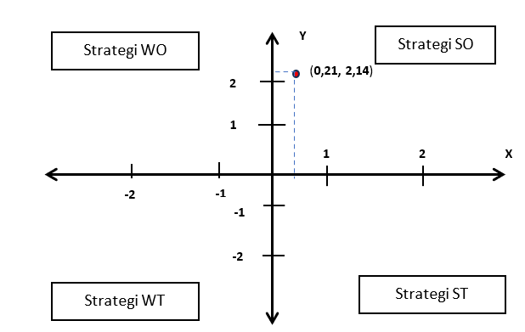

**1. Strengthening Destination Appeal and Local Participation, Supported by Policy**

The development of regional tourism through thematic tour packages must begin with enhancing the appeal of destinations. This includes:

* Improving cleanliness, safety, and environmental aesthetics.
* Increasing dissemination of tourism information via digital platforms.
* Expanding the range of activities at each destination (e.g., guided treks, cultural performances).
* Upgrading accessibility through road development and adding visitor accommodations.
* Establishing partnerships with travel agencies and tour operators.

Local community involvement is essential for success. Establishing tourism-awareness groups (e.g., *POKDARWIS*) or cooperatives under local government oversight can empower residents to actively manage tourism businesses. Training programs should be provided on hospitality, cooking, tour marketing, and digital promotion to ensure inclusiveness and professionalism.

This aligns with capacity-building for community-based tourism organisations (CBTOs) and MSMEs, enhances local empowerment and a sense of ownership.

In parallel, policy support from the local government is critical. This includes:

* Issuing licenses for tour package operators.
* Allocating budget for tourism infrastructure and promotional campaigns.
* Conducting regular mentoring and monitoring for tourism enterprises.  
  Such government-community collaboration will create a more enabling environment for tourism growth and attract more visitors.

**2. Local Economic Empowerment and Environmental Sustainability**

Tourism development must generate inclusive and sustainable benefits. This involves not only attracting tourists but also:

* Enhancing local income sources,
* Preserving environmental and cultural assets, and
* Preventing the overexploitation of natural resources.

Adopting a Community-Based Tourism (CBT) approach allows local communities to be both the designers and direct beneficiaries of tourism activities. CBT models lead to increased community welfare, biodiversity protection, and regional revenue growth.

Therefore, environmental and economic integration must be the foundation of tourism development. Initiatives such as eco-guided tours, community homestays, and handicraft cooperatives can link conservation with livelihood enhancement. Tourism thus becomes not only an economic engine but a transformative tool for regional resilience and ecological sustainability.

**3.4 Discussion: Integrating Tour Packages as a Regional Development Strategy**

The findings of this study support the premise that strategic packaging of tourism attractions offers a viable pathway for regional development in Tapanuli Tengah. Unlike isolated destination promotion, tour packages create synergistic value by connecting multiple sites, lengthening visitor stays, and increasing average tourist spending. This aligns with tourism economic models that emphasize itinerary-based travel behavior and spatial bundling.

Moreover, the SO strategic position revealed in the SWOT analysis highlights the regency’s readiness to move beyond passive tourism promotion toward an integrated, proactive development framework. The diversity of attractions—marine, cultural, religious, and adventure—offers ample opportunity for segmentation and thematic branding. However, gaps in physical infrastructure and digital promotion channels must be urgently addressed to capitalise on this potential.

Stakeholder interviews underscore that community readiness is not a limiting factor. Rather, the bottleneck lies in institutional coordination, policy implementation, and resource allocation. If these governance issues are addressed, the tour packaging model can evolve from a conceptual recommendation to a functional mechanism for equitable and sustainable regional tourism.

This study also indicates that economic spillovers from tourism are likely to benefit marginalized groups if inclusive practices are embedded early—e.g., training women in homestay hospitality or involving youth in digital content creation for promotion. Future tourism strategies in Tapanuli Tengah should thus be designed with a dual lens: economic efficiency and social equity.

Table 8: Summary of Policy Implications from the SWOT Strategy

|  |  |
| --- | --- |
| **SWOT Strategy** | **Policy Implication** |
| **SO Strategy** | Encourage investment in developing integrated tour packages leveraging local attractions and digital marketing. |
| **WO Strategy** | Allocate targeted funding for infrastructure improvement and establish local tourism promotion units. |
| **ST Strategy** | Develop eco-tourism regulations and implement heritage education programs for schools and communities. |
| **WT Strategy** | Strengthen institutional coordination and establish multi-stakeholder tourism development forums. |

1. **CONCLUSION AND RECOMMENDATIONS**

**4.1 CONCLUSION**

This study explored the feasibility and strategic implementation of tour package-based tourism development in Tapanuli Tengah Regency, a region rich in both natural and cultural assets. By employing the Object and Attraction Evaluation (ODTWA) and SWOT analysis frameworks, the research provided empirical evidence to assess the viability of four key tourism destinations and formulate actionable development strategies.

The findings revealed that Makam Papan Tinggi and Pulau Kalimantung are highly feasible for immediate tourism development, possessing strong attractiveness, accessibility, and cultural value. Meanwhile, Air Terjun Sipitu-pitu and Aek Bottar—despite their scenic potential—require significant improvements in infrastructure and visitor facilities to become competitive destinations. These disparities underscore the need for a spatially inclusive tourism strategy that balances resource investment across diverse site types.

Stakeholder perspectives across the public and private sectors, as well as local communities, indicated strong support for the development of thematic tour packages. Thematic bundling—such as religious heritage trails, coastal leisure circuits, or eco-adventure routes—not only offers operational coherence but also serves as a tool to extend visitor stays, improve satisfaction, and amplify economic benefits across the region.

The strategic positioning of Tapanuli Tengah within the SO (Strength–Opportunity) quadrant of the SWOT matrix reinforces the urgency and feasibility of adopting an aggressive, asset-based development strategy. Such a strategy can generate multiplier effects across local economies by stimulating ancillary sectors including accommodation, food services, transportation, and cultural industries.

In conclusion, tour package-based tourism offers Tapanuli Tengah a structured and scalable path toward regional development. With the right blend of policy support, stakeholder collaboration, infrastructure investment, and community involvement, this model can transform the regency into a competitive and inclusive tourism destination—both within Sumatra and on the national stage.

**4.2 RECOMMENDATIONS**

To support the strategic development of tourism in Tapanuli Tengah, this study recommends a multi-pronged, phased approach grounded in infrastructure enhancement, institutional collaboration, and community empowerment. Priority should be given to improving basic infrastructure, particularly in less-developed destinations such as Air Terjun Sipitu-pitu and Aek Bottar. Upgrading road access, visitor amenities, and signage will be critical to raising the feasibility of these sites for inclusion in integrated tour packages.

In parallel, the local government should initiate pilot tour packages centred around the most viable sites—Makam Papan Tinggi and Pulau Kalimantung. These pilots can serve as proof-of-concept models that demonstrate how bundled destinations can increase tourist engagement, extend length of stay, and elevate regional branding. Their success could provide leverage for scaling the approach to other sites in the regency.

Effective implementation will require strong collaboration between stakeholders. Establishing formal partnerships among local government, tourism operators, and community leaders can foster shared ownership of tourism outcomes and improve coordination. Additionally, digital marketing efforts—such as targeted social media campaigns and collaboration with tourism influencers—should be deployed to promote these tour packages, particularly to the growing segment of domestic travellers.

Equally important is the active involvement of local communities. Programs to train residents in tourism services—especially women and youth—can build local capacity and ensure that economic benefits are distributed equitably. Finally, these efforts must be backed by clear policy direction and dedicated budget allocations at the regional level, possibly supplemented by public-private partnerships and tourism-related grants....

Disclaimer (Artificial intelligence)

Option 1:

Author(s) hereby declare that NO generative AI technologies such as Large Language Models (ChatGPT, COPILOT, etc.) and text-to-image generators have been used during the writing or editing of this manuscript.

Option 2:

Author(s) hereby declare that generative AI technologies such as Large Language Models, etc. have been used during the writing or editing of manuscripts. This explanation will include the name, version, model, and source of the generative AI technology and as well as all input prompts provided to the generative AI technology

Details of the AI usage are given below:

1.

2.

3.

**References**

Chaisriya, K., Preeyawongsakul, P., Gilbert, L., Nualnoom, P., Rattanarungrot, S., Narongrach, R., & Silakun, N. (2024). Enhancing visitor experiences and economic outcomes through gamified AR: The impact of a location-based augmented reality game in agritourism. *Journal of Open Innovation: Technology, Market, and Complexity, 10*(4), 100415. <https://doi.org/10.1016/j.joitmc.2024.100415>

Efthimiou, S. (2024). The adaptation of tourism industry and COVID-19. *Theoretical Economics Letters, 14*(6), 2081–2094. <https://doi.org/10.4236/tel.2024.146103>

Ghanbari, H., Pour, M. A. A., & Barshod, A. (2012). Using SWOT analysis in tourism studies with system approach. *International Journal of Academic Research, 6*, 2953–2957.

Karunanithi, S. A., & Kemat, B. B. (2024). Exploring the interplay between perceived destination image, government tourism campaigns, and domestic hotel tourism growth: Insights from post-COVID-19 Malaysia. *Journal of Digitainability, Realism & Mastery (DREAM), 3*(12), 60–72. <https://doi.org/10.56982/dream.v3i12.289>

Kiper, T. (2013). Role of ecotourism in sustainable development. In O. E. Özdemir (Ed.), *Advances in landscape architecture* (pp. 773–802). InTech. <https://doi.org/10.5772/55749>

Li, K. X., Jin, M., & Shi, W. (2018). Tourism as an important impetus to promoting economic growth: A critical review. *Tourism Management Perspectives, 26*, 135–142. <https://doi.org/10.1016/j.tmp.2017.10.002>

Litvinova-Kulikova, L., Aliyeva, Z., & David, L. D. (2023). MICE tourism: How the pandemic has changed it. *Journal of Tourism and Services, 14*(26), 197–218. <https://doi.org/10.29036/jots.v14i26.496>

Obradović, S., & Tešin, A. (2023). Local communities’ perceptions of tourism planning in natural areas. *Tourism and Hospitality, 4*(2), 336–354. <https://doi.org/10.3390/tourhosp4020021>

Pan, Y., Zhang, S., & Zhang, M. (2024). The impact of entrepreneurship of farmers on agriculture and rural economic growth: Innovation-driven perspective. *Innovation and Green Development, 3*(1), 100093. <https://doi.org/10.1016/j.igd.2023.100093>

Rwigema, P. C. (2024). Domestic tourism in Rwanda: Untackled potential. *The Strategic Journal of Business & Change Management, 11*(1), 101–147. <http://dx.doi.org/10.61426/sjbcm.v11i1.2841>

Satrya, I. D. G., Kaihatu, T. S., Budidharmanto, L. P., Karya, D. F., & Rusadi, N. W. P. (2023). The role of ecotourism in preserving environmental awareness, cultural and natural attractiveness for promoting local communities in Bali, Indonesia. *Journal of Eastern European and Central Asian Research (JEECAR), 10*(7), 1063–1075. <https://doi.org/10.15549/jeecar.v10i7.1386>

Usmaedi, Lansiwi, M., Studyanto, A., Gymnastiar, I., & Amin, F. (2024). Cultural heritage preservation through community engagement: A new paradigm for social sustainability. *Indonesian Journal of Studies on Humanities, Social Sciences and Education, 1*, 50–59. <https://doi.org/10.54783/cv5q0011>

Wang, D., Richards, D., Bilgin, A., & Chen, C. (2020). A predictive model for citizens’ utilization of open government data portals. In M. Janssen, Y. Charalabidis, & A. Zuiderwijk (Eds.), *Electronic Government: 19th IFIP WG 8.5 International Conference, EGOV 2020, Linköping, Sweden, August 31–September 2, 2020, Proceedings* (pp. 192–204). Springer. <https://doi.org/10.1007/978-3-030-64452-9_14>

Dema, Tashi, & Gyeltshen , K. (2023). Community Based Sustainable Tourism and Its Impact on Socio-Economic Development of Phobjikha Valley. Asian Journal of Education and Social Studies, 46(4), 12–44.

Bayih, B. E., & Singh, A. (2020). Modeling domestic tourism: motivations, satisfaction and tourist behavioral intentions. Heliyon, 6(9).

Moya Calderón, M., Chavarría Esquivel, K., Arrieta García, M. M., & Lozano, C. B. (2022). Tourist behaviour and dynamics of domestic tourism in times of COVID-19. Current Issues in Tourism, 25(14), 2207-2211.