**Evaluating Faith in Science and Distrust in Scientists in Rural Azamgarh, Uttar Pradesh, India: A Quantitative Case Study**

**ABSTRACT**

This study explores the scientific mindset of people living in Anjaan Shaheed village of Azamgarh, Uttar Pradesh, India. It aims to evaluate how participants perceive the effect of science and technology on society. An offline survey was undertaken with 246 participants using a paper questionnaire to assess the views of participants on the role of science in society and their trust or lack of trust in science. Surprisingly, the findings indicated in no uncertain terms that while nearly 80 percent of the respondents believed that scientists apply scientific method correctly and accurately, only a little over 45 percent reposed their faith in scientists. The findings highlighted an interesting trend: although most people trust scientific progress, they don't have much trust in scientists. This disagreement shows how scientific know-how and public confidence are linked. It highlights the need to devise location specific strategies based on a fuller appreciation of the socio-economic as well as cultural background of the target community to better connect the public with scientists. The study suggests the urgent need for community-driven science communication to bridge the gap between scientific knowledge and public trust.

*Keywords: Scientific Temper, Science and Society, Science Communication, Science Outreach*

**1. INTRODUCTION**

Azamgarh district, located in the eastern region of Uttar Pradesh, India covers an area of 4,234 square kilometres. Geographically, it is situated between 25°38' and 26°27' North latitude and 82°40' to 83°52' East longitude (mapsofindia, 2024). The Hindi speaking district is administratively subdivided into eight tehsils (local administrative division in India) and 22 development blocks, covering a total of 4,101 villages. According to the 2011 Indian Census, Azamgarh was populated by 4,613,913 people, with a density of 1,138 people per square kilometre. The district had a sex ratio of 1,019 women for every 1,000 men, indicating a marginally more significant female population (Government of Uttar Pradesh, 2025). Azamgarh was ranked 26th in terms of literacy among the state's districts, with a literacy rate of 70.9%, which exceeded the state average of 67.7%. The district had a population growth rate of 17.11% from 2001 to 2011 (Directorate of Census Operations, Uttar Pradesh, 2011).

Despite its comparatively high literacy level, Azamgarh has serious developmental problems. It was recognised by the Ministry of Panchayati Raj in 2006 as being among the 250 most backward districts of India out of 640. It is, therefore, still one of the 34 districts of Uttar Pradesh that are given financial aid under the Backward Regions Grant Fund Programme (BRGF) to boost infrastructure and socio-economic development (Ministry of Panchayati Raj, 2009). This demographic and economic profile calls for sustained policy interventions to support improved educational opportunities, economic development, and overall living standards in the district.

Our study was carried out in Anjaan Shaheed, which is a village in the Azamgarh district of Uttar Pradesh, with PIN code 276125. The village covers an area of about 209.8 hectares (2.098 square kilometres) and is inhabited by a population of 4,182. Based on the 2011 Census, there are 528 households in Anjaan Shaheed (Directorate of Census Operations, Uttar Pradesh, 2011).

The village is dominated by a well-established educational system, which includes two pre-primary schools, three primary schools, two secondary schools, and one senior secondary school. Apart from that, the inhabitants enjoy basic communication facilities, such as mobile phone signal and newspaper delivery. Health assistance is also provided by Accredited Social Health Activists (ASHA) workers, who help with numerous medical and healthcare requirements (Directorate of Census Operations, Uttar Pradesh, 2011). This demographic and infrastructural profile captures the village's proximity to essential amenities as well as pointing towards areas of additional development.

The infrastructural and demographic profile of Anjaan Shaheed village indicates a population with access to necessary amenities but a demand for further development. Fostering scientific temper in such rural communities is the key to societal progress. Scientific temper, being rational and evidential in essence, can enable people to think critically about information, make informed decisions, and look for innovative practices. Rationality is used to solve local problems, increase education levels, and promote economic development. For example, small cotton producers in Madhya Pradesh's Chhindwara district switched to organic farming by adopting scientific techniques, which improved the fertility of soil and income levels (Landrin, 2024). Such instances demonstrate that the inclusion of scientific temper in everyday life can spur sustainable growth and raise the standard of living among rural communities.

**1.1 Scientific Temper and Its Contribution to Societal Progress, Education and Economic Development**

Scientific temper, or a rational and evidence-based approach to the world, is the foundation to promoting social development and progress, particularly in a multicultural and fast-changing country like India**.** The National Curriculum Framework (NCF) underscored the significance of scientific temper in education, public policy, and overall societal well-being. It also advocated its integration into the learning process to nurture critical thinking and inquiry-based learning (National Council of Educational Research and Training [NCERT], 2005).

The term "scientific temper" was popularised in India by Jawaharlal Nehru, emphasising the necessity of inculcating rational thinking among citizens (Mahanti, 2013). According to (Saxena, 2014), scientific temper is not just limited to an understanding of science but extends to its application in daily life and decision-making processes. The debate surrounding public trust in scientists has gained traction in recent years, particularly in light of misinformation and media narratives (Thomas, 2025). The historical roots of scientific temper in India can be traced back to early scientific advancements documented in ancient texts such as the Rigveda. However, recent issues, including the spread of pseudoscience and misinformation, call for the urgent need to advance scientific literacy and rationality aggressively (Bhargava & Chakrabarti, 2010).

The concept of scientific temper is in line with the vision of Nehru, which he had visualised as a mode of living rather than a scientific approach (Mahanti, 2016). Additionally, Mahanti (2016) pointed out that the growth of scientific temper is discouraged by pseudoscience, religious intolerance, and dogmatic philosophies and hence emphasises the eradication of superstitions through education. Pandey (2022) contended that scientific temper is basically a required aspect in contemporary times with problems like climate change, disinformation, and superstitious beliefs. Without a scientifically literate population, societies may struggle to make informed decisions on global challenges. And further reveals that the development of scientific temper should not be restricted to classroom instruction alone. Instead, it should extend into media, policy, and public discourse. Bhargava and Chakrabarti (2010) stated, “If one were to pick out three or four most important reasons for the country's backwardness or failure in many areas, the lack of scientific temper would be one of them." (Singh et al., 2016). Strengthening scientific inquiry and rationality in education, media, and community interactions can pave the way for a progressive and scientifically literate society.

Education plays an important part in creating a scientific mindset. Researchers argue that an experiential learning, inquiry approach—marked by student participation in experiments, problem-solving exercises, and analytical discussion—allows the creation of a scientific disposition (Jahanger & Dar, 2019). While initiatives such as citizen science projects are identified as effective tools in nurturing curiosity and critical thinking among students (Jenkins, 2011), media plays a prominent role in shaping public perception of science. Although countering misinformation and fostering a well-informed public, reliable and accurate science journalism and science communication are crucial (Tsegyu et al., 2023), research suggests that when science is communicated effectively, it strengthens trust in the scientific community and promotes a more engaged and critically thinking society (Rautela, 2024).

Even with great progress in science and technology, scientific temper is still elusive at a wider social level (Kumar, 2023). Thus, fostering a culture of scientific thinking is not just an academic goal but a necessity for sustainable national development. Jahanger and Dar (2019) conducted a study on scientific temper among rural and urban senior secondary school students in Baramulla, in the Indian state of Jammu and Kashmir, and found significant differences in scientific awareness. In the study of a sample of 300 students, Jahangir and Dar (2019) found that urban students were far more objective, logical, and inquisitive compared to rural students. Both groups were, however, equally open-minded in the sense that they were equally likely to follow up on new ideas when the opportunity presented itself. The findings serve to underscore the necessity of increasing access to scientific education and scientific equipment in rural areas to create a culture of inquiry and rationality.

For the solution of the lack of scientific thinking among rural and urban students, special education programs are needed. Jahanger and Dar (2019) emphasised the need to enhance access to quality science education in rural schools as a way to increase scientific awareness. Yet, promoting scientific awareness is not entirely reliant on education but also on good public outreach with science. One of the major challenges facing India is a lack of institutional support and endorsement for scientists undertaking science communication. According to Iqbal and Kar (2021), many researchers struggle to balance public engagement with their academic and professional commitments due to competing demands on their time and the absence of formal incentives. Additionally, most public engagement initiatives tend to be one-directional—such as lectures and media publications—rather than interactive efforts that encourage dialogue and collaboration with communities. Systematic interventions, including formal training programs, institutional mechanisms, and increased funding for public outreach programs could be an alternate manner in which to engage with science communication as a key academic responsibility.

**1.2 Science and Trust**

Oreskes (2019) examined the basis of public trust in science, tracing historical justifications from reliance on scientists' credibility in the 18th century to faith in the scientific method in the 19th century (Gadagkar, 2020). However, 20th-century thinkers such as Karl Popper, Ludwik Fleck, and Thomas Kuhn challenged the singular reliance on method, emphasising the social nature of scientific progress. Yet another argument is based on the fact that science’s reliability stems from expert consensus and its self-correcting nature through peer review. This point of view rejects both authority and method as sole justifications. Oreskes (2019) advocated a socially inclusive approach to enhance scientific credibility. Gadagkar (2020), however, recommended further research on scientists' trust in science, within and across disciplines.

Trust among scientists is built upon empirical validation, peer review, and transparency. Coll and Taylor (2004) experimented with scientists' willingness to adopt different beliefs and found that although they reject traditional superstitions, their decisions are still prone to personal and social experience. Since the complexity of scientific trust usually emanates from the interaction of scepticism and belief, Manahti (2013) looked at the role of trust in science as a foundation for national development, upholding the view that the progress of science relies on the shared commitment to rationality and evidence-based investigation.

With the findings of such studies converging, it would seem self-evident that the cultivation of scientific temper is a social necessity and not an intellectual or academic pursuit. This initial conjecture is employed to frame the foundation for investigating a research study conducted in the Azamgarh district with a specific aim of understanding and cultivating a scientific attitude in India's cultural context. The study sought to investigate the complexity of scientific temper at the grassroots level, more precisely in Anjaan Shaheed village, where our research evaluates the popular attitude towards science and its applications in society. The results and discussion sections shed light on the attitudes and implications for the advancement of scientific involvement.

**2. METHODOLOGY**

**2.1 Sample Design**

The research employed an offline survey technique to gather a representative and comprehensive collection of opinions. The participants were chosen using a combination of random and purposive sampling techniques, which made for a diverse collection of participants with a range of demographic and socio-economic backgrounds. This gave a wide range of public opinions towards science in the survey.

**2.2 Sample Size**

246 people took part in the survey. The sample was structured to represent a broad range of participants with attention to demographic diversity in terms of age, gender, educational level, and socio-economic status to maximise the generalisability of the results.

**2.3 Data Collection and Analysis**

The survey used standardised scales to gauge participants' faith in scientific pursuits, the extent to which scientific principles affect social dynamics, and how much trust the general public has in scientists. All data gathered from the survey were processed using Microsoft Excel with the use of descriptive statistical methods to determine trends and patterns in public views on science.

**2.4 Survey Questionnaire**

The survey questionnaire was divided into two sections. The first section had seven questions that referred to the demographic profile of participants, and the second had eleven questions that referred to participants’ opinions and perceptions about science and technology. For the purpose of diversity and inclusion, questions present in the survey were provided both in English and the local language, Hindi. Participants were informed that the activity was voluntary and that responses would not be judged. Participants were asked to provide answers in honest terms to ensure data collected remains valid. Additionally, a description of data protection rules was shared to ensure the anonymity and confidentiality of personal details.

**3. RESULTS AND DISCUSSION**

**3.1 Profile of Respondents**

To shed light on the social and educational backgrounds, participants were asked specific questions on their gender, age, educational qualification, and profession.

**3.1.1 Demography**

All 246 participants originated from the Anjaan Shaheed village of Azamgarh district, Uttar Pradesh.

**3.1.2 Age & Gender**

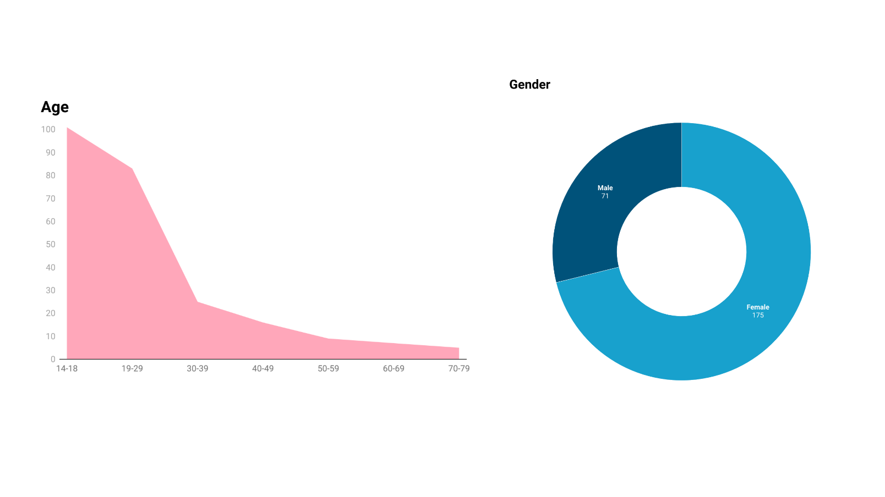

**Fig. 1. Graph showing the age and gender of the participants**

Out of the respondents, 71.4% were female, and 28.6% were male, with no participants identifying with other gender categories. The majority fell into the categories of teenagers (14-18 years) at 41.2% and young adults (19-29 years) at 33.9%. A smaller percentage included adults aged 30-49 years (9.8%), followed by 40-49 (6.5%), 50-59 (3.7%), 60-69 (2.9%), and 70-79 years (2%), as shown in Figure 1.

**3.1.2 Educational Qualification**

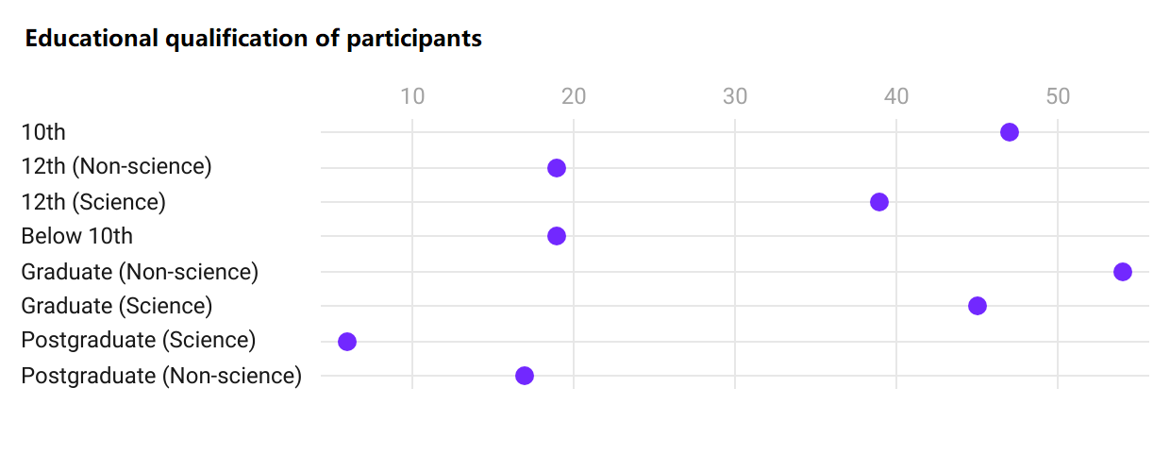

**Fig. 2. Graph showing the educational qualification of the participants**

Figure 2 shows participants exhibited diverse educational backgrounds, with the majority being non-science graduates (22%), followed by 10th graders (19.2%), science graduates (18.4%), 12th grade science students (15.9%), 12th grade non-science students (7.8%), individuals below the 10th grade (7.8%), non-science postgraduates (6.5%), and science postgraduates (2.4%).

**3.1.3 Profession of Participants**

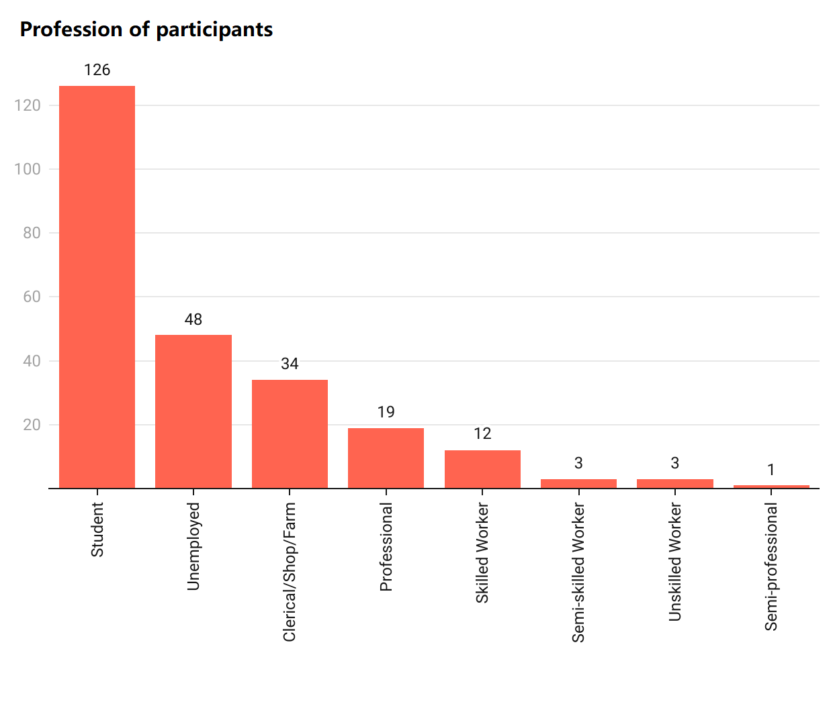

**Fig. 3. Graph showing the occupation of the participants**

Figure 3 shows the participant pool comprised primarily of students (51.4%) and professionals, including doctors, engineers, and industry professionals (7.3%). Unemployed individuals constituted 19.6%, followed by clerical/shop owners/farmers (13.9%). The rest of the group included different types of workers. About 4.9% were skilled workers, 1.2% were semi-skilled, and 1.2% were unskilled workers. This mix gives a good look at a comprehensive demographic overview, enriching a clearer view of their thoughts on science and technology.

**3.2 Public Perceptions of Science and Technology: Importance, Trust, and Societal Impact**

**3.2.1 Public Perception of the Importance of Science and Technology**

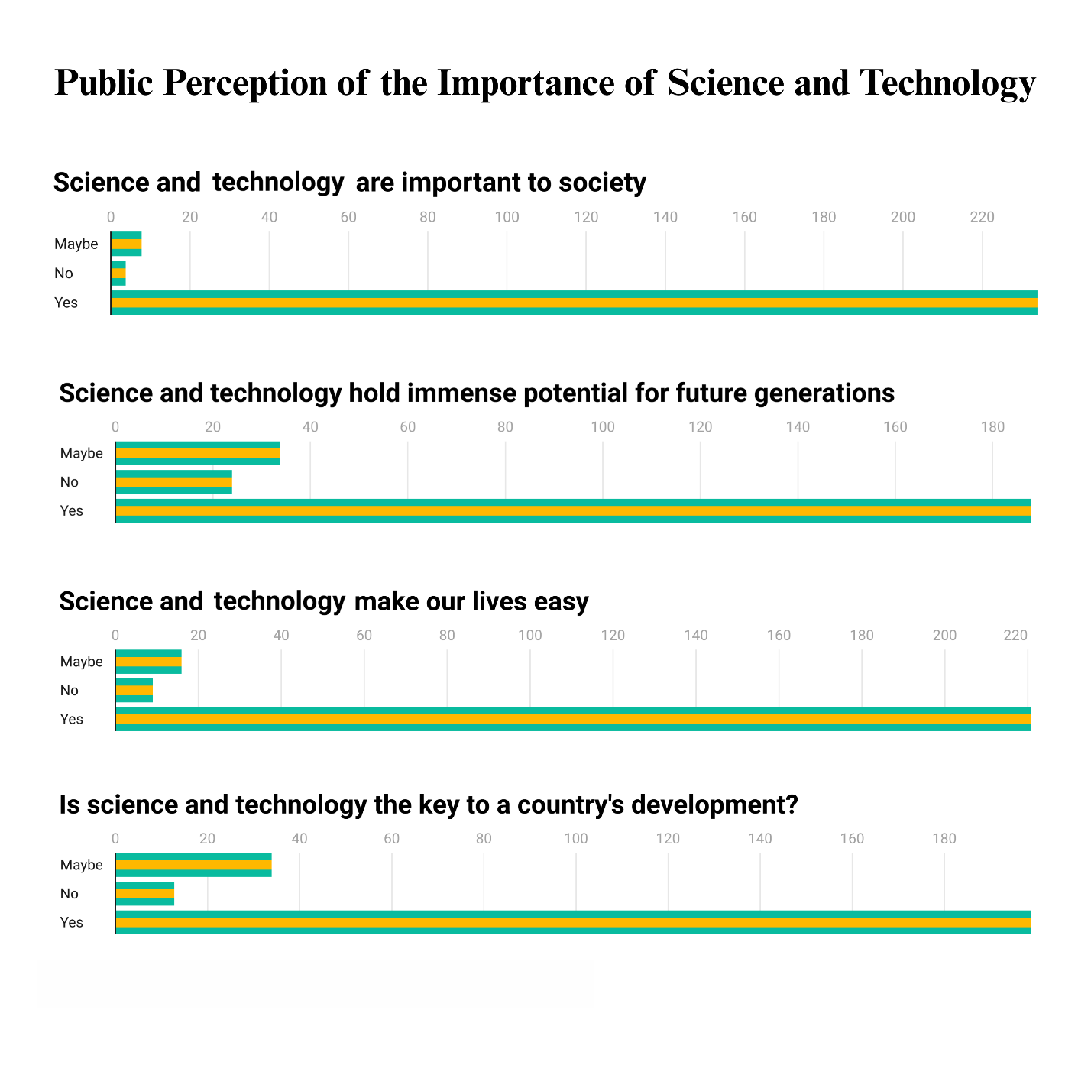

**Fig. 4. Public perception of the importance of science and technology**

The findings of the survey, as shown in Figure 4, reinforce a positive attitude towards science and technology's contribution to society. A staggering 94.3% of the respondents are aware of the significance of science and technology, with a tiny percentage disagreeing. Likewise, 79.7% consider scientific progress as having immense scope for future generations, while 88.9% feel that science and technology simplify life. Also, 85.2% validate that a nation needs science and technology for development, supporting that scientific development forms an integral component of national growth. Overall, the trend suggests the public perception of science and technology is positively looked at not just in perception but in development as well as the potential it holds for future generations.

**3.2.2 Science and Technology as a Solution to Global Challenges**

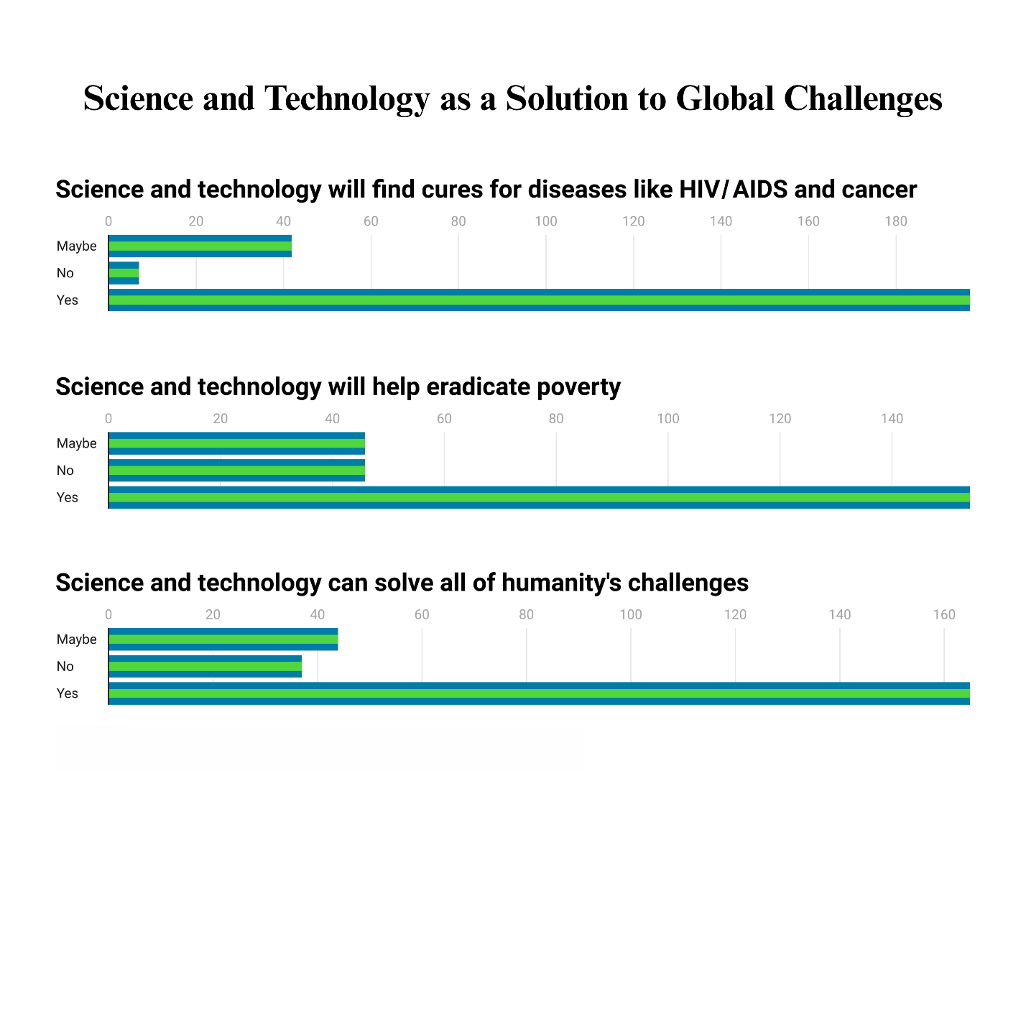

**Fig. 5. Science and technology as a solution to global challenges**

There is strong faith among participants in the power of science and technology to solve problems. As shown in Figure 5, an overwhelming 79.5% are hopeful that science and technology can find cures for diseases such as HIV/AIDS and cancer. Yet, there is a slightly declining optimism regarding comprehensive socio-economic challenges—62.3% say scientific developments would be able to eliminate poverty, while 68.3% are optimistic that science and technology can find a solution for all the major challenges humanity faces. These findings indicate that although there is faith in scientific advancement, there is still lingering doubt regarding its capacity to solve intricate societal problems.

**3.2.3 Perceived Risks and Ethical Considerations of Science and Technology**

In weighing the greater benefits of science and technology against the risks, while 70.6% of the participants feel that the benefits of science and technology outweigh the potential adverse effects, 18.9% are neutral. Perceptions of consequences for the environment are more polarised—50.2% hold science and technology responsible for harming the environment, while 28.3% disagree, and 21.5% are neutral, as shown in Figure 6. These polarised stances indicate that even though scientific advances are generally positive, concerns regarding unintended consequences remain.

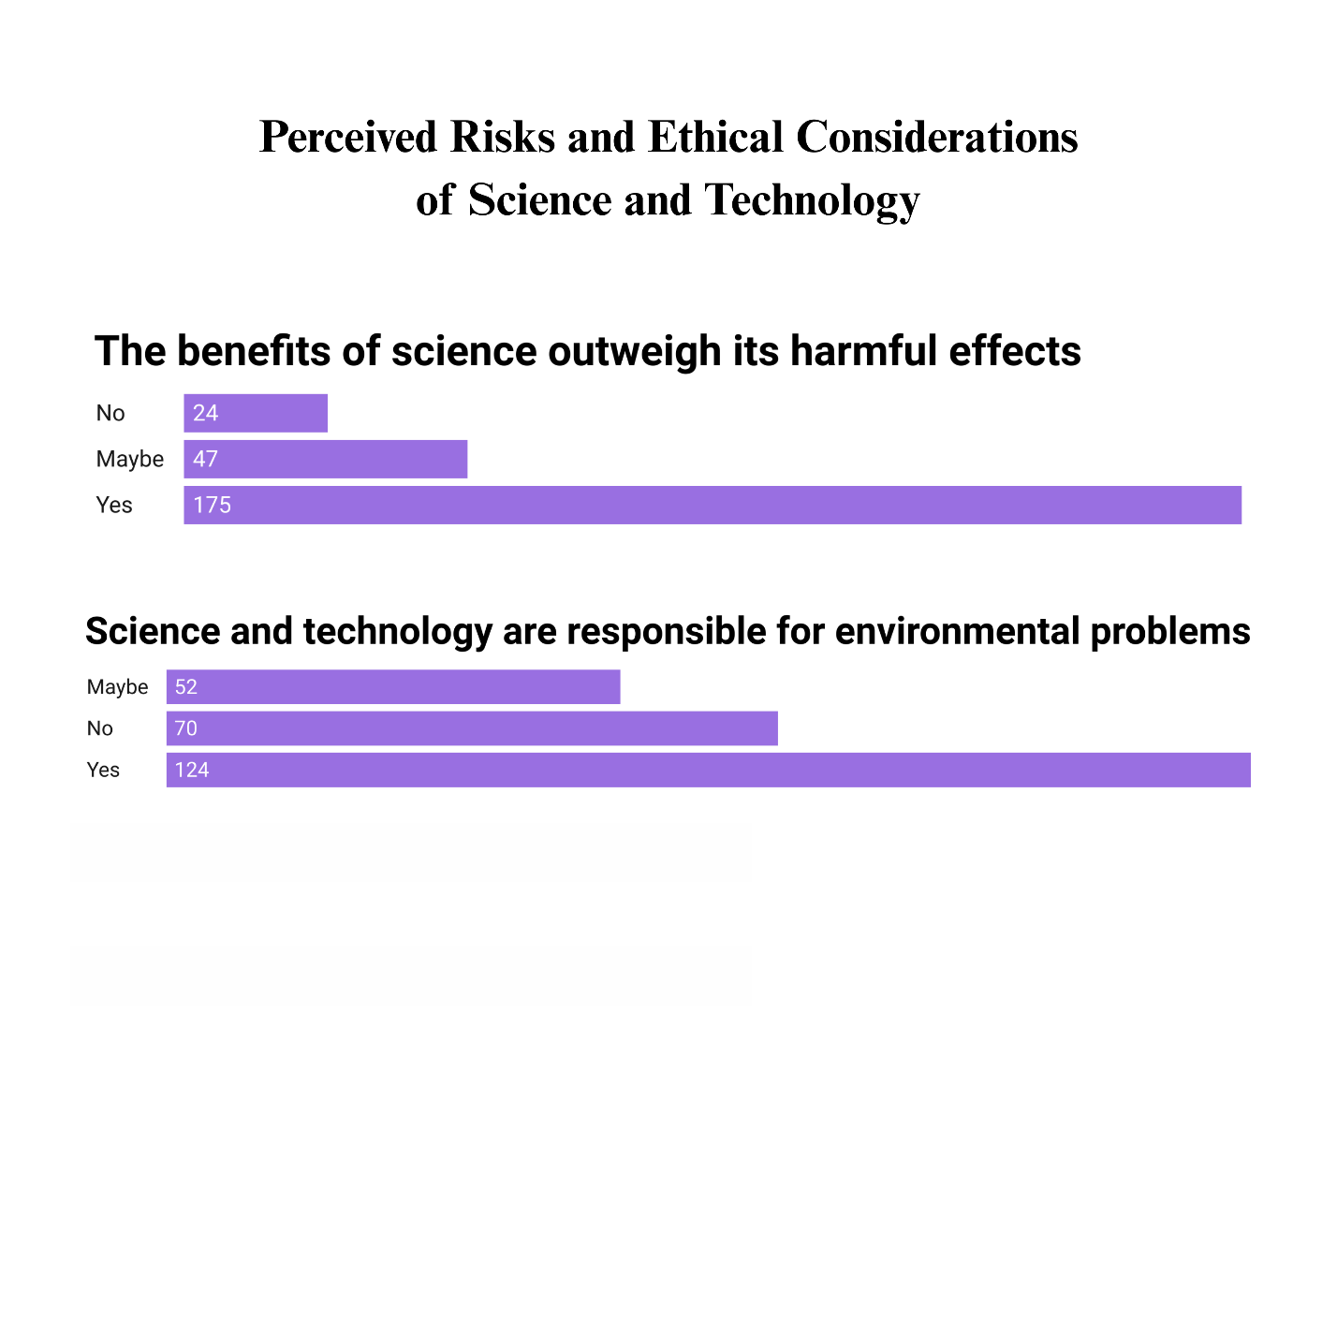

**Fig. 6. Perceived risks and ethical considerations of science and technology**

**3.2.4 Trust in Scientific Methods and Scientists**

As shown in Figure 7, trust in the scientific process is relatively high, with 79.7% of the respondents indicating the belief that scientists apply the agreed scientific method correctly and accurately. When, however, respondents were questioned as to whether scientists should always be trusted in all things, findings indicated a more cautious approach—only 45.5% agreed, with a substantial 37.4% unsure of their position and 17.1% having outright scepticism regarding the trustworthiness of scientists. This context indicates a more complex attitude: while a significant portion of the participants trust the general methods employed in science, they may show more reluctance to place their trust entirely in scientists.

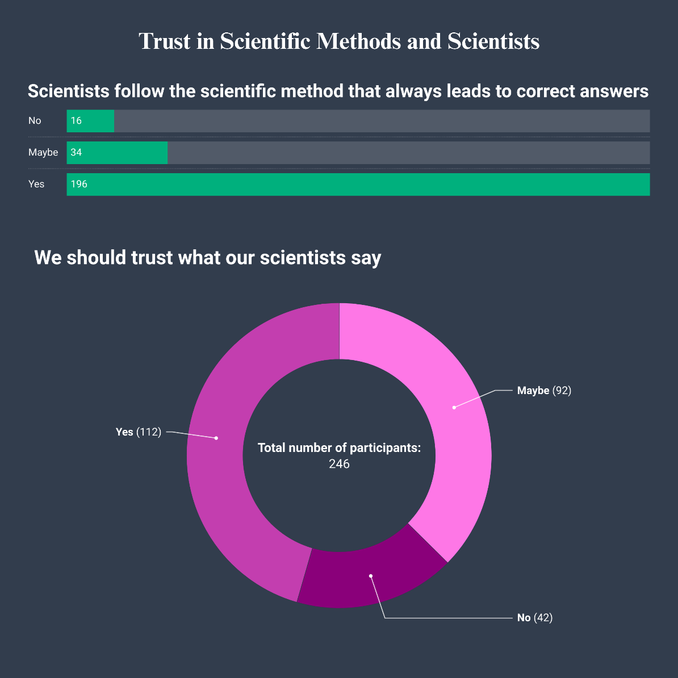

**Fig. 7. Trust in scientific methods and scientists**

Oreskes (2019) contended that science should be trusted on the basis of its ongoing confrontation with reality and its self-correction through expert consensus and peer review. It further pointed out how, even with personal biases, the scientific community as a whole cancels out outliers, making knowledge production credible. This is consistent with our research in Anjaan Shaheed, Azamgarh, where the respondents acknowledged the utility of science on a large scale but were reluctant to trust scientists completely. The mistrust witnessed in our research is consistent with international tendencies, where fears about fraud, irreproducibility, and political or ideological bias in research lead to public mistrust. To address this gap in trust, fostering a scientific mindset is essential. Oreskes (2019) argued that science must be inclusive to establish its epistemological base. This aligns with the necessity for inclusive community-based science communication practices.

Researchers have noted that greater public involvement through participatory research, active science teaching, and transparent communication can develop greater trust in scientific processes (Jahanger & Dar, 2019; Rautela, 2024). Gadagkar (2020) raised two important questions: (1) Why do scientists turn to scientific fields outside their own expertise? (2) Why do they sometimes have doubts about the science within their own area? Investigating these questions through empirical studies can yield valuable insights into the nature of scientific trust and enhance the way scientific information is communicated. This research adds to the conversation by emphasising that public perception in rural areas, such as Anjaan Shaheed, Azamgarh, is influenced not only by the availability of scientific information but also by wider social and cultural factors. Addressing these challenges requires concerted interventions, varying from science education to facilitating direct interactions between scientists and society.

The findings point to a high level of public trust in science and technology as major drivers of development, problem solvers, and benefits to society as a whole. There is, however, some level of scepticism towards the ability of science and technology to solve all problems, the risks of scientific innovation, and the absolute dependability of scientists. Developing a scientific mindset in rural areas requires specific educational strategies. Jahanger and Dar (2019) proposed that the use of inquiry-based learning techniques and critical thinking exercises could enhance science education in rural schools. Outreach programs that engage rural students with scientists provide important avenues for direct experimentation and reasoning. Furthermore, students from rural and urban schools can participate in programs, including student exchanges or joint science activities, and this could help remedy the deficiency of knowledge opportunities for rural students. There is an urgent need for a strategy to strengthen the culture of science in rural India.

Key elements such as institutional incentives, modifications to the curriculum, and community outreach initiatives play a crucial role in enhancing access to scientific literacy. Policymakers and educators would be able to create an understanding and appreciation of the science while making it applicable for social development by dealing with the hindrances that restrict public participation in science. This enables society to be more informed and engaged by integrating science into day-to-day activities.

Varying approaches need to be utilised to nurture scientific temper in urban and rural India. Technological platforms, science museums, and popular science magazines are the primary forces behind the encouragement of rational thinking in cities. In contrast, rural regions benefit more from hands-on demonstrations, community-based scientific projects, and localised learning. Research by Basu and Aslam (2015) indicated that rural students tend to be less influenced by superstitions compared to their urban counterparts, which challenges common assumptions. This suggests that with the right support, a strong scientific mindset can be cultivated.

Our study takes a holistic approach to studying such attitudes, and it finds a complex situation—while there is trust in the benefits of scientific progress, there simultaneously exists a contradictory lack of trust in the scientists themselves. These findings highlight the need for public participation in science. It is essential to communicate scientific information responsibly and formulate policies that encourage advancements in an ethical manner. What could also go a long way is understanding why some people are sceptical about science and how the contemporary manner of approaching the situation could be tweaked for conceptualising and executing strategies that promote a more positive perception of science among the local target community.

**4. CONCLUSION**

The study carried out in Anjaan Shaheed, Azamgarh, provides an evaluation of people’s understanding of science and their faith in scientists. Some participants were willing to accept the progress of science, but when it came to trust, the scientists seemed to lose out. This reflects the inadequate public understanding of scientific contributions and developments. Challenges, such as less engagement, ambiguous scientific terminologies, and language barriers, are some of the reasons for this scepticism, which shows that there is a need for engaging in a more concerted effort in designing communication strategies that are focused on the beneficiaries who are supposed to partake of the science messages targeted at them. A scientific approach is important for the development of any society, especially in underdeveloped regions where faith in science and scientists is often uneven. The gap can be appropriately filled by improving scrutiny, encouraging public participation, and greater interaction between scientists, communities, and scientists. Scientific education is crucial for the public’s attitude to science, the public understanding of science and technology, and science and technology’s critical benefits for society. Moreover, as social and ethical constructs determine the perception of science, there is also a need to publicise locally appropriate strategies that enhance service uptake. Contextualising the findings of the study, it is not hard to see the veracity of responses received being reflective of Azamgarh district declared as backward over two decades back by the Ministry of Panchayati Raj. These findings show that the relationship between science and society is complicated, and it involves many people from different disciplines, such as politicians, teachers, or scientists, who all contribute to the level of trust attained in practitioners and highlight the need to devise location specific strategies based on a fuller appreciation of the socio-economic as well as cultural background of the target community to better connect the public with scientists.

**FUNDING**

This research received funding from START (Search for Truth and Return to Science), a non-profit outreach operation based in New Delhi and registered within India under the Societies Registration Act XXI of 1860 with Registrar of Societies(SE/151/Dist. South East/2013).

**ACKNOWLEDGEMENTS**

The authors would like to express their appreciation to Subhi Srivastava of Radio Azamgarh for her support and cooperation in the data collection process, and to Anu for providing valuable feedback. The authors are also deeply grateful to Mirza Qamarul Hasan Beg and Mirza Shamsul Hasan Beg for their continued support throughout the study.

**CONFLICTS OF INTEREST**

The authors declare that the research was conducted with the absence of any financial and commercial intent that could be construed as a potential conflict of interest.

**Disclaimer (Artificial intelligence)**

**Option 1:**

**Author(s) hereby declare that NO generative AI technologies such as Large Language Models (ChatGPT, COPILOT, etc.) and text-to-image generators have been used during the writing or editing of this manuscript.**

**Option 2:**

**Author(s) hereby declare that generative AI technologies such as Large Language Models, etc. have been used during the writing or editing of manuscripts. This explanation will include the name, version, model, and source of the generative AI technology and as well as all input prompts provided to the generative AI technology**

**Details of the AI usage are given below:**

**1.**

**2.**

**3.**

**Consent**

**As per international standards or university standards, Participants’ written consent has been collected and preserved by the author(s).**

**REFERENCES**

Basu N. and Aslam S. (2015). Scientific temper and academic achievement of rural and urban secondary school students. Scholarly Research Journal, 2(12), 3193- 3204. <https://www.srjis.com/downloadPdf/146857284627.%20Basu.pdf/1425/34>

Bhargava, P. M., & Chakrabarti, C. (2010). Angels, devil, and science: A collection of articles on scientific temper. National Book Trust. <https://dn790005.ca.archive.org/0/items/AngelsDevilsAndScience/angels-devils.pdf>

Coll, R. K., & Taylor, N. (2004). Probing scientists’ beliefs: how open‐minded are modern scientists? International Journal of Science Education, 26(6), 757–778. <https://doi.org/10.1080/0950069032000138860>

Directorate of Census Operations, Uttar Pradesh. (2011). District census handbook, Azamgargh. Location: Directorate of Census Operations, Uttar Pradesh. <https://censusindia.gov.in/nada/index.php/catalog/1170/download/3694/DH_2011_0960_PART_A_DCHB_AZAMGARH.pdf>

Gadagkar, R. (2020). Book review: why trust science? Current Science, 118(9). <https://www.i-scholar.in/index.php/CURS/article/view/196517/183023#tp1>

Government of Uttar Pradesh. (2025). Demography. https://azamgarh.nic.in. Retrieved from <https://azamgarh.nic.in/demography/>

Iqbal, S., & Kar, B. (2021). A survey to gather perspectives of DBT/Wellcome Trust India Alliance-funded researchers on public engagement with science. Wellcome Open Res. 6(269). <https://doi.org/10.12688/wellcomeopenres.17120.2>. PMID: 35509370; PMCID: PMC9021671.

Jahanger, J., & Dar, G. N. (2019). Scientific temper of rural and urban senior secondary school students. International Journal of Advanced Multidisciplinary Scientific Research, 2(1), 15-20. <https://doi.org/10.31426/ijamsr.2019.2.1.1113>

Jenkins, L. L. (2011). Using citizen science beyond teaching science content: a strategy for making science relevant to students’ lives. Cultural Studies of Science Education, 6(2), 501–508. <https://doi.org/10.1007/s11422-010-9304-4>

Kumar D. (2023). Science for development. In Science and society in modern India (pp. 117-145). Location: Cambridge University Press. <https://assets.cambridge.org/97810093/50655/frontmatter/9781009350655_frontmatter.pdf>

Landrin, Sophie. (2024, September 5). Central India's green cotton gently weaves its web. Le Monde. Retrieved from <https://www.lemonde.fr/en/environment/article/2024/09/05/central-india-s-green-cotton-gently-weaves-its-web_6724956_114.html>

Mahanti, Subodh. (2013). A perspective on scientific temper in India. Journal of Scientific Temper, 1(1), 46-62. <http://op.niscpr.res.in/index.php/JST/article/view/1099/0>

Mahanti, Subodh. (2016). Nehru’s vision of scientific temper. Journal of Scientific Temper, 4(3&4), 154-166. <http://op.niscpr.res.in/index.php/JST/article/view/20886>

MapsofIndia. (2024). Mapsofindia.com. Retrieved on February 18, 2025. <https://www.mapsofindia.com/maps/uttarpradesh/districts/azamgarh.htm>

Ministry of Panchayati Raj. (2009). A note on the backward regions grant fund programme. Retrieved from <https://web.archive.org/web/20120405033402/http://www.nird.org.in/brgf/doc/brgf_BackgroundNote.pdf>

National Council of Educational Research and Training (NCERT). (2005). National curriculum framework. <https://ncert.nic.in/pdf/nc-framework/nf2005-english.pdf>

Oreskes, N. (2019). Why trust science? Location: Princeton University Press. <https://press.princeton.edu/books/paperback/9780691212265/why-trust-science>

Pandey, A. (2022). Development of strategies to enhance scientific temper among secondary school students (Doctoral dissertation). Maharaja Sayajirao University of Baroda, India. <http://dspace.mirror.hmlibrary.ac.in:8080/jspui/handle/123456789/3887>

Rautela, G.S. (2024). Science communication and sustainable development. In Sobti, R.C. (Eds.) Role of science and technology for sustainable future. Location: Springer, Singapore. <https://doi.org/10.1007/978-981-97-0710-2_20>

Saxena, Abhishek. (2014). Understanding scientific temperament and assessing its social relevance. Journal of Scientific Temper, 2(1&2), pp. 121-140. <http://op.niscair.res.in/index.php/JST/article/view/7011>

Singh, Anita., Dogra, Bharti., & Singh, Jaspal. (2016). Development of standardized scientific temper tool. Journal of Scientific Temper, 4(3&4), pp. 145-153. <https://nopr.niscpr.res.in/handle/123456789/47271>

Thomas, Liji. (2025). Public trust in science holds steady globally. News-Medical.net. Retrieved from <https://www.news-medical.net/news/20250121/Public-trust-in-science-holds-steady-globally.aspx>

Tsegyu, Santas., Garba, Suleiman., & Muhammad, Usaman. (2023). Utilising public relations to combat misinformation and promote evidence-based policies for sustainable development. TheInternational Journal of African Language and Media Studies, 3(2), 56-71. <https://www.rhycekerex.org/upload/56%20Utilising%20Public%20Relations.pdf>