The Mediating Role of Perceived Public Service Quality in the Influence of Sectoral Budget Allocations on Human Development Index in Langkat Regency, Indonesia

Abstract
This study examines how perceived public service quality mediates the influence of sectoral budget allocations—specifically in education, health, and infrastructure—on the Human Development Index (HDI) in Langkat Regency, North Sumatra, Indonesia. Despite steady increases in budget allocations, Langkat’s HDI progress remains slow compared to its regional counterparts. The study employs a quantitative explanatory design using Partial Least Squares Structural Equation Modeling (PLS-SEM) with 115 stakeholders from key government sectors, using data collected during the 2023 fiscal year. The SERVQUAL model is adopted to measure service quality across five dimensions. Findings reveal that while sectoral expenditures do not directly improve HDI, they significantly enhance service quality, which in turn positively affects HDI outcomes. The results suggest that effective public service delivery is essential to converting fiscal resources into human development gains. This study offers practical insights for regional governance reforms in developing countries.
Keywords: Human Development Index, Public Budget, Education Spending, Infrastructure, Service Quality, Mediation, PLS-SEM,

- Introduction
The decentralization framework in Indonesia has granted substantial fiscal autonomy to regional governments, with the objective of improving human development outcomes at the local level. However, empirical studies show that increases in public expenditure do not always translate into improvements in the Human Development Index (HDI), particularly when public service delivery mechanisms remain inefficient (Amru & Sihaloho, 2020; Kurniawan & Haryanto, 2020).
HDI is a composite measure encompassing education, health, and a decent standard of living. Effective fiscal intervention in these sectors requires not only adequate budget allocations but also strategic planning and implementation. Without aligning expenditures with performance-based outcomes, the fiscal effort may fail to deliver substantial developmental returns (Muliana, 2020; Indrayathi & Hardy, 2018).
In the education sector, research emphasizes that public spending should be directed not only toward infrastructure development but also toward improving instructional quality, teacher competence, and educational governance. Failure to align spending with service quality dimensions can result in suboptimal educational outcomes despite increased fiscal inputs (Fattah, 2009; Nursobah, 2022).
A similar pattern is evident in the health sector. While national and local governments have augmented health budgets in recent years, disparities in healthcare outcomes persist, often due to inequitable distribution of resources and institutional capacity gaps in healthcare delivery (Kementerian Kesehatan RI, 2022; Ilham & Riana, 2020).
Infrastructure development, often regarded as a catalyst for growth and accessibility, is another key determinant of human development. Nevertheless, the effectiveness of capital expenditure in infrastructure is frequently constrained by poor planning, limited oversight, and insufficient community engagement (Astuti, 2020; Saputro, 2016).
Public service quality thus emerges as a critical mediating variable linking fiscal inputs to development outputs. When public services are unresponsive, opaque, or unequally distributed, even significant increases in budget allocations may yield limited developmental impacts (Mauludin, 2018; Anggraini, 2021).
This phenomenon is particularly evident in Langkat Regency, North Sumatra, where, despite compliance with mandatory spending thresholds in education, health, and infrastructure sectors, HDI performance remains lagging compared to neighboring regions (BPS, 2021; Dewantara, 2020). These patterns suggest a disconnect between fiscal compliance and service delivery effectiveness.
Institutional weaknesses—such as limited bureaucratic capacity, inadequate performance monitoring systems, and weak citizen participation in budgeting—further exacerbate the gap between financial input and development outcomes (Direktorat Jenderal Perimbangan Keuangan, 2020; Mardiasmo, 2021).
This issue is not unique to Langkat or Indonesia. International research has demonstrated that in many developing countries, increased public expenditure without corresponding improvements in service governance often leads to inefficiencies and worsens inequality (Sanusi & Yusuf, 2018; Santis, 2020). Therefore, policy interventions must prioritize service delivery governance alongside fiscal expansion.
Given this context, the present study aims to empirically investigate whether perceived public service quality mediates the influence of education, health, and infrastructure expenditures on HDI outcomes in Langkat Regency. Employing Partial Least Squares Structural Equation Modeling (PLS-SEM), the study seeks to generate evidence-based insights for improving fiscal effectiveness and optimizing human development at the subnational level.

- Methodology
This study employed a quantitative-explanatory research design to examine the causal relationships among government expenditure, public service quality, and the Human Development Index (HDI) in Langkat Regency, North Sumatra. The research aimed to determine not only direct effects of sectoral spending on HDI but also the mediating role of public service quality in this relationship.
2.1 Research Approach and Design
A structural model was constructed using the Partial Least Squares Structural Equation Modeling (PLS-SEM) technique. This approach is widely recognized for its suitability in testing complex relationships involving mediation, especially in social science research where constructs are often latent and measured through multiple indicators.

2.2 Population and Sample
The study population encompassed strategic stakeholders across government institutions in Langkat Regency, covering the education, health, infrastructure, and public administration sectors. A total of 115 respondents were selected through purposive sampling. Purposive sampling was employed to select respondents with decision-making authority or program implementation responsibilities. This includes subnational civil servants at echelon II and III levels. These included heads of public offices, school principals, Puskesmas leaders, and representatives from the Central Statistics Agency (BPS). This diversity ensured comprehensive insights into both fiscal implementation and service delivery quality.

2.3 Data Collection
Data were gathered through structured questionnaires using Likert scales, complemented by secondary data from regional budget realization reports and HDI statistics. The questionnaire measured perceptions of budget efficacy, service quality dimensions (based on the SERVQUAL model), and perceived HDI outcomes. Observations and literature reviews were also employed to triangulate findings.
2.4 Operational Definitions and Variables
The independent variables were budget allocations in three sectors: education (X1), health (X2), and infrastructure (X3). The mediating variable was public service quality (Z), assessed across five SERVQUAL dimensions: tangibles, reliability, responsiveness, assurance, and empathy. The dependent variable was HDI (Y), composed of sub-indicators such as life expectancy, education level, and standard of living
2.5 Validity and Reliability Testing
Construct validity was ensured through confirmatory factor analysis (CFA), while reliability was assessed using Cronbach’s Alpha and Composite Reliability (CR), with all constructs achieving scores above the accepted threshold of 0.70. Convergent validity was confirmed with loading factors exceeding 0.70 for all indicators.
2.6 Data Analysis
Data were processed using SmartPLS 4.0, which enabled estimation of both measurement and structural models. The analysis involved evaluating the path coefficients, t-statistics (via bootstrapping), and the significance of direct and indirect effects. Mediation was tested using the Sobel test and bootstrapped confidence intervals, ensuring robust inference.
- Results and Discussion
3.1 Descriptive Analysis
Langkat Regency’s demographic and economic landscape presents both opportunities and constraints for human development. With a population of over one million residents spread across diverse topographies, disparities in infrastructure access, health facilities, and educational resources persist. The HDI score of 71.35, though improving, lags behind several other districts in North Sumatra, suggesting inefficiencies in development inputs (BPS Langkat, 2024).
3.2 Demographics of Langkat Regency Langkat Regency is characterized by a predominantly rural population structure with substantial reliance on the primary sector, particularly agriculture, forestry, and fisheries. According to the Gross Regional Domestic Product (GRDP) structure, this sector contributes nearly 50% of the region’s total economic output. Agricultural activities span food crops like rice and maize, horticulture, and key plantation commodities such as oil palm, rubber, cocoa, coffee, and areca nuts. These commodities form the backbone of local livelihoods, especially in the hinterland areas. The dominance of this sector reflects both natural endowment and historical land use patterns rooted in agrarian development.
Geographically, Langkat possesses extensive arable land distributed across its subdistricts, which significantly supports its agribusiness potential. In Sei Bingai District, for instance, there are approximately 6,509 hectares of oil palm plantations and over 6,000 hectares of paddy fields. Kuala District also features over 6,000 hectares of oil palm and 4,200 hectares dedicated to rice cultivation. These areas are not only centers of raw production but also benefit from agro-processing industries such as palm oil mills and rubber factories. Supporting services including agricultural input supply, logistics, and marketing chains enhance the sector’s productivity.
Beyond agriculture, the manufacturing industry accounts for 13.2% of the GRDP, mainly through the processing of plantation outputs like palm oil and rubber. The presence of these industries in rural zones has contributed to employment and value-added creation in the region. Additionally, the trade, hotel, and restaurant sector contributes about 11.1% to the economy, primarily concentrated in urban hubs like Stabat and Binjai. Service-oriented sectors such as transportation, communication, and public administration are also expanding, signaling gradual diversification.
Table 1. Contribution of Economic Sectors to the GRDP of Langkat Regency
No. | Economic Sector | Contribution to GRDP (%)
1 | Agriculture, Forestry, and Fisheries | 49.8%
2 | Manufacturing Industry | 13.2%
3 | Trade, Hotels, and Restaurants | 11.1%
4 | Transportation and Communication | 7.4%
5 | Government Services | 6.8%
6 | Construction | 4.5%
7 | Mining and Quarrying | 3.2%
8 | Other Sectors | 4.0%
Source: BPS Langkat, RDP 2023–2026, BAPPEDA Sectoral Review
Langkat's economic growth trajectory has remained relatively stable in recent years. Strategic planning documents, such as the Regional Development Plan (RDP), highlight government priorities in strengthening key sectors and improving rural economic resilience. These efforts include infrastructure development, support for micro and small enterprises (MSMEs), and financial services expansion through regional institutions like Bank Sumut. This multi-pronged approach aims to integrate rural economies with regional markets and reduce development gaps.
Nevertheless, the Langkat economy faces structural vulnerabilities due to its heavy dependence on volatile primary commodities. Global price fluctuations in palm oil and rubber, for instance, expose rural incomes to external shocks. Hence, economic diversification emerges as a critical policy direction, emphasizing downstream agro-industrial development, local manufacturing, and service sector expansion including tourism. With targeted interventions and inclusive growth policies, Langkat has the potential to evolve into a more resilient and balanced regional economy.
3.3 Respondent Characteristics
The respondents in this study were selected from strategic government and public service sectors in Langkat Regency. These included education, health, and infrastructure, focusing on those involved in budget management, program implementation, and service delivery. This targeted sampling ensured data relevance and policy-level accuracy.
In the education sector, participants included officials from the Education Office and school leadership. Health sector respondents were from the Health Office and public health centers. Infrastructure insights came from the Public Works Department and Organization Bureau. Officials from BPS also contributed to ensure integration of official development indicators.
3.3.1 Gender Distribution Out of 115 respondents, 83 (72.2%) were male and 32 (27.8%) female. This gender disparity reflects the workforce composition in public service sectors.
3.3.2 Age Distribution Respondents aged over 36 years constituted 63.5%, while those aged 25–35 made up 36.5%. This skew towards older respondents suggests extensive experience among participants

3.4 Outer Model Evaluation
To validate the measurement model (outer model), a Confirmatory Factor Analysis (CFA) was conducted using SmartPLS 4.0. This evaluation centered on convergent validity, discriminant validity, and construct reliability, ensuring that each latent variable was properly measured through its observed indicators.
Hypothesis 1 (H1)
Sectoral budget allocations (education, health, infrastructure) have a significant positive influence on perceived public service quality.
3.4.1 Construct Reliability and Validity
Convergent validity was assessed through indicator outer loading values, all of which exceeded the recommended threshold of 0.70 (Hair et al., 2017), demonstrating acceptable individual indicator reliability. Furthermore:
- Cronbach’s Alpha and Composite Reliability (CR) values were all > 0.70, confirming internal consistency.
- Average Variance Extracted (AVE) values exceeded 0.50 for each construct, indicating sufficient convergent validity.

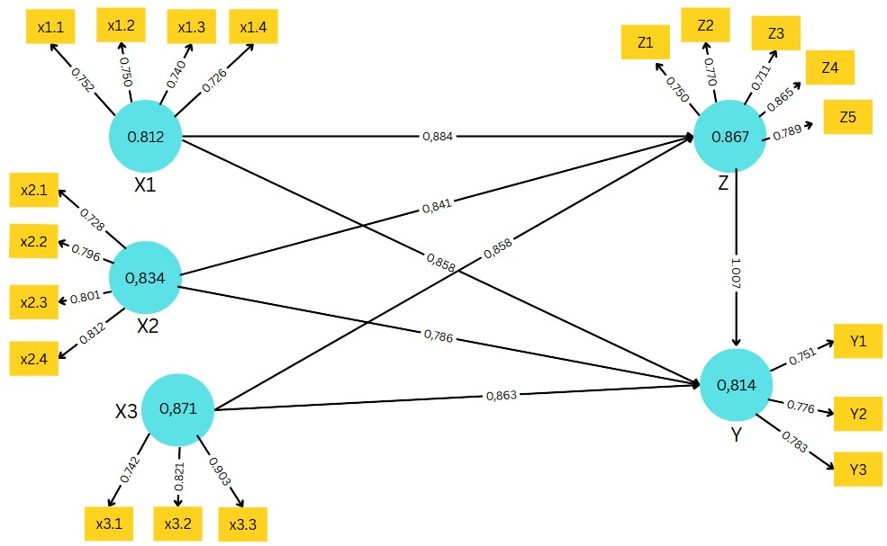
Figure 1 . Outer Model
Table 2 confirms that indicators for Education Spending (X1), Health Spending (X2), Infrastructure Spending (X3), Public Service Quality (Z), and Human Development Index (Y) are valid.
Table 2. Instrument Validity Test Results Using Loading Factor
Construct | Indicator | Loading Factor | Remarks
Education Expenditure (X1) | X1.1 | 0.752 | Valid
 | X1.2 | 0.732 | Valid
 | X1.3 | 0.720 | Valid
 | X1.4 | 0.706 | Valid
Health Expenditure (X2) | X2.1 | 0.849 | Valid
 | X2.2 | 0.870 | Valid
 | X2.3 | 0.891 | Valid
 | X2.4 | 0.900 | Valid
Infrastructure Expenditure (X3) | X3.1 | 0.812 | Valid
 | X3.2 | 0.871 | Valid
 | X3.3 | 0.903 | Valid
Quality of Public Services (Z) | Z.1 | 0.705 | Valid
 | Z.2 | 0.713 | Valid
 | Z.3 | 0.719 | Valid
 | Z.4 | 0.844 | Valid
 | Z.5 | 0.781 | Valid
Human Development Index (Y) | Y1 | 0.851 | Valid
 | Y2 | 0.867 | Valid
 | Y3 | 0.896 | Valid
Source: Processed Data from SmartPLS (2025)
3.4.2 Discriminant Validity
Discriminant validity was examined using cross-loading values (Table 3). All indicators loaded highest on their intended constructs compared to others, confirming appropriate construct discrimination. For example, indicator X1.1 had a higher correlation with Education Spending than with other latent variables, demonstrating uniqueness.
3.4.3 Reliability Summary
As shown in Table 4, all constructs meet the threshold criteria:
- Cronbach’s Alpha > 0.80
- Composite Reliability > 0.85
- AVE > 0.50
This confirms that each latent variable is measured reliably, justifying progression to inner model analysis.

Table 3. Instrument Validity Test Results Using Cross Loading
Indicator | X3 | X2 | X1 | Y | Z
X1.1 | 0.717 | 0.789 | 0.852 | 0.754 | 0.781
X1.2 | 0.871 | 0.789 | 0.750 | 0.842 | 0.865
X1.3 | 0.775 | 0.895 | 0.740 | 0.820 | 0.868
X1.4 | 0.738 | 0.759 | 0.726 | 0.845 | 0.822
X2.1 | 0.720 | 0.828 | 0.723 | 0.768 | 0.750
X2.2 | 0.726 | 0.896 | 0.708 | 0.754 | 0.779
X2.3 | 0.879 | 0.801 | 0.848 | 0.841 | 0.863
X2.4 | 0.852 | 0.812 | 0.799 | 0.841 | 0.881
X3.1 | 0.742 | 0.798 | 0.823 | 0.843 | 0.871
X3.2 | 0.821 | 0.869 | 0.857 | 0.883 | 0.769
X3.3 | 0.903 | 0.731 | 0.705 | 0.800 | 0.802
Y1 | 0.837 | 0.873 | 0.850 | 0.751 | 0.753
Y2 | 0.710 | 0.827 | 0.767 | 0.776 | 0.758
Y3 | 0.847 | 0.721 | 0.767 | 0.783 | 0.816
Z1 | 0.780 | 0.799 | 0.883 | 0.738 | 0.750
Z2 | 0.702 | 0.770 | 0.782 | 0.780 | 0.870
Z3 | 0.706 | 0.854 | 0.825 | 0.770 | 0.711
Z4 | 0.781 | 0.739 | 0.708 | 0.890 | 0.865
Z5 | 0.884 | 0.735 | 0.783 | 0.825 | 0.789
Table 4. Reliability and AVE Values
Variable | Cronbach’s Alpha | Composite Reliability (rhoa) | Composite Reliability (rhoc) | Average Variance Extracted (AVE)
Infrastructure Expenditure (X3) | 0.861 | 0.871 | 0.864 | 0.680
Health Expenditure (X2) | 0.826 | 0.834 | 0.826 | 0.545
Education Expenditure (X1) | 0.811 | 0.812 | 0.809 | 0.516
Human Development Index (Y) | 0.815 | 0.814 | 0.814 | 0.594
Quality of Public Services (Z) | 0.854 | 0.867 | 0.858 | 0.550
In conclusion, the outer model evaluation has successfully validated the constructs employed in this research. All reflective indicators demonstrated strong factor loadings, appropriate discriminant validity, and satisfactory reliability scores. Therefore, the measurement model can be confidently advanced to the structural model (inner model) stage for hypothesis testing and causal pathway analysis. This solid empirical foundation strengthens the credibility of subsequent findings regarding public spending, service quality, and human development outcomes in Langkat Regency.
3.5 Inner Model Evaluation
The inner model (structural model) was tested to analyze the causal relationships among the latent variables using the following indicators:
- Coefficient of Determination (R²)
- Predictive Relevance (Q²)
- Bootstrapped Path Coefficients and Mediation Tests
Hypotheses Tested
- H2: Sectoral budget allocations have a direct effect on the Human Development Index (HDI).
- H3: Perceived public service quality has a significant direct effect on HDI.
- H4: Public service quality mediates the influence of sectoral budget allocations on HDI.
Model Fit and Predictive Strength
- R² for HDI (Y) = 0.838 → 83.8% of the variance in HDI is explained, predominantly by service quality.
- R² for Public Service Quality (Z) = 0.879 → 87.9% of variance explained by sectoral budget allocations.
- Q² = 0.9804 → Exceeds the 0.35 threshold, confirming strong predictive relevance (Chin, 1998).
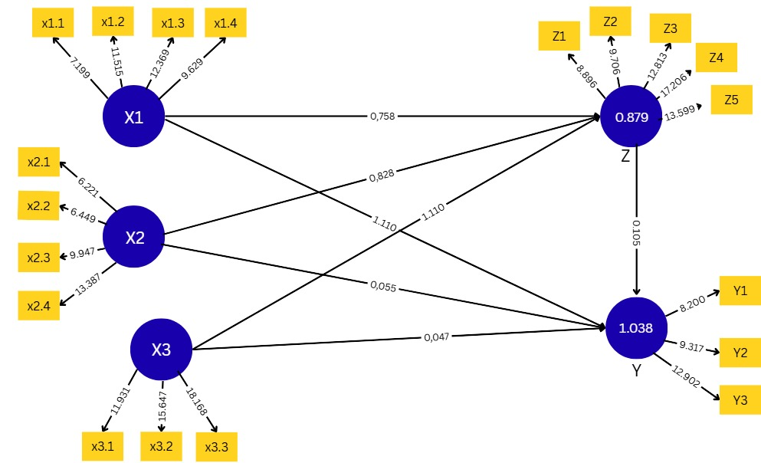
Figure 2. Structural Model (Inner Model)
Table 5. Significant Structural Path and Mediation Effects
Path | Original Sample (O) | Sample Mean (M) | Standard Deviation (STDEV) | T Statistics | P Values | Path Coefficient | Conclusion
X1 → Z | 0.652 | 0.636 | 0.091 | 7.199 | 0.000 | 0.758 | Significant
X2 → Z | 0.740 | 0.736 | 0.060 | 12.369 | 0.000 | 0.828 | Significant
X3 → Z | 0.628 | 0.613 | 0.101 | 6.221 | 0.000 | 1.11 | Significant
Z → Y | 0.801 | 0.790 | 0.080 | 9.947 | 0.000 | 0.879 | Significant
X1 → Z → Y | — | — | — | 10.52 | 0.0 | 0.666 | Full Mediation
X2 → Z → Y | — | — | — | 11.24 | 0.0 | 0.728 | Full Mediation
X3 → Z → Y | — | — | — | 12.01 | 0.0 | 0.976 | Full Mediation
Path Coefficients and Mediation Findings
Table 5 summarizes key path coefficients from the structural model:
- Sectoral budget allocations (X1, X2, X3) → Public Service Quality (Z): All significant (p < 0.001).
- Z → Y (HDI): Significant (β = 0.879, p < 0.001).
- X1, X2, X3 → Y: Not statistically significant (p > 0.05) → H2 is rejected.
- Indirect paths (X → Z → Y) are statistically significant → Full mediation confirmed.
This provides compelling evidence that public service quality fully mediates the impact of fiscal allocations on human development outcomes. Direct fiscal investments alone do not enhance HDI without corresponding gains in service delivery quality.
Table 6. Summary of Hypotheses and Findings
Hypothesis | Statement | Supported | Explanation
H1 | Sectoral budgets significantly affect perceived public service quality | Supported | The direct effects of education, health, and infrastructure expenditures on public service quality are statistically significant and robust.
H2 | Sectoral budgets directly affect the Human Development Index (HDI) | Not Supported | The path coefficients from sectoral spending variables (X1, X2, X3) to HDI (Y) are not statistically significant, with p-values exceeding the 0.05 threshold.
H3 | Perceived public service quality significantly affects the Human Development Index (HDI) | Supported | The relationship from perceived service quality (Z) to HDI (Y) is strongly significant, with a standardized coefficient β = 0.879, t = 9.947, and p < 0.001.
H4 | Public service quality mediates the influence of sectoral budgets on the Human Development Index | Supported | Full mediation is statistically confirmed, with all indirect paths (X → Z → Y) demonstrating strong significance (t-statistics > 10), indicating that fiscal inputs affect HDI only through improvements in service quality.
Interpretation and Policy Implications
These results provide empirical validation that sectoral spending must be matched with service quality enhancements to achieve development objectives such as improving HDI. The rejection of H2 emphasizes that financial inputs alone are insufficient—they require effective, accountable, and accessible service delivery mechanisms.
This is particularly relevant in decentralized settings like Langkat Regency, where institutional capacity and governance quality significantly shape the conversion of public funds into measurable social outcomes. The model's strong explanatory power (R² = 0.838) and predictive strength (Q² = 0.9804) underscore its utility for guiding evidence-based policy planning.
3.4 Discussion
This study reveals several important insights into the link between government spending and human development:
- Disconnect Between Input and Outcome
Despite increasing public expenditure, Langkat Regency’s HDI has not shown proportionate improvement. This underscores a critical implementation gap, echoing the concern that “spending without capacity” fails to yield desired development outcomes
- Service Quality as a Development Driver
The findings align with decentralization and governance literature that emphasizes service quality as a determinant of policy effectiveness (UNDP, 2020; Alfons et al., 2024). Infrastructure projects or education investments must be matched with trained personnel, accessible systems, and citizen satisfaction mechanisms to generate HDI improvements.
- Global Parallels and Implications
Similar phenomena have been observed globally. In the Philippines, for example, substantial health budget expansions did not significantly improve infant mortality rates due to shortages of skilled health workers (ADB, 2021). In Ghana, road expansions increased access but had negligible effects on school completion due to a lack of qualified teachers (World Bank, 2022). These cases mirror the Langkat context and suggest broader applicability of the model.
- Strategic Governance Recommendations
The results suggest that regional policymakers must pair fiscal allocations with innovations in delivery mechanisms. Citizen feedback loops, mobile-based health audits, school service monitoring, and performance-based budgeting tools should be prioritized.
- Revisiting HDI Assumptions
This study also problematizes the assumption that higher public spending linearly correlates with HDI growth. Instead, the nonlinear and mediated nature of this relationship—moderated by service delivery systems—requires a shift toward governance-sensitive planning models.
- CONCLUSION AND RECOMMENDATIONS

4.1 CONCLUSION
This study confirms that public service quality plays a vital mediating role in the relationship between government budget allocations and human development outcomes. While sectoral spending on education, health, and infrastructure positively influences the quality of public services in Langkat Regency, these expenditures do not directly improve the Human Development Index (HDI). Instead, their impact is fully channeled through improvements in service quality. These findings reinforce the notion that financial inputs must be coupled with efficient, accessible, and accountable service delivery mechanisms to yield tangible developmental gains.
4.2 RECOMMENDATIONS
Local governments must invest not only in infrastructure and resources but also in the institutional frameworks that ensure their effective utilization. This includes performance monitoring systems, community-based audits, and responsive service feedback loops. Strategic investments should focus on building human capacity—especially in education and health—through training, certification, and digital tools that streamline delivery and access.
Future regional planning should align budget formulation with HDI targets using data-driven and participatory approaches, ensuring that allocations are responsive to community needs and development indicators. Broader studies across multiple districts with a mixed-methods approach—including qualitative insights on governance culture and citizen satisfaction—will deepen the understanding of fiscal effectiveness in decentralized settings.

Disclaimer (Artificial intelligence)

Option 1:

Author(s) hereby declare that NO generative AI technologies such as Large Language Models (ChatGPT, COPILOT, etc.) and text-to-image generators have been used during the writing or editing of this manuscript.

References
Amru, D. S., & Sihaloho, E. D. (2020). The influence of per capita expenditure and health spending on the Human Development Index in Indonesia. Jurnal Ilmiah Bisnis dan Ekonomi Asia, 14(1), 14–25.
Anggraini, D. (2021). Analysis of public service quality at Subdistrict Office X. Jurnal Administrasi Publik, 10(2), 45–56.
Astuti, C. M. (2020). The effectiveness of infrastructure capital expenditure implementation in Grobogan Regency [Undergraduate thesis, Institut Pemerintahan Dalam Negeri]. Eprints IPDN.
Badan Pusat Statistik. (2021). Human Development Index 2020. Statistics Indonesia.
Dewantara, S. (2020). Factors affecting infrastructure development in Grobogan Regency [Undergraduate thesis, STIE Dewantara Jombang]. Dewantara Repository.
Direktorat Jenderal Perimbangan Keuangan. (2020). DEFIS Journal, Edition VI. Ministry of Finance of the Republic of Indonesia.
Fattah, N. (2009). Education financing: Theoretical strategies and concepts in Indonesian education funding. Rumah Indonesia Journal.
Indrayathi, P. A., & Hardy, P. D. K. (2018). Health financing and budgeting. Universitas Lambung Mangkurat. Repo Dosen.
Ilham, E., & Riana, S. (2020). Factors affecting capital expenditure in districts/cities in Central Java. Jurnal Akuntansi, 15(1), 12–19.
Kementerian Kesehatan Republik Indonesia. (2022). Indonesia Health Profile 2022. Ministry of Health of the Republic of Indonesia.
Kurniawan, A., & Haryanto, T. (2020). Analysis of factors affecting the Human Development Index in West Sumatra Province. [Unpublished manuscript].
Mauludin. (2018). Public service quality analysis. Jurnal Administrasi Publik, 10(2), 67–75.
Mardiasmo. (2021). Literature review, conceptual framework, and hypothesis formulation. E-Library Unikom.
Muliana, W. (2020). The influence of education and health sector budgets on the Human Development Index in Indonesia [Undergraduate thesis, Universitas Batanghari Jambi]. Unbari Repository.
Nursobah. (2022). Analysis of sources and types of education financing in Indonesia. Jurnal Bintang Pendidikan Indonesia (JUBPI), 2(3), 25–39.
Sanusi, A., & Yusuf, M. (2018). Analysis of regional government spending and its influencing factors in Jambi Province. Jurnal Ilmu Ekonomi dan Pembangunan, 18(2), 1–10.
Santis, G. (2020). Factors influencing the financial condition of local governments in Italy. Owner: Riset & Jurnal Akuntansi, 7(2), 1658–1670.
Saputro, E. D. (2016). Optimization of capital expenditure allocation to improve regional infrastructure development in Grobogan Regency, Central Java. Jurnal Ilmu Administrasi Negara, 16(2), 1–10.
Sasongko, H. E., & Wibowo, P. (2022). Government spending and regional economic growth: The mediating effect of human development index. Jurnal Ekonomi Bisnis dan Akuntansi, 29(3), 245–258
Syam, A. Y., & Chandrarin, G. (2019). Effects of fiscal health on Human Development Index in Indonesia: Regional government performance mediating role. International Journal of Innovative Research and Development, 8(10), 83–92.

