**Optimizing Water Distribution Efficiency Through Sustainable District Meter Area (DMA) Planning in Doloksanggul, Indonesia**

**Abstract**

Water loss in urban distribution systems is a persistent challenge, especially in developing regions where infrastructure and management systems are often inadequate. This study investigates the piped water distribution performance in Kecamatan Doloksanggul, Kabupaten Humbang Hasundutan, Indonesia, where non-revenue water (NRW) levels reach 32%, far exceeding the national tolerance threshold of 20%. The central aim of this research is to assess the feasibility and impact of implementing phased District Meter Areas (DMAs) as a sustainable strategy to optimize water distribution efficiency. Using spatial and temporal analysis—including GIS-based demand mapping, hydraulic zoning, and population projection modeling from 2024 to 2044—we identified key service gaps, infrastructure inefficiencies, and future supply-demand imbalances. Findings reveal that, without intervention, the region will shift from water surplus to deficit by 2039. Estimated annual water losses currently total approximately 494,000 m³. A phased DMA rollout, expanding from 12 zones in 2024 to 20 zones by 2044, demonstrates potential to reduce NRW by up to 25%, stabilize pressure zones, and enhance leakage detection capacity. This study differs from existing literature by focusing on small urban centers and incorporating institutional readiness and spatial equity into DMA planning. The results offer strategic insights for municipalities and utilities in similar demographic contexts across Southeast Asia, emphasizing the need for integrated land-water planning, inter-agency coordination, and proactive investment to achieve sustainable urban water services.

**Keywords:** District Meter Area (DMA), Non-Revenue Water (NRW), Water Distribution System, Urban Water Management, Hydraulic Zoning

1. **INTRODUCTION**

Urban water utilities in developing nations frequently face systemic inefficiencies, with non-revenue water (NRW) representing one of the most critical operational and financial burdens. NRW includes physical losses from leaks, commercial losses due to theft or meter inaccuracies, and unbilled authorized consumption, collectively amounting to over 32 billion m³ annually worldwide. In Southeast Asia, average NRW rates consistently surpass 30%, undermining financial sustainability and jeopardizing equitable water access, particularly in semi-urban and peri-urban settlements (Dos Santos et al., 2017; Grönwall & Danert, 2020).

In Indonesia, this issue is especially pressing. Regional water utilities such as Perusahaan Daerah Air Minum (PDAM) often report NRW values well above the national tolerance threshold of 20%, with extreme cases like Balikpapan reaching losses of up to 59%. These inefficiencies are attributed to aging infrastructure, inadequate hydraulic zoning, and fragmented governance mechanisms. Despite investments from national programs like Pamsimas and SPAM Regional, the overall decline in NRW has been marginal, reinforcing the need for integrated and data-driven solutions (de Sousa et al., 2025; Mwitirehe & Kipruto, 2024).

One of the most promising operational approaches to address NRW is the implementation of District Meter Areas (DMAs). DMAs divide a water distribution network into hydraulically discrete zones, enabling utilities to monitor inflow and outflow, control pressure, and detect leaks in real time. International case studies suggest that DMA adoption can reduce water losses by up to 40% within five years when combined with smart metering and GIS-based monitoring. In South Korea, for example, pressure optimization through DMA zoning significantly improved network efficiency and consumer satisfaction (Kwon & Lee, 2025; Mala-Jetmarova et al., 2018).

In the Indonesian context, GIS-based zoning methods have led to better outcomes in urban planning, especially when aligned with local development instruments such as the RPJMD and RISPAM. However, such implementation has largely been limited to major urban utilities with advanced infrastructure and digital capacity. Small- and medium-sized towns remain underrepresented in both academic research and practical implementation (Anschütz et al., 2024).

Doloksanggul, a subdistrict in North Sumatra, typifies these overlooked urban areas. Despite the presence of SPAM infrastructure with a production capacity of 1.2 million m³/year, piped water service covers only 29.28% of the population. Many residents still rely on unregulated groundwater extraction, raising long-term sustainability concerns. Meanwhile, annual water losses exceed 494,000 m³, reflecting systemic inefficiencies despite idle capacity (Alkalsh & Kliks, 2024; Gunarathna et al., 2023).

To overcome these challenges, this study proposes a phased DMA zoning strategy grounded in spatial analytics, service connection mapping, and hydraulic gradient modeling. Nearest Neighbor Analysis and Standard Deviational Ellipse techniques are used to identify priority areas based on SR clustering and topographic suitability. The methodology emphasizes the integration of spatial planning and hydraulic principles to stabilize pressure and enhance leakage control (Bouma & Slob, 2014; Cortinovis & Geneletti, 2020).

Institutional coordination is also critical. Without synergy between UPT SPAM, Bappeda, Dinas PU, and community-level operators, even the most technically sound DMA plans risk limited impact. Embedding these strategies within formal planning instruments ensures alignment with urban expansion, infrastructure budgets, and climate resilience goals. In contrast to previous studies that focus solely on modeling, this research incorporates policy frameworks, institutional readiness, and local behavioral factors to create a replicable model for similar settings (JETP, 2023).

Accordingly, this study addresses the following research questions:

1. What are the current patterns of water loss and distribution inefficiency in Doloksanggul?
2. How can DMA zoning be spatially and hydraulically optimized to reduce non-revenue water?
3. What are the projected outcomes of phased DMA implementation on system performance and water availability by 2044?

By focusing on these questions, the study offers an evidence-based planning model that bridges technical, institutional, and spatial dimensions of water distribution, providing practical guidance for utilities and planners in secondary urban regions across Southeast Asia.

1. **METHODS**

**2.1 Study Area**

This research was conducted in Kecamatan Doloksanggul, located in Kabupaten Humbang Hasundutan, North Sumatra, Indonesia. The region consists of 13 administrative villages with a combined service population of approximately 33,874 people as of 2024. The area is characterized by moderate topography and is served by both centralize d SPAM systems and decentralized water sources such as borewells. Field data collection and analysis were conducted from September to November 2024.

**2.2 Data Collection**

Primary and secondary data were obtained from multiple sources:

* Technical reports and distribution system layouts from UPT. SPAM and Pamsimas
* Demographic projections from BPS Humbang Hasundutan
* Satellite imagery and land use maps (SPOT-6 and Google Earth Pro)
* Water demand coefficients sourced from Permen PUPR No. 27/2020
* Groundwater data from the Ministry of Energy and Mineral Resources

On-site surveys were conducted to validate service point locations (SR), elevation profiles, and piping network configurations. A total of 485 SR coordinate points were mapped using GPS.

**Figure 1.** Kumbang Hasundutan Regency Map

Source: PUTR, Humbang Hasundutan 2024

**2.3 Estimating Water Demand**

Water demand was projected using population growth rates and standard per capita consumption rates for urban, semi-urban, and rural categories. These were calculated for five time points: 2024, 2029, 2034, 2039, and 2044. The base per capita demand used was 120 liters/person/day for urban areas, 90 liters/person/day for semi-urban areas, and 60 liters/person/day for rural areas, following national guidelines.

Demand calculations included:

* Total water need per settlement unit
* Domestic and non-domestic allocations
* Loss adjustment factors using a 32% NRW assumption

**2.4 Spatial and Statistical Analysis**

A Geographic Information System (GIS) was employed to analyze spatial patterns of demand and distribution. The following spatial tools were used:

* **Nearest Neighbor Analysis**: To assess clustering of demand points
* **Median Center and Directional Distribution (Standard Deviational Ellipse)**: To determine central tendency and directional bias of demand
* **Thiessen Polygon Method**: To delineate influence zones for SRs
* **Overlay Analysis**: To combine layers of demand, elevation, land use, and infrastructure

Statistical measures included the z-score for spatial randomness and trend analysis for demand growth.

**2.5 Water Balance and Supply Projection**

Water supply availability was computed for both piped (SPAM) and non-piped (groundwater) sources. The water balance equation considered:

* Installed capacity of SPAM systems (L/det)
* Idle capacity and losses (32% leakage)
* Safe yield estimates for groundwater extraction until 2044

The difference between projected demand and reliable supply defined system surplus or deficit for each time step.

**2.6 DMA Design and Zoning**

District Meter Areas (DMAs) were delineated using a hybrid approach:

* Spatial zoning based on hydraulic boundary feasibility (topography and flow direction)
* Demand density and SR proximity
* Institutional readiness and pipeline accessibility

The initial 2024 configuration includes 12 DMA zones, expanding to 20 zones by 2044. Each zone was designed to be hydraulically isolated with one primary inlet and equipped with monitoring devices (simulated). Zones were prioritized based on population density and water loss potential.

**2.7 Limitation and Validation**

This study did not include hydraulic simulation using software such as EPANET or WaterCAD due to data constraints. However, zonal balancing and DMA formation were validated through comparison with similar studies in Balikpapan and Cirebon.

1. **RESULTS AND DISCUSSION**

**3.1. Water Demand and Supply Projections (2024–2044)**

The projected water demand in *Kecamatan Doloksanggul* over the 20-year planning horizon exhibits a marked increase, driven by population growth, expanded service coverage, and evolving patterns of domestic and non-domestic water use. Based on planning parameters from SNI 6728.1:2015 and applying differentiated coefficients for consumption types, the peak-hour water demand is expected to rise from 53.01 L/s in 2024 to 129.16 L/s in 2044. This equates to an annual volumetric demand increase from approximately 1.67 million m³ to 4.07 million m³.

These projections incorporate spatial heterogeneity by distinguishing urban core, peri-urban, and peripheral zones, alongside anticipated improvements in service coverage—from 37.2% to 85.2%—and a reduction in non-revenue water (NRW) losses from 32% to 7%. The increasing contribution of non-domestic users, such as markets, small businesses, and public institutions, adds further pressure on the piped water system.

**Table 1.** Peak Demand and Annual Water Requirement Projections

|  |  |  |
| --- | --- | --- |
| **Year** | **Peak Demand (L/s)** | **Annual Demand (m³/year)** |
| 2024 | 53.01 | 1,671,723.36 |
| 2029 | 72.01 | 2,270,907.36 |
| 2034 | 91.29 | 2,878,921.44 |
| 2039 | 110.46 | 3,483,466.56 |
| 2044 | 129.16 | 4,073,189.76 |

While water demand continues to escalate, the installed production capacity of the centralized piped water system remains static at approximately 1.2 million m³/year, as no major infrastructure upgrades are scheduled under the current *RPJMD* (Regional Medium-Term Development Plan). A supply deficit is projected to emerge by 2029, intensifying in 2039 and reaching a critical level by 2044. This condition highlights the urgency for demand-side efficiency interventions, particularly through pressure management, loss reduction, and District Metered Area (DMA) implementation.

Although groundwater remains widely utilized, the absence of regulatory oversight poses long-term sustainability concerns—especially in areas facing declining recharge rates or competitive usage from agriculture. Therefore, integrating demand management with infrastructural and institutional reforms is essential for ensuring future service continuity and water system resilience.

**3.2. Land Cover Change Analysis (2024–2044)**

Urban expansion and land use transformation represent critical factors influencing hydrological behavior, surface runoff, and water demand patterns in semi-urban areas such as *Kecamatan Doloksanggul*. This study employs multi-temporal satellite imagery from 2014, 2019, and 2024, processed via Google Earth Engine (GEE), and applies land cover prediction modeling using the MOLUSCE (Modules for Land Use Change Simulation) plugin within QGIS.

Classification was conducted using the Random Forest algorithm, achieving overall accuracy (OA) values exceeding 0.78 and Kappa coefficients above 0.72, indicating reliable model performance. Future land cover predictions for 2029, 2034, 2039, and 2044 were generated using a cellular automata approach. This model incorporated multiple spatial drivers—including proximity to roads and rivers, slope gradients, existing built-up zones, and central activity areas. An Artificial Neural Network (ANN) model validated the simulation with high predictive precision (error rate = 0.00340, Kappa = 0.88531).

**Table 2. Predicted Land Cover Changes in Kecamatan Doloksanggul (2024–2044)**

|  |  |  |  |  |  |
| --- | --- | --- | --- | --- | --- |
| **Land Cover Class** | **2024 (Ha)** | **2029 (Ha)** | **2034 (Ha)** | **2039 (Ha)** | **2044 (Ha)** |
| Built-up Area | 871.02 | 873.72 | 877.29 | 903.10 | 907.20 |
| Rice Fields | 1,552.05 | 1,607.49 | 1,610.17 | 1,583.29 | 1,582.31 |
| Dryland Agriculture | 9,144.09 | 9,684.39 | 9,872.93 | 9,984.32 | 9,995.51 |
| Open Land | 587.43 | 284.13 | 134.13 | 84.04 | 78.04 |
| Shrub/Bushes | 5,303.33 | 4,993.19 | 4,988.33 | 4,976.67 | 4,926.65 |
| Forest | 8,559.78 | 8,574.78 | 8,534.85 | 8,486.28 | 8,527.99 |

**Figure 2. Predicted Land Cover in Kecamatan Doloksanggul for 2039 and 2044**

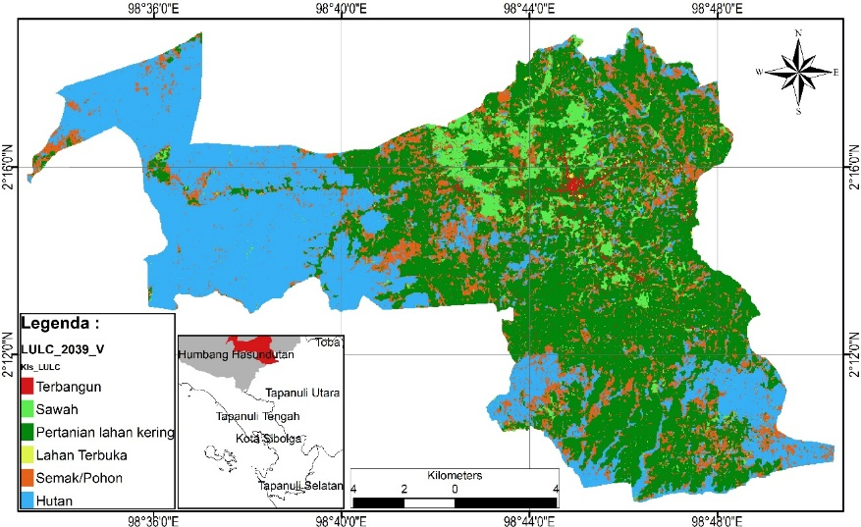

*Source: Processed from ANN-MOLUSCE model using Sentinel and Landsat imagery.*

The results indicate a moderate but consistent increase in built-up land from 871.02 ha in 2024 to 907.20 ha in 2044, reflecting ongoing urbanization processes. This growth corresponds with infrastructure development and rising demand for residential, commercial, and institutional land. A significant increase is also observed in dryland agricultural areas, which expand from 9,144.09 ha to 9,995.51 ha over the 20-year span. This suggests a strategic shift toward more flexible agricultural practices, potentially driven by the conversion of open or semi-natural areas into productive use.

Conversely, open land exhibits a sharp decline from 587.43 ha in 2024 to only 78.04 ha by 2044, indicative of intensifying land utilization pressures. Such reductions have implications for ecosystem services, particularly related to infiltration, runoff absorption, and local climate moderation. Shrublands and forested areas show minor fluctuations. While the forest cover remains relatively stable, a slight decrease from 8,559.78 ha to 8,527.99 ha underscores the need for continuous monitoring, given the ecological sensitivity of these areas.

These land cover transitions will likely alter the hydrological regime of Doloksanggul, particularly through increased impervious surfaces in built-up zones. As a result, the risk of surface runoff intensification and stress on existing drainage systems will rise. This emphasizes the need for integrated land use and water infrastructure planning, particularly aligning spatial zoning with DMA water service strategies to ensure adaptive resilience.

**3.3 Spatial Distribution of Household Water Connections (SR) by Grid Classification (2024–2044)**

This section analyzes the spatiotemporal dynamics of household water connection (Sambungan Rumah/SR) distribution across Kecamatan Doloksanggul between 2024 and 2044. The analysis utilizes a standardized spatial grid framework (150 m × 150 m), enabling a consistent assessment of service coverage and density over time.

Grids were categorized into ten SR density classes, ranging from grids with zero connections to those with more than 90. This classification facilitates the identification of spatial trends in service penetration, highlighting both areas of rapid expansion and those requiring targeted interventions.

**Figure 3.** Spatial Distribution of SR Grid Classifications in Kecamatan Doloksanggul (2039–2044)

**Table 3. Number of Grids per SR Density Class (2024–2044)**

|  |  |  |  |  |  |  |
| --- | --- | --- | --- | --- | --- | --- |
| **No** | **SR Classification** | **2024** | **2029** | **2034** | **2039** | **2044** |
| 1 | 0 | 9,175 | 8,476 | 7,743 | 7,314 | 6,779 |
| 2 | 1 – 2 | 2,627 | 3,117 | 3,576 | 3,724 | 4,025 |
| 3 | 3 – 6 | 197 | 370 | 586 | 805 | 944 |
| 4 | 7 – 12 | 21 | 51 | 93 | 137 | 210 |
| 5 | 13 – 20 | 12 | 9 | 22 | 34 | 55 |
| 6 | 21 – 30 | 6 | 9 | 4 | 6 | 5 |
| 7 | 31 – 45 | 2 | 6 | 9 | 4 | 5 |
| 8 | 46 – 65 | 0 | 2 | 5 | 12 | 9 |
| 9 | 66 – 90 | 0 | 0 | 2 | 3 | 6 |
| 10 | 91 – 123 | 0 | 0 | 0 | 1 | 2 |
|  | **Total** | **12,040** | **12,040** | **12,040** | **12,040** | **12,040** |
| *Source: Processed Data, 2024* |  |  |  |  |  |  |

The number of grids with no SR connections decreases steadily from 9,175 in 2024 to 6,779 by 2044, indicating a progressive expansion of piped water coverage. Simultaneously, grids within higher SR density classes, particularly the “1–2 SRs,” “3–6 SRs,” and “7–12 SRs” brackets, show consistent growth, both in absolute numbers and in spatial spread.

The dominance of the “1–2 SRs” class throughout the planning horizon suggests that network expansion is initially focused on peripheral or low-density zones, rather than intensifying in already serviced urban cores. This pattern reflects an equitable distribution strategy, potentially driven by policy priorities on universal access and alignment with projected urban growth corridors. Furthermore, the growth in medium-density classes such as “3–6 SRs” and “7–12 SRs” by 2044 indicates not only geographic expansion but also local densification within partially served areas. This aligns with the broader objective of phased network densification and systematic reduction of service disparities.

These spatial dynamics provide a foundational dataset for guiding the placement of District Metered Areas (DMAs), enabling utility managers to prioritize zones with emerging densities and to implement pressure control, leakage detection, and service reliability measures efficiently

**3.4. Spatial Patterns, Centers, and Direction of Household Water Connection (SR) Distribution in Kecamatan Doloksanggul (2024–2044)**

To characterize the spatial configuration and directional evolution of household water connections (SR) in *Kecamatan Doloksanggul*, spatial statistical analysis was conducted using ArcGIS tools. Specifically, the **Average Nearest Neighbor (ANN)**, **Median Center**, and **Directional Distribution (Standard Deviational Ellipse)** methods were applied to evaluate the degree of clustering, spatial orientation, and central tendencies of SR dispersion over time.

**3.4.1 Average Nearest Neighbor (ANN) Analysis**

The ANN metric assesses whether the observed spatial pattern of SR points deviates from a random distribution. For the base year 2024, the analysis yielded a Nearest Neighbor Ratio (NNR) of 1.316292 with a z-score of 66.394570, indicating a highly dispersed spatial pattern (NNR > 1, z-score > 2.58). This result implies that SR installations are spreading outward across space rather than concentrating within specific urban clusters.

**Figure 4.** Average Nearest Neighbor Analysis of SR Distribution in Kecamatan Doloksanggul (2024)

*Source: ArcGIS Spatial Statistics Tool, 2024*

**3.4.2 Median Center and Directional Distribution**

Complementing the ANN analysis, the spatial Median Center and Standard Deviational Ellipse (SDE) were used to track the shifting centroid and directional growth axis of SR distribution. Results indicate that the Median Center consistently falls within Kelurahan Pasar Doloksanggul, establishing it as the origin point of network expansion. The elliptical spread demonstrates a clear southeast–northwest growth trajectory, aligning with regional development patterns and urban expansion corridors documented in the regional spatial plan (*RTRW*).

**Figure 5.** Predicted Center and Directional Distribution of SR Network Expansion in 2044

*Source: ArcGIS SDE and Median Center Analysis*

The spatial trend suggests a systematic extension of piped water infrastructure from the urban center toward surrounding semi-urban and rural areas. This expansion trajectory aligns with service equity objectives and supports the case for a phased District Metered Area (DMA) implementation, beginning with central high-density zones and extending outward in response to demographic and infrastructure growth. The strategic placement of infrastructure upgrades, pressure management zones, and leakage monitoring systems in anticipation of future service loads

**3.5. Groundwater Availability Analysis in Kecamatan Doloksanggul (2024–2044)**

A comprehensive groundwater potential assessment was conducted using a grid-based runoff coefficient modeling approach. This methodology integrates multiple hydrological variables, including annual rainfall, evapotranspiration, land cover types, and topographic characteristics, to estimate sustainable groundwater recharge at the sub-district level.

**3.5.1 Rainfall and Evapotranspiration Trends**

The average annual precipitation in Kecamatan Doloksanggul from 2015 to 2024 was 2,284 mm, with variability observed across the decade—ranging from a low of 1,854 mm in 2021 to a peak of 2,680 mm in 2015. Evapotranspiration (ET₀) was estimated using the Thornthwaite method, producing an average annual corrected ET₀ value of **93.53 mm/year**, accounting for local temperature and seasonal variation.

**3.5.2 Runoff Coefficient-Based Groundwater Estimation**

Runoff potential was estimated at the grid level using Hassing’s method, which combines soil texture, vegetation cover, slope, and land use to generate a composite runoff coefficient. These coefficients were applied to hydrological inputs to estimate net groundwater recharge per grid cell.

**Table 4.** Groundwater Support Capacity by Grid Classification (2024–2044)

|  |  |  |  |  |  |  |
| --- | --- | --- | --- | --- | --- | --- |
| **No** | **Volume Class (thousand m³)** | **2024** | **2029** | **2034** | **2039** | **2044** |
| 1 | ≤ 3 | 0 | 0 | 0 | 0 | 0 |
| 2 | 3.01 – 6 | 0 | 0 | 0 | 0 | 0 |
| 3 | 6.01 – 9 | 78 | 79 | 80 | 86 | 86 |
| 4 | 9.01 – 12 | 69 | 69 | 74 | 67 | 67 |
| 5 | 12.01 – 16 | 101 | 100 | 96 | 98 | 97 |
| 6 | 16.01 – 20 | 287 | 301 | 318 | 316 | 326 |
| 7 | 20.01 – 24 | 714 | 707 | 706 | 707 | 708 |
| 8 | 24.01 – 28 | 2,423 | 2,326 | 2,423 | 2,319 | 2,428 |
| 9 | 28.01 – 32 | 914 | 936 | 943 | 949 | 948 |
| 10 | > 32 | 7,454 | 7,522 | 7,400 | 7,498 | 7,380 |

*Source: Hydrological Grid-Based Modeling, 2024*

The analysis confirms that the majority of spatial grids consistently fall within the highest groundwater availability category (greater than 32,000 m³/year), indicating a robust and resilient groundwater potential across the sub-district. Importantly, no grids fell within the lowest categories (≤6,000 m³/year), demonstrating the general abundance and reliability of natural recharge processes throughout the region.

**Figure 6.** Spatial Distribution of Groundwater Availability Grids (2039–2044)  
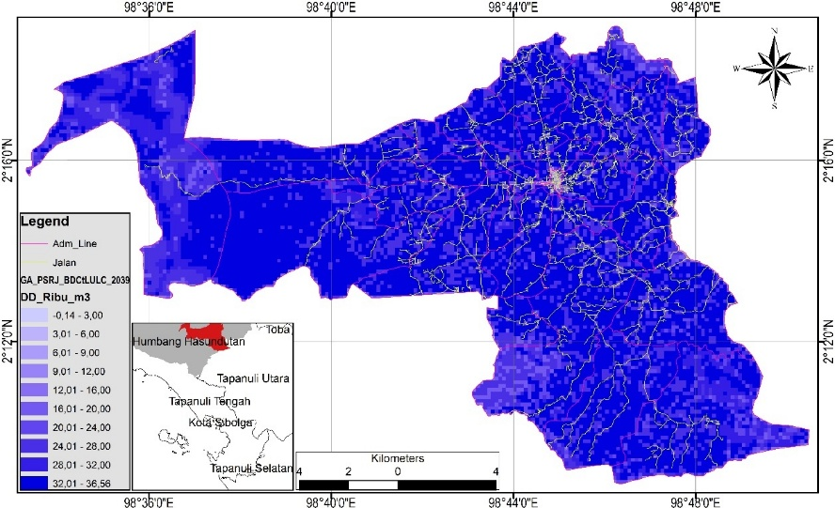

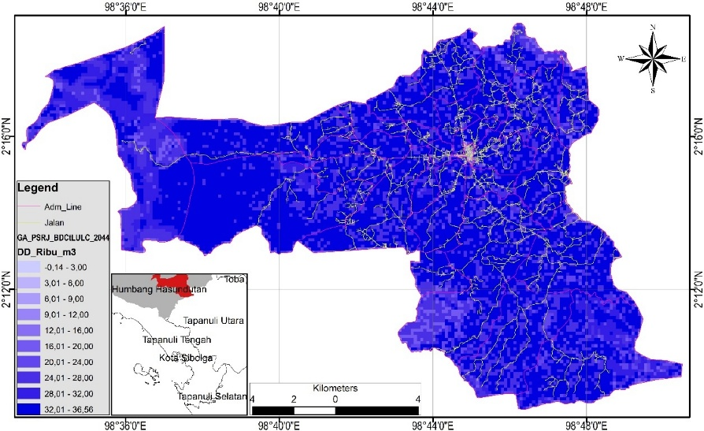

*Source: GIS-based grid overlay with runoff coefficient model*

From a planning perspective, this surplus groundwater availability provides a **strategic opportunity to support decentralized water supply systems**, especially in peripheral or low-density areas where piped systems are infeasible. Grids classified with >32,000 m³/year potential could serve as priority zones for non-piped SPAM (Sistem Penyediaan Air Minum) development, such as borewell systems or localized small-scale treatment units.

This hydrological surplus, if managed sustainably, can act as a buffer against projected shortfalls in piped water systems and offers a means of diversifying the water supply portfolio. Nonetheless, institutional capacity and abstraction monitoring will be critical to ensure long-term groundwater sustainability and ecological balance

**3.6. Summary and Implications for DMA Planning and SPAM Optimization**

This section synthesizes the results of spatial, demographic, hydrological, and service coverage analyses from 2024 to 2044, with a particular focus on the implications for District Metered Area (DMA) planning and optimization of water supply systems (SPAM) in *Kecamatan Doloksanggul*.

*3.6.1. SPAM Water Balance Assessment*

The water balance analysis highlights a pivotal shift in the supply-demand dynamic across the study horizon. While piped water systems maintain a surplus capacity until 2034, deficits are projected to emerge by 2039 and worsen significantly by 2044 due to accelerated demand growth outpacing incremental production increases and loss reduction efforts.

**Table 5.** SPAM Water Balance Projections in Kecamatan Doloksanggul (2024–2044)

|  |  |  |  |  |  |  |  |
| --- | --- | --- | --- | --- | --- | --- | --- |
| **Year** | **Population** | **Piped Coverage (%)** | **Demand (m³/year)** | **Production (m³/year)** | **Losses (%)** | **Balance (m³/year)** | **Status** |
| 2024 | 54,718 | 37 | 842,701 | 1,422,308 | 32 | +663,877 | Surplus |
| 2029 | 59,001 | 49 | 1,201,780 | 1,552,556 | 26 | +470,955 | Surplus |
| 2034 | 63,287 | 61 | 1,603,490 | 1,682,804 | 19 | +239,663 | Surplus |
| 2039 | 67,565 | 73 | 2,047,544 | 1,813,052 | 13 | –29,737 | Deficit |
| 2044 | 71,848 | 85 | 2,534,280 | 1,938,090 | 7 | –342,762 | Deficit |

*Source: Author's Calculation, 2024*

These findings underline the importance of leveraging early surplus years (2024–2034) to implement strategic improvements in infrastructure and operations. By 2039–2044, failure to address capacity constraints and non-revenue water (NRW) could result in service disruptions and declining coverage equity.

*3.6.2. DMA Prioritization Strategy*

DMA zoning analysis, based on SR grid density projections, supports a phased implementation approach. High-density zones—such as *Kelurahan Pasar Doloksanggul*—exhibit the greatest potential for NRW reduction and cost-effective service improvement.

**Table 6. Priority DMA Zones Based on SR Density (2044 Projection)**

|  |  |  |
| --- | --- | --- |
| **Rank** | **DMA Zone** | **SR Density (per Grid)** |
| 1 | Kel. Pasar Doloksanggul | 65.90 |
| 2 | Kel. Pasar Doloksanggul (Zone 2) | 55.75 |
| 3 | Desa Lumban Tobing, Sihite I | 9.81 |
| ... | ... | ... |
| 20 | Desa Sampean | 1.00 |

*Source: Grid-Based SR Spatial Model, 2024*

This prioritization enables utilities to concentrate initial DMA development in zones where monitoring, leakage control, and pressure management will yield the greatest operational benefits. Lower-density areas—such as Desa Sampean—are recommended for inclusion in later phases or supported via decentralized water supply systems, particularly where groundwater availability is high.

1. **CONCLUSION AND RECOMMENDATION**

This study presents an integrated spatial-temporal assessment of water demand, land use dynamics, groundwater availability, and service distribution in *Kecamatan Doloksanggul* over a 20-year planning horizon (2024–2044). The findings reveal a critical transition point in the water service landscape, wherein projected increases in demand—driven by demographic growth and urban expansion—will outpace existing supply capacities by 2039. Although current system conditions exhibit a temporary surplus, spatial disparities in service density and land development pressures underscore the urgency for preemptive planning. Groundwater remains a viable supplemental resource, but its sustainable utilization must be closely regulated to ensure long-term reliability and environmental balance.

To navigate the impending supply-demand imbalance, it is imperative that local authorities adopt a phased and spatially responsive approach to water infrastructure investment. Early years of surplus (2024–2034) should be leveraged to implement DMA zoning, improve hydraulic performance, and deploy targeted pressure and leakage control systems. Simultaneously, integration of high-yield groundwater zones into decentralized SPAM systems can improve coverage in low-density areas. These actions must be aligned with existing spatial development policies (RTRW), infrastructure plans (RPJMD), and long-term water safety strategies (RISPAM) to ensure institutional coherence and financial viability. A proactive, data-driven governance model will be essential to achieve equitable, resilient, and sustainable water service delivery across Doloksanggul.

Disclaimer (Artificial intelligence)

Option 1:

Author(s) hereby declare that NO generative AI technologies such as Large Language Models (ChatGPT, COPILOT, etc.) and text-to-image generators have been used during the writing or editing of this manuscript.

Option 2:

Author(s) hereby declare that generative AI technologies such as Large Language Models, etc. have been used during the writing or editing of manuscripts. This explanation will include the name, version, model, and source of the generative AI technology and as well as all input prompts provided to the generative AI technology

Details of the AI usage are given below:

1.

2.

3.

**References**

Dos Santos, S., Adams, E. A., Neville, G., Wada, Y., de Sherbinin, A., Bernhardt, E., & Adamo, S. B. (2017). Urban growth and water access in sub-Saharan Africa: Progress, challenges, and emerging research directions. Science of the Total Environment, 607–608, 497–508. <https://doi.org/10.1016/j.scitotenv.2017.06.157>

Grönwall, J., & Danert, K. (2020). Regarding groundwater and drinking water access through a human rights lens: Self-supply as a norm. Water, 12(2), 419. <https://doi.org/10.3390/w12020419>

de Sousa, C. O. M., de Souza, R. F., & Fouto, N. M. M. D. (2025). Key drivers of non-revenue water in developing countries: Insights from a multilevel study in Brazil. Cleaner Water, 3, 100078. <https://doi.org/10.1016/j.clwat.2025.100078>

Mwitirehe, J., & Kipruto, C. W. (2024). Analyzing non‑revenue water dynamics in Rwanda: Leveraging machine learning predictive modeling for comprehensive insights and mitigation strategies. Water Practice & Technology, 19(6), 2376–2398. <https://doi.org/10.2166/wpt.2024.145>

Kwon, S. H., & Lee, S. (2025). Resilient isolation valve system design considering water shortage equity of water distribution system. Journal of Disaster Science and Management, 1(2). <https://doi.org/10.1007/s44367-024-00002-y>

Mala-Jetmarova, H., Sultanova, N., & Savic, D. (2018). Lost in optimisation of water distribution systems? A literature review of system design. Water, 10(3), 307. <https://doi.org/10.3390/w10030307>

Anschütz, C., Ebner, K., & Smolnik, S. (2024). Size does matter: A maturity model for the special needs of small and medium-sized smart cities. Cities, 150, 104998. <https://doi.org/10.1016/j.cities.2024.104998>

Alkalsh, M. M. H., & Kliks, A. (2024). Enhancing Wireless Network Efficiency with the Techniques of Dynamic Distributed Load Balancing: A Distance-Based Approach. Sensors, 24(16), 5406. <https://doi.org/10.3390/s24165406>

Gunarathna, U., Xie, H., Tanin, E., Karunasekera, S., & Borovica-Gajic, R. (2023). Real-time road network optimization with coordinated reinforcement learning. ACM Transactions on Intelligent Systems and Technology, 14. <https://doi.org/10.1145/3603379>

Bouma, G., & Slob, A. (2014). How spatial planning can connect to river basin management. In G. Woltjer, E. Al (Eds.), Integrating water and land use: Perspectives and practical applications (pp. 219–233). Springer. <https://doi.org/10.1007/978-3-642-38598-8_12>

Cortinovis, C., & Geneletti, D. (2020). A performance-based planning approach integrating supply and demand of urban ecosystem services. Landscape and Urban Planning, 201, 103842. <https://doi.org/10.1016/j.landurbplan.2020.103842>

Joint Energy Transition Partnership Secretariat. (2023, November 21). Comprehensive investment and policy plan (CIPP). JETP Indonesia. <https://jetp-id.org/storage/official-jetp-cipp-2023-vshare_f_en-1700532655.pdf>