**Original Research Article**

**Credit and Forestry Cooperatives in Bulgaria: Historical Development, Economic Rule and Legal Framework and their contribution to sustainable development of rural and forestry regions**

.

ABSTRACT

This study examines the emergence, development and contemporary role of credit cooperatives in Bulgaria, focusing on their contribution to the sustainable development of rural and forest areas.

For the analysis, there are used the literature on the subject, the legal acts of the Republic of Bulgaria regulating the activity of credit co-operatives, the European legislation, regulations in the research area, data from the National Statistical Institute and from different Bulgarian Ministries, reports and materials of the World Council of Credit Unions (WOCCU).

A brief historical overview of the cooperative movement in the world, Europe and Bulgaria is provided.

In Bulgaria, according to statistics from 1944 over 76% of all co-operatives in the country fell into the category rural credit cooperatives.

The period 1948–1989 characterize cooperatives by the loss of their independence and by their institutional survival and their role as providers of social functions under the conditions of a planned economy.

After the 1990 there established in Bulgaria 33 rural credit cooperatives with a focus on microfinance with the support of EU. In the field of forestry was formed only 44 forest cooperatives, 38 of which are in the Rhodopes, region Smolyan. The share of private forests managed by forestry cooperatives is very small and according the legislation they cannot fulfil saving and credit activities.

In conclusion, cooperatives must consider as a modern and democratic tool for sustainable resource management, social solidarity and economic empowerment of marginalized communities. In the face of growing challenges to forestry – fires, erosion, climate change – the co-operative model offers a long-term solution based on collaboration, local knowledge and shared responsibility.

Forest owners in Bulgaria must be assisted in development the necessary changes in legislation and in the formation of new forestry cooperatives in regions with a large share of private forests.

*Keywords: Credit cooperatives, cooperative movement, forestry, microfinance, rural areas, legislation.*

1. INTRODUCTION

Credit unions are a special type of non-profit organisation based on the principles of mutual aid, democratic governance and social responsibility. They emerged in response to limited access to financial services for social and professional groups, particularly in rural and marginalised regions. In contrast to commercial banks, whose main objective is to generate profits for shareholders, credit unions place the satisfaction of their members' needs at the centre of their activities.

In the past, credit cooperatives have established themselves as one of the most effective instruments for mobilising local capital and providing accessible finance to small farmers and foresters, artisans, entrepreneurs and households. By combining economic efficiency and social commitment, the co-operative model is able to contribute both to the improvement of living standards and to the sustainable development of the areas in which it operates.

This article examines the emergence, stages of development and changes of credit co-operatives in Bulgaria, focusing on their application in the forestry sector. We pay particular attention to their contribution to economic activity in rural areas, their role as microfinance institutions and the challenges they face in today's regulatory and market environment. The aim is to identify opportunities to strengthen and expand the cooperative model through appropriate government and European support for the sustainable management of natural resources and social cohesion in the marginalised regions of the country.

2. material and methods

For the analysis, there are used the literature on the subject, the legal acts of the Republic of Bulgaria regulating the activity of credit co-operatives and the regulatory documents of the Bulgarian National Bank. There are also used the European legislation and regulations in the research area, data from the National Statistical Institute, Ministry of Agriculture and Food, Ministry of Economy and Ministry of Finance, reports and materials of the World Council of Credit Unions (WOCCU).

National legislation relating to the management and financing of credit cooperatives is analysed. There were used a systematic and comparative approach. Various research methods and techniques are used as tools: Abstraction, analysis and synthesis, systematic approach, comparison etc.

3. results and discussion

3.1. Origin and Models of Cooperatives in Europe and in Word

The co-operative movement in Europe has its roots in the socio-economic changes of the industrial age, when large sections of the population – farmers, artisans and workers – remained beyond the reach of commercial banks and utility companies. In response to these challenges, the first co-operatives emerged, based on the principles of voluntary participation, equality of members, mutual aid and local solidarity.

In 1844, a group of weavers in Rochdale, England, founded the world's first officially registered co-operative. In doing so, they laid the foundations for the so-called “Rochdale Principles”, which still form the basis of the international co-operative movement today (1). At this time, parallel forms of co-operatives with different functional orientations were developing in France and Germany – consumer, credit, production and insurance co–operatives.

Of particular importance is the development of two main models of credit co-operatives in Germany:

Friedrich Raiffeisen rural model, which originated in 1864 and is aim are farmers and owners in rural regions. This type of co-operative is strongly socially oriented, pays no dividends and works with the accumulation of capital from share deposits and savings (2).

Hermann Schulze-Delitzsch urban model, which founded in 1850 and is aim are artisans and small business owners in an urban environment. In contrast to the Raiffeisen model, it allows the distribution of profits and emphasises more intensive financial activity and cooperation with other institutions (3).

These two types of co-operatives laid the foundations for the so-called "dual co-operative system", which gradually spread to Austria-Hungary, Italy, Belgium, the Netherlands, the Scandinavian countries and the Balkans by the 1890s. In the 20th century, co-operatives strengthened their structures through the establishment of co-operative associations, national and European networks, including COGECA (Confederation of Agricultural Co-operatives in the EU), founded in 1959 (4).

Today, co-operatives in the European Union comprise over 130,000 companies with over 160 million members. Credit co-operatives account for around 13% of all co-operatives, but unite around 40% of co-operatives and carry out 16% of all banking transactions in the EU (5). They are establishing themselves as stable, long-term partners for small producers, particularly in rural and marginalised areas.

World Council of Credit Unions (WOCCU) established on Nov. 10, 1970 and began operations Jan. 1, 1971 is the only global trade association that represents the interests of credit unions and financial cooperatives at the international level (6).

Today, World Council acts as the leading voice for global advocacy and development on behalf of the international credit union community. World Council continues to promote economic freedom and the sustainable growth of financial cooperatives across the globe through education, collaboration and community-based development projects.

The data in Table 1 show that in the period from 2005 to 2023 members, credit unions and member countries of WOCCU increased significantly. The savings and shares, loans, reserves and assets increase about 4 times in the same period.

Table 1

Main economic data for WOCCU in the period 2005 -2023

|  |  |  |  |  |  |  |
| --- | --- | --- | --- | --- | --- | --- |
|  | Measure | 2005 | 2010 | 2015 | 2020 | 2023 |
| Credit unions countries | Numbers | 92 | 100 | 109 | 118 | 104 |
| Credit unions | Thousands | 42,7 | 53,0 | 60,6 | 86,5 | 74,6 |
| Members | Million | 157,1 | 188,0 | 222,8 | 375,2 | 411,0 |
| Savings and shares | Billion USD | 763,8 | 1229,4 | 1508,9 | 2690,2 | 3057,6 |
| Loans | Billion USD | 612,2 | 960,1 | 1242,4 | 2057,2 | 2596,4 |
| Reserves | Billion USD | 91,6 | 131,7 | 185,3 | 264,6 | 354,0 |
| Assets | Billion USD | 894,4 | 1460,6 | 1824,7 | 3207,7 | 3747,4 |
| Penetration | % | 6,6 | 7,5 | 8,3 | 12,2 | 13,5 |

Source: (7)

# The financial data for credit unions and financial cooperatives around the world point out that they has a stable and sustainable development during the period from 2005 to 2023. The penetration also increase from 6,6 to 13,5 %.

The analysis of the literature shows that credit cooperatives are developing successfully in all countries of Western Europe. In the countries of Eastern Europe (Hungary, Poland, Czechoslovakia, etc.) after the beginning of the transition from a planned to a market economy, credit cooperatives that existed before the Second World War began to be restored, as well as new ones to be formed (8, 9, 10, 11). It is characteristic of these countries that they develop new legislative documents for credit cooperatives, using the experience accumulated in the past as well as in the countries of Western Europe.

According to the state of credit cooperatives in the world, we can summarize that:

- the movement of credit cooperatives has common patterns of emergence and development;

- in economically developed countries, credit unions are represented by highly organized two- or three-tier systems that have significant importance in the financial market and have a serious impact on the socio-economic development of society;

- the cooperative credit system requires the formation of an internal infrastructure that provides a solution to organizational, legal, financial and social tasks;

- at a certain stage of development, credit unions and national systems of credit cooperatives need to create various types of associations and international organizations to implement the basic principles of self-organization and mutual assistance;

- the current state of the international community of credit cooperatives demonstrates dynamic progressive development, confirming the vitality of the cooperative and its relative advantages over other participants in the financial market.

The study of the theoretical foundations and foreign experience in the activities of credit cooperatives allows us to conclude that currently credit cooperatives in Bulgaria can and should develop. At the same time, it is imperative to ensure strict compliance with the basic principles of activity laid down in the classical cooperative theory, the requirements of the current legislation and the accumulated global and domestic experience.

The further dynamic development of credit cooperatives depends on their association at the regional and national levels, cooperation with the international credit cooperative movement, the dissemination of ideas for cooperation and assistance in solving the financial and social problems of the population.

**3.2. Origin and development of cooperatives in Bulgaria**

The co-operative movement in Bulgaria emerged at the end of the 19th century in connection with the growing economic need to unite small producers, artisans and farmers. The first co-operatives in Bulgaria emerged at the end of the 19th century and their growth was particularly intensive after the 1920s. Unlike in Western Europe, where co-operatives often emerged in urban areas, their origin in Bulgaria was mainly rural - due to the structure of society and the distribution of the means of production. At the end of the 19th century, more than 80% of the country's population lived in rural areas and agriculture formed the basis of the national economy.

The first Bulgarian cooperative was founded on 26 October 1890 in the village of Mirkovo in the Sofia region - "Mirkovo Loan, Savings and Agricultural Society "Oralo", although the beginnings of cooperative activity could already be observed in the 1880s. In the early 20th century, numerous rural consumer and credit cooperatives emerged, providing farmers with access to credit, fertilisers, equipment and markets. They developed under the influence of the German and Russian co-operative model, but quickly acquired a national distinctiveness (12).

The first cooperative law passed in 1907. It created a legal and organisational framework for cooperative activity. After 1920, the cooperative movement entered a phase of accelerated institutionalisation. Branches and regions as well as national structures such as the Bulgarian Agricultural and Co-operative Bank (BACB), which supported a significant part of the agricultural sector until 1947, founded co-operative associations. Rural credit and consumer co-operatives experienced particularly strong growth and accounted for more than 75 of the country's registered co-operatives in the early 1940s. In 1939, there were 3,320 co-operatives in Bulgaria, and by 1944, their number exceeded 5,000. In 1944, there were more than 70 types of co-operatives in Bulgaria (13, 14). The credit cooperatives play an important role not only in lending and procurement, but also in the establishment, the development and financing of social infrastructure – shops, community centres, schools and health centres as well as financially and materially helping their members.

At the same time, forestry co-operatives also developed, particularly in the mountain regions. After the adoption of the law on the sale of state forests in 1911 there were founded the first forestry cooperative. These associations enabled local residents and landowners to acquire shares in forests and manage them jointly. Forestry co-operatives are of particular importance in the mountain regions. Following the adoption of the Forestry Act in 1922 (15), they developed into labor-production cooperatives, concerned with the sustainable management, harvesting and processing of timber. The regional co-operative associations that emerged in Strandzha, the Rhodopes and the Pre-Balkans unite dozens of villages. The co-operative movement in forestry strongly developed in Strandzha, where the local co-operative unites 3 towns and 14 villages and operates six sawmills, a factory and a shipyard in Tsarevo for small sea vessels and exports wood and charcoal abroad (16).

**Table 2. Number of forestry cooperatives established during the period 1922 – 1945**

|  |  |  |
| --- | --- | --- |
| Periods | Number of forestry cooperatives | % |
| Since 1922 | 16 | 6.1 |
| 1923 - 1926 | 45 | 17.3 |
| 1927 - 1931 | 72 | 27.7 |
| 1932 - 1936 | 55 | 21.2 |
| 1937 - 1941 | 45 | 17.3 |
| 1941 - 1945 | 26 | 10.0 |
| Unspecified year | 1 | 0.4 |
| Total | 260 | 100.0 |

According to the statutes of the forestry labour and production cooperatives of 1936, the forestry cooperatives also carry out credit transactions in addition to their specific forestry activities.

The existence of a well-organised cooperative financial infrastructure supported the functioning of the cooperatives during this period. The Bulgarian Agricultural and Co-operative Bank (BACB), founded in 1904, worked closely with the co-operative structures and provided funding for co-operative initiatives on preferential terms. This gave the co-operatives financial independence and the ability to plan for the long term.

In the period between the two world wars, the co-operatives established themselves as an important economic and social unit in Bulgarian society. They established the link between individual ownership and collective interest and created a model for sustainable local development. Until 1944, co-operatives in Bulgaria operated with a high degree of autonomy and financial stability and perceived by the population as a trustworthy partner and source of security.

**3.3. The role of cooperatives until nationalization (1948)**

By 1948, the co-operative sector in Bulgaria had reached its highest historical level and had become a key element of the country's economic, social and cultural fabric. The co-operatives operated as multi-faceted institutions that carried out a wide range of activities - from procurement and lending to supporting their members in the fields of education, culture and even health. They not only facilitated economic life in the villages, but also played the role of a kind of social centre.

In 1945, the number of members of all forestry co-operatives was 31,451 and 205 forestry co-operatives were members of the Forestry Co-operative Association. In the period from 1945 to 1946, there founded 64 new forestry co-operatives with 15,000 new members.

During this period, rural consumer credit co-operatives were the most widespread and, according to statistics from 1944, over 76% of all co-operatives in the country fell into this category. They granted micro-loans on favourable terms, without the intermediation of private moneylenders, which significantly improved the financial security of the rural population. In addition, they also function as supply units, providing their members with fertilisers, seeds, equipment, building materials and other essential goods.

Parallel to them, specialised cooperatives also developed - dairy farming, viticulture, tobacco, beekeeping - which supported the association in production and ensured the realisation of production. The co-operatives often also owned processing plants - dairies, wineries, and distilleries - that enabled them to gain advantages and improve their market position.

In addition to their economic role, the co-operatives also fulfilled an important social function. They organised evening schools, literacy courses, community centres, theatre groups, offered health services, and community support. In this way, the cooperatives established themselves as the driving force behind the modernisation processes in rural Bulgaria.

By the end of this period, the co-operative movement in the country was characterised by a relatively high degree of autonomy, self-management and public trust. Due to this efficiency, cooperatives became the focus of state economic policy after the establishment of the new political regime in 1944, which subsequently led to their transformation into centrally administered structures.

**3.4. Cooperatives during socialism (1948–1989)**

The period after 1948 marked a sharp turn in the development of the co-operative movement in Bulgaria. With the adoption of the Law on the Management and Use of Forests of 27 March 1948 (17) and the general orientation of the socialist economy, there take extensive measures there to nationalise private property and transform the cooperatives into instruments of centralised planning. This ended the autonomous existence of the co-operative sector and subordinated it to state structures.

In the agricultural sector, the so-called mass co-operation took place, which began in the early 1950s. Private farmers were forced to join to Labor Agricultural Cooperative Farms (LCAF), often through administrative pressure, including violence and confiscation of working agriculture animals and working agriculture tools. By the end of the 1950s, there were over 2,500 co-operatives in Bulgaria with more than 500,000 co-operative families farming more than half of the country's arable land.

In the 1970s, there create agro-industrial complexes (AICs) - highly centralised production structures that integrated agriculture, processing, logistics and scientific services. The legal independence of co-operative farms practically abolished, and agricultural co-operatives do not function like traditional co-operatives despite their formal affiliation to the co-operative form.

The transformation of the forestry co-operatives took place in a similar way. In 1948, private forest ownership and the associated cooperatives were nationalised. The possibility of co-operative activity remained only within the framework of consumer and production co-operatives, which were active in light industry, trade and the service sector. They united in centralised associations and were subject to the guidelines of the Central Association of Cooperatives. Despite the formal decline of traditional co-operative autonomy, some co-operative structures survived and even adapted to the new circumstances. They participated in production chains, supplied the population with everyday goods, built cultural and household-related infrastructure facilities and sometimes even supported state social policy. In smaller settlements, the co-operative shops and production facilities remained the most important source of supplies and employment.

The Central Cooperative Union (CCU), which united and coordinated the activities of all consumer co-operatives in the country, played a key role during this period. Despite its dependence on the state administration, the CCU managed to preserve parts of the co-operative identity that formed the basis for the re-establishment of the independent co-operative movement after 1990.

To summarise, the period 1948–1989 is characterised by a two-dimensional development of cooperatives – on the one hand by the loss of their independence and subordination to state power, and on the other by their institutional survival and their role as providers of social functions under the conditions of a planned economy.

**3.5. Restart after 1990 and challenges**

After the changes in Bulgaria in 1989, the co-operative movement confronted with the need for a complete transformation as part of the transition from a planned to a market economy. The dismantling of the socialist production structures and the process of land and forest restitution posed numerous institutional, financial and administrative challenges for the co-operatives. Although the co-operative remained as a legal form, its role, functions and powers changed.

In 1991, a new law on co-operatives passed (18), which created a modern legal framework for the voluntary association of natural and legal persons with economic objectives. The law restored the autonomy of cooperatives by recognising their right to ownership, self-management and free participation in the market. However, the lack of specific provisions for credit co-operatives leads to a regulatory vacuum that hinders the restoration of their role in finance and credit.

Significant progress has been made through the pilot project "Agricultural Capital Fund Scheme", which was initiated in 1996 by the Ministry of Agriculture and Forestry with the support of the EU. As part of this programme, there established in Bulgaria 33 credit cooperatives based on the Raiffeisen bank model with a focus on regional coverage and microfinance (fig. 1). Of these, 32 are still operating successfully today and grant their members short-term loans on preferential terms. There establish also in Bulgaria an Association of Agricultural Co-operatives in Bulgaria to protect the interests of the co-operatives and supporting their adaptation to the new economic realities. These cooperatives, called Mutual Credit Cooperatives of Private Farmers, are entered in the register of the Bulgarian National Bank as a financial institution that carries out the activity of acquiring shareholdings (Art. 3, para. 2 of the Credit Institutions Act (19). In addition, their activities are also regulated by Decree of the Council of Ministers 343/30.12.2008 on the procedure for continuing the activities of mutual credit cooperatives of private farmers (20).

The remaining cooperatives, which were formed in accordance with the Cooperatives Act, do not have the right to carry out deposit and credit activities. Article 36, paragraph 3 of the Cooperatives Act stipulates: "The cooperative, by decision of the general meeting and by resolution of the Bulgarian National Bank, under the terms and conditions regulated in a special law, may carry out deposit and credit activities."

Despite the sector's efforts, mass privatisation, trade liberalisation and lack of access to capital have put cooperatives at a competitive disadvantage compared to the private sector and banks.

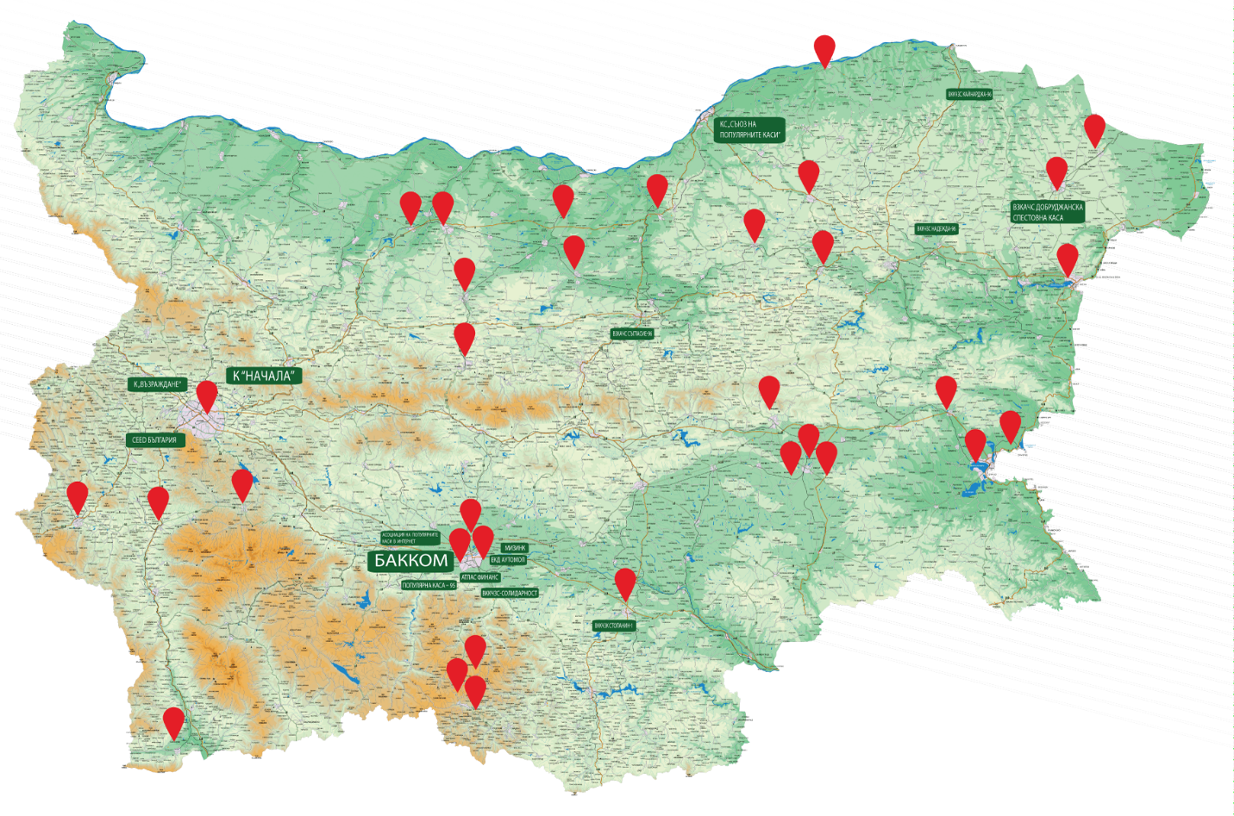

Fig. 1. Territorial distribution of agricultural credit cooperatives established under the Agriculture Capital Fund Scheme

Source: (21)

Newly established cooperatives must overcome the following challenges:

- Lack of specific legislation for credit activities.

- Low financial literacy of the population in the target regions.

- Mistrust of the co-operative model due to negative historical experiences from the socialist era.

- Limited opportunities for access to investment and European projects.

Against this backdrop, co-operatives survive thanks to their local character, social capital and traditions of community solidarity, which continue to play an important role in rural and forestry areas.

**3.6. Forestry cooperatives: potential and limitations**

Forestry co-operatives are a unique instrument in Bulgaria to unite owners of small forest plots for the purpose of effective and sustainable management of forest resources. They combine elements of social economy, the traditional practise of joint management and modern principles of collective ownership and economic efficiency. The revival of these structures after 1997 is due to legal changes related to the restoration of ownership rights to forests in cooperatives that been dissolved during nationalisation.

Ownership of the forests that was managed by cooperatives before nationalization isn’t returned to the individual heirs, but to the co-operatives themselves – their legal successors, which creates a legal opportunity to resume their activities. This is especially true for regions with historical traditions in the co-operative movement – the Rhodopes, Strandzha, the Pre-Balkans and other mountainous regions where private forest ownership is highly fragmented and independent management is economically inefficient.

Till now in Bulgaria was formed only 44 forest cooperatives, 38 of which are in the Rhodopes, region Smolyan, where before nationalization the management of private forests was taken place mostly by forest cooperatives (fig.2).

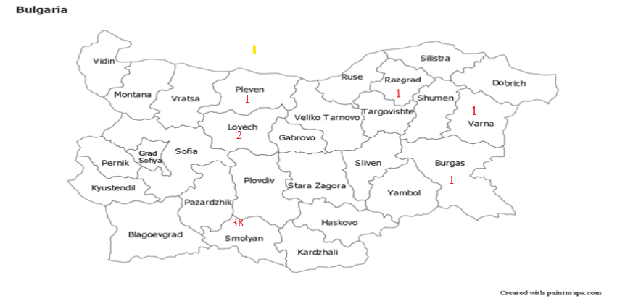

Fig. 2. Distribution of number of forest cooperatives in Bulgaria by regions

The area which is managed by cooperatives in region Smolyan is 26635 ha (10% from total area of region’s forests) and 56,7 % from the total private forests in the region.

The area of private forests in Bulgaria is 377580 ha (9,55% from the total forest area) and the share of the cooperative forests is about 7 % from the private forests in the country. Distribution of area of non-state forests (private forests of individuals and legal entities, forests owned by municipalities, forests of public organizations, forests managed by municipalities, forests owned by religious organizations, forests, foreign property and forests in co-ownership) in % by regions is showed on fig.3.

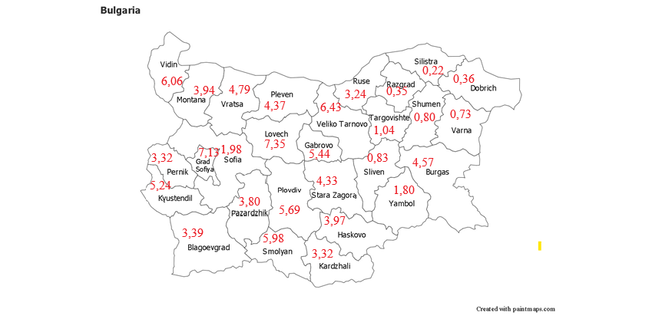

Fig. 3. Distribution of forest area of non-state forests by regions in %.

Source: (22).

The distribution of area of non-state forests by regions is very uneven. The largest area of ​​non-state forests is in the districts of Lovech, Sofia region, Veliko Tarnovo, Vidin and Smolyan. Of these districts, forestry cooperatives have been formed only in Smolyan region. Data from fig. 3 shows that in Bulgaria, as well as in most of the countries in Europe, the main problem of non-state forestry is the small size of the properties (average area is 0,72 ha and there are no properties larger than 10 ha.

This leads to some problems in the management, use and reproduction of forests, which can be overcome through the mechanisms of association, cooperation and land consolidation.

As can be seen from the data, the share of private forests managed by forestry cooperatives is very small. The experience gained by forestry cooperatives shows that they successfully carry out mainly logging activities, processing and selling wood. All forestry cooperatives pay their members rent for the managed areas, as well as dividends from the profits received. The practice of forestry cooperatives shows that they form cash funds (reserve, investment and for fire prevention and silvicultural activities), the funds from which are used for sustainable management of their forests. In addition, all cooperatives allocate funds to support socially disadvantaged and sick members of the cooperatives, as well as to support the activities of schools and churches and the holding of traditional local holidays.

The forest co-operatives has potential in several directions:

Economic integration: the co-operative form offers smallholders access to technology, infrastructure, market information and collective market power.

Sustainable management: Co-operatives can implement forest management plans, certification schemes (e.g. FSC) and good practices to combat erosion, fires and illegal logging.

Social cohesion: By mobilising the community, cooperatives re-establish traditions of solidarity and shared responsibility for natural resources.

Despite this potential, there are still significant limitations:

Insufficient legal support: – There are no specific legal provisions for forest co-operatives and especially for their credit functions. The existing law on co-operatives does not take into account the specificities of community forest management.

Financial barriers: Access to bank credit is limited due to the underestimation of co-operative risk by commercial banks. There is no specific state or European instrument geared towards small forest cooperatives.

Organisational instability: In some areas, cooperatives are barely active or formal due to a lack of leadership, administrative capacity and transparency.

Social scepticism: In some cases, negative memories of collectivisation during the time of socialism hinder the willingness of owners to join forces.

From a territorial development perspective, forest cooperatives could become centres for the sustainable use of the forest bioeconomy – through timber harvesting and processing, the collection of non-timber forest products, the development of forest tourism and the implementation of biomass energy solutions. However, to unlock this potential, private forest owners must to establish forest cooperatives and these cooperatives need to integrate into rural development strategies and become beneficiaries of the circular and green economy.

**3.7. Economic importance and social contribution**

Credit and forestry cooperatives may to play a significant role in stimulating economic activity and social development in rural and mountainous areas of Bulgaria. They may act as microfinance institutions, while at the same time performing the function of a social buffer that reduces the vulnerability of the population to market and natural risks. In conditions of limited access to banking services, high thresholds for entry into markets and fragmented ownership, cooperatives can to provide an alternative for participation in economic life under fair and mutually beneficial conditions.

Credit cooperatives function as microfinance institutions, providing affordable loans with minimal fees and low interest rates. They promote self-employment, investment in agriculture and forestry and the improvement of the living environment. Their advantage is flexibility, local connection between members and democratic governance - each member has one vote, regardless of their capital.

**3.7.1. Economic functions**

Credit cooperatives provide their members with small-scale financing that meets their current needs: agricultural and forestry activities, short-term investments, repairs, children's education, covering seasonal expenses, etc. The size of the loans usually varies between 500 and 2500 Euros, and the terms and conditions include:

- Minimal or symbolic membership fees.

- Simplified application process without collateral.

- Low interest rates.

- No penalty fees for early repayment.

In addition to loans, cooperatives offer savings storage, mutual assistance in disasters (e.g. fires, storms) and services related to forestry - from planning and harvesting to transport and sale of wood.

Forestry cooperatives can also carry out collective market activity by negotiating with customers and logging companies on behalf of their members. This ensures a higher purchase price and reduces the risk of unfair practices. Some cooperatives develop activities for the utilization of non-timber forest resources, including the collection and processing of herbs, wild fruits, mushrooms, bee products and hunting tourism.

**3.7.2. Social and cultural role**

Cooperatives also play a significant social role – by building trust, strengthening social capital and encouraging participation in public life. They often also perform informal educational functions, by training members in basic economic and legal knowledge, property management and sustainable management. In many small settlements, the cooperative remains the only active legal entity that organizes local initiatives, applies for projects and represents the interests of people before institutions.

From the point of view of territorial cohesion, cooperatives contribute to:

- Retaining the young population by creating income and employment opportunities.

- Preventing depopulation in economically and demographically vulnerable areas.

- Mobilizing local resources and initiatives without external pressure.

- Increasing trust in democratic self-governance mechanisms.

This dual function – economic and social – distinguishes cooperatives from ordinary commercial companies. Thus, they are a particularly valuable tool in policies for sustainable development, social economy and bioeconomy.

**3.8. Legislative and Regulatory Issues**

Despite the deep historical roots and proven contribution of credit and forestry cooperatives in Bulgaria , their full potential remains unrealised in today's economic and social context due to a number of legal and institutional barriers. One major problem is the lack of a specific legal regulation for credit cooperatives that takes into account the specificities of their activities and distinguishes them from other cooperative forms of organisation. Credit cooperatives suffer from the lack of a specific law regulating their activities. The draft law presented in 2001 was never discussed by Parliament. This leads to legal uncertainty, limited market access and restricted development opportunities.

**3.8.1. Shortcomings in the current legislation**

According to the current Cooperatives Act (23), credit cooperatives fall under the general category of voluntary associations of natural and legal persons for carrying out an economic activity. The law contains no definition, requirements or control mechanisms to ensure the financial stability, accountability and protection of depositors in these co-operatives. This has the following consequences:

- There is no clear distinction between savings and credit co-operatives.

- There are no specific regulations for registration, licencing and supervision.

- There are no requirements for capitalisation, liquidity and accountability.

- There is no provision for a supervisory or deposit protection authority (similar to the Bulgarian National Bank or the Financial Supervision Commission).

This legal loophole leads to legal uncertainty, low institutional trust and restrictions on access to public funds.

**3.8.2. Failed reform attempts**

In 2001, a draft law on credit co-operatives (24) was drawn up with the aim of creating a legal framework similar to that in the EU countries. The draft law provided for a definition of a credit co-operative, membership rules, capital requirements, official supervision and mechanisms for state control. Despite consultations with experts from the co-operative sector, the draft wasn’t submitted for discussion in the National Assembly and received no political support.

At the same time, European and international standards require a clear regulatory demarcation of microfinance institutions, including credit cooperatives, which fall under the social economy. Moreover, Directive 2013/36/EU of the European Parliament and of the Council of 26 June 2013 on access to the activity of credit institutions and the prudential supervision of credit institutions and investment firms, amending Directive 2002/87/EC and repealing Directives 2006/48/EC and 2006/49/EC states: “(49) …In order to ensure a sustainable and diverse banking culture in the Union, which primarily serves the interests of Union citizens, small-scale banking activities, such as those of credit unions and cooperative banks, should be encouraged (25). Reports by the FAO, 2025 (26), COGECA, 2021 (5) and the European Commission, 2023 (27) emphasise the need for regulatory separation, the protection of savers and incentives for the development of cooperatives in rural areas.

**3.8.3. Lack of institutional support**

In addition to the regulatory obstacles, cooperatives also have to contend with administrative and procedural hurdles:

- Limited access to programmes from the Ministry of Agriculture and Food, the Ministry of Environment and Water Resources and to EU funds.

- Lack of prioritisation in rural development strategies.

- Lack of awareness of the co-operative model among local administrations and banking institutions.

- Lack of national coordination and statistical monitoring of the sector.

All this means that co-operatives occupy a marginal position compared to other economic entities, despite their proven contribution to social cohesion, the circular economy and the sustainable use of resources.

**4. Conclusion and recommendations**

The historical and current role of credit and forestry co-operatives in Bulgaria is an important but underestimated resource for the sustainable development of rural and mountain areas. The experience of co-operatives in the 20th century combined with the social and economic challenges of the present – such as depopulation, fragmented ownership, limited access to finance and increased climate risks – make the co-operative model particularly relevant.

The restoration and modernisation of the cooperative sector, especially in forestry, can play a key role in achieving national and European goals:

- Sustainable forestry.

- The development of the circular bioeconomy.

- Strengthening the social economy and local self-government.

- Implementing the Green Deal and the Biodiversity Strategy 2030.

Specific strategic and regulatory steps are required to unlock this potential byl:

- Adoption of a specific law on credit unions that defines their activities introduces governance, accountability and control requirements and ensures depositor protection.

- Institutionalise support for forestry cooperatives through their inclusion in national and regional development programmes, access to subsidies and preferential financing.

- Building management capacity – through training, advisory support, information campaigns and platforms for the exchange of best practises between co-operatives, NGOs and research institutes.

- Supporting the digitalisation and certification of cooperative activities, which improves their transparency, efficiency and competitiveness in the market.

- Creation of a national association or network of forest cooperatives to represent the interests of the sector, participate in consultations with institutions and play a role in strategic planning.

Cooperatives must not consider as a relic of the past, but as a modern and democratic tool for sustainable resource management, social solidarity and economic empowerment of marginalised communities. In the face of growing challenges to forestry – fires, erosion, climate change – the co-operative model offers a long-term solution based on collaboration, local knowledge and shared responsibility.

Forest owners in Bulgaria must be assisted in implementing the necessary changes in legislation, in the formation of new forestry cooperatives in regions with a large share of private forests, as well as in expanding their activities for sustainable and profitable management of private forests.

COMPETING INTERESTS DISCLAIMER:

Authors have declared that they have no known competing financial interests OR non-financial interests OR personal relationships that could have appeared to influence the work reported in this paper.

Disclaimer (Artificial intelligence)

Author(s) hereby declare that NO generative AI technologies such as Large Language Models (ChatGPT, COPILOT, etc.) and text-to-image generators have been used during the writing or editing of this manuscript.

References

1. Fairbairn, Brett (1994). The Meaning of Rochdale: the Rochdale pioneers and the co-operative principles (PDF). Saskatoon, Saskatchewan: Centre for the Study of Co-operatives. p. 32. ISBN 9780888803177. <https://ageconsearch.umn.edu/record/31778/?v=pdf>
2. ICA.COOP, 2025, Friedrich Wilhelm Raiffeisen, <https://ica.coop/en/friedrich-wilhelm-raiffeisen>
3. Popov Ivan, 2016, Credit Cooperatives - the Genesis of Ethical Finance, Paper presented at the International Conference "Ethical Finance and Digital Technologies" on 27.09.2016 at the Plovdiv International Fair. (Bg), <https://baccom.eu/2016/10/03/%D0%BA%D1%80%D0%B5%D0%B4%D0%B8%D1%82%D0%BD%D0%B8%D1%82%D0%B5-%D0%BA%D0%BE%D0%BE%D0%BF%D0%B5%D1%80%D0%B0%D1%86%D0%B8%D0%B8-%D0%B3%D0%B5%D0%BD%D0%B5%D0%B7%D0%B8%D1%81-%D0%BD%D0%B0-%D0%B5%D1%82%D0%B8/>
4. <https://copa-cogeca.eu/about-cogeca>
5. COGECA (2021). Cooperative Banks and Agricultural Cooperatives in the EU: Structure and Importance. Brussels: Confederation of Agricultural Cooperatives. <https://copa-cogeca.eu/>
6. <https://www.woccu.org/about/history>
7. 2005, 2010, 2015, 2020, 2023 Statistical report, https://www.woccu.org/member_services/our_network/statreport
8. Vig Zoltan, 2020, Comparative analysis of the current cooperative regulation in Hungary, MTA Law Working Papers 2020/23, <https://real.mtak.hu/121748/1/2020_23_Vig.pdf>
9. Zakrzewski Piotr, 2020, Legal Framework Analysis - National Report Poland, ICA-EU Partnership, Cooperatives Europe, <https://coops4dev.coop/sites/default/files/2021-03/Poland%20Legal%20Frameworks%20Analysis%20Report%20.pdf>
10. Nĕmcová Lidmila, 2005, From Solidarity to Robbery: Credit Cooperatives in Czechoslovakia, Finance & Bien Commun, 2005/1 No 21, <https://shs.cairn.info/revue-finance-et-bien-commun-2005-1-page-101?lang=en>
11. Karafolas Simeon, 2005, Development and Prospects of the Greek Cooperative Credit System, JOURNAL OF RURAL COOPERATION, 33(1) 2005:3-20, ISSN 0377-7480, <file:///D:/Downloads/Development%20and%20Prospects%20of%20teh%20Green%20Cooperative%20Credit%20System.pdf>
12. Kostadinova Evelina, The First Bulgarian Cooperative, Zemya newspaper, October 4, 2012, (BG), <https://www.cks.bg/uploads/storage/%D0%B2%D0%B5%D1%81%D1%82%D0%BD%D0%B8%D0%BA%20-%D0%B7%D0%B5%D0%BC%D1%8F/04_10_2012.pdf>
13. Treneva M., 1992, History and Theory of Cooperatives, University Publishing House Stopanstvo, Sofia, ISBN 954-494-031-5, (BG). <https://scholar.google.bg/scholar?hl=bg&as_sdt=0%2C5&q=%D0%9C%D0%B0%D1%80%D0%B8%D1%8F+%D0%9F%D0%B5%D1%82%D1%80%D0%BE%D0%B2%D0%B0+%D0%A2%D1%80%D0%B5%D0%BD%D0%B5%D0%B2%D0%B0&oq>=
14. Zlatev Z., 1999, The Cooperative Movement, pp441-451, In Bulgaria 20th Century: Almanac ,- edited by Filip Panayotov, IK Trud, (BG). <https://books.google.bg/books?id=j3UslQH52OsC&printsec=frontcover&hl=bg#v=onepage&q&f=false>
15. Law on Forests, 1922, Approved by Decree of Tsar Boris III of April 20, 1922, Published in the State Gazette, Issue 24/1922, (BG). <https://re.lex.bg/forum/viewtopic.php?p=129646>
16. RAYCHEVSKI Stoyan, 2016, FORESTRY COOPERATIVES IN STRANDZHA (1922–1944), , pp 55-68, In: GOVERNING THE COMMONS AND COOPERATIVES: Contemporary Issues, Edited by Sinisa Zaric and Vojislav Babic, JOURNAL OF SOCIAL SCIENCES AND HUMANITIES, Broj 3/2016, Publisher: HERAedu, ISSN 1820-0869 <file:///D:/Downloads/Limes---Economic-Principies---za-stampu.pdf>
17. Forest Management and Use Act (March 27, 1948), (BG). <file:///D:/Downloads/17062025000000_10_8319%20(4).pdf>
18. Law on Cooperatives. State Gazette, issue 63 of 03.08.1991, (BG). <https://www.ciela.net/svobodna-zona-darjaven-vestnik/document/2132573697/issue/2656/zakon-za-kooperatsiite?resolution=detected>
19. Credit Institutions Act, SG, 59/21.07.2006 (BG), <https://www.bnb.bg/bnbweb/groups/public/documents/bnb_law/laws_creditinstitutions_bg.pdf>
20. Decree of the Council of Ministers 343/30.12.2008 on the procedure for continuing the activities of mutual credit cooperatives of private farmers, SG, 4/16.01.2009, (BG), <https://pris.government.bg/document/b36d262bd7f55d2cf481d0c9d5b8e922>
21. <https://baccom.eu/%D0%BF%D0%B0%D1%80%D1%82%D0%BD%D1%8C%D0%BE%D1%80%D1%81%D1%82%D0%B2%D0%BE/>
22. Domuschiev N., Economic assessment of non-state forests in Bulgaria according to the management pdfsystem and their size. Dissertation abstract., Sofia, 2017. https://ltu.bg/images/files/file/Fakulteti/SU/Doctoranti/N_Domuschiev/Abtoreferat_Nestor_Domuschiev.pdf
23. Law on Cooperatives, SG 113, 28.12.1999, <https://lex.bg/laws/ldoc/2134696966>
24. Law on Credit Cooperatives and associations - project 2001, (BG). <https://www.bsdp.bg/document/?document_id=101>
25. Directive 2013/36/EU of the European Parliament and of the Council of 26 June 2013 on access to the activity of credit institutions and the prudential supervision of credit institutions and investment firms, amending Directive 2002/87/EC and repealing Directives 2006/48/EC and 2006/49/EC Text with EEA relevance, https://eur-lex.europa.eu/eli/dir/2013/36/oj/eng
26. FAO 2025, Forest Producer Organisations, <https://www.fao.org/forestry/our-focus/forests-people/producer-organizations/en>
27. Еuropean Commission (2021). EU Forest Strategy for 2030 –. <https://eur-lex.europa.eu/legal-content/EN/TXT/HTML/?uri=CELEX:52021DC0572>