**Evaluation of the antifungal chitinase activity of *Bacillus mycoides* isolated from the ancient ruins of the Red Mosque**

**Abstract**

Background: *Lal Masjid* (Red Mosque) is located in Haroa area of North 24 Parganas, West Bengal, India in the ancient port city of Chandraketugarh, representing the Gangaridai of Greaco-Roman accounts. Originally a Buddhist Stupa,which was afterwards converted into a Masjid, commonly known as Lal Masjid. Although the ruins are neither protected nor under routine surveillance; there is no fungal invasion so far.

Materials and Methods: We collected swabs from the surfaces of the ruins of the Lal Masjid and culture the collected swabs on different bacteriological media to isolate microorganisms.

Results: Ultimately, we could isolate *Bacillus mycoides* – a bacterium with known antifungal properties. The culture suspension and filtrate of this bacterium showed significant zone of inhibition against *Candida albicans* (11.0 mm) and *Candida parapsilosis* (8.5 mm) (which was also confirmed by the MIC results; MIC ~ 10<5-7 *Bacillus mycoides* per gram). Further chitinase study with *Bacillus mycoides* against both natural and synthetic chitin delineated the chitin-degrading properties of the microbe.

Conclusion: Chitinase activities of *Bacillus mycoides* prevent fungal growth on ancient ruins of Lal Masjid.

Key words: Chitinase, Lal Masjid, *Bacillus mycoides*, *Candida albicans*, *Candida parapsilosis*.

1. **INTRODUCTION**

Microbial archaeology is an emerging field of study in this age playing a huge role in decoding the details associated with these undiscovered archaeological sites (Warinner et al. 2017). With archaeological microbiology, we get a thorough understanding of all the microorganisms residing here including bacteria, viruses, fungi, protozoa, parasites, etc (Laura et al. 2023). One such key bacteria that was found after 16srRNA gene sequencing of soil samples collected from the sculptures among the ruins of Chandraketugarh is *Bacillus mycoides* (Chatterjee et al, 2025), its antifungal chitinase activity study is the main focus of this research. *B. mycoides* is a non-pathogenic, rod-shaped, filamentous, gram-positive bacterium that is found ubiquitously in the soil. It is mainly a facultative anaerobe which explains its presence amid the ruins. *B. mycoides* is a part of the group *B. cereus*, but unlike its other well-known members like *B. Anthracis* and *B. thuringienis*, there is very little study on this specific species (Ghazal et al., 2013). Despite being non-pathogenic in nature *B. mycoides* proves to have value both organically and economically. Studies include the usage of the bacteria in the field of biocontrol specifically with PGPR (plant growth promoting rhizobacteria) ability, as an eco-friendly biocontrol against plant pathogens, and as an effective bio-surfactant. However, research is lacking focusing on the strains of *B. mycoides* that have the capability of producing chitinase, which makes it a potential biological fungicidal agent against both plant and human fungal pathogens (Goodwin et al., 1994) (Yi et al. 2018).

As it is known chitin is the chief composition of the fungal cell wall and a major target site of almost all crucial antifungal drugs because of its absence in the human and other craniates. But with antimicrobial resistance being a great threat worldwide, hostile fungal infections tend to be a very pivotal danger to mankind. With fleeting time, undetected usage and ready accessibility of antibiotics, pathogenic fungal strains are growing into resistance towards practically all antifungal drugs (Lenardon et al., 2010) (Brown et al., 2020). Hence, there is a dire necessity to find new drugs that will prove to be potent and functional against these resistant fungal pathogens. Furthermore, antifungal drugs are already scarce in number and with the emerging problem of drug resistance it has become difficult to treat patients successfully, this brings us to the need to find new remedies (Cowen et al., 2024). WHO published a Fungal Priority Pathogen List (FPPL) in 2022 to bring light and acknowledge this issue of antifungal resistance which affects annually roughly 6.5 billion people (Rhijn et al., 2024). Predominant treatment includes generally 4 classes of antifungal drugs that are used systematically namely polyenes, azoles, echinocandins, and 5-flucytosine. Resistance has been shown against all four classes of these drugs by pathogenic strains of *Aspergillus.* spp*, Candida.* spp, and several others. Individuals are regularly exposed to various airborne pathogenic fungal spores and thus are prone to diseases; this raises a greater concern and gives us more reasons to find new and useful antifungal agents as soon as possible (Fisher et al. 2022).

Chitinases are a group of enzymes which can break chitin – a major component in fungal cell walls. These enzymes are produced by many microorganisms – Actinobacteria, green and purple bacteria, *Streptomyces* spp. etc. among them *Bacillus* spp. are most important because they do not depend on interaction of chitin-binding proteins. Chitinases of *Bacillus* spp. can destroy fungal cell walls completely within 36 hours. These enzymes are glycosyl hydrolases and they cleave the glycosidic bonds in chitin. Ultimately there are formation of N-acetyl-D-glucosamine and chitooligosaccharides. Other than the general classification of exochitinases and endochitinases, they are further classified as 1,4-β-glucosaminidases and chitobiosidases. . Chtinases are grouped in different glycoside hydrolases (GH) depending on amino acid sequences. Among them bacterial GH18 chitinases are separated into three major subfamilies – A,B,C. Due to structural similarity the lytic pathways of chitin and cellulose run in parallel steps.

This brings us to our study with *Bacillus mycoides*, a bacterium that has chitinase activity and therefore has the potential to be an active biological antifungal agent. In this study, we will evaluate the antifungal action and chitin degrading activities of this microbe isolated from an ancient ruin of *Lal Masjid*.

**2. MATERIALS AND METHODS**

Ten swab samples were collected from different areas and they were kept in sterile containers for transport after proper labelling. The samples were collected by gentle rotation on the surfaces of the artifacts. After culture on different media we isolated *Bacillus mycoides* and confirmed it by 16sRNA sequencing (Chatterjee et al.,2025).

**2.1 Gra****m Staining:**

After the samples were collected, possible presence of microorganisms was to be detected. To do this gram staining was done to those that showed distinct colonies on blood agar, nutrient agar and Mueller Hinton Agar. This allowed us to make sure the filamentous colony observed was of a facultative anaerobe bacterium is *B.**mycoides.* Details of these findings are mentioned by Chatterjee et al, 2025. Gram’s stain was used so that to confirm the colonies of *B. mycoides* only for this study.

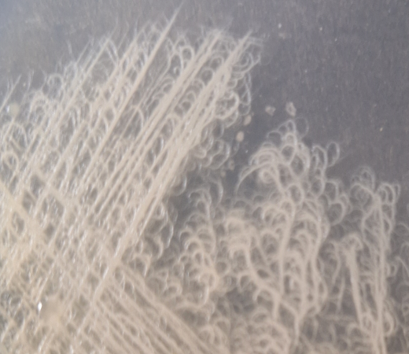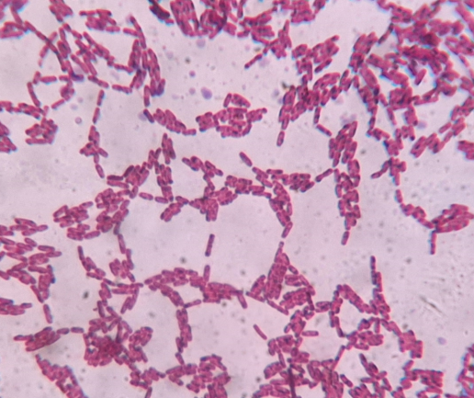

|  |
| --- |
| ***FIG 1. Bacillus mycoides* colony morphology** |

|  |
| --- |
| ***FIG 2. Bacillus mycoides* under 1000x magnification** |

**2.2 Preparation of** ***Ba******cillus mycoides* supernatant:**

To prepare the supernatant from the microorganism, which contains the all-bioactive compounds, loopful of *B.**mycoides*was inoculated in test-tube containing peptone broth as medium and was incubated for 30hrs at 37ºC as *B.mycoid*es show peak growth after 30 hrs (Andriani et al. 2017) with formation of maximum bioactive metabolites. The bacterial suspension was then centrifuged at 13000 rpm for 5 minutes. The supernatant (produced by ~ 108 bacteria per ml) was carefully pipetted out and was passed through 0.2-micron syringe filter and stored at -20ºCfor further usage.

**2.3 Dis****c and agar well diffusion assay:**

This assay is done to determine the antimicrobial efficacy and, in this study, particularly antifungal efficacy of *B**. mycoides.* First Mueller Hinton agar plates are inoculated with suspensions of *Candida albicans, Candida parapsilosis* individually. These fungi were ATCC 10231 and MDR strains respectively identified in Vitek 2 automated system. Then three sterile filter paper discs were placed on each agar plates or wells are punched out on each plate. Then they are presented with 50µl of peptone broth, 10 µL 0.5 McFarland *B. mycoides* bacterial suspension and 10 µL *B. mycoides* supernatant respectively. These plates are then incubated for 24 hrs at 37 ºC and the zones of inhibitions were measured with standard scale of HiMedia.

**2.4 Minimum Inhibition** **Concentration assay:**

In order to perform the MIC assay of *Bacillus mycoides* against fungal pathogens *Candida albicans* and *Candida parapsilosis*, 96 well plates were used. 100µl each of peptone broth, 0.5 McFarland *B.* *my**coides*bacterial suspension (~ 108 bacteria per ml) and *B. my**coides* supernatant was added to three consecutive column each and serial dilution was done. Then 10µl fungal suspension (~ 106 per ml) of *Candida albicans and Candida parapsilosis* was added individually to all wells. The O.D was taken at 660nm at 0 hrs and again after 24hrs of incubation at 37ºC.Calculations were done by subtracting the 0 h O.D. from 24 h O.D. and the graphs were plotted.

**2.5 Natural chitin preparation from shrimp shells:**

For determining the chitinase activity of *Bacillus* *mycoides*, chitin was prepared from shrimp shells available in the local market. To do so, first the shells were collected and washed thoroughly and grinded well using mortar and pestle to make it into fine powder. This was weighted properly and to it was added 5 volumes of 1N HCl and kept. This step was repeated after 3 hours and the mixture was kept overnight. Then it was washed properly several times with distil water to wash away unwanted any unwanted minerals and dried for an hour. Then 5 volumes of 5% NaOH was added and heated at 75ºC in the water bath to deproteinise it. Lastly, it was again washed properly and cautiously with distilled water at kept at 65ºCovernight. The material obtained was natural chitin confirmed by Van Wisselingh Test with iodine, purity is high as observed by spectroscopic and microscopic observations, which was then used for future experimentations (Islam et al. 2016).

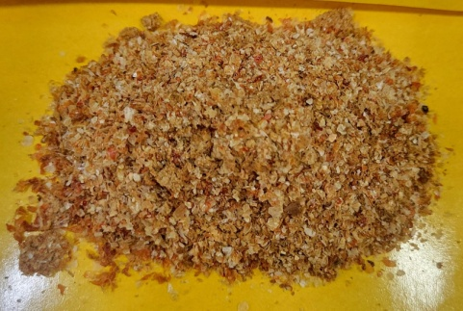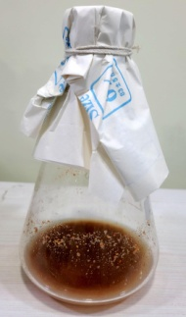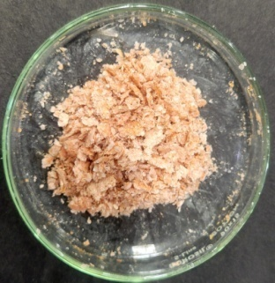

|  |
| --- |
| **FIG 3. Preparation process of natural chitin from shrimp shells. Left to right: shrimp shells, treatment with NaOH and purified chitin.** |

**2.6 Evaluating** **chitinase activity of *Ba******cillus mycoides*****against natural versus synthetic chitin by measuring optical density:**

To measure the chitinase activity of *Bacillus mycoides*, three experiential sets for both natural and synthetic (HiMedia) chitin [molecular formula (C8H13NO5)N] with high purity (sulphated ash <= 5.00%) individually were taken: control set (with chitin powder 1% and 1% saline water), *B.* *my**coides* bacterial suspension set (with 1% 0.5 McFarland *B. mycoides* bacterial suspension, chitin powder 1% and 1% saline water) and *B. mycoides* supernatantset (with 1% *B. mycoides* supernatant, chitin powder 1% and 1% saline water). Optical densities were observed using spectrophotometer at 640nm at intervals of every 15 minutes from 0-1 hour. This data was noted down to plot a graph (Shafiq et al. 2024). Chitinase activities was confirmed by detecting reducing sugars after breakdown.

**2.7 Difference in chitin degrading activity of *Bacillus mycoides*against natural versus synthetic chitin:**

In a sterile petri plate, 1% chitin power (both natural and synthetic separately), 0.5% normal saline and 1.5% agarose are to be taken and allowed to solidify. Then sterile filter paper discs are placed on each plate which were previously inoculated with 0.5 McFarland *B. mycoides* bacterial suspension and *B. mycoides* supernatant discretely. They were then incubated at 37ºC for 24hrs and the growth of *Bacillus mycoides* was observed under the microscope. With the only source of nutrition being chitin, in order to grow *B. mycoides* must degrade the available chitin, this gives us our desired experimental results.

**3. RESULTS**

**3.1 Disc and agar well diffusion assay:**

There was zone of inhibitions observed for all the four fungal strains tested against *Bacillus mycoides*. The zone of inhibition measured for 0.5 McFarland *B. mycoides* bacterial suspension against *Candida albicans* was 11.0 mm, that of *Candida* *parapsilosis* was 6.25mm and for *B. mycoides* supernatant against *Candida albicans* was 6.0 mm, that of *Candida parapsilosis* was 8.5mm. This brings us to the understanding that *Bacillus mycoides* is an effective antifungal agent as it is capable of inhibiting the growth of these fungi.

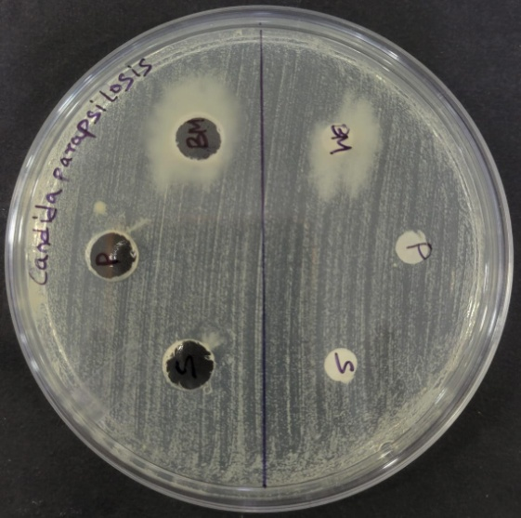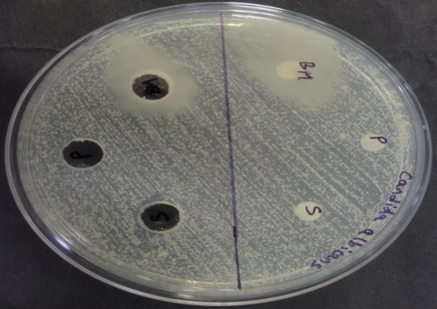

|  |  |
| --- | --- |
|  |  |

|  |  |  |
| --- | --- | --- |
| **FIG 4. Zone of inhibition shown by *Bacillus mycoides* against *Candida parapsilosis*.** | |  | | --- | | **FIG 5. Zone of inhibition shown by *Bacillus mycoides* against *Candida albicans*.** | |

**3.2 Minimum Inhibition** **Concentration assay:**

MIC values showed ~ <105 *Bacillus mycoides* per gram of surface materials in *C. albicans* and ~ 106-7 *Bacillus mycoides* per gram of the surface materials in case of *C. parapsilosis*.

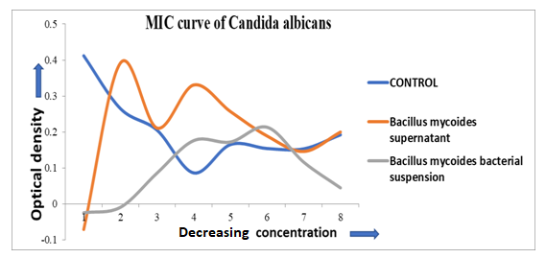

|  |
| --- |
| **FIG 6. Graphical representation of MIC values of *Bacillus mycoides* against *Candida albicans*. MIC ~ <105 *Bacillus mycoides* per gram** |

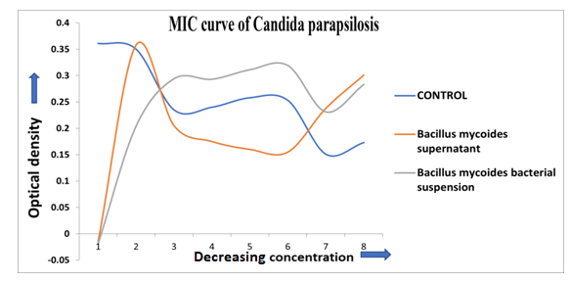

|  |
| --- |
| **FIG 7.Graphical representation of MIC values of *Bacillus mycoides* against *Candida parapsilosis*. MIC ~ 106-7 *Bacillus mycoides* per gram** |

**3.3 Evaluating** **chitinase activity of *Bacillus mycoides* against natural versus synthetic chitin by mesuring optical density:**

The chitinase activity of *Bacillus mycoides* was significantly different for natural and synthetic chitin. From the graphs we can say that the action of chitin breakdown starts within 15m as in case of natural chitin, whereas it takes 45m for synthetic chitin to start its chitinase activity. This delay in action in case of synthetic chitin maybe due to various reasons such as; the source of shrimp shells for synthetic and natural chitin maybe different in both cases. Synthetic chitin has presence of added preservative (chitosan) to increase shelf life which is absent in the chitin extracted naturally. This must have caused the lag in activity in case of synthetic chitin as compared to the natural one.

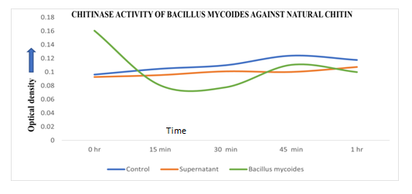

|  |
| --- |
| **FIG 8.Graphical representation of chitinase activity of *Bacillus mycoides* against natural chitin.** |

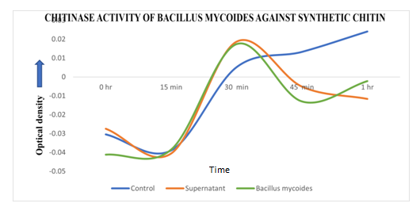

|  |
| --- |
| **FIG 9.Graphical representation of chitinase activity of *Bacillus mycoides* against synthetic chitin.** |

**FIG 10.Difference in chitinase activity of *Bacillus mycoides* against natural versus synthetic chitin:**

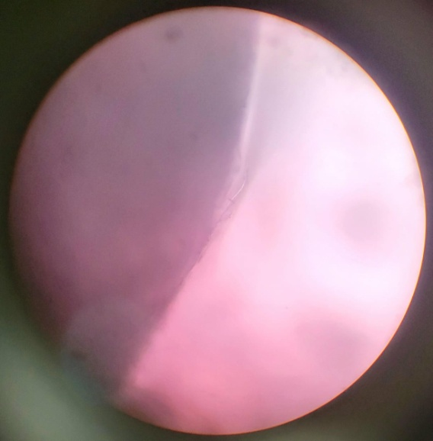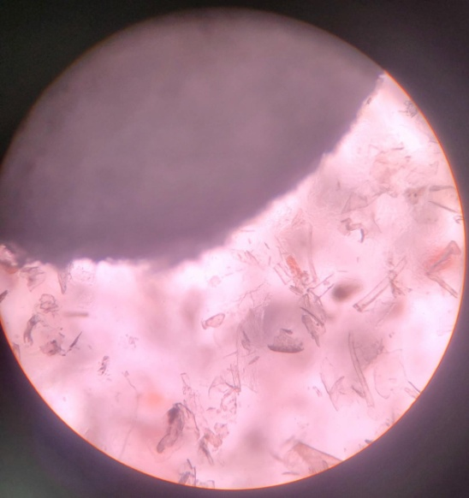

|  |
| --- |
| **Natural chitin, chitinase activity is good by *B. mycoides* (left) and Synthetic chitin, chitinase activity is not good by *B. mycoides* (right)** |

**4. DISCUSSION AND CONCLUSION:**

The absence of fungus around the artifacts in the ruins of Lal Masjid (we visited the site on 6th May 2024) made us curious about its reason. It was evident that despite the place being abandoned with no sunlight and moist surroundings, which are deemed ideal for the growth of fungus, there were none. This led us to dig deep into the reason and find out the agent that was acting as an effective antifungal. With gene isolation and sequencing (Chatterjee et al., 2025) of the soil samples collected from the crevices of the ruins, we finally came across the presence of a microbe that has major antifungal activity. This was identified to be *Bacillus mycoides* from the family of *B. cereus* and an effective antifungal agent. It was due to the presence of this bacterium no fungus was able to grow on the artifacts from the ruins. This led us to further experimentation on the antifungal nature of *Bacillus mycoides*.

The search for antifungal agents that are naturally found in the environment is vital with the want to discover new and effective ways to battle fungal pathogens. Thus, we evaluate the chitinase activity of *Bacillus mycoides* as chitin is the most essential part of the cell wall structure of a fungus. Hence, if the bacteria can effectively degrade chitin, it will prove to successfully degrade fungal pathogens. In our study, *Bacillus mycoides* has shown positive results in inhibiting fungal pathogens like *Candida albicans* and *Candida parapsilosis.* Besides giving proper zone of inhibitions in disc diffusion and well plate assay. The zone of inhibition measured against *B. mycoides* bacterial suspension against *Candida albicans* was 11.0mm and for *Candida parapsilosis* was 6.25mm. And for *B. mycoides* supernatant against *Candida albicans* was 6.0mm and for *Candida parapsilosis* was 8.5mm. Also, the MIC results observed were. Further chitinase study with *Bacillus mycoides* against both natural and synthetic chitin helped us discover the chitin-degrading properties of the microbe.

This brings us to the decision that *Bacillus mycoides* has chitinase activity and is an active antifungal agent against all these fungal pathogens.

**DISCLAIMER (ARTIFICIAL INTELLIGENCE)**

Author(s) hereby declare that NO generative AI technologies such as Large Language Models (ChatGPT, COPILOT, etc) and text-to-image generators have been used during writing or editing of this manuscript.

**REFERENCES:**

Andriani, Y., Rochima, E., Safitri, R., &Rahayuningsih, S. R. (2017). Characterization of Bacillus megaterium and Bacillus mycoides bacteria as probiotic bacteria in fish and shrimp feed. KnE Life Sciences, 127-135.

Brown, H. E., Esher, S. K., &Alspaugh, J. A. (2020). Chitin: A "Hidden Figure" in the Fungal Cell Wall. Current topics in microbiology and immunology, 425, 83–111. https://doi.org/10.1007/82_2019_184

Cowen, L. E., Sanglard, D., Howard, S. J., Rogers, P. D., & Perlin, D. S. (2014). Mechanisms of Antifungal Drug Resistance. Cold Spring Harbor perspectives in medicine, 5(7), a019752. https://doi.org/10.1101/cshperspect.a019752

Chatterjee, D., Panda, D. K. B., Dey, G., Paira, K., & Das, S. (2025). Bacillus mycoides Protects ArcheologicalArtifacts from Fungal Invasion: A Possible Mechanism as Observed in Ancient Remains of Lal Masjid at Khasbalanda, Haroa, North 24 Parganas, West Bengal, India. *South Asian Journal of Research in Microbiology*, *19*(6), 108-116.

Di Franco, C., Beccari, E., Santini, T., Pisaneschi, G., &Tecce, G. (2002). Colony shape as a genetic trait in the pattern-forming Bacillus mycoides. BMC microbiology, 2, 1-15.

Fisher, M. C., Alastruey-Izquierdo, A., Berman, J., Bicanic, T., Bignell, E. M., Bowyer, P., & Verweij, P. E. (2022). Tackling the emerging threat of antifungal resistance to human health. Nature reviews microbiology, 20(9), 557-571.

Ghazal, M. F., Moussa, L. A., Fayed, S. A., &Mostfa, A. A. (2013). The use of bacillus mycoides and bacillus subtlis as biocontrol agents for the fungi causing root rot disease in common bean. J. Biotechnol, 44.

Goodwin, A. E., Roy, J. S., Grizzle, J. M., & Goldsby, M. T. (1994). Bacillus mycoides: a bacterial pathogen of channel catfish. Diseases of aquatic organisms, 18, 173-173.

Islam, S. Z., Khan, M., &Alam, A. N. (2016). Production of chitin and chitosan from shrimp shell wastes.

Kurniawan, A., & Chuang, H. W. (2022). Rhizobacterial Bacillus mycoides functions in stimulating the antioxidant defence system and multiple phytohormone signalling pathways to regulate plant growth and stress tolerance. Journal of applied microbiology, 132(2), 1260–1274. https://doi.org/10.1111/jam.15252

Lenardon, M. D., Munro, C. A., &Gow, N. A. (2010). Chitin synthesis and fungal pathogenesis. Current opinion in microbiology, 13(4), 416–423. https://doi.org/10.1016/j.mib.2010.05.002

Shafiq, Maheen& Rahman, Sajjad &Laeeq, Rabeea&Abedien, Zain & Sajid, Sanaullah. (2024). In vitro assessment of antifungal activity of chitinase extracted from Bacillus subtilis. Malaysian Journal of Microbiology. 20. 494-500. 10.21161/mjm.230230.

Turchi, L., Santini, T., Beccari, E., & Di Franco, C. (2012). Localization of new peptidoglycan at poles in Bacillus mycoides, a member of the Bacillus cereus group. Archives of microbiology, 194, 887-892.

van Rhijn, N., Arikan-Akdagli, S., Beardsley, J., Bongomin, F., Chakrabarti, A., Chen, S. C., & Hagen, F. (2024). Beyond bacteria: the growing threat of antifungal resistance. The Lancet, 404(10457), 1017-1018.

Warinner, C., Herbig, A., Mann, A., Fellows Yates, J. A., Weiß, C. L., Burbano, H. A., Orlando, L., & Krause, J. (2017). A Robust Framework for Microbial Archaeology. Annual review of genomics and human genetics, 18, 321–356. https://doi.org/10.1146/annurev-genom-091416-035526

Weyrich, L. S., & Pérez, V. (2023). Archaeological microbiology. Handbook of Archaeological Sciences, 1, 557-574.

Yi, Y. (2018). Bacillus mycoides: novel tools for studying the mechanisms of its interaction with plants.