**Computational study of optical properties of calcium tungstate (CaWO4) based on Density Functional Theory (DFT)**

**ABSTRACT**

|  |
| --- |
| This study theoretically investigated the optical properties of calcium tungstate (CaWO₄) in its scheelite phase using first-principles calculations based on Density Functional Theory (DFT), aiming to understand its interaction with electromagnetic radiation and assess its potential for optoelectronic and photonic applications. Conducted at the Department of Physics of the State University of Maranhão (UEMA), Brazil, between January and March 2025, the research employed the CASTEP module of the Materials Studio software to compute spectra for the complex refractive index, reflectivity, absorption coefficient, dielectric function, energy loss function, and optical conductivity, considering light polarization along the (1,0,0) direction and a 3×3×3 k-point mesh. The results revealed strong absorption in the extreme ultraviolet, with distinct features in the reflectivity, absorption, and conductivity spectra; the dielectric function exhibited dispersive behavior, and the energy loss function showed a pronounced peak in the violet region. Additionally, the simulated Raman spectra closely matched experimental data. These findings confirm that DFT-based methods offer a detailed characterization of CaWO₄’s optical response, supporting its potential use in optical and photonic devices. |

*Keywords: DFT, optical properties, CaWO₄, calcium tungstate, computational modeling.*

**1. INTRODUCTION**

In recent years, luminescent materials capable of emitting light without the presence of external dopants—known as *self-activated*—have gained prominence in research aimed at advanced optical technologies. These materials are explored in light-emitting devices, sensors, pigments, scintillators, and laser host matrices due to their intrinsic properties, such as stable luminescence, high optical efficiency, elevated quantum yield, and potential catalytic activity, which make them highly relevant [1,2,3].

Among the compounds exhibiting these characteristics, tungstates demonstrate remarkable performance as inorganic oxides [4], known for their good chemical stability and spectral absorption in the ultraviolet range [3,1]. Notably, calcium tungstate (CaWO₄) stands out by emitting high-efficiency blue light when excited by ultraviolet radiation [5].

CaWO₄ belongs to the family of metal tungstates and crystallizes in a scheelite-type tetragonal structure (I₄₁/a) [4]. In this structural configuration, calcium ions occupy distorted octahedral coordination sites [CaO₈], while tungstate ions form tetrahedral units [WO₄²⁻] [6,7]. Studies indicate that the photoluminescent properties of CaWO₄, especially its violet-blue emission in the absence of activator dopants, are associated with internal electronic transitions of the ¹T₂ → ¹A₂ type within the [WO₄²⁻] groups [8].

Moreover, research shows that this blue emission is temperature-sensitive, undergoing significant variations in intensity and efficiency with increasing temperature [9,6], which makes it useful in thermo-optical applications.

Despite the recognized potential of CaWO₄ in photoluminescent and photocatalytic applications—as highlighted by various recent experimental studies [10,11]—there remains a significant gap in the theoretical understanding of its fundamental optical properties. Among the experimental advances, doping studies with elements such as silver and zinc have shown high catalytic efficiency in degrading organic compounds, such as methylene blue, under UV radiation [10]. However, such investigations are not accompanied by systematic analyses of the optical mechanisms associated with the electronic structure of pure CaWO₄.

This absence of computational studies specifically targeting the linear optical response of CaWO₄ limits the rational development of devices based on this material. Density Functional Theory (DFT), applied using the CASTEP module, is a robust and well-established approach for analyzing such properties, enabling accurate data on the material’s interaction with electromagnetic fields.

The purpose of this work is, therefore, to investigate the optical properties of CaWO₄ in its scheelite-type phase through DFT-based simulations. The central goal is to provide a detailed theoretical characterization of its optical response. This is expected to offer theoretical support for advancing optoelectronic, photonic, and sensing device applications by deepening the understanding of CaWO₄’s optical behavior.

DFT is widely employed to describe electronic systems in solid-state physics and computational chemistry. Rather than dealing directly with the many-body wave function, it uses the electronic density as the fundamental variable, simplifying the problem to just three spatial coordinates instead of the 3N required for a system with N electrons [12,13]. This approach significantly reduces computational cost while allowing for the efficient investigation of structural, electronic, and optical properties.

The modern formulation of DFT is based on the Hohenberg and Kohn theorems, which demonstrate that the ground-state electronic density contains all the information about the system [14,13]. Although the Schrödinger equation is impractical for real systems due to multi-particle interactions, the Born-Oppenheimer approximation allows nuclei to be treated as fixed, facilitating the electronic problem [15,16,17].

Kohn and Sham proposed a practical method in which the real system of interacting electrons is replaced with a fictitious system of non-interacting particles that reproduce the same electronic density [18,19]. This model employs an effective potential that incorporates external, Coulomb, and exchange-correlation effects and is solved iteratively until the density converges.

In this context, the total energy of the system is expressed as a functional of the density, containing kinetic, electrostatic, and electronic correlation terms. DFT has been widely applied to predict with precision properties such as band structure, optical response, and material stability, and has become essential in atomistic-scale modeling [20,21].

In this work, we investigate the intrinsic optical properties of scheelite-phase calcium tungstate (CaWO₄) through first-principles simulations based on Density Functional Theory (DFT), aiming to elucidate its interaction with electromagnetic radiation and assess its suitability for optoelectronic and photonic applications.

**2. methodology**

This study combines a literature review with Density Functional Theory (DFT)-based computational simulations to analyze the optical properties of CaWO₄.

Initially, a literature review was conducted using reputable scientific databases to support the selection of simulation parameters and provide theoretical context for interpreting results. The simulations were performed using the *Materials Studio* software, specifically the *CASTEP* module [22], with structural data obtained from experimental sources.

The geometry of the crystal structure was optimized under strict convergence criteria: a maximum of 300 self-consistent field (SCF) cycles and an energy tolerance defined per atom. A norm-conserving pseudopotential with relativistic treatment under the Schrödinger approximation was employed. The adopted computational parameters included a 3 × 3 × 3 k-point mesh and an energy cutoff of 750 eV, ensuring precision in electronic results. Additionally, the exchange-correlation treatment used the GGA-PBE (Generalized Gradient Approximation – Perdew, Burke, and Ernzerhof) functional.

The optical properties were directly calculated within CASTEP, based on the obtained electronic data. For these calculations, the simulation mode was set to *polarized*, with a smearing value of 0.5 eV, and light polarization aligned along the (1,0,0) direction. However, for the dielectric function, an average over distinct crystallographic directions was used to simulate a polycrystalline optical response.

The results were quantitatively analyzed using *Origin* software through graphs and statistical methods, enabling clearer interpretation and identification of patterns across the studied variables.

This work employed previously optimized atomic coordinates of CaWO₄ obtained from simulations performed in an earlier study [23]. The considered structure retains the original space group (I4₁/a), characteristic of the scheelite phase. *Figure 1* illustrates the crystal structure used in the simulations carried out for this study.

.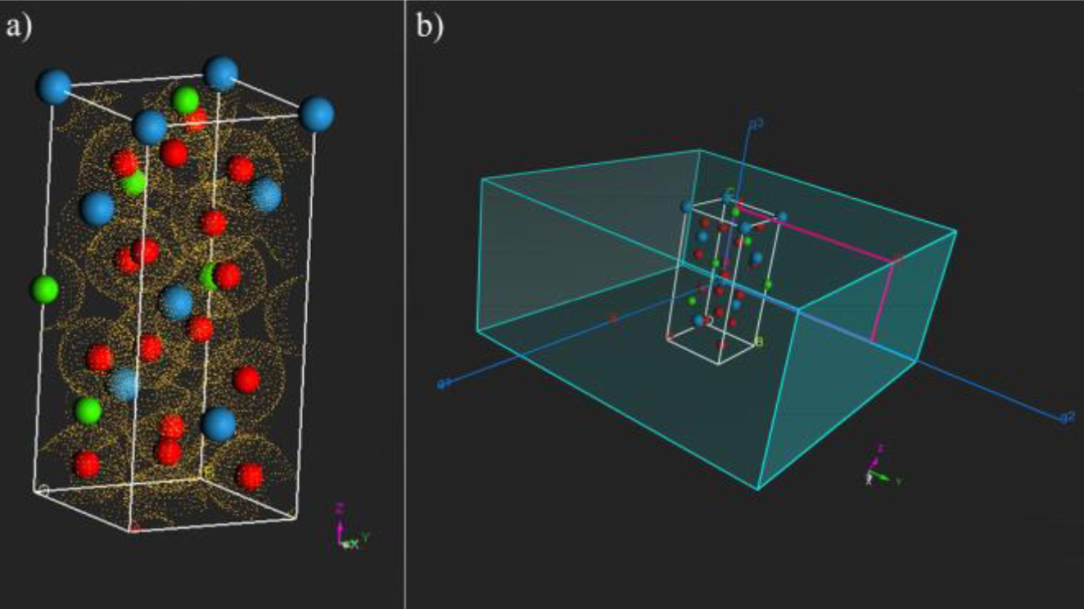

**Fig. 1. The crystal CaWO₄** **structure used in the simulations carried out for this study**

**3. results and discussion**

This section discusses the optical properties of calcium tungstate based on calculated spectra for refractive index, reflectivity, optical absorption, dielectric function, loss function, optical conductivity, and Raman spectra. These results offer a comprehensive view of the material’s behavior across different ranges of the electromagnetic spectrum, enabling a detailed characterization of its optical responses.

Figure 2 presents the real (n) and imaginary (k) parts of CaWO₄’s refractive index. The real part, n, is associated with the light propagation speed in the medium, while the imaginary part, k, expresses the degree of electromagnetic radiation absorption by the material [24,25]. Together, they constitute the complex refractive index ñ, given by:

$ñ=n+ik$ (1)

The extinction coefficient k shows a sharp peak between 100 and 150 nm, reaching a maximum of 1.7 at 131 nm, indicating strong absorption in the deep ultraviolet range. The real part n rises from 110 nm and peaks at 2.8 around 260 nm. From 300 nm onward, n stabilizes between 2.9 and 2.2. High refractive index values are typically associated with dense materials [26], as seen here. Beyond 350 nm, k approaches zero, confirming low absorption, as also observed in Figure 4.

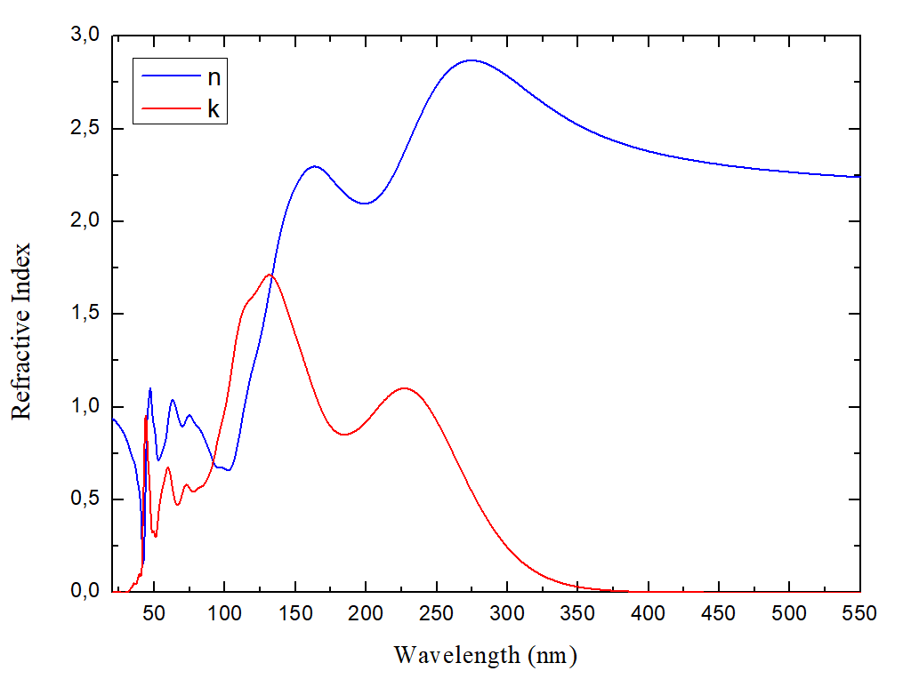

**Fig. 2. Real (n, blue) and imaginary (k, red) parts of the complex refractive index of CaWO₄ as a function of wavelength.**

Figure 3 shows CaWO₄’s reflectivity spectrum starting at 20 nm. A pronounced peak appears at 42 nm with a reflectivity close to 0.6, indicating a strong optical response in the extreme ultraviolet. The curve then rapidly decreases, remaining between 0.1 and 0.4 in the 80–300 nm range. Beyond 350 nm, it stabilizes near 0.15, denoting low reflectivity and transparency in the visible region. The reflectivity R is related to the real and imaginary parts of the refractive index by:

$R=\frac{{\left(n-1\right)}^{2}+k^{2}}{{\left(n+1\right)}^{2}+k^{2}}$ (2)

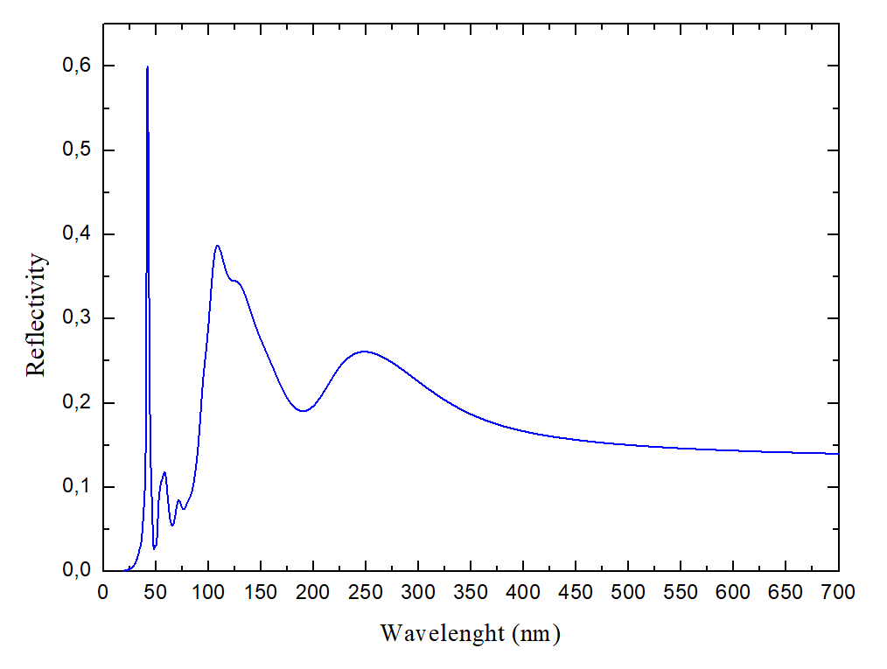

**Fig. 3. Wavelength-Dependent Reflectivity**

The optical absorption spectrum of CaWO₄ is shown in Figure 4, highlighting a sharp peak at 42 nm, with a coefficient of approximately 4.35 × 10⁵ cm⁻¹, indicating strong absorption in the extreme ultraviolet. Between 80 and 150 nm, attenuation is observed. From 230 nm onward, the absorption gradually decreases, reaching zero beyond 360 nm. These spectra cover the 20 to 450 nm range.

Optical properties describe the interaction between photons and the material, helping infer its electronic behavior, since absorption promotes electrons from the valence band to the conduction band [27]. Generally, the larger the bandgap, the lower the absorption efficiency [25]. For CaWO₄, the reported energy gap is 3.94 eV [28], consistent with the absorption patterns observed in this study.

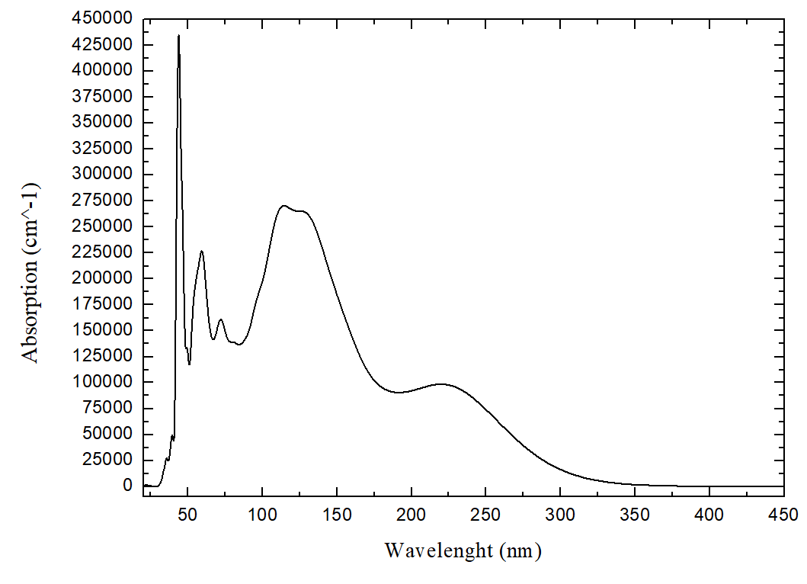

**Fig. 4. Absorbance as a Function of Wavelength (nm).**

Figure 5 presents the dielectric function of CaWO₄ averaged over various crystallographic directions (POLY). The graph displays the real (Re, blue) and imaginary (Im, red) parts. The real part, linked to material polarization under an external field, becomes significant around 133 nm and peaks at 7.98 near 260 nm. Negative values appear between 41.5 – 44.5 nm and 92 – 133 nm. The imaginary part exhibits two major peaks: one at 140 nm (value 6.2) and another at 240 nm (value 5.2). Above 350 nm, both components stabilize.

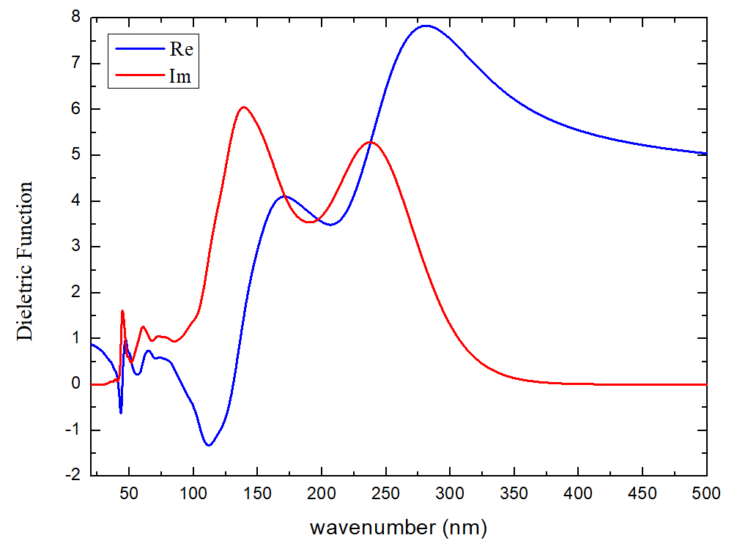

**Fig. 5. Complex Dielectric Function of CaWO₄: Real (ε₁) and Imaginary (ε₂) Components as a Function of Wavelength.**

The loss function, calculated in the (1,0,0) direction, quantifies the probability of inelastic electron scattering in solids and directly relates to the material’s dielectric response [29]. *Figure 6* shows a sharp peak around 40 nm with an intensity near 12. Minor oscillations occur between 50–100 nm. After 120 nm, values gradually stabilize, and after 380 nm, the loss function approaches zero.

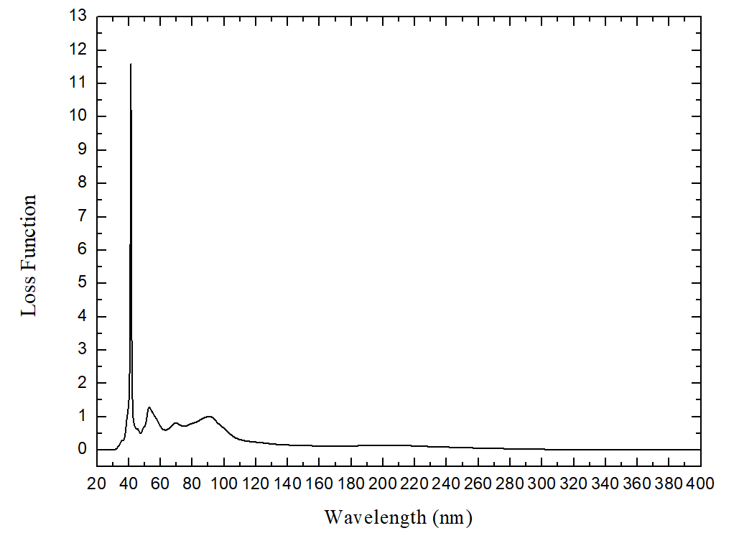

**Fig. 6. Electron Energy Loss Function Im(–1/ε) as a Function of Wavelength**

*Figure 7* displays the optical conductivity of CaWO₄ versus wavelength, with real (red) and imaginary (blue) components. The response reveals photon-induced electronic transitions: the real part reflects effective conduction, while the imaginary part corresponds to polarization-related losses.

The real component shows a prominent peak around 139 nm, reaching 6.8 (1/fs). A second significant peak appears near 232 nm, followed by a steep drop, with values approaching zero at longer wavelengths. This again suggests weak interaction with visible light. The imaginary component shows a negative, asymmetric trend, with strong oscillations below 300 nm. Beyond 400 nm, both components stabilize.

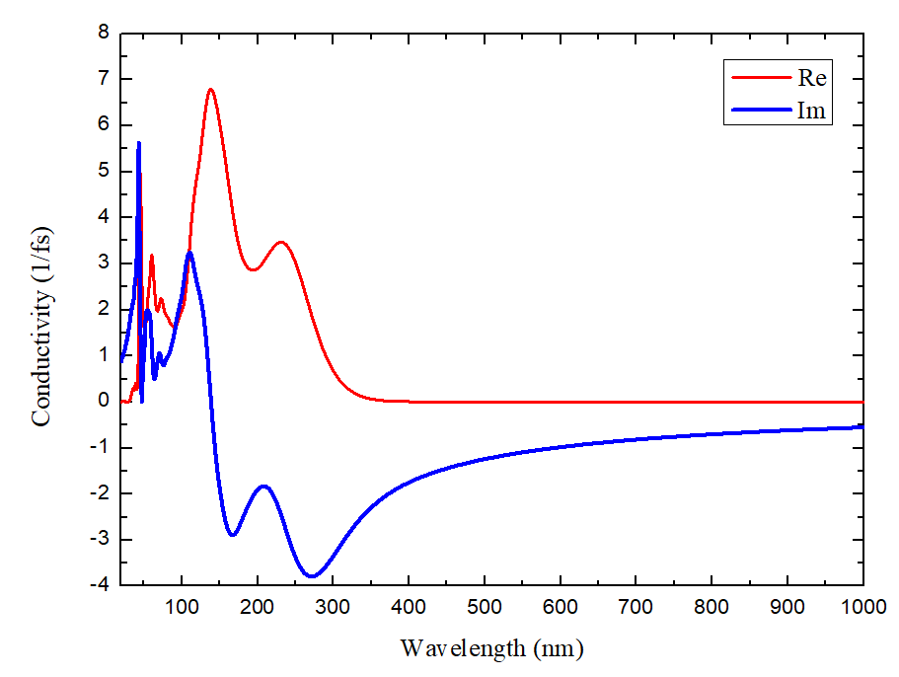

**Fig. 7. Optical Conductivity Spectrum of CaWO₄: Real and Imaginary Components as a Function of Wavelength**

Raman spectroscopy analyzes the inelastic scattering of light to identify vibrational modes in materials, revealing chemical structure and making it a key tool for characterizing solid compounds [30]. Figure 8 compares experimental Raman spectra of CaWO₄ from [8] (in red) with simulated data (in black).

The results reveal a prominent peak around 950 cm⁻¹. Notable oscillations appear between 200 and 400 cm⁻¹, especially around 300 and 400 cm⁻¹. After 400 cm⁻¹, intensity drops to zero until nearly 800 cm⁻¹, where variations resume. Overall, good agreement is observed between theoretical and experimental Raman results, especially in the position of the main vibrational modes.

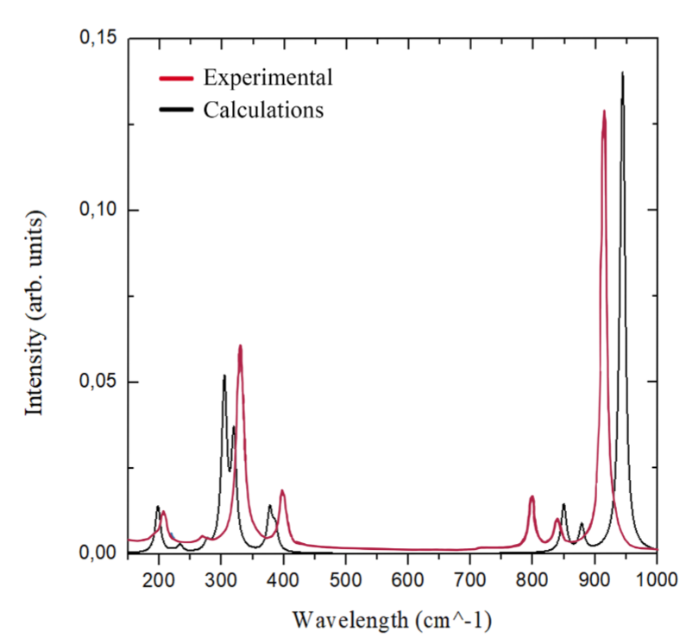

**Fig. 8. Raman Spectra of CaWO₄: Comparison between Experimental (red) and Simulated (black) Data.**

**4. Conclusion**

The optical properties of CaWO₄ were investigated through calculations based on Density Functional Theory (DFT), revealing strong absorption in the ultraviolet region and well-defined peaks across the simulated spectra.

Overall, the analysis of the various optical functions characterized CaWO₄ as a material with a significant response to high-energy radiation. The presence of sharp spectral features—combined with transparency at longer wavelengths—indicates an interesting spectral selectivity that may be leveraged for specific technological applications. In particular, CaWO₄ exhibited pronounced ultraviolet absorption, with a peak near 42 nm, highlighting its strong optical activity in this range.

The dielectric function demonstrated dispersive behavior, while the energy loss function revealed a prominent peak in the violet region. Furthermore, the obtained spectra showed good agreement with experimental Raman spectroscopy data reported in the literature, reinforcing the reliability of the adopted methodology. These findings may contribute to the theoretical understanding of CaWO₄’s optical behavior and support future experimental research involving this compound

**Disclaimer (Artificial intelligence)**

Option 1:

Author(s) hereby declare that NO generative AI technologies such as Large Language Models (ChatGPT, manuscript.

Option 2:

Author(s) hereby declare that generative AI technologies such as Large Language Models, etc. have been used during the writing or editing of manuscripts. This explanation will include the name, version, model, and source of the generative AI technology and as well as all input prompts provided to the generative AI technology

Details of the AI usage are given below:

1.

2.

3.

**References**

[1] Wang, S., et al. (2020). Structure characterization, optical and photoluminescence properties of scheelite-type CaWO₄ nanophosphors: Effects of calcination temperature and carbon skeleton. Optical Materials, 99, 109562.

[2] Gao, H., et al. (2022). CaMoO₄/CaWO₄ heterojunction micro/nanocomposites with interface defects for enhanced photocatalytic activity. Colloids and Surfaces A, 642, 128642.

[3] Bai, S., et al. (2020). Enhanced quantum efficiency and thermal stability in CaWO₄:Eu³⁺ phosphor based on structural modification induced by co-doping Al³⁺. Journal of Luminescence, 225, 117351.

[4] Sousa, P. D., et al. (2021). Electronic structure, optical and sonophotocatalytic properties of spindle-like CaWO₄ microcrystals synthesized by the sonochemical method. Journal of Alloys and Compounds, 855, 157377.

[5] Xia, M., et al. (2018). Red-emitting enhancement by inducing lower crystal field symmetry of Eu³⁺ site in CaWO₄:Eu³⁺ phosphor for N-UV W-LEDs. Journal of Alloys and Compounds, 739, 439–446.

[6] Yadav, P., et al. (2024). Investigation of structural and optoelectronic integrity of Sm³⁺-doped CaWO₄ for LED applications. Ceramics International, 50(19), 35203–35213.

[7] Shivakumara, C., et al. (2015). Scheelite-type MWO₄ (M = Ca, Sr, and Ba) nanophosphors: Facile synthesis, structural characterization, photoluminescence, and photocatalytic properties. Materials Research Bulletin, 61, 422–432.

[8] Cavalcante, L., et al. (2012). Electronic structure, growth mechanism and photoluminescence of CaWO₄ crystals. CrystEngComm, 14(3), 853–868.

[9] Xiao, H.; Meng, Q. (2024). Eu³⁺ doped CaWO₄ nanophosphor for high sensitivity optical thermometry. Spectrochimica Acta Part A, 305, 123542.

[10] Neto, N. A., et al. (2020). Synthesis and characterization of Ag⁺ and Zn²⁺ co-doped CaWO₄ nanoparticles by a fast and easy sonochemical method. Journal of Alloys and Compounds, 823, 153617.

[11] Ayappan, C., et al. (2019). One-step hydrothermal synthesis of CaWO₄/α-Ag₂WO₄ heterojunction: An efficient photocatalyst for removal of organic contaminants. Materials Science in Semiconductor Processing, 104, 104693.

[12] Santos, M. d. S., et al. (2022). Study of superconductivity in rotated graphene bilayer interspersed with carbon. Federal University of Campina Grande.

[13] Orio, M., Pantazis, D. A., & Neese, F. (2009). Density functional theory. Photosynthesis Research, 102, 443–453.

[14] Brito, D. M. S. (2022). Study of the structural, magnetic, electronic, and optical properties of the multiferroic manganites LuMnO₃ and HoMnO₃ via calculations based on non-collinear spin DFT. Postgraduate in Physics.

[15] Born, M., & Oppenheimer, R. (2000). On the quantum theory of molecules. In: Quantum Chemistry: Classic Scientific Papers. World Scientific.

[16] Prasad, R. (2013). Electronic Structure of Materials. CRC Press.

[17] Sholl, D. S., & Steckel, J. A. (2022). Density Functional Theory: A Practical Introduction. John Wiley & Sons.

[18] Hohenberg, P., & Kohn, W. (1964). Inhomogeneous electron gas. Physical Review, 136(3B), B864.

[19] Silva, C. P. da. (2010). High-performance computing with graphics cards to accelerate Density Functional Theory processing. PUC-Rio.

[20] Botelho, I. T. D. (2024). Gold nanoparticle for biomedical detection. Monograph (Physics Undergraduate Course). Maranhão State University.

[21] Silva, P. M. da. (2023). Study of the third-order macroscopic property using the supermolecule approach. Master’s Thesis, Universidade Estadual de Goiás.

[22] Clark, S. J., et al. (2005). First principles methods using CASTEP. Zeitschrift für Kristallographie – Crystalline Materials, 220(5–6), 567–570.

[23] Silva, J., et al. (2025). Structural and electronic properties of CaWO₄. Revista Multidisciplinar do Nordeste Mineiro, 5(1), 1–17.

[24] Yu, X., Yi, B., & Wang, X. (2007). Prediction of refractive index of vinyl polymers by using density functional theory. Journal of Computational Chemistry, 28(14), 2336–2341.

[25] Ashraf, R., et al. (2021). DFT-based investigations of BaWO₄: electronic and optical properties. Physics B: Condensed Matter, 621, 413309.

[26] Nesa, M., et al. (2020). Structural, optical and electronic properties of CuO and Zn-doped CuO: DFT-based first-principles calculations. Chemical Physics, 528, 110536.

[27] Ghaleb, A., & Ahmed, A. (2022). Structural, electronic, and optical properties of sphalerite ZnS compounds calculated using DFT. Chalcogenide Letters, 19(5).

[28] Du, P., Wu, S., & Yu, J. S. (2016). Synthesis, electronic structure and luminescence properties of color-controllable Dy³⁺/Eu³⁺-codoped CaWO₄ phosphors. Journal of Luminescence, 173, 192–198.

[29] Sun, Y., et al. (2016). Calculations of energy-loss function for 26 materials. Chinese Journal of Chemical Physics, 29(6), 663–670.

[30] Rodrigues, A. D. G., & Galzerani, J. C. (2013). Infrared, Raman and photoluminescence spectroscopy: potentialities and complementarities. Brazilian Journal of Physics Teaching, 34, 4309