**Experimental study of hygrothermal exchanges in an evaporative heat exchanger based on fired clay plates for air cooling in hot and dry climates**

**ABSTRACT**

|  |
| --- |
| In hot and dry climates like Burkina Faso, conventional air conditioning is energy-intensive and costly, accounting for 20% of global energy consumption according to the International Energy Agency. The "Argiclim" evaporative heat exchanger, developed at the Renewable Thermal Energy Laboratory (L.E.T.RE) of Joseph KI-ZERBO University, uses porous fired clay plates to cool air through evaporation. Tested from April to June 2023, the prototype (18x18x2 cm, PVC casing) achieved a thermal efficiency of 89%. It reduced the temperature from 42°C to 29°C and increased relative humidity from 30% to 95% under conditions with an inlet air temperature of 42°C and 30% relative humidity, with a 2 cm plate spacing. Measurements using type K thermocouples (accuracy ±1°C) and hygrometers showed a 15°C temperature drop and a relative humidity of 95% at 2 cm from the duct. Simulations using Matlab, based on Luikov’s equations, validated the experimental results (deviations <5%). Despite high outlet humidity and water dependency, "Argiclim" offers a sustainable and cost-effective alternative to traditional air conditioners, leveraging local materials for accessible thermal comfort in Sahelian regions. |

***Keywords:*** *Heat exchanger, evaporation, fired clay, thermal efficiency, hygrothermal, hot and dry climate.*

1. **Introduction**

In regions with hot and dry climates, such as Burkina Faso, ensuring thermal comfort is a major challenge due to high temperatures and ambient aridity. Conventional air conditioning systems, while effective, are costly, energy-intensive, and often inaccessible to low-income populations. According to the International Energy Agency (IEA), air conditioning accounts for approximately 20% of global energy consumption (International Energy Agency, 2020), with demand projected to increase by 2040 due to climate change and urbanization (International Energy Agency, 2018). In this context, evaporative heat exchangers, which utilize water evaporation to cool air, offer a sustainable, cost-effective, and suitable alternative for arid climates (Duan et al. , 2012), (Porumb et al. , 2016). This study, derived from Salifou Cisse’s doctoral dissertation, evaluates the performance of an evaporative heat exchanger with porous fired clay plates, named “Argiclim,” developed at the Renewable Thermal Energy Laboratory (L.E.T.RE) of Joseph Ki-Zerbo University. Fired clay, an abundant local material, was chosen for its porosity, which enables efficient water evaporation, resulting in a significant decrease in air temperature and an increase in relative humidity. Experimental tests conducted between April and June 2023 demonstrated a thermal efficiency of up to 89%, with a temperature reduction of 15 °C (from 44 °C to 29 °C) and relative humidity increasing from 30% to 95% under optimal conditions (Salifou Cisse et al., 2024). These results were corroborated by numerical simulations performed using Matlab, based on Luikov’s equations to model hygrothermal transfers (Luikov, A. V., 1964), (Çengel, Y. A., & Ghajar, A. J., 2015). By analyzing the inlet and outlet air conditions of the heat exchanger, this research aims to validate numerical results with experimental results of an evaporative heat exchanger based on fired clay plates for air cooling in hot and dry climates, offering a viable alternative to traditional air conditioning, reducing energy dependency while promoting an eco-friendly and accessible technology.

**2. Materials and methods**

**2.1 Exchanger design**

The prototype, designed at L.E.T.RE, consists of fired clay plates (18 cm x 18 cm x 2 cm) integrated into a PVC casing (20 cm x 20 cm x 20 cm). The plates, moistened but not saturated, are arranged with a 2 cm spacing to allow the circulation of hot, dry air (Salifou Cisse et al., 2024). The system operates on the principle of evaporative cooling: water evaporates from the pores of the clay, absorbing heat from the air and increasing its relative humidity. Figure 1 illustrates the Principle schematics of the heat exchanger (Argiclim)

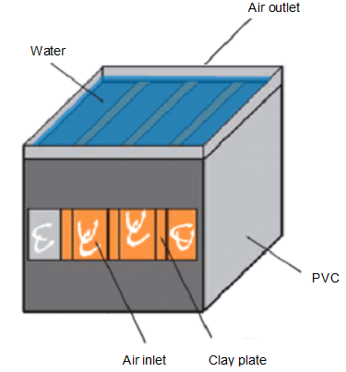

**Figure 1: Principle schematics of the heat exchanger (Argiclim)**

The properties of fired clay, PVC, air, and water used are provided in Table 1.

**Table 1: Physical properties of fired clay, PVC, air, and water (Wang, S. K., 2001, Salifou Cisse et al. , 2024)**

|  |  |  |  |  |
| --- | --- | --- | --- | --- |
| **Properties** | **Fired Clay** | **PVC** | **Air** | **Water** |
| **Thermal Conductivity (W·K⁻¹·m⁻¹)** | 0.6 | 0.18 | 0.026 | 0.59 |
| **Specific Heat (J·kg⁻¹·K⁻¹)** | 850 | 1470 | 1000 | 4185 |
| **Density (kg·m⁻³)** | 1380 | 1190 | 1250 | 1000 |
| **Dynamic Viscosity (Pa·s)** | ***** | ***** | $$168.2x{10}^{-8}$$ | $$547.1x{10}^{-8}$$ |
| **Porosity (%)** | 0.3 | ***** | ***** | ***** |

**2.2 Experimental Setup**

Figure 2 illustrates the experimental setup.

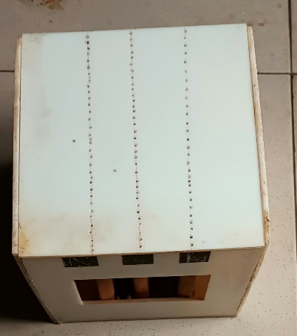

Data logger

Hot

air

Cool air

Fan

Pump

Thermocouples

**Figure 2: Diagram of the experimental setup**

The experimental setup illustrated in Figure 2 includes:

* **Fired clay plates**: Locally manufactured, these plates have suitable porosity for water retention and evaporation.
* **PVC casing**: Provides insulation and structural support for the system.
* **Fan**: Generates a controlled airflow (1 m/s).
* **Sensors**: Thermocouples measure temperature, and hygrometers record relative humidity along the duct formed by two moist porous plates.

The objective was to measure hygrothermal parameters, such as the temperature and relative humidity of the air circulating between two permanently water-soaked porous plates. The tests were conducted between April and June 2023, with inlet air temperatures ranging from 308 K (35 °C) to 315 K (42 °C) and an initial relative humidity of 30% to 40%.

**2.3 Experimental protocol**

Measurements were taken at regular intervals along the duct, with the abscissa ranging from 0 to 0.2 m, to evaluate:

* The evolution of air temperature.
* The increase in relative humidity.

During the period from April to June 2023, measurements were repeated at least three times per month. These measurements were performed using K-type thermocouples made of nickel-chromium and nickel-aluminum (5%) + silicon alloys (Emilios et al., 2022). These thermocouples are resistant to radiation. They are connected to two programmable temperature recorders (MIDI LOGGER GL 220). The accuracy of these devices is 1% for temperatures between 20 °C and 50 °C. The accuracy of K-type thermocouples is ± (0.05% of the reading + 1.0 °C) for temperatures ranging from -100 °C to 1370 °C (Omega Engineering. ,2023).

The data were compared to numerical simulations to validate the physical model.

**3. Results and discussion**

**3.1 Temperature evolution**

The temperature evolution along the heat exchanger for the days of April 27, May 9, and June 21, 2023, is shown in Figure 3.

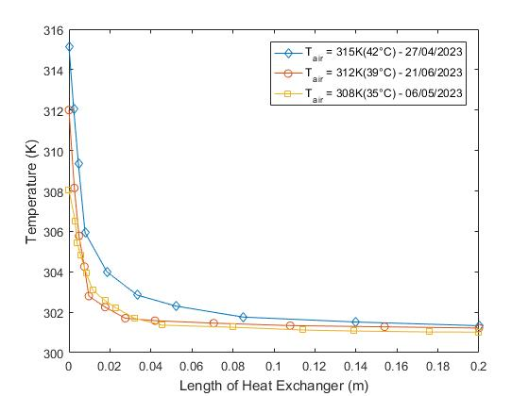

**Figure 3: Temperature evolution along the heat exchanger duct for the period of 04/27/2023, 05/09/2023, and 06/21/2023**

In Figure 3, we observe that the curves decrease significantly from 0 to 4 cm along the exchanger, then decrease slightly from 4 cm to 20 cm. A temperature drop of 12 K is noted from 0 to 3 cm along the exchanger, from 315 K to 303 K, with stabilization around 14 cm for the inlet temperature of 315 K (April 27, 2023). For the inlet temperature of 308 K (May 9, 2023), a sharp temperature decrease is observed, from 308 K to 301.5 K, from 0 to 3 cm along the exchanger duct. At 4 cm, the temperature begins to stabilize until the outlet (301 K). For the inlet temperature of 312 K (June 21, 2023), a temperature drop of 10.4 K is noted from 0 to 4 cm along the exchanger duct, from 312 K to 301.6 K. The outlet temperatures for the different inlet temperatures are approximately 301 K.

The experimental results show a significant reduction in air temperature through the exchanger duct. For an inlet temperature of 315 K (42 °C), a maximum temperature drop of 15 °C was observed at the outlet, where the air is in contact with two wet plates.

We observe that the outlet temperature of air entering at 39 °C is lower than that of air entering at 35 °C; this is explained by the fact that the air entering at 39 °C has a lower relative humidity (RH = 30%) compared to that at 35 °C (40%), allowing for more effective evaporation and greater cooling.

It is observed that the higher the inlet temperature, the greater the temperature drop between 0 and 3 cm along the heat exchanger. Indeed, the larger the temperature gradient between the plates and the air, the more significant the heat transfer, allowing the air to release its sensible heat and absorb latent heat from the evaporation of water in the porous plates. The gain in latent heat by the air from water evaporation accounts for the temperature decrease.

**3.2 Evolution of relative humidity**

The evolution of relative humidity along the exchanger for the days of April 27, May 9, and June 21, 2023, is shown in Figure 4.

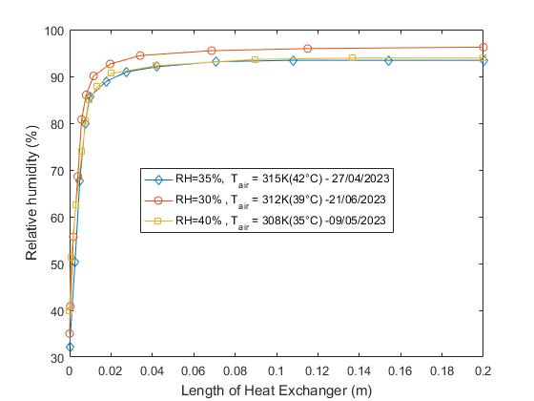

**Figure 4 : Evolution of relative humidity along the exchanger duct for the period of 27/04/2023, 09/05/2023, and 21/06/2023**

The curves in Figure 4 show the variation of the relative humidity of the air in the exchanger duct. Analysis of the curves for the period of 27-04-2023, with an initial relative humidity of 35%, shows a significant increase in relative humidity at 2 cm from the exchanger, followed by slight variation until the outlet, where it reached 95%. For the period of 21-06-2023, with an initial relative humidity of 30%, a significant increase in relative humidity is observed from 0 to 2 cm along the exchanger, followed by slight variation until the outlet, where the relative humidity of the air at the duct outlet is 94%. For the period of 09-05-2023, analysis of the curves shows a significant increase in relative humidity at 2 cm from the exchanger, followed by slight variation until the outlet. With an initial relative humidity of 40%, the relative humidity of the air at the exchanger duct outlet is 94%. The relative humidity increases significantly as the air passes through the exchanger duct. Under optimal conditions, the relative humidity reaches 95%. The humidification of the air is explained by the fact that, in the duct, the air is in contact with two water-soaked porous plates, facilitating moisture transfer to the air. The temperature drop of approximately 15 K (15 °C) is notable and comparable to commercial evaporative systems, although limited by the moisture absorption capacity of dry air.

**3.3 Cooling efficiency**

The saturation efficiency, which is the efficiency of the evaporative exchanger, is defined by the relation (1):

$η=\frac{T_{e}-T_{s}}{T_{e}-T_{bh}}×100$ (1)

The evolution of saturation efficiency along the heat exchanger duct is shown in Figure 5.

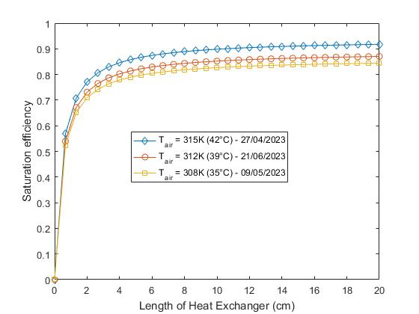

**Figure 5 : Evolution of saturation efficiency along the heat exchanger duct for the period of 27-04/2023, 09/05/2023, and 21/06/2023**

In Figure 5, we observe that the saturation efficiency of the different ducts increases sharply from 0 to 0.02 m. This increase is 0.89 for April 27, 2023, 0.84 for May 9, 2023, and 0.88 for June 21, 2023. The thermal efficiency, defined as the ratio of the actual temperature drop to the maximum possible temperature drop, ranges between 0.50 and 0.94 (El-Dessouky, H. et al. , 2004). It reaches a peak of 0.89 for inlet air at 42 °C and a relative humidity of 30%, with a 2 cm spacing of the porous plates. The results confirm that cooling efficiency increases with higher inlet air temperature and lower humidity, in line with evaporation principles (Verploegen et al., 2019). The best performance was achieved due to an increased exchange surface area and greater evaporation.

**4. Validation of Results**

To quantify the deviations between the results, we used the statistical indicator RMSE (Root Mean Square Error), defined by Equation 2.

$RMSE=\sqrt{\frac{1}{N}\sum_{i}^{N}{{\left(X_{exp,i}^{*}-X_{num}^{*}\right)}^{2}}}$ (2)

With: $X_{exp,i}^{*}$ the experimental value at index i; $X_{num}^{*}$ the numerical value at index i and $N$ the number of values considered.

**4.1 Comparison with the Numerical Study**

Figure 6 presents a comparison of the air temperature evolution along the exchanger duct from a numerical study (Salifou Cisse et., 2024) compared with our experimental results from April 27, May 9, and May 21, 2023.

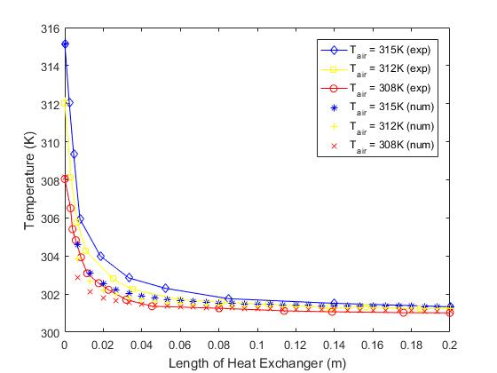

**Figure 6 : Comparison of our experimental (Air Temperature) results with a numerical study**

In Figure 6, we observe that the air temperature evolution curves have the same profile. Slight deviations are noted at certain points between experimental and numerical results. The air cooling is nearly identical in both simulation and experimentation. The experimental results are similar to the compared numerical results. The error for an inlet air temperature of 315 K is estimated at 0.806; 0.803 for an inlet temperature of 312 K; and 0.801 for an inlet temperature of 308 K.

Figure 7 presents a comparison of the relative humidity evolution of the air along the exchanger duct from a numerical study (Saliffou Cisse et al., 2024) compared with our experimental results from April 27, May 9, and May 21, 2023.

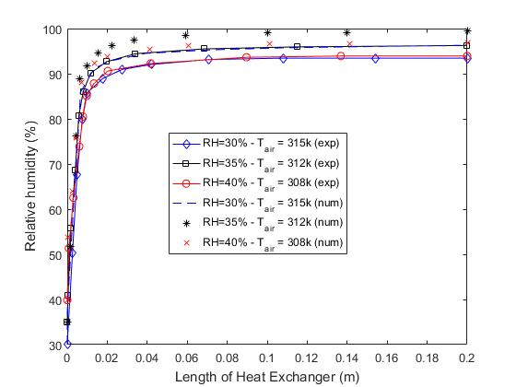

**Figure 7 : Comparison of our experimental (Relative Humidity) results with a numerical study**

The curves in Figure 7 validate our experimental results. We observe that the relative humidity evolution curves have the same profile. Minimal deviations are noted at certain points. The experimental results are similar to the numerical results. The air humidification is nearly identical in both simulation and experimentation.

The comparison with the simulation shows good correlation between experimental and theoretical data ( Incropera, F. P. et al, 2007). The observed deviations between numerical and experimental results, less than 5%, are attributable to local climatic variations, the thermophysical properties of the materials used, and model approximations.

Given the observed error margins (maximum 1.058 K), we can confirm that our numerical and experimental results are in good agreement.

**4.2 Comparison of the Present Study with Other Studies**

A comparison of the operating parameters and performance of the current and previous studies is presented in Table 2.

**Table 2: Comparison of operating parameters and performance of current and previous studies**

|  |  |  |  |  |
| --- | --- | --- | --- | --- |
|  | **Present Study** | **Wu et al.** | **Alonso et al.** | **Heidarinejad et al.** |
| **System Description Method** | Experiment | Simulation and Experiment | Experiment | Experiment |
| **Cooling Type** | Direct Evaporative Cooling | Direct Evaporative Cooling | Direct Evaporative Cooling | Two-Stage Indirect/Direct Evaporative Cooling |
| **Flow Arrangement** | Cross-Flow | Cross-Flow | Cross-Flow | Cross-Flow |
| **Inlet Air Temperature (°C)** | 29–45 | 27.2–37.1 | 25–35 | 33.0–46.6 |
| **Inlet Air Humidity (g/kg)** | 6.8–27 | 7.3–17.6 | 10.6–12.4 | 8.2–17.1 |
| **Inlet Air Velocity (m/s)** | 1 | 2 | 0.022 m³/s | 0.472 m³/s |
| **Channel Length (m)** | 0.2 | 0.138 | 0.3 | 0.4 |
| **Channel Gap (mm)** | 20 | N/A | 3 | 7 |
| **Outlet Air Temperature (°C)** | 22–31 | 22.4–30.4 | 20.8–24.8 | 16.1–24.8 |
| **Outlet Air Humidity (g/kg)** | - | 10.9–20.3 | 10.6–12.4 | 12.0–21.0 |
| **Saturation Efficiency** | 0.74–0.95 | 0.70–1.00 | 0.77–0.93 | 1.08–1.11 |

Table 2 compares the performance of the present study on the fired clay plate-based evaporative heat exchanger with other studies. In this study, we examined the outlet air conditions, humidity, and system efficiency for various inlet air conditions. Compared to the simulation and experimental results of Wu et al., the results of the present study provide nearly similar outcomes. The difference is that Wu used an air velocity of 2 m/s and a channel gap of 10 mm, whereas in the present study, the inlet velocity was 1 m/s and the gap was 20 mm. The direct evaporative cooling experimented by Wu et al. (J.M. Wu et al, 2009) and in the present study showed that the air humidity rate increased during the cooling process. The indirect evaporative cooling studied by Alonso et al. (Nikos Kampelis et al., 2020) also demonstrated a dew point evaporative cooling characteristic, with no variation in humidity for the outlet air. An efficiency greater than 100% is observed in the experimental results of the two-stage indirect/direct evaporative cooling system studied by Wu et al. and Heidarinejad et al. (G. Heidarinejad et al., 2009) for various inlet air conditions, while an efficiency of approximately 92% is achieved in the present study. The comparison of our experimental results with other studies on evaporative heat exchangers is presented in Table 2.

**5. Conclusion**

The experimental study of the “Argiclim” evaporative exchanger, developed at the Renewable Thermal Energy Laboratory (L.E.T.RE) of Joseph Ki-Zerbo University, demonstrates its effectiveness for air cooling in hot and dry climates. Using porous fired clay plates, this system achieves a saturation efficiency of 94%, reducing air temperature by up to 15 °C (from 44 °C to 29 °C) and increasing relative humidity from 30% to 95% under optimal conditions (Salifou Cisse et al., 2024). These performances, validated by numerical simulations using MATLAB (Salifou Cisse et al. , 2024), confirm the potential of fired clay as a local, cost-effective, and sustainable material for evaporative cooling applications. The results highlight the importance of parameters such as plate spacing (2cm for maximum efficiency) and inlet air conditions, providing avenues for optimization. However, limitations remain, notably the high relative humidity at the outlet (95%), which may be problematic for certain applications, and the dependence on a constant water supply. Future improvements could include integrating desiccants to control humidity or optimizing plate porosity.

In conclusion, “Argiclim” represents a viable alternative to traditional air conditioners, reducing energy consumption while leveraging local resources. This technology opens prospects for accessible thermal comfort in Sahelian regions, contributing to sustainable development in the face of climatic challenges.

**Abbreviations**

* Te: Inlet temperature in K
* Ts: Outlet temperature in K
* Tbh: Wet-bulb temperature in K
* V: Velocity in m/s
* η: Efficiency in %

**Acronyms and Abbreviations**

* L.E.T.RE : Renewable Thermal Energy Laboratory
* IEA : International Energy Agency
* PVC : Polyvinyl Chloride

**DISCLAIMER (ARTIFICIAL INTELLIGENCE)**

Author(s) hereby declare that NO generative AI technologies such as Large Language Models (ChatGPT, COPILOT, etc) and text-to-image generators have been used during writing or editing of this manuscript.

**References**

Çengel, Y. A., & Ghajar, A. J. (2015). Heat

and Mass Transfer: Fundamentals

and Applications. 5th Edition,

McGraw-Hill Education.

Duan, Z., Zhan, C., Zhang, X., Mustafa, M.,

Zhao, X., Alimohammadisagvand, B., &

Hasan, A. (2012). Indirect evaporative

cooling: Past, present and future

potentials. Renewable and Sustainable

Energy Reviews, 16(9), 6823-6850.

<https://doi.org/10.1016/j.rser.2012.07.007>  
El-Dessouky, H. T., Ettouney, H. M., & Al-

Zeefari, A. (2004). Performance

analysis of two-stage evaporative

coolers. Chemical Engineering Journal,

102(3), 255-266.

<https://doi.org/10.1016/j.cej.2004.01.036>

Emilios Leonidas, Sabino Ayvar-Soberanis,

Hatim Laalej, Stephen Fitzpatrick, Jon

R. Willmott (2022). A Comparative

Review of Thermocouple and Infrared

Radiation Temperature Measurement

Methods during the Machining of

Metals. Sensors 2022, 22(13), 4693;

<https://doi.org/10.3390/s22134693>

G. Heidarinejad, M. Bozorgmehr, S.

Delfani, J. Esmaeelian. (2009).

Experimental investigation of

two-stage indirect/direct

evaporative cooling system in

various climatic conditions,

Building and Environment 44,

2073–2079.

Holman, J. P. (2010). Heat Transfer. 10th

Edition, McGraw-Hill Education.

Incropera, F. P., DeWitt, D. P., Bergman, T.

L., & Lavinerist, A. S. (2007).

Fundamentals of Heat and Mass

Transfer. 6th Edition, John Wiley &

Sons.

International Energy Agency (IEA). (2018).

The Future of Cooling: Opportunities

for Energy-Efficient Air Conditioning.

OECD/IEA. DOI:

https://doi.org/[10.13140/RG.2.2.18958.43846](http://dx.doi.org/10.13140/RG.2.2.18958.43846)

International Energy Agency (IEA). (2020).

Global Status Report for Buildings

and Construction. Paris, France.

J.M. Wu, X. Huang, H. Zhang. (2009).

Theoretical analysis on heat and

mass transfer in a direct

evaporative cooler, Applied

Thermal Engineering 29, 980–

984.

<https://doi.org/10.1016/j.applthermaleng.2008.05.016>

Nikos Kampelis, Papayiannis, Denia

Kolokotsa, George Galanis, Daniela

Isidori, C. Cristalli (2020) An Intefgrated

Energy Simulation Model for Buildings.

Energie, March 2020 13(5) : DOI:

https://doi.org/[10.3390/en13051170](http://dx.doi.org/10.3390/en13051170)

Luikov, A. V. (1964). Heat and Mass Transfer

in Capillary-Porous Bodies.

Pergamon Press.

Omega Engineering. (2023).

Thermocouple accuracy table by

type and temperature. Omega

Technical.

<https://www.omega.com/en-us/resources/thermocouple-accuracy-table>

Porumb, B., Ungureșan, P., Tutunaru, L. F.,

Șerban, A., & Bălan, M. (2016). A review

of indirect evaporative cooling operating

conditions and performances. Energy

Procedia, 85, 452-460.

<https://doi.org/10.1016/j.egypro.2015.12.226>

Salifou Cisse, Boureima Kabore, Germain

Wende Pouire Ouedraogo, Sié Kam,

Dieudonné Joseph Bathiebo. (2024).

Numerical Study of an Evaporative

Exchanger Based on Fired Clay,

Science Research, Vol. 12, No. 2, pp.

20-27

<https://doi.org/10.11648/j.sr.20241202.11>

Verploegen, E., Ekka, R., &TAB;Gil, G. (2019).

Evaporative Cooling for Improved

Vegetable and Fruit Storage in Rwanda

and Burkina Faso. MIT D-Lab

Wang, S. K. (2001). Handbook of Air

Conditioning and Refrigeration.

McGraw-Hill.