**Thermal and mechanical analysis of clay bricks stabilized with peanut shells**

**ABSTRACT :**

|  |
| --- |
| In Burkina Faso, people used non-ecological matérial such as concrete, cement to build their houses.This type of house increases energy consumption.To resolve this problem, some techniques like earth bricks are used to solve this problem. This study aims to stabilize Kounda clay blocks using peanut shells, with the goal of producing durable and eco-friendly adobe bricks. A preliminary geotechnical characterization of the raw material was carried out to determine its structure and grain size distribution through a series of standardized tests. Adobe bricks were then made by incorporating varying percentages 5%,10%,15% and 20% of peanut shells as a natural stabilizer. The bricks were dried under shelter, away from direct sunlight, to minimize the risk of cracking and ensure controlled moisture evaporation. The thermal performance of the samples was analyzed, revealing a progressive increase in insulating properties with higher stabilizer content. Furthermore, mechanical compression tests showed a maximum strength of 1.38 MPa at 5% peanut shell content, compared to a minimum strength of 0.63 MPa at 20%. The results indicate that incorporating peanut shells into the clay matrix is an effective way to valorize agricultural waste. This approach offers an ecological and economical solution for construction in rural areas, improving both building thermal comfort and organic waste management. |

***Keywords:*** *Bricks, Clay, Peanuts Shells, Thermal Performance, Mechanical Performance.*

**1. INTRODUCTION**

Africa is undergoing rapid demographic expansion, characterized by a predominantly young population. This growth presents multiple socio-economic and environmental challenges. As a developing nation, Burkina Faso is not immune to these issues, particularly the acute shortage of adequate housing. Current housing solutions largely depend on industrial construction materials such as cement, lime, and reinforced concrete. The production and widespread use of these materials are associated with high carbon dioxide emissions, significant greenhouse gas release, and intensive energy consumption, thereby exacerbating environmental pressures and undermining efforts toward sustainable development [1]. Studies have shown that modern buildings are a major source of excessive energy consumption [2]. Buildings constructed with industrial materials account for 40% of total global energy consumption. This high energy demand is primarily driven by the pursuit of thermal comfort, which relies heavily on air conditioning and climate control systems [3].

A major global concern is the adaptation of housing to climate change through the use of construction materials that can significantly reduce greenhouse gas emissions and energy consumption. Climatic conditions directly affect the internal environment of buildings through the envelope and the materials used in their construction. In Burkina Faso, where peak temperatures often exceed 38 °C, this leads to a growing energy demand.

In search of alternative solutions, researchers have conducted studies that point toward the use of local materials particularly earth as building envelopes. Earth presents several key advantages: it is abundantly available and requires relatively low physical and industrial energy for its use in construction. Scientific studies conducted by Losini et al.[4] have demonstrated that clay-based materials used in building walls provide effective thermal and acoustic comfort.

However, the use of raw earth in construction presents certain limitations, such as the formation of cracks and poor resistance to rainwater. To address these shortcomings, various stabilization techniques have been investigated by researchers. Among these, Bamogo et al.[5] used cow dung to stabilize clay, demonstrating a reduction in cracking and an improvement in material strength. Nshimiyimana et al. [6] showed that the incorporation of rice husks into clay enhances thermal comfort while also reducing fissures. Similarly, Imbga et al. [7] showed that adobe bricks made from straw-stabilized earth offer good thermal performance and reduced cracking. Other scientific studies have also confirmed that local materials can provide comfortable living conditions while significantly lowering energy consumption [8],[9], [10], [11]. Despite these promising results, some of the materials used for stabilizing clay are not always readily available in large quantities.

The main objective of our work is to improve the thermal comfort and mechanical strength of buildings by stabilizing clay with peanut shells. Peanut shells are abundant in Burkina Faso and are often a source of environmental pollution due to their uncontrolled dispersion in urban areas. This study involves a geotechnical analysis of clay, a thermal characterization of clay stabilized with peanut shells, and a mechanical evaluation of the resulting adobe bricks.

**2.MATERIALS AND METHODS**

***Experimental material***

The clay used in this study was collected from Site 1, located in the village of Kounda, approximately 60 kilometers from Ouagadougou, in the Centre-South region of Burkina Faso. It was mixed with varying percentages 5%,10%,15% and 20% of peanut shells, derived from plant-based organic matter, in order to assess their physical properties. The peanut shells were lightly crushed before being incorporated into the clay. All experiments were conducted at the **National Laboratory for Buildings and Public Works (L.N.B.T.P)** using high-performance equipment:Casagrande Liquid, Mechanical Stirrer etc. Figure 1 shows the peanut shells used in the study. Figure 2 illustrates the clay material employed for the production of adobe bricks. Figures 3 and 4 present the Casagrande cup and the grooving tool, respectively.

|  |  |
| --- | --- |
| **Figure 1 : Peanut Shells** | **Figure 2 : Clay Soil** |
| **Figure 3 : Casagrande Liquid Limit Device** | **C:\Buro\PROTOCOLE DE THESE\THESE\Bibliographie Inamé\PHOTO PHD\DSC05947.JPGFigure 4 : Casagrande Grooving Tool** |

Figures 5 and 6 respectively, show a mechanical stirrer, whose role is to agitate the fine particles contained in the solution, and a methylene blue stain on filter paper, which is used to determine the absorption capacity of the clay particles (Figure 6).

|  |  |
| --- | --- |
| **Figure 5 : Mechanical Stirrer C:\Users\ASUS PC\AppData\Local\Packages\5319275A.WhatsAppDesktop_cv1g1gvanyjgm\TempState\ABA53DA2F6340A8B89DC96D09D0D0430\WhatsApp Image 2024-06-19 à 21.41.28_78329f82.jpg** | **Figure 6 : Methylene Blue Stain on Filter Paper C:\Users\ASUS PC\Pictures\Screenshots\Capture d'écran 2024-06-08 213305.png** |

Square-mesh sieves are used to separate the granular material by decreasing particle size, retaining the aggregates according to the mesh openings. The beaker serves as a settling container during the sedimentation test process.

Figures 7 and 8 respectively show square-mesh sieves and a beaker.

|  |  |
| --- | --- |
| **Figure 7 : Square-Mesh Sieve** | **Figure 8: Beaker Used for Sedimentation Analysis** |

Figure 9 illustrates the shearing device used to test the sample and measure the material's resistance duration under applied forces.

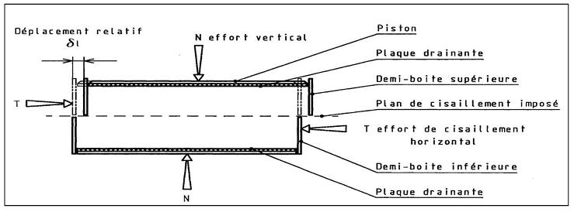

**Figure 9: Diagram representing the simple of a shear test**

Figure 10 illustrates the complete experimental setup.

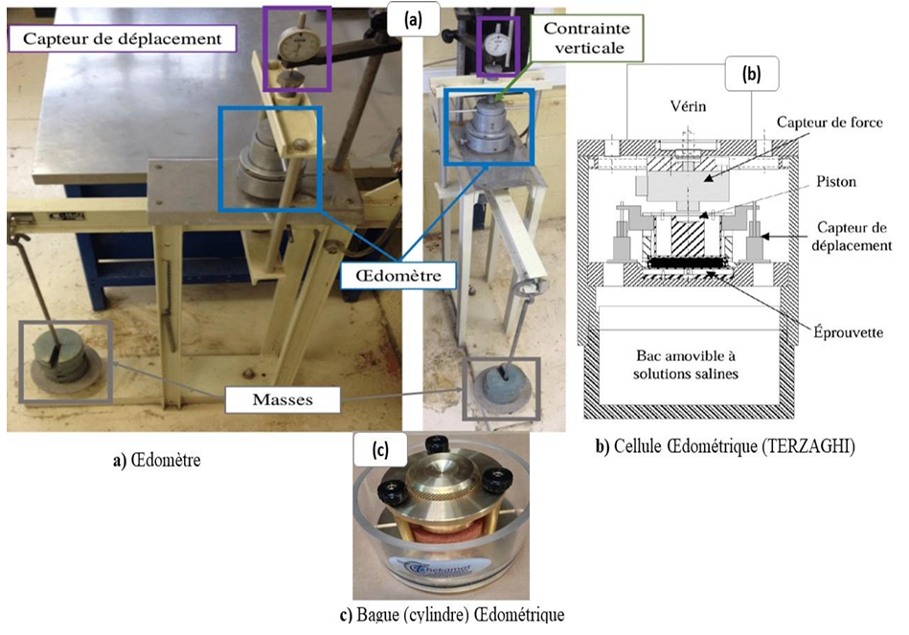

**Figure 10: The setup of the oedometer test**

Figures 11 and 12 show the samples of bricks made and the press used to perform the mechanical characterization of the bricks.

|  |  |
| --- | --- |
| **Figure 11: Adobe bricks of 4x4x16 cm** | **Figure 12 : Experimental device for compression** |

Figure 13 is a visual representation of the KDpro device. It allows for the thermal characterization of bricks.

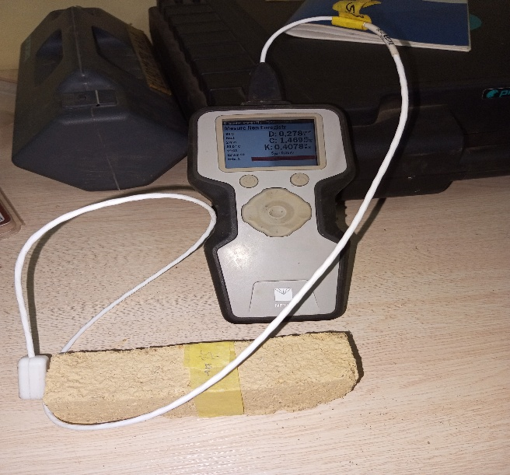

**Figure 13: Device for measuring thermal parameters**

***Experimental method***

* **Particle Size Analysis**

Sieve analysis is used to assess the grains of the material with diameters greater than or equal to 0.063 mm. The material passing through the finest sieve (0.063 mm) is subjected to sedimentation analysis, which complements the particle size analysis. Sedimentation analysis determines the distribution of grains with diameters smaller than 0.063 mm by measuring the settling velocity of the particles in a liquid. This method allows for the determination of the grain size distribution based on sedimentation rates. For the particle size analysis, a sample of the material is collected and washed to remove impurities, then decanted and dried. The drying process is carried out either in an oven at 50 °C for 8 hours or at 105 °C for 4 hours. In this study, the latter condition was used: 4 hours at 105 °C. The sieve analysis was performed in accordance with standard **NFP 94-056** [12]. To perform the particle size analysis of soils by the sedimentation method, the following standard is used: NF P94-057 [13].

* **The Atterberg Limit**

**The Atterberg Limit** is a standardized laboratory test conducted to evaluate the behavioral characteristics of fine-grained soils. This test serves to determine the plasticity properties of soils, specifically the transition from a **liquid state to a plastic state**, referred to as the**liquid limit (wₗ),** and the transition from a **plastic state to a solid state**, known as the **plastic limit (wₚ)**. These parameters are critical for classifying soil consistency and assessing its engineering properties.

* **Liquid Limit (wₗ)**

A soil sample of approximately 1 kg is collected, washed, and left to settle by decantation. After sedimentation, the supernatant water is carefully removed. A subsample of 70 g is then spread onto a smooth glass plate and homogenized through kneading to ensure uniformity. A portion of the homogenized paste is placed into the Casagrande cup and leveled. The sample is then divided along its center using a standard grooving tool. A series of controlled blows are applied to the cup until the two separated edges close over a 1 cm span. The number of blows required for closure is recorded. This procedure is repeated for $4$ to $5$ trials, ensuring that the recorded number of blows falls within the acceptable range of 15 to 35. For valid test results, a small portion of the sample is extracted and manually rolled into threads of $2–3 mm$ diameter with varying lengths. The Liquid Limit **(wₗ)** is defined as the critical moisture content at which the soil transitions from a liquid to a plastic state. To determine the Atterberg limit, we used the standard NF P94-051[14]. It is mathematically expressed by the relationship (1).

$W_{l}=\frac{M_{water}}{M_{echan sec}}×100$ (1)

With $M_{water}={ m}_{1}-m_{2}$, $M_{échan.sec}=m_{2}-m_{tare}$

$M_{water}$*: the mass of water; $M_{echan.sec}$:* the mass of the dried sample after oven-drying

$m_{1}$*: the mass of the wet sample; $m_{2}$: the mass of the dry sample; $m_{tare}$:tare weight*

* **Plasticity limit**

The plastic limit is the transition of a soil from a liquid state to a solid state. This transition is characterized by a loss of water or a decrease in the moisture content of the material. The rods obtained are rolled evenly until cracks appear. Once the cracks appear, the central part is taken to measure the moisture content contained in the material. This measurement is done by drying the rods. After drying, we weigh the sample in order to know the new mass.

* **The plasticity index**

The plasticity index is the différence between the liquid limit and the plastic limit.It is obtained from equation 2.

$I_{p} = W_{l} - W_{p}$*(2)*

* **The organic matter content**

Organic matter content refers to the presence of organic material within a given substance. It is quantified as a percentage. This organic matter may originate from plant debris, deceased animal matter, or the degradation of certain rock types. For the experimental procedure, we adhered to the XP P94-047 standard. A sample of the material was placed in a temperature-controlled oven, set at 105°C for 4 hours. Equation (3) enables the determination of the organic matter content.

Organic matter content (mo) en % = $\frac{m1-mf}{m1} X 1OO$ (3)

either m1 = initial mass of the sample plus the crucible

mf = final mass of the sample and the crucible

* **Methylene blue test**

The methylene blue adsorption test serves as a method for characterizing fine soils. The measured parameter, known as the Methylene Blue Value (MBV), is determined following the French standard NF P94-068 [15]. A clay sample weighing between 30 g and 60 g is carefully collected and introduced into a beaker containing 500 ml of distilled water. The mixture is initially dispersed using a mechanical stirrer at 700 revolutions per minute (700 rpm). The stirring speed is then reduced to 400 rpm to ensure complete dispersion of the clay within the beaker. Subsequently, 5 to 10 cm³ of methylene blue solution (10 g/L concentration) is added to the suspension, with the exact volume determined by the clay content. After exactly one minute (1 min) of testing, a droplet of the suspension is deposited onto filter paper using a glass rod. The deposited droplet should form a central spot measuring 8 to 12 mm in diameter.

The test is considered successful if a light blue peripheral ring, approximately one millimeter wide, appears in the moist area surrounding the spot. Should this result not be achieved, the procedure must be repeated by successively adding additional 5 to 10 cm³ aliquots of methylene blue solution to the suspension. The methylene blue value (MBV) of the soil, denoted as VBS and corresponding to the compound C₁₆H₁₈N₃SCl, is determined using Equation (4).

VBS $=\frac{\frac{B}{m_{h}} ×100}{1+W}$ (4)

B= V x 0,01

with V: total volume of the methylene blue solution introduced into the solution (c=10g/l)

mh(g): the mass of the sample

W: the initial water content determined in parallel

The blue activity index (BAI) of soil can be determined from the relationship (5) :

ACB = $\frac{100X VBS}{C}$ (5)

With C: the clay fraction content in percentage of the soil.

* **The shearing**

The shear test is conducted to determine the shear strength of a material. This strength characterizes the material's ability to withstand applied loads without undergoing sliding or deformation. The test is performed in accordance with standard NF P94-071-1

The test involves preparing the material specimen and placing it in a perforated container designed to allow water infiltration. The container and its contents are fully immersed in water until the material reaches saturation. Upon achieving saturation, the container and specimen are transferred to the cutting apparatus. The machine is then activated while recording measurements from the display unit.

* **The oedometric**

This geotechnical test serves to determine a soil's compressibility and consolidation characteristics, specifically its deformation behavior under applied loads. The oedometer test was conducted in compliance with standard NF P94-071-1.

The oedometer test is performed on a material specimen placed within a metal cylindrical cell. During testing, the apparatus applies a vertical axial force to the saturated sample. A series of incremental vertical loads is progressively applied to the specimen, with loading stages maintained at constant pressures in both increasing and decreasing sequences.

Throughout the test, vertical settlement measurements are recorded at each loading stage. These data enable the calculation of soil compression parameters. A designated time is required to allow pore water expulsion from the saturated specimen under the applied load regime. Only following this phase can the consolidation phenomenon be properly quantified [16].

* **Mechanical characterization**

The adobe bricks were stabilized using peanut shells incorporated at varying proportions: 5%, 10%, 15%, and 20%. The prepared samples measured 4 × 4 × 16 cm. Each brick was precisely bisected into two halves, which were then stacked to form a single test specimen. The compressive strength, denoted as Rc, was calculated using Equation 6 :

**Rc =** *(6)*

**F**: is the maximum force applied to the adobe in (N)

**S**: is the surface of the section on which the force (in mm2)

* **Thermal properties of adobes**

The measurement of these parameters was conducted using the KDPro instrument (METER Group). The device features a dual-needle probe that simultaneously propagates heat through the material and measures three key thermal parameters: thermal conductivity, heat capacity, and thermal diffusivity. Thermal effusivity (E), an additional parameter, can be derived from Equation (7).

E = $\sqrt{λ x C}$*(7)*

Avec E: thermal effusivity (J.k-1.m-2. S-1/2)

𝜆 : thermal conductivity of the material (W m-1 K -1)

𝐶 : mass specific heat capacity of the material (J Kg-1 K -1)

**3. RESULTS AND DISCUSSIONS**

**3.1. Geotechnical Characterization of the Soil**

**The particle size analysis**

The particle size granulometric analysis reveals a distribution of 52% retained material, 48% passing material, and 24% fines at the 0.002 μm sieve. The granulometric curve is continuous and well-graded, reflecting a dense particle packing with both coarse grains and fines. Such a tight gradation suggests that the material is appropriate for adobe fabrication. The coarser particles are likely to serve as aggregates, while the fine fraction acts as a binder, promoting inter-particle cohesion. These results align with previous studies on adobes used in the construction of Nubian vaults [2].

Figure 14 shows the results of the granulometric analysis of the soil.

**Figure 14: The granulometric analysis curve**

* **The Atterberg limit**

Table 1: presents the results obtained after performing the Atterberg limit. The Atterberg limit allows us to know the degree of plasticity of a soil based on its plasticity index.

Table 1: Summary table of Atterberg Limit results.

|  |  |
| --- | --- |
| Geotechnical characterization | Clay |
| Plasticity limit Wp (%) | 29 |
| Liquidity limit Wl (%) | 61 |
| Plasticity index IP (%) | 32 |

Based on the results obtained from the test, as presented in the table above, and with reference to the soil classification chart according to plasticity indices, the soil can be classified as plastic. According to the GTR (Road Earthworks Guide) classification system, the soil is identified as clayey and plastic.

* **The content of organic matter**

The organic matter content found in the material is 5.33%. This relatively low concentration is beneficial, as it reacts with the material to form air pockets, thereby reducing thermal exchange within the adobe structures.

* **The methylene blue test**

Following the methylene blue test, a VBS value of 3.59% was obtained. Referring to the threshold table

for methylene blue values corresponding to soil types, the soil is classified as having medium plasticity

and low activity. Indeed, soil classification is possible through a methylene blue test ; for a methylene

blue value between 2.5% to 5%, the soil is classified as having medium plasticity. We obtained a VBS

value equal to 3.59%, therefore we have a soil with medium plasticity according to the NF P 94 -068

standard. Referring to the work of Kouka J. Ouédraogo [17] who obtained methylene blue values of

2.7% and 4.1% from two different clayey soils, we have the same type of soil, that of soils with medium

plasticity.

* **Shear test**

The results obtained after the shear test are in Table 2.

Table 2: summary of the results of the shear test**.**

|  |  |
| --- | --- |
| Designation | Material |
| Angle φ (°) | 13 |
| Cohesion coefficient Cc (bar) | 0,23 |

The stresses obtained from the application of the various loads are as follows: With a normal stress of 0.5 bar applied, we have a tensile force equal to 1.3 daN. With a normal stress of 1.0 bar, the attractive force increases to 1.8 daN. When the applied normal stress is 2.0 bar, the attractive force increases to 2.45 daN. The angle obtained is equal to 13°, an acute angle; it designates the angle of internal friction of the material. The cohesion coefficient Cc = 0.23 bar represents the cohesion of the material. Indeed, it is the shear strength in the absence of normal stress. We have a material that resists shearing due to the high Cc value. The material is rough due to the interaction between the different particles.

* **Oedometer**

We have on the abscissa the contraints (σ'p) scale 1cm=10mm, in ordinate we have the indices of the voids noted (eI) with 1cm=10mm

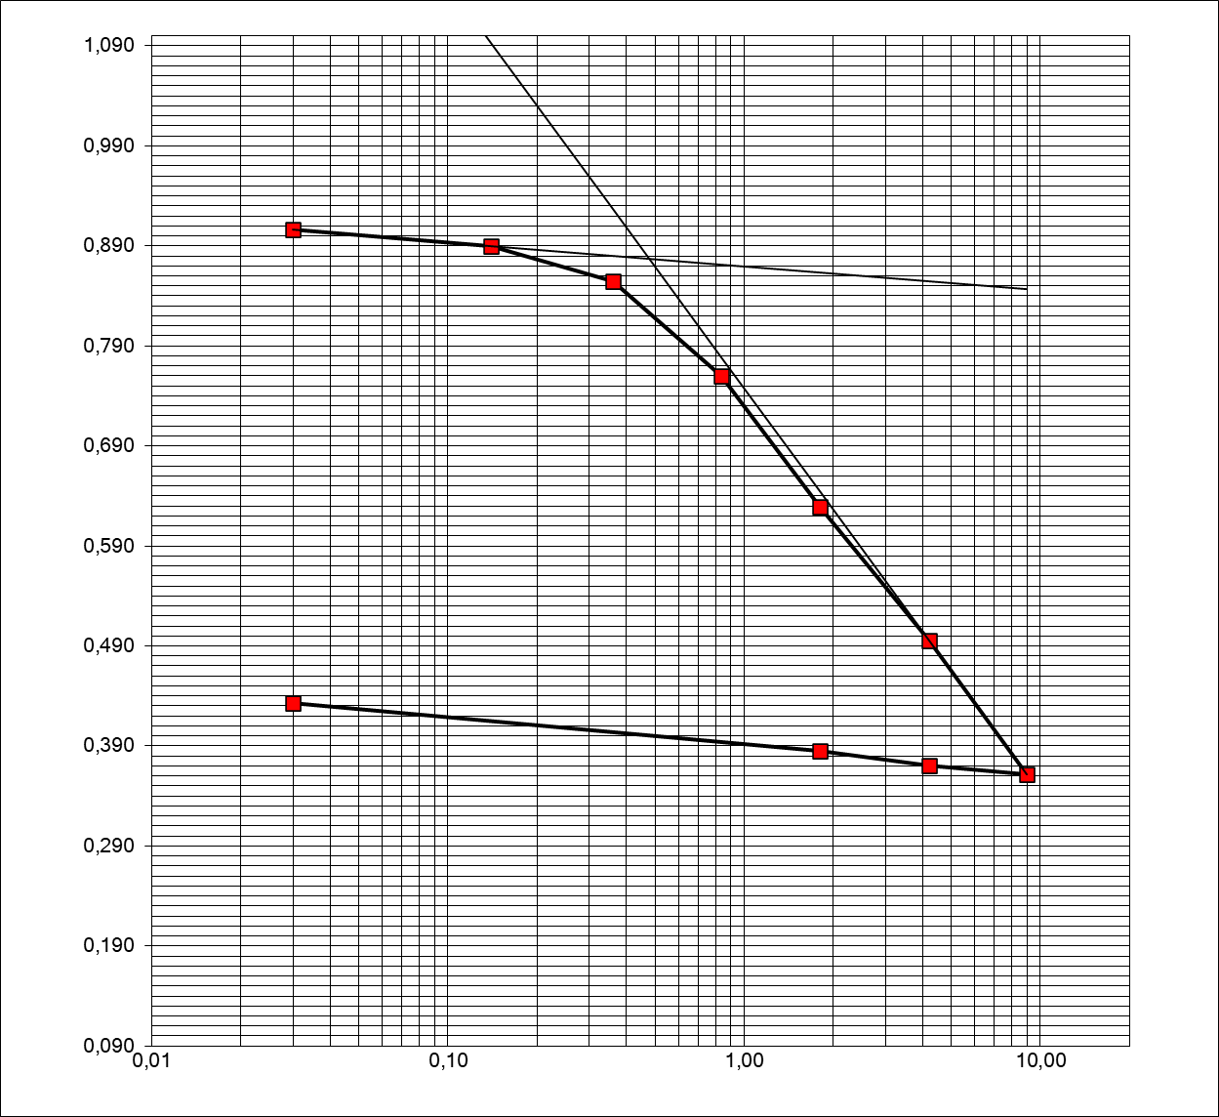Figure15 presents the results of the oedometer tests.

Y(eI)

X (σ'p)

**Figure 15: oedometer curve**

**Table 3: summary of the results of the oedometer test**

|  |  |  |  |  |  |  |
| --- | --- | --- | --- | --- | --- | --- |
| Designation | e0 | ef | Cc | Cg | Eoed (Mpa) | σ'p (MPa) |
| Clay | 0,906 | 0,433 | 0,404 | 0,058 | 19,626 | 0,480 |

The results of Table 3 were deduced from Figure 15

The material exhibits a high initial void ratio (*e₀*) and a high compressibility index, along with a relatively low swelling coefficient (*Cg*). The oedometer modulus (*Eₒed*) is 19.626 MPa, and the preconsolidation stress (*σ'p*) is 0.480 Pa. Based on the oedometer test results, the material demonstrates good stability, limited swelling behavior, and a high degree of compaction, attributable to its void ratio. Its mechanical strength is enhanced by a well-graded particle size distribution, with a significant presence of both coarse grains and fine particles. The material exhibits satisfactory compressive strength, as reflected in the value of its oedometer modulus. According to the classification of soils based on oedometer modulus values, the material can be categorized as a uniform silty soil (3 < *Eₒed* < 35). These characteristics indicate that the soil is suitable for use in adobe production.

**3.2 Mechanical and thermal characterization of bricks**

* **Mechanical characterization.**

Compressive strength tests wer conducted 60 days after the preparation of the sample.It was observed that the mechanical strength decreased progressively as the proportion of groundnut shells increased.The results of our study are broadly consistent with those reported in the literature, notably by Imbga et al.[7], as well as those obtained in [18], where soil was stabilized with lime in proportions ranging from 0% to 10%, yielding compressive strength values between 0.6 and 1.3 MPa. Similarly, compressive strength tests performed on earthen bricks stabilized with 0% and 2% sugarcane residue yielded values of 0.7 MPa and 0.78 MPa, respectively, as reported by Lima et al. [19]. These findings are comparable to ours in terms of strength performance. The increase in peanut shells in the clay material creates voids; the higher the percentage of shells, the greater the number of voids, which explains the reduction in the mechanical strength of the bricks.

Figure 16 shows the results of compression test noted (Rc).

**Figure 16: Graph illustrating the compressive strength**

* **Thermal characterization**

Figure 17 shows the evolution of thermal conductivity as a function of the amount of peanut shell.

Thermal conductivity decreases progressively with the increase in the percentage of groundnut shells incorporated into the material. In general, the addition of groundnut shells contributes to a reduction in thermal conductivity.

**Figure 17: Graph representing thermal conductivity as a function of the percentage of addition of peanut shells.**

Figure 18 illustrates the variation in thermal diffusivity as a function of the groundnut shell content. Thermal diffusivity remains relatively constant up to a 10% addition, after which it decreases significantly up to 20%. This indicates that groundnut shells have a notable influence on thermal diffusivity, effectively reducing heat transfer within the material

**Figure 18: graph representing thermal diffusivity as a function of stabilization percentages in peanut shells.**

Figure 19 shows the variation in thermal effusivity as a function of the groundnut shell content. A significant reduction in effusivity values is observed with increasing percentages of groundnut shells. Groundnut shells introduce air pockets throughout the material. The stabilizer increases overall porosity. Naturally, groundnut shells contain both air voids and fibrous elements. These air pockets and fibers contribute to the reduction of thermal exchange between the material and the interior environment. The stabilizing agent creates favorable conditions that slow down heat transfer, with the entrapped air pockets effectively reducing the rate of heat propagation.

**Figure 19: graph illustrating thermal effusivity as a function of the percentage of added peanut shells.**

**4.CONCLUSION**

This study examines the thermal and mechanical properties of bricks stabilized with peanut shells. The results show that stabilization with shells significantly reduces thermal conductivity (from 0.747 to 0.267 W/m·K at 20%) and improves the thermal insulation of buildings. On the other hand, mechanical strength decreases with the increase in the stabilizer content (from 1.881 to 0.635 MPa). This process, in addition to being efficient in thermal performance, allows for the valorization of a local agricultural waste, contributing to environmentally friendly constructions.

**Disclaimer (Artificial intelligence)**

Option 1:

Author(s) hereby declare that NO generative AI technologies such as Large Language Models (ChatGPT, COPILOT, etc.) and text-to-image generators have been used during the writing or editing of this manuscript.

**REFERENCES**

[1] E. Ouedraogo, O. Coulibaly, A. Ouedraogo, and A. Messan, “Mechanical and thermophysical characterization of compressed earth blocks stabilized with paper (cellulose) and/or cement.”, J. Mater. Eng., 2(2), pp. 68-76, (2015).

[2] K. Toussakoe, E. Ouedraogo, K. B. Imbga, A. Messan, and F. P. Kieno, “Mechanical and thermophysical characterization of adobe used in the Nubian vault,” Afrique SCIENCE, 19(5), pp. 186-199, (2021).

[3] W. Zhang, F. Liu, and R. Fan, “Improved thermal comfort modeling for smart buildings: A data analytics study,” International Journal of Electrical Power & Energy Systems, 103, p. 634‑643, (2018).

[4] A. E. Losini, A.-C. Grillet, M. Bellotto, M. Woloszyn, and G. Dotelli, “Natural additives and biopolymers for raw earth construction stabilization–a review”, Construction and Building Materials, 304(124507), (2021).

[5] H. Bamogo *et al.*, « Improvement of water resistance and thermal comfort of earth renders by cow dung: an ancestral practice of Burkina Faso », *Journal of Cultural Heritage*, vol. 46, p. 42‑51, nov. 2020, doi: 10.1016/j.culher(2020).

[6] P. Nshimiyimana, N. Fagel, A. Messan, D. O. Wetshondo, et L. Courard, « Physico-chemical and mineralogical characterization of clay materials suitable for production of stabilized compressed earth blocks », *Construction and Building Materials*, vol. 241, p. 118097,(2020) doi: 10.1016/j.conbuildmat.2020.118097.

[7] B. K. Imbga, P. F. Kieno, et E. Ouedraogo, « Thermal and mechanical study of the adobe stabilized with straws and/or cement at different dosage rates », *Int. J. Eng. Innov. Tech*, vol. 4, no 4, p. 200‑204 (2014).

[8] I. B. Kossi, K. P. Florent, S. Vincent, O. Emmanuel, G. Daniel, et T. P. Moussa, « Study of the Thermal and Mechanical Performance of Laterite Blocks Mixed with Néré Pod for the Thermal Insulation of Buildings », *Physical Science International Journal*, p. 1‑10,(2016) doi: 10.9734/PSIJ/2016/25610.

[9] S. A. DJOMO, H. C. KOUAKOU, O. A. H. KONAN, et E. EMERUWA, « Stabilisation des blocs d’argile avec une base naturelle, la potasse », *Afrique SCIENCE*, vol. 15, no 5, p. 1‑11 (2019).

[10] E. Malbila, S. Delvoie, D. Toguyeni, S. Attia, et L. Courard, « An Experimental Study on the Use of Fonio Straw and Shea Butter Residue for Improving the Thermophysical and Mechanical Properties of Compressed Earth Blocks », *JMMCE*, vol. 08, no 03, p. 107‑132, (2020) doi: 10.4236/jmmce.2020.83008.

[11] Ohindemi G. Yameogo, Donzala D. Some, Sié Kam, Adamah Messan, Takenori Hino, et Dieudonné J. Bathiebo, « Thermomechanical and Hydrous Effect of Heavy Fuel Oil in a Building Material Based on Silty Clayey Soil », *JCEA*, vol. 17, no 5 (2023) doi: 10.17265/1934-7359/2023.05.001.

[12] P. NF, “94-056, Soils: Surveys and Tests, Granulometric Analysis, Dry Sieving Method after Washing,” French Association for Standardization, France (in French), (1996).

[13] N. AFNOR, “P94-057. Soils: Surveys and Tests. Granulometric Analysis,” Sedimentation Method. Paris: French Association for Standardization, (1992).

[14] P. NF, *Détermination des limites d’Atterberg*.(1993).

[15] P. NF, Measurement of the Quantity and Activity of the Clay Fraction. Determination of the Methylene Blue Value of a Soil by the Stain Test. (1993).

[16] K. A. J. Ouedraogo, “Stabilization of sustainable and ecological construction materials based on raw earth using organic and/or mineral binders with low environmental impacts,” PhD, Université Paul Sabatier - Toulouse III, 2019. Accessed (2024). [Online]. Available at: https://theses.hal.science/tel-02628530

[17] K. A. J. Ouedraogo, “Stabilization of sustainable and ecological construction materials based on raw earth using organic and/or mineral binders with low environmental impacts,” PhD, Université Paul Sabatier - Toulouse III, 2019. Accessed (2024). [Online]. Available at: https://theses.hal.science/tel-02628530

[18] I. Alam, A. Naseer, et A. A. Shah, « Economical stabilization of clay for earth buildings construction in rainy and flood prone areas », *Construction and Building Materials*, vol. 77, p. 154‑159,(2015).

[19] S. A. Lima, H. Varum, A. Sales, et V. F. Neto, « Analysis of the mechanical properties of compressed earth block masonry using the sugarcane bagasse ash », *Construction and Building Materials*, vol. 35, p. 829‑837 (2012).