**A survey on lumpy skin disease (lsd) among dairy farmers of Palampur tehsil of Himachal Pradesh, India and constraints in adopting control measures**

**Abstract**

Lumpy skin disease (LSD) is the most fatal viral disease that causes huge economic losses in Cattle farming. The study aims to assess the knowledge, awareness, and practices of dairy farmers in Palampur Tehsil regarding LSD, identify constraints in adopting control measures, and inform effective disease management strategies. The study was conducted from January to June 2025 among 150 farmers from five panchayats (Andreta, Saliana, Sungal, Arla Khas and Paror) in Palampur Tehsil, Kangra district, Himachal Pradesh, India. The survey study on Lumpy Skin Disease in cattle involves systematic data collection and analysis to understand its prevalence, risk factors, and impact on the affected cattle population. The results on the awareness of LSD among dairy farmers revealed that overall, farmers exhibited a neutral or uncertain attitude toward the disease. There was no significant difference in attitude between farmers who had previously encountered lumpy skin disease and those who had not. However, participation in seminars, group discussions, and lectures on lumpy skin disease showed a positive correlation with farmers' attitudes and awareness. Knowledge about the symptoms, modes of transmission, first aid, and preventive and control measures was generally found to be at a high or medium. It is reported that 43.33% dairy farmers exhibited a high level of awareness about lumpy skin disease, while 32.66% and 24% of farmers have medium and low awareness of the disease. Media exposure, interpersonal communication channels, seminars, and workshops attended had a significant role in the general awareness of lumpy skin disease. The majority of the farmers used mobile phones as a source of information (41.33%), other sources are newspaper (33.33%), television (32.66%), and radio (22.66%). The overall distribution of dairy farmers based on awareness of first aid and disease management was also studied, and it is worth stating that the majority of dairy farmers had high awareness of first aid and disease management, i.e. 42.66%, while 36% and 21.33% of farmers had medium and low awareness about disease management. Regarding constraints faced by farmers in adopting control measures, most felt constraints were decreased milk costs during the pandemic (53.33%) and reduction in the production & quality of milk in infected cattle (49.33%).

**Keywords**: Lumpy skin disease, symptoms, pandemic, constraints, transmission

**Introduction**

The livestock sector plays a vital role in global food security, economic development, and rural livelihoods, especially in agrarian economies like India. With an estimated livestock population of 535.78 million, including cattle, buffaloes, sheep, goats, and pigs, India is not only a significant contributor to the global livestock industry but also the world’s largest milk producer, accounting for approximately 24% of global milk output (20th Livestock Census, 2019). The economy of Himachal Pradesh, a northern hill state of India, significantly depends on agriculture, horticulture, and animal husbandry. As per the 2019 census, the state hosts around 4.41 million livestock, including 1.83 million cattle, underscoring the importance of animal husbandry to rural livelihoods. However, the productivity of livestock in India is frequently threatened by various infectious diseases, among which viral infections are widespread among the livestock populations, diseases such as foot and mouth disease, anthrax, bovine tuberculosis, and particularly lumpy skin disease (LSD) have been associated with reduced productivity, reproductive abnormalities and even mortality leading to notable economic losses in the dairy and livestock sectors. LSD is a contagious, non-zoonotic viral infection caused by the Lumpy Skin Disease Virus (LSDV), a member of the *Capripoxvirus* genus in the *Poxviridae* family (Al-Salihi, 2014 and Tuppurainen *et al*., 2017). Other names of this infection are “Pseudo urticaria”, “Neethling virus disease”, “exanthema nodularisbovis” & “*knopvelsiekte*” (Kaler et al., 2025; Tuppurainen et al., 2017). The disease primarily affects cattle and water buffaloes and is transmitted predominantly through blood-sucking vectors such as mosquitoes, flies, and ticks (Tuppurainen *et al*., 2011 and Lubinga *et al*., 2013). Clinical symptoms include fever, lymph node enlargement, skin nodules, reduced milk yield, infertility, and sometimes death, especially in exotic breeds like Holstein Friesian and Jersey (Abutarbush *et al*., 2013 and Gupta *et al*., 2020). LSD has a low mortality but high morbidity rate, and the virus's resilience in harsh environmental conditions further worsens its spread and persistence. Since it was initially identified in Zambia in 1929 (Morris, 1931), LSD has since spread across Africa, the Middle East, and South Asia. It was first reported in India in August 2019 in Odisha and West Bengal (Sudhakar *et al*., 2020), and by 2022, the country faced a widespread outbreak with over 2.9 million cattle affected and approximately 155,000 deaths across 251 districts in 15 states (ICAR Report, 2023). Himachal Pradesh, too, witnessed significant outbreaks, with Kangra district being the most severely impacted. The socio-economic impact of LSD is profound. As a List A disease by the World Organisation for Animal Health (OIE), LSD causes both direct losses, such as reduced milk production, weight loss, and abortions and indirect losses due to trade restrictions, control measures, and decreased genetic improvement (Tuppurainen and Oura, 2011 and Babiuk *et al*., 2008). Control strategies primarily rely on vaccination, ring immunisation during outbreaks, and sanitary measures such as vector control and movement restrictions (Wilson *et al*., 2020 and Gari *et al*., 2012). During an outbreak, large-scale immunisation of bovines is the most effective control measure when combined with bovine movement restrictions (EFSA; 2018; Tuppurainen et al., 2021). The objective of the study is to assess the knowledge, awareness, and practices of dairy farmers in Palampur Tehsil regarding LSD, identify constraints in adopting control measures, and inform effective disease management strategies.

**Material and methods**

The present study was conducted from 1st January to 30th June 2025 to know the awareness of dairy farmers regarding the outbreak of lumpy skin disease (LSD). The study was carried out based on a survey on lumpy skin disease by the Department of Zoology, Sri Sai University, Palampur in five panchayatas viz., Andreta, Saliana, Sungal, Arla Khas, Paror of Palampur Tehsil, district Kangra. Survey studies on Lumpy skin disease in cattle involve systematic data collection and analysis to understand its prevalence, risk factors, and impact on the affected cattle population. Here's a methodology outline for conducting such a survey.

**3.1 Study area:**

The study area has an altitude of 1472-2350 m with average rainfall of 1578 mm (62.1 inches) per year, and the annual temperature is 16.8℃. The latitude of Palampur is 32.11, and the longitude is 76.53.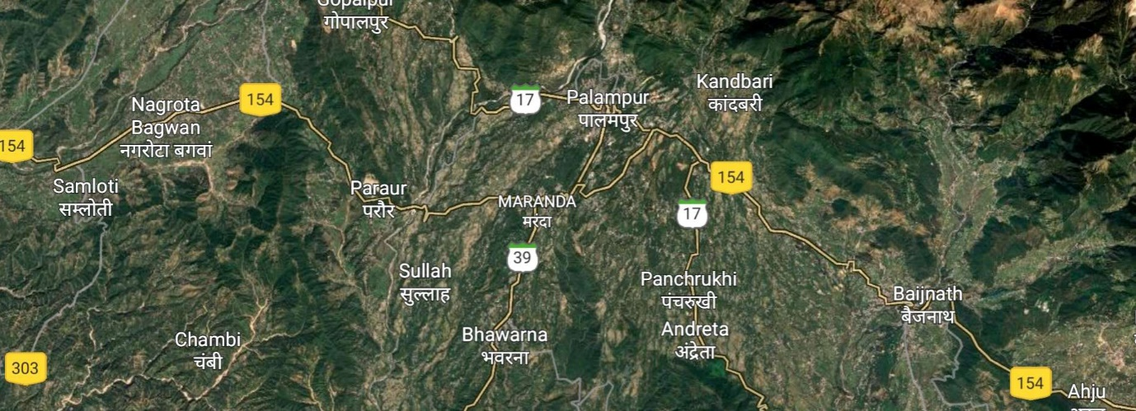

**Plate 1: Survey area**

**Plate2: Location**

Palampur: Palampur is a beautiful hill town and a municipal corporation in the Kangra valley of Himachal Pradesh. It is surrounded by lush green tea gardens, pine forests, and the Dhauladhar mountain ranges, with numerous streams flowing from the mountains to the plains. It is well connected to nearby villages and towns through a well-developed road network. 60% of the population of Palampur tehsil is dependent on cattle farming for milk production.

**Gram panchayats:**

Andreta: Andreta village is located in Palampur Tehsil of Kangra district in Himachal Pradesh. The total geographical area of Andreta is 91.41 hectares. Andreta has a total population of 1125 people, out of which 190 people rear cattle.

Saliana: Saliana village is located in Palampur Tehsil, which is the sub-district headquarters of Saliana village. The total geographical area of the village is 56.82 hectares. Saliana has a total population of 890 people, out of which 155 people rear cattle.

Sungal: Sungal is a village in Palampur Tehsil of Kangra district with a total geographical area is 1002.43 hectares. Sungal has a total population of 599 people, out of which 110 people are dependent on cattle for their livelihood.

Arla Khas: It is located in the Palampur Tehsil of Kangra district with total geographical area is 163.42 hectares. The total population of Arla Khas is 2055 people, out of which 350 people are directly dependent on cattle farming.

Paror khas: Paror khas is a village in Palampur Tehsil with a total geographical area is 301.5 hectares and a total population of 1931 people, out of which 400 people are dependent on cattle for their livelihood.

**Study design:** a semi-structured questionnaire was prepared in order to procure data.

**CHART 1 : Selection Measuring Tool**

**I. Personal variables** Schedule developed

1.Age -do-

2. Experience in dairy farming -do-

3. Educational qualification status -do-

4.Herd size -do-

5.Breed -do-

6. Occupation -do-

7. Annual income -do-

**II. Communication exposure**

1. Media exposure -do-

2. Interpersonal channels -do-

3.Seminars/workshops attended -do-

III. Lumpy skin disease (season of surge, awareness of symptoms and first aid, preventive measures and constraints in adopting control measures)

1. Cattle with Lumpy skin disease -do-

2. Season of surge of LSD among cattle -do-

3. Awareness of symptoms of LSD -do-

4. Awareness about first aid and disease management -do-

5. Preventive measures and controls -do-

6. Constraints in Lumpy skin disease management -do-

**Results and discussions**

**PERSONAL VARIABLE**

**4.1.1 Age**

Distribution of dairy farmers based on age

(n=150)

|  |  |  |  |
| --- | --- | --- | --- |
| **Sr. no.** | **Category** | **Frequency (f)** | **Percentage (%)** |
|  | Young (18-30) | 13 | 8.66 |
|  | Middle (31-45) | 79 | 52.66 |
|  | Old (46-70) | 48 | 32.00 |
|  | Very old (71-80) | 10 | 6.66 |

**Table 1: Percentage of dairy farmers based on age**

Data in table 1 indicated that the distribution of dairy farmers’age groups is as follows; 52.66% farmers belong to middle age group, 32.00% were in the older age group, 8.66% belongs to the younger age group and 6.66% are classified in to very old age group.

**4.1.2 Experience in dairy farming**

Distribution of dairy farmers based on experience in dairy

(n=150)

|  |  |  |  |
| --- | --- | --- | --- |
| **Sr. no.** | **Category** | **Frequency (f)** | **Percentage (%)** |
| 1 | Low (1-3) animal | 92 | 61.33 |
| 2 | Medium (4-8) animal | 45 | 30.00 |
| 3 | High (8-12) animal | 13 | 8.66 |

**Table 2: Percentage of dairy farmers based on experience**

Data in Table 2 represented that 43.33% of farmers have relatively low experience in dairy farming, ranging from 5 to 15 years. Meanwhile, 36.66% of farmers have a medium level of experience, between 25 to 35 years. Only 20.00% of farmers have extensive experience, spanning 40 to 55 years, across all five panchayats of Palampur Tehsil.

**4.1.3 Literacy/ Educational status**

Qualification status of respondents from the present study

(n=150)

|  |  |  |  |
| --- | --- | --- | --- |
| **Sr. no.** | **Education** | **Frequency (f)** | **Percentage (%)** |
| 1 | Illiterate | 25 | 16.66 |
| 2 | Primary | 22 | 14.66 |
| 3 | Middle/High school | 80 | 53.33 |
| 4 | Senior Secondary | 11 | 7.33 |
| 5 | Graduate | 10 | 6.66 |
| 6 | Post Graduate | 2 | 1.33 |

**Table 3: Percentage of dairy farmers based on educational qualification**

Data in Table 3 showed that the majority of dairy farmers (53.33%) have attained schooling up to middle and high school. Other educational qualifications included primary schooling (14.66%), senior secondary (7.33%), graduation (6.66%) and post-graduation (1.33%). Additionally, 16.66% of the farmers had no formal education.

**4.1.4 Herd size**

Distribution of dairy farmers based on herd size

(n=150)

|  |  |  |  |
| --- | --- | --- | --- |
| **Sr. no.** | **Category** | **Frequency (f)** | **Percentage (%)** |
| 1 | Low (1-3 animals) | 44 | 29.33 |
| 2 | Medium (4-8 animals) | 71 | 47.33 |
| 3 | High (8-12 animals) | 35 | 23.33 |

**Table 4: Percentage of dairy farmers based on herd size**

Data in Table 4 showed that cattle herd size was low in the case of 61.33% respondents, whereas it was medium and high in the case of 30.00% and 8.66% of respondents, respectively.

The herd size of cattle was significantly correlated with lumpy skin disease. A research study found that cattle in larger herd sizes were more prone to lumpy skin disease compared to those in smaller herds. These observations are consistent with the findings of (Arjkumpa *et al*.,2024; Arjkumpa *et al*., 2024; and Ochwo *et al*.,2019), who reported that larger herd sizes are associated with a greater intensity of lumpy skin disease virus transmission.

**4.1.5 Breed**

Distribution of cattle based on breed

(n=95)

|  |  |  |
| --- | --- | --- |
| **Breed** | **Number of Cows** | **Percentage (%)** |
| Ordinary | 14 | 14.73 |
| Sahiwal | 23 | 24.21 |
| Gir | 8 | 8.42 |
| Jersey | 40 | 42.10 |
| Sindhi | 10 | 10.52 |

**Table 5: Percentage of cows based on breed**

Data in Table 5 showed that the Jersey breed cattle in local domestic animals are 42.10% while Sahiwal, Ordinary, Sindhi and Gir are 24.21%, 14.73%, 10.52% and 8.42%, respectively.

Jersey and Holstein cattle with thin skins usually have more signs of the disease than other thick-skinned indigenous breeds; these breeds typically have thinner skin, which makes them more susceptible to insect vectors that transmit the disease (Coetzer and Tuppurainen, 2004 and Tageldin *et al*.,2014). These observations are in agreement with those of Devi *et al*. (2025) who reported that the percentage of jersey breed was high in having milk fever disease.

**4.1.6 Primary occupation**

The primary occupation of respondents from the present study

(n=150)

|  |  |  |  |
| --- | --- | --- | --- |
| **Sr. no.** | **Category** | **Frequency (f)** | **Percentage (%)** |
| 1 | Agriculture/Dairying | 70 | 46.66 |
| 2 | Business/Shop | 35 | 23.33 |
| 3 | Govt. job | 16 | 10.66 |
| 4 | Casual labour/ MNREGA | 17 | 11.33 |
| 5 | Others | 12 | 7.33 |

**Table 6: Percentage of farmers based on primary occupation**

Data in table 6 revealed that the primary occupation of the majority of the respondents (46.66%) was Agriculture/Dairying, whereas, 23.33%, 11.33% and 10.66% of respondents were engaged in private jobs/ business/shop, casual labour/MNREGA and Govt. jobs respectively. Only 7.33% had another job as their primary occupation.

**4.1.7 Annual income**

Annual income of respondents from the present study

(n=150)

|  |  |  |  |
| --- | --- | --- | --- |
| **Sr. no.** | **Category** | **Frequency (f)** | **Percentage (%)** |
| 1 | Low (<100000) | 32 | 21.33 |
| 2 | Medium (Rs. 200000-Rs. 300000) | 98 | 65.33 |
| 3 | High (>400000) | 20 | 13.33 |

**Table 7: Percentage of farmers based on annual income**

Data in Table 7 showed that the annual income of the majority of respondents was medium (65.33%). 21.33% earned a low level of annual income, and only 13.33% have a high level of annual income.

**4.2. COMMUNICATION VARIABLES**

**4.2.1 Media exposure**

Distribution of dairy farmers based on media exposure

(n=150)

|  |  |  |  |
| --- | --- | --- | --- |
| **Sr. no.** | **Media exposure** | **Frequency (f)** | **Percentage (%)** |
| 1 | Newspaper | 50 | 33.33 |
| 2 | Radio | 34 | 22.66 |
| 3 | Television | 49 | 32.66 |
| 4 | Mobile phone | 62 | 41.33 |

**Table 8: Percentage of dairy farmers based on media exposure**

The data presented in Table 8 revealed that the majority of dairy farmers, i.e. 41.33% dairy farmers, relied on mobile phones as their primary source of information. Other sources of information used by the dairy farmers, in decreasing order of preference, included newspaper (33.33%), Television (32.66%) and Radio (22.66%).

Assessment of LSD awareness among livestock owners through communication channels highlights the importance of interpersonal and mass media channels, i.e. mobile phones, radio and local newspapers in disease knowledge transmission (Siddique *et al*., 2020; Kumar *et al*.,2020 and Sharma *et al*., 2023).

**4.2.2 Interpersonal channels**

Distribution of dairy farmers based on interpersonal channels as the source of information

(n=150)

|  |  |  |  |
| --- | --- | --- | --- |
| **Sr. no.** | **Interpersonal channel** | **Frequency(f)** | **Percentage (%)** |
| 1 | Friends | 38 | 25.33 |
| 2 | Neighbours | 47 | 31.33 |
| 3 | Veterinary hospital | 73 | 48.66 |
| 4 | Milk society workers | 41 | 27.33 |
| 5 | Livestock group discussion | 16 | 10.66 |

**Table 9: Percentage of dairy farmers based on interpersonal channels as the source of information**

The data presented in table 9 showed that majority of respondents (48.66%) became aware of Lumpy skin disease through veterinary hospitals. This was followed by information received from neighbour (31.33%), Milk society workers (27.33%), friends (25.33%) and livestock group discussions (10.66%).

**4.2.3 Seminars****/ workshops/ class lectures attended**

Distribution of dairy farmers based on the seminars, workshops and class lectures attended

(n=150)

|  |  |  |  |
| --- | --- | --- | --- |
| **Sr.no.** | **Information source** | **Frequency(f)** | **Percentage (%)** |
| 1 | Seminars | 82 | 54.66 |
| 2 | Workshops | 68 | 45.33 |
| 3 | Class lecture | 91 | 60.66 |
| 4 | No source of information | 44 | 29.33 |

**Table 10: Percentage of dairy farmers based on seminars/ workshops/ class lectures attended**

Table 10 indicates that 60.66% of dairy farmers attended lecture classes on lumpy skin disease (LSD). Additionally, 54.66% participated in seminars. While, 45.33% attended workshops. Meanwhile, 29.33% of the farmers reported having no source of information on the subject.

In Himachal Pradesh, traditional media channels such as newspapers, radio and television continue to be widely used and accessible sources of information among livestock owners. Regular broadcasts and articles help in creating timely information about emerging diseases like lumpy skin disease. Considering the findings of the study regarding information on lumpy skin disease, a study conducted in the Tiruvarur district of Tamil Nadu, India, assessed cattle farmers’ awareness of LSD, their findings indicated that farmers received information about LSD disease through multiple channels, including class lecture, awareness sessions and seminars (Ramachandiran *et al*., 2024; Sharma *et al*., 2023 and FAO 2017).

**4.3 LUMPY SKIN DISEASE (SEASON OF SURGE, AWARENESS OF SYMPTOMS & FIRST AID, PREVENTIVE MEASURES AND CONSTRAINTS IN ADOPTING CONTROL MEASURES).**

**4.3.1 Cows with lumpy skin disease**

Distribution of cows with lumpy skin disease

(n=95)

|  |  |  |  |  |
| --- | --- | --- | --- | --- |
| **Location** | **Panchayat’s** | **Total no. of cows** | **No. of affected cattle** | **Percentage (%)** |
|  | Andreta | 21 | 8 | 38.09 |
|  | Saliana | 17 | 6 | 35.29 |
| Palampur | Sungal | 23 | 4 | 17.39 |
|  | Arla khas | 14 | 5 | 35.71 |
|  | Paror | 20 | 6 | 30.00 |

**Table 11: Percentage of cows with lumpy skin disease**

Data presented in Table 11 indicates that the total number of cows in Andreta, Saliana, Sungal, Arla khas and Paror were 21, 17, 23, 14 and 20, respectively. Among these, the number of affected cows was 8 in Andreta, 6 in Saliana, 4 in Sungal, 5 in Arla Khas and 6 in Paror, corresponding to disease infection rates of 38.09%, 35.29%, 17.39%, 35.71% and 30%, respectively.

The transmissible diseases or disorders are caused by direct contact with infected animals or contaminated equipment and feed may contribute to transmission (OIE, 2021). The presence of large populations of biting insects (mosquitoes, ticks, etc.) significantly increases the risk of LSD transmission (Chihota *et al*., 2001). Farms with inadequate hygiene, disinfection, and control over the movement of animals or personnel are at higher risk (Sudhakar *et al*., 2020). Unvaccinated cattle populations are significantly more vulnerable to infection and outbreaks (FAO, 2017).

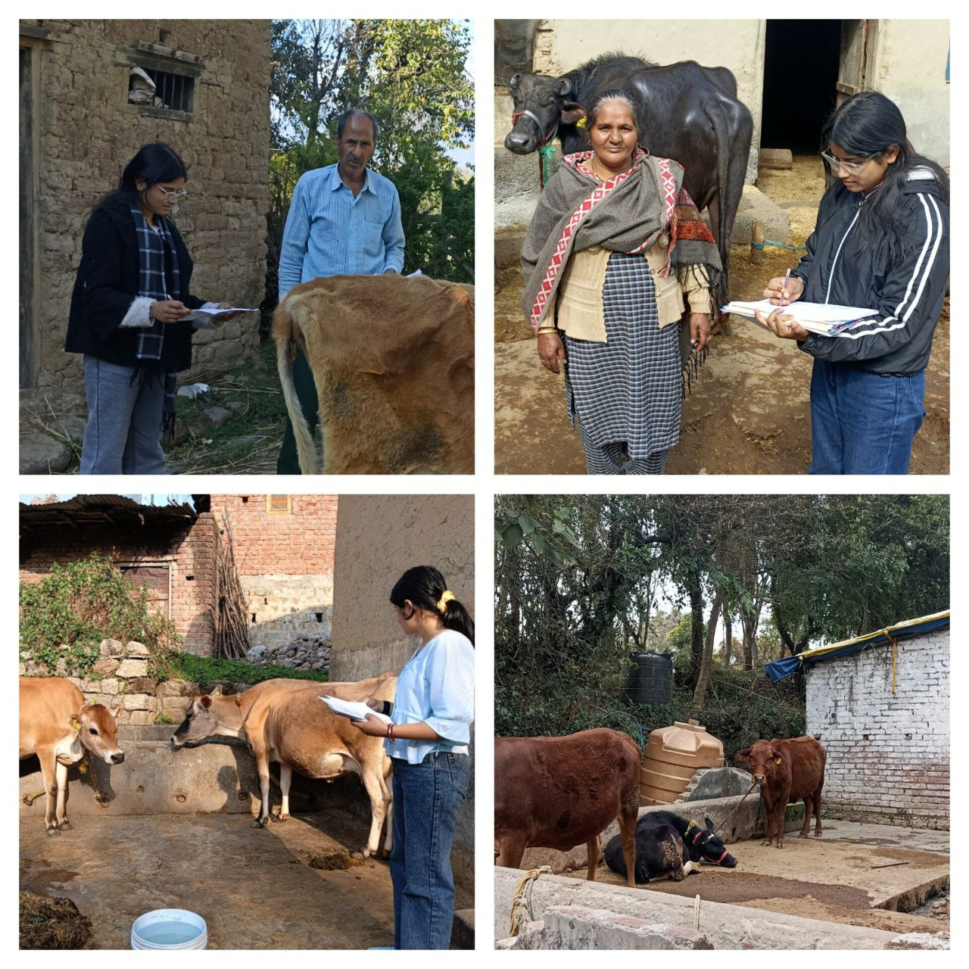

**Plate 3: Survey at Palampur Tehsil**

**4.3.2 Seasonal surge of LSD among cattle**

Distribution of dairy farmers based on the knowledge of the season of the surge of LSD

(n=150)

|  |  |  |  |
| --- | --- | --- | --- |
| **Sr.no.** | **Name of Season** | **Frequency(f)** | **Percentage (%)** |
| 1 | Summer | 37 | 24.66 |
| 2 | Monsoon | 64 | 42.66 |
| 3 | Autumn | 16 | 10.66 |
| 4 | Winter | 33 | 22.00 |

**Table 12: Percentage of dairy farmers based on the knowledge of the season of the surge of LSD**

Data in Table 12 demonstrates that (42.66%) of dairy farmers conveyed that maximum LSD cases were observed during the monsoon season. While, 24.66%, 22% and 10.66% of farmers observed LSD during Summer, Winter and Autumn seasons, respectively.

Outbreaks are typically more prevalent during rainy and warm months, which provide favourable conditions for the proliferation of mechanical vectors such as mosquitoes and biting flies (Tuppurainen and Oura, 2012). The warm temperatures and increased humidity during the summer months create ideal conditions for the breeding of insects, facilitating rapid disease spread (Abutarbush, 2015). Similarly, in India, a study observed that outbreaks coincided with monsoon and post-monsoon periods, this period is marked by increased rainfall and humidity, which promote the vector growth (Sudhakar *et al*., 2022).

**4.3.3 Awareness of symptoms of LSD**

Distribution of dairy farmers based on the awareness of symptoms of LSD

(n=150)

|  |  |  |  |
| --- | --- | --- | --- |
| Sr. no. | Symptoms | Frequency(f) | Percentage(%) |
| 1 | Round, firm skin lesions on the whole body of cattle | 61 | 40.66 |
| 2 | Noticeable increase in body temperature | 35 | 23.33 |
| 3 | Reduced intake of food and water | 16 | 10.66 |
| 4 | Decreased activity and weakness | 13 | 8.66 |
| 5 | Difficulty in breathing and nasal congestion | 17 | 11.33 |
| 6 | Reduced milk production in lactating cows | 37 | 24.66 |
| 7 | Infertility and abortion in pregnant cows | 9 | 6.00 |
| 8 | Fluidly discharge from the nose and eyes | 19 | 12.66 |

**Table 13: Percentage of dairy farmers based on the awareness of symptoms of LSD**

Data in Table 13 revealed that the majority of dairy farmers were aware of the symptoms of lumpy skin disease. The most commonly recognised symptom, reported by 40.66% of farmers, was the presence of round, firm skin lesions across the body of the affected cattle. This was followed by reduced milk production in lactating cows (24.66%), noticeable increase in body temperature (23.33%) and watery discharge from the nose and eyes (12.66%). Other symptoms identified included difficulty in breathing and nasal congestion (11.33%), reduced intake of food and water (10.66%), decreased activity and general weakness (8.66%). Additionally, around 6% of farmers reported infertility and abortion in pregnant cows as a symptom of the disease.

The most prominent symptom observed was the appearance of firm, well-circumscribed nodules of varying sizes on the skin, particularly over the head, neck, back and on the limbs (Irons *et al*., 2005 and Tuppurainen *et al*.,2012). Affected cattle showed excessive tearing and nasal discharge, reduced feed intake, and general depression were common (Ayelet *et al*.,2014 and Ferraro *et al*.,2021). These findings are somewhat similar to those of many other researchers For instance, Kumar *et al*. (2021) documented skin lesions, fever and decline in milk yield among affected cattle.

**4.3.3 (a) Overall distribution of cattle farmers based on awareness of LSD symptoms**

(n=150)

|  |  |  |  |
| --- | --- | --- | --- |
| **Sr. no.** | **Category** | **Frequency(f)** | **Percentage (%)** |
| 1 | Low (1-3) | 49 | 32.66 |
| 2 | Medium (4-6) | 36 | 24.00 |
| 3 | High (7-8) | 65 | 43.33 |

**Table 14: Percentage of the Overall distribution of cattle farmers based on awareness of LSD symptoms**

Data in Table 14 showed that 43.33% of the dairy farmers had high Awareness about lumpy skin disease symptoms, 32.66% of the dairy farmers had low awareness, and 24% had medium awareness about the symptoms of the disease, respectively.

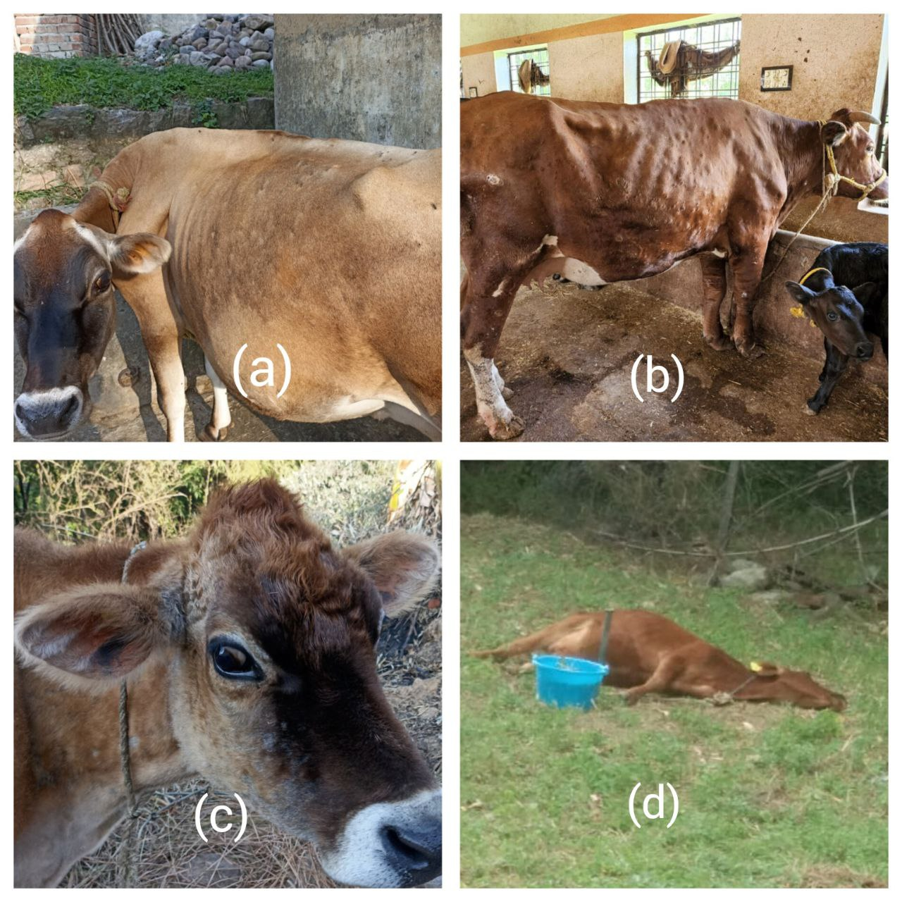

**Plate 4: (a), (b) and (c) showing round skin lesions on the whole body of diseased cattle and (d) Mortality due to lumpy skin disease in cattle**

**4.3.4 Awareness about first aid and disease management**

Distribution of Awareness about first aid and disease management

(n=150)

|  |  |  |  |
| --- | --- | --- | --- |
| **Sr. no.** | **Category** | **Frequency (f)** | **Percentage(%)** |
| 1 | Antibiotic ointments are given for the treatment of LSD | 57 | 38.00 |
| 2 | Knowledge of vaccination against LSD among cattle farmers | 68 | 45.33 |
| 3 | Antipyretics ( fever reducers) are given to reduce high fever during LSD | 43 | 28.66 |
| 4 | Adequate Knowledge of LSD treating drugs in cattle farmers | 49 | 32.66 |
| 5 | Providing supplements to enhance the immunity | 29 | 19.33 |
| 6 | Clean the affected areas with antiseptic solutions | 38 | 25.33 |
| 7 | No specific treatment for Lumpy skin disease | 24 | 16.00 |

**Table 15: Percentage of Awareness about first aid and disease management**

Data in table 15 revealed that majority of the dairy farmers had knowledge of vaccination of LSD (45.33%), Antibiotic ointments are also given by the farmers for the treatment of LSD (38%), Antipyretics ( fever reducers) are given for reducing high fever during LSD (28.66%), Some farmers clean the affected areas with antiseptic solutions (25.33%), some are providing supplements i.e. Vitamins A, D3, E, B-complex, zinc and copper to enhance the immunity (19.33%) and a few (16%) farmers have no idea about any specific treatment.

**4.3.4 (a) Overall distribution of dairy farmers based on awareness of first aid and disease management about lumpy skin disease (LSD)**

(n=150)

|  |  |  |  |
| --- | --- | --- | --- |
| **Sr.no.** | **Category** | **Frequency(f)** | **Percentage(%)** |
| 1 | Low(1-2) | 32 | 21.33 |
| 2 | Medium(3-4) | 54 | 36.00 |
| 3 | High(5-7) | 64 | 42.66 |

**Table 16: Percentage of the Overall distribution of dairy farmers based on awareness of first aid and disease management about lumpy skin disease (LSD)**

Data in table 16 reported that 42.66% farmers have high awareness about lumpy skin disease, 36% and 21.33% farmers have medium and low awareness about the disease.

These observations are consistent with those of (EFSA, 2020 and Kumar *et al*.,2022), who reported that knowledge about preventive measures such as vaccination and vector control was widespread among the farmers surveyed. Various first aid practices reported, such as washing lesions with antiseptic water, isolating the infected animals, use of herbal/home remedies, and applying wound healing creams as essential first aid steps in LSD control guidelines (FAO, 2017 and OIE, 2021)

**4.3.5 Preventive measures and controls**

Distribution of dairy farmers on their knowledge about the preventive measures and controls

(n=75)

|  |  |  |  |
| --- | --- | --- | --- |
| **Sr. no.** | **Treatment given to cows** | **Frequency(f)** | **Percentage(%)** |
| 1 | Meloxicam | 43 | 57.33 |
| 2 | Chloropheniramine maleate | 35 | 46.66 |
| 3 | Oxytetracycline | 17 | 22.66 |
| 4 | Streptopenicillin | 32 | 42.66 |
| 5 | Flunixin meglumine | 14 | 18.66 |

**Table 17: Percentage of dairy farmers on their knowledge about the preventive measures and controls**

Data in table 17 indicates that the majority of the dairy farmers (57.33%) used meloxicam as treatment for lumpy skin disease (LSD). Additionally, 46.66%, 42.66%, 22.66% and 18.66% of farmers reported using chloropheniramine meleate, streptopenicillin, oxytetracycline and flunixin meglumine, respectively, for the treatment of LSD in dairy cows.

A survey study showed that anti-inflammatory drugs ( meloxicam/ flunixin meglumine ) were effective against fever, pain and inflammatory symptoms of LSD (Kumar *et al*, 2020). One of the published reports suggested administering antibiotics ( oxytetracycline and streptopenicillin) effective against the lumpy skin disease ( Tuppurainen *et al*., 2017 and Abera *et al*., 2015).

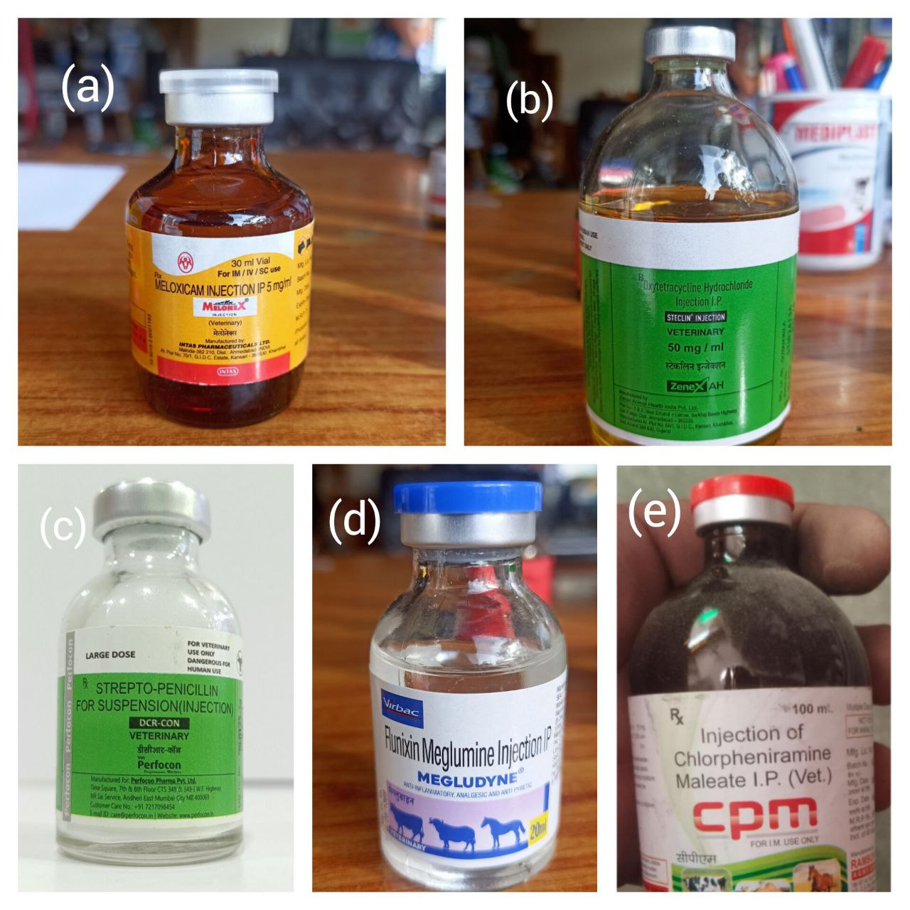

**Plate 5:** **Medicines used by dairy farmers for the treatment of lumpy skin disease in cattle**

**(a)Meloxicam (b)Oxytetracycline (c)Streptopenicillin (d)Flunixin meglumine (e)Chloropheniramine maleate**

**4.3.6 Constraints in lumpy skin disease management**

Distribution of constraints in adopting control measures

(n=75)

|  |  |  |  |
| --- | --- | --- | --- |
| Sr. no. | Constraints in adopting control measures | Frequency(f) | Percentage(%) |
| 1 | Lumpy skin disease treatment is costly | 30 | 40.00 |
| 2 | Lack of space for the isolation of infected cattle | 13 | 17.33 |
| 3 | Inadequate veterinary services during nighttime | 15 | 20.00 |
| 4 | Reduction in the production and quality of milk in infected cattle | 37 | 49.33 |
| 5 | Mortality cases are observed in infected cattle | 20 | 26.66 |
| 6 | Unregulated livestock movement between regions | 8 | 10.66 |
| 7 | Limited vaccine availability | 10 | 13.33 |
| 8 | Unavailability of veterinary doctors during official holidays | 14 | 18.66 |
| 9 | Lack of knowledge about the subtlety of initial symptoms | 35 | 46.66 |
| 10 | Decreased milk costs during the pandemic | 40 | 53.33 |

**Table 18: Percentage of constraints of lumpy skin disease management**

Data in Table 18 demonstrated that the most commonly reported constraint was the decreased milk costs during the pandemic (53.33%). Other significant issues included reduction in the production & quality of milk in infected cattle (49.33%), lack of knowledge about the subtlety of initial symptoms ( 46.66%), lumpy skin disease treatment is costly (40%), mortality cases are observed in infected cattles (26.66%), inadequate veterinary services during night time (20%), unavailability of veterinary doctors during official holidays (18.66%), lack of space for the isolation of infected cattle (17.33%), limited vaccine availability (13.33%), unregulated livestock movement between regions (10.66%). These findings are somewhat similar to those of many other researchers For instance, Kumar *et al*. (2022) reported that 53.33% of respondents felt the decreased price of milk during the pandemic. Other constraints include lack of knowledge regarding the early, subtle symptoms of LSD( 46.66%), often leading to delayed diagnosis and treatment ( Sharma *et al*., 2023 and Siddique *et al*., 2021).

**Conclusions**

The study showed that educational interventions like seminars, class lectures improved attitudes, but formal education had no effect on knowledge. Jersey breed was mainly affected due to this disease (42.10%). Major sources of information included mobile phone (41.33%), newspaper (33.33%) and television (32.66%). Interpersonal channels, especially veterinary hospitals, were also very crucial. Most of the cases of lumpy skin disease were observed by the farmersin the monsoon season (42.66%). Symptoms like round, firm skin lesions on the whole body of cattle and reduced milk production in lactating cows are most common. Treatment knowledge varied among farmers with meloxicam (57.33%). Major constraints observed by farmers, such as decreased milk cost during the pandemic (53.33%), LSD treatment is costly (40.00%). Improved understanding and awareness of these constraints are crucial for effective disease management.

**COMPETING INTERESTS DISCLAIMER:**

Authors have declared that they have no known competing financial interests OR non-financial interests, OR personal relationships that could have appeared to influence the work reported in this paper.

Disclaimer (Artificial intelligence)

Option 1:

Author(s) hereby declare that NO generative AI technologies such as Large Language Models (ChatGPT, COPILOT, etc.) and text-to-image generators have been used during the writing or editing of this manuscript.

Option 2:

Author(s) hereby declare that generative AI technologies such as Large Language Models, etc. have been used during the writing or editing of manuscripts. This explanation will include the name, version, model, and source of the generative AI technology and as well as all input prompts provided to the generative AI technology

Details of the AI usage are given below:

1.

2.

3.

**References**

1. Abera Z., Degefu H., Gari G. and Kidane M. (2015). Sero-prevalence of lumpy skin disease in selected districts of West Wollega zone, Ethiopia. *BMC Veterinary Research*, 11: 135.
2. Abutarbush S.M., Ababneh M.M., Al Zoubil I.G., Al Sheyab O.M., Al Zoubi M.G., et al. (2013). Lumpy skin disease in Jordan: Disease emergence, clinical signs, complications and preliminary-associated economic losses. *Transboundary and Emerging Diseases*, 62: 549–554.
3. Al-Salihi K. (2014). Lumpy skin disease: Review of literature*. Mirror of Research in Veterinary Sciences and Animals*, 3(3): 6–23.
4. Ayelet G., Abate Y., Sisay T., Nigussie H., Gelaye E., Jemberie S. and Asmare K. (2013). Lumpy skin disease: preliminary vaccine efficacy assessment and overview on outbreak impact in dairy cattle at Debre Zeit, central Ethiopia. *Antiviral Research*, 98(2): 261–265.
5. Babiuk S., Bowden T., Boyle D., Wallace D. and Kitching R.P. (2008). *CapriPoxviruses*: an emerging worldwide threat to sheep, goats and cattle. *Transboundary and Emerging Diseases*, 55: 263–272.
6. Chihota C.M., Rennie L.F., Kitching R.P. and Mellor P.S. (2001). Mechanical transmission of lumpy skin disease virus by *Aedes aegypti* (Diptera: Culicidae). *Epidemiology and Infection*, 126(2): 317–321.
7. Coetzer J.A.W. and Tuppurainen E.S.M. (2004). Lumpy skin disease. In: Coetzer J.A.W. and Tustin R.C. (Eds.), *Infectious Diseases of Livestock*. 2nd ed. Oxford University Press, Cape Town, pp. 1268–1276.
8. 9.Devi, S., Sharma, S., Manshi, M., Sharma, D., and Shivani. (2025). Survey on milk fever (parturient paresis) disease among dairy farmers of Palampur Tehsil and constraints in adopting control measures. *Biological Forum*, 17(5): pp 103–110.
9. Ferraro, S., Fecteau, G., Dubuc, J., Francoz, D., Rousseau, M., Roy, J. P., & Buczinski, S. (2021). Scoping review on clinical definition of bovine respiratory disease complex and related clinical signs in dairy cows. Journal of Dairy Science, 104(6), 7095-7108.
10. Arjkumpa, O., Wachoom, W., Puyati, B., Jindajang, S., Suwannaboon, M., Premashthira, S., ... & Punyapornwithaya, V. (2024). Analysis of factors associated with the first lumpy skin disease outbreaks in naïve cattle herds in different regions of Thailand. Frontiers in Veterinary Science, 11, 1338713.
11. EFSA (European Food Safety Authority). (2020). Lumpy skin disease epidemiological report IV: data collection and analysis*. EFSA Journal*, 18(3).
12. Food and Agriculture Organization of the United Nations (FAO). (2017). Field manual on African swine fever and lumpy skin disease surveillance and diagnosis (20).
13. Gari, G., Waret-Szkuta, A., Grosbois, V., Jacquiet, P., and Roger, F. (2012). Risk factors associated with observed clinical lumpy skin disease in Ethiopian cattle herds. Preventive Veterinary Medicine, 102(2), 118–125.
14. Gupta T., Patial V., Bali D., Angaria S., Sharma M. and Chahota R. (2020). A review: Lumpy skin disease and its emergence in India. *Veterinary Research Communications*, 44(3): 111–118.
15. Tageldin, M. H., Wallace, D. B., Gerdes, G. H., Putterill, J. F., Greyling, R. R., Phosiwa, M. N., ... & Al Ismaaily, S. I. (2014). Lumpy skin disease of cattle: an emerging problem in the Sultanate of Oman. Tropical animal health and production, 46(1), 241-246.
16. Indian Council of Agricultural Research (ICAR). (2023). Lumpy Skin Disease Outbreak Status Report (2022) New Delhi: ICAR.
17. Irons P.C., Tuppurainen E.S.M. and Venter E.H. (2005). Excretion of lumpy skin disease virus in bull semen. *Theriogenology*, 63(5): 1290–1297.
18. Wilson, A. L., Courtenay, O., Kelly-Hope, L. A., Scott, T. W., Takken, W., Torr, S. J., & Lindsay, S. W. (2020). The importance of vector control for the control and elimination of vector-borne diseases. PLoS neglected tropical diseases, 14(1), e0007831.
19. Kumar A., Venkatesan G., Kushwaha A., et al. (2022). Genomic characterization of Lumpy Skin Disease virus (LSDV) from India: Circulation of Kenyan-like LSDV strains with unique signatures. *Transboundary and Emerging Diseases*, 69(4): 451–462.
20. Kumar N., Chander Y., Kumar R., Khandelwal N., Riyesh T., Chaudhary K., Shanmugasundaram K., Kumar S. and Gupta M.K. (2021). Isolation and characterization of lumpy skin disease virus from cattle in India. *PLOS ONE*, 16(1): e0241022.
21. Kumar, N., Rai, A., Dwivedi, P., Chander, V., and Kumar, R. (2020). Lumpy skin disease: An emerging threat to livestock. *Veterinary World*, 13(9): pp 2089–2094.
22. Lubinga J.C., Tuppurainen E.S.M., Stoltsz W.H., Ebersohn K., Coetzer J.A.W. and Venter E.H. (2013). The role of *Rhipicephalus (Boophilus) decoloratus*, *Rhipicephalus appendiculatus* and *Amblyomma hebraeum* in the transmission of lumpy skin disease virus. *Experimental and Applied Acarology*, 61: 129–138.
23. Morris J.P.A. (1930). Pseudo-urticaria. *Northern Rhodesia Department of Animal Health*, *Annual Report*, 12.
24. 26.Ochwo, S., VanderWaal, K., Munsey, A., Ndekezi, C., Oura, C. A. L., and Mwiine, F. N. (2019). Molecular detection and phylogenetic analysis of lumpy skin disease virus in Uganda (2017–2018). *Archives of Virology*, 164(12): pp 3201–3209.
25. OIE (World Organisation for Animal Health). (2021). Lumpy skin disease. In Manual of Diagnostic Tests and Vaccines for Terrestrial Animals.
26. Ramachandiran H., Nallusamy M., Alimudeen S., Banoth S.N., Kumar K.S., Pranav O.B. and Kailas P. (2024). Evaluating cattle farmers' awareness of lumpy skin disease: Insights on transmission, prevention, and control in Tiruvarur District, Tamil Nadu, India. *Microbiology Research Journal International*, 34(10).
27. Sharma A., Goswami T.K., Badasara S.K., et al. (2023). Lumpy skin disease: The underestimated epidemic for cattle in India. *International Journal of Scientific and Global Health*, 8(1): 58–65.
28. Siddique, M. A. B., Sethi, R. K., Senapati, S. K., Mishra, N., and Hemadri, D. (2020). Molecular epidemiology of lumpy skin disease outbreak in Odisha, India. *International Journal of Current Microbiology and Applied Sciences*, 9(8): pp 2255–2263.
29. Siddique M., Sethi R.K., Senapati S.K., et al. (2021). Molecular epidemiology of lumpy skin disease outbreak in Odisha, India. *Veterinary Research Communications*, 45(6): 1205–1215.
30. Sudhakar S.B., Mishra N., Kalaiyarasu S., Jhade S.K., Hemadri D., Sood R., Bal G.C., Hosamani M. and Singh V.P. (2020). Lumpy skin disease (LSD) outbreaks in cattle in Odisha state, India in August 2019: Epidemiological features and molecular studies. *Transboundary and Emerging Diseases*, 67(6): 2408–2412.
31. Sudhakar S.B., Mishra N., Kalaiyarasu S., Jhade S.K., Hemadri D., Sood R., Bal G.C., Nayak M.K., Pradhan S.K. and Singh V.P. (2020). Lumpy skin disease (LSD) outbreaks in cattle in Odisha state, India in August 2019: Epidemiological features and molecular studies. *Transboundary and Emerging Diseases*, 67(6): 2408–2422.
32. Sudhakar S.B., Mishra N., Kalaiyarasu S., Jhade S.K. and Singh V.P. (2022). Genetic and phylogenetic analysis of lumpy skin disease viruses (LSDV). *Transboundary and Emerging Diseases*, 69(4).
33. Tuppurainen E.S.M. and Oura C.A.L. (2011). Review: Lumpy skin disease: An emerging threat to Europe, the Middle East and Asia. *Institute for Animal Health*, Pirbright, UK, 6: 243–255.
34. Tuppurainen, E. S. M., Stoltsz, W. H., Troskie, M., Wallace, D. B., Oura, C. A. L., Mellor, P. S., Coetzer, J. A. W., & Venter, E. H. (2011). A potential role for ixodid (hard) tick vectors in the transmission of Lumpy Skin Disease virus in cattle. *Transboundary and Emerging Diseases*, 58(2), 93–104.
35. Tuppurainen E.S.M. and Oura C.A.L. (2012). Review: Lumpy skin disease: An emerging threat to Europe, the Middle East and Asia. *Transboundary and Emerging Diseases*, 59(1): 40–48.
36. Tuppurainen E.S.M., Venter E.H., Shisler J.L., Gari G., Mekonnen G.A., Juleff N., Lyons N.A., De Clercq K., Upton C., Bowden T.R., Babiuk S. and Klement E. (2017). Capripoxvirus diseases: Current status and opportunities for control. *Transboundary and Emerging Diseases*, 64(3): 729–745.
37. Tuppurainen E.S., Alexandrov T. and Beltran-Alcrudo D. (2017). Lumpy skin disease field manual – A manual for veterinarians. *FAO Animal Production and Health Manual*, 20: 1–60.
38. Kaler, P., Devi, S., Sharma, A., Sharma, A., Thakur, Y., Chaudhary, D., Bhardwaj, D., Rana, K., Rehaliya, R., Thakur, A., Koundal, A., & Kapoor, S. (2025). Survey on Socio-Economic Impact of Lumpy Skin Disease (LSD) on Livestock Farmers: A Review. Biological Forum – An International Journal, 17(1), 95-99.
39. European Food Safety Authority (EFSA). (2018). Lumpy skin disease II. Data collection and analysis. EFSA Journal, 16(2), e05176.
40. Tuppurainen, E., Dietze, K., Wolff, J., Bergmann, H., Beltran-Alcrudo, D., Fahrion, A., ... & Knauf, S. (2021). Vaccines and vaccination against lumpy skin disease. Vaccines, 9(10), 1136.