***Original Research Article***

**Prevalence and Associated Uropathogens Among Apparently Healthy Students of a Tertiary Institution in South-East, Nigeria**

**ABSTRACT**

**Background:** Urinary Tract Infections (UTIs) are one of the most severe public health problems encountered, caused by a range of pathogens mostly bacteria, and others like yeast and mould. The infection could start as cystitis, disseminate to pyelonephritis and could result to complications like renal failure or septicaemia. UTI prevalence and associated uropathogens vary worldwide.

**Aim**: This study was undertaken to determine the prevalence and uropathogens that are responsible for UTI among apparently healthy undergraduates of a university in South-Eastern Nigeria.

**Methodology:**

**Study design:** Descriptive cross sectional study.

**Place and duration of study:** Department of Microbiology, Renaissance University Ugbawka, Enugu State, Nigeria; between May to July, 2024

Stratified random sampling, to get a total of 460 students (209 males and 251 females) who were randomly selected and gave their informed consent. Freshly voided midstream early morning urine specimens were collected and examined with standard Microbiological cultural methods. The uropathogens were identified using standard microbiological and molecular methods. Statistical analysis was done using percentages and Chi square tests on Statistical Package for Social Sciences (SPSS) version 22 and *P*-value set at ≤0.05.

**Results:** A total of 170 specimens (37%) had positive urine cultures with 148(32.2%) and 22(4.8%) specimens that showed monomicrobial and polymicrobial growth. Non- significant growth was observed in 175(38%) specimens while 115(25%) specimens showed no growth. The uropathogens isolated from female students 125(64.4%) were higher compared to males 69(35.6%) and there is a significant association between the characteristic growth patterns and sex of the study participants (*P*-value =0.001). The most predominant bacterium was *Klebsiella pneumoniae* 34(17.6%), followed by *Escherichia coli* 29(5.0%), *Staphylococcus aureus* 19(9.8%) among others. Other rare UTI bacteria pathogens isolated include: *Providencia alcalifaciens* 3(1.6%), *Klebsiella quasipneumoniae* 2(1.0%) and *Enterobacter hormaechei* 1(0.5%). *Candida albicans* 12(6.2%) and *Lichteimia* species 9(4.6%) were the most occurring yeast and mould isolates.

**Conclusion:** The high prevalence and wide range of uropathogens observed in this study suggest that compulsory UTI screening should be conducted among the students especially at the entry level to the university; to ensure early detection of asymptomatic UTI.

**Key words: Prevalence, Uropathogens, Mid-stream urine, Co-infection, Candidiasis**

**1. INTRODUCTION**

Urinary tract infections (UTIs) occur due to the invasion and multiplication of microorganisms in the urinary tract (Nwankwo *et al*., 2020). It is one of the mostly encountered bacterial infections that result when microbial count of properly collected midstream early morning urine specimens is greater than 104cfu/ml (Akter *et al*., 2014, Nwankwo *et al*., 2024); with or without clinical symptoms such as dysuria, fever, urgency, flank pain and hematuria (Donkor *et al*., 2019; Boye *et al*., 2012). UTI affects human population of all ages, their sexes not withstanding (Onanuga and Selekere, 2016); and so could be both community and hospital acquired (Nwankwo *et al*., 2024). Community acquired urinary tract infection (CA-UTI); occurs in the community or within less than 48 hours of hospital admission (Kabugo *et al*. 2016). Hospital acquired UTI (nosocomial UTI) could also be defined as the onset of UTI in patients, 48 hours after admission (Donkor *et al*., 2019). UTI may involve single sites such as urethra - urethritis, prostate- prostatitis; bladder- cystitis; kidney – pyelonephritis; or the whole system which is always at a risk of invasion by bacteria once any part is infected (Nsofor *et al*, 2016). UTI usually starts as a bladder infection but often disseminates to encompass the kidneys and ultimately can result in renal failure or spreads also to the blood normally referred to as septicaemia (Osungunna and Adeyemi; 2016).

UTI has an estimated annual global incidence of at least 250 million, and has been commonly encountered infectious disease in developing countries including Nigeria (Sharma and Bidwai, 2013; Akinjogunla and Divine-Anthony; 2013). It has been reported that from 1990 to 2021, the number of UTI cases globally increased by 66.45%, reaching 4.49 billion cases, with an Age-Standadized Incidence Rate (ASIR) of 5,531.88 per 100,000 population (Yining *et al*., 2025) . Transmission occurs in four ways; namely through sexual intercourse, from mother to the foetus via placenta, through poor personal hygiene and via communal sponge and towel usage (Osungunna and Adeyemi; 2016). However the prevalence is higher in females due to short urethra, absence of prostatic secretion, pregnancy and easy contamination of the urinary tract with fecal flora (Onanuga and Selekere, 2016). The commonest mode of infection is the ascending route, through which organisms of the bowel flora contaminate the urethra, ascends to the bladder and migrate to the kidney or prostate (Osungunna and Adeyemi, 2016). The close proximity of the urethral orifice to the rectum, which is in direct contact with perineal microbes, also makes the females to be more susceptible to UTI (Gebremariam *et al*., 2019; Onyebueke *et al*., 2020). In males, the sterility of the proximal two-thirds of the urethra, its longer length and the bactericidal effect of prostatic secretion constitute an excellent immunological defense against bacterial infection (Onyebueke *et al*., 2020).

Uropathogens which are etiologic agents that cause UTI are majorly of enteric origin and also opportunistic pathogens (Onoh *et al.,* 2013). They include *Escherichia coli, Staphylococcus aureus, Enterococcus faecalis, Proteus mirabilis, Klebsiella pneumoniae, Pseudomonas aeruginosa,* *Citrobacter* species, *Streptococcus agalactiae* and *Candida* species (Ahmed *et al*., 2016; Donkor *et al*., 2019). Gram negative bacteria like *Escherichia coli* and *Klebsiella* species have been reported by researchers to be the most predominant organisms in UTI cases (Onoh *et al.*, 2013; Onanuga and Selekere, 2016; Onanuga *et al*., 2020; Nwankwo *et al*., 2024). Mould species have also been reported to cause UTI including *Aspergillus niger, A. fumigatus, Penicillium digitatum, Scedosporium apiospermum, Acremonium polychromium, Arthroderma* species, *Lichteimia and Geotrichum* species (Khalaif and Abuad, 2015; Benamu *et al*., 2018; Ferrante *et al*., 2020 and Kumar *et al*., 2024).

The isolation of significant uropathogens in a midstream urine specimens from individuals with or without symptoms referable to UTI is common, but the prevalence in a population varies widely with age, sex and the presence of genitourinary abnormalities (Osungunna and Adeyemi, 2016).Standard microbiological methods and molecular studies are therefore paramount to specifically identify the uropathogens responsible for causing UTI. Molecular study is used in detecting pathogens more quickly and accurately than conventional approaches. Molecular techniques are sometimes used since phenotypic methods usually have less sensitivity and specificity than genotypic methods (Sadeghi *et al.,* 2023). When the genome sequences and the identity of uropathogens are known, they help to guide treatment options.

In Nigeria, the prevalence of UTI among apparently healthy undergraduates has been reported in Akwa Ibom, Osun, Abia and Bayelsa States as 64.3%, 77%, 47% and 52% (Akinjogunla and Divine-Anthony, 2013; Osungunna and Adeyemi; 2016; Nwankwo *et al*., 2017; Onanuga *et al*., 2020 respectively). There is limited data on the prevalence and uropathogens that cause UTI among undergraduates in the study area. A research finding from the same state as the study area reported a prevalence of 40.2% among the female undergraduate students alone (Onyebueke *et al*., 2020), and this may not be a wholistic representation of the students population. Since there exist variations in prevalence and uropathogens in different geographical locations, this study therefore aimed at investigating the prevalence and uropathogens associated with UTI among students (both sexes) in a tertiary institution in Enugu State, Nigeria.

**2. MATERIALS AND METHODS**

**2.1 Study Site**

The study was conducted at Renaissance University Ugbawka, Enugu State Nigeria. The school is a fast growing Private university located in Ugbawka in Nkanu East Local Government of Enugu State which lies on the latitude of 6°27'30.12"N and longitude of 7°32'47"E. Agbani, the nearest town to Renaissance University is gradually growing cosmopolitan as a result of the presence of many secondary schools, a campus of the Nigerian Law School and the headquarters of a Local Government. The analysis of specimens collected and Biochemical Identification were done at the Microbiology Laboratories of Renaissance University, Enugu and Paul University, Awka, Anambra State. Molecular identification of isolates was done at Bioformatics Services Laboratory, Ibadan, Oyo State, Nigeria.

**2.2 Study Design and Ethical Approval**

This was a descriptive cross-sectional study carried out over a period of 8 weeks between May to July, 2024. Ethical clearance was obtained from Research and Development Committee of Renaissance University Ugbawka, Enugu State. Informed consent was obtained from each student before the administration of questionnaire and subsequent collection of specimens.

**2.3 Study Population**

The study population comprised of apparently healthy undergraduates of Renaissance University Ugbawka (RNU), Enugu State, Nigeria. The study participants included those who have not taken antibiotics within 2 weeks before the commencement of specimen collection and also are willing to participate in the study. The students were fully informed and made to understand clearly the reasons for collecting their urine and the processes involved. Informed consents were obtained without coercion, and they were informed that they should be free to decline without any negative consequences. The participants were clearly made to understand how the urine will be collected and that there is no potential risks or benefits. They were informed that the data obtained should be kept confidential and only shared with individuals who are authorized and necessary for research purposes. The identity of the participants was anonymous.

**2.4 Sample Size Determination**

Sample size population method as described by (Araoye, 2003) was used to calculate the sample size. The total number of the students in the school for that semester was six hundred and eighty two (310 males and 372 females) obtained from the admission unit and that guided the calculation of sample size which gave 460 participants.

N=Z2pq/d2

where Z= standard deviation at 1.96 which corresponds to 95% confidence interval;

p= asymptomatic UTI prevalence at Umudike= 47% (Nwankwo *et al*., 2017)

q=1-p d= degree of accuracy (precision expected)= 0.05.

N= 1.96x1.96x 0.47x0.53/0.052

=3.8416x0.47x0.53/0.0025

=382.717= 383

For 20% attrition, the number was multiplied by 1.2

i.e 383 x 1.2 = 459.6

=460 participants.

Considering the total number of students in the school, the ratio of male to female was 155:186.

Using stratified random sampling;

155/341x 460= 209 male participants

186/341 x 460= 251 female participants

Therefore 209 males and 251 female participants were selected. The 460 students were randomly selected from various departments after they have given their informed consent. They were adequately counseled and instructed on how to collect mid- stream urine specimens

**2.5 Specimen Collection and Processing**

Clean-catch midstream (early morning) urine specimens were used for the study. Early morning urine specimens were used because it is more concentrated and suitable for urine examination to determine the state of the urinary tract (Milani and Jialal, 2023). Sterile leak-proof specimen bottles (which were labeled) were distributed to the students early morning before taking their bath, after they were instructed on how to collect such specimens (which involves the initial cleaning of the urethral area with clean water) and the importance of clean catch midstream urine in the study. The specimens collected from the students hostels were transported to the Microbiology laboratory of the university in specimen box containing ice pack (Emiru *et al.,* 2013) and laboratory analysis was undertaken within 1-2 hours of collection (Cheesbrough, 2006; Onoh *et al.,* 2013; Kabugo *et al.*, 2016). The study participants reside inside school hostels and they have a particular time they must leave the hostel for their classes. The students who could not submit at the hostel, stopped over at the Microbiology laboratory to drop the specimens before proceeding to their various classes. At some occasions where immediate processing was not possible, the specimens were refrigerated promptly at 40C to avoid multiplication of bacterial at room temperature (Oyagade *et al.,* 2004, Cheesbrough, 2006). The specimens were cultured according to standard practice

**2.6 Microbiological Examination of Specimens**

The specimens were cultured on Cystine Lactose Electrolyte Deficient (CLED) and Sabouraud Dextrose Agar (SDA: supplemented with chloramphenicol-50µg/ml) media with a standard wire loop and incubated aerobically at 37°C for 24 hours. The standard wire-loop was used to aseptically inoculate the specimens into freshly prepared and well dried Cystein Lactose Electrolyte Defficient (CLED) agar and SDA plates. The standard wire-loop method was employed as described by Cheesbrough, (2006) the method was also used to estimate bacterial numbers. The freshly collected mid-stream urine samples were mixed by rotating the container. With the wire-loop, a loopful of urine was inoculated on a plate of CLED agar which has been correctly labeled. The specimen was well streaked on the plate to give discrete colonies. This process was repeated for all samples from different batches. The plates were incubated aerobically at 370C for 24 hours, and examined for significant bacterial growth. A significant bacterial growth was taken as any count of uniform colonies (especially enterobacteria) equal to or more than 104 colony forming units (cfu) per milliliter of urine ( Forbes *et al.*, 2007 and Akter *et al.*, 2014, Nwankwo *et al*., 2024). The colony count/bacterial numbers were estimated using a simple Mathematical method (Cheesbrough, 2006). The SDA was used for isolation of yeast and mould. The morphological characteristics of the colonies that have shown significant count on the plates were observed and noted. The isolates that exhibited significant bacterial growth were further purified by sub-culturing into MacConkey agar plates. The plates were incubated also at 370C for 24 hours to obtain pure isolates. These were stored for further characterization tests.

**2.7 Identification of Isolates**

Isolated bacteria were identified based on their colony morphology, Gram- stain reactions and biochemical tests including motility, catalase, coagulase, sugar fermentation, urease, oxidase, Triple Sugar Iron (TSI), citrate utilization, indole, litmus milk decolorization, and Eosin Methylene Blue (EMB) agar tests. The fungal isolates, in addition to direct microscopy of wet unstained preparation and germ tube test were confirmed to species level using their morphological appearance on Chromatic Candida Agar (CCA: **Liofilchem-srl)**). The DNA extraction was carried out for bacteria and fungal isolates with ZR fungal/bacterial DNA miniprep kit (Zymo Research); according to recommended protocol. Bacterial isolates with unique morphological characteristics were further identified using 16S rRNA gene amplification using forward (27F: AGAGTTTGATCMTGGCTCAG) and reverse (1525R: AAGGAGGTGWTCCARCCGCA) primers. However, *Candida* species with unique morphology on CCA were further identified using Internal Transcribed Spacer (ITS) gene amplification with forward (ITS 1: TCC GTA GGT GAA CCT GCG G) and reverse primer (ITS4 TCCTCCGCTTATTGATATGS). Gel electrophoresis and PCR were carried out and amplified fragments were sequenced using a Genetic Analyzer 3130xl sequencer from Applied Biosystems using manufacturers’ manual while the sequencing kit used was that of BigDye terminator v3.1 cycle sequencing kit. Bio- Edit software and MEGA X were used for all genetic analysis. The nucleotide sequences were blasted for all organisms to get the detailed characteristics (like the percentage coverage, e- value, query cover and accession numbers) of all organisms using National Center for Biotechnology Information (NCBI) Database from https://blast.ncbi.nlm.nih.gov/Blast.cgi. The hits which are the sequences found in the database that are similar to the query sequence, were downloaded and plotted to get a phylogenetic tree showing how closely related the sequences of the bacteria and yeast isolates were to those in NCBI database. The mould isolates were identified by morphological appearance on photomacrograph in comparison with Identifying Filamentous Fungi; A clinical laboratory handbook (St-Germain and Summerbell, 1996) and Descriptions of Medical Fungi (Kidd *et al*., 2016).

**3. RESULTS**

One hundred and seventy (170) specimens out of the 460 specimens examined, were found to contain heavy and appreciable microbial growth/significant microbial growth giving an overall prevalence of 37%. The colony morphological characteristics of some isolates are shown (Figures 1-3). A unique isolate showed deep purple interior with pink periphery as shown in Figure 1. A particular yeast isolate showed whitish appearance and then metallic blue at the reverse side (Figure 2 A and B). Polymicrobial mould growth was recorded in our study (Figure 3).

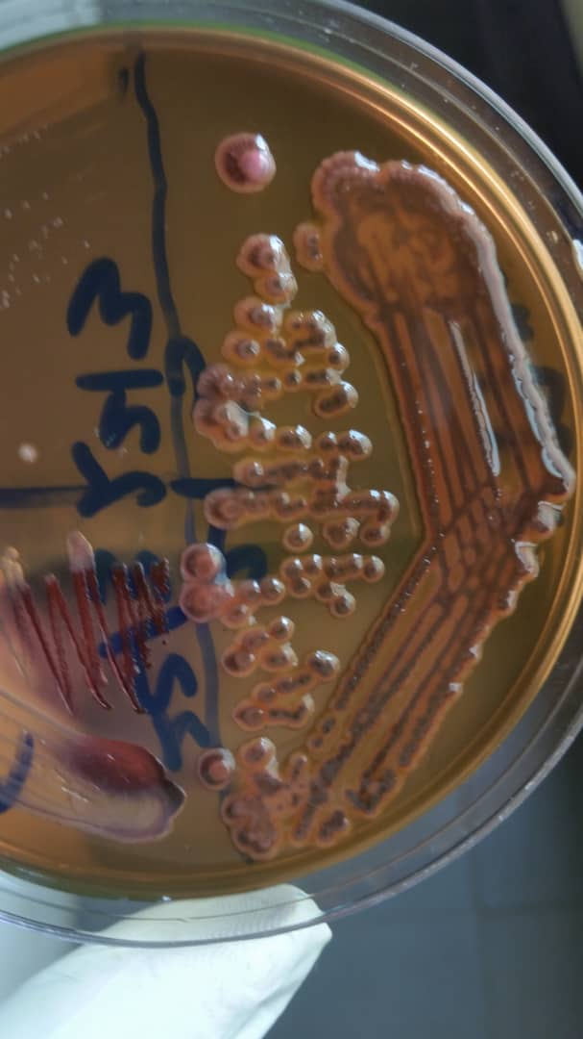

Deep purple interior colony with pink periphery

Figure 1: EMB Culture**:** Light pinkish colonies with deep purple center of *Enterobacter aerogenes* strain ps-3*.*

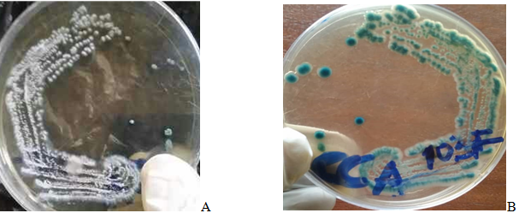

**Figure 2: Appearance of isolate 103FB on Chromatic Candida Agar**. A: Whitish colonies at the surface*.* **B:** Metallic Blue reverse. Isolate identified using ITS gene sequence as *Candida albicans* strain AUMC13495.

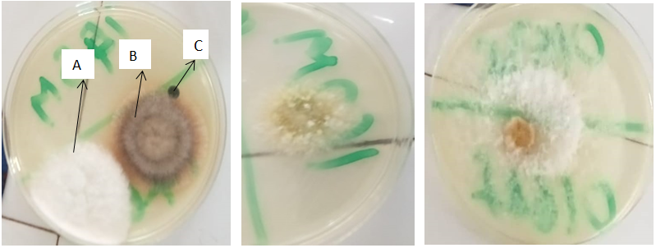

**Figure 3**. **Morphological appearance of some mould isolates on Sabouraud Dextrose Agar**. **Left:** Polymicrobial growth; A= *Lichteimia* species. B= *Arthroderma* species. C= Slow growth of *Exserohilium* species. **Middle**: *Aspergillus* species, **Right**: *Scytalidum* species.

Figures 4 and 5 showed the gel images amplification of the specific gene 16S rRNA and ITS gene for bacteria and yeast respectively. The genes were successfully amplified for both bacteria and yeast at 1500kbp and 650bp respectively. The phylogenetic tree obtained after the Hits from NCBI database were plotted are shown in Figure 6 for bacteria, showing how closely related the sequences of the isolates are with those of NCBI database. Those clustered together are related.

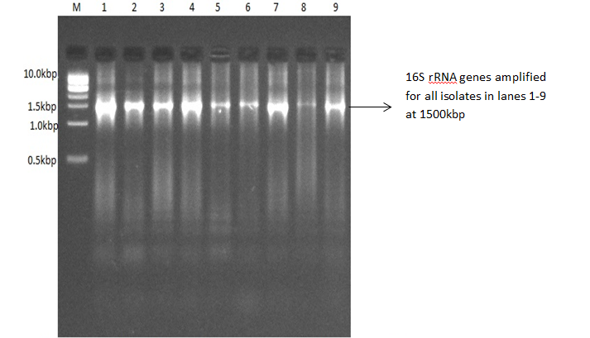

**Figure 4: Gel image of amplification of the 16S rRNA genes at 1500kbp**. Lane 1=33M, Lane 2=77F, Lane 3=84F, Lane 4=177M, Lane 5=198F, Lane 6=235M, Lane 7= 320FA, Lane 8=334F, Lane 9= 456M, Lane M is 1kbp DNA ladder

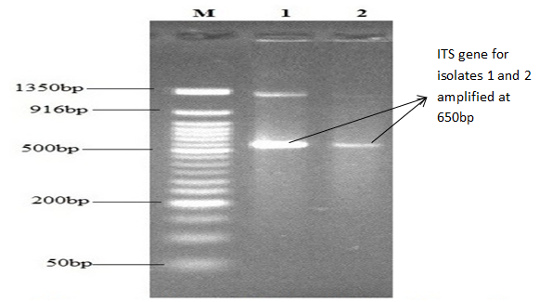 Figure 5: Gel image of amplification of the Internal Transcribed Spacer (ITS) of the isolates at 650bp. Lane M is 50bp DNA ladder, Lane 1=103FB, Lane 2= 149F.

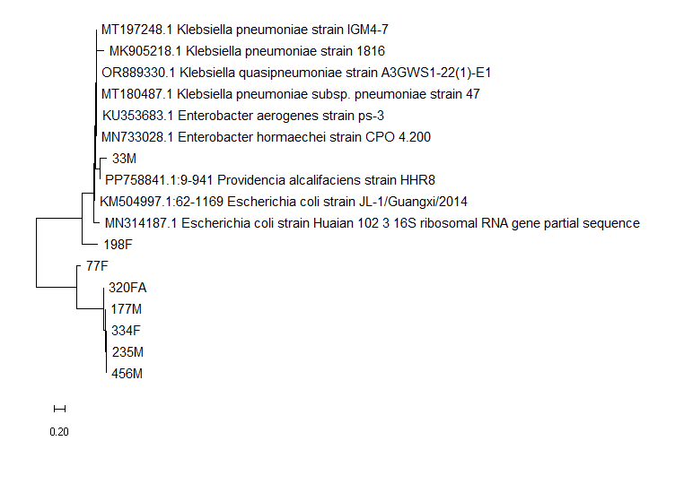

**Figure 6: Phylogenetic tree of 16S rRNA identified bacteria isolates.**

The uropathogens isolated in this study ranged from Gram positive bacteria (Table 1); Gram negative bacteria (Tables 2 and 3), yeast (Tables 4 and 5) and mould species (Table 6). The biochemical and molecular characteristics of bacteria and yeast were stated in these Tables. However, there are divergencies between preliminary laboratory identification and molecular identification.

**Table 1: Morphological and Biochemical Characterization of Gram Positive Bacterial Isolates**



**Table 2: Morphological and Biochemical Characteristics of Gram Negative Isolates**



S= Serial, CLED = Cystine Lactose Electrolyte Deficient, R = Red-pink (alkaline reaction), Y = Yellow (Acid reaction)

EMB = Eosin Methylene Blue agar, D = different strains give different reaction, TSI = Tripple sugar iron agar, NT= Not tested

H2S = Hydrogen sulphide, + = Positive, - = Negative, NT= Not Tested.

**Table 3: Morphological and Molecular Identification of Bacteria Isolates**



S= Serial, CLED = Cystine Lactose Electrolyte Deficient, EMB = Eosin Methylene Blue agar, LF= Lactose fermenting, NA= Nutrient agar, MAC= Mac Conkey agar

**Table 4: Morphological and Biochemical Characteristics of *Candida* Isolates**

**KEY: CLED = Cystine Lactose Electrolyte Deficient, A+G=Acid+gas, A= Acid, - = Negative**

**Table 5: Morphological and Molecular Identification of *Candida* Isolates**



**Table 6: Morphological Characteristics of Mould Isolates on Sabouraud Dextrose Agar (SDA)**



The frequency of isolated uropathogens with respect to sex is shown in Table 7. A total of one hundred and ninety four (194) isolates were obtained out of 170 specimens that showed positive growth. This was so because some specimens yielded more than one organism. One hundred and sixty 160(82.5%) of these isolates are bacteria while 14(7.3%) and 20(10.3%) are yeast and mould respectively. Greater number of the uropathogens were isolated from female students 125(64.4%) compared to males 69(35.6%).

**Table 7: Frequency of Isolated Uropathogens in Relation to Sex of Participants**

**Summary**

Gram positive bacteria: 47(24.2%)

Gram negative bacteria: 113(58.2%)

*Candida species*: 14(7.2%)

Mould: 20(10.3%)

Gram positive bacteria occurred at the frequency of 47(24.2%) with *Staphylococcus aureus* 19(9.8%) being the most frequently isolated in this group and *Staphylococcus* *epidermidis* var *violagabriellae* 1(0.5%) being the least. Gram negative bacteria showed the frequency of 113(58.2%) with *Klebsiella* *pneumoniae* 34(17.6%) being the most frequently isolated. The most frequently isolated mould were *Lichteimia* species 9(4.6%) followed by *Scedosporium* species 4(2.1%).

Monomicrobial growth was observed in more than half 148 (87.1%) of the positive cases (n = 170). Polymicrobial growth was also encountered in 22(12.9%) out of the 170 positive cases. Non-significant bacterial growth was observed in 175(38%) of the total specimens while no bacterial growth was recorded in 115(25%) of the specimens examined (Figure 7). There is significant association between the prevalence of UTI and characteristic growth patterns among the undergraduate students (*P*=0.000). Table 8 showed the growth patterns in relation with sex of the participants. There is also a significant difference between the characteristic growth patterns and sex of the participants (*P* =0.001).

Co- infection 10(5.9%) among the three groups of microorganisms isolated was also observed in undergraduate students. Co-infection with bacteria and *Candida* species and then bacteria and mould occurred at the same frequency 5(50%) each (Table 9).

**C**

**Table 8: Characteristic Growth Patterns in relation with sex of the study participants**



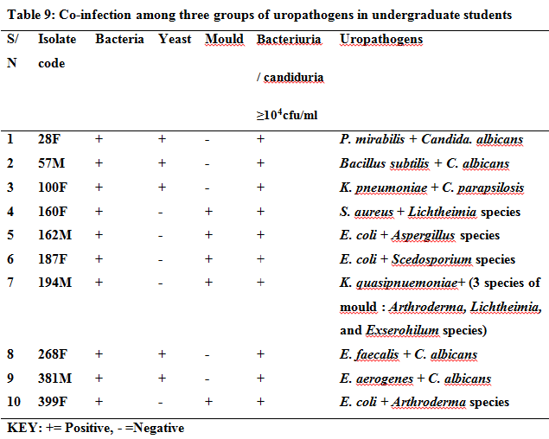

**4. DISCUSSIONS**

Urinary Tract Infections (UTIs) involve majorly bacterial and sometimes yeast invasion and increase of the pathogen in the organs of the urinary tract system (Anidiobu *et al*., 2024). Mid-stream catch specimen-collection technique was applied in this study to ensure the normal microbial flora were flushed before the specimen for analysis was obtained (Onwujekwe *et al.,* 2018; Nwankwo *et al.,* 2024). Onwujekwe *et al* (2018) also reported that frequent voiding is necessary to flush out invading bacteria from the walls of urethra.

The most predominant bacteria isolated was *Klebsiella pneumoniae* 34(17.6%) with 2 other strains of *Klebsiella* (*Klebsiella quasipneumonia*e 2(1.0) and *Klebsiella pneumonia*e subsp *pneumoniae* 1(0.5%), making *Klebsiella* species to occur at a prevalence of 37(23.1%) among the 160 bacteria isolates. This is consistent with the report by Onanuga and Selekere (2016) and Anidiobu *et al.*, (2024); who stated that *Klebsiella pneumoniae* was the most predominant isolate with 47(23.5%), and 55 (38.7%) respectively in their studies, though with a higher prevalence than that observed in this study. This finding was not in agreement with most other reports from research findings; which stated that *E. coli* was the most predominantly isolated organism in UTI infection (Assouma *et al*., 2023; Mike-Ogburia *et al*., 2023; Youssef *et al*., 2020; Nwankwo *et al*., 2017). However, *Klebsiella pneumoniae* is an important bacterium that causes serious infections in humans, and its symptoms differ depending on the body part affected by the bacteria (Anidiobu *et al*., 2024). Two strains of *Klebsiella quasipneumoniae* referred to as emerging pathogen in UTI (Mike-Ogburia *et al*., 2023) was isolated from female undergraduate students.

The second most frequently isolated pathogen in this study was *E.coli* 29(15%) which has been widely reported as the most common pathogen for UTI in several study findings (Godwin *et al.*, 2023; Assouma *et al*., 2023; Mike-Ogburia *et al*., 2023; Youssef *et al*., 2020; Nwankwo *et al*., 2017). The possible explanation for this high isolation rate of *E. coli i*n the present finding could be due to the contamination of the urinary tract from the rectal area and it could also be due to the fact that *E. coli* has various enhanced virulence factors specific for colonization and invasion of the urinary epithelium (Gebremariam *et al*., 2019). Other Gram negative bacteria isolated in this study including *Enterobacter cloacae, E. aerogenes, E hormachei, Pseudomonas aeruginosa, Proteus mirabilis Provedencia alcafaciens* and *Citrobacter freundii*; are not commonly isolated as etiologic agents of UTI. *Enterobacter cloacae* isolated in this study has a higher prevalence of 15(7.8%) compared to that in the study of De Miranda *et al.*, 2014 (1.1%). De Miranda *et al*., (2014) and Godwin *et al*., (2024) also reported *Citrobacter freundii* with prevalence of 1.0% and 0.9% respectively, a little higher than that in this study 1(0.5%). Khan *et al.*, (2011) and Nayar *et al.*, (2014) reported in their studies that *Citrobacter* are emerging as significant pathogens that are usually misidentified in routine methods employed in laboratory practice due to the fact that they mimic most enteric organism in colony morphology and biochemical characteristics.

*Enterobacter hormaechei*, an emerging opportunistic pathogen with an ability to acquire resistance determinants (Martins *et al*., 2020) was also isolated in this study 1(0.5%). *Providencia alcalifaciens*, earlier considered a rare pathogen, has now been increasingly recognized as a notorious opportunistic pathogen to serious nosocomial infections mainly UTI (Rajni *et al*., 2022). This organism was also isolated in this study from male students with the prevalence of 3(1.6%). The lowest isolated Gram negative bacteria include *Klebsiella pneumonia*e subsp *pneumoniae, C. freundii and Enterobacter hormaechei* 1(0.5%).

*Staphylococcus aureus*, a Gram positive bacterium was the third mostly isolated pathogen 19(9.8%). Godwin *et al*., (2023) also reported the pathogen as the third most frequent isolate in their studies with a higher prevalence of 9 (25.7%). Coagulase negative Staphylococci (CoNS), was also isolated in the present study 9 (4.1%), with a lower prevalence compared to that observed in Northern 17(23%) and Eastern Ethiopia 22(43.1%) respectively (Gebremariam *et al*., 2019; Fetene *et al*., 2024). The involvement of CoNS as an etiologic agent of UTI could be as CoNS are a normal flora of the urogenital area at puberty, which may invade the urinary tract during sexual activity especially in females (Gebremariam *et al*., 2019). The least isolated Gram positive bacteria is *Staphylococcus epidermidis* var *Viollagabriellae* 1(0.5%), a rare pathogen in UTI though it has been reported that 29 strains have been isolated from normal human skin over a period of 3 years in Philadelphia (Marples,1969).

*Candida* species with the prevalence of 14(7.3%) was isolated from our study, candidiasis an issue of concern among the students. This is consistent with the study findings of Umeaku *et al.*, (2020) that recorded *Candida* species though with higher prevalence 14(14%); in the same study group. According to Umeaku *et al.*, (2020), *Candida albicans* is the most frequent colonizer of the lower genital tract of 20-50% of healthy women. This report concurs with the result of this study that observed *C. albicans* as the most prevalent 12(6.2%) with greater percentage 7(58.3%) occurring in females. *Candida* being a normal flora in the vagina and perineum, it could be understood that under favourable humid condition, that by a certain way of multiplication and ascending of the agent to urethral meatus, that infection can be initiated at this point (Almushait *et al.*, 2013).

There is a great concern as regards the observation in this study on the divergence between molecular and preliminary identification. For instance an isolate with code 198F with unique morphology on EMB (brownish with pink boarder) was identified as *E. coli*. We blasted with the partial sequence provided and discovered 5 organisms with similar sequence; with *Kosakonia cowani* having the greatest percentage cover (82.69%) and from the same source (female urine) with our isolate but was not considered the organism because the query coverage is low (33%) compared to that of *E coli* (79%). Query coverage, represents the percentage of the query sequence that is aligned with a matching sequence in the database In the same vein an isolate with the code 320FA showed moderately large cream colonies with projection at 2 sides, no growth on EMB, urease positive at 4 hours 30 minutes without gas production from the sugars tested; was identified as *Klebsiella pneumoniae* strain 1816 at molecular level. For the *Candida* species a particular organism with the code 103FB showed whitish colonies with metallic blue colour on the reverse side on Chromatic Candida agar (CCA; Liofilchem, Italy), was identified as *Candida albicans* at the molecular level. This organism did not show the green appearance of *C. albicans* on the CCA. Another isolate with pink colour appearance on CCA was still identified as *Candida albicans*. These observed divergences in standard laboratory and molecular identification of isolate is of great concern, and we suggest that further studies be made to unravel the mystery behind these differences.

The results of this study revealed that environmental fungi that rarely cause disease in humans, which have increasingly been implicated in healthcare-associated outbreaks (Vasquez *et al*., 2018) can also cause diseases in immunocompetent individuals; in agreement with the findings of (Elinav *et al*., 2009, da Cunha *et al*., 2012). The most frequently isolated mould in this studywas *Lichtheimia* speciesfollowed by *Scedosporium* species, which were isolated byKumar *et al*., (2024) and Benamu *et al.,* (2018) in their studies andreported as extremely rare pathogens in UTI; with *Lichteimia* reported as angioinvasive fungus, which invades kidneys hematogenously as part of multi -organ disease (Kumar *et al*., 2024).

*Acremonium* and *Aspergillus* species isolated in this study is in agreement with research findings at Iraq that reported the genera as fungal pathogens of UTI (Khlaif and Abuad, 2015). *Aspergillus* however can infect the kidney as part of systemic or disseminated mycotic infection and their presence alone indicates infection (Imam and Gomela, 2024). *Arthroderma* species has also been reported as etiologic agent of lower UTI, infecting the prostate organs (Ferrante *et al*., 2020).

*Exophiala* species, an environmental organism but have been identified and reported to cause catheter-associated bloodstream infections (Vasquez *et al*., 2018). The presence of this organism in the current study could be as a result of contamination during the process of specimen collection, since the organism is an occasional contaminant of feet and nail (St-Germain and Summerbell, 1996).

*Exserohilum* species, a black mould isolated in this study has been reported to cause human infections (mainly allergic sinusitis, keratitis, and, less frequently, endocarditis, endophthalmitis, peritonitis, and invasive infections affecting brain, bones, lungs, and urinary tract) predominantly in tropical and subtropical regions, affecting mainly immunocompetent patients (da Cunha *et al*., 2012). *Scytalidium* is a well established agent of nail and skin infections (dermatomycosis) and rarely cause invasive or disseminated infections (Elinav *et al*., 2009). However, it has been isolated as opportunistic pathogens in immunocompetent adults (Elinav *et al*., 2009) and renal transplant patients (Garinet *et al*., 2015). The presence of this fungus in urine specimen in the current study could be as a result of contamination with the skin.

The result (frequency of isolates) in this study revealed a changing trend in the bacterial profile found in bacteriuria among apparently healthy undergraduate students; having revealed that the most predominant isolate, was *K. pneumoniae* followed by *E. coli.* The dominance of Gram negative bacteria 113(58.5%) could be explained by the fact that they are intestinal normal flora, which might enter the urethra through washing or cleaning perineum wrongly (Almushait *et al.*, 2013; Vyas *et al*., 2015).

The overall prevalence of urinary tract infection in this study was 37% which was found closely related with 40% observed in Enugu, among undergraduate students (Onyebueke *et al.*, 2020). The prevalence in this study was higher compared to that recorded in Agulu, Anambra State: 4% Ugwu *et al.,* (2019), Harmaya University Ethiopia; 18.1%: Fetene *et al* (2024) and India:19.8% Vyas *et al.*, (2015) among the same study participants. Higher prevalence than that observed in this study has been reported at Ile Ife: Osun state (77%: Osungunna and Adeyemi, 2016), Bayelsa state (56.0%), Umudike: Abia state (47%) and Yola (46%) respectively, all in Nigeria (Osungunna and Adeyemi, 2016; Onanuga and Selekere, 2016; Nwankwo *et al*, 2017 and Godwin *et al*, 2023). These variations in overall prevalence may be explained by the fact that there are differences in geographical locations, social habits of the students, standard of personal hygiene and eating habits (Vyas *et al.*, 2015; Onanuga and Selekere, 2016). It may also be explained by variation in the methodology used, sexual behavior (Fetene *et al*., 2024: those sexually active individuals are more exposed to urinary tract infection), which is as a result of ascending route of infection from genital to the urinary tract. Climatic and geographic variation might be attributed to cold climate that leads to a lack of personal and environmental hygiene of participants, lack of sanitary materials in the university such as access of water (Gebremariam *et al*., 2019). Considering the fact that the uropathogens isolated in this study are mostly of enteric origin, awareness should be created among students and the public on the need to adopt stringent personal hygiene (like frequent hand washing technique with soap and rushing water) and good environmental sanitation and provision of portable water.

Majority of the isolates 125(64.8%) from this study were from female participants which support other research findings that females are at high risk for UTI (Onanuga and Selekere, 2016; Osungunna and Adeyemi, 2016; Hantoosh *et al*., 2016; Ugwu *et al*, 2019, Godwin *et al*., 2023; Anidiobu *et al*., 2024). This high prevalence of UTI among female participants may be due to the fact that females have shorter and wider urethra which is close to the anus and vaginal introitus, lack of prostatic fluid which acts as an antimicrobial agent; and having warm and moist urethra which could be supportive for the optimal growth of bacteria compared to males (Gebremariam *et al*., 2019). It has been reported that in women, fecal-perineal-urethral contamination is the most probable explanation for urinary tract infections caused by enteric bacteria (Hantoosh *et al.*, 2016). Also, other behavioral factors such as the mechanical introduction of pathogens into the bladder and trauma effect during sexual intercourse could also be a reason for this high prevalence of UTI among female individuals (Agbagwa and Ifeanacho 2015; Gebremariam *et al*., 2019).

Polymicrobial infection 22(12.9%) out of the positive cases (n = 170) and 22(4.8%) out of the total population (n = 170) was also encountered. Bacterial counts as demonstrated in mixed infection in this study was up to 104cfu/ml for each of the species. This is in line with the findings of Akter *et al.*, (2014), and Nwankwo *et al.*, (2024). Our results 22(12.9%) of mixed microbial flora (2 pathogens) is consistent with that of Nwankwo *et al*, (2024): 11(10.3%) and Bajpai *et al.*, (2014): (9.7%) but different from that of Akter *et al.*, (2014) and Gebremariam *et al*., (2019). who reported polymicrobial prevalence of 2.26% and 2,8 % in their study findings. It has been reported that the consequence of mixed microbial inoculation into the urinary tracts of model organisms (example transurethral inoculation of Staphylococcus saprophyticus or Proteus mirabilis in rat model), resulted in ascending pyelonephritis significantly more often when the two organisms were inoculated together compared to single species infection, suggesting a synergistic virulence between the two species (Kline and Lewis 2016). Co-infection among the students 10(5.9%) as observed in this study, from the three groups of pathogens (bacteria, yeast and mould) is an issue of concern and based on this finding we suggest that urine culture should be done with non-selective media for bacteria and yeast like CLED media and SDA concurrently, that allows the growth of yeast and mould. One of the limitations of this study is that the data obtained from the study population was for a short period of time. The sampling was carried out within a period of eight weeks.

**5. CONCLUSION**

The overall prevalence of UTI among apparently healthy undergraduate students is 37%. This high prevalence is of public health concern since large number of students are at the risk of the invasion of the whole system by uropathogens which may involve the bladder and could lead to complications like renal failure or septicaemia. Monomicrobial, polymicrobial, non-significant and no growth patterns were observed in urine cultures of students. *Klebsiella pneumoniae* was the most frequently isolated bacterium. The uropathogens observed in this study include rare pathogens that have not been commonly reported to cause UTI in the study participants and include *Providencia alcalifaciens*, *C. freundii and Enterobacter hormaechei* and *Staphylococcus epidermidis* var *Viollagabriellae.* . *Candida albicans* was predominant among *Candida* species*.* From our study it was obvious that non-*Candida albicans* species (*C. tropicalis, C, glabrata* and *C. parapsilosis*) were also involved as causative agents of UTI in the study area. Mould species from literature accessed have not been reported as etiologic agents of UTI among undergraduate students, were isolated from the current study, with *Lichtheimia* species being the most frequently isolated. The uropathogens isolated from female students 125(64.4%) were higher compared to males 69(35.6%) and there is a significant association between the characteristic growth patterns and sex of the study participants. With the diversity of uropathogens isolated, including those that are rare UTI pathogens; this study also recommends that empirical treatment should be avoided in the study area, instead students should be screened and adequate treatment recommended if UTI is discovered. Identifying specific urpathogens whether they occurred singly or in combination across groups of microbes is paramount for accurate diagnosis and treatment to avoid complications.

Disclaimer (Artificial intelligence)

Option 1:

Author(s) hereby declare that NO generative AI technologies such as Large Language Models (ChatGPT, COPILOT, etc.) and text-to-image generators have been used during the writing or editing of this manuscript.

The authors didn’t use any generative AI Technologies

Option 2:

Author(s) hereby declare that generative AI technologies such as Large Language Models, etc. have been used during the writing or editing of manuscripts. This explanation will include the name, version, model, and source of the generative AI technology and as well as all input prompts provided to the generative AI technology

Details of the AI usage are given below:

1.

2.

3.

**REFERENCES**

1. Nwankwo, U.G., Ezebialu, C.U., Ezeadila, J.O. & Okoli, I. (2024). Prevalence of Uropathogens and Associated Risk Factors in Urinary Tract Infection in Pregnant Women Attending Antenatal Clinic in a Teaching Hospital in Awka, Nigeria. Journal of Advances in Microbiology; **24**(4):104-114. Doi:10.9734/JAMB/2024/v24i4819
2. Akter, L., Haque, R. & Salam, A. (2014). Comparative evaluation of chromogenic agar medium and conventional culture system for isolation and presumptive identification of uropathogens. *Pakistan Journal of Medical Science;* **30**(5):1033-1038.
3. Nwankwo, U.G., Ezebialu, C.U., Ezeadila, J.O. & Okoli, I. (2020) Macroscopy and Microscopy Urinalysis: A vital Screening Procedure for Urinary Tract Infections (UTIs) in a Hospital in Awka, Nigeria*. Journal of Biology and Life Science*; **11**(1):143-153. Doi:10.5296/jbls.v11i1.16454
4. Donkor, E. S., Horlortu, P. Z., Dayie, N. T., Obeng-Nkrumah, N. & Labi, A. (2019). Community acquired urinary tract infections among adults in Accra, Ghana. *Infection and Drug Resistance*; ***12***, 2059-2067. [Doi:10.2147/IDR.S204880](https://doi.org/10.2147/IDR.S204880)
5. Boye, A., Siakwa, P.M., Boampong, J.N., Koffuor, G.A., Ephraim, R.K.D., Amoateng, P. et al. (2012). Asymptomatic urinary tract infections in pregnant women attending antenatal clinic in Cape Coast, Ghana. *E3 Journal of Medical Research;* **1**(6): 074-083.
6. Onanuga, A. & Selekere, T.L. (2016). Virulence and antimicrobial resistance of common urinary bacteria from asymptomatic students of Niger Delta University, Amassoma, Bayelsa State, *Nigeria Journal of Pharmacy and Bioallied Sciences*;**8**:29‑33. Doi:10.4103/0975-7406.171684
7. Kabugo, D., Kizito, S., Ashok, D.D., Graham, A.K., Nabimba, R., Namunana, S. et al. (2016). Factors associated with community-acquired urinary tract infections among adults attending assessment centre, Mulago Hospital Uganda. African Health Science; 16(4): 1131-1142.
8. Nsofor, C.A., Obijuru, C.E. & Ozokwor, C.L. (2016). Asymptomatic bacteriuria among female students of a tertiary institution in Southeast Nigeria*. EC Bacteriology and Virology Research;* 2.3: 106-112.
9. Osungunna, M. O. & Adeyemi, A. V. (2016). Asymptomatic bacteriuria: Occurrence and antibiotic susceptibility profiles among students of a tertiary institution in Ile-Ife, Nigeria. *African Journal of Microbiology Research*; **10**(15):505-510. Doi:10.5897/AJMR2016.7956.
10. Sharma, P. U. & Bidwai, U. (2013). Isolation and identification of bacteria causing urinary tract infections in pregnant women in Vidarbha and their drug susceptibility patterns in them. *International Journal of Current Microbiology and Applied Sciences;* **2**(4):97 -103
11. Akinjogunla, O.J. & Divine-Anthony, O. (2013). Asymptomatic bacteriuria among apparently healthy undergraduate students in Uyo, South- South,Nigeria. *Annual Review and Research in Biology*; **3**(3): 213-225.
12. Yining, H., Zhao,J., Wang, L., Han, C., Yan, R., Zhu, P. et al. (2025). Epidemiological trends and predictions of urinary tract infections in the global burden of disease study 2021. *Nature*;15:4702. Doi:10.1038/s41598-025-89240-5
13. Gebremariam, G., Legese, H., Woldu, Y., Araya, T., Hagos, K. & Wasihun, G. A*.* (2019). Bacteriological profile, risk factors and antimicrobial susceptibility patterns of symptomatic urinary tract infection among students of Mekelle University, northern Ethiopia. *BMC Infectious Diseases;* **19**: 950. Doi:10.1186/s12879-019-4610-2.
14. Onyebueke, E., Onyebueke, C., Udoh, I. & Maduakor, U. (2020). Prevalence of Urinary Tract Infection and Antibiotic Susceptibility Pattern of Isolates Amongst Female Students of Two Nigerian Universities. *The Internet Journal of Microbiology*; **17**(1):1-8. DOI**:** 10.5580/IJMB.54498
15. Onoh, R. C., Umeora, O.U.J., Egwuatu, V. E., Ezeonu, P.O. & Onoh, T.J.P. (2013). Antibiotic Sensivitity pattern of Uropathgens from Pregnant Women with Urinary Tract, Infection in Abakaliki, Nigeria. *Infection and Drug Resistance;* **6**:225-233.
16. Ahmed, M. A., Shukla, G.S. & Bajaj, H.K. (2016). Incidence of Urinary Tract Infections and determination of their susceptibility to antibiotics among Pregnant Women. *International Journal of Cell Science and Biotechnology;* **5** (2016): 12-16.
17. Onanuga, A., Eboh, D.D., Odetoyin, B. &Adamu, O. J. (2020). Detection of ESBLs and NDM-1 genes among urinary *Escherichia coli* and *Klebsiella pneumoniae* from healthy students in Niger Delta University, Amassoma, Bayelsa State, Nigeria. *PAMJ- One Health***; 2**(12). Doi:10.11604/pamj-oh.2020.2.12.23588.
18. Khlaif, I. Z. & Abuad, S. H. (2015). Genetic Diagnosis and Prevalence of Urinary Tract Fungal Pathogen With Antifungal Susceptibility Pattern in Iraq”. *Journal of Advances in Medicine and Medical Research* ;**7** (5):410-418. [Doi:10.9734/BJMMR/2015/12559](https://doi.org/10.9734/BJMMR/2015/12559).
19. Benamu, E., Yu, A. T., Xie, L., Fernandez-Pol, S., Liu, A. Y. & Ho, D.Y. (2018).*Scedosporium apiospermum* Infection of the Urinary System with a Review of Treatment Options and cases in the literature. *Transplant Infectious Disease*; **20**(1): 1-11. Doi:10.1111/tid.12804
20. Ferrante, C., Chiavaroli, A., Angelini, P., Venanzoni, R., Angeles, F. G., Brunetti, L. *et al*. (2020). Phenolic Content and Antimicrobial and Anti-Inflammatory Effects of *Solidago virga-aurea*, *Phyllanthus niruri*, *Epilobium angustifolium*, *Peumus boldus*, and *Ononis spinosa* Extracts. *Antibiotics* (Basel); **9**(11):783. Doi:10.3390/antibiotics9110783.
21. Kumar, M., Sharma, S., Raina, P., Shamra, K. & Chauhan, S. (2024). Mucormycosis in the urinary bladder, the devil is in the details: a rare case report. *Authorea;* 2024.  
    Doi: [10.22541/au.170668894.46143679/v1](https://doi.org/10.22541/au.170668894.46143679/v1).
22. Sadeghi, M., Mojtahedi, A., Nikokar, I. & Roushan, Z. A. (2023). The emergence of plasmid-encoded oxacillinase and carbapenemase among uropathogenic *Escherichia coli* (UPEC) isolated from hospitalized patients in the North of Iran. *Heliyon*; **9**: 1-6. Doi.org/10.1016/j.heliyon.2023.e15386
23. Nwankwo, I.U., Onwuakor, C.E., Ifediora, A.C. & Azubuike, F.M. (2017). Asymptomatic urinary tract infection amongst some Students of Michael Okpara University of agriculture,Umudike. *World Journal of Microbiology*, **5**(1): 075-081.
24. Araoye, M.O. (2003). Sample Size Determination. In: Margaret, O.A., Ed., Research Methodology with Statistics for Health and Social Sciences, Nathadex Publishers, Ilorin, Nigeria, 115-119. Accessed on 30th August 2022 from <https://www.scirp.org/(S(lz5mqp453edsnp55rrgjct55.))/reference/referencespapers.aspx?referenceid=2696808>
25. Milani, Q.D.A., & Jialal, I. (2023). Urinalysis. In: StatPearls [Internet]. Treasure Island (FL): StatPearls Publishing; Acessed on 13 September 2023 from: https://www.ncbi.nlm.nih.gov/books/NBK557685/.
26. Emiru, T., Beyene, G., Tsegaye, W. & Melaku, S. (2013). Associated risk factors of urinary tract infection among pregnant women at Felege Hiwot Referral Hospital, Bahir Dar, North West Ethiopia. *BMC Research Notes*,***6***(292), 1-6. [Doi:10.1186/1756-0500-6-292](https://doi.org/10.1186/1756-0500-6-292)
27. Cheesbrough, M. (2006). District Laboratory Practice in Tropical Countries Part 2.Cambridge Univesity Press; London. 1-266, 382-407.
28. Oyagade, A.O., Smith S. I., & Famurewa, O. (2004).Asymptomatic significant bacteriuria amony pregnant women in Ado-Ekiti, Ekiti State, Nigeria. *African Journal of Clinical and Experimental Microbiology;* **5** (1): *64-77*
29. Forbes, B.A., Sahm, D.F. & Weissfeld, A.S. (2007). *Bailey & Scotts Diagnostic Microbiology.* (12thed.). West line Industrial drive, St. Louis Missouri: Mosby Elsevier. pp 187-194, 842-855.
30. St-Germain, G. & Summerbell, R. (1996). Descriptions in: Identifying Filamentous Fungi: A clinical Labortory Handbook. English ed. Star Publihing Company; Californai, USA. Pp 51-241.
31. Kidd, S., Halliday, C., Alexiou, H. & Ellis, D.(2016). Descriptions of Medical Fungi. 3rd ed. Newstyle Printing; Adelaide,South Australia.
32. Anidiobu, C.O., Ajayi, A.O., Fowora, M.A. & Adejoh, O.P. (2024). Isolation of Antibiotic Resistant *Klebsiella pneumoniae* from Students with Urinary Infections at a Tertiary Institution, Southwest Nigeria. *Bima Journal of Science and Technology*, **8**(1A) :107-115. Doi: 10.56892/bima.v8i1.594
33. Onwujekwe, E. C., Agbo, A. & Ezemba, C. C. (2018). Incidence of Urinary Tract Infections, among Adolescent and Adult Women in Ogbete Coal Camp, Enugu. *Universal Journal of Public Health*; **6**(6): 326-331. Doi: 10.13189/ujph.2018.060603.
34. Assouma, .F.F., Sina, H., Adjobimey, T., Noumavo, A.D.P., Socohou, A., Boya B. et al. (2023). Susceptibility and Virulence of Enterobacteriaceae Isolated from Urinary Tract Infections in Benin. *Microorganisms*;**11**(213):1-18. Doi:10.3390/microorganisms11010213.
35. Mike-Ogburia, M.I., Monsi, T.P. & Nwokah, E.G. (2023). Prevalence and Associated Risk Factors of Uropathogenic Klebsiella species in Port Harcourt. *Advances in Infectious Diseases*;**13**: 333-353. Doi:[10.4236/aid.2023.132030](https://doi.org/10.4236/aid.2023.132030).
36. Youssef, S.A., Mohamed, G.A., Abdelrahman, R.A., Baker, R.M.A., Abass, N.A. & Ahmed, H.K.M. (2020). Asymptomatic Urinary Tract Infection among Female University Students. *Egyptian Journal of Health Care*;**11**(4):341-353.
37. Godwin, F., Emmanuel, B. N., Onuoha, C.C., Musa, C. M., Ajibola, N.T. & Ewansiha, J.U*.* (2023). The prevalence of urinary tract infection among students of Modibbo Adama University of Technology, Yola Nigeria and the effects of plasmid curing on the antibiotic resistance profile of uropathogens. *Microbes and Infectious Diseases*; Article-In-Press. Doi:10.21608/mid.2023.229369.1604.
38. [De Miranda](https://www.ncbi.nlm.nih.gov/pubmed/?term=Miranda%20%26%23x000c9%3BJ%5BAuthor%5D&cauthor=true&cauthor_uid=25076433), E.J.P.,  [De Oliveira](https://www.ncbi.nlm.nih.gov/pubmed/?term=Oliveira%20GS%5BAuthor%5D&cauthor=true&cauthor_uid=25076433), G.S.S., [Roque](https://www.ncbi.nlm.nih.gov/pubmed/?term=Roque%20FL%5BAuthor%5D&cauthor=true&cauthor_uid=25076433), F.L., [Dos Santos](https://www.ncbi.nlm.nih.gov/pubmed/?term=Santos%20SR%5BAuthor%5D&cauthor=true&cauthor_uid=25076433), S.R.,  [Olmos](https://www.ncbi.nlm.nih.gov/pubmed/?term=Olmos%20RD%5BAuthor%5D&cauthor=true&cauthor_uid=25076433), R.D. & [Lotufo](https://www.ncbi.nlm.nih.gov/pubmed/?term=Lotufo%20PA%5BAuthor%5D&cauthor=true&cauthor_uid=25076433), A.P. (2014). Susceptibility to antibiotics in urinary tract infections in a secondary care setting from 2005-2006 and 2010-2011, in São Paulo, Brazil: data from 11,943 urine cultures. *Journal of the São Paulo Institute of Tropical Medicine*; **56**(4): 313–324.
39. Khan, F., Rizvi, M., Shukla, I. & Malik, A. (2011). A novel approach for identification of members of Enterobacteriaceae isolated from clinical samples. *Biology and Medicine*; **3** (2):313-319.
40. Nayar, R., Shukla, I. & Sultan, A. (2014). Epidemiology, Prevalence and Identification of *Citrobacter species* in Clinical Specimens in a Tertiary Care Hospital in India.*International Journal of Scientific and Research Publications;* **4**( 4): 1-6.
41. Martins, E.R., Bueno, M.F.C., Francisco, G.R., Casella, T., de Oliveira Garcia, D., Cerdeira, L.T.et al. (2020). Genome and plasmid context of two rmtG-carrying *Enterobacter hormaechei* isolated from urinary tract infections in Brazil. *Journal of Global Antimicrobial Resistance;* **20**:36-40. Doi:10.1016/j.jgar.2019.06.020.
42. Rajni E, Jain A, Garg VK, Sharma R, Vohra R. & Jain SS. (2022) *Providencia* Causing Urinary Tract Infections: Are We Reaching a Dead End? *Indian Journal of Critical Care Medicine*;**26**(4):446-451. Doi: 10.5005/jp-journals-10071-24163.
43. Fetene G, Marami D, Ayele F. & Abate D. (2024). Bacterial profiles, antibiotic susceptibility patterns, and associated factors of symptomatic urinary tract infections among symptomatic university students at Haramaya University, Eastern Ethiopia: Cross-sectional study. *Medicine (Baltimore)*; **5**;103(27):e38726. Doi 10.1097/MD.0000000000038726.
44. Marples, R. R. (1969). Violagabriellae Variant of *Staphylococcus epidermidis* on Normal Human Skin. *Journal of Bacteriology*; **100** **(**1**):**47-50. Copyright © 1969 American Society for Microbiology.
45. Umeaku, C. N., Ukoha, C. C., Ebe,T. E., Ozo, C. N. Egbuna, H. I.,Ibekwe, M. I.et al. (2020). Prevalence of Candidiasis amongst Undergraduate Students of COOU, Uli, Nigeria. *Global Journal of Medical Research: C* *Microbiology and Pathology;*20 .(1)1 Version 1.0.
46. Almushait, M.A., Mohammed, H.A., Al- Harthy, D.A. & Abdullah, A.M. (2013). Prevalence and Predisposing Factors of Urinary Tract Infections among Pregnant Women in Abha General Hospital .*International Journal of Sciences: Basic and Applied Research;* **11**(1):18-29.
47. Vasquez, A., Zavasky, D., Chow,N. A., Gade,L., Zlatanic, E., Elkind, S. et al. (2018). Management of an Outbreak of Exophiala dermatitidis
48. Elinav,H., Izhar,U., Benenson, S., Admon,D., Hidalgo-Grass, C., Polacheck, I. et al. (2009). Invasive *Scytalidium dimidiatum* Infection in an Immunocompetent Adult. *Journal of Clinical Microbiology*;**47**(4):1259–1263. Doi: 10.1128/JCM.01874-08.
49. da Cunha, K.C., Sutton, D.A., Gené, J., Capilla, J., Cano, J. & Guarro, J. (2012). Molecular Identification and In Vitro Response to Antifungal Drugs of Clinical Isolates of Exserohilum. Antimicrobial Agents and Chemotherapy; **56**. Doi: 10.1128/aac.00488-12.
50. [Imam](https://www.msdmanuals.com/professional/authors/imam-talha), T. H. & [Gomella](https://www.msdmanuals.com/professional/authors/gomella-leonard), L. G. (2024). Fungal Urinary Tract Infections. MSD Manual. Professional Version. Accessed on 19th June, 2025 from <https://www.msdmanuals.com/professional/genitourinary-disorders/urinary-tract-infections-utis/fungal-urinary-tract-infections>.
51. Garinet, S.., Tourret, J., Barete, S., Arzouk, N., Meyer, I., Frances, C.et al. (2015). Invasive cutaneous Neoscytalidium infections in renal transplant recipients: a series of five cases. *BMC Infectious Diseases* **15**:535. Doi: 10.1186/s12879-015-1241-0
52. Vyas, S., Sharma,P., Srivastava, K., Nautiyal, V. & Shrotriya, V.P. (2015). Role of Behavioural Risk Factors in Symptoms Related to UTI Among Nursing Students. *Journal of Clinical and Diagnostic Research;* **9**(9):15-18. DOI: 10.7860/JCDR/2015/10995.6547.
53. Hantoosh, S. F., Sodani, J. I. & Sh. Zageer, D. (2016). Urinary Tract Infections in Adult Women: Review. *Journal of Advances in Medical and Pharmaceutical Sciences*, **9**(4), 1–10. Doi:10.9734/JAMPS/2016/28241
54. Ugwu, M.C, Nnoli, A., Ezejiegu, C.K., Jibuaku, C., Ogwaluonye, U.C., Ejikeugwu, C.P. et al. (2019). Prevalence and Antibiogram of Asymptomatic Bacteriuria among University Students in Agulu, Anambra, Nigeria. Annals of Clinical Immunology and Microbiology; **1**(2): 1009:1-4.
55. Agbagwa O. E. & Ifeanacho E. J. U. (2015).The Prevalence of UTI Pathogens in Urine Specimen Obtained from a Hospital in Rivers State Nigeria. *Journal of Microbiology Research;* **5**(5):143-148
56. Bajpai, T., Pandey, M., Varma, M. & Bhatambare, G.S. (2014). Mixed flora in the urine of hospitalized patients: Contamination or true infection? *Nigerian Journal of Experimental and Clinical Biosciences;* **2**(1):20-27.
57. Kline, K.A. & Lewis, A.L. (2016). Gram-Positive Uropathogens, Polymicrobial Urinary Tract Infection, and the Emerging Microbiota of the Urinary Tract. *Microbiology Spectrum*;**4**(2): 1-54. Doi: 10.1128/microbiolspec.UTI-0012-2012.