**Indigenous Microbes, Potent Solutions: Antimicrobial Activity of Lactic Acid Bacteria from Burkina Faso Curdled Milk and Genetic Insights into Bacteriocin Production**

**ABSTRACT**

Lactic acid bacteria (LAB) are known to be sources of various antimicrobial metabolites that are harmless to humans. This study aimed to evaluate the antimicrobial activity of LAB isolated from curdled milk in Burkina Faso against bacterial pathogens and toxigenic fungi and to investigate the role of LAB in bacteriocin synthesis. A total of 12 LABs were used in the study. Antibacterial activity was assessed by agar diffusion against seven pathogenic strains, including three clinical strains (*Staphylococcus aureus* 781, *Klebsiella pneumoniae* 787, *Acinetobacter baumannii* 844) and four reference strains (*Escherichia coli* ATCC25922, *Staphylococcus aureus* ATCC29213, *Pseudomonas aeruginosa* ATCC27853*, Streptococcus oralis* NCTC8029). Minimum inhibitory concentrations (MICs) were determined at 20 mg/mL for all the strains tested. All the strains tested showed inhibition against *Staphylococcus aureus*, with diameters ranging from 13 mm (V1, V24) to 31 mm (Vr5). Finally, the strongest inhibitory activity was observed against *Klebsiella pneumoniae* with strain Vr1, which produced a 35 mm zone of inhibition. However, no minimum bactericidal concentration (MBC) was observed at the maximum concentration tested. Antibacterial activity was found to be predominantly bacteriostatic. In terms of antifungal activity, comparison tests revealed a wide range of fungal inhibition percentages, from 0% to 100%. From 12 LAB isolates screened, five strains were selected for their strong antifungal activity, corresponding to two *Enterococcus sp*., two *Lactococcus sp*., and one *Pediococcus sp*. PCR identified two types of bacteriocin synthesis genes in 6 out of 12 LAB strains, indicating their potential for bacteriocin production

Keywords : Lactic acid bacteria ; antimicrobial ; antibacterial ; antifungal ; bacteriocin genes

1. **INTRODUCTION**

Lactic acid bacteria can synthesize metabolites with inhibitory, bactericidal, or fungicidal action. These metabolites may or may not be of ribosomal origin. There is a wealth of literature on the use of these lactic acid bacteria against pathogenic or altering microbes. The antimicrobials produced by LAB are essentially divided into three groups : Peptide or protein bacteriocins, organic acids, and minor molecules such as diacetyl, hydrogen peroxide, acetaldehyde, acetoin, reuterin, and reutericyclin. The bacteriocins developed by LAB are generally active against related strains and the producing strain. However, there are bacteriocins with a broad spectrum of action (Chikindas *et al*.,2018). These protein antimicrobials are ideal for use in food because of their multiple advantages. Firstly, LAB by-products are classified by the FDA as GRAS (Sieuwerts *et al*., 2018); secondly, LAB bacteriocins are colorless and painless; thirdly, they do not affect the organoleptic and sensory characteristics of foods; and fourthly, they are eliminated by proteolytic enzymes in the digestive system. The bacteriocins produced by LABs are antimicrobial promoters in the agri-food industry for food safety. Nisin remains the bacteriocin recognized by the FDA for use in food to this day (Ng *et al*., 2020). However, several bacteriocins that can be used in food are currently being tested. Also, the non-specific antimicrobials produced by LABs can inhibit the growth of Gram-negative and Gram-positive bacteria as well as molds in various food products. Organic acids are also considered to be safe molecules for humans. Their antimicrobial effect is exerted by dissociation of the molecule through deprotonation, which alters the membrane of the target bacteria. As well as organic acids, LABs produce small antimicrobial molecules. These include diacyl, reuterin, and hydrogen peroxide. Diacyl controls the growth of Gram-positive and Gram-negative bacteria. Reuterine and hydrogen peroxide inactivate key enzymes for the growth of target strains (Bertin *et al*., 2017). The study aimed to highlight the antimicrobial capacity of LABs and to identify the genes responsible for protein-based metabolites.

1. **MATERIALS AND METHODS**
   1. **Origin of lactic strains**

Lactic acid bacteria were isolated from cow and goat curdled milk at Léo (Latitude : 11° 44‘ 59.99’ N Longitude : -2° 54‘ 59.99’ W) and Gorom-Gorom (Latitude 14° 26' 60.00 ’N Longitude 0° 13' 60.00 ’W) in Burkina Faso. These bacteria were phenotypically characterised to assign them to bacterial genera.

* 1. **Antibacterial activity**

This study evaluated the antibacterial activity of lactic acid bacterial strains against clinical and reference pathogenic strains. These pathogenic strains were *Staphylococcus aureus*, *Pseudomonas aeruginosa*, *Acinetobacter baumannii*, *Staphylococcus oralis,* *Staphylococcus* *aureus* (781), *Klebsiella pneumoniae*, and *Escherichia coli* ATCC25922.

Firstly, a sensitivity test was carried out by exposing these pathogens to the supernatants of the lactic cultures. Secondly, the antibacterial parameters were determined: the Minimum Inhibitory Concentrations (MIC) and Bactericidal Concentrations (BMC) were assessed by testing serial dilutions of the lactic supernatant (from 100% to 0.78%, using a geometric gradient), following standardized protocols (CLSI, 2023). The supernatants, sterilized by filtration (Millipore filters), were applied to Mueller Hinton media inoculated with the target strains.

**2.2.1** **Sensitivity test**

The Mueller Hinton (MH) solid media diffusion method using paper (Whatman No. 1) in the form of a disc soaked in bacterial suspension (Anani *et al*., 2000) was used to assess the in vitro antibacterial activity of the different strains of lactic acid bacteria obtained. A bacterial suspension of the pathogenic strain to be tested was inoculated using a swab onto MH media poured into Petri dishes. The bacterial suspension was obtained by homogenizing young colonies of the strain in sterile distilled water and then adjusting the turbidity to 0.5 on the Mc Farland scale (SFM, 2019). After inoculation, sterile 5 mm diameter Whatman No 1 paper discs were placed on the dish using sterile forceps. The discs were then carefully impregnated with 40 µl of 100 mg/ml lactic acid bacteria inoculum. A negative control was performed using sterile distilled water in place of the lactic acid bacteria. The plates were then left for 15 to 30 min at room temperature (25°C ± 2°C) for pre-diffusion of the substances before being incubated at 37°C. The diameters of any zones of inhibition were measured using a graduated ruler after 24 h of incubation (Doughari *et al*., 2007). The experiment was duplicated for each strain of lactic acid bacteria.

**2.2.2 Determination of the Minimum Inhibitory Concentration**

Minimum Inhibitory Concentrations (MICs) were determined following the microdilution method using iodonitrotetrazolium (INT) as a bacterial viability indicator (Amoussa *et al*., 2015). A range of nine concentrations (10 to 0.039 mg/mL) of lactic bacteria supernatants was tested on the microbial strains. Indeed, 150 µl of distilled water was distributed in wells 1 to 9 of the 96-well microplate. Next, 150 µl of each lactic acid strain at 20 mg/mL was introduced into wells 0 and 1, followed by successive one-half dilutions from well 1 to well 9. Next, 150 µl of pathogenic bacterial suspension (106 CFU/mL) was added to all the wells. The plates were then incubated at 37°C. After 18 h incubation, 10 µl of violet para-iodonitrotetrazolium solution (INT, 0.2 mg/mL) was added to all wells. The plates were re-incubated at 37°C for 30 min. The MIC corresponds to the first well in which no red/pink coloration was observed due to the presence of INT.

**2.2.3** **Determination of the Minimum Bactericidal Concentration**

The Minimum Bactericidal Concentration (MBC) was determined according to the results of the MIC determination. To do this, after identifying the MIC, we used a loop to inoculate all the other tubes from the MIC to the high concentrations on Petri dishes containing MH agar medium. The plates were examined after 24 h incubation at 37°C. On observation, the concentration of lactic bacteria supernatants where no bacterial growth was observed corresponded to the MBC.

1. **Evaluation of antifungal activity**

Firstly, we carried out a qualitative test using the confrontation method. A total of bacterial isolates, identified as LAB by biochemical and physiological analyses, were screened for antifungal activity against 3 fungal strains including Fusarium solani, Aspegillus niger, and Cladosporium sp. After 18h incubation, the LAB strains were streaked in two lines 2 cm apart on MRS agar and incubated at 30°C for 48h. A 5-day-old section of fungal strain was then placed in the center of the agar plates and incubated at 30°C. After 3 days, the diameter of the fungal colonies was measured and compared to a control, which was an unclear fungal strain cut, which should be better explained deposited in the center of the agar plate without LAB (Laref and Guessas, 2013). The percentage of growth inhibition (I) was calculated as follows :

$$\boxed{I=\frac{R_{w}-R_{t}}{R_{w}} x 100}$$

Where Rw is the maximum radial distance grown by pathogenic fungus in the non-LAB control and Rt is the radial distance grown by the fungus towards the antagonist (in centimeters) (Wang *et al*., 2002). All experiments were performed in triplicate and repeated three times.

1. **Search for bacteriocin-producing genes**

The genes responsible for bacteriocin synthesis were sought using the PCR technique. The amplification conditions were similar for all the genes tested. An initial denaturation step at 94°C for 5 min, 34 cycles at 94°C for 30°C, hybridization at 55°C for 30s, and extension at 72°C for 30s, followed by a final extension at 72°C for 7 min. The amplicons were then subjected to electrophoretic migration on a 1.5% agarose gel and visualized. Table 1 shows the bactericin genes searched for (Macwana *et al*., 2012).

Table 1 : Primers used

|  |  |  |  |
| --- | --- | --- | --- |
| Primers | 5’ 3’ | Size | References |
| MesY | F:ATGACGAATATGAAGTC  R:TTACCAAAATCCATTTCC | 186 | Xiraphi *et al*.,2008 |
| PlnA | F: GTACAGTACTAATGGGAG  R: CTTACGCCATCTATACG | 450 | Rasha *et al*., 2020 |
| PlnC | F: GGTGGCGACAGGAGATTTAC  R: AGAAACGCGTTCCGATTTTA | 353 | Tsapieva *et al*., 2011 |

1. **RESULTS AND DISCUSSION**

**5.1 Sensitivity tests**

The sensitivity tests demonstrated variable inhibitory activity of lactic strains Vr1, Vr14, Vr2, Vr5, V1, V5, V10, V11, V14, V15, V18 and V24 against various clinical pathogenic bacteria and reference strains.

The antagonistic potency of these isolates was assessed against seven (7) target strains, including three (3) clinical pathogens (*Staphylococcus aureus* 781, *Klebsiella pneumoniae*, *Acinetobacter baumannii*) and four (4) reference strains representing altering bacteria (*Escherichia coli*, *Staphylococcus aureus*, *Pseudomonas aeruginosa*, *Staphylococcus oralis*). The inhibitory activity was manifested by the formation of clear zones around the inoculation points, reflecting inhibition (Figure 2) of the growth of the target micro-organisms. The diameters of the inhibition zones (Zi) are shown in Figure 1. The results show that all the isolates tested had antibacterial activity against *Staphylococcus aureus*, with inhibition diameters ranging from 13 mm (strains V1 and V24) to 31 mm (strain Vr5). Significant activity was also observed against *Staphylococcus oralis*, with diameters ranging from 10 mm (strain V15) to 20 mm (strains V1, V14, and Vr1). For *Acinetobacter baumannii*, inhibition diameters ranged from 10 mm (strains V1, V5, Vr14) to 30 mm for strain V14. For *Escherichia coli*, the majority of isolates showed inhibitory activity, except strain V24. The inhibition diameters recorded ranged from 8 mm (V1) to 20 mm (V10). For *Pseudomonas aeruginosa*, some lactic strains did not express inhibitory activity; however, the diameters observed ranged from 10 mm (V10, V18) to 25 mm (V11).

Finally, the most marked inhibition was observed with the Vr1 strain against *Klebsiella pneumoniae*, with an inhibition diameter of 35 mm, indicating a particularly high antibacterial potential of this isolate. Evaluation of the antagonistic power of LAB strains against various pathogenic bacteria revealed significant antibacterial activity. Lactic bacilli showed marked activity, particularly against *Klebsiella pneumoniae* (Gram-negative), with a zone of inhibition of up to 35 mm. Significant activity was also recorded against *Staphylococcus aureus* and *Staphylococcus oralis* (17-20mm). These results differ from those obtained by Allouche *et al*. (2010), who reported greater efficacy of lactobacilli against Gram-positive strains such as *S. aureus* and *Bacillus subtilis*. Lactic coques (*Lactococcus*, *Leuconostoc*, and *Streptococcus* genera) also showed significant inhibitory potential. The greatest activity was against *S. aureus* (13-31mm), followed by *Acinetobacter baumannii* (10-30mm). These results differ slightly from those obtained by Belarbi (2011), who found that lactic coques, mainly the genera *Lactococcus*, *Leuconostoc*, and *Streptococcus*, had high antagonistic activity against *E. coli* (0-24mm) and *S. aureus* (0-16mm). And the observations of Mameche (2008), who reports the better activity of lactic coques against Gram-negative bacteria. The antibacterial activity observed can be attributed to the production of several antimicrobial compounds : lactic acid (acidifying effect of the medium), diacetyl (known inhibitor), hydrogen peroxide (H₂O₂), and bacteriocins, protein substances with a targeted effect on other bacteria.

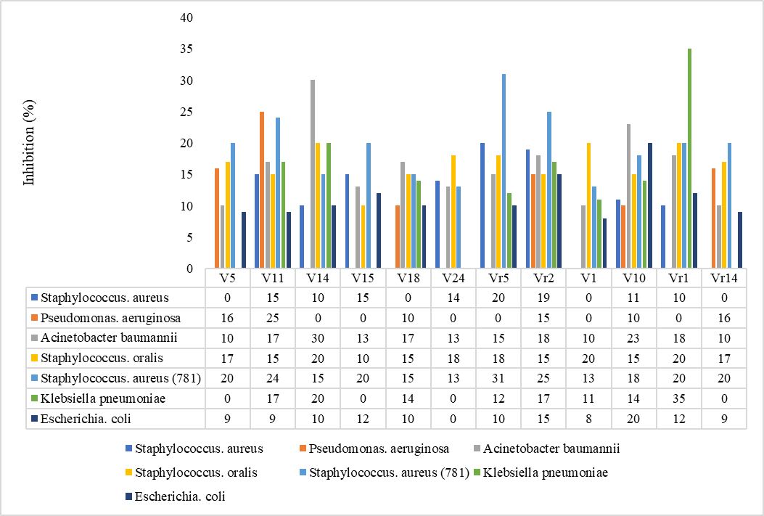

Figure 1 : Bacterial inhibition in %.

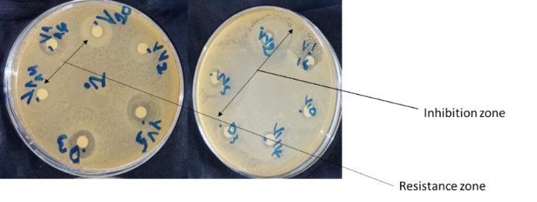

Figure 2: susceptibility to klebsiella

**5.2 Determination of MICS and BMCS**

MICs and BMCs were determined for each lactic acid strain against pathogenic bacteria. The results are summarised in Table 2. Figure 3 shows the BMC evaluation. For all lactic strains (Vr1, Vr14, Vr2, Vr5, V5, V10, V11, V13, V14, V15, V18, V24), the MIC was 20 mg/mL for all bacteria tested, whether clinical or reference. This indicates that this concentration is necessary to inhibit pathogen growth. The MBC was greater than 20 mg/mL for all strains, meaning that no bactericidal activity was observed at the maximum concentration tested. This suggests that lactic strains have a predominantly bacteriostatic rather than bactericidal activity under the experimental conditions used.

Table 2 : Research into the nature of the inhibitory effect of lactic bacteria strains

|  |  |  |  |  |  |  |  |  |
| --- | --- | --- | --- | --- | --- | --- | --- | --- |
| Lactic acid bacteria | Parameters  mg /mL | *S.aureus* | *P.aeruginosa* | 844 | *S.oralis* | 781 | 787 | *E.coli* |
| Vr1 | MIC | 20 | 20 | 20 | 20 | 20 | 20 | 20 |
| MBC | >20 | >20 | >20 | >20 | >20 | >20 | >20 |
| MBC/MIC | Nd | Nd | Nd | Nd | Nd | Nd | Nd |
| Vr2 | MIC | 20 | 20 | 20 | 20 | 20 | 20 | 20 |
| MBC | >20 | >20 | >20 | >20 | >20 | >20 | >20 |
| MBC/MIC | Nd | Nd | Nd | Nd | Nd | Nd | Nd |
| Vr5 | MIC | 20 | 20 | 20 | 20 | 20 | 20 | 20 |
| MBC | >20 | >20 | >20 | >20 | >20 | >20 | >20 |
| MBC/MIC | Nd | Nd | Nd | Nd | Nd | Nd | Nd |
| Vr14 | MIC | 20 | 20 | 20 | 20 | 20 | 20 | 20 |
| MBC | >20 | >20 | >20 | >20 | >20 | >20 | >20 |
| MBC/MIC | Nd | Nd | Nd | Nd | Nd | Nd | Nd |
| V5 | MIC | 20 | 20 | 20 | 20 | 20 | 20 | 20 |
| MBC | >20 | >20 | >20 | >20 | >20 | >20 | >20 |
| MBC/MIC | Nd | Nd | Nd | Nd | Nd | Nd | Nd |
| V10 | MIC | 20 | 20 | 20 | 20 | 20 | 20 | 20 |
| MBC | >20 | >20 | >20 | >20 | >20 | >20 | >20 |
| MBC/MIC | Nd | Nd | Nd | Nd | Nd | Nd | Nd |
| V11 | MIC | 20 | 20 | 20 | 20 | 20 | 20 | 20 |
| MBC | >20 | >20 | >20 | >20 | >20 | >20 | >20 |
| MBC/MIC | Nd | Nd | Nd | Nd | Nd | Nd | Nd |
| V13 | MIC | 20 | 20 | 20 | 20 | 20 | 20 | 20 |
| MBC | >20 | >20 | >20 | >20 | >20 | >20 | >20 |
| MBC/MIC | Nd | Nd | Nd | Nd | Nd | Nd | Nd |
| V14 | MIC | 20 | 20 | 20 | 20 | 20 | 20 | 20 |
| MBC | >20 | >20 | >20 | >20 | >20 | >20 | >20 |
| MBC/MIC | Nd | Nd | Nd | Nd | Nd | Nd | Nd |
| V15 | MIC | 20 | 20 | 20 | 20 | 20 | 20 | 20 |
| MBC | >20 | >20 | >20 | >20 | >20 | >20 | >20 |
| MBC/MIC | Nd | Nd | Nd | Nd | Nd | Nd | Nd |
| V18 | MIC | 20 | 20 | 20 | 20 | 20 | 20 | 20 |
| MBC | >20 | >20 | >20 | >20 | >20 | >20 | >20 |
| MBC/MIC | Nd | Nd | Nd | Nd | Nd | Nd | Nd |
| V24 | MIC | 20 | 20 | 20 | 20 | 20 | 20 | 20 |
| MBC | >20 | >20 | >20 | >20 | >20 | >20 | >20 |
| MBC/MIC | Nd | Nd | Nd | Nd | Nd | Nd | Nd |

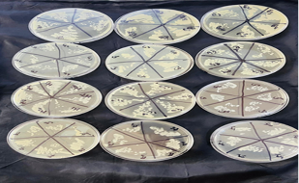

Figure 3: MBC research

**5.3. Antifungal activity**

A total of 12 bacterial isolates, identified as LAB by biochemical and physiological analysis, were screened for antifungal activity against 3 fungal strains 1, 2, and 3. The results are set out in Table 3. The antifungal activity of the 12 LAB isolates was investigated using the confrontation method against the fungal strains. After incubation, the vertical and horizontal diameters of the mycelium inhibited by LAB were measured. The test revealed variable antifungal activity of the bacterial strains, with percentages of inhibition of fungal growth between 0% and 100% against SF1 : Fusarium solani fungal strain and SF3 : *Cladosporium sp* fungal strain. However, there was no inhibition against SF2 : *Aspegillus niger* fungal strain, except for isolate V18, which showed partial inhibition. The results are presented in Figure 4. This study made it possible to select 5 LAB strains with strong antifungal activity, including 2 *Enterococcus sp*, 2 *Lactococcus sp* and 1 *Pediococcus sp*. Table (3) summarises all the results obtained. Figure (4) shows some screening tests using the confrontation method. The antifungal activity of the 12 LAB isolates was tested by the direct confrontation method against three fungal strains: *Fusarium solani* (SF1), *Aspergillus niger* (SF2) and *Cladosporium sp*. (SF3). The results showed variable inhibition of mycelial development depending on the bacterial strains and fungi targeted. Inhibition percentages ranging from 0% to 100% were observed against *F. solani* and *Cladosporium sp*. On the other hand, *A. niger* showed marked resistance to the action of LAB, except for strain V18, which showed partial inhibition. The study identified five particularly effective LAB strains, belonging to the genera *Enterococcus* (2 strains), *Lactococcus* (2 strains), and *Pediococcus* (1 strain). This diversity of antifungal action suggests the involvement of several mechanisms, including the production of organic acids, H₂O₂, or specific antifungal peptides, as has been suggested in other studies.

Table 3 : sensitivity of lactic acid bacteria to three fungal strains

|  |  |  |  |
| --- | --- | --- | --- |
| Lactic acid bacteria | Fungal strain 1 | Fungal strain 2 | Fungal strain 3 |
| *Enterococcus sp* Vr2 | +++ | - | +++ |
| *Enterococcus sp* Vr5 | +++ | - | +++ |
| *Streptococcus sp* V5 | - | - | +++ |
| *Lactobacillus sp* V10 | - | - | - |
| *Lactococcus sp* V11 | +++ | - | +++ |
| *Pediococcus sp*V14 | +++ | - | +++ |
| *Enterococcus sp* V15 | + | - | + |
| *Lactococcus sp* V18 | +++ | ++ | +++ |

Legend : (-) - no visible inhibition, (+) - low antifungal activity with an inhibition rate between 13.3% and 38.9%, (++) - intermediate antifungal activity with an inhibition rate between 40% and 70%, (+++) - high antifungal activity with an inhibition rate ≥ 70%.

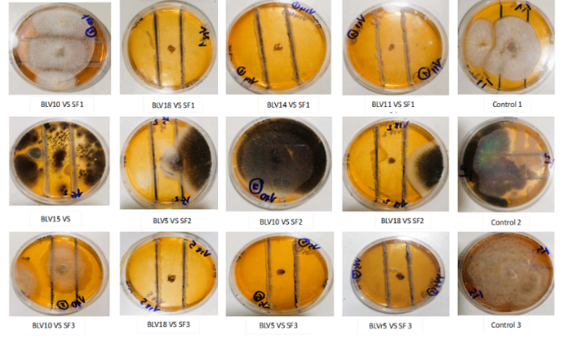

Figure 4 : Antifungal activity. Legend : SF3 : Fungal strain *Cladosporium sp* ; SF2 : Fungal strain *Aspegillus niger*

**5.4 Bacteriocin synthesis genes**

Bacteriocins are protein metabolites synthesized by LABs for their defense. They are antimicrobial agents. In this study, we looked for a set of genes involved in the synthesis of a variety of bacteriocins. Two types of genes were detected. These were genes 186 bp in size and genes 450 bp in size (Figure 5). 6/12 lactic bacteria strains showed at least one gene involved in bacteriocin synthesis.

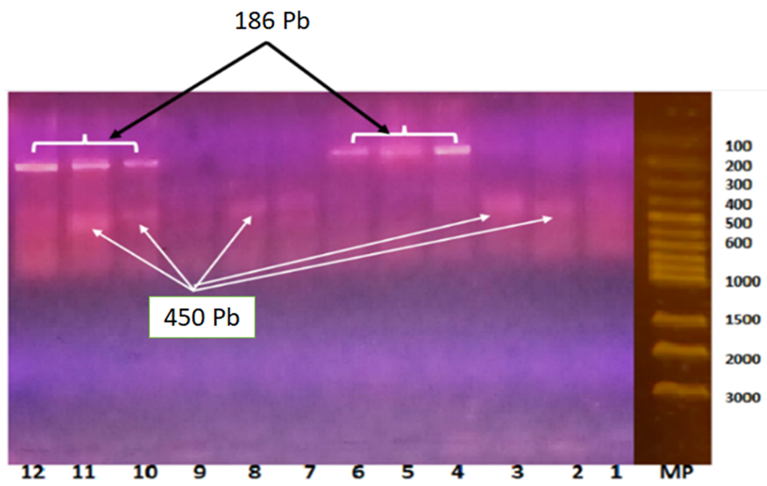

Figure 5 : Electrophoretic migration gel

**Legend : 1 : Vr1 2 : V10 3 : Vr2 4 : Vr14 5 : V18 6 : Vr5 7 : V11 8 : V1 9: Negative control 10 : V5 11 : V14 12 : V15**

Table 4- Biochemical assays and species affiliations of the bacterial isolates

|  |  |  |  |  |  |  |  |  |  |  |  |  |
| --- | --- | --- | --- | --- | --- | --- | --- | --- | --- | --- | --- | --- |
|  | **V5** | **V14** | **V15** | **V24** | **V18** | **V11** | **V10** | **V1** | **Vr5** | **Vr1** | **Vr2** | **Vr14** |
| **Form** | **C** | **C** | **B** | **C** | **C** | **C** | **B** | **B** | **C** | **Cb** | **C** | **B** |
| **Gram** | **+** | **+** | **+** | **+** | **+** | **+** | **+** | **+** | **+** | **+** | **+** | **+** |
| **Catalase** | **-** | **+** | **-** | **+** | **-** | **-** | **-** | **-** | **-** | **-** | **-** | **-** |
| **H2S** | **-** | **-** | **-** | **-** | **-** | **-** | **-** | **-** | **-** | **-** | **-** | **-** |
| **IND** | **+** | **-** | **-** | **-** | **+/-** | **-** | **-** | **-** | **-** | **-** | **+** | **-** |
| **ADH** | **-** | **+** | **+** | **+** | **+** | **+** | **+** | **+** | **+** | **+** | **+** | **-** |
| **ODC** | **-** | **-** | **-** | **+** | **-** | **+** | **+** | **-** | **-** | **+** | **+/-** | **-** |
| **CIT** | **-** | **-** | **+/-** | **-** | **-** | **-** | **+** | **-** | **-** | **-** | **-** | **-** |
| **TDA** | **-** | **-** | **+** | **+** | **-** | **+** | **-** | **-** | **-** | **-** | **+** | **-** |
| **GLU** | **+** | **+** | **+** | **+** | **+** | **+** | **+** | **+** | **+** | **+** | **+** | **+** |
| **MAN** | **-** | **+** | **+** | **+** | **+** | **+/-** | **+** | **+/-** | **+** | **+/-** | **+** | **+/-** |
| **INO** | **-** | **+** | **+** | **-** | **-** | **-** | **+** | **-** | **-** | **-** | **-** | **+/-** |
| **SOR** | **-** | **+** | **+** | **+/-** | **+** | **+/-** | **+** | **+** | **-** | **+/-** | **-** | **+/-** |
| **RHA** | **+** | **+** | **+/-** | **-** | **+** | **+/-** | **+/-** | **+/-** | **+** | **+** | **+** | **+** |
| **SAC** | **+** | **+** | **+/-** | **+** | **+** | **+** | **+** | **+** | **+/-** | **+** | **+** | **+** |
| **MEL** | **-** | **+** | **+/-** | **-** | **-** | **-** | **+** | **+/-** | **+/-** | **+/-** | **+** | **+** |
| **AMY** | **-** | **+** | **+/-** | **+** | **+** | **+/-** | **+** | **+/-** | **+** | **+** | **+** | **+/-** |
| **ARA** | **+** | **+** | **-** | **-** | **+** | **+/-** | **+** | **+** | **+** | **+** | **+** | **+** |
| **Affiliation** | ***Streptococcus* sp.** | ***Pediococcus* sp.** | ***Enterococcus* sp.** | ***Enterococcus* sp.** | ***Lactococcus* sp.** | ***Lactococcus* sp.** | ***Lactobacillus* sp.** | ***Lactobacillus* sp.** | ***Enterococcus* sp.** | ***Lactobacillus* sp.** | ***Enterococcus* sp.** | ***Lactobacillus sp* .** |

Legend : +: Positive reaction; -: Negative reaction; +/-: Variable reaction; C: Coccus; Cb: Coccobacillus; B: Bacillus; H2S: Sodium thiosulphate; IND: Indole; ADH: Arginine dihydrolase; ODC : Ornithine decarboxylase; CIT: Citrate; TDA: Tryptophan deaminase; GEL: Gelatine; GLU: Glucose; MAN: Mannose; INO: Inositol; SOR: Sorbitol; RHA: Rhamnose; SAC: Sucrose; MEL: Melibiose; AMY: Amygladine; ARA: Arabinose.

1. **CONCLUSION**

This study highlighted the diversity, antimicrobial, and antifungal potential of lactic acid bacteria (LABs) strains isolated from traditional cow and goat curdled milk. Assessment of their antimicrobial activity showed significant efficacy against various pathogenic strains, in particular *Staphylococcus aureus*, *Acinetobacter baumannii*, *Klebsiella pneumoniae* and *Escherichia coli*, with significant zones of inhibition, although the activity was mainly bacteriostatic. In addition, several strains showed marked antifungal activity, suggesting the production of potential fungistatic or fungicidal metabolites. The identification of these properties highlights the value of these indigenous LABs as natural alternatives to chemical preservatives and conventional antibiotics. Their use could contribute to the development of new bioconservation strategies in the agri-food industry, as well as to the formulation of probiotics for nutritional or therapeutic purposes. Additional studies, in particular genomic characterization, purification of bioactive compounds, and in vivo evaluation, are nevertheless necessary to confirm their safety, stability, and efficacy under real conditions of application.

Disclaimer (Artificial intelligence)

Option 1:

Author(s) hereby declare that NO generative AI technologies such as Large Language Models (ChatGPT, COPILOT, etc.) and text-to-image generators have been used during the writing or editing of this manuscript.

Option 2:

Author(s) hereby declare that generative AI technologies such as Large Language Models, etc. have been used during the writing or editing of manuscripts. This explanation will include the name, version, model, and source of the generative AI technology and as well as all input prompts provided to the generative AI technology

Details of the AI usage are given below:

1.

2.

3.

**Reference :**

Allouche, F.N., Hellal,, A. and Laraba, A. (2010). Etude de l’activité antimicrobienne des souches de lactobacilles thermophiles utilisées dans l’industrie laitière. Nature & Technologie, 13-20

Amoussa, A.M.O., Sanni, A. and Lagnika, L. (2015). Antioxidant activity and total phenolic, flavonoid and flavonol contents of the bark extracts of Acacia ataxacantha. Journal of Pharmacognosy and Phytochemistry; 4(2) : 172-178

Anani, K., Hudson, J B., de Souza, C., Akpagana, K.G.H.N., Tower, J.T., And Arnason, M.G. (2000). Investigation of Medicinal Plants of Togo for Antiviral and Antimicrobial Activities, Pharmaceutical Biology, 38:1, 40-45, DOI: 10.1076/1388-0209(200001)3811-BFT040

Belarbi, A.Y., de Almeida, O.G.G., And Gatto, V. (2022)*.* Investigating the biotechnological potential of lactic acid bacteria strains isolated from different Algerian dairy and farm sources. Archives of Microbiology **204**, 220. https://doi.org/10.1007/s00203-022-02828-7

Bertin, Y., Habouzit,C., Dunière, L., Laurier, M., Durand, A., and Duchez, D. (2017). Lactobacillus reuteri suppresses E. coli O157:H7 in bovine ruminal fluid: Toward a pre-slaughter strategy to improve food safety? PLoS ONE 12(11): e0187229. <https://doi.org/10.1371/journal>. pone.0187229

CA-SFM/EUCAST. (2019). Https://www.bing.com/search?q=CASFM+%2F+EUCAST+2019&cvid=876c1b1bccb044a2adb894132c95eac7&aqs=edge..69i57j69i60.4058j0j1&pglt=43&FORM=ANNTA1&PC=U531. (s. d.).

Chikindas, M.L., Weeks, R., Drider, D., Chistyakov, V.A., and Dicks., L.M.T. (2018). Functions and emerging applications of bacteriocins. Current Opinion in Biotechnology, 49 (2), 23-28. 10.1016/j.copbio.2017.07.011

Doughari, J.H., Elmahmood., A.M., and Manzara., S. (2007). Studies on the antibacterial activity of root extracts ofCarica papaya L. African Journal of Microbiology Research pp. 037-041 online http://www.academicjournals.org/ajmr

Gaur, P., Hada, V., Rath, R.S., Mohanty, A., Singh,P., and Rukadikar, A. (2023). Interpretation of Antimicrobial Susceptibility Testing Using European Committee on Antimicrobial Susceptibility Testing (EUCAST) and Clinical and Laboratory Standards Institute (CLSI) Breakpoints: Analysis of Agreement. Cureus 15(3):e36977. DOI 10.7759/cureus.36977

Laref, N., Guessas, B., and kihal, M. (2013). Antifungal compounds production in different temperatures, pH and modified MRS agar by Lactobacillus strains. Journal of Biological Sciences, 13 (2) ; 94-99

Macwana, S.J., and Muriana, P.M.A. (2012). ‘bacteriocin PCR array’ for identification of bacteriocin-related structural genes in lactic acid bacteria. J Microbiol Methods 88:197–204. <https://doi.org/10.1016/j.mimet.2011.11.008>

Ng, Z.J., Zarin, M.A.,, Lee, K.C., and Tan, J.S. (2020). Application of bacteriocins in food preservation and infectious disease treatment for humans and livestock: a review. Royal Society of Chemistry, (10), 38937 DOI : 10.1039/d0ra06161a

Refay, R.M., Abushady, H.M., Amer, S.A., and Mailam, M.A. (2020). Determination of bacteriocin-encoding genes of lactic acid bacteria isolated from traditional dairy products of Luxor province, Egypt. Journal of Pharmaceutical Sciences 6:22 <https://doi.org/10.1186/s43094-020-00031-3>

Sieuwerts, S., Bron, P.A., and Smid, E.J. (2018). Mutually stimulating interactions between lactic acid bacteria and Saccharomyces cerevisiae in sourdough fermentation, LWT - Food Science and Technology doi: 10.1016/j.lwt.2017.12.022.

Tsapieva,A., Duplik, N., and Suvorov, A. (2011). Structure of plantaricin locus of Lactobacillus plantarum 8P-A3. Beneficial Microbes 1, 2(4) : 255-61. https://doi. org/10.3920/BM2011.0030.

Wang, M.Y., West, B.J., Jensen, C.J., Nowicki, D., Su, C., and Palu, A.K. 2002. Morinda citrifolia (Noni): a literature review and recent advances in Noni research. Acta pharmacologica sinica; 23 : 1127-41.

Xiraphi, N., Georgalaki, M., Rantsiou, K., Cocolin, L., Tsakalidou, E., and Drosinos, E.H. (2008). Purification and characterization of a bacteriocin produced by Leuconostoc mesenteroides E131. Meat Science 80 :194–203