***Original Research Article***

**Study of endophytic and rhizospheric fungi from *Mappia nimmoniana* (J.Graham) Byng & Stull. for camptothecin analysis and antibacterial activity**

**Abstract:**

Camptothecin, the third essential and commonly used alkaloid, is derived from the endangered *Mappia nimmoniana* (J. Graham) Byng & Stull plant in India for commercial use. In this study, endophytes from various plant parts (leaf, petiole, and stem) as well as a rhizospheric fungus associated with *Mappia nimmoniana* were isolated. *M. nimmoniana* was collected from Sawantwadi- Amboli, Sindhudurg, Maharashtra, India. The collection of plant material and rhizosphere soil samples was carried out using the method of Dongmo and Oyeyiola. Ten fungi were isolated, including six rhizosphere fungi and four endophytic fungi. Out of 10 fungi, two endophytes and one rhizosphere fungus are reported to produce bioactive compounds, camptothecin, which were analysed using HPLC. The camptothecin-producing fungus was further identified using the ITS1/ITS4 molecular method. The presence of camptothecin in the fungus was confirmed by LC-HRMS analysis. Camptothecin levels in two endophytes were found to be 1.957 mg/100 mg and 0.3622 mg/100 mg, respectively, whereas the rhizospheric fungus recorded 0.1445mg/100mg. In addition to that antibacterial activity of endophyte *Fusarium falciforme* and rhizosphere fungi *Rhizopus arrhizus* against *Escherichia coli*, *Staphylococcus aureus* and *Bacillus subtilis* was studied by the disc diffusion method. It is observed that *Fusarium falciforme* shows significant antibacterial activity.

**Keyword**: Camptothecin, Endophyte, rhizospheric fungi, antibacterial activity

**Introduction**:

The zone surrounding the root surface, known as the rhizosphere, is one of the most active associations. According to Bonfante and Anca (2009), the microbiota situated in the rhizosphere of agroecosystems can have a significant influence on the development, nutrition, and health of plants. Endophytes are described as microorganisms that inhabit the interior tissues of plants, can be separated from the plant by surface disinfection, and do not pose a threat to plant growth (Gaiero et al., 2013). Endophytes comprise an extremely diverse group of microorganisms that are ubiquitous in plants and maintain a symptomless and unobtrusive union with their hosts for at least a period of their life cycle (Goyal et al., 2022; Goyal et al., 2023). Soil, being a complex ecosystem, harbours fungi belonging to all the major taxonomic groups, along with other microbes. Since each species is dependent on certain other species for its survival, any imbalance in the ratio will cause disruption to its survival. Hence, a thorough study of plants with their associated microbes, like fungi, bacteria, viruses, MLOs, etc., is essential. Endophytic fungi are found in every plant on Earth. Novelty of bioactive compounds such as antifungal, antibacterial, anticancer, anti-inflammatory, antiviral, antioxidant, nematicidal/insecticidal, immunosuppressant, etc have been isolated from fungal endophytes (Riya & Sohrab, 2022; Manganyi & Ateba, 2020).

*Mappia nimmoniana* is an under tree of the Icacinaceae family that is found in India, Sri Lanka, China, Taiwan, Isabela province, South East Asia, Luzon and the Philippines. It is also known by the synonyms *Nothapodytes nimmoniana*, *Nothapodytes foetida*, and *Mappia foetida*. Karehed investigated and observed species native to the Western Ghats (Ka ̊rehed, 2001).

As per published literature on flora, it is now also observed in the forest of Odisha, India (Das et al., 2020). It is a 3-8 m tall tree with smooth, grey, wrinkled bark and prominent leaf scars. Alternately arranged leaves are slightly leathery, elliptic-oblong, and crowded at the end of branches. Flowers in terminal corymbose panicles, densely pubescent. Petals yellow, densely villous. Fruits are ellipsoid, purple when ripe. Flowering takes place in the monsoon season (Singh et al., 2001).

The cytotoxic, camptothecin, is a monoterpene pentacyclic quinoline alkaloid and anti-cancer drug isolated from parts of the commercially demanded medicinal plant *M. nimmoniana*. *M. nimmoniana* was shown to contain varying quantities of camptothecin in its stem, roots, leaves and fruits, with the roots containing a significant concentration (Namdeo and Sharma, 2012; Padmanabha et al., 2006). It is an active inhibitor of HIV replication in vitro and has been shown to be effective in the treatment of cancer malignancies (Pommier, 2006; Priel et al., 1991). After vinca and taxol alkaloids, camptothecin (CPT) is the third alkaloid that the pharmaceutical sector is searching for worldwide (Lorence and Nessler, 2004; Panneerselvam et al., 2024). The availability of these phytochemicals is primarily dependent on plant sources as the raw material. As the demand for plant-derived CPT does not support the requirement of a huge supply from the global market, to increase the production of CPT by other options such as the in vitro culture method, yield improvement by precursor feeding, and elicitation but the success rate is insufficient to meet the demand.

With a stated trade volume estimated to go above a thousand tons, and unrecorded trade at least twice the stated one. India is the world's top trader of dried *M. nimmoniana* woodchips, which are primarily exported to Japan, the USA, and Spain for the market (Patwardhan, 2006). The population of *M. nimmoniana* has been severely exploited in the Western Ghats of India, and it has been classified as vulnerable being to the growing demand for the alkaloid and its maximum quantity in *M. nimmoniana,* one of the potential sources (Suhas et al., 2007; Takeuchi et al., 1991; Takimoto et al., 1998). Hence, microbes and their relation and interaction with the natural vegetation are essential. With this background, the present study has been undertaken to understand the association between the rhizosphere and endophytic fungi with *M. nimmoniana,* a demanded medicinal plant. Moreover, the CPT producing endophyte and rhizosphere fungal extract antimicrobial was tested against the *Escherichia coli*, *Staphylococcus aureus* and *Bacillus subtilis* bacterial strains.

**Material and Methods:**

**Collection of plant material**

After taking permission from the Maharashtra State Biodiversity Board, *M. nimmoniana* was collected from Sawantwadi- Amboli, Sindhudurg, Maharashtra, India (15.96070 N, 73.99470 E), as *M. nimmoniana* is under the endangered category of plants. The collection of plant material and rhizosphere soil sample was carried out using the method of Dongmo and Oyeyiola (2006). Experts from the Savitribai Phule Pune University Department of Botany in Pune, India, identified and verified it. For experimental studies, fresh, uninfected leaves and stem segments of the *M. nimmoniana* plant were taken for studies and stored at 4 °C in clean, dry polythene bags.

**Isolation of Rhizosphere mycoflora**

Soil from the root surface of *M. nimmoniana* was collected. 1 g weighted soil was mixed in 10 ml of sterile distilled water in sterile conditions. The dilution up to 10-6 was performed. From each dilution, three replicates were inoculated on PDA medium plates. The PDA plates with soil dilutions were kept at 28 °C for 7 days to allow the rhizosphere fungi to grow (Johnson and Curl, 1972)

**Isolation of Endophyte:**

The collected material was cleaned with running tap water and sterile water to get rid of any dust. In order to surface sterilise the explants for one minute, 1% (v/v) NaOCl was applied to the petioles and leaves. After giving it a thorough wash in distilled sterile water, the explants had two treatments: one minute of 70% (v/v) ethanol and another minute of sterile distilled water. This was done to ensure that any remaining ethanol was completely removed from the plant components. The sterile plant part section (about 1 cm2) was placed on Petri dishes with PDA medium that had been added with 100 µg/ml of streptomycin to prevent bacterial growth. Negative controls were used on transplants that had not undergone surface sterilisation in order to guard against false positives caused by microbial contamination. The plates with explants were incubated at 28 °C for seven days to allow the endophytes to grow. After 5-7 days, the severed ends began to grow endophytes. To get pure colonies, the endophytes were isolated and plated on a fresh medium (Bisht et al., 2016).

**Liquid State Fermentation:**

Full loops of mycelia were streaked from pure colonies of endophytes onto slants prepared with PDA medium and cultured for seven days at 28 °C. At a pH of 5.6, 250 ml Erlenmeyer flasks were filled with 50 ml of PDB (HiMedia, Mumbai) to establish suspension cultures (in duplicate). The obtained suspension culture was allowed to develop at 28 °C and 120 rpm in an incubator shaker. Following an 8-day growing period, the shaking flasks (in duplicate) were collected in order to estimate the biomass and yield of camptothecin.

**Extraction of CPT:**

After 8 days of cultivation in Potato Dextrose broth, the mycelia and culture broth were separated by double muslin cloth. Mycelia were air dried after being cleaned in sterile distilled water. Mycelium was crushed in chloroform: methanol (4:1). Centrifuged for 10 min at 10 °C at 10,000 rpm. The upper aqueous part was collected and evaporated until it was dry. The residue was diluted in methanol and then filtered through a 0.2 µm filter. These extracted samples were used for HPLC and LC-HRMS analysis (Ran et al., 2017).

**HPLC analysis:**

In the mobile phase, 25% acetonitrile was used, and five microliters of camptothecin extract were injected at 0.8 ml/min. The stationary phase used an Agilent 5 TC-C18 (2) 150 X 4.6 ODS column (Infinitely superior) with a 5 µm particle size at a column temperature of 30°C. The absorbance of camptothecin was considered at 254 nm using a photodiode array detector (Shweta et al., 2017). The region of the peak derived from the fungal isolates at the same retention, in addition to the concentration and yield from the various fungal isolates, period in comparison with the standard peak of camptothecin was determined (3.8 min). The corresponding concentrations from different fungal isolates were calculated.

**LC-HRMS analysis:**

The analysis was succeeded by the introduction of 5 µL aliquots at a rate of 120 µL min−1 into the electrospray ionisation (ESI) chamber. The mass spectra were obtained by LC-HRMS. In ESI type 50–1500 m/z; capillary at 4500 V; −500 V at end plate; charging voltage set at 2000 V; corona set at 0 nA; nebuliser set at 1.7 bar; dry heater set at 200°C and dry gas set at 7.0 L min−1; APCI heater set at 0^C. The Bruker Compass Data Analysis 4.2 software was used to evaluate the baseline-corrected and spectra-visualised data. By comparing the sample's m/z to the reference standard m/z (371.107139), the mass was verified (Ran et al., 2017).

**Molecular Identification of Fungi**

**Extraction of DNA**

By using molecular analysis, the endophytic fungus was further identified. The modified CTAB approach was utilised to extract the genomic DNA from the mycelium (Aamir *et al*., 2015). About 300 mg of fungal mycelium from a pure culture of fungus was first extracted for DNA extraction, and they were then crushed into a fine powder under liquid nitrogen. Added one millilitre of lysis buffer and centrifuged. After adding chloroform and PCI (Isoamyl alcohol) and shaking vigorously, the mixture was centrifuged once more. Once the upper layer has been separated, mix isoamyl alcohol (CI) with the same volume of chloroform. The centrifuge was used, and 100% ethanol was added. The pellet was spun at 10,000 rpm for 10 minutes, and the resulting supernatant was washed with 70% ethanol. The pellet was then dissolved in 50–70 µl of 1X TE buffer, with the addition of 1 µl RNase. It was kept for 30 minutes at 37 °C. The 2 µl of genomic DNA is electrophoresed on a 0.8% agarose gel, and then the gel is viewed using a UV transilluminator gel documentation system.

**Amplification of DNA by PCR and Purification**

After observing the DNA band of the sample, proceed with amplifying DNA using a PCR machine (Prima- 96, HiMedia). Total 25 µl reaction mixtures were prepared, which consist of PCR master mix, nuclease-free H2O, forward ITS primer, reverse primer and template DNA. With the universal primers ITS 1 and ITS4, the flanking ITS sections that separate the 5.8s rDNA and the large subunit of rRNA were amplified (GeNei, Bengaluru, India). After purification of the PCR sample by NT1 and NT3 wash buffer, then again confirmed by gel electrophoresis, then observed the gel was observed under a UV trans illuminator gel documentation system which provided for sequencing. Following nucleotide BLAST on the subsequent sequences, phylogenetic analysis was conducted using the homologous sequences of the generated species. The isolates (*Fusarium falciforme, Aspergillus tamarii* and *Rhizopus arrhizus*) were deposited in the National Fungal Culture Collection, Agharkar Research Institute, Pune, India, with accession numbers 5814, 5815 and 5817, respectively.

**Antimicrobial activity:**

**Test Microorganisms**

To check the antibacterial activity of fungal extract, bacterial strains were collected from ARI, National Fungal Culture Collection (NFCCI), Pune. 121-*Escherichia coli*, 2940-*Staphylococcus aureus*, and 739-*Bacillus subtilis* species were used.

**Test Cultures Growth:**

Bacteria were grown in Nutrient agar (Himedia, India) at pH 7.2 for 24 h and at 37 °C. Then cells were harvested and suspended in the Nutrient broth at a concentration of approximately 1.2× ­106 CFU/ml.

**Determination of Antimicrobial Activity by Disc Diffusion Method**

Methanol was added to dried crude extracts to a concentration of 100 mg/ml. Then, 30 µL of the dissolved extract was pipetted to 5 mm diameter sterile circular discs (Whatman Paper No. 1) and was permitted to air dry for one hour in the incubator set at 35°C. Three paper discs containing the extract were placed evenly spaced on each inoculated nutrient agar plate. Paper discs eluted with 30 µL of methanol and a 300mg standard Streptomycin disc were included in the nutrient agar plate as negative and positive controls, respectively. All plates were incubated at 37 °C in an incubator for 24 hours, and resulting zones of inhibition were measured (Adhikari et al., 2022).

**Result:**

Plant material was identified and confirmed by an expert from the Department of Botany at Savitribai Phule Pune University in Pune, India. The *M. nimmoniana* plant's fresh, healthy leaf and stem segments were collected (Fig. 1). After 5-7 days of incubation, endophytes began to emerge from the cut ends. After that, they were plated separately on fresh media to produce pure endophyte colonies (Fig. 2). The pure culture was allowed to grow at 28 °C and 120 rpm. After an 8-day growth phase, the shaking flasks (in duplicate) were collected to measure CPT biomass and yield.

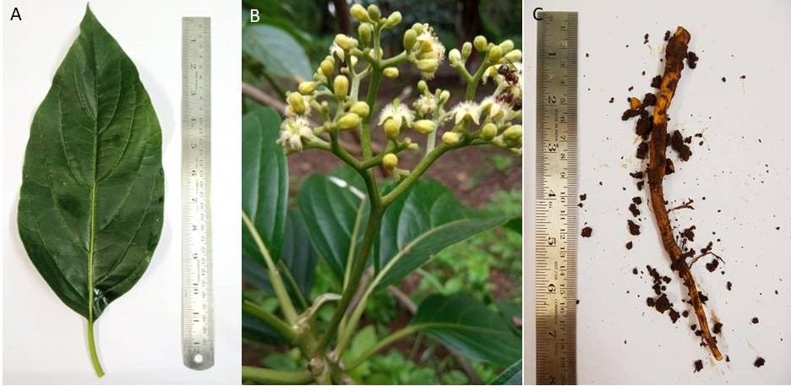

**Figure 1** (A)-*Mappia nimmoniana*-Leaf, (B)-Plant, (C)- Root with Rhizosphere soil

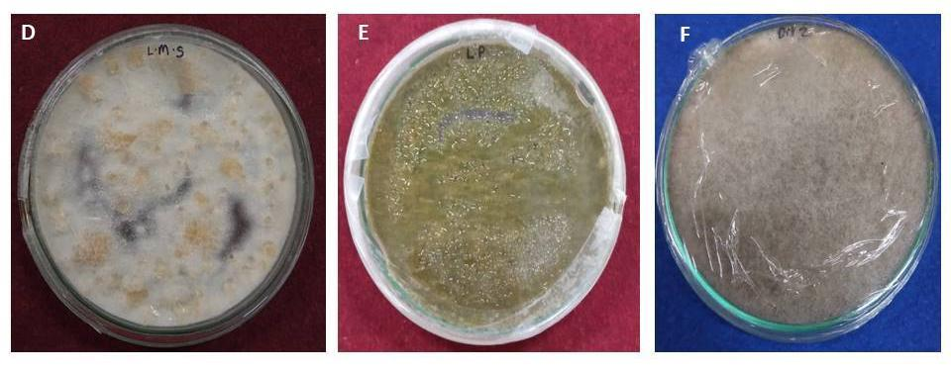

**Figure 2** (D)- *Fusarium falciforme*, (E)-*Aspergillus tamarii*, (F)-*Rhizopus arrhizus*

Ten fungi were isolated, including six rhizosphere fungi and four endophytic fungi. Two endophytes and one rhizosphere fungus are known to produce the bioactive metabolite CPT. The endophyte isolated from the leaf midrib produced a significantly high level of CPT, which was further identified at the molecular level. These three fungi's ITS rDNA sequence data were most closely related to *Fusarium falciforme*, *Aspergillus tamarii*, and *Rhizopus arrhizus* in the NCBI GenBank database. A phylogenetic tree was created for these endophyte and rhizosphere fungi (Fig. 3). The AB219373.1 *Achlya treleaseana* and KF420260.1 *Pythium sp*. are considered out-groups. The Mega 11 software is used for generating a phylogenetic tree by the maximum likelihood method.

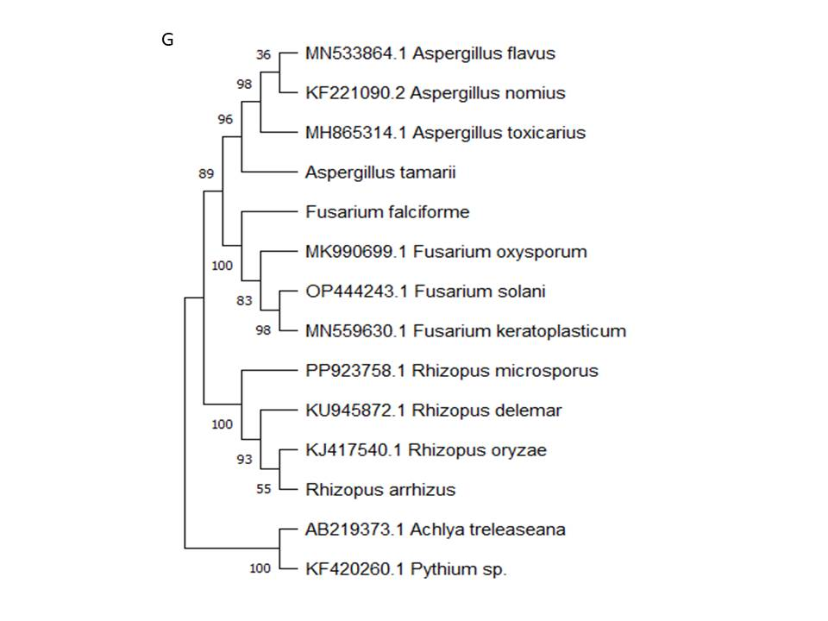

**Figure 3** (G)- Phylogenetic tree

These three fungus species' HPLC studies indicated a peak eluting at a retention time that corresponds to the standard CPT. CPT from the standard was determined to be at 3.8 minutes by 25% acetonitrile in the mobile phase of 0.8 ml/min flow (Fig. 4).

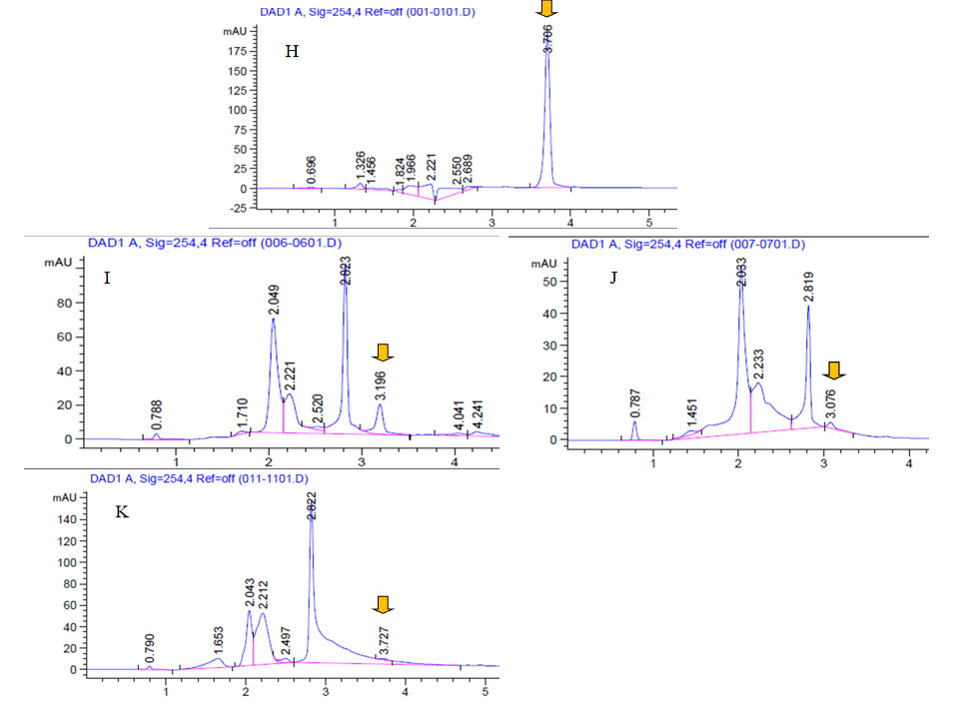

**Figure 4** -HPLC analysis (H)-Standard CPT, (I)-*Fusarium falciforme*, (J)- *Aspergillus tamarii*, (K)- *Rhizopus arrhizus*

The amount of CPT present was determined using the peak's area. Two endophytes revealed camptothecin concentrations of 1.957mg/100mg, 0.3622mg/100mg, and 0.1445mg/100mg for rhizospheric fungi. Furthermore, LC-HRMS verified the presence of CPT in these four fungal samples. Camptothecin absorbance at 254 nm was measured using a photodiode array detector. CPT was also detected using LC-HRMS analysis (Fig. 5). By comparing the sample's m/z to the reference standard m/z, the mass was verified (371.107139).

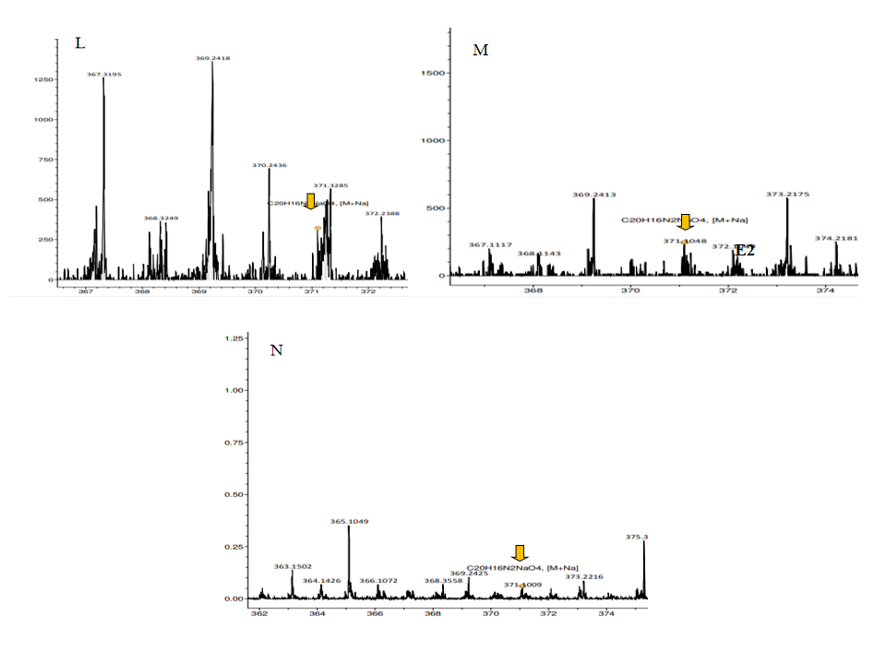

**Figure 5**- LC-HRMS analysis (L)-*Fusarium falciforme*, (M)- *Aspergillus tamarii,* (N)-*Rhizopus arrhizus*

In a preliminary study of the antibacterial activity of fungal extract, no activity was observed in *Aspergillus tamarii*; therefore, only two fungal extracts were tested for antibacterial activity. *Fusarium falciforme* and *Rhizopus arrhizus* showed antibacterial activity against *Escherichia coli*, *Staphylococcus aureus* and *Bacillus subtilis,* which ranged from 9.3±0.1 to 21.3±0.1. Among them, *Fusarium falciforme* was found to be the most potent against all the tested pathogens (Fig. 6).



**Figure 6-** Antibacterial assay:

The grouped bar chart showed maximum inhibition (mm) of bacterial starin by *F. falciforme,* then *Rhizopus arhizus*  (Fig. 7).

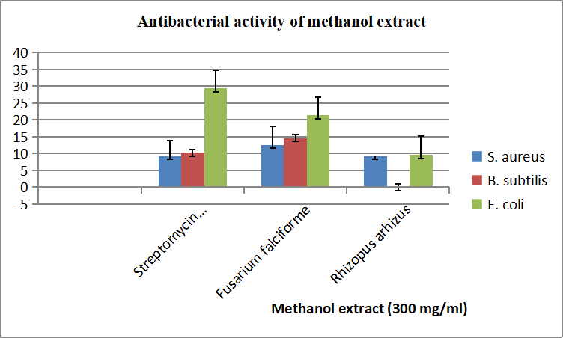

**Figure 7**- Grouped bar chart of Antibacterial assay activity.

**Discussion:**

CPT is a major alkaloid used to treat cancer. It is produced mostly by two overharvested and endangered species, *Camptotheca acuminata* and *Nothapodytes nimmoniana* (Suhas et al., 2006; Vladu et al., 2000). Endophytic fungus is a viable replacement for CPT production. In this work, we focused on the bioactive metabolite CPT found in endophytic and rhizospheric fungi. The continual harvesting of *M. nimmoniana* over the previous five years has dramatically reduced the tree's population. The same study has been noticed in Sri Lanka. Endophytic fungi were isolated from *M. nimmoniana* leaves, *Diaporthe guangxiensis*, an isolated fungus, produced a greater production of CPT when treated with tryptophan in Sabouraud Dextrose Broth (Degambada et al., 2023).

The primary obstacle is the fungi's decrease in camptothecin productivity during storage and subculturing. Therefore, one of the most helpful prototypes would be to look for endophytic fungal isolates living in ethnopharmacological plants that have a unique metabolic consistency and are efficient for CPT synthesis (Ruan et al., 2021). Endophytes isolated from other medicinal plants are also a source of CPT, such as *Aspergillus terreus*, an endophyte of *Cestrum parqui*, which exhibited the highest potential for the biosynthesis of camptothecin (El-Sayed et al., 2023). The study reported on the continuous sub-culturing of these fungi with a yield of CPT. Using Plackett-Burman design bioprocessing, *A. terreus* was able to maximise its CPT production, resulting in a total 1.5-fold increase (170.5µg/L) as compared with control cultures (El-Sayed et al., 2022).

The study found that the endophyte *Phyllosticta elongata* generated the effective anticancer medication CPT. This endophyte was isolated from *Cipadessa baccifera* in the Sathyamangalam Tiger Reserve forest in the Western Ghats (Dhakshinamoorthy et al., 2021). *Penicillium* sp. was the only isolated fungus species from *Ixora chinensis* shown to be a source of CPT (Doan et al., 2024). Although the potential for employing fungi as a platform for the industrial manufacture of CPT is raised by their ability to produce CPT. The problem is that their CPT output is reduced during subculture and preservation.

*Aspergillus terreus* was the most productive endophyte from *Cinnamomum camphora*, producing 89.4μg/l of CPT. According to the Gel-based DNA assay, the putative CPT significantly impacted cancer cell lines and exhibited a high affinity for inhibiting human Topoisomerase 1 (IC50 0.362 μg/ml). This is the first study to investigate whether the natural *C. camphora* microbiome may be exploited to manufacture CPT commercially, with the *A. terreus* endophyte serving as a fundamental platform for constant sustainability (Eldeghidy et al., 2023).

*Alternaria brassicicola* isolated from the *Catharanthus roseus* produced the highest amount of CPT (96.5 μg/L) of all the endophytes. The antiproliferative effect of the pure *A. brassicicola* CPT is potent against cancer cell lines. The 1% disinfectant *C. roseus* leaves restored the CPT productivity of the attenuated *A. brassicicola*, indicating that the plant microbiome and *A. brassicicola* link would promote the gene cluster for synthesis of CPT (El-Hady et al., 2024). *Neurospora crassa*, an endophyte isolated from the seed of *Nothapodytes foetida*, was examined as a potential source of camptothecin, an anticancer medication lead compound. By comparing the contents of this fungus to actual camptothecin, chromatography and spectroscopy tests confirmed the presence of an anticancer component. In the future, the isolated endophyte *N. crassa* might be a readily available source for large-scale production of a precursor anticancer therapeutic molecule (Rehman et al., 2008).

The productions of camptothecin by fungal endophytes of wild and in vitro cultivated *Astragalus fruticosus* were investigated. *Aspergillus flavus*, an endophyte from the *A. fruticosus* explant, produced the highest (51.7µg/l) CPT. The isolated *A. flavus* camptothecin showed significant effectiveness against MCF7, HCT29, and HEPG-2 (IC50 0.9 mM, 1.2-1.35 mM) cell lines. Methyl jasmonate increased camptothecin production in *A. flavus* by 1.6 times (El-Sayed et al., 2024).

Several bioactive secondary metabolites produced by endophytic fungi can protect plants against several diseases. Some of them might be therapeutics for various bacterial and fungal diseases. The disc diffusion methods were used to compare fungal ethyl acetate extracts to the test microorganisms for antibacterial activity. In the present study, *Fusarium falciforme* endophyte isolated from *M. nimmoniana* showed maximum antibacterial activity. The highest inhibition zone measured against *E. coli* (21.3 mm) was recorded using the disc diffusion technique.

In some previous literature studies, it has been shown that endophyte isolated from *N. nimmoniana* *Colletotrichum* sp. inhibited *Staphylococcus aureus* strongly. The highest Minimum inhibitory concentration (25mg/disc) was found in *C. globosum* isolates (Nimbalkar & Singh, 2023). *Fusarium oxysporum* isolated from the leaf of *N. nimmoniana* has shown considerable antimicrobial activity against *Staphylococcus aureus*, *Pseudomonas aeruginosa*, *Escherichia coli,* and *Candida albicans* test pathogens (Musavi & Balakrishnan 2013). The endophytic actinomycetes found from the Panxi plateau and the endophytic *Streptomyces* sp. obtained from Elite *Citrus nobilis* fruit presented the strongest antimicrobial properties, inhibiting pathogens such as *Colletotrichum truncatum*, *Geotrichum candidum*, *Fusarium* *oxysporum*, and *F. udum* (Srivastava & Raghuwanshi, 2023).

Endophyte *Fusarium* sp. was obtained from the bark of yew trees in the eastern Himalayas. Ethyl acetate extract from its fermentation broth revealed substantial antimicrobial activity against pathogenic bacteria and fungi. The metabolite confirmed the largest inhibition zone against *K. pneumoniae* (27 mm) and the smallest against *C. albicans* (10 mm) (Tayung et al., 2011). The metabolite extracted from the endophytic *F. oxysporum* sourced from *Acorus calamus* rhizomes exhibited strong inhibitory effects on *Shigella flexneri* (31.3 mm), followed by *Staphylococcus epidermidis* (19.6 mm) and *Escherichia coli* (17.6 mm). Minimal inhibitory zone was observed against *Staphylococcus aureus* (8.6 mm). *Cochliobolus affinis* and *Pestalotiopsis guepinii* demonstrated prominent antibacterial activity against various clinical bacterial strains. The research specified a rich diversity of endophytic fungi in *Memecylon umbellatum*, which varied based on isolation techniques, seasons, plant parts, and some of these could possibly aid as future sources (Gagana & Shivanna, 2020).

*Diaporthe caatingaensis* is an endophytic fungus obtained from *Buchanania axillaris*. The plant specimens were gathered from the Sathyamangalam Tiger Reserve in Tamil Nadu. The extract of the endophytic fungus confirmed a growth inhibition range of 15–22 mm in the antibacterial assay on nutrient agar plates. With all microorganisms examined, the Minimum Inhibitory Concentration demonstrated the antibacterial potential at a lower concentration of 12.5–25 μg/ml. (Dhakshinamoorthy et al., 2021).

**Conclusion:**

A total of ten fungi were isolated, including six from the rhizosphere and four endophytic fungi. Out of ten fungi, two endophytes and one rhizosphere fungus are found to be producing bioactive metabolites, camptothecin. It will be crucial to create effective and sustainable production techniques as the market for CPT expands. The endophyte isolated from the leaf midrib results in a comparatively high level of CPT. Rhizosphere and endophytic fungi provide encouraging ways to satisfy the need for bioactive metabolites with the least amount of stress on natural populations. Further research on increasing CPT through various treatments will be vital, and studies on the ongoing supply of CPT from fungal biomass are also essential factors that need to be taken into account. The antibacterial study revealed that *F. falciforme* is the effective antibacterial agent than other isolated fungal extracts from *M. nimmoniana* by the disc diffusion method.

**Ethical approval**

Since this study did not include human subjects, informed permission was not necessary.

**Informed consent**

Informed consent was not mandatory for this study, as it did not include human participants.

**Data Availability Statement:** Not applicable

Disclaimer (Artificial intelligence)

Option 1:

Author(s) hereby declare that NO generative AI technologies such as Large Language Models (ChatGPT, manuscript.

Option 2:

Author(s) hereby declare that generative AI technologies such as Large Language Models, etc. have been used during the writing or editing of manuscripts. This explanation will include the name, version, model, and source of the generative AI technology and as well as all input prompts provided to the generative AI technology.

Details of the AI usage are given below:

1.

2.

3.

**References:**

1. Aamir, S.; Sutar, S.; Singh, S.K.; Baghela, A. A rapid and efficient method of fungal genomic DNA extraction, suitable for PCR based molecular methods. Plant Pathol. Quar. 2015, 5, 74–81.
2. Adhikari P, Agnihotri V, Suman SK, Pandey A (2022). Deciphering the antimicrobial potential of Taxus Wallichiana Zucc: identification and characterization using bioassay-guided fractionation. Chem Biodivers 19:e202200572.
3. Barik, B. P., Tayung, K., Jagadev, P. N., & Dutta, S. K. (2010). Phylogenetic placement of an endophytic fungus *Fusarium oxysporum* isolated from *Acorus calamus* rhizomes with antimicrobial activity. EJBS, 2(1), 8-16.
4. Bisht R, Sharma D, Agrawal PK (2016) Antagonistic and antibacterial activity of endophytic fungi isolated from needle of *Cupressus torulosa* D. Don. Asian J Pharm Clin Res 9:282–288
5. Bonfante, P., & Anca, I. A. (2009). Plants, mycorrhizal fungi, and bacteria: a network of interactions. Annual review of microbiology, 63(1): 363-383.
6. Das, P. K., Kamila, P. K., & Panda, P. C. (2020). *Nothapodytes nimmoniana* (J. Graham) Mabb.(Icacinaceae) - an addition to the forest trees of Odisha, India, 11(2): 63-66.
7. Degambada KD, Kumara PA, Salim N, Abeysekera AM, Chandrika UG. Diaporthe sp. F18. (2023). a new source of camptothecin-producing endophytic fungus from *Nothapodytes nimmoniana* growing in Sri Lanka. Natural Product Research. Jan 2; 37(1):113-8.
8. Dhakshinamoorthy, M., Packiam, K. K., Kumar, P. S., & Saravanakumar, T. (2021). Endophytic fungus *Diaporthe caatingaensis* MT192326 from *Buchanania axillaris*: An indicator to produce biocontrol agents in plant protection. Environmental Research, 197, 111147.
9. Dhakshinamoorthy, M., Ponnusamy, S. K., Kannaian, U. P. N., Srinivasan, B., Shankar, S. N., & Packiam, K. K. (2021). Plant-microbe interactions implicated in the production of camptothecin–An anticancer biometabolite from *Phyllosticta elongata* MH458897 a novel endophytic strain isolated from medicinal plant of Western Ghats of India. Environmental Research, 201, 111564.
10. Doan NT, Le DT, Ho AN, Ho TT, Do TT, Hoang H, Nguyen MH, Bui TM, Chu HH. (2024). Isolation, anticancer potency and camptothecin–producing ability of endophytic fungi isolated from *Ixora chinensis*.
11. Dongmo J.C. and Oyeyiola G.P. (2006). *Fusaria* in the rhizosphere and rhizoplane of groundnut (*Arachis hypogaea*). Journal of Agricultural Research and Development, 5(2): 153-164.
12. Eldeghidy A, Abdel-Fattah G, El-Sayed AS, Abdel-Fattah GG. (2023). Production, bioprocessing and antiproliferative activity of camptothecin from *Aspergillus terreus*, endophyte of *Cinnamomum camphora*: restoring their biosynthesis by indigenous microbiome of *C. camphora*. Microbial Cell Factories. Aug 3;22(1):143.
13. El-Hady, N. A. A., ElSayed, A. I., Wadan, K. M., El-Saadany, S. S., & El-Sayed, A. S. (2024). Bioprocessing of camptothecin from *Alternaria brassicicola*, an endophyte of *Catharanthus roseus*, with a strong antiproliferative activity and inhibition to Topoisomerases. Microbial Cell Factories, 23(1), 214.
14. El-Sayed AS, George NM, Abou-Elnour A, El-Mekkawy RM, El-Demerdash MM. (2023). Production and bioprocessing of camptothecin from *Aspergillus terreus*, an endophyte of *Cestrum parqui*, restoring their biosynthetic potency by *Citrus limonum* peel extracts. Microbial Cell Factories. Jan 6; 22(1):4.
15. El-Sayed AS, Zayed RA, El-Baz AF, Ismaeil WM. (2022). Bioprocesses optimization and anticancer activity of camptothecin from *Aspergillus flavus*, an endophyte of in vitro cultured *Astragalus fruticosus*. Molecular Biology Reports. Jun; 49(6):4349-64.
16. El-Sayed, A. S., ElSayed, A. I., Wadan, K. M., El-Saadany, S. S., & Abd El-Hady, N. A. (2024). Camptothecin bioprocessing from *Aspergillus terreus*, an endophyte of *Catharanthus roseus*: antiproliferative activity, topoisomerase inhibition and cell cycle analysis. Microbial Cell Factories, 23(1), 15.
17. Gagana, S. L., & Shivanna, M. B. (2020). Diversity and antibacterial activity of endophytic fungi in *Memecylon umbellatum* Burm. F.-A medicinal plant in the Western Ghats of Karnataka, India. Indian Journal of Ecology, 47(1), 171-180.
18. Gaiero, J. R., McCall, C. A., Thompson, K. A., Day, N. J., Best, A. S., & Dunfield, K. E. (2013). Inside the root microbiome: bacterial root endophytes and plant growth promotion. American journal of botany, 100(9): 1738-1750.
19. Johnson L. F. and Curl. E. A. (1972). Methods for research on the ecology of soil-borne plant pathogens. Methods for research on the Ecology of Soil-Borne Plant Pathogens, 247 pp.
20. Ka ̊rehed J. (2001). Trees of tropical Asia old icacinaceae. American Journal of Botany, 88: 2259–2274.
21. Lorence, A., & Nessler, C. L. (2004). Camptothecin, over four decades of surprising findings. Phytochemistry, 65(20): 2735-2749.
22. Musavi, S. F., & Balakrishnan, R. M. (2013). Biodiversity, antimicrobial potential, and phylogenetic placement of an endophytic *Fusarium oxysporum* NFX 06 isolated from *Nothapodytes foetida*. Journal of Mycology, 2013(1), 172056.
23. Namdeo, A. G., & Sharma, A. (2012). HPLC analysis of camptothecin content in various parts of *Nothapodytes foetida* collected on different periods. Asian Pacific Journal of Tropical Biomedicine, 2(5), 389-393.
24. Nimbalkar, V. S., & Singh, S. K. (2023). Antimicrobial activities of endophytic fungi isolated from Catharanthus roseus (L.) G. Don, Nothapodytes nimmoniana (Grah.) Mabb. and Pongamia pinnata (L.) Pierre.
25. Padmanabha, B. V., Chandrashekar, M., Ramesha, B. T., Gowda, H. H., Gunaga, R. P., Suhas, S., & Shaanker, R. U. (2006). Patterns of accumulation of camptothecin, an anti-cancer alkaloid in *Nothapodytes nimmoniana* Graham., in the Western Ghats, India: implications for identifying high-yielding sources of the alkaloid. Current Science, 90(1); 95-100.
26. Panneerselvam, K., Bhavanisankar, K., Jayapragasam, M., Kumar, A., Rathakrishnan, P., Vijayaraghavan, A., & Adalarasan, R. (2004). Effect of growth regulators and planting media on rooting of cuttings in *Nothopododytes nimmoniana* Mabberly. Indian Journal of Plant Physiology, 9: 308-312.
27. Patwardhan, A. (2006). Domestication of *Nothapodytes nimmoniana* (grah.) Mabb. An endangered medicinal tree from Western Ghats of India. The rufford small grants foundation, UK, 7-15.
28. Pommier, Y. (2006). Topoisomerase I inhibitors: camptothecin and beyond. Nature Reviews Cancer, 6(10), 789-802.
29. Priel E, Showalter SD, Blair DG. (1991). Inhibition of Human Immuno Deficiency Virus (HIV-l) replication in vitro by non-cytotoxicdoses of CPT, a topoisomerase inhibitor. Aids Research and Human Retrovir, 7,65–72.
30. Ran, X., Zhang, G., Li, S., & Wang, J. (2017). Characterization and antitumor activity of camptothecin from endophytic fungus *Fusarium solani* isolated from *Camptotheca acuminate*. African health sciences, 17(2): 566-574.
31. Rehman S, Shawl AS, Kour A, Andrabi R, Sudan P, Sultan P, Verma V, Qazi GN. (2008). An endophytic *Neurospora* sp. from *Nothapodytes foetida* producing camptothecin. Applied biochemistry and microbiology. Mar;44:203-9.
32. Ruan, Q., Patel, G., Wang, J., Luo, E., Zhou, W., Sieniawska, E., & Kai, G. (2021). Current advances of endophytes as a platform for production of anti-cancer drug camptothecin. Food and Chemical Toxicology, 151, 112113.
33. Shweta, S., Gurumurthy, B. R., Ravikanth, G., Ramanan, U. S. & Shivanna, M. B. (2013). Endophytic fungi from *Miquelia dentata* Bedd., produce the anti-cancer alkaloid, camptothecine. Phytomedicine, 20, 337–342.
34. Singh N.P., Lakshminarasimhan P., Karthikeyan and Prasanna (2001). Flora of Maharashtra state-dicotyledons (flora of India series 2). The director, Botanical Survey of India, Calcutta, 2: 517,518.
35. Srivastava, A., & Raghuwanshi, R. (2023). Endophytes and their secondary metabolites against human pathogenic mdr microbes. In Endophytic association: What, why and how (pp. 277-303). Academic Press.
36. Suhas, S., Ramesha, B. T., Ravikanth, G., Gunaga, R. P., Vasudeva, R., Ganeshaiah, K. N., & Shaanker, R. U. (2007). Chemical profiling of *Nothapodytes nimmoniana* populations in the Western Ghats, India for anti-cancer compound, camptothecin. Current science, 25: 1142-1147.
37. Takeuchi, S., Dobashi, K., Fujimoto, S., Tanaka, K., Suzuki, M., Terashima, Y., & Tamaya, T. (1991). A late phase II study of CPT-11 on uterine cervical cancer and ovarian cancer. Research Groups of CPT-11 in Gynecologic Cancers. Gan to kagaku ryoho. Cancer & Chemotherapy, 18(10), 1681-1689.
38. Takimoto, C. H., Wright, J., & Arbuck, S. G. (1998). Clinical applications of the camptothecins. Biochimica et Biophysica Acta (BBA)-Gene Structure and Expression, 1400(1-3): 107-119.
39. Tayung, K., Barik, B. P., Jagadev, P. N., & Mohapatra, U. B. (2011). Phylogenetic investigation of endophytic *Fusarium* strain producing antimicrobial metabolite isolated from Himalayan Yew Bark. Malaysian Journal of Microbiology, 7(1), 1-6.
40. Vladu, B., Woynarowski, J. M., Manikumar, G., Wani, M. C., Wall, M. E., Von Hoff, D. D., & Wadkins, R. M. (2000). 7-and 10-substituted camptothecins: dependence of topoisomerase I-DNA cleavable complex formation and stability on the 7-and 10-substituents. Molecular Pharmacology, 57(2): 243-251.
41. Goyal, S., Singhal, P., Kumar, R., Sharma, P., Singh, R., Umar, A., & Gupta, M. (2022). Antimicrobial potential of endophytic fungi from medicinal plants of tropical islands in Andaman India. ES Food & Agroforestry, 8, 57-65.
42. Goyal, S., Bansal, P., Singhal, P., Kumar, R., Gupta, A., Rakhra, G., ... & Baskoutas, S. (2023). First report of endophytic Bipolaris axonopicola from untapped Bastar forests, India, producing human lipase and histone deacetylase inhibitors. South African Journal of Botany, 155, 318-329.
43. Riya, S. A., & Sohrab, M. H. (2022). Endophytic Fungi and Phytochemical Profile of Withania somnifera. Journal of Pharmaceutical Research International, 34(40B), 12–19. <https://doi.org/10.9734/jpri/2022/v34i40B36261>
44. Manganyi, M. C., & Ateba, C. N. (2020). Untapped potentials of endophytic fungi: A review of novel bioactive compounds with biological applications. *Microorganisms*, *8*(12), 1934.

Supplementary Images:

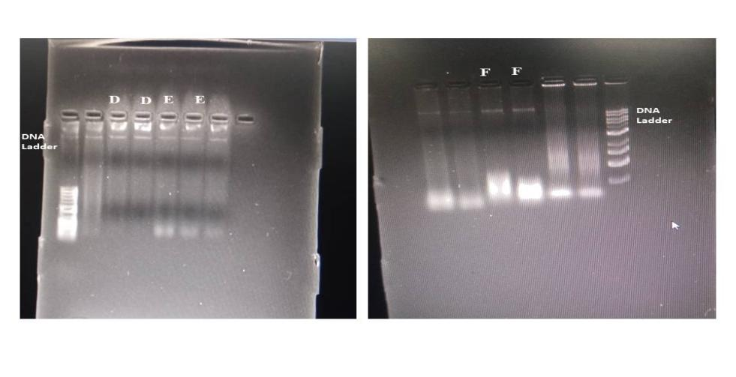

**Figure S1- DNA Gel-**(D)- *Fusarium falciforme*, (E)-*Aspergillus tamarii*, (F)-*Rhizopus arrhizus 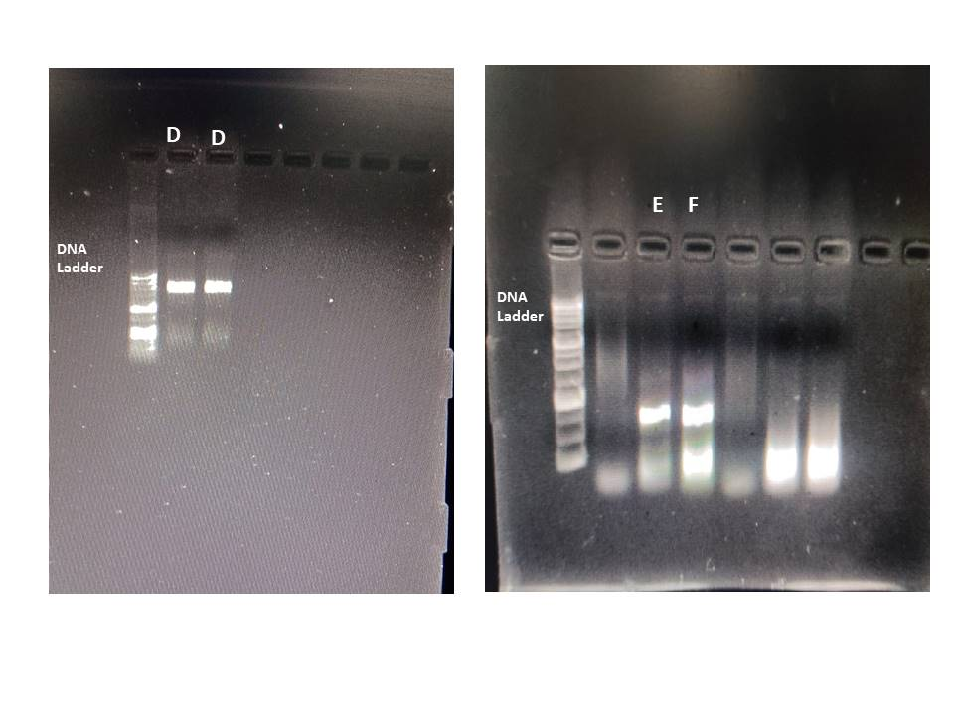*

**Figure S2-PCR Gel--**(D)- *Fusarium falciforme*, (E)-*Aspergillus tamarii*, (F)-*Rhizopus arrhizus*