Impact of Genotype and Phosphorus Fertilization on the Occurrence of Phosphorus Solubilizers at Different Developmental Stages of Wheat

.

Abstract

|  |
| --- |
| This study aimed to investigate (i) how wheat genotype (landrace vs. modern cultivars) and phosphorus (P) fertilization influence the occurrence of phosphate-solubilizing bacteria (PSB) in rhizospheric soil, roots, and shoots across different developmental stages, and (ii) to characterize the functional traits of PSB isolates to identify efficient candidates for bioinoculant development. The study design of the field trails was randomized block design and it was carried out in the research fields of the Department of Plant Breeding and Genetics, College of Agriculture, Punjab Agriculture University Ludhiana Punjab. Experiments were conducted with a wheat landrace (LC306) and two modern cultivars (PBW725, HD3086) under P-amended and P-starved conditions in a randomized block design. Samples from rhizospheric soil, root, and shoot tissues were collected at four developmental stages (20-25 days after sowing DAS, 60DAS, 90DAS, and flowering). PSB were isolated on Pikovskaya’s agar and characterized for solubilization index (SI) and quantitative phosphate solubilization in broth. Efficient isolates were identified by 16S rRNA gene sequencing. Phylogenetic relationships were assessed, and morphological and biochemical traits documented. P-starved rhizospheres showed significantly higher PSB counts at early growth stages (log 6.95 cfu/g at 20-25 DAS in LC306) compared to P-amended soils. Root tissues also had higher PSB under P starvation initially, but counts declined toward flowering. Conversely, shoots had greater PSB counts under P-amended conditions. The landrace LC306 consistently harbored more PSB, especially under P stress. Among 21 isolates, SI ranged from 2.06 to 2.71, and phosphate solubilization reached up to 76.86 μg/ml at 5 days. Three highly efficient isolates were identified as *Bacillus cereus* and *Bacillus subtilis* by 16S rRNA analysis. Our findings demonstrate that wheat genotype and P availability distinctly shape PSB abundance in rhizospheric and endophytic niches, with the landrace supporting richer PSB communities under P stress. The study underscores the potential of harnessing PSB from landrace varieties grown under P-deficient conditions for developing biofertilizers aimed at reducing reliance on chemical phosphorus inputs. |

*Keywords: Wheat landrace and cultivars, phosphate fertilization, phosphate solubilizing bacteria, solubility index, 16S rRNA identification*

1. INTRODUCTION

As the world's population grows, one of the most difficult challenges facing the agricultural community will be meeting the demands placed on agriculture to supply future food (Hemathilake *et al* 2022). To meet this challenge, a significant effort focusing on the soil biological system and the agroecosystem as a whole is required to better understand the complex processes and interactions governing the stability of agricultural land (Sengupta and Gunri 2015). Agricultural scientists have begun to focus on belowground plant characteristics, including plant, soil and environmental factors that influence above-ground traits like yield. Yield is an essential aspect for farmers and is influenced by soil-related factors involving below-ground microbiomes (Preece and Penuelas 2016). The belowground microbiome communicates between plants and available nutrient and water in soil (Orrelle and Bennett 2013).

Among the many challenges being faced by agricultural, soil nutrient deficiency is a significant environmental stress that limits plant growth and crop productivity. Plants respond to the availability and distribution of nutrients in soils by modulating their root architecture and using efficient physiological strategies to obtain nutrients from less soluble sources (Francis *et al* 2023; Gatesi and Nsanzimana 2017). Root exudates from plants attract microbes and interlink plants to soil microbiota. They are plant responses to conditions that may be favourable or unfavourable for growth and play a role in overcoming different stresses (Iannucci *et al* 2017).

Phosphorus is an essential plant nutrient whose deficiency severely limits crop yields especially wheat (Munishi and Ndakidemi2022). Wheat is a critical staple crop that accounts for approximately 20 % of the global daily caloric intake. Substantial enhancements in wheat yields are required to mitigate the ongoing population expansion (Erenstein *et al* 2022). Agricultural intensification has necessitated the addition of phosphate not only to increase crop yield but also to improve soil phosphorus status to avoid further soil degradation (Rawal *et al* 2025). However, it is becoming increasingly clear that conventional agricultural practices cannot sustain a healthy plant-soil system as a production base. Agriculturally important microbes, biofertilizers, can potentially be used to reduce dependency on chemical P fertilizers. For the present study, we hypothesized that the abundance of phosphate solubilizing bacteria (PSB) present associated with locally adapted landrace variety would be greater from that associated with modern cultivars. Our second focus question was to determine whether the PSB were more predominant in rhizospheric soil than endophytic tissue (root and shoot). It has been reported that decades of breeding programs have resulted in alteration of plant holobionts (Dasotgeer et al 2020). Landrace varieties evolve naturally in absence of anthropogenic control and exhibit greater adaptability to natural environment.

2. mETHODOLOGY

***2.1 Experimental design and soil sampling***

In our study, we focused on two independent variables- wheat genotype and the P level of the soil. Wheat varieties- landrace (locally adapted wild variety) LC306 and a high yielding modern cultivars PBW 725 and HD3086 were procured from the Department of Plant Breeding and Genetics, Punjab Agricultural University, Ludhiana. Seeds were surface sterilized by treating with 70% ethanol and 0.1% HgCl2. The sterile seeds were washed with autoclaved water for at least 3-5 minutes. Seeds were placed on 0.5% Nutrient Agar plates and incubated at 25-28°C for 24-48 h. Sterility was confirmed by the absence of microbial growth on the agar plates. Sterile seeds of winter wheat were sown in 1.5m X 1.5 m plots. Approximately 250 g of seeds were sown into manually dug 5 cm deep tranches in the winter season of 2023-2024 and 2024-2025. Plots of each variety (LC 306 and PBW 725) and two treatments, P-amended and P-starved, were replicated in a randomized block design. These plots were in a research field where the rice-wheat monoculture cropping system is extensively practiced. Plots were managed manually for agronomic operations as weeding, and examined visually for the appearance of any disease. Diammonium phosphate (DAP) was applied @ 30g/plot in P amended plots ([pp_rabi.pdf](https://www.pau.edu/content/ccil/pf/pp_rabi.pdf)), commensurate with 55kg/acre farmer advisory). In P-starved condition, no P fertilization was provided. Ita application was synchronized with irrigation. Soil moisture level was maintained at 40% and checked subjectively.

Rhizospheric soil, root and shoot tissue samples were collected at different developmental stages of growth- at 20-25 days after sowing (DAS), 60 DAS, 90 DAS and at the flowering stage. The seedlings were harvested carefully by digging around each plant to a depth of at least 6-8”. Rhizospheric, root and shoot tissue were collected from at least five plants per plot. Plants were placed in sterile bags and transported to the laboratory. Roots were shaken to remove the bulk soil. They were then placed in flasks having 50 ml of sterile 0.85% NaCl to collect rhizospheric soil samples. These containers were placed in an orbital shaker for 20 minutes. The contents were centrifuged at 5000 rpm for 15 minutes. The pellet having rhizospheric soil was stored at -20°C.

***2.2 Isolation of phosphate solubilizers from rhizospheric soil, root and shoot samples samples***

Appropriate dilution of 10 g of rhizospheric soil were serially diluted in saline blanks and plated (10⁻3 to 10⁻⁵ dilutions, 100 μl each) on Pikovskaya’s agar medium. Plates were incubated at 28±2 °C for 48–96 hours. Morphologically distinct colonies were purified through repeated subculturing to obtain pure cultures. Root and shoot tissues (10 g fresh weight) were washed with autoclaved distilled water, surface-sterilized with 70% ethanol and 0.1% HgCl2 and then washed with sterile water. Samples were macerated aseptically and suspended in 90 ml sterile phosphate buffer (pH 7.0) in 150 mL flasks. The suspensions were sonicated using Probe Sonicator (10 min, 82% power, 40 kHz, 25°C), serially diluted to 10⁻², and plated (10⁻³ to 10⁻⁵ dilutions, 100 μl) on Pikovskaya’s agar. Plates were incubated at 28 °C for 48–96 h, and distinct colonies were purified by repeated subculturing.

***2.3 Quantitative estimation of phosphate solubilization on agar and broth***

The viable cell counts for the quantitative estimation of phosphate solubilization ability corresponded to McFarland Standard 0.5 (1.5 x 108 CFU/ml). Pure cultures of bacterial isolates obtained earlier from rhizospheric soil, root, and shoot tissues were sub-cultured and spot-inoculated onto Pikovskaya’s agar plates. Plates were incubated at 28 °C for 9 days. Phosphate solubilization was indicated by zone of clearing around the colony and solubilization efficiency was quantified by measuring the diameter of the clear zone relative to the colony diameter. The solubilization index (SI) was calculated using the following formula:

Solubilization index (PSI) = z+c /c

where Z= Zone of solubilization (mm), C= Colony diameter (mm)

Isolates exhibiting zone of clearing were grown in Pikovskaya’s broth to achieve McFarland Standard 0.5. Equal volume of broth culture aliquots was centrifuged at 10,000 rpm for 15 min. From the supernatant, 100 μL was transferred to a 50 mL volumetric flask. 10 mL of chloromolybdic acid reagent and 1 mL of chlorostannous acid reagent were added, and the volume was made up to 50 mL with distilled water. Absorbance was measured at 600 nm using a spectrophotometer (Shimadzu UV-1280). A standard curve was prepared using phosphorus solution at concentrations of 0–10 μg/mL (Fig 1). Reagents were added similarly and absorbance was recorded at 600 nm to interpolate phosphate concentrations in the test samples. Standard curve thus prepared facilitated the interpolation of the curve to ascertain the concentration of soluble phosphorus in the test samples.

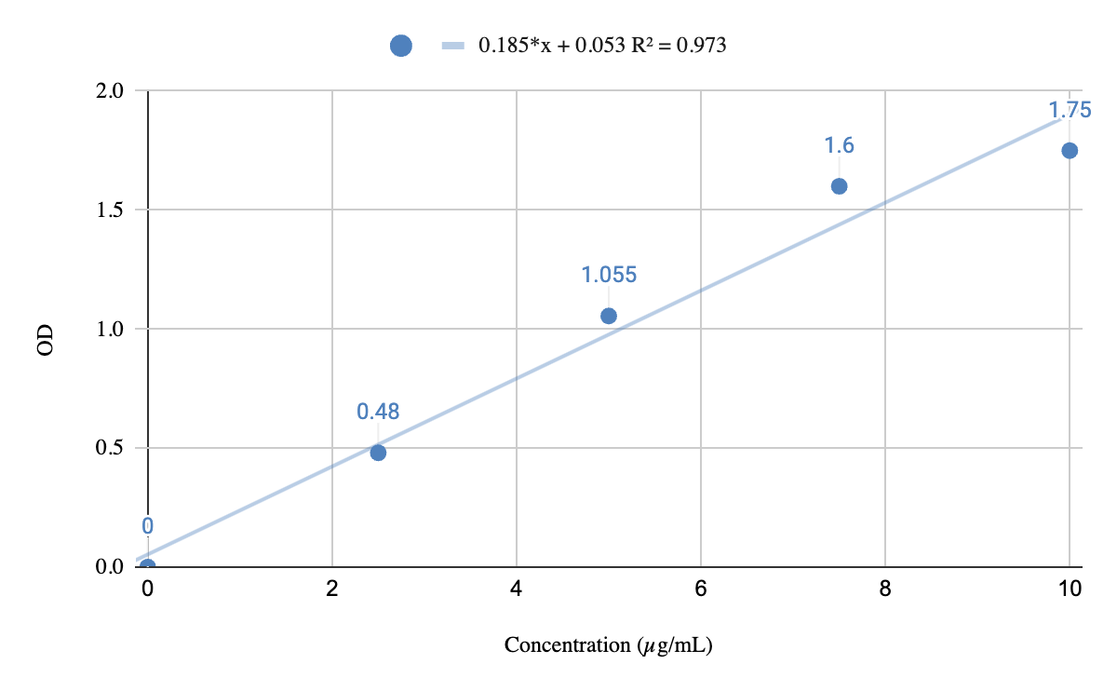*Equation-* y = 0.185x + 0.053, R² = 0.973

Fig 1 Standard curve for estimation of phosphate solubilization

***2.4 Microscopic, colony and biochemical characterization of isolates***

The cultural and morphological characterization of phosphate-solubilizing bacterial isolates was carried out by observing 24-hour-old colonies for shape, size, color, margin, opacity and elevation. Microscopic characterization was done by Gram staining the isolates. Biochemical characterization with IMViC test was performed to assess metabolic traits.

***2.5 Identification of efficient PSB isolates***

Genomic DNA from bacterial isolates was extracted using the HiPurA™ Bacterial DNA Purification Kit. A 1.5 ml overnight bacterial culture was centrifuged at 13,000 rpm for 2 min, and the pellet was resuspended in 180 µL lysis buffer with 20 µL Proteinase K. After incubation at 55 °C, lysis and wash steps were performed using prewash, wash, and elution buffers. Purified DNA was eluted in 200 µL elution buffer and stored for downstream applications. The 16S rRNA gene (~1200bp) was amplified using universal primers in a 20µL PCR reaction containing 100 ng DNA, 2 U Taq polymerase (TaKaRa TaqTM), 10X buffer, 0.1 mM dNTPs, and 0.5µM primers. PCR conditions included initial denaturation at 95°C for 3 min, followed by 32 cycles of denaturation (95°C, 30s), annealing (42°C, 30 s), extension (72°C, 1 min), and a final extension at 72°C for 10 min. Amplified products were visualized on a 1.5% agarose gel stained with ethidium bromide and documented under UV illumination. Sanger sequencing was performed on an ABI 3500XL platform. Universal primers targeting hypervariable V4-V7 regions were used for taxonomic profiling and phylogenetic analysis. Resulting sequences were analyzed using BLAST against NCBI GenBank to identify isolates based on > 97% sequence similarity. Top hits with the lowest E-values and highest identity were used to confirm bacterial species. Validated sequences were submitted to NCBI for accession.

3. results and discussion

The phosphate solubilizing bacterial (PSB) counts were assessed in rhizospheric soil, root and shoot tissues of three wheat (landrace LC306 and cultivars PBW725, HD3086) under phosphorus (P) amended and P starved conditions across four growth stages (20-25 DAS, 60 DAS, 90 DAS, and flowering). Plant growth promoting traits of efficient isolates were estimated and they were later identified using 16S rRNA profiling.

**3.1 Phosphate solubilizing bacterial (PSB) counts in rhizosphere, roots, and shoots**

**3.1.1 Rhizospheric PSB**

The PSB counts in the rhizospheric soil varied with phosphorus (P) availability and genotype (Fig 2). At 20-25DAS, P-starved plants exhibited significantly higher PSB counts (log 6.95±0.03 cfu/g in LC306) compared to P-amended treatments (log 6.00±0.03 cfu/g), *P* < .0001, indicating a stimulation of PSB proliferation under P deficiency. At the same developmental stage, PSB count in cultivars PBW725 and HD3086 was significantly higher in P starved 6.80 and 6.45 log cfu/g, respectively (*P* < 0.0001 for PBW725, *P* of .001 for HD3086). The PSB counts stabilized near 6.00 log cfu/g at flowering. However, HD3086 exhibited a high count of 6.95 log cfu/g.

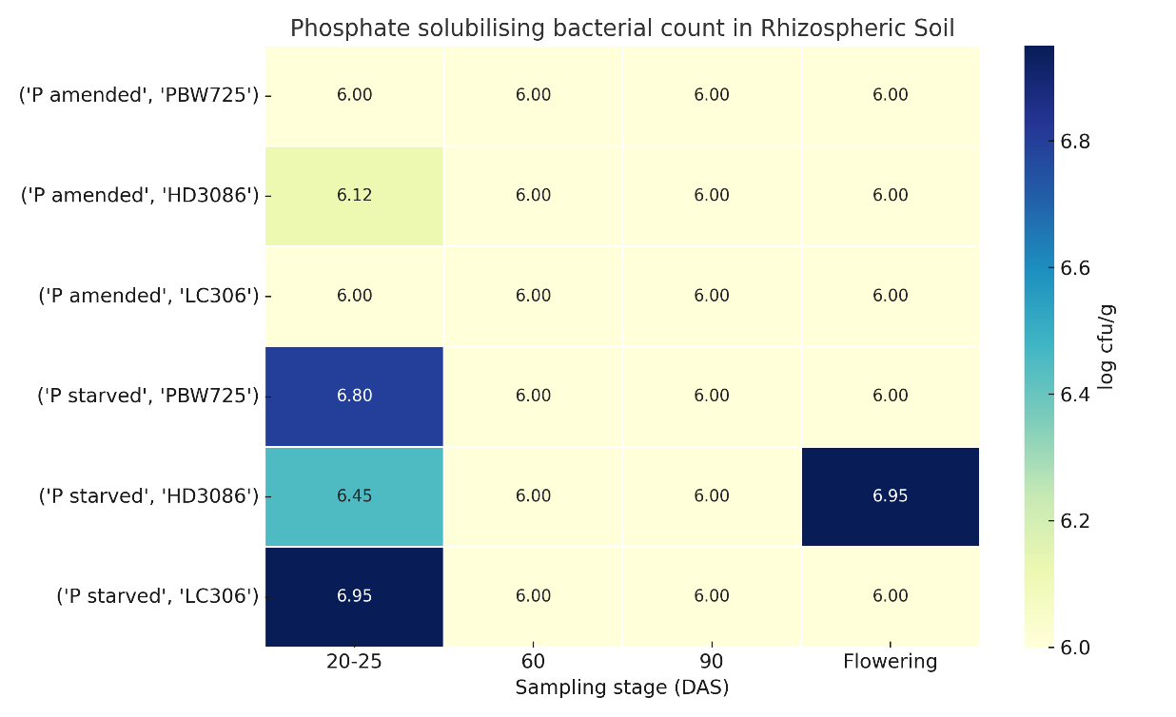

Fig 2- **Heatmap of rhizospheric PSB counts (log cfu/g) across wheat genotypes, treatments, and sampling stages.**

**Note:**Illustrates population densities under P-amended vs. P-starved conditions across genotypes PBW725, HD3086, and LC306, from early vegetative stages (20-25 DAS) to flowering.

**3.1.2 Root-associated PSB**

PSB colonization in root tissues showed a genotype- and treatment-dependent trend, a gradual decline in PSB count over time (Fig 3). A greater abundance of PSB bacteria was recorded in P starved than in P amended condition. In P-starved, at 20-25 DAS, higher counts were recorded under P-starved conditions (log 4.10±0.07 cfu/g in LC306) which steadily decreased to 3.4 log cfu/g at flowering. Statistically significant difference between 20-25DAS and flowering was recorded for PBW 725 and HD3086 as well (*P* <.01). Comparing PSB counts at these two stages in P-amended conditions, both cultivars PBW725 and HD3086 exhibited PSB count between 3.30-3.62 log cfu/g and landrace LC306 exhibited a stable count between 3.20 and 3.40 log cfu/g. Broadly, the PSB counts decreased significantly with development in all cultivars and in both conditions- P-amended and P-starved, indicating reduced endophytic colonization over time (*P* <.05).

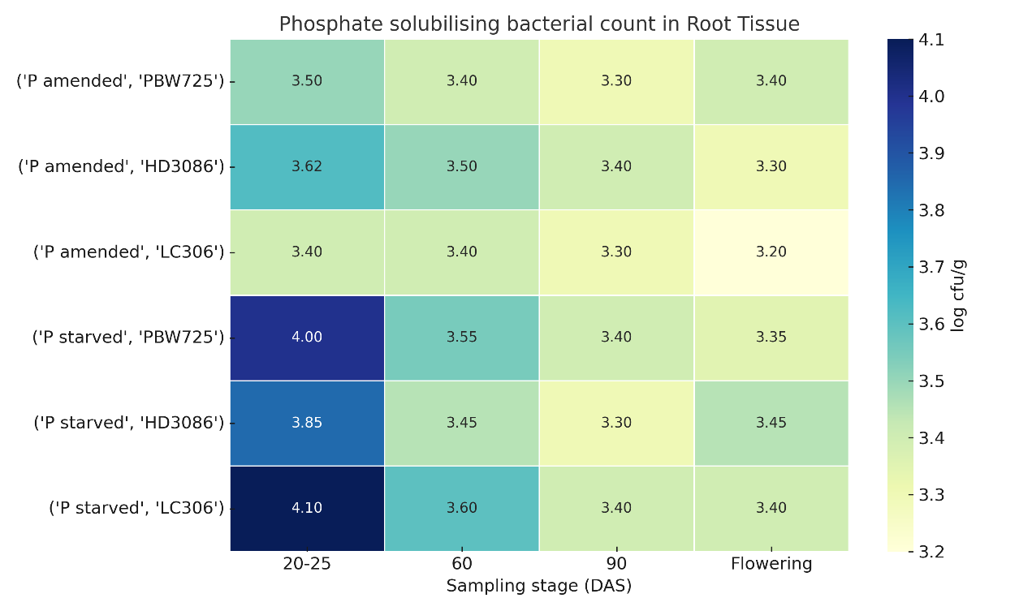

Fig 3- **Heatmap of root associated PSB counts (log cfu/g) across wheat genotypes, treatments, and sampling stages**.

**Note:** Illustrates population densities under P-amended vs. P-starved conditions across genotypes PBW725, HD3086, and LC306, from early vegetative stages (20-25 DAS) to flowering.

**3.1.3 Shoot-associated PSB**

Shoot tissues exhibited significant differences across treatments and cultivars (*P* < .005) (Fig 4). PSB counts were statistically higher in P-amended conditions, than P -starved, in all three genotypes and at all stages of development, *P* <.05. In P-starved, LC306 exhibited abundance of PSB at 20-25DAS, 3.85 log cfu/g. PSB count gradually declined as the plant matured (P-starved) and greater abundance of PSB was recorded in P amended compared to P starved.

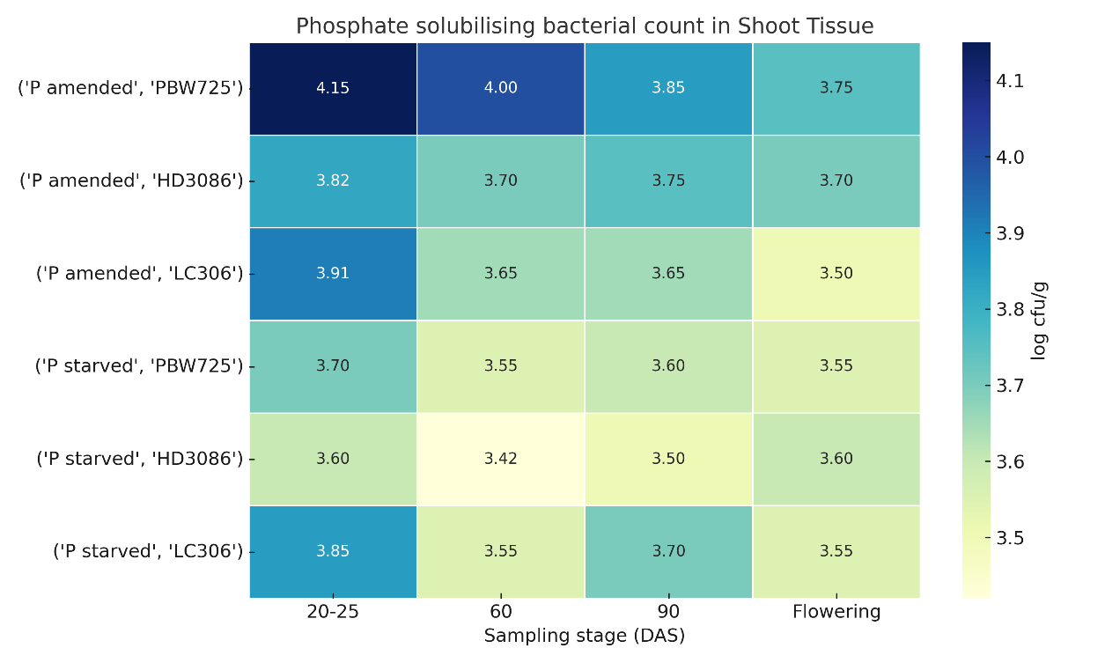

Fig 4- **Heatmap of root associated PSB counts (log cfu/g) across wheat genotypes, treatments, and sampling stages**.

**Note:** Illustrates population densities under P-amended vs. P-starved conditions across genotypes PBW725, HD3086, and LC306, from early vegetative stages (20-25 DAS) to flowering.

**3.2 PSB functional traits: Solubility index and phosphate solubilization capacity**

A total of 21 isolates were obtained in this study-13 from samples drawn from P-starved conditions and 8 from samples drawn from P-amended conditions. Most of the isolates were obtained from root tissue and rhizospheric soil suggesting compartmentalization of PSB in P-stress conditions. Also, landrace LC306 harboured greater abundance of PSB than the modern cultivars. The SI of PSB isolates varied between 2.06 to 2.71. Isolate 16 recorded the highest SI (2.71±0.16), indicating robust *in vitro* solubilization. Appreciable solubilization was recorded by isolate 1 at 2.53+0.18, isolate 19 at 2.52 ±0.20, isolate 12 at 2.45 ± 0.12, isolate 13 at 2.45 ± 0.14 and isolate 8 at 2.45 ± 0.16. Fig 5a shows a violin plot displaying the range and density of SI values, with the inner box indicating the median and interquartile range. The spread highlights variability in organic acid-mediated phosphate solubilization potential among isolates. Most of the isolates recording SI of 2.2-2.4. Fig 5b shows isolates with zone of clearing on Pikovskaya's Agar.

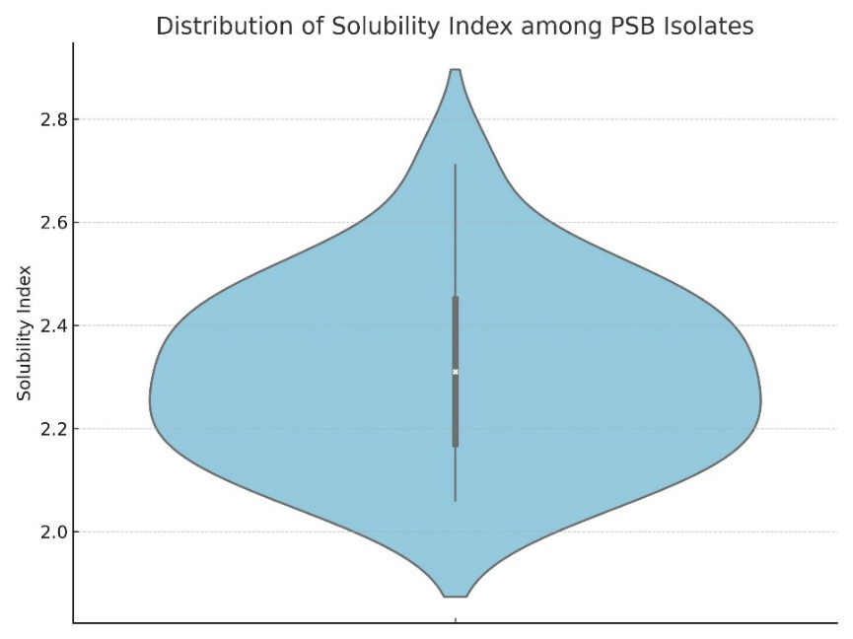

Fig 5a- **Graph indicating Distribution of Solubility index among PSB Isolates**

Fig 5a shows a violin plot displaying the range and density of SI values, with the inner box indicating the median and interquartile range. The spread highlights variability in organic acid-mediated phosphate solubilization potential among isolates

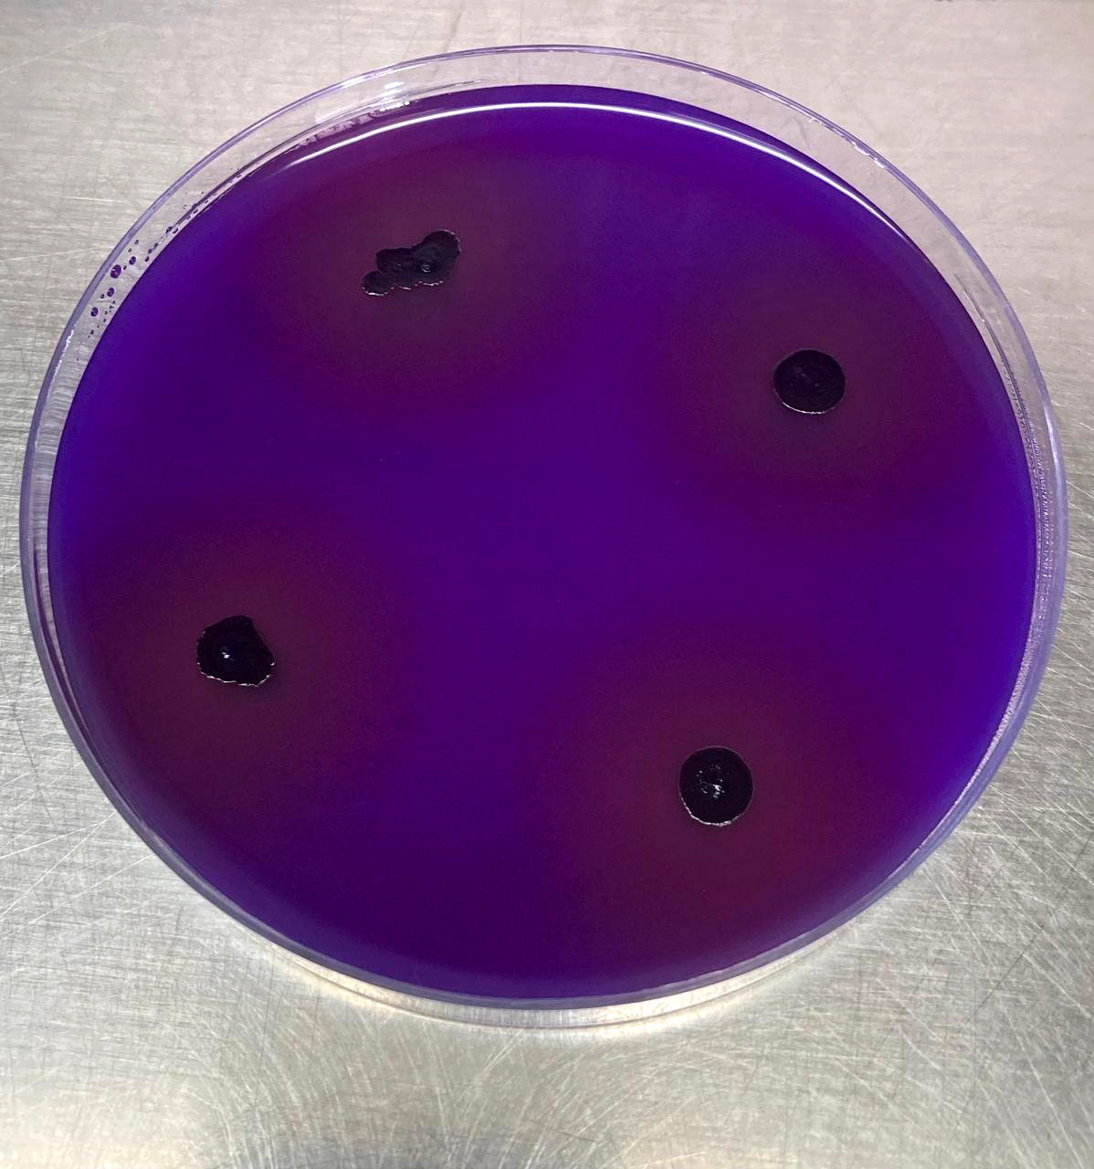

Fig 5b- *In vitro* phosphate solubilization as evidenced by zone of clearing

We observed dynamic changes in phosphate solubilization capacity with time. Fig 6 depicts the mean phosphate solubilization (μg/mL) at 2, 5, and 9 days across all isolates, with shaded area representing standard deviation. Peak solubilization was observed at 5 days indicates optimal metabolic activity for phosphate release. High phosphate solubilization ability was recorded with 9 isolates obtained from both P-amended and P-starved conditions. It varied between 76.86 μg/mL and 73.89 μg/mL. This time-dependent pattern mirrors the metabolic adaptability of PSB in mineralizing insoluble phosphate, as reported by Pan and Cai (2023). A slight decline in some isolates after peak days hints at re-assimilation or precipitation phenomena (Jagadesh *et al*., 2024) suggesting variability in metabolic sustainability and phosphorus utilization efficiency among isolates.

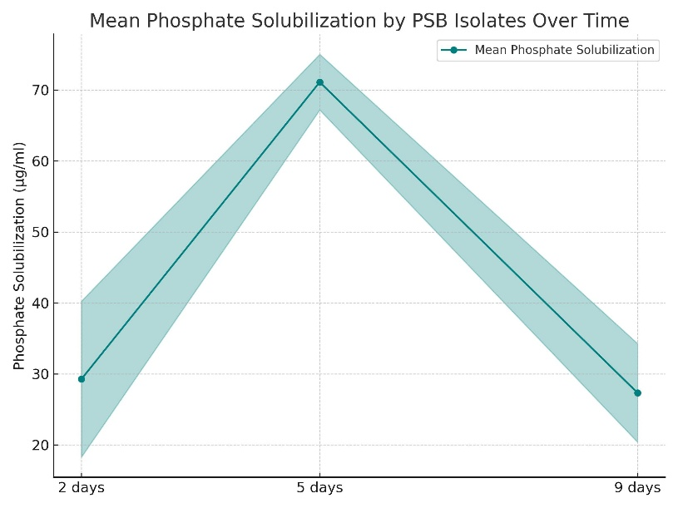

Fig 6- **Mean phosphate solubilization by PSB isolates over time.**

**Note:** Line plot showing average phosphate solubilization (μg/ml) at 2, 5, and 9 days across all isolates, with shaded area representing standard deviation. Peak solubilization observed at 5 days indicates optimal metabolic activity for phosphate release.

**3.3 Identification of isolates**

Microscopic characteristicsof phosphate solubilizing isolate revealed that the isolates belonged to Gram-positive and Gram-negative groups (Suppl Table 1). They were mostly cocci in shape. They colonies formed by them were butyrous, glistening, flat, round, translucent to opaque. Preliminary biochemical characterization gave an insight to the metabolic pathways and nature of end products and utilization of citrate as sole carbon source (Suppl Table 2). 16S rRNA sequence of three isolates, isolate 9, isolate 13, and isolate 20, exhibiting high phosphate solubilityhas been submitted to NCBI with the accession numbers PP889728, PP889727 and PP889726, respectively. Two of these isolates are deposited as a general deposit in the MTCC (Microbial Type Culture Collection), with accession numbers MTCC 13666 and MTCC 13667. Phosphate solubilization recorded by these three isolates was 75.51 μg/mL (isolate 9, LC306, 20-25DAS, root tissue, P-starved conditions), 75.78 μg/Ml (isolate 13, PBW725, 90DAS, root tissue, P-starved conditions) and 76.86 μg/mL (isolate 20, LC306, 20-25DAS, rhizospheric soil, P-amended conditions).

A phylogenetic tree, constructed using 16S rRNA sequences to elucidate phylogenetic distance between these isolates is presented in Fig 7. The phylogenetic tree reveals distinct clades of bacteria predominantly within the *Bacillus cereus* and *Bacillus subtilis* groups. *Bacillus cereus*clade includes strains such as *Bacillus cereus KR3M-30*, CPO 4.227 and others. These strains cluster closely together, indicating a shared genetic lineage. Their presence in the samples suggests that *Bacillus cereus* might be a common component of the wheat rhizosphere under both P amended and P starved conditions. *Bacillus subtilis*clade, group encompasses strains like *Bacillus subtilis soilG2B*, KA9 and HS8. The strains in this clade are known for their roles in soil health and plant growth promotion, which might reflect the adaptive responses of the wheat-associated microbiome to nutrient deficiency stress other *Bacillus* species and strains such as *Bacillus sp. D2201* and *Bacillus tequilensis SKC-10* occupy distinct branches.

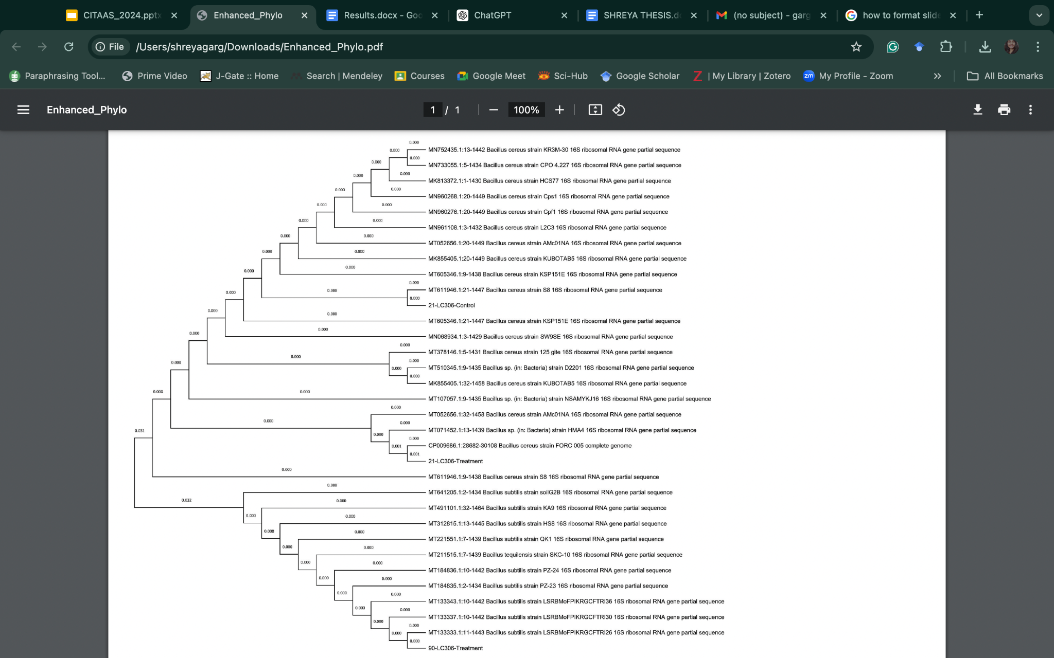

Fig 7 Phylogenetic tree for identified isolates (Evolutionary analysis by Maximum Likelihood method)

Wheat, a worldwide staple, has seen substantial changes in its growing methods to satisfy population demands. Phosphorus is essential for its growth but extensive agriculture has reduced soil phosphorus levels. Understanding the relationships between wheat varieties, phosphate levels and abundance of phosphate-solubilizing bacteria (PSB) levels can promote the advancement of sustainable farming techniques. PSB are well known for their role in the rhizosphere, where they convert insoluble phosphorus into forms accessible to plants. Although less common, their presence in shoot tissues offers potential benefits for plant growth and systemic health. In shoots, PSB help mobilize internal phosphorus by converting stored organic forms into available inorganic forms, a function that becomes vital under limited root activity or phosphorus-deficient conditions. Beyond nutrient solubilization, PSB in shoots can directly promote growth by regulating cell division, elongation, and differentiation through phytohormones such as auxins, cytokinins, and gibberellins. Some PSB strains also induce systemic resistance, improving defense against pathogens that target aerial parts like leaves and stems. Additionally, PSB can enhance tolerance to abiotic stresses such as salinity and drought. PSB have been reported in the rhizospheres and endospheres of many cereals, including wheat, by Korenblum *et al* (2022) and Liu *et al* (2020).

In our study we observed that phosphorus availability significantly affects the PSB community in rhizospheric soil, root tissue and shoor tissue of wheat. Under phosphorus-starved conditions, root tissues revealed greater abundance of PSB at early growth stages (20–25 DAS), likely due to increased exudation of organic acids and other compounds that promote microbial proliferation and phosphate solubilization. It corroborates findings that phosphorus deficiency enhances root exudation, thereby recruiting beneficial microbes (Richardson *et al.,* 2011; Sharma *et al.,* 2013). In contrast, shoots exhibited lower PSB colonization under the same conditions, likely due to reduced nutrient translocation. At 60 DAS, PSB counts stabilized across treatments, suggesting possible equilibrium between root exudates and PSB populations, similar to observations by Sharma *et al.* (2023). At later stages (90 DAS and flowering), PSB counts in both P-amended and P-starved plants tend to converge, suggesting a compensatory adaptation in plant–microbe interactions. This indicates a temporal shift in PSB colonization possibly due to changes in root exudate profile commensurate with developmental stages (Rajput *et al.*, 2024). In the rhizospheric soil, P-starved plants showed significantly higher PSB counts at 20-25 DAS, aligning with reports by Cheng *et al*. (2023) who demonstrated that P-starvation increases root exudation, thereby enhancing PSB colonization, Comparing P-starved and P-amended conditions, root and shoot tissues showed transient higher colonization under P-starvation indicating phenology-driven shifts (Rajput *et* *al.,* 2024; Enriquez-León *et al.,* 2025). This may imply preferential allocation of PSB colonization sites from aerial to root zones over plant maturity (Enriquez-León *et al.,* 2025). Aligning with our hypothesis, the landrace variety did influence PSB abundance and composition compared to modern cultivars as also reported by Zaidi *et al.,* 2015. The LC306 wheat variety consistently showed significantly higher PSB counts under P-starved condition, indicating presence of traits that support enhanced microbial colonization during nutrient limitation. Moreover, the significant variability observed in shoot tissues suggests systemic effects of PSB colonization that are influenced by both nutrient status and host genotype. This underscores the importance of targeting early crop stages for bioinoculant application to maximize P mobilization and uptake (Liu *et al.,* 2020).

The solubility indices of isolates ranged from 2.06 to 2.71, with 25 % above 2.5 and 62.5 % of isolates displayed solubility index values surpassing 2.3. 14 isolates consistently exhibited a high solubility capacity (75.78 μg/ml) and a stable solubility index (2.45), exhibiting outstanding performance under all conditions. *In vitro* phosphate solubilization was recorded at a concentration ranging from 70.92 to 76.86 μg/ml. The solubility of phosphate varied between 64.16 and 70.11 μg/ml in P-starved circumstances. 7 of the 21 isolates (33.33 %) demonstrated solubility levels surpassing 68.0 μg/ml. Of these isolates, 14 exhibits the highest solubility capacity at 75.78 μg/ml. 11 of the 21 isolates had solubility over 74.0 μg/ml. Correlation between SI and solubilization was moderate at 2 days (r=0.40, p=0.08), but negligible at later stages. These patterns highlight differences in phosphate solubilization kinetics, likely influenced by isolate-specific metabolic traits and phosphorus availability in the medium. These trends agree with dynamic PSB solubilization models (Gomez *et al.,* 2023; Pan and Cai 2023). The synergistic role of PSB under P-starved conditions, not only enhances rhizospheric populations but also transiently colonizes endophytic niches. Such interactions are critical for sustainable phosphorus acquisition strategies in cereals. This is similar to the recent paradigms on microbiome-assisted nutrient mobilization reported by some workers (Wang *et al.,* 2022). Moreover, selecting efficient PSB from plant grown under P-stress holds promise for isolation of a robust strain for bioinoculant development to minimize chemical P fertilizer reliance.

The microscopic analysis of the phosphate-solubilising bacterial isolates revealed distinct morphological features. A negligible percentage of the cells were bacilli, while the rest were cocci. Gram-positive and Gram-negative bacteria were evenly distributed across the population. Previous studies highlighting the diversity of PSB strains (Sharma *et al.,* 2013, Oteino *et al* 2015) support our findings, which are consistent with our research. Cocci-shaped PSB were more prevalent in maize rhizospheres than in other cellular configurations. Xiang-qian *et al* (2012) showed that the isolates were mostly cocci. The cellular features of the isolates suggest that PSB may swiftly colonize plant environments and adapt to many ecological niches. Research by Matos *et al* (2017) and Sharma *et al* (2013) indicates that PSB isolates display a diverse colony characteristic.75 % of the isolates had a butyrous texture. The colonies transitioned to a cream and yellow colouration after being primarily white or creamy for most, a change related to the presence of phosphorus. The colony's morphology and microscopic properties are mostly affected by phosphorus availability. Isolates from P-amended showed increased variability in surface roughness, opacity and elevation, while P-starved isolates showed more consistency in texture, surface and elevation. Phosphorus may alter the appearance and evolution of bacterial colonies by enhancing the diversity of colony characteristics. Beneduzi and Passaglia (2011) ascribe the variety in colony characteristics to ecological niche adaptation and genetic diversity. Sharma *et al* (2013) contended that the varied population of phosphorus-solubilizing bacteria in the rhizosphere and endosphere of wheat may clarify the interactions between plants and soil phosphorus concentrations. They claimed that the phosphate solubilization capabilities of isolates correlate with their genetic diversity.

This will enable the separation of the solubility index and variations in phosphate solubility. Vesey and Heisinger (2001) contend that biofertilizers can be derived from isolates with high solubility indices and the capacity to solubilize phosphorus. This would promote plant growth and augment their phosphorus availability. Villa *et al* (2005) advocate for using landraces to identify PSB strains with improved phosphate solubility. The PSB isolates found in the wheat rhizosphere and endosphere displayed a complex and dynamic microbial community. This population is characterised by a diverse array of colony traits and microscopic attributes. According to Sharma *et al* (2013), enhancing the impact of PSB populations on plant growth and phosphorus uptake depends on comprehending these interactions and the dynamics of these populations.

Phosphate solubilization capabilities of isolates correlate with their genetic diversity (Sharma *et al* 2013). The genetic diversity and adaptability of landrace samples to various environmental circumstances provided PSB isolates that are more efficient than those derived from isolates obtained from modern cultivars. LC-306 generated 14 of 21 PSB isolates, PBW735 yielded three and HD086 provided four. The separation of PSB displayed distinct patterns particular to each variety. In comparison to modern cultivars, LC-306 demonstrated enhanced effectiveness. Landrace samples, which possess natural genetic variation and display tolerance to diverse environmental situations, demonstrate enhanced efficiency. Richardson *et al* (2009) reported that increased number of isolates during the early growth phase indicate that PSB colonization and activity are crucial for plant development, especially at peak phosphorus need.

4. Conclusion

Integrated implications of our work centre around PSB occurence with respect to phosphorus availability and wheat genotype. Higher nutrient uptake is required at early stages of growth compared to maturity. In the rhizospheric soil, P-starved plants showed significantly higher PSB counts at 20-25 DAS, aligning with recent reports. Root and shoot tissues showed transient higher colonization under P-starvation, but declined by flowering stage, indicating phenology-driven shifts. Overall, these results emphasize the synergistic role of PSB under P-starved conditions, not only enhancing rhizospheric populations but also transiently colonizing endophytic niches. Such interactions are critical for sustainable phosphorus acquisition strategies in cereals, aligning with recent paradigms on microbiome-assisted nutrient mobilization. Moreover, selecting high-SI isolates holds promise for bioinoculant development to minimize chemical P fertilizer reliance.

**Data availability** The datasets generated during the current study are available in the NCBI with accession number PP889728 [Bacillus cereus strain SG7-LC306 16S ribosomal RNA gene, partial seque - Nucleotide - NCBI](https://www.ncbi.nlm.nih.gov/nuccore/PP889728.1/); PP889727 [Bacillus cereus strain C-LC307 16S ribosomal RNA gene, partial sequenc - Nucleotide - NCBI](https://www.ncbi.nlm.nih.gov/nuccore/PP889727.1/) and PP889726 [Bacillus subtilis strain 10-LC306 16S ribosomal RNA gene, partial sequ - Nucleotide - NCBI](https://www.ncbi.nlm.nih.gov/nuccore/PP889726.1/)

**Highlights-**

* Phosphate solubilising bacteria colonized rhizosphere, roots and shoots.
* PSB counts were higher under phosphorus-starved than amended conditions.
* Isolates varied in solubility index and temporal phosphate solubilization.
* Correlation of solubility index with P release was transient and stage-dependent.
* Findings support PSB selection to improve phosphorus use efficiency in wheat.

Disclaimer (Artificial intelligence)

Author(s) hereby declare that no generative AI technologies such as Large Language Models (ChatGPT, COPILOT, etc.) and text-to-image generators have been used during the writing or editing of this manuscript.

References

1. Hemathilake, D. M. K. S., & Gunathilake, D. M. C. C. (2022). Agricultural productivity and food supply to meet increased demands. In *Future foods* (pp. 539–553). Academic Press. <https://doi.org/10.1016/B978-0-323-91001-9.00016-5>
2. Sengupta, A., & Gunri, S. K. (2015). Microbial intervention in agriculture: An overview. *African Journal of Microbiology Research*, *9*(18), 1215–1226. <https://doi.org/10.5897/ajmr2014.7325>
3. Preece, C., & Peñuelas, J. (2016). Rhizodeposition under drought and consequences for soil communities and ecosystem resilience. *Plant and Soil*, *409*(1), 1–17. <https://doi.org/10.1007/s11104-016-3090-z>
4. Orrell, P., & Bennett, A. E. (2013). How can we exploit above–belowground interactions to assist in addressing the challenges of food security? Frontiers in Plant Science, 4, 432. <https://doi.org/10.3389/fpls.2013.00432>
5. Francis, B., Aravindakumar, C. T., Brewer, P. B., & Simon, S. (2023). Plant nutrient stress adaptation: A prospect for fertilizer-limited agriculture. Environmental and Experimental Botany, 213, 105431. <https://doi.org/10.1016/j.envexpbot.2023.105431>
6. Gatesi, J., & Nsanzimana, O. (2017). Responses of nodulation and grain yield to fertilization with phosphorus (p) of outstanding low p tolerant *Phaseolus vulgaris* L. genotypes in highly acidic and phosphorus deficient soils such of Rwanda. International Journal of Plant & Soil Science, 18(2), 1–10. <https://doi.org/10.9734/IJPSS/2017/33390>
7. Iannucci, A., Fragasso, M., Beleggia, R., Nigro, F., & Papa, R. (2017). Evolution of the crop rhizosphere: Impact of domestication on root exudates in tetraploid wheat (Triticum turgidum L.). Frontiers in Plant Science, 8, 2124. <https://doi.org/10.3389/fpls.2017.02124>
8. Munishi, L. K., & Ndakidemi, P. A. (2022). Increasing agricultural soil phosphate (P) status influences water P levels in paddy farming areas: Their implication on environmental quality. Case Studies in Chemical and Environmental Engineering, 6, 100259. <https://doi.org/10.1016/j.cscee.2022.100259>
9. Erenstein, O., Jaleta, M., Mottaleb, K. A., Sonder, K., Donovan, J., & Braun, H. J. (2022). Global trends in wheat production, consumption and trade. In M. P. Reynolds & H. J. Braun (Eds.), Wheat improvement (pp. [insert page range if available]). Springer. <https://doi.org/10.1007/978-3-030-90673-3_4>
10. Rawal, V. K., Lal, H., Shanker, K., Tutlani, A., & Khan, R. R. (2025). Improving fertilizer use efficient method and strategies: a sustainable approach for future. International Journal of Environment and Climate Change, 15(5), 39–50. <https://doi.org/10.9734/ijecc/2025/v15i54833>
11. Dastogeer, K.M.G., Tumpa, F.H., Sultana, A., Akter, M.A., Chakraborty, A. (2020) Plant microbiome–an account of the drivers that shape community composition and structure. *Curr Plant Biol*, 23 [https://doi.org/10.1016/j.cpb. 2020.100161](https://doi.org/10.1016/j.cpb.%202020.100161)
12. Sharma, S. B., Sayyed, R. Z., Trivedi, M. H., & Gobi, T. A. (2013). Phosphate-solubilizing microbes: Sustainable approach for managing phosphorus deficiency in agricultural soils. SpringerPlus, 2, 587. <https://doi.org/10.1186/2193-1801-2-587>
13. Rajput, A., Kumar, S., Dhyani, B. P., Kumar, Y., Singh, A., & Singh, B. (2024). Enhancing yield and sustainability in a maize+ mungbeanwheat cropping sequence through integrated nutrient management: a viable alternative to the rice-wheat system. *Plant Archives (09725210)*, *24*(2).
14. Enriquez-León, R., De la Cruz-Mantilla, J., & Huerta-Chombo, G. L. (2025). Evaluation of Phosphate-Solubilizing Bacteria (PSB) on Phosphorus Availability in Agricultural Soils and the Growth of Wheat (Triticum aestivum L.). *Sustainability*, *17*(10), 4545.
15. Gómez, E., Alonso, A., Sánchez, J., Muñoz, P., Marín, J., Mostaza-Colado, D., & Mauri, P. V. (2024). Application of biostimulant in seeds and soil on three chickpea varieties: impacts on germination, vegetative development, and bacterial facilitation of nitrogen and phosphorus. *Life*, *14*(1), 148.
16. Pan, L., & Cai, B. (2023). Phosphate-solubilizing bacteria: advances in their physiology, molecular mechanisms and microbial community effects. *Microorganisms*, *11*(12), 2904.
17. Jagadesh, M., Dash, M., Kumari, A., Singh, S. K., Verma, K. K., Kumar, P., ... & Sharma, S. K. (2024). Revealing the hidden world of soil microbes: metagenomic insights into plant, bacteria, and fungi interactions for sustainable agriculture and ecosystem restoration. *Microbiological Research*, *285*, 127764.
18. Korenblum, E., Solanki, M. K., Kai, M., & Prestwich, B. D. (2022). Small molecules bridging terrestrial microbial interactions in multitrophic systems. *Frontiers in Microbiology, 9*, 53–57.
19. Liu, J., Ma, Q., Hui, X., Ran, J., Ma, Q., Wang, X., & Wang, Z. (2020). Long-term high-P fertilizer input decreased the total bacterial diversity but not *phoD*-harboring bacteria in wheat rhizosphere soil with available-P deficiency. *Soil Biology and Biochemistry, 149*, 107918. <https://doi.org/10.1016/j.soilbio.2020.107918>
20. Richardson, A.E., et al. (2011). Plant and microbial strategies to improve the phosphorus efficiency of agriculture. Plant and Soil, 349(1-2), 121-156.
21. Cheng, Y., Narayanan, M., Shi, X., Chen, X., Li, Z., & Ma, Y. (2023). Phosphate-solubilizing bacteria: Their agroecological function and optimistic application for enhancing agro-productivity. *Science of The Total Environment*, *901*, 166468.
22. Zaidi, A., Khan, M. S., Ahmad, E., & Saif, S. (2015). Role of plant growth promoting rhizobacteria in sustainable production of vegetables: Current perspective. *Scientia Horticulturae, 193*, 231–239. <https://doi.org/10.1016/j.scienta.2015.07.020>.
23. Wang, Z., Zhang, H., Liu, L., Li, S., Xie, J., Xue, X., & Jiang, Y. (2022). Screening of phosphate-solubilizing bacteria and their abilities of phosphorus solubilization and wheat growth promotion. *BMC microbiology*, *22*(1), 296.
24. Oteino, N., Lally, R. D., Kiwanuka, S., Lloyd, A., Ryan, D., Germaine, K. J., & Dowling, D. N. (2015). Plant growth promotion induced by phosphate solubilizing endophytic Pseudomonas isolates. Frontiers in Microbiology, 6, 745. <https://doi.org/10.3389/fmicb.2015.00745>
25. Zhang, X.-Q., Hu, G.-Q., Bai, X.-M., & Zhang, Q.-G. (2012). Effects of nitrogen fertilization and root separation on the plant growth and grain yield of maize and its rhizosphere microorganisms. Ying Yong Sheng Tai Xue Bao (Chinese Journal of Applied Ecology), 23(1), 79–82.  
    (Note: Chinese names have been adapted to APA format with family name first and initials capitalized. Let me know if you want to keep original romanization.)
26. Matos, A. D. M., Gomes, I. C. P., Nietsche, S., Xavier, A. A., Gomes, W. S., Dos Santos, J. A. Neto, & Pereira, M. C. T. (2017). Phosphate solubilization by endophytic bacteria isolated from banana trees. Anais da Academia Brasileira de Ciências, 89(4), 2945–2954. <https://doi.org/10.1590/0001-3765201720160111>
27. Beneduzi, A., & Passaglia, L.M.P. (2011). Genetic and Phenotypic Diversity of Plant Growth Promoting Bacilli. In: Maheshwari, D. (Eds) Bacteria in Agrobiology: Plant Growth Responses. Springer, Berlin, Heidelberg. <https://doi.org/10.1007/978-3-642-20332-9_1>
28. Vessey, J. K. & Heisinger, K. G. (2001) Effect of *Penicillium bilaii* inoculation and phosphorus fertilization on root and shoot parameters of field-grown pea. *Canadian J Plant Sci* 81:361–366 <https://doi.org/10.4141/P00-083>
29. Villa, T.C.C., Maxted, N., Scholten, M. & Ford-Lloyd, B. (2005) Defining and identifying crop landraces. *Plant Genetic Resources* 3:373–384 <https://doi.org/10.1079/PGR200591>
30. Richardson, A.E., Barea, J.M,, McNeill, A.M, *et al.* (2009) Acquisition of phosphorus and nitrogen in the rhizosphere and plant growth promotion by microorganisms. *Plant Soil* 321, 305–339 <https://doi.org/10.1007/s11104-009-9895-2>

**Supplementary Table 1-Microscopic and colony characteristics of Phosphate solubilizing bacteria isolates**

|  |  |  |  |  |  |  |  |  |  |  |
| --- | --- | --- | --- | --- | --- | --- | --- | --- | --- | --- |
| **Isolate No.** | **Microscopic characteristics** | | | **Colony characteristics** | | | | | | |
| **Gram reaction** | **Cell shape** | **Cell arrangement** | **Texture** | **Surface** | **Opacity** | **Color** | **Edge** | **Shape** | **Elevation** |
| **P-starved conditions** | | | | | | | | | | |
| 1 | +ve | Cocci | Present singly, in pairs, forming tetrads. | Butyrous | Glistening | Translucent | Greyish White | Entire | Irregular | Flat |
| 2 | -ve | Coccobacilli | Present singly or forming simple chain-like structures | Butyrous | Smooth | Clear | White | Entire | Round | Flat |
| 3 | +ve | Bacilli | Present individually or in pairs. | Butyrous | Glistening | Translucent | White | Entire | Irregular | Flat |
| 4 | -ve | Round | Present singly or arranged in pairs. | Butyrous | Glistening | Transparent | Greyish White | Entire | Round | Flat |
| 5 | -ve | Round | Present singly or in pairs, occasionally forming short chains. | Butyrous | Glistening | Translucent | Yellow | Entire | Round | Flat |
| 6 | -ve | Coccobacilli | Present singly or in linear chains. | Butyrous | Smooth | Translucent | White | Entire | Round | Flat |
| 7 | +ve | Cocci | Present singly, in pairs, or in small clusters. | Butyrous | Smooth | Translucent | White | Wavy | Tiny | Flat |
| 8 | +ve | Cocci | Present singly, in pairs, or forming short linear arrangements. | Butyrous | Glistening | Transparent | Light greenish | Wavy | Angular | Flat |
| 9 | +ve | Cocci | Present singly or arranged in pairs. | Butyrous | Glistening | Translucent | Yellow | Entire | Round | Flat |
| 10 | -ve | Cocci | Present singly or in small clusters. | Rough | Glistening | Clear | White | Entire | Round | Flat |
| 11 | +ve | Cocci | Present singly, in pairs, or forming tetrads | Butyrous | Glistening | Translucent | Light | Entire | Round | Flat |
| 12 | +ve | Cocci | Present singly, in pairs, or occasionally forming clusters. | Butyrous | Rough | Dull | Light | Undulate | Round | Raised |
| 13 | -ve | Cocci | Present singly, in pairs, or forming short chains. | Viscid | Glistening | Transparent | White | Entire | Round | Flat |
| 14 | -ve | Coccobacilli | Present singly, in pairs, or in small groups. | Butyrous | Rough | Translucent | White | Undulate | Angular | Flat |
| **P-amended condition** | | | | | | | | | | | |
| 14 | -ve | Coccobacilli | Present singly, in pairs, or in small groups. | Butyrous | Rough | Translucent | White | Undulate | Angular | Flat |
| 15 | -ve | Cocci | Present singly, in pairs, or simple groupings. | Brittle | Glistening | Translucent | White | Entire | Round | Flat |
| 16 | -ve | Cocci | Present singly, in pairs, or forming short linear sequences | Butyrous | Glistening | Translucent | Light grey | Entire | Round | Raised |
| 17 | -ve | Cocci | Present singly, in pairs, or occasionally forming tetrads. | Butyrous | Rough | Clear | White | Entire | Round | Flat |
| 18 | +ve | Bacilli | Present singly or in small groupings. | Butyrous | Rough | Opaque | Creamy | Undulate | Wavy | Flat |
| 19 | -ve | Bacilli | Present singly or forming simple linear arrangements. | Butyrous | Rough | Opaque | Creamish | Undulate | Irregular | Flat |
| 20 | +ve | Coccobacilli | Present singly or in small clusters. | Smooth | Smooth | Opaque | Yellow cream | Entire | Round | Raised |
| 21 | +ve | Bacilli | Present singly, in pairs, or forming short linear groupings. | Butyrous | Smooth | Opaque | White | Entire | Round | Raised |

(-ve) negative (+ve) positive

**Supplementary Table 2- Biochemical characterization of PSB isolates (IMViC test)**

|  |  |  |  |  |
| --- | --- | --- | --- | --- |
| **Isolate** | **Methyl red test** | **Voges-Proskauer test** | **Indole test** | **Citrate Utilization Test** |
| 1 | -ve | -ve | -ve | +ve |
| 2 | -ve | -ve | -ve | +ve |
| 3 | +ve | -ve | -ve | -ve |
| 4 | +ve | +ve | -ve | -ve |
| 6 | +ve | -ve | +ve | -ve |
| 7 | +ve | -ve | +ve | -ve |
| 8 | +ve | +ve | -ve | -ve |
| 9 | +ve | -ve | -ve | -ve |
| 10 | +ve | -ve | +ve | +ve |
| 11 | -ve | +ve | -ve | +ve |
| 12 | -ve | +ve | -ve | -ve |
| 13 | -ve | +ve | +ve | +ve |
| 14 | -ve | +ve | +ve | -ve |
| 15 | +ve | +ve | +ve | +ve |
| 16 | -ve | +ve | +ve | -ve |
| 17 | -ve | +ve | +ve | -ve |
| 18 | -ve | +ve | +ve | -ve |
| 19 | -ve | +ve | -ve | -ve |
| 20 | -ve | -ve | -ve | -ve |
| 21 | -ve | +ve | -ve | -ve |
| 5 | -ve | +ve | -ve | -ve |

(-ve) negative (+ve) positive