***Original Research Article***

**Computer-Aided Analytical Design of a Ridge Plastering Attachment to Power Tiller**

.

ABSTRACT

|  |
| --- |
| **Aim:** To develop and theoretically validate a ridge plastering machine compatible with power tillers (6-12 hp) to mechanize bund preparation operations like trimming, plastering, and compaction in smallholder paddy fields. The aim is to provide a low-cost, locally manufacturable alternative to expensive tractor-mounted machinery, catering especially to small and marginal farmers in regions like Kerala.  **Study design:** Analytical design and simulation-based validation study.  **Place and Duration of Study:** Department of Farm Machinery and Power Engineering, Kelappaji College of Agricultural Engineering and Technology, Tavanur, Malappuram, Kerala, India; during the academic year 2021-2022.  **Methodology:** The design was developed analytically and modeled using SolidWorks. A 9 hp KAMCO KMB 200 power tiller served as the prime mover. Speed was reduced from 315 rpm to 215 rpm by modifying the auxiliary gearbox with a 34-tooth gear. Torque at 2000 rpm was calculated as 33.43 Nm, confirming safe operation under maximum load. Gears (21 and 34 teeth, module 3 mm) were designed using Lewis and Buckingham equations and validated for bending stress, contact stress (1331.10 N/mm²), dynamic load (10.44 kN), and wear load (10.66 kN). Shafts, splines, and chain drives were sized with safety factors above 4.0. The functional units-trimming, plastering, and compacting - used twisted blades, plastering discs, and rollers mounted on a square pipe frame. All validations were computational; no prototype was fabricated.  **Results:** Theoretical calculations confirmed that the transmission system, shafting, and ridge-forming assemblies can safely operate under expected field conditions. Design validation via CAD modeling demonstrated feasibility of operation, alignment, and motion paths. The unit was shown to theoretically perform bund trimming, plastering, and compaction in a single pass. Structural elements, material specifications, and torque transmission systems were confirmed to be within safe design limits for use with 6-12 hp power tillers.  **Conclusion:** The proposed design offers a viable, low-cost, power tiller-driven alternative for ridge plastering in smallholder paddy systems. The theoretical validation confirms mechanical feasibility; however, physical prototyping and field trials are needed to evaluate actual performance. Once developed, this machine could reduce labor, cost, and time significantly, thus promoting mechanization and sustainable productivity in small farms. |

*Keywords: Ridge plastering machine, power tiller attachment, gearbox modification, farm mechanization, spline shaft design, paddy field bunding*

1. INTRODUCTION

Agriculture is the cultivation of crops and animals and is still the mainstay of the Indian economy, with India being the second largest producer of agricultural products in the world (Food and Agriculture Organization, 2021). Agricultural contribution to India's Gross Domestic Product (GDP) was almost 20% during 2020-2021, which was its highest in 17 years, as per Economic Survey 2020-2021 (Ministry of Finance, Government of India, 2018). Paddy cultivation is dominant in Kerala, a state with an agriculturally rich network of rivers, streams, and backwaters. Paddy is cultivated in approximately 600 varieties of rice, most of which are cultivated on lowland paddy fields dependent upon both flooding from the monsoon rains and irrigation (Basheer, *et al*., 2021). Paddy fields in Kerala traditionally consist of earthen bunds, about 10-15 cm high, that have been constructed to hold water for the greater part of the growing season. Nonetheless, rice farming in most places continues to depend on traditional manual methods, such as bund preparation with basic tools like hoes and spades or animal-drawn plough. Although farm mechanization has greatly improved, with tractors and power tillers readily available for ploughing, puddling, and leveling operations, most of the processes like sowing, transplanting, harvesting, and ridge preparation continue to be largely manual, especially in small and marginal farms.

Ridge or bund preparation is an important process in lowland paddy systems, where bunds are made across the land slope to hold water and regulate drainage. Proper and timely bund construction is important, particularly following rice transplanting and prior to rainfall, to avoid water loss and soil erosion. In the past, ridge plastering-where field bunds are cut, plastered, and rammed with the excavated soil-was done by hand. This is time- and labor-consuming process. Singh et al. (2016) stated that a typical skilled labourer can plaster and trim 90-120 meters of bund in a day, while an individual can pack or firm the bund at the rate of 100-150 meters per hour (Singh *et al*., 2016). Pathirana et al. (2010) also stated that it would approximately take 30 minutes to clear one side bund and 45 minutes to plaster an 18-meter-long bund (Pathirana *et al*., 2010). Fakruddin (2018) and Rajaiah et al. (2020) highlighted that bund plastering with appropriate mechanization significantly improves field efficiency while reducing labour demand (Fakruddin, 2018; Rajaiah *et al*., 2020). Huang et al. (2003) emphasized that improper bund construction may lead to excessive seepage and water losses in paddy fields (Huang *et al*., 2003). Manual bunding is also subject to inefficiencies like insufficient alignment, poor compaction, and rodent contamination, which lower the effectiveness and lifespan of bunds. Current mechanical options, like tractor-mounted ridge plastering machines, have substantial gains in efficiency, lowering labor costs by ₹2000-2500 per hectare over manual operations and delivering outputs of 900-1000 meters/hour. The machines also lower the reliance on human labor by nearly 96% (Rahul *et al*., 2018). Yet, their expense and their use for extensive fields restrict their availability to marginal and small-scale farmers. In addition, these machines are usually fuelled or electricity-powered, which might not be feasible for small-scale farms.

In recent years, advancements in small-scale farm mechanization have been accelerating, particularly with the development of affordable power tiller attachments for ridge and bund formation. Studies published between 2022 and 2024 highlight that these innovations reduce operation time and labor requirements by over 50% compared to traditional manual methods (Brownstone, 2025). The introduction of locally-adapted, low-cost ridge plastering devices has also been reported to enhance field efficiency under varied paddy field conditions. Recent years have also seen the development of integrated machines like the tractor-operated bund former which combines mulching, soil pulverizing, and bund formation in a single pass, enhancing operational efficiency while conserving soil moisture and reducing seepage (Sood *et al*., 2023).

To build upon these advancements and overcome existing challenges, the current study aims at designing and developing a power tiller-driven ridge plastering machine with the help of analytical techniques. The machine would facilitate both ridge making and plastering operations and is adaptable to dry as well as wet field conditions. This financially viable, locally compatible solution is specially designed to satisfy the mechanization requirements of small and marginal farmers, thus improving farm productivity and minimizing labor dependence.

2. material and methods

**2.1 Selection of Prime Mover**

The KAMCO KMB 200 power tiller (figure 1), manufactured by Kerala Agro Machinery Corporation Ltd., was selected as the prime mover for the ridge plastering machine. This is a model widely adopted in small and medium-field scale operations in Kerala and applicable for marginal farmers. The power tiller runs on a 9 hp (7 kW), single-cylinder, water-cooled, compression ignition engine with an operating speed of 2000 rpm. The detailed technical specifications are provided in Appendix A.

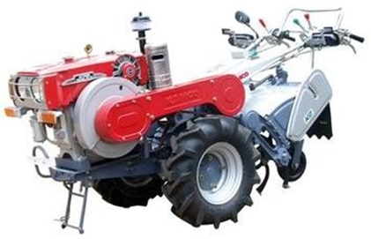

**Fig. 1. KAMCO KMB 200 power tiller**

**2.2 Modification of Auxiliary Gearbox**

The auxiliary gearbox of the KAMCO power tiller was modified to power the ridge plastering unit (figure 2). The existing 29-teeth gear, which operated at 315 rpm was removed and substituted with a 34-teeth gear running at a slower speed of 215 rpm. Additional reduction to about 146 rpm was attained through the use of a sprocket and chain drive system. These adaptations provided a proper speed and torque ratio for efficient ridge plastering. The chosen gear ratio was 34-21 teeth for the required speed reduction. The rotavator shaft was shortened and replaced to accommodate the new gear ratio.

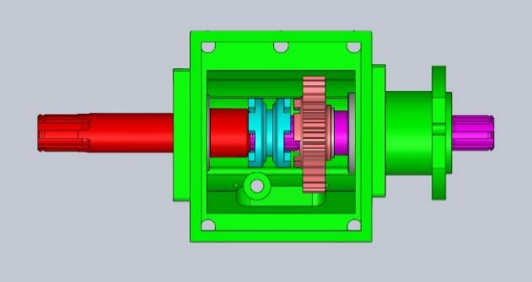

**Fig. 2. Gearbox of power tiller after modifications**

**2.3 Torque-Power Analysis**

The torque vs. power curve of the power tiller engine was examined to establish the performance of the machine for different conditions of loading (figure 3). Considering the given power rating of 7 kW at a speed of 2000 rpm, the torque value was found to be 33.43 Nm. From the torque transmission curve, it was seen that the maximum torque is generally attained at a speed of about 1700 rpm, which is lower than the rated speed. This analysis was critical for selecting appropriate transmission components and verifying that the maximum torque condition was well within the safe operational limits.

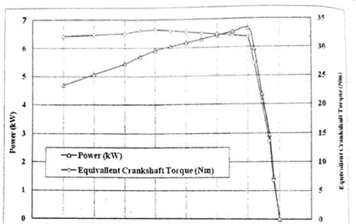

**Fig. 3. Torque-Power Analysis**

**2.4 Gear Design**

The gears were designed by analytical approaches according to the Lewis equation and bending strength requirements. A gear set with 21 teeth (pinion) and 34 teeth (gear) was chosen, which yielded a speed reduction ratio of 1.62. Module of 3 mm and a pitch circle diameter appropriate for the torque transmission required were selected. The Lewis form factors for pinion and gear were determined, and the weaker component was determined to be analysed for stress. Contact stress, dynamic load, and wear load were also checked for safety in the design. The step-by-step calculations are given in Appendix B.

**2.5 Shaft and Spline Design**

The transmission shaft between the gearbox and the plastering unit was designed for the highest torque condition of 283.39 Nm. A straight-sided spline (medium series, size 6 × 28 × 34, according to IS 2327:1993) was chosen to enable power transmission. The diameter of the shaft was kept standardized at 28 mm for the input shaft and 34 mm for the output shaft, according to torsional shear stress criteria with suitable factor of safety. The detailed spline and shaft calculations are provided in Appendix C.

**2.6 Sprocket and Chain Drive Design**

The chain and sprocket power transmission system were used to deliver power from the gearbox to the plastering unit in an efficient manner. The number of teeth on drive and driven sprocket as 15 and 12 respectively. The 12B-1 series was selected as the selected chain drive. A straight slot shaped metal box of length 560 mm and width 160 mm was designed which can be welded and fabricated. The chain case of the ditching unit and plastering disc assembly is 60º and 5º inclined with the horizontal with respect to engine mounting position.

The torque acting on the sprocket was calculated using the relationship:

$$T=F* rT$$

where T is the torque (in Nm), F is the load acting on the sprocket (in N), and r is the center distance (in meters) at which the torque is applied.

The dynamic load rating (C) is defined as the constant radial load that a group of apparently identical bearings will theoretically endure for a rating life of one million revolutions. The dynamic loading and sprocket stress calculations confirmed the system’s suitability (see Appendix D).

* 1. **Design of Ditching and Plastering Units**

The ditching unit comprised of five twisted blades (45° angle) of high-carbon steel, set for cutting and ejecting the soil laterally. The plastering unit comprised of plastering discs made from trapezoidal plates laid in a circular pattern and a forming roller set on a shared shaft for ridge compaction and shaping. The disc and blade configuration were streamlined to achieve equal plastering of soil along the sides of the ridge.

* 1. **Structural Frame**

A square pipe structural frame (50 × 50 × 4 mm) was built to hold the ditching and plastering units securely onto the power tiller's auxiliary gearbox. The frame was structured to achieve sufficient strength and stability under operational loads.

* 1. **CAD Modelling**

The entire ridge plastering machine, together with the transmission system, was simulated in SolidWorks. Parametric design techniques were employed to provide accurate part fit, ease of assembly, and correct motion simulation.

**2.10 Scope and Limitations**

This study focused on the analytical design and CAD-based validation of a ridge plastering attachment for a power tiller, tailored for small and marginal farmers. All component designs-including gearbox modifications, power transmission system, and plastering units-were verified using standard analytical methods and validated through SolidWorks modeling. However, no physical prototype was fabricated or field-tested during this phase. Future work will include prototype development and performance evaluation under field conditions to validate the machine's efficiency, durability, and labor-saving potential.

3. results and discussion

The ridge plastering machine and its transmission system were designed analytically and validated through CAD simulation to ensure reliable performance under typical operating conditions. No prototype testing was performed in this phase.

**3.1 Design of Gear**

Depending on the requirement of speed reduction, a gear set involving a 21-teeth pinion and a 34-teeth gear was determined. A module of 3 mm was chosen for the gear set to provide sufficient strength for transmitting torque. The summarization of gear design is shown in Table 1.

**Table 1. Summarization of gear design**

|  |  |  |  |
| --- | --- | --- | --- |
| **S. No.** | **Nomenclature** | **Notation** | **Value** |
| 1 | Module | m | 3 mm |
| 2 | Centre distance | a | 82.5 mm |
| 3 | No. of teeth on pinion | 𝑧1 | 21 |
| 4 | No. of teeth on gear | 𝑧2 | 34 |
| 5 | Width of gear | b | 30 mm |
| 6 | Height factor | f | 1 |
| 7 | Diameter of input shaft | 𝑑𝑠1 | 28 mm |
| 8 | Diameter of output shaft | 𝑑𝑠2 | 34 mm |

The design was verified for bending strength, contact stress, dynamic load, and wear load, and the results confirmed that the design was safe under the expected operating conditions.

* Calculated contact stress: 1331.10 N/mm², which is within the permissible limit.
* Dynamic load: 10.44 kN, within safe range.
* Wear load: 10.66 kN, greater than the dynamic load, ensuring safety.

**3.2 Design of Shaft**

The input and output shafts were designed based on the torque transmitted and allowable shear stress.

* Input Shaft Diameter: 28 mm (standard size)
* Output Shaft Diameter: 34 mm (standard size)
* Material: EN-24 steel
* Factor of Safety: Minimum 4.0 for all shafts, considering shock loads.

The shaft diameters were selected to safely withstand torsional loads with a conservative factor of safety. Detailed calculations supporting these sizes are presented in Appendix B.

**3.3 Spline Shaft Design**

A straight-sided spline shaft was selected according to IS 2327:1993.

* Spline Size: 6 × 28 × 34 mm
* Material: EN-24 (case hardened)
* Length of Spline: 36 mm
* Factor of Safety: 4.0 (based on shear stress)

The spline design was confirmed to safely transmit torque without failure under both shear and compressive stresses.

**3.4 Sprocket and Chain Drive Design**

The sprocket and chain drive system were designed to efficiently transmit power to the plastering unit.

* Drive Sprocket: 15 teeth
* Driven Sprocket: 12 teeth
* Selected Chain: 12B-1 type
* Load Capacity: 617.8 kgf, which is well within the chain's breaking load of 2950 kgf
* Factor of Safety: 4.77

The 6006 bearing (dynamic load capacity: 13.2 kN) was selected to support the shafts, ensuring the design's reliability under dynamic loading.

**3.5 Plastering and Ditching Units**

The plastering unit comprised plastering discs and a forming roller on a common shaft. The dimensions of the shaft (28 mm inner and 34 mm outer diameter) were chosen to coincide with the transmission shaft since torque was reduced at higher speed after sprocket reduction. The ditching unit consisted of five twisted blades (6 mm thick × 100 mm long) spaced at 45° on the blade holder for efficient cutting and splashing of soil towards the plastering disc.

**3.6 Structural Frame**

A sturdy structural frame was made of 50 mm × 50 mm × 4 mm square pipes to support the mounting of the ditching and plastering units firmly. The frame was rigidly mounted on the power tiller gearbox.

**3.7 CAD Modelling and Assembly Validation**

The assembly was designed and assembled with SolidWorks software. The validation of the assembly ensured accurate alignment, clearance, and motion feasibility of all the moving components. The figure 4 shows the detailed CAD drawings of key components of the ridge plastering machine. The 2D drawing of an assembled ridge plastering machine is presented in figure 5. A field-ready power tiller attachment including the ridge plastering unit is illustrated in figure 6.

|  |  |  |
| --- | --- | --- |
|  |  |  |
| (a) | (b) | (c) |
|  |  |  |
| (d) | (e) | (f) |
|  |  |  |
| (g) | (h) | (i) |

**Fig. 4. CAD drawings of key components of the ridge plastering machine- (a) Teeth gear (b) Straight sided splined shaft (c) Shaft (d) Drive shaft support pipe (e) Chain drive case (f) Ditching unit assembly (g) Plastering disc assembly (h) Forming roller (i) Guard cover**

The power tiller drives the ridge plastering assembly through the modified auxiliary gearbox and chain drive. The ditching unit digs into the earth and spews it on to the plastering disc. The spinning disc applies the soil along the ridge sides, and the forming roller hardens the top of the ridge, thereby reinforcing and shaping the bund.

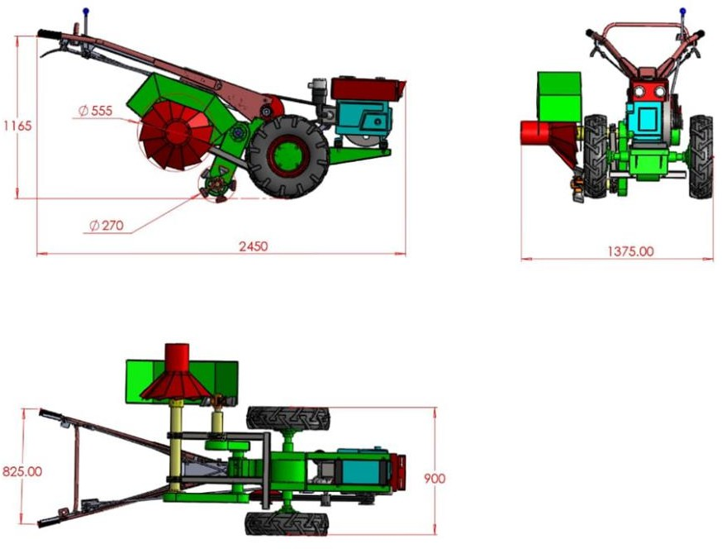

**Fig. 5. Two-dimensional drawing of power tiller attached ridge plastering machine**

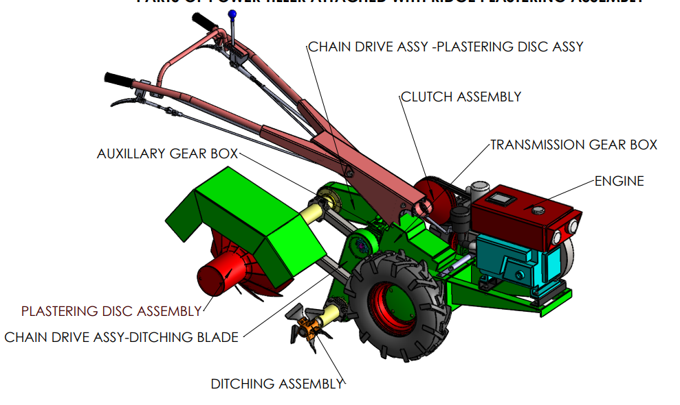

**Fig. 6. Power tiller attached with ridge plastering attachment**

4. Conclusion

The design of a power tiller-driven ridge plastering machine presents a low-cost, compatible, and locally available answer to small and marginal farmers, particularly in paddy-growing areas such as Kerala. New farm machinery is usually not accessible to these farmers due to the high costs involved, and this design fills that void by being a low-cost, compatible alternative that functions well with widely available 6-12 hp power tillers.

The machine was properly designed with analytical techniques and CAD modeling on SolidWorks, with the major change to the auxiliary gearbox involving substituting the 29-teeth gear (315 rpm) with a 34-teeth gear (215 rpm) to facilitate the desired speed reduction. The gear train, shafts, spline shaft, sprocket and chain drive, ditching, and plastering units were all safely designed to endure field loads with the required safety factors. The machine does ridge trimming, plastering, and compaction in one pass, and can be used for both dry and wet field conditions.

For future improvement, it is suggested to make the prototype and carry out detailed field trials under various soil, moisture, and operational conditions. Optimization of material with lighter and corrosion-resistant material would enhance durability and handling ease. Training programs can be developed for dissemination of the machine among small farmers. Furthermore, a thorough cost-benefit analysis would determine its economic feasibility. Some future developments could be modular attachments, variable ditching blades, and real-time sensing systems for more accurate operations. In conclusion, the proposed ridge plastering machine is a viable, cost-saving method for enhancing bund maintenance in paddy fields that leads to sustainable and efficient farming practices among smallholders.

Consent

Not applicable.

Ethical approval

Not applicable.

**Disclaimer (Artificial intelligence)**

Authors hereby declare that NO generative AI technologies such as Large Language Models (ChatGPT, COPILOT, etc.) and text-to-image generators have been used during the writing or editing of this manuscript.

References

Food and Agriculture Organization (FAO). (2021). FAOSTAT Statistical Database. Retrieved from https://www.fao.org/faostat/en/

Ministry of Finance, Government of India. (2018). Farmers gain as agriculture mechanisation speeds up, but more R&D needed. The Financial Express, 29 January 2018. Retrieved from https://www.financialexpress.com

Basheer, K. K., Muneer Babu, M., & Abraham, B. (2021). The evolving landscape of paddy cultivation in Kerala. International Journal of Food and Nutritional Sciences, 10(12). Retrieved from https://www.ijfans.org/issue-content/the-evolving-landscape-of-paddy-cultivation-in-kerala-12935

Singh, S. P., Solanki, R. C., Singh, M. K., & Singh, K. (2016). Development of tractor operated bund former-cum-packer for increasing resource productivity. Indian Journal of Agricultural Sciences, 86(9), 1121–1126.

Pathirana, P. H. S., Bandara, P. C., Ratnaweera, A. C., Balasooriya, C. P., & Bandara, M. A. (2010). Sustainable farming through mechanization: Development of a bund making machine. International Conference on Sustainable Built Environment, University of Peradeniya, Sri Lanka, 461.

Fakruddin, S. K. B. (2018). Development of bund trimming and plastering equipment for rice fields (M.Tech. thesis). Acharya N. G. Ranga Agricultural University, Andhra Pradesh.

Rajaiah, P., Laxman, B., Vennela, B., & Reddy, A. P. (2020). Development and evaluation of mini tractor operated ridge plastering machine. International Journal of Chemical Studies, 8(5), 45–48.

Huang, H. C., Liu, C. W., Chen, S. K., & Chen, J. S. (2003). Analysis of percolation and seepage through paddy bunds. Journal of Hydrology, 284, 13–25. https://doi.org/10.1016/S0022-1694(03)00237-4

Rahul, A., Prashant, G., & Rajaiah, P. (2018). Performance evaluation of tractor operated ridge plastering machine. International Journal of Chemical Studies, 8(5), 45–48.

Brownstone, S. (2025). Labor market effects of agricultural mechanization: Experimental evidence from India. AEA Papers and Proceedings. Retrieved from https://www.aeaweb.org/journals/pandp

Sood, A., Dixit, A.K., Khurana, R., Singh, M., Modi, R.U., & Verma, A. (2023). Design and development of a tractor operated bund former for mulched field. Agricultural Mechanization in Asia, Africa and Latin America, 54(1), 57–62

Bureau of Indian Standards. (1993). IS 2327:1993 - Straight sided splines for cylindrical shaft dimension with internal centring. New Delhi: BIS.

APPENDIX A

Table 1: TECHNICAL SPECIFICATIONS OF KAMCO KMB 200 POWER TILLER

|  |  |
| --- | --- |
| **Particulars** | **Specifications** |
| Source of prime mover | Power tiller |
| Main power transmission | Rotary transmission (gearbox output shaft to rotary shaft) |
| Overall dimensions of the implement   * Length, mm * Width, mm * Height, mm | 2450  940  1175 |
| Gearbox Type | Sliding mesh |
| Engine type | Single cylinder, horizontal, water cooled, indirect injection, compression ignition engine. |
| Engine speed (rpm)   * Maximum speed at no load * Rated speed * Speed at maximum torque | 2100 ± 25  2000  1700 |
| Power | 9 hp (7 kW) |
| Cylinder   * Number * Disposition * Bore/stroke (mm) * Stroke volume (cc) * Compression ratio * Type of combustion chamber * Type of cylinder liner | 1  Horizontal 95/105  744  19.6 : 1  Pre combustion chamber Wet, replaceable |
| Fuel system type | Gravity |
| Fuel tank capacity (l) | 10.7 |
| Governor   * Type * Governed range of engine speed (rpm) * Rated engine speed (rpm) | Mechanical, centrifugal 800 to 2125  2000 |
| Pre-cleaner type | Cyclone with transparent dust collector |
| Air cleaner   * Type * Oil capacity (l) | Wet, oil bath 0.200 |
| Exhaust   * Type of silencer | Updraft, cylindrical |
| Lubricating system   * Type * Oil sump capacity (l) * Grade of oil used | Force feed cum splash 3.0  SAE 40 |
| Pump   * Type * Method of drive * Minimum permissible pressure (kgf/sq.cm) | Lobe, trochoid type From cam shaft 2.50 |
| Cooling system   * Type * Details of fan * Bare radiator capacity (l) * Capacity of cooling system (l) | Water cooled, thermosiphon with pressurized radiator pressure cap  Suction type having 10 nos of metallic blades with a diameter of 180 mm  1  3.65 |
| Belt -pulley (engine to clutch assembly)   * Type * Number * Size of belts * Size of drive pulley (mm) * Size of driven pulley (mm) * Reduction ratio | V belt and pulley 3  B – size 150  220  1.47:1 |
| Clutch   * Type * Diameter of discs (mm) * Number of friction plates * Method of operation | Dry, Multi disc 175  3  By hand operator lever provided on RHS of handle bar |
| Gear drive (clutch to gear box)   * Type * No. of teeth on drive gear * No. of teeth on idler gear * No. of teeth on driven gear * Reduction ratio | Gear drive  17  33  32  1.88:1 |

**APPENDIX B**

**DESIGN OF GEAR**

* Number of teeth on Pinion ($z_{1}$) and Gear ($z_{2})$

$$z_{1}= \frac{2F_{0}}{\sin^{2}∝}$$

$z_{1}= \frac{2 ×1}{\sin^{2} 20}$ = 17.097

We have existing gear of teeth = 21

Reduction Ratio, $i=\frac{N_{2}}{N_{1}}= \frac{236}{146}=1.62$

⸫ $z_{2}=1.62 ×21=34.02 ≈34$

Lewis form factor calculated by:

For Pinion, $Y_{1}= π\left( 0.154-\frac{0.912}{21}\right)= 0.3471$

For Gear, $Y_{2}= π\left( 0.154-\frac{0.912}{34}\right)= 0.3993$

Weakest member determination:

For Pinion, $S_{1}=$ $σ_{b1} × Y_{1}=1100 ×0.3471$

$=381.81$ N/ ${mm}^{2}$

For Gear, $S_{2}=$ $σ_{b2} × Y_{2}=1100 ×0.3993$

$=439.23$ N/ ${mm}^{2}$

* Checking of bending:

Power, $P= \frac{2π N_{1}M_{T}}{60}$

$7×{10}^{3}=\frac{2×π×236× M_{T}}{60}$

Torque, $\left[M_{T}\right]=283390 Nmm$

$$∴module,m=1.26\sqrt[3]{\frac{283390}{0.3471×1100×6×21}}$$

= 2.274 mm

Increasing 20% load, $m=2.274×1.2=2.73$ mm

Take standard $m$ value as 3.0 mm

* Checking of contact stress

Reduction ratio, $i$ = 1.62

Centre distance, $a$ $= \frac{m\left(z_{1}+z_{2}\right)}{2}= \frac{3\left(21+34\right)}{2}=82.5 mm$

Face width, b =10 $×m=10×3=30 mm$

Young’s modulus, $E$ = $2.10×{10}^{5}$ N/ ${mm}^{2}$

$$σ_{c}=0.74×\frac{i+1}{a}\sqrt{\frac{i+1}{i×b}×E×M_{T}}$$

$$=0.74×\frac{1.62+1}{82.5}\sqrt{\frac{1.62+1}{1.62×30}×2.10×{10}^{5}×283390}$$

$$=1331.10 <σ_{c} \left(1400 N/{mm}^{2}\right)$$

⸫ Design is safe.

* Checking of dynamic load

$F_{s}$ = $\left[σ_{b1}\right]×b×Y_{1}×m$

= $1100×30×0.3471×3$

= 34.362 kN

$F_{d}$ = $F_{T}×CV$

$F_{T}$ = $\frac{2M_{T}}{d_{1}}= \frac{2×283390}{63}$

where $, d_{1}=m×z_{1}=3×21=63 mm$

$CV$ = $\frac{5.5+ V_{m}^{1/2}}{5.5}=\frac{5.5+ {0.778}^{1/2}}{5.5}$

Where, $V_{m}=\frac{π×d_{1}×N_{1}}{60}= \frac{3.14×0.063×236}{60}=0.778 m/s$

$F_{d}$ = $\frac{2×283390}{63}×\frac{5.5+ {0.778}^{1/2}}{5.5}=10.439 kN$

$F_{s}>F_{d}$

⸫ Design is safe for dynamic loading.

* Checking for wear load

$F_{w}$ = $d_{1}×Q×b×k$

$Q=\frac{2×i}{i+1}$ = $\frac{2×1.62}{1.62+1}=$ 1.24

$$k=\frac{σ_{c1}^{2}× \sin{∝}×\left\{\frac{1}{E_{1}}+\frac{1}{E_{2}}\right\}}{1.4}$$

$$k=\frac{1400× \sin{20°}×\left\{\frac{1}{2.10×{10}^{5}}+\frac{1}{2.10×{10}^{5}}\right\}}{1.4}$$

$k$ = 4.56 N/ ${mm}^{2}$

$F_{w}$ = $63×\frac{2×1.62}{1.62+1}×30×4.56=10658.5 N$

= 10.66 kN $>F_{d}$

So, Design is safe.

* Constructional Details

For pinion,

$$n_{1}=0.55×\sqrt[4]{P_{c}×z_{1}^{2}}$$

$P_{c}$ = $π×m=3.14×3=0.942 mm$

$z_{1}$ = 21

⸫ $n_{1}=0.55×\sqrt[4]{0.942×{21}^{2}}=2.48$

For gear, $$n_{2}=0.55×\sqrt[4]{P_{c}×z_{2}^{2}}$$

$z_{2}$ = 34

⸫ $n_{2}=0.55×\sqrt[4]{0.942×{34}^{2}}=3.159$

Pinion will be integral type and gear will be solid type.

* Design of Shafts

$$M_{T}= \frac{π}{16}×d_{s1}^{3}×τ$$

$τ$ = 70 N/ ${mm}^{2}$

$M_{T}$ = 283390 $Nmm$

$⸫ 283390= \frac{π}{16}×d_{s1}^{3}×70$

$d_{s1}=27.42 mm$

Take standard value for $d_{s1}$ as 28 mm.

$\frac{d_{s2}}{d_{s1}}= \sqrt[3]{i}$ = $\sqrt[3]{1.62}$

⸫ $d_{s2}=28 ×1.2=33.6 mm$

Take standard value for $d_{s2}$ as 34 mm.

**APPENDIX C**

**DESIGN OF STRAIGHT SIDED SPLINE AND SHAFT**

Reference IS -2327:1993 Straight Sided Splines for cylindrical shaft dimension with internal centring Dimensions and Tolerances and Verification.

A standard straight sided spline of medium series spline of size 6 × 28 × 34 is selected. (IS -2327:1993)

The material selected for the shaft is EN-24 with case hardened with the following specifications:

Tensile strength =1100 MPa

Shear strength, SS= 634 Mpa

Compressive strength, SC = 324 Mpa

Outer most diameter = 34 mm  
Reduced diameter, Di = 28 mm

Width of the spline, B=7 mm  
No. of Spline, N= 6   
Length of spline selected, Le: = 36 mm   
Mean radius of the spline, r= (28+34)/4 = 15.5mm  
Resulting effective depth of the teeth (y) = (D- Di)/2 = (34-28)/2 =3 mm

K a= 2.4 (Medium shock for internal combustion engine)

K d = 1 (Closed fit loaded)

K f =1.0 (No. of start/ stop cycles= 10000)

For a fixed /Guided spline,

$$K_{s}= \frac{K_{a}.K_{d}}{K_{f}}$$

$$K_{s}= \frac{2.4 x 1}{1.0}=2.4$$

The shear stress in the reduced shaft diameter (Di),

= 157.875 Mpa

Factor of Safety = $\frac{S_{s}}{τ}$ = $\frac{634}{157.875}$ ~ 4.0

The compressive stress in the spline and the shaft,

$$σ_{c}= \frac{T.K_{s}}{Le.n.r.y}$$

$$σ_{c}= \frac{283.39×4.8 }{36×6×15.5×3}$$

$=$ 135.43 Mpa

Factor of Safety = $\frac{S_{c}}{σ_{c}}$ = $\frac{324}{135.43}$ = 2.239

So, the design is safe.

**DESIGN OF SHAFT:**

Assuming the shaft is subjected to twisting moment only and neglecting bending moment.

EN 24 is the shaft material

Yield strength = 1100 MPa

Yield shear strength = Yield strength x k

= 1100 x 0.6

= 660 MPa

Assume FOS = 8

Allowable shear stress,

$f_{s}$ = $\frac{660}{8}$

= 82.5 MPa

Torque

$$T= \frac{π}{16}f_{s}d^{3}$$

$$283390 = \frac{π}{16} x 82.5 x d^{3}$$

$d^{3}$ = 17503.34

d = 25.96 mm

After bending moment considerations, the diameter of shaft is taken as 30mm.

So, bearing selected = 6006

The dynamic loading capacity of bearing 6006 is 13.2 kN.

Reference PSG Design Databook for the design of shaft.

**APPENDIX D**

**DESIGN OF SPROCKET**

Power = 7 kW

Rpm at maximum torque condition= 1700 rpm

Selected chain drive = 12 B-1

Number of teeth on drive sprocket = 15

Number of teeth on driven sprocket = 12

Torque = force $×$ distance

For 12 teeth sprocket,

226712 = load x 36.86

Load = 6150.62 N = 615 kgf

For 15 teeth sprocket,

283390 = load x 45.87

Load = 6178.1N = 617.8 kgf

According to PSG Design Databook the braking load corresponding to 12 B-1 is 2950 kgf.

As 617.8 kgf < 2950 kgf, the design is safe.

Factor of safety = 2950/617.8 = 4.77

For 6006 bearings,

Dynamic load rating = 13200 N

Thus, it can bear a load of 617.8 kgf which is less than 1320 kgf.

Therefore, 6006 bearing is selected i.e., 30 mm diameter