# *Original Research Article*

# Design, Fabrication, and Evaluation of a Cow Dung Dewatering Machine for Small farms

## ABSTRACT

Smallholder dairy farms face persistent challenges in managing high-moisture cow dung, which hampers its reuse in composting, biogas generation, and nutrient recycling. This study presents the design and development of a screw press-based cow dung dewatering machine tailored for decentralized applications. The system integrates a 3 HP (2.24 kW) single-phase motor, a 1:40 worm gearbox, and a constant-pitch auger to achieve solid–liquid separation under constrained operational settings. Machine components including shaft, pressure plate, and filter mesh were optimized through iterative prototyping, engineering calculations, and factorial experiments. Filtration trials were conducted using three slurry feed ratios (0.5:1, 1:1, 2:1) and three filter mesh sizes (0.5 mm, 1.0 mm, 1.5 mm). Results revealed that the 1:1 dung-to-water ratio combined with a 0.5 mm filter mesh delivered the most effective performance. The machine offers a reliable and field-serviceable solution for managing semi-solid organic waste in smallholder farms, promoting sustainable manure handling practices.

## 1. INTRODUCTION

Smallholder dairy farms face persistent challenges in managing cow dung, which accumulate in large volumes due to increased livestock density. Traditional handling methods fail to cope with the dung’s high moisture content (80–90%), making it unsuitable for direct field application, storage, or transport. The lack of low-cost, efficient dewatering equipment hinders sustainable manure management, especially for farmers with limited resources.

Conventional methods such as pit storage or open dumping often result in nutrient losses, labor inefficiencies, and environmental hazards (Nkoa, 2014). While mechanical dewatering, particularly screw auger technology, proved effective in reducing manure volume and moisture, these systems remain largely inaccessible to smallholders due to cost, maintenance complexity, and unsuitability for heterogeneous organic material (Senfter et al., 2024; Jha et al., 2024). Commercial models are overbuilt for rural applications and fail to address the economic constraints and variable feedstock conditions typical of small farms.

Prior studies by Salehion et al. (2013), Kataria et al. (2018), and More et al. (2023) evaluated the torque-performance trade-offs in screw press dewatering systems, confirming the suitability of constant-pitch augers and optimized motor-pairing strategies. El Idrissi et al. (2020a) presented a statistical and multivariate model of wood pulp dewatering using a screw press, evaluating how screw speed, inlet consistency, back-pressure, and fiber characteristics influence dewatering efficiency and throughput. This modelling demonstrated clear evidence of simulation-based evaluation of screw press performance. The design of filter geometry and surface area was guided by methodologies reviewed by Eaves (2020), Kolawole et al. (2012), and Senfter et al. (2024), all of whom emphasized the critical role of filter porosity and slit area in achieving efficient separation without clogging. Studies by El Idrissi et al. (2019) and Senfter et al. (2024) have shown that moisture reduction efficiency is highly sensitive to filter slit width and applied compression pressure.

Recent literature has consistently underscored the need for decentralized, low-cost manure processing technologies that utilize locally available materials, resist clogging, and allow flexible adjustment of output moisture (Prapaspongsa et al., 2010; More et al., 2023; Yadav et al., 2023; Dwivedi et al., 2023; Senfter et al., 2024). These systems are also associated with broader benefits such as reduced greenhouse gas emissions, improved farm-level income, and alignment with sustainability-focused regulatory frameworks (Oyedun et al., 2025; Tou et al., 2024). In response, this study aimed to design and evaluate a compact screw auger-based dewatering machine specifically suited for cow dung and smallholder dairy farm conditions. The primary objectives were: (i) to engineer a cost-effective and field-adaptable mechanical system, and (ii) to experimentally determine the optimal slurry feed ratio and filter mesh size that maximize liquid extraction efficiency and solid recovery while minimizing energy input and processing time.

**2. MATERIALS AND METHODS**

The research followed a structured engineering design methodology involving four phases: requirement analysis, design and development, fabrication and performance evaluation.

### 2.1 REQUIREMENT ANALYSIS

Feedback was collected from smallholder dairy farms managing between one and ten cattle. Farmers identified major challenges such as odour, labour intensity, drudgery and space constraints in composting. The demand for a compact, reliable, and energy-efficient solution was evident.

### 2.2 DESIGN AND DEVELOPMENT

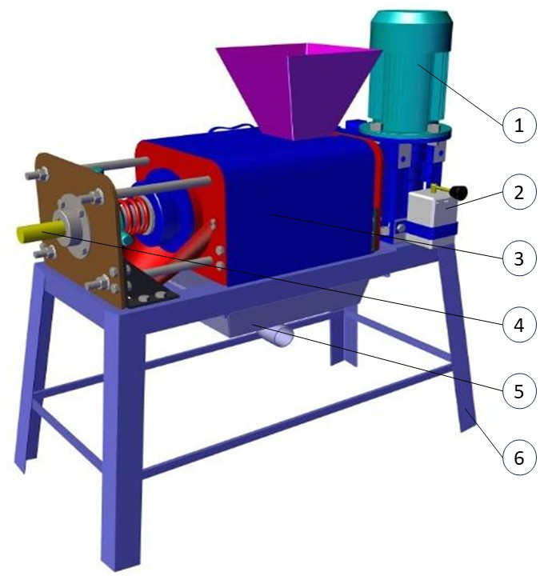

Fig: 1: Schematic of the cow dung dewatering machine showing motor, gearbox and frame assembly. (1- Motor, 2- Two-way switch, 3- Filter cover, 4- Shaft, 5-Liquid tray, 6- Frame)

The machine concept relied on single-screw auger mechanics suited to the rheological behaviour of cow dung.

#### 2.2.1 SHAFT AND SCREW AUGER DESIGN

A survey of commercially available single-phase electric motors ranging from 0.5 HP to 3 HP was conducted to identify a unit suitable for small-farm operation. Selection criteria included market availability, power rating, and grid compatibility. The optimal choice, determined through torque-speed performance calculations, was a single-phase 3 HP (2.24 kW), 1440 rpm motor, offering the required mechanical power while aligning with commonly available equipment in rural settings. Each candidate motor was analytically paired with a 1:40 single-stage worm gearbox to achieve a low output speed of 36 rpm essential for compressing viscous organic material. Torque generation, shaft stress, and pressure requirements (Table 1) were computed using standard power-to-torque conversions.

The 3 HP configuration produced a maximum shaft torque of approximately 593.45 Nm, outperforming lower-rated options and proving mathematically optimal for the system’s load and operational demands. A review by Honkalas et al. (2021) supports the selection of a single-stage, 1:40 worm gearbox, highlighting its compact design, substantial torque multiplication, quiet operation, and self-locking characteristics particularly beneficial for slurry dewatering systems.

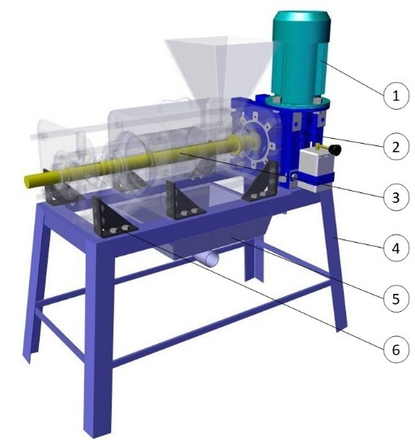

Fig 2: Shaft assembly showing auger shaft supported by bearings and filter housing (1- Motor, 2- Worm reduction gear box, 3- Shaft, 4- Frame, 5- Liquid tray, 6- Footing clamp)

Torque was determined using the motor power and shaft speed based on the standard mechanical design formulation (Shigley & Mischke, 2004). Based on the gearbox output torque: to determine the size of the shaft, the required torque is first calculated:

$P=\frac{2πnT}{60} ⇒T=\frac{9550P_{motor}}{n_{out}}$

Applying the torsional shear stress formula for a solid circular shaft where d is shaft diameter:

$τ=\frac{Tr}{J} with J=\frac{πd^{4}}{32}, r=\frac{d}{2}$

The minimum shaft diameter was derived using the torsional shear stress formula:

$d_{min}=\sqrt[3]{\frac{16×T}{π×τ_{allow}}}$

Applying the bearing‐Spacing Rule for Shaft Length:

20d ≤ L ≤ 40d: $L_{min}=k*d$

Where:

* 9550 is unit-conversion factor to convert power in kW and speed to torque in Nm
* P is power (kW)
* $n_{out}$ is rpm
* T is shaft torque (Nmm)
* $τ_{allow}$ is allowable shear stress = 210 / 4 = 52.5 N/ ${mm}^{2}$
* J is polar moment of inertia (m⁴)
* r is shaft radius (m)
* L(min)​ is minimum distance between bearings (unsupported span)
* d is shaft diameter
* k is empirical multiplier, typically 20 to avoid excessive bending and misalignment under load
* L is unsupported span between bearings
* D is shaft diameter

Structural integrity is ensured by supporting the shaft over a span of 920 mm, diameter to maintain stiffness and alignment. Final mechanical durability is guaranteed using tapered roller bearings in oil-sealed housings, providing long-term stability and protection against slurry access.

This resulted in a theoretical minimum shaft diameter of 38.6 mm. Applying a Factor of Safety of 4.0, the final selected diameter was selected as 46 mm to incorporate safety margins, machining allowances, and to ensure performance under unexpected loading conditions.

##### Table 1. Motor Power vs. Shaft Parameters

| **Motor Power (HP)** | **Power (W)** | **Motor Torque (Nm)** | **Shaft Torque (Nmm)** | **Minimum Shaft Diameter (mm)** | **Final Shaft Diameter (mm)** |
| --- | --- | --- | --- | --- | --- |
| 0.5 | 373 | 2.47 | 98,941.32 | 21.3 | 26 |
| 1.0 | 746 | 4.95 | 197,882.65 | 26.8 | 32 |
| 2.0 | 1492 | 9.89 | 395,765.29 | 33.7 | 40 |
| 3.0 | 2238 | 14.84 | 593,647.94 | 38.6 | 46 |

A review of existing systems for processing biological waste such as cow dung indicates that augers with reduced pitch (less than the flight diameter) are frequently employed to enhance material compression and improve metering in high-resistance environments. Industry standards classify pitch size relative to flight diameter OD; for instance, short pitch is defined as approximately 2/3D, and reduced-pitch configurations like 0.4D (60 mm for a 150 mm flight) have been shown to increase conveying efficiency on inclines and during compression tasks Based on these insights, a 60 mm pitch was selected. Additionally, a market survey of commercial dewatering equipment supports the use of augers with diameters up to 152.4 mm and lengths of 300–400 mm, confirming that our chosen dimensions align with established industry practice. The following parameters were compared across configurations during design selection:

##### Table 2. Screw Press Design Parameters Derived from Motor Selection

| **Motor Power (HP)** | **Screw Press OD (mm)** | **Screw Pitch (mm)** | **Screw Length (mm)** | **Force by Screw (N)** | **Slurry Pressure (**N/ ${mm}^{2}$**)** |
| --- | --- | --- | --- | --- | --- |
| 0.5 | 152 | 60 | 300 | 51,805.56 | 4.92 |
| 1.0 | 152 | 60 | 300 | 103,611.1 | 9.84 |
| 2.0 | 152 | 60 | 300 | 207,222.2 | 19.69 |
| 3.0 | 152 | 60 | 300 | 310,833.3 | 29.53 |

#### 2.2.2 SELECTION OF FILTER ELEMENT

The performance of the screw-press dewatering system was evaluated using three mesh filter sizes 0.5 mm, 1.0 mm, and 1.5 mm under cow dung slurry-to-water feed ratios of 0.5:1, 1:1, and 2:1, achieved by mixing 5 kg of cow dung with 10 L, 5 L, and 2.5 L of water, respectively. Prior to performance evaluation trials, a laboratory survey of commercially available manure separators confirmed that slot sizes typically range from 0.3 mm to 3.0 mm, as offered by leading screw-press manufacturers.

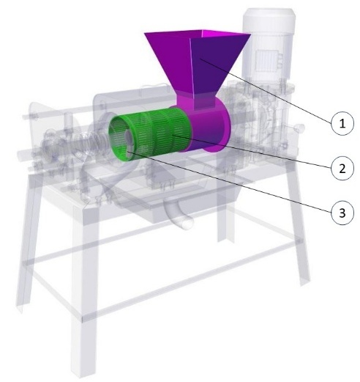

Fig 3: filter assembly with hopper. (1- Hopper, 2- Filter, 3- Auger flight)

A laboratory-scale, manually operated hydraulic filter press rig was set up for testing the filters. The setup had a centrally mounted bottle-type hydraulic jack equipped with a lever and pressure gauge to apply controlled vertical pressure. The jack acted on a movable upper bed guided by vertical columns and supported by coil springs, ensuring uniform compression. The perforated filters of different sizes were typically placed between the upper and middle beds and pressure required was applied. These filters were tested in a laboratory setup to access their performance for further experiments. Filters with slit sizes ranging from 0.3 mm to 3 mm were tested, and based on performance, three optimal sizes—0.5 mm, 1.0 mm, and 1.5 mm—were selected for experimental analysis. This compact rig is ideal for evaluating slurry dewatering efficiency and filter media behaviour under controlled laboratory conditions. The rig simulates field conditions by enabling controlled compression pressures equivalent to auger-induced compaction, allowing evaluation of filter clogging, fluid release behavior, and solid retention under varied loads.

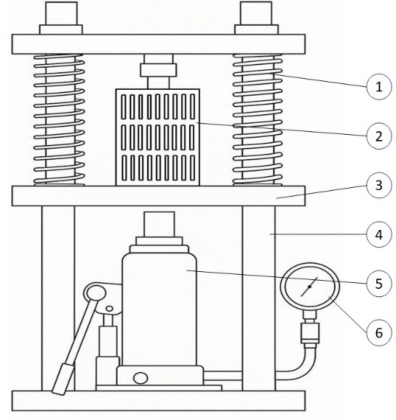

Fig 4: Manual Hydraulic Filter Press Rig – Lab Scale. (1- Return spring, 2- Filter, 3- Base plate, 4- Rig frame, 5- Hydraulic jack with lever, 6- Pressure gauge)

**2.2.3 PRESSURE PLATE ASSEMBLY**

A spring-loaded pressure plate was used to regulate the outlet resistance, ensuring sufficient compression of solids before discharge. The pressure plate was mounted concentrically at the auger outlet and pressed against the block pressure plate using a compression spring. Preload

adjustment was provided via a handle block mechanism incorporating four radial pins for manual turning and thread tightening. This enabled fine-tuning of the outlet gap without the need for additional tools. This setup allowed manual control of the final moisture content in the discharged solids without requiring hydraulic or electronic actuation. The design maintained structural simplicity while ensuring operational flexibility and consistent dewatering performance under variable feed conditions.

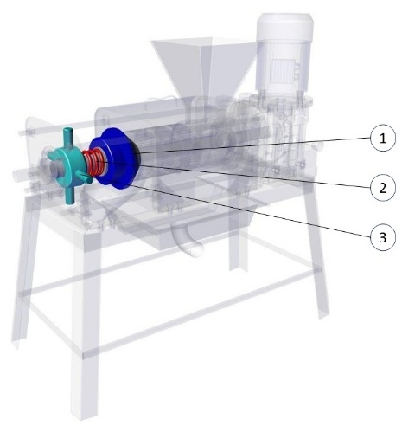

Fig: 5: Pressure plate assembly. (1- Pressure plate, 2- Spring, 3- Handle block)

Based on system pressure and space constraints, the spring dimensions were selected to balance compressive force and manual adjustability. The recommended spring had an outer diameter of 100 mm, wire diameter of 10 mm, and free length between 150 mm and 200 mm. The spring consisted of 3 active coils and a stiffness of approximately 150–250 N/mm. These parameters ensured sufficient axial force application while maintaining compatibility with the screw auger housing and allowing field-level adjustment without tools.

### 2.3 FABRICATION

The prototype was constructed using mild steel framing and incorporated a 3 HP single-phase induction motor operating at 1440 rpm. Power was transmitted through a 1:40 worm gearbox, effectively reducing the shaft speed to 36 rpm, a necessary condition for achieving progressive material compression within the screw press. The motor was mounted on a dedicated pedestal, secured to block plates which were bolted to the main frame. This ensured mechanical stability and precise alignment. A keyed shaft interface connected the gearbox output to a single screw auger, transmitting torque efficiently for dewatering operations.

The shaft was fabricated from high-strength mild steel, selected for its mechanical integrity under torsional and axial loads. It was supported at both ends using tapered roller bearings: a 50 mm ID × 90 mm OD × 24.75 mm bearing at the drive-end for combined radial and thrust loads, and a 35 mm ID × 72 mm OD × 24.25 mm bearing at the free-end to ensure axial stability. A 55 mm ID × 90 mm OD × 16 mm thrust bearing was positioned within the compression block to counter axial loads generated during auger operation. Shaft collars were used to prevent lateral displacement, and machined slots helped maintain shaft alignment.

At the outlet end, a spring-loaded pressure plate was installed to regulate backpressure, ensuring only adequately compacted solids were discharged. A threaded tensioner allowed manual preload adjustments to control the moisture content of the output. Positioned between the inlet and compression zones, a monolithic filter plate with 0.5 mm slits enabled the effective separation of the liquid fraction. Beneath the filter, dedicated drainage channels were incorporated to facilitate efficient slurry removal. All rotating components were housed within oil-lubricated bearing enclosures to prevent slurry ingress and ensure long-term durability under both batch and continuous operation modes.

The inlet housing incorporated the primary slurry channel and a removable filter screen seated within grooved slots, allowing for easy removal and cleaning. A pressure plate at the outlet was spring-loaded, using an Ø100 mm helical compression spring (10 mm wire diameter, 100–200 mm free length, stiffness 200 N/mm). Tension was adjusted manually via a threaded block with four radial pins. All major components including the inlet and outlet blocks, pressure plate, auger, housing, and support stands were fabricated from mild steel, welded and aligned on a compact 1.2 × 0.6 × 1.2 m (L × W × H) frame. The complete assembly weighed under 110 kg, and its design prioritized ease of alignment, disassembly, repair, and servicing using basic hand tools, making it especially suitable for deployment in rural settings.

### 2.4 PERFORMANCE EVALUATION

Performance evaluation was conducted using fresh cow dung with an initial moisture content of 82–85%. Moisture reduction was measured using oven-drying (AOAC, 2023). Additional parameters included throughput, energy use, structural stability, and ease of maintenance. Multiple test cycles confirmed consistency and viability under rural conditions.

##### Table 3. Complete Experimental Matrix: Filter Performance by Slurry Ratio

|  |  |  |  |  |  |  |  |  |
| --- | --- | --- | --- | --- | --- | --- | --- | --- |
| **Treatment** | **Dung: Water Ratio** | **Cow Dung (kg)** | **Water Added (kg)** | **Total Slurry Mass (kg)** | **Filter Size (mm)** | **Time Taken (min)** | **Liquid Extracted (L)** | **Solid Mass (kg)** |
| S1F1R1 | 0.5:1 | 10 | 20 | 30 | 0.5 | 16.56 | 27.19 | 2.81 |
| S1F1R2 | 0.5:1 | 10 | 20 | 30 | 0.5 | 16.21 | 27.33 | 2.67 |
| S1F1R3 | 0.5:1 | 10 | 20 | 30 | 0.5 | 16.38 | 27.28 | 2.72 |
| S2F1R1 | 1:1 | 10 | 10 | 20 | 0.5 | 14.12 | 17.09 | 2.91 |
| S2F1R2 | 1:1 | 10 | 10 | 20 | 0.5 | 14.28 | 17.11 | 2.89 |
| S2F1R3 | 1:1 | 10 | 10 | 20 | 0.5 | 14.37 | 17.04 | 2.96 |
| S3F1R1 | 2:1 | 10 | 5 | 15 | 0.5 | 14.59 | 12.26 | 2.74 |
| S3F1R2 | 2:1 | 10 | 5 | 15 | 0.5 | 14.51 | 12.36 | 2.64 |
| S3F1R3 | 2:1 | 10 | 5 | 15 | 0.5 | 14.31 | 12.32 | 2.68 |
| S1F2R1 | 0.5:1 | 10 | 20 | 30 | 1 | 13.46 | 27.62 | 2.38 |
| S1F2R2 | 0.5:1 | 10 | 20 | 30 | 1 | 13.53 | 27.6 | 2.4 |
| S1F2R3 | 0.5:1 | 10 | 20 | 30 | 1 | 13.12 | 27.68 | 2.32 |
| S2F2R1 | 1:1 | 10 | 10 | 20 | 1 | 11.43 | 17.42 | 2.58 |
| S2F2R2 | 1:1 | 10 | 10 | 20 | 1 | 11.00 | 17.4 | 2.6 |
| S2F2R3 | 1:1 | 10 | 10 | 20 | 1 | 11.10 | 17.48 | 2.52 |
| S3F2R1 | 2:1 | 10 | 5 | 15 | 1 | 10.58 | 12.54 | 2.46 |
| S3F2R2 | 2:1 | 10 | 5 | 15 | 1 | 11.00 | 12.48 | 2.52 |
| S3F2R3 | 2:1 | 10 | 5 | 15 | 1 | 10.43 | 12.52 | 2.48 |
| S1F3R1 | 0.5:1 | 10 | 20 | 30 | 1.5 | 9.32 | 27.9 | 2.1 |
| S1F3R2 | 0.5:1 | 10 | 20 | 30 | 1.5 | 9.14 | 28.17 | 1.83 |
| S1F3R3 | 0.5:1 | 10 | 20 | 30 | 1.5 | 8.52 | 28.02 | 1.98 |
| S2F3R1 | 1:1 | 10 | 10 | 20 | 1.5 | 7.28 | 17.72 | 2.28 |
| S2F3R2 | 1:1 | 10 | 10 | 20 | 1.5 | 7.33 | 17.86 | 2.14 |
| S2F3R3 | 1:1 | 10 | 10 | 20 | 1.5 | 7.41 | 17.81 | 2.19 |
| S3F3R1 | 2:1 | 10 | 5 | 15 | 1.5 | 7.28 | 13.06 | 1.94 |
| S3F3R2 | 2:1 | 10 | 5 | 15 | 1.5 | 6.39 | 13.13 | 1.87 |
| S3F3R3 | 2:1 | 10 | 5 | 15 | 1.5 | 6.44 | 13.02 | 1.98 |

S- slurry ratios (S1- 0.5:1, S2- 1:1, S3-2:1) F- Filter size (F1- 0.5 mm, F2- 1 mm, F3- 1.5 mm)

Experimental trials were conducted across all combinations of slurry-to-water ratios and filter meshes. The 1:1 slurry ratio consistently outperformed others, delivering faster dewatering and higher solid mass recovery particularly when paired with a 0.5 mm filter mesh. In contrast, the 0.5:1 ratio caused over-dilution and protracted processing times, while the 2:1 ratio limited liquid output due to reduced water content and required more time for extraction – particularly when considering volume owing to its higher viscosity. As evident, the 1:1 slurry with 0.5 mm mesh yielded the best dewatering efficiency, balancing liquid output and processing speed.

A two-way ANOVA confirmed the statistical significance of both variables: slurry consistency (F = 27.57, p < 0.0001) and filter fineness (F = 286.50, p < 0.0001) with no significant interaction detected (p = 0.103), indicating independent contributions to performance. These findings justify the choice of the 0.5 mm mesh with a 1:1 feed ratio for the final design, as this combination optimally balances throughput and separation efficiency for small-scale manure-handling systems. This suggests that slurry ratio and filter size influence performance independently, allowing each parameter to be optimized separately.

Experimental data collected across few trials showed that the 0.5 mm filter produced the best overall performance in terms of liquid extracted per unit of time. Across three feed ratios and three slurry batches, 0.5 mm filters consistently yielded the highest average solid extraction (2.78 kg), outperforming both 1.0 mm (2.47 kg) and 1.5 mm (2.03 kg) slit sizes.

## 3. RESULTS AND DISCUSSION

The cow dung dewatering machine was systematically evaluated under controlled field conditions to assess its mechanical performance, throughput efficiency, moisture reduction capability, and operational stability. Powered by a 3 HP single-phase induction motor coupled with a 1:40 worm reduction gearbox, the system generated a shaft torque of approximately 593,648 Nmm. This configuration enabled the auger to rotate at 36 rpm, a speed optimized for compressing high-viscosity cow dung slurry without inducing thermal or mechanical stress on the motor. Theoretical torque estimates were confirmed through empirical observations, and the findings were consistent with earlier reports by Honkalas et al. (2021), indicating effective resistance to clogging and pressure loss along the auger. The shaft-bearing assembly maintained structural integrity, exhibiting no vibration or misalignment even during extended runs.

Moisture reduction trials were conducted on raw cow dung with an initial moisture content of 82–85%. Using AOAC (2000) oven-drying protocols, the system consistently reduced the moisture content of the solid fraction to an average of 49.6%, exceeding the values reported by Kataria et al. (2018) and aligning closely with More et al. (2023), thereby demonstrating the efficiency of the screw-press configuration. Observations on slurry flow dynamics matched the screw press models developed by El Idrissi et al. (2020), supporting the mechanical effectiveness of the design. The extracted liquid was nutrient-rich, low in suspended solids, and suitable for applications such as fertigation and anaerobic digestion. A series of nine experimental combinations of slurry feed ratios and filter mesh sizes revealed that a 1:1 dung-to-water ratio combined with a 0.5 mm mesh provided optimal performance in terms of liquid extraction, dewatering time, solid recovery, and throughput. Lower slurry ratios (0.5:1) caused over-dilution and reduced solid retention, while higher ratios (2:1) led to insufficient free water and hindered flow due to increased viscosity. Two-way ANOVA confirmed that both slurry ratio (F = 27.57, p < 0.0001) and filter size (F = 286.50, p < 0.0001) had significant independent effects on performance, with no interaction effect (p = 0.103). Solid recovery averaged 2.78 kg for the 0.5 mm mesh, compared to 2.47 kg and 2.03 kg for the 1.0 mm and 1.5 mm meshes, respectively, validating the use of finer mesh sizes for improved separation efficiency under optimized slurry conditions.

## Operationally, the manually adjustable pressure plate enabled real-time control of backpressure and thus, the moisture content of the discharged solids. This mechanism, devoid of hydraulic or electronic components, adds to the system’s robustness and cost-effectiveness. The prototype exhibited no mechanical failures, bearing fatigue, or seal degradation during continuous 2-hour trials, attesting to its reliability in rural operating environments. Its modular design allowed for quick disassembly, cleaning, and reassembly—an essential feature for smallholder users with limited access to technical services.

## When benchmarked against commercial manure separators—which are generally overengineered, power-intensive, and cost-prohibitive for low-input systems—this machine stands out as a practical, scalable solution. As supported by recent evaluations (Senfter et al., 2024; Jha et al., 2024), the design’s compact footprint, low energy demand, and customizable filter assembly render it especially suitable for decentralized organic waste processing on small farms.

## 4. CONCLUSION

The developed screw auger-based cow dung dewatering system met the design intent by reducing slurry moisture content and improving handling efficiency on smallholder farms. Using a 3 HP motor and a constant-pitch auger mechanism, the machine consistently achieved effective solid-liquid separation, minimizing mechanical complexity and cost. Trials verified moisture reduction to 49.6% and throughput rates of up to 220 kg/h. No clogging or bearing wear was observed across continuous 2-hour trials using fresh cow dung at 82–85% initial moisture.

## The integration of a 0.5 mm slit filter and an adjustable spring-loaded pressure plate enabled effective control over dryness and throughput. The system was built on a compact 1.2 × 0.6 x 1.2 m (L x W x H) frame, ensuring portability and ease of deployment in constrained farm environments. Locally sourced materials and modular fabrication methods further enhanced field maintainability. Overall, the system offers a viable manure management solution suited to small-scale agricultural operations. Future improvements may include automation of pressure control mechanisms, cost optimization through component standardization, and modular adaptations for varying herd sizes. Integration of solar-powered drive systems and composting modules could further enhance sustainability. Deploying such units in clustered farming systems can reduce environmental contamination from unmanaged manure, improve nutrient circularity, and lower operational costs for smallholder farmers.

## ETHICAL APPROVAL

This study did not involve any human or animal subjects. All data collected were obtained through mechanical testing of agricultural waste with informed consent from participating farm owners.

Disclaimer (Artificial intelligence)

Option 2:

Author(s) hereby declare that generative AI technologies such as Large Language Models, etc. have been used during the writing or editing of manuscripts. This explanation will include the name, version, model, and source of the generative AI technology and as well as all input prompts provided to the generative AI technology

Details of the AI usage are given below:

1. Chat GPT 4o (mini) has been used for editing and correcting of article

## REFERENCES

* Amon, T., Amon, B., Kryvoruchko, V., et al. (2007). Methane production through anaerobic digestion of various energy crops grown in sustainable crop rotations. *Bioresource Technology, 98*(17), 3204–3212. ( <https://www.researchgate.net/profile/Erich-Poetsch/publication/6853966_Methane_production_through_anaerobic_digestion_of_various_energy_crops_grown_in_sustainable_crop_rotations/links/5a3a6c1faca2728e698a98ff/Methane-production-through-anaerobic-digestion-of-various-energy-crops-grown-in-sustainable-crop-rotations.pdf>)
* AOAC International. (2023). Official methods of analysis of AOAC International (22th ed., Vol. 1). Method 934.01: Moisture in animal feed. Gaithersburg, MD, USA: Association of Official Analytical Chemists. (<https://www.aoac.org/official-methods-of-analysis/>)
* Chandrakar, M., Victor, V. M., Chandraker, A. K., & Dwivedi, A., (2023). Assessing the efficiency of a cattle dung dewatering machine. The Pharma Innovation Journal, 12(9), 2034–2039. (<https://www.thepharmajournal.com/archives/2023/vol12issue9S/PartAA/S-12-9-165-738.pdf>)
* Eaves, T. S., Paterson, D. T., Hewitt, D. R., Balmforth, N. J., & Martinez, D. M. (2020). Dewatering saturated, networked suspensions with a screw press. *Journal of Engineering Mathematics*, *120*(1), 1-28. (<https://link.springer.com/article/10.1007/s10665-019-10029-3>)
* El Idrissi, B., Loranger, É., Lanouette, R., Bousquet, J. P., & Martinez, M. (2019). Dewatering parameters in a screw press and their influence on the screw press outputs. *Chemical Engineering Research and Design, 152*, 300–308. (<https://doi.org/10.1016/j.cherd.2019.10.001>)
* El Idrissi, B., Loranger, É., Lanouette, R., Bousquet, J. P., & Martinez, M. (2020a). Modelling of dewatering wood pulp in a screw press using statistical and multivariate analysis. *BioResources, 15*(3), 5899–5912. (<https://doi.org/10.15376/biores.15.3.5899-5912>)
* El Idrissi, B., Loranger, E., Lanouette, R., Bousquet, J. P. et Martinez, M. (2020b). *Kraft, BCTMP, and TMP dewatering behaviour along the axis of a screw press.* BioResources, 15 (1). pp. 1282-1297. ISSN 1930-2126 (<https://bioresources.cnr.ncsu.edu/wp-content/uploads/2020/01/BioRes_15_1_1282_El_Idrissi_LLBM_Kraft_BCTMP_TMP_Dewatering_Behav_Flow_Screw_Press_16590.pdf>)
* Honkalas, R., Deshmukh, B., & Pawar, P. (2021). A review on design and efficiency improvement of worm and worm wheel of a gear motor. In *Journal of Physics: Conference Series*, 1969 (1): 012023. IOP Publishing. ( <https://www.researchgate.net/publication/353422557_A_Review_on_Design_and_Efficiency_Improvement_of_Worm_and_Worm_Wheel_of_a_Gear_Motor>)
* Jha, A. K., Jojiju, S., Darlami, H., & Basnet, B. (2024). Performance evaluation of dewatering systems for bio-digestate for developing countries. *Energy Storage and Conversion*, *2*(3), 1431. <https://doi.org/10.59400/esc.v2i3.1431>
* Kataria Mahendra, B., Khunt, H., & Kondhiya, P. (2018). Design of a screw press for dewatering of cattle dung slurry. *Int J Sci Develop Res (IJSDR)*, 296-304. (<https://ijsdr.org/papers/IJSDR1706042.pdf>)
* Kolawole, O. P., Agbetoye, L. A. S., Ogunlowo, A. S., & Samuel, T. M. (2012). Effect of speed and back pressure on the performance of screw press in dewatering of cassava mash. *Greener Journal of Science, Engineering and Technological Research*, *2*(1), 017-023. (<https://www.researchgate.net/publication/272686204_Effect_of_Speed_and_Back_Pressure_on_the_Performance_of_Screw_Press_in_Dewatering_of_Cassava_Mash#:~:text=DOI%3A10.15580/GJSETR.2012.1.1217>)
* More, M., Agrawal, C., & Sharma, D. (2023). Development of Screw Press-Dewatering Unit for Biogas Slurry. In *Smart Sensors Measurement and Instrumentation: Select Proceedings of CISCON 2021* (pp. 303-322). Singapore: Springer Nature Singapore. (<https://www.researchgate.net/publication/369175262_Development_of_Screw_Press-Dewatering_Unit_for_Biogas_Slurry>)
* Nkoa, R. (2014). Agricultural benefits and environmental risks of soil fertilization with anaerobic digestates: A review. *Agronomy for Sustainable Development, 34*(2), 473–492.( <https://www.researchgate.net/publication/271913549_Agricultural_benefits_and_environmental_risks_of_soil_fertilization_with_anaerobic_digestates_A_review>)
* Oyedun, A. O., Salami, H. A., Odewole, M. M., Lawal, L. O., Akpenpuun, T. D., & Adebayo, H. O. (2025). A review of emerging trends in circular manure management and the role of digital solutions. Journal of the Saudi Society of Agricultural Sciences, 24, Article 21. (<https://www.researchgate.net/publication/393257877_A_review_of_emerging_trends_in_circular_manure_management_and_the_role_of_digital_solutions>)
* Prapaspongsa, T., Christensen, P., Schmidt, J. H., & Thrane, M. (2010). LCA of comprehensive pig manure management incorporating integrated technology systems. *Journal of Cleaner Production*, *18*(14), 1413-1422. (<https://www.researchgate.net/publication/239365098_LCA_of_comprehensive_pig_manure_management_incorporating_integrated_technology_systems>)
* Salehion, A. R., Minaei, S., & Razavi, S. J. (2013). Design and performance evaluation of a screw press separator for separating dairy cattle manure. *International Journal of Agronomy and Plant Production, 4*(S), 3849–3858. (<https://www.cabidigitallibrary.org/doi/pdf/10.5555/20143088486>)
* Senfter, T., Schweiggl, I., Berger, M., Mayerl, C., Kofler, T., Kraxner, M., ... & Pillei, M. (2024). The dewatering performance of a compact screw press manure separator for non-typical substrates. *Separations*, *11*(1), 28. (<https://www.mdpi.com/2297-8739/11/1/28>)
* Shigley, J. E., Mischke, C. R., & Budynas, R. G. (2004). *Mechanical engineering design* (7th ed.). McGraw-Hill. (<https://books.google.co.in/books?id=A2mjQR6Nwn4C>)
* Tou, L., Wang, J., & Chu, M. (2024). From intention to action: Enabling sustainable agriculture in emerging economies through decentralized regulations for manure management. Public Administration and Development, 44(5). (<https://ideas.repec.org/a/wly/padxxx/v44y2024i5p445-459.html>)
* Yadav, S., Jha, A. K., & Darlami, H. B. (2023). Design and improvement of dewatering system implemented for biogas slurry. International Journal for Multidisciplinary Research, 5(5), 97–101. (<https://www.ijfmr.com/research-paper.php?id=9184>)