Assessment of ripening behaviour of banana (Musa acuminata) under ambient condition

ABSTRACT
India is the leading producer of bananas, with an annual production of 37.47 million metric tonnes. As a climacteric fruit, bananas undergo natural ripening characterized by a respiratory peak post-harvest; however, this process typically requires a long duration. The present study aimed to evaluate the ripening behavior of bananas under ambient conditions. For this purpose, fresh matured banana fruits were harvested, washed and then used for experiment. As a natural ripening process, fruits were covered with paddy straw and stored in plastic containers at ambient condition. At two-day intervals, key physico-chemical properties—including pH, total soluble solids (TSS in °Brix), firmness (N), weight loss (%), and color values (L*, a*, and b*) were measured over a 12 days period. Results showed that pH (5.57 to 5.26) and firmness (28.00 to 7.96 N) decreased steadily with storage time, while TSS (4.65 to 18.07 °Brix) and weight loss (0.16% to 28.10%) increased consistently. Among the color parameters, L* value (82.61 to 79.02) showed a gradual decline. Notably, after 12 days of storage, bananas failed to attain the desired color and TSS levels suitable for commercial marketing.
1. INTRODUCTION
India is the second-largest producer of fruits in the world, after China, with an annual production of 96.75 million tons across 6.5 million hectares (Horticultural Statistics at a Glance, 2019). In many tropical countries around the world, bananas serve as a vital food crop and are integral to daily diets. India and Brazil are the leading countries in the world that produce sweet bananas. Banana is rich in easily digestible carbohydrates with 67–137 calories per 100 g of fruit, it has a high content of readily absorbed carbohydrates. Other key components of banana fruit include oligosaccharides and different antioxidants, which have been linked to improved blood pressure regulation, weight loss, and the treatment of intestinal disorders as well as the prevention of diabetes, colon cancer, and other diseases (Higgins, 2014; Obrenovich et al., 2011, 2010; Wang et al., 2014). B6-rich bananas are vital for the synthesis of heme, the iron-containing component of hemoglobin, and also assist strengthen immunity. In addition, bananas are a great source of health-promoting phytochemicals, vitamins, minerals, and satisfying tastes. (Clark and Slavin, 2013; Ergin et al., 2013; Houston, 2011; Seth et al., 2014) In addition, bananas which are prized for both their flavor and therapeutic qualities are an excellent source of potassium, fiber, and energy.
The banana is a climacteric fruit that ripens naturally, showing a respiratory peak after harvest but required long duration. The majority of banana bunches are picked while fully mature, still green and unripe, and then left to ripen in natural environments. Green banana bunches are artificially ripened in order to meet the usual household requirement. One of the most popular techniques used to promote ripening is smoke treatment (Ram et al. 1979). When banana fruit achieves full maturity, endogenous ethylene naturally evolves or is applied from outside, which is how banana fruit ripens (Marriott and Palmer 1980). Under typical ripening conditions, the color of the banana peel changes from green to yellow. Numerous biochemical, ultrastructural, and physiological alterations occur during ripening (Maqbool et al. 2011; Eshghi et al. 2014; Jiao et al. 2018).
Bananas must be stored and ripened properly to preserve their quality and enhance their shelf life. Careful supervision is necessary when using traditional ripening methods, which frequently involve the use of ethylene or controlled climatic conditions, in order to achieve consistent ripening and prevent spoiling. To study the natural ripening process of banana this study was planned which will help to understand the ripening behaviour and need of artificial ripening agent.
2. MATERIAL AND METHODS
2.1. Raw material
The banana fruits purchased from M/s Mahesh Krishi Farm, Village-Datrenga, Post – Sejbahar, District Raipur (Chhattisgarh) (Fig. 1). In the study, physiologically mature banana (Cv. G-9) fruits were harvested during morning hours (from 8.30 a.m. to 10.00 a.m.) from the field. Then the harvested fruits were washed and cleaned for further investigation. The experiment was conducted in the winter season with the average temperature of 26-30°C with relative humidity ranges from 53-57%. The experiment is conducted in 3 replications.
2.2. Ripening process
For the ripening process, banana kept in the 20 litre of plastic container by covering with paddy straw (layer by layer) i.e. one layer of straw and one layer of banana and fill the box. The plastic container has top plastic lid to cover the box as and when required (Fig. 2).
2.3. Physico-chemical characteristics
The physico-chemical characteristics during ripening of banana fruits like pH, total soluble solids (ºBrix), firmness (N), weight loss (%) and colour value (L*, a* and b*) were recorded by standard methods. These values were measured and recorded for every two days until ripening was completed.
2.3.1 pH
The pH is a measure of the active acidity, which influences the flavour or palatability of a product and affects the processing requirements. The pH value was determined by using a digital pH meter and it was standardized with distilled water of pH 7.0 and standards at pH 5.0. Three fruits were selected randomly and pulped using a mixer grinder for measuring the pH.
2.3.2 Total soluble solids (TSS)
Three fruits were selected at random and pulped using a mixer-grinder. Small samples of the fruit pulp were filtered through muslin cloth and a drop of filtrate was taken to determine the total soluble solids (TSS) using a digital hand-held pocket refractometer and TSS was expressed as ºBrix (Ranganna, 1986).
2.3.3 Firmness
Firmness was measured with the help of digital fruit penetrometer. The fruit firmness was measured after removing about 1 cm² of the skin of the fruit in the middle of the fruit and with the help of 8 mm stainless steel plunger force required to penetrate was measured. The value indicated by the device represents the maximum force expressed in Newton (Tano et al., 2007).
2.3.4 Weight loss
The fruit mass was determined by weighing the fruits in each box at two days interval from three replicates. The weight loss was calculated by the following formula suggested by Srivastava and Tandon (1968) and expressed in percentage.
$$Weight loss=\frac{Intial weight-Final weight }{Initial weight}$$
2.3.5 Colour
The colour of fruit was measured by using Hunter lab colour analyser. The color of fruit sample was expressed as L* (whiteness or darkness), a* (redness or greenness), b* (yellowness or blueness) as per the standard procedure. Small quantity of sample was filled in the 10 mm optical glass chamber and placed into the chamber channel. The colour reading was recorded in L*a*b*/RYB scale.
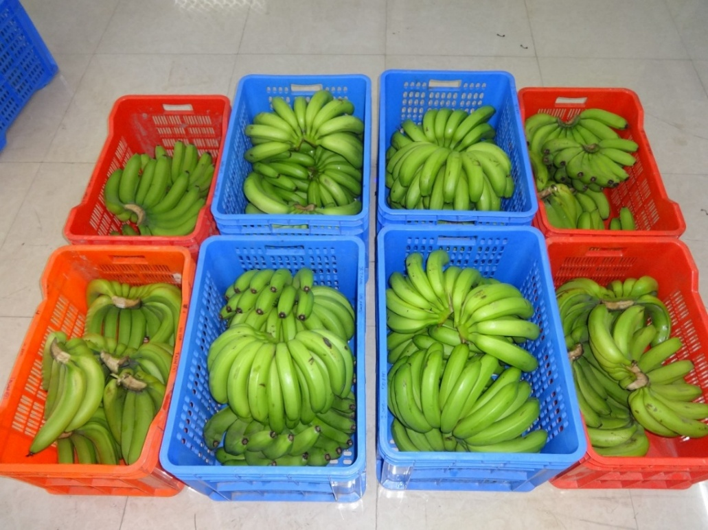
Fig. 1. Matured banana sample used for study

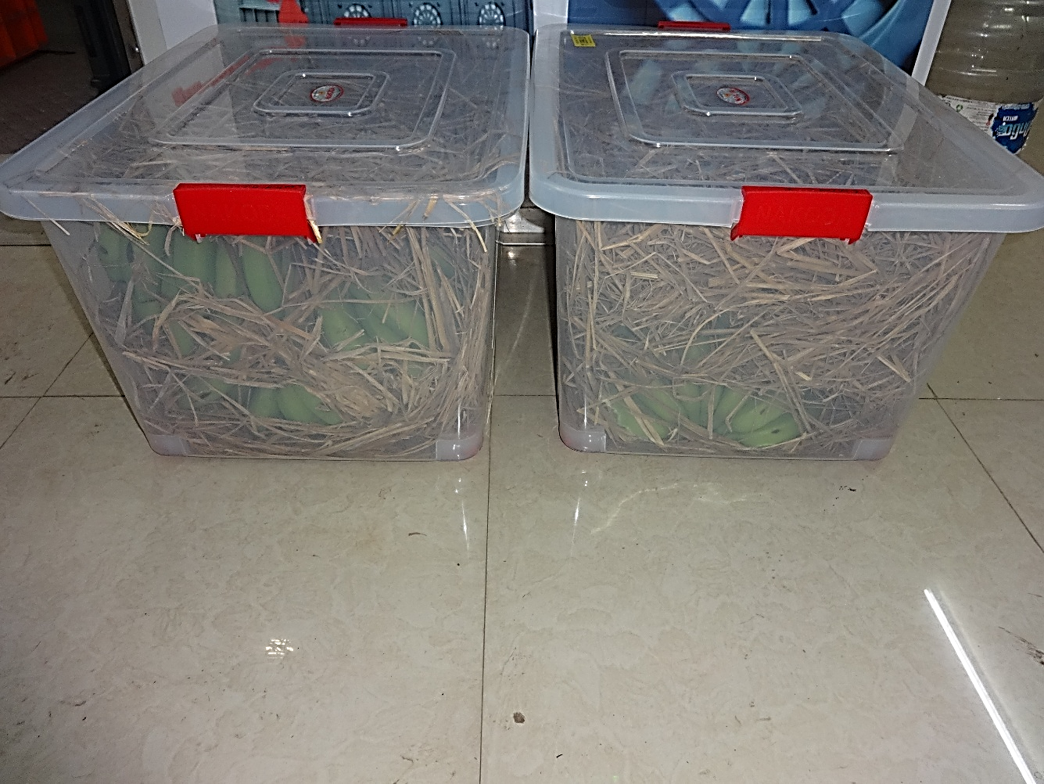

Fig. 2. Storage of banana fruits in plastic container and covered with paddy straw

3. RESULT AND DISCUSSION
3.1. Physico-chemical properties of banana fruits at harvest stage
The data presented in Table 1 shows the experimental result of certain physico-chemical properties of banana Cv. G9 fruits at harvest stage. The maturity of banana was determined with the help of instrument called ‘banana caliper’ in which finger diameter more than 1.2 inches were selected for harvesting also other marker was angularity of the fruit. In matured fruits angularity was reduced (sides rounder, not sharply ridged).

Table. 1 Physico-chemical properties of banana fruits Cv. G9 at harvest stage
S. No. | Parameters | Value | Method of measurement
1 | pH | 5.87 | Digital pH-meter
2 | Total soluble solid, °Brix | 4.12 | Digital refractometer
3 | Firmness, N | 29.03 | Digital fruit penetrometer
4 | Colour |  | Hunter lab colour analyser
 | L* value | 82.11
 | a* value | -0.19
 | b* value | 16.21
3.2 Effect of storage period on physico-chemical changes during ripening of banana fruits.
As per the set objective, the variation in physico-chemical properties of banana with respect to duration of storage is summarized in Table 2. The pH is one of the important quality parameters which predict the ripening stages of banana fruit. It was observed that, the pH value gradually decreased from (5.57 to 4.83) up to 8 days and then increased (5.11 to 5.26) on 10th and 12th day. This pattern reflects the initial accumulation of organic acids during the early stages of ripening, followed by the breakdown of acids and accumulation of sugars as ripening progresses.
Total Soluble Solids (TSS) refer to the concentration of dissolved substances in a fruit’s juice, primarily composed of sugars (glucose, fructose, sucrose), organic acids, vitamins, minerals, and other soluble compounds. In general, the unripe green bananas have low TSS (4-6 °Brix) due to high starch content and as ripening progresses, TSS increases to 18-22 °Brix in fully ripe bananas making the fruit sweeter. It was observed that, the value of TSS increased rapidly up to first 8 days of storage and 8 day onwards, TSS values became relatively stable, indicating the transition from active ripening to full ripeness (Table 2.).
Firmness is a crucial indicator of the ripening and textural quality of bananas. As bananas ripen, their firmness decreases due to enzymatic breakdown of cell walls, starch degradation, and moisture loss. During ripening of banana, the value of firmness (N) gradually decreased from 28.00 to 25.34 N up to 8 days and then dropped significantly to 7.96 N (day 8 to 12).
Weight loss in banana fruits is a crucial parameter that affects postharvest quality, shelf life, and marketability. It is mainly caused by moisture loss due to respiration and transpiration during storage. During experiment it was observed that, there was continuous increased in weight loss percentage, but rate of weight loss was very less during initial days i.e. from 0.16 to 7.36 % and then increased up to 28.10 % from day 8 to day 12, leading to maximum weight loss (%). Similar trend was observed during the ripening of banana by (Ahmad and Thompson, 2007).
Table 2. Physico-chemical characteristics of banana fruits during ripening in a control condition.
Storage period, Days | pH | TSS,  °B | Firmness (N) | Wt. loss, % | L* | a* | b*
2 | 5.57 | 4.65 | 28.00 | 0.16 | 82.61 | 0.39 | 17.42
4 | 5.50 | 4.60 | 27.12 | 0.35 | 79.98 | 0.58 | 18.00
6 | 4.87 | 11.07 | 26.20 | 7.36 | 74.12 | 2.14 | 18.87
8 | 4.83 | 17.00 | 25.34 | 13.53 | 65.00 | 2.73 | 17.41
10 | 5.11 | 17.73 | 17.35 | 19.90 | 69.53 | 1.95 | 19.24
12 | 5.26 | 18.07 | 7.96 | 28.10 | 79.02 | 0.43 | 20.80

Fig. 3 Variation in colour values with respect to storage days.

The L* value (lightness) is an essential indicator of the color changes during banana ripening, reflecting the transition from green to yellow and eventually to brown as the fruit ripens. A higher L* value indicates a brighter color, while a lower L* value suggests darkening or senescence. During ripening of banana, the L* value continuously decreased from 82.61 to 65.00 with respect to storage period of 2 to 8 days and then slightly increased to 79.02 at 12 days (Fig. 3). Similar results were observed by Salvador et. al. (2007) on ripening the banana fruits. The a* value represents the red-green color balance in bananas during ripening. Negative a* values indicate greenness, while positive values indicate yellowing and eventual browning. During banana ripening, the a* value continuously increased from 0.39 to 2.73 with respect to storage period of 2 to 6 days and then start decreasing from 1.95 to 0.43 for 8 to 12 days. The b* value is a key indicator of banana pulp color development and ripening progression. In the control sample of banana, the b* value gradual increased from 17.42 to 20.80 with respect to storage period of 2 to 12 days and in between on 8th day b* value slightly reduced to 17.41 and then again increased. Fig. 4 shows the physical appearance of banana fruits at different days of ripening.

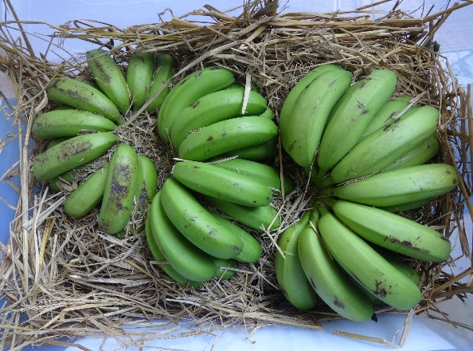 | 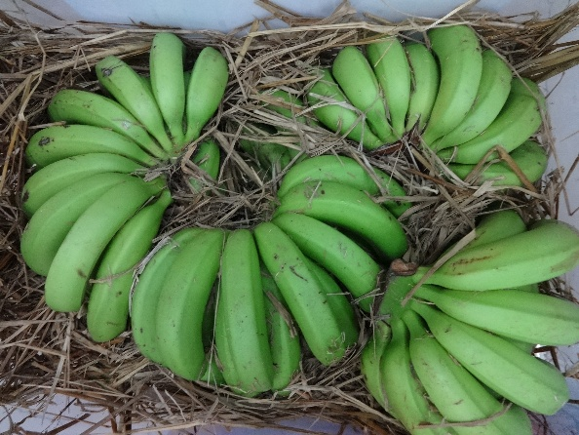
2nd day of banana ripening | 4th day of banana ripening
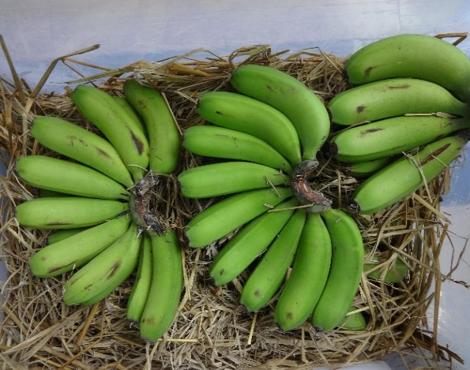 | 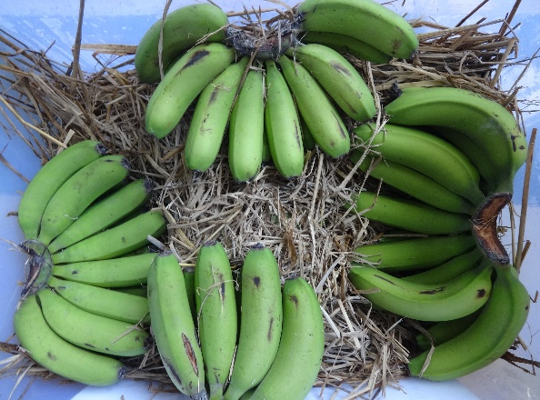
6th day of banana ripening | 8th day of banana ripening
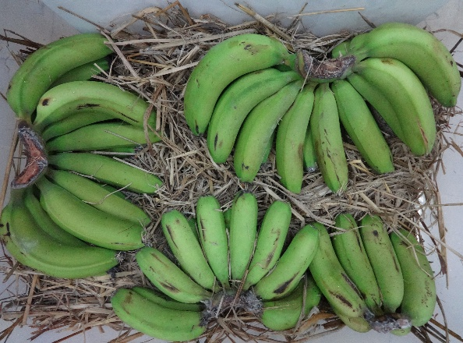 | 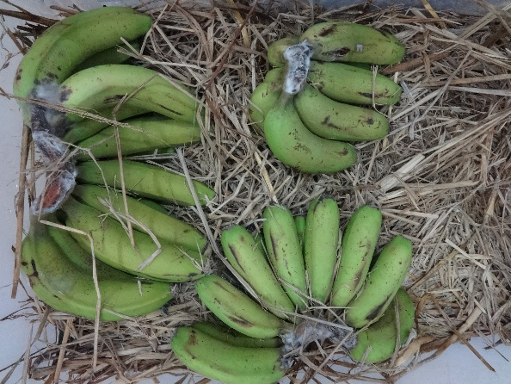
10th day of banana ripening | 12th day of banana ripening
Fig. 4. Physical appearance of banana at different days of ripening

4. CONCLUSION
In this study, the ripening behavior of banana (cv. Grand Naine) was assessed under ambient conditions without the use of any artificial ripening agents. The natural ripening process extended up to 12 days. By the end of this period, the firmness of the fruit reduced to 7.96 N and pH reached 5.26, indicating physiological ripeness. However, the corresponding values of total soluble solids (TSS at 18.07 °Brix) and color parameters (L* = 79.02, a* = 0.43, b* = 20.80) suggested that full ripening was not achieved. Furthermore, after 8 days of storage, noticeable deterioration in the physical appearance of the fruits indicated that they were unlikely to remain suitable for market sale, highlighting the limitations of natural ripening under ambient conditions for commercial purposes.
Acknowledgement
The author’s thanks to AICRP on Post-Harvest Engineering and Technology Scheme, ICAR, New Delhi, for providing financial and technical support.

Disclaimer (Artificial intelligence)
Option 1:
Author(s) hereby declare that NO generative AI technologies such as Large Language Models (ChatGPT, COPILOT, etc.) and text-to-image generators have been used during the writing or editing of this manuscript.
Option 2:
Author(s) hereby declare that generative AI technologies such as Large Language Models, etc. have been used during the writing or editing of manuscripts. This explanation will include the name, version, model, and source of the generative AI technology and as well as all input prompts provided to the generative AI technology
Details of the AI usage are given below:
1.
2.
3.

4. REFERENCES
Ahmad, S. and Thompson, A. K. 2007. Effect of modified atmosphere storage on the ripening and quality of ripe banana fruit. Acta Horticulture, 741: 273-278.
Eshghi, S., Hashemi, M., Mohammadi, A., Badii, F., Mohammadhoseini, Z., Ahmadi, K. 2014. Effect of nanochitosan-based coating with and without copper loaded on physicochemical and bioactive components of fresh strawberry fruit (Fragaria × ananassa Duchesne) during storage. Food Bioproc. Technol., 7(8): 2397–2409.
Higgins, J.L. 2014. Resistant starch and energy balance: Impact on weight loss and maintenance. Crit. Rev. Food Sci. Nutr. 54(9):1158–1166.
Horticultural Statistics at a Glance 2019. Horticulture Statistics Division, Department of Agriculture and Farmers Welfare, Ministry of Agriculture and Farmers Welfare, Government of India.
Jiao, W., Xi, Y., Cao, J., Fan, X., and Jiang, W. 2018. Regulatory effects of CaCl2, Sodium Isoascorbate, and 1-Methylcyclopropene on chilling injury of banana fruit at two ripening stages and the mechanisms involved. Journal of Food Processing and Preservation, 42(2): 13442.
Marriott, J., & Palmer, J. K. 1980. Bananas physiology and biochemistry of storage and ripening for optimum quality. Critical Reviews in Food Science and Nutrition, 13(1), 41-88.
Maqbool, M., Ali, A., Alderson, P. G., Zahid, N. and Siddiqui, Y. 2011. Effect of a novel edible composite coating based on gum arabic and chitosan on biochemical and physiological responses of banana fruits during cold storage. J. of Agril and Food Chemistry, 59(10): 5474-5482.
Obrenovich, M.E., Y. Li, K. Parvathaneni, B.B. Yendluri, H.H. Palacios, J. Leszek, and G. Aliev. 2011. Antioxidants in health, disease and aging. CNS Neurol. Disord. Drug Targets 10(2):192–207.
Ram, H. B., Singh, S. K., Singh, R. V., Surjeet Singh, S. S. 1979. Effect of ethrel and smoking treatment on ripening and storage of banana cultivar. Himachal Prog Hort, 11(3): 69–75.
Ranganna, S. 1986. Handbook of Analysis and Quality control for Fruit and Vegetable Products. Tata McGraw-Hill Education. 920-933.
Salvador, A., T. Sanz and S. Fiszman. 2007. Changes in colour and texture and their relationship with eating quality during storage of two different dessert bananas. Postharvest biology and technology. 43:319-325.
Tano, K., Oule, M.K., Doyon, G., Lencki, R.W and Arul, J. 2007. Comparative evaluation of effect of storage temperature fluctuation of modified atmosphere packages of selected fruit and vegetables. Postharvest Biology and Technology. 46: 511-516.
Wang, Y., Xie, X., and Long, L. E. 2014. The effect of postharvest calcium application in hydro-cooling water on tissue calcium content, biochemical changes, and quality attributes of sweet cherry fruit. Food Chemistry, 106: 22–30.

