***Original Research Article***

**Assessment of Vegetation Impact Using Vegetative Indices Due to Forest Fires in Uttarakhand**

**ABSTRACT**

Forest fires impact the forest ecosystems in the form of decline in forest cover, loss in biodiversity, and alterations in land use/land cover, which further modify the hydrological cycle, accelerating the runoff and soil erosion. All these problems require effective management strategies. This study estimates the impact of forest fires on soil moisture and vegetation in Uttarakhand, using Landsat 8 imagery and four vegetation indices: NDVI, NDMI, NBR, and MSAVI based on different forest types. Data from 42 forest fire sites within five forest types were analysed to evaluate the changes in vegetation loss, moisture depletion, and burn severity. The results show a significant decline in NDVI in the Himalayan Moist Temperate Forest at sites S36, S37, and S1. NBR effectively shows burn severity, which was found to be highest in Subtropical Pine Forest at sites S19, S12, S16 and Tree Outside Forest types at S33. NDMI index shows considerable decreases in soil moisture in Subtropical Pine forests at sites S19 and S39, while MSAVI detected considerable vegetation cover loss, especially in Subtropical Pine forests at sites S35 and S16. Statistical analysis highlighted the NDMI index’s sensitivity to moisture changes and shows the highest M-statistics with 1.55, followed by NBRs, which is reliable in assessing burn severity. The study highlights the effectiveness of different indices in assessing the impacts of forest fires, which may be of immense utility to establish strategies for post-fire forest management, monitoring, and rehabilitation.

***Keywords:*** *Forest fire****,*** *Vegetative indices, Forest type, Remote sensing, NDVI*

1. **INTRODUCTION**

Forests are vulnerable to both gradual and sudden disruptions that differ in frequency, intensity, and extent. According to van der Werf *et al.* 2006, fire affects over 350 million hectares worldwide each year, potentially having a significant impact on the amount of carbon released from terrestrial ecosystems (Andreae & Merlet, 2001; Simmonds *et al.*, 2005)**.** Fires cause enduring changes to vegetation composition, impact vast areas worldwide, leading to severe consequences such as decline in biodiversity, a reduction in forest cover, alterations to the landscape, soil degradation, an increase in greenhouse gas emissions, and disruption of ecosystem functioning and landscape patterns, all of which promote the processes of desertification. Evaluating the effects of fire is crucial for understanding the fire-induced degradation, improving our understanding of ecosystem recovery after fire, and quantifying the related economic losses. Various approaches have been developed to assess fire severity, such as spectrum mixture analysis (Veraverbeke & Hook, 2013; Quintano *et al.*, 2013), simulation methods (De Santis *et. al*, 2010; De Santis *et al.*, 2007), and spectral indices (SIs) (French *et al.*, 2008). The most popular method is spectral indices because of its ease of use and computational effectiveness (Veraverbeke *et al.*, 2011). Fire severity is expressed by fire severity indices, which measure the extent of environmental alteration and organic matter loss. According to the optical perspective, vegetation burning causes a significant decrease in visible to near-infrared surface reflectance (i.e., 0.4–2.5 µm) linked to the vegetation damage caused by the fire severity and represented by a change in the spectral index values **(**White *et al.*, 1996**).**

The study of vegetation index is essential to comprehend how forest fires affect the ecosystem. Vegetation indices, which are mathematical computations based on aerial or satellite photography, assess the health and quantity of vegetation. Satellite remote sensing (SRS), offers rapid and affordable means for estimating fire intensity and vegetation recovery. These spectrum indices are based on normalised difference spectral indices (NDSIs), like commonly used Normalised Burn Ratio (NBR) (Epting *et al.* 2005, Key and Benson 2006, Miller and Thode 2007) and the Normalised Difference Vegetation Index (NDVI) (e.g. Chafer *et al.* 2004). NBR correlates with vegetation wetness by merging the NIR and SWIR (short wave infrared) reflectance, while NDVI measures the quantity of green vegetation by using R (red) and NIR (near-infrared) spectral regions. The modified soil-adjusted vegetation index (MSAVI) surpasses NDVI in performance (Veraverbeke *et al.*, 2012, Qi *et al.*, 1994, Rogan & Yool, 2001, Schepers *et al.*, 2014) and reduces soil spectral interference (Huete, 1988). NDMI index is essential for estimating vegetation moisture levels, which can indicate conditions like drought that could increase the risk of fire (Ochtyra *et al.*, 2020). MSAVI index reduces the effect of the soil brightness, which increases the precision of vegetation analysis in sparse areas. Combined, these indices support forest fire detection, evaluation, and management, resulting in more efficient fire prevention, response, and recovery plans. This study primarily aims to evaluate the variations in vegetation indices before and after fire. This will provide insight into vegetation recovery and the effects on forest ecosystems. Each of them leads to a different Normalised Difference Vegetation Index (dNDVI) (Chafer *et al.* 2004), a different Normalised Burn Ratio (dNBR) (Key and Benson 2006), a different Normalised Difference Moisture Index, and something else entirely.

The forest fires are a major global concern, especially in countries like India where vast areas of forested cover are exposed to different degrees of fire threat. In India, the forest fire cases were recorded as 345,989 by SNPP-VIIRS (Suomi-National Polar-orbiting Partnership - Visible Infrared Imaging Radiometer Suite) and 52,785 during the years 2020 to 2021 through MODIS (Moderate Resolution Imaging Spectro-radiometer) (Forest Survey of India, 2021). Forest types, like dry deciduous forests, are susceptible to severe fires; evergreen, semi-evergreen, and high-temperate forests are relatively less vulnerable (Forest Survey of India, 2015). According to estimates, forest fires frequently occur in more than 36% of the nation's forest cover. About 4% of the nation's forest cover is extremely prone to fire, while 6% is assessed to be very highly prone to fire (Forest Survey of India, 2019).

Forest fires are a primary driver of extensive ecological and socioeconomic disruptions in Uttarakhand, contributing significantly to rural outmigration. Approximately 45.44% (24,305 km²) of Uttarakhand’s total geographical area has experienced high fire incidences in recent years (Forest Survey of India, 2021). Between the years 2010 and 2023, the state witnessed multiple forest fire events, with the most severe fire season recorded in 2019. During that year, 2,158 fire incidents impacted 2,981.55 hectares of forest land, predominantly in the Garhwal and Kumaon regions (Negi, 2019). The phenomenon of forest fires in Uttarakhand has been relatively underexplored in scientific literature. This research aims to assess the impact of forest fires in the region and formulate comprehensive mitigation and control strategies. The study holds significant relevance in advancing fire management policies and strategic interventions that not only safeguard local populations but also ensure the preservation and resilience of the broader ecosystem.

1. **MATERIAL AND METHODS**

**2.1 Study Area**

The study was carried out in the state of Uttarakhand, India (Fig. 1). It is situated on the southern slope of the Himalayan range, spanning 53,483 km2 and lying between latitudes 28° 44' and 31° 28' N and longitudes 77° 35' and 81° 01' E. Uttarakhand can be categorised geographically into three zones: The Terai region, the Siwaliks, and the Himalayas. Uttarakhand's climate is distinctly divided into two zones: the limited lowland plains and the predominantly hilly terrain that constitutes the majority of the state. The state is characterised by steep slopes, extensive snow-covered regions, and predominantly mountainous topography. Uttarakhand's climate is distinctly divided into two zones: limited lowland plains and the predominantly hilly terrain that constitutes the majority of the state. The southern foothills experience a subtropical climate with summer temperatures of roughly 30°C and winter temperatures of roughly 18°C. The Middle Himalayan valleys experience warm, temperate weather, with summers typically hitting around 25°C and winters being milder. In the highest regions of the Middle Himalayas, cool temperate weather predominates. Summer temperatures often range from 15°C to 18°C, while winter temperatures fall below freezing. According to ICFRE (2013), the state receives about 1,547 mm of rainfall on average per year. The State's total area covered by forests is 24,305 km2, or 45.44% of its total land area. According to forest canopy density classes, the State has 6,482 km2 of Open Forest (OF), 12,768 km2 of Moderately Dense Forest (MDF), and 5,055 km2 of Very Dense Forest (VDF) (Forest Survey of India, 2021).

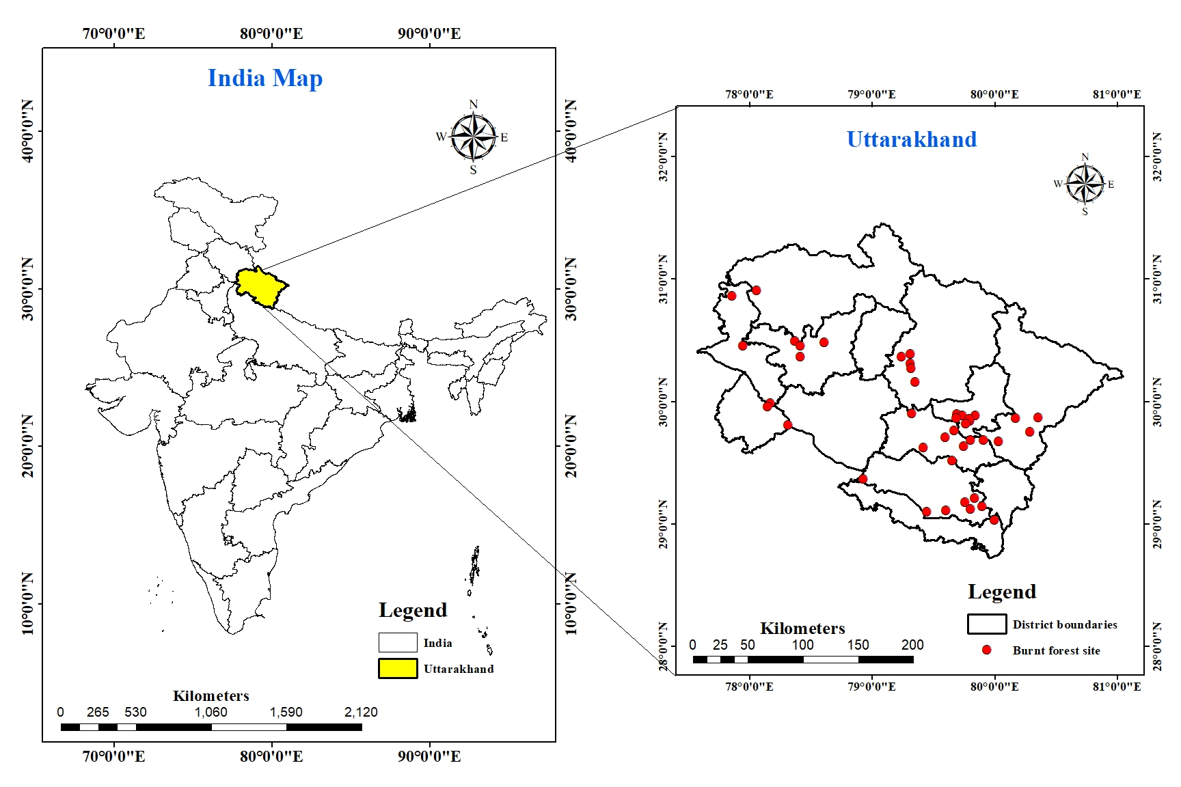 (a)

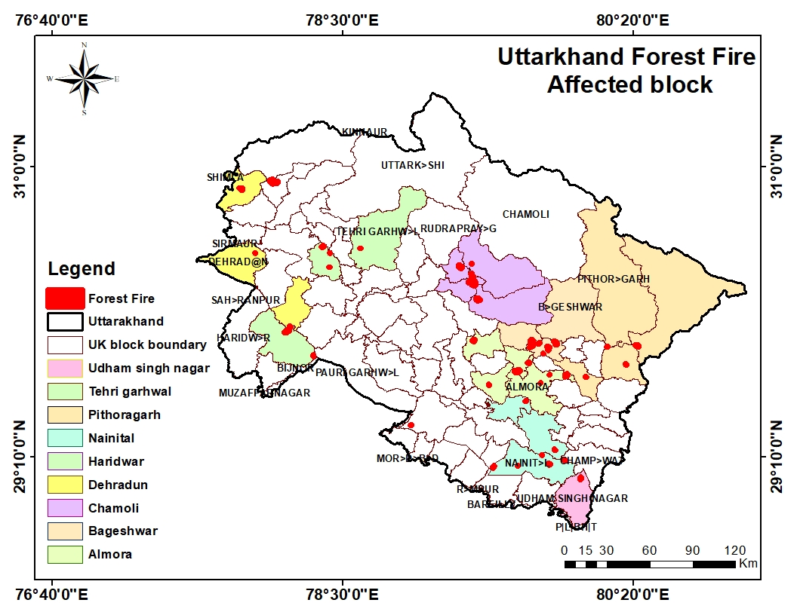 (b)

**Fig. 1 (a) Map of Uttarakhand and location of 42 burn sites (b) Map of forest fire-affected blocks in Uttarakhand**

**2.2 Data**

Official data concerning forest fires, including specific locations and dates, has been made available for the study region by the Forest Research Institute (FRI). Utilizing GPS technology, burnt plots were identified and polygons were created accurately delineating boundaries of the burned areas. This dataset includes 42 forest sites vulnerable to forest fire; many additional variables such as forest type, district, division, block/range, beat, and the forest canopy cover and its degree of damage have been included. The area measurement measures the extent of the areas that have been targeted for burning and the FCM deals with the burnt areas and the remaining forest. The table 1 categorizes five forest types and analyses the extent of fire-affected areas, highlighting regions with extreme and moderate burn severity. This classification illustrates the varying degrees of fire impact across different forest ecosystems.

**Table 1 Description of Total Burnt Sites According to Forest Types**

|  |  |  |  |
| --- | --- | --- | --- |
| **S. No.** | **Forest type** | **Burnt Severity** | |
| **Moderately Burnt** | **Low Burnt** |
| **1.** | Group 3- Tropical Moist Deciduous Forests | 4 | 2 |
| **2.** | Group 5- Tropical Dry Deciduous Forests | Nil | 2 |
| **3.** | Group 9 -Subtropical Pine Forests | 18 | 2 |
| **4.** | Group 12- Himalayan Moist Temperate Forests | 9 | 2 |
| **5.** | Group- TOF/Plantation | 1 | 2 |
| **Total** | | **32** | **10** |

The method of estimating vegetative indices was performed in a number of steps. First of all, the Landsat 8 pre- and post-fire images of the year 2019 with a cloud cover percentage of less than 10% were downloaded from Earth Explorer. To remove atmospheric distortions and errors from the satellite data, an atmospheric correction was performed using the ACP plugin in QGIS 3.34.11. The ArcGIS applications were consequently used for the interpretation of the data sets, respectively. Four different vegetation indices were computed from bands 4, 5, 6 and 7, which were used in this study.

**2.3 Analysis of Vegetative Indices and Computation**

Out of the several spectral indices and image processing methods that have been documented in the literature, we have chosen four distinct methods that were created for the Landsat sensors and are frequently employed to determine the extent of burns. For every Landsat data set, VI equations were used (Table 2). Lastly, SI values were estimated at each of the 42 burned sites from the newly formed layers.

**Table 2 List of Vegetative Indices *Red* = visible red Landsat TM band 4; *NIR* = near infrared Landsat TM band 5; *SWIR* = shorter shortwave infrared Landsat TM band 6; *lSWIR* = longer shortwave infrared Landsat TM band 7**

|  |  |  |  |
| --- | --- | --- | --- |
| **Vegetative Indices** | **Abbreviation** | **Equation** | **Reference** |
| Normalized Difference Vegetation Index | NDVI | $$\left(NIR-RED\right)/\left(NIR+RED\right)$$ | Rouse *et al.* (1974) |
| Normalized Burn Ratio | NBR | $$\left(NIR-SWIR\right)/\left(NIR+SWIR\right)$$ | Key & Benson 2006, Lopez & Caselles 1991, Koutsias & Karteris 2000 |
| Normalized Difference Moisture Index | NDMI | $$\left(NIR-lSWIR\right)/\left(NIR+lSWIR\right)$$ | Wilson & Sader 2002; |
| Modified Soil Adjusted Vegetation Index | MSAVI | $$\frac{2∙NIR +1 - \sqrt{{\left(2∙NIR +1\right)}^{2} - 8 ∙ \left(NIR - RED\right)}}{2}$$ | Qi *et al.* (1994) |

NDVI is an index that measures the change in the level of greenness of vegetation, NBR determines the level of burn, NDMI helps in the determination of moisture content of vegetation, and MSAVI reduces the effects of soil on vegetation cover analysis in less vegetated areas. Therefore, these indices are used in tandem due to their ability to fully demonstrate fire and post-fire recovery mechanisms. Their efficiency has also been demonstrated in the contexts in which fire-impacted forest ecological change has been the unit of measure in numerous studies. All of the abbreviations used in this section, along with the VI equations and literature references, are presented in Table 2 and the accompanying legend. The indices that were chosen are described in the following sections.

The significance of each vegetation index (VI) in differentiating pre-fire and post-fire, and also the Change in VI values, could be understood through the various statistical metrics that measure the spectral distance of two distributions. Among these, the M-statistic was found to be the most powerful of all parameters in measuring class separateness. This statistic is the difference between the two classes' means (μ) and standard deviations (σ). The M-statistic can also be seen as a form of signal-to-noise ratio. Here, the signal is the difference between the means, while the noise is the sum of standard deviations. The degree of separation between two distributions is computed quantitatively by the M-statistic and hence provides an objective way of evaluating vegetation indices as change detection factors. It was revealed in the analysis that with the highest M-statistic, separateness as well as the degree of relative changes increase. Alternatively, with a lower M-statistic, it was noted that class separateness as well as the degree of relative changes were also reduced. The M-statistic has already found application and been employed by many researchers in the area of fire effect and burned area discrimination, in some well-known works (Melchiori *et al.*, 2015; Lasaponara 2006; Libonati *et al.*, 2011; Smith *et al.*, 2007). The *M*-statistic is expressed as

$M=\left( \frac{μ_{pre} - μ_{post}}{σ_{pre} + σ_{post}}\right)$*Equation* (1)

Where: n is the number of sites, the numerator represents the difference between mean pre and post-fire values, and the denominator represents the sum of standard deviations between mean pre- and post-fire values.

**2.4 Modified Formula for Pre and Post-fire Vegetative Indices**

$M_{pre}= \frac{∑ Prefire Indices}{42}$ Equation (2)

$M_{pre}= \frac{1}{n}{∑\left(\frac{Prefire Index - M_{pre}}{M_{pre}}\right)}^{2}$ Equation (3)

$M_{post}= \frac{\sum{Postfire Indices}}{42}$ Equation (4)

$M_{post}= \frac{1}{n}{∑\left(\frac{Postfire Index - M_{post}}{M_{post}}\right)}^{2}$ Equation (5)

Here: Mpre and Mpost are M-statistics for Pre and Post-fire.

**3. Results and Discussion**

**3.1 Response of Vegetative Indices**

Figure 2 depicts the trends of vegetative indices (NVDI, NBR, NDMI, MSAVI) over different areas S1 to S42, where burned area values are represented using bar graphs and the change of the mentioned indices is presented using line graphs, where the effect of forest fires on the vegetation properties such as health, moisture and coverage is established. The analysis of vegetative indices (NDVI, NBR, NDMI, and MSAVI) unveils the consequences of forest fires affecting different sites S1 to S42. The pre-burn NDVI values were between 0.07 and 0.54, with the highest at S5, while S4 had the lowest while The post-burn NDVI values ranged from 0.05 to 0.43, the highest being S8 and the lowest remaining at S4. The most significant change in NDVI, which constitutes a remarkable 0.37, was at S36, wherein S36, S37, S1, S41 and S38 sustained the highest level of vegetation loss. Pre-burn NBR values are also within the range of 0.20 and 0.64, including the highest values at S19, S5, S15 and S12, and the lowest NBR value at S9, showing limited vegetation cover. Post-burn NBR values decline significantly, ranging between 0.42 to 0.08, highest values noted for sites S2, S15, S6 and S8, which are also subjected to the most intense fire. The NDMI values, which reflect soil moisture content, show a significant decrease after fire, with pre-burn values ranging from -0.012 to 0.685, highest at S39 and lowest at S8, post-burn value ranges from -0.09 to 0.30. Most NDMI changes, which are around 0.66, occur at S19, S39, S36 and S12, indicating severe moisture depletion. The MSAVI, which measures vegetation density or greenness, also shows substantial impacts, with pre-burn values highest at S21, S18, S3, and S16, and post-burn values lowest at S35, S4, S34, and S9. The largest changes were around 0.47 for S35, corresponding to the site as most affected. As a group, these indices demonstrate the importance of the vegetation decline, estimate burn severity, moisture losses, and density changes after forest fire, offering essential information for monitoring post-fire recovery, forest management and supervisory restoration efforts.

The figure provides a thorough comprehensive overview of how forest fires affect vegetation health, burnt severity, and moisture content as determined by various vegetation indices, namely NDVI, NBR, NDMI, and MSAVI in various forest types and locales. The different forest types include Himalayan Moist Temperate (HMT), Subtropical Pine (STP), Tropical Moist Deciduous (TMD), Tropical Dry Deciduous (TDD) and Tree outside the Forest (TOF). NDVI, which measures the greenness of vegetation, indicates a decrease in post-burn for all sites, signifying the loss of vegetation due to fire. It shows that there is a larger loss of vegetation in the HMT forest type, especially in the regions S36, S37, and S1, indicating these regions had the most depleted vegetation. Similarly, the highest NBR declines are seen in STP forests (e.g., S19, S12, S16) and TOF forests (e.g., S33). This is because NBR is sensitive to changes in vegetation structure and soil exposure brought on by fire; these alterations highlight the intensity of burns in these sites. This is consistent with pine biomass's high flammability, which promotes rapid fire spread and damaging effects. The vegetation moisture content is measured by NDMI, which makes it a crucial indicator for evaluating the impact of fire. Two types of forests have had a noticeable drop in NDMI after the fire, but Sub-Tropical Pine (STP), especially those at sites S19 and S39, have seen the sharpest drops. Additionally, there is a noticeable change in HMT forests, including site S36, suggesting that there was a significant reduction of vegetation moisture in these areas during the fire. Significant decreases in MSAVI are seen at STP forest, especially at S35 and S16, whereas at TMD, S8 is also affected by fire; these sites experienced the biggest alterations, suggesting a severe fire impact and showing a drastic decrease in the health of vegetation after the fire. In the Himalayan Moist Temperate (HMT), site S2 exhibits a higher MSAVI, indicating a localised loss of vegetation. The data visualisation reveals that STP sites are the most severely affected by fire, displaying the greatest changes in NDMI. Specific locations within HMT and TOF follow in terms of impact, while TMD and TDD forest types show more subdued effects.

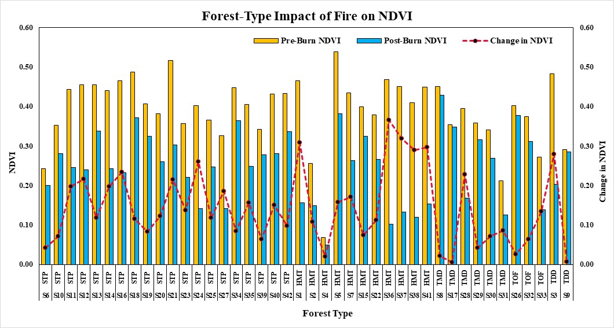

(a)

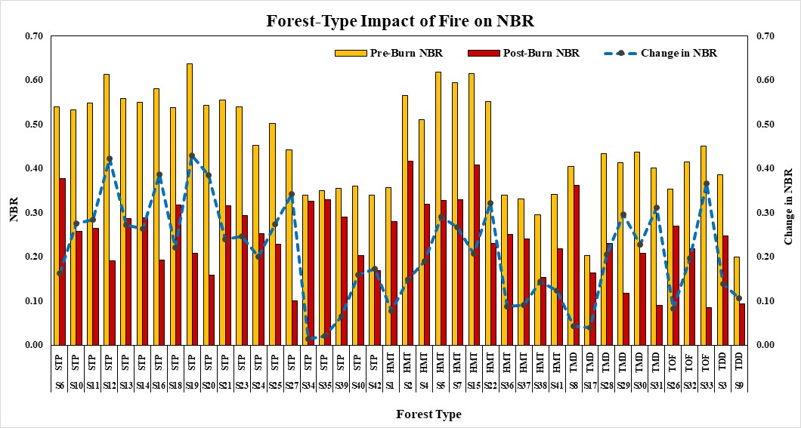

(b)

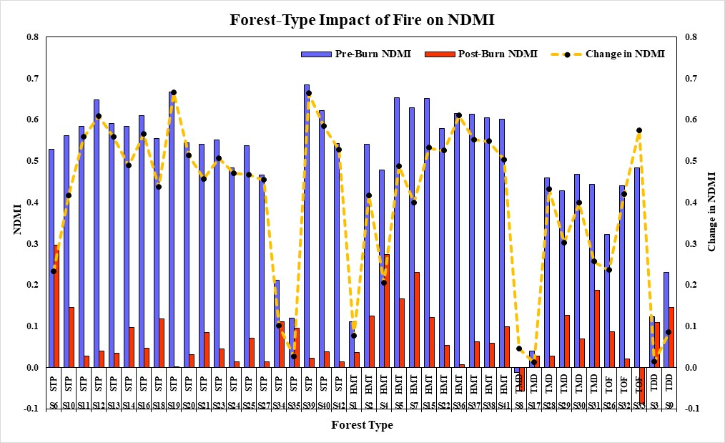

(c)

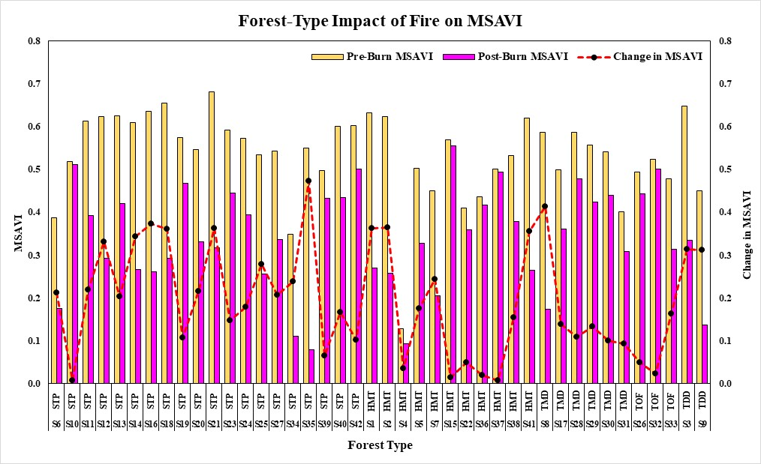

(d)

**Fig. 2 Spectral Indices changes over forest type and sites: pre- and post-fire, and change in vegetative indices. The plots represent 4 vegetative indices values for the pre, post fire and change in VI of all sites (a) Forest type impact of fire on NDVI (b) Forest type impact of fire on NBR (c) Forest type impact of fire on NDMI (d) Forest type impact of fire on MSAVI**

**3.2 Response of M-Statistics and Statistics Summary**

Table 3 exhibited a separability index (M-statistic) for the four VI, and Figure 3 exhibited a statistical summary for vegetative indices. The four vegetation Indices for 42 burnt sites of Uttarakhand react differently to forest fire and show dissimilar patterns. These patterns can be observed in the VI trajectories and can be quantified by comparing the values of the *M*-statistic. Among them, we can notice that STP and HMT tend to be more affected by forest fire. This pattern is found in all the VI. All plots were burned during the dry season between 2019 and 2020, which is described as one of the most severe forest fires in Uttarakhand. The extreme climate conditions had a significant impact on vegetation and soils, such as pronounced decreases in moisture content. The primary cause of forest fires in Uttarakhand is the accumulation of dry biomass from pine trees, which is highly flammable. This dry matter acts as a potent fuel, making it easier for fires to ignite and spread rapidly. The situation is further aggravated during the dry season, characterised by heatwaves and rising temperatures, which create ideal conditions for forest fires to occur.

The M-statistics for the spectral indices NDVI, NBR, NDMI, and MSAVI give more insight on their separability and also their effectiveness in assessing the vegetation’s overall change due to fire. Immediately after the fire incident, as observed over the 42 burnt sites, NDMI was found to change greatly from a mean of 0.142 before the fire to a mean of 0.994 after the fire. The very high value of M (1.55) that measures separability indicates that NDMI has increased capacity to detect changes in moisture content and assess fire severity. This is consistent with its use in estimating post-fire increase or decrease in moisture content. NBR which was developed specifically to measure fire severity, also had very good separability with a magnitude of change of 1.05. Its performance underscores its reliability in locating and mapping of burn areas and burn severity accurately. MSAVI, which adjusts for soil background impacts, also performed well by M value of 0.88, which means moderate sensitivity to changes in vegetation due to fire in sparse/soil-dominated areas. On the other hand, NDVI showed an M value of 0.81, and this can be explained as good separation for areas characterised by vegetation being lost and recovering being strong. NDVI's sensitivity to green vegetation highlights its role in capturing the initial reduction in biomass and subsequent regrowth. Overall, the various indices showed degrees of separability and ecological sensitivity, with NDMI outperforming better than the other indices moisture content detection, and NBR did much better in terms of mapping the burn severity index. The computed M-statistics validate the selection of these indices for post-fire impact assessment, which findings have earlier been reported by Key and Benson (2006) that emphasise their usability in fire-prone ecosystems. Together, these indices augment the understanding of fire behaviour and the pattern of recovery of the affected ecosystems.

The graph illustrates the statistical data for vegetative indices denoted as NDVI, NBR, NDMI and MSAVI with respect to six measures of central tendency: i.e. mean, standard deviation, sample variance, coefficients of skewness and kurtosis, including confidence level. The mean NDVI is low (0.14), implying negative kurtosis of -0.55, which means that such a distribution has thin tails. The NBR best performed, demonstrating the greatest range and also the highest skewness at 0.55. This signifies that the results are variable and asymmetrical. NDMI has a skewness of 0.47, which is just a moderate coefficient; therefore, other factors must be considered. NDMI shows low (-0.28) kurtosis of which leans on a slightly skewed distribution. MSAVI returns the best value of the coefficient of skewness at 0.26 and extreme -1.00 for the coefficient of kurtosis; this essentially means that heavy-tailed data is expected. Based on the statistical description, NBR appears to be the most effective for distinguishing burn severity due to its high variance and skewness, which signify its sensitivity to changes in burn severity conditions.

**Table 3. Separability Index (*M*-statistic) for the Four Vegetative indices**

|  |  |  |  |
| --- | --- | --- | --- |
| **M-Statistic- 42 Burnt Sites (Mean)** | | | |
| **Spectral Index** | **Pre-Fire** | **Post-Fire** | **Changes in VI** |
| NDVI | 0.050 | 0.130 | 0.81 |
| NBR | 0.061 | 0.116 | 1.05 |
| NDMI | 0.142 | 0.994 | 1.55 |
| MSAVI | 0.035 | 0.124 | 0.88 |

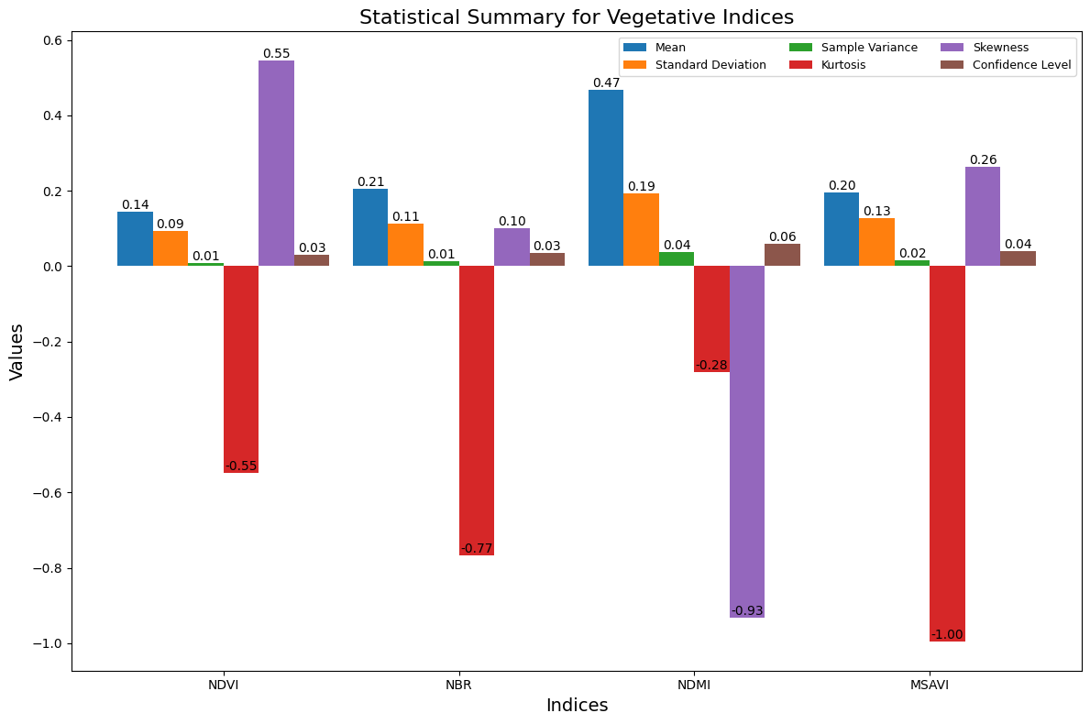

**Fig. 3 Statistical summary for vegetative indices**

1. **CONCLUSION**

This study provides an in-depth analysis of the effects of forest fires on vegetation health, burn severity, and moisture content across different sites and forest types. The study evaluates four important vegetative indices, including MSAVI, NDMI, NBR, and NDVI, to assess the spatial and temporal dynamics of ecosystems impacted by fire. The analysis revealed significant differences in vegetation indices before and after the fire occurrences. We observed a significant decline in NDVI values, which reflect vegetation greenness, which was consistently seen across all the sites. The greatest loss was found in the Himalayan moist temperate (HMT) forests, indicating destructive vegetation damage at these sites. NBR applied to mapping burn severity also shows a significant decline, especially in STP and Tree Outside Forest (TOF) sites, showing higher values, indicating regions of destructive fire impact. NDMI, as a measure of soil moisture content, revealed drastic alterations after the fire, particularly in STP forests, indicating the impact of fires on soil moisture. MSAVI, as a well-known implicit, which is sensitive to vegetation cover and bare soil, also displayed a sharp reduction in STP sites, thus confirming the extensive impact on the forest ecosystem. Statistical analysis, including M-statistics and data analysis, revealed that NDMI was the most sensitive index to post-burn moisture changes, while NBR was the most reliable index capable of predicting burn scars. Having higher application in the assessment of vegetation cover loss and extent of the burn area, respectively, and NDMI being superior in the estimation of the moisture content. . These observations suggest that the application of these indices complements each other in the post-fire evaluation and management of forest resources. In this way complement each other in the case of how best to plan the rehabilitation efforts.

This research shows the interesting relationship between vegetation burning, burn severity caused by forest fires and soil moisture of diverse forest ecosystems. Aspects of vegetative change caused by fire could be evaluated with NDVI, NBR, NDMI, and MSAVI as vegetation health indicators. Among the indices, NDMI was the most sensitive to moisture deficiency that followed the fire, and NBR was relatively the most appropriate for burn severity mapping, especially in STP and HMT forests, which were the most affected. Different index values, which were obtained after the fire in the forest indicate that fire has different effects in different forest types. STP forests were the worst damaged, with the most vegetation cover and moisture loss. The usage of the indices was confirmed in the statistical analysis. NBR performed well for burn severity analysis with a high degree of separability, while MSAVI did well when changes in vegetation were detected. Overall, the study highlights the importance of using multiple indices to gain a holistic understanding of fire impact assessments and in the design of strategies for rehabilitation, monitoring and management of the forests after forest fire. These findings point towards increasing recognition of the need for distinct strategies for forest management and restoration, taking into consideration the different levels of damage inflicted by fire to various forest types.

**CONSENT (WHERE EVER APPLICABLE)**

NOT AVAILABLE (N.A.)

**ETHICAL APPROVAL (WHERE EVER APPLICABLE)**

NOT AVAILABLE (N.A.)

**Disclaimer (Artificial intelligence)**

Author(s) hereby declare that NO generative AI technologies such as Large Language Models (ChatGPT, COPILOT, etc.) and text-to-image generators have been used during the writing or editing of this manuscript.

**REFERENCES**

Andreae, M. O., & Merlet, P. (2001). Emission of trace gases and aerosols from biomass burning. *Global biogeochemical cycles*, *15*(4), 955-966.

Bora, K., Borah, N., Bose, S., Goswami, J., & Kashyap, P. J. (2025). NDVI-Based Geospatial Analysis of Forest Cover Alterations in Daldali Reserve Forest, Assam, India. *Asian Journal of Geographical Research*, *8*(1), 61-72.

Chafer, C. J., Noonan, M., & Macnaught, E. (2004). The post-fire measurement of fire severity and intensity in the Christmas 2001 Sydney wildfires. *International Journal of Wildland Fire*, *13*(2), 227-240.

Champion, H. G., & Seth, S. K. (1968). *A revised survey of the forest types of India*. Manager of publications.

De Santis, A., & Chuvieco, E. (2007). Burn severity estimation from remotely sensed data: Performance of simulation versus empirical models. *Remote Sensing of Environment*, *108*(4), 422-435.

De Santis, A., Asner, G. P., Vaughan, P. J., & Knapp, D. E. (2010). Mapping burn severity and burning efficiency in California using simulation models and Landsat imagery. *Remote Sensing of Environment*, *114*(7), 1535-1545.

Elakiya, N., Keerthana, G., & Safiya, S. (2023). Effects of forest fire on soil properties. *International Journal of Plant & Soil Science*, *35*(20), 8-17.

Epting, J., Verbyla, D., & Sorbel, B. (2005). Evaluation of remotely sensed indices for assessing burn severity in interior Alaska using Landsat TM and ETM+. *Remote sensing of environment*, *96*(3-4), 328-339.

Forest Survey of India. (2015). India State of Forest Report. MOEF, Govt. of India.

Forest Survey of India. (2019). India State of Forest Report. MOEF, Govt. of India.

Forest Survey of India. (2021). India State of Forest Report. MOEF, Govt. of India.

French, N. H., Kasischke, E. S., Hall, R. J., Murphy, K. A., Verbyla, D. L., Hoy, E. E., & Allen, J. L. (2008). Using Landsat data to assess fire and burn severity in the North American boreal forest region: an overview and summary of results. *International Journal of Wildland Fire*, *17*(4), 443-462.

Garcia, M. L., & Caselles, V. (1991). Mapping burns and natural reforestation using Thematic Mapper data. *Geocarto International*, *6*(1), 31-37.

Huete, A. R. (1988). A soil-adjusted vegetation index (SAVI). *Remote sensing of environment*, *25*(3), 295-309.

ICFRE, (2013). Forest Types of India: Revisited, Indian Council of Forestry Research and Education, Dehradun, India, pp. 484

ICFRE, (2013). Satellite based assessment of fire severity and validation in Uttarakhand.

Key, C. H., & Benson, N. C. (2006). Landscape assessment (LA). *In: Lutes, Duncan C.; Keane, Robert E.; Caratti, John F.; Key, Carl H.; Benson, Nathan C.; Sutherland, Steve; Gangi, Larry J. 2006. FIREMON: Fire effects monitoring and inventory system. Gen. Tech. Rep. RMRS-GTR-164-CD. Fort Collins, CO: US Department of Agriculture, Forest Service, Rocky Mountain Research Station. p. LA-1-55*, *164*.

Koutsias, N., & Karteris, M. (2000). Burned area mapping using logistic regression modeling of a single post-fire Landsat-5 Thematic Mapper image. *International Journal of Remote Sensing*, *21*(4), 673-687.

Lasaponara, R. (2006). Estimating spectral separability of satellite derived parameters for burned areas mapping in the Calabria region by using SPOT-Vegetation data. *Ecological Modelling*, *196*(1-2), 265-270.

Libonati, R., DaCamara, C. C., Pereira, J. M. C., & Peres, L. F. (2011). On a new coordinate system for improved discrimination of vegetation and burned areas using MIR/NIR information. *Remote Sensing of Environment*, *115*(6), 1464-1477.

Melchiori, A. E., Candido, P. A., Libonati, R., Morelli, F., Setzer, A., de Jesus, S. C., & Korting, T. S. (2015). Spectral indices and multi-temporal change image detection algorithms for burned area extraction in the Brazilian Cerrado. *Anais XVII Simpsio Brasileiro de Sensoramiento Remoto, Joao Pessoa-PB, Brasil*.

Miller, J. D., & Thode, A. E. (2007). Quantifying burn severity in a heterogeneous landscape with a relative version of the delta Normalized Burn Ratio (dNBR). *Remote sensing of Environment*, *109*(1), 66-80.

Negi, G. C. S. (2019). Forest fire in Uttarakhand: causes, consequences and remedial measures. *International Journal of Ecology and Environmental Sciences*, *45*(1), 31-37.

Ochtyra, A., Marcinkowska-Ochtyra, A., & Raczko, E. (2020). Threshold-and trend-based vegetation change monitoring algorithm based on the inter-annual multi-temporal normalized difference moisture index series: A case study of the Tatra Mountains. *Remote Sensing of Environment*, *249*, 112026.

Qi, J., Chehbouni, A., Huete, A. R., Kerr, Y. H., & Sorooshian, S. (1994). A modified soil adjusted vegetation index. *Remote sensing of environment*, *48*(2), 119-126.

Quintano, C., Fernández-Manso, A., & Roberts, D. A. (2013). Multiple Endmember Spectral Mixture Analysis (MESMA) to map burn severity levels from Landsat images in Mediterranean countries. *Remote Sensing of Environment*, *136*, 76-88.

Rogan, J., & Yool, S. R. (2001). Mapping fire-induced vegetation depletion in the Peloncillo Mountains, Arizona and New Mexico. *International Journal of Remote Sensing*, *22*(16), 3101-3121.

Rouse, J. W., Haas, R. H., Schell, J. A., & Deering, D. W. (1974). Monitoring vegetation systems in the Great Plains with ERTS. *NASA Spec. Publ*, *351*(1), 309.

Schepers, L., Haest, B., Veraverbeke, S., Spanhove, T., Borre, J. V., & Goossens, R. (2014). Burned area detection and burn severity assessment of a heathland fire in Belgium using airborne imaging spectroscopy (APEX). *Remote Sensing*, *6*(3), 1803-1826.

Simmonds, P. G., Manning, A. J., Derwent, R. G., Ciais, P., Ramonet, M., Kazan, V., & Ryall, D. (2005). A burning question. Can recent growth rate anomalies in the greenhouse gases be attributed to large-scale biomass burning events. *Atmospheric Environment*, *39*(14), 2513-2517.

Smith, A. M. S., Drake, N. A., Wooster, M. J., Hudak, A. T., Holden, Z. A., & Gibbons, C. J. (2007). Production of Landsat ETM+ reference imagery of burned areas within Southern African savannahs: comparison of methods and application to MODIS. *International Journal of Remote Sensing*, *28*(12), 2753-2775.

Van der Werf, G. R., Randerson, J. T., Giglio, L., Collatz, G. J., Kasibhatla, P. S., & Arellano Jr, A. F. (2006). Interannual variability in global biomass burning emissions from 1997 to 2004. *Atmospheric Chemistry and Physics*, *6*(11), 3423-3441.

Veraverbeke, S., & Hook, S. J. (2013). Evaluating spectral indices and spectral mixture analysis for assessing fire severity, combustion completeness and carbon emissions. *International journal of wildland fire*, *22*(5), 707-720.

Veraverbeke, S., Gitas, I., Katagis, T., Polychronaki, A., Somers, B., & Goossens, R. (2012). Assessing post-fire vegetation recovery using red–near infrared vegetation indices: Accounting for background and vegetation variability. *ISPRS Journal of Photogrammetry and Remote Sensing*, *68*, 28-39.

Veraverbeke, S., Harris, S., & Hook, S. (2011). Evaluating spectral indices for burned area discrimination using MODIS/ASTER (MASTER) airborne simulator data. *Remote Sensing of Environment*, *115*(10), 2702-2709.

White, J. D., Ryan, K. C., Key, C. C., & Running, S. W. (1996). Remote sensing of forest fire severity and vegetation recovery. *International Journal of Wildland Fire*, *6*(3), 125-136.

Wilson, E. H., & Sader, S. A. (2002). Detection of forest harvest type using multiple dates of Landsat TM imagery. *Remote Sensing of Environment*, *80*(3), 385-396.