**Genotype × Environment interaction of elite mulberry genotypes in different seasons for vegetative and fruit traits**

**Abstract**

An investigation was undertaken to study the Genotype × Environment interaction of elite mulberry genotypes across different seasons at Department of Sericulture, UAS, GKVK, Bengaluru during 2023-24. Analysis of variance revealed that significant differences among mulberry genotypes for traits such as number of leaves per plant at 30 DAP, leaf yield per plant, complete flowering duration, inflorescence length, number of fruits per plant, fruit weight, fruit width and fruit yield per plant across three seasons. Similarly, environmental variance was significant for all characteristics except for the number of days required for fruit formation. Significant G × E interaction variance was observed for most of the traits across the three seasons, with the exception of internodal distance at 60 DAP, number of branches per plant at 30 and 60 DAP, single leaf area (cm²) at 30 DAP, total shoot length at 60 DAP, number of days to first flower initiation, inflorescence breadth, fruit length, fruit width and fruit weight. Therefore, both genotype and environment significantly influence most mulberry traits, with notable G × E interactions indicating that trait expression varies across environments.

**Keywords:** *G × E interactions; Seasons; Mulberry genotypes;* *traits; Significant*

1. **Introduction**

Sericulture is an important agro-based cottage industry, where the convergence of art, agriculture and industry occurs. Mulberry (*Morus* spp.) is a rapidly growing, woody, deciduous and perennial plant primarily cultivated as the only host for rearing the domesticated silkworm, *Bombyx mori* L. It has a deep root system, the leaves are alternate, simple, stipulate, entire or lobed, petiolate (Sinha, 2008). The inflorescence, which bears unisexual flowers, resembles a catkin with a drooping or pendulous peduncle. The mulberry plant produces tiny syncarps as its fruits, fleshy, and succulent, with an oval shape and a soft texture, consisting of multiple drupes. Fruit colours varies from dark purple, red or black to white or pale yellow, depending on the species and level of ripeness (Sushmitha et al., 2024; Fatima et al., 2025).

Phenotype results from the interaction between genotype and environment. A specific genotype may not display the same phenotypic traits across different seasons. This variation caused by the disparity between genetic and environmental effects is referred to as genotype-environment interaction. However, GE interaction can introduce significant bias in these estimates, complicating the assessment of a variety's potential to maintain stable performance across varying environments. Therefore, studying G × E interaction and phenotypic stability is vital not only for obtaining unbiased estimates of genetic variation across different traits but also for identifying varieties with low G × E interaction. Varieties with low G × E interaction will demonstrate greater stability, while those with high G × E interaction will be more unstable when cultivated in variable environments.

Eberhart and Russell (1966) made additional modifications to the Finlay and Wilkinson model. This model states that an estimate of the intended stability parameters can be obtained by regressing the variety mean on the environmental index and calculating a result of the squared deviations from this regression. A variety that exhibits consistent performance across all settings has been referred to as a stable variety.

Stability in mulberry over a wide range of environments is one of the most desirable parameters to be considered for selecting a mulberry for large scale cultivation. Sarkar *et al*., and Bari *et al*., have emphasized that knowledge of the nature and relative magnitude of the genotype × environment interaction has great importance for selecting superior genotypes to be used commercially in diverse environmental conditions. Leaf yield of mulberry fluctuates with the season due to sensitivity of the genotypes to growing conditions. A genotype x environment interaction exists where the relative performance of varieties changes from environment to environment. Exploitation of G x E interaction may prove useful in identifying stable genotypes for different environmental conditions.

The present study has been undertaken to know the impact of genotype x season interaction for growth and yield parameters of elite mulberry genotypes in different seasons.

1. **Material and methods**

The experimental material for the present study comprised eight elite mulberry genotypes for fruit purposes *viz.,* *Morus indica,* *M. cathayana,* *M. latifolia,* *M. macroura,* *M. alba,* *M. multicaulis,* *M. indica* (S-34)and *M. indica* (M-5) Standard check which were selected from the germplasm unit maintained at the Department of Sericulture, UAS, GKVK, Bengaluru. These eight elite mulberry genotypes maintained in the main field with spacing of 4 x 4 feet in a randomized complete block design with three replications. The garden is two years old and maintained at four feet shoot height. The experimental site was located in the Eastern Dry Zone (Zone-5) of Karnataka at coordinates 13°08' N latitude and 77°34' E longitude, situated at an altitude of 930 m above mean sea level. The experimental plot is maintained as per the recommended package of practices for rain-fed mulberry (Dandin and Giridar 2010). The genotypes were evaluated 30th on 60th day after pruning for different vegetative and fruit parameters during winter, summer and rainy season. The mean data of each genotype for each season were subjected to analysis of variance in order to study the genotype × season interaction and genotypes stability following the Eberhart and Russell model (1966) by using linear regression model. The performance of each genotype were evaluated by selecting five competitive plants in each replication for recording different vegetative and fruit traits at three different seasons.

**Table 1: List of elite mulberry genotypes and their accession number used in the study**

|  |  |  |  |
| --- | --- | --- | --- |
| **Treatments** | **Genotypes/scientific name** | **Accession number** | **National accession number** |
| T1 | *Morus indica* | MI-0516 | IC-314082 |
| T2 | *M. cathayana* | ME-0018 | EC-493775 |
| T3 | *M. latifolia* | ME-0067 | EC-493765 |
| T4 | *M. macroura* | ME-0220 | EC-493947 |
| T5 | *M. alba* | ME-0086 | EC-493843 |
| T6 | *M. multicaulis* | ME-0006 | EC-493763 |
| T7 | *M. indica* (S-34) | MI-0160 | IC-313779 |
| T8 | *M. indica* (M-5)- Standard check | MI-0014 | IC-313679 |

**Table 2: Various F ratios were calculated,**

i) To test the significance differences among the genotype means: F=MS1/ MS4

|  |  |  |  |  |
| --- | --- | --- | --- | --- |
| **Source of variance** | **d.f** | **Sum of squares** | **Mean squares** | **F-ratios** |
| Total | nv-1 | ∑i∑j Y2ij-C. F (TSS) | -- |  |
| Genotype | (v-1) | -C F (GSS) | MS1 |  |
| Environment | (n-1) | $$\sum_{j}{JY^{2}/v-C.F (ESS)}$$ | -- | -- |
| Genotype× Environment | (v-1) (n-1) | TSS-GSS-ESS | MS2 |  |
| Environment+ Genotype × Environment (Linear) | v(n-1) | ∑i∑jY2ij-Yi2/n | -- | _ |
| Environment (Linear) | 1 | 1/v(∑jYjI2j)/∑jI2j |  |  |
| G ×E (Linear) | (v-1) | (∑jYijIj)2/∑jI2j-Env (linear)S.S. | MS3 |  |
| Pooled deviation | v(n-2) | ∑i∑jδ2ij | MS4 |  |
| Genotype I | (n-2) | ∑jY2ij-(Yi)2/n-∑j(YijIj)2/∑jI2j | Md1 |  |
| Genotype V | (n-2) | ∑jY2vj-(Yj2/n-∑j(YvjIj)2/∑jI2j-∑δ2vj |  |  |
| Pooled error | Nv (r-1) (v-1) |  | MS5 |  |

n=number of environments r=number replications v=number of genotypes C.F.=Correction Factor.

1. To test the genetic differences among genotypes for their regression on the environment index: F= (MS3/MS4)
2. To test the deviation from regression for each genotype: F= {∑jδij2) S-2}/MS5

In this model the total sum of squares (SS) has been partitioned into (i) SS due to genotype (ii) SS due to environment, Genotype x Environment (linear) and iii) pooled error. Further, the sum of squares due to environment plus Genotype x Environment (linear) has been partitioned into (a) SS due to environment (linear), (b) SS due to environment (linear) and (c) pooled deviation. Again, the SS due to pooled deviation was divided into deviation from regression due to each (ith) genotype (i=1, 2……v)

The regression co-efficient (βi) were examined for their significance of deviation from value by employing “t”-test.

t=1-βi / SEβi

SEβi= [∑jδ2ij/n-2)/∑jIj2]1/2

1. **Results and discussion**
   1. **Analysis of variance for vegetative traits for eight elite mulberry genotypes** **in three seasons**

The mean data recorded in eight mulberry genotypes for different character in three seasons (winter 2023, summer and rainy of 2024) were examined separately to determine the variation in mulberry genotypes, which is explained in Table 3. The study revealed that magnitudes of genotype x season interaction as well as the influence of season on genotypes were assessed for all the characters over season by using the pooled data over environments. Analysis of variance revealed that significance of mean sum of squares due to season for all observable characteristics, including total shoot length, number of branches per plant, internodal distance, number of leaves per plant, single leaf area and leaf yield per plant. The mean sum of squares due to genotype × season was significant for leaf yield and number of leaves per plant at 30 DAP.

Further, it was found that the internodal distance (cm) for both 30 and 60 DAP, total shoot length, number of branches per plant, number of leaves per plant, and leaf yield per plant significantly variations due to season (linear). Similarly, for internodal distance at 30 DAP, number of leaves per plant at 30 and 60 DAP, single leaf area at 60 DAP, total shoot length at 30 DAP and leaf yield per plant were recorded significance variance due to genotype × season (linear). Whereas the pooled variation was significant for number of branches per plant at 60 DAP, total shoot length at 60 DAP, internodal distance at 30 DAP and single leaf area (cm2) at 30 DAP (Table 3).

These results are corroborate with those of earlier studies conducted by Chakravorthy *et al*. (2012) who proposed that interaction between cultivars and the additive environment had a major impact on leaf yield and all growth metrics for the total shoot length (cm), leaf yield (g) and number of leaves per plant. Similarly, Ahalya *et al*. (2022) reported that the seasons had a major effect on the mean squares. The analysis of variance data revealed a strong seasonal connection in the mean sum of squares for the number of branches per plant, number of leaves per plant, leaf yield per plant and area of a single leaf.

According to Sushmitha and Murali (2024) different mulberry hybrids have differing leaf yields per plant from season to season

* 1. **Analysis of variance for reproductive traits of elite mulberry genotypes in three seasons**

The mean data recorded in eight mulberry genotypes for different characters in each season were analyzed individually to find out the differences among the mulberry genotypes as explained in Table 4. Analysis of variance indicated that significance of mean sum of squares due to season recorded for all the traits *viz*., number of days required for first flower initiation, complete flower duration, length of inflorescence and breadth of inflorescence. The mean sum of squares due to genotype × season was significant for complete flower duration and length of inflorescence. The variance due to season (linear) was significant for number of days required for first flower initiation, complete flower duration, length of inflorescence and breadth of inflorescence. Whereas variance due to Genotype × Season (linear) was significant for complete flower duration and length of inflorescence. The pooled deviation was significant for number of days required for first flower initiation.

The results of this study corroborate with those of earlier studies by Rahman *et al*. (2015) who reported the strawberry genotypes for significant mean squares that showed a difference between places due to environments (linear). With the exception of days to flowering, all of the characteristics genotype × environment interactions were found to be significant.

* 1. **Analysis of variance for fruit traits of elite mulberry genotypes in three seasons**

The mean data obtained in eight mulberry genotypes for different character in each season were analyzed individually to find out the differences among the mulberry genotypes (Table 5). The analysis of variance recorded significant mean sum of squares for the season across all traits, including the number of days required for fruit formation, fruit length, fruit width, fruit weight, number of fruits per branch, number of fruits per plant and fruit yield per plant. The genotype × season interaction was significant for fruit width, fruit weight and number of fruits per plant, but non-significant for the number of days required for fruit formation, fruit length, number of fruits per branch and fruit yield per plant. Additionally, the variance due to season(linear) was significant for all traits except for the number of days required for fruit formation. The Genotype × Season (linear) interaction was significant for all traits, except for the number of days required for fruit formation. The pooled deviation was significant for the number of days required for fruit formation, number of fruits per branch, number of fruits per plant and fruit yield per plant.

Similar findings were obtained by Rahman *et al*. (2015) who reported significant genotype × environment interaction which showed the inconsistency of performance of strawberry genotypes across the environments. Most of the fruit traits were found significant for the pooled deviation and non-significant for the traits which indicated the stability of the genotypes with different locations.

1. **Conclusion**

Analysis of variance indicated significance of mean sum of squares due to season for all the characters. Analysis of variance for mean sum of squares due to genotype × season was non significant for almost all the characters except Number of leaves per plant at 30 DAP, Complete flower duration, Length of inflorescence(cm), Fruit width (cm), Fruit weight (g) and Number of fruits per plant. Further, it could be observed that variance due to seasons (linear) were significant for almost all the characters except number of days required for fruit formation. Genotype × Season (linear) significant for almost all the characters. pooled analysis of mean squares due to seasons was non significant for almost all the characters.

**DISCLAIMER (ARTIFICIAL INTELLIGENCE):**

Author(s) hereby declare that NO generative AI technologies such as Large Language Models (ChatGPT, COPILOT, etc) and text-to-image generators have been used during writing or editing of manuscripts.

1. **References**

Ahalya., Chikkalingaiah., Jayaramu, H. D., & Chandrashekar, S. (2022). Genotype × Environmental interaction for growth and yield parameters of tree mulberry genotypes in different seasons. *International Journal of Environment and Climate change*, **10**(12), 6-12.

Chakraborthy, R., Neog, K., Talukdar, P. (2012). Studies on phenotypic stability and Genotype × Environment interaction of thirteen mulberry varieties under the agro climaic conditions of Assam. Annual Report, CMR& TI, CSB Lahdoigarh Jorhat.105-108.

Dandin, S. B., & Giridhar, K. (2010). Hand book of sericulture technologies, CSB publications, P.13.

Eberhart, S. F., Russel, W. A. (1966). Stability parameters for comparing varieties. *Crop Science.,* 6: 36-40.

Rahman, M. M., Rahman, M. M., Mian, M. A. K., & Islam, M. A. (2015). G×E Interaction for Growth, Yield and Quality Characters of Strawberry (*Fragaria ananassa* Duch.) under Bangladesh Conditions: Genotype Environment Interaction of Strawberry. *Biological Science, PJSIR.*, 58(1), 11-18.

Sushmitha, C., & Murali, K. (2024). Genetic variability for mulberry fruit traits in different mulberry accessions (*Morus* spp.) *Journal of Advanced Biology*, 27(5), 471-480.

Sushmitha, C., Marappa, N., & Murali, K. (2024). Genotype x Environmental Interaction for Growth and Yield Parameters of Elite Mulberry Hybrids in Different Seasons. *Mysore Journal of Agricultural Sciences*, *58*(4).

Fatima, S., Kaveri, A., & Vasantha, K. R. (2025). Performance of Eight Elite Mulberry Genotypes for Different Growth and Leaf Yield Parameters in Different Seasons and Their Stability. *Journal of Advances in Biology & Biotechnology*, *28*(1), 536-557.

|  |  |  |  |  |  |  |  |  |  |  |  |  |  |
| --- | --- | --- | --- | --- | --- | --- | --- | --- | --- | --- | --- | --- | --- |
| **Sl.no** | **Source of variations** | **Mean sum of squares due to** | | | | | | | | | | | |
| **d.f** | **Internodal distance (cm)** | | **Number of branches per plant** | | **Number of leaves per plant** | | **Single leaf area (cm2)** | | **Total shoot length (cm)** | | **Leaf yield/plant (g/kg)** |
|  | **30 DAP** | **60DAP** | **30DAP** | **60DAP** | **30DAP** | **60DAP** | **30DAP** | **60DAP** | **30DAP** | **60DAP** |
| **1.** | **Replication with in season** | 6 | 0.014 | 0.013 | 0.009 | 0.018 | 1.805 | 3.183 | 2.217 | 13.560 | 0.492 | 0.913 | 19.407 |
| **2.** | **Genotypes (G)** | 7 | 2.164** | 1.946** | 3.944** | 3.881** | 1449.860** | 1595.774** | 1658.013** | 2089.989** | 438.466** | 846.616** | 12992.770** |
| **3.** | **Seasons+**  **(G × S)** | 16 | 0.242** | 0.055** | 0.916** | 0.912** | 305.036** | 217.152** | 223.892** | 350.525** | 52.908** | 107.103** | 1940.806** |
| **4** | **Seasons** | 2 | 1.737** | 0.371** | 6.435** | 6.406** | 2388.757** | 1658.094** | 1691.347** | 2550.297** | 393.292** | 815.425** | 14737.950** |
| **5** | **G × S** | 14 | 0.028 | 0.010 | 0.127 | 0.127 | 7.361* | 11.303 | 14.256 | 36.272 | 4.282 | 5.014 | 112.642** |
| **6** | **Seasons (Lin)** | 1 | 3.473** | 0.741** | 12.871** | 12.812** | 4777.514** | 3316.188** | 3382.695** | 5100.594** | 786.585** | 1630.850** | 29475.900** |
| **7** | **G × S (Lin)** | 7 | 0.042* | 0.010 | 0.181 | 0.168 | 12.496** | 18.140* | 17.047 | 58.060* | 6.624* | 7.153 | 211.229** |
| **8** | **Pooled deviation** | 8 | 0.012* | 0.009 | 0.065 | 0.075* | 1.948 | 3.909 | 10.031** | 12.674 | 1.697 | 4.091* | 12.299 |
| **9** | **Pooled Error** | 42 | 0.005 | 0.007 | 0.031 | 0.029 | 2.327 | 3.876 | 2.228 | 8.286 | 1.094 | 1.771 | 16.072 |

**Table 3. Analysis of variance for vegetative traits of elite mulberry genotypes in three different seasons**

*Significant @ 5%, ** Significant @1%, DAP: days after pruning

**Table 4. Analysis of variance for reproductive traits of elite mulberry genotypes in three different seasons**

|  |  |  |  |  |  |  |
| --- | --- | --- | --- | --- | --- | --- |
| **Sl.no.** | **Source of variations** | **Mean sum of squares due to** | | | | |
| **d.f** | **Number of days required for first flower initiation** | **Complete flower duration** | **Length of inflorescence(cm)** | **Breadth of inflorescence(cm)** |
| **1.** | **Replication with in season** | 6 | 0.042 | 0.065* | 0.001 | 0.048 |
| **2.** | **Genotypes (G)** | 7 | 5.828** | 12.44** | 0.398** | 0.324** |
| **3.** | **Seasons+ (G × S)** | 16 | 2.851** | 8.965** | 0.021** | 0.014** |
| **4** | **Seasons** | 2 | 21.818** | 68.427** | 0.130** | 0.075** |
| **5** | **G × S** | 14 | 0.141 | 0.470** | 0.006* | 0.005 |
| **6** | **Seasons (Lin)** | 1 | 43.635** | 136.854** | 0.260** | 0.151** |
| **7** | **G × S (Lin)** | 7 | 0.159 | 0.924** | 0.009* | 0.007 |
| **8** | **Pooled deviation** | 8 | 0.108** | 0.014 | 0.002 | 0.002 |
| **9** | **Pooled Error** | 42 | 0.020 | 0.056 | 0.001 | 0.156 |

*Significant @ 5%, ** Significant @1%, DAP: days after pruning

**Table 5. Analysis of variance for fruit traits of elite mulberry genotypes in three different seasons**

|  |  |  |  |  |  |  |  |  |  |
| --- | --- | --- | --- | --- | --- | --- | --- | --- | --- |
| **Sl.no.** | **Source of variations** | **Mean sum of squares due to** | | | | | | | |
| **d.f** | **Number of days required for fruit formation** | **Fruit length (cm)** | **Fruit width (cm)** | **Fruit weight (g)** | **Number of fruits per branch** | **Number of fruits per plant** | **Fruit yield per plant (g)** |
| **1.** | **Replication with in season** | 6 | 0.195 | 0.118 | 0.063 | 0.013 | 0.004 | 0.959 | 4.980 |
| **2.** | **Genotypes (G)** | 7 | 26.069** | 1.297** | 0.445** | 0.689** | 1.839** | 364.207** | 1166.780** |
| **3.** | **Seasons+ (G × S)** | 16 | 23.612** | 0.030** | 0.016** | 0.048** | 0.964** | 245.730** | 2051.459** |
| **4** | **Seasons** | 2 | 181.701** | 0.221** | 0.112** | 0.365** | 6.972** | 1701.731** | 159466.040** |
| **5** | **G × S** | 14 | 1.028 | 0.002 | 0.003* | 0.003** | 0.106 | 37.729** | 66.520 |
| **6** | **Seasons (Lin)** | 1 | 363.461 | 0.442** | 0.223** | 0.731** | 13.945** | 3403.461** | 31892.080** |
| **7** | **G × S (Lin)** | 7 | 0.611 | 0.004* | 0.004* | 0.005** | 0.183** | 68.523** | 102.534* |
| **8** | **Pooled deviation** | 8 | 1.264** | 0.001 | 0.001 | 0.000 | 0.025** | 6.069** | 26.692** |
| **9** | **Pooled Error** | 42 | 0.250 | 0.084 | 0.067 | 0.044 | 0.008 | 0.715 | 5.117 |

*Significant @ 5%, ** Significant @1%, DAP: days after pruning

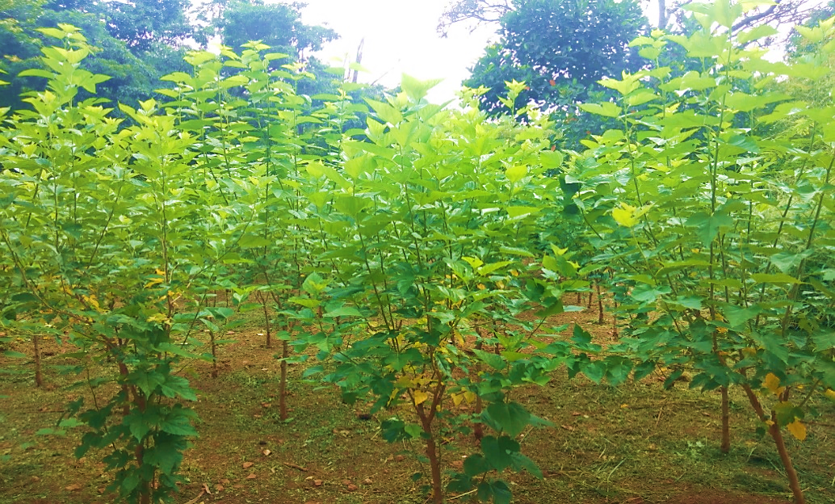

**Plate 1. General view of the experimental plot**

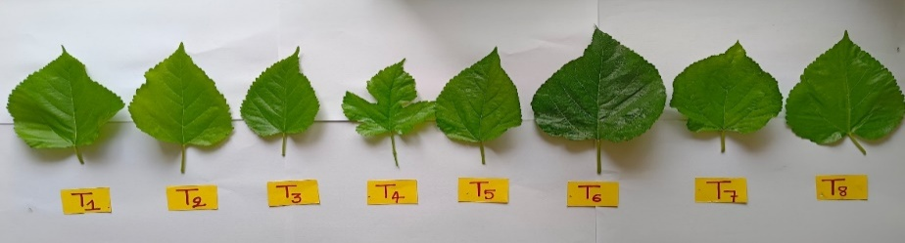

S1

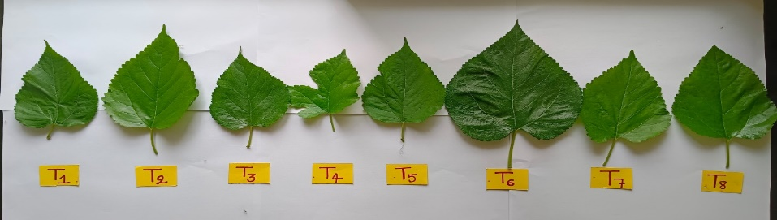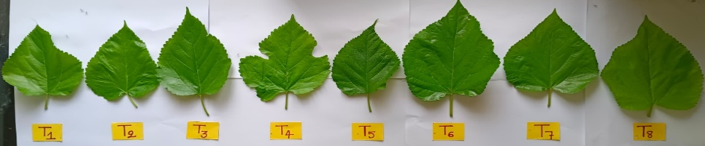

S2

S3

**Plate 2. Effect of different seasons on leaf size of different elite mulberry genotypes (S1, S2 and S3)**

S1=2023 winter season (Dec-Jan), S2=2024 Summer season (March-April) S3=2024 Rainy season (May-June)

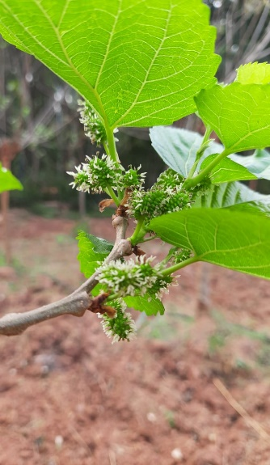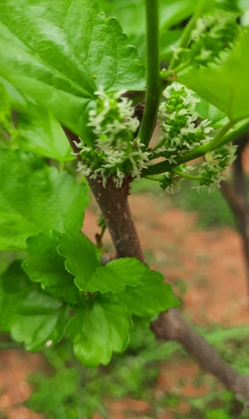

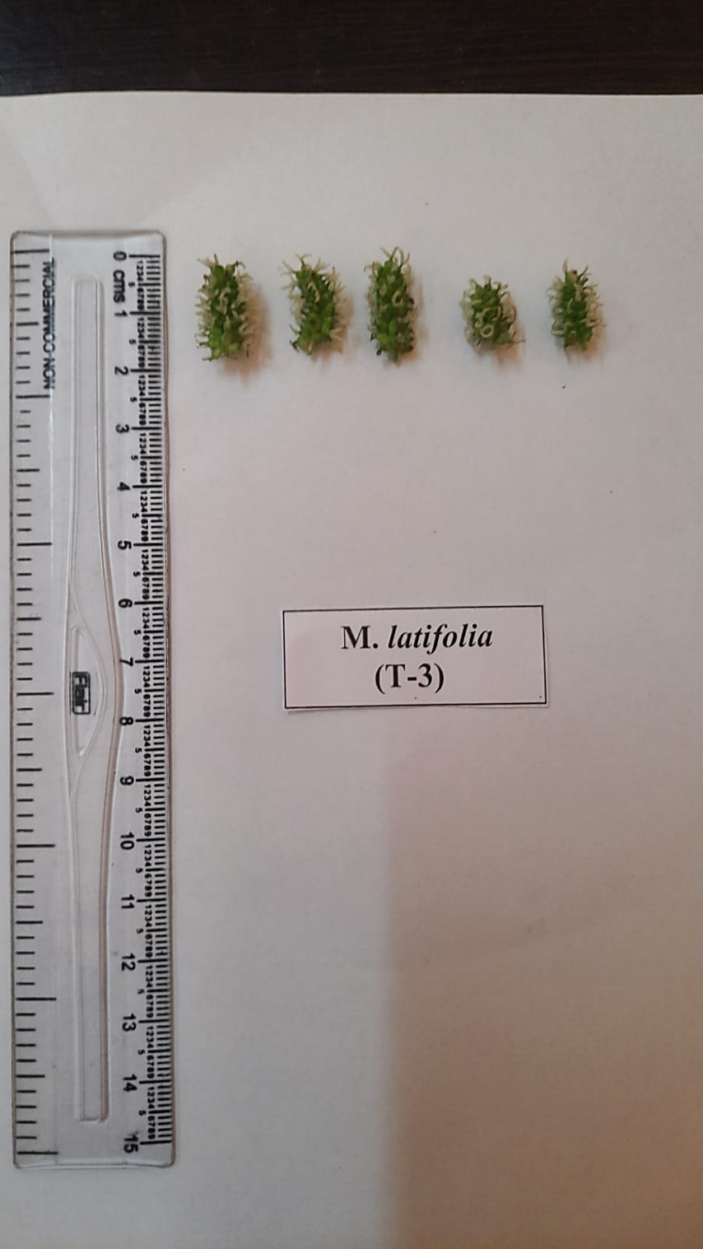

**Plate 3. Inflorescence of mulberry genotype ME-0006**

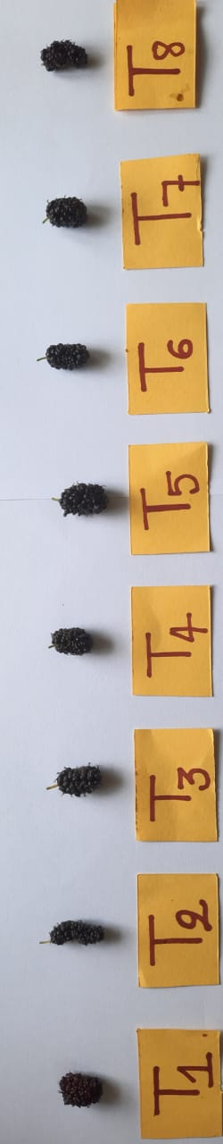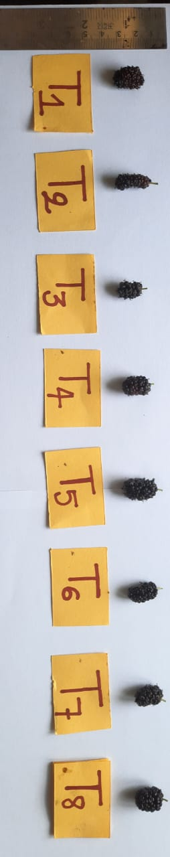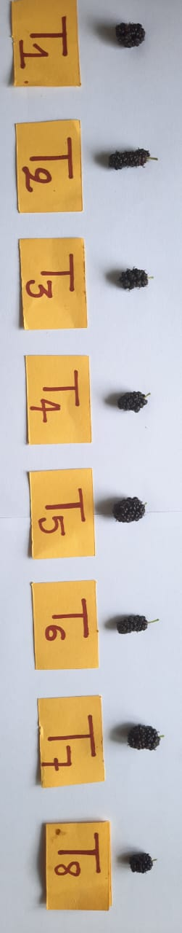

S1

S2

S3

**Plate 4. Effect of different seasons on fruit size of different elite mulberry genotypes (S1, S2 and S3)**

S1=2023 winter season (Dec-Jan), S2=2024 Summer season (March-April) S3=2024 Rainy season (May-June)