**Impact of Freeze-Drying Conditions on the Functional Properties of Probiotic Lactic Acid Bacteria and Methods to Assess their Viability**

**Abstract**

Fermented dairy products contain probiotic lactic acid bacteria (LAB), which are well known for their positive health effects such as enhancing host immunity and modifying the gut microbiota. Freeze-drying (lyophilization) is the favored technique for conserving these microorganisms. However, this presents significant obstacles to their viability and functionality. Therefore, we examined the influence of cryoprotectants and freeze-drying conditions on the shelf life and functional characteristics of LAB. Current advances in freeze-drying techniques for the preservation of probiotic lactic acid bacteria (LAB) from fermented dairy foods are discussed in this review. Freeze-drying processes need to be optimized to preserve the viability, functionality, and shelf life of probiotic bacteria. Cryoprotectant formulations, freeze-drying conditions, and their impact on probiotic properties, metabolic activity, and LAB survival were also reviewed. It also shows cryoprotectant effectiveness towards certain probiotics, the effect of freeze-drying treatment on the functional and metabolic characteristics of LAB, and finally explores methodological improvements towards assaying probiotic effectiveness following freeze-drying.

**Keywords**: Probiotics, freeze-drying, cryoprotectants, viability, functionality, fermented dairy foods, microencapsulation,

**1. Introduction**

Probiotic lactic acid bacteria (LAB) from fermented dairy foods have garnered significant attention in the functional food market because of their documented health benefits including enhanced gut health, immunomodulation, and metabolic regulation (Pacheco et al., 2023; Meena, Taneja, Jain, et al., 2023b). Key probiotic LAB genera include Lactobacillus, Bifidobacterium, and Streptococcus, which are naturally present in fermented dairy products (Meena, Joshi, et al., 2020; Meena et al., 2025). These gram-positive anaerobic cocci include strains such as *Streptococcus thermophilus*, *Lactococcus lactis*, and *Enterococcus lactis* (Meena, Taneja, Jain, et al., 2023a). Additionally, Propionibacterium spp., Bacillus spp., certain yeasts, fungi, and microbial enzymes also exhibit probiotic potential (Xie et al., 2023). LAB are used as probiotics because of their documented roles in cancer suppression, antidiabetic activity, allergy prevention, pathogen inhibition, cholesterol reduction, and enhancement of the gut microbiota balance (Meena, Taneja, et al., 2025). Notably, Lactobacillus and Bifidobacterium strains also function as biocontrol agents owing to their mycotoxin-neutralizing and bioavailability-enhancing properties (Meena et al., 2022).

Freeze-drying or lyophilization is the preferred method for preserving probiotic viability over extended storage periods (Singh et al., 2023; Meena et al., 2024). This process removes water via ice sublimation under low pressure, producing dry powders that are stable at room temperature (Nowak and Jakubczyk, 2020; Meena, Taneja, Ojha, et al., 2023). Lyophilization reduces water activity to nearly zero, ensuring microbial stability and long-term viability (Yuste et al., 2021). Owing to the rising global demand for functional probiotics, researchers are advancing lyophilization techniques, focusing on cryoprotectant development, process optimization, and improved packaging solutions to extend the shelf life while maintaining probiotic functionality (Zhi et al., 2023; Wang et al., 2022).

Controlled freeze-drying conditions, including the freezing rate, temperature, vacuum pressure, and residual moisture level, are critical for minimizing cellular damage from oxidative stress, membrane phase transitions, osmotic imbalances, and ice crystal formation (Wang et al., 2025). The incorporation of protective matrices, such as sugars, milk proteins, amino acids, dietary fibers, and glycerol, helps to preserve membrane integrity and cellular viability (Araújo et al., 2020; Rishabh et al., 2021; Meena, Taneja, Ojha, et al., 2023).

To address the challenges of probiotic viability loss during freeze-drying, this review examines advances in effective cryoprotectant formulations and process optimization. It highlights key freeze-drying parameters that influence viability and functionality, surveys cryoprotective agents used for preserving probiotic LAB in fermented dairy products, and discusses the strain-specific efficacy of these agents. This review emphasizes the need for tailored strategies combining optimized process conditions with appropriate cryoprotectants to maintain both the survival and functional attributes of probiotic LAB.

**2. Probiotic Lactic Acid Bacteria in Fermented Dairy Products**

**2.1 Common Probiotic LAB Species in Dairy Products**

Probiotics are live microorganisms that provide health benefits to the host when administered in sufficient quantities (Meena et al., 2008; Cremon et al., 2018). They are gaining prominence for their function in regulating digestive and immune status, which is becoming a powerful therapeutic tool, as shown by the growing utilization in healthcare systems (Sanders et al., 2018), and they provide evidence-based health-improving effects, especially in maintaining gastrointestinal wellness and overall physiological health (Meena et al., 2023). Lactic acid bacteria (LAB) are gram-positive, non-spore-forming, usually non-motile bacteria within the Lactobacillales (phylum Firmicutes). They are cocci or rods, prefer both aerobic and anaerobic conditions, and are important in fermentation for use in the food, farming, and health industries. The enzymatic system of LAB allows them to be active in glycolysis (fermentation of sugar), lipolysis (breakdown of fats), and proteolysis (breakdown of proteins). Thus, LAB can ferment food macromolecules and break down indigestible polysaccharides into useful products, primarily lactic acid, thereby acidifying food products (Al-Kharousi, 2025).

LAB are also adaptable to low-oxygen heights and operate well in acidic pH conditions. Moreover, they are generally recognized as safe (GRAS) and included in the Qualified Presumption of Safety (QPS) list, which makes them a trusted choice for various food applications (Cirat et al., 2024; Meena et al., 2022). Several strains of *Lacticaseibacillus rhamnosus* GG*, Lacticaseibacillus casei Shirota*, *Bifidobacterium animalis* subsp*. lactis* BB-12, and *Streptococcus thermophilus* have proven probiotic qualities (Sanders et al., 2018).

**2.2 Functional Properties of Lactic Acid Bacteria**

# Lactic acid bacteria (LAB) are one of the greatest vital bacteria responsible for food fermentation and have been increasingly recognized due to their extensive functional properties. The major functional properties of LAB are as follows:

# 2.2.1 Antimicrobial Activity

# LAB produce an array of antibacterial compounds, such as bacteriocins, hydrogen peroxide, diacetyl, and organic acids (lactic and acetic probiotic strains with antimicrobial activity that can effectively modulate the composition and performance of the human gut microbiota (Sabina et al., 2023).

# 2.2.2 Probiotic Effects

These beneficial effects can be classified based on their prevalence and the taxonomic level of probiotic bacteria, which include functions such as colonization resistance, competitive exclusion of [pathogens](https://www.sciencedirect.com/topics/medicine-and-dentistry/pathogen), [organic acid](https://www.sciencedirect.com/topics/medicine-and-dentistry/carboxylic-acid) and short-chain fatty acid (SCFA) production, regulation of intestinal transit, and normalization of gut microbiota. Most strains of a probiotic species have effects such as direct antagonism, vitamin synthesis, [bile salt](https://www.sciencedirect.com/topics/medicine-and-dentistry/bile-salt) metabolism, gut barrier reinforcement, neutralization of carcinogens, and enzymatic activity (Ma et al., 2023).

# 2.2.3 Technological Properties

# “Exopolysaccharides (EPS) are extracellular macromolecules excreted as tightly bound capsule or loosely attached slime layer in microorganisms. They exhibit most crucial role against desiccation, phagocytosis, cell recognition, phage assault, antibiotics or toxic substances and osmotic stresss” (Angelin and Kavitha, 2020).

**2.2.4 Health-Promoting Activities**

“Health-Promoting Activities includes**:** production of vitamins, especially B-group vitamins (B12, folate); the generation of bioactive peptides with anti-inflammatory, antihypertensive, and antioxidant qualities; and the reduction of cholesterol via bile salt hydrolase activity” (Zommiti et al., 2020; Meena et al., 2017).

## 2.2.5 Antioxidant Properties

“LAB synthesises enzymes such as catalase and superoxide dismutase and  
boosts host organisms' cellular antioxidant defenses. In a variety of experimental models, oxidative stress markers have decreased” (Divyashri et al., 2022; Joshi et al., 2025).

**3. Freeze drying**

Freeze-drying is defined as a “controllable method of dehydrating labile products by vacuum desiccation” (Ward and Matejtschuk, 2021). “The freeze-drying method has gradually gained acceptance and popularity due to its high microbial content, small inoculation amount, convenient transportation, and long shelf life” (Buahom et al., 2023; He et al., 2023). Numerous stresses, including freezing, dehydration, and oxidative damage, are applied to bacterial cells during the freeze-drying process. These pressures can jeopardize the structural integrity of the cells and metabolic processes that are essential for probiotic activity (Xie et al., 2022).

Cryopreservation encompasses several methodologies, including isochoric, isobaric, and hyperbaric approaches (Bhattacharya et al., 2018). A typical cryopreservation protocol involves sample preparation, controlled freezing, thawing, and post-thaw recovery. Cellular damage during freezing is primarily explained by two theories: mechanical injury from intracellular ice crystals disrupting membranes and osmotic stress due to increased solute concentration as water freezes (Whaley et al., 2021). Temperature profiles during freezing and drying phases critically influence ice crystal formation, glass transition behavior, and water removal kinetics. Studies indicate that using optimized primary drying temperatures (−20°C to −40°C) and controlled freezing rates (1–5°C/min) enhances survival by 1–2 log CFU/g compared to uncontrolled methods (Bustamante et al., 2022). Additionally, vacuum pressure modulation affects the sublimation rate and product temperature; improper management can increase thermal stress (Zhang et al., 2023). Process time optimization during secondary drying is essential to achieve adequate dehydration (2–4% residual moisture), balancing reduced viability with improved functional preservation (Wang et al., 2024).

**3.1 Fundamentals of Freeze-Drying Process for Probiotic Preservation**

**3.1.1 Principles of Freeze-Drying**

“Freeze-drying, or lyophilization, is a dehydration method in which water is removed through sublimation, transitioning directly from solid ice to vapor without passing through the liquid phase” (Nowak & Jakubczyk, 2020). The process involves freezing the bacterial suspension, followed by vacuum sublimation of ice to produce a stable powder that is easy to store, transport, and incorporate into food matrices (Chen et al., 2021). Freeze-drying is a multi-step process comprising freezing (typically under atmospheric pressure), primary drying (ice sublimation under reduced pressure), and secondary drying (desorption of bound water) to achieve target residual moisture (Nowak & Jakubczyk, 2020). Critical parameters affecting process efficiency and product quality include the rate of freezing, chamber pressure, and shelf temperature. Fast freezing influences ice crystal structure, chamber pressure affects drying dynamics and product quality, while shelf temperature determines material structure during drying.

**3.2 Critical Stress Factors During Freeze-Drying**

Probiotic bacteria encounter multiple stresses during freeze-drying that can compromise cell viability and functionality (Figure 1). “LAB experiences various stresses, including thermal stress from freezing and sublimation, osmotic stress as water is removed, the concentration of solutes increases, starve stress, and mechanical stress due to the formation of ice crystals and changes in physical structure” (Noufeu et al., 2025). “Stress responses can cause changes in the activity of enzymes involved in glycometabolic pathways. These enzymes that facilitate carbohydrate synthesis and breakdown may be upregulated or downregulated in response to stress, affecting the overall balance of carbohydrate metabolism” (Zhen et al., 2020).

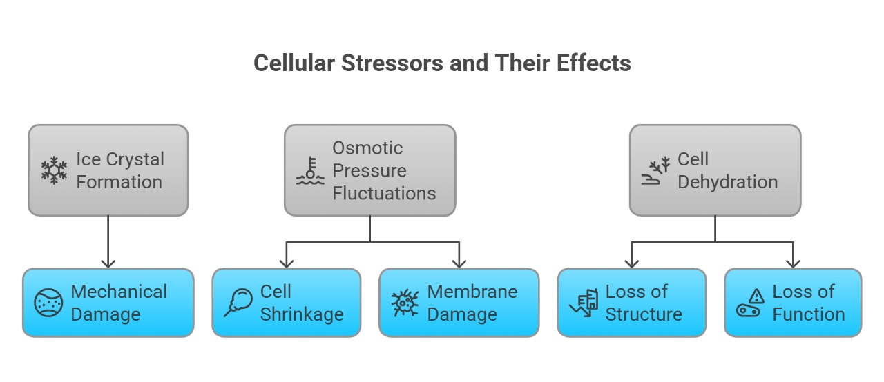

**Figure 1** : Different physical stressors during freeze drying.

**3.2.1 Physical stress** : “The formation of ice crystals during freezing can result in the piercing of cell membranes and the disruption of cellular structures, ultimately compromising the overall viability of the bacteria” (Noufeu et al., 2025).

**3.2.2 Chemical Stressors**

Freeze drying process can cause oxidative stress and denaturation of proteins, which can impair the metabolic functions of the bacteria (Figure:2). The pH also affects glycometabolism in LAB throughout Freeze drying. It does this by changing the stability of enzymes, the shape of proteins, the transport of substrates, the production of metabolites, and the stability of cofactors (Noufeu et al., 2025).

 Excessive aw > 0.3 can cause strong oxidation, which affects sample storage and loss of viability (Shu et al., 2018).

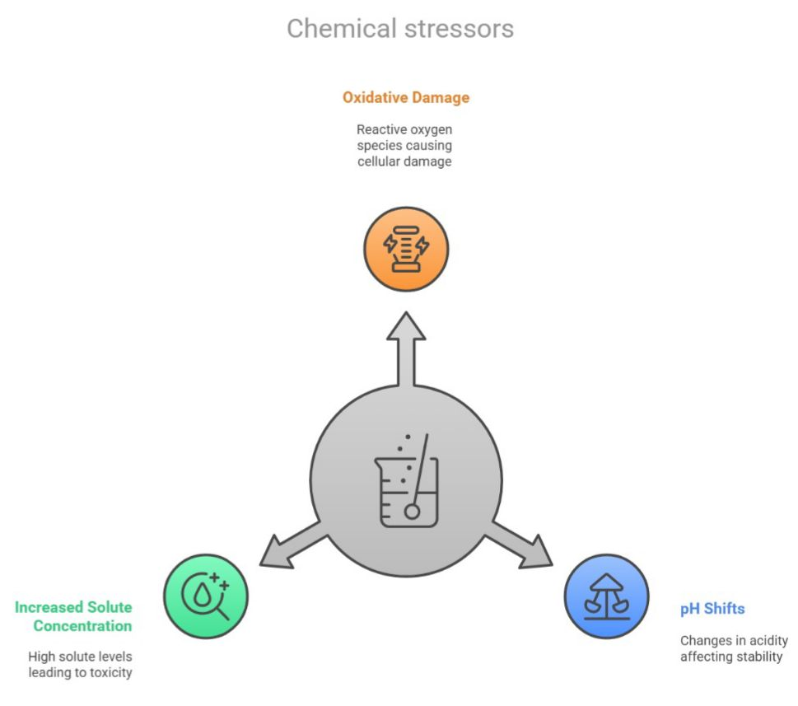

**Figure 2 :** Chemical stressors during freeze drying.

**3.2.3 Thermal Stressors**

“One of the stress responses of LAB is heat-­ related stress (Chang-­ Ho et al., 2015).Figure-3) The process involves extreme temperature fluctuations for primary drying temperature setting is −15 °C, 0.1 mbar for 50 h, with pressure controlled via a capacitance manometer. Secondary drying was conducted at 40 °C for 6 h, with a ramp of 0.2 °C/min between primary and secondary drying” (Schneid et al., 2025).

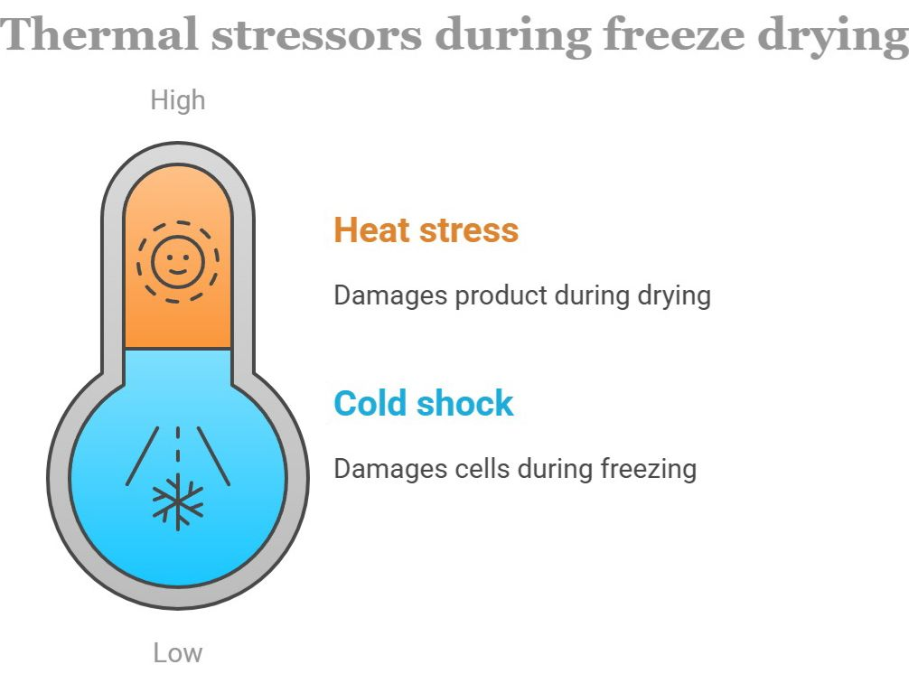

**Figure 3**: Thermal stressors during freeze drying .

# 4 Cryoprotectants for Probiotic Preservation

# 4.1 Cryoprotective Agents for Preserving Probiotic LAB in Fermented Dairy Products

Probiotic lactic acid bacteria preservation in fermented dairy goods is still a major technological problem, and cryoprotective chemicals are essential for preserving the bacteria's viability and functionality throughout processing and storage. Particularly for dairy-based probiotic applications, recent studies have discovered a number of extremely efficient cryoprotectants and protective mechanisms.   
In dairy matrices, disaccharides—specifically, trehalose and sucrose—have shown themselves to be excellent cryoprotectants for probiotic LAB. Trehalose significantly enhances the resistance of cells to these stress conditions; for example, it improves the heat tolerance of fungi (Liu et al., 2019; Wang et al., 2025), the freezing survival rate of some probiotics (Yuste et al., 2021; Wang et al., 2025). Previous studies have shown that, after exogenous trehalose was added, the freeze-drying survival rate of *Lactococcus lactis* was approximately 46 % (Eh et al., 2024), while the survival rate of *Lactiplantibacillus plantarum* was approximately 70 % compared with 17 % in the control group (Wang et al., 2021).

Proteins originating from dairy have demonstrated exceptional cryoprotective qualities, making them especially suitable for fermented dairy products. For a number of probiotic bacteria, whey protein isolate (WPI) at concentrations of 5–7% has shown better protection than conventional cryoprotectants. WPI gave *Lactobacillus rhamnosus* outstanding protection during freeze-drying, preserving not only viability but also important functional characteristics as immunomodulatory activity and adhesion capacity (Zhang et al., 2021). According to Jawan et al. (2022), the survival rate of lyophilized *Lactococcus lactis* is highest with the addition of 10 % trehalose. It has recently been found that milk proteins hydrolyzed by enzymes, particularly those with molecular weights ranging from 1 to 5 kDa, exhibited better cryoprotective properties than intact proteins (Li et al., 2024).

Prebiotic oligosaccharides play a dual role in probiotic LAB: as growth promoters and cryoprotectants. FOS and GOS at 2-4% (w/v) concentration have provided significant protection. When compared to controls with no protectants, it was found that supplementing fermented milk cultures with 3% GOS prior to freeze-drying improved the survival of *Bifidobacterium longum* by nearly 1.5 log CFU/g (Singh et al., 2023). Additionally, in comparison with non-prebiotic carbohydrate-treated samples, these compounds accelerated metabolic recovery following rehydration, with acid production restored approximately 40% more quickly.

Synergistic cryoprotectant mixtures have been demonstrated in recent studies to be more effective than single molecules. Some examples of these mixtures include

1) trehalose + sodium ascorbate,

2) milk proteins + glycerol,

3) prebiotic oligosaccharides + antioxidants.

It was demonstrated that blending WPI (5%) with ascorbic acid (0.2%) greatly enhanced protection for *Lactobacillus casei* in fermented milk than that of each component in isolation, with results of almost 2 log CFU/g increased survival upon 6 months of storage (Zhao et al., 2022).

The most suitable cryoprotectant mix for *Streptococcus thermophilus* 937 was determined to be 6% sucrose /8% skim milk /4% sodium glutamate, with the freeze-dried survival rate and viable counts of 90.59% and 1.78 × 1011CFU/g, respectively. Meanwhile, this cryoprotectant combination also had a good protective effect on the other two cocci, *Streptococcus thermophilus* Grx02 and *Enterococcus faecium* 218 (Di et al.,2023). Phospholipids and membrane-stabilizing compounds have gained attention for their ability to preserve not only viability but also important functional properties. Milk phospholipid fractions (0.5%) significantly preserved the adhesion capacity and immunomodulatory properties of *Lactobacillus rhamnosus* GG during the freeze-drying of fermented dairy products (Kim et al., 2021).

A study was conducted to investigate features and economic examination of cryoprotectants, the sucrose (8.2%)–skim milk (8.0%)–inulin (8.2%) mixture was suggested and enhanced to improve freeze-drying confrontation of probiotic bacterium. Existence, viable cell counts and inactivation rate during storage at 4°C of *Lactiplantibacillus plantarum* grx16 shielded by the mixture was 94.9%, 1.89 × 1011 cfu/g and 0.0116. The optimized sucrose–skim milk–polymer prebiotics mixture could also successfully shield many other probiotics, with the survival rate being 89.2–95.6% (Ma et al., 2024). The addition of trehalose and skim milk as cryoprotectants enhanced survival to 15.17% post-freeze drying, emphasizing the role of protective agents in improving viability (Wang et al., 2025). It was found that phospholipids integrated into bacterial membranes, increases fluidity and resistance to freeze-induced damage.

The best cryoprotective techniques for probiotic LAB in fermented dairy products include multi-component systems that addresses many stress mechanisms. Depending on the exact probiotic strain and dairy matrix involved, optimal formulations usually include oxidation inhibitors (ascorbates), water replacement agents (trehalose, sucrose), and membrane stabilizers (dairy proteins, phospholipids).

**4.2 Classification and Mechanisms of Cryoprotectants**

Cryoprotectants are compounds added to bacterial suspensions prior to freeze-drying to mitigate the detrimental effects of processing. They can be classified based on their chemical nature and protective mechanisms. In order to maintain the structural integrity of the cell membrane and improve overall cell viability both before and after cryopreservation, it important that the right cryoprotectant is used (Nguyen et al., 2023). Commercially available cryoprotectants are determined on the basis of their capacity to enter cells (Chang & Zhao, 2021).(Figure-4)

### Penetrating Cryoprotectants

Penetrating cryoprotectants are little molecular heaviness compounds that can cross cellular membranes and equilibrate with intracellular water. Membrane-permeable cryoprotectants are also called penetrating cryoprotectants because they can enter the cell and facilitate its frozen survival like DMSO, dimethyl acetate (DMA), Dimethyl-formamide (DMF), propylene glycol, cell banker series, ethylene glycol, trehalose, methanol, dimethylacetamide and glycerol (Iftikhar and Yaqoob,2024). The most commonly used penetrating cryoprotectants include:

•**Dimethyl sulfoxide (DMSO)**: Dimethyl sulfoxide is often utilized as permeable CPAs with the ability to pass into the cell and inhibit the growth of ice crystals outside and within the cell, hence stopping cell damage (Tutrina and Zhurilov, 2024).

•**Ethylene glycol (EG):** Often utilized in cryopreservation of cells owing to its fast kinetics of permeation

• **Propylene glycol (PG)**: Widely applied in cryopreservation with less toxicity than the other glycols

**• Glycerol**: at concentrations of 2–55% is a cryoprotectant and is most commonly applied in the preservation of microorganisms (Whaley et al., 2021; Murray and Gibson, 2022).

**4.2.2 Non-Penetrating Cryoprotectants**

Non-membrane-permeating cryoprotectants are also referred to as non-penetrating cryoprotectants, for example, 2-methyl-2,4-pentanediol and polymers, for example, PVP, hydroxyethyl starch, and other sugars, PEG, egg yolk, hydroxyethyl starch (HES), dextrin, glucose, and sucrose. They also prevent ice crystal formation. However, in certain situations, they act like toxic chemicals relative to membrane-permeable cryoprotectants at identical concentrations. Moreover, protecting cells from freezing damage (Iftikhar and Yaqoob,2024).

* **Sucrose:** A disaccharide widely used in combination with penetrating agents
* **Trehalose:** A non-reducing disaccharide with excellent glass-forming properties
* **Skim milk:** It is widely used as a cryoprotectant in the probiotics industry ([Diet al.*,* 2023](https://www.kjom.org/journal/view.html?uid=460&sort=&scale=&key=year&keyword=&s_v=60&s_n=3&pn=vol&year=2024&vmd=Full#B4)).
* **Hydroxyethyl starch (HES):** Used particularly in cell suspension cryopreservation

Non-penetrating cryoprotectants function differently from penetrating agents by maintaining osmotic balance and providing extracellular protection without entering the cell (Chen et al., 2021).

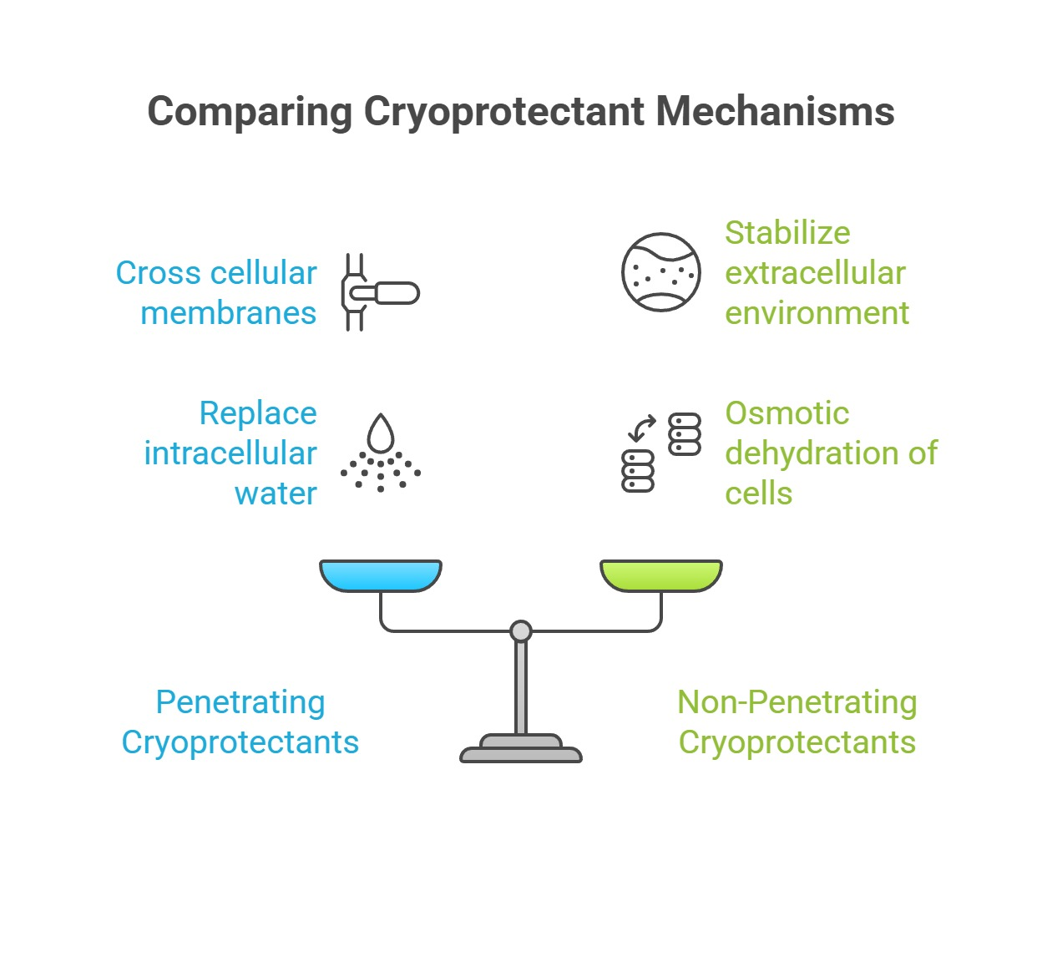

**Figure 4**: A comparison between penetrating and non-penetrating cryoprotectants.

**4.3 Cryoprotectant Efficacy for Specific Probiotic LAB**

Probiotic lactic acid bacteria play a crucial role in the health-promoting properties of fermented dairy products. However, maintaining their viability and functional properties during processing and storage remains a significant challenge. Effective preservation methods, particularly freeze-drying combined with appropriate cryoprotectants, are essential to deliver high-quality probiotic products to consumers.

1. ***Lactobacillus species:***

**Efficacy of cryyoprotectant depends on strain and composition-**

Whey and inulin were not effective in increasing *Lactiplantibacillus plantarum* CNCM I-4459 survival to long-term-storage (4 log reductions at 9 months storage). However, the inclusion of micellar casein in saccharose greatly enhanced the protective role of the lyoprotectant also lowered water activity after freeze-drying and its maintenance during storage (0.13 ± 0.05).

In case of *L. casei* DSM 2753 inulin-containing lyoprotectant was the least effective, though adding of micellar casein or whey did not enhance sucrose defense. Apart from this, survival of *L. rhamnosus* DSM 16605 was considerably greater in the presence of whey-containing lyoprotectant compared to the micellar casein-containing lyoprotectant (Bodzen et al., 2021).

For *L. plantarum* an effective cryoprotectant was found to be 20% soy peptone / 1% lactose with a survival rate of 80% (Jang *et al*., 2024). A 10% (w/v) mixture of galactose and trehalose at -30°C is the optimal for achieving high viability and stability of freeze-dried *Lactococcus lactis* Gh1( Jawan et al., 2022). In case of *Lactiplantibacillus plantarum****,*** most effective cryoprotectant is 15% trehalose with a 95% survival rate after 90 days (Yuate et al., 2021). The addition of trehalose and skim milk cryoprotectants for cryopreservation of *Lactobacillus rhamnosus* GG, enhanced survival to 15.17% post-freeze drying (Wang et al.,2025).Similarly, a mix of 20% soy peptone and 1% lactose resulted in 80% survival for *L. plantarum*. This suggests that protein and sugar combinations can be beneficial (Jang et al., 2024).

**Superior protection with multicomponent cryoprotectants:** A blend of four agents - skim milk, sucrose, sorbitol, and tyrosine resulted in 97.4% survival for *L. plantarum* L1 and 92.3% for *L. fermentum* L2. These agents preserved the integrity of the cell membrane, as evidenced by decreased leakage of β-galactosidase and LDH, and enhanced ATPase activity (Cheng et al., 2022).These mixtures not only improved viability but also maintained membrane integrity and increased ATPase activity, indicating better functional stability*. Lactococcus lactis* ZFM559 achieved an optimal survival rate of 81% using a cryoprotectant blend of trehalose, mannitol, skim milk, and glutamic acid monosodium (Ge et al., 2024). This showcases the benefits of optimizing formulations through statistical methods.

**Role of Specific Saccharides**

Trehalose showed high effectiveness across different strains. It led to 91.69% survival in L. acidophilus FMNS-10 when combined with skim milk and glutamate (Li et al., 2025).Lactococcus lactis ml3 thrived in formulations based on trehalose and sucrose with skim milk and glutamate (Mahmoodian et al., 2024).However, inulin offered minimal protection with less than 1% survival during storage, despite its prebiotic benefits (Oluwatosin et al., 2022).Maltodextrin and sucrose also performed well in both freeze-drying and storage, especially at 4 °C.Skim milk was a consistently effective cryoprotectant, achieving survival rates of up to 91% (Oluwatosin et al., 2022). It was widely used in combination with sugars and amino acids across different strains.

1. ***Bifidobacterium species***

**Strain specific optimization:** *B. bifidum* BB01 showed high viability at 90.37% when freeze-dried with a multi-component cryoprotectant optimized using response surface methodology (RSM). Optimal formulation: 5.5% glycine, 0.8% sodium bicarbonate, 7% xylo-oligosaccharides, 4.5% arginine, and 25% skim milk. This statistical optimization matched well with predicted outcomes, indicating a reliable and reproducible cryopreservation strategy (Chen et al., 2019).

**Different process conditions:** Process conditions like- Pre-freezing, Sublimation Drying also influence viability of *Bifidobacterium* BB68S. Survival of 94.9% was achieved after pre-freezing at −40 °C, but this dropped to 65.4% after sublimation drying at −10 °C. This suggests that initial freezing steps may be more critical to survival than the drying phase. Yeast and beef extracts media supported higher tolerance under thermal stress (Sang et al., 2023).

**Demerits of cryoprotectant:** *B. longum* showed ineffective response to high concentration of various popular cryoprotectants. Glucitol reduced survival to 17% and trehalose to 34%, respectively. In contrast, survival was 40% without any additive and 43% with maltodextrin (Haindl et al., 2020). These results suggest potential osmotic or metabolic stress caused by certain protectants in this strain when used at 100% dry matter equivalence.

**Enhancement of Culture Medium:** Modification of culture media enhances tolerance to freeze-drying. In *B. longum* CCFM 1029, adding 21 g/L proline to the culture medium before freeze-drying doubled survival from 18.6% to 38.7% (Cui et al., 2022). This demonstrates that osmoprotectant loading or pre-conditioning prior to drying can greatly increase stress resistance.

1. ***Streptococcus species***

**Natural Protectants** Betaine, derived from sugar beet,is known to provide protection similar to synthetic agents while also exhibiting antioxidant activity in S. thermophilus. This makes it a promising multifunctional cryoprotectant from natural sources (Singh & Kumar, 2024).

Viability and post-thaw performance can be improved by additives with these dual functions.

**Superior protection with multicomponent cryoprotectants:** Optimal blends of sucrose, skim milk, and sodium glutamate have shown strong protective effects. *S. thermophilus* 937 survived at 90.59% with 6% sucrose, 8% skim milk, and 4% sodium glutamate (Di et al., 2023). Another effective mixture included 116.4 g/L skim milk, 79.6 g/L glycerol, and 77.4 g/L sodium glutamate, achieving 93.58% survival (Lu et al., 2017). These combinations take advantage of the synergy between carbohydrates, proteins, and amino acids. They improve osmotic balance, structural stability, and cellular energy maintenance*. S. thermophilus* stored with 100 mg/mL trehalose or a mix of 50 mg/mL trehalose and 1 mg/mL polyvinyl alcohol (PVA) had much better survival rates than those with the usual 20% glycerol. The glycerol only achieved a survival rate of 41.03% (Jiang et al., 2023).

1. **Enterococcus spp.**

**High Tolerance and increased Functionality after Lyophilization** : Enterococcus faecalis strains freeze-dried in skim milk maintained a very high viability of 95.9% to 103.42% after 30 days at 4°C. They also showed improved antimicrobial activity against Clostridium difficile (Romyasamit et al., 2021). This shows not only strong viability but also preserved functional properties, suggesting they are suitable for therapeutic uses.For Enterococcus durans, lactulose was the most effective cryoprotectant. It helped maintain both viability and physiological stability during long-term storage at 4°C and 25°C for 92 days, while preserving acid and bile tolerance (Estilarte et al., 2021).

**5 Impact of Freeze-drying on Functional and Metabolic Properties of Probiotic LAB**

The most important indicator of freeze-drying success is survivability, whereas probiotic efficacy relies on retention of metabolic activity. Although it has numerous benefits, freeze drying LAB possesses a number of drawbacks that can affect their viability and functionality.

Both biological factors (e.g., strain type, cell age, and initial cell concentration) and physicochemical parameters (e.g., cell growth conditions, freezing conditions, dehydration extent, and lyoprotectant selection) can influence the survival of bacterial cells during freeze drying (Polo et al., 2017; Wang et al., 2025). Cell viability can still be compromised due to ice crystal formation, high osmolarity-induced membrane injury and macromolecule denaturation by dehydration (Wang et al., 2020).

Freeze drying induces thermal, osmotic, and mechanical stresses that can impact the glycometabolism of LAB, which is the process of converting carbohydrates into energy (Noufeu et al., 2025).

One of the primary concerns is the potential for cellular damage during the Freeze drying process (Coulibaly et al., 2018).

The denaturation and inactivation of certain sensitive proteins and enzymes in cells and DNA damage will additionally influence the physiological metabolic process of cells and even cause cell death (Guerrero-Sanchez et al., 2023; Marcial-Coba et al., 2018).

Stress responses can cause changes in the activity of enzymes involved in glycometabolic pathways. These enzymes that facilitate carbohydrate synthesis and breakdown may be upregulated or downregulated in response to stress, affecting the overall balance of carbohydrate metabolism (Zhen et al., 2020).

The glycolytic activity of LAB is interrupted in the freezing phase; additionally, the activity of glycolytic enzymes like hexokinase, phosphofructokinase, and pyruvate kinase is inhibited, and adenosine triphosphate (ATP) formation declines appreciably in the sublimation phase; these enzyme activities and ATP formation almost come to a standstill and exopolysaccharide (EPS) formation changes during the secondary drying phase (Noufeu et al., 2025). At sublimation stage, LAB are subjected to stresses like dehydration, oxidative stress, and osmotic pressure changes, which can have a strong impact on the activity of glycolytic enzymes, thus further restricting the production of adenosine triphosphate (ATP) (Fonseca et al., 2020).

Endpoint detection at sublimation is critical in Freeze drying to prevent incorrect sublimation, which would compromise structural integrity and lead to bacterial breakdown (Harguindeguy et al.,2021 ; Jeyapradhap et al., 2023). A reduction in the viability of bacterial cells can also be caused by the repeated exposure of bacterial cells to extreme environments (Wang et al., 2020; Li et al., 2024). Bacterial cell cytoplasmic membrane is a highly recognized location of stress-induced injury. Its integrity, fluidity and fatty acid composition are the key characteristics affecting the survival of bacteria (Li et al., 2024).

**5.1 Effect of cryoprotectants**

Cryoprotectants had a water replacement action. Sugars like trehalose create stabilizing matrices that engage with the cell membrane through water molecule replacement during dehydration (Liu et al., 2019). There was a significant reduction in the viability of LGG, irrespective of the solvent used. Solvents may modify the formation of ice crystals by affecting water–water hydrogen bonds. With regards to PBS, the presence of salts can cause water from within the cells to move to the extracellular space by osmosis, encouraging the development of extracellular crystalline ice (Hu et al., 2022). This water removal from the inner cellular space raises the concentration of solutes and thus results in high osmolarity-induced cell membrane injury (Wang et al., 2025). The widespread cell injury of PBS could be due to a mix of ice crystal formation, increased intracellular concentration of solutes, and osmotic imbalance, all contributing to cell structure and viability compromise (Whaley et al., 2021; Jameel, 2023).

**5.2 Effect of temperature**

Pre-freezing temperature and rate of temperature are very important factors that need to be controlled for improved survival in lyophilization (Zeng et al., 2022). Low pre-freezing temperatures would result in the failure to freeze the sample suspension completely, expansion and foaming during the following sublimation process under vacuum conditions. Conversely, when pre-freezing temperatures are excessively low, not only will the energy consumption be high, but the viability of bacteria following freeze drying will also be affected adversely (Zhen et al., 2020). Flash freezing destroys the functionality of cells to extrude water in proper manner to equilibrate osmotic pressures, resulting in ice crystal formation in cells that can lead to severe structural injury or result in cellular death (Jeyapradhap et al., 2023). The extent of this lethal damage is strain-specific (Chen et al., 2017; Zhen et al., 2020).

**5.3 Effect of dehydration**

Dehydration during the drying procedure can also cause irreparable injury to bacterial cells. Water plays a critical role in maintaining the structure and functionality of the bacterial cell membrane. Removal of water during the drying process can cause cell collapse and irreparable membrane damage (Chou et al., 2019). Hydration helps bacterial cells to stay intact by enabling water molecules to interact with the polar group of phospholipid membranes (Broeckx et al., 2016; Wang et al.,2025). However, dehydration induces phospholipid phase transition from the liquid crystalline phase into the gel phase, leading to cell membrane leakage. Dehydration can lead to the breakage of hydrogen bonds between phospholipids and the surrounding extracellular water (Wang et al., 2025). Steric hindrance within membrane components and the inability of protectants to form sufficient hydrogen bonds can still lead to viability losses during dehydration (Fissore et al., 2025).

**6 Methods of Assessing the Action of Probiotics**

Viability testing has been divided into two subgroups: (1) culture-dependent techniques, that are based on the ability of the cells to replicate, and (2) culture-independent techniques, that are based on other cell characteristics than the ability to replicate (Wendel,2022).

**6.1 Culture-Dependent Techniques for Viability Testing**

Culture-dependent methods, where plate count enumeration is the most prevalent, have for long been the standard for viability measurement of probiotic cultures and products (Hansen et al., 2020; Kiefer et al., 2020). Oxygen tolerance, antibiotic resistance, and nutritional requirements are some factors that need to be taken into consideration when selecting and designing appropriate media and growth conditions. Thus, although sometimes possible with antibiotics, it can be difficult to separate a mixture of two or several strains with highly similar growth requirements (Hansen et al., 2018; Vinderola et al., 2019; Kiefer et al., 2020).

**6.1.1 Plate Count Enumeration**

There are multiple ways of performing plate count enumeration. In brief, the probiotic bacterium sample is suspended/melted in buffer/medium and diluted to an appropriate concentration. The solution so obtained is spread either onto a petri plate containing solid agar medium or blended with molten agar medium and allowed to harden in a petri plate. The colonies formed after incubation under appropriate conditions can be counted and estimated to determine the number of viable cells in the original sample (Wendel ,2022).

Plate count methods of enumeration for viability determinations comes with a number of limitations. Initially, culturing bacteria on agar plates is very time-consuming, primarily because of preparation of media and extended incubation times (Vinderola et al., 2019). Enumeration by plate count is also founded on the premise that one cell will grow to create a single colony However, during manufacturing of a culture powder , there is a risk for clumping ([Vinderola et al., 2019](https://www.frontiersin.org/journals/microbiology/articles/10.3389/fmicb.2021.818468/full#B116)).  Plate count enumeration of bacterial cells exposed to stress conditions e.g., due to freeze-drying and manufacturing, can also affect culturability ([Olszewska et al., 2019](https://www.frontiersin.org/journals/microbiology/articles/10.3389/fmicb.2021.818468/full#B89)).

**6.1.2 Most Probable Number**

Most probable number is a method which relies on the fact that a liquid medium becomes turbid due to bacterial growth (Angelov, 2014; Wendel, 2022). By making a 10-fold serial dilution of a bacterial cell solution in replicates, the point will be reached where the solution is so diluted that only a few of the replicates of a certain dilution give rise to turbidity. The number of tubes with proved turbidness, and hence growth, at various thinning can be used to approximation the original number of feasible cells using premade tables based on statistics from the use of 95% confidence intervals. Though not conventionally employed for probiotics' viability measurements, there are several instances (Bibiloni et al., 2001; Angelov, 2014; Wendel,2022). Though customarily employed when working with very diluted samples, which is generally not the situation with probiotics, this technique offers a choice over plate count enumeration when experiencing difficulties with colony growth e.g., due to an exponential matrix disruptive effect (Sutton, 2010; Blodgett, 2020).

**6.1.3 Growth Curves**

Growth curves are obtained by incubating bacterial cells in liquid culture and monitoring continuously the rise in optical density (OD) as cells replicate and subsequently graphing the OD values obtained against time. The curves so obtained can indicate several different properties. Parameters of particular interest for determination of replication capacity are the maximal growth rate, μmax, and the lag phase, tlag (Bircher et al., 2018). It was also noted that tlag is inversely related to viable cell numbers, in this instance measured with the most probable number technique, and that prior manufacturing and storage conditions, i.e., freezing, freeze-drying, and spray-drying, affect generation times and start of growth (Bircher et al., 2018; Wendel,2022). Indications of low viability, as interpreted from growth curves, may have a direct link to metabolic activity in the GIT (Bircher et al., 2018).

**6.1.4 Acidification Rate**

Acidification rate analysis, obtained by merely measurement the pH alteration in a liquid medium culture with respect to time, is usually applied for evaluating the excellence of milk starter cultures that include LAB. An ISO method is available for this application, ISO 26323 (ISO, 2009). Yet, the volume of generated lactic acid could also be employed as an adjunct or alternative to other measures of viability in various samples with probiotic LAB (Saez-Lara et al., 2015; Wendel ,2022). Acidification rate to compare the resistance to freezing between number of different LAB strains and could see that the acidification rate was proportional to cell concentration under well-defined experimental conditions. Such poor reliability in plate count enumeration as a consequence of chain building can be avoided by performing acidification rate measurements instead (Wendel, 2022).

**6.1.5 Isothermal Microcalorimetry**

Isothermal microcalorimetry is a technology that relies on the fact that heat is generated by an evolving, metabolizing population of bacteria (Mihhalevski et al., 2011; Garcia et al., 2017; Fredua-Agyeman and Gaisford, 2019; Nykyri et al., 2019). The heat production is around 2 pW per cell, which allows measurement in samples of bacteria with cell numbers from about 106 CFU/ml (Fredua-Agyeman and Gaisford, 2019). Heat manufacture varies with the amount of bacterial cells in a sample and can be graphed as μW vs. time. y after the heat generation of the bacterial population, it is possible to obtain real-time, continuous viability data, in contrast to for example plate count enumeration that only gives the endpoint of the viability measurement (Braissant *et al*., 2010; Fredua-Agyeman and Gaisford, 2019). The technique allows for high sensitivity measurements because of the low detection levels of the generated heat and minimum scattering of the data, hence, offering viability data of high accuracy and minimal standard errors (Braissant et al., 2010; Garcia et al., 2017; Wendel, 2022.). Isolation by drying and subsequent rehydration does not appear to interfere with isothermal microcalorimetry data.

**6.2 Culture-Independent Viability Determination Methods**

**6.2.1 Flow cytometery**

The flow cytometry analytical method allows for the qualitative and quantitative identification of microorganisms in the sample under test within a very brief period, which is a gain over culturing techniques. The study uses fluorescent dyes, which enable the assessment of parameters related to the surface, structure, and size of cells (Michelutti et al.,2020). With the application of fluorescence in flow cytometry, it is feasible to separate the living and dead populations of cells and spores (Genovese et al.,2021). Furthermore, it must be noted that due to the application of cytometry, viable but nonculturable cells (VBNC) can be identified. These are resting bacteria that can tolerate adverse environmental conditions (Dong et al.,2020). The VBNC cells are defined by the absence of growth on culture media but maintain cell integrity and metabolic activity. Depending on the fluorescent dyes, one can identify the population of all cells contained in the product (TO—thiazole orange) and that of dead and damaged cells (PI—propidium iodide) (Foglia et al., 2020). The SYTO 24 dye enters living and dead cells, while PI enters just the damaged ones and through damaged cell covers; DiOC2(3) dye allows the measurement of cells with an intact functioning membrane potential (Wilkinson et al., 2018).

**6.2.2 Molecular Methods**

Usage of molecular methods, which are based on nucleic acid detection, enables detection and in combination with identification of bacteria on a strain-level with high specificity and sensitivity in a high-throughput manner. Thus, molecular methods are very useful in samples or products with several probiotic strains (Hansen et al., 2018; Kiefer et al., 2020).

Though, nucleic acid content is not regarded as a viable marker solely (Amor et al., 2007; Kiefer et al., 2020). Nucleic acid content was formerly thought to differentiate among live and dead cells due to post-mortem degradation (Wendel,2022). However, the DNA molecule is very stable and can persist in cells even after death has occurred. The RNA molecule on the other hand, is very unstable and is therefore not optimal to be the base of high accuracy live/dead measurements. Furthermore, both growth rate as well as position in the cell cycle can produce large differences in nucleic acid levels in live cells. But the potency of molecular techniques to detect certain probiotic species and strains, renders them ideal to use in combination with other techniques detecting markers of viability, or in combination with viability dyes for strain-selective detection of viable cells (Wendel,2022).

**6.2.3 Digital Polymerase Chain Reaction**

Digital PCR (dPCR) is a PCR technique in which the sample is highly diluted and further separated into individual minireactors, in the form of droplets or in a chip format (Hindson et al., 2011; Huggett et al., 2013; Hansen et al., 2018; Kiefer et al., 2020). Like qPCR, dPCR can differentiate between very closely related probiotic strains quantitatively with high accuracy in a brief time frame (Hansen et al., 2018). However, unlike standard qPCR technologies, dPCR allows absolute quantification of DNA sequence copy numbers that are not dependent on a standard curve with purified DNA (Hindson et al., 2011; Hansen et al., 2018). Therefore, the dPCR method is less prone to inhibitors than qPCR and can detect lower genetic material concentrations (Huggett et al., 2013; Gobert et al., 2018).

**6.2.4 Polymerase Chain Reaction-Based Approaches Along with Ethidium Monoazide (EMA) and Propidium Monoazide (PMA) Staining**

EMA is permeable through the membrane, whereas PMA is not. Thus, these dyes facilitate selective amplification of genetic material from membrane-intact cells. PCR techniques involving PMA and EMA staining are commonly called viability PCR, or v-PCR. Both qPCR and dPCR have been applied for viable and non-viable bacteria separation on a strain basis with PMA/EMA chemistry (Gobert et al., 2018; Kiefer et al., 2020).

**7. Advanced Strategies for Improved Probiotic Stability**

**7.1 Microencapsulation Techniques**

Microencapsulation confers further protection to probiotic bacteria during freeze-drying and subsequent storage through physical isolation from environmental stressors:

**7.1.1 Extrusion Methods**

Encapsulation, specifically extrusion and co-extrusion, is a common practice to protect probiotics from the harsh conditions of the digestive tract as well as processing. Hydrocolloids such as proteins and starches, either natural or modified, are a group of ingredients used as the wall material in extrusion. Hydrocolloids, based on their character, can serve to advance the probiotic survival rate of the final powder during storage and the process of microencapsulation (Homayouni-Rad et al., 2024). Extrusion technology is reported to exhibit superior probiotic survivability rates of 85–90% under gastric acid and bile conditions relative to other technologies. The method bypasses thermal processing and enables a greater survival rate of probiotics. In the extrusion process, there is usually a hydrocolloid material like alginate, carrageenan, gelatin, or chitosan used as a coating substance. In brief, the hydrocolloid solution is blended with probiotics, filtered through a syringe (lab scale) or an extruder (pilot scale), and released into a gelling solution with a multivalent cation (e.g., CaCl2) in order to formulate a hard capsule (Haji et al., 2022).

**7.1.2 Emulsion-Based System**

Emulsions may be employed for encapsulating probiotic cells.

The two kinds of simple emulsions, which are generally used, are

(a) oil-in-water (O/W) and

(b) water-in-oil (W/O) (Bai et al., 2017).

Emulsions may be prepared using physical (mechanical) and chemical procedures (interfacial chemistry). The probiotic encapsulation emulsion systems have broadly been classified into two broad categories depending on stabilizing surfactants utilized. There are conventional emulsions stabilized with molecular (conventional) surfactants and particle-stabilized Pickering emulsions (Haji et al., 2022). W/O/W emulsions were made where the inner aqueous phase included probiotic cells and additional protectant molecules (Ding et al.,2022).

**7.1.3 Spray Drying with Protective Carriers**

Spray-drying is arguably the most common microencapsulation process. The method is well suited for continuous mass production and for obtaining a homogenous particle size distribution (Pupa et al., 2021). The process of spray drying technology is that a polymer solution containing an active ingredient, for instance, suspension, solution, or emulsion is sprayed into a drying chamber and the solvent is rapidly evaporated through the flow of hot gas and is deposited as nano- or micro-sized particles (Piñón-Balderrama et al., 2020). To reduce reduction in probiotic viability, a co-current spray flow of sprayed material and hot carrier is desirable since it exposes the dried particles to the minimum heat (Sehrawat et al., 2022).

8.Economic aspects of Cryoprotectants

Cryoprotectants are used to preserve the quality and extend the shelf life of frozen goods, which can lower losses and increase profitability. The overall cost of manufacturing may be impacted by the cryoprotectant selection, particularly if large quantities or long-term storage are needed.

There is a considerable range in the cost of cryoprotective agents. In industrial and scientific settings, some, like skim milk, are favored due to their affordability, accessibility, and ability to maintain microbial and probiotic viability.Modified growth media and skim milk can be both cost-effective and efficient, which makes them appealing for routine or large-scale applications (Pyar et al., 2014). DMSO and glycerol are two of the most widely utilized CPAs because of their efficiency and affordability, although they can be harmful at larger quantities. Ethylene glycol serves a similar purpose, but it is less frequently utilized because of a number of issues. Alternative techniques with particular advantages are provided by hydroxyethyl starch and trehalose, however they could be costly or need special treatment (Aarattuthodi et al .,2025).Some cryoprotectants, such as skim milk or glycerin, are more suited for extensive industrial or laboratory application due to their availability and scalability, which further increases their appeal from an economic standpoint (Tutrina et al.,2024). Higher cryprotectant concentrations can improve preservation outcomes, but they can also increase toxicity, which lowers cell viability and raises costs for damage mitigation or procedure improvement.

**9. Conclusion and Future Perspectives**

Freeze-drying remains the preferred method for industrial probiotic preservation, producing shelf-stable products with minimal viability loss. Optimization of parameters and protective formulations must consider strain-specific sensitivities, intended storage conditions, and applications. Advances in understanding molecular mechanisms of freeze-drying-induced damage have facilitated rational protective strategies that transcend empirical approaches. Integrating these insights with practical production considerations including tailored strain-specific protocols, multi-component protective blends targeting diverse stress pathways, real-time process analytical technology, functional assays confirming health benefits, and an integrated preservation strategy encompassing upstream conditioning, formulation design, and packaging will enhance the stability, functionality, and market competitiveness of probiotic dairy-based products, delivering stronger health benefits to consumers.

Future research on freeze-drying conditions and viability assessment of probiotic lactic acid bacteria (LAB) should prioritize developing novel cryoprotectants tailored to specific strains to enhance survival and maintain functionality. Implementing advanced analytical techniques, such as flow cytometry and metabolomics, would enable rapid, precise viability assessments. Investigating microencapsulation and combining prebiotics with probiotics may improve stability and functional performance. Genomic and proteomic studies could reveal molecular mechanisms of LAB stress responses, guiding targeted improvements in strain resilience. Research should also explore optimizing large-scale freeze-drying processes and comparing novel methods, such as spray-freeze-drying or supercritical fluid drying, with conventional techniques. Establishing standardized protocols for assessing viability and functionality, along with studying long-term stability under varied storage conditions, will be essential to ensure product quality, efficacy, and shelf-life across the industry.

**Competing interests**

The authors declare that the research was conducted in the absence of any commercial or financial relationships that could be construed as a potential conflict of interest.

**Ethics approval**: Not applicable

**Consent** : Not applicable

**Consent for publication**: All the co-authors have read the manuscript and have approved this submission. The authors report no conflicts of interest.

**Availability of data and material**: Not applicable

Disclaimer (Artificial intelligence)

Option 1:

Author(s) hereby declare that NO generative AI technologies such as Large Language Models (ChatGPT, COPILOT, etc.) and text-to-image generators have been used during the writing or editing of this manuscript.

Option 2:

Author(s) hereby declare that generative AI technologies such as Large Language Models, etc. have been used during the writing or editing of manuscripts. This explanation will include the name, version, model, and source of the generative AI technology and as well as all input prompts provided to the generative AI technology

Details of the AI usage are given below:

1.

2.

3.

**References**

Aarattuthodi, S., Kang, D., Gupta, S. K., Chen, P., Redel, B., Matuha, M., ... & Sinha, A. K. (2025). Cryopreservation of biological materials: applications and economic perspectives. *In Vitro Cellular & Developmental Biology-Animal*, 1-24.

Al-Kharousi, Z. S. (2025). Highlighting Lactic Acid Bacteria in Beverages: Diversity, Fermentation, Challenges, and Future Perspectives. Foods, 14(12), 2043. <https://doi.org/10.3390/foods14122043>

Angelin, J., & Kavitha, M. (2020). Exopolysaccharides from probiotic bacteria and their health potential. *International journal of biological macromolecules*, *162*, 853–865. <https://doi.org/10.1016/j.ijbiomac.2020.06.190>

Anisa I, Irfan y. A Brief Review of Current Strategies and Advances in Cryopreservation Techniques. Adv Biotech & Micro. 2024; 18(1): 555978. DOI:[10.19080/AIBM.2024.17.555978](http://dx.doi.org/10.19080/AIBM.2024.17.555978)

Araújo, C. M., Sampaio, K. B., Menezes, F. N. D. D., Almeida, E. T. D. C., Lima, M. D. S., Viera, V. B., ... & de Oliveira, M. E. G. (2020). Protective effects of tropical fruit processing coproducts on probiotic *Lactobacillus* strains during freeze-drying and storage. *Microorganisms*, *8*(1), 96.

Bai, L., Huan, S., Li, Z., & McClements, D. J. (2017). Comparison of emulsifying properties of food-grade polysaccharides in oil-in-water emulsions: Gum arabic, beet pectin, and corn fiber gum. *Food hydrocolloids*, *66*, 144-153.

Bhatta, S., Stevanovic Janezic, T., & Ratti, C. (2020). Freeze-drying of plant-based foods. *Foods*, *9*(1), 87.

Bhattacharya, S. (2018). Cryopretectants and Their Usage in Cryopreservation Process. IntechOpen. doi: 10.5772/intechopen.80477.

Bircher, L., Geirnaert, A., Hammes, F., Lacroix, C., and Schwab, C. (2018). Effect of cryopreservation and lyophilization on viability and growth of strict anaerobic human gut microbes. Microb. Biotechnol. 11, 721–733. doi: 10.1111/1751-7915.13265

Blodgett, R. (2020). FREEZE DRYINGFREEZE DRYINGA Bacteriological Analytical Manual (BAM), Appendix 2: Most Probable Number from Serial Dilutions. Available online at: [https://www.freeze dryingfreeze dryinga.gov/food/laboratory-methods-food/bam-appendix-2-most-probable-number-serial-dilutions](https://www.fda.gov/food/laboratory-methods-food/bam-appendix-2-most-probable-number-serial-dilutions)

Broeckx, G., Vandenheuvel, D., Claes, I. J., Lebeer, S., & Kiekens, F. (2016). Drying techniques of probiotic bacteria as an important step towards the development of novel pharmabiotics. International journal of pharmaceutics, 505(1-2), 303-318.

Chen, H., Tian, M., Chen, L., Cui, X., Meng, J., & Shu, G. (2019). Optimization of composite cryoprotectant for freeze-drying *Bifidobacterium bifidum* BB01 by response surface methodology. Artificial Cells, Nanomedicine, and Biotechnology, 47(1), 1559–1569. <https://doi.org/10.1080/21691401.2019.1603157>

Chen, W., Chiu, H. T., Feng, Z., Maes, E., & Serventi, L. (2021). Effect of spray-drying and freeze-drying on the composition, physical properties, and sensory quality of pea processing water (Liluva). Foods, 10(6), 1401.

Cheng, Z., Yan, X., Wu, J., Weng, P., & Wu, Z. (2022). Effects of freeze drying in complex lyoprotectants on the survival, and membrane fatty acid composition of *Lactiplantibacillus plantarum* L1 and *Lactobacillus fermentum* L2. Cryobiology, 105, 1-9.

Choi, I. S., Ko, S. H., Kim, H. M., Chun, H. H., Lee, K. H., Yang, J. E., ... & Park, H. W. (2019). Shelf-life extension of freeze-dried *Lactobacillus brevis* WiKim0069 using supercooling pretreatment. Lwt, 112, 108230.

Cirat, R., Capozzi, V., Benmechernene, Z., Spano, G., Grieco, F., & Fragasso, M. (2024). LAB Antagonistic Activities and Their Significance in Food Biotechnology: Molecular Mechanisms, Food Targets, and Other Related Traits of Interest. *Fermentation*, *10*(4), 222. <https://doi.org/10.3390/fermentation10040222>

Coulibaly, I., Kouassi, E. K., N’guessan, E., Destain, J., Béra, F., & Thonart, P. (2018). Lyophilization (drying method) cause serious damages to the cell viability of lactic acid bacteria. Annu. Res. Rev. Biol, 24, 1-15.

Cui, S., Zhou, W., Tang, X., Zhang, Q., Yang, B., Zhao, J., Mao, B., & Zhang, H. (2022). The Effect of Proline on the Freeze-Drying Survival Rate of  *Bifidobacterium longum*CCFM 1029 and Its Inherent Mechanism. *International Journal of Molecular Sciences*, *23*(21), 13500. https://doi.org/10.3390/ijms232113500

Di, L., Ma, W., Kang, W., Huang, Y., Wu, Z., Yin, B., … Gu, R. (2023). Synergistic combination of cryoprotectants for high freeze-dried survival rate and viable cell counts of *Streptococcus thermophilus.* Drying Technology, 41(9), 1444–1453. <https://doi.org/10.1080/07373937.2022.2155971>

Dong, K.; Pan, H.; Yang, D.; Rao, L.; Zhao, L.; Wang, Y.; Liao, X. Induction, detection, formation, and resuscitation of viable but non-culturable state microorganisms. Compr. Rev. Food Sci. Food Saf. 2020, 19, 149–183.

Estilarte, M. L., Tymczyszyn, E. E., de los Ángeles Serradell, M., & Carasi, P. (2021). Freeze-drying of *Enterococcus durans*: Effect on their probiotics and biopreservative properties. Lwt, 137, 110496.

Fijan, S. (2023). Probiotics and Their Antimicrobial Effect. *Microorganisms*, *11*(2), 528. <https://doi.org/10.3390/microorganisms11020528>

Fissore, D., & Bosco, F. (2025). Freeze-drying and cultural heritage: An overview. Drying Technology, 43(1-2), 21-33.

Foglia, C.; Allesina, S.; Amoruso, A.; De Prisco, A.; Pane, M. New insights in enumeration methodologies of probiotic cells in finished products. J. Microbiol. Methods 2020, 175, 105993.

Fonseca, F., Girardeau, A., & Passot, S. (2020). Freeze-drying of lactic acid bacteria: A stepwise approach for developing a freeze-drying protocol based on physical properties. In Cryopreservation and freeze-drying protocols (pp. 703-719). New York, NY: Springer US.

Ge, S., Han, J., Sun, Q., Ye, Z., Zhou, Q., Li, P., & Gu, Q. (2024). Optimization of cryoprotectants for improving the freeze-dried survival rate of potential probiotic *Lactococcus lactis*  ZFM559 and evaluation of its storage stability. LWT, 198, 116052.

Ge, S., Han, J., Sun, Q., Zhou, Q., Ye, Z., Li, P., & Gu, Q. (2024). Research progress on improving the freeze-drying resistance of probiotics: a review. Trends in Food Science & Technology, 104425.

Genovese, M.; Poulain, E.; Doppler, F.; Toussaint, R.; Boyer, M. Bacillus spore enumeration using flow cytometry: A proof of concept for probiotic application. J. Microbiol. Methods 2021, 190, 106336.

Gobert, G., Cotillard, A., Fourmestraux, C., Pruvost, L., Miguet, J., and Boyer, M. (2018). Droplet digital PCR improves absolute quantification of viable lactic acid bacteria in faecal samples. J. Microbiol. Methods 148, 64–73. doi: 10.1016/j.mimet.2018.03.004

Haindl, R., Neumayr, A., Frey, A. et al. Impact of cultivation strategy, freeze-drying process, and storage conditions on survival, membrane integrity, and inactivation kinetics of *Bifidobacterium longum*. Folia Microbiol 65, 1039–1050 (2020). <https://doi.org/10.1007/s12223-020-00815-3>

Han, X., Ding, S., Ma, Y., Fang, J., Jiang, H., Li, Y., & Liu, G. (2021). *Lactiplantibacillus plantarum* and *Lactobacillus brevis* alleviate intestinal inflammation and microbial disorder induced by ETEC in a murine model. Oxidative Medicine and Cellular Longevity, 2021(1), 6867962.

Hansen, S. J. Z., Morovic, W., DeMeules, M., Stahl, B., and Sindelar, C. W. (2018). Absolute enumeration of probiotic strains *Lactobacillus acidophilus*NCFM ® and *Bifidobacterium animalis* subsp. lactis Bl-04 ® via Chip-Based Digital PCR. Front. Microbiol. 9:704. doi: 10.3389/fmicb.2018.00704

Hansen, S. J. Z., Tang, P., Kiefer, A., Galles, K., Wong, C., and Morovic, W. (2020). Droplet digital PCR is an improved alternative method for high-quality enumeration of viable probiotic strains. Front. Microbiol. 10:3025. doi: 10.3389/fmicb.2019.03025

Harguindeguy, M., & Fissore, D. (2021). Temperature/end point monitoring and modelling of a batch freeze-drying process using an infrared camera. European Journal of Pharmaceutics and Biopharmaceutics, 158, 113-122.

Homayouni-Rad, A., Mortazavian, A. M., Pourjafar, H., & Moghadam, S. K. (2024). Extrusion and Co-extrusion: A Technology in Probiotic Encapsulation with Alternative Materials. Current Pharmaceutical Biotechnology, 25(15), 1986-2000.

Hu, R., Zhang, M., Liu, W., Mujumdar, A. S., & Bai, B. (2022). Novel synergistic freezing methods and technologies for enhanced food product quality: A critical review. Comprehensive Reviews in Food Science and Food Safety, 21(2), 1979-2001.

Huang, D., Yang, B., Chen, Y., Stanton, C., Ross, R. P., Zhao, J., ... & Chen, W. (2020). Comparative genomic analyses of *Lactobacillus rhamnosus* isolated from Chinese subjects. Food Bioscience, 36, 100659.

Huggett, J. F., Foy, C. A., Benes, V., Emslie, K., Garson, J. A., Haynes, R., et al. (2013). The digital MIQE guidelines: minimum information for publication of quantitative digital PCR experiments. Clin. Chem. 59, 892–902. doi: 10.1373/clinchem.2013.206375

Jeyapradhap, T., Srinivasan, G., & Raja, B. (2023). Endpoint estimation using a measurement sensor for freeze-drying process control. Thermal Science and Engineering Progress, 41, 101848.

Joshi, M., Meena, K. K., Kumar, A., & Meena, S. (2025). Optimization of a novel probiotic-fermented pearl millet-based strained yoghurt-like functional dessert: Physicochemical, microbial and sensory characterization. *Food Sustainability*, 1–12. <https://doi.org/10.1039/d5fb00001g>

Joshi, T. J., Salini, S. V., Mohan, L., Nandagopal, P., & Arakal, J. J. (2024). Functional metabolites of probiotic lactic acid bacteria in fermented dairy products. Food and Humanity, 3, 100341

Kiefer, A., Tang, P., Arndt, S., Fallico, V., and Wong, C. (2020). Optimization of viability treatment essential for accurate droplet digital PCR enumeration of probiotics. Front. Microbiol. 11:1811. doi: 10.3389/fmicb.2020.01811

Li, X. M., Che, L. H., Wu, Y., Li, C., & Xu, B. C. (2024). An effective strategy for improving the freeze-drying survival rate of *Lactobacillus curvatus* and its potential protective mechanism. Food Bioscience, 58, 103794.

Li, X., Wang, M., Ding, M., Pang, X., Sun, J., & Lu, Y. (2025). Effects of complex cryoprotectant on the freeze-drying survival of *Lactobacillus acidophilus* FMNS-10 and its protective mechanisms. Journal of Stored Products Research, 112, 102646.

Liu, B., Liu, Z., Wang, P., Huang, Z., Wang, Q., Zhang, Y., ... & Tang, X. (2024). Potential of trehalose and sucrose-raffinose combination instead of sucrose applied to the cytarabine/daunorubicin co-loaded lyophilized liposome: Investigation on the protective effect and mechanism of various lyoprotectants. Journal of Drug Delivery Science and Technology, 92, 105360.

Liu, H., Cui, S. W., Chen, M., Li, Y., Liang, R., Xu, F., & Zhong, F. (2019). Protective approaches and mechanisms of microencapsulation to the survival of probiotic bacteria during processing, storage and gastrointestinal digestion: A review. Critical reviews in food science and nutrition, 59(17), 2863-2878.

Liu, X. M., Wu, X. L., Wei, G. A. O., Qu, J. B., Qiang, C. H. E. N., Huang, C. Y., & Zhang, J. X. (2019). Protective roles of trehalose in Pleurotus pulmonarius during heat stress response. Journal of integrative agriculture, 18(2), 428-437.

Lu, Y., Huang, L., Yang, T., Lv, F., & Lu, Z. (2017). Optimization of a cryoprotective medium to increase the viability of freeze-dried *Streptococcus thermophilus* by response surface methodology. Lwt, 80, 92-97.

Ma, T., Shen, X., Shi, X., Sakandar, H. A., Quan, K., Li, Y., ... & Sun, Z. (2023). Targeting gut microbiota and metabolism as the major probiotic mechanism-An evidence-based review. Trends in Food Science & Technology, 138, 178-198.

Ma, W., Li, Y., Kang, W., Han, Y., Yin, B., Yang, R., ... & Gu, R. (2024). Synergistic combination of cryoprotectants improved freeze‐dried survival rate and viable counts of *Lactiplantibacillus plantarum.*International Journal of Dairy Technology, 77(2), 348-357.

Meena, K. K., Joshi, M., Rao, P., Lal, N., Gupta, L., & Meena, S. (2025). Evaluation of probiotic properties of lactic acid bacteria isolated from sheep milk and its suitability as a starter in a milk‐cereal-based beverage. *Food Biomacromolecules*, *1*, 1–15. https://doi.org/10.1002/fob2.70002.

Meena, K. K., Kapila, S., Chand, R., Haque, E., Singh, S., & Aggarwal, P. K. (2008). Immunomodulatory effect of oral administration of milk fermented with *Lactobacillus helveticus* in mice. *Milchwissenschaft*, *63*(1), 27–29.

Meena, K. K., Kapila, S., Chand, R., Kumawat, D. K., & Verma, G. (2017). Specific immune response of oral administration of Dahi and milk fermented with *Lactobacillus helveticus* against *Salmonella enteritidis* in mice. *Indian Journal of Dairy Science*, *70*(4), 404–410.

Meena, K. K., Taneja, N. K., Jain, D., & Ojha, A. (2023a). Bioactive Components and Health Benefits of Maize-based Fermented Foods : A Review. *Biointerface Research in Applied Chemistry*, *13*(4), 1–22. https://doi.org/https://doi.org/10.33263/BRIAC134.338.

Meena, K. K., Taneja, N. K., Jain, D., & Ojha, A. (2023b). Spontaneously fermented cereal based products : An ancient health promoting formulae for consumption of probiotic lactic acid bacteria. *Biointerface Research in Applied Chemistry*, *13*(5), 465–491. https://doi.org/https://doi.org/10.33263/BRIAC135.465

Meena, K. K., Taneja, N. K., Jain, D., & Ojha, A. (2024). Optimization and production of dairy-cereal grain-based probiotic beverage powder and its probiotic survivability under simulated gastric and pancreatic conditions. *Discover Food*, *4*(1), 1–15. https://doi.org/10.1007/s44187-024-00099-3.

Meena, K. K., Taneja, N. K., Jain, D., Ojha, A., Badgujar, P., & Raigar, R. K. (2025). Physicochemical, Morphological, and Microbial Characterization of Spray‐Dried Dairy–Cereal Grain‐Based Probiotic Beverage. *Future Postharvest and Food*, *00*, 1–9. https://doi.org/10.1002/fpf2.70011

Meena, K. K., Taneja, N. K., Jain, D., Ojha, A., Kumawat, D., & Mishra, V. (2022). In vitro assessment of probiotic and technological properties of lactic acid bacteria isolated from indigenously fermented cereal-based food products. *Fermentation*, *8*(10), 529–551. <https://doi.org/10.3390/fermentation8100529>

Meena, K. K., Taneja, N. K., Ojha, A., & Meena, S. (2023). Application of spray-drying and freeze-drying for microencapsulation of lactic acid bacteria : A review. *Annals of Phytomedicine*, *12*(1), 706–716. <https://doi.org/10.54085/ap.2023.12.1.76>

Michelutti, L.; Bulfoni, M.; Nencioni, E. A novel pharmaceutical approach for the analytical validation of probiotic bacterial count by flow cytometry. J. Microbiol. Methods 2020, 170, 105834.

Nguyen, T. H., Kim, J.-S., Kwon, H.-J., & Kang, C.-H. (2023). The Effect of a Glutathione (GSH)-Containing Cryo-Protectant on the Viability of Probiotic Cells Using a Freeze-Drying Process. *Fermentation*, *9*(2), 187. <https://doi.org/10.3390/fermentation9020187>

Nguyen, T. T., Nguyen, P. T., Nguyen, T. T. U., Nguyen, T. B. N., Bui, N. B., & Nguyen, H. T. (2022). Efficacy of the incorporation between self‐encapsulation and cryoprotectants on improving the freeze‐dried survival of probiotic bacteria. Journal of Applied Microbiology, 132(4), 3217-3225.

Noufeu, T., Li, Y., Toure, N. F., Yao, H., Zeng, X., Du, Q., & Pan, D. (2025). Overview of Glycometabolism of Lactic Acid Bacteria During Freeze-Drying: Changes, Influencing Factors, and Application Strategies. *Foods*, *14*(5), 743. <https://doi.org/10.3390/foods14050743>

Nowak, D., & Jakubczyk, E. (2020). The Freeze-Drying of Foods-The Characteristic of the Process Course and the Effect of Its Parameters on the Physical Properties of Food Materials. Foods (Basel, Switzerland), 9(10), 1488. <https://doi.org/10.3390/foods9101488>

Nykyri, J., Herrmann, A. M., and Håkansson, S. (2019). Isothermal microcalorimetry for thermal viable count of microorganisms in pure cultures and stabilized formulations. BMC Microbiol. 19:65. doi: 10.1186/s12866-019-1432-8

Olszewska, M. A., Nynca, A., Białobrzewski, I., Kocot, A. M., and Łaguna, J. (2019). Assessment of the bacterial viability of chlorine- and quaternary ammonium compounds-treated Lactobacillus cells via a multi-method approach. J. Appl. Microbiol. 126, 1070–1080. doi: 10.1111/jam.14208

Oluwatosin, S. O., Tai, S. L., & Fagan-Endres, M. A. (2022). Sucrose, maltodextrin and inulin efficacy as cryoprotectant, preservative and prebiotic–towards a freeze dried *Lactiplantibacillus plantarum* topical probiotic. Biotechnology Reports, 33, e00696.

Pacheco-Martínez, C. K., Saucedo-Castañeda, G., Rodríguez-Durán, L. V., & Pérez-Chabela, M. D. L. (2023). Characteristics of microorganisms used as probiotics and new probiotics. Actualidades Biológicas, 45(119).

Piñón-Balderrama, C. I., Leyva-Porras, C., Terán-Figueroa, Y., Espinosa-Solís, V., Álvarez-Salas, C., & Saavedra-Leos, M. Z. (2020). Encapsulation of active ingredients in food industry by spray-drying and nano spray-drying technologies. Processes, 8(8), 889.

Pupa, P., Apiwatsiri, P., Sirichokchatchawan, W., Pirarat, N., Muangsin, N., Shah, A. A., & Prapasarakul, N. (2021). The efficacy of three double-microencapsulation methods for preservation of probiotic bacteria. Scientific reports, 11(1), 13753.

Pyar, H., & Peh, K. K. (2014). Cost effectiveness of cryoprotective agents and modified De-man Rogosa Sharpe medium on growth of Lactobacillus acidophilus. *Pakistan journal of biological sciences : PJBS*, *17*(4), 462–471. https://doi.org/10.3923/pjbs.2014.462.471

Rishabh, D., Athira, A., Preetha, R., & Nagamaniammai, G. (2021). Freeze dried probiotic carrot juice powder for better storage stability of probiotic. Journal of Food Science and Technology, 1-9.

Romyasamit, C., Saengsuwan, P., Boonserm, P., Thamjarongwong, B., & Singkhamanan, K. (2021). Optimization of cryoprotectants for freeze-dried potential probiotic *Enterococcus faecal*i*s* and evaluation of its storage stability. Drying Technology, 40(11), 2283–2292. <https://doi.org/10.1080/07373937.2021.1931294>

Saboori, B., Shahidi, F., Hedayati, S., & Javadmanesh, A. (2022). Investigating the Probiotic Properties and Antimicrobial Activity of Lactic Acid Bacteria Isolated from an Iranian Fermented Dairy Product, Kashk. *Foods*, *11*(23), 3904. <https://doi.org/10.3390/foods11233904>

Sanders, M. E., Merenstein, D., Merrifield, C. A., & Hutkins, R. (2018). Probiotics for human use. Nutrition bulletin, 43(3), 212-225.

Sang, Y., Wang, J., Zhang, Y., Gao, H., Ge, S., Feng, H., Zhang, Y., Ren, F., Wen, P., & Wang, R. (2023). Influence of Temperature during Freeze-Drying Process on the Viability of *Bifidobacterium longum* BB68S. *Microorganisms*, *11*(1), 181. <https://doi.org/10.3390/microorganisms11010181>

Sardar, D., & Hossain, T. (2022). Stability evaluation of lyophilized probiotic bacteria. GSC Biological and Pharmaceutical Sciences, 21(3), 105-111.

Schneid, S. C., Cohrs, M., & Lenger, J. H. (2025). Scaling up controlled nucleation in freeze drying: Translating vacuum-induced surface freezing from laboratory to GMP. European journal of pharmaceutical sciences : official journal of the European Federation for Pharmaceutical Sciences, 204, 106968. <https://doi.org/10.1016/j.ejps.2024.106968>

Sehrawat, R., Abdullah, S., Khatri, P., Kumar, L., Kumar, A., & Mujumdar, A. S. (2022). Role of drying technology in probiotic encapsulation and impact on food safety. Drying Technology, 40(8), 1562-1581.

Shu, G., Wang, Z., Chen, L., Wan, H., & Chen, H. (2018). Characterization of freeze-dried *Lactobacillus acidophilus* in goat milk powder and tablet: Optimization of the composite cryoprotectants and evaluation of storage stability at different temperature. LWT, 90, 70-76.

Singh, P., Pandey, V. K., Singh, R., & Dar, A. H. (2023). Spray-freeze-drying as emerging and substantial quality enhancement technique in food industry. Food science and biotechnology, 33(2), 231–243. <https://doi.org/10.1007/s10068-023-01409-8>

Soto-Bustamante, F., Bassu, G., Fratini, E., & Laurati, M. (2023). Effect of composition and freeze-thaw on the network structure, porosity and mechanical properties of polyvinyl-alcohol/chitosan hydrogels. Gels, 9(5), 396.

Tutrina, A., Zhurilov, P. Efficacy assessment of different cryoprotectants for preserving the viability of *Enterobacterales* strains at − 20 °C. *Sci Rep* **14**, 20843 (2024). https://doi.org/10.1038/s41598-024-71529-6

Vinderola, G., Reinheimer, J., and Salminen, S. (2019). The enumeration of probiotic issues: from unavailable standardised culture media to a recommended procedure? Int. Dairy J. 96, 58–65. doi: 10.1016/j.idairyj.2019.04.010

Wang, G. Q., Pu, J., Yu, X. Q., Xia, Y. J., & Ai, L. Z. (2020). Influence of freezing temperature before freeze-drying on the viability of various *Lactiplantibacillus plantarum* strains. Journal of Dairy Science, 103(4), 3066-3075.

Wang, G., He, J., Dai, L., Luo, L., Hung, W., Jiang, Q., ... & Ai, L. (2025). Endogenous trehalose improves the freeze-drying survival of *Lactiplantibacillus plantarum*. Food Bioscience, 68, 106432.

Wang, J., Wu, P., Dhital, S., Yu, A., & Chen, X. D. (2025). Impact of Freezing and Freeze Drying on *Lactobacillus rhamnosus* GG Survival: Mechanisms of Cell Damage and the Role of Pre-Freezing Conditions and Cryoprotectants. *Foods*, *14*(10), 1817. https://doi.org/10.3390/foods14101817

Wang, M., Li, Z., Chen, A., Tian, Q., Liu, X., Luo, Q., & Pei, C. (2022). Influence of the freezing and lyophilization of bacterial cellulose hydrogel on water removal from both water-in-oil and oil-in-water emulsion. Cellulose, 29(11), 5979-5990.

Wang, T., Yu, T., Li, W., Liu, Q., Sung, T. C., & Higuchi, A. (2024). Design and lyophilization of mRNA-encapsulating lipid nanoparticles. International Journal of Pharmaceutics, 662, 124514.

Wendel, U. (2022). Assessing viability and stress tolerance of probiotics—a review. Frontiers in Microbiology, 12, 818468.

Wilkinson, M.G. Flow cytometry as a potential method of measuring bacterial viability in probiotic products; A review. Trends Food Sci. Technol. 2018, 78, 1–10.

Xie, H., Zhao, R., Liu, C., Wu, Y., Duan, X., Hu, J., ... & Wang, H. (2022). Dynamic changes in volatile flavor compounds, amino acids, organic acids, and soluble sugars in lemon juice vesicles during freeze-drying and hot-air drying. Foods, 11(18), 2862.

Zawistowska-Rojek, A., Zaręba, T., & Tyski, S. (2022). Microbiological Testing of Probiotic Preparations. *International Journal of Environmental Research and Public Health*, *19*(9), 5701. https://doi.org/10.3390/ijerph19095701

Zeng, Z., Zeng, X., Guo, Y., Wu, Z., Cai, Z., & Pan, D. (2022). Determining the role of UTP-glucose-1-phosphate uridylyltransferase (GalU) in improving the resistance of *Lactobacillus acidophilus* NCFM to freeze-drying. Foods, 11(12), 1719.

Zhang, B., Lynch, B., Zhao, J., Guo, Y., & Mak, A. (2021). *Lactobacillus rhamnosus* MP108: Toxicological evaluation. Journal of food science, 86(1), 228-241.

Zhen, N., Zeng, X., Wang, H., Yu, J., Pan, D., Wu, Z., & Guo, Y. (2020). Effects of heat shock treatment on the survival rate of *Lactobacillus acidophilus* after freeze-drying. Food Research International, 136, 109507.

Zheng, D. W., Li, R. Q., An, J. X., Xie, T. Q., Han, Z. Y., Xu, R., ... & Zhang, X. Z. (2020). Prebiotics‐encapsulated probiotic spores regulate gut microbiota and suppress colon cancer. Advanced Materials, 32(45), 2004529.

Zhi, L., Chen, Y., Lai, K. Y. N., Wert, J., Li, S., Wang, X., ... & Liu, D. (2023). Lyophilization as an effective tool to develop AAV8 gene therapy products for refrigerated storage. International Journal of Pharmaceutics, 648, 123564.

Zommiti, M., Feuilloley, M. G. J., & Connil, N. (2020). Update of Probiotics in Human World: A Nonstop Source of Benefactions till the End of Time. Microorganisms, 8(12), 1907. <https://doi.org/10.3390/microorganisms8121907>