*Original Research Article*

*In vitro Evaluation of Growth and Mass Sporulation of the Entomopathogenic Fungus Nomuraea rileyi*

.

ABSTRACT

|  |
| --- |
| This study evaluated the effect of eight locally available substrates on the sporulation of the entomopathogenic fungus *Nomuraea rileyi* (Farlow) Samson under *in vitro* conditions at PG laboratory, Department of Agricultural Microbiology, N. M. College of Agriculture, Navsari Agricultural University, Navsari (Gujarat). A total eight different locally available substrates were tested, including paddy straw, paddy husk, finger millet grain, finger millet husk, wheat grain, sorghum grain, sugarcane trash and rice flakes by adopting Complete Randomized Design. Among different substrates, significantly highest sporulation (3.60 × 109 conidia ml-1) was recorded in sorghum grain. The next effective treatments were wheat grain and finger millet grain, with sporulation rates of 2.70 × 109 and 1.28 × 109 conidia ml-1, respectively. However, low sporulation was recorded in paddy straw, paddy husk, rice flakes and sugarcane trash. The findings suggest that locally available cereal grains and substrates are suitable for the mass production of *N. rileyi*, and optimizing substrate formulations can enhance sporulation rates and improve the efficacy of this biocontrol agent. |

***Keywords****:* Substrates, *Nomuraea rileyi*, mass production, growth

1. INTRODUCTION

The phylum Deuteromycota has a globally dispersed group of insect-pathogenic fungi (Zimmermann, 1986 and Humber, 1997). According to Moore et al. (1996), there are around 300 fungal isolates that infect the Coleoptera, Dermaptera, Hemiptera, Lepidoptera, and Orthoptera orders. These entomopathogenic fungus (EPF) offers effective biological control solutions of different insect-pests. *Beauveria bassiana*, *Isaria fumosorosea*, *Lecanicilium* (=*Verticilium*) *lecanii*, *Nomuraea* (=*Metarhizium*) *rileyi* and *Metarhizium anisopliae* are some of important entomopathogenic fungus. Among all, *Nomuraea* (=*Metarhizium*) *rileyi* is an ideal entomopathogenic fungus and effective against lepidopteran pests throughout the world (Lingappa and Patil, 2002; de Faria & Wraight, 2007; Mascarin and Jaronski, 2016 and Prajapati and Chandaragi, 2022). Mass production of entomopathogenic fungi and testing of germination are important steps in successful utilization of EPFs as biocontrol agents.

The type of nutrients used will depend on the specific fungus being mass produced. Entomopathogenic fungi needs oxygen, water, an organic carbon and energy source, a source of inorganic or organic nitrogen, and other elements such as minerals and growth factors (Shah et al., 2006 and Francisco et al., 2006). For an effective and successful integrated pest management program, it is important that entomopathogenic fungi can be mass-produced easily and inexpensively.

Earlier, many researchers observed that agricultural by-products and waste provide a simple productive medium for mass production of entomopathogenic fungi (Sowmya et al. 2022 and Ranadev et al., 2024). Therefore, current study evaluates different locally available agro waste and grains as substrates for the mass production of *N. rileyi*.

2. Materials and methods

This study aims to investigate the growth and sporulation of *N. rileyi* on locally available substrates (chopped straws/broken grains/husk/rice flakes) under *in vitro* conditions (Table 1), with the objective of identifying suitable substrates for mass production of entomopathogenic fungi, *N. rileyi*.

**2.1 Experimental details**

**List 1 : Details of the experiment**

|  |  |  |
| --- | --- | --- |
| Location | : | PG Laboratory of Department of Agricultural Microbiology, N. M. College of Agriculture, NAU, Navsari |
| Year of experiment | : | 2023 to 2025 |
| Experimental design | : | Completely Randomized Design (CRD) |
| Treatments | : | Eight (8) |
| Repetitions | : | Three (3) |

**Table 1: Different locally available substrates used for mass production of *Nomuraea rileyi***

|  |  |
| --- | --- |
| Tr. No. | Substrates |
| T1 | Paddy straw |
| T2 | Paddy husk |
| T3 | Finger millet grain |
| T4 | Finger millet husk |
| T5 | Wheat grain |
| T6 | Sorghum grain |
| T7 | Sugarcane trash |
| T8 | Rice flakes |

**2.2 Methodology**

The different substrates (chopped straws/broken grains/husk/rice flakes) were soaked in thirty per cent water (in 100.0 g substrate) overnight. Each of these substrates (100.0 g) was taken in one kg capacity autoclave bag (Plate 1). These bags were sealed with a rubber band and plugged with non-absorbent cotton for fungal inoculation and better aeration during the incubation period.

The bags prepared with different substrates were autoclaved twice at 15 psi pressure and 121°C temperature for 30 minutes, which was repeated the next day to avoid the chances of contamination. The autoclaved bags were inoculated with a circular agar disc of five mm diameter, taken from the thirty-day-old fungal culture under aseptic conditions. Each bag was inoculated with three discs and mixed with it to disperse the inoculum. These bags were incubated at room temperature at 27 ± 2°C for 30 days. Three repetitions were maintained for each treatment.

|  |  |  |  |
| --- | --- | --- | --- |
|  |  |  |  |
| T1 Paddy straw | T2 Paddy husk | T3 Finger millet  grain | T4 Finger millet  husk |
|  |  |  |  |
| T5 Wheat grain | T6 Sorghum grain | T7 Sugarcane trash | T8 Rice flakes |
| **Plate 1: Different locally available substrates used for mass production of *Nomuraea rileyi*** | | | |

**2.4 OBSERVATION RECORDED**

The conidial load per gram of the treated substrate (chopped straws/broken grains/husk) was estimated by taking a one-gram homogeneous sample drawn from each of three uniformly inoculated flasks after thirty days of inoculation. The samples were transferred to 10 ml of distilled water with 0.5 ml of Tween-80 in a conical flask. The flasks were shaken on a mechanical shaker (rpm) for five minutes and then filtered through a double-layered muslin cloth. The spore suspension obtained was used for determining the number of conidia per ml and then conidia per gram of grain were calculated by using Neubauer’s hemocytometer.

**2.5 Statistical analysis**

The experiment was conducted using a Complete Randomized Design (CRD) with eight treatments and three repetitions to evaluate the suitability of different botanicals for the growth of *N. rileyi*. The data were subjected to rigorous statistical analysis using GRAPES data analysis tool (Gopinath et al., 2020). Among treatments, significant differences were determined through Duncan’s New Multiple Range Test (Steel and Torrie, 1980).

3. results and discussion

The present study aimed to evaluate the effect of different locally available substrates on the sporulation of entomopathogenic fungi, *N. rileyi*. Eight different locally available substrates were tested for their suitability for sporulation of *N. rileyi*. The data on the effect of various substrate media on *N. rileyi* are presented in Table 2 and depicted in Fig. 1 and Plate 2.

Data on the sporulation of *N. rileyi* on different substrates fluctuated between 0.0 to 3.60 × 109 conidia ml-1. Among the different substrates tested, sorghum grain exhibited the highest sporulation rate of 3.60 × 109 conidia ml-1, followed closely by wheat grain with a sporulation rate of 2.70 × 109 conidia ml-1. The next effective treatment was Finger millet grain showed sporulation rate of 1.13 × 109 conidia ml-1. However, paddy straw, paddy husk, finger millet husk, rice flakes and sugarcane straw resulted in lower sporulation rates of 0.36 × 109, 0.41 × 109, 0.42 × 109, 0.44 × 109 and 0.51 × 109 conidia ml-1, respectively.

**Table 2: Effect of different locally available substrates on sporulation of *N. rileyi***

|  |  |  |
| --- | --- | --- |
| Tr. No. | Substrates | Sporulation (× 109 conidia ml-1) |
| T1 | Paddy straw | 0.92d (0.36)# |
| T2 | Paddy husk | 0.95d (0.41) |
| T3 | Finger millet grain | 1.28c (1.13) |
| T4 | Finger millet husk | 0.96d (0.42) |
| T5 | Wheat grain | 1.79b (2.70) |
| T6 | Sorghum grain | 2.02a (3.60) |
| T7 | Sugarcane straw | 1.00d (0.51) |
| T8 | Rice flakes | 0.97d (0.44) |
|  | S.Em.± | 0.04 |
|  | CD at 5% | 0.11 |
|  | CV (%) | 5.40 |
| Note: #Figures in the parentheses are original values; those outside are $\sqrt{x+0.5}$ transformed values; Means followed by a common letter in a column are not significantly different at *p* = 0.05 | | |

More or less similar results were also found by Neeraja (2008), who found that crushed sorghum grain with yeast extract as a favorable food medium for faster and higher sporulation (2.40 × 109 spores ml-1) of *N. rileyi* in 15 days, while ragi and wheat grains have proved inferior for spore production. Present results align with the findings of Sharma *et al*. (1999) and Bhide (2001), who obtained the maximum sporulation of *M. anisopliae* on sorghum grains. Purwar and Sachan (2006) recorded sorghum-based media producing higher biomass and conidial counts of the entomopathogenic fungus.

Furthermore, Veni *et al*. (2015) observed that ragi grain had the lowest number of *N. rileyi* spores under storage conditions due to its high fiber content (3.60% per 100 g) and grain clumping during grain medium autoclaving. As stated by Preez *et al*. (1985), crushed sorghum has been proven to be a suitable source of soluble starch because it produces more glucose and maltose when its starch hydrolyzed.

These findings suggest that cereal grains are suitable for the mass production of *N. rileyi*, and improving substrate formulations can enhance sporulation rates and improve the efficacy of this biocontrol agent. The variation in sporulation rates across different substrates may be attributed to differences in nutrient availability, moisture content, and surface area, which can influence the growth and development of fungi. Overall, the study highlights the potential of using locally available substrates, particularly cereal grains, to promote the sporulation of *N. rileyi* and suitable for mass production.

|  |  |  |  |
| --- | --- | --- | --- |
|  |  |  |  |
| T1: Paddy straw | T2: Paddy husk | T3: Finger millet grain | T4: Finger millet husk |
|  |  |  |  |
| T5: Wheat grain | T6: Sorghum grain | T7: Sugarcane trash | T8: Rice flakes |
| **Plate 2: Growth of *Nomuraea rileyi* on different substrates** | | | |

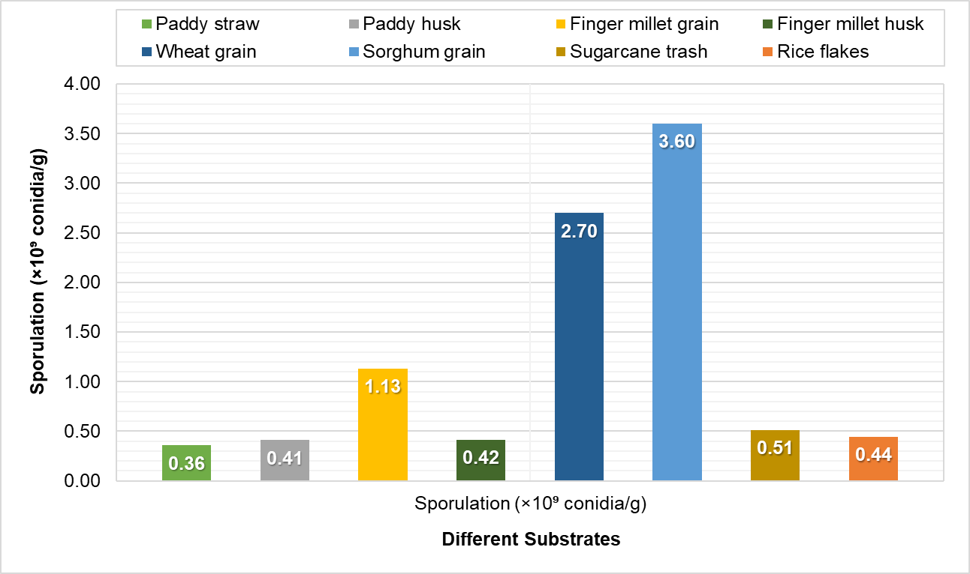

**Fig. 1: Effect of different substrates on sporulation of *Nomuraea rileyi***

**4 CONCLUSIONS**

In conclusion, the results indicated that sorghum grain was the most effective substrate, yielding a sporulation rate of 3.60 × 109 conidia ml-1, followed by wheat grain at 2.70 × 109 conidia ml-1. In contrast, other substrates such as paddy straw, paddy husk, finger millet husk, rice flakes, and sugarcane straw demonstrated significantly lower sporulation rates. The findings accentuate the potential of utilizing cereal grains for the mass production of *N. rileyi*, suggesting that optimizing substrate formulations could further enhance sporulation rates and the overall efficacy of this biocontrol agent. The observed variations in sporulation rates can be attributed to factors such as nutrient availability, moisture content, and surface area, which are critical for fungal growth and development of entomopathogenic fungi. This research highlights the importance of exploring locally available substrates to improve the production and application of *N. rileyi* in biocontrol strategies, ultimately contributing to sustainable agricultural practices.

Disclaimer (Artificial intelligence)

Author(s) hereby declare that NO generative AI technologies such as Large Language Models (ChatGPT, COPILOT, etc.) and text-to-image generators have been used during the writing or editing of this manuscript.

References

Bhide, S. G. (2001). The use of *M. anisopliae* for the control of Rhinoceros beetle infesting coconut palms. *Thesis M. Sc. (Agri.) (Unpublished)*, Dr. Balasaheb Sawant Konkan Krushi Vidhyapeeth, Dapoli, Maharashtra.

de Faria, M. R. & Wraight, S. P. (2007). Mycoinsecticides and mycoacaricides: a comprehensive list with worldwide coverage and international classification of formulation types. Biological control, 43 (3), 237-256.

Francisco, E. A., Mochi, D. A., Correia, A. D. C. B. & Monteiro, A. C. (2006). Influence of Culture Media in Viability Test of Conidia of Entomopathogenic Fungi. Ciência Rural, 36, 1309-1312.

Gopinath, P. P., Parsad, R., Joseph, B. & Adarsh, V. S. (2020). GRAPES (General R-based Analysis Platform Empowered by Statistics). (Available on: <https://www.kaugrapes.com/home>; Version 1.0.0) (DOI: <https://doi.org/10.5281/zenodo.4916978>)

Humber, R. A. (1997). Manual on techniques in insect pathology. Academic Press, London, pp. 153-155.

Lingappa, S. & Patil, R. K. (2002). *Nomuraea rileyi* - A Potential Mycoinsecticide. University of Agricultural Sciences, Dharwad, pp. 30.

Mascarin, G. M., &amp; Jaronski, S. T. (2016). The production and uses of *Beauveria bassiana* as a microbial insecticide. World Journal of Microbiology and Biotechnology, 32, 1-26.;

Moore, D. & Higgins, P. M. 1996. Viability of stored conidia of *Metarhizium flavouride* produced under differing culture regimes and stored with clays. Biocontrol Sci. Technol., 7, 335-343.

Neeraja, D. B. (2008). Studies on the mass production and pathogenicity of *Nomuraea rileyi*: an entomopathogenic fungus. *Thesis M.Sc. (Agri.)*, Acharya N. G. Ranga Agricultural University, Hyderabad.

Prajapati, A. R. & Chandaragi, M. K. (2022). *Metarhizium* (*Nomuraea*) *rileyi* (Farlow) Kepler, S. A. Rehner & Humber: a weapon against lepidopteran pests. In New Frontiers in Entomology – Vol. 1. *Advent Publishing*, Maharashtra. Pp. 101-117.

Preez, J. C., Jong, F. P., Botes, J. & Lategon, T. M. (1985). Fermentation alcohol from grain sorghum starch. Biomass, 8 (2), 101-117. (DOI: https://doi.org/10.1016/0144-4565(85)90021-6)

Purwar, J. P. & Sachan, G. C. (2006). Evaluation of media for growth and sporulation of entomogenous fungi. Annals of Plant Protection Sciences, 14 (2), 484-485.

Ranadev, P., Nagaraju, K. & Vasanth Kumari R. (2024). From Waste to Utilization: Assessing the Feasibility of Using Post-Mushroom Substrate and Other Agro-Wastes for the Mass Production of Entomopathogenic Fungi. J. Agric. Sci. Technol., 26 (5), 1073-1082.

Shah, F. A., Wang, C. S. & Butt, T. M. (2005). Nutrition influences growth and virulence of the insect-pathogenic fungus *Metarhizium anisopliae*. FEMS Microbiology Letters, 251 (2), 259-266.

Sharma, S., Gupta, R. B. L. & Yadava, C. P. S. (1999). Mass multiplication and formulation of entomopathogenic fungi and their efficacy against white grub. Journal of Mycology and Plant Pathology, 29 (3), 299-305.

Sowmya, E., Hosamani, A. & Mamatha, M. (2022). Mass production of insect pathogenic hypocreale fungi, *Metarhizium anisopliae* on solid substrates and liquid media. Journal of Biological Control, 36 (2&3), 169-174. (DOI: 10.18311/jbc/2022/30970)

Steel, R. G. D. & Torrie, J. H. (1980). Principles and procedures of statistic a biomatereal approach. 2nd edition. McGraw-Hill. New York, USA. pp. 107-117.

Veni, S. K., Manjula, K. & Krishna, T. M. (2015). Preparation of grain formulations of *Nomuraea rileyi* (Farlow) Samson and evaluation of viability of spores. Andhra Pradesh Journal of Agricultural Sciences, 1 (1), 39-42.

Zimmermann, G. 1986. The galleria bait method for detection of entomopathogenic fungi in soil. J. Appl. Entomol., 102:213-215.