*Original Research Article*

**ON *CAVISOMA MAGNUM* (ACANTHOCEPHALA: CAVISOMIDAE) IN THE PERSIAN GULF NEAR BASRA, WITH NEW MORPHOLOGICAL OBSERVATIONS AND A MOLECULAR PROFILE**

**ABSTRACT**

**Aims:** To supplement the description of *Cavisoma magnum* (Southwell, 1927) Van Cleave, 1931 which was originally described from a sea bass, *Serranus* sp. Cuvier and spotted surgeonfish, *Ctenochaetus strigosus* (Bennett) (Perciformes) off Sri Lanka before its more recent redescription from milkfish in the Philippines in 1995. We also describe its molecular profile for the first time.

**History:** We recently provided a comprehensive revision of this species including SEM images, new systematic observations, metal analysis of hooks, and histopathology in a mullet intestinal tissue for the first time. Adjustments and corrections to previous descriptive accounts were made. The results of our x-ray analysis displayed high levels of sulfur especially at the tips and edges of the proboscis hooks.

**Study design**: We examined new specimens from Persian Gulf material and produced new SEM and light microscopy images that were not previously known. In addition, we provided the molecular characterization of the nuclear gene (18S) of ribosomal subunit. To elucidate the phylogenetic relationships of the *C. magnum* and the other genera in the family Cavisomidae, phylogenetic analyses were performed using maximum likelihood (ML) and Bayesian inference (BI).

**Place and duration of study.** The study took a few months in the Persian Gulf in 2023 but the molecular analysis was conducted in India for a longer period.

**Methodology.** Routine methods of processing and examination of specimens by light microscopy and SEM imaging were followed. PCR reactions were carried out and the 18S sequence data phylogenetic trees were constructed using maximum likelihood (ML) with MEGA v11. The genetic distances (uncorrected p-distance) were calculated with MEGA v11

**Results and conclusions:** New images of various morphological structures and of hosts and recovered worms add more perspective towards the description of this worm and the phylogenetic analysis showed that Cavisomidae has a sister relationship with Rhadinorhynchidae + Gymnorhynchidae.

**Importance:** This work redescribes the taxonomy of *Cavisoma magnum* and provides new images as well as its molecular analysis for the first time.

*Key words: Acanthocephala, Cavisoma magnum, nuclear gene (18S), Mugil cephalus, Persian Gulf, new description*.

**INTRODUCTION**

The nomenclature history of *Cavisoma magnum* (Southwell, 1927) Van Cleave, 1931 underwent turbulent changes since its original description. It was initially inadequately described as *Oligoterorhynchus magnus* by Southwell (1927) from the stomach and pyloric ceca of the sea bass, *Serranus* sp. Cuvier (Serranidae) (20 worms) and from the spotted surgeonfish *Acanthurus strigosus* Bennett (=*Ctenochaetus strigosus* Bennet) (Acanthuridae) (6 worms) off Negapatam, Ceylon (Sri Lanka). Southwell (1927) provided a line drawing of a short wrinkled male specimen with invaginated proboscis (his Fig. 1), a proboscis with eight hooks per row showing no roots, a praesoma with invaginated proboscis and lemnisci shorter than the receptacle, and an egg. Van Cleave (1931) created the new genus *Cavisoma* in his new family Oligoterorhynchidae later becoming Cavisomidae or Cavisominae of Meyer (1932) in Echinorhynchidae to accommodate *Oligoterorhynchus magnus* of Southwell and declared *C. magnus* as its type species. Van Cleave (1931) did not redescribe *C. magnum* but gave the following generic diagnosis: “Parasitic in marine fish of Ceylon. Body devoid of spines. Proboscis club-shaped, with simple hooks. Receptacle double-walled with brain near its center and with retinacula near its middle. Lemnisci shorter than receptacle. Male organs confined to posterior fifth of body; testes in broad contact; cement glands four, tubular. Middle membrane of embryos with conspicuous polar prolongations.”

Meyer (1932) amended the genus *Cavisoma* and included a species description identical to that of Southwell (1927). Petrochenko (1956) included *Cavisoma* in his family Cavisomatidae (Van Cleave, 1931) Petrochenko, 1956 with three other genera, *Rhadinorhynchoides* Fukui and Morosita, 1937, *Pararhadinorhynchus* Johnston and Edmonds, 1947, and *Filisoma* Van Cleave, 1928. Petrochenko’s (1956) description was also identical to that of Southwell (1927) and Meyer (1932); no line drawings were provided. Golvan’s (1969) description of *C. magnum* copied Southwell’s (1927) line drawings and his description was similarly identical to that of Southwell’s (1927).

Much of the work on *C. magnum* from milkfish has taken place in the Philippines from milkfish until we recently made our breakthrough in the Persian Gulf. Velasquez (1984) summarized much of her work during the 1970s on pests and diseases of milkfish from various sites in the Philippines that included reference to one species of Acanthocephala identified as *Acanthocephalus* sp. Available evidence suggests that this acanthocephalan must have been *C. magnum* as has also been recognized by Arthur et al. (1995). In her Master’s thesis, Regidor (1989) studied a population of *C. magnum* from milkfish in the Philippines and monitored infection patterns in fish from fry to commercial sizes. In a survey of parasites of milkfish examined in Zamboanga, Mindanao, Regidor and Arthur (1992) identified *C. magnum* from milkfish in the Philippines for the first time prompting the redescription of this acanthocephalan by Arthur et al. (1995) who provided the only description of *C. magnum* that is not based on Southwell’s (1927) account. That redescription was detailed and showed some variations in measurements from those of Southwell’s (1927) and ours (Table 1), and was augmented with 6-line mostly flawed drawings that were mostly flawed. For instance, their (Arthur et al., 1995) Fig. 1 showed a disproportionate size of the male reproductive system compared to trunk, and lemnisci longer than receptacle. Their Fig. 2 showed a proboscis with rootless hooks throughout and a row of 6 hooks. Their Fig. 3 showed an anterior hook with an inaccurate root. Their Fig. 4 showed an egg with truncated polar ends. Their Fig. 5 showed an incorrect uterus shape. The shape of Saefftigen’s pouch, undulating posterior body wall and proportions of testes size (Fig. 6) were also inaccurate. *Cavisoma magnum* was subsequently reported in specimens of adult milkfish *Chanos chanos* (Forsskål) (Chanidae) in the Philippines (Briones et al., 2015) and included in the checklist by (Arthur and Lumanian-Mayo 1997). Some of the information lacking in the original description (Southwell, 1927) was addressed in the redescription by Arthur et al. (1995) of specimens from *C. chanos* caught in the southern Philippines. Much remained to be addressed.

Milkfish were also found infected with *C. magnum* in the Persian Gulf. Our collection of 1,450 worms from one flathead grey mullet, *Mugil cephalus* Linn. (Mugilidae) in the Persian Gulf off the Iraqi coast (Amin et al., 2018) provided the materials to describe *C. magnum* using SEM images, made new systematic observations and metal analysis of hooks, and reported on the histopathology in the mullet intestinal tissue. Amin et al. (2018) provided comparative morphometrics between the Persian Gulf material and those of Southwell (1927) and Arthur et al. (1995).

The molecular characterization of the 18S ribosomal DNA sequence data of C. magnum is provided for the first time. Besides this, we concisely discuss the systematics of *C. magnum*, we concisely discuss the systematics of *C. magnum* to explain its phylogenetic relationships.

1. **MATERIALS AND METHODS**

**2.1 Collections**

Fishes were purchased at the local fish market in the Al-Faw City area in southern Iraq, northwest Persian Gulf ([29°58′33″N 48°28′20″E](https://tools.wmflabs.org/geohack/geohack.php?pagename=Al-Faw&params=29_58_33_N_48_28_20_E_region:IQ_type:city_source:GNS-enwiki)). One 130-cm long milkfish, *C. chanos*, obtained at this fish market on November 14, 2017 (Fig. 1) was infected with about 350 specimens of *C. magnum*. The intestine of one of 8 flathead grey mullets, *Mugil cephalus* examined from the Persian Gulf off the coast of Basra, Iraq in January and February 2017 was infected with 1,450 worms (Fig. 2). The fish averaged about 120 cm in total length. Recovery of parasites was made by Essa T. Mohammad and Majid A. A. Bannai of the Marine Science Center, University of Basra, Iraq in 2017.

Our examination of the intestinal tract revealed many unidentified crustaceans. Selected samples were shipped to our Scottsdale, Arizona facility for processing and further studies.

**2.2 Study of specimens**

Worms were processed for microscopical examination, SEM, X-ray microanalysis (EDXA: Energy dispersive x-ray analysis), for ion sectioning of hooks, and histological studies as in Amin et al. (2018). Voucher specimens were deposited in the University of Nebraska’s State Museum’s Harold W. Manter Laboratory (HWML) collection in Lincoln, Nebraska, USA.

**2.3 Molecular methods**

Adult worms were washed with sterile distilled water for DNA extraction to remove ethanol. Total genomic DNA was extracted using the Qiagen DNeasy tissue kit (Qiagen Inc., Valencia, California, USA) according to the manufacturer’s instructions and kept at -20 °C until use. PCR reactions were carried out in a total volume of 30 μL of reaction mixture containing 2 × red PCR premix (Ampliqon, Odense, Denmark), 20 pmol of each primer, and three μL of extracted DNA. The partial 18S rRNA gene was amplified using the forward primer (5′-AGATTAAGCCATGCATGCGTAAG-3′) and reverse primer (5′-ACCCACCGAATCAAGAAAGAG-3′) (Amin et al., 2020). PCR conditions included an initial denaturing step of 95 °C for 5 min and 35 cycles followed by 35 cycles consisting of 95 °C for 30 s (denaturation), 61°C for 30 s (annealing), and 60 s at 72 °C (extension) with a final extension of 72°C for 7 minutes. The PCR amplicons were separated on 1.5% agarose gel and visualized with UV transluminator (Vilber Lourmat, Collégien, France). Finally, PCR products were sequenced by an ABI 3730 DNA Analyzer (Applied Biosystems, Foster City, CA, USA). Both sequences were aligned using ClustalW implemented in MEGA v11 (Tamura et al., 2021). The newly obtained DNA sequences were compared using the BLASTn algorithm with the available closely related sequences in the NCBI database (http://www.ncbi.nlm.nih.gov). The 18S sequence of C. magnum was subsequently deposited in the GenBank database with the accession number: PV423517.

The 18S sequence data phylogenetic trees were constructed using maximum likelihood (ML) with MEGA v11 (Tamura et al., 2021) and Topali 2.5 (Milne et al., 2009), respectively. Bolbosoma spp. (Palaeacanthocephala: Polymorphidae) were chosen as the out-group. The phylogenetic analysis included species representing members of 09 family with sequences available on GenBank, i.e., Gymnorhadinorhynchidae, Rhadinorhynchidae, Cavisomidae, Transvenidae, Diplosentidae, Tenuisentidae, Echinorhynchidae, and Echinorhynchidae. For the 18S phylogenetic analysis, the jModelTest 0.1.1 program (Darriba et al., 2012) was used to choose the best-fit nucleotide substitution model, and the Akaike Information Criterion (AIC) was chosen. The model GTR + G + I (general time-reversible model, including estimations of invariant sites and gamma distributed among-site variation) was identified as the best-fitting optimal nucleotide model for the 18S gene. The program MEGA v.11 was used for phylogenetic trees analyses by ML, and reliabilities for maximum likelihood inference were verified using 1000 bootstrap replications. The Bayesian Inference analysis used Topali 2.5 (Milne et al., 2009) using Metropolis-coupled Markov Chain Monte Carlo (MCMCMC) search on two simultaneous runs of 4 chains over, and sampling a tree with every 1000 generations. The first 25% of trees were set as “burn-in”. The genetic distances (uncorrected p-distance) were calculated with MEGA v11. The 18S new sequence generated here for *Cavisoma magnum* in the present study was deposited in GenBank for accession number.

1. **RESULTS**

The prevalence of infection in the grey mullet in our study was low, 1 of 8 fish. However, the intensity of infection of one fish with 1,450 large worms was, however, very high. Grey mullets have never been previously reported as hosts of *C. magnum*.

**3.1 Findings**

Our specimens from grey mullet in the Persian Gulf provided considerably more information than those described by Southwell (1927) and Arthur et al. (1995). The original description was incomplete and the redescription corrected many of the earlier problems but had its own inadequacies and oversights especially regarding the proboscis armature and hook roots, egg anatomy, and reproductive system structures in males and females. Differences in the egg shape and the organization of cement glands may have also been related to different host or geographical variables. Our objective is to restudy the specimens reported by Amin et al. (2018) and account for new morphological features not previously reported. The re-examination of additional specimens produced new SEM images of structures that we had not previously observed. Other features that were included in Amin et al. (2018) that will not be addressed here include (1) morphometric comparisons between our Persian Gulf specimens and those reported by Southwell (1927) and Arthur et al. (1995) (Table 1), (2) line drawings showing detail of hook roots and the paravaginal fibrous bundles missing from other descriptions (Figs. 1-7), (3) SEM images (Figs. 8-19), (4) histological sections (Figs. 20-25), (5) measurements of hook length, thickness and roots in males and females (Table 2), (6) EDXA spectra (Figs. 26, 27 and Table 3). Our detailed description (Amin et al., 2018, p. 3) need not be repeated here. Still, a commentary on the additional morphological features depicted in the new SEM and microscopy images added in this report will complete the pictorial presentation of this species.

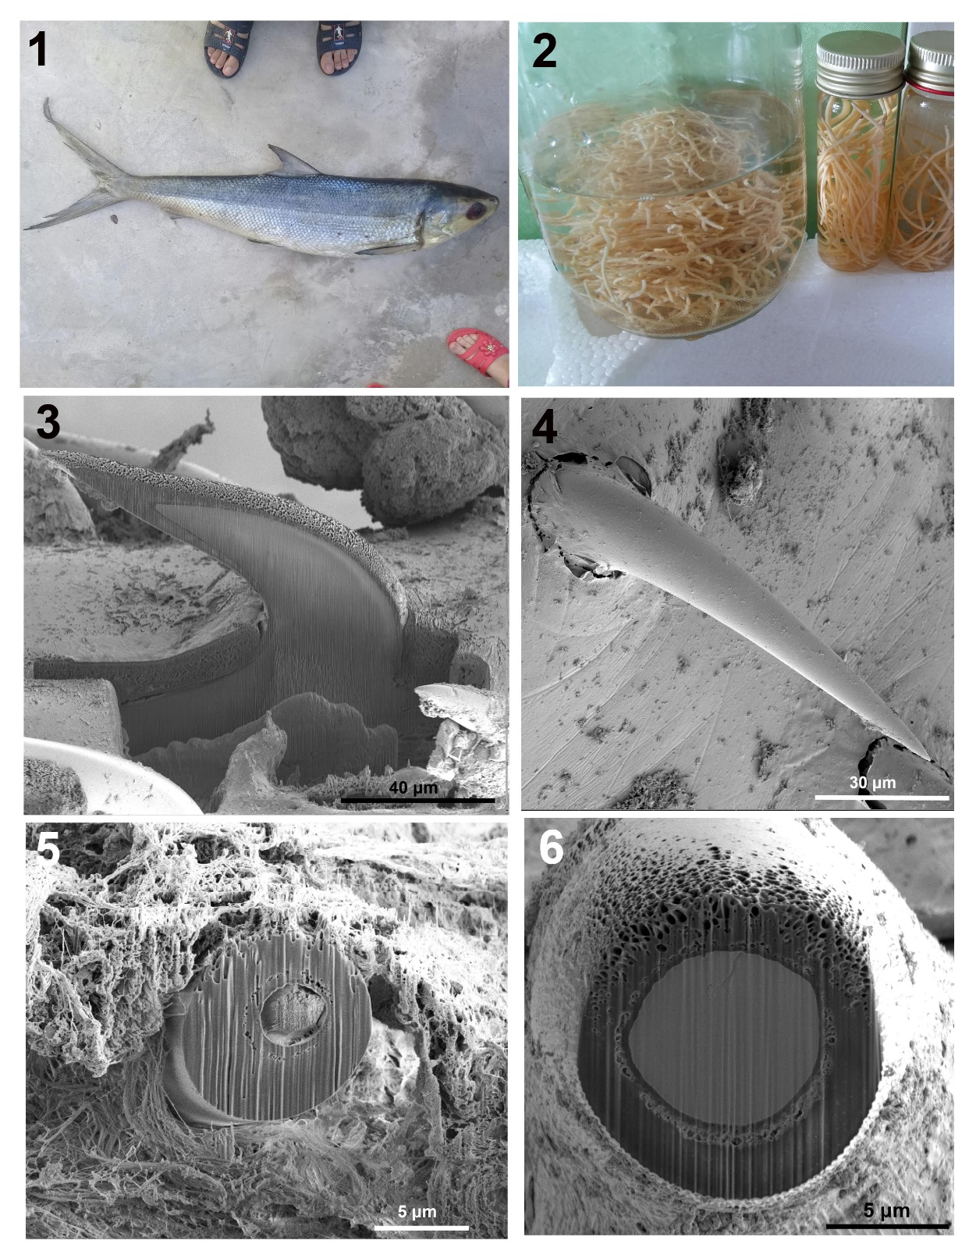

**Figures 1-6.** Images of host and specimens of *Cavisoma magnum*. **1. A** 130-cm long milkfish, *C. chanos*, obtained at a fish market in November, 2017, was infected with about 350 specimens of *C. magnum*. Human feet in the images give a measure of fish size. **2.** About 1,450 acanthocephalans collected from one of 8 flathead grey mullets, *Mugil cephalus* about 120 cm in total length examined from the Persian Gulf off the coast of Basra, Iraq in January and February, 2017. Two other small vials loaded with specimens from the same fish are not shown. The other seven mullets were negative. **3.** A lateral Gallium-cut section of a middle hook showing the thick core and somewhat thick cortical layer. Note the porous texture and the continuity with the root; no separation. 4. Face view of a lamellated sub-apical hook. **5.** A Gallium-cut cross section of a middle hook near its base. Note the very thick core and thin cortical layer. **6.** A Gallium-cut cross section of another middle hook near its apical end shows the thicker cortical layer and the smaller core.

**3.2 New observations**

These worms have a tough club-shaped proboscis with 12-13 rows of strong hooks deeply rooted anteriorly (Fig. 3). The hooks gradually decrease in size posteriorly. Basal hooks appear to emanate from anterior trunk where paired sensory pores are found. The hook in Fig. 4 is similar to those cross-sectioned basally (Fig. 5) and at tip (Fig. 6). Corresponding longitudinal sections show the same pattern of thicker medullary regions basally and heavier cortical region terminally. These hooks cause considerable damage to the intestinal wall of the host as they penetrate deeply into the submucosa with host collagenous fibers attached to the hooks causing intensive host cell necrosis and hemorrhaging due to destruction of capillary vessels (Fig. 7). The body wall is studied with micropores of various diameter and distribution across multiple trunk regions (Fig. 8) which is essential for differential absorption of nutrients. The notched shallow epidermal annulations (Fig. 9) are not a result of shrinkage or a byproduct of a pseudo-segmentation. They are actually fixed circular rings throughout the trunk connecting regularly spaced fusiform plates (Fig. 10). These plates appear to be sensory that need to be verified and researched. These circular rings are connected with longitudinal cords (Fig. 9, arrow). A section through the outer cuticle (Fig. 11) shows the beginning of the thick tegument just above the circular muscle layer. A lateral view of the rounded bursa (Fig. 12) shows the absence of specialized appendages, sensory structures, pores, or discs.

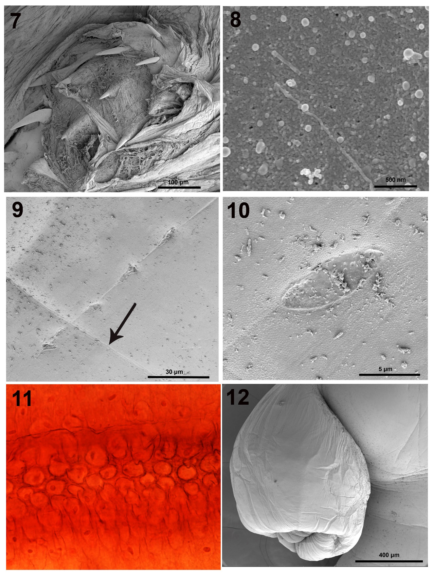

**Figures 7-12.** Images of specimens of *Cavisoma magnum*. **7.** Damage to the intestinal wall of a mullet showing deep penetration of acanthocephalans into the submucosa with host collagenous fibers attached to the hooks causing intensive host cell necrosis. **8.** Micropores at the anterior trunk of a worm. **9.** Notched shallow epidermal annulations are fixed circular rings throughout the trunk with regularly spaced fusiform plates. These annulations are connected with longitudinal channels (arrow). **10.** A higher magnification of one of the fusiform plates shown in Fig. 9. These plates appear to be sensory structures. **11.** A microscopical section through the mono-nucleated outer cuticular cells. **12.** A rounded bursa lacking any apparent external specialized structures or pores.

**3.3 Molecular results**

We also provide a molecular analysis of *Cavisoma magnum* from our *Mugil cephalus* material from the Persian Gulf for the first time. The phylogenetic results based on the 18S sequence data using ML and BI methods, correspondingly, were very analogous (Fig. 13). In the tree, C. magnum clustered together with the representatives of Cavisoma + Rhadinorhynchidae and Gymnorhadinorhynchidae with strong support (BP= 94, PP= 1) (Fig. 13). *Cavisoma magnum* also formed a sister relationship with other representatives of Transvenidae + Diplosentidae + Tenuisentidae with moderate support (BP= 84, PP= 0.89). *Cavisoma magnum* is clearly a valid species; it utilizes the 18S region and is a good genetic marker for identifying and differentiating acanthocephalans. However, we noted that the scarcity of the genetic data from the species of the family Cavisomidae limited our analysis.

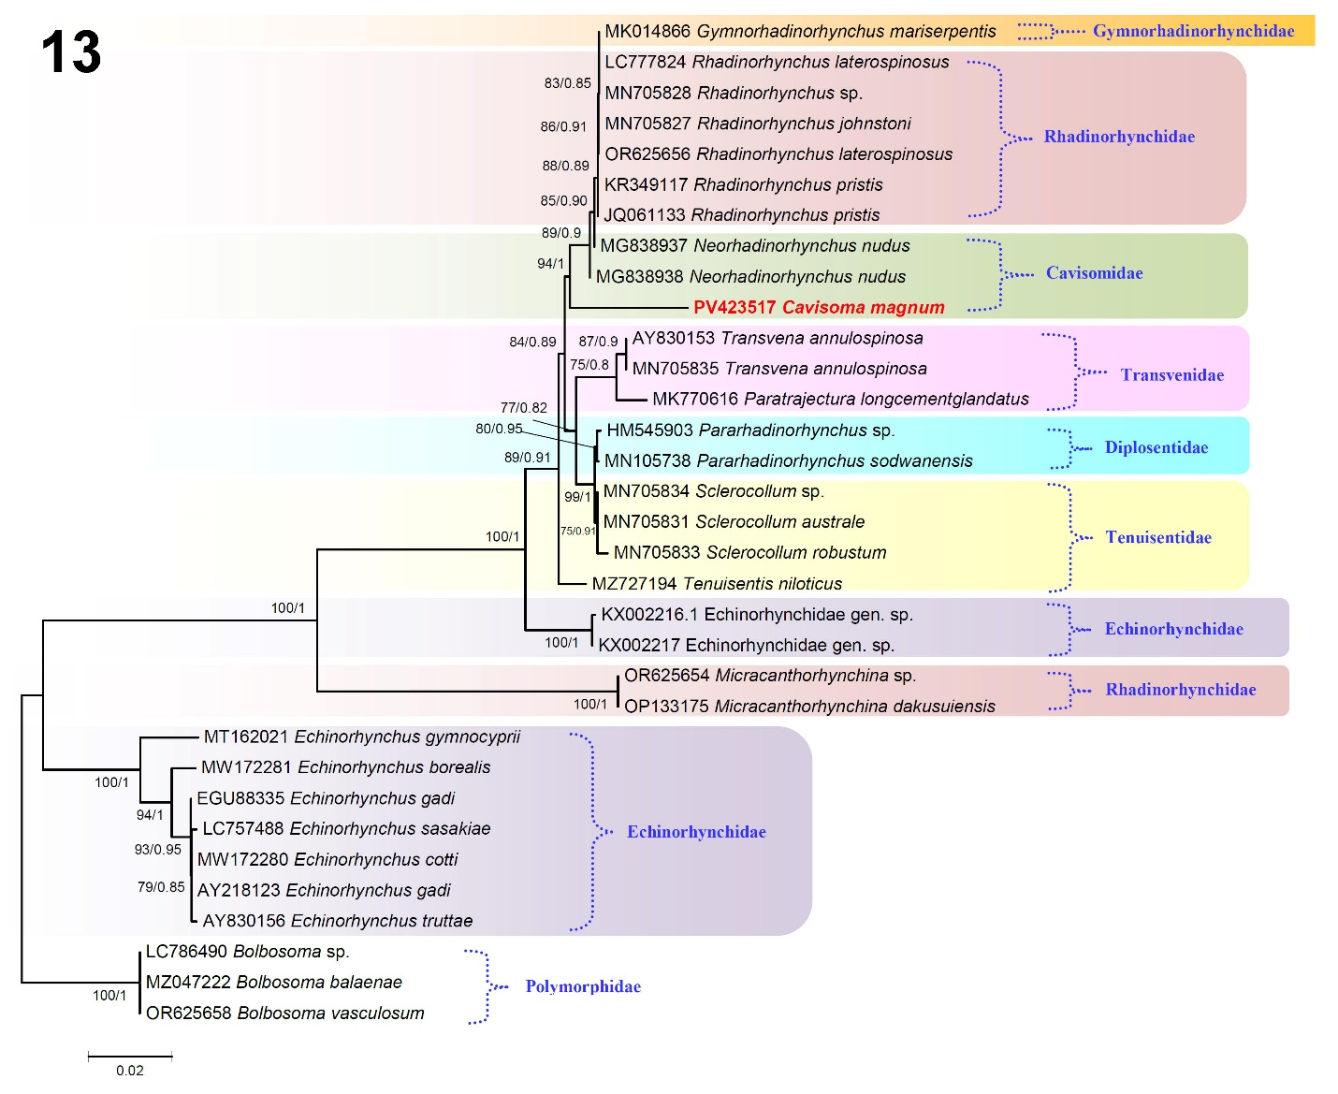

**Figure 13.** Phylogenetic reconstruction based on the 18S rDNA sequences of *Cavisoma magnum* and sequences of other closely related acanthocephalans available in the GenBank. The numbers indicate values of bootstrap > 70%. *Bolbosoma* species are used as an outgroup. Numbers next to nodes refer to support values of Maximum Likelihood (ML) and Bayesian inference (BI) as ML/BI. GenBank accession numbers are included before the species name. Species sequenced in the present study are shown in bold. The branch length scale bar indicates the number of substitutions per site.

**­**

**4. DISCUSSION**

The morphological revision of *C. magnum* was elaborated by Amin et al. (2018), which should be consulted as the reference line for this species. In the present contribution, we provide a pictorial accounting of additional morphological features that have not been reported by other authors including Amin et al. (2018). Our phylogenetic results using ML and BI methods both showed that the genus Cavisoma formed a separate clade as no sequence is available on the NCBI for any ribosomal gene of this species. Only a mitochondrial genome for C. magnum is available on the NCBI database (Muhammad et al., 2020). *Cavisoma magnum* shows a sister relationship with Rhadinorhynchidae + Gymnorhynchidae species with firm support. Our results agree with the previous phylogenetic analyses of the familial affiliation of *Pseudocavisoma* Golvan & Houin, 1964 from Japan by Kita et al. (2024). Earlier studies agreed well with the 18S region being a worthy genetic tool for the molecular studies (Near et al., 1998; García-Varela et al., 2000, 2002; Li et al., 2017; Chaudhary et al., 2019; Dai et al., 2022; Ru et al., 2022; Sharifdini and Amin, 2022; Ortega-Olivares et al., 2023; Amin et al., 2024). The current phylogenetic results also sustained the validity of the genus Cavisoma, which revealed that the present results obtained herein, should be perceived as a primary for the molecular validation of the species of genus *Cavisoma*. However, further rigorous molecular phylogenetic studies with more representatives of the Cavisomidae are much needed in order to further clarify and substantiate the phylogenetic relationships of Cavisoma and the other genera of Cavisomidae for a more stable classification.

**5. Conclusions.** We redescribe *cavisoma magnum*. The redescription is supported by new images of morphology, pathology, and collection data not previously reported. We also provide a molecular analysis of *C. magnum* from our *Mugil cephalus* material for the first time. The phylogenetic results are based on the 18S sequence data using ML and BI methods. This is the first time that the molecular analysis of any member of the genus *Cavisoma* has become available.

**CONSENT**

All authors declare that ‘written informed consent was obtained from coauthors for publication of this work and accompanying images. A copy of the written consent is available for review by the Editorial office/Chief Editor/Editorial Board members of this journal

**STATEMENTS AND DECLARATIONS**

**Availability of data and material**

All samples used in this study have been deposited in the relevant curated, internationally recognized museum collection as outlined in this paper.

**Ethical approval**

All applicable institutional, national, and international guidelines for the care and use of animals were followed.

**Conflict of interest**

Authors declare no conflicts of interests.

**Disclaimer (Artificial intelligence)**

Option 1:

Author(s) hereby declare that NO generative AI technologies such as Large Language Models (ChatGPT, COPILOT, etc.) and text-to-image generators have been used during the writing or editing of this manuscript.

References

Amin, O. M., Sharifdini, M., Heckmann, R. A. & Zarean, M. (2020). New perspectives *on Nephridiacanthus major* (Acanthocephala: Oligacanthorhynchidae) collected from hedgehogs in Iran. Journal of Helminthology 94: e133-e133.

Amin, O. M., Chaudhary, A., Sharifdini, M., & Singh, H. S. (2024). First molecular description of *Neorhadinorhynchus nudus* (Acanthocephala: Cavisomidae) from fish in the Pacific coast of Vietnam, with notes on biogeography. Systematic Parasitology 101: 23.

Amin, O. M., Heckmann, R. A., & Bannai, M. A. (2018). *Cavisoma magnum* (Cavisomidae), a unique Pacific acanthocephalan redescribed from an unusual host, *Mugil cephalus* (Mugilidae), in the Arabian Gulf, with notes on histopathology and metal analysis. Parasite 25: 5.

Arthur, J. R. & Lumanian-Mayo, S. (1997). Check list of the parasites of fishes of the Philippines. FAO Fisheries Technical Paper 369.

Arthur, J. R., Regidor, S. E. & Albert, E. (1995). Redescription of *Cavisoma magnum* (Southwell, 1927) (Acanthocephala: Cavisomidae) from the milkfish, *Chanos chanos*, in the Philippines. Journal of the Helminthological Society of Washington 62: 39–43.

Briones, J. C. A., Papa, R. D. S., Cauyan, G. A. & Urabe, M. (2015). The first report of three acanthocephalan parasite species from Philippine fishes. Helminthologia 52: 384–389.

Chaudhary, A., Amin, O. M. & Singh, H. S. (2019). Molecular characterization and phylogenetic relationships of *Pallisentis* (*Brevitritospinus*) *indica* (Acanthocephala: Quadrigyridae), a parasite of the Spotted Snakehead (Channa punctatus). Journal of Parasitology 105: 180–185.

Dai, G. D., Yan, H. B., Li, L., Zhang, L. S., Liu, Z. L., Gao, S. Z., Ohiolei, J. A., Wu, Y. D., Guo, A. M., Fu, B. O. & Jia, W. Z. (2022). Molecular characterization of a new Moniliformis sp. from a Plateau Zokor (*Eospalax* *fontanierii baileyi*) in China. Frontiers in Microbiology 13: 806882.

Darriba, D., Taboada, G. L., Doallo, R. & Posada, D. (2012). jModelTest 2: more models, new heuristics and parallel computing. Nature Methods 9: 772.

García-Varela, M., Pérez-Ponce de León, G., De la Torre, P., Cummings, M. P., Sarma, S. S., Laclette, J. P. (2000). Phylogenetic relationships of Acanthocephala based on analysis of 18S ribosomal RNA gene sequences. Journal of Molecular Evolution 50: 532–540.

García-Varela, M., Cummings, M. P., Pérez-Ponce de León, G., Gardner, S. L. & Laclette, J. P. (2002). Phylogenetic analysis based on 18S ribosomal RNA gene sequences supports the existence of class Polyacanthocephala (Acanthocephala). Molecular Phylogenetics and Evolution 23: 288–292.

Golvan, Y. (1969). Systématique des Acanthocephales (Acanthocéphala Rudolphi, 1801), L’ordre des Palaeacanthocephala Meyer, 1931, La superfamille des Echinorhynchidea (Cobbold, 1876) Golvan et Houin 1973. Mémoires du Muséum Natl d’Histoire Nat 47: 1–373.

Kita, Y., Nitta, M. & Kajihara, H. (2024). Systematics of *Pseudocavisoma* (Acanthocephala: Echinorhynchida): assessment of familial affiliation, establishment of a new species, and complementary redescription of the type species based on syntypes. Systematic Parasitology 101: 73.

Li, L., Chen, H. X., Amin, O. M. & Yang, Y. (2017). Morphological variability and molecular characterization of *Pomphorhynchus zhoushanensis* sp. nov. (Acanthocephala: Pomphorhynchidae), with comments on the systematic status of *Pomphorhynchus* Monticelli, 1905. Parasitology International 66: 693–698.

Meyer, A. (1932). Dr. H. G. Bronn’s Klassen und Ordnungen des Tierreichs. 4. Band, 2. Abt., 1. Buch. Acanthocephala. Akademische Verlagsgesellschaft, Leipzig, Germany.

Milne, I., Lindner, D., Bayer, M., Husmeier, D., McGuire, G., Marshall, D. F. & Wright, F. (2009). TOPALi v2: A rich graphical interface for evolutionary analyses of multiple alignments on HPC clusters and multi-core desktops. Bioinformatics 25: 126–127.

Muhammad, N., Li, L., Suleman, Zhao, Q., Bannai, M. A., Mohammad, M. T., Khan, M. S., Zhu, X. Q. & Ma, J. (2020). Characterization of the complete mitochondrial genome of *Cavisoma magnum* (Acanthocephala: Palaeacanthocephala), first representative of the family Cavisomidae, and its phylogenetic implications. Infection Genetics and Evolution 80: 104173.

Near, T. J., Garey, J. R. & Nadler, S. A. (1998). Phylogenetic relationships of the Acanthocephala inferred from 18S ribosomal DNA sequences. Molecular Phylogenetics and Evolution 10: 287–298.

Ortega-Olivares, M. P., Velázquez-Urrieta, Y., Sereno-Uribe, A. L., Harvey, M. B. & García-Varela, M. (2023). A molecular and ecological study of *Macracanthorhynchus ingens* (von Linstow, 1879) (Acanthocephala: Archiacanthocephala), in its paratenic and definitive hosts in southeastern Mexico and the Eastern USA. Systematic Parasitology 100: 543–556.

Petrochenko, V. (1956). Acanthocephala of domestic and wild animals, Vol. I. Izdatel’stvo Akademii Nauk SSSR, Moscow.

Regidor, S. E. (1989). A survey of the parasites of milkfish in the Philippines. Master’s Thesis. Retrieved from [https://animorepository.dlsu.edu.ph//etd_masteral/1240](https://animorepository.dlsu.edu.ph/etd_masteral/1240).

Regidor, S. E. & Arthur, J. R. (1992). A survey of the parasite fauna of milkfish, *Chanos chanos* (Forskal), in the Philippines. In Diseases in Asian Aquaculture I M. Shariff, R. P. Subasinghe & J. R. Arthur (eds.). Fish Health Section, Asian Fisheries Society, Manila, Philippines, pp. 313–322.

Ru, S. S., Yang, R. J., Chen, H. X., Kuzmina, T. A., Spraker, T. R. & Li, L. (2022). Morphology, molecular characterization and phylogeny of *Bolbosoma nipponicum* Yamaguti, 1939 (Acanthocephala: Polymorphidae), a potential zoonotic parasite of human acanthocephaliasis. International Journal of Parasitology: Parasites and Wildlife 18: 212–220.

Sharifdini, M. & Amin, O. M. (2022). Molecular analysis of *Pomphorhynchus kashmirensis* based on 18S rDNA and ITS-rDNA. International Journal of Zoology and Animal Biology 5: 000372.

Southwell, T. (1927). New species of Acanthocephala (*Oligoterorhynchus magnus*) from a marine fish. Annals of Tropical Medicine and Parasitology 21: 165–169.

Tamura, K., Stecher, G. & Kumar, S. (2021). MEGA11: Molecular Evolutionary Genetics Analysis Version 11. Molecular Biology and Evolution 38: 3022–3027.

Van Cleave, H. J. (1931). New Acanthocephala from fishes of Mississippi and a taxonomic reconsideration of forms with unusual numbers of cement glands. Transactions of the American Microscopical Society 50: 348–363.

Velasquez, C. C. (1984). Pest/parasites and diseases of milkfish in the Philippines. In Advances in Milkfish Biology and Culture J. V. Juario, R. P. Ferraris & L. V. Benitz (eds.). Island Publishing House, Metro Manila, and SEAFDEC Aquaculture Department, Manila, Philippines, pp. 155–159.