**Transforming Indian Agriculture through Blockchain Technology: A Comprehensive Review of Innovations and Applications**

**ABSTRACT**

Agriculture is a cornerstone of India’s economy, contributing 18.3% to the Gross Value Added (GVA). Despite its importance, it remains one of the least digitized industries, facing challenges in transparency, efficiency, and trust. Blockchain technology, with its decentralized and immutable ledger system, has emerged as a revolutionary tool to address these challenges. This review explores the potential of blockchain in transforming Indian agriculture by analysing real-life case studies like Fertilizer Subsidy Management, Seed Distribution, Traceability interface, and land records, Public distribution systems, Blood Bank and Secure and Seamless Taxation. These applications showcase blockchain's capacity to enhance transparency, efficiency, and accountability while addressing systemic inefficiencies. The paper discusses the current progress, challenges, and the future trajectory of blockchain adoption in Indian agriculture. While showcasing promising applications, the study also discusses the challenges of scalability, digital literacy, and regulatory frameworks that must be addressed for widespread adoption.

***Keywords:****Blockchain Technology, Smart Contracts, Traceability, Land Records, Public Distribution System, Fertilizer Subsidy Management, Seed Distribution*

1. **INTRODUCTION**

## Indian agriculture faces inefficiencies due to limited digital penetration and challenges in transparency. Blockchain, a decentralized distributed ledger technology, promises secure, immutable, and transparent transaction records, addressing these longstanding issues [20-22]. This paper explores blockchain's application in agriculture through significant case studies, analyzing its benefits, challenges, and future potential.

## Blockchain Technology

## Blockchain is a shared, immutable ledger that facilitates the process of recording transactions and tracking assets in a business network.

## How Blockchain Work?

The transaction process in a blockchain can be summarized as follows:

1. **Transaction Facilitating:**A new transaction enters into the blockchain network. All the information that needs to be transmitted is doubly encrypted using public and private keys.
2. **Transaction Verification:** The transaction is transmitted to the network of peer-to-peer computers distributed across the world. All the nodes on the network will check for the validity of the transaction like sufficient balance is available for carrying out the transaction.
3. **New Block Formation:**In a typical blockchain network there are many nodes and many transactions get verified at a time. Once the transaction is verified and declared a legitimate transaction, it will be added to the mempool.  All the verified transactions at a particular node form a mempool and such multiple mempools form a block.
4. **Consensus Algorithm:** The nodes that form a block will try to add the block to the blockchain network to make it permanent. But if every node is allowed to add blocks in this manner then it will disrupt the working of the blockchain network. To solve this problem, the nodes use a consensus mechanism to ensure that every new block that is added to the Blockchain is the only version of the truth that is agreed upon by all the nodes in the Blockchain, and only a valid block is securely attached to the blockchain [18,19]. The node that is selected to add a block to the blockchain will get a reward and hence we call them “miners”. The consensus algorithm creates a hash code for that block which is required to add the block to the blockchain.
5. **New Block Addition in Blockchain:**After the newly created block has got its hash value and is authenticated, now it is ready to be added to the blockchain. In every block, there is a hash value of the previous block and that is how the blocks are cryptographically linked to each other to form a blockchain. A new block gets added to the open end of the blockchain.
6. **Transaction Completion:**As soon as the block is added to the blockchain the transaction is completed and the details of this transaction are permanently stored in the blockchain. Anyone can fetch the details of the transaction and confirm the transaction.

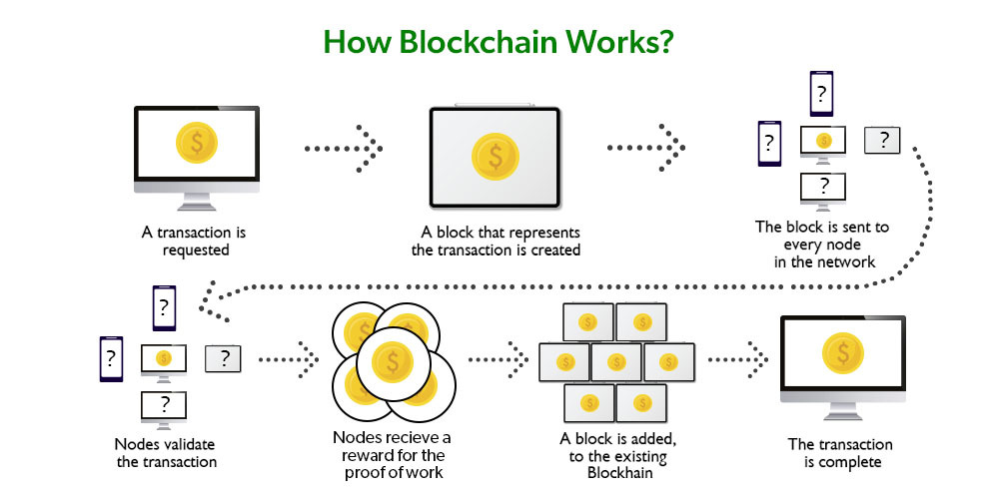

**Fig. 1 Blockchain workflow**

1. **TYPES OF BLOCKCHAIN:**

Blockchain networks are generally categorized into four main types: public, private, consortium, and hybrid. Each type differs in terms of access, permissions, and governance structure, which influences how suitable they are for various use cases.



**Fig. 2 Types of blockchain technology**

**Public Blockchains** are open and permissionless networks where anyone can join, access the data, and take part in the consensus mechanism. Their decentralized and distributed structure makes them highly transparent and secure. Well-known examples include Bitcoin and Ethereum.

**Private Blockchains** are permissioned networks managed by a single organization or a select group, where access and participation are restricted. They provide enhanced control and privacy compared to public blockchains, making them ideal for internal operations within companies or specific sectors. For example, they are often used in supply chain management, allowing only authorized participants to view or alter the data.

**Consortium Blockchains** are semi-decentralized networks managed by a group of predetermined organizations instead of a single authority. They combine features of both public and private blockchains, providing a balance between transparency and centralized control. These blockchains are commonly used by financial institutions to facilitate efficient cross-border transactions and settlements.

**Hybrid Blockchains** integrate elements of both public and private blockchains, enabling selective access and data sharing. This approach offers flexibility and greater control over how information is managed and distributed. A common use case is in loyalty programs, where general data can be made publicly available, while confidential customer details remain securely private.

1. **AGRICULTURAL SUPPLY CHAIN MANAGEMENT SERVICES**

**Supply chain management** in agriculture sector encompasses the range of solutions designed to optimize the flow of agricultural produces from farm to consumer. These services include procurement, production planning, inventory management, transportation, storage, and distribution, all tailored to meet the unique challenges of the agriculture sector. By integrating technology such as blockchain, IoT and data analytics, it improves visibility, traceability, and efficiency across the supply chain. It also helps to reduce post-harvest losses, enhance product quality, and ensure timely delivery, ultimately supporting farmers, agribusinesses, and retailers in meeting market demands more effectively.

Several top vendors provide robust and secure supply chain management tools specifically designed to streamline agricultural distribution. These solutions help manage everything from production planning and inventory tracking to transportation and delivery, ensuring greater efficiency and transparency across the supply chain.

Leading providers often offer features like real-time data analytics, blockchain integration for traceability, and mobile access for field operations. By leveraging these advanced tools, agricultural businesses can reduce waste, optimize logistics, and enhance collaboration among farmers, distributors, and retailers.

Here is a list of leading vendors that provide powerful supply chain management solutions designed to streamline and simplify agricultural distribution.

### **IBM Corporation**

IBM Corporation provides a range of agricultural supply chain services. These services are designed to improve efficiency, transparency, and sustainability within the agricultural sector. The latest technologies, such as AI, blockchain, and IoT, are integrated into the supply chain to enhance various aspects of operations.

IBM Food Trust offers a blockchain-based solution that increases traceability and transparency in the food supply chain. IBM Watson's decision platform for agriculture has AI and data analytics integrated to offer actionable insights to farmers. The company also supplies IoT-based solutions that enable real-time monitoring and management of agricultural operations.  The supply chain solution offered by IBM for agricultural purposes improves multiple aspects of the supply chain, right from procurement to distribution. These solutions support sustainable farming strategies and reduce carbon footprints. It also helps the cultivators to ensure compliance with environmental regulations.

### **Trellis LTD**

Trellis LTD is a leading company focused on providing advanced technological solutions to optimize agricultural supply chains. The company offers a holistic supply chain intelligence service that gives real-time visibility and predictive analytics.

The platform has machine learning and AI integrated that forecast demand, yield, and supply chain disruptions. These predictive analytics help make informed decisions and improve inventory management and timely distribution of agricultural products. Trellis leverages advanced analytics to assist farmers and agricultural businesses in improving crop yields. The tool identifies and mitigates risks related to weather, pests, and market fluctuations. Trellis integrates blockchain technology to ensure transparency and traceability in the agricultural supply chain. This secure and immutable ledger helps track the provenance of agricultural products, ensuring authenticity and quality for consumers and stakeholders.

### **AgriDigital**

AgriDigital provides innovative agricultural supply chain services. The company utilizes blockchain technology, smart contracts, and cloud-based platforms to streamline processes. Its blockchain platform ensures secure, transparent transactions throughout the agricultural supply chain.  Recording transactions on an immutable ledge helps improve traceability, reduce fraud, and develop trust among participants. Its agricultural supply chain service facilitates secure and instant payments through its platform.

### **Bext Holdings Inc.**

Bext Holdings Inc., also known as bext360, offers innovative agricultural supply chain services. The platform offered by the company has embedded advanced technologies such as blockchain technology, AI, machine learning, and IoT. It provides comprehensive services that optimize the traceability and quality control of agricultural products. It gives blockchain-based traceability to ensure end-to-end traceability of agricultural products. The company employs AI and machine learning to analyze data collected throughout the supply chain. It is an efficient way to identify patterns, predict outcomes, and optimize processes. It also integrates IoT devices to collect real-time data. The platform collects data on various parameters such as soil health, weather conditions, and crop quality. Farmers can embrace solutions for quality control and authentication of agricultural products.

### **GrainChain, Inc.**

GrainChain, Inc. provides robust agricultural supply chain service. By adopting blockchain technology, IoT, and smart contracts, GrainChain aims to revolutionize how agricultural commodities are tracked, managed, and transacted.  It provides self-executing contracts to ensure that payments and deliveries are made. It also offers comprehensive tools for managing the procurement, storage, and sale of agricultural commodities.

### **ChainPoint**

ChainPoint delivers advanced agricultural supply chain services by integrating blockchain technology, data analytics, and IoT to deliver a comprehensive platform for managing and optimizing agricultural supply chains.  This platform allows stakeholders to track products from farm to table which ensuring product authenticity and quality.

### **LexisNexis Risk Solutions (Proagrica)**

Proagrica is a subsidiary of LexisNexis Risk Solutions that offers a wide range of advanced agricultural supply chain services.  The company takes advantage of data analytics, connectivity, and integration technologies to offer comprehensive services. This includes farm management systems, machinery data, satellite imagery, weather data, and market information. These supply chain services for agriculture allow stakeholders to improve decision-making and operational performance.

### **Agri Value Chain**

Agri Value Chain relies on advanced technologies and innovative solutions to provide comprehensive services that address the needs of all stakeholders in the agricultural supply chain. It provides efficient supply chain management solutions that streamline the flow of agricultural products from producers to consumers. It delivers tools and systems for monitoring and maintaining the quality of agricultural products throughout the supply chain. It has a risk management platform that helps identify and mitigate risks associated with weather, pests, market fluctuations, and supply chain disruptions.

### **Geora Ltd.**

Geora Ltd. has expertise in providing innovative agricultural supply chain services. It puts a strong emphasis on integrating advanced blockchain technologies to improve transparency, traceability, and efficiency. Its aim is to revolutionize the agricultural supply chain through data integration, smart contracts, and real-time analytics. It provides secure and efficient financial services, facilitating instant and transparent payments within the supply chain.

### **Eka**

Eka is a pioneer in offering advanced agricultural supply chain management services. It offers wide range of services that integrate technology to streamline operations and optimize decision-making capabilities. It provides comprehensive commodity management solutions tailored for the agricultural sector including the functionalities for managing contracts, procurement, logistics, and inventory across the supply chain.

1. **APPLICATIONS OF BLOCKCHAIN IN INDIAN AGRICULTURE**

Blockchain technology in Indian agriculture offers transformative potential by enhancing transparency, traceability, and efficiency across the supply chain. It can securely record every transaction from farm to consumer, ensuring farmers receive remunerative prices by reducing intermediaries and enabling direct market access. Blockchain also facilitates fertilizer subsidy management, seed distribution, traceability interface for Indian spices, land record management, supports transparent subsidy distribution, and aids in authenticating organic and quality certifications for fostering trust, reducing fraud, and empowering farmers with greater control over their produce.

**Fertilizer Subsidy Management**

NITI Aayog, in collaboration with Gujarat Narmada Valley Fertilizers & Chemicals Limited (GNFC), has pioneered a **Proof-of-Concept (PoC)** application using blockchain technology to revolutionize fertilizer subsidy management in India. Agriculture, contributing 18.3% to the Gross Value Added (GVA) of the Indian economy, relies heavily on government subsidies. Annually, approximately ₹70,000 crore is disbursed to fertilizer manufacturers for producing 31 million metric tons of fertilizers. However, the conventional subsidy disbursal process is plagued with inefficiencies, involving multiple intermediaries, complex verification procedures, and significant delays of two to three months.

The blockchain-based system aims to transform this cumbersome process by automating and streamlining subsidy transfers, making them real-time and transparent. Key features of the blockchain platform include **distributed computing, confidentiality, authenticity, non-repudiation, data integrity, and availability**. Through the use of **smart contracts**, transactions between multiple stakeholders are reconciled quickly and accurately, with minimal human intervention. This eliminates dependency on intermediary agencies and ensures tamper-proof records with verifiable audit trails.

The PoC implementation underscores the potential of blockchain to enhance subsidy management, improve efficiency, and significantly reduce leakages. The outcomes of this project are expected to inform policy recommendations for scaling similar blockchain applications across India's agricultural sector. This case study illustrates the transformative impact of blockchain in addressing inefficiencies and enhancing governance in a critical component of the agricultural value chain.

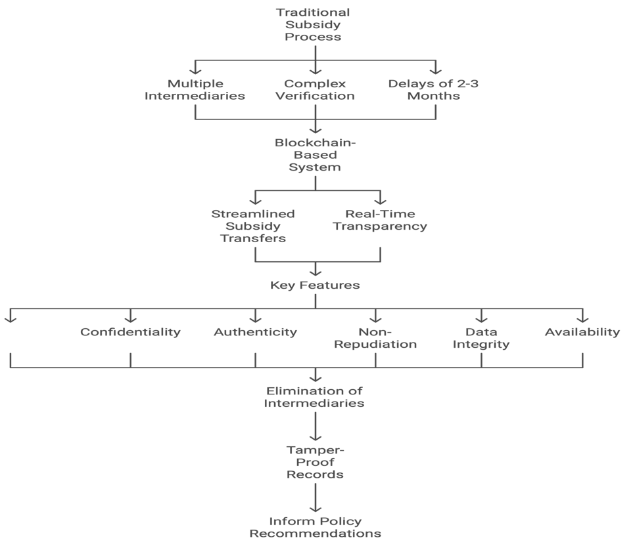

**Fig. 3 Traditional subsidy process**

**Seed Distribution**

Jharkhand has emerged as a pioneer in the implementation of blockchain technology in agriculture by becoming the first state in India to deploy a production-grade blockchain-based seed distribution program. This initiative aims to address systemic inefficiencies in seed distribution while enhancing transparency and efficiency. Under this program, all stakeholders, including suppliers, distributors, and farmers, have been onboarded onto the blockchain platform, with dedicated training sessions conducted to ensure smooth technology adoption.

The blockchain platform facilitates real-time tracking of seed supply across the entire distribution chain. It begins with the issuance of supply orders by the Directorate of Agriculture, followed by seed demand placement by district agriculture officers. The process tracks seed distribution from government-approved seed-producing agencies to distributors, retailers, Local Area Marketing Societies (LAMPS), Primary Agricultural Credit Societies (PACS), Farmer Producer Organizations (FPOs), and finally to the farmers. This system eliminates middlemen and ensures the authenticity of seeds distributed under the seed exchange scheme and other government initiatives.

By leveraging blockchain's capabilities, the program ensures traceability, real-time monitoring, and efficient management of government schemes. It provides crucial data for micro-level monitoring, such as district-wise seed distribution, variety and quantity of seeds purchased, and frequency of seed purchases by farmers. The government has prioritized making quality seeds available to farmers at the right time, filtering out inefficiencies, and creating a robust farmer database. This database is envisioned to enhance the delivery of various agriculture and horticulture schemes while enabling e-KYC for Aadhaar-based farmer authentication.

Jharkhand's blockchain-based seed distribution program represents a transformative step toward digitizing agricultural supply chains. By ensuring transparency and efficiency, it enhances farmers' access to quality inputs while laying the groundwork for a robust and technology-driven agricultural ecosystem. This initiative not only improves service delivery but also sets a benchmark for other states in leveraging blockchain technology to modernize agricultural processes.

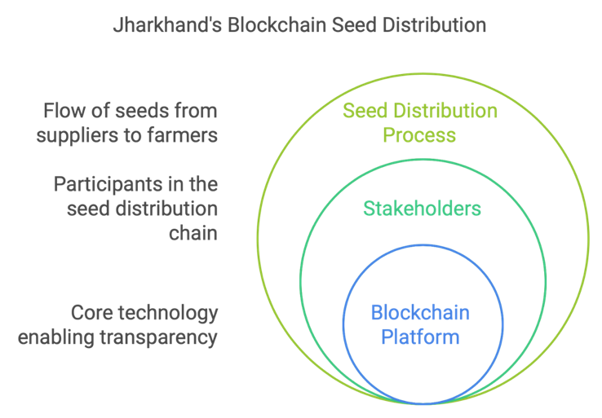

**Fig. 4 : Blockchain based seed distribution system in Jharkhand**

**Traceability Interface for Indian Spices**

The Spices Board of India, under the Ministry of Commerce and Industry, in collaboration with UNDP India’s Accelerator Lab, has initiated a transformative project to enhance transparency and efficiency in the Indian spices supply chain. Through a signed Memorandum of Understanding (MoU), the two organizations aim to develop a blockchain-based traceability interface for spices, addressing complexities in data management across the supply chain. This system involves farmers, brokers, distributors, processors, retailers, regulators, and consumers, ensuring transparency at every stage while simplifying operations.

The blockchain interface is being integrated with the e-Spice Bazaar portal, a digital platform designed by the Spices Board to connect spice farmers directly with markets. The pilot project involves over 3,000 farmers engaged in chilli and turmeric cultivation across select districts of Andhra Pradesh. By providing seamless access to supply chain data, the platform empowers farmers and other stakeholders with real-time insights, enabling informed decision-making and equitable participation in the trade.

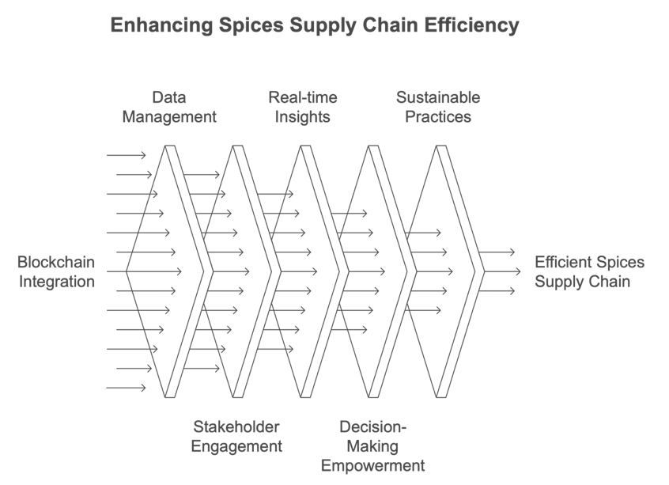

**Fig. 5 Supply Chain for Spices**

This initiative is expected to make the spices supply chain more efficient by reducing information asymmetry, enhancing traceability, and promoting sustainable farming practices. It sets a precedent for leveraging blockchain technology to modernize agricultural trade, boost farmers' incomes, and improve the global competitiveness of Indian spices.

**Land Records Management**

In India, land ownership is currently proven through a presumptive land titling system, relying on a chain of documents that trace the transfer of title over time. However, this system is fraught with challenges, including the potential for disputes over intermediate transactions and widespread property fraud. The office of the sub-registrar (SRO), governed by the Central Registration Act of 1908, only registers deeds between parties without verifying ownership, leaving significant gaps in the system's reliability.

The Revenue and Panchayati Raj Departments act as custodians of land records, maintaining details of ownership, crop information, irrigation sources, and rights and liabilities. However, the land record systems vary across states and often fail to integrate seamlessly with the registration departments, which operate independently. Farmers heavily rely on Record of Rights (RoR) documents to access government benefits such as subsidies, loans, and sales assistance, further underscoring the importance of maintaining accurate and transparent land records.

Blockchain technology presents a robust solution to these challenges by enabling a transparent, immutable, and decentralized record-keeping system. Integrating blockchain into land record management can ensure real-time updates, secure transaction validation, and tamper-proof documentation. With blockchain, the sale deed registration process, including biometric verification and digital documentation, can be linked directly to land ownership records, eliminating discrepancies and reducing fraud. This technological intervention has the potential to revolutionize land governance in India by streamlining processes, increasing trust, and enhancing the delivery of benefits to stakeholders, particularly farmers.

**Public Distribution System (PDS)**

The Public Distribution System (PDS) in India is a critical mechanism for providing subsidized food grains to ration card holders. However, it is plagued by inefficiencies and a lack of accountability throughout its supply chain, which includes farmers, millers, transporters, state agencies, fair price shop (FPS) owners, and beneficiaries. Leakages and delays in payments, especially to farmers, are common challenges.

Blockchain technology offers a transformative solution for managing the PDS supply chain through its decentralized distributed ledger. By integrating blockchain, the entire supply chain—from procurement at Minimum Support Price (MSP) to final distribution at FPS—can be streamlined. Farmers register with millers to supply produce under MSP, and payments to farmers can be triggered immediately after procurement, eliminating delays that typically occur while waiting for milling or other intermediate processes. Blockchain ensures non-repudiation by requiring farmers to approve transactions before millers can register collected quantities, enhancing transparency and accountability.

A Proof of Concept (PoC) application has been developed as a Python-based web platform, incorporating blockchain and relational database management systems (RDBMS). The PoC supports three stakeholders: farmers, millers, and administrators. The system enables miller and farmer registrations, with data written simultaneously to both blockchain and database systems. Updates to procurement data are securely logged and compared to identify anomalies. The superuser module further ensures data integrity by cross-verifying information between the database and blockchain. Deployed within a Docker container, the application facilitates efficient stakeholder interaction and decision-making based on a local copy of the blockchain ledger.

By addressing payment delays and ensuring data provenance through blockchain, this initiative showcases the potential for a more transparent, efficient, and equitable PDS system in India, mitigating long-standing inefficiencies and bolstering farmer confidence in government support mechanisms.

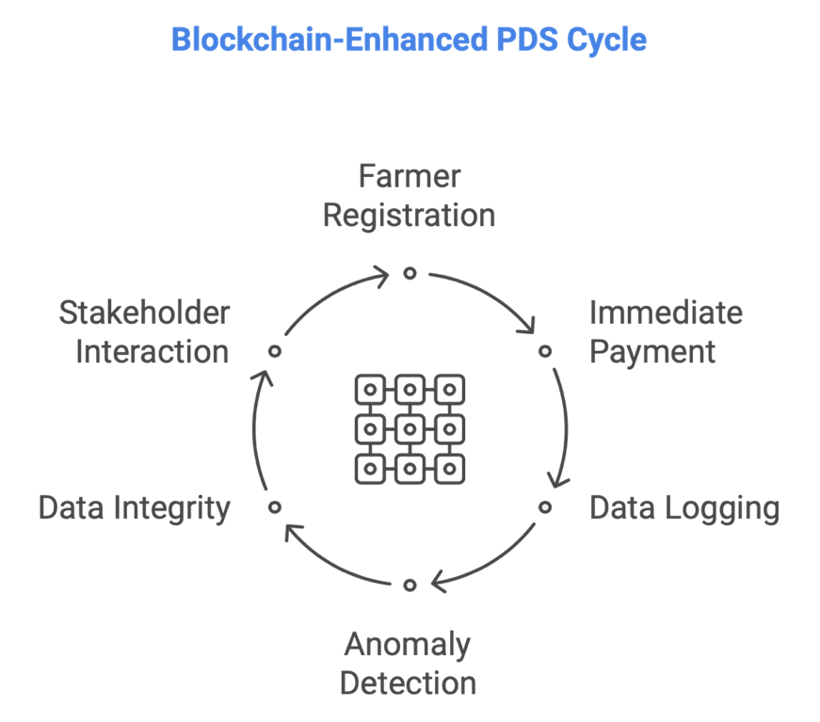

**Fig. 6 Blockchain based public distribution cycle**

1. **OPPORTUNITIES AND CHALLENGES**

Blockchain technology presents significant opportunities for transforming Indian agriculture, primarily by fostering **transparency and trust** throughout the supply chain through the elimination of intermediaries and enhanced traceability. It promises **efficiency gains** by automating processes, reducing delays, and streamlining the disbursement of subsidies. Furthermore, it empowers farmers by enabling the creation of robust databases, ensuring targeted interventions and equitable access to various schemes. This technological advancement also contributes to India's**global competitiveness** by enhancing product authenticity and supply chain visibility, thereby boosting export potential.

However, the path to integrating blockchain in Indian agriculture is not without its hurdles. Key **technical barriers** include limited digital literacy among stakeholders and inadequate infrastructure in rural areas. **Scalability issues** present a considerable challenge, as integrating blockchain across the diverse and fragmented agricultural systems of India requires substantial investment. Moreover, the absence of standardized **policy and regulation** frameworks, along with the need for legal recognition of blockchain-based records, creates uncertainty. Finally, ensuring **data privacy** while simultaneously maintaining the transparency inherent to blockchain technology remains a critical concern that needs careful addressing.

**Conclusion**

The adoption of blockchain in Indian agriculture is in its nascent stage but shows immense promise. Policymakers, private players, and researchers must collaborate to overcome challenges, scale successful PoCs, and develop innovative solutions tailored to the sector's needs. With strategic implementation, blockchain can revolutionize Indian agriculture by fostering transparency, efficiency, and inclusivity.

**COMPETING INTERESTS DISCLAIMER:**

Authors have declared that they have no known competing financial interests OR non-financial interests OR personal relationships that could have appeared to influence the work reported in this paper.

Disclaimer (Artificial intelligence)

Option 1:

Author(s) hereby declare that NO generative AI technologies such as Large Language Models (ChatGPT, COPILOT, etc.) and text-to-image generators have been used during the writing or editing of this manuscript.

1. **REFERENCES**
2. M. Awasthi, C.S. Raghuvanshi, C. Dudhagara, A. Awasthi, Exploring virtual smart healthcare trends using digital twins, *Digital Twins for Smart Cities and Villages*. (Elsevier, Amsterdam, 2025), PP. 377–406.

<https://doi.org/10.1016/B978-0-443-28884-5.00017-8>

1. A.S. Gaur, H.O. Sharan, C. Dudhagara, Research Trends in Blockchain and Digital Twins, *Digital Twins for Smart Cities and Villages*. (Elsevier, Amsterdam, 2025), PP. 561-580.

<https://doi.org/10.1016/B978-0-443-28884-5.00024-5>

1. Dudhagara, C. R. & Joshi, A., (2017). API integration in web application. *International Journal of Trend in Scientific Research and Development,* 1(2), 31-34.
2. Desai M., Dudhagara, C. R. (2023), Managing Data Structure in R, [*Data Wrangling: Concepts, Applications and Tools*](https://onlinelibrary.wiley.com/doi/book/10.1002/9781119879862)*.* Scrivener Publishing LLC.

<https://doi.org/10.1002/9781119879862.ch7>

1. Kamilaris, A., Fonts, A., & Prenafeta-Boldú, F. X. (2019). The rise of blockchain technology in agriculture and food supply chains. *Trends in Food Science & Technology*, 91, 640–652.
2. Kumar, R., Joshi, A., Sharan, H.O., Peng, S.-L., Dudhagara, C.R. *The Ethical Frontier of AI and Data Analysis*; IGI Global: Hershey, PA, USA, 2024; p. 475.

ISBN 979-836932965-8.

1. Kumar and I. Sharma, (2022) "Enhancing Cybersecurity Policies with Blockchain Technology: A Survey," *5th* International Conference on Contemporary Computing and Informatics (IC3I), Uttar Pradesh, India, PP. 1050-1054,

DOI: 10.1109/IC3I56241.2022.10072588

1. Lin, Q., Wang, H., Pei, X., & Wang, J. (2019). Food safety traceability system based on blockchain and EPCIS. *IEEE Access*, 7, 20698–20707.
2. Paul, D., Bagri, S., Jhajhriya, S., Garai, S., & Dutta, S. (2024). Blockchain enabled seed traceability for enhancing seed quality assurance, *Journal of Agriculture and Livestock Farming,* 1(4), 10-20. <https://doi.org/10.61577/jalf.2024.1000018>
3. Seth, A., & Ganguly, K., (2017). Digital technologies transforming Indian agriculture. *The global innovation index*, 105-111.
4. Sharma, C., Pathak, P., Kumar, A., & Gautam, S. (2024). Sustainable regenerative agriculture allied with digital agri-technologies and future perspectives for transforming Indian agriculture. *Environment, Development and Sustainability*, 1-36.
5. Sharma, R., Samad, T. A., Chiappetta Jabbour, C. J., & de Queiroz, M. J. (2025). Leveraging blockchain technology for circularity in agricultural supply chains: evidence from a fast-growing economy. *Journal of Enterprise Information Management*, 38(1), 32-67.
6. Sugandh, U., Khari, M., & Nigam, S. (2021). How Blockchain Technology Can Transfigure the Indian Agriculture Sector: A Review. Handbook of Green Computing and Blockchain Technologies, 69-88.
7. Tripoli, M., & Schmidhuber, J. (2020). Emerging opportunities for the application of blockchain in the agri-food industry. FAO and ICTSD.
8. Government of India: Press Information Bureau

<https://www.pib.gov.in/Pressreleaseshare.aspx?PRID=1537221>

1. Settlemint Blockchain Platform

<https://www.settlemint.com/blockchain-platform-how-to-demo>

1. Blockchain Technology in PDS

<https://blockchain.gov.in/Home/CaseStudy?CaseStudy=PDS>

1. Blockchain and Land Records

<https://blockchain.gov.in/Home/CaseStudy?CaseStudy=LandRegistration>

1. Spices Board India Initiatives

<https://www.pib.gov.in/PressReleasePage.aspx?PRID=1709674>

1. <Https://www.techopedia.com/4-types-of-blockchain-explained-a-complete-guide>
2. <Https://www.kingsresearch.com/blog/top-10-agricultural-supply-chain-services-2024>
3. <Https://blockchain.gov.in/Home/CaseStudy?CaseStudy=gstchain>
4. <Https://crustlab.com/blog/types-of-blockchain-technology-a-complete-overview/>
5. <Https://www.geeksforgeeks.org/how-does-the-blockchain-work/>