Engineering Properties of Maize, Groundnut and Paddy Seeds for the Design of Seed Metering Mechanism of Multi Crop Planter

Abstract

Physical and engineering properties of agricultural grains are necessary for the design of seeding, planting, storage, handling and processing equipment. The present study was undertaken to study the physical and mechanical properties of maize (Hybrid: Yuvraj Gold), groundnut (TAG 24) and paddy (GB1) seeds for the design of seed metering mechanism of power tiller operated strip-till multi-crop planter. The average initial moisture contents on wet basis were found to be 11.61%, 9.42%, and 10.98% for maize, groundnut and paddy, respectively. The average length, width and thickness were 9.53, 12.32, 7.63; 7.53, 7.94, 2.57; and 4.20, 7.03, 2.02 mm for maize, groundnut and paddy, respectively. The average sphericity, shape index, surface area, aspect ratio and porosity were 0.71, 0.72, 0.45; 1.70, 1.65, 3.35; 141.20, 244.80, 36.52 mm²; 0.80, 0.65, 0.38; and 56.37, 39.86, 57.91% for maize, groundnut and paddy seeds, respectively. The angles of repose were 24.64, 22.64 and 35.30° for maize, groundnut and paddy, respectively. The average bulk density of maize, groundnut and paddy seeds was 754.49, 603.99 and 537.91 kg m⁻³, respectively. The seed properties determined relevant to the design of components of a multi-crop planter such as seed hopper, seed metering plates and seed delivery tubes. It also helps to select the materials for the fabrication of the planter.

Key words: Planter, seed metering mechanism, seed properties, sphericity, shape index, bulk density

1. Introduction
Seed metering mechanism is the heart of seeding and planting machines and its function is to distribute seeds uniformly at the desired application rates. Devices for metering single seeds usually have cells on a moving member or an arrangement to pick up single seeds and lift them out of a seed mass. Inclined plate metering devices have cups or cells around the periphery that pass through a seed reservoir fed under a baffle from the hopper, lift the seeds through cups or cells of the plate travel, and drop into delivery tube. Seeds are handled more gently than with horizontal plate units because there is no cutoff device. The metering plates have been designed for the sowing of maize, groundnut and paddy directly in the field. The cell size on the periphery of the plates varies with the shape and size of the seeds.
“Manual methods of planting resulted in low seed placement, low spacing efficiency, and health issues for the farmer considering the size of the farm land” (Soyoye et al., 2018). “The multi-crop planter is equipment which helps in the planting of seeds in a desired position, thereby assisting the farmers to save money and time. The basic objective of seeding operation is to bear the seed, put the seed in rows at desired depth and seed to seed spacing, cover the seeds with soil and provide proper compaction over the seed” (Soyoye et al., 2018). However, for the fabrication of this mechanized planting equipment, some properties of the seeds which are to be planted must be determined in order to accurately specify the design considerations. The physical properties of the seeds such as size, shape, axial dimensions, shape index, aspect ratio and sphericity help to determine the maximum size of the cup in the seed plate, the weight help in the material selection for the frame of the planter, the bulk density and moisture content help to know the interaction between the seed and the material used for the hopper of the planter. The mechanical properties such as the angle of repose help to ensure free flow of seed in the hopper, the terminal velocity helps to determine the flow of the seed in air between the point of discharge and impact on the soil.
Maize: “Maize (Zea mays L), also known as corn, is one of the most extensively cultivated cereal crops in the world. Almost every country cultivates it both for consumption by man and animal and commercial purposes. The crop plays many roles in the human diet and the production of animal feeds” (Idowu and Onifade, 2021). “It is processed to make an assortment of products which includes corn oil, maize flour, and bio-fuels. It has been reported that maize is cultivated on about 139 million hectares with a total yearly production of 598 million metric tonnes worldwide” (Atere et al., 2016). The variations in the physical properties of crops have necessitated its measurement for a proper design. Production of maize crops from cultivations to processing involves using machines to easy the job for mechanization. To design an efficient machine for mechanization of this crop, the engineering properties of the crop is required. The data on the physical and engineering properties of crops is important knowledge for engineers, machine manufacturers, food scientists and even the consumer’s decision.
Groundnut: “Groundnut (Arachis hypogaea L.) is an oilseed crop found throughout the world for its economic and nutritional importance. It is considered to be the poor man’s cashew and has been widely accepted for replacing expensive nuts such as almonds, cashews and pistachio as an urban snack. Groundnut is an important edible oilseed crop. These nuts are used as oil crops and grain legume crops. One can get good cash return and is widely grown in all tropical and subtropical regions of the world for its food value, oil and high protein content. About 80% of the world groundnut production comes from seasonally rain fed areas” (Gibbons, 1980). “Ground nuts are grown during warm season. They need abundant sunshine and warm climate to thrive. The plant requires adequate moistures during its growing seasons and also distinctive dry seasons during pod ripening and maturity. They are adaptable to a wide range of climatic conditions. India occupies second rank in the world, in respect of area (69.52 million ha), production (56.17 Mt.) and productivity (808 kg ha⁻¹) of groundnut. The yield of groundnut has been steadily decreasing for decades as a result of lack of organized breeding program to address production constraints. Disease, insects, and drought are the widespread constraints of groundnut production” (Banla et al., 2018). “Crop dependency has made producers vulnerable to losses because of the lower prices paid for the pods and kernels” (Nautiyal, 2002). The non-availability of improved seeds, insufficient extension activities, non-availability of gypsum and fertilizers are the problems faced by the farmers (Kalyan et al. 2011).
“Groundnut is largely cultivated in India during Kharif season (June to October) under rainfed conditions with low input use and high pressure of insect-pests including weeds leading to low productivity. In Rabi season (October to March), the crop is grown on residual moisture with protective irrigation or in river bed areas. Summer groundnut (Feb-May) grown under assured irrigation is generally practiced with high input application and low pressure of insect-pests attributing to higher productivity. Five states namely Andhra Pradesh, Gujarat, Karnataka, Rajasthan and Tamil Nadu account for about 80% of the total groundnut area and production of the country. Gujarat alone contributes about 35% of the total production of groundnut. One of the important legume crops of tropical and semiarid regions is groundnut, major source of edible oil and protein. Groundnut kernels contain 47-53% oil and 25-36% protein” (Sunandini and Devi, 2020; Banla et al., 2018; Taru et al., 2008). The major producers of groundnut are India, China and USA, which together account for over two-thirds of global output. India ranks first in the production of groundnut among the major edible oilseed crops (Rai et al., 2016).
Paddy: “Paddy (Oryza sativa L.) is the most important and extensively grown food crop in the World and the staple food of more than 60 percent of the world population. Rice production, processing and marketing constitute the biggest industry in the country. Physical and engineering properties are important in many problem associated with the design of machines and the analysis of the behavior of the product during agricultural process operations such as handling, planting, harvesting, threshing, cleaning, sorting and drying”. (Sahu et al., 2018).
The different physical properties viz., length, width, thickness, thousand grain mass, geometric mean diameter, aspect ratio, surface area, sphericity, volume, bulk density, true density and porosity. Hundred grains were randomly selected and their three principle dimensions (length, width and thickness) were measured using a vernier caliper to an accuracy of 0.01 cm. The 1000 grain mass was determined by selecting different thousand grains counted manually and were recorded for their corresponding weights by the use of digital weighing balance with an accuracy of 0.001 g. The average value of three replications was taken.
2. Materials and methods
For the development of seed metering system, it is necessary to determine physical and mechanical properties of the seeds. The average length, width and thickness of the maize, groundnut and paddy seeds were determined by randomly selecting 50 kernels of each seeds from the seed sample. The seeds were selected randomly from bulk storage of each variety.
The planter was operated for sowing three different crops in three seasons. The samples of maize (Hybrid: Yuvraj Gold), groundnut (TAG 24) and paddy (GB1) seeds were collected from local market, Kalyani and Balindi research complex, BCKV, Mohanpur, Nadia.
2.1 Measurement of linear dimensions
The three principal dimensions which were perpendicular to each other namely length, width and thickness of fifty randomly selected seeds from the bulk storage of the sample were measured using a digital vernier calliper with an accuracy ±0.01 mm (Fig. 1). Based on the measured values of the three principal dimensions, arithmetic mean diameter, geometric mean diameter, sphericity, shape index, surface area and aspect ratio were calculated by using the formulae given in Table 1.
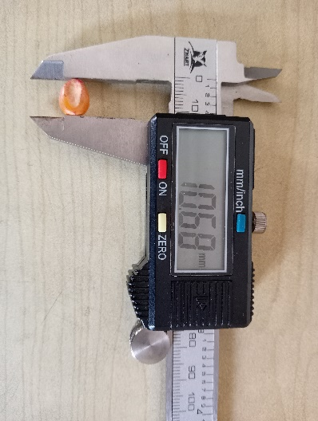 | 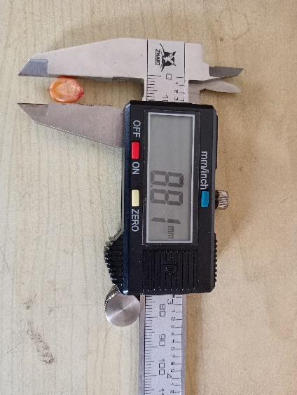 | 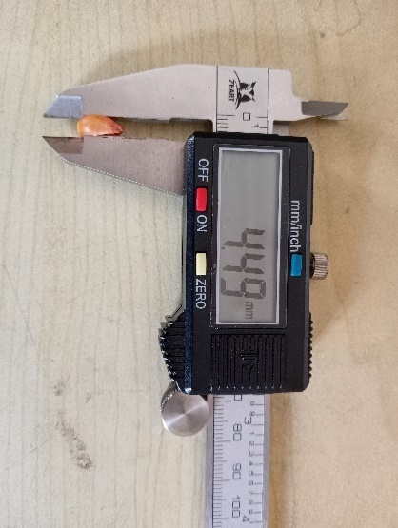
(a) Maize
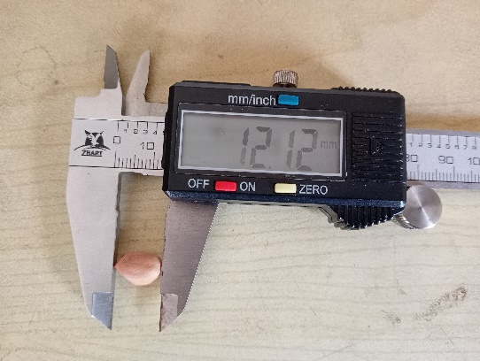 | 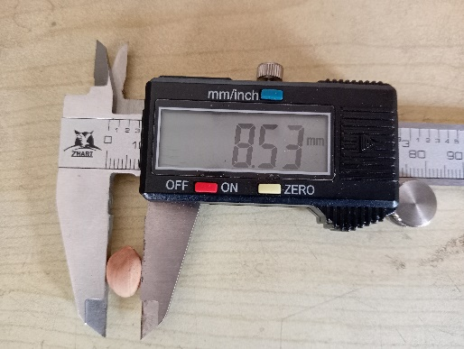 | 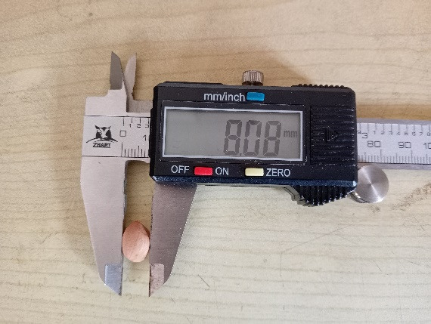
(b) Groundnut
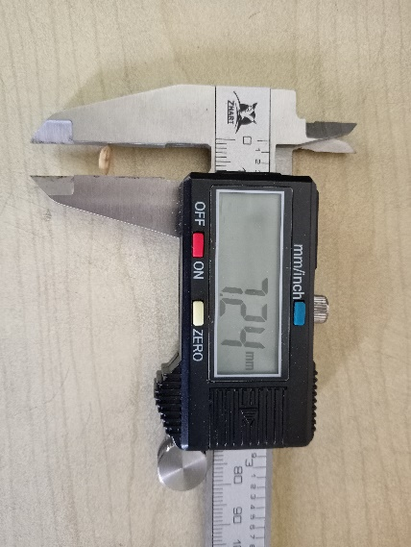 | 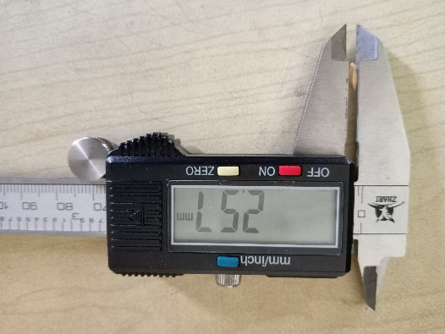 | 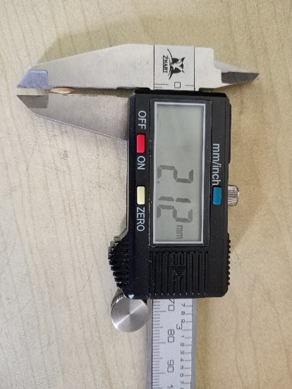
(c) Paddy
Fig. 1 Measurement of length, width and thickness of seeds with vernier caliper
The seed metering mechanism is the heart of the seeding and planting machines. The performance of the seeding machine depends on the proper and smooth running of its metering mechanism. The metering devices should meet the basic agronomic requirements of the various crops as seed rate, seed to seed spacing, row to row spacing etc. varies from crop to crop. The basic considerations in designing of seed metering mechanism are minimal damage to the seed, good seed singulation while metering and low cost of manufacturing.

Table 1: Measurement and calculations of properties of seeds
Parameters | Formulae | References
Arithmetic mean diameter (D_{a}) | D_{a} = $\frac{L+W+T}{3}$ | Tarighi et al., 2011; Sangamithra et al., 2016 and Dayou et al., 2019
Geometric mean diameter (D_{g}) | D_{g} = (L x W x T)^{1/3} | Tarighi et al., 2011; Sangamithra et al., 2016 and Dayou et al., 2019
Sphericity (Φ) | Φ = $\frac{{(L x W x T)}^{1/3}}{L}$ | Krishnappa et al., 2017; Chandio et al., 2021; Panwar et al., 2023
Shape Index (SI) | SI = $\frac{L}{\sqrt{WT}}$ | Bwade et al., 2013; Nkambule et al., 2023
Surface area (S) | S = π D_{g}² | Tarighi et al., 2011; Sangamithra et al., 2016 and Dayou et al., 2019
Aspect ratio (R_{a}) | R_{a} =$\frac{W}{L}$ | Davies, 2009; Parihar et al., 2021
Porosity (ε) | ε = $\frac{ρt- ρb}{ρt}x100$ | Shende and Sidhu, 2015; Parihar et al., 2021
Moisture content (wb) | $\frac{W_{1}- W_{2}}{W_{2}- W_{3}}$ x 100 | Chakraverty et al., 2003; Ofori et al., 2020
Bulk density (ρ_{b}) | ρ_{b} = $\frac{M}{V}$ | Krishnappa et al., 2017
True density (ρ_{t}) | ρ_{t}$=\frac{M}{V1}$ | Krishnappa et al., 2017
Angle of repose (ϴ) | ϴ = tan⁻¹ ($\frac{h_{0}}{r}$) | Krishnappa et al., 2017; Brar et al., 2017
Abbreviations:
L: length of seed; W: width of seed; T: thickness of seed; V: total volume of sample; V₁: volume of solid; W₁: weight of wet sample including box; W₂: weight of dry sample including box; W₃: weight of empty box; h₀: height of heap of seeds; r: radius of heap
3. Results and discussion
The dimensions of any seed are very important for design of the machine as it has a major role on the dimensions of the machine components specially the seed metering mechanism. A strip-till multi-crop planter consists of seed hopper, seed metering device, seed tubes, furrow openers, ground drive wheel, strip tilling unit and power source. Each of the machine components can be designed on the basis of dimensions, engineering properties and agronomic aspects of the seeds as well as properties of the constructional materials. The major dimensions and the engineering properties of the maize, groundnut and paddy seeds are presented in Table 2.
Table 2 Engineering properties of maize, groundnut and paddy seeds
Parameters | Crops
 | Maize | Groundnut | Paddy
Length, mm | 9.53±0.67 | 12.32±1.29 | 7.63±0.40
Width, mm | 7.53±0.73 | 7.94±0.48 | 2.57±0.16
Thickness, mm | 4.20±0.32 | 7.03±0.52 | 2.02±0.08
Arithmetic mean diameter, mm | 7.09±0.36 | 9.10±0.60 | 4.07±0.18
Geometric mean diameter, mm | 6.31±0.36 | 8.81±0.54 | 3.41±0.14
Sphericity | 0.71±0.04 | 0.72±0.05 | 0.45±0.02
Shape Index | 1.70±0.14 | 1.65±0.17 | 3.35±0.17
Surface area, mm² | 141.20 | 244.80 | 36.52
Aspect ratio | 0.80±0.11 | 0.65±0.06 | 0.38±0.02
Porosity, % | 56.37±0.85 | 39.86±1.43 | 57.91±1.87
Test weight (1000 seeds), g | 286.69±4.43 | 375.25±3.69 | 18.93±0.72
Moisture content (wb), % | 11.61±0.74 | 9.42±0.49 | 10.98±0.36
Bulk density, kg m⁻³ | 754.49±4.83 | 603.99±5.73 | 537.91±4.82
Angle of repose, degree | 24.64±0.62 | 22.64±1.18 | 35.30±0.75

From Table 2, it was found that groundnut (TAG 24) seed is the longest (12.32±1.29 mm) and wider (7.94±0.48 mm) as compared to maize seed (Hybrid: Yuvraj Gold) and paddy seed (GB1). The geometric mean diameter of groundnut is higher (8.81±0.54 mm) as compared to maize (6.31±0.36 mm) and paddy (3.41±0.14 mm).
The details of basic engineering properties of the seeds are given under materials and methods in Table 1. If the shape index (SI) ≤ 1.5 then the seed is spherical in shape and for SI > 1.5, the seed is oval in shape. From the Table 2, it was found that the shape index of maize, groundnut and paddy all have the value greater than 1.5. But the SI value of maize (1.70±0.14) and groundnut (1.65±0.17) seeds are closer to 1.5 than the paddy seeds (3.35±0.17). Therefore, the paddy seeds are more oval in shape as compared to maize and groundnut seeds. The shape of the cell on the periphery of the seed metering plate will be based on the shape index of the seeds. The geometric mean diameter of the seeds will also play the important role for deciding the cell size of the seed metering plate.

(a) | (b)
Fig. 2 Properties of seeds (a) surface area (mm²), porosity (%), bulk density (kg m⁻³) & angle of repose (degree) and (b) sphericity, shape index & aspect ratio
The sphericity of any material varies from 0 to 1. If the sphericity of any seed is higher or nearer to 1 then their angle of repose will be very low and those seeds will fall down easily against the inclined surface. The sphericity of maize seeds (0.71±0.04) and groundnut seeds (0.72±0.05) are nearly equal and higher than the paddy seeds (0.45±0.02). Therefore, the seed hopper will require higher angle of repose for paddy seeds. The various properties of the seeds are also represented graphically in Fig. 2.
The bulk density of paddy seeds is minimum (537.91±4.82 kg m⁻³) as compared to maize (754.49±4.83 kg m⁻³) and groundnut seeds (603.99±5.73 kg m⁻³). Therefore, the volume of hopper required for paddy seeds is higher as compared to other selected seeds. Considering the bulk density and angle of repose, the paddy was given importance for the design of seed hopper and inclination of seed metering plate.

4. Conclusions
Physical and mechanical properties of maize (Hybrid: Yuvraj Gold), groundnut (TAG 24) and paddy (GB1) were determined for the design of multi-crop planter specially seed hopper, seed metering mechanism and seed tubes. The properties such as arithmetic and geometric mean diameter, sphericity, porosity, surface area, shape index, aspect ratio, bulk density, 1000 seeds weight, angle of repose and moisture content were determined and based on these parameters the multi-crop planter was accordingly designed.

Disclaimer (Artificial Intelligence)
Author(s) hereby declare that NO generative AI technologies such as Large Language Models (Chat GPT, COPILOT, etc.) and text-to-image generators have been used during the writing or editing of this manuscript.

References
Atere, A. O., Olalusi, A. P. and Olukunle, O. J. (2016). Physical properties of some maize varieties. Journal of Multidisciplinary Engineering Science and Technology, 3(2): 3874-3880.
Banla, E.M., Dzidzienyo, D.K., Beatrice, I.E. (2018). Groundnut production constraints and farmers’ trait preferences: a pre-breeding study in Togo. Journal of Ethnobiology and Ethnomedicine, 14: 75
Brar, I. S., Dixit, A. K., Khurana, R. and Gautam, A. (2017). Studies on physical properties of maize (Zea mays L.) seeds. International Journal of Current Microbiology and Applied Sciences, 6(10): 963-970.
Bwade, E. K., Abubakar, Y., Kwaji, A. M. and Abba, M. U. (2013). Some engineering properties of rice seed (Oryzasativa L.) relevant to planter design. International Journal of Engineering Science Invention, 10(10): 1-7.
Chakraverty, A., Majumdar, A. S., Raghavan, G. S. V. and Ramaswamy, H. S. (2003). Handbook of Postharvest Technology: Cereals, Fruits, Vegetables, Tea, and Spices, Marcel Dekker, Inc., New Yark, U.S.A., 907p.

Chandio, F. A., Li, Y., Ma, Z., Ahmad, F., Syed, T. N., Shaikh, S. A. and Tunio, M. H. (2021). Influences of moisture content and compressive loading speed on the mechanical properties of maize grain orientations. International Journal of Agricultural and Biological Engineering, 14(5): 41-49.
Choudhary, V., Machavaram, R., Vikash and Singh, R. S. (2020).Engineering properties of groundnut pods and kernels: A key role for designing the post-harvest processing equipment. International Journal of Current Microbiology and Applied Sciences, 9(8): 1751 – 1761.
Davies, R. M. (2009). Some physical properties of groundnut grains. Research Journal of Applied Sciences, Engineering and Technology,1(2): 10-13.
Dayou, E. D., Zokpodo, K. L. B. and Kakai, A. L. R. G. (2019). Evaluation of the physical, mechanical and kinetic properties of some cereals and leguminous seeds in Benin republic. International Journal of Engineering, Science and Technology, 11(1): 33-42.
Idowu, D. O. and Onifade, T. B. (2021). Investigation of effect of maize varieties on selected physical properties. Journal of Agricultural and Crop Research, 9(1): 8-16.
Krishnappa, M., Maddi, A., Matamari, V. and Kulkarni, P. (2017). Engineering properties of some selected groundnut (Arachis Hypogea L.) varieties. International Journal of Agriculture Science and Research, 7(4): 203-216.
Kumar, A. B., Rao, P. V. K. and Edukondalu, L. (2017). Physical properties of maize grains. International Journal of Agriculture Sciences,9(27): 4338-4341.
Mahilang, K. K. S., Sonboier, K., Minj, P., Jaisawal, Y., Khare, N. and Mahilang, T. T. (2018). Some physical properties of paddy seeds and fertilizer. International Journal of Current Microbiology and Applied Sciences, 7(2): 235 – 241.
Nkambule, S., Workneh, T., Sibanda, S., Alaika, K. and Lagerwall, G. (2023). The effect of moisture contents on the physical properties of both bambara groundnut seeds and pods in south Africa. African Journal of Food, Agriculture, Nutrition and Development, 23(6): 23817-23834.
Ofori, H., Amoah, F., Arah, I. K., Piegu, M. K. A., Aidoo, I. A. and Commey, E. D. N. A. (2020). Physical properties of selected groundnut (Arachis hypogea L.) varieties and its implication to mechanical handling and processing. African Journal of Food Science, 14(10): 353-365.
Panwar, G., Swarnkar, R., Kumar, N. and Shukla, K. (2023). Evaluation of physical properties of maize and pigeon-pea seeds for seed metering mechanism. Journal of Experimental Agriculture International, 45(12): 89-97.
Parihar, N. S., Kumar, V and Ankit (2021). Engineering properties of basmati-370. International Journal of Chemical Studies, 9(2): 68-70.
Rai, S.K., Charak, D., Bharat, R. (2016). Scenario of oilseed crops across the globe. Plant Archives, 16: 125−132.
Sahu, B., Khokhar, D., Patel, S., Mishra, N. K. and Chandel, G. (2018). Some engineering properties of selected paddy varieties. International Journal of Pure and Applied Bioscience, 6(2): 1337-1342.
Sangamithra, A., Swamy, G. J., Sorna, P. R., Nandini, K., Kannan, K., Sasikala, S. and Suganya, P. (2016). Moisture dependent physical properties of maize kernels. International Food Research Journal, 23(1): 109-115.
Sharma, V., Basu, S., Lal, S. K., Anand, A., Hossain, F. and Munshi, A. D. (2017). Comparison of physical and physiological properties of specialty maize inbred lines. Chemical Science Review and Letters, 6(23): 1758-1763.
Shende, D. and Sidhu, G. K. (2015). Effect of moisture content on engineering properties of maize (Zea mays, L.). Agricultural Engineering Today, 39(3): 22-28.
Soyoye, B. O., Ademosun, O. C. and Agbetoye, L. A. S. (2018). Determination of some physical and mechanical properties of soybean and maize in relation to planter design. Agric Engg Int: CIGR Journal, 20(1): 81-89.
Sravani, M., Boreddy, S. R., Madhava, M. and Kumari, P. L. (2020). Physico-chemical properties of four selected groundnut varieties. Current Journal of Applied Science and Technology, 39(34): 27-35.
Sunandini, G. P. and Devi, I. S. (2020). Economic analysis of groundnut production in Andhra Pradesh. International Journal of Economic Plants, 7(4): 176-179.
Tarighi, J., Mahmoudi, A. and Alavi, N. (2011). Some mechanical and physical properties of corn seed (DCC 370). African Journal of Agricultural Research,6(16): 3691-3699.
Taru, V.B., Kyagya, I.Z., Mshelia, S.I., Adebayo, E.F. (2008). Economic efficiency of resource use in groundnut production in Adamawa state of Nigeria. World Journal of Agricultural Sciences, 4: 896−900.
Varnamkhasti, M. G., Mobli, H., Jafari, A., Rafiee, S., Heidarysoltanabadi, M. and Kheiralipour, K. (2007). Some engineering properties of paddy (var. Sazandegi). International Journal of Agriculture and Biology, 9(5): 763-766.

