Review Article

HYDROPONICS: A SUSTAINABLE WAY OF FARMING

Abstract
This review-based study aims to assess hydroponics as a sustainable and economically viable alternative to conventional agriculture. By analyzing both technical approaches and economic indicators, it highlights hydroponics’ potential to increase productivity while conserving critical resources. Notably, hydroponic systems use up to 90 per cent less water and offer a high internal rate of return (60.6%), making them a promising solution for food security and climate resilience. The growing global population and declining per capita land availability pose significant challenges to traditional agriculture. Furthermore, the excessive use of chemical fertilizers and pesticides continues to degrade soil health and food quality. As a sustainable and resource-efficient alternative, soil-less cultivation techniques such as hydroponics, aeroponics and aquaponics are gaining momentum. This review focuses on hydroponics, an innovative method of growing plants in nutrient-rich water solutions without soil. It explores its applications in vegetable and fodder production, highlights environmental and economic benefits, and presents a detailed cost-benefit analysis of a system established using the Nutrient Film Technique (NFT). The study reveals strong economic viability with a short payback period (9.43 months), a benefit-cost ratio of 5.317 and a profitability index of 4.31. Despite challenges such as high initial investment, technical complexity and power dependency, hydroponics holds immense potential, especially when combined with renewable energy, automation and farmer training. With strategic policy support and increased awareness, hydroponics can play a transformative role in ensuring food security and promoting sustainable agriculture in India and beyond.
Keywords: Hydroponics, growing medium, soilless technique, nutrients, vertical farming, sustainable.
Introduction
In 1960, when the global population was around 3 billion, the per capita availability of cultivable land was approximately 0.5 hectares. Today, with a population exceeding 6 billion, this has declined to 0.25 hectares and by 2050, it is expected to drop further to just 0.16 hectares (Bhattacharya, 2017). Under such circumstances, it will become increasingly difficult to feed the growing population using traditional open-field agricultural systems alone. In response to these challenges, soil-less cultivation methods are gaining attention as sustainable alternatives.
Soil-less culture refers to the practice of growing plants without soil. These systems offer improved space and water efficiency and have shown promising results worldwide. The primary techniques under soil-less cultivation include hydroponics, aeroponics and aquaponics.
Hydroponics is a technique of growing plants without soil, using a nutrient-rich water solution. The term originates from the Greek words ‘hydro’ (water) and ‘ponos’ (labour). In hydroponic systems, plants are grown in controlled environments where temperature, humidity, and lighting are carefully regulated. The term "hydroponics" was coined by Professor W.F. Gericke in the early 1930s to describe the cultivation of plants with roots suspended in nutrient solutions. These roots are supported by growing media such as gravel, perlite or coconut coir, which facilitate continuous nutrient uptake (Sharma et al., 2018; Habeeba et al., 2023).
Aeroponics involves growing plants in an air or mist environment without the use of soil or an aggregate medium. Aquaponics is a symbiotic integration of aquaculture (fish farming) and hydroponics, wherein fish waste provides nutrients for plant growth and plants help purify the water for fish.
Sustainable Agriculture
Sustainable agriculture emphasizes ecological balance and aims to reduce the environmental degradation caused by conventional farming. It promotes the use of environmentally friendly energy sources such as solar, wind and hydropower, which have minimal environmental impact. While technological advancements in agriculture have helped meet rising food demand, they have also led to the depletion of natural resources. Therefore, sustainability in agriculture has become essential due to pressures from population growth and economic development. The goal is to balance economic, environmental and social aspects of farming. Practices such as vertical farming, organic farming, Integrated Pest Management (IPM) and agroforestry fall under the umbrella of sustainable agriculture (Arumugam & Manida, 2023).
Vertical Farming: Part of sustainable agriculture
Vertical farming is a modern agricultural technique where crops are grown in vertically stacked layers within controlled indoor environments, often using hydroponic or aeroponic systems. This approach offers several advantages: efficient space usage, reduced water consumption, faster crop cycles, lower pesticide use and protection from adverse weather conditions. Additionally, vertical farms can be set up in non-traditional locations, such as basements or rooftops, enabling hyper-localized food production. This reduces food transportation distances and enhances freshness. The term "vertical farming" was introduced by Gilbert Ellis Bailey. A historic example is the Hanging Gardens of Babylon, built over 2,500 years ago (Eldridge et al., 2020; Shamshiri et al., 2018).
Types of Vertical Farming
There are three main types of vertical farming,
- Hydroponics
- Aeroponics
- Aquaponics
Hydroponics
Hydroponics involves growing plants in a water-based, nutrient-rich solution. In this controlled environment, factors such as temperature, humidity and lighting are optimized. The plant roots are supported in an inert medium, which helps in nutrient uptake and anchorage (Habeeba et al., 2023).
Global Scenario of Hydroponics
The global hydroponics market was valued at USD 5.00 billion in 2023 and is projected to grow at a compound annual growth rate (CAGR) of 12.4 per cent from 2024 to 2030 (grandviewresearch.com). In countries like the U.S. and Canada, around 90 per cent of lettuce and tomatoes are produced hydroponically (mordorintelligence.com). Mordor Intelligence further estimates that the market will grow from USD 5.06 billion in 2024 to USD 7.36 billion by 2029 with a CAGR of 7.8 per cent over the period. Controlled environmental conditions in hydroponic systems also help mitigate the adverse effects of climate change, ensuring consistent annual crop production.
Indian Scenario of Hydroponics
In India, hydroponics is still in its early stages, but rapid developments are underway. According to Datam Intelligence, the Indian hydroponics market is projected to grow at a CAGR of 13.53 per cent from 2020 to 2027, significantly surpassing the global average growth rate of 6.8 per cent. Southern India leads the adoption with cities like Hyderabad, Bangalore and Chennai witnessing a surge in small and medium-scale hydroponic farms.
Plants/Crops suitable for hydroponics
According to Sonawane (2018), a wide range of crops can be cultivated hydroponically, including:
- Cereals: Rice, Maize
- Fruits: Strawberry
- Vegetables: Tomato, Chilli, Brinjal, Green Bean, Beetroot, Winged Bean, Bell Pepper, Cabbage, Cauliflower, Cucumber, Radish, Onion
- Leafy Vegetables: Lettuce, Kang Kong
- Condiments: Parsley, Mint, Sweet Basil, Oregano
- Flower Crops: Marigold, Carnation, Chrysanthemum, Rose
- Medicinal Crops: Indian Aloe, Coleus
- Fodder Crops: Sorghum, Alfalfa, Barley, Bermuda Grass
These findings are supported by studies conducted by Ashok & Sujitha (2020) and Barman et al. (2016), which confirm the feasibility of growing a diverse range of crops using hydroponic techniques.
Table 1: Growing Media for Hydroponics
Growing Media | Description | Properties | Advantages | Notes
Rockwool | Fibers spun from molten granite or basalt, formed into blocks, cubes, or slabs. | Sterile, porous, high water-holding capacity, inert. | Excellent aeration and moisture retention. Requires pH adjustment before use; non-biodegradable. | Needs pH conditioning before use
Hydroton (LECA) | Lightweight expanded clay aggregate, fired at high temperatures. | pH-neutral, reusable, good drainage and aeration, stable. | Easy to clean and reuse. Slightly heavy; offers no nutrients. | Neutral pH, inert
Coco Coir/Chips | Made from coconut husks; available in coarse fiber or chip form. | Organic, pH-neutral, retains moisture well, allows root aeration. | Sustainable, biodegradable, long-lasting. May need calcium/magnesium buffering. | Organic, degrades slowly
Perlite | Volcanic glass expanded under high heat. | Lightweight, porous, neutral pH, excellent drainage and aeration. | Often used in mixes. Can be dusty (wear mask); doesn’t hold nutrients well alone. | Often mixed with other media
Vermiculite | Silicate mineral expanded under heat, spongier than perlite. | High water retention, high cation exchange capacity, lightweight. | Good for water-loving plants. Tends to compact over time; can float. | Higher cation exchange capacity
Floral Foam | Synthetic foam used in floristry; similar to Oasis cubes. | High water absorption, soft texture. | Easy to use. Degrades over time; prone to over-saturation and root rot. | Must avoid over-saturation
River Rock | Smooth, rounded stones often used for support in large plant systems. | Heavy, reusable, inert. | Good base support. Poor water retention; no nutrient or cation exchange capacity. | Provides physical support only
Rice Hulls | By-product of rice milling, used dry or composted. | Lightweight, decomposes slowly, improves drainage. | Inexpensive and eco-friendly. Needs mixing with other media for water retention. | Low decomposition, minimal nutrient value

Table 2: Types of Hydroponics
System | Description | Type | Key components | Suitable for
Wick System | Simplest passive system; nutrient solution moves to roots via capillary action using a wick. | Passive | Wick, reservoir, growing medium | Herbs, leafy greens
Water Culture System | Plants float on a nutrient solution; air stone provides oxygen to the roots. | Active | Styrofoam platform, air pump, air stone | Lettuce, spinach
Ebb and Flow (Flood) System | The tray is periodically flooded with nutrients and then drained back into the reservoir. | Active | Timer, pump, reservoir, grow tray | Vegetables, small fruit crops
Nutrient Film Technique (NFT) | A thin film of nutrient solution constantly flows over the roots. | Active | Pump, sloped channel, reservoir | Leafy greens, herbs
Drip System | Nutrient solution is dripped at the plant base via emitters; it can be recovery or non-recovery. | Active | Drippers, tubing, reservoir, timer | Tomatoes, cucumbers, peppers

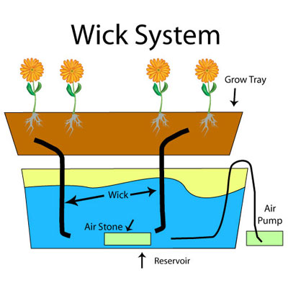 | 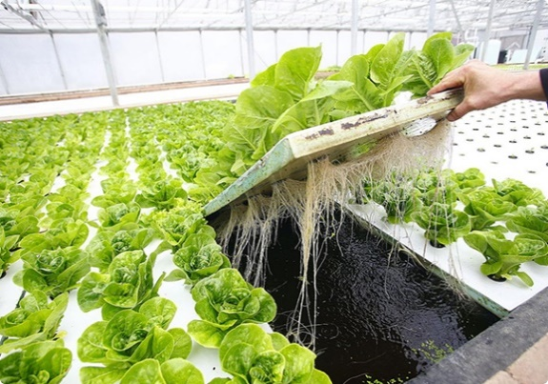
Figure 1: Wick System | Figure 2: Water culture system
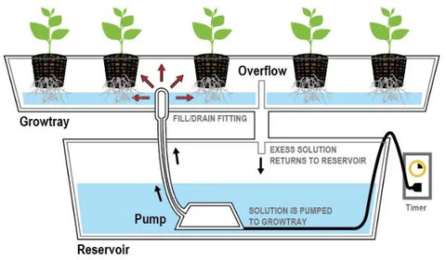 | 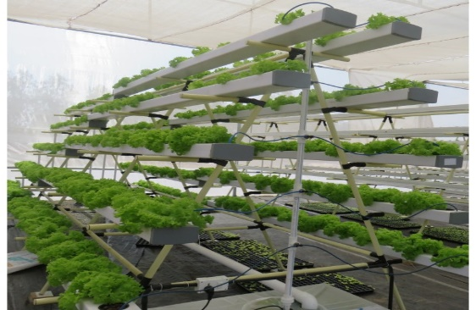
Figure 3: EBB and Flow system | Figure 4: Nutrient film technique
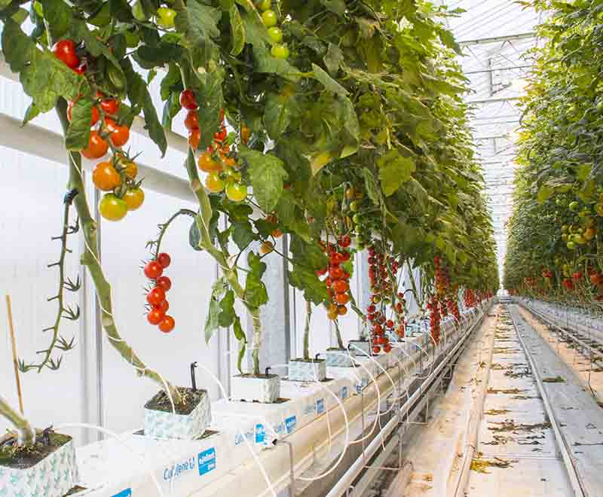
Figure 5: Drip system
Table 3: Environmental factors for hydroponic systems
Parameter | Optimal Range | Purpose
Temperature | 19-22°C | Supports growth and nutrient uptake
Relative Humidity | ~60% | Maintains transpiration and prevents wilting
Light Intensity | ~2000 lux | Promotes photosynthesis
Photoperiod | 12-16 hours/day | Mimics natural sunlight
Aeration | 3 minutes every 2 hours | Provides oxygen to roots
Source: Ghorbel et al., (2022)
Hydroponic for fodder purposes
Only 5 per cent of the cropped land area is utilized for cultivating fodder. According to Shit (2019) we facing a deficit of 35.6 per cent green fodder, 26 per cent of dry fodder and 41 per cent of concentrate feed ingredients. Yvonne Kamanga (2016) suggested that only 1.5-2.0 litres of water is enough for 1 kg of hydroponic fodder production compared to 73, 85 and 160 litres of water to produce 1 kg green fodder of barley, alfalfa and rhodes grass under conventional field conditions, respectively. Increase in the nutritive value of the fodder by using the hydroponic technique (Jan et al., 2020). Malhi et al., 2020 reported that more palatable and digestible fodder was produced by a hydroponic system. 13.7 per cent increase in the milk yield and higher net profit of Rs. 12.67/cow/day on feeding hydroponic maize fodder (Naik et al., 2014). According to Naik & Singh (2013) using hydroponics technology, up to 1000 kg of maize fodder can be produced daily from a 45-50 m area which is equivalent to the conventional fodder produced in 25 acres of cultivable land. Naik et al. (2014) reported that in the hydroponic fodder production system, the seed cost contributes 85-90 per cent of the total cost of production. Mainly maize, barley, sorghum, alfa-alfa, bermuda grass etc. are grown (Shit, 2019).
Limitations and future directions
Despite its benefits, hydroponics faces challenges including high initial investment, technical complexity, energy dependency and limited awareness. The cost of seeds and system failures due to power cuts are additional concerns. However, these challenges can be addressed through:
- Provision of training and extension services for farmers to build technical capacity
- Development of low-cost hydroponic models using locally available materials
- Introduction of government subsidies and support schemes
- Adoption of solar-powered and automated systems to reduce energy dependence
- Continued research on crop-specific nutrient formulations to improve efficiency and yield
Promoting hydroponics in educational institutions, urban households and commercial farms can accelerate its adoption across India and other developing regions.
Economic analysis of hydroponics
Thanushree et al. (2024) conducted a detailed cost-benefit analysis of hydroponic farming using the Nutrient Film Technique (NFT) for growing lettuce. Their study identifies key cost elements involved in establishing and operating a hydroponic system over an area of 5000 sq. ft.
Table 4: Cost calculation of a hydroponic plant as per the NFT technique
Various elements required | Cost for the element (in rupees)
Poly house shelter | 600000
Pipes (4 inches) | 700000
Pipes (2 inches) | 12000
Pipe connectors | 120000
Stand platform (includes 40 Stands and 32 pipes for each) | 100000
20000 ltrs. Tank | 55000
1000 ltrs. Plastic tanks (2 no.) | 15000
5000 ltrs. Plastic tank | 22000
Water pumps (1 hp) and 4 no. | 30000
Water pumps (0.5 hp) and 2 no. | 10000
Net cups | 100000
Water cooler | 60000
Reverse Osmosis system | 50000
PH meter | 1200
TDS (Total Dissolved Solids) meter | 2000
Labour cost | 10000
Total cost | 1887200

Source: Thanushree et al., 2024
Table 5: Various elements and the cost incurred for each element
Sl. No. | Variables | Lettuce
1 | Initial investment / one time setup cost | Rs.18,87,200
2 | Total number of harvests p.a | 5 times
3 | Net production capacity per harvest | 2200 kg
4 | Total production per annum | 11,000kg
5 | Price per kg | Rs.350
6 | Total revenue per annum | Rs.38,50,000
7 | Operating expenses per cycle | Rs.1,92,000
8 | Total operating expenses per annum | Rs.9,60,000
9 | Estimated life of the growing system | 5 years
10 | Discount rate | 10 per cent
11 | Depreciation | Rs.3,77,440

Note: Depreciation is provided under straight line method.
Source: Thanushree et al., 2024
Table 6: Cost-benefit analysis of hydroponic farming in India.
Various cost-benefit analysis techniques | Values
Net Present Value (NPV) | Rs.8147057
Benefit-cost ratio | 5.317
Other econometrics are:
Payback period | 9.43 months
Internal rate of return | 60.6 per cent
Profitability index | 4.31

Source: Thanushree et al., 2024
The analysis shows that NPV was Rs. 81,47,057 for the duration of 5 years, benefit-cost ratio was 5.317, payback period (PBP) was less than 1 year (i.e., 9.43 months), internal rate of return (IRR) was 60.6 per cent and profitability index (PI) was 4.31. The study shows that the investment required for hydroponic farming is high but still it can be recovered within one year and sometimes it may take 1.5 years. The high NPV and a BCR greater than 1 are positive indicators for adopting the Nutrient Film Technique (NFT) for growing lettuce. Internal rate of return was calculated using discount rates of 5 per cent and 20 per cent (Thanushree et al., 2024).
Market Potential of hydroponics in Anand district
According to Thanushree et al. (2024) for one hydroponic plant set-up, ideally 5000 sq.ft. area is required and cost incurred is Rs. 1887200. In Anand district, total 2337 hectare land is available for hydroponic farming which include cultivable as well as, barren land 5000 sq.ft. Means 0.046 hectare is for 1 plant set-up.
Market Potential = Total area in Anand district available for hydroponics × Number of plants / Ideal required area for 1 hydroponic plant × price
= 2337 hectare × 1 plant / 0.046 hectare × 1887200
= 50,804 Hydroponic plants can be set-up in Anand district.
= 95877308800 Rs.
(Data Source: Land use planning survey 2022-23).
Advantages of Hydroponics:
Hydroponics offers numerous advantages over conventional agriculture. Solanki et al. (2017) reported that it enables the production of healthier crops with higher yields per unit area. One of the most significant benefits is water conservation, with hydroponic systems using 80-90 per cent less water compared to traditional farming methods (Biswas & Das, 2022). Nutrient delivery can be precisely controlled, reducing fertilizer usage and allowing for nutrient recycling, which significantly lowers input costs (Pandey et al., 2009). Space efficiency is another strength; hydroponics supports high-density planting and requires less land (K.K.R. et al., 2012). Furthermore, continuous cropping is possible without the need for crop rotation, allowing farmers to focus on high-demand crops (Shrestha & Dunn, 2010). Sousa et al. (2024) observed fewer pest and disease occurrences, which makes treatment easier and less chemical-intensive. The controlled environment reduces environmental impact and enables production closer to consumers, thereby lowering transportation emissions. Weeding is unnecessary (Singh & Davidson, 2016) and systems can be installed on infertile land, which expands the usability of previously non-arable spaces (Ghorbel et al., 2022). Additionally, hydroponics reduces carbon footprints and labour needs, making it an environmentally and economically sustainable method, especially for fodder production.
Disadvantages of Hydroponics
Despite its benefits, hydroponics has several limitations. High initial capital investment and maintenance costs make it suitable primarily for high-value crops (Solanki et al., 2017; Khan et al., 2018). The system requires technical knowledge and constant monitoring (Pomoni et al., 2023). Hydroponic fodder is highly perishable in hot climates and vulnerable to oxygen deficiency if not stored correctly. Environmental sensitivity, especially to temperature and humidity, can increase the risk of fungal and microbial infections. Uncontrolled environments may promote mold or bacterial growth. Shared nutrient solutions also raise the risk of waterborne diseases spreading from plant to plant (Ghorbel et al., 2022).
Challenges
Key challenges include low farmer adoption due to uncertain yield outcomes (Sisodia et al., 2020). Hydroponic systems demand precise control of nutrient solution pH and total dissolved solids (TDS). Temperatures above 30°C can damage many crops, although some species like capsicum and marigold tolerate heat (Meric et al., 2011). Dependency on electricity makes systems vulnerable to power cuts. A lack of buffering (as in soil) means system failures can lead to rapid plant death (Senel et al., 2020). Nutrient optimization for different crops remains a technical hurdle (Sousa et al., 2024). Continuous supervision is essential and there is a risk of introducing water- or soil-borne pathogens. Moreover, the need for constant light and energy further increases operational costs (Barman et al., 2016).
Possibilities
Hydroponics holds promising possibilities for sustainable agriculture. Regular water changes (every 20–25 days) can prevent algal and microbial growth (Sardare & Admane, 2013). Waste materials like plastic bottles and tubs can be repurposed for small-scale systems, promoting green chemistry (Sharma et al., 2018). Cheaper construction materials like PVC and timber can lower greenhouse setup costs, although they may lack the durability of metal structures. Innovations like geothermal energy, under trial in Holland, could offer affordable energy solutions. Training programs can address the need for skilled management. Additionally, automation and mobile-based monitoring apps allow farmers to control and observe their systems remotely in real-time (Senel et al., 2020). Disease prevention is also possible with stringent sanitation protocols (Nichols & Lennard, 2010). These advancements could help mainstream hydroponics in both urban and rural India.
Conclusion
Hydroponics presents a promising solution to address the limitations of traditional agriculture, particularly in the context of rapid population growth, land scarcity and water constraints. This study highlights the effectiveness of hydroponics in producing vegetables and fodder efficiently, while reducing water usage, land dependency and environmental degradation. The economic analysis demonstrates that, although the initial setup cost is high, the system offers strong profitability, a quick return on investment and continuous yield. While several barriers, such as high capital cost, lack of technical know-how and energy dependency, persist, these can be mitigated through farmer training, adoption of low-cost and solar-powered systems and government incentives. The market potential, as demonstrated in the Anand district, further reinforces hydroponics as a scalable and economically viable approach. With the right infrastructure, awareness, and support, hydroponics can significantly contribute to sustainable food production, enhance rural livelihoods and support India’s goals of climate resilience and food security.
Disclaimer (Artificial intelligence)
Option 1:
Author(s) hereby declare that NO generative AI technologies such as Large Language Models (ChatGPT, manuscript.
Option 2:
Author(s) hereby declare that generative AI technologies such as Large Language Models, etc. have been used during the writing or editing of manuscripts. This explanation will include the name, version, model, and source of the generative AI technology and as well as all input prompts provided to the generative AI technology
Details of the AI usage are given below:
1.
2.
3.
References
Arumugam, U., & Manida, M. (2023). Sustainable farming management in India. Shanlax International Journal of Management, 11(1), 54-60.
Ashok, A., & Sujitha, E. (2020). Hydroponic vegetable cultivation. International Journal of Chemical Studies, 8, 1207-1213.
Barman, N. C., Hasan, M. M., Islam, M. R., & Banu, N. A. (2016). A review on present status and future prospective of hydroponics technique. Plant Environment Development, 5(2), 1-7.
Bhattacharya, N. (2017). Hydroponics: Producing plants in-vitro on artificial support medium. International Journal of Scientific and Engineering Research, 8(4), 224-229.
Biswas, S., & Das, R. (2022) Hydroponics: A promising modern intervention in agriculture. Agriculture & Food e-newsletter, 4(1), 334-338.
Dubey, N., & Nain, V. (2020). Hydroponic - The future of farming. International Journal of Environment, Agriculture and Biotechnology, 5(4).
Eldridge, D. J., Reed, S., Travers, S. K., Bowker, M. A., Maestre, F. T., Ding, J., Havrilla, C., Rodriguez-Caballero, E., Barger, N., Weber, B., Antoninka, A., Belnap, J., Chaudhary, B., Faist, A., Ferrenberg, S., Huber-Sannwald, E., Malam Issa, O., & Zhao, Y. (2020). The pervasive and multifaceted influence of biocrusts on water in the world’s drylands. Global Change Biology, 26(10), 6003-6014.
Ghorbel, R., Chakchak, J., Kosum, N., & Cetin, N. S. (2022). Hydroponic technology for green fodder production: concept, advantages, and limits. In 6th International Students Science Congress Proceedings,1-10.
Habeeba, I., Vinothini, G., & Rajasekar, G. (2023). Hydroponics - The future farming. Just Agriculture, 3(7), 133-138.
Jan, S., Rashid, Z., Ahngar, T. A., Iqbal, S., Naikoo, M. A., Majeed, S., Bhat, T. A., Gul, R., & Nazir, I. (2020). Hydroponics - A review. Int. J. Curr. Microbiol. App. Sci, 9(8), 1779-1787.
KKR, L., Kasturi, K., & KRS, S. R. (2012). Role of hydroponics and aeroponics in soilless culture in commercial food production. Journal of Agricultural Science and Technology, 1(1), 26-35.
Maiti, M., & Saha, T. (2020). Understanding hydroponics and its scope in India. Just Agriculture, 1(2), 281-288.
Malhi, G. S., Kaur, M., Sharma, K., & Gupta, G. (2020). Hydroponics technology for green fodder production under resource deficit condition. Vigyan Varta, 1(5), 65-68.
Meric, M. K., Tuzel, I. H., Tuzel, Y., & Oztekin, G. B. (2011). Effects of nutrition systems and irrigation programs on tomato in soilless culture. Agricultural water management, 99(1), 19-25.
Nichols, M., & Lennard, W. (2010). Aquaponics in New Zealand. Practical Hydroponics and Greenhouses, 6(115), 46-51.
Pandey, R., Jain, V., & Singh, K. P. (2009). Hydroponics agriculture: Its status, scope and limitations. Division of Plant Physiology, Indian Agricultural Research Institute, New Delhi, 20.
Pomoni, D. I., Koukou, M. K., Vrachopoulos, M. G., & Vasiliadis, L. (2023). A review of hydroponics and conventional agriculture based on energy and water consumption, environmental impact, and land use. Energies, 16(4), 1690.
Quagrainie, K. K., Flores, R. M. V., Kim, H. J., & McClain, V. (2018). Economic analysis of aquaponics and hydroponics production in the US Midwest. Journal of Applied Aquaculture, 30(1), 1-14.
Shamshiri, R. R., Weltzien, C., Hameed, I. A., Yule, I. J., Grift, T. E., Balasundram, S. K., Pitonakova, L., Ahmad, D., & Chowdhary, G. (2018). Research and development in agricultural robotics: A perspective of digital farming, International Journal of Agricultural and Biological Engineering, 11(4), 1-14.
Sardare, M. D., & Admane, S. V. (2013). A review on plant without soil-hydroponics. International Journal of Research in Engineering and Technology, 2(3), 299-304.
Senel, U., Senel, I., Yildirim, R., Cemek, M., Isildak, I., & Agir, I. (2020). Hydroponic greenhouse - The common problems and solutions. International Journal of Agriculture and Environmental Research, 3(4), 10-18.
Sharma, N., Acharya, S., Kumar, K., Singh, N., & Chaurasia, O. P. (2018). Hydroponics as an advanced technique for vegetable production: An overview. Journal of soil and water conservation, 17(4), 364-371.
Shit, N. (2019). Hydroponic fodder production: An alternative technology for sustainable livestock production in India. Exploratory animal & medical research, 9(2), 108-119.
Shrestha, A., & Dunn, B. (2010). Hydroponics. Oklahoma Cooperative Extension Service. HLA- 6442,1-4.
Singh, D. J., & Davidson, J. (2016). Introduction to Hydroponics-Growing Your Plants Without Any Soil. Mendon Cottage Books.
Sisodia, G. S., Alshamsi, R., & Sergi, B. S. (2021). Business valuation strategy for new hydroponic farm development - A proposal towards sustainable agriculture development in United Arab Emirates. British Food Journal, 123(4), 1560-1577.
Solanki, S., Gaurav, N., Bhawani, G., & Kumar, A. (2017). Challenges and possibilities in hydroponics: An Indian perspective. International journal of advanced research, 5(11), 177-182.
Sonawane, M. S. (2018). Hydroponics: An upcoming and innovative way of future farming. International archive of applied sciences and technology, 9(10), 69-74.
Sousa, D. R., Braganca, L., Silva, M.V.D., & Oliveira, R. S. (2024). Challenges and solutions for sustainable food systems: The potential of home hydroponics. MDPI, Sustainability, 16(2), 817, DOI: 10.3390/su16020817
Swain, A., Chatterjee, S., & Vishwanath, M. (2021). Hydroponics in vegetable crops: A review. The Pharma Innovation Journal, 10(6), 629-634.
Thanushree, B. V., & Kumar, H. (2024). Cost-benefit analysis of hydroponic farming: Growing lettuce under nutrient film technique in India. Educational Administration: Theory and Practice, 30(5), 1623-1627.

